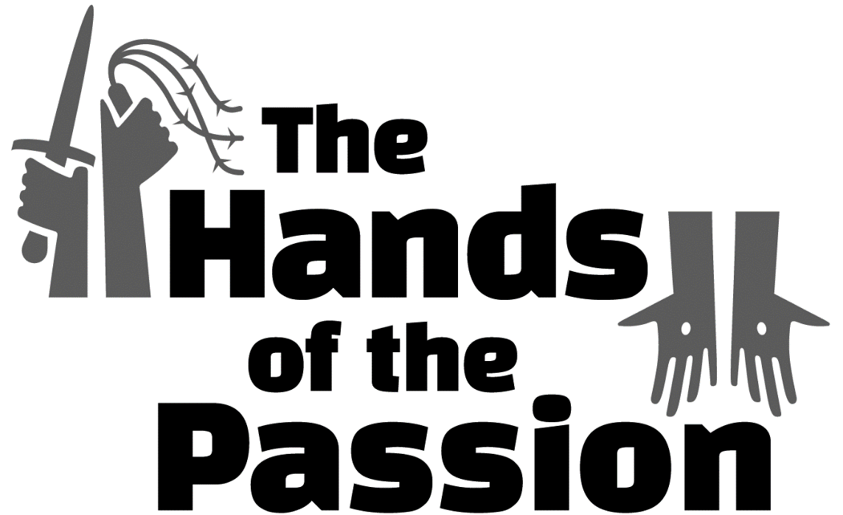

The Sixth Sunday in Lent
PALM SUNDAY
“The Hands of Praise”

tRINITY EVANGELICAL LUTHERAN CHURCH | Saline, Michigan
March 25/28, 2021

WELCOME TO WORSHIP

Thank you for joining us in God’s house today! We cordially ask that our Guests with us this morning sign one of the guestbooks located at either the front or back entryways.

THANK OFFERING: Members of Trinity give their offering as an expression of love and thankfulness to the Lord and to help support the Lord’s work in our community and around the world. Visitors need not feel obligated to participate in this offering which supports our ministry.

Restrooms are located at the back of the upper level (the annex), and in the basement (down the back stairs of the sanctuary or annex). Handicap access is available, please ask an usher for assistance.

Young Families / Toddler Bags – We are GLAD YOU BROUGHT YOUR CHILDREN to our worship service. Jesus said: “Let the little children come to me and do not hinder them, for the kingdom of God belongs to such as these.” We know that having little children in church can be a challenge, but DO NOT WORRY about it. Many of your fellow worshippers have been in your shoes and are just happy you brought your children with you. For your convenience, we have reserved the back rows of seating for parents with small children. These areas provide more flexibility for your family, as well as, easy access to move downstairs if necessary. A closed-circuit TV system allows families to continue participating in the service while downstairs. Pre-school toddler bags and children’s bulletins are available for their enjoyment. Ask an usher for one to use during the service and please return the toddler bag afterwards.

OPENING HYMN CW #131

invocation

Please stand, if you are able

M: In the name of the Father and of the Son (+) and of the Holy Spirit.
C: Amen.

CONFESSION

M: Dear friends, let us approach God with a true heart and confess our sins, asking him in the name of our Lord Jesus Christ to forgive us.
C: Lord of life, I confess that I am by nature dead in sin.
For faithless worrying and selfish pride, for sins of habit and sins of choice,
For the evil I have done and the good I have failed to do,
You should cast me away from your presence forever.
O Lord, I am sorry for my sins. Forgive me, for Jesus’ sake.

ABSOLUTION
M: Christ has died. Christ is risen. Christ will come again. In his great mercy, God made us alive in Christ even when we were dead in our sins. Hear the word of Christ through his called servant:
I forgive you all your sins in the name of the Father and of the Son (+) and of the Holy Spirit.

C: Amen.

PRAYER
M: Lord God, you have brought us safely to this hour of prayer. We thank you for providing all that we need for body and life. Bless us who have gathered in your name. Forgive our sins. Speak to our hearts. Dispel our sorrows with the comfort of your Word, and receive our hymns of thanks and praise, through Jesus Christ, our living Savior, who reigns with you and the Holy Spirit, one God, now and forever.
C: Amen.
Please be seated
PSALM Psalm 24

Refrain
The earth is the LORD’S, and everything in it,*
the world, and all who live in it;
for he founded it upon the seas*
and established it upon the waters.
Who may ascend the hill of the LORD?*
Who may stand in his holy place?
He who has clean hands and a pure heart,*
he will receive blessing from God his Savior.
Refrain
Lift up your heads, O you gates;
be lifted up, you ancient doors,*
that the King of glory may come in.
Who is this King of glory?*
The LORD strong and mighty,
the LORD mighty in battle.
Lift up your heads, O you gates;
lift them up, you ancient doors,*
that the King of glory may come in.
Who is he, this King of glory?*
The LORD Almighty—he is the King of glory.
Glory be to the Father and to the Son*
and to the Holy Spirit,
as it was in the beginning,*
is now, and will be forever. Amen.
Refrain

Refrain Tune: Richard Proulx. © 1986 GIA Publications, Inc., Chicago, IL, www.giamusic.com. All rights reserved. Used by permission.
PSALM PRAYER

M: Lord God, Ruler of heaven and earth, cleanse our lives and purify our hearts so that your Son, the King of glory, may come in and lead us rejoicing to your heavenly city, the New Jerusalem, where with him and the Holy Spirit you live and reign, one God, now and forever.

C: Amen.

LESSON: The Passion History – Part Five

Pilate called together the chief priests, the rulers, and the people, and said to them, “You brought this man to me as one who is misleading the people. Look, I have examined him in your presence. I have found in this man no basis for the charges you are bringing against him. Herod did not either, for he sent him back to us. See, he has done nothing worthy of death. So I will have him flogged and release him.”
At the time of the Festival the governor had a custom to release to the crowd any one prisoner they wanted. At that time they were holding a notorious prisoner named Barabbas, who had been thrown in prison for a rebellion in the city and for murder. The crowd came up and began to ask Pilate to do for them what he usually did.
So when they were assembled, Pilate said to them, “Do you want me to release the King of the Jews to you? Which one do you want me to release to you? Barabbas—or Jesus, who is called Christ?” For Pilate in fact knew that they had handed Jesus over to him because of envy.
While he was sitting on the judgment seat, Pilate’s wife sent him a message. “Have nothing to do with that righteous man,” she said, “since I have suffered many things today in a dream because of him.” But the chief priests and the elders persuaded the crowd to ask for Barabbas and to have Jesus put to death. The governor asked them, “Which of the two do you want me to release to you?”
They all shouted together with one voice: “Take him away! Release Barabbas to us!”
Pilate said to them, “Then what do you want me to do with the man you call the King of the Jews? What should I do with Jesus, who is called Christ?”
They all said to him, “Crucify him!”
But the governor said, “Why? What has he done wrong?”
But they kept shouting even louder: “Crucify him!”
Pilate addressed them again, because he wanted to release Jesus. But they kept shouting, “Crucify! Crucify him!”
He said to them the third time, “Why? What evil has he done? I have found no grounds for sentencing him to death. So I will whip him and release him.” But they kept pressuring him with loud voices, demanding that he be crucified. And their voices were overwhelming.
Then Pilate took Jesus and had him flogged.
The governor’s soldiers took Jesus into the Praetorium and gathered the whole cohort of soldiers around him. They stripped him and put a scarlet robe on him. They twisted together a crown of thorns and put it on his head. They put a staff in his right hand, knelt in front of him, and mocked him by saying, “Hail, King of the Jews!” They spit on him, took the staff, and hit him repeatedly on his head. They also kept hitting him in the face.
Pilate went outside again and said to them, “Look, I am bringing him out to you to let you know that I find no basis for a charge against him.”
So Jesus came out wearing the crown of thorns and the purple robe. Pilate said to them, “Behold the man!”
When the chief priests and guards saw him, they shouted, “Crucify! Crucify!”
Pilate told them, “Take him yourselves and crucify him, for I find no basis for a charge against him.”
The Jews answered him, “We have a law, and according to that law he ought to die, because he claimed to be the Son of God.”
When Pilate heard this statement, he was even more afraid. He went back inside the palace again and asked Jesus, “Where are you from?”
But Jesus gave him no answer.
So Pilate asked him, “Are you not talking to me? Don’t you know that I have the authority to release you or to crucify you?”
Jesus answered, “You would have no authority over me at all if it had not been given to you from above. Therefore the one who handed me over to you has the greater sin.”
From then on Pilate tried to release Jesus. But the Jews shouted, “If you let this man go, you are no friend of Caesar! Anyone who claims to be a king opposes Caesar!”
When Pilate heard these words, he brought Jesus outside. He sat down on the judge’s seat at a place called the Stone Pavement, or Gabbatha in Aramaic. It was about the sixth hour on the Preparation Day for the Passover. Pilate said to the Jews, “Here is your king!”
They shouted, “Away with him! Away with him! Crucify him!”
Pilate said to them, “Should I crucify your king?”
“We have no king but Caesar!” the chief priests answered.
When Pilate saw that he was accomplishing nothing and that instead it was turning into a riot, he decided that what they demanded would be done. He took water, washed his hands in front of the crowd, and said, “I am innocent of this righteous man’s blood. It is your responsibility.”
And all the people answered, “Let his blood be on us and on our children!”
Since he wanted to satisfy the crowd, Pilate released Barabbas to them.
So then Pilate handed Jesus over to them to be crucified.
After they had mocked him, the soldiers took off the robe and put his own clothes on him. Then they led him away to crucify him. Jesus was carrying his own cross.
As they were going out of the city, a certain man, Simon of Cyrene (the father of Alexander and Rufus), was passing by on his way in from the country. They placed the cross on him and made him carry it behind Jesus. A large crowd of the people was following him, including women who were mourning and wailing for him.
Jesus turned to them and said, “Daughters of Jerusalem, stop weeping for me, but weep for yourselves and for your children. Be sure of this: The days are coming when they will say, ‘Blessed are the childless women, the wombs that never gave birth, and the breasts that never nursed.’ Then they will begin to say to the mountains, ‘Fall on us!’ and to the hills, ‘Cover us.’ For if they do these things to the green wood, what will happen to the dry?”

SEASONAL RESPONSE: (All)

M: We join in responding:

C: All we like sheep have gone astray, and the Lord has laid on him the
iniquity of us all. By his wounds we are healed.

SERMON HYMN CWS #133

SERMON TEXT: Mark 11:1-10
¹ As they approached Jerusalem, at Bethphage and Bethany, on the Mount of Olives, he sent two of his disciples ² and told them, “Go into the village ahead of you. As soon as you enter it, you will find a colt tied there, on which no one has ever sat. Untie it and bring it here. ³ If anyone asks you, ‘Why are you doing this?’ say, ‘The Lord needs it, and he will send it back here without delay.’”
⁴ They left and found a colt on the street, tied at a door; and they untied it. ⁵ Some who were standing there asked them, “What are you doing, untying that colt?” ⁶ The disciples answered them just as Jesus had instructed them, and the men let them go.
⁷ They brought the colt to Jesus, threw their garments on it, and Jesus sat on it. ⁸ Many people spread their garments on the road. Others spread branches that they had cut from the fields. ⁹ Those who went in front and those who followed were crying out,
Hosanna!
Blessed is he who comes in the name of the Lord!
¹⁰ Blessed is the coming kingdom of our father David!
Hosanna in the highest!
“The Hands of Praise”

Please stand, if you are able

APOSTLES’ CREED

I believe in God, the Father almighty,
maker of heaven and earth.
I believe in Jesus Christ, his only Son, our Lord,
who was conceived by the Holy Spirit,
born of the virgin Mary,
suffered under Pontius Pilate,
was crucified, died, and was buried.
He descended into hell.
The third day he rose again from the dead.
He ascended into heaven
and is seated at the right hand of God the Father almighty.
From there he will come to judge the living and the dead.
I believe in the Holy Spirit,
the holy Christian Church,
the communion of saints,
the forgiveness of sins,
the resurrection of the body,
and the life everlasting. Amen.

PRAYER OF THE CHURCH

THE LORD’S PRAYER

C: Our Father, who art in heaven, hallowed be thy name, thy kingdom come, thy will be done on earth as it is in heaven. Give us this day our daily bread; and forgive us our trespasses, as we forgive those who trespass against us; and lead us not into temptation, but deliver us from evil. For thine is the kingdom and the power and the glory forever and ever. Amen.

Please be seated

HYMN #130

Please stand, if you are able

CLOSING PRAYER
M: Lord God, all holy desires, all good counsels, and all just works come from you. Give to us, your servants, that peace which the world cannot give, that our hearts may be set to obey your commandments. Defend us also from the fear of our enemies that we may live in peace and quietness, through the merits of Jesus Christ our Savior, who lives and reigns with you and the Holy Spirit, one God, now and forever.

M: Brothers and sisters, go in peace. Live in harmony with one another. Serve the Lord with gladness.
M: The Lord bless you and keep you.
The Lord make his face shine on you and be gracious to you.
The Lord look on you with favor and (+) give you peace.

Please be seated

CLOSING HYMN #716

Serving In Worship
Liturgy Pastor Natsis
Preacher Pastor Natsis
Organist Marcia Marion Ackling
Deacons (Thursday) Dave Frey and Duane Mason
(Sunday - 8:30) Jim Tice and Ed Wheeler
(Sunday – 11:00) Robert Niethammer and Jeff Neuburger
Altar Guild Shirley Klumpp and Ann Latowski
Videographer Rick Schneider

Copyright information
Service of the Word: Christian Worship. © 1993 Northwestern Publishing House. All rights reserved.
Reprinted with permission under ONE LICENSE #A-727703 and CCLI #1151741/CSPL126093

Words and Music: All rights reserved. Reprinted with permission under ONE LICENSE #A-727703 and
CCLI #1151741/CSPL126093

