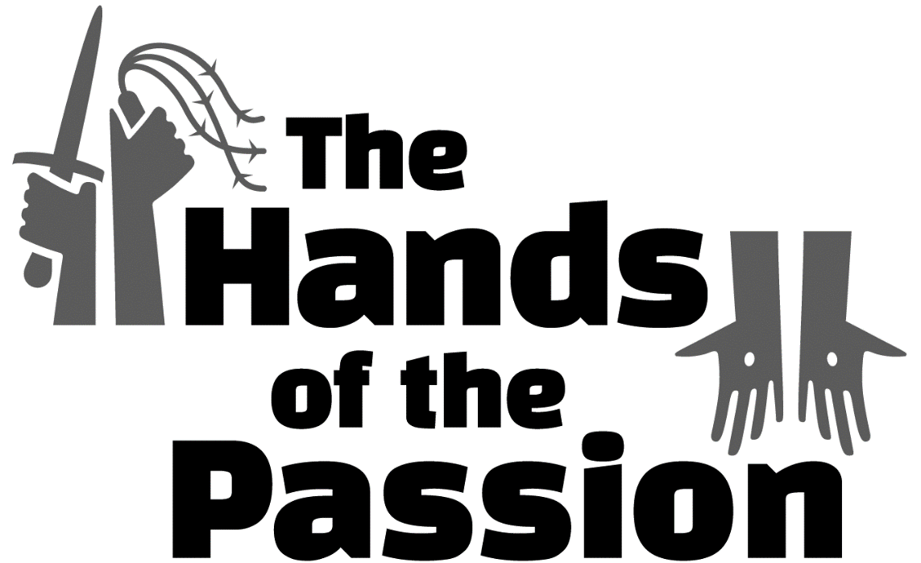

The Fourth Sunday in Lent – March 11/14
“The Hands of Hypocrisy”

tRINITY EVANGELICAL LUTHERAN CHURCH | Saline, Michigan
March 11/14, 2021

WELCOME TO WORSHIP

Thank you for joining us in God’s house today! We cordially ask that our Guests with us this morning sign one of the guestbooks located at either the front or back entryways.

THANK OFFERING: Members of Trinity give their offering as an expression of love and thankfulness to the Lord and to help support the Lord’s work in our community and around the world. Visitors need not feel obligated to participate in this offering which supports our ministry.

Restrooms are located at the back of the upper level (the annex), and in the basement (down the back stairs of the sanctuary or annex). Handicap access is available, please ask an usher for assistance.

Young Families / Toddler Bags – We are GLAD YOU BROUGHT YOUR CHILDREN to our worship service. Jesus said: “Let the little children come to me and do not hinder them, for the kingdom of God belongs to such as these.” We know that having little children in church can be a challenge, but DO NOT WORRY about it. Many of your fellow worshippers have been in your shoes and are just happy you brought your children with you. For your convenience, we have reserved the back rows of seating for parents with small children. These areas provide more flexibility for your family, as well as, easy access to move downstairs if necessary. A closed-circuit TV system allows families to continue participating in the service while downstairs. Pre-school toddler bags and children’s bulletins are available for their enjoyment. Ask an usher for one to use during the service and please return the toddler bag afterwards.

OPENING HYMN CW #397

invocation

Please stand, if you are able

M: In the name of the Father and of the Son (+) and of the Holy Spirit.
C: Amen.

CONFESSION

M: Dear friends, let us approach God with a true heart and confess our sins, asking him in the name of our Lord Jesus Christ to forgive us.
C: Lord of life, I confess that I am by nature dead in sin.
For faithless worrying and selfish pride, for sins of habit and sins of choice,
For the evil I have done and the good I have failed to do,
You should cast me away from your presence forever.
O Lord, I am sorry for my sins. Forgive me, for Jesus’ sake.

ABSOLUTION
M: Christ has died. Christ is risen. Christ will come again. In his great mercy, God made us alive in Christ even when we were dead in our sins. Hear the word of Christ through his called servant:
I forgive you all your sins in the name of the Father and of the Son (+) and of the Holy Spirit.

C: Amen.

PRAYER
M: Lord God, you have brought us safely to this hour of prayer. We thank you for providing all that we need for body and life. Bless us who have gathered in your name. Forgive our sins. Speak to our hearts. Dispel our sorrows with the comfort of your Word, and receive our hymns of thanks and praise, through Jesus Christ, our living Savior, who reigns with you and the Holy Spirit, one God, now and forever.
C: Amen.
Please be seated
PSALM Psalm 2

Refrain
Why do the nations conspire*
and the peoples plot in vain?
The kings of the earth take their stand and the rulers
gather together against the LORD*
and against his Anointed One.
Refrain
The One enthroned in heaven laughs;*
the Lord scoffs at them.
Then he rebukes them in his anger
and terrifies them in his wrath, saying,*
“I have installed my King on Zion, my holy hill.”
I will proclaim the decree of the LORD:*
He said to me, “You are my Son;
today I have become your Father.”
Glory be to the Father and to the Son*
and to the Holy Spirit,
as it was in the beginning,*
is now, and will be forever. Amen.
Refrain

Refrain Tune: Kermit G. Moldenhauer. © 1993 Kermit G. Moldenhauer (admin. Northwestern Publishing House). All rights reserved. Used by permission.

PSALM PRAYER

M: Lord God, you anointed your Son to be King for the sake of your Church. Help us, as members of his kingdom, to serve him faithfully and to come to the full knowledge of his grace and glory, who lives and reigns with you and the Holy Spirit, one God, now and forever.

C: Amen.

LESSON: The Passion History – Part Three
While Jesus was still speaking, suddenly Judas (one of the Twelve) arrived. With him was a large crowd with lanterns, torches, swords, and clubs, who came from the chief priests and elders of the people. Judas was leading them.
Jesus, knowing everything that was going to happen to him, went out and asked them, “Who are you looking for?”
“Jesus the Nazarene,” they replied.
“I am he,” Jesus told them.
Judas, the betrayer, was standing with them. When Jesus told them, “I am he,” they backed away and fell to the ground.
Then Jesus asked them again, “Who are you looking for?”
“Jesus the Nazarene,” they said.
“I told you that I am he,” Jesus replied. “So if you are looking for me, let these men go.” This was to fulfill the statement he had spoken: “I did not lose any of those you have given me.”
Now the betrayer had given them a sign: “The one I kiss is the man. Arrest him.” Immediately he went to Jesus and said, “Greetings, Rabbi!” and kissed him.
Jesus said to him, “Judas, are you betraying the Son of Man with a kiss?”
Then they advanced, took hold of Jesus, and arrested him. When those who were around him saw what was about to happen, they said to him, “Lord, should we strike with a sword?” Then Simon Peter, who had a sword, drew it, struck the high priest’s servant, and cut off his right ear. The servant’s name was Malchus.
But Jesus responded, “Stop! No more of this! Put your sword back into its place, because all who take the sword will die by the sword. Do you not realize that I could call on my Father, and at once he would provide me with more than twelve legions of angels? But then how would the Scriptures be fulfilled that say it must happen this way?” Then he touched the servant’s ear and healed him.
At that same time Jesus said to the crowd, “Have you come out to arrest me with swords and clubs as if I were a robber? Day after day I was sitting in the temple courts teaching, and you did not arrest me. But all this has happened so that the writings of the prophets would be fulfilled.” Then all the disciples deserted him and fled.
The company of soldiers, their commander, and the Jewish guards arrested Jesus and bound him. First they led him to Annas, because he was father-in-law to Caiaphas, who was the high priest that year. Now it was Caiaphas who had advised the Jews, “It is better that one man die for the people.”
Simon Peter and another disciple kept following Jesus. That disciple was known to the high priest, so he went into the high priest’s courtyard with Jesus. But Peter stood outside by the door. So the other disciple, the one known to the high priest, went out and talked to the girl watching the door and brought Peter in.
The servants and guards were standing around a fire of coals that they had made because it was cold. While they warmed themselves, Peter was standing with them, warming himself too.
One of the servant girls of the high priest came there. When she saw Peter warming himself, she looked directly at him and said, “You were also with Jesus the Galilean.”
But he denied it in front of everyone, saying, “I don’t know what you are talking about. Woman, I do not know him.”
When Peter went out to the entryway, someone else saw him and said to those who were there, “This is one of them. This fellow was with Jesus of Nazareth.”
Again Peter denied it with an oath and said, “I do not know the man.”
After a little while those who stood by came and said to Peter, “Surely you are also one of them, because even your accent gives you away. You are a Galilean!”
Then he began to curse and to swear, “I do not know this man you are talking about! I do not know the man!”
At that very moment, while he was still speaking, the rooster crowed. The Lord turned and looked at Peter. Then Peter remembered the Lord’s word, how he had said to him, “Before the rooster crows today you will deny me three times.” He went outside, broke down, and wept bitterly.
The high priest questioned Jesus about his disciples and his teaching.
Jesus answered him, “I have spoken openly to the world. I always taught in a synagogue or at the temple, where all the Jews gather. I said nothing in secret. Why are you questioning me? Ask those who heard what I told them. Look, they know what I said.”
When he said this, one of the guards standing there hit Jesus in the face. “Is that how you answer the high priest?” he demanded.
“If I said something wrong,” Jesus answered, “testify about what was wrong. But if I was right, why did you hit me?”
The chief priests and the whole Sanhedrin were looking for false testimony against Jesus so that they could put him to death. They found none, even though many false witnesses came forward. Finally two came forward and said, “This fellow said, ‘I am able to destroy the temple of God and rebuild it in three days.’” Yet even on this point, their testimony did not agree.
The high priest stood up and said to him, “Have you no answer? What is this that these men are testifying against you?” But Jesus remained silent. Then the high priest said to him, “I place you under oath by the living God: Tell us if you are the Christ, the Son of God!”
Jesus said to him, “It is as you have said. But I tell you, soon you will see the Son of Man sitting at the right hand of power and coming on the clouds of heaven.”
Then the high priest tore his robes and said, “He has spoken blasphemy! Why do we need any more witnesses? See, you have just heard the blasphemy! What do you think?”
They answered, “He is deserving of death!” Then some began to spit on him. They covered his face, struck him with their fists, and said, “Prophesy to us, Christ! Who hit you?” The guards also took him and beat him. And they went on saying many other blasphemous things against him.

SEASONAL RESPONSE: (All)

M: We join in responding:

C: All we like sheep have gone astray, and the Lord has laid on him the
iniquity of us all. By his wounds we are healed.

SERMON HYMN CWS #115

SERMON TEXT: Mark 14:55-65
⁵⁵ The chief priests and the whole Sanhedrin were looking for testimony against Jesus in order to put him to death, but they did not find any. ⁵⁶ Many testified falsely against him, but their testimonies did not agree. ⁵⁷ Some stood up and gave this false testimony against him: ⁵⁸ “We heard him say, ‘I will destroy this temple made with hands, and in three days I will build another made without hands.’” ⁵⁹ Yet even on this point, their testimony did not agree.
⁶⁰ The high priest stepped forward and questioned Jesus, “Have you no answer? What is this they are testifying against you?” ⁶¹ But Jesus was silent and did not answer anything. Again the high priest asked him, “Are you the Christ, the Son of the Blessed One?”

⁶² “I am,” Jesus said. “And you will see the Son of Man sitting at the right hand of power and coming with the clouds of heaven.”

⁶³ The high priest tore his robes and said, “Why do we need any more witnesses? ⁶⁴ You have heard the blasphemy! What do you think?”

They all condemned him as being worthy of death. ⁶⁵ Then some began to spit on him. They covered his face and struck him with their fists, saying, “Prophesy!” The guards also took him and beat him.
“The Hands of Hypocrisy”
Please stand, if you are able

APOSTLES’ CREED

I believe in God, the Father almighty,
maker of heaven and earth.
I believe in Jesus Christ, his only Son, our Lord,
who was conceived by the Holy Spirit,
born of the virgin Mary,
suffered under Pontius Pilate,
was crucified, died, and was buried.
He descended into hell.
The third day he rose again from the dead.
He ascended into heaven
and is seated at the right hand of God the Father almighty.
From there he will come to judge the living and the dead.
I believe in the Holy Spirit,
the holy Christian Church,
the communion of saints,
the forgiveness of sins,
the resurrection of the body,
and the life everlasting. Amen.

PRAYER OF THE CHURCH

THE LORD’S PRAYER

C: Our Father, who art in heaven, hallowed be thy name, thy kingdom come, thy will be done on earth as it is in heaven. Give us this day our daily bread; and forgive us our trespasses, as we forgive those who trespass against us; and lead us not into temptation, but deliver us from evil. For thine is the kingdom and the power and the glory forever and ever. Amen.

Please be seated

HYMN #120

Please stand, if you are able

CLOSING PRAYER
M: Lord God, all holy desires, all good counsels, and all just works come from you. Give to us, your servants, that peace which the world cannot give, that our hearts may be set to obey your commandments. Defend us also from the fear of our enemies that we may live in peace and quietness, through the merits of Jesus Christ our Savior, who lives and reigns with you and the Holy Spirit, one God, now and forever.

M: Brothers and sisters, go in peace. Live in harmony with one another. Serve the Lord with gladness.
M: The Lord bless you and keep you.
The Lord make his face shine on you and be gracious to you.
The Lord look on you with favor and (+) give you peace.

Please be seated

CLOSING HYMN #116

Serving In Worship
Liturgy Pastor Natsis
Preacher Pastor Natsis
Organist Sarah Hanke
Deacons (Thursday) Dave Frey and Duane Mason
(Sunday - 8:30) Jim Tice and Ed Wheeler
(Sunday – 11:00) Robert Niethammer and Jeff Neuburger
Altar Guild Shirley Klumpp and Ann Latowski
Videographer Cindy Dresch

Copyright information
Service of the Word: Christian Worship. © 1993 Northwestern Publishing House. All rights reserved.
Reprinted with permission under ONE LICENSE #A-727703 and CCLI #1151741/CSPL126093

Words and Music: All rights reserved. Reprinted with permission under ONE LICENSE #A-727703 and
CCLI #1151741/CSPL126093

