the FIFTH Sunday
after EPIPHANY

tRINITY EVANGELICAL LUTHERAN CHURCH | Saline, Michigan
December 6, 2022

WELCOME TO WORSHIP

Thank you for joining us in God’s house today! We cordially ask that our Guests sign one of the guestbooks located at either the front or back entryways, or fill out a “Let’s Get Acquainted” card located in the hymnal pew rack and place it in the collection plate.

THANK OFFERING: Members of Trinity give their offering as an expression of love and thankfulness to the Lord and to help support the Lord’s work in our community and around the world. Visitors need not feel obligated to participate in this offering which supports our ministry.

Restrooms are located at the back of the upper level (the annex), and in the basement (down the back stairs of the sanctuary or annex). Handicap access is available, please ask an usher for assistance.

Young Families / Toddler Bags – We are GLAD YOU BROUGHT YOUR CHILDREN to our worship service. Jesus said: “Let the little children come to me and do not hinder them, for the kingdom of God belongs to such as these.” We know that having little children in church can be a challenge, but DO NOT WORRY about it. Many of your fellow worshippers have been in your shoes and are just happy you brought your children with you. For your convenience, we have reserved the back rows of seating for parents with small children. These areas provide more flexibility for your family, as well as, easy access to move downstairs if necessary. A closed-circuit TV system allows families to continue participating in the service while downstairs. Pre-school toddler bags and children’s bulletins are available for their enjoyment. Ask an usher for one to use during the service and please return the toddler bag afterwards.

celebration of holy communion:
In His Word, God makes it clear that the Lord’s Supper is to be shared by people of a common proclamation of faith (1 Corinthians 11:26; 1 Corinthians 10:16-17). Without judging anyone’s hearts, we invite those who share in our confession by their membership in our congregation or another congregation of the Wisconsin Evangelical Lutheran Synod (WELS) or the Evangelical Lutheran Synod (ELS) and who are properly prepared (1 Corinthians 11;27-29) to receive the Sacrament. Page 295 in the front of Christian Worship provides a guide for preparation.
Guests, we would love to have you join us in communion fellowship in the future, and for that to be possible, we ask that you speak with one of the pastors so that we may speak with you on how that would be possible. We thank you for respecting the way we celebrate the Lord’s Supper in our congregations.
DIVINE SERVICE II

Opening hymn CW #745

745 Hark, the Voice of Jesus Crying CW 745
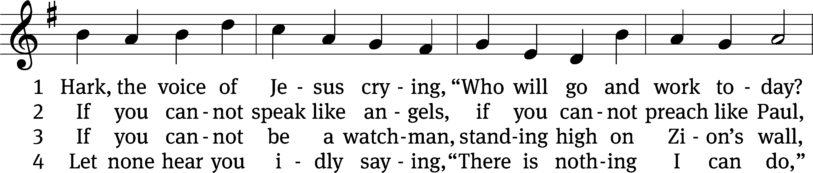
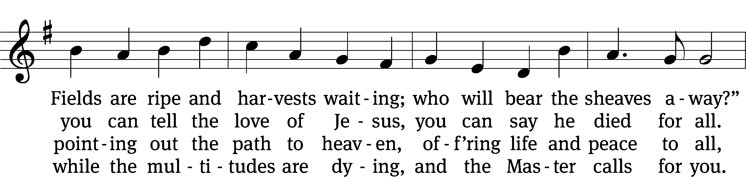
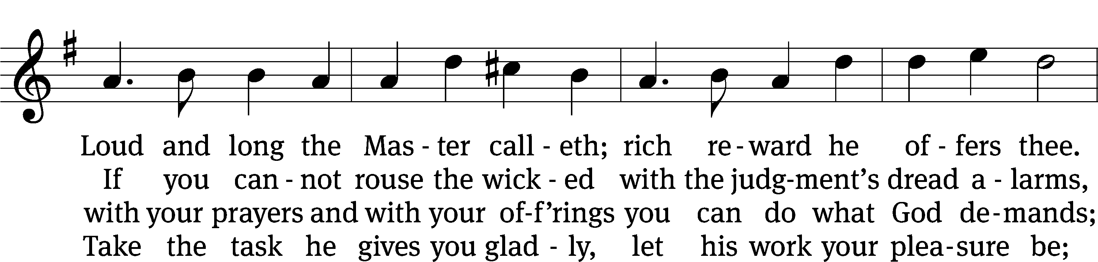
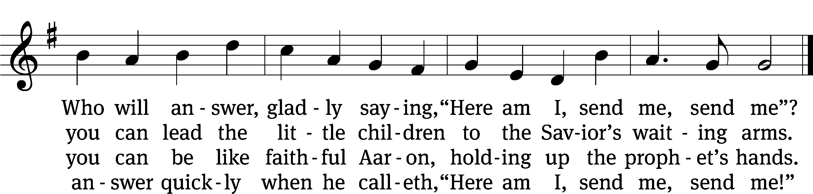
Text and tune: Public domain

invocation
Please stand, if you are able.

M: In the name of the Father and of the Son (+) and of the Holy Spirit.
C: Amen.

CONFESSION

M: Dear friends, let us approach God with a true heart and confess our sins, asking him in the name of our Lord Jesus Christ to forgive us.
C: Lord of life, I confess that I am by nature dead in sin.
For faithless worrying and selfish pride,
For sins of habit and sins of choice,
For the evil I have done and the good I have failed to do,
You should cast me away from your presence forever.
O Lord, I am sorry for my sins. Forgive me, for Jesus’ sake.

ABSOLUTION

M: Christ has died. Christ is risen. Christ will come again. In his great mercy, God made us alive in Christ even when we were dead in our sins. Hear the word of Christ through his called servant:
I forgive you all your sins in the name of the Father and of the Son (+) and of the Holy Spirit.
C: Amen.

LORD, HAVE MERCY

M: In peace, let us pray to the Lord.
For the well-being of all people everywhere, that they may receive from you all they need to sustain body and life, hear our prayer, O Lord.
C: Lord, have mercy.
M: For the spread of your life-giving gospel throughout the world, that all who are lost in sin may be brought to faith in you, hear our prayer, O Christ.
C: Christ, have mercy.
M: For patience and perseverance in this life, that we may not lose the hope of heaven as we await your return, hear our prayer, O Lord.
C: Lord, have mercy.
M: Lord of life, live in us that we may live for you.
C: Amen.

GLORY BE TO GOD (Tune from CW #320) Luke 2:14

THE WORD
SALUTATION
M: The Lord be with you.
C: And also with you.

PRAYER OF THE DAY

M: Let us pray.
(The Prayer of the Day is spoken.)
C: Amen.

Please Be Seated
FIRST LESSON: Isaiah 6:1-8

¹ In the year that King Uzziah died, I saw the Lord sitting on a throne, high and exalted, and the train of his robe filled the temple. ² Above him stood the seraphim. Each one had six wings. With two they covered their faces. With two they covered their feet. With two they flew. ³ One called to another and said,
Holy, holy, holy is the Lord of Armies!
The whole earth is full of his glory!
⁴ The foundations of the thresholds shook at the voice of the one who called, and the temple was filled with smoke.
⁵ Then I said, “I am doomed! I am ruined, because I am a man with unclean lips, and I dwell among a people with unclean lips, and because my eyes have seen the King, the Lord of Armies!”
⁶ Then one of the seraphim flew to me, carrying a glowing coal in his hand, which he had taken from the altar with tongs. ⁷ He touched my mouth with the coal and said, “Look, this has touched your lips, so your guilt is taken away, and your sin is forgiven.”
⁸ Then I heard the Lord’s voice, saying, “Whom shall I send? Who will go for us?”
Then I said, “Here I am. Send me!”

PSALM OF THE DAY Psalm 67E
67E O God, Show Us Your Mercy Psalm 67E
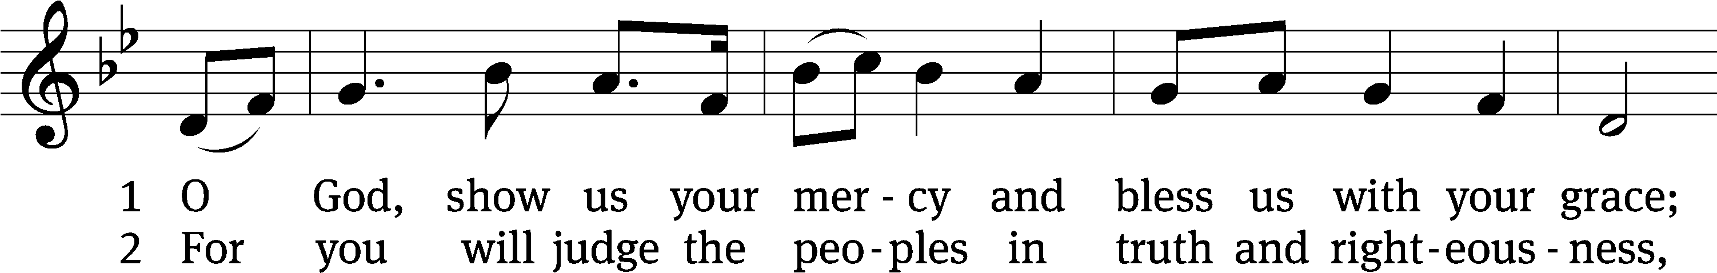
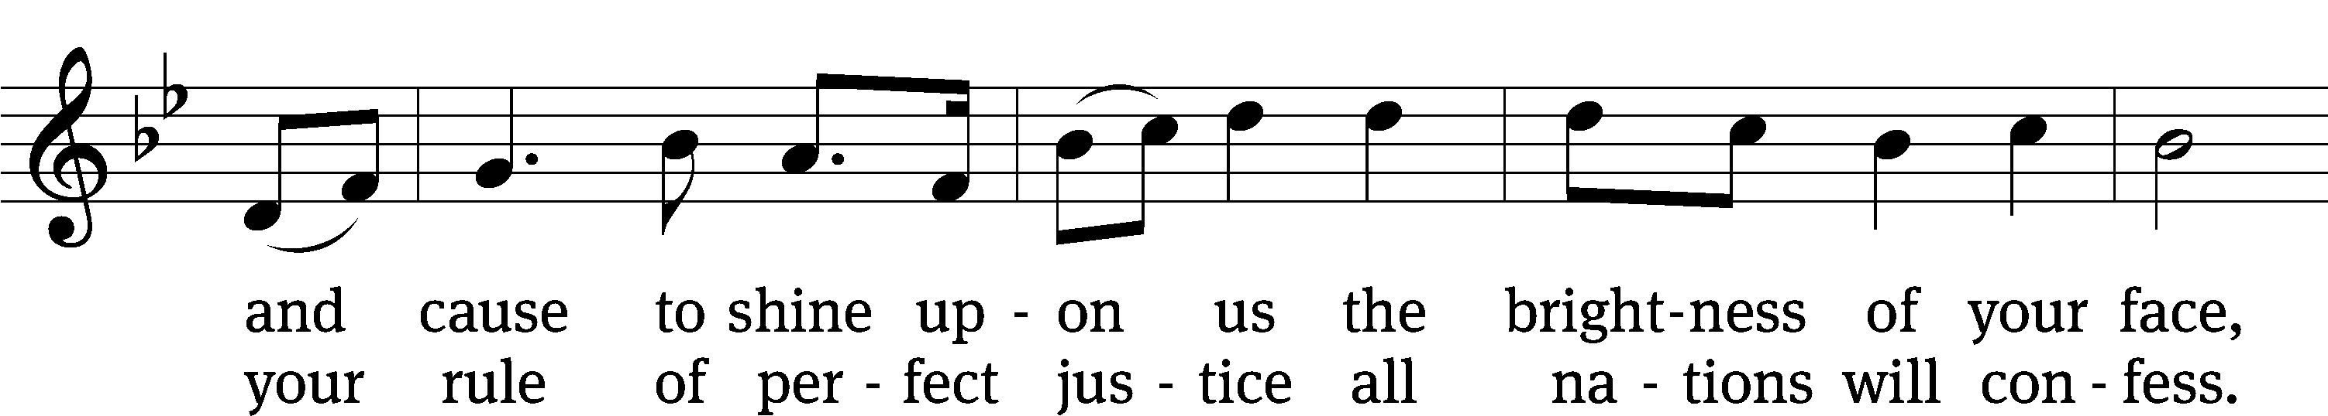
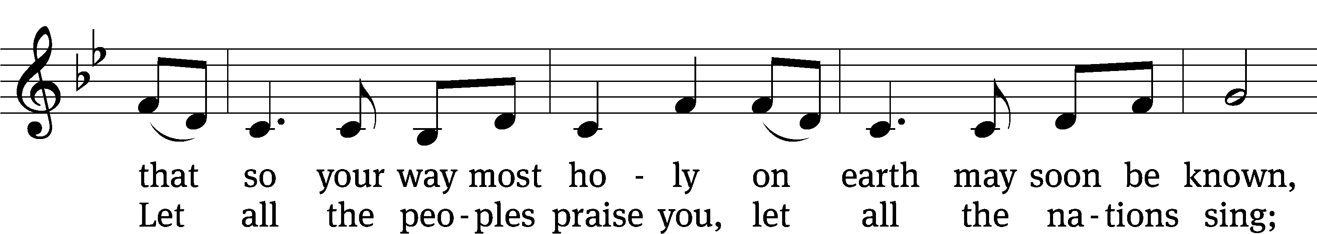
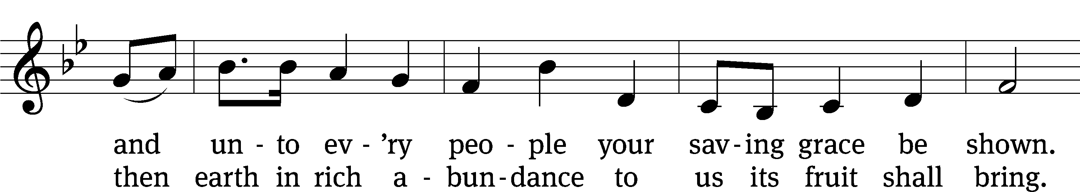
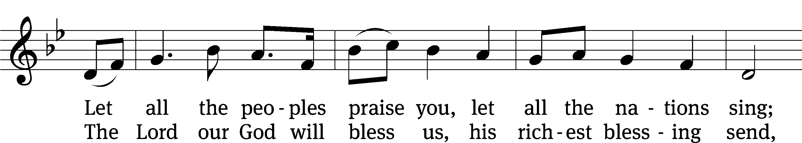
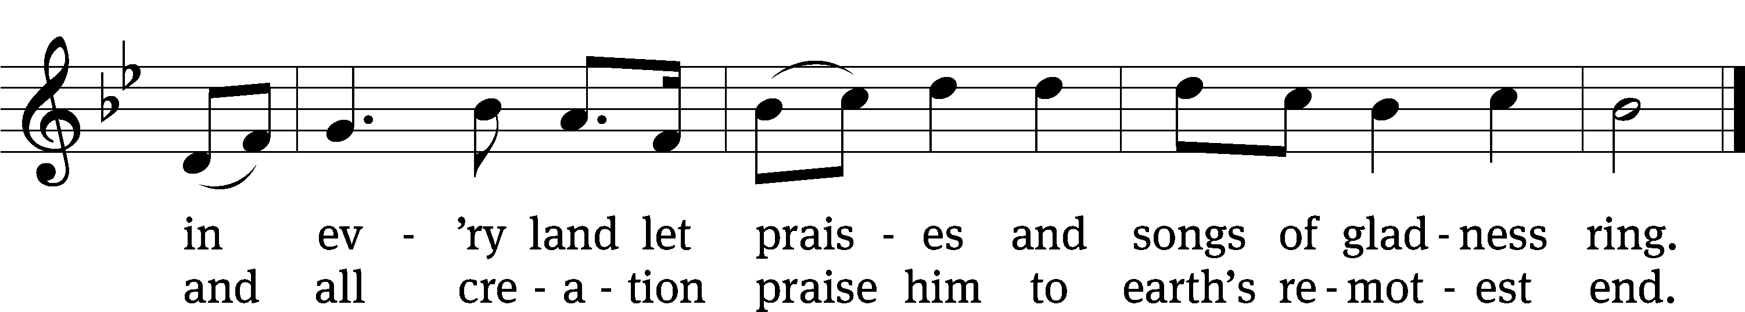
Text and tune: Public domain

SECOND LESSON: Romans 10:12-17
¹² So there is no distinction between Jew and Greek, because the same Lord is Lord of all, who gives generously to all who call on him. ¹³ Yes, “Everyone who calls on the name of the Lord will be saved.”
¹⁴ So then, how can they call on the one they have not believed in? And how can they believe in the one about whom they have not heard? And how can they hear without a preacher? ¹⁵ And how can they preach unless they are sent? Just as it is written, “How beautiful are the feet of those who preach the good news of peace, who preach the gospel of good things!”
¹⁶ But not all obeyed the gospel. For Isaiah says, “Lord, who believed our message?” ¹⁷ So then, faith comes from hearing the message, and the message comes through the word of Christ.

Please stand, if you are able.

GOSPEL Luke 5:1-11

M: The Gospel according to Luke, chapter 5, verses 1-11
C: Glory be to you, O Lord.

¹ One time, while the crowd was pressing in on Jesus and listening to the word of God, he was standing by the Lake of Gennesaret. ² He saw two boats there along the lakeshore. The fishermen had left them and were washing their nets. ³ Jesus got into one of the boats, which belonged to Simon, and asked him to put out a little from the shore. He sat down and began teaching the crowds from the boat. ⁴ When he had finished speaking, he said to Simon, “Put out into the deep water, and let down your nets for a catch.”
⁵ Simon answered him, “Master, we worked hard all through the night and caught nothing. But at your word I will let down the nets.” ⁶ When they had done this, they caught a great number of fish, and their nets were about to tear apart. ⁷ They signaled their partners in the other boat to come and help them. They came and filled both boats, so that they began to sink. ⁸ When Simon Peter saw this, he fell down at Jesus’ knees, saying, “Go away from me, because I am a sinful man, Lord.” ⁹ For Peter and all those with him were amazed at the number of fish they had caught, ¹⁰ and so were James and John, the sons of Zebedee, who were partners with Simon.
Jesus said to Simon, “Have no fear. From now on you will be catching people.”
¹¹ After they brought their boats to the shore, they left everything and followed him.

M: This is the Gospel of the Lord.
C: Praise be to you, O Christ.

Please Be Seated

SERMON HYMN CW #707
707 Cling Tightly to the Word of God CW 707
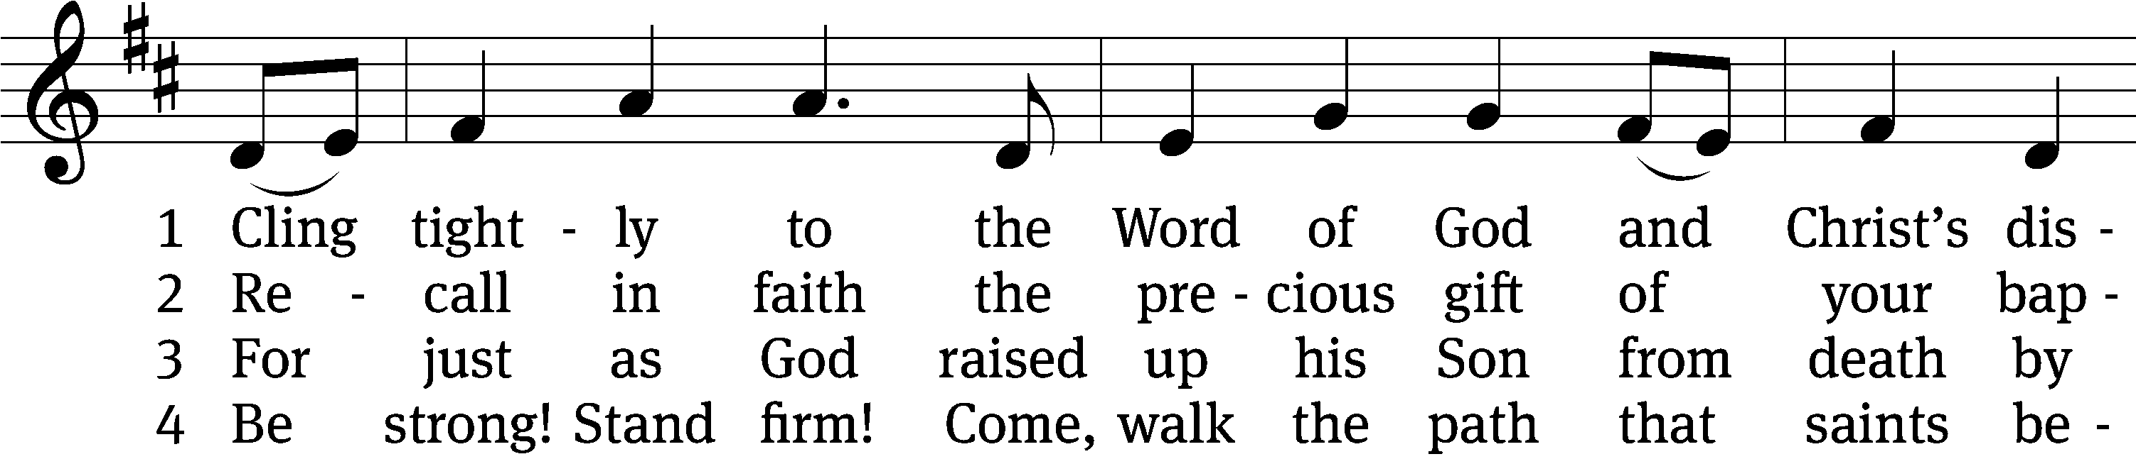
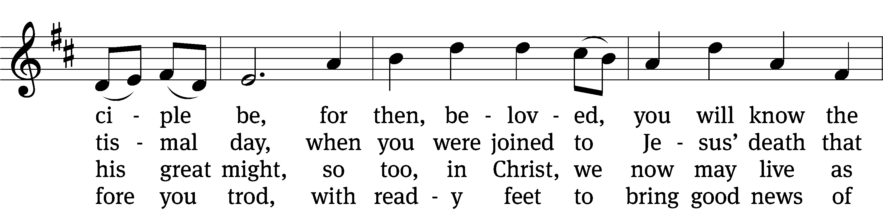
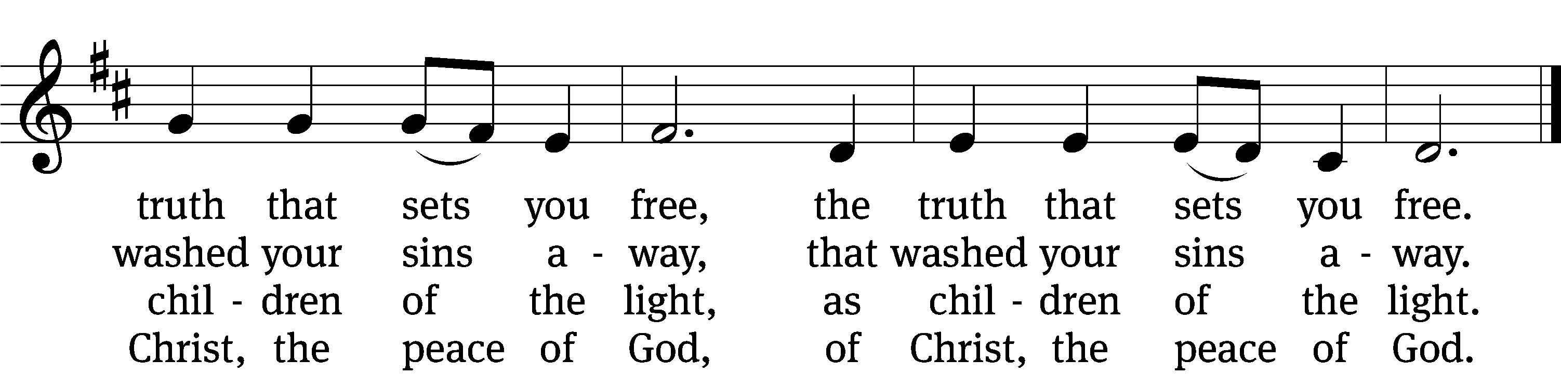

5 Know that his body and his blood
will feed your hungry soul
like manna in life’s wilderness,
until you reach your goal,
until you reach your goal.

6 Now fix your eyes on Jesus Christ;
“Come, follow me,” says he.
“Deny yourself, take up your cross;
come, lose your life for me,
come, lose your life for me.”
Text: © 2005 Stephen P. Starke, admin. Concordia Publishing House. Used by permission: OneLicense no. 727703
Tune: © 2005 Wayne Leupold Editions, Inc. Used by permission: OneLicense no. 727703

SERMON luke 5:1-11
“One of Us”

Please stand, if you are able.

nicene creed

We believe in one God, the Father, the Almighty, maker of heaven and earth, of all that is, seen and unseen.
We believe in one Lord, Jesus Christ, the only Son of God, eternally begotten of the Father, God from God, Light from Light, true God from true God, begotten, not made, of one being with the Father. Through him all things were made. For us and for our salvation, he came down from heaven, was incarnate of the Holy Spirit and the virgin Mary, and became fully human. For our sake he was crucified under Pontius Pilate. He suffered death and was buried. On the third day he rose again in accordance with the Scriptures. He ascended into heaven and is seated at the right hand of the Father. He will come again in glory to judge the living and the dead, and his kingdom will have no end.
We believe in the Holy Spirit, the Lord, the giver of life, who proceeds from the Father and the Son, who in unity with the Father and the Son is worshiped and glorified, who has spoken through the prophets. We believe in one holy Christian and apostolic Church. We acknowledge one baptism for the forgiveness of sins. We look for the resurrection of the dead and the life of the world to come. Amen.

Please Be Seated

OFFERTORY

Please stand, if you are able.

THE PRAYER

The Sacrament of Holy Communion
Trinity Lutheran Church follows the historic Christian practice of close communion. We ask that only members of Trinity or one of our sister congregations partake of the sacrament. If you are not a member, please see the note about Holy Communion in the beginning of the Worship Folder.
M: The Lord be with you.
C: And also with you.
M: Lift up your hearts.
C: We lift them up to the Lord.
M: Let us give thanks to the Lord our God.
C: It is good and right so to do.

M: It is truly good and right that we should at all times and in all places give you thanks, O Lord, holy Father, almighty and everlasting God, through Jesus Christ, our Lord, who has called us to be his own so that we may live under him in his kingdom and serve him in everlasting righteousness, innocence, and blessedness. Therefore, with all the saints on earth and hosts of heaven, we praise your holy name and join their glorious song:

HOLY, HOLY, HOLY (Tune from CW #412) Isaiah 6:3; Matthew 21:9

PRAYER OF THANKSGIVING

M: Blessed are you, O Lord of heaven and earth. We praise and thank you for sending your Son, Jesus Christ, and we remember the great acts of love through which he has ransomed us from sin, death, and the devil’s power.

By his incarnation, he became one with us.
By his perfect life, he fulfilled your holy will.
By his innocent death, he overcame hell.
By his rising from the grave, he opened heaven.

Invited by your grace and instructed by your Word, we approach your table with repentant and joyful hearts. Strengthen us through Christ’s body and blood, and preserve us in the true faith until we feast with him and all his ransomed people in glory everlasting.

C: Amen.

LORD’S PRAYER

C: Our Father, who art in heaven, hallowed be thy name, thy kingdom come, thy will be done on earth as it is in heaven. Give us this day our daily bread; and forgive us our trespasses, as we forgive those who trespass against us; and lead us not into temptation, but deliver us from evil. For thine is the kingdom and the power and the glory forever and ever. Amen.

Words of institution

M: Our Lord Jesus Christ, on the night he was betrayed, took bread; and when he had given thanks, he broke it and gave it to his disciples, saying: “Take and eat. This is my ☩ body, which is given for you. Do this in remembrance of me.”

Then he took the cup, gave thanks, and gave it to them, saying, “Drink from it all of you; this is my ☩ blood of the new covenant, which is poured out for you for the forgiveness of sins. Do this, whenever you drink it, in remembrance of me.”

The peace of the Lord be with you always.
C: Amen.

Please Be Seated

DISTRIBUTION
During the distribution the congregation may sing one or more hymns.

DISTRIBUTION HYMNS CW #743 and 702

743 I Hear the Savior Calling CW 743
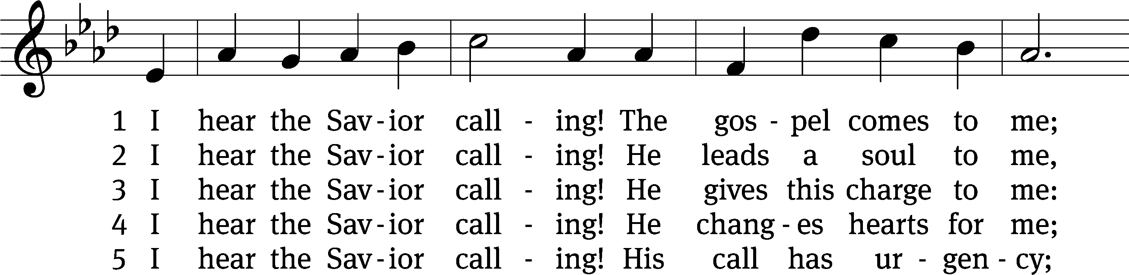
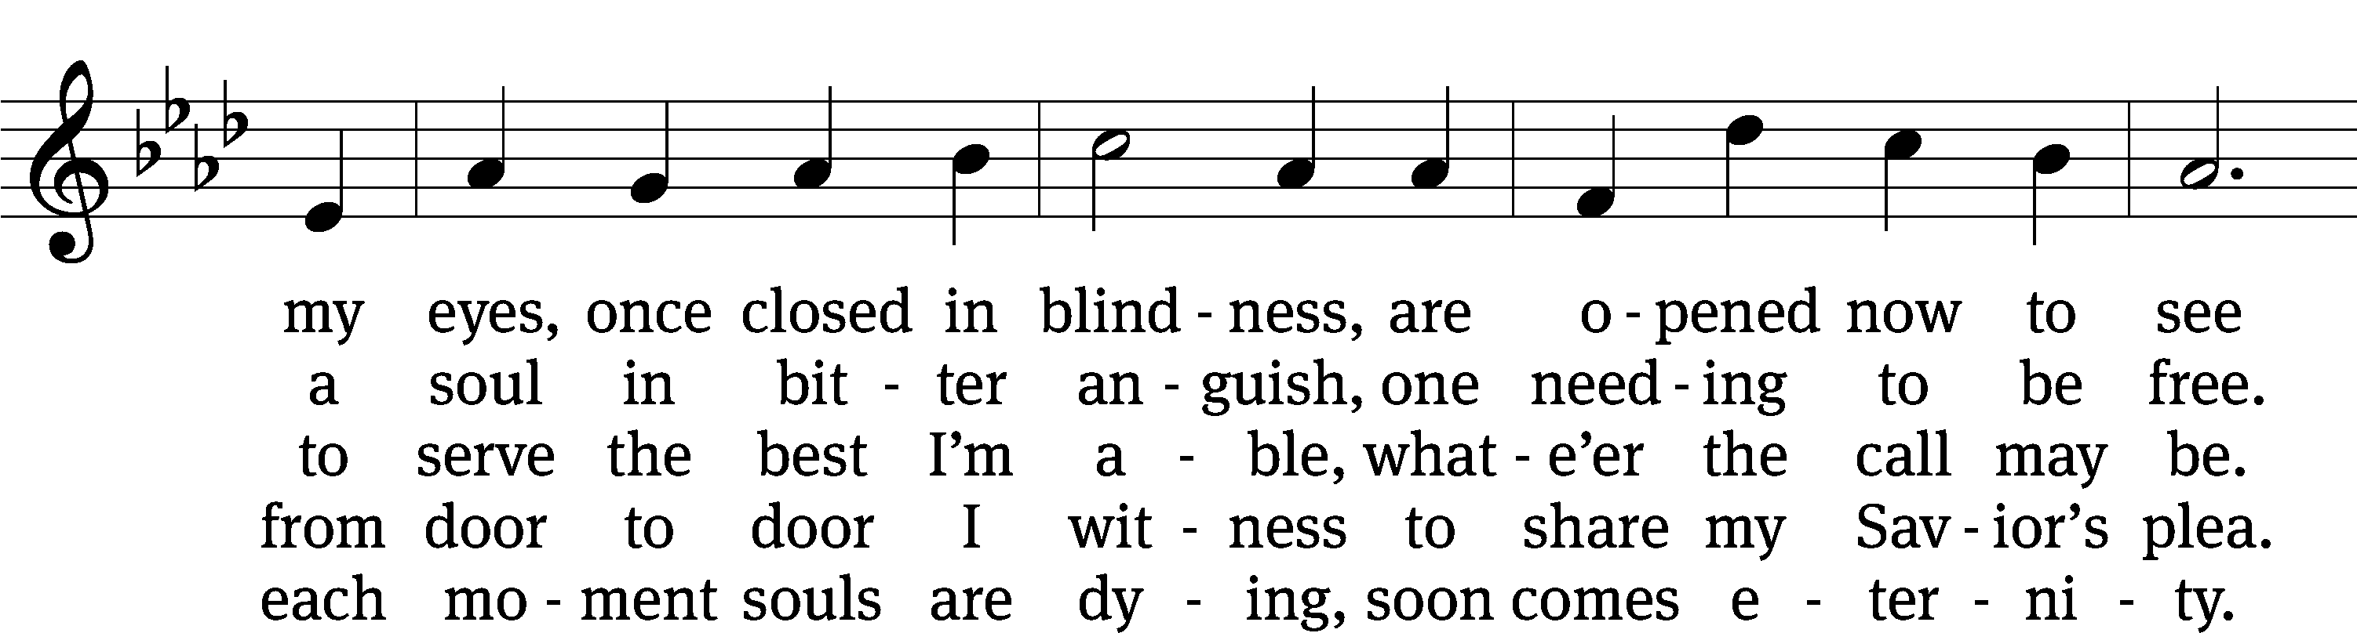
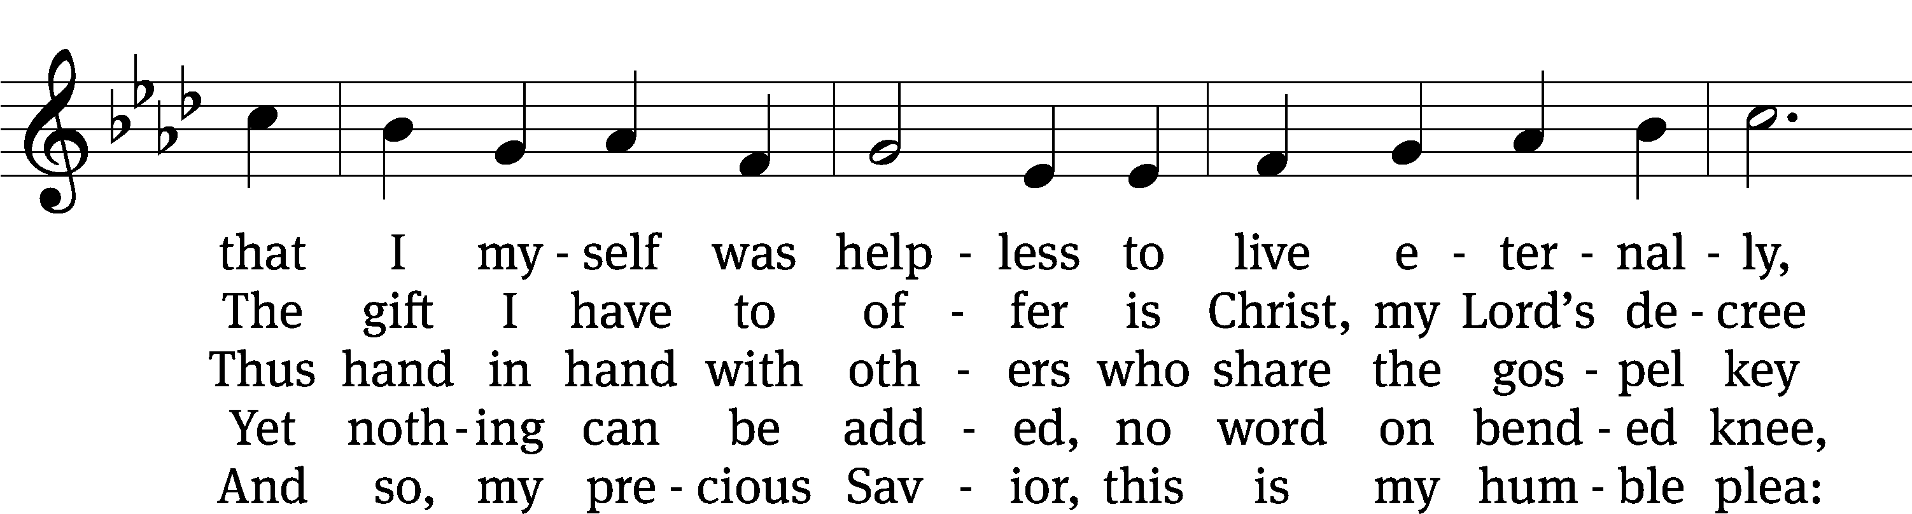
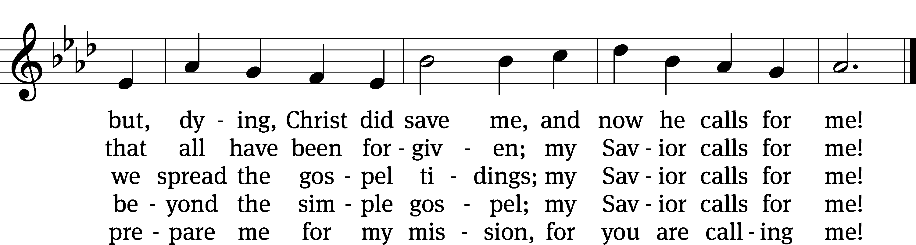
Text: © 1993 John C. Lawrenz, admin. Northwestern Publishing House. Used by permission: OneLicense no. 727703
Tune: Public domain

702 Come, Follow Me, the Savior Spake CW 702
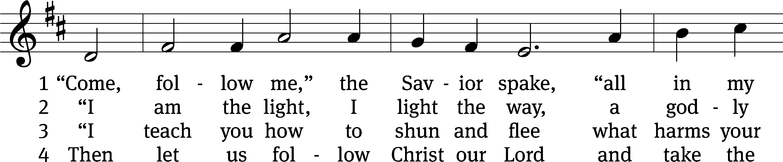
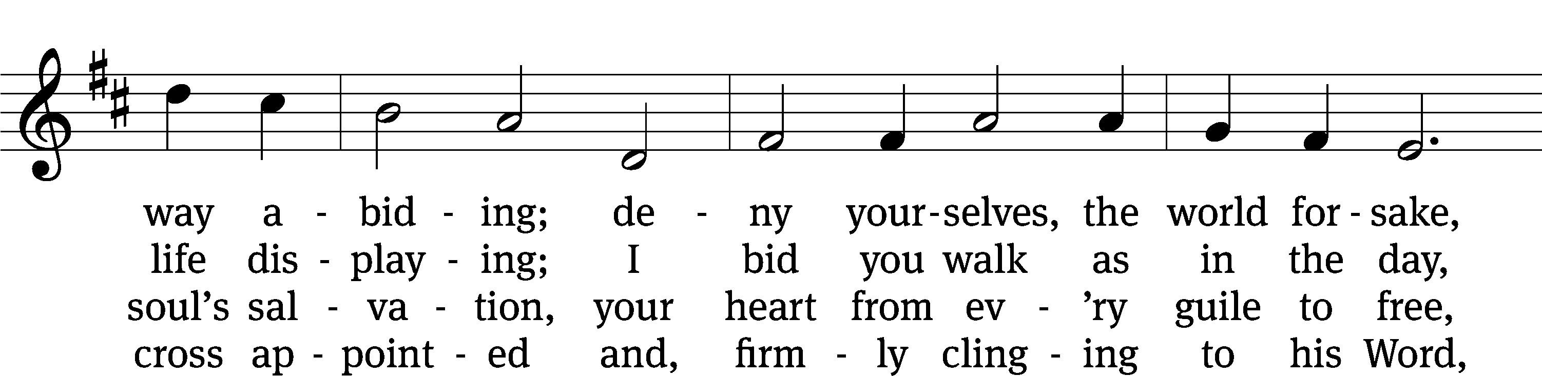
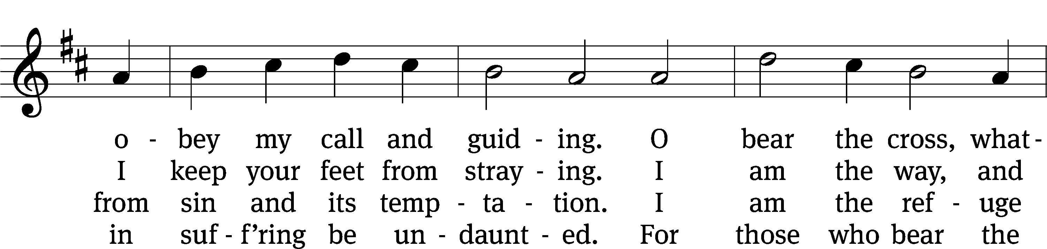
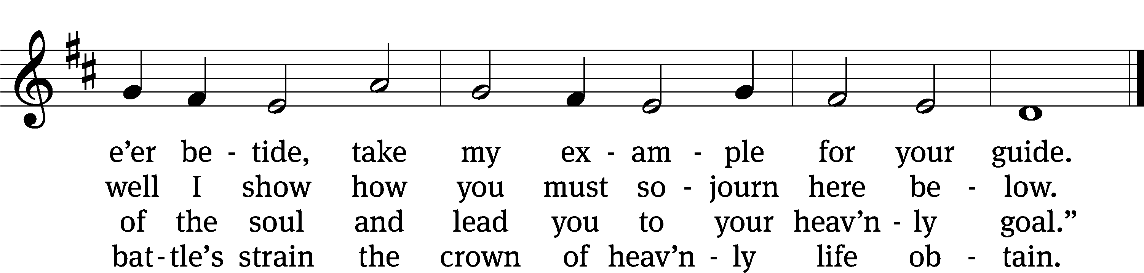
Text and tune: Public domain

Please stand, if you are able.

THANKSGIVING

SONG OF SIMEON (Tune from CW #384) Luke 2:29-32

M: We give you thanks, O Lord, for the foretaste of the heavenly banquet that you have given us to eat and to drink in this sacrament. Through this gift you have fed our faith, nourished our hope, and strengthened our love. By your Spirit help us to live as your holy people until that day when you will receive us as your guests at the wedding supper of the Lamb, who lives and reigns with you and the Holy Spirit, one God, now and forever.

C: Amen.

BLESSING

M: The Lord bless you and keep you.
The Lord make his face shine on you and be gracious to you.
The Lord look on you with favor and (+) give you peace.

C: Amen.

Please Be Seated

CLOSING HYMN CW #716
716 O Christ, Who Called the Twelve CW 716
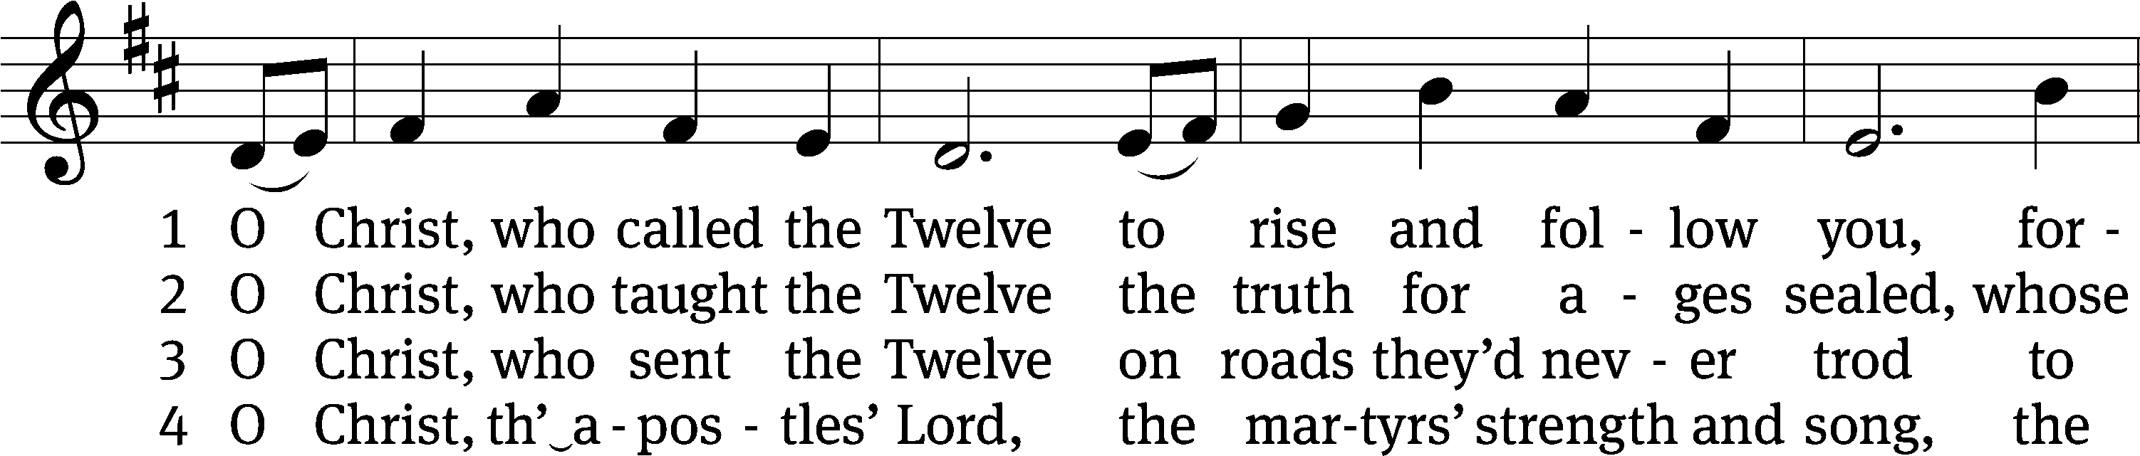
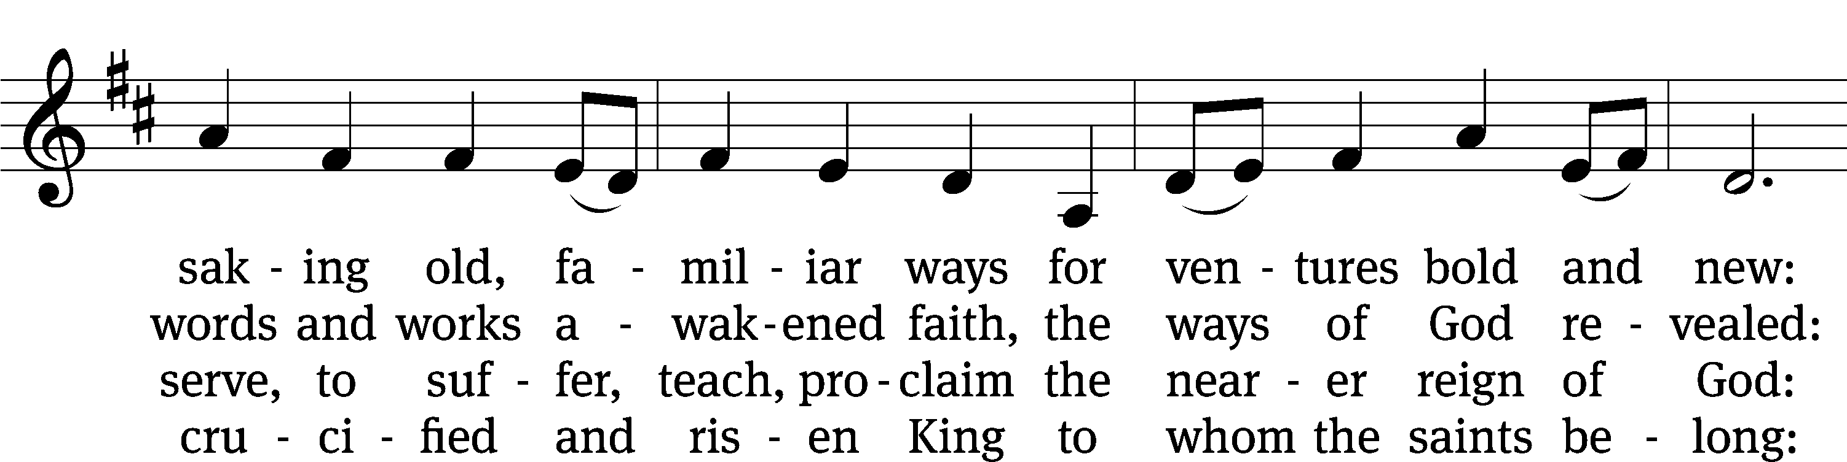
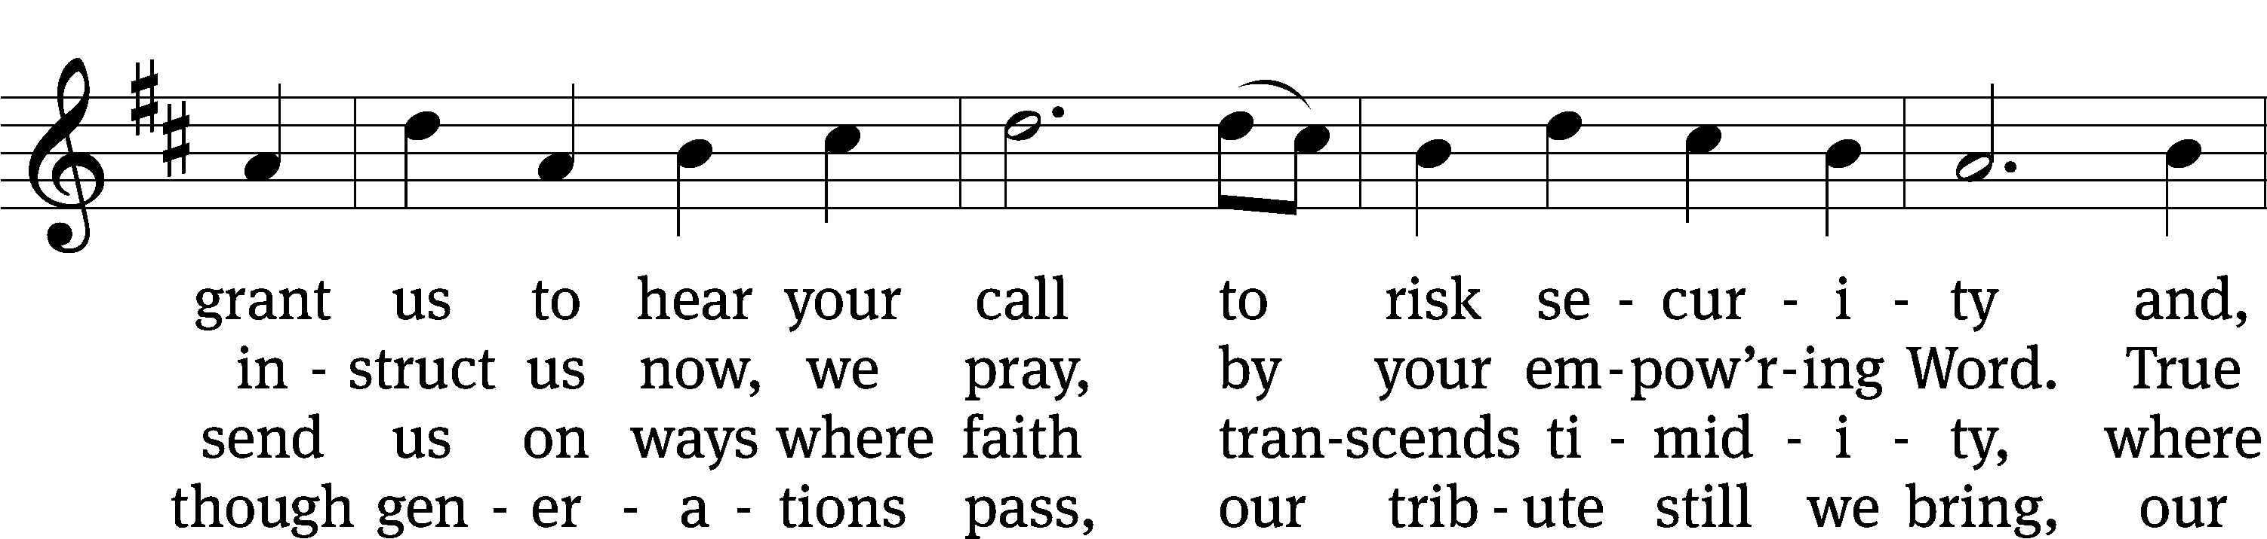
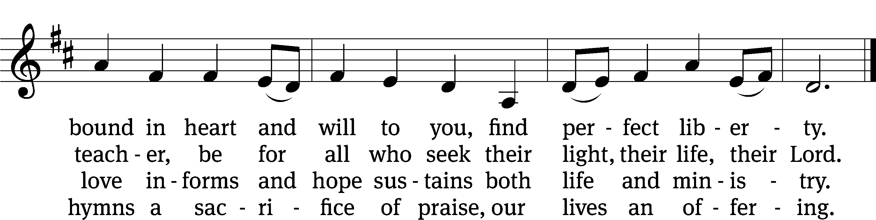
Text: © 1993 GIA Publications, Inc. Used by permission: OneLicense no. 727703
Tune: Public domain

Serving In Worship

Officiant Pastor Natsis
Organist Emily Wheeler
Deacons (8:30) Dave Frey and Dave Stevenson
(11:00) Steve Hoeft and Ed Wheeler
Ushers (8:30) Dale Radak
(11:00) Ron Zahn
Altar Guild Margaret Hoeft and Brenda Stevenson
Videographer Richard Lindemann

Divine Service II: Christian Worship Supplement. © 2008 Northwestern Publishing House. All rights reserved. Reprinted under ONE LICENSE #A-727703 and CCLI #1151741/CSPL126093
Words and Music: All rights reserved. Reprinted under ONE LICENSE #A-727703 and CCLI #1151741/CSPL126093

