fiFTH SUNDAY in lent

TRINITY EVANGELICAL LUTHERAN CHURCH | Saline, Michigan
WELCOME TO WORSHIP April 3, 2022
Thank you for joining us in God’s house today! We cordially ask that our Guests sign one of the guestbooks located at either the front or back entryways, or fill out a “Let’s Get Acquainted” card located in the hymnal pew rack and place it in the collection plate.

THANK OFFERING: Members of Trinity give their offering as an expression of love and thankfulness to the Lord and to help support the Lord’s work in our community and around the world. Visitors need not feel obligated to participate in this offering which supports our ministry.

Restrooms are located at the back of the upper level (the annex), and in the basement (down the back stairs of the sanctuary or annex). Handicap access is available, please ask an usher for assistance.

Young Families / Toddler Bags – We are GLAD YOU BROUGHT YOUR CHILDREN to our worship service. Jesus said: “Let the little children come to me and do not hinder them, for the kingdom of God belongs to such as these.” We know that having little children in church can be a challenge, but DO NOT WORRY about it. Many of your fellow worshippers have been in your shoes and are just happy you brought your children with you. For your convenience, we have reserved the back rows of seating for parents with small children. These areas provide more flexibility for your family, as well as, easy access to move downstairs if necessary. A closed-circuit TV system allows families to continue participating in the service while downstairs. Pre-school toddler bags and children’s bulletins are available for their enjoyment. Ask an usher for one to use during the service and please return the toddler bag afterwards.

celebration of holy communion:
In His Word, God makes it clear that the Lord’s Supper is to be shared by people of a common proclamation of faith (1 Corinthians 11:26; 1 Corinthians 10:16-17). Without judging anyone’s hearts, we invite those who share in our confession by their membership in our congregation or another congregation of the Wisconsin Evangelical Lutheran Synod (WELS) or the Evangelical Lutheran Synod (ELS) and who are properly prepared (1 Corinthians 11;27-29) to receive the Sacrament. Page 295 in Christian Worship provides a guide for preparation.
Guests, we would love to have you join us in communion fellowship in the future, and for that to be possible, we ask that you speak with one of the pastors so that we may speak with you on how that would be possible. We thank you for respecting the way we celebrate the Lord’s Supper in our congregations.
the SERVICE – setting one - WITH HOLY COMMUNION CW, page 154

920 Christ Is Made the Sure Foundation CW 920
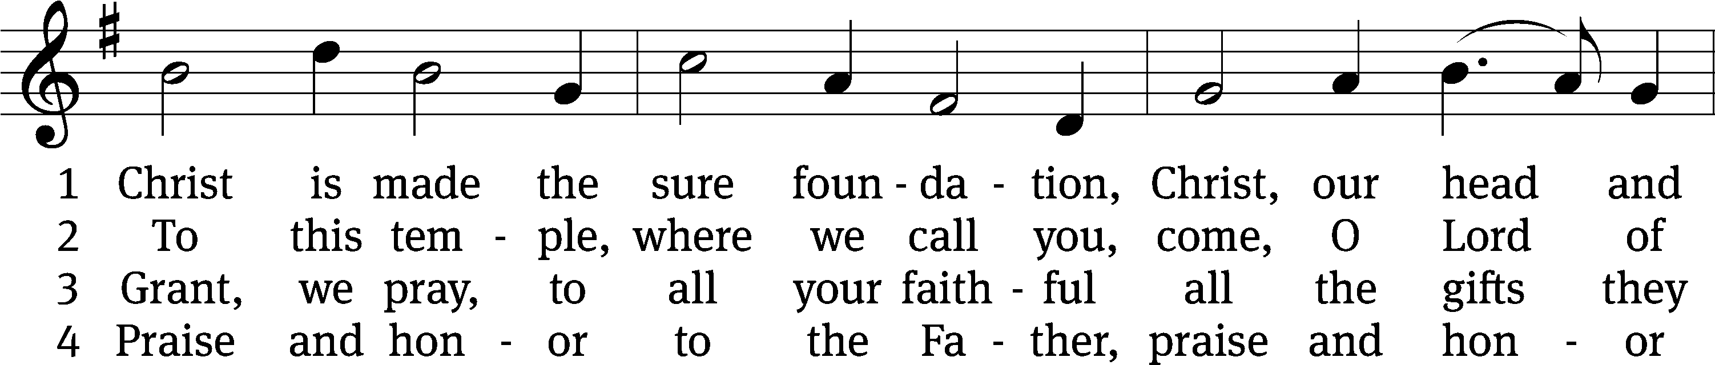
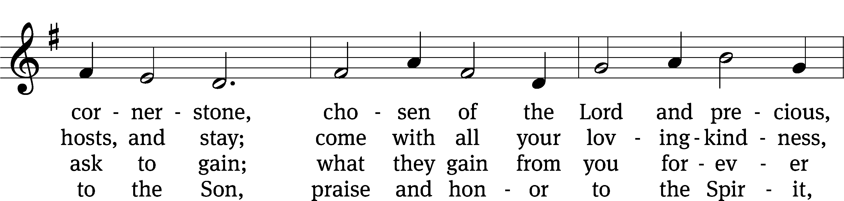
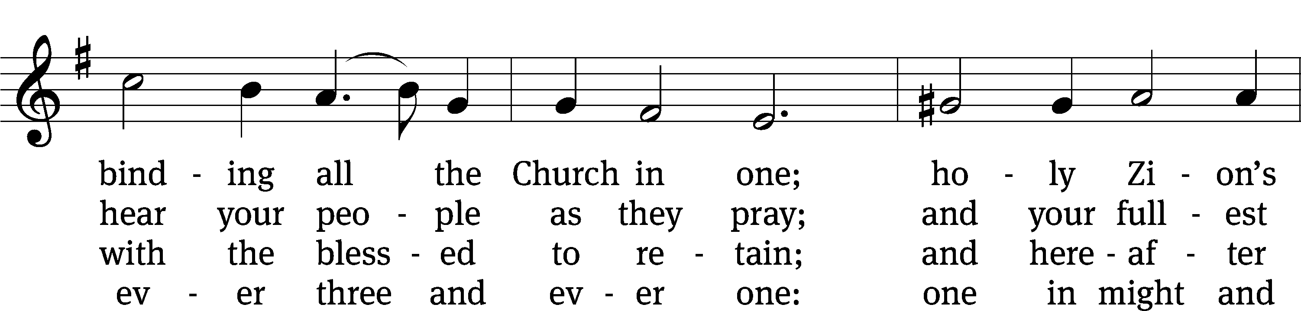
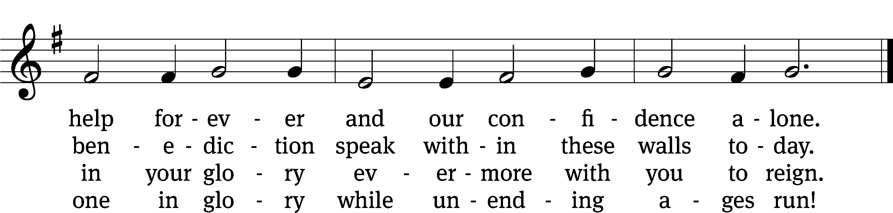
Text: tr. John Mason Neale, 1818–1866, abr., alt.; Latin, c. 8th cent., abr.
Tune: Henry Purcell, 1659–1695, adapt.
Text and tune: Public domain

Please stand, if you are able
Invocation
In the name of the Father and of the Son and of the Holy Spirit.
Amen.
Confession
If we claim to be without sin, we deceive ourselves and the truth is not in us.
If we confess our sins, God is faithful and just
and will forgive us our sins
and purify us from all unrighteousness.

Let us confess our sins to the Lord.
Holy God, gracious Father,
I am sinful by nature
and have sinned against you in my thoughts, words, and actions.
I have not loved you with my whole heart;
I have not loved others as I should.
I deserve your punishment both now and forever.
But Jesus, my Savior, paid for my sins
with his innocent suffering and death.
Trusting in him, I pray: God, have mercy on me, a sinner.

Our gracious Father in heaven has been merciful to us. He sent his only Son, Jesus Christ, who gave his life as the atoning sacrifice for the sins of the whole world. Therefore, as a called servant of Christ and by his authority, I forgive you all your sins in the name of the Father and of the Son and of the Holy Spirit. Amen.

Lord, Have Mercy

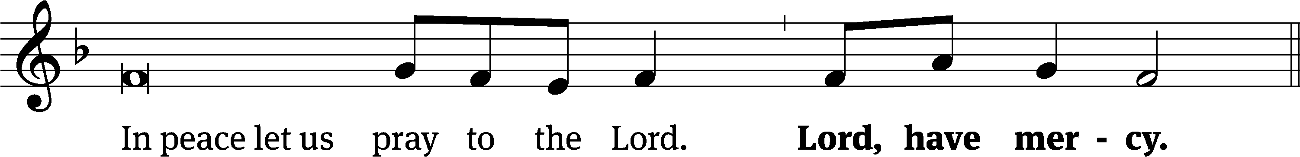
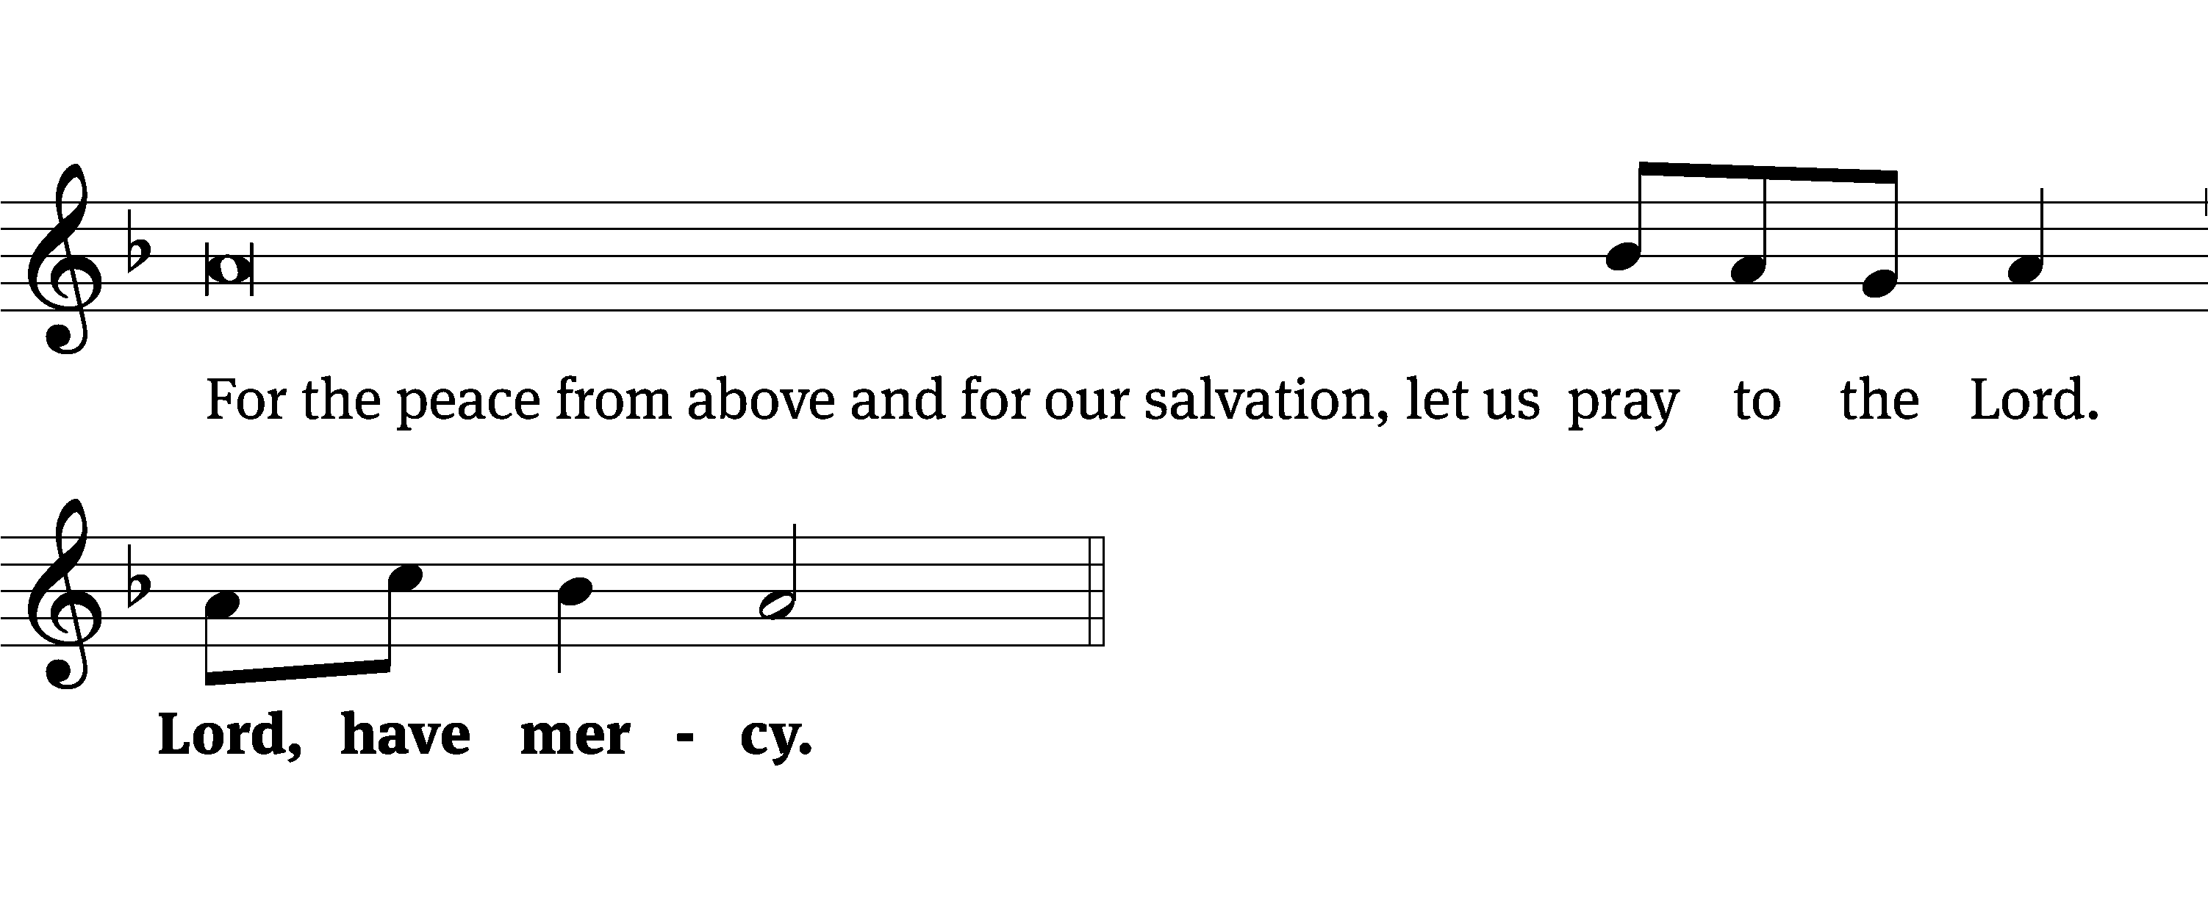
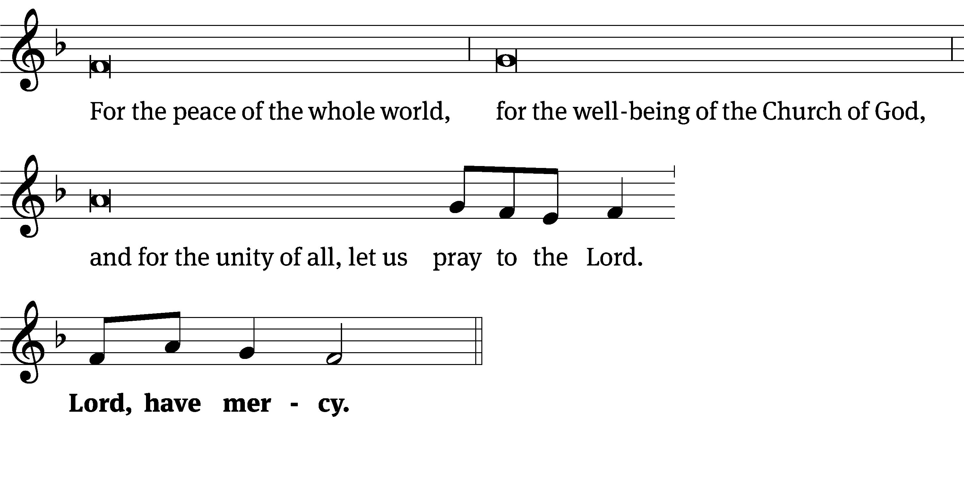
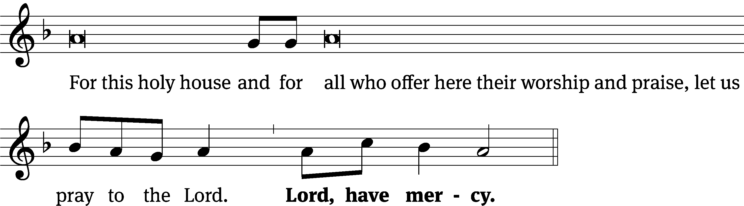
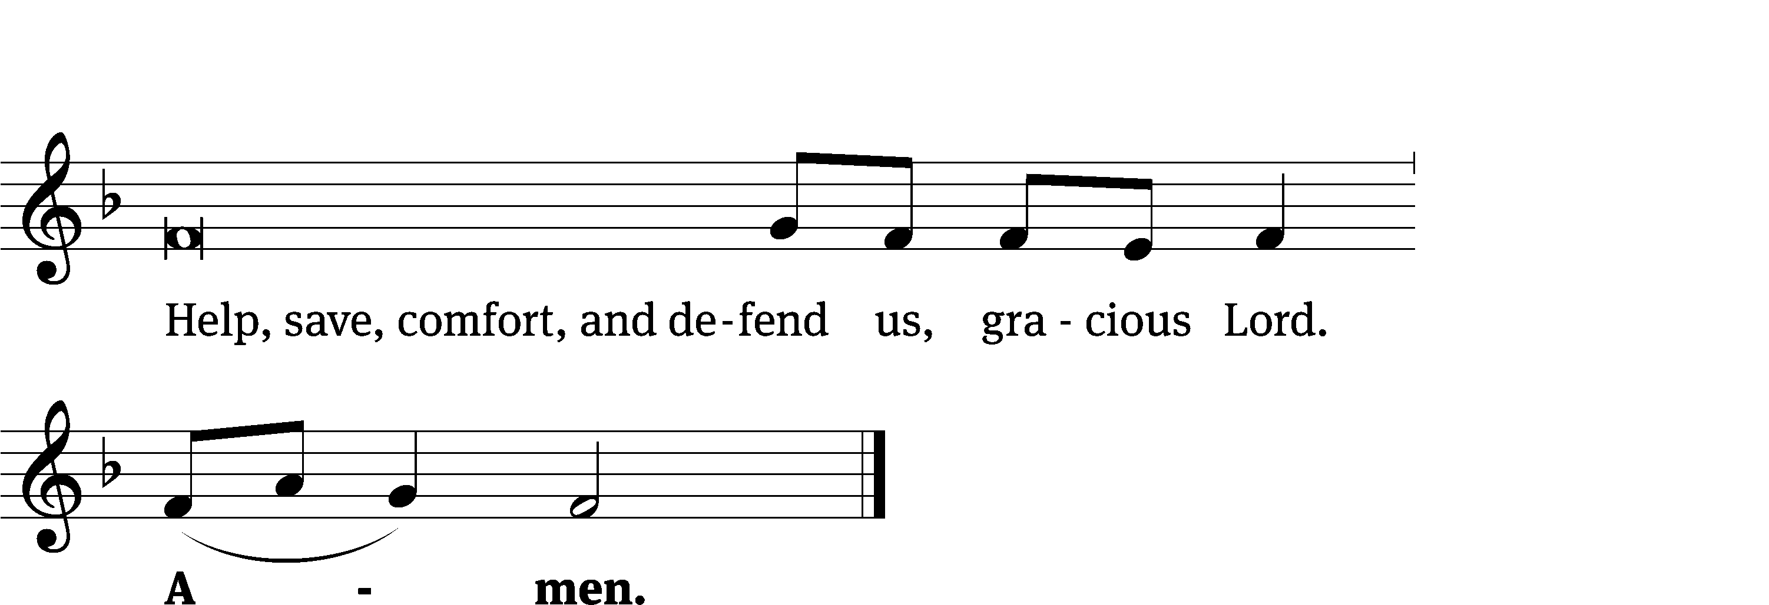
Tune: Kevin Becker
Tune: © 2021 Northwestern Publishing House. Used by permission: OneLicense no. 727703

Glory Be to God CW 157
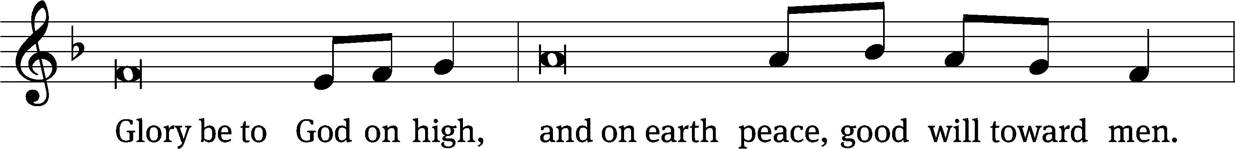
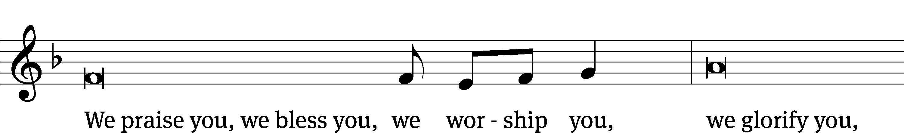
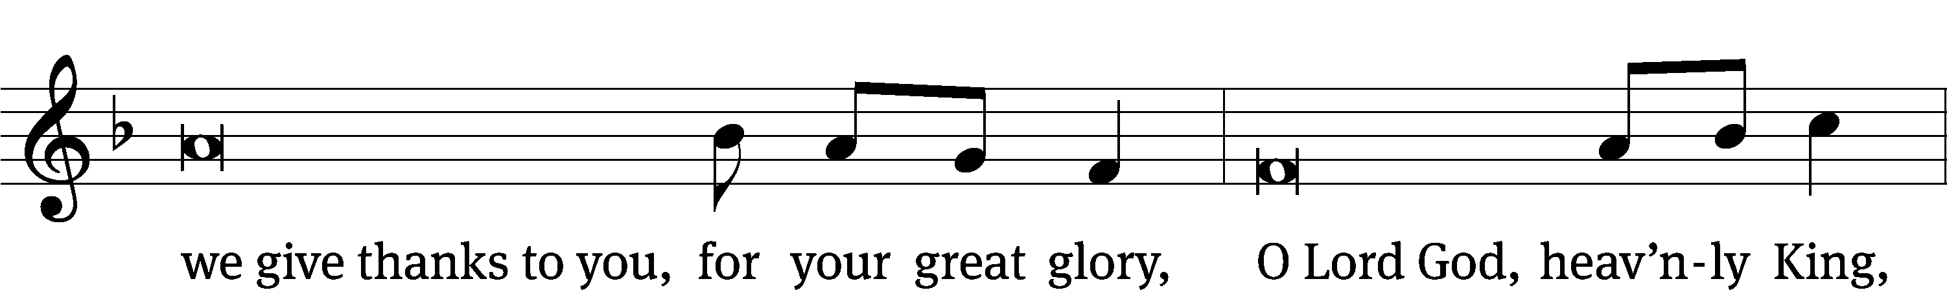
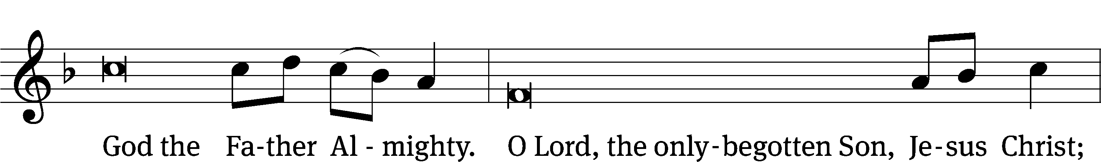
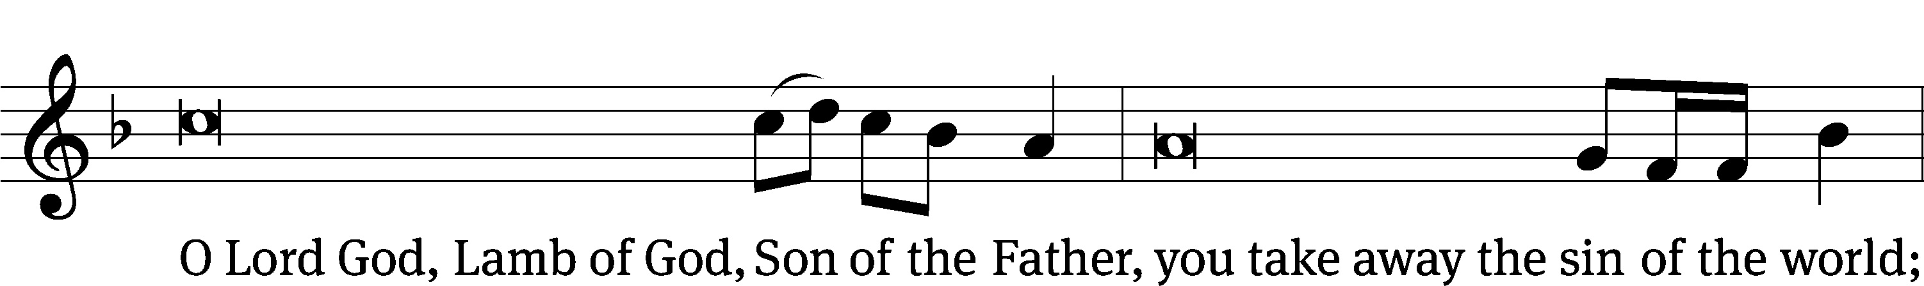
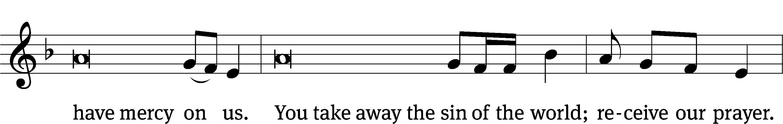
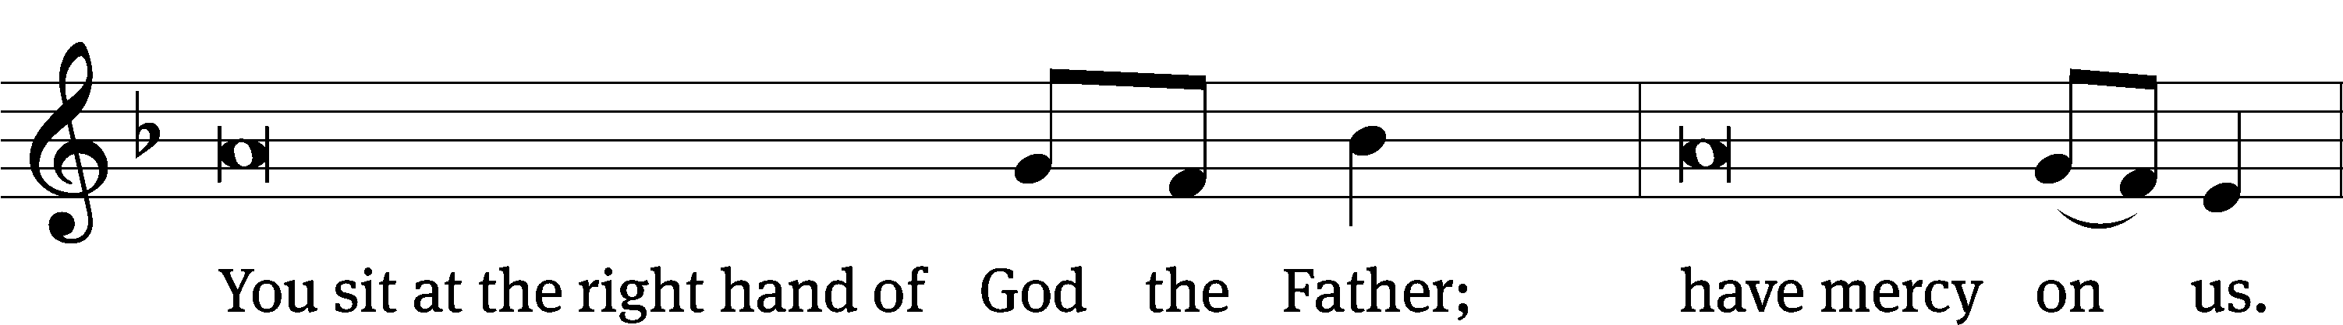
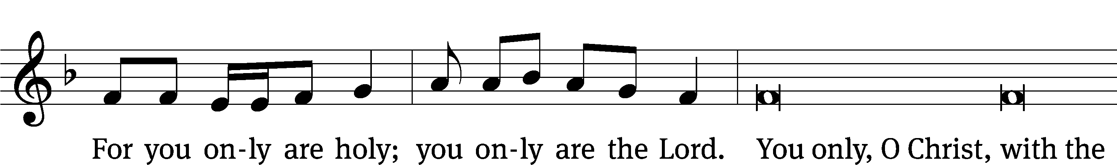
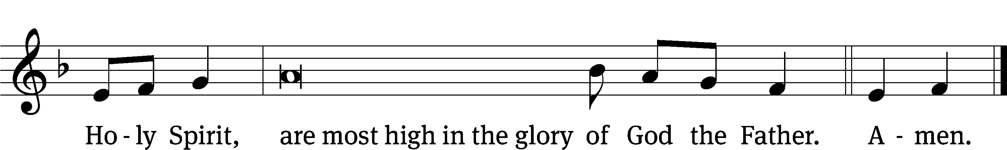

The Lord be with you.
And also with you.
Prayer of the Day
Let us pray.

Almighty God, by your great goodness, mercifully look upon your people that we may be governed and preserved evermore in body and soul; through your Son, Jesus Christ our Lord, who lives and reigns with you and the Holy Spirit, one God, now and forever.
Amen.

Please be seated

First Reading Isaiah 43:16-21

¹⁶ This is what the Lord says,
who makes a road through the sea
and a path through mighty waters,
¹⁷ who brings out the chariot and the horses,
the army and the strong warrior.
They will all lie down together.
They will not get up.
They are extinguished.
Like a wick they go out.
¹⁸ Do not remember the former^{[a]} things.
Do not keep thinking about ancient things.
¹⁹ Watch, I am about to do a new thing.
Now it will spring up. Don’t you know about it?
Indeed I will make a road in the wilderness.
In the wasteland I will make rivers.
²⁰ The wild animals, the jackals and ostriches, will honor me,
because I am providing water in the wilderness,
rivers in a parched wasteland,
water for my chosen people to drink.
²¹ This people that I formed for myself will declare my praise.

The Word of the Lord.
Thanks be to God.

73B Surely, It Is God Who Saves Me Psalm 73B

Second Reading Philippians 3:4b-14
If anyone else thinks that he has grounds for confidence in the flesh, I have more: ⁵ circumcised on the eighth day, of the people of Israel, of the tribe of Benjamin, a Hebrew of Hebrews; in regard to the law, a Pharisee; ⁶ in regard to zeal, persecuting the church; in regard to the righteousness that is in the law, blameless.
⁷ But, whatever things were a profit for me, these things I have come to consider a loss because of Christ. ⁸ But even more than that, I consider everything to be a loss because of what is worth far more: knowing Christ Jesus, my Lord. For his sake, I have lost all things and consider them rubbish, so that I may gain Christ ⁹ and be found in him, not having a righteousness of my own, which comes from the law, but that which comes through faith in Christ, the righteousness that comes from God by faith. ¹⁰ I do this so that I may know him and the power of his resurrection and the fellowship of his sufferings, being conformed to his death, ¹¹ in the hope that in some way I may arrive at the resurrection from the dead.
¹² Not that I have already obtained this or have already reached the goal, but I press on to take hold of that for which Christ Jesus also took hold of me. ¹³ Brothers, I do not consider myself to have taken hold of it yet, but there is one thing I do: Forgetting the things that are behind and straining toward the things that are ahead, ¹⁴ I press on toward the goal, for the prize of the upward call of God in Christ Jesus.
The Word of the Lord.
Thanks be to God.

Please stand, if you are able

Gospel Acclamation Psalm 118:22
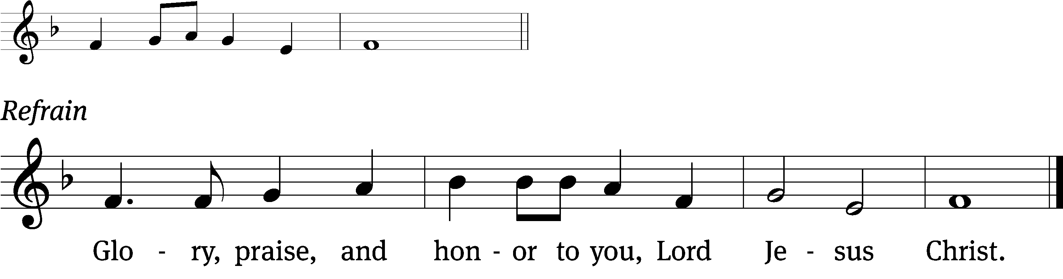
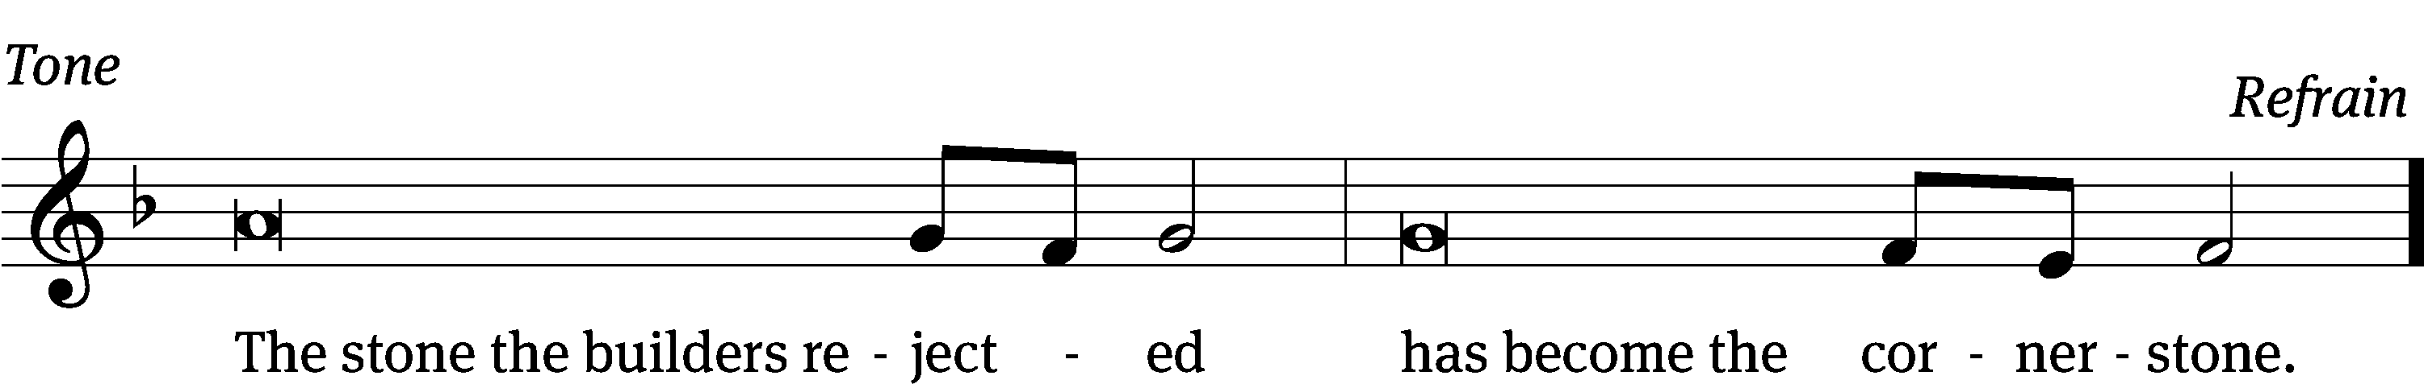
Tune: © 2021 Northwestern Publishing House. Used by permission: OneLicense no. 727703

Gospel Luke 20:9-19
⁹ He began to tell the people this parable: “A man planted a vineyard, leased it to some tenant farmers, and went away on a journey for a long time. ¹⁰ When it was the right time, he sent a servant to the tenants to collect his share of the fruit of the vineyard. But the tenant farmers beat the servant and sent him away empty-handed. ¹¹ The man went ahead and sent yet another servant, but they also beat him, treated him shamefully, and sent him away empty-handed. ¹² He then sent yet a third. They also wounded him and threw him out. ¹³ The owner of the vineyard said, ‘What should I do? I will send my son, whom I love. Perhaps they will respect him.’
¹⁴ “But when the tenant farmers saw him, they talked it over with one another. They said, ‘This is the heir. Let’s kill him, so that the inheritance will be ours.’ ¹⁵ They threw him out of the vineyard and killed him. So what will the owner of the vineyard do to them? ¹⁶ He will come and destroy those tenant farmers and give the vineyard to others.”
When they heard this, they said, “May it never be!”
¹⁷ But he looked at them and said, “Then what about this that is written:
The stone that the builders rejected has become the cornerstone?
¹⁸ “Everyone who falls on that stone will be broken to pieces, and it will crush the one on whom it falls.”
¹⁹ That very hour the chief priests and the experts in the law began looking for a way to lay hands on him, because they knew he had spoken this parable against them. But they were afraid of the people.
The Gospel of the Lord.
Praise be to you, O Christ!

Please be seated
407 When I Survey the Wondrous Cross CW 407
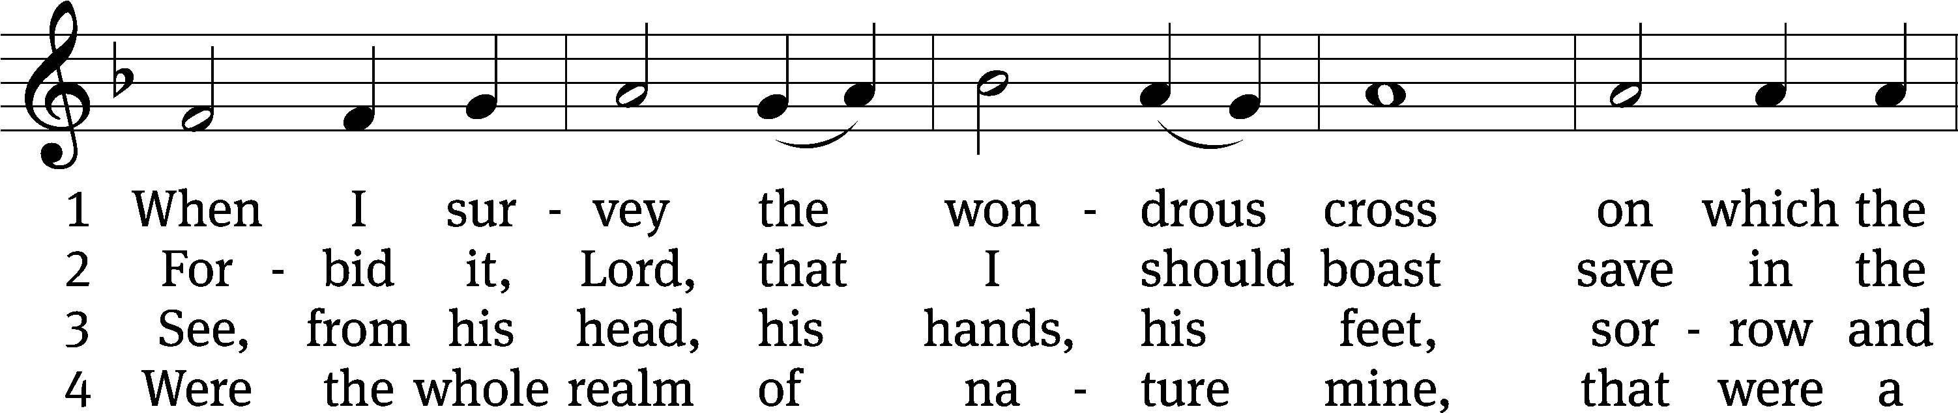
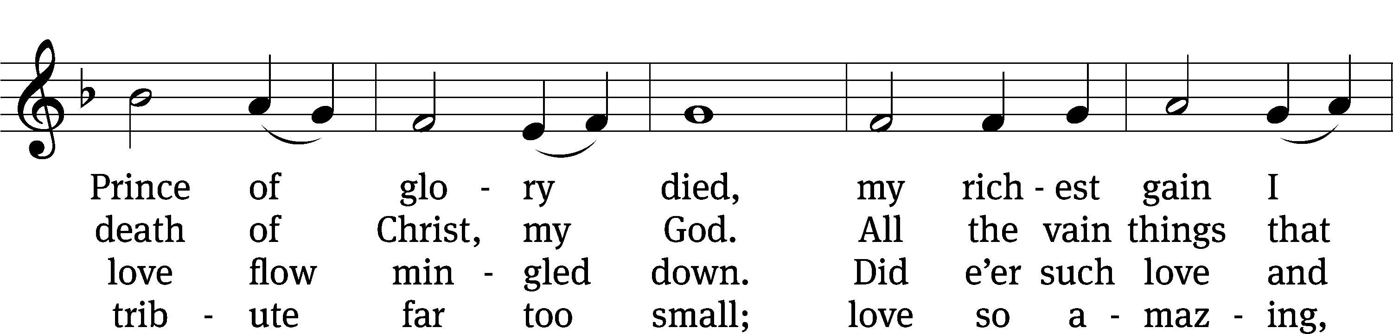
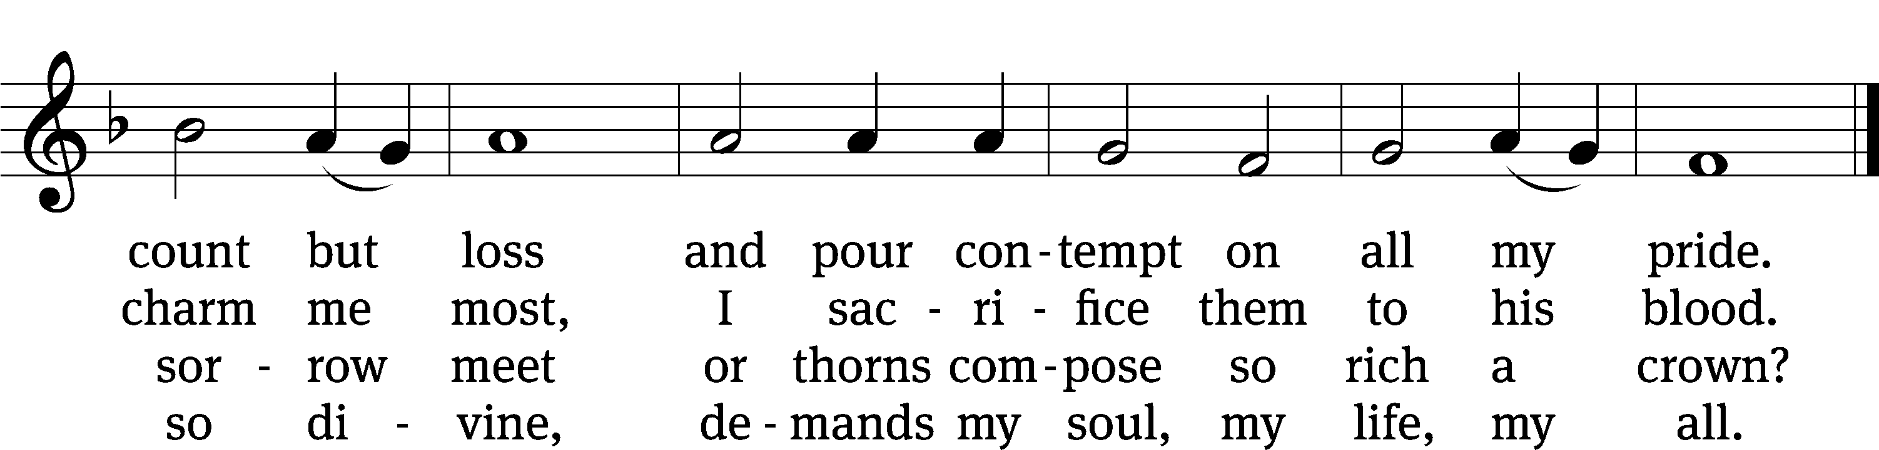
Text: Isaac Watts, 1674–1748, abr., alt.
Tune: Lowell Mason, 1792–1872
Text and tune: Public domain

SERMON Luke 20:9-19
“The Two Sides of Jesus’ Suffering and Death”

Please stand, if you are able
Nicene Creed
We believe in one God, the Father, the Almighty,
maker of heaven and earth,
of all that is,
seen and unseen.
We believe in one Lord, Jesus Christ, the only Son of God,
eternally begotten of the Father,
God from God, Light from Light, true God from true God,
begotten, not made,
of one being with the Father.
Through him all things were made.
For us and for our salvation, he came down from heaven,
was incarnate of the Holy Spirit and the Virgin Mary,
and became truly human.
For our sake he was crucified under Pontius Pilate.
He suffered death and was buried.
On the third day he rose again in accordance with the Scriptures.
He ascended into heaven
and is seated at the right hand of the Father.
He will come again in glory to judge the living and the dead,
and his kingdom will have no end.
We believe in the Holy Spirit,
the Lord, the giver of life,
who proceeds from the Father and the Son,
who in unity with the Father and the Son
is worshiped and glorified,
who has spoken through the prophets.
We believe in one holy Christian and apostolic Church.
We acknowledge one baptism for the forgiveness of sins.
We look for the resurrection of the dead
and the life of the world to come. Amen.
Offertory
Prayer of the Church

The Sacrament
Preface CW 165
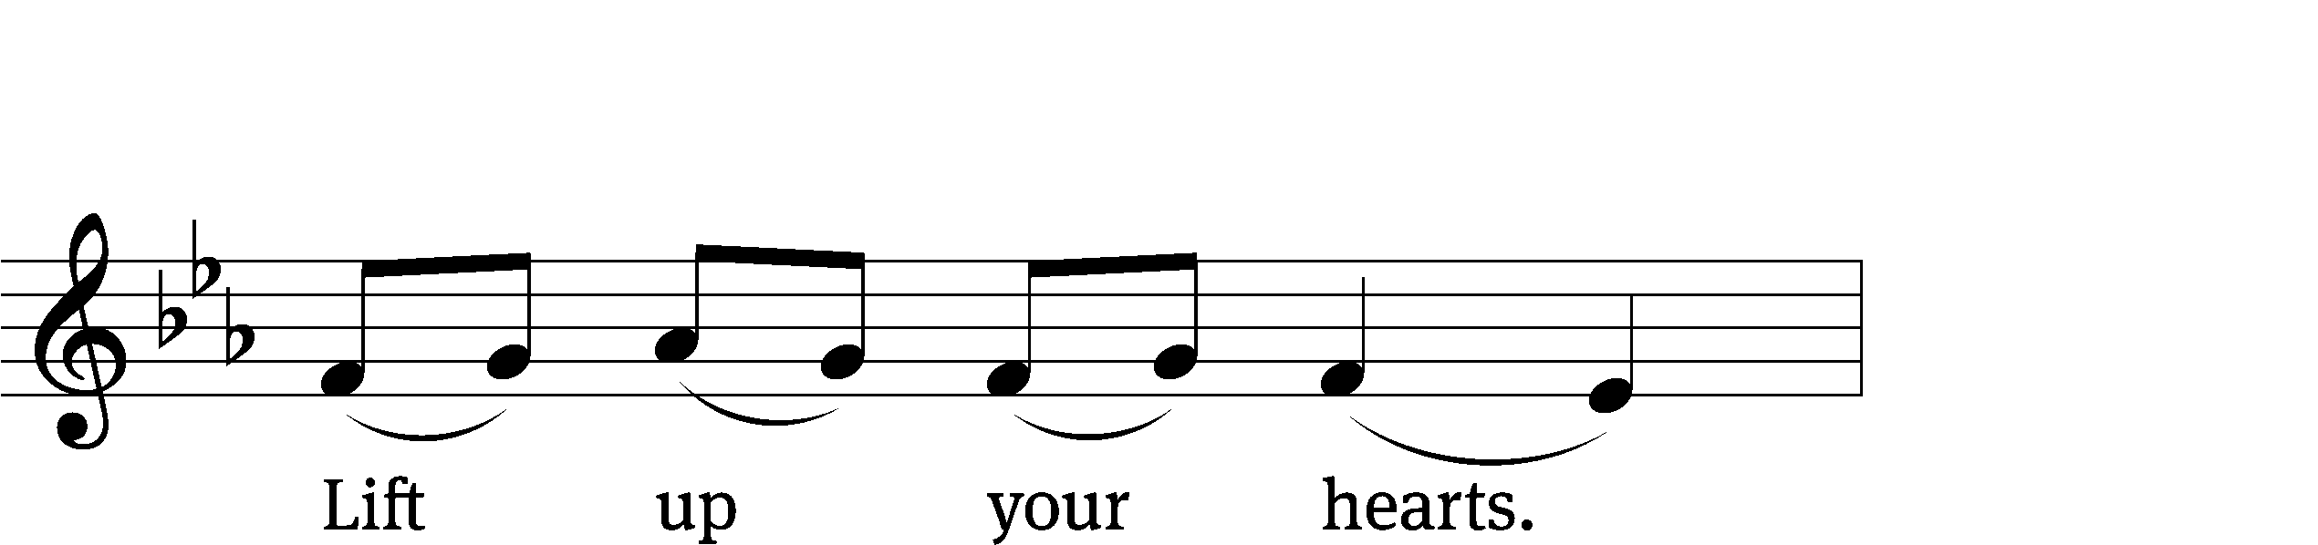
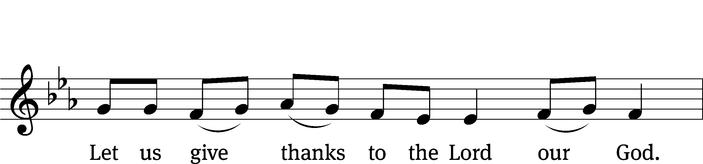
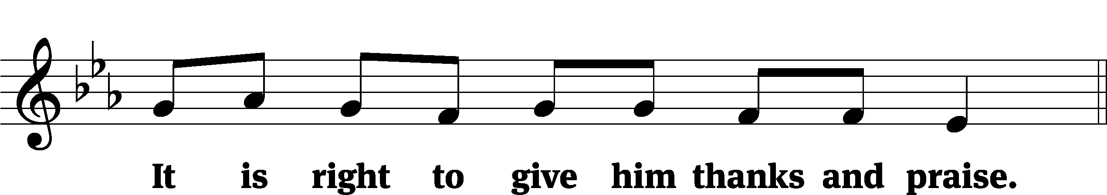

It is truly good and right that we should at all times and in all places give you thanks, O Lord, holy Father, almighty and everlasting God, through Jesus Christ our Lord, who brought the gift of salvation to all people by his death on the tree of the cross so that the devil, who overcame us by a tree, would in turn by a tree be overcome. Therefore, with all the saints on earth and hosts of heaven, we praise your holy name and join their glorious song:

Holy, Holy, Holy CW 167
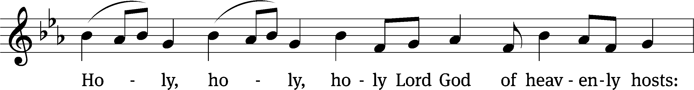
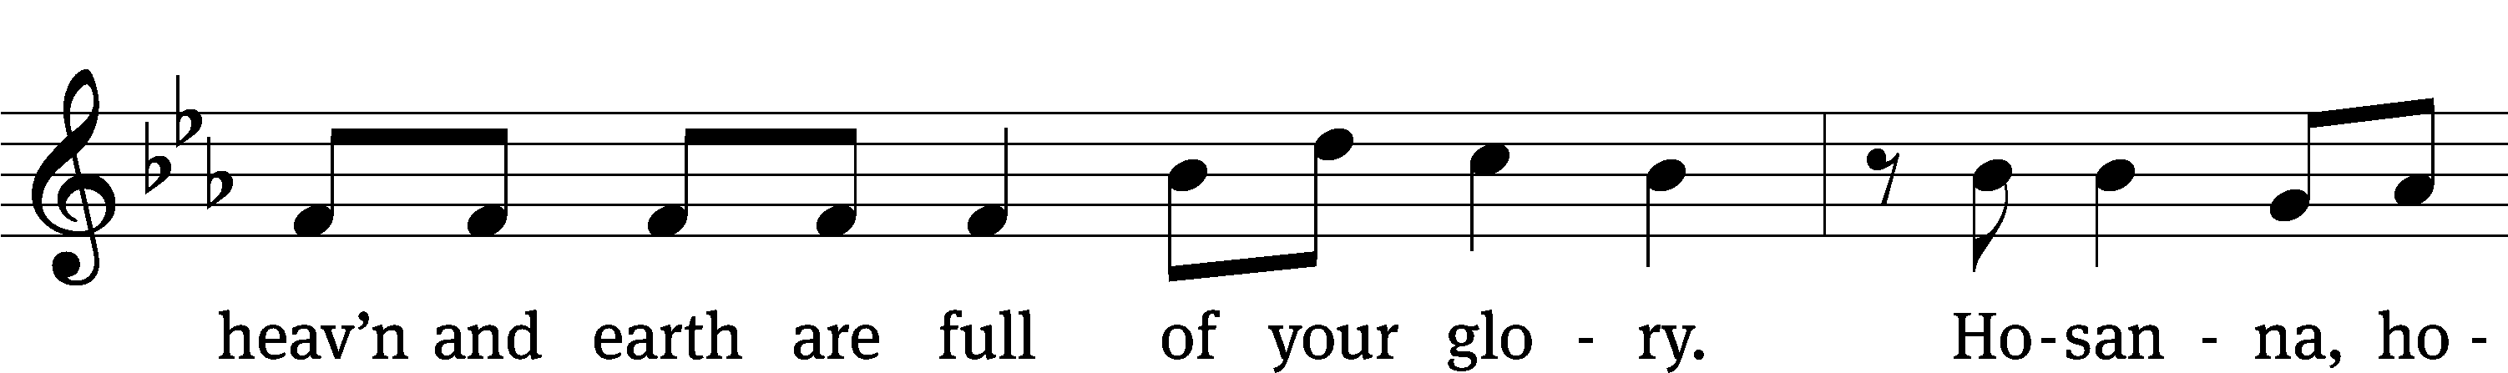
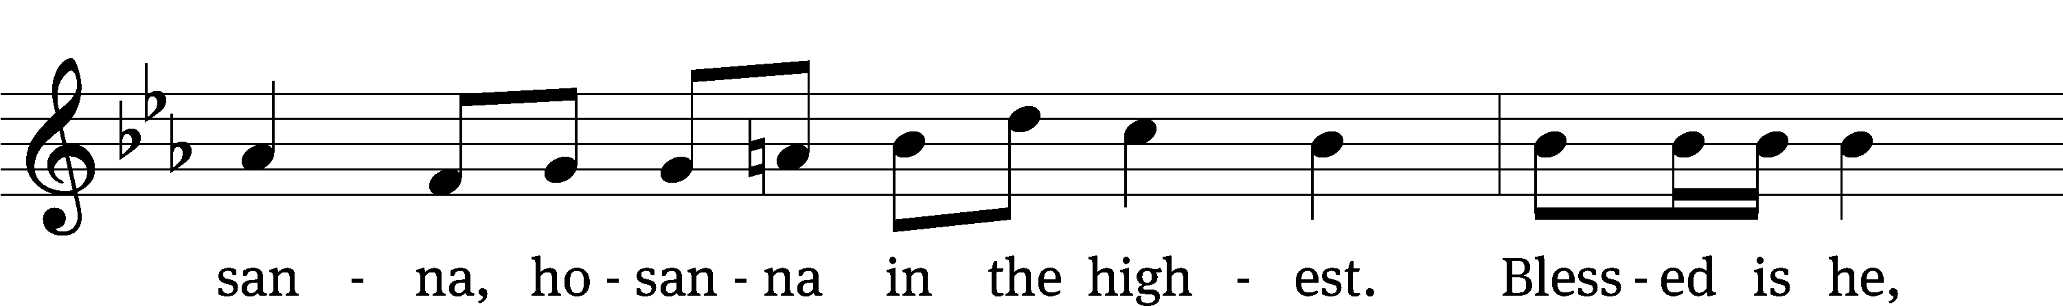
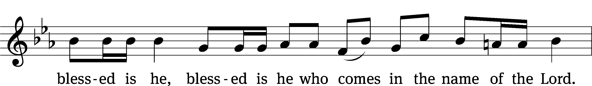
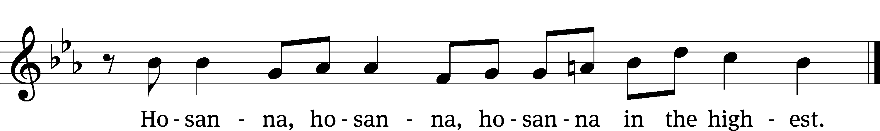

Prayer of Thanksgiving
We give thanks to you, O God, through your dear Son, Jesus Christ, whom you sent to be our Savior, our Redeemer, and the messenger of your grace. Through him you made all things; in him you are well pleased. He is the incarnate Word, conceived by the Holy Spirit and born of the Virgin Mary. To fulfill your promises, he stretched out his hands on the cross and released from eternal death all who believe in you.

As we remember Jesus’ death and resurrection, we thank you that you have gathered us together to receive your Son’s body and blood. Send us your Spirit, unite us as one, and strengthen our faith so that we may praise you in your Son, Jesus Christ. Through him, we glorify and honor you, O God our Father, with the Holy Spirit, one God, now and forever.
Amen.

Lord’s Prayer
Our Father, who art in heaven, hallowed be thy name, thy kingdom come, thy will be done on earth as it is in heaven. Give us this day our daily bread; and forgive us our trespasses, as we forgive those who trespass against us; and lead us not into temptation, but deliver us from evil. For thine is the kingdom and the power and the glory forever and ever. Amen.

Words of Institution
Our Lord Jesus Christ, on the night he was betrayed, took bread; and when he had given thanks, he broke it and gave it to his disciples, saying, “Take and eat; this is my body, which is given for you. Do this in remembrance of me.”

Then he took the cup, gave thanks, and gave it to them, saying, “Drink from it, all of you; this is my blood of the new covenant, which is poured out for you for the forgiveness of sins. Do this, whenever you drink it, in remembrance of me.”

The peace of the Lord be with you always.
Amen.
O Christ, Lamb of God CW 169
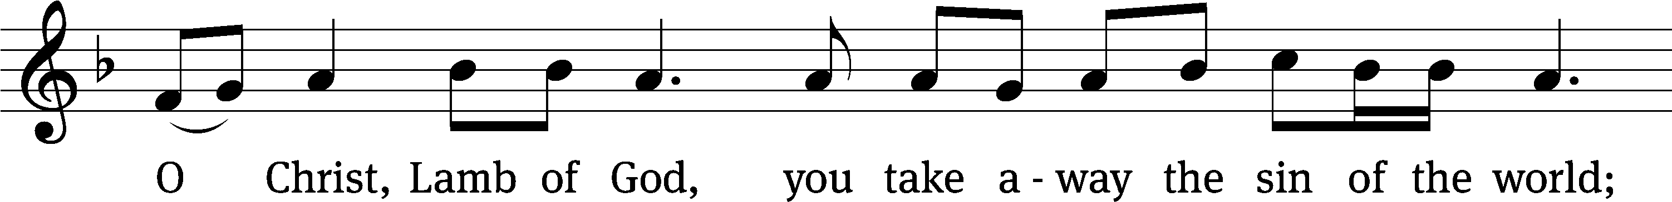
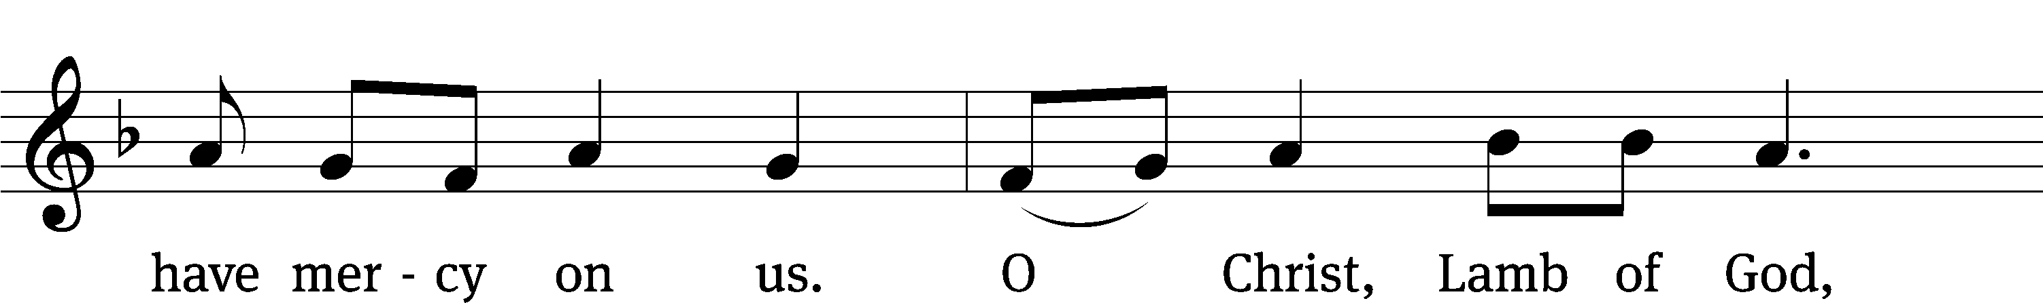
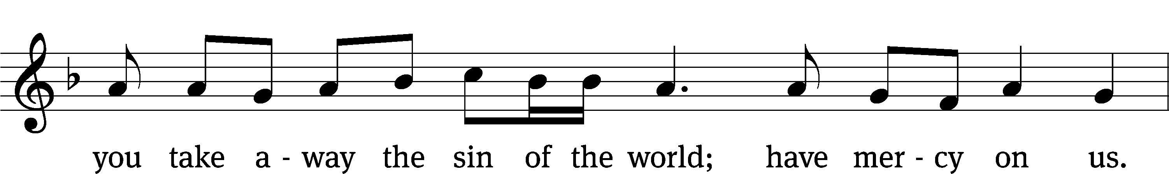
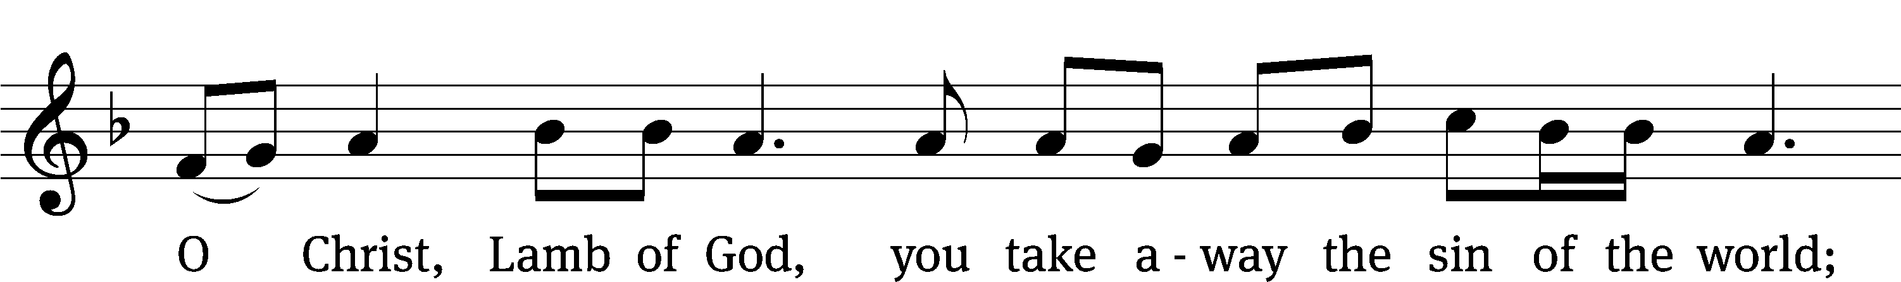
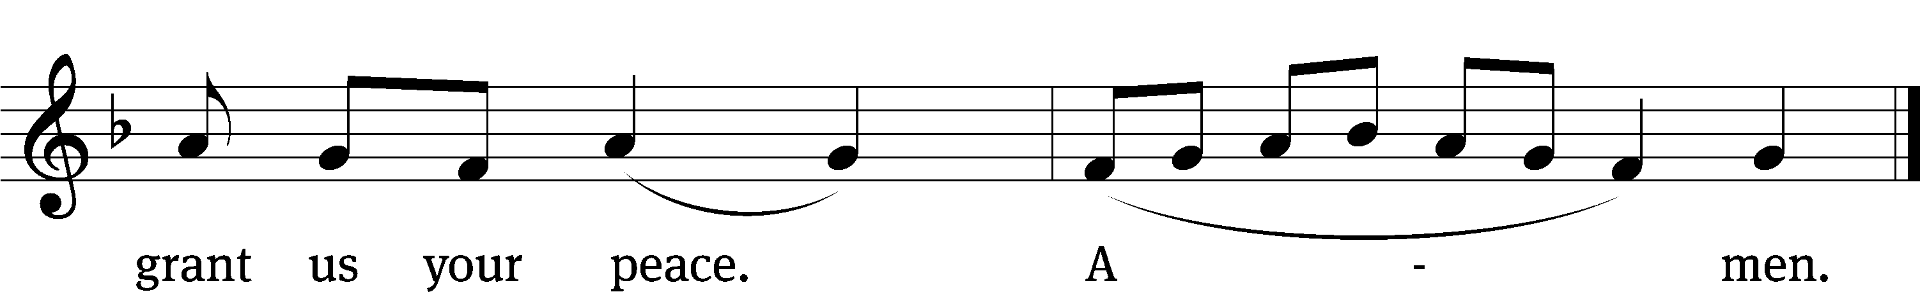

Please be seated
570 God Loved the World So That He Gave CW 570
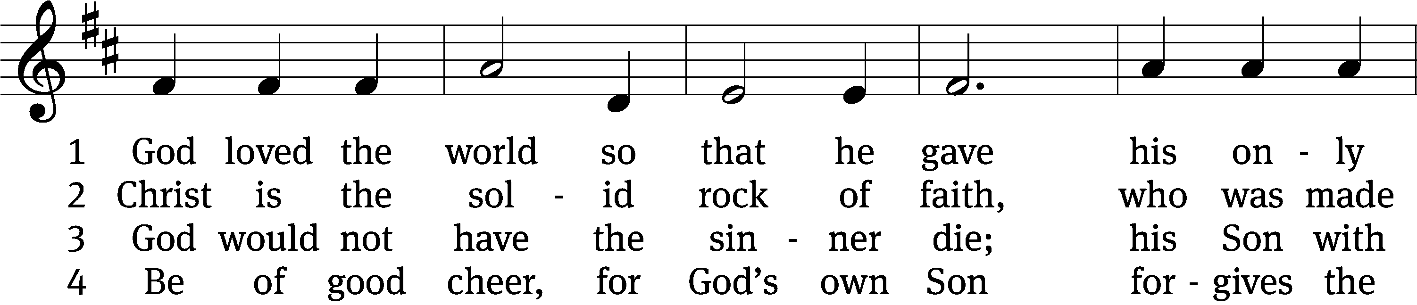
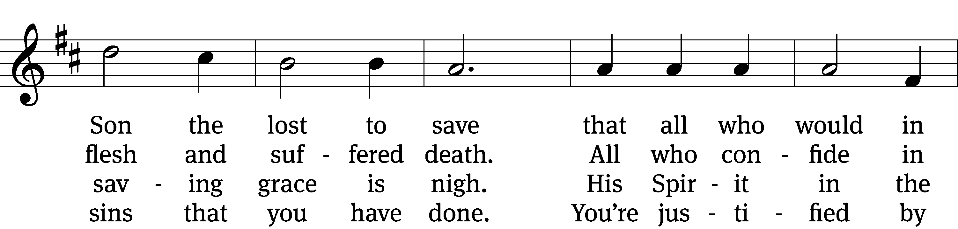
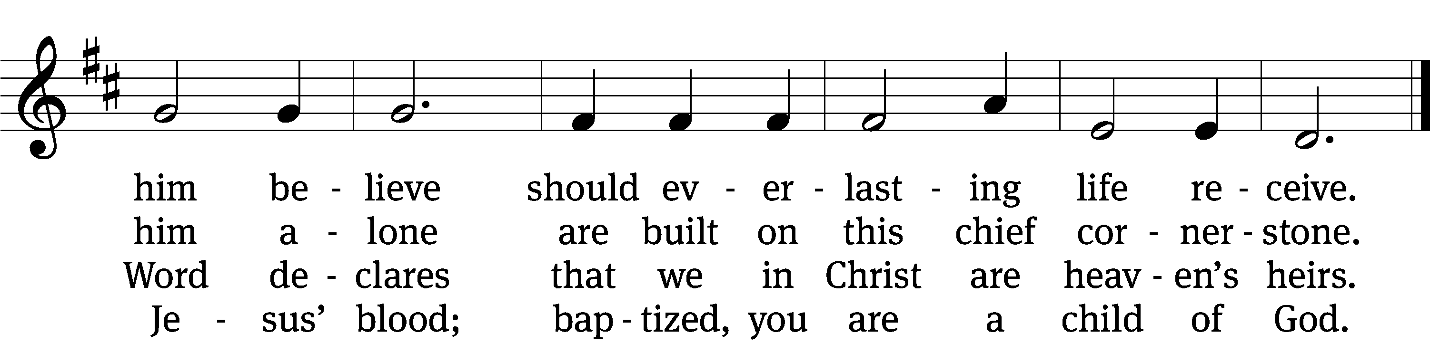

5 If you are sick, if death is near,
this truth your troubled heart can cheer:
Christ Jesus saves my soul from death;
this is the anchor of my faith!

6 Glory to God the Father, Son,
and Holy Spirit, Three in One!
To you, O blessèd Trinity,
be praise now and eternally!

Text: tr. August Crull, 1845–1923, alt.; Heiliges Lippen- und Hertzens- Opffer, Stettin, c. 1778
Tune: George J. Elvey, 1816–1893
Text and tune: Public domain
573 Jesus, Your Blood and Righteousness CW 573
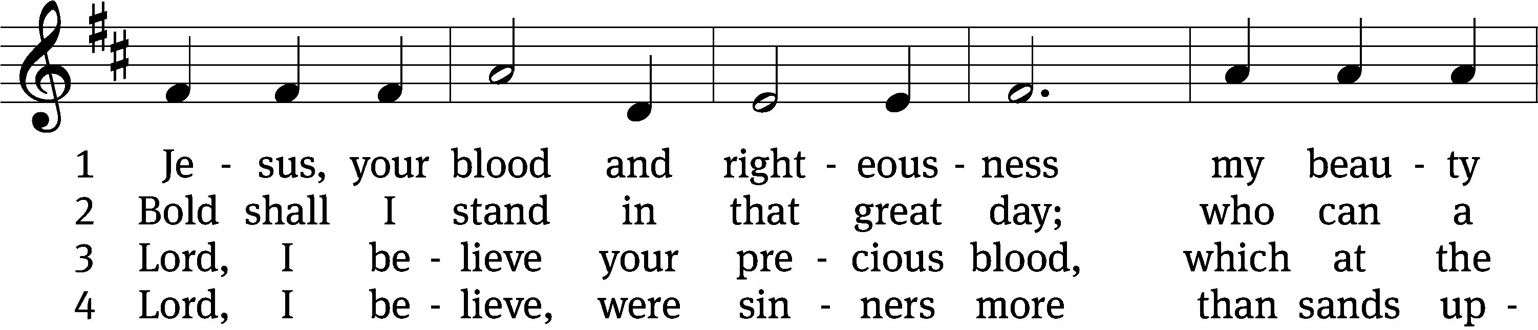
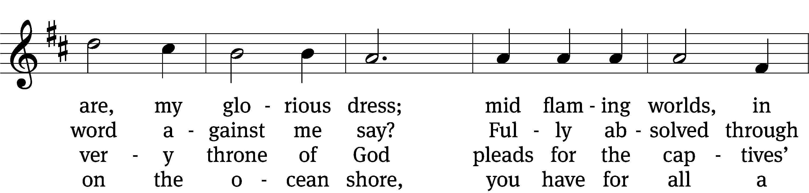
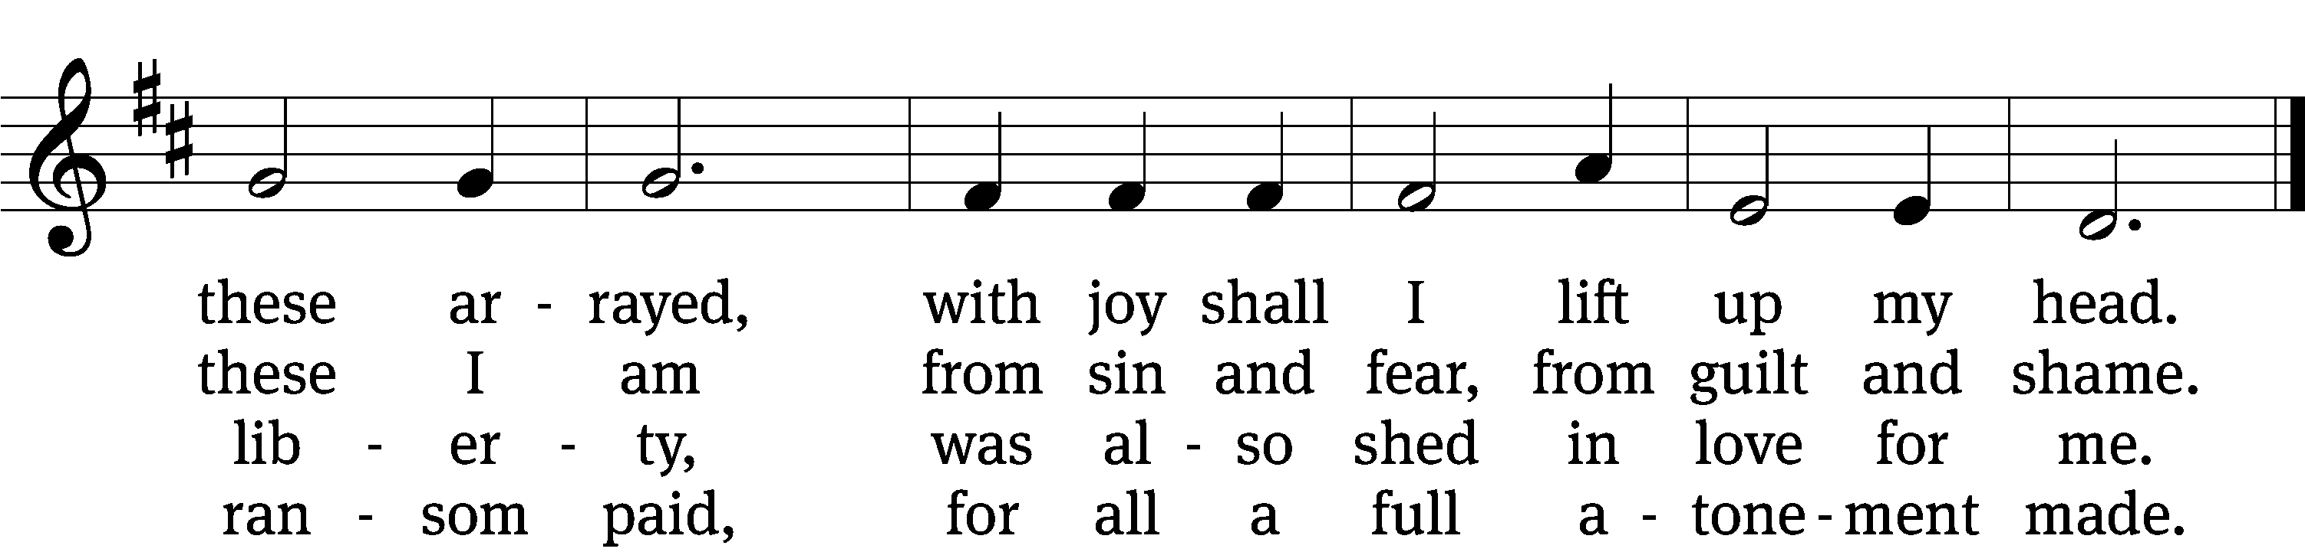

5 When from the dust of death I rise
to claim my mansion in the skies,
this then shall be my only plea:
Jesus has lived and died for me.

6 Jesus, be worshiped endlessly!
Your boundless mercy has for me,
for me and all your hands have made,
an everlasting ransom paid.

Text: tr. John B. Wesley, 1703–1791, alt.; Nicolaus L. von Zinzendorf, 1700–1760, abr.
Tune: George J. Elvey, 1816–1893
Text and tune: Public domain

Please stand, if you are able

Give thanks to the Lord, for he is good;
his mercy endures forever.
Whenever we eat this bread and drink this cup,
we proclaim the Lord’s death until he comes.
We give thanks, almighty God, that you have refreshed us with this saving gift. We pray that through it you will strengthen our faith in you and increase our love for one another. We ask this in the name of Jesus Christ our Lord, who lives and reigns with you and the Holy Spirit, one God, now and forever.
Amen.

Blessing
The Lord bless you and keep you.
The Lord make his face shine on you and be gracious to you.
The Lord look on you with favor and T give you peace.
Amen.

Please be seated
914 Christ Is Our Cornerstone CW 914
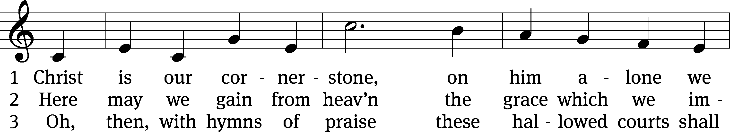
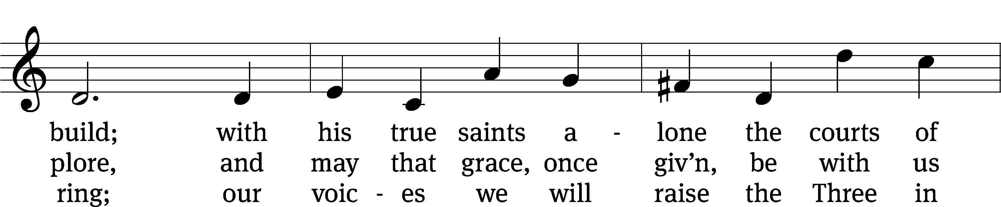
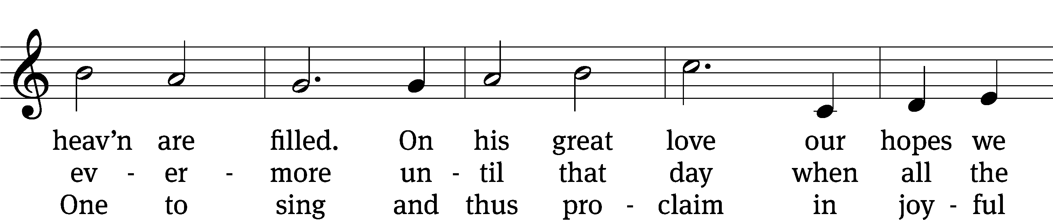
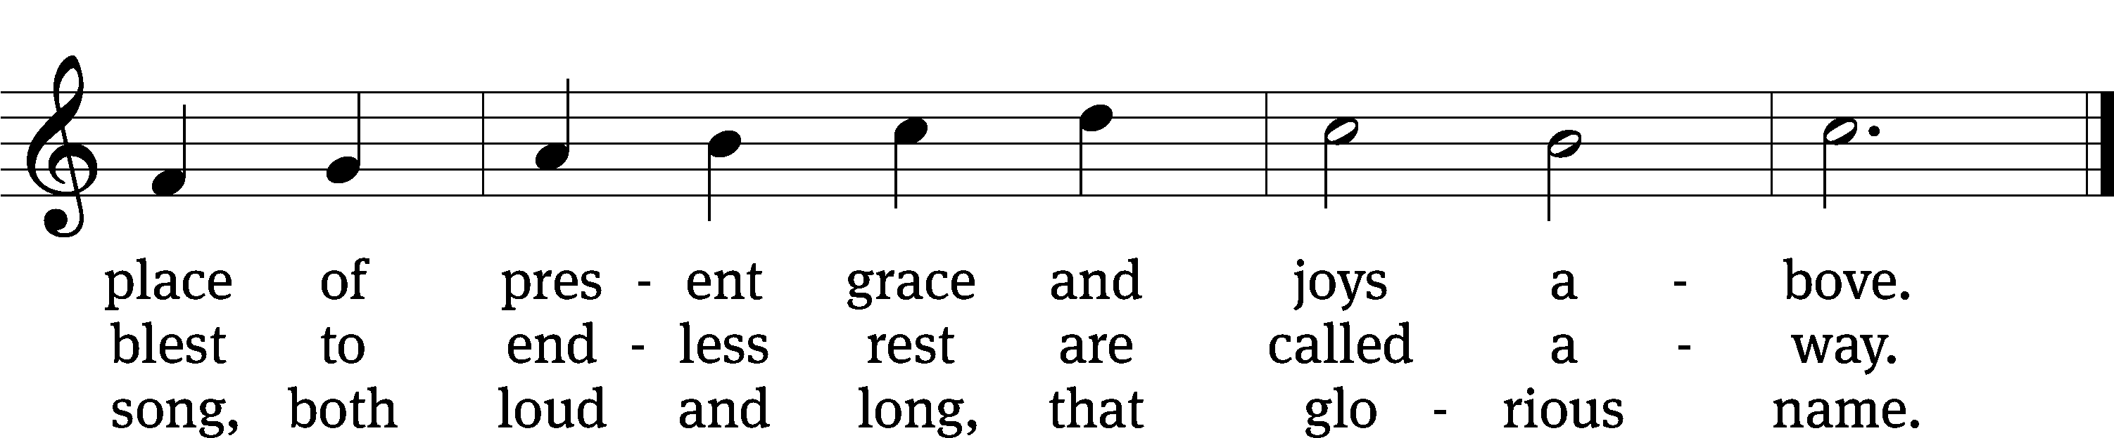

Text: tr. John Chandler, 1806–1876, alt.; Latin, c. 8th cent., abr.
Tune: John Darwall, 1731–1789 Text and tune: Public domain
Acknowledgments
Setting One from Christian Worship
Software distributed in partnership with Northwestern Publishing House.
Created by Christian Worship: Service Builder © 2022 Concordia Publishing House.

Serving in Worship
Officiant Pastor Natsis
Organist Ann Hoeft
Deacons (8:30) Jim Tice and Dave Stevenson
(11:00) Steve Hoeft and Jeff Neuburger
Ushers (8:30) Dale Finkbeiner and Mark Finkbeiner
(11:00) Ed Sala and Al Whitley
Altar Guild Shirley Klumpp and Ann Latowski
Videographer Ann Latowski

* * * * * * * * * * * * * * * * * * * * * * * * * *

trinitylutheran-saline.org
v

