the first sunday
after CHRISTMAS

tRINITY EVANGELICAL LUTHERAN CHURCH | Saline, Michigan
December 31, 2023

WELCOME TO WORSHIP

Thank you for joining us in God’s house today! We cordially ask that our Guests with us this morning sign one of the guestbooks located at either the front or back entryways.

THANK OFFERING: Members of Trinity give their offering as an expression of love and thankfulness to the Lord and to help support the Lord’s work in our community and around the world. Visitors need not feel obligated to participate in this offering which supports our ministry.

Restrooms are located at the back of the upper level (the annex), and in the basement (down the back stairs of the sanctuary or annex). Handicap access is available, please ask an usher for assistance.

Young Families / Toddler Bags – We are GLAD YOU BROUGHT YOUR CHILDREN to our worship service. Jesus said: “Let the little children come to me and do not hinder them, for the kingdom of God belongs to such as these.” We know that having little children in church can be a challenge, but DO NOT WORRY about it. Many of your fellow worshippers have been in your shoes and are just happy you brought your children with you. For your convenience, we have reserved the back rows of seating for parents with small children. These areas provide more flexibility for your family, as well as, easy access to move downstairs if necessary. A closed-circuit TV system allows families to continue participating in the service while downstairs. Pre-school toddler bags and children’s bulletins are available for their enjoyment. Ask an usher for one to use during the service and please return the toddler bag afterwards.

SERVICE of the word

497 O Light of Gentile Nations CW 497
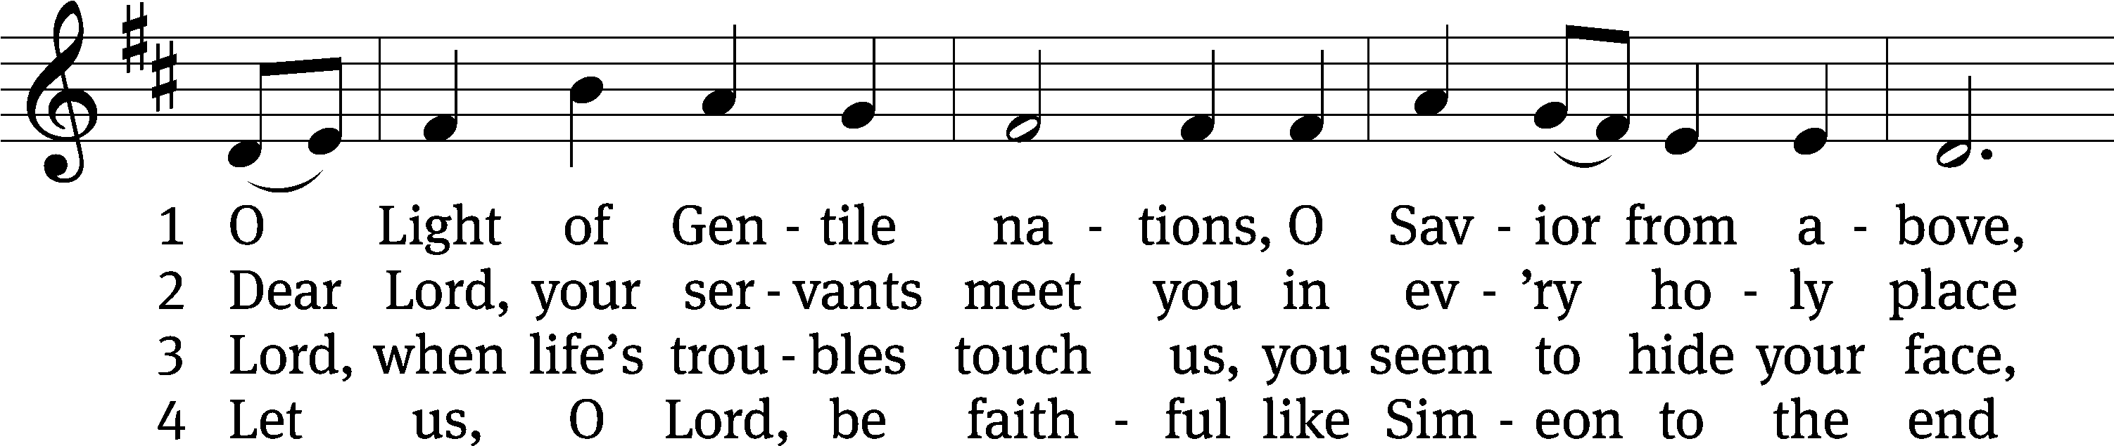
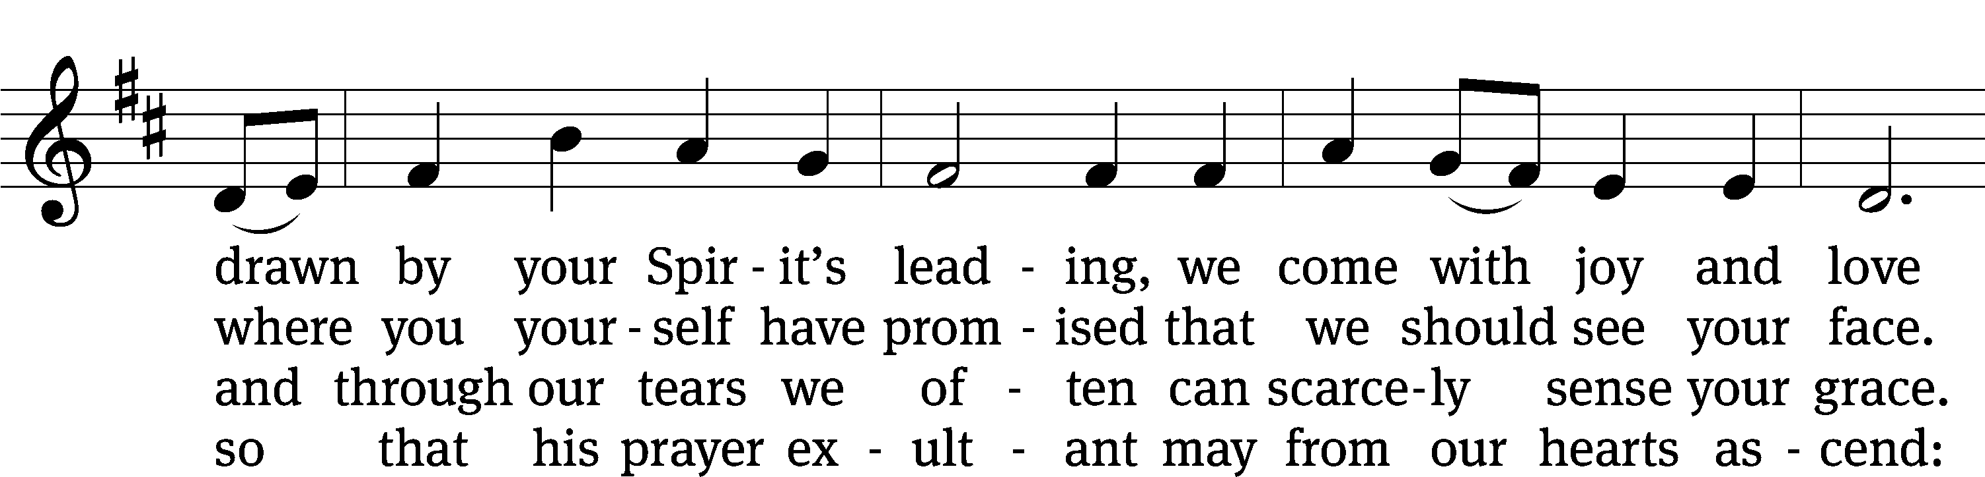
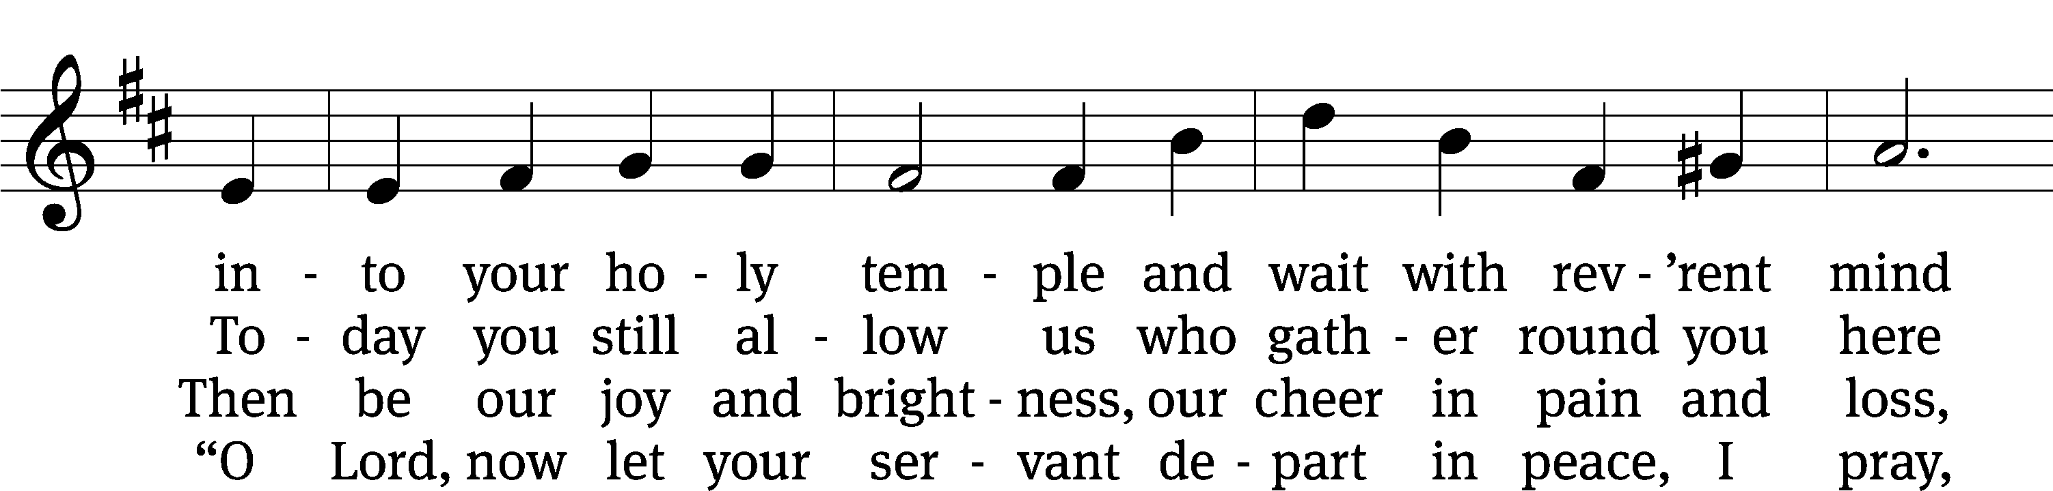
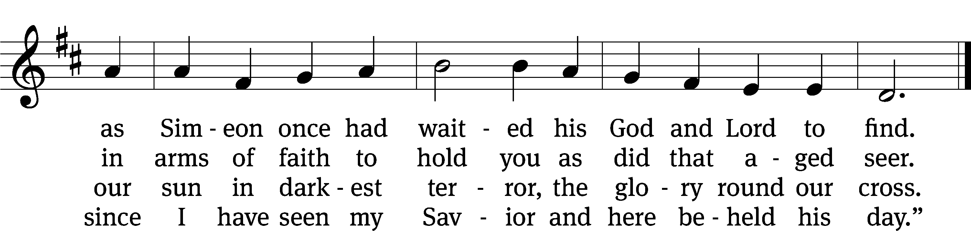
Text: tr. Catherine Winkworth, 1827–1878, alt.; Johann Franck, 1618–1677, abr., adapt.
Tune: Neu-vermehrtes . . . Gesangbuch, 3rd. ed., Meiningen, 1693
Text and tune: Public domain

PLEASE STAND, IF YOU ARE ABLE

invocation
M: The grace of our Lord (+) Jesus Christ and the love of God and the fellowship of the Holy Spirit be with you.
C: And also with you.

CONFESSION OF SINS
M: We have come into the presence of God, who created us to love and serve him as his dear children. But we have disobeyed him and deserve only his wrath and punishment. Therefore, let us confess our sins to him and plead for his mercy.

C: Merciful Father in heaven, I am altogether sinful from birth. In countless ways I have sinned against you and do not deserve to be called your child. But trusting in Jesus, my Savior, I pray: Have mercy on me according to your unfailing love. Cleanse me from my sin, and take away my guilt.

M: God, our heavenly Father, has forgiven all your sins. By the perfect life and innocent death of our Lord Jesus Christ, he has removed your guilt forever. You are his own dear child. May God give you strength to live according to his will.

C: Amen.
PRAYER AND PRAISE

M: In the peace of forgiveness, let us praise the Lord.

OH, TASTE AND SEE

PRAYER OF THE DAY

Let us pray.

Almighty God, in mercy you sent your one and only Son to take upon himself our human nature. By his gracious coming, deliver us from the corruption of our sin, and transform us into the likeness of his glory; through your Son, Jesus Christ our Lord, who lives and reigns with you and the Holy Spirit, one God, now and forever.

PLEASE BE SEATED
The Word

the FIRST LESSON 1 Kings 8:6-13

⁶ The priests brought the Ark of the Covenant of the Lord to its place in the inner sanctuary of the house, to the Most Holy Place, under the wings of the cherubim, ⁷ for the cherubim were spreading their wings over the place for the ark, so that the cherubim covered the ark and its poles with their wings. ⁸ The poles were so long that the ends of the poles could be seen from the Holy Place in front of the inner sanctuary, but they could not be seen from outside. They are there to this day.
⁹ There was nothing in the ark except the two stone tablets, which Moses had placed there at Horeb, where the Lord made a covenant with the people of Israel when they came out of the land of Egypt.
¹⁰ When the priests came out from the Holy Place, the cloud filled the House of the Lord. ¹¹ The priests were not able to take their positions to minister in the presence of the cloud, because the Glory of the Lord had filled the House of the Lord.
¹² Then Solomon said, “The Lord has said that he dwells in thick darkness. ¹³ I have truly built a majestic house for you, a place for you to dwell forever.”

Psalm 111B I Will Give Thanks to the LORD Psalm 111B
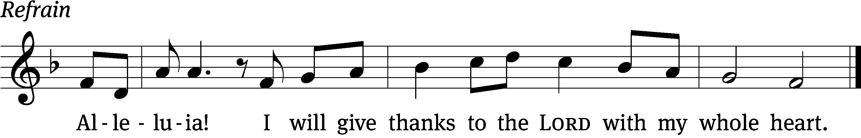
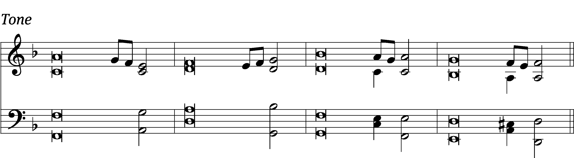

Great are the works / of the Lord;
they are pondered by all who de- / light in them.
Glorious and majestic / are his deeds,
and his righteousness endures for- / ever. Refrain

He has caused his wonders to be re- / membered;
the Lord is gracious and com- / passionate.
He provided redemption for his / people;
holy and awesome / is his name.
Glory be to the Father and / to the Son
and to the Holy / Spirit,
as it was in the be- / ginning,
is now, and will be forever. / Amen. Refrain
Text: Book of Common Prayer, 1979
Tune: David Cherwien
Setting: David Cherwien
Music: © 1989 Concordia Publishing House. Used by permission: License no. 130003540

SECOND LESSON Colossians 3:12-17

¹² Therefore, as God’s elect, holy and loved, clothe yourselves with heartfelt compassion, kindness, humility, gentleness, and patience. ¹³ Bear with one another and forgive each other if anyone has a complaint against anyone else. Forgive, just as Christ forgave you. ¹⁴ And, in addition to all these things, put on love, which ties things together in perfect unity. ¹⁵ Let the peace of Christ control your hearts, to which you were also called, in one body. And be thankful.
¹⁶ Let the word of Christ dwell in you richly, as you teach and admonish one another with all wisdom, singing psalms, hymns, and spiritual songs, with gratitude in your hearts to God. ¹⁷ And everything you do, whether in word or deed, do it all in the name of the Lord Jesus, giving thanks to God the Father through him.

Verse of the day

Alleluia. But when the set time had fully come, God sent his Son to be born of a woman, so that he would be born under the law, in order to redeem those under the law. Alleluia.

THE GOSPEL LESSON Luke 2:22-40
M: The Gospel according to Luke chapter 2, verses 22-40
²² When the time came for their purification according to the law of Moses, they brought him up to Jerusalem to present him to the Lord. ²³ (As it is written in the law of the Lord, “Every firstborn male will be called holy to the Lord.”) ²⁴ And they came to offer a sacrifice according to what was said in the law of the Lord, “A pair of turtledoves or two young pigeons.”
²⁵ Now there was a man in Jerusalem whose name was Simeon. This man was righteous and devout, waiting for the comfort of Israel, and the Holy Spirit was on him. ²⁶ It had been revealed to him by the Holy Spirit that he would not see death before he had seen the Lord’s Christ. ²⁷ Moved by the Spirit he went into the temple courts. When the parents brought in the child Jesus to do for him what was customary according to the law, ²⁸ Simeon took him into his arms and praised God. He said,
²⁹ Lord, you now dismiss your servant in peace, according to
your word,
³⁰ because my eyes have seen your salvation,
³¹ which you have prepared before the face of all people,
³² a light for revelation to the Gentiles, and the glory of your
people Israel.
³³ Joseph and the child’s mother were amazed at the things that were spoken about him. ³⁴ Then Simeon blessed them and said to Mary his mother, “Listen carefully, this child is appointed for the falling and rising of many in Israel and for a sign that is spoken against, ³⁵ so that the thoughts of many hearts may be revealed. And a sword will pierce your own soul too.”
³⁶ Anna, a prophetess, was there. She was a daughter of Phanuel, of the tribe of Asher. She was very old. She had lived with her husband for seven years after her marriage, ³⁷ and then she was a widow of eighty-four years. She did not leave the temple complex, since she was worshipping with fasting and prayers night and day. ³⁸ Standing nearby at that very hour, she gave thanks to the Lord. She kept speaking about the child to all who were waiting for the redemption of Jerusalem.
³⁹ When they had accomplished everything according to the law of the Lord, they returned to Galilee, to their own town, Nazareth. ⁴⁰ The child grew and became strong. He was filled with wisdom, and God’s favor was on him.

M: This is the Gospel of the Lord.

PLEASE BE SEATED

355 Let All Together Praise Our God CW 355
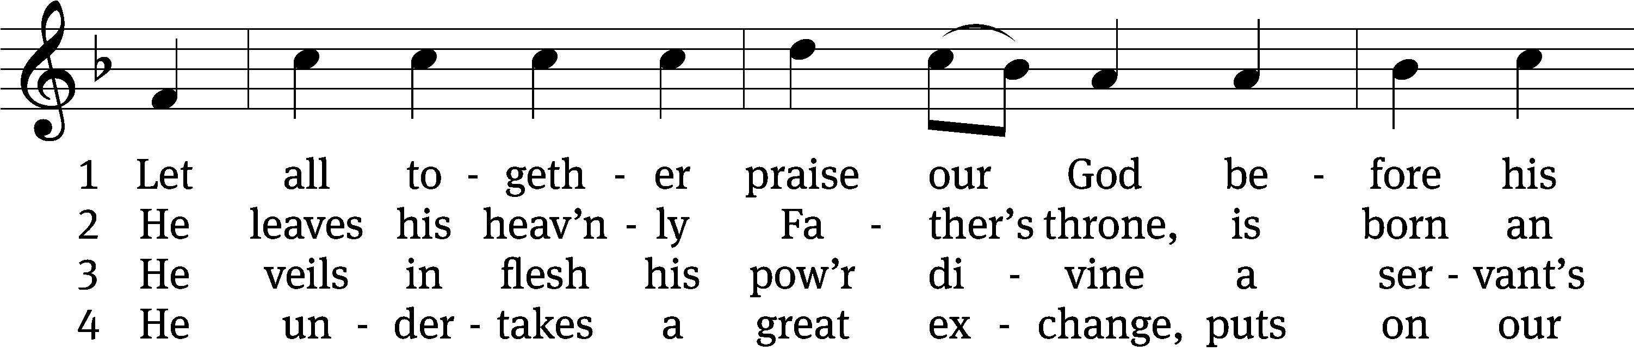
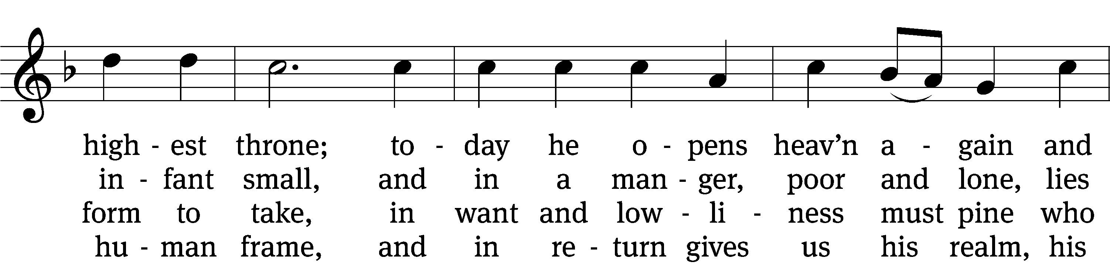
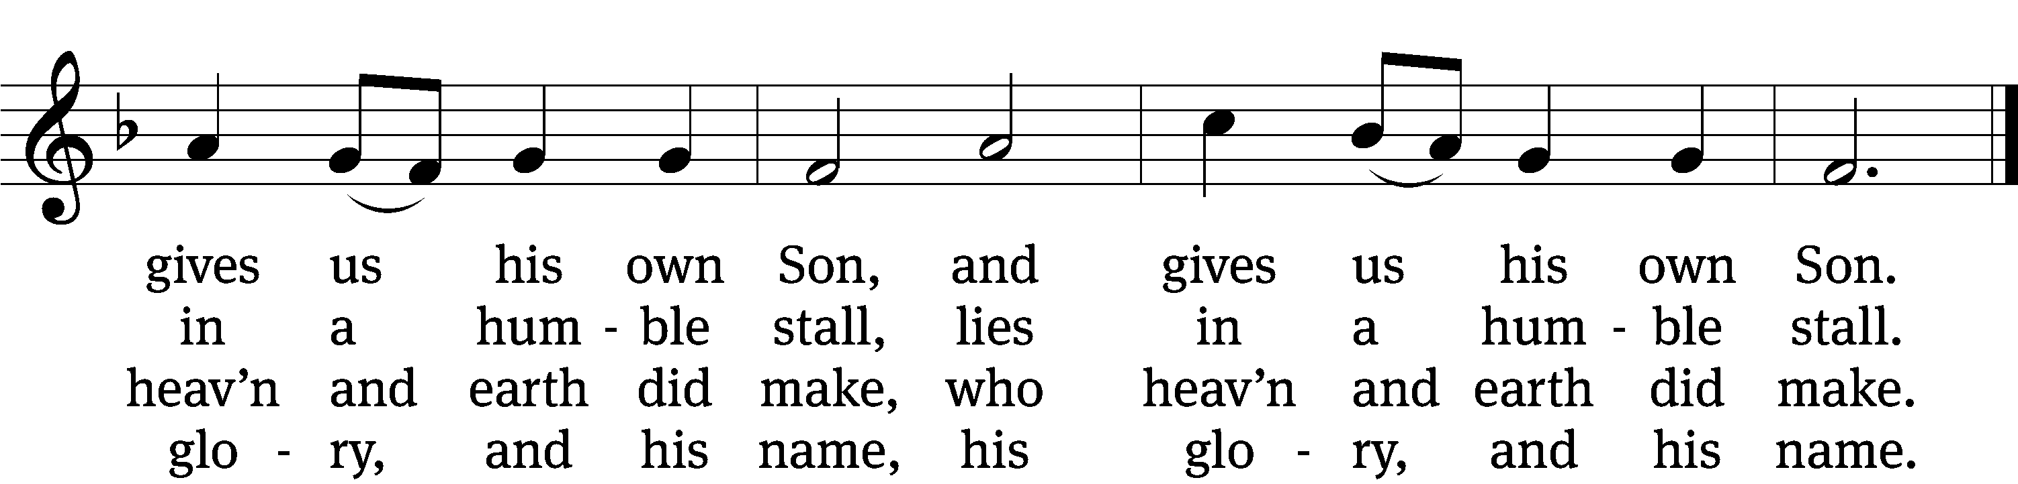

5 He serves that I a lord may be—
a great exchange indeed!
Could Jesus’ love do more for me
to help me in my need,
to help me in my need?

6 For us he opens wide the door
of paradise today.
The angel guards the gate no more;
to God our thanks we pay,
to God our thanks we pay.
Text: Nicolaus Herman, c. 1480-1561, abr.; (sts. 1–3, 5–6): tr. August Crull, 1845–1923, sts. 1-3,5,6, alt.; (st. 4): tr. F. Samuel Janzow, 1913–2001, st. 4
Tune: Nicolaus Herman, c. 1480–1561
Text (st. 4): © 1969 Concordia Publishing House. Used by permission: OneLicense no. 727703
Text (sts. 1–3, 5–6) and tune: Public domain

SERMON Luke 2:22-40
“As You Have Promised”

PLEASE STAND, IF YOU ARE ABLE

THE APOSTLES’ CREED

I believe in God, the Father almighty,
maker of heaven and earth.
I believe in Jesus Christ, his only Son, our Lord,
who was conceived by the Holy Spirit,
born of the virgin Mary,
suffered under Pontius Pilate,
was crucified, died, and was buried.
He descended into hell.
The third day he rose again from the dead.
He ascended into heaven
and is seated at the right hand of God the Father almighty.
From there he will come to judge the living and the dead.
I believe in the Holy Spirit,
the holy Christian Church,
the communion of saints,
the forgiveness of sins,
the resurrection of the body,
and the life everlasting. Amen.

PRAYER OF THE CHURCH
THE LORD’S PRAYER

C: Our Father, who art in heaven, hallowed be thy name, thy kingdom come, thy will be done on earth as it is in heaven. Give us this day our daily bread; and forgive us our trespasses, as we forgive those who trespass against us; and lead us not into temptation, but deliver us from evil. For thine is the kingdom and the power and the glory forever and ever. Amen.

PLEASE BE SEATED
330 Peace Came to Earth CW 330
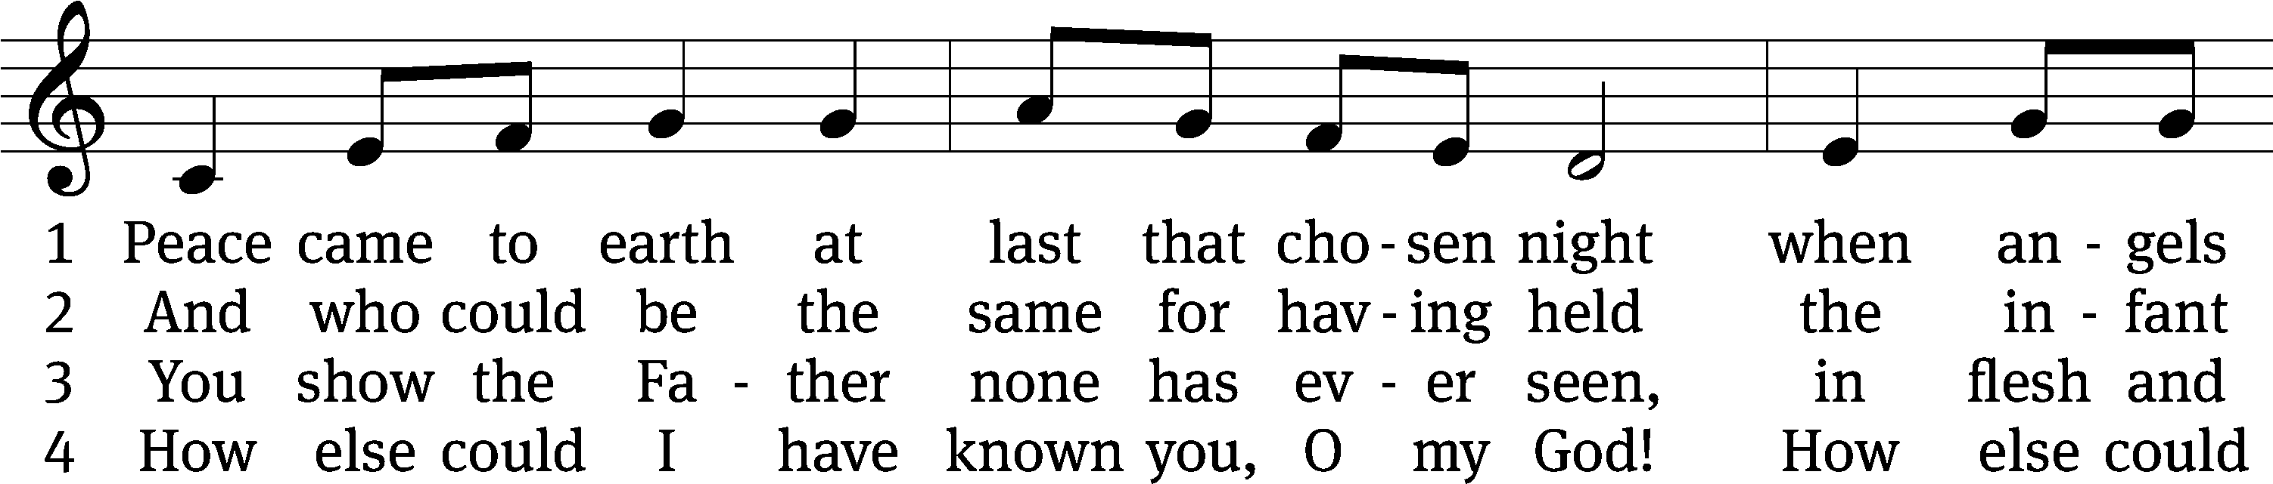
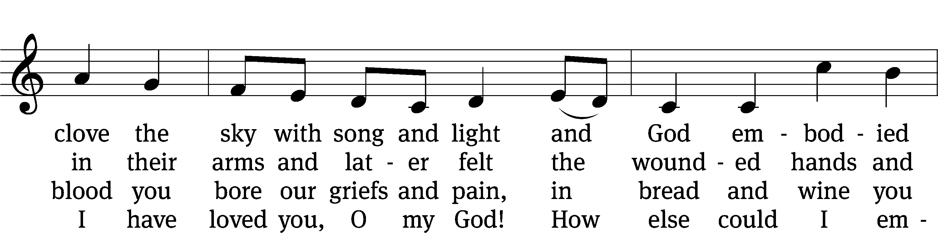
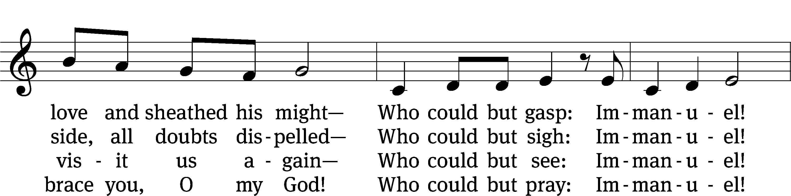
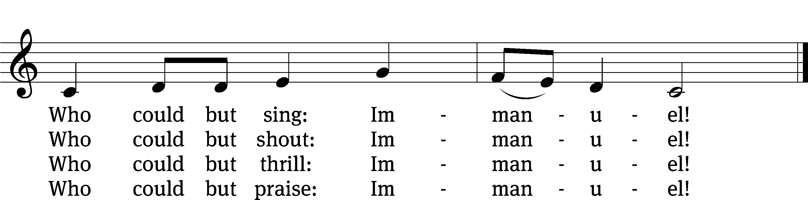

Text: Jaroslav J. Vajda, 1919–2008
Tune: arr. Mark Kellner, 1959–2015, alt.; Richard Jeffrey, b. 1952
Text: © 1984 Concordia Publishing House. Used by permission: OneLicense no. 727703
Tune: © 2000 MorningStar Music Publishers, Inc. Used by permission: OneLicense no. 727703

PLEASE STAND, IF YOU ARE ABLE

CLOSING PRAYER
M: Almighty God, we thank you for teaching us the things you want us to believe and do. Help us by your Holy Spirit to keep your Word in pure hearts that we may be strengthened in faith, guided in holiness, and comforted in life and in death, through Jesus Christ, our Lord, who lives and reigns with you and the Holy Spirit, one God, now and forever.

M: Brothers and sisters, go in peace. Live in harmony with one another. Serve the Lord with gladness.
The Lord bless you and keep you.
The Lord make his face shine on you and be gracious to you.
The Lord look on you with favor and (+) give you peace.

PLEASE BE SEATED

927 Lord, Dismiss Us with Your Blessing CW 927
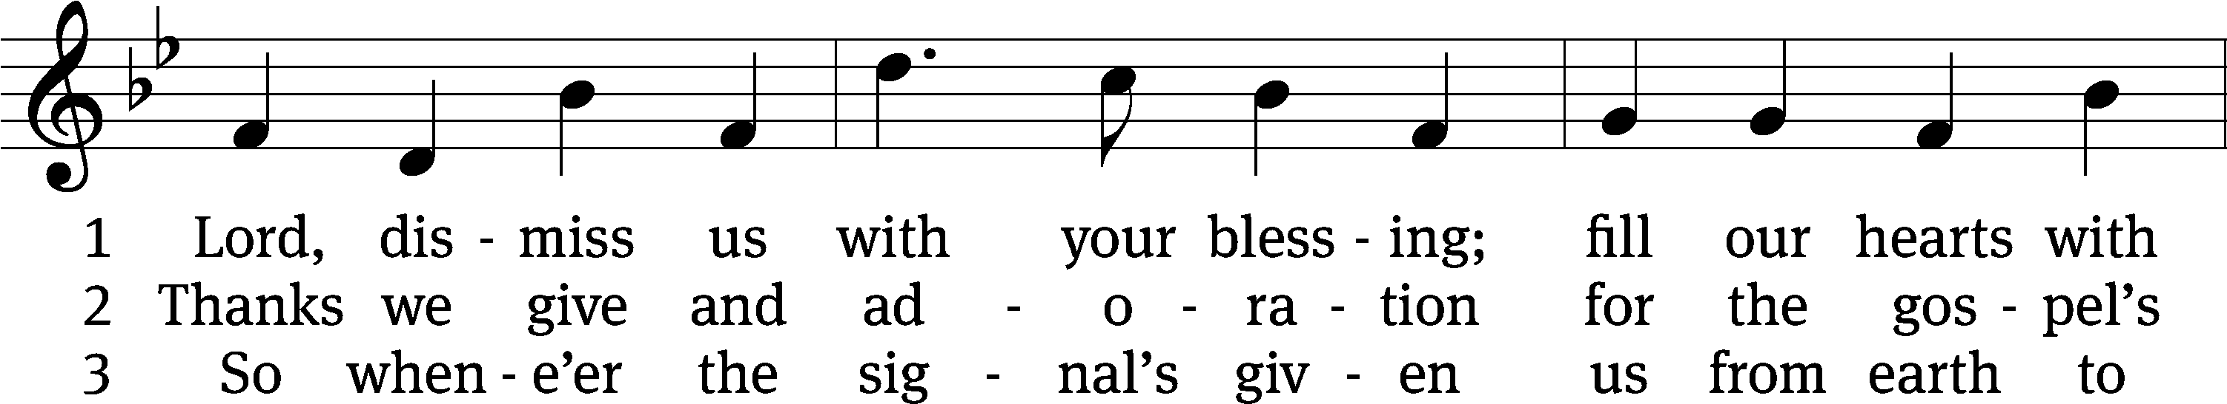
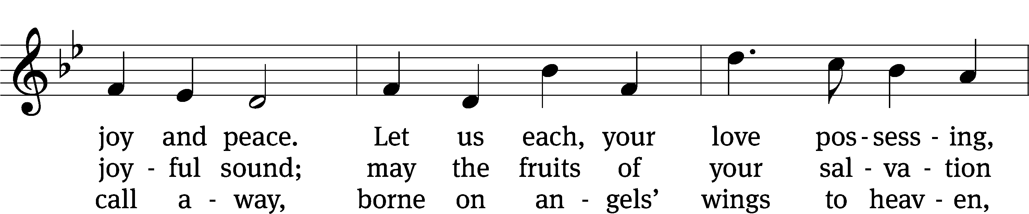
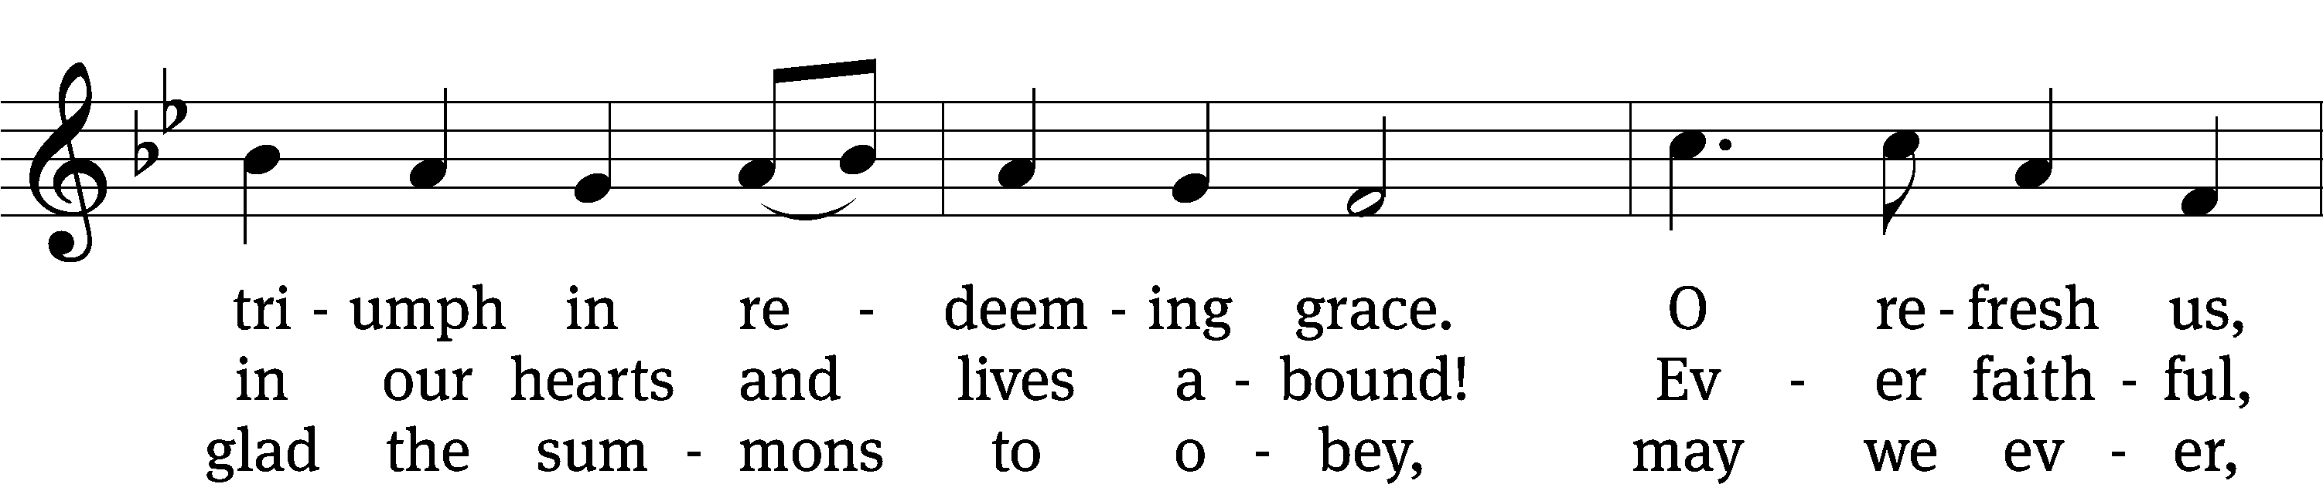
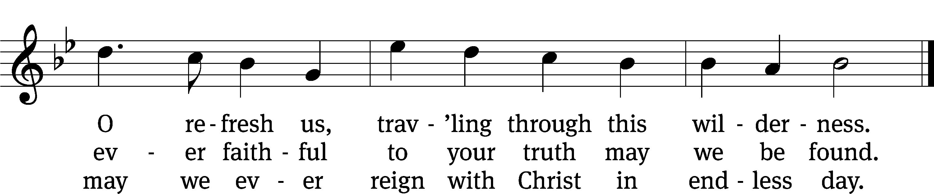
Text: attr. John Fawcett, 1740–1817, alt.
Tune: Henry T. Smart, 1813–1879
Text and tune: Public domain

Serving In Worship
Officiant Pastor Pappenfuss
Organist Marcia Marion Ackling
Deacons (8:30) Duane Mason and Jim Tice
Deacons (11:00) Jeff Neuburger and Robert Niethammer
Altar Guild Sharon Boswell
Videographer Cindy Dresch

Copyright information
Service of the Word: Christian Worship. © 1993 Northwestern Publishing House. All rights reserved.
Reprinted with permission under ONE LICENSE #A-727703 and CCLI #1151741/CSPL126093

Words and Music: All rights reserved. Reprinted with permission under ONE LICENSE #A-727703 and
CCLI #1151741/CSPL126093
tlcsaline.church

