The FOURTH SUNDAY
IN ADVENT

TRINITY EVANGELICAL LUTHERAN CHURCH | Saline, Michigan
WELCOME TO WORSHIP December 24, 2023
Thank you for joining us in God’s house today! We cordially ask that our Guests sign one of the guestbooks located at either the front or back entryways, or fill out a “Let’s Get Acquainted” card located in the hymnal pew rack and place it in the collection plate.

THANK OFFERING: Members of Trinity give their offering as an expression of love and thankfulness to the Lord and to help support the Lord’s work in our community and around the world. Visitors need not feel obligated to participate in this offering which supports our ministry.

Restrooms are located at the back of the upper level (the annex), and in the basement (down the back stairs of the sanctuary or annex). Handicap access is available, please ask an usher for assistance.

Young Families / Toddler Bags – We are GLAD YOU BROUGHT YOUR CHILDREN to our worship service. Jesus said: “Let the little children come to me and do not hinder them, for the kingdom of God belongs to such as these.” We know that having little children in church can be a challenge, but DO NOT WORRY about it. Many of your fellow worshippers have been in your shoes and are just happy you brought your children with you. For your convenience, we have reserved the back rows of seating for parents with small children. These areas provide more flexibility for your family, as well as, easy access to move downstairs if necessary. A closed-circuit TV system allows families to continue participating in the service while downstairs. Pre-school toddler bags and children’s bulletins are available for their enjoyment. Ask an usher for one to use during the service and please return the toddler bag afterwards.

the SERVICE – setting one - WITHOUT HOLY COMMUNION CW, page 154

360 Behold, a Branch Is Growing CW 360
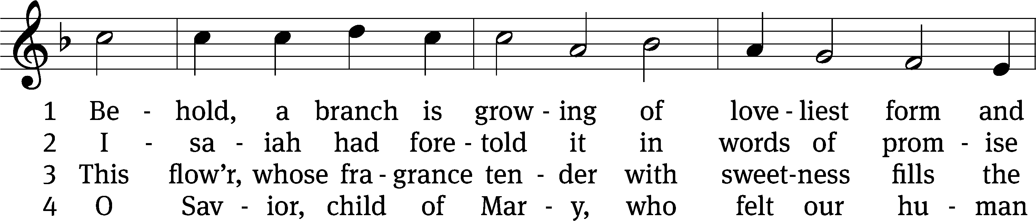
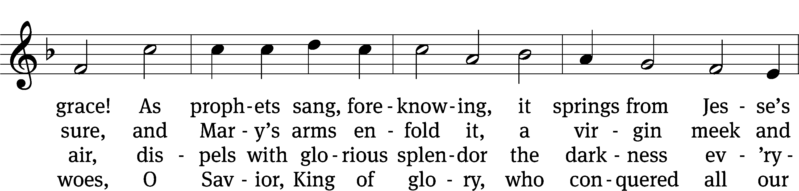
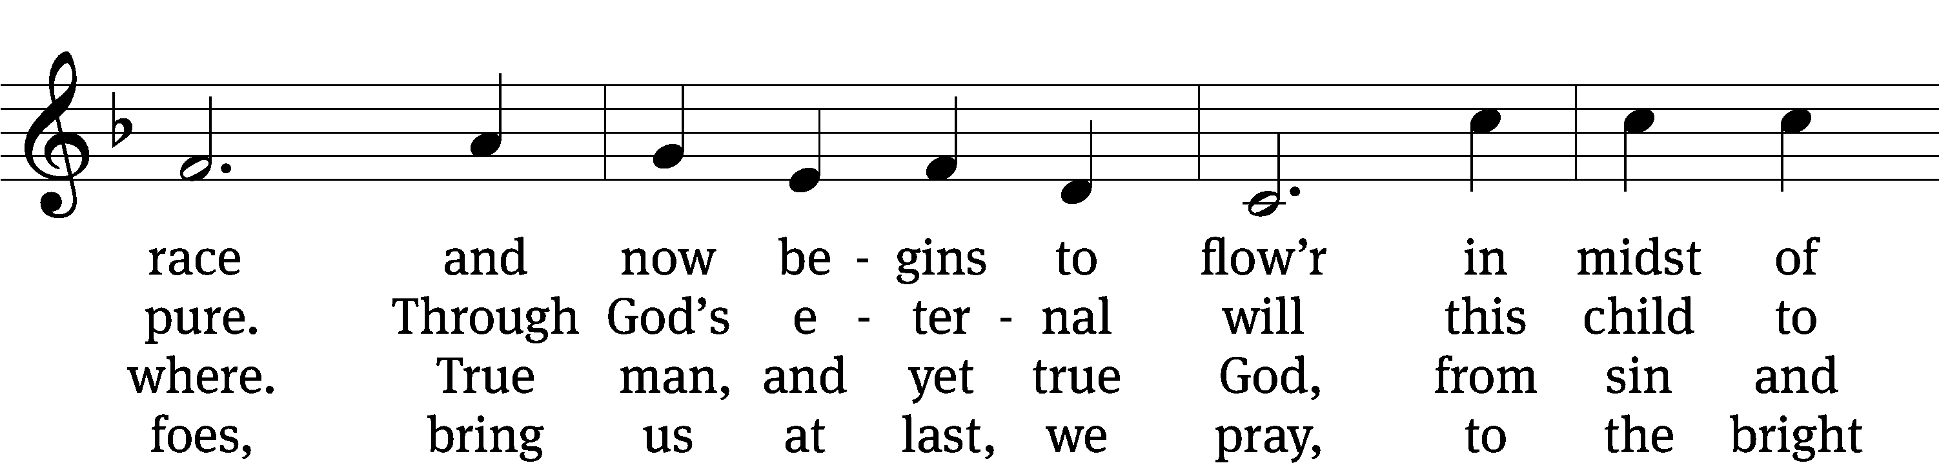
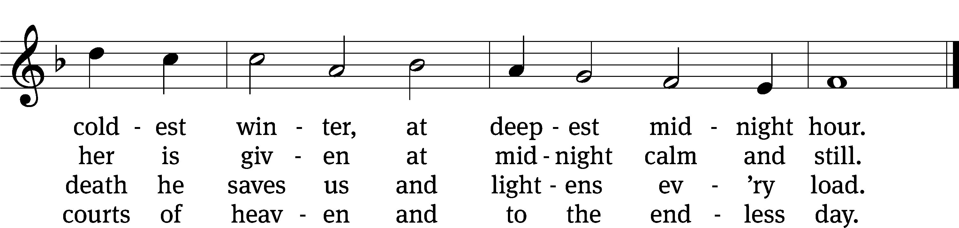
Text: German, 16th cent.; (sts. 1–3): tr. Harriet R. K. Spaeth, 1845–1925; (st. 4): John C. Mattes, 1876–1948, alt.
Tune: Alte Catholische Geistliche Kirchengeseng, Köln, 1599
Text and tune: Public domain

Please stand, if you are able

Invocation
In the name of the Father and of the Son and of the Holy Spirit.
Amen.

Confession
If we claim to be without sin, we deceive ourselves and the truth is not in us.
If we confess our sins, God is faithful and just
and will forgive us our sins
and purify us from all unrighteousness.

Let us confess our sins to the Lord.
Holy God, gracious Father,
I am sinful by nature
and have sinned against you in my thoughts, words, and actions.
I have not loved you with my whole heart;
I have not loved others as I should.
I deserve your punishment both now and forever.
But Jesus, my Savior, paid for my sins
with his innocent suffering and death.
Trusting in him, I pray: God, have mercy on me, a sinner.

Our gracious Father in heaven has been merciful to us. He sent his only Son, Jesus Christ, who gave his life as the atoning sacrifice for the sins of the whole world. Therefore, as a called servant of Christ and by his authority, I forgive you all your sins in the name of the Father and of the Son and of the Holy Spirit.
Amen.

Lord, Have Mercy
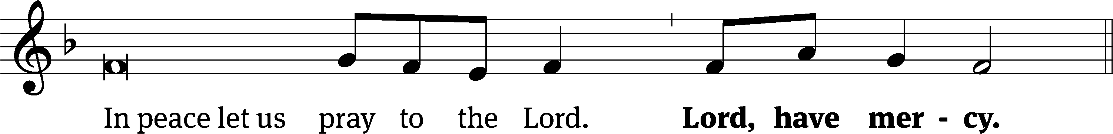
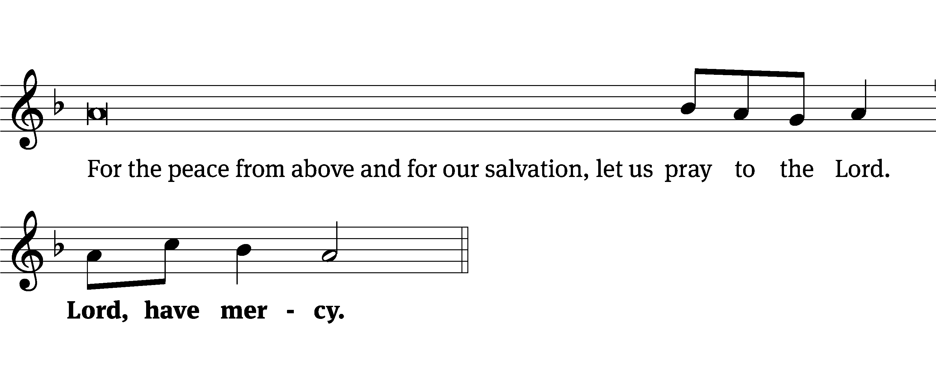
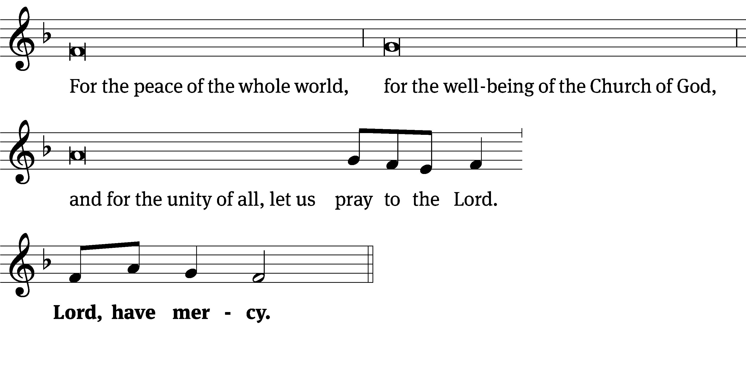
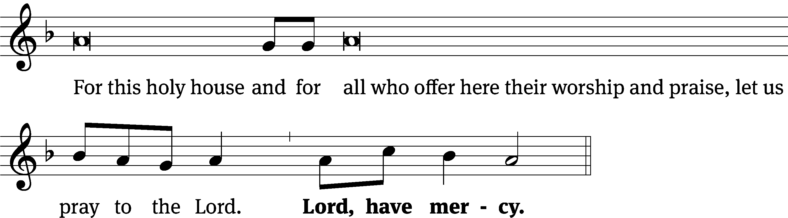
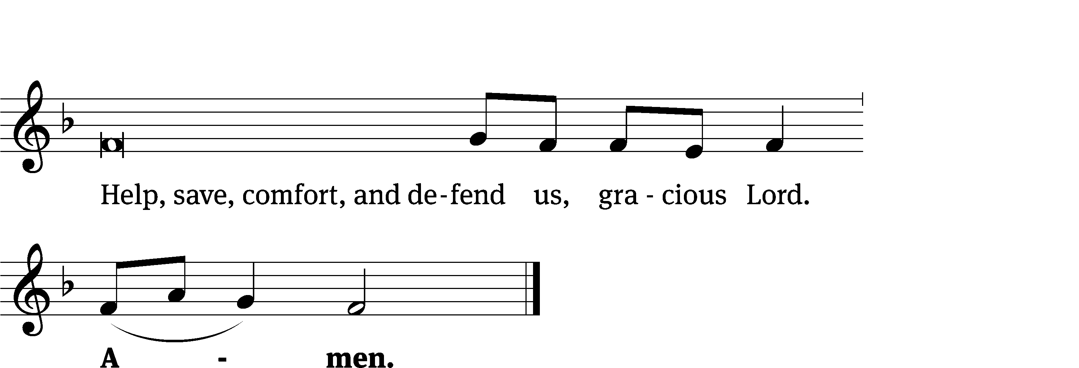
Tune: Kevin Becker
Tune: © 2021 Northwestern Publishing House. Used by permission: OneLicense no. 727703

Glory Be to God CW 157
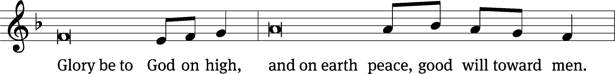
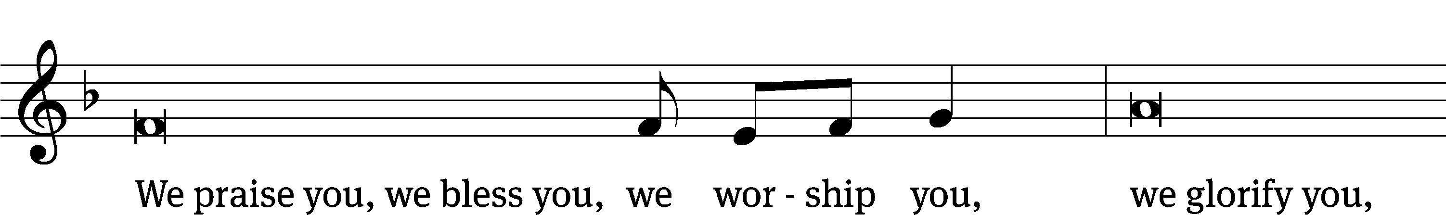
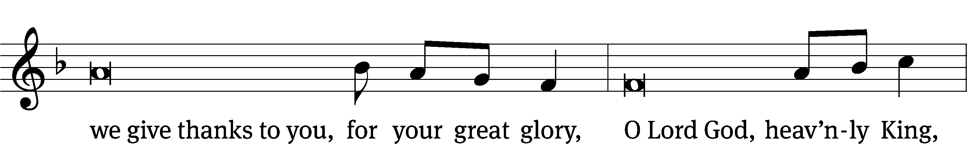
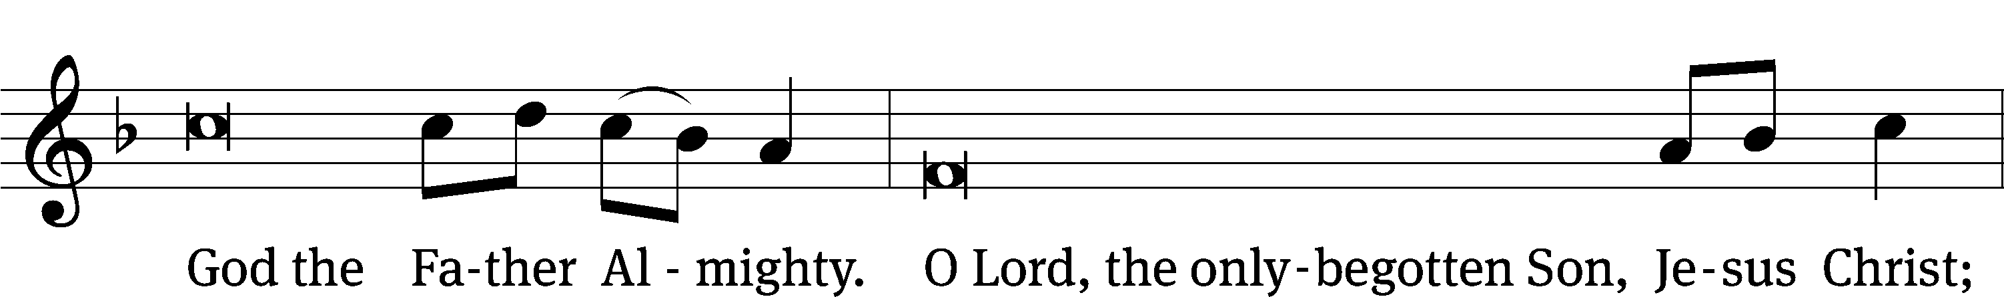
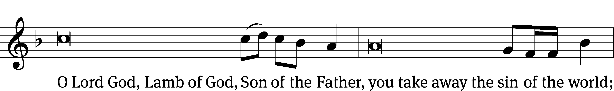
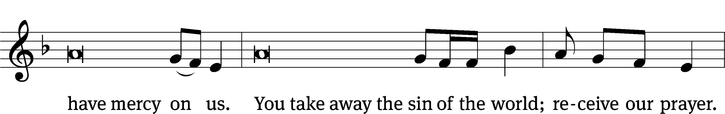
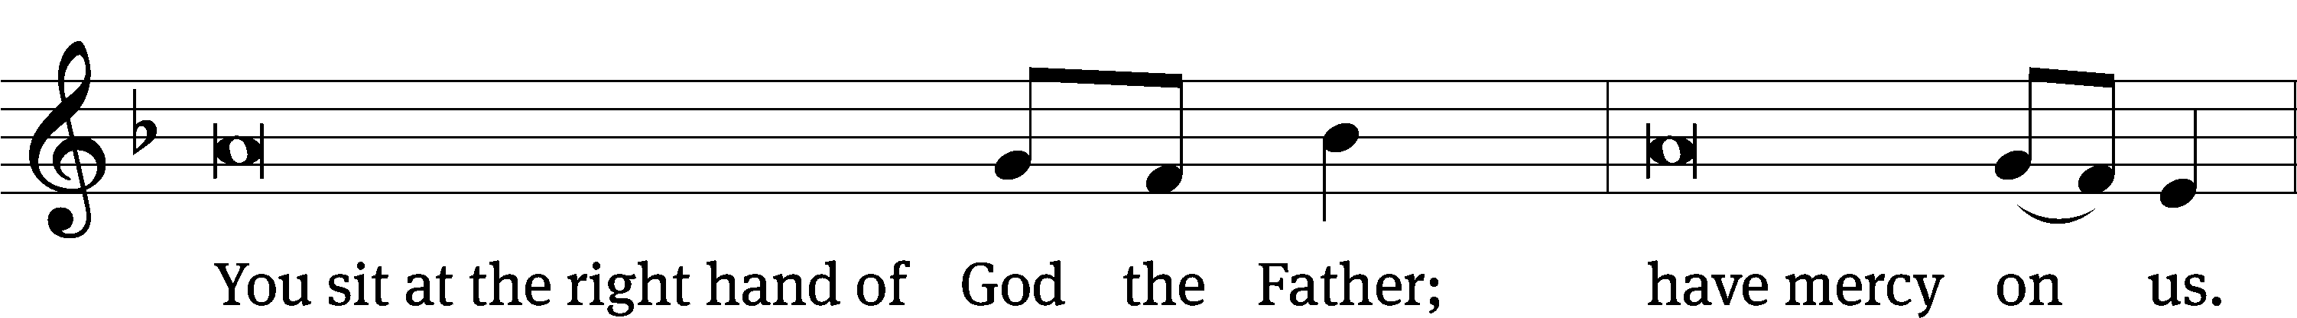
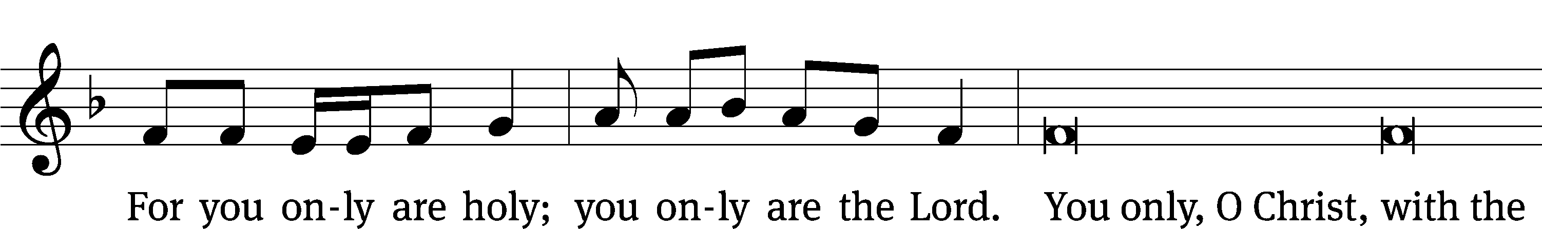
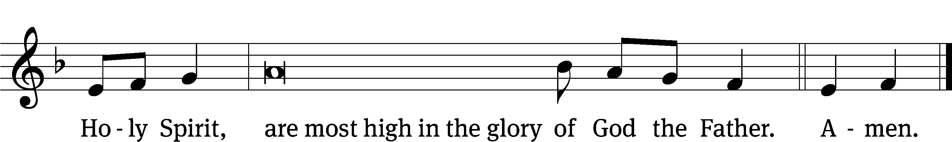

Tune: © 2021 Northwestern Publishing House. Used by permission: OneLicense no. 727703
The Lord be with you.
And also with you.
Prayer of the Day
Let us pray.

Stir up your power, O Lord, and come. Take away the burden of our sins, and make us ready for the celebration of your birth, that we may receive you in joy and serve you always; for you live and reign with the Father and the Holy Spirit, one God, now and forever.
Amen.

Please be seated

First Reading 2 Samuel 7:8-16
⁸ You are also to say the following to my servant David.
This is what the Lord of Armies says. I took you from the pasture, from following sheep, to be ruler over my people, over Israel. ⁹ I have been with you wherever you went. I have cut off all your enemies from before you. I will make your reputation great, like that of the great ones on the earth. ¹⁰ I will set up a place for my people Israel, and I will plant them there. They will dwell there, and they will not be disturbed again. Violent men will not afflict them again as they did at the beginning ¹¹ and ever since the day I appointed judges over my people Israel. I will give you rest from all your enemies.
The Lord also declares to you that the Lord himself will make a house for you. ¹² When your days are complete and you rest with your fathers, I will raise up after you your seed, who will come from your own body. I will establish his kingdom. ¹³ He will build a house for my name, and I will establish the throne of his kingdom forever. ¹⁴ I will be his father, and he will be my son. When he sins, I will discipline him with a rod used by men and with blows of the sons of men. ¹⁵ My faithful mercy will not depart from him as I removed it from Saul, whom I removed to make room for you. ¹⁶ Your house will stand firm, and your kingdom will endure forever before you. Your throne will be established forever.

The Word of the Lord.
Thanks be to God.

Duet “Mary, Did You Know?”

Mary, did you know that your baby bot would some day walk on water?
Mary, did you know that your baby boy would save our sons and daughters?
Did you know that your baby boy has come to make you new?
This child that you delivered will soon deliver you.
Mary, did you know that your baby boy will give sight to a blind man?
Mary, did you know that your baby boy will calm a storm with his hand?
Did you know that your baby boy has walked where angels trod?
When you kissed your little baby, then you kissed the face of God.
The blind will see, the deaf will hear, the dead will live again;
The lame will leap, the dumb will speak the praises of the Lamb.
Mary, did you know that your baby boy is Lord of all creation?
Mary, did you know that your baby boy will one day rule the nations?
Did you know that your baby boy was heaven’s perfect Lamb?
This sleeping child you’re holding is the great, the great “I AM.”

Second Reading Romans 16:25-27
²⁵ Now to him who is able to strengthen you—
according to my gospel and the proclamation of Jesus Christ, according to the revelation of the mystery that was veiled in silence for long ages past, ²⁶ but now has been revealed through the prophetic Scriptures and made known to all the Gentiles, in keeping with the command of the eternal God, resulting in the obedience of faith—
²⁷ to God, who alone is wise, be glory forever through Jesus Christ. Amen.

The Word of the Lord.
Thanks be to God.

Please stand, if you are able
Gospel Acclamation Matthew 1:23
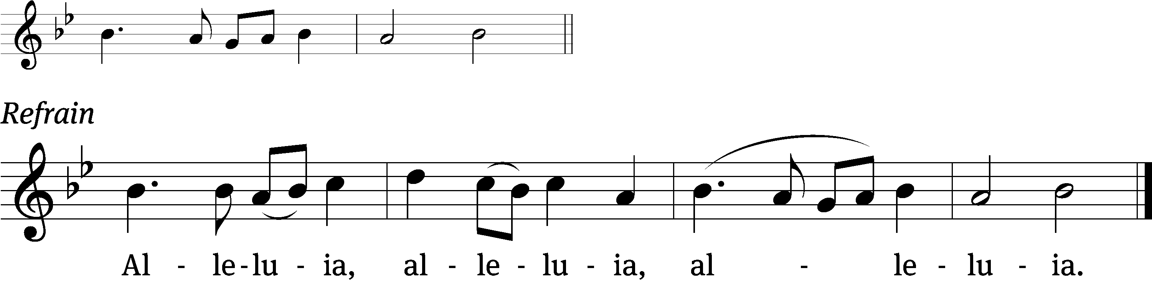
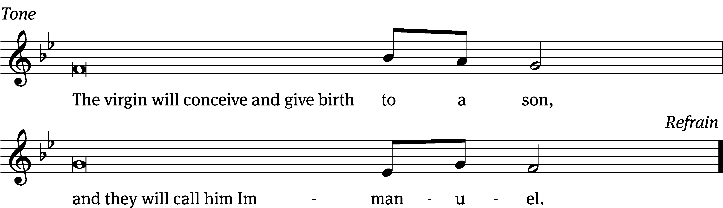
Tune: © 2021 Northwestern Publishing House. Used by permission: OneLicense no. 727703

Gospel Luke 1:26-38
²⁶ In the sixth month, the angel Gabriel was sent from God to a town of Galilee named Nazareth, ²⁷ to a virgin pledged in marriage to a man whose name was Joseph, of the house of David. The virgin’s name was Mary. ²⁸ The angel went to her and said, “Greetings, you who are highly favored! The Lord is with you. Blessed are you among women.”^{[a]}
²⁹ But she was greatly troubled by the statement and was wondering what kind of greeting this could be. ³⁰ The angel said to her, “Do not be afraid, Mary, because you have found favor with God. ³¹ Listen, you will conceive and give birth to a son, and you are to name him Jesus. ³² He will be great and will be called the Son of the Most High. The Lord God will give him the throne of his father David. ³³ He will reign over the house of Jacob forever, and his kingdom will never end.”
³⁴ Mary said to the angel, “How will this be, since I am a virgin?”
³⁵ The angel answered her, “The Holy Spirit will come upon you, and the power of the Most High will overshadow you. So the holy one to be born will be called the Son of God. ³⁶ Listen, Elizabeth, your relative, has also conceived a son in her old age even though she was called barren, and this is her sixth month. ³⁷ For nothing will be impossible for God.”
³⁸ Then Mary said, “See, I am the Lord’s servant. May it happen to me as you have said.” Then the angel left her.
The Gospel of the Lord.
Praise be to you, O Christ!

Please be seated
328 The Angel Gabriel from Heaven Came CW 328
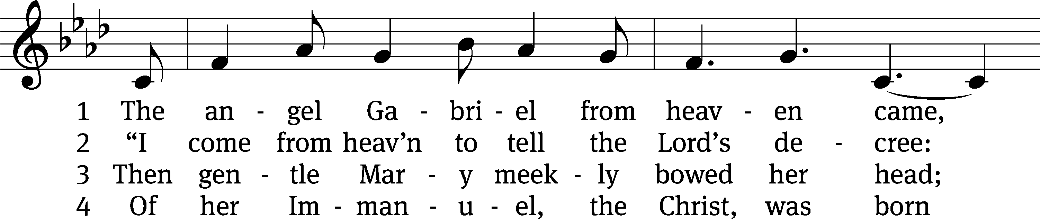
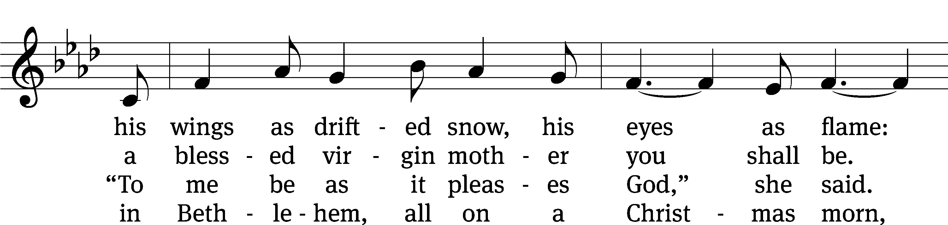
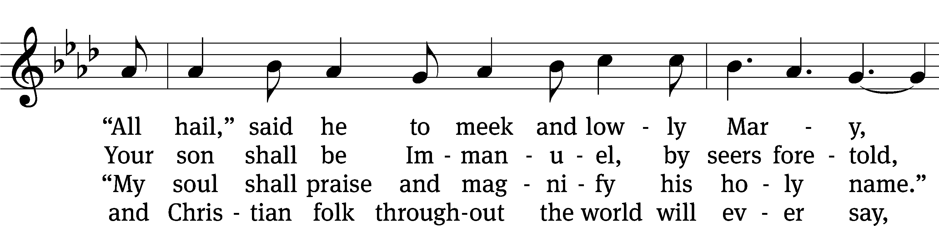
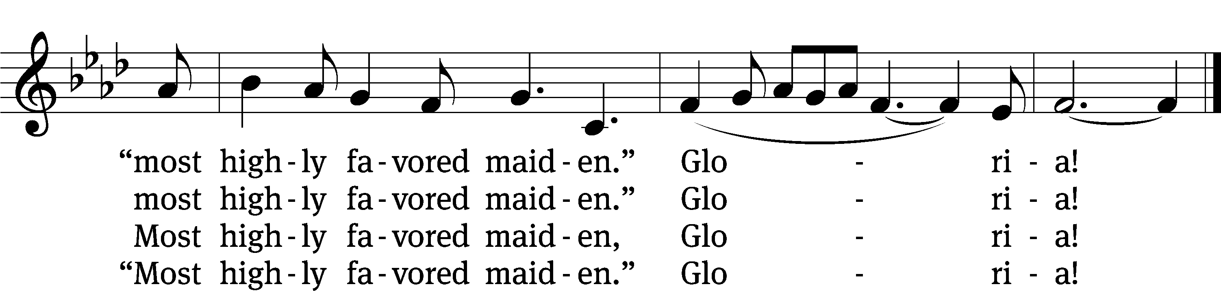
Text: para. Sabine Baring-Gould, 1834–1924, alt.; Basque, c. 18th cent.
Tune: Basque, c. 18th cent.
Text and tune: Public domain

Sermon Luke 1:26-38
“Messages Meant Not Just for Mary”

Please stand, if you are able
Apostles’ Creed
I believe in God, the Father Almighty,
maker of heaven and earth.

I believe in Jesus Christ, his only Son, our Lord,
who was conceived by the Holy Spirit,
born of the Virgin Mary,
suffered under Pontius Pilate,
was crucified, died, and was buried.
He descended into hell.
The third day he rose again from the dead.
He ascended into heaven
and is seated at the right hand of God the Father Almighty.
From there he will come to judge the living and the dead.

I believe in the Holy Spirit,
the holy Christian Church,
the communion of saints,
the forgiveness of sins,
the resurrection of the body,
and the life everlasting. Amen.

Prayer of the Church

Gracious Lord, you sent your Son into our world to destroy the power of Satan and restore the human race as your children and heirs. Work in us during this Advent season so that we may rejoice in the coming of our Savior and long for his coming again.
Make us eager to receive the King who comes to save us.

Use the preaching of your holy law to rid us of all delusions that we can gain your love with our own efforts. Move us to realize how hopeless we are because of sin and to feel sorrow for what we have done wrong.
Lead us to be honest about our sinful status in your sight.

Lift up our hearts to see the King who comes to save. Reveal to us his willingness to take on our human form and stand in our place. Show us the power he extends in his Word and sacraments to make us your children and keep us in faith. Thrill us with his promise to come and take us to our eternal home to live with you forever.
Open our eyes to see and believe the wonders of the Savior’s love.

As we live with Christ and trust in him, move us to turn away from sin day after day with the strength your Holy Spirit provides. When we fall, forgive us and renew us to love and serve you and all people.
Empower us and guide us to walk with Christ by faith.

Protect us from the distractions that come at this time of the year. Even in gift-giving and celebrating, keep our hearts focused on Christ and his forgiving love.
Give us joy at his coming at Christmas, his coming in the gospel, and his coming again.

Move us to share with others the most important gift of this season, the truth about Jesus. Even in busy times lead us to pray for those whose joy is diminished because of sickness, pain, or loss. [Especially bless… here name the person and the cause of the petition.] Give us opportunities to provide help to those in need.
May others see the love of Christ in our words and actions.

Hear us, Lord, as we pray in silence.

Silent prayer

Loving Lord, work in us during this Advent season so that our joy may be genuine and may rest in the promises of the King who comes to save.
Come, Lord Jesus. Amen.

Please be seated

893 For All the Faithful Women CW 893 sts. 1, 8, 3–4
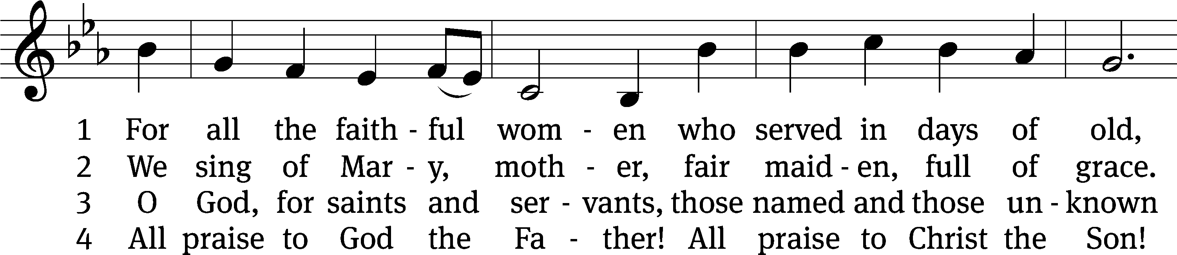
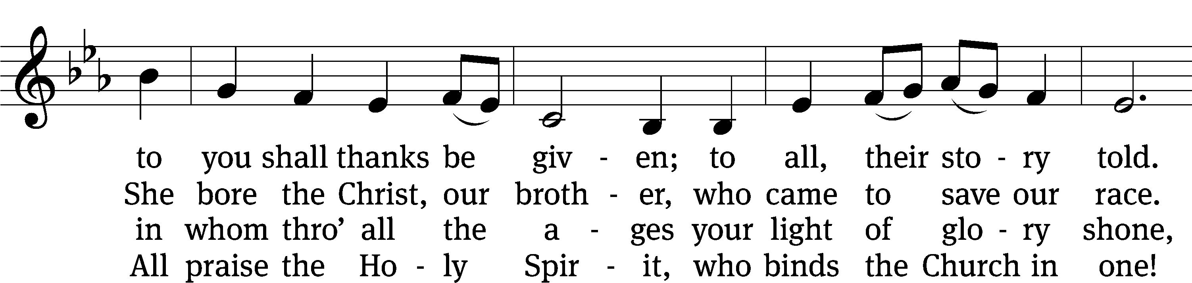
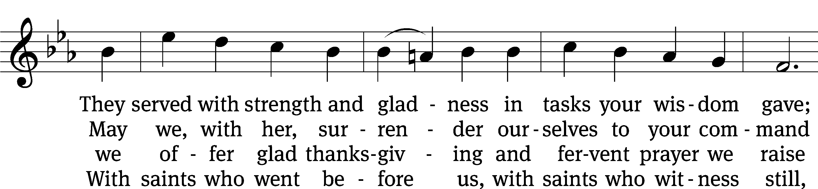
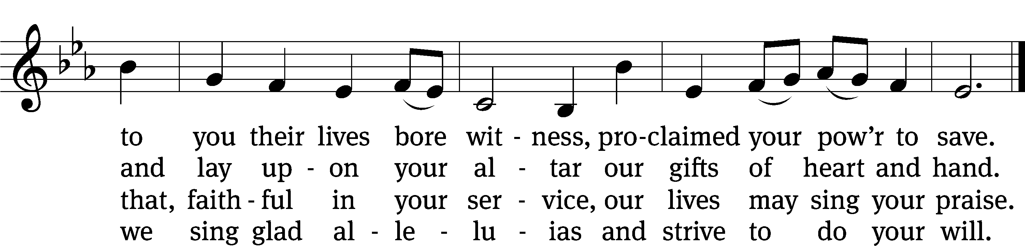
Text: Herman G. Stuempfle, Jr., 1923–2007, alt.
Tune: Finnish
Text: © 1993, 1997, 2003 GIA Publications, Inc. Used by permission: OneLicense no. 727703
Tune: Public domain

Please stand, if you are able
Prayer
Blessed Lord, you have given us your Holy Scriptures for our learning. May we so hear them, read, learn, and take them to heart that, being strengthened and comforted by your holy Word, we may cling to the blessed hope of everlasting life; through Jesus Christ our Lord, who lives and reigns with you and the Holy Spirit, one God, now and forever.
Amen.
Lord’s Prayer
Our Father, who art in heaven, hallowed be thy name, thy kingdom come, thy will be done on earth as it is in heaven. Give us this day our daily bread; and forgive us our trespasses, as we forgive those who trespass against us; and lead us not into temptation, but deliver us from evil. For thine is the kingdom and the power and the glory forever and ever. Amen.

Blessing
The Lord bless you and keep you.
The Lord make his face shine on you and be gracious to you.
The Lord look on you with favor and give you peace.
Amen.

Please be seated
331 From Heaven Above to Earth I Come CW 331 sts. 1–2, 13–15
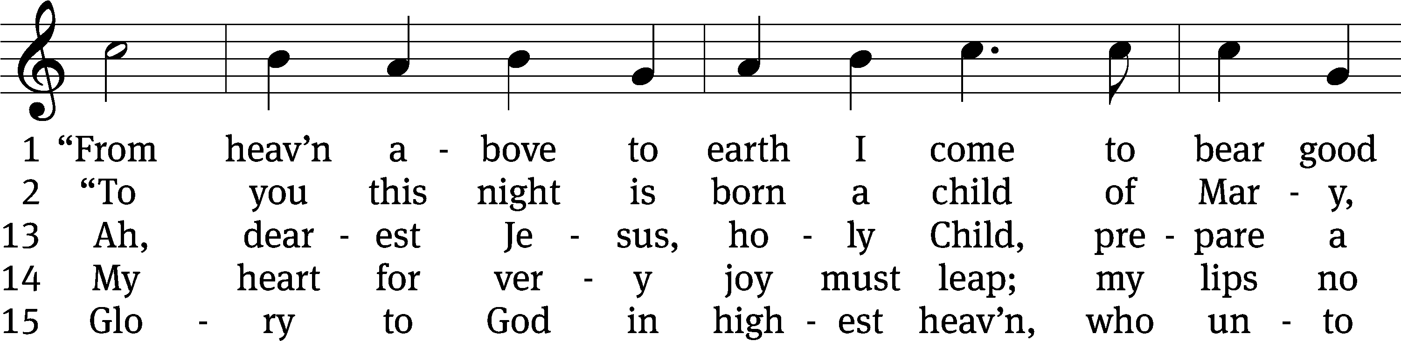
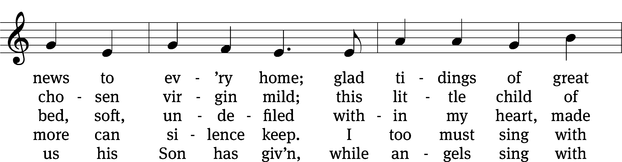
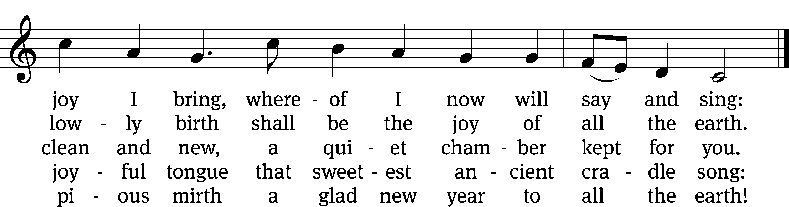
Text: tr. Catherine Winkworth, 1827–1878, alt.; Martin Luther, 1483–1546
Tune: Geistliche lieder, Leipzig, 1539, ed. Valten Schumann
Text and tune: Public domain

Acknowledgments
Setting One from Christian Worship
Software distributed in partnership with Northwestern Publishing House.
Created by Christian Worship: Service Builder © 2022 Concordia Publishing House.

Serving in Worship
Officiant Pastor William Natsis
Organist Sarah Hanke
Duet Cynthia Natsis and Jim Tice
Deacons (8:30) Duane Mason and Jim Tice
(11:00) Jeff Neuburger and Robert Niethammer
Ushers (8:30) Bob Newman and Henry Schneider
(11:00) Dave Boswell and Jake Vershum
Altar Guild Sharon Boswell
Videographer Cindy Dresch

