THE THIRD SUNDAY
IN ADVENT

TRINITY EVANGELICAL LUTHERAN CHURCH | Saline, Michigan
WELCOME TO WORSHIP December 17, 2023

Thank you for joining us in God’s house today! We cordially ask that our guests sign one of the guestbooks located at either the front or back entryways.

THANK OFFERING: Members of Trinity give their offering as an expression of love and thankfulness to the Lord and to help support the Lord’s work in our community and around the world. Visitors need not feel obligated to participate in this offering which supports our ministry.

Restrooms are located at the back of the upper level (the annex), and in the basement (down the back stairs of the sanctuary or annex). Handicap access is available, please ask an usher for assistance.

celebration of holy communion:
In His Word, God makes it clear that the Lord’s Supper is to be shared by people of a common proclamation of faith (1 Corinthians 11:26; 1 Corinthians 10:16-17). Without judging anyone’s hearts, we invite those who share in our confession by their membership in our congregation or another congregation of the Wisconsin Evangelical Lutheran Synod (WELS) or the Evangelical Lutheran Synod (ELS) and who are properly prepared (1 Corinthians 11;27-29) to receive the Sacrament. Page 295 in the front of Christian Worship provides a guide for preparation.

Guests, we would love to have you join us in communion fellowship in the future, and for that to be possible, we ask that you speak with one of the pastors so that we may speak with you on how that would be possible. We thank you for respecting the way we celebrate the Lord’s Supper in our congregations.

SERVICE OF WORD AND SACRAMENT

352 Joy Has Dawned CW 352
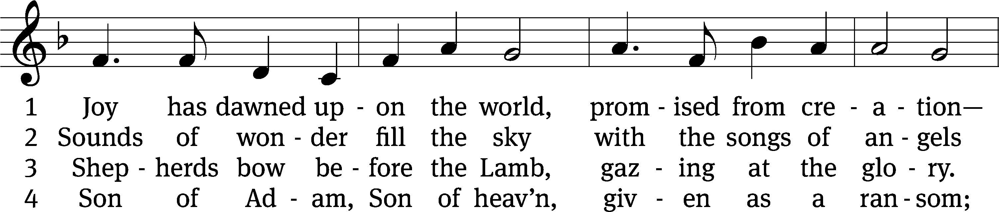
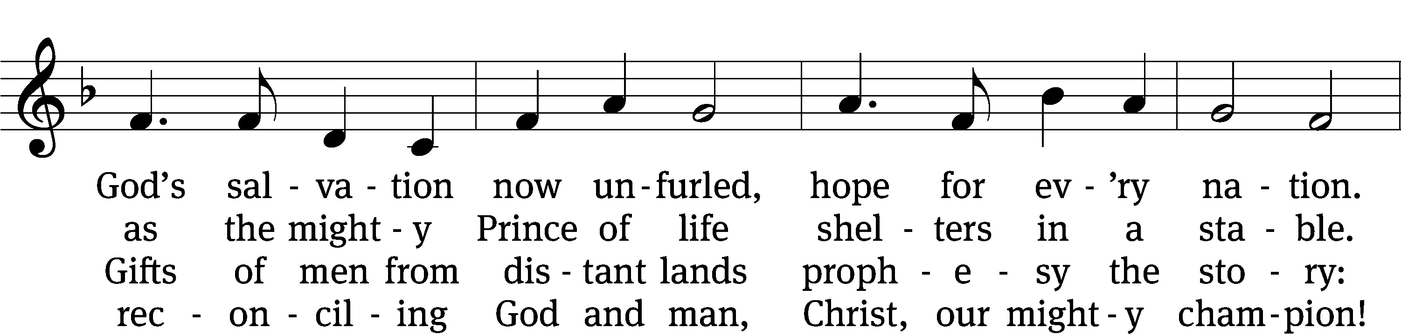
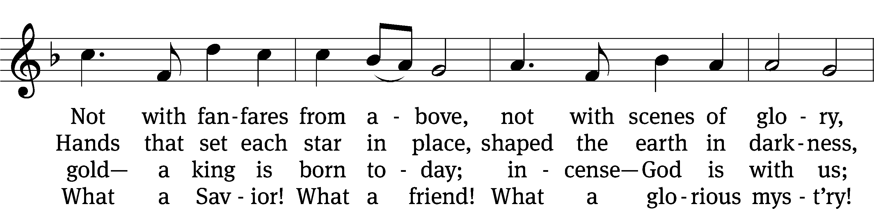
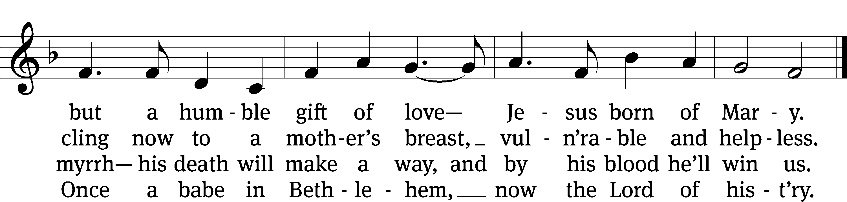
Text: Stuart Townend, b. 1963; Keith Getty, b. 1974
Tune: Stuart Townend, b. 1963; Keith Getty, b. 1974
Text and tune: © 2005 Thankyou Music, admin. CapitolCMGPublishing,com. Used by permission: OneLicense no. 727703

PLEASE STAND, IF YOU ARE ABLE

invocation

M: The grace of our Lord (+) Jesus Christ and the love of God and the fellowship of the Holy Spirit be with you.
C: And also with you.

CONFESSION OF SINS
M: God invites us to come into his presence and worship him with humble and penitent hearts. Therefore, let us acknowledge our sinfulness and ask him to forgive us.
C: Holy and merciful Father, I confess that I am by nature sinful, and that I have disobeyed you in my thoughts, words, and actions. I have done what is evil and failed to do what is good. For this I deserve your punishment both now and in eternity. But I am truly sorry for my sins, and trusting in my Savior Jesus Christ, I pray: Lord, have mercy on me, a sinner.
M: God, our heavenly Father, has been merciful to us and has given his only Son to be the atoning sacrifice for our sins. Therefore, as a called servant of Christ and by his authority, I forgive you all your sins in the name of the Father and of the Son (+) and of the Holy Spirit.
C: Amen.
PRAYER AND PRAISE
LORD, HAVE MERCY
Kyrie
M: For all that we need in life and for the wisdom to use all your gifts with gratitude and joy, hear our prayer, O Lord.

M: For the steadfast assurance that nothing can separate us from your love and for the courage to stand firm against the assaults of Satan and every evil, hear our prayer, O Christ.

M: For the well-being of your holy Church in all the world and for those who offer here their worship and praise, hear our prayer, O Lord.

M: Merciful God, maker and preserver of life, uphold us by your power and keep us in your tender care:

M: The works of the Lord are great and glorious; his name is worthy of praise.

Prayer of the day

M: Let us pray.

Hear our prayers, Lord Jesus Christ, and come with the good news of your mighty deliverance. Drive the darkness from our hearts, and fill us with your light; for you live and reign with the Father and the Holy Spirit, one God, now and forever.

PLEASE BE SEATED

The Word

first lesson Isaiah 61:1-3, 10-11

¹ The Spirit of the Lord God is upon me,
because the Lord has anointed me
to preach good news to the afflicted.
He sent me to bind up the brokenhearted,
to proclaim freedom for the captives
and release for those who are bound,
² to proclaim the year of the Lord’s favor
and the day of vengeance for our God,
to comfort all who mourn,
³ to provide for those who mourn in Zion,
to give them a crown of beauty instead of ashes,
the oil of joy instead of mourning,
a cloak of praise instead of a faint spirit,
so that they will be called oaks of righteousness,
a planting of the Lord to display his beauty.

¹⁰ I will rejoice greatly in the Lord.
My soul will celebrate because of my God,
for he has clothed me in garments of salvation.
With a robe of righteousness he covered me,
like a bridegroom who wears a beautiful headdress like a priest,
and like a bride who adorns herself with her jewelry.
¹¹ For as the earth produces its growth,
and as a garden causes what has been sown to sprout up,
so God the Lord will cause righteousness and praise to sprout up
in the presence of all the nations.

SENIOR CHOIR “Let All Mortal Flesh Keep Silence”

Let all mortal flesh keep silence, and with fear and trembling stand;

Ponder nothing earthly minded, for the blessing in his hand.

Christ our God to earth descendeth, our full homage born to demand.

King of kings, yet born of Mary, as of old on earth he stood,

Lord of lords, in human vesture, in the body and the blood,

He will give to all the faithful his own self for heavenly food.

Rank on rank the host of heaven spreads its vanguard on the way,

As the light descendeth from the realms of endless day,

That the powers of hell may vanish as the darkness clears away.

Let all mortal flesh keep silence.

second lesson 1 Thessalonians 5:16-24
¹⁶ Rejoice always. ¹⁷ Pray without ceasing. ¹⁸ In everything give thanks. For this is God’s will for you in Christ Jesus. ¹⁹ Do not extinguish the Spirit. ²⁰ Do not treat prophecies with contempt. ²¹ But test everything. Hold on to the good. ²² Keep away from every kind^{[b]} of evil.
²³ May the God of peace himself sanctify you completely, and may your whole spirit, soul, and body be kept blameless at the coming of our Lord Jesus Christ. ²⁴ The one who calls you is faithful, and he will do it.

PLEASE STAND, IF YOU ARE ABLE
VERSE OF THE DAY Matthew 11:10

Alleluia. I will send my messenger ahead of you, who will prepare your way before you. Alleluia.

GOSPEL John 1:6-8, 19-28
⁶ There was a man, sent from God, whose name was John. ⁷ He came as an eyewitness to testify about the light so that everyone would believe through him. ⁸ He was not the light, but he came to testify about the light.
¹⁹ This is the testimony John gave when the Jews from Jerusalem sent priests and Levites to ask him, “Who are you?”
²⁰ He confessed and did not deny. He confessed, “I am not the Christ.”
²¹ And they asked him, “Who are you then? Are you Elijah?”
He said, “I am not.”
“Are you the Prophet?”
“No,” he answered.
²² Then they asked him, “Who are you? Tell us so we can give an answer to those who sent us. What do you say about yourself?”
²³ He said, “I am the voice of one crying out in the wilderness, ‘Make straight the way of the Lord,’ just as Isaiah the prophet said.”
²⁴ They had been sent from the Pharisees. ²⁵ So they asked John, “Why then do you baptize, if you are not the Christ, or Elijah, or the Prophet?”
²⁶ “I baptize with water,” John answered. “Among you stands one you do not know. ²⁷ He is the one coming after me, whose sandal strap I am not worthy to untie.”
²⁸ These things happened in Bethany beyond the Jordan, where John was baptizing.
M: This is the Gospel of the Lord.

PLEASE BE SEATED
387 Arise, Your Light Is Come CW 387
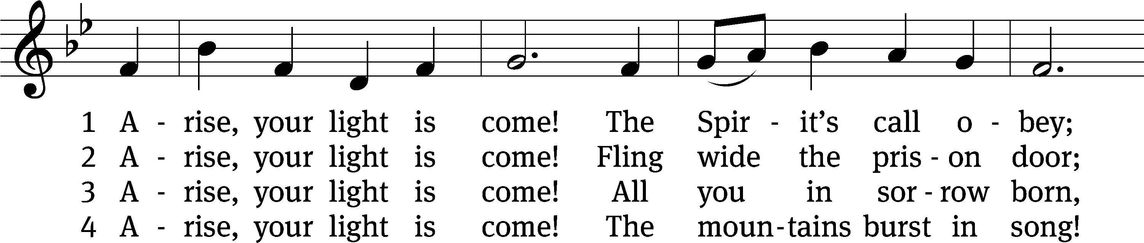
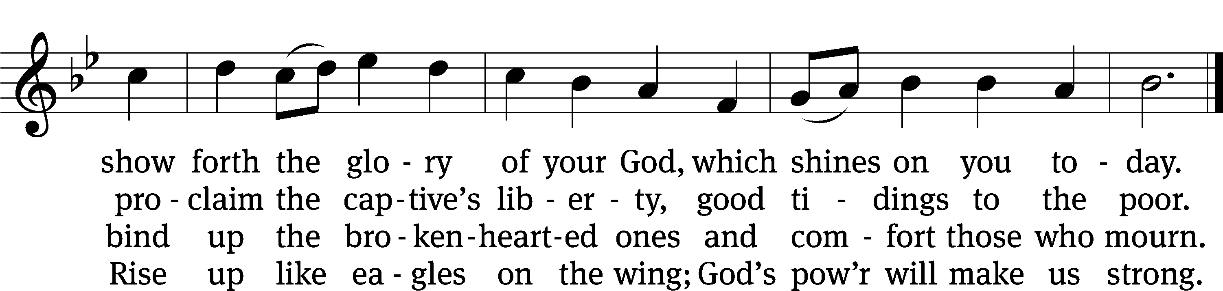
Text: Ruth Duck, b. 1947
Tune: William H. Walter, 1825–1893
Text: © 1992 GIA Publications, Inc. Used by permission: OneLicense no. 727703
Tune: Public domain

Sermon iSAIAH 61:1-3, 10-11

“JOY”

please stand, if you are able

nicene creed

We believe in one God, the Father, the Almighty, maker of heaven and earth, of all that is, seen and unseen.
We believe in one Lord, Jesus Christ, the only Son of God, eternally begotten of the Father, God from God, Light from Light, true God from true God, begotten, not made, of one being with the Father. Through him all things were made. For us and for our salvation, he came down from heaven, was incarnate of the Holy Spirit and the virgin Mary, and became truly human. For our sake he was crucified under Pontius Pilate. He suffered death and was buried. On the third day he rose again in accordance with the Scriptures. He ascended into heaven and is seated at the right hand of the Father. He will come again in glory to judge the living and the dead, and his kingdom will have no end.
We believe in the Holy Spirit, the Lord, the giver of life, who proceeds from the Father and the Son, who in unity with the Father and the Son is worshiped and glorified, who has spoken through the prophets. We believe in one holy Christian and apostolic Church. We acknowledge one baptism for the forgiveness of sins. We look for the resurrection of the dead and the life of the world to come. Amen.

prayer of the church

lord’s prayer

C: Our Father, who art in heaven,
hallowed be thy name,
thy kingdom come,
thy will be done
on earth as it is in heaven.
Give us this day our daily bread;
and forgive us our trespasses,
as we forgive those
who trespass against us;
and lead us not into temptation,
but deliver us from evil.
For thine is the kingdom
and the power and the glory
forever and ever. Amen.

The Sacrament of Holy Communion
Trinity Lutheran Church follows the historic Christian practice of close communion. We ask that only members of Trinity or one of our sister congregations partake of the sacrament. If you are not a member, please see the note about Holy Communion in the beginning of the Worship Folder.

M: The Lord be with you.

M: Lift up your hearts.

M: Let us give thanks to the Lord our God.

M: Praise to the God and Father of our Lord Jesus Christ! In love he has blessed us with every spiritual blessing. He sends the Holy Spirit to testify that we are his children and to strengthen us when we are weak. Now have come the salvation and the power and the kingdom of our God and the authority of his Christ. To him who sits on the throne and to the Lamb be praise and thanks and honor and glory for ever and ever:

Holy, Holy, Holy

Words of institution
M: Our Lord Jesus Christ, on the night he was betrayed, took bread; and when he had given thanks, he broke it and gave it to his disciples, saying: “Take and eat. This is my ✙ body, which is given for you. Do this in remembrance of me.”
Then he took the cup, gave thanks, and gave it to them, saying, “Drink from it all of you; this is my ✙ blood of the new covenant, which is poured out for you for the forgiveness of sins. Do this, whenever you drink it, in remembrance of me.”
M: The peace of the Lord be with you always.

O CHRIST, LAMB OF GOD

663 Soul, Adorn Yourself with Gladness CW 663
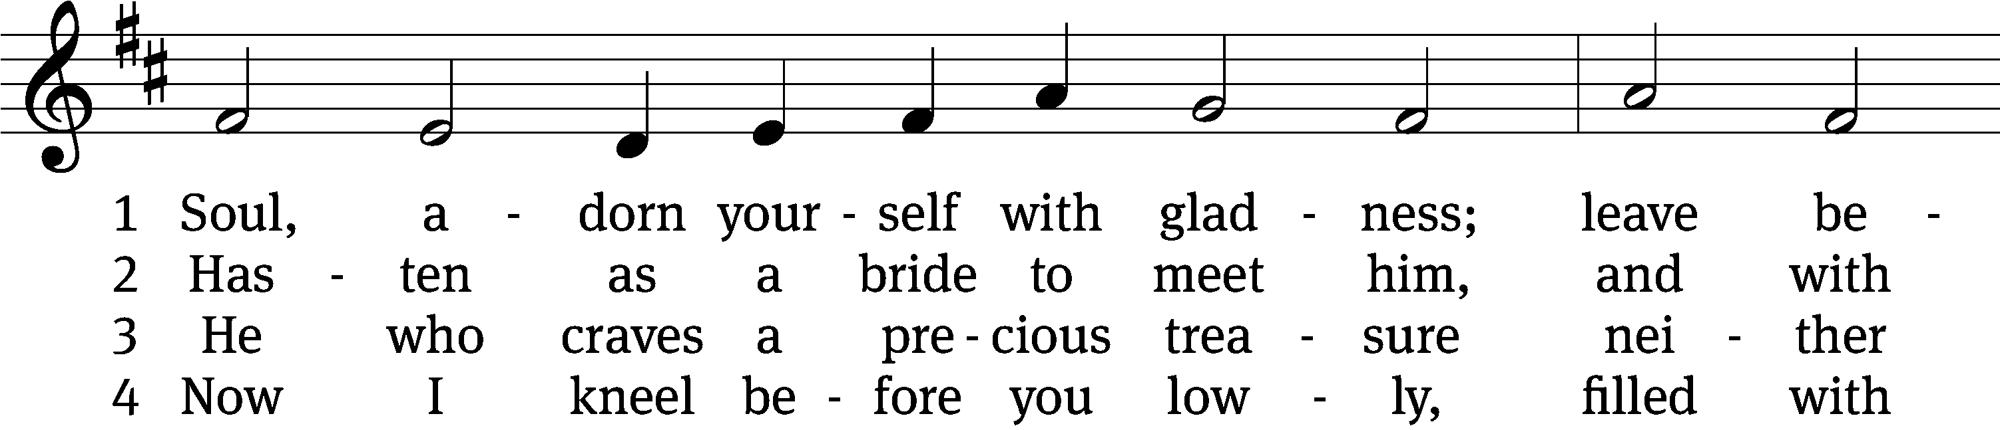
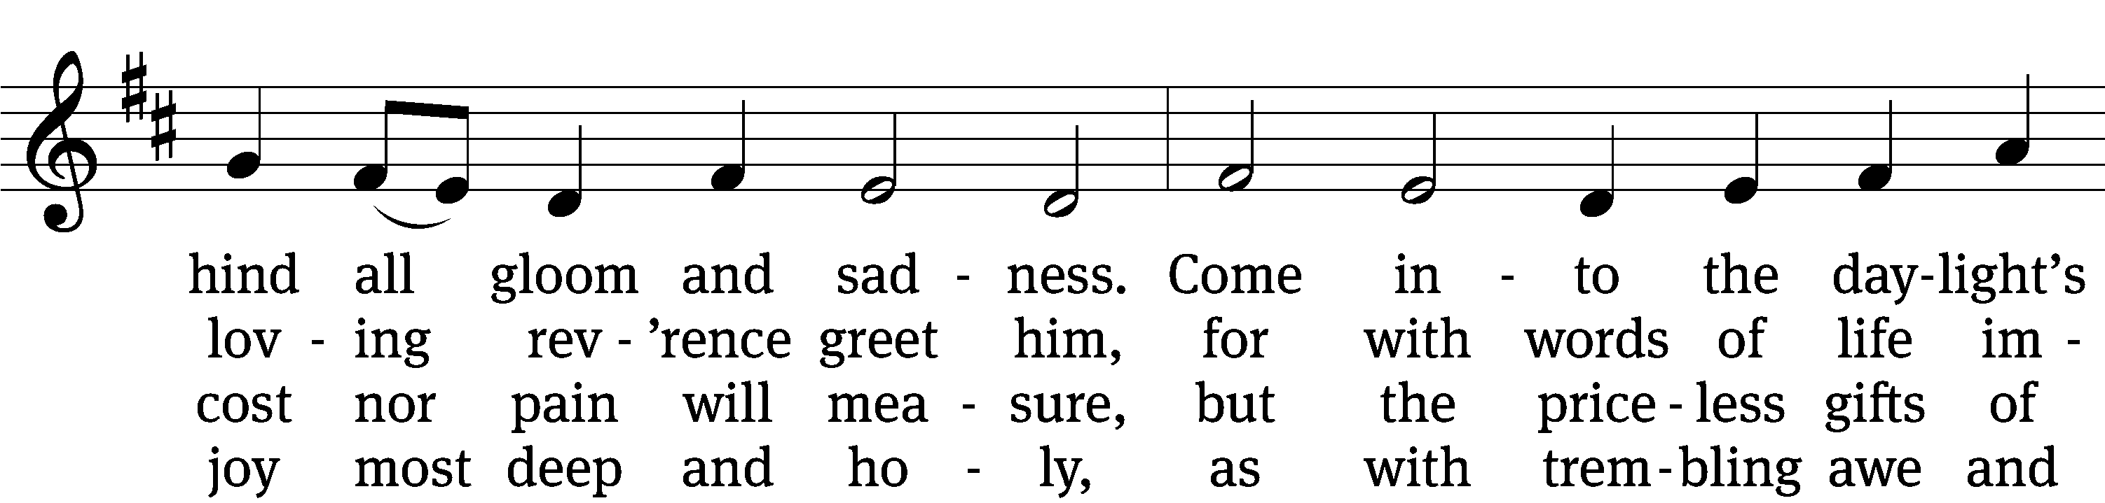
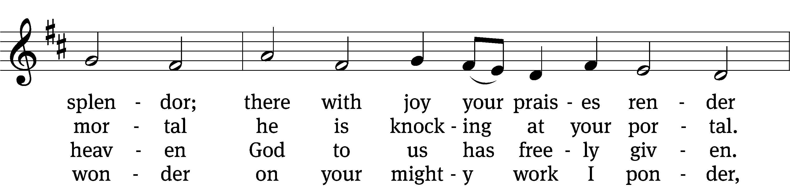
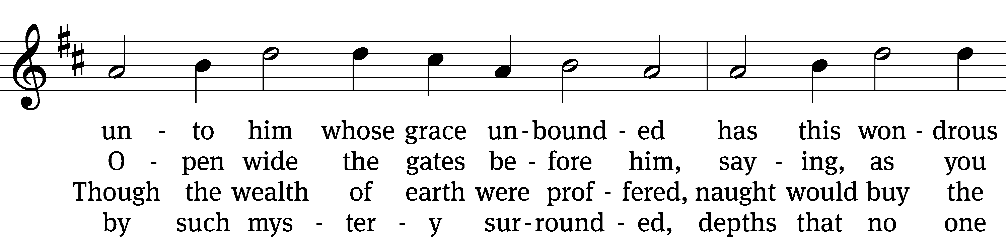
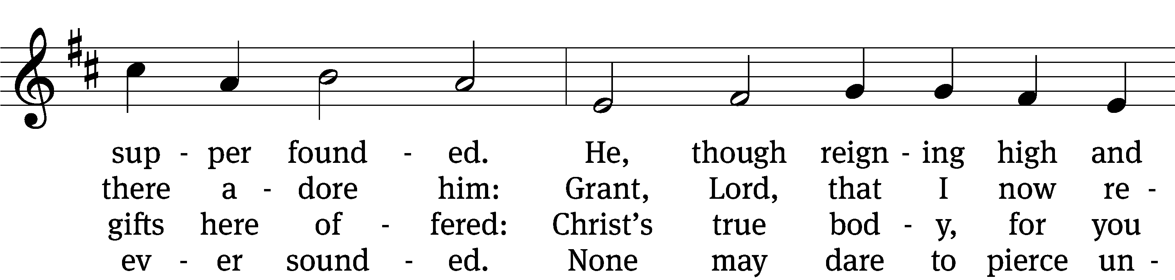
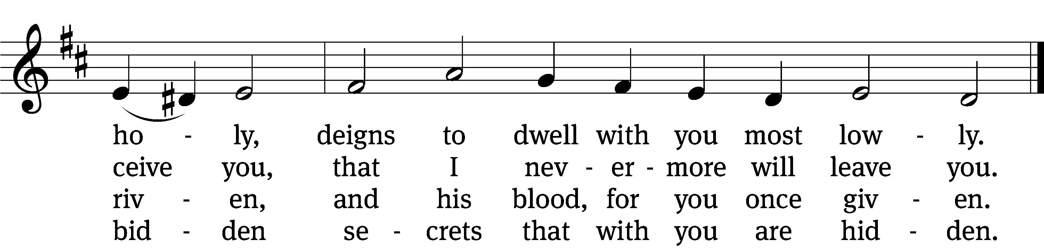

5 Human reason, though it ponders,
cannot fathom these great wonders,
that Christ’s body must be boundless
since the souls it feeds are countless,
and that he his blood is giving
with the wine we are receiving.
These great mysteries unsounded
are by God alone expounded.

6 Lord, by love and mercy driven,
you have left your throne in heaven
on the cross for me to languish
and to die in bitter anguish,
to forgo all joy and gladness
and to shed your blood in sadness.
By this blood redeemed and living,
Lord, I praise you with thanksgiving.

7 Jesus, sun of life, my splendor,
Jesus, friend of friends most tender,
Jesus, joy of my desiring,
fount of life, my soul inspiring:
at your feet I cry, my maker,
let me be a fit partaker
of this blessèd food from heaven
for our good, your glory, given.

8 Jesus, Lord of life in heaven,
help me when this meal is given
to receive it for my blessing
as I come, my sins confessing.
In this supper let me measure,
Lord, how deep is your love’s treasure,
that, as I on earth have eaten,
I may be your guest in heaven.
Text: Johann Franck, 1618–1677, abr.; (sts. 1–2, 4, 7): tr. Catherine Winkworth, 1827–1878, alt.; (sts. 3, 5–6): tr. The Lutheran Hymnal, 1941, alt.; (st. 8): tr. Peter M. Prange, b. 1972
Tune: Johann Crüger, 1598–1662
Text (st. 8): © 2021 Peter M. Prange, admin. Northwestern Publishing House. Used by permission: OneLicense no. 727703
Text (sts. 1–7) and tune: Public domain

PLEASE STAND, IF YOU ARE ABLE

M: Hear the prayer of your people, O Lord, that the lips which have praised you here may glorify you in the world, that the eyes which have seen the coming of your Son may long for his coming again, and that all who have received in his true body and blood the pledge of your forgiveness may be restored to live a new and holy life, through Jesus Christ, our Lord, who lives and reigns with you and the Holy Spirit, one God, now and forever.

M: Brothers and sisters, go in peace. Live in harmony with one another.
Serve the Lord with gladness.
The Lord bless you and keep you.
The Lord make his face shine on you and be gracious to you.
The Lord look on you with favor and (+) give you peace.

PLEASE BE SEATED

517 Praise the One Who Breaks the Darkness CW 517
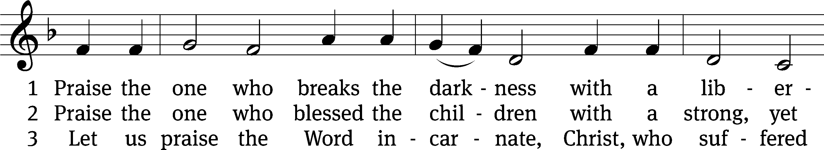
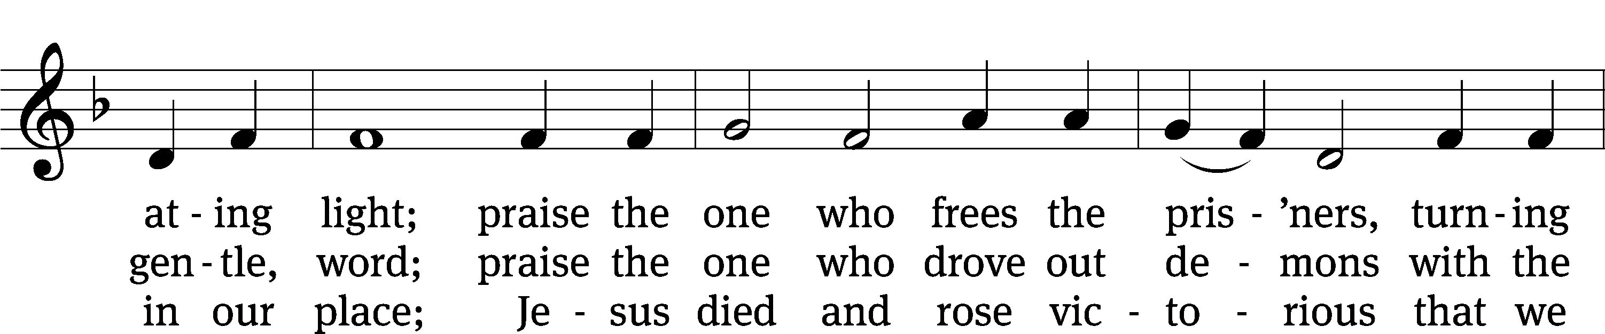
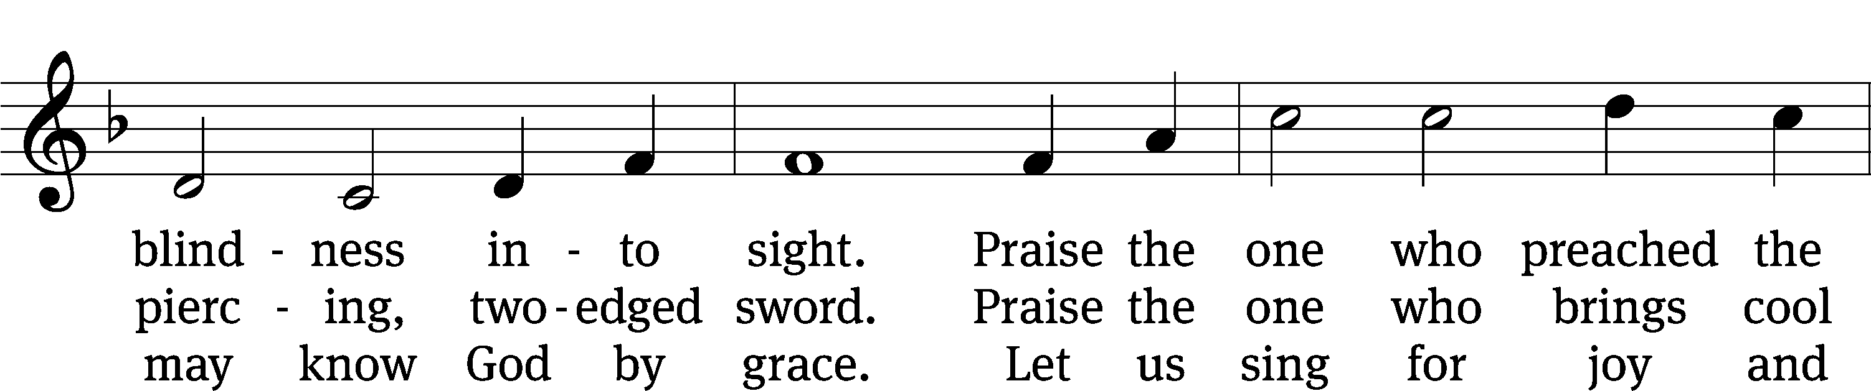
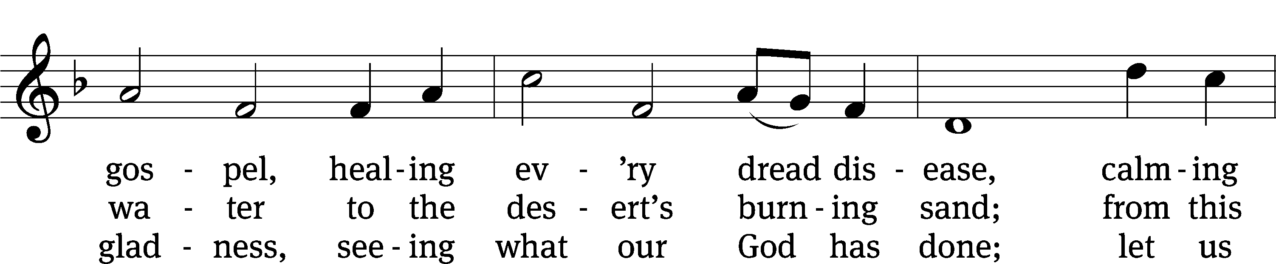
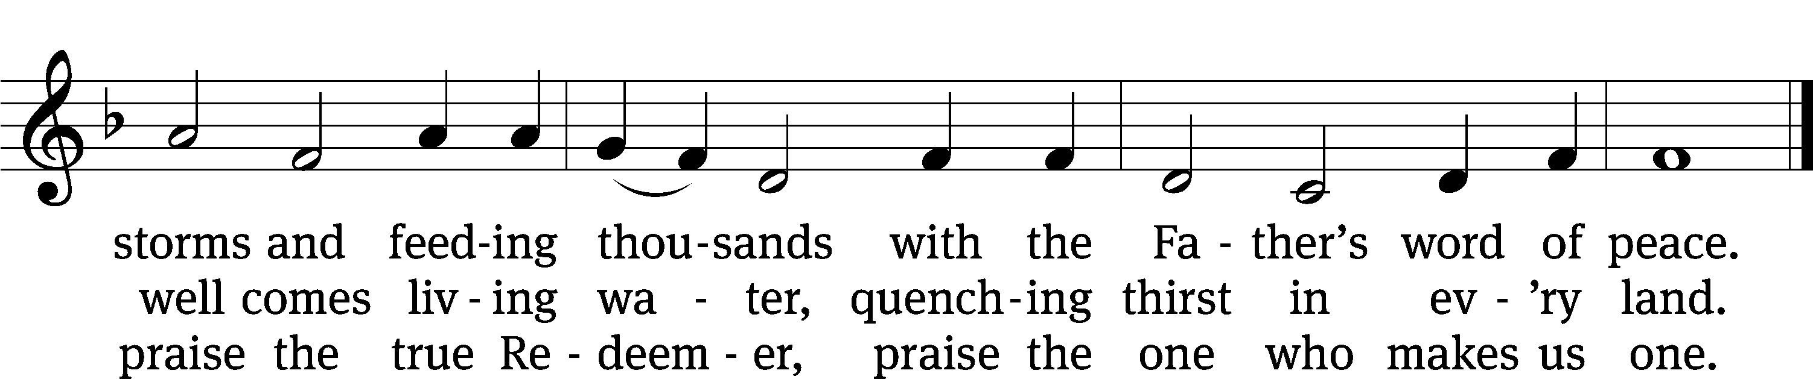
Text: Rusty Edwards, b. 1955, alt.
Tune: The Sacred Harp, Philadelphia, 1844
Text: © 1987 Hope Publishing Co. Used by permission: OneLicense no. 727703
Tune: Public domain

Serving In Worship

Officiant Pastor Pappenfuss
Organist Sarah Hanke
Choir Director Cynthia Natsis
Accompanist Laura Sala
Deacons (8:30) Duane Mason and Jim Tice
(11:00) Jeff Neuburger and Robert Niethammer
Ushers (8:30) Bob Newman and Henry Schneider
(11:00) Dave Boswell and Jake Vershum
Altar Guild Sharon Boswell
Videographer Cindy Dresch

Copyright information
Service of Word and Sacrament: Christian Worship. © 1993 Northwestern Publishing House. All rights reserved. Reprinted under ONE LICENSE #A-727703 and CCLI #1151741/ CSPL126093
Words and Music: All rights reserved. Reprinted/Podcast/Streamed with permission under ONE LICENSE #A-727703 and CCLI #1151741/CSPL126093

