THE TWENTY-FIFTH SUNDAY
AFTER PENTECOST

TRINITY EVANGELICAL LUTHERAN CHURCH | Saline, Michigan
WELCOME TO WORSHIP November 19, 2023

Thank you for joining us in God’s house today! We cordially ask that our guests sign one of the guestbooks located at either the front or back entryways.

THANK OFFERING: Members of Trinity give their offering as an expression of love and thankfulness to the Lord and to help support the Lord’s work in our community and around the world. Visitors need not feel obligated to participate in this offering which supports our ministry.

Restrooms are located at the back of the upper level (the annex), and in the basement (down the back stairs of the sanctuary or annex). Handicap access is available, please ask an usher for assistance.

celebration of holy communion:
In His Word, God makes it clear that the Lord’s Supper is to be shared by people of a common proclamation of faith (1 Corinthians 11:26; 1 Corinthians 10:16-17). Without judging anyone’s hearts, we invite those who share in our confession by their membership in our congregation or another congregation of the Wisconsin Evangelical Lutheran Synod (WELS) or the Evangelical Lutheran Synod (ELS) and who are properly prepared (1 Corinthians 11;27-29) to receive the Sacrament. Page 295 in the front of Christian Worship provides a guide for preparation.

Guests, we would love to have you join us in communion fellowship in the future, and for that to be possible, we ask that you speak with one of the pastors so that we may speak with you on how that would be possible. We thank you for respecting the way we celebrate the Lord’s Supper in our congregations.

SERVICE OF WORD AND SACRAMENT

PRESERVICE CLARINET music

sunday school “I Love to Tell the Story”
739 Forth in Your Name, O Lord, I Go CW 739
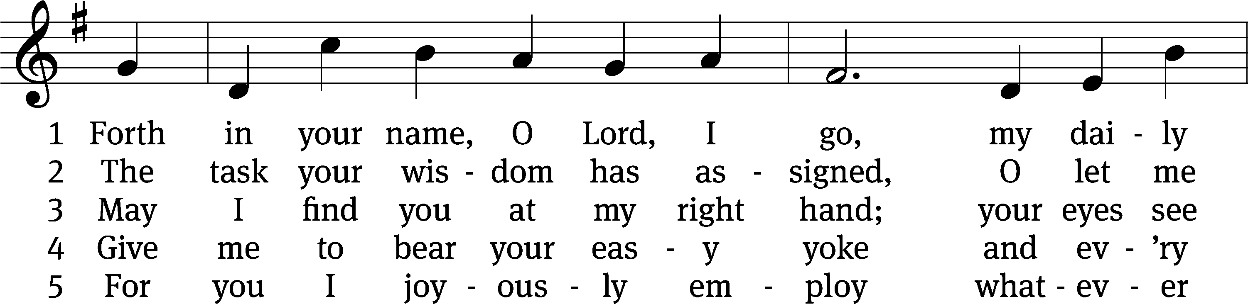
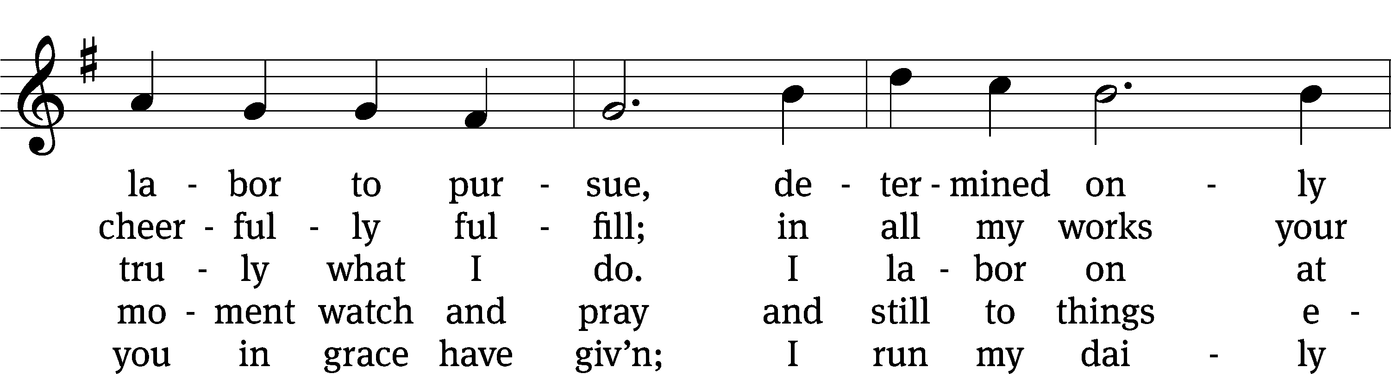
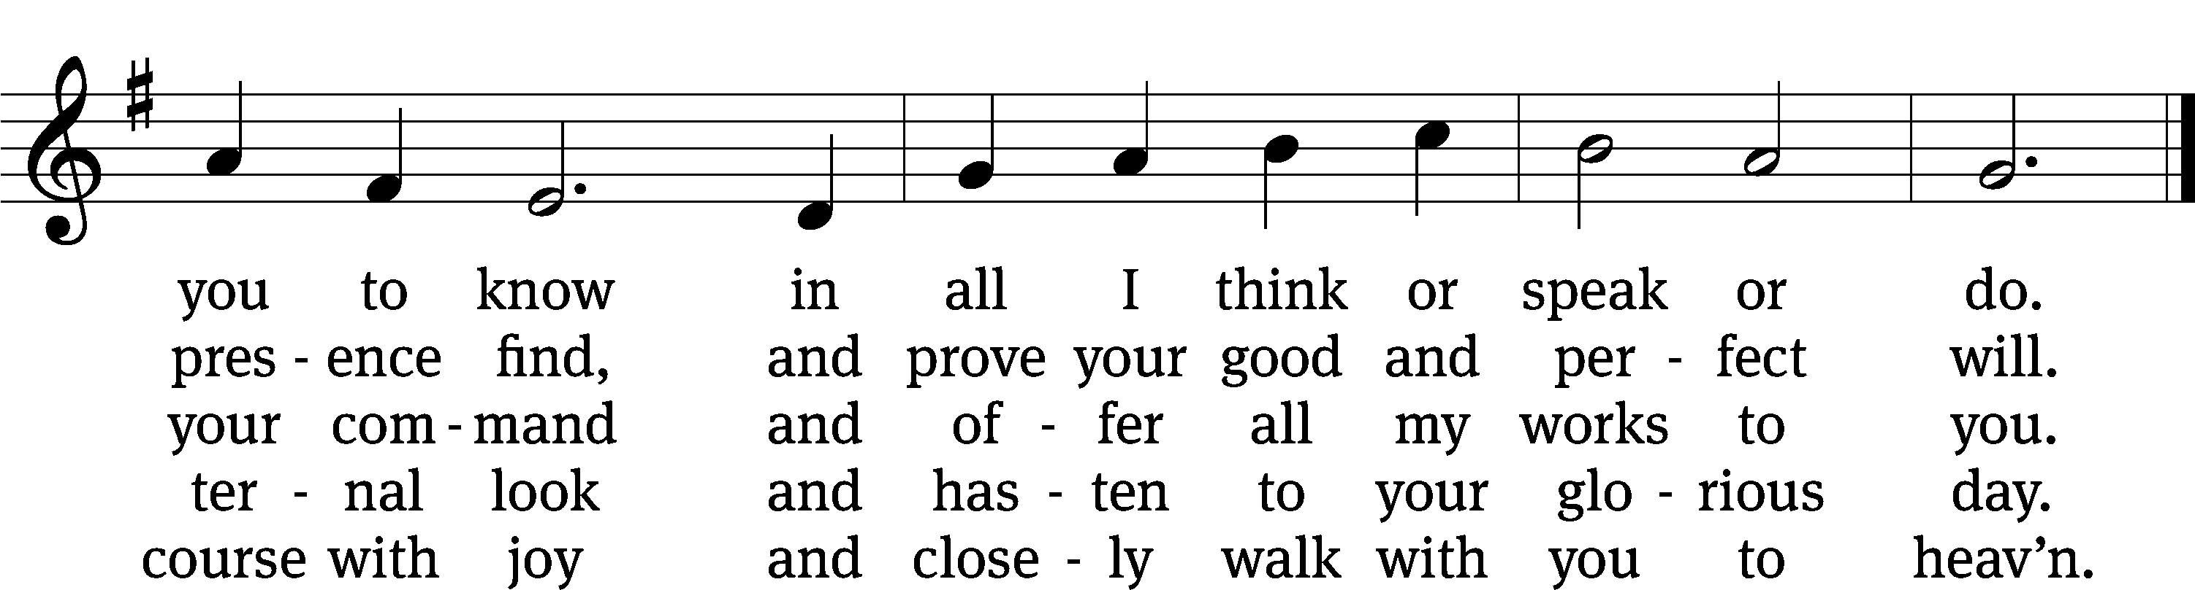
Text: Charles Wesley, 1707–1788, abr., alt.
Tune: Barry L. Bobb, b. 1951
Text: Public domain
Tune: © 1981, 1982 Barry L. Bobb. Used by permission: OneLicense no. 727703

PLEASE STAND, IF YOU ARE ABLE

invocation

M: The grace of our Lord (+) Jesus Christ and the love of God and the fellowship of the Holy Spirit be with you.
C: And also with you.

CONFESSION OF SINS
M: God invites us to come into his presence and worship him with humble and penitent hearts. Therefore, let us acknowledge our sinfulness and ask him to forgive us.
C: Holy and merciful Father, I confess that I am by nature sinful, and that I have disobeyed you in my thoughts, words, and actions. I have done what is evil and failed to do what is good. For this I deserve your punishment both now and in eternity. But I am truly sorry for my sins, and trusting in my Savior Jesus Christ, I pray: Lord, have mercy on me, a sinner.
M: God, our heavenly Father, has been merciful to us and has given his only Son to be the atoning sacrifice for our sins. Therefore, as a called servant of Christ and by his authority, I forgive you all your sins in the name of the Father and of the Son (+) and of the Holy Spirit.
C: Amen.
PRAYER AND PRAISE
LORD, HAVE MERCY
Kyrie
M: For all that we need in life and for the wisdom to use all your gifts with gratitude and joy, hear our prayer, O Lord.

M: For the steadfast assurance that nothing can separate us from your love and for the courage to stand firm against the assaults of Satan and every evil, hear our prayer, O Christ.

M: For the well-being of your holy Church in all the world and for those who offer here their worship and praise, hear our prayer, O Lord.

M: Merciful God, maker and preserver of life, uphold us by your power and keep us in your tender care:

M: The works of the Lord are great and glorious; his name is worthy of praise.

Prayer of the day

M: Let us pray.

Lord God Almighty, so rule and govern our hearts and minds by your Holy Spirit that we may always look forward to the end of this present evil age and the day of your righteous judgment. Keep us steadfast in true and living faith, and present us at last holy and blameless before you; through your Son, Jesus Christ our Lord, who lives and reigns with you and the Holy Spirit, one God, now and forever.

PLEASE BE SEATED

The Word

first lesson Isaiah 1:10-18

¹⁰ Hear the word of the Lord, you rulers of Sodom!
Listen to the law of our God, you people of Gomorrah!
¹¹ What do your many sacrifices mean to me? says the Lord.
I have more than enough rams as burnt offerings
and enough fat from well-fed animals.
I am not pleased with the blood of bulls
or the blood of lambs and male goats.
¹² When you come to appear before me,
who has asked for this from your hands:
this trampling on my courts?
¹³ Stop bringing worthless offerings!
Your incense is an abomination to me.
I cannot stand your sinful assemblies
on the new moons, Sabbaths, and holy days.
¹⁴ Deep in my soul I hate your new moons and your appointed feasts.
They have become a burden to me.
I am tired of putting up with them.
¹⁵ When you spread out your hands, I will hide my eyes from you.
Indeed, even though you make many prayers, I will not hear.
Your hands are full of blood.
¹⁶ Wash yourselves. Purify yourselves.
Remove your evil deeds from my sight.
Stop doing evil. ¹⁷ Learn to do good.
Seek justice. Relieve the oppressed.
Seek justice for the fatherless. Plead for the widow.
¹⁸ Come now, and let us reason together, says the Lord.
Though your sins are like scarlet, they will be as white as snow.
Though they are as red as crimson, they will be like wool.

128C Blest Are Those Who Love You Psalm 128C
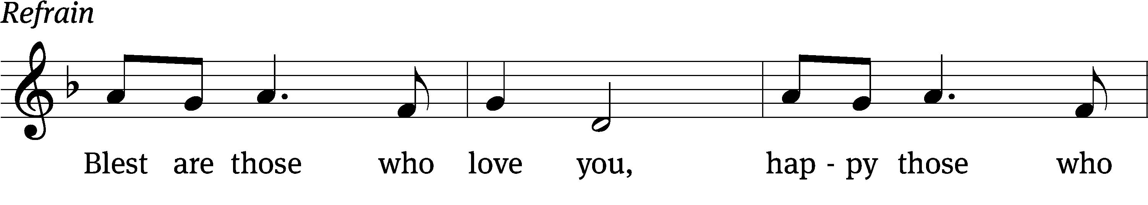
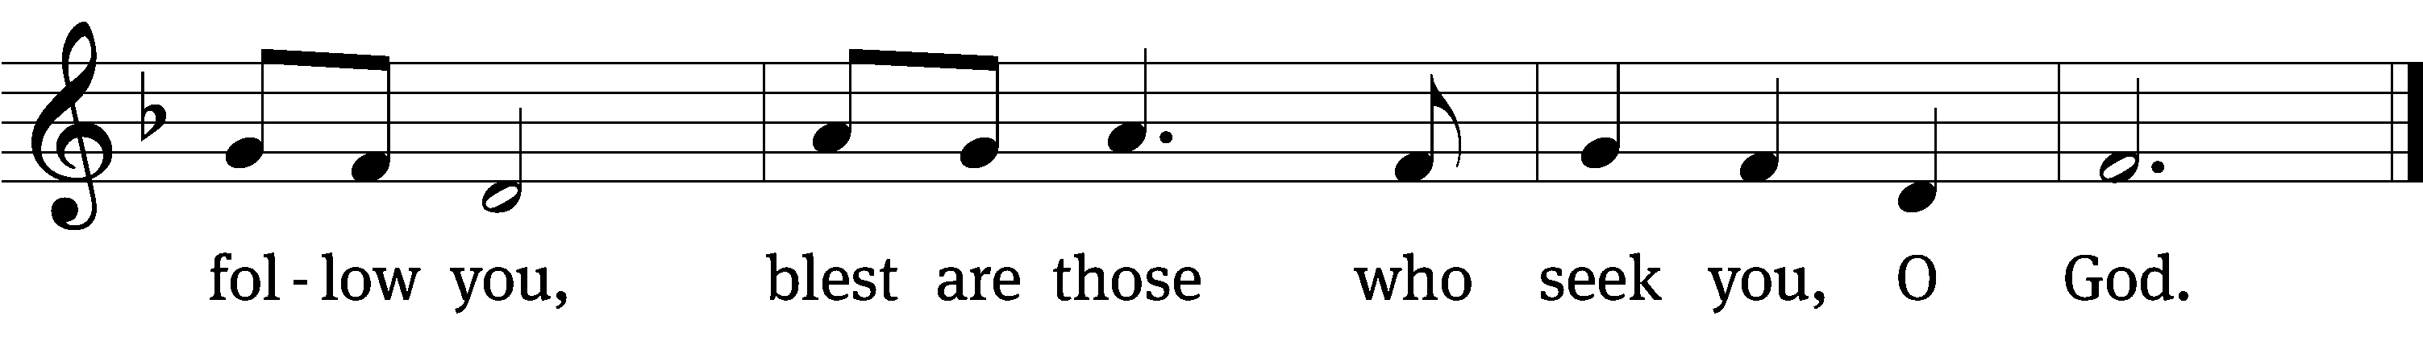

Blessed are all who / fear the Lord,
who walk in obedi- / ence to him.
You will eat the fruit of your / labor;
blessings and prosperity / will be yours.
Your wife will be like a fruitful vine with- / in your house;
your children will be like olive shoots around your / table. Refrain

Yes, this will be the / blessing
for the man who / fears the Lord.
May the Lord bless you from / Zion;
may you see the prosperity of Jerusalem all the days / of your life.
May you live to see your children’s / children—
peace be on / Israel.
Glory be to the Father and / to the Son
and to the Holy / Spirit,
as it was in the be- / ginning,
is now, and will be forever. / Amen. Refrain
Text: Marty Haugen
Tune: Marty Haugen
Text and tune: © 1987 GIA Publications, Inc. (refrain). Used by permission: OneLicense no. 727703
Setting: © 2011 Faith Alive Christian Resources. Used by permission: License no. 130003540

second lesson Romans 12:1-8
¹ Therefore I urge you, brothers, by the mercies of God, to offer your bodies as a living sacrifice—holy and pleasing to God—which is your appropriate worship. ² Also, do not continue to conform to the pattern of this world, but be transformed by the renewal of your mind, so that you test and approve what is the will of God—what is good, pleasing, and perfect.
³ So by the grace given to me, I tell everyone among you not to think of yourself more highly than you ought, but think in a way that results in sound judgment, as God distributed a measure of faith to each of you. ⁴ For we have many members in one body, and not all the members have the same function. ⁵ In the same way, though we are many, we are one body in Christ, and individually members of one another.
⁶ We have different gifts, according to the grace God has given us. If the gift is prophecy, do it in complete agreement with the faith. ⁷ If it is serving, then serve. If it is teaching, then teach. ⁸ If it is encouraging, then encourage. If it is contributing, be generous. If it is leadership, be diligent. If it is showing mercy, do it cheerfully.

PLEASE STAND, IF YOU ARE ABLE

VERSE OF THE DAY Revelation 2:10

Alleluia. Be faithful, even to the point of death, and I will give you the crown of life. Alleluia.

GOSPEL Matthew 25:14-30
¹⁴ “You see, the kingdom of heaven is like a man going on a journey. He called his servants and entrusted his possessions to them. ¹⁵ To one he gave five talents, to another two talents, and to still another one talent, each according to his own ability. Then he went on his journey. ¹⁶ The servant who had received the five talents immediately put them to work and gained five more talents. ¹⁷ In the same way, the servant who had received the two talents gained two more. ¹⁸ But the servant who had received one talent went away, dug a hole in the ground, and hid his master’s money.
¹⁹ “After a long time the master of those servants came and settled accounts with them. ²⁰ The servant who received the five talents came and brought five more talents. He said, ‘Master, you entrusted five talents to me. See, I have gained five more talents.’
²¹ “His master said to him, ‘Well done, good and faithful servant! You were faithful with a few things. I will put you in charge of many things. Enter into the joy of your master.’
²² “The servant who received the two talents came and said, ‘Master, you entrusted me with two talents. See, I have gained two more talents.’
²³ “His master said to him, ‘Well done, good and faithful servant! You were faithful with a few things. I will put you in charge of many things. Enter into the joy of your master.’
²⁴ “Then the servant who received one talent came and said, ‘Master, I knew that you are a hard man, reaping where you did not plant and gathering where you did not scatter seed. ²⁵ Since I was afraid, I went away and hid your talent in the ground. See, you have what is yours.’
²⁶ “His master answered him, ‘You wicked and lazy servant! You knew that I reap where I did not plant and gather where I did not scatter seed? ²⁷ Well then, you should have deposited my money with the bankers so that when I came I would get my money back with interest. ²⁸ Take the talent away from him and give it to the servant who has the ten talents. ²⁹ Because everyone who has will be given more, and he will have an abundance. But the one who does not have, even what he has will be taken away from him. ³⁰ Throw that worthless servant into the outer darkness, where there will be weeping and gnashing of teeth.’

M: This is the Gospel of the Lord.

PLEASE BE SEATED

751 O God, Your Hand the Heavens Made CW 751
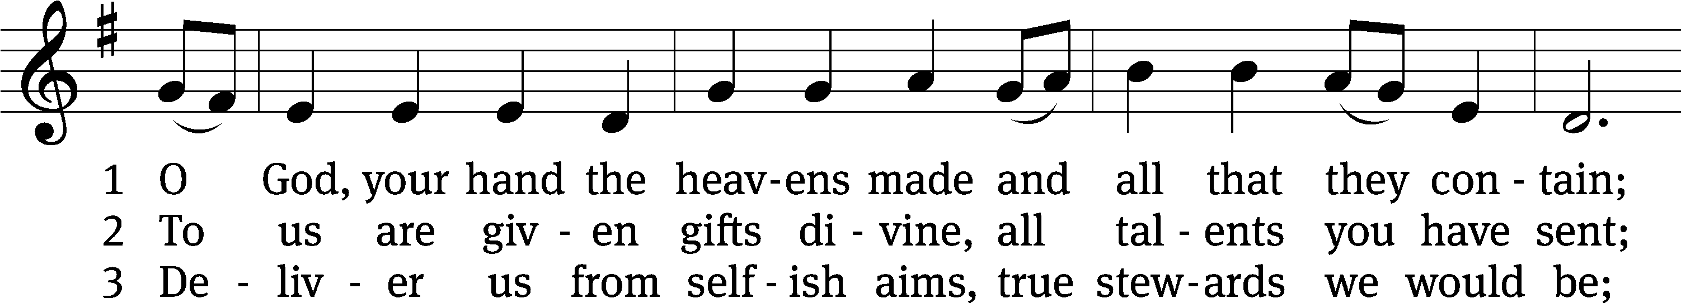
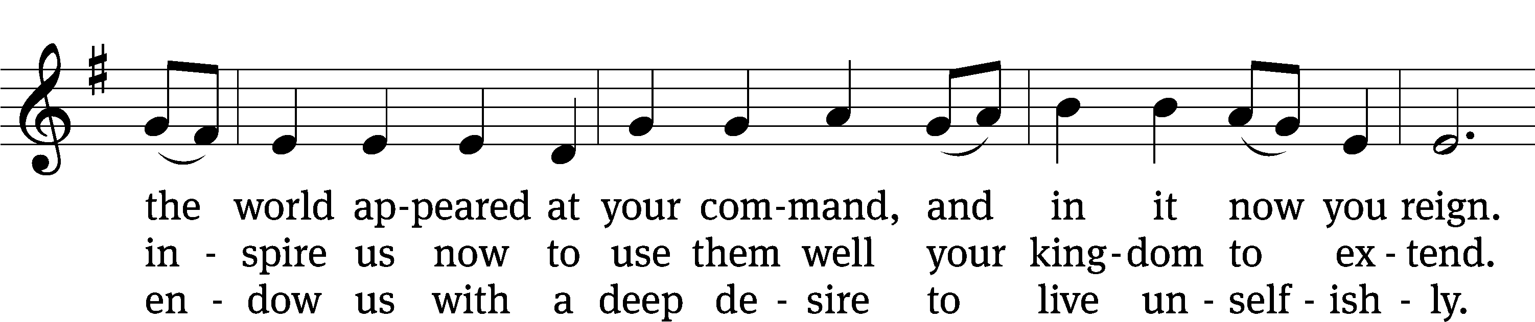
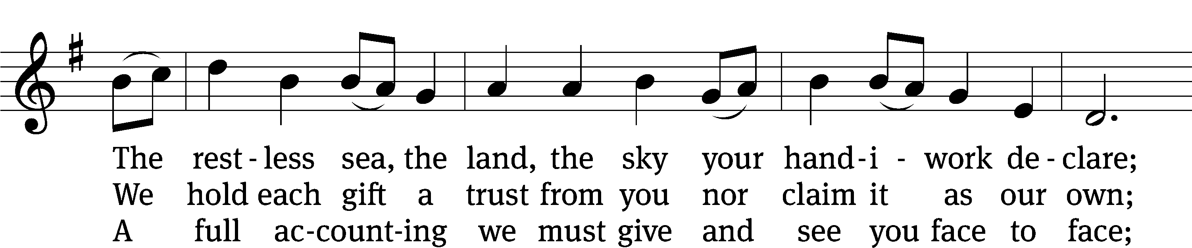
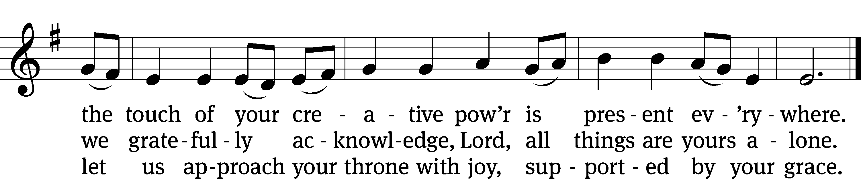
Text: Frank L. Cross, 1904–2001
Tune: English; adapt. Ralph Vaughan Williams, 1872-1958, alt.
Text: © 1961, ren 1989 The Hymn Society, admin. Hope Publishing Co. Used by permission: OneLicense no. 727703
Tune: Public domain

Sermon Matthew 25:14-30

“Put It to Work”

please stand, if you are able

nicene creed

We believe in one God, the Father, the Almighty, maker of heaven and earth, of all that is, seen and unseen.
We believe in one Lord, Jesus Christ, the only Son of God, eternally begotten of the Father, God from God, Light from Light, true God from true God, begotten, not made, of one being with the Father. Through him all things were made. For us and for our salvation, he came down from heaven, was incarnate of the Holy Spirit and the virgin Mary, and became truly human. For our sake he was crucified under Pontius Pilate. He suffered death and was buried. On the third day he rose again in accordance with the Scriptures. He ascended into heaven and is seated at the right hand of the Father. He will come again in glory to judge the living and the dead, and his kingdom will have no end.
We believe in the Holy Spirit, the Lord, the giver of life, who proceeds from the Father and the Son, who in unity with the Father and the Son is worshiped and glorified, who has spoken through the prophets. We believe in one holy Christian and apostolic Church. We acknowledge one baptism for the forgiveness of sins. We look for the resurrection of the dead and the life of the world to come. Amen.

HANDBELL DUET

prayer of the church

lord’s prayer

C: Our Father, who art in heaven,
hallowed be thy name,
thy kingdom come,
thy will be done
on earth as it is in heaven.
Give us this day our daily bread;
and forgive us our trespasses,
as we forgive those
who trespass against us;
and lead us not into temptation,
but deliver us from evil.
For thine is the kingdom
and the power and the glory
forever and ever. Amen.
The Sacrament of Holy Communion
Trinity Lutheran Church follows the historic Christian practice of close communion. We ask that only members of Trinity or one of our sister congregations partake of the sacrament. If you are not a member, please see the note about Holy Communion in the beginning of the Worship Folder.

M: The Lord be with you.

M: Lift up your hearts.

M: Let us give thanks to the Lord our God.

M: Praise to the God and Father of our Lord Jesus Christ! In love he has blessed us with every spiritual blessing. He sends the Holy Spirit to testify that we are his children and to strengthen us when we are weak. Now have come the salvation and the power and the kingdom of our God and the authority of his Christ. To him who sits on the throne and to the Lamb be praise and thanks and honor and glory for ever and ever:

Holy, Holy, Holy

Words of institution
M: Our Lord Jesus Christ, on the night he was betrayed, took bread; and when he had given thanks, he broke it and gave it to his disciples, saying: “Take and eat. This is my ✙ body, which is given for you. Do this in remembrance of me.”
Then he took the cup, gave thanks, and gave it to them, saying, “Drink from it all of you; this is my ✙ blood of the new covenant, which is poured out for you for the forgiveness of sins. Do this, whenever you drink it, in remembrance of me.”
M: The peace of the Lord be with you always.

O CHRIST, LAMB OF GOD

PLEASE BE SEATED

735 Before You I Kneel CW 735
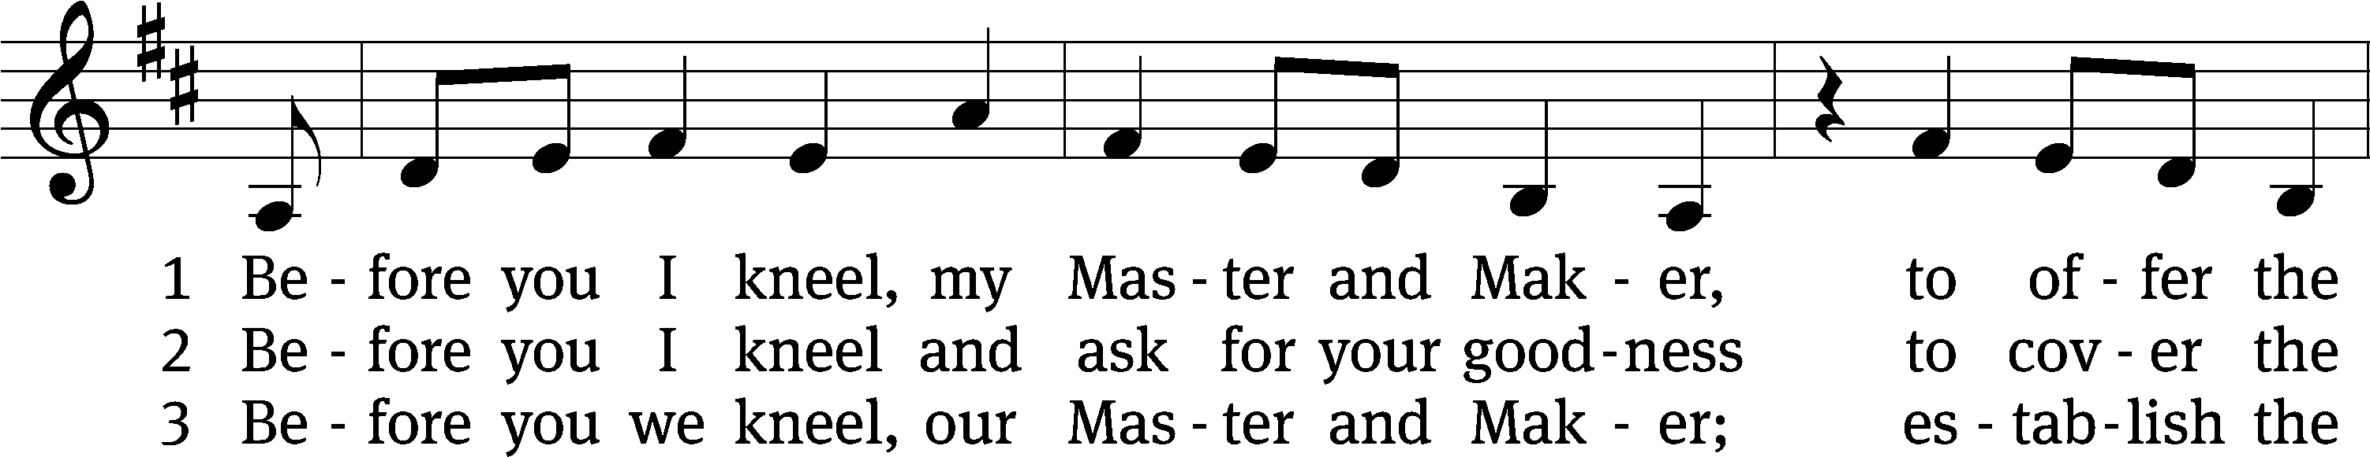
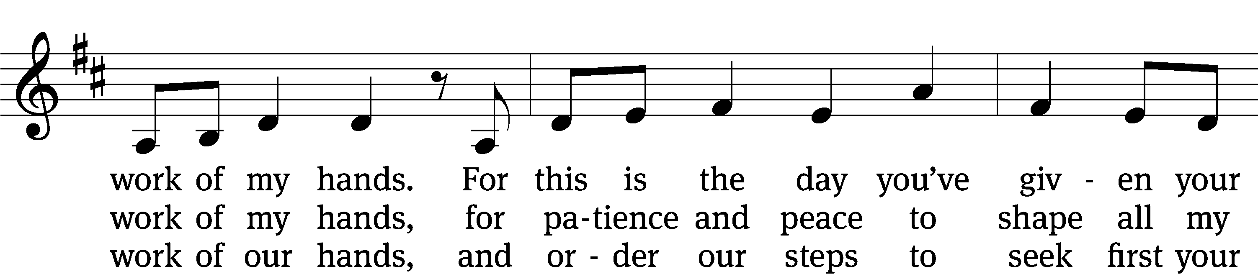
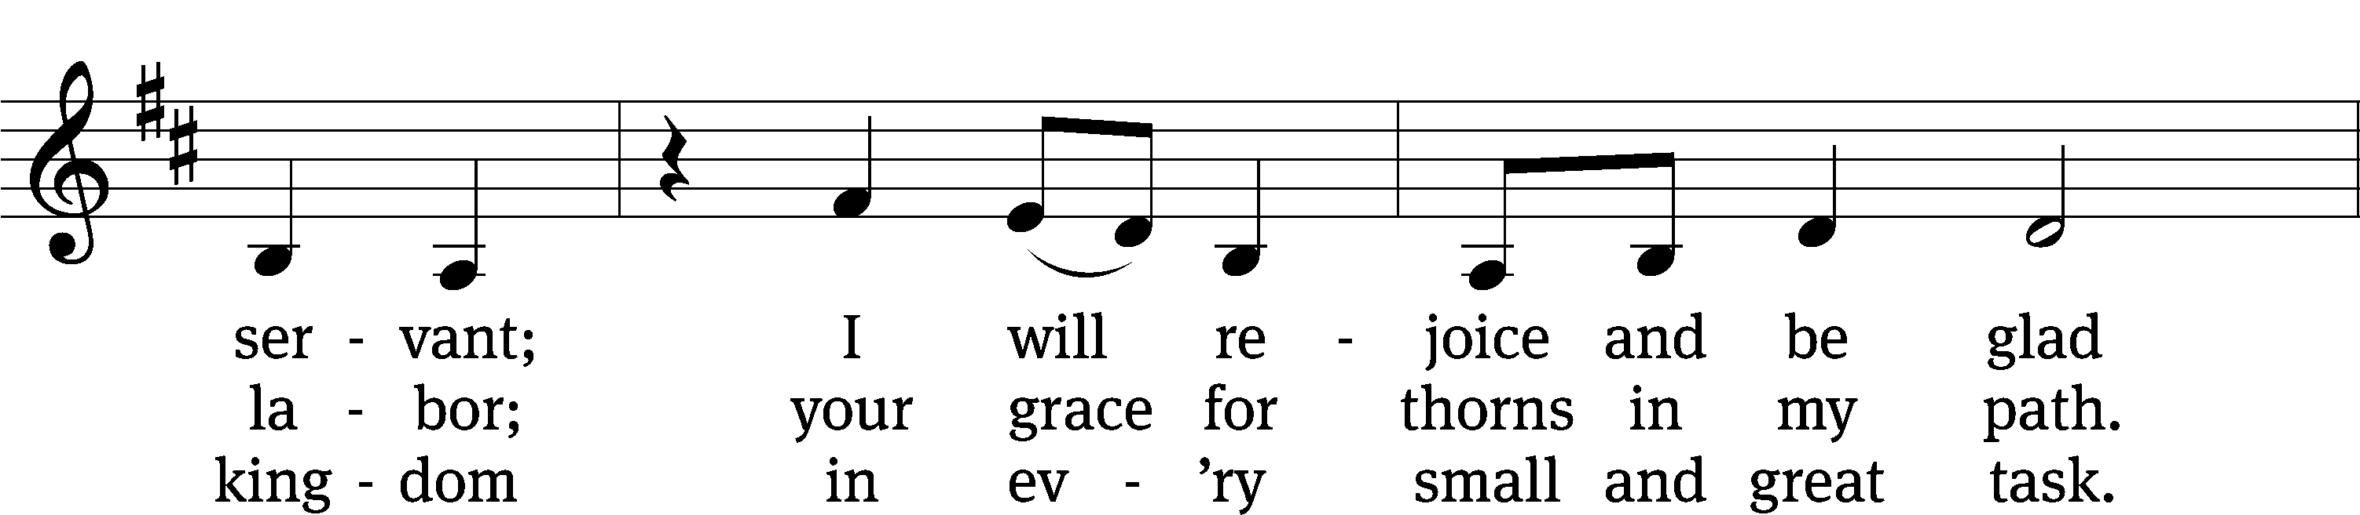
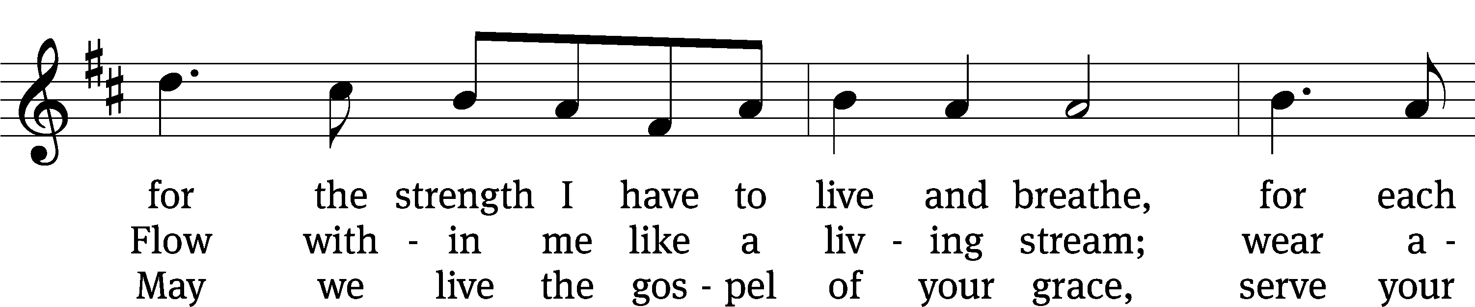
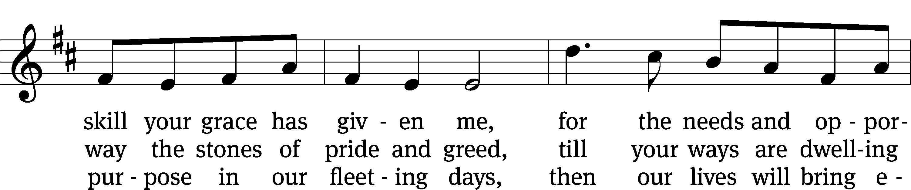
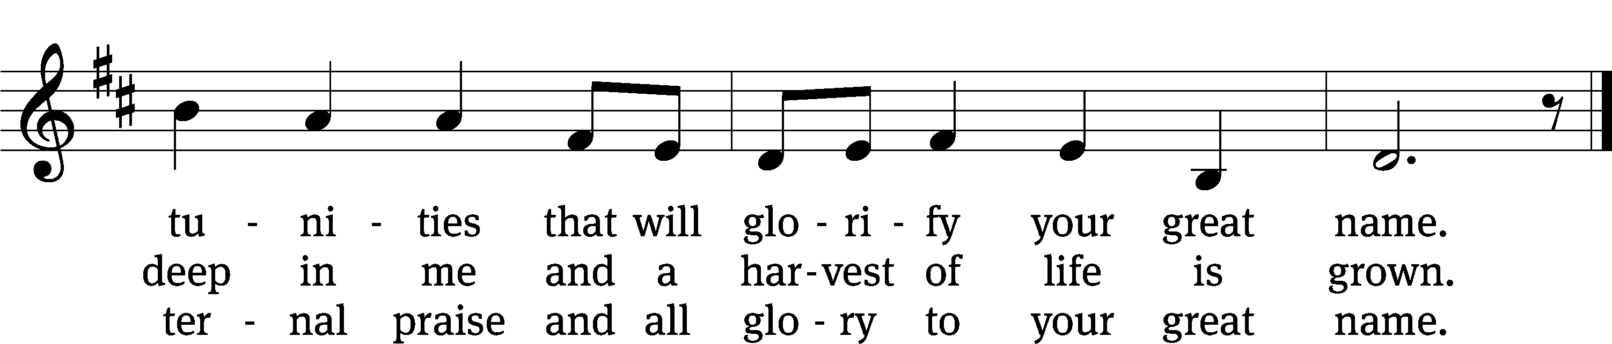
Text: Stuart Townend, b. 1963; Jeff Taylor, b. 1957; Kristyn Getty, b. 1980; Keith Getty, b. 1974
Tune: Stuart Townend, b. 1963; Jeff Taylor, b. 1957; Kristyn Getty, b. 1980; Keith Getty, b. 1974
Text and tune: © 2012 Getty Music and Seek 1st Publishing, admin. MusicServices.org and Townend Music. Used by permission: OneLicense no. 727703

PLEASE STAND, IF YOU ARE ABLE

M: Hear the prayer of your people, O Lord, that the lips which have praised you here may glorify you in the world, that the eyes which have seen the coming of your Son may long for his coming again, and that all who have received in his true body and blood the pledge of your forgiveness may be restored to live a new and holy life, through Jesus Christ, our Lord, who lives and reigns with you and the Holy Spirit, one God, now and forever.

M: Brothers and sisters, go in peace. Live in harmony with one another.
Serve the Lord with gladness.
The Lord bless you and keep you.
The Lord make his face shine on you and be gracious to you.
The Lord look on you with favor and (+) give you peace.

PLEASE BE SEATED

930 Go, My Children, with My Blessing CW 930
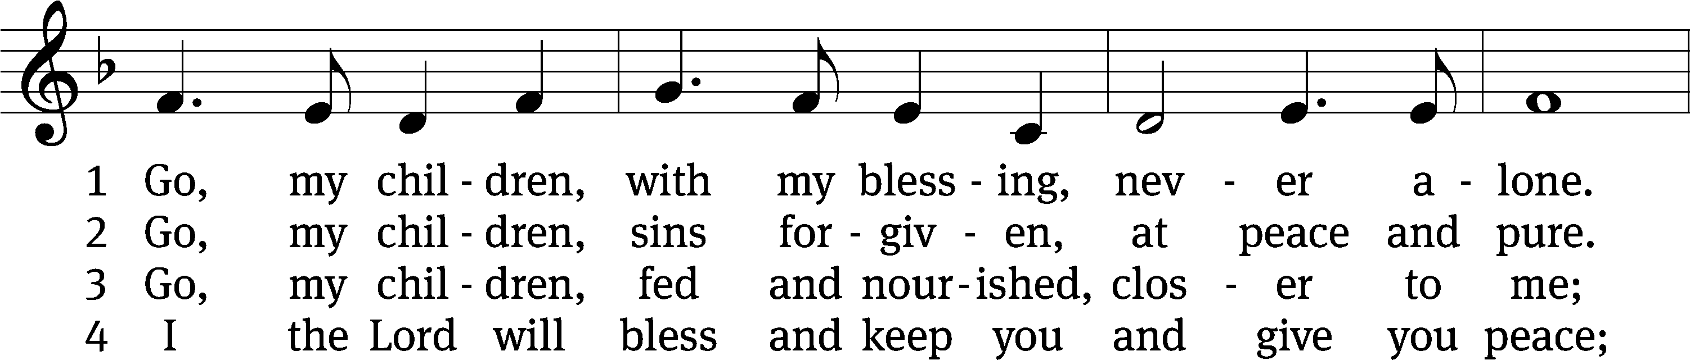
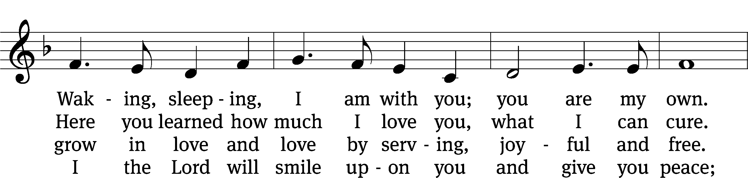
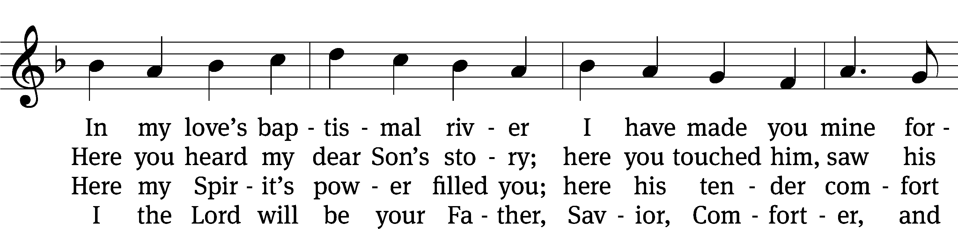
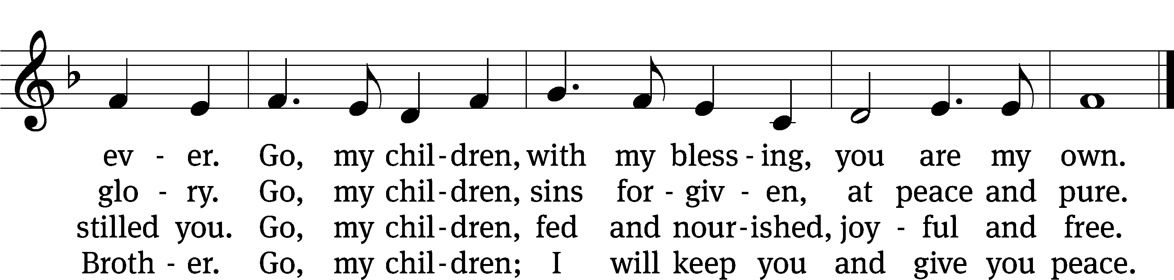
Text: Jaroslav J. Vajda, 1919–2008
Tune: Welsh, 18th cent.
Text: © 1983 Concordia Publishing House. Used by permission: OneLicense no. 727703
Tune: Public domain

Serving In Worship

Officiant Pastor Pappenfuss
Organist Marcia Marion Ackling
Sunday School Leader Marcia Marion Ackling
Choir Director Cynthia Natsis
Handbell Duet Marcia Marion Ackling and Meg Nortley
Instrumentalist Malory Marion
Deacons (8:30) Duane Mason and Dave Stevenson
(11:00) Jeff Neuburger and Robert Niethammer
Ushers (8:30) Tim Phelps
(11:00) Ron Zahn
Altar Guild Margaret Hoeft and Brenda Stevenson
Videographer Cindy Dresch

Copyright information
Service of Word and Sacrament: Christian Worship. © 1993 Northwestern Publishing House. All rights reserved. Reprinted under ONE LICENSE #A-727703 and CCLI #1151741/ CSPL126093
Words and Music: All rights reserved. Reprinted/Podcast/Streamed with permission under ONE LICENSE #A-727703 and CCLI #1151741/CSPL126093

