THE TWENTY-THIRD SUNDAY
AFTER PENTECOST
ALL SAINTS DAY
TRINITY EVANGELICAL LUTHERAN CHURCH | Saline, Michigan
WELCOME TO WORSHIP November 5, 2023
Thank you for joining us in God’s house today! We cordially ask that our Guests sign one of the guestbooks located at either the front or back entryways, or fill out a “Let’s Get Acquainted” card located in the hymnal pew rack and place it in the collection plate.

Thank Offering: Members of Trinity give their offering as an expression of love and thankfulness to the Lord and to help support the Lord’s work in our community and around the world. Visitors need not feel obligated to participate in this offering .

Restrooms are located at the back of the upper level (the annex), and in the basement (down the back stairs of the sanctuary or annex). Handicap access is available, please ask an usher for assistance.

Young Families / Toddler Bags – We are GLAD YOU BROUGHT YOUR CHILDREN to our worship service. Jesus said: “Let the little children come to me and do not hinder them, for the kingdom of God belongs to such as these.” We know that having little children in church can be a challenge, but DO NOT WORRY about it. Many of your fellow worshippers have been in your shoes and are just happy you brought your children with you. For your convenience, we have reserved the back rows of seating for parents with small children. These areas provide more flexibility for your family, as well as, easy access to move downstairs if necessary. A closed-circuit TV system allows families to continue participating in the service while downstairs. Pre-school toddler bags and children’s bulletins are available for their enjoyment. Ask an usher for one to use during the service and please return the toddler bag afterwards.

Holy Communion – In His Word, God makes it clear that the Lord’s Supper is to be shared by people of a common proclamation of faith (1 Corinthians 11:26; 1 Corinthians 10:16-17). Without judging anyone’s hearts, we invite those who share in our confession by their membership in our congregation or another congregation of the Wisconsin Evangelical Lutheran Synod (WELS) or the Evangelical Lutheran Synod (ELS) and who are properly prepared (1 Corinthians 11;27-29) to receive the Sacrament. Page 295 in Christian Worship provides a guide for preparation.
Guests, we would love to have you join us in communion fellowship in the future, and for that to be possible, we ask that you speak with one of the pastors so that we may speak with you on how that would be possible. We thank you for respecting the way we celebrate the Lord’s Supper in our congregations.

the SERVICE – setting one - WITH HOLY COMMUNION CW, page 154
Senior Bells (11 o’clock service) “Holy Manna”
880 For All the Saints CW 880
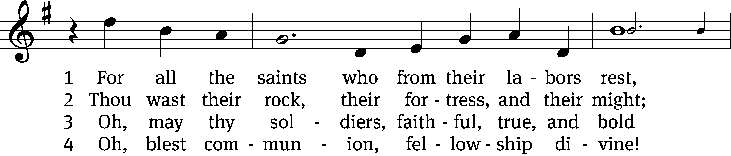
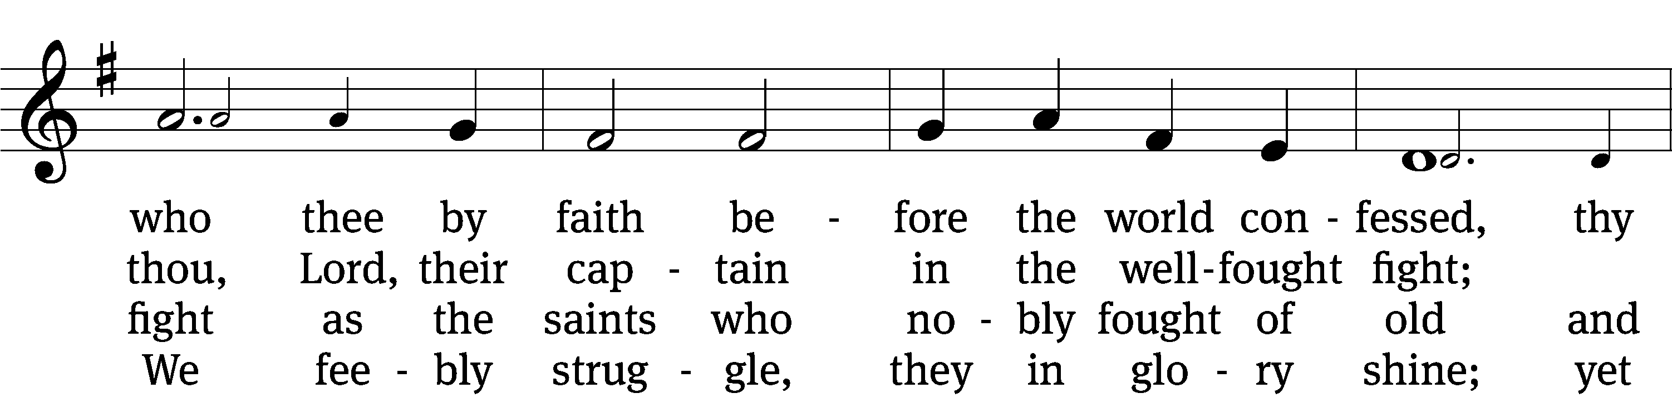
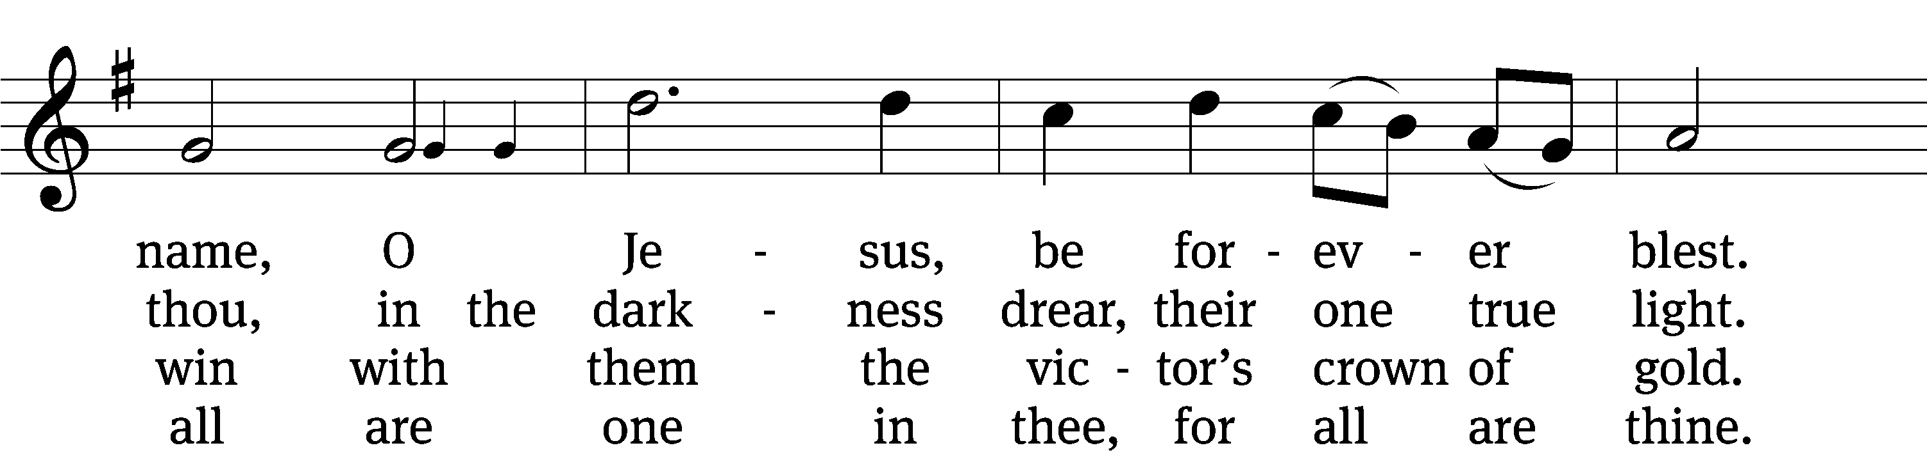
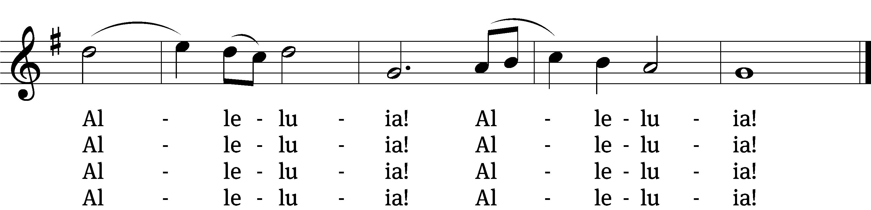

5 And when the fight is fierce, the warfare long,
steals on the ear the distant triumph-song,
and hearts are brave again and arms are strong.
Alleluia! Alleluia!

6 The golden evening brightens in the west;
soon, soon, to faithful warriors cometh rest;
sweet is the calm of paradise the blest.
Alleluia! Alleluia!

7 But, lo, there breaks a yet more glorious day:
the saints triumphant rise in bright array;
the King of glory passes on his way.
Alleluia! Alleluia!

8 From earth’s wide bounds, from ocean’s farthest coast,
through gates of pearl streams in the countless host,
singing to Father, Son, and Holy Ghost.
Alleluia! Alleluia!
Text: William W. How, 1823–1897, alt.
Tune: Ralph Vaughan Williams, 1872–1958
Text and tune: Public domain

Please stand, if you are able

Invocation

In the name of the Father and of the Son and of the Holy Spirit.
Amen.

Confession

If we claim to be without sin, we deceive ourselves and the truth is not in us.
If we confess our sins, God is faithful and just
and will forgive us our sins
and purify us from all unrighteousness.

Let us confess our sins to the Lord.
Holy God, gracious Father,
I am sinful by nature
and have sinned against you in my thoughts, words, and actions.
I have not loved you with my whole heart;
I have not loved others as I should.
I deserve your punishment both now and forever.
But Jesus, my Savior, paid for my sins
with his innocent suffering and death.
Trusting in him, I pray: God, have mercy on me, a sinner.

Our gracious Father in heaven has been merciful to us. He sent his only Son, Jesus Christ, who gave his life as the atoning sacrifice for the sins of the whole world. Therefore, as a called servant of Christ and by his authority, I forgive you all your sins in the name of the Father and of the Son and of the Holy Spirit.
Amen.

Lord, Have Mercy

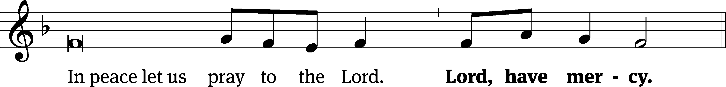
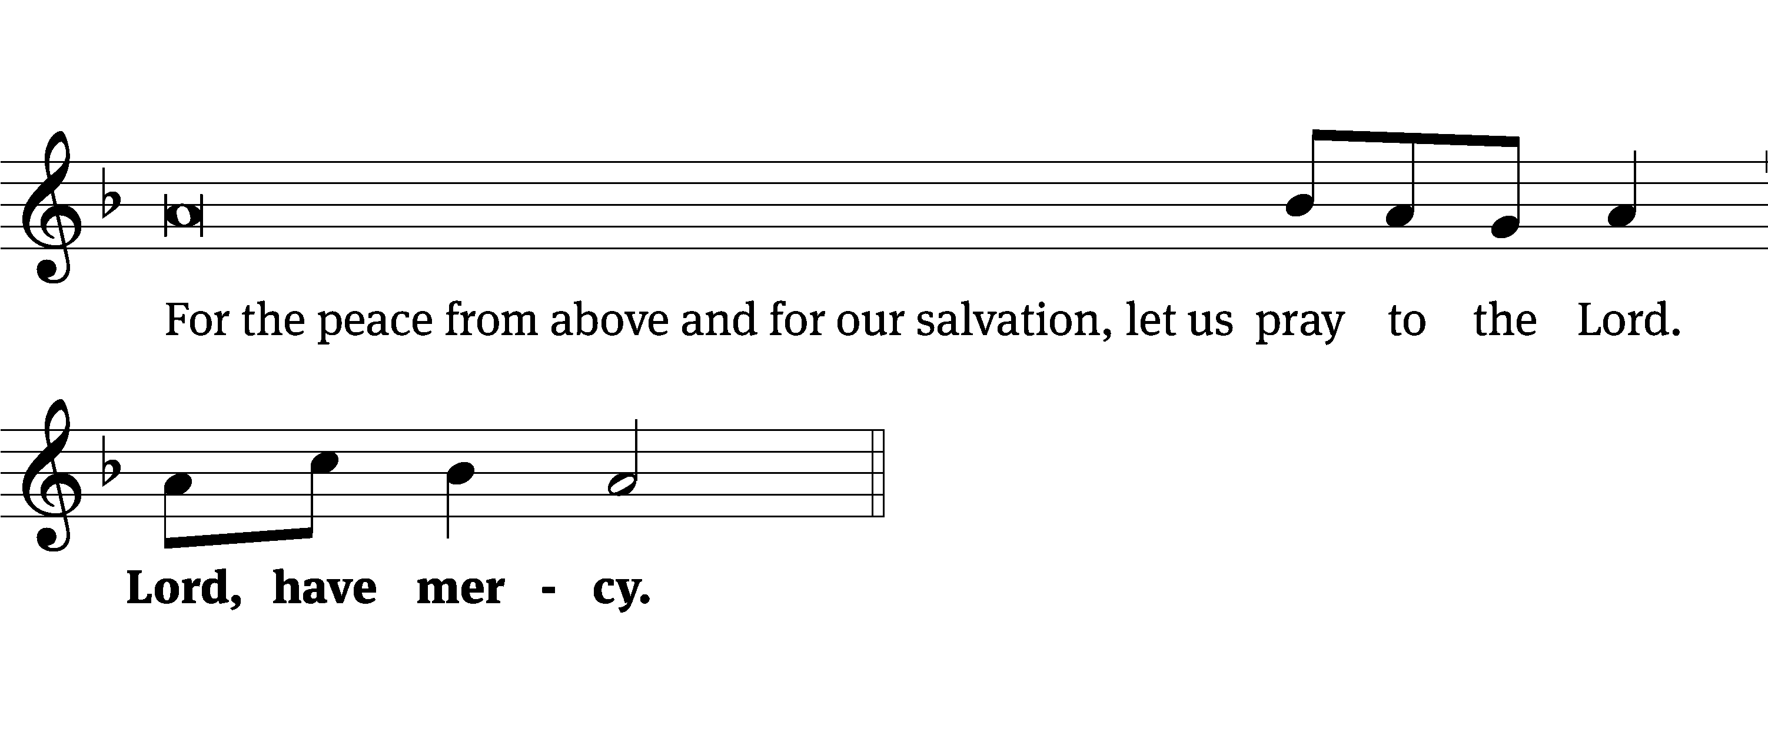
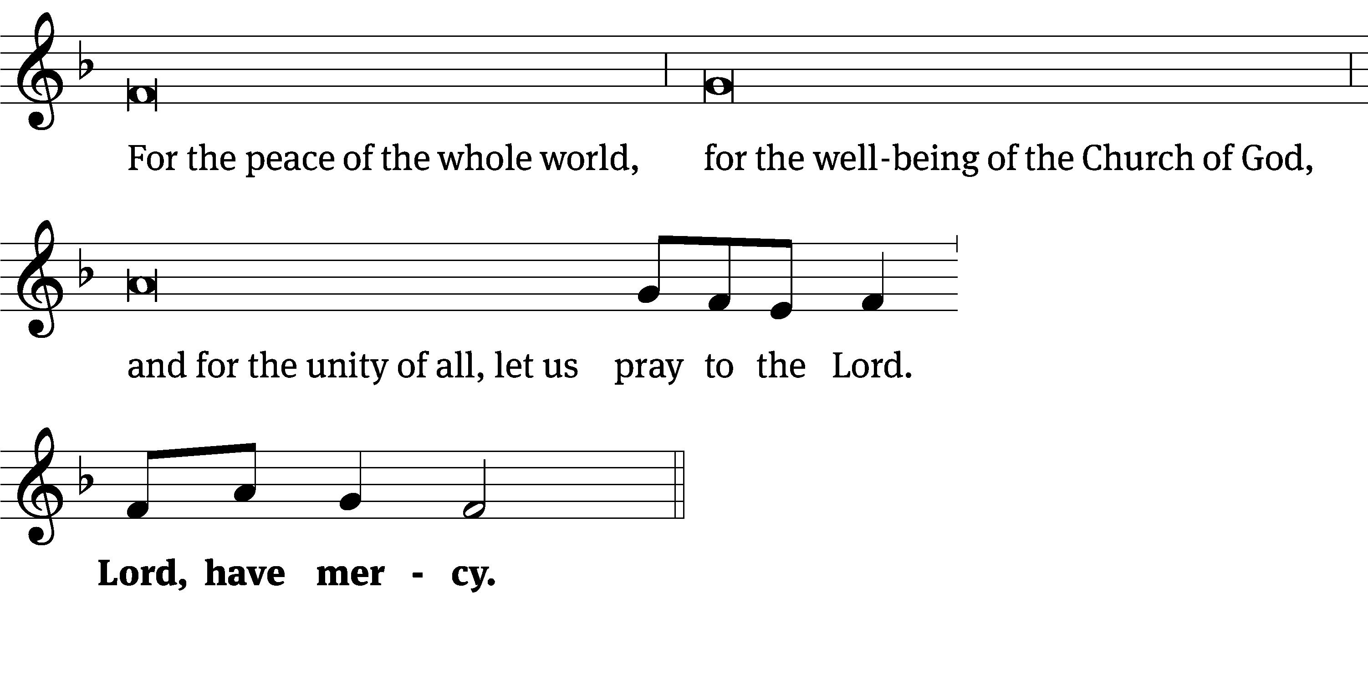
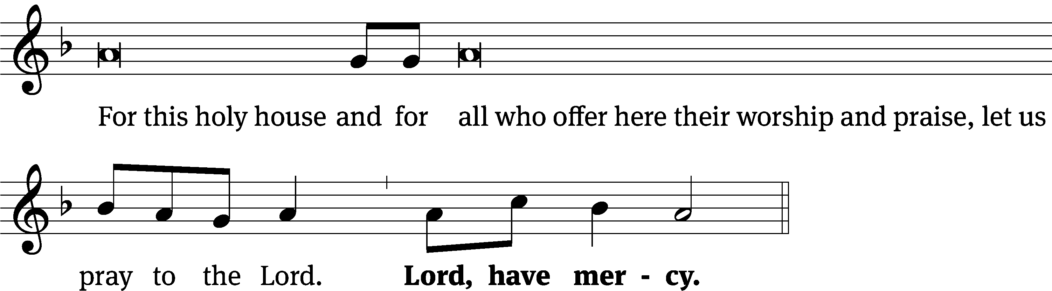
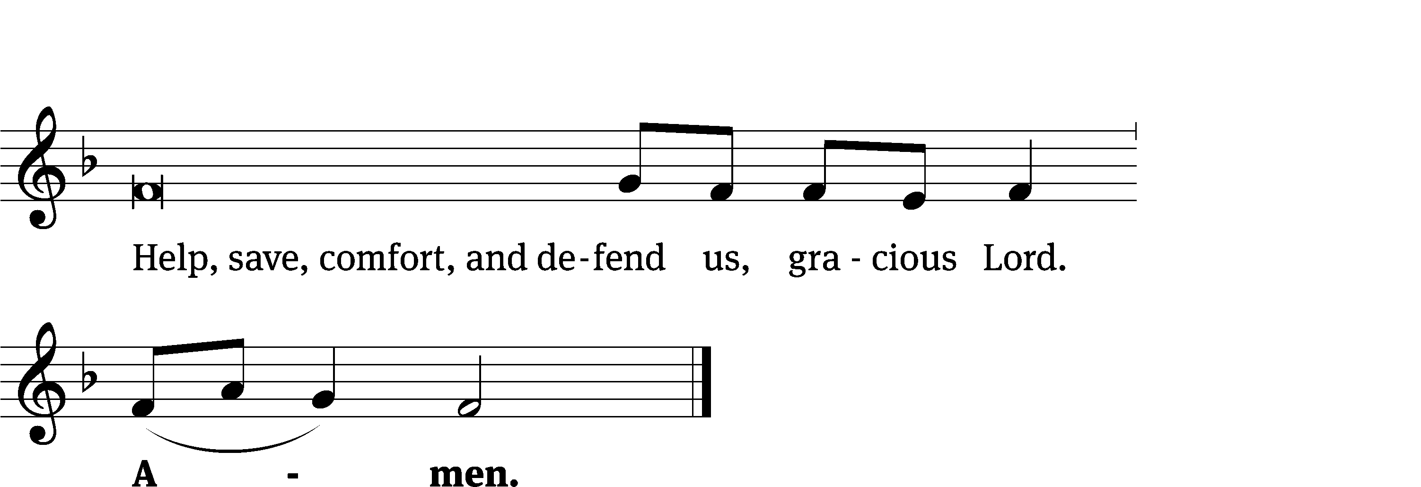
Glory Be to God on High CW 157
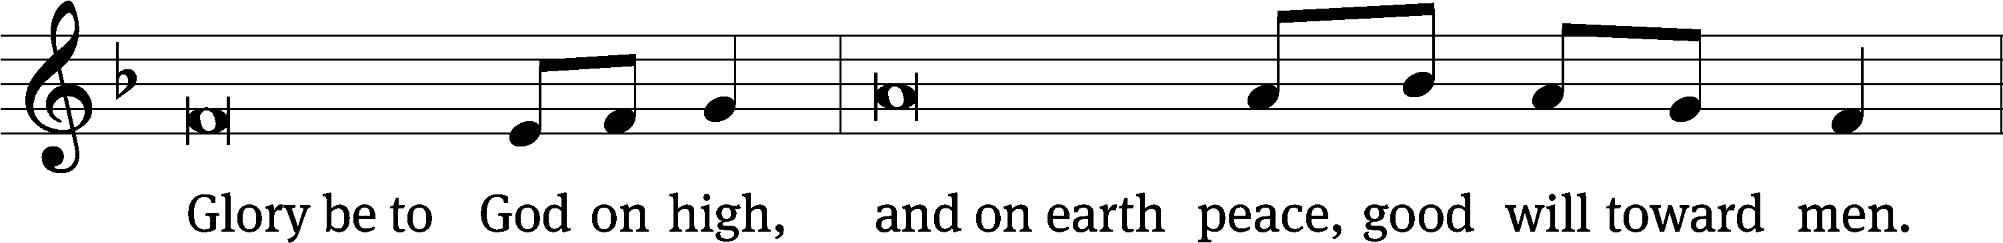
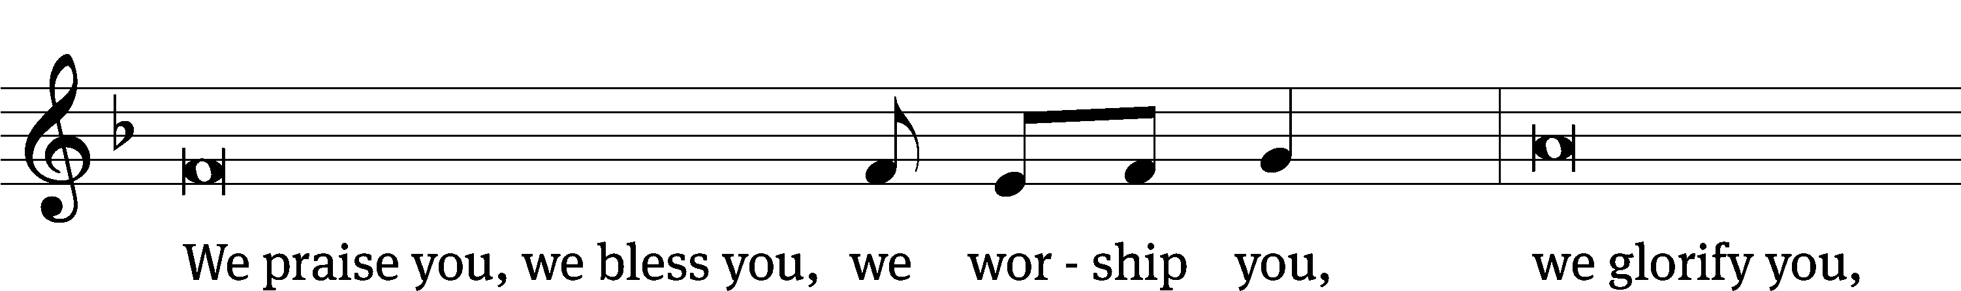
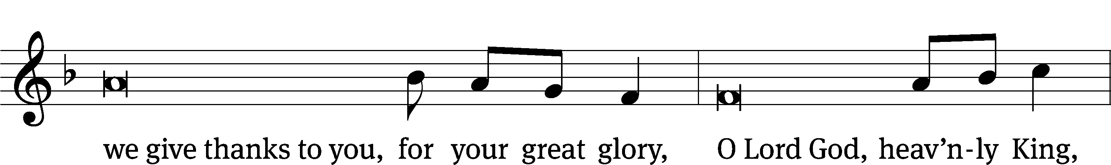
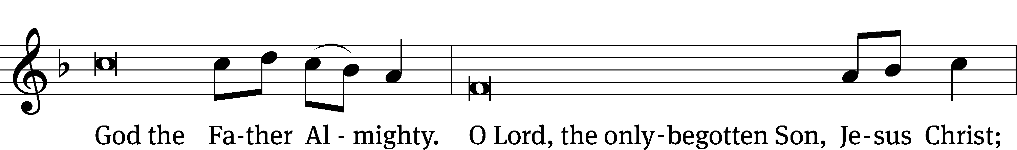
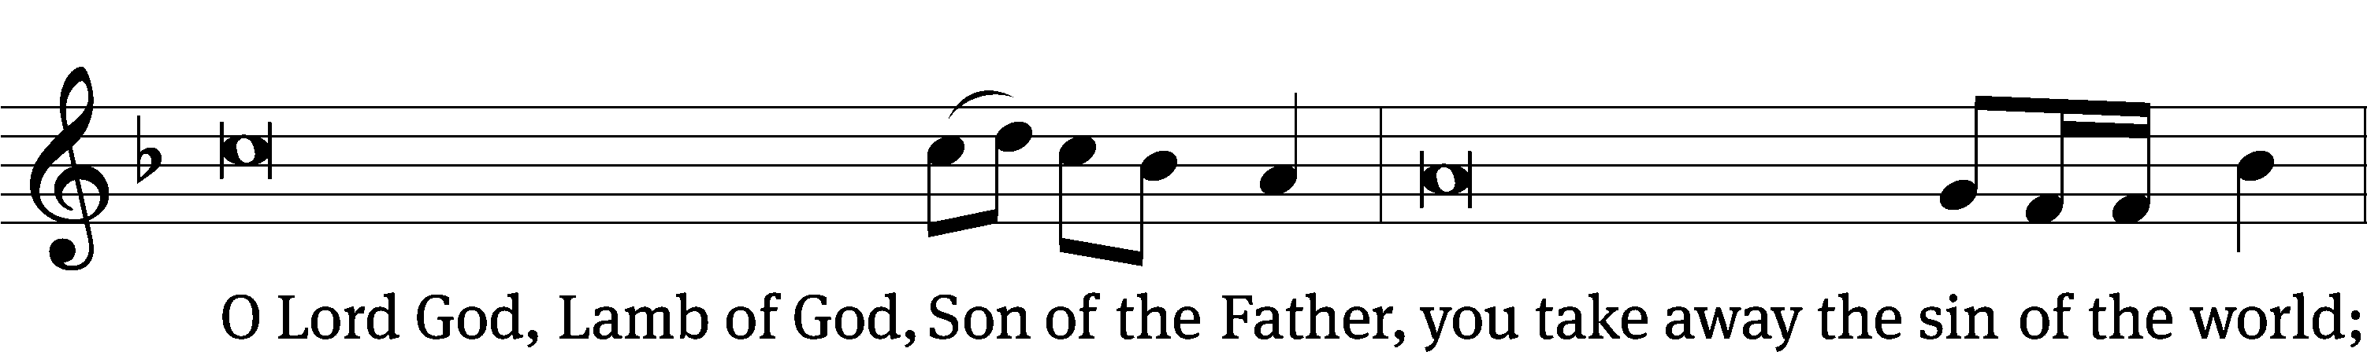
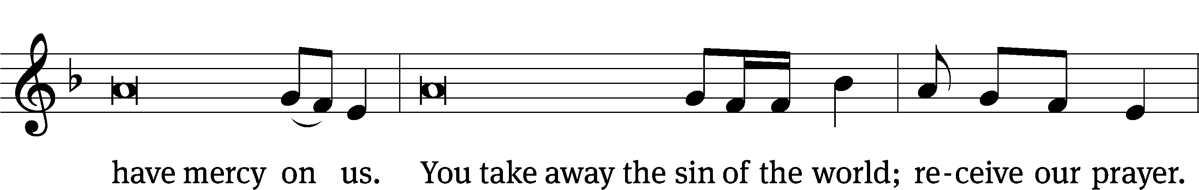
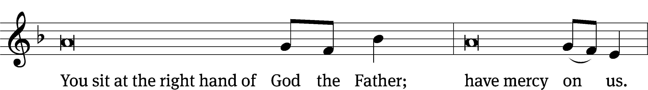
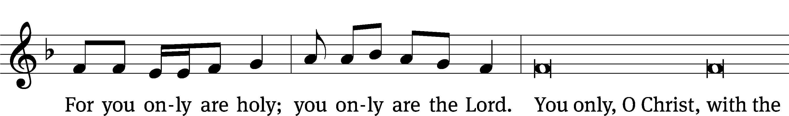
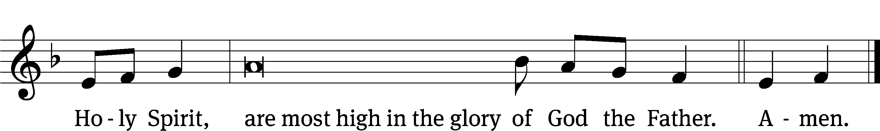

The Lord be with you.
And also with you.
Prayer of the Day
Let us pray.

Almighty God, you have knit your people together into one holy Church, the body of Christ our Lord. Grant us grace to follow the example of your blessed saints in lives of faith and willing service and with them at last inherit the inexpressible joys that you have prepared for those who love you; through your Son, Jesus Christ our Lord, who lives and reigns with you and the Holy Spirit, one God, now and forever.
Amen.

Please be seated

First Reading Revelation 7:9-17
⁹ After these things I looked, and there was a great multitude that no one could count, from every nation, tribe, people, and language, standing in front of the throne and of the Lamb, clothed with white robes, and with palm branches in their hands. ¹⁰ They called out with a loud voice and said:
Salvation comes from our God, who sits on the throne, and from
the Lamb.
¹¹ All the angels stood around the throne, the elders, and the four living creatures. They fell on their faces before the throne and worshipped God, ¹² saying:
Amen. Blessing and glory and wisdom and thanks and honor and
power and might belong to our God forever and ever. Amen.
¹³ One of the elders spoke to me and said, “These people dressed in white robes, who are they and where did they come from?”
And I answered him, “Sir, you know.”
¹⁴ And he said to me:
These are the ones who are coming out of the great tribulation.
They have washed their robes and made them white in the blood of
the Lamb.
¹⁵ Because of this they are in front of the throne of God,
and they serve him day and night in his temple.
He who sits on the throne will spread his tent over them.
¹⁶ They will never be hungry or thirsty ever again.
The sun will never beat upon them, nor will any scorching heat,
¹⁷ for the Lamb at the center of the throne will be their shepherd.
He will lead them to springs of living water.
And God will wipe away every tear from their eyes.

The Word of the Lord.
Thanks be to God.
Senior Choir “All Things New”
Light after darkness, gain after loss,
Strength after weakness, crown after cross;
Sweet after bitter, hope after fears,
Home after wand’ring, praise after tears.
Alpha and Omega, beginning and the end,
He is making all things new,
Springs of living water shall wash away each tear.
He is making all things new, he is making all things new.

Sight after myst’ry, sun after rain.
Joy after sorrow, peace after pain.
Near after distant, gleam after gloom,
Love after loneliness, life after tomb.
Alpha and Omega, beginning and the end,
He is making all things new,
Springs of living water shall wash away each tear.
He is making all things new, he is making all things new.

Second Reading 1 John 3:1-3

¹ See the kind of love the Father has given us that we should be called children of God, and that is what we are! The world does not know us, because it did not know him. ² Dear friends, we are children of God now, but what we will be has not yet been revealed. We know that when he is revealed we will be like him, and we will see him as he really is. ³ Everyone who has this hope purifies himself just as Jesus is pure.

The Word of the Lord.
Thanks be to God.

Please stand, if you are able
Gospel Acclamation Revelation 7:15
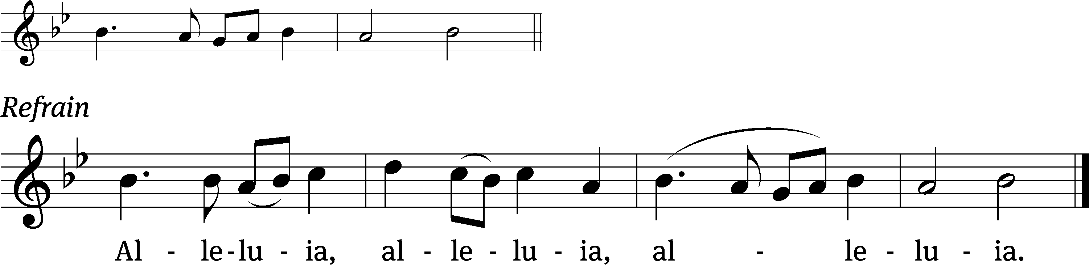
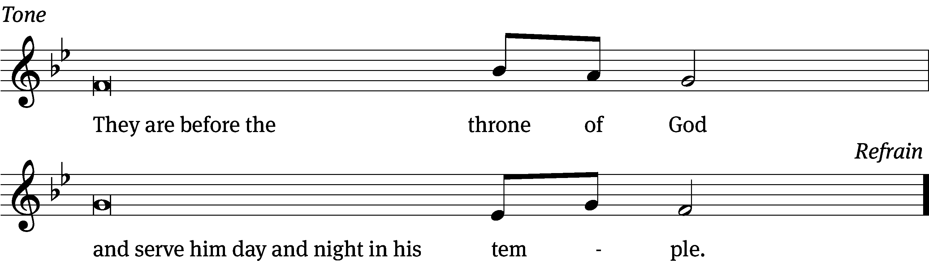
Tune: © 2021 Northwestern Publishing House. Used by permission: OneLicense no. 727703

Gospel Matthew 5:1-12
¹ When Jesus saw the crowds, he went up onto a mountain. When he sat down, his disciples came to him. ² He opened his mouth and began to teach them. He said these things:
³ “Blessed are the poor in spirit,
because theirs is the kingdom of heaven.
⁴ Blessed are those who mourn,
because they will be comforted.
⁵ Blessed are the gentle,
because they will inherit the earth.
⁶ Blessed are those who hunger and thirst for righteousness,
because they will be filled.
⁷ Blessed are the merciful,
because they will receive mercy.
⁸ Blessed are the pure in heart,
because they will see God.
⁹ Blessed are the peacemakers,
because they will be called sons of God.
¹⁰ Blessed are those who are persecuted because of righteousness,
because theirs is the kingdom of heaven.
¹¹ “Blessed are you when people insult you and persecute you and falsely say all kinds of evil against you because of me. ¹² Rejoice and be glad, because great is your reward in heaven. In fact, that is how they persecuted the prophets who were before you.”
The Gospel of the Lord.
Praise be to you, O Christ!

Please be seated

837 When Will I Walk CW 837
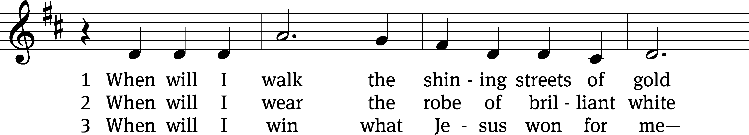
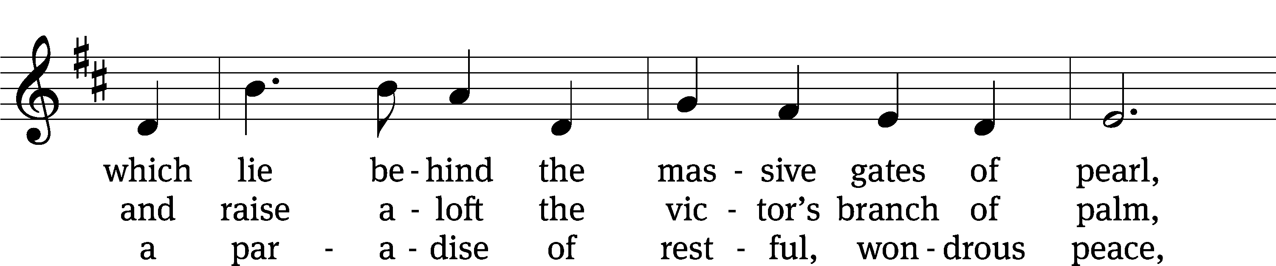
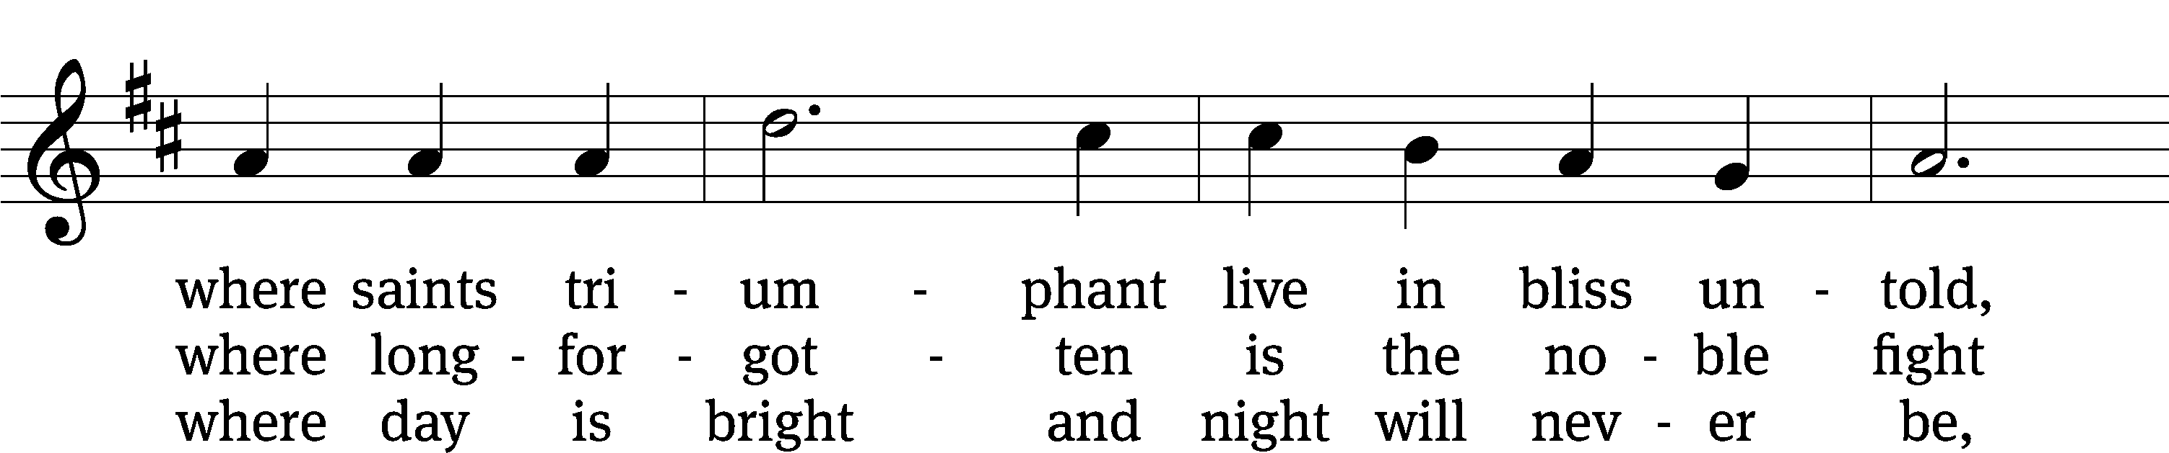
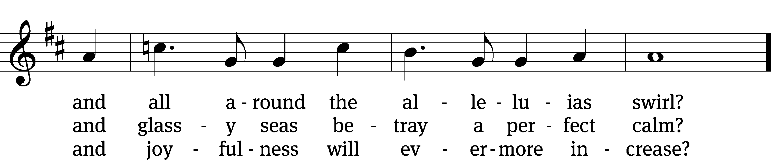
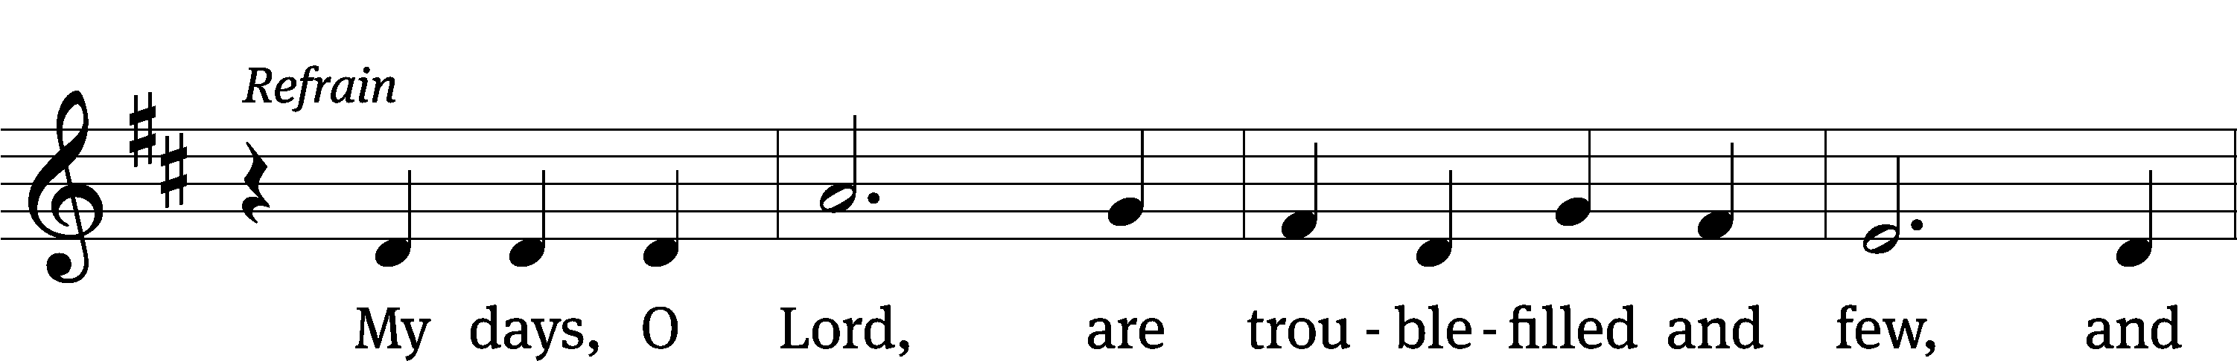
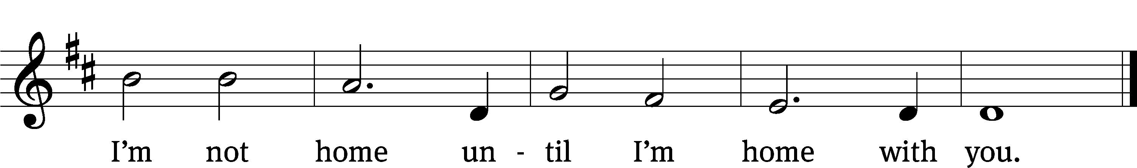
Text: Michael D. Schultz, b. 1963
Tune: Michael D. Schultz, b. 1963
Text and tune: © 2021 Michael D. Schultz, admin. Northwestern Publishing House. Used by permission: OneLicense no. 727703

SERMON Revelation 7:9-17
“Standing before the Throne”

Please stand, if you are able

nicene creed
We believe in one God, the Father, the Almighty, maker of heaven and earth, of all that is, seen and unseen.
We believe in one Lord, Jesus Christ, the only Son of God, eternally begotten of the Father, God from God, Light from Light, true God from true God, begotten, not made, of one being with the Father. Through him all things were made. For us and for our salvation, he came down from heaven, was incarnate of the Holy Spirit and the virgin Mary, and became truly human. For our sake he was crucified under Pontius Pilate. He suffered death and was buried. On the third day he rose again in accordance with the Scriptures. He ascended into heaven and is seated at the right hand of the Father. He will come again in glory to judge the living and the dead, and his kingdom will have no end.
We believe in the Holy Spirit, the Lord, the giver of life, who proceeds from the Father and the Son, who in unity with the Father and the Son is worshiped and glorified, who has spoken through the prophets. We believe in one holy Christian and apostolic Church. We acknowledge one baptism for the forgiveness of sins. We look for the resurrection of the dead and the life of the world to come. Amen.
Senior Bells (8:30 service) “Holy Manna”
Prayer of the Church

The Sacrament
Preface CW 165
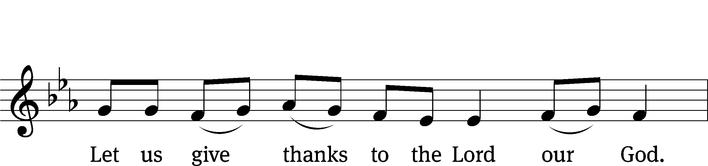
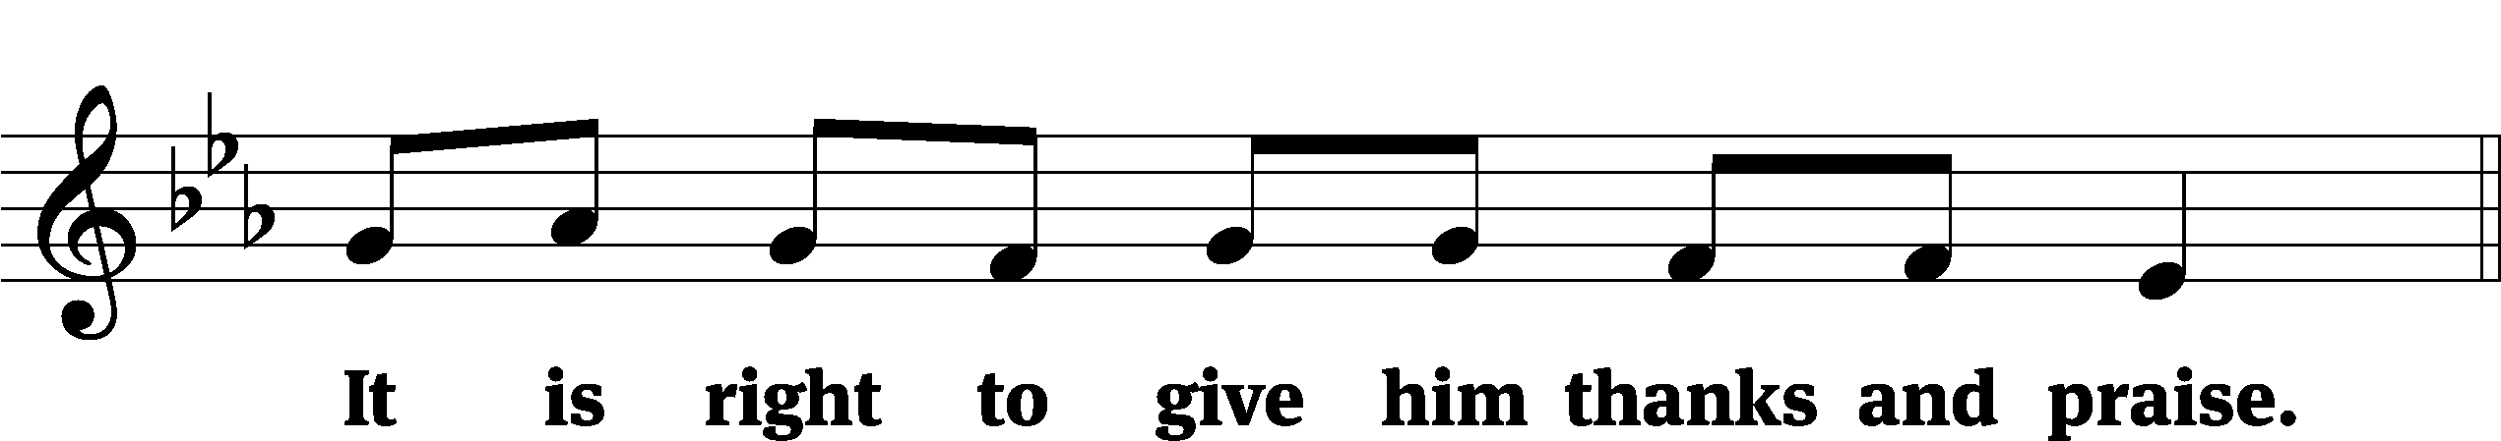

It is truly good and right that we should at all times and in all places give you thanks, O Lord, holy Father, almighty and everlasting God, through Jesus Christ our Lord, who by his willing sacrifice on the cross took away the sins of the world and by his glorious resurrection restored everlasting life. Therefore, with all the saints on earth and hosts of heaven, we praise your holy name and join their glorious song:

Holy, Holy, Holy CW 167
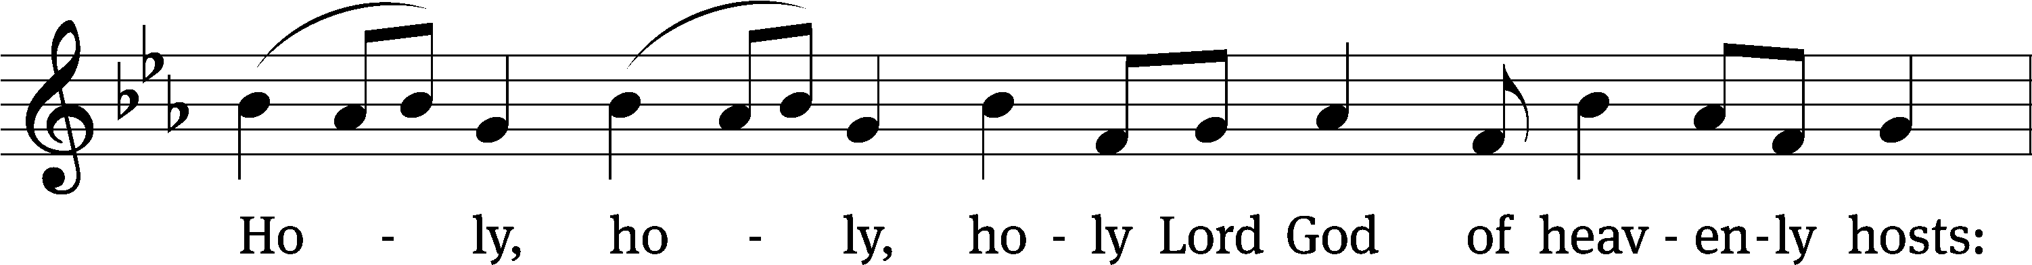
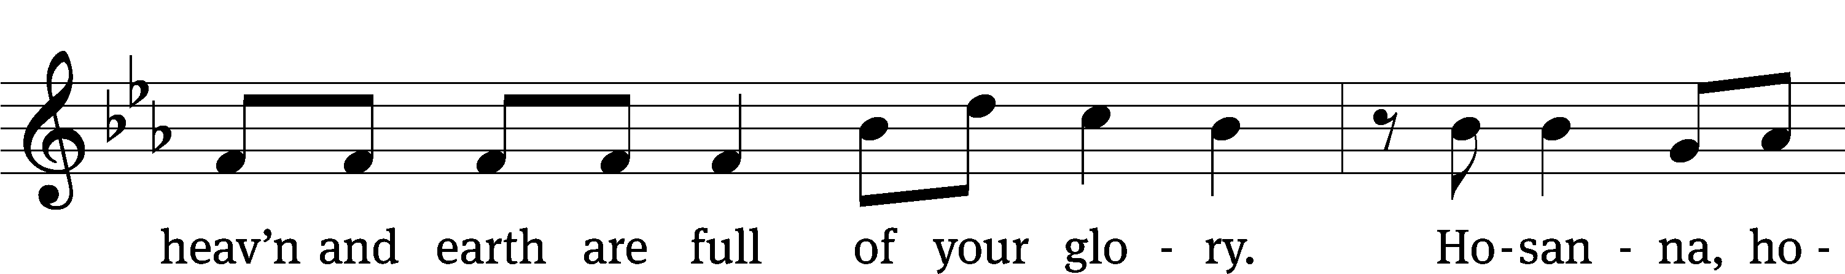
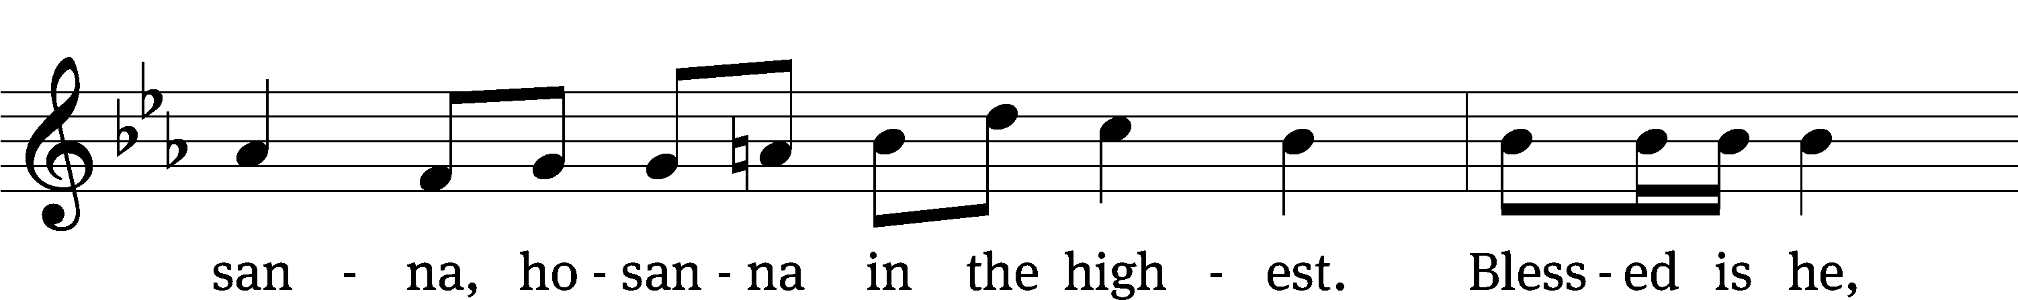
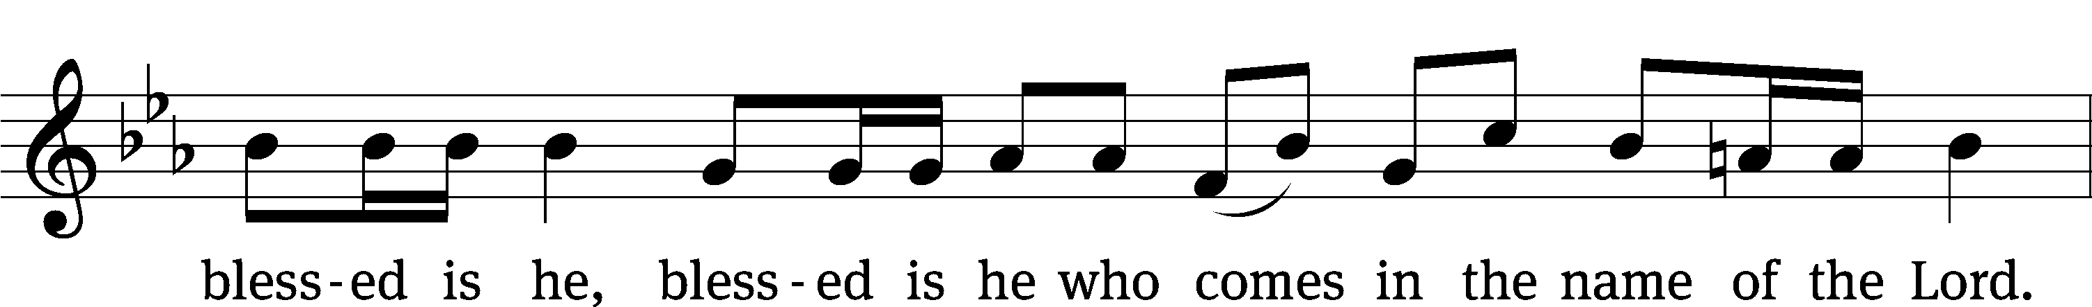
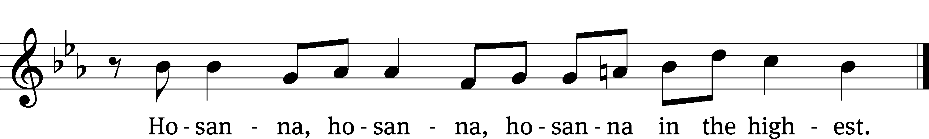

Prayer of Thanksgiving
We give thanks to you, O God, through your dear Son, Jesus Christ, whom you sent to be our Savior, our Redeemer, and the messenger of your grace. Through him you made all things; in him you are well pleased. He is the incarnate Word, conceived by the Holy Spirit and born of the Virgin Mary. To fulfill your promises, he stretched out his hands on the cross and released from eternal death all who believe in you.
As we remember Jesus’ death and resurrection, we thank you that you have gathered us together to receive your Son’s body and blood. Send us your Spirit, unite us as one, and strengthen our faith so that we may praise you in your Son, Jesus Christ. Through him, we glorify and honor you, O God our Father, with the Holy Spirit, one God, now and forever.
Amen.

Lord’s Prayer
Our Father, who art in heaven, hallowed be thy name, thy kingdom come, thy will be done on earth as it is in heaven. Give us this day our daily bread; and forgive us our trespasses, as we forgive those who trespass against us; and lead us not into temptation, but deliver us from evil. For thine is the kingdom and the power and the glory forever and ever. Amen.

Words of Institution
Our Lord Jesus Christ, on the night he was betrayed, took bread; and when he had given thanks, he broke it and gave it to his disciples, saying, “Take and eat; this is my body, which is given for you. Do this in remembrance of me.”
Then he took the cup, gave thanks, and gave it to them, saying, “Drink from it, all of you; this is my blood of the new covenant, which is poured out for you for the forgiveness of sins. Do this, whenever you drink it, in remembrance of me.”

The peace of the Lord be with you always.
Amen.
O Christ, Lamb of God CW 169
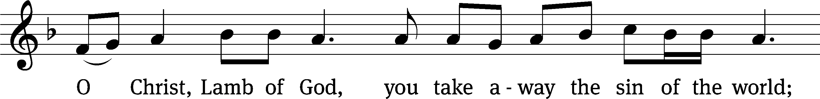
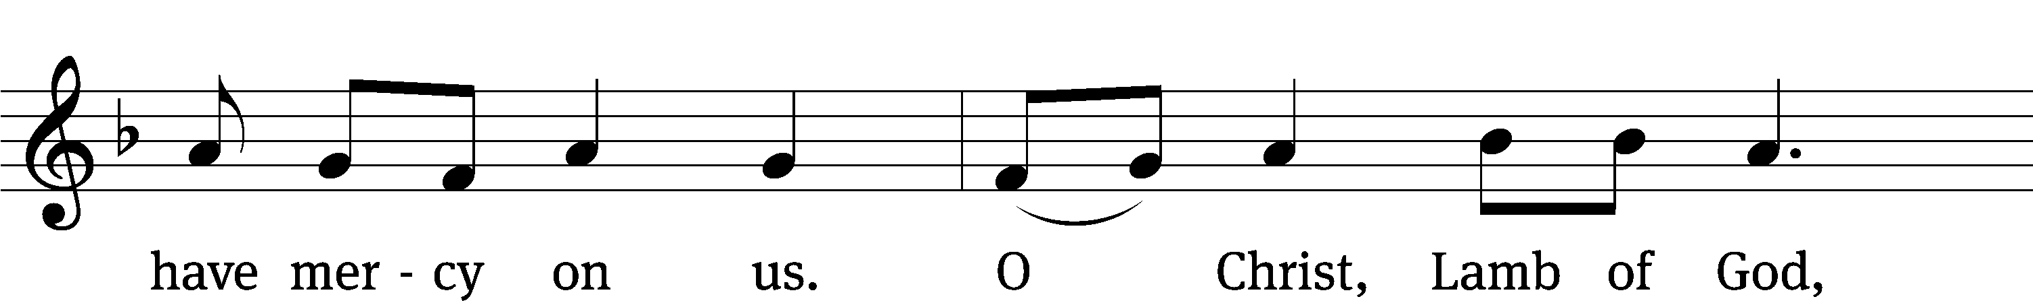
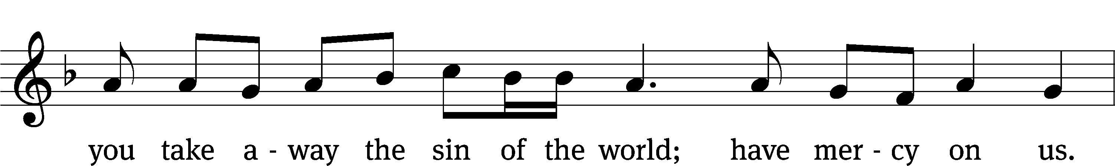
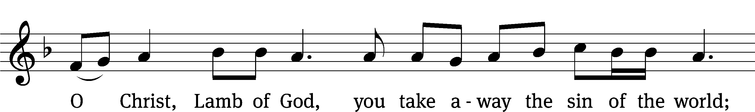

889 Jerusalem the Golden CW 889
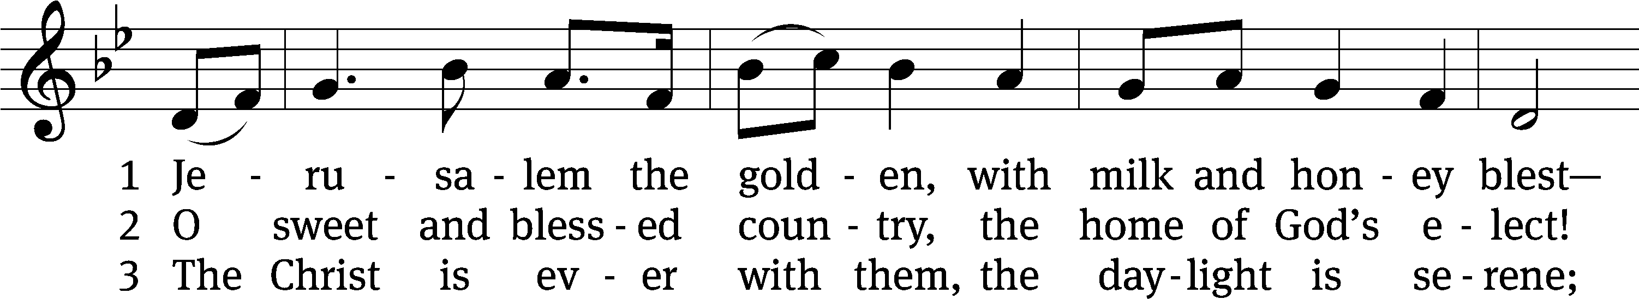
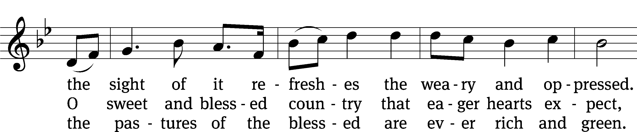
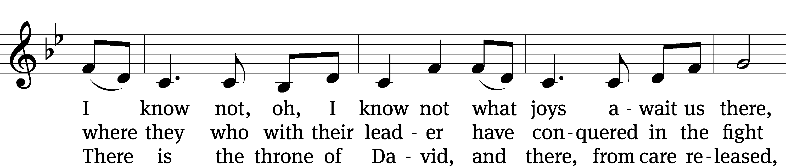
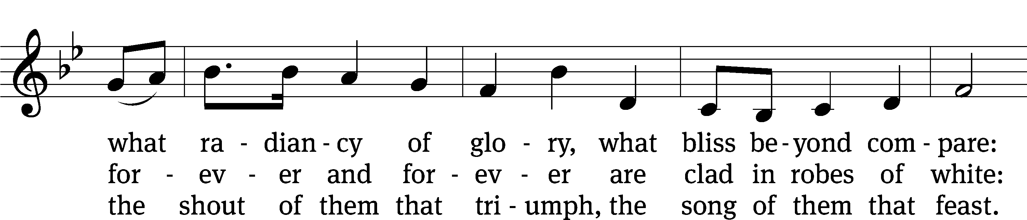
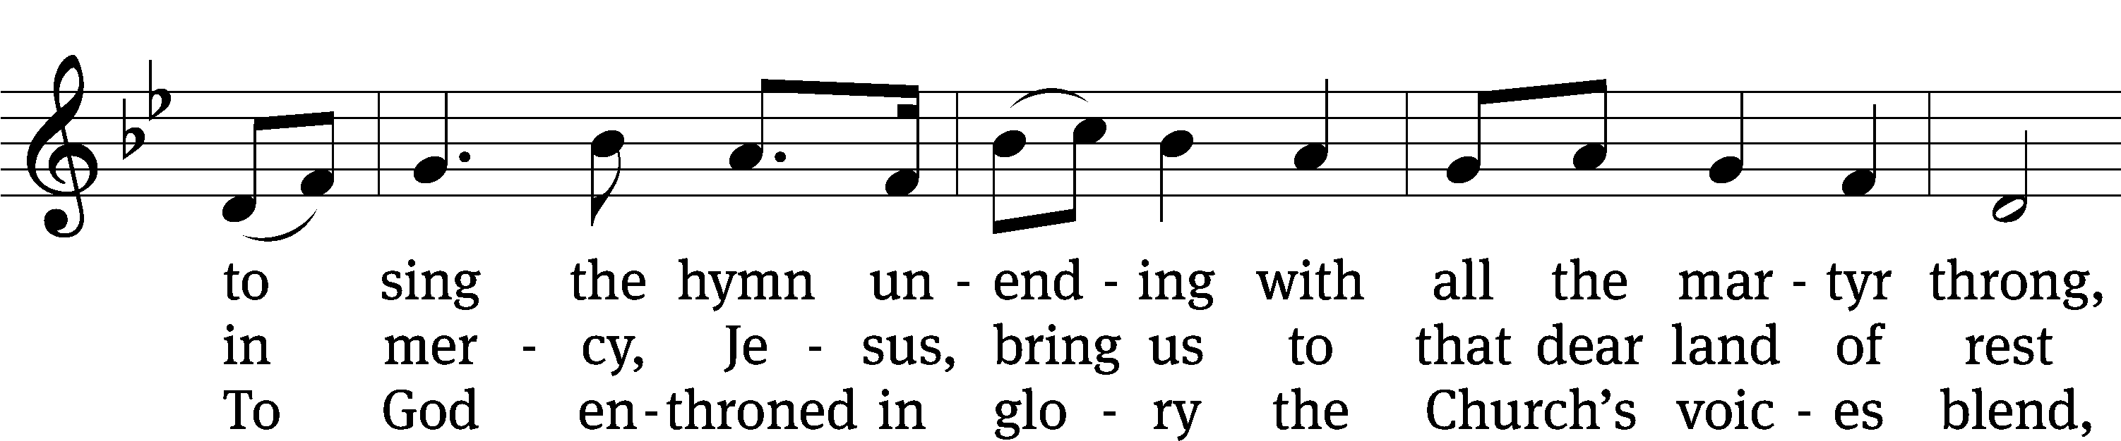
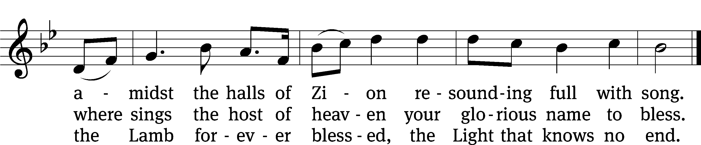
Text: tr. John Mason Neale, 1818–1866, alt.; Bernard of Cluny, 12th cent., abr.
Tune: Gustav Holst, 1874–1934
Text and tune: Public domain

Please stand, if you are able

Give thanks to the Lord, for he is good;
his mercy endures forever.

Whenever we eat this bread and drink this cup,
we proclaim the Lord’s death until he comes.

We give thanks, almighty God, that you have refreshed us with this saving gift. We pray that through it you will strengthen our faith in you and increase our love for one another. We ask this in the name of Jesus Christ our Lord, who lives and reigns with you and the Holy Spirit, one God, now and forever.
Amen.

Blessing
The Lord bless you and keep you.
The Lord make his face shine on you and be gracious to you.
The Lord look on you with favor and give you peace.
Amen.

Please be seated

883 Behold a Host, Arrayed in White CW 883
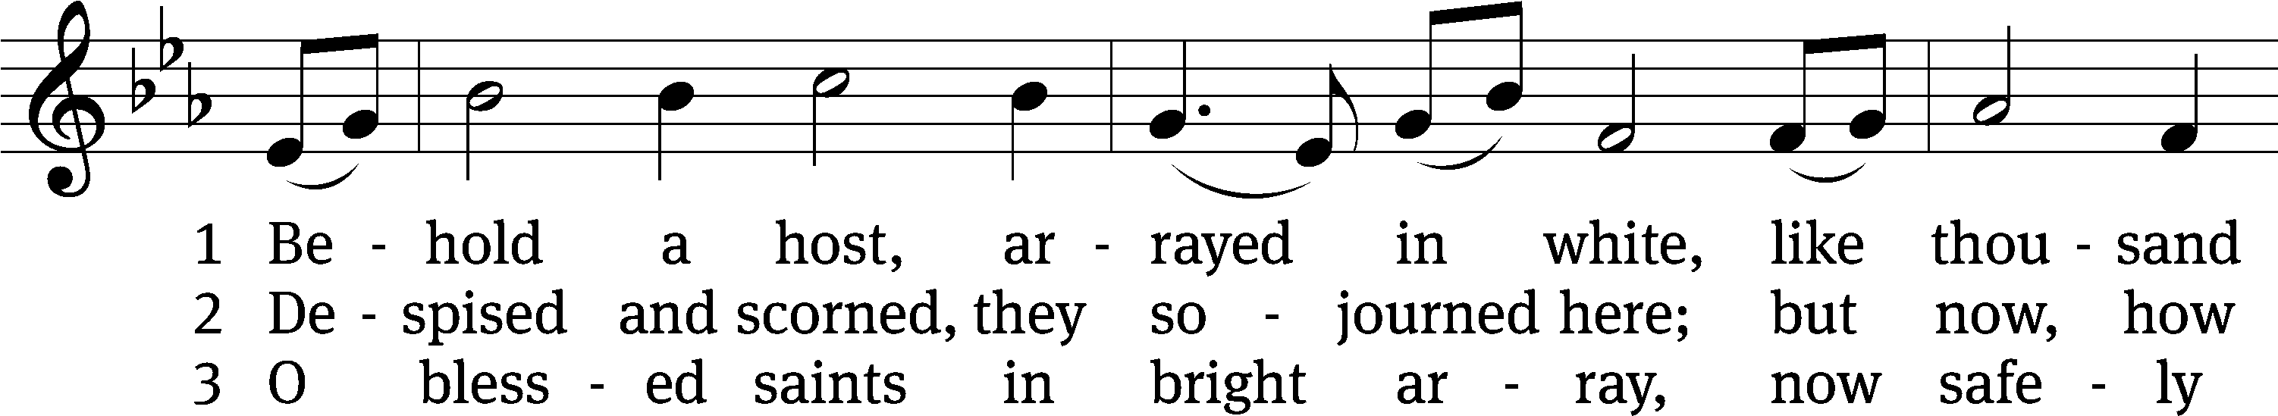
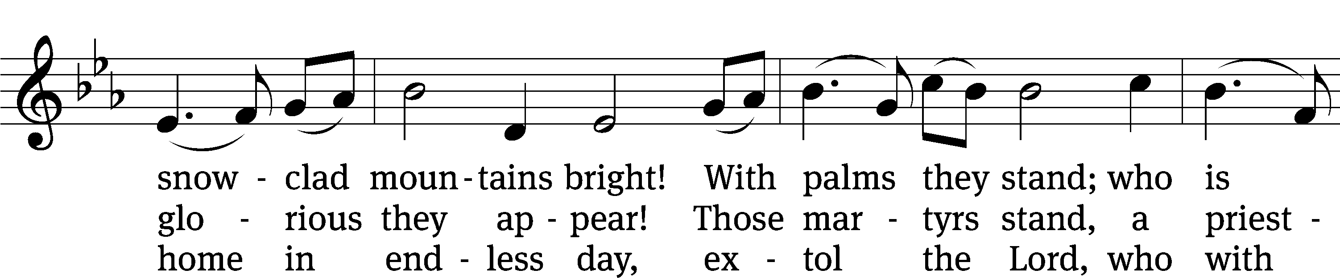
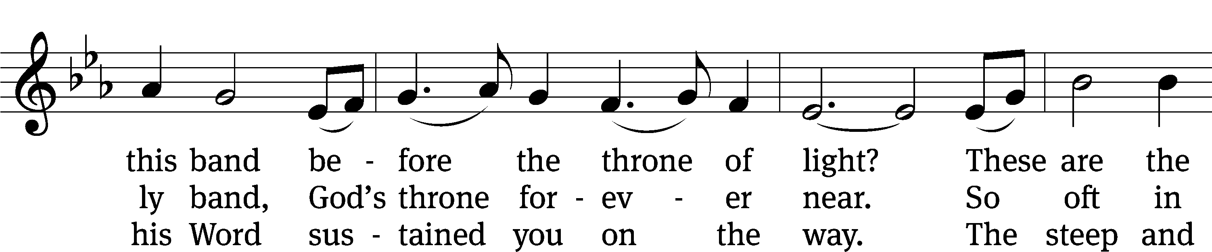
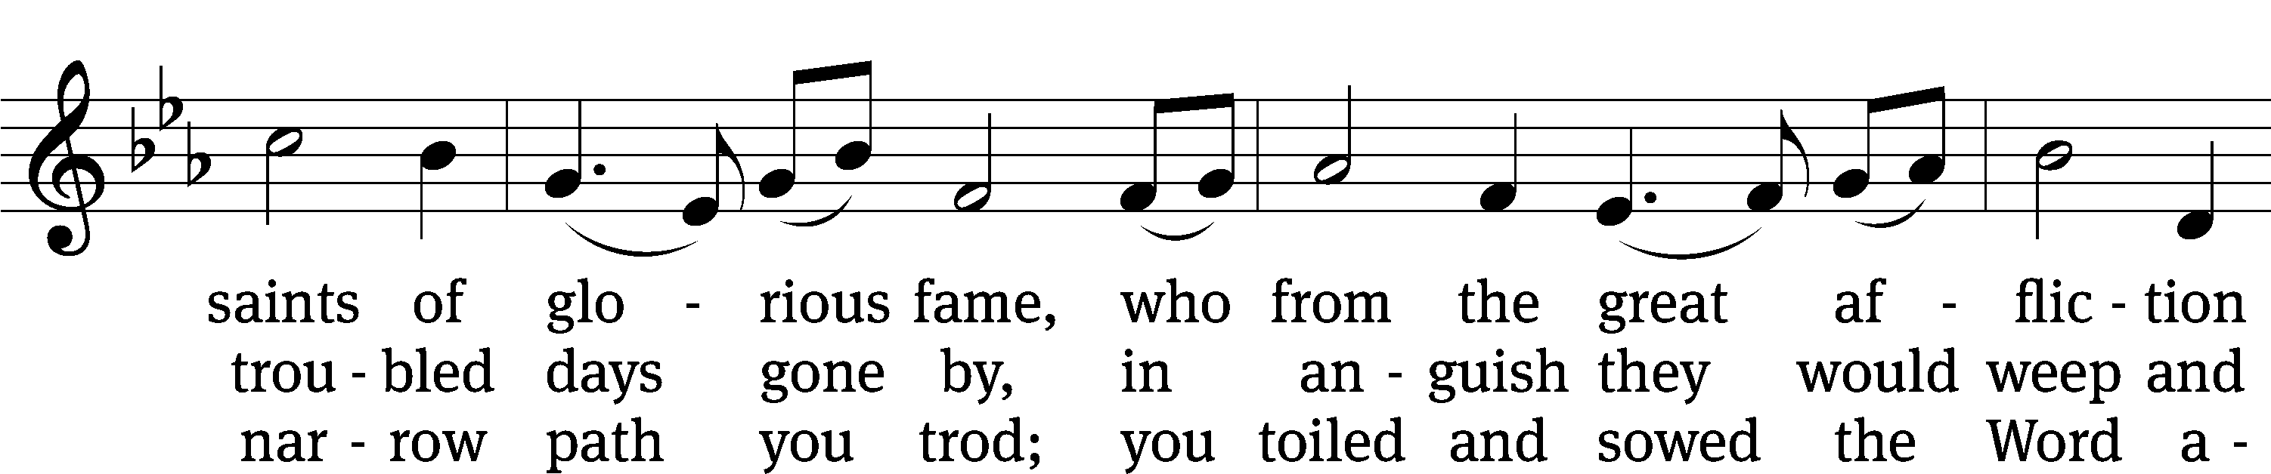
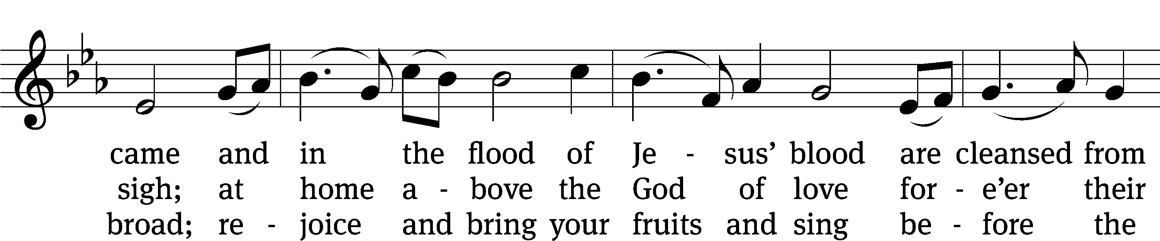
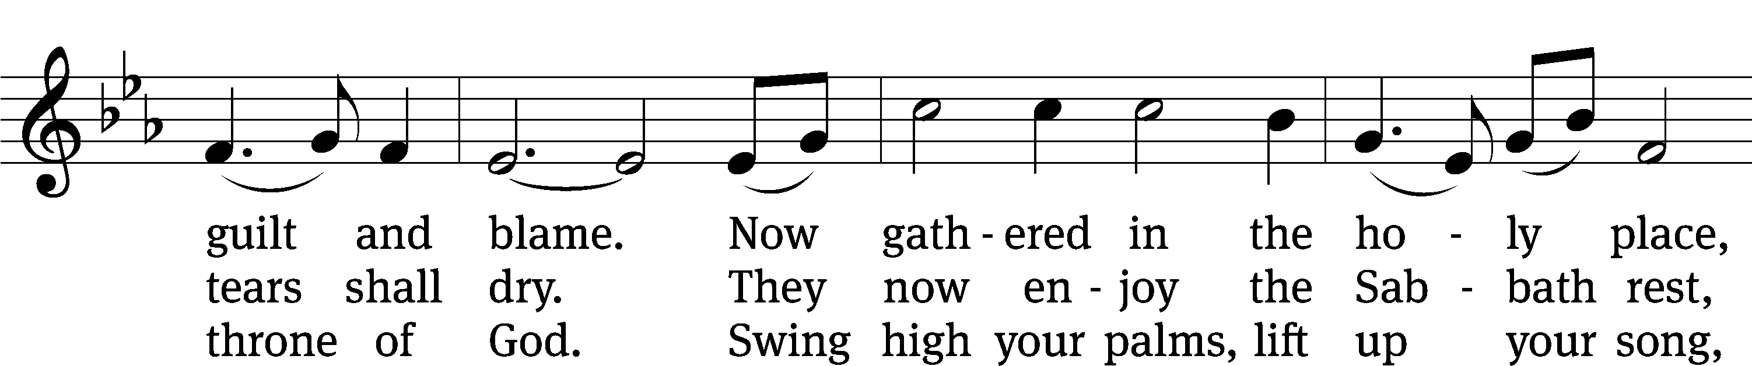
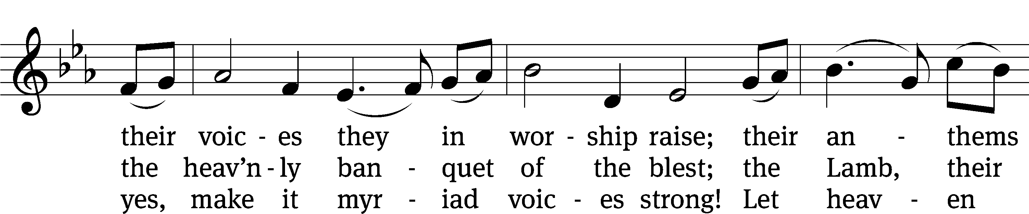
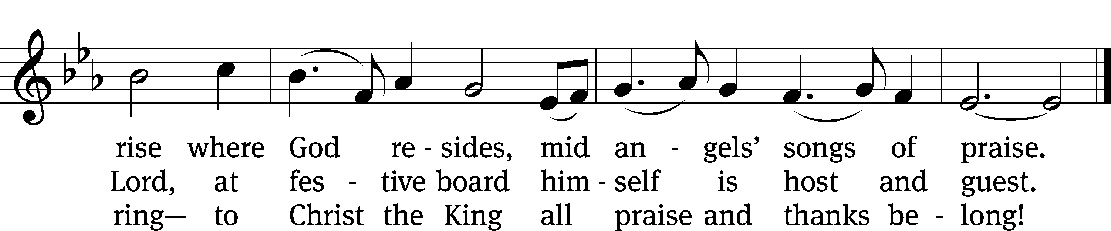
Text: tr. The Lutheran Hymnal, 1941, alt.; Hans Brorson, 1694–1764
Tune: Norwegian, 17th cent.
Text and tune: Public domain

Acknowledgments
Setting One from Christian Worship
Software distributed in partnership with Northwestern Publishing House.
Created by Christian Worship: Service Builder © 2022 Concordia Publishing House.
Serving in Worship
Officiant Pastor Pappenfuss
Organist Marcia Marion Ackling
Choir Director Cynthia Natsis
Bell Choir Director Meg Nortley
Accompanist Laura Sala
Deacons (8:30) Duane Mason and Dave Stevenson
Deacons (11:00) Steve Hoeft and Robert Niethammer
Ushers (8:30) Tim Phelps
Ushers (11:00) Ron Zahn
Altar Guild Margaret Hoeft and Brenda Stevenson
Videographer Ann Latowski

