THE TWENTIEth SUNDAY
AFTER PENTECOST

tRINITY EVANGELICAL LUTHERAN CHURCH | Saline, Michigan
October 23, 2022

WELCOME TO WORSHIP

Thank you for joining us in God’s house today! We cordially ask that our Guests with us this morning sign one of the guestbooks located at either the front or back entryways.

THANK OFFERING: Members of Trinity give their offering as an expression of love and thankfulness to the Lord and to help support the Lord’s work in our community and around the world. Visitors need not feel obligated to participate in this offering which supports our ministry.

Restrooms are located at the back of the upper level (the annex), and in the basement (down the back stairs of the sanctuary or annex). Handicap access is available, please ask an usher for assistance.

Young Families / Toddler Bags – We are GLAD YOU BROUGHT YOUR CHILDREN to our worship service. Jesus said: “Let the little children come to me and do not hinder them, for the kingdom of God belongs to such as these.” We know that having little children in church can be a challenge, but DO NOT WORRY about it. Many of your fellow worshippers have been in your shoes and are just happy you brought your children with you. For your convenience, we have reserved the back rows of seating for parents with small children. These areas provide more flexibility for your family, as well as, easy access to move downstairs if necessary. A closed-circuit TV system allows families to continue participating in the service while downstairs. Pre-school toddler bags and children’s bulletins are available for their enjoyment. Ask an usher for one to use during the service and please return the toddler bag afterwards.

SERVICE of the word
917 God Himself Is Present CW 917
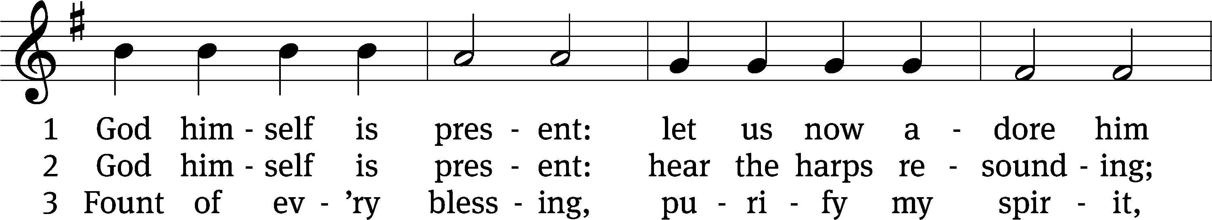
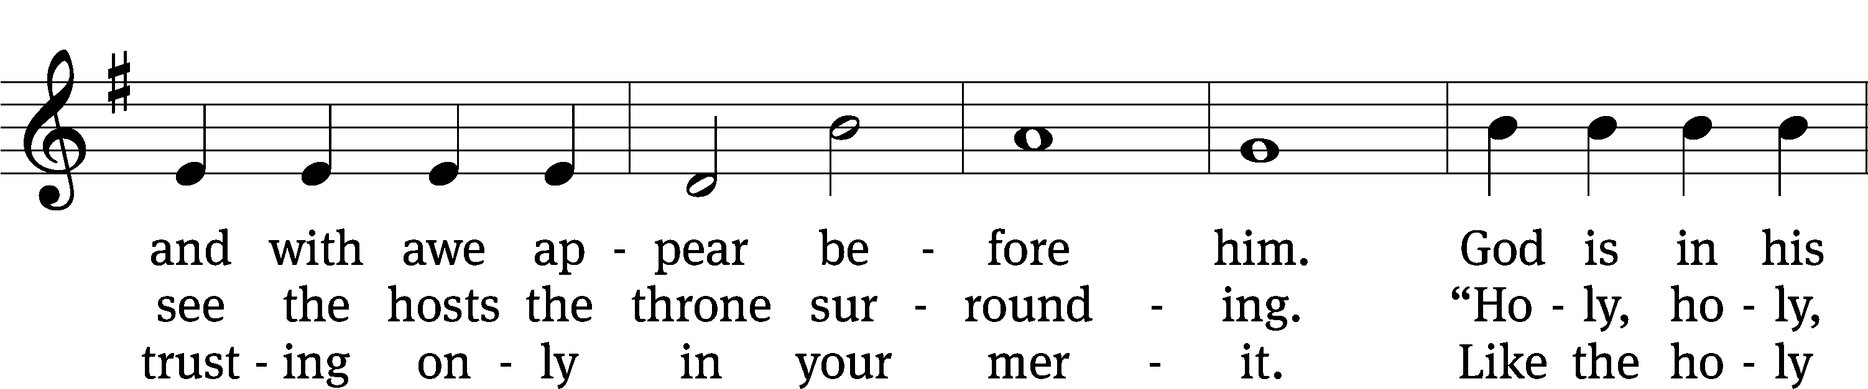
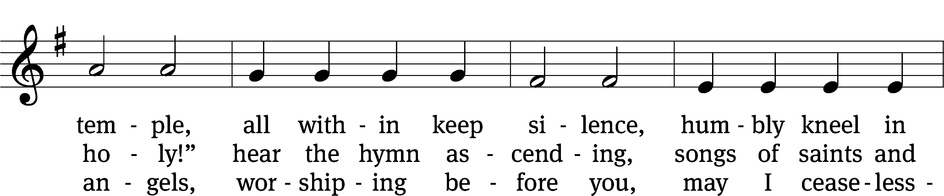
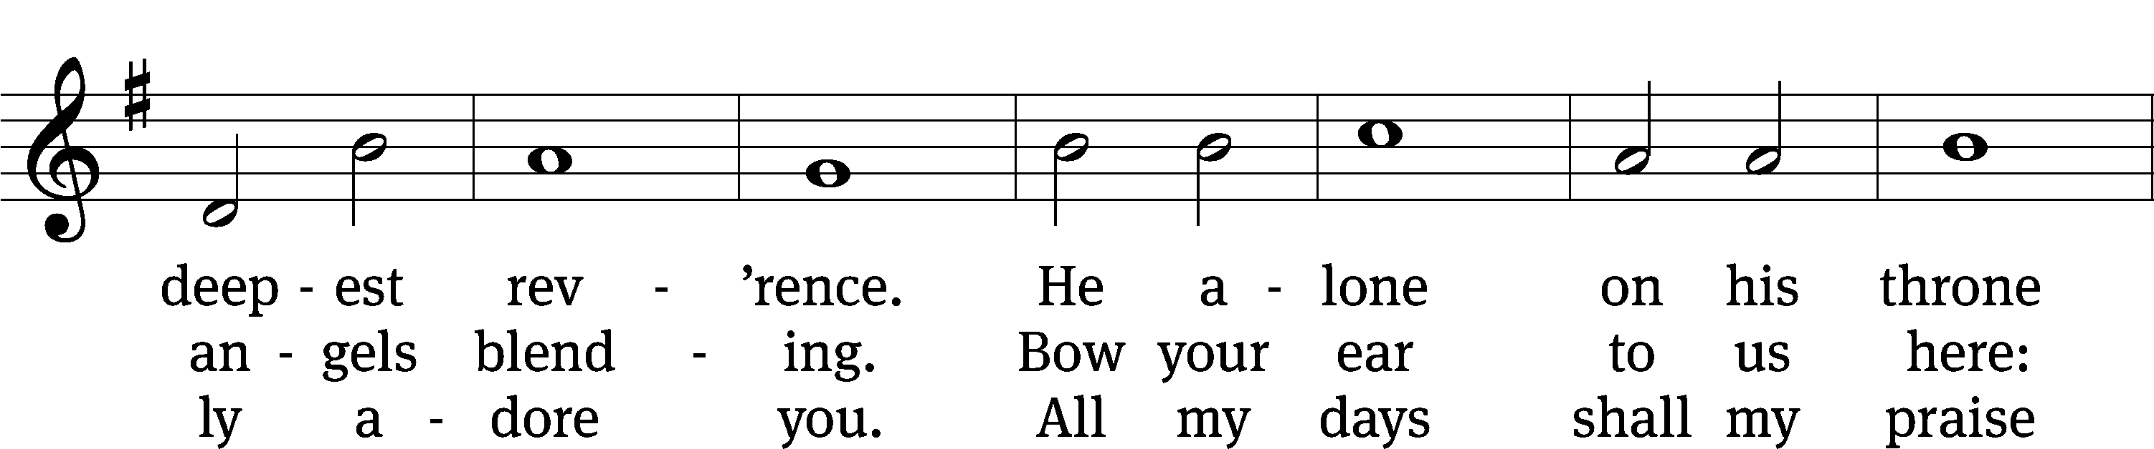
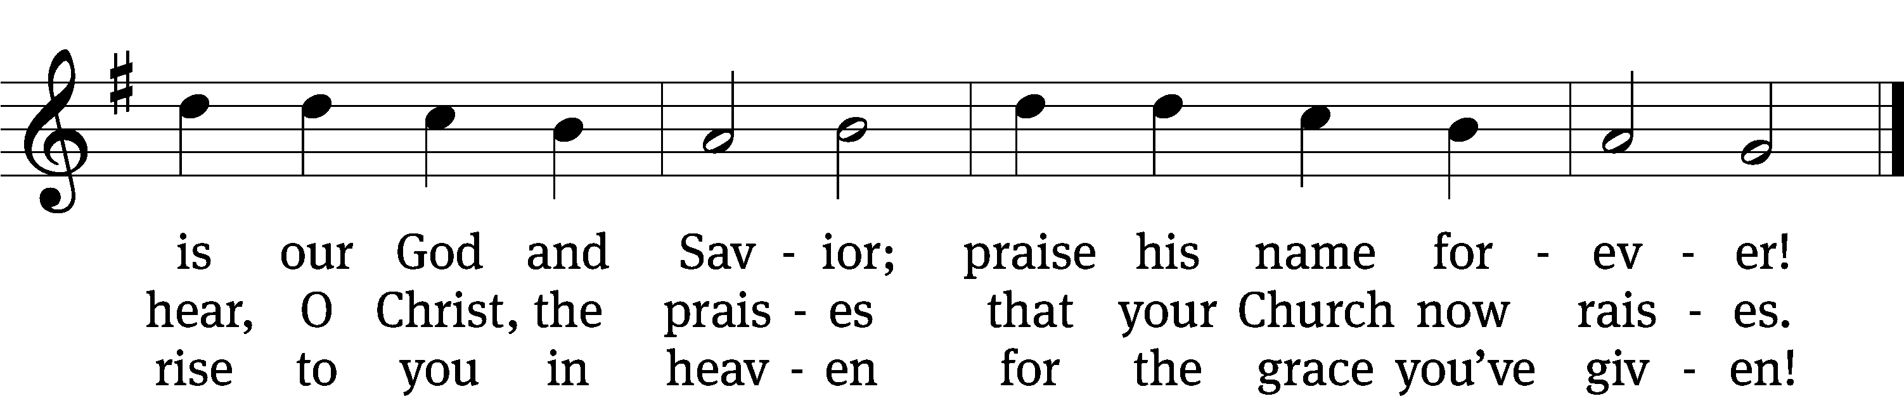
Text: tr. John Miller, 1756–1790, alt.; tr. Frederick W. Foster, 1760–1835; Gerhard Tersteegen, 1697–1769, abr.
Tune: Joachim Neander, 1650–1680
Text and tune: Public domain

PLEASE STAND, IF YOU ARE ABLE

invocation
M: The grace of our Lord (+) Jesus Christ and the love of God and the fellowship of the Holy Spirit be with you.
C: And also with you.
CONFESSION OF SINS
M: We have come into the presence of God, who created us to love and serve him as his dear children. But we have disobeyed him and deserve only his wrath and punishment. Therefore, let us confess our sins to him and plead for his mercy.

C: Merciful Father in heaven, I am altogether sinful from birth. In countless ways I have sinned against you and do not deserve to be called your child. But trusting in Jesus, my Savior, I pray: Have mercy on me according to your unfailing love. Cleanse me from my sin, and take away my guilt.
M: God, our heavenly Father, has forgiven all your sins. By the perfect life and innocent death of our Lord Jesus Christ, he has removed your guilt forever. You are his own dear child. May God give you strength to live according to his will.

C: Amen.

PLEASE BE SEATED

Michigan Lutheran Seminary Concert Choir – Set 1

The Word

the FIRST LESSON Deuteronomy 10:12-22
¹² So now, Israel, what is the Lord your God asking of you but to fear the Lord your God, to walk in all his ways, and to love him and to serve the Lord your God with all your heart and with all your soul, ¹³ to keep the commandments of the Lord and his statutes that I am commanding you today for your own good.
¹⁴ Indeed, the heavens and the heaven of heavens, the earth and everything that is on it—these belong to the Lord your God. ¹⁵ Still, the Lord attached himself to your fathers, loved them, and he chose their descendants after them (that’s you!) from all peoples, as it is today.
¹⁶ So cut away the tough shell of your sinful nature, and do not be stubborn any longer.
¹⁷ The Lord your God is God of Gods and Lord of Lords, the great God, the mighty one and the awesome one, who does not show favoritism and does not take a bribe. ¹⁸ He carries out justice for the fatherless and widows. He loves the alien who dwells among you and gives him food and clothing. ¹⁹ So you are to love the alien, because you were aliens in the land of Egypt.
²⁰ Fear the Lord your God, serve him, cling to him, and take your oaths in his name.
²¹ He is your glory. He is your God, who performed for you these great and awesome things that your own eyes have seen.
²² When your fathers went down to Egypt, they numbered seventy people, but now the Lord your God has made you as numerous as the stars of the sky.

THE SECOND LESSON 1 John 2:15-17

¹⁵ Do not love the world or the things in the world. If anyone loves the world, the love of the Father is not in him. ¹⁶ For everything in the world—the lust of the flesh, the desire of the eyes, boasting about material possessions—is not from the Father but from the world. ¹⁷ The world and its desires pass away, but the one who does the will of God remains forever.ove the world or the

PLEASE Stand, if you are able

Verse of the day

Alleluia. Love the Lord your God with all your heart and with all your soul and with all your mind. Alleluia.

THE GOSPEL LESSON Luke 18:18-30
M: The Gospel according to Luke chapter 18, verses 18-30
¹⁸ A certain ruler asked Jesus, “Good teacher, what must I do to inherit eternal life?”
¹⁹ Jesus asked him, “Why do you call me good? No one is good, except one—God. ²⁰ You know the commandments: ‘You shall not commit adultery. You shall not murder. You shall not steal. You shall not give false testimony. Honor your father and mother.’”^{[a]}
²¹ “I have kept all these since I was a child,” he said.
²² When Jesus heard this, he said to him, “You still lack one thing. Sell all that you have and give to the poor, and you will have treasure in heaven. Then come, follow me.”
²³ But when the ruler heard these words, he became very sad, because he was very rich.
²⁴ When Jesus saw that the man became very sad, he said, “How hard it is for those who have riches to enter the kingdom of God! ²⁵ In fact, it is easier for a camel to go through the eye of a needle than for a rich man to enter the kingdom of God.”
²⁶ Those who heard this said, “Then who can be saved?”
²⁷ He replied, “What is impossible for people is possible for God.”
²⁸ And Peter said, “Look, we have left our possessions^{[b]} and followed you.”
²⁹ He said to them, “Amen I tell you: Anyone who has left house or wife or brothers or parents or children for the sake of the kingdom of God ³⁰ will most certainly receive many times more in this time, and in the age to come, eternal life.”

M: This is the Gospel of the Lord.

PLEASE BE SEATED

SERMONETTE Matthew 9:36-38

⁰³⁶ When he saw the crowds, he was moved with compassion for them, because they were troubled and downcast, like sheep without a shepherd. ³⁷ Then he said to his disciples, “The harvest is plentiful, but the workers are few. ³⁸ Therefore pray that the Lord of the harvest will send out workers into his harvest.”
“What Do We See?”

PLEASE STAND, IF YOU ARE ABLE

THE APOSTLES’ CREED
I believe in God, the Father almighty,
maker of heaven and earth.
I believe in Jesus Christ, his only Son, our Lord,
who was conceived by the Holy Spirit,
born of the virgin Mary,
suffered under Pontius Pilate,
was crucified, died, and was buried.
He descended into hell.
The third day he rose again from the dead.
He ascended into heaven
and is seated at the right hand of God the Father almighty.
From there he will come to judge the living and the dead.
I believe in the Holy Spirit,
the holy Christian Church,
the communion of saints,
the forgiveness of sins,
the resurrection of the body,
and the life everlasting. Amen.

Michigan Lutheran Seminary Concert Choir – Set 2
PRAYER OF THE CHURCH

Eternal Father, your Word is a lamp for our feet and a light to our path. You inspired the Scriptures for teaching, rebuking, correcting, and training in righteousness, so that your servants might be thoroughly equipped for every good work.
Lead us to love your Word more and more and to receive your message with great eagerness.

You have given us your Word that we may believe that Jesus is the Christ, the Son of God, and that by believing we may have life in his name. Enable us to see the wonders of your love in Christ from the beginning to the end of your holy book.
Help us to see Jesus, the pioneer and perfector of our faith.

Work in all your people, especially in parents, the resolve and patience to teach little children the simple truths about the Savior who loves them. Walk with us as we take our children to the manger, the cross, and the empty tomb. Let them find Jesus in stories, songs, and prayers.
Move us to bring up our children in the training and instruction of the Lord.

Provide wisdom and commitment to teachers who train our young people in Sunday Schools and Bible classes. Deepen their knowledge of your Word as they prepare and share the lessons they teach. Move them to model a sincere devotion to the Scriptures.
Lead us to plan for and support the Christian training of children.

Bless the schools and teachers who prepare public ministers of the gospel for service in our churches and around the world. Lead teachers and professors to be faithful to your Word and provide insights that enable them to pass on your truth to their students. Ignite the zeal of young men and women to be willing and eager to share the truths of Scripture with others. Move us to support with our prayers and gifts the schools our synod has established.
We pray that you send workers in your harvest fields.

Work in us that we may find the lasting value of growing in the grace and knowledge of Christ. Lead us to be faithful in our personal study of the Scriptures and in participating in regular Bible classes. Rid us of all thoughts that Christian education ends in our youth. Make us life-long students of your precious Word.
Lead us to believe that at every age your Word remains a lamp for our feet and a light to our path.

How can a young person stay on the path of purity? By living according to your Word. Even when we are old and gray, lead us to meditate on your decrees that we may delight in your wonderful deeds.
Do good to your servants, Lord, according to your Word. Amen.
THE LORD’S PRAYER

C: Our Father, who art in heaven, hallowed be thy name, thy kingdom come, thy will be done on earth as it is in heaven. Give us this day our daily bread; and forgive us our trespasses, as we forgive those who trespass against us; and lead us not into temptation, but deliver us from evil. For thine is the kingdom and the power and the glory forever and ever. Amen.

M: Brothers and sisters, go in peace. Live in harmony with one another. Serve the Lord with gladness.
The Lord bless you and keep you.
The Lord make his face shine on you and be gracious to you.
The Lord look on you with favor and (+) give you peace.

PLEASE BE SEATED

518 Christ Be My Leader CW 518
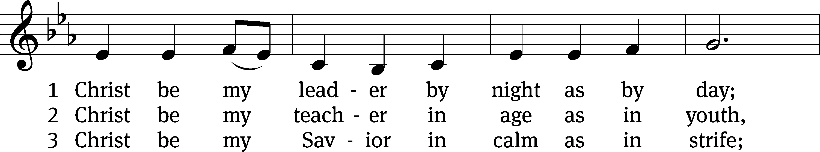
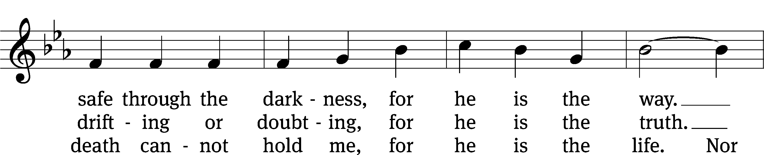
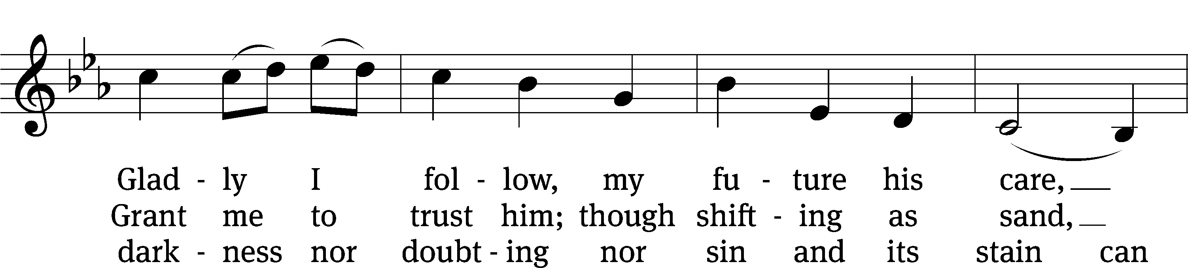
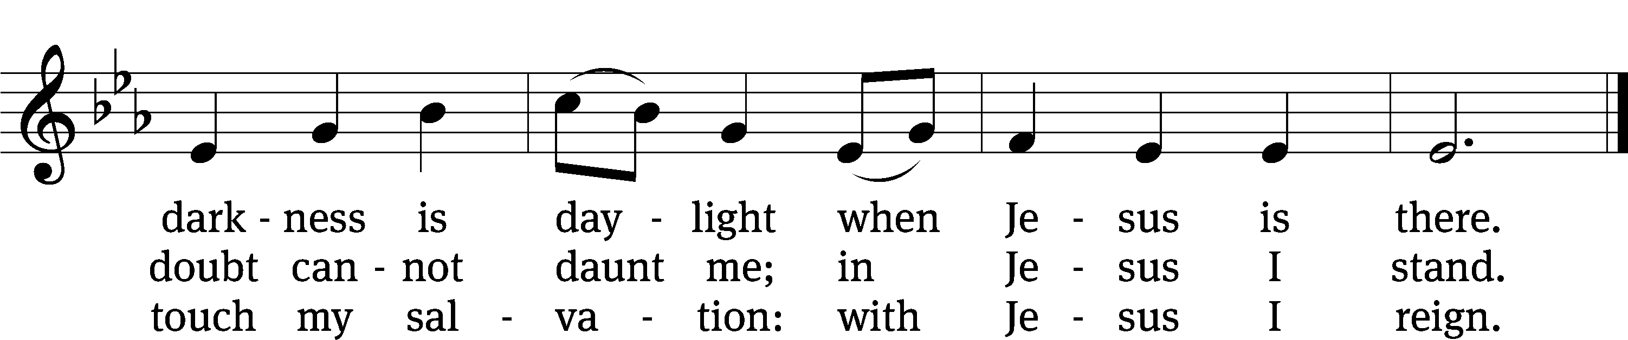
Text: Timothy Dudley-Smith, b. 1926
Tune: Irish
Text: © 1964, ren. 1992 Hope Publishing Co. Used by permission: OneLicense no. 727703
Tune: Public domain

Serving In Worship
Officiant Pastor Natsis
Organist Marcia Marion Ackling
Deacons (8:30) Dave Stevenson and Jim Tice
(11:00) Steve Hoeft and Jeff Neuburger
Ushers (8:30) Dale Finkbeiner and Mark Finkbeiner
(11:00) Ed Sala and Al Whitley
Altar Guild Sandy Kirkpatrick and Barb Neuburger
Videographer Jake Vershum

Copyright information
Service of the Word: Christian Worship. © 1993 Northwestern Publishing House. All rights reserved.
Reprinted with permission under ONE LICENSE #A-727703 and CCLI #1151741/CSPL126093

Words and Music: All rights reserved. Reprinted with permission under ONE LICENSE #A-727703 and
CCLI #1151741/CSPL126093

tlcsaline.church

0

