THE EighTEENth SUNDAY
AFTER PENTECOST

tRINITY EVANGELICAL LUTHERAN CHURCH | Saline, Michigan
October 9, 2022

WELCOME TO WORSHIP

Thank you for joining us in God’s house today! We cordially ask that our Guests with us this morning sign one of the guestbooks located at either the front or back entryways.

THANK OFFERING: Members of Trinity give their offering as an expression of love and thankfulness to the Lord and to help support the Lord’s work in our community and around the world. Visitors need not feel obligated to participate in this offering which supports our ministry.

Restrooms are located at the back of the upper level (the annex), and in the basement (down the back stairs of the sanctuary or annex). Handicap access is available, please ask an usher for assistance.

Young Families / Toddler Bags – We are GLAD YOU BROUGHT YOUR CHILDREN to our worship service. Jesus said: “Let the little children come to me and do not hinder them, for the kingdom of God belongs to such as these.” We know that having little children in church can be a challenge, but DO NOT WORRY about it. Many of your fellow worshippers have been in your shoes and are just happy you brought your children with you. For your convenience, we have reserved the back rows of seating for parents with small children. These areas provide more flexibility for your family, as well as, easy access to move downstairs if necessary. A closed-circuit TV system allows families to continue participating in the service while downstairs. Pre-school toddler bags and children’s bulletins are available for their enjoyment. Ask an usher for one to use during the service and please return the toddler bag afterwards.

SERVICE of the word
505 For the Beauty of the Earth CW 505
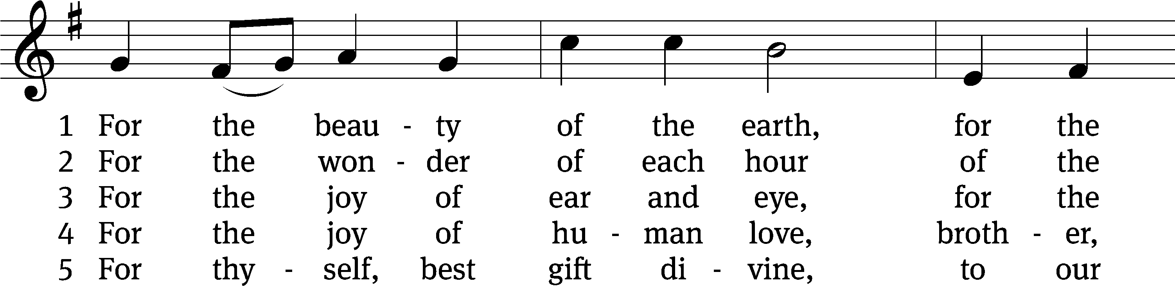
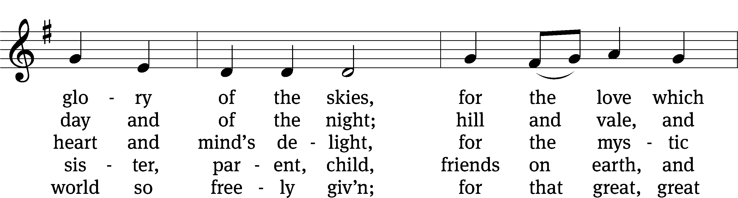
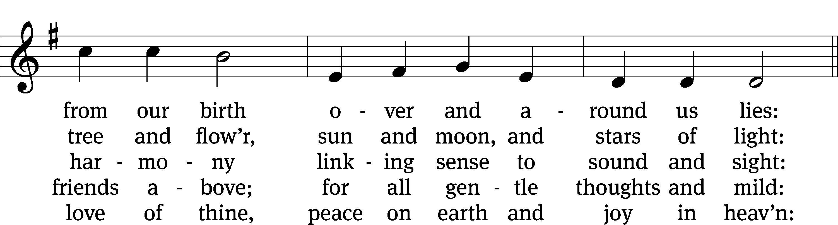
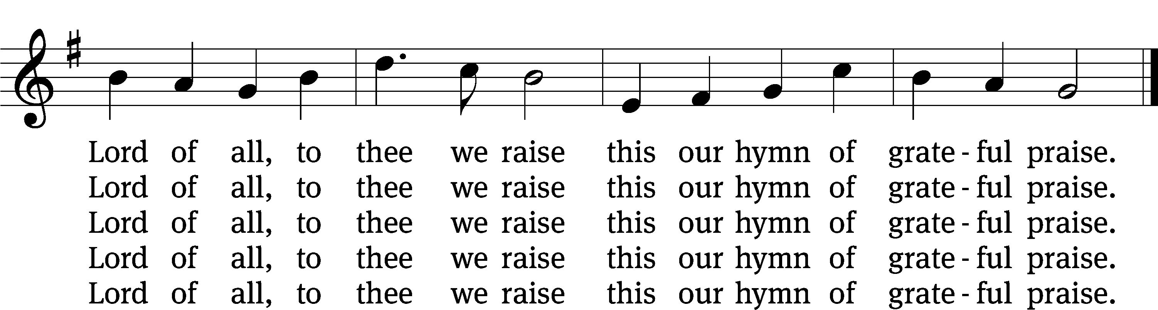
Text: Folliott S. Pierpoint, 1835–1917, abr., alt.
Tune: Conrad Kocher, 1786–1872, alt.
Text and tune: Public domain

PLEASE STAND, IF YOU ARE ABLE

invocation
M: The grace of our Lord (+) Jesus Christ and the love of God and the fellowship of the Holy Spirit be with you.
C: And also with you.
CONFESSION OF SINS
M: We have come into the presence of God, who created us to love and serve him as his dear children. But we have disobeyed him and deserve only his wrath and punishment. Therefore, let us confess our sins to him and plead for his mercy.

C: Merciful Father in heaven, I am altogether sinful from birth. In countless ways I have sinned against you and do not deserve to be called your child. But trusting in Jesus, my Savior, I pray: Have mercy on me according to your unfailing love. Cleanse me from my sin, and take away my guilt.
M: God, our heavenly Father, has forgiven all your sins. By the perfect life and innocent death of our Lord Jesus Christ, he has removed your guilt forever. You are his own dear child. May God give you strength to live according to his will.

C: Amen.

PRAYER AND PRAISE

M: In the peace of forgiveness, let us praise the Lord.

OH, TASTE AND SEE

PRAYER OF THE DAY

Let us pray.

Grant, O merciful Lord, to your faithful people pardon and peace that they may be cleansed from all their sins and serve you with a quiet mind; through your Son, Jesus Christ our Lord, who lives and reigns with you and the Holy Spirit, one God, now and forever.

PLEASE BE SEATED

The Word

the FIRST LESSON Genesis 8:15-22
¹⁵ God spoke to Noah. He said, ¹⁶ “Go out of the ark—you, your wife, your sons, and your sons’ wives with you. ¹⁷ Bring out with you every living thing of every sort that is with you, all flesh, including birds, livestock, and every creeping thing that creeps on the earth, so that they may swarm over the earth, and be fruitful and multiply on the earth.”
¹⁸ Noah went out with his sons, his wife, and his sons’ wives along with him. ¹⁹ Every animal, every creeping thing, every bird, and whatever swarms on the earth went out of the ship, species by species.
²⁰ Noah built an altar to the Lord and took from every clean animal and every clean bird and offered burnt offerings on the altar. ²¹ The Lord smelled the pleasant aroma. The Lord said in his heart, “I will never again curse the soil anymore because of man, for the thoughts he forms in his heart are evil from his youth. Neither will I ever again strike every living thing, as I have done. ²² While the earth remains, seedtime and harvest, cold and heat, summer and winter, and day and night shall not cease.”
111B I Will Give Thanks to the LORD Psalm 111B
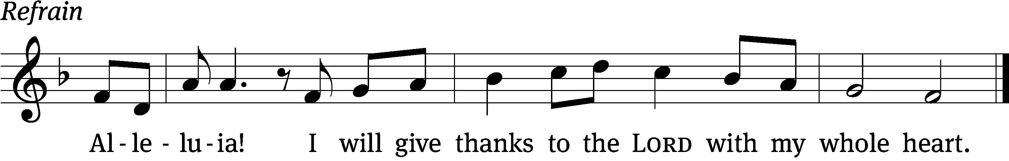
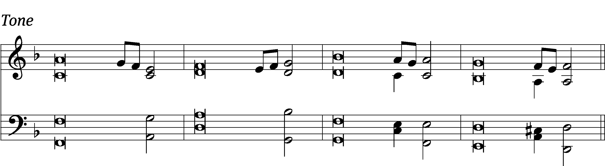

Great are the works / of the Lord;
they are pondered by all who de- / light in them.
Glorious and majestic / are his deeds,
and his righteousness endures for- / ever. Refrain

He has caused his wonders to be re- / membered;
the Lord is gracious and com- / passionate.
He provided redemption for his / people;
holy and awesome / is his name.
Glory be to the Father and / to the Son
and to the Holy / Spirit,
as it was in the be- / ginning,
is now, and will be forever. / Amen. Refrain
Text: Book of Common Prayer, 1979
Tune: David Cherwien
Setting: David Cherwien
Text: Public domain
Music: © 1989 Concordia Publishing House. Used by permission: License no. 130003540

THE SECOND LESSON 2 Corinthians 9:10-15
¹⁰ And he who provides seed to the sower and bread for food will provide and multiply your seed for sowing, and will increase the harvest of your righteousness. ¹¹ You will be made rich in every way so that you may be generous^{[a]} in every way, which produces thanksgiving to God through us.
¹² To be sure, the administration of this service is not only making up for what is lacking among the saints, but it is also overflowing in many prayers of thanksgiving to God. ¹³ By proving yourselves in this service, many people are glorifying God, as they see the obedience shown in your confession of the gospel of Christ, and the generosity^{[b]} shown in your sharing with them and all people. ¹⁴ At the same time as they pray for you, they also express their longing for you, because of the extraordinary measure of God’s grace given to you. ¹⁵ Thanks be to God for his indescribable gift!

PLEASE Stand, if you are able

Verse of the day

THE GOSPEL LESSON LUKE 17:11-19
M: The Gospel according to Luke chapter 17, verses 11-19
¹¹ On another occasion, as Jesus was on his way to Jerusalem, he was passing along the border between Samaria and Galilee. ¹² When he entered a certain village, ten men with leprosy met him. Standing at a distance, ¹³ they called out loudly, “Jesus, Master, have mercy on us!”
¹⁴ When he saw them, he said, “Go, show yourselves to the priests.” As they went away they were cleansed.
¹⁵ One of them, when he saw that he was healed, turned back, glorifying God with a loud voice. ¹⁶ He fell on his face at Jesus’ feet, thanking him. And he was a Samaritan. ¹⁷ Jesus responded, “Were not ten cleansed? Where are the other nine? ¹⁸ Was no one found to return and give glory to God except this foreigner?” ¹⁹ Then he said to him, “Get up and go your way. Your faith has saved you.”
M: This is the Gospel of the Lord.

PLEASE BE SEATED

503 Oh, That I Had a Thousand Voices CW 503
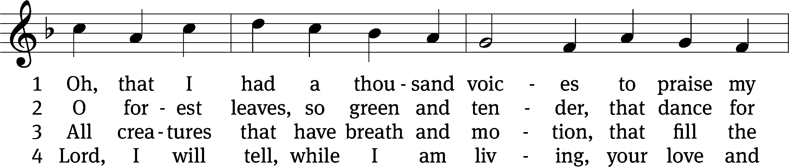
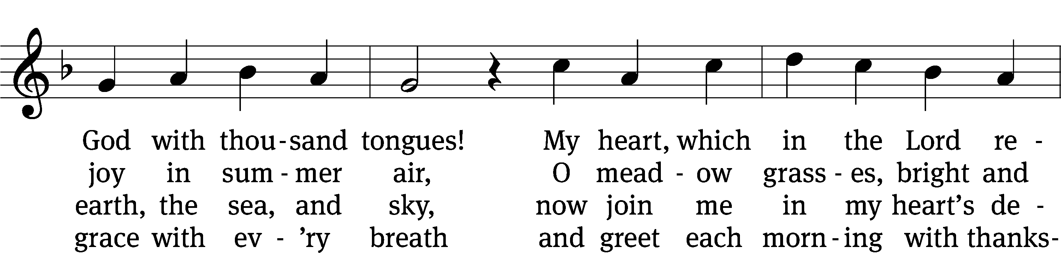
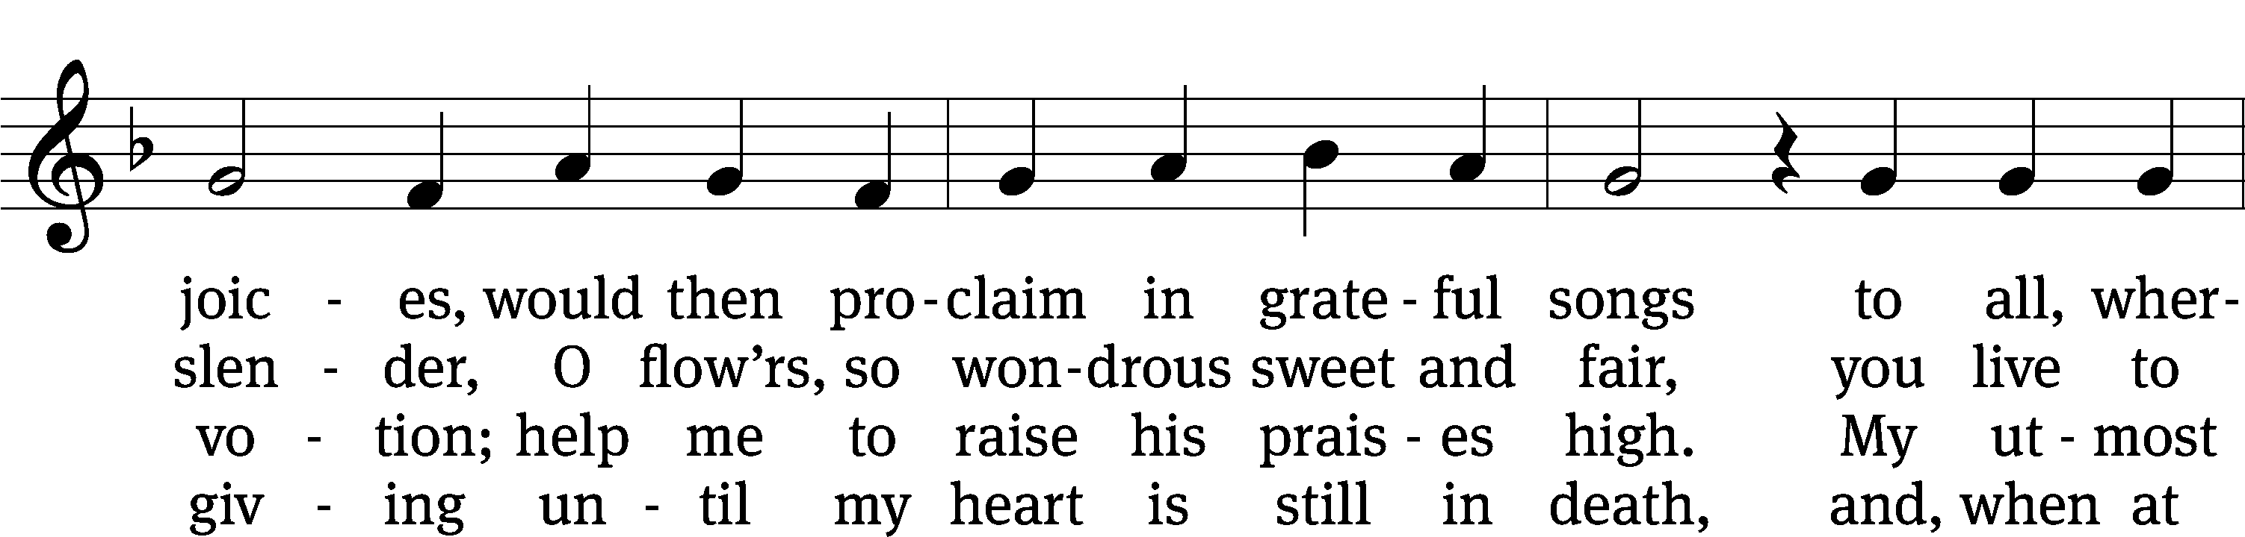
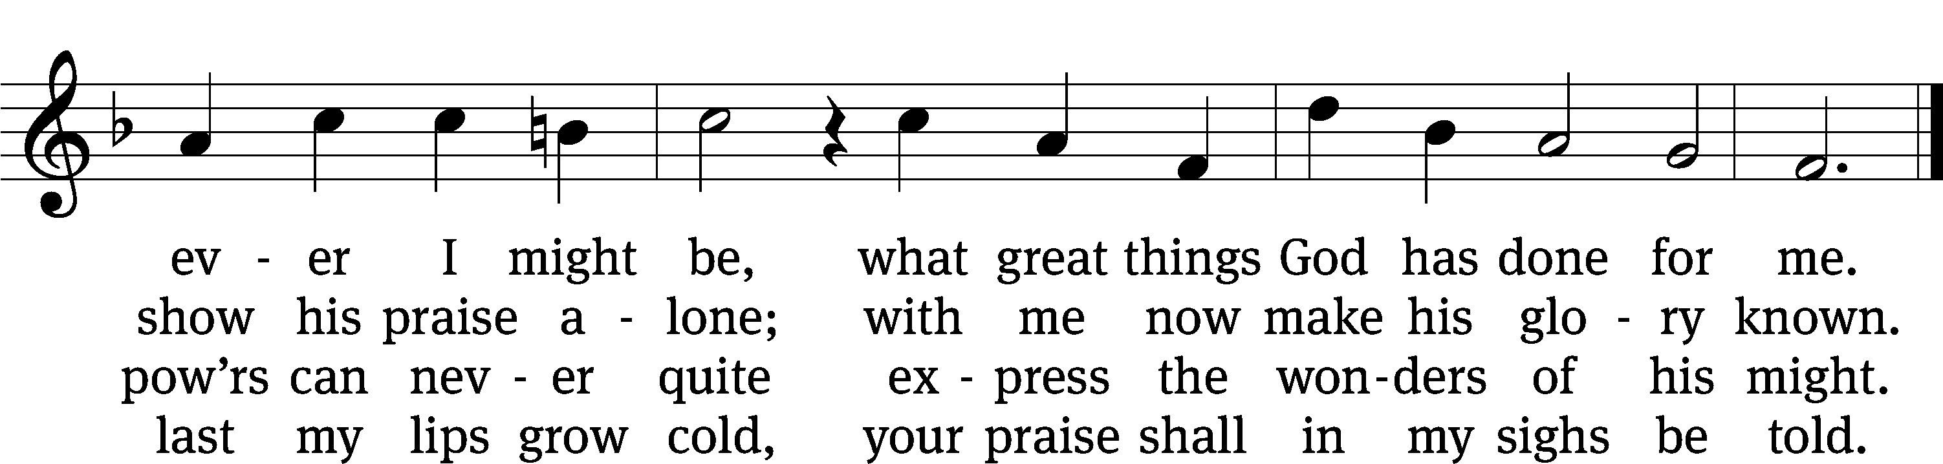
Text: tr. The Lutheran Hymnal, 1941, alt.; Johann Mentzer, 1658–1734, abr.
Tune: Johann B. König, 1691–1758
Text: © 1941 Concordia Publishing House. Used by permission: OneLicense no. 727703
Tune: Public domain

ONE BY ONE Part Two

PLEASE STAND, IF YOU ARE ABLE

THE APOSTLES’ CREED
I believe in God, the Father almighty,
maker of heaven and earth.
I believe in Jesus Christ, his only Son, our Lord,
who was conceived by the Holy Spirit,
born of the virgin Mary,
suffered under Pontius Pilate,
was crucified, died, and was buried.
He descended into hell.
The third day he rose again from the dead.
He ascended into heaven
and is seated at the right hand of God the Father almighty.
From there he will come to judge the living and the dead.
I believe in the Holy Spirit,
the holy Christian Church,
the communion of saints,
the forgiveness of sins,
the resurrection of the body,
and the life everlasting. Amen.

PRAYER OF THE CHURCH

THE LORD’S PRAYER

C: Our Father, who art in heaven, hallowed be thy name, thy kingdom come, thy will be done on earth as it is in heaven. Give us this day our daily bread; and forgive us our trespasses, as we forgive those who trespass against us; and lead us not into temptation, but deliver us from evil. For thine is the kingdom and the power and the glory forever and ever. Amen.

PLEASE BE SEATED

624 Praise to the Lord, the Almighty CW 624
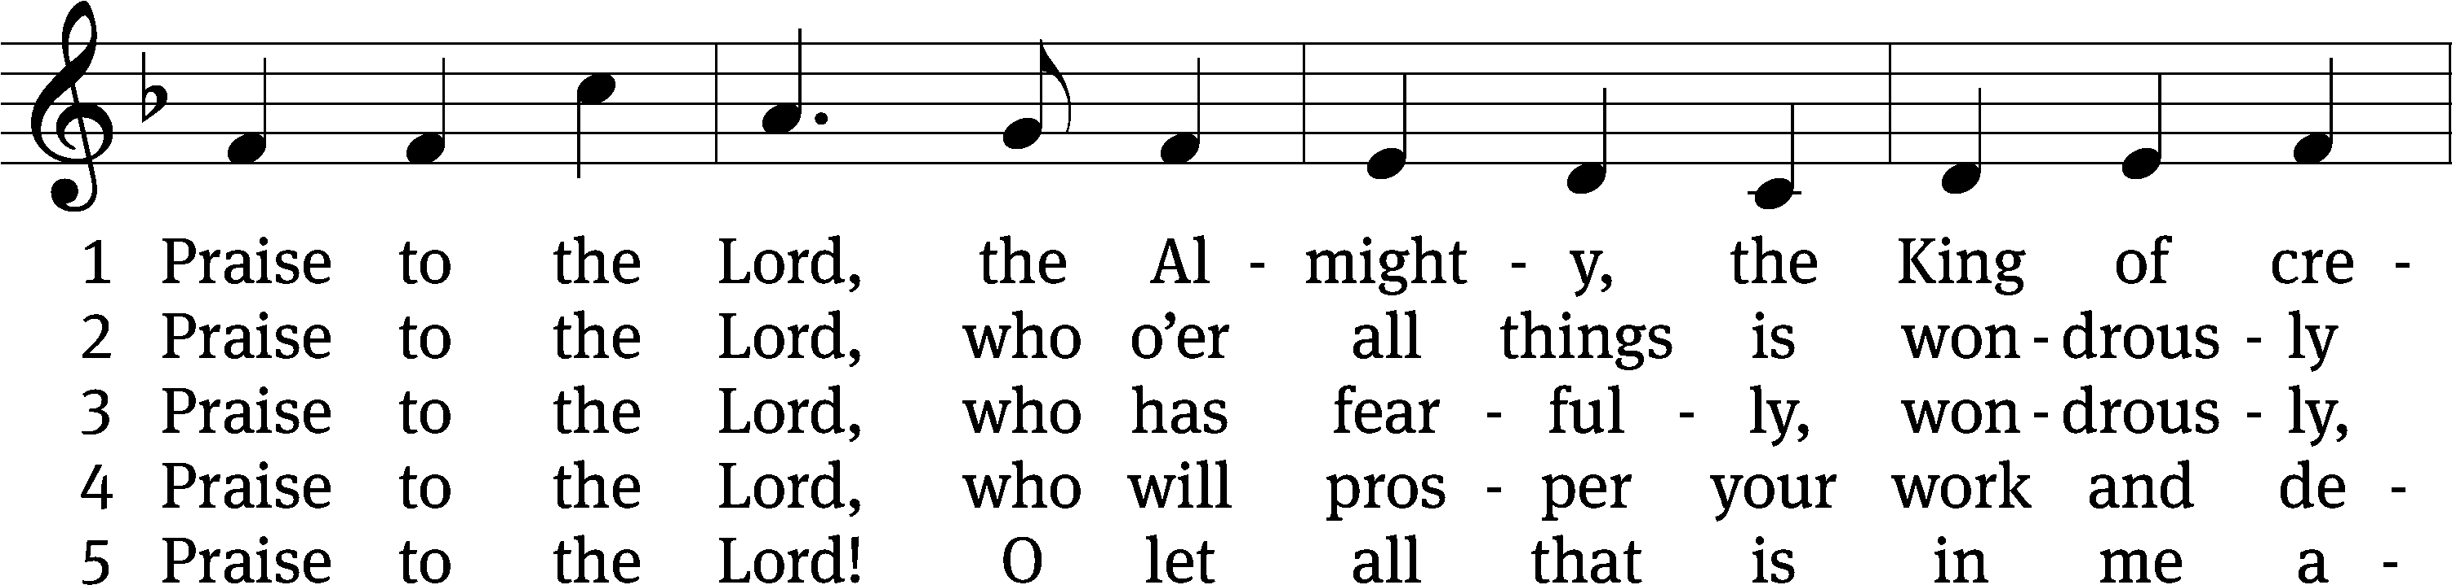
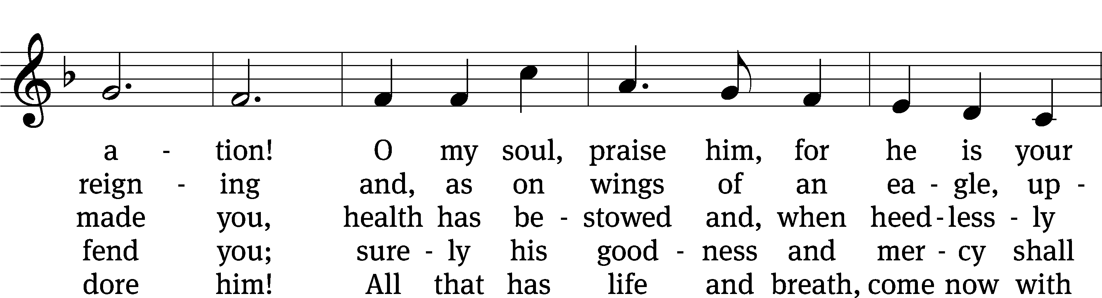
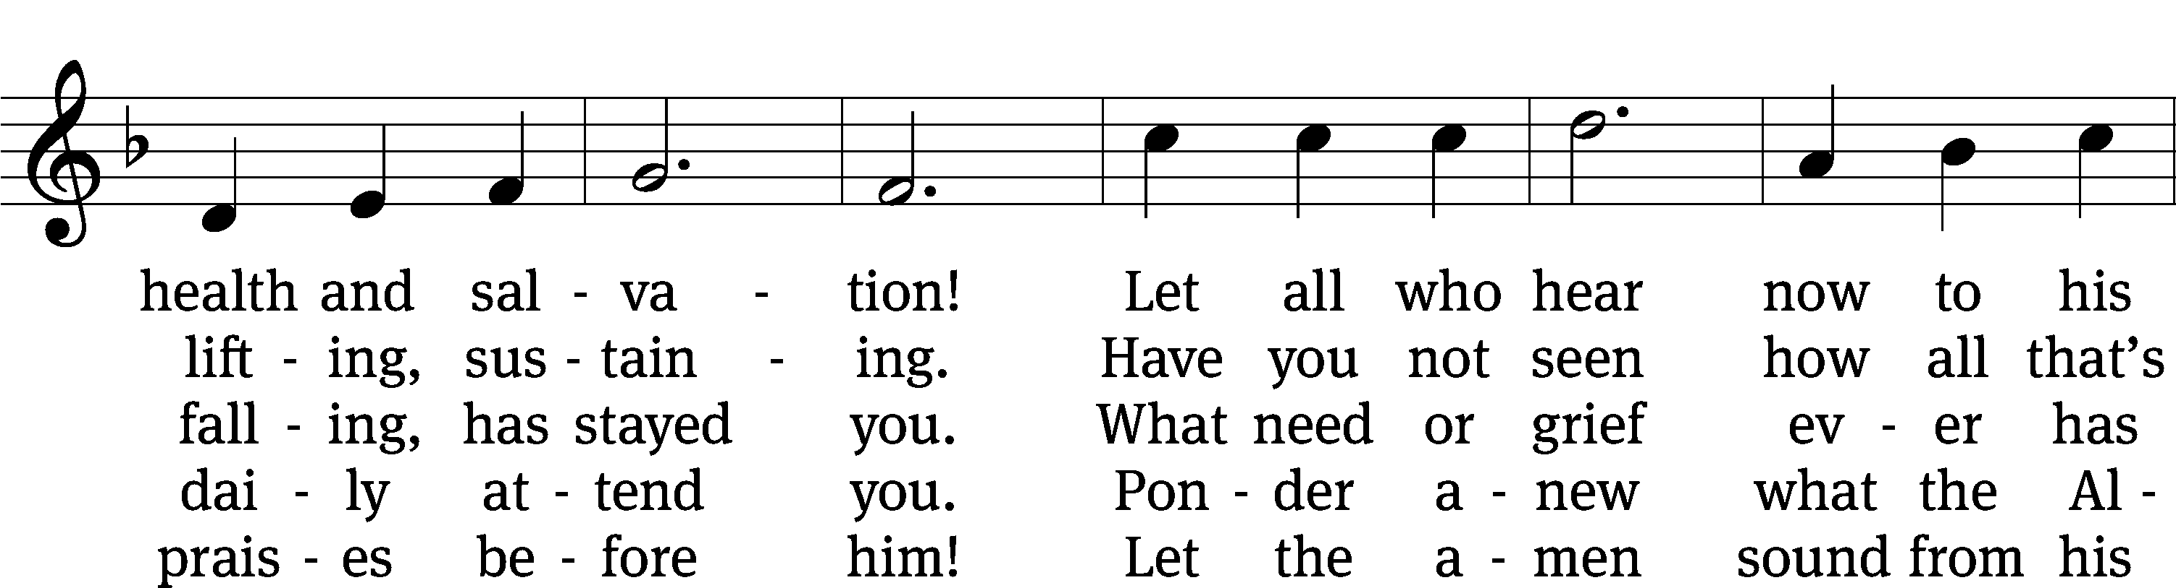
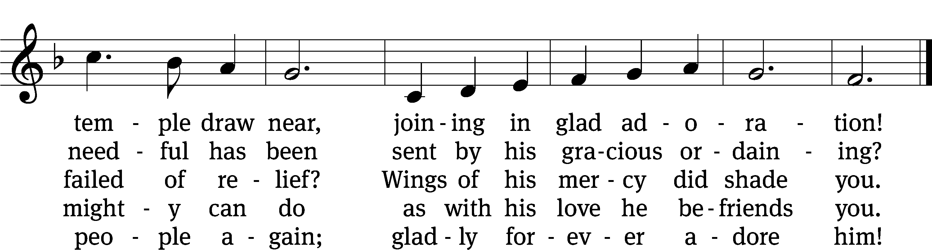
Text: tr. Catherine Winkworth, 1827–1878, alt.; Joachim Neander, 1650–1680
Tune: Ander Theil Des Erneuerten Gesang-Buchs, Stralsund, 1665, alt
Text and tune: Public domain

PLEASE STAND, IF YOU ARE ABLE

CLOSING PRAYER
M: Almighty God, we thank you for teaching us the things you want us to believe and do. Help us by your Holy Spirit to keep your Word in pure hearts that we may be strengthened in faith, guided in holiness, and comforted in life and in death, through Jesus Christ, our Lord, who lives and reigns with you and the Holy Spirit, one God, now and forever.

M: Brothers and sisters, go in peace. Live in harmony with one another. Serve the Lord with gladness.
The Lord bless you and keep you.
The Lord make his face shine on you and be gracious to you.
The Lord look on you with favor and (+) give you peace.

PLEASE BE SEATED

623 O Bless the Lord, My Soul CW 623
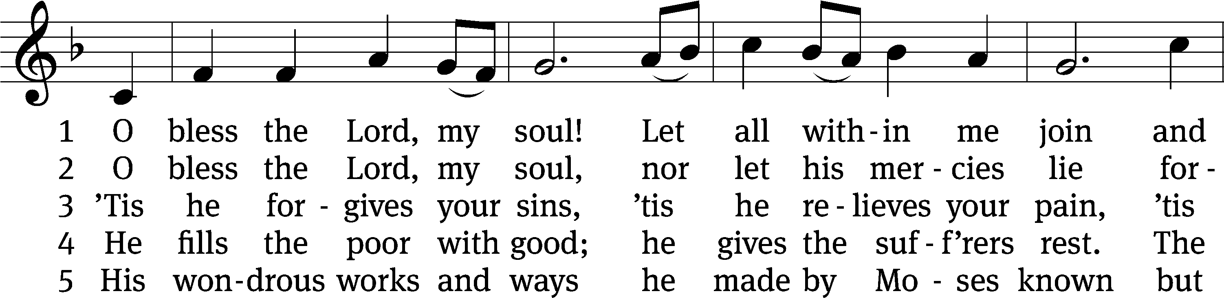
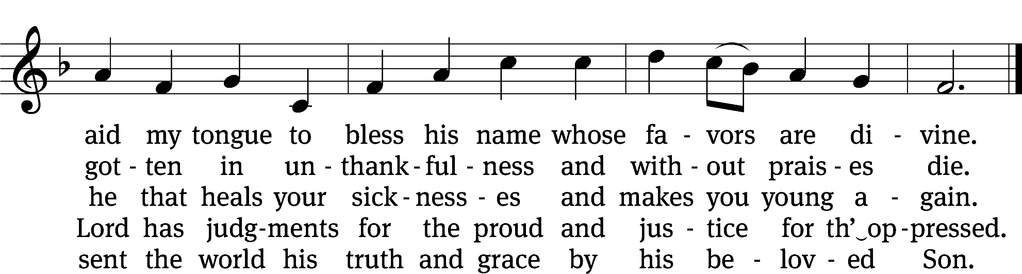
Text: Isaac Watts, 1674–1748, abr., alt.
Tune: Aaron Williams, 1731–1776
Text and tune: Public domain

Serving In Worship
Officiant Pastor Natsis
Organist Sarah Hanke
Deacons (8:30) Dave Stevenson and Jim Tice
(11:00) Steve Hoeft and Jeff Neuburger
Ushers (8:30) Dale Finkbeiner and Mark Finkbeiner
(11:00) Ed Sala and Al Whitley
Altar Guild Sandy Kirkpatrick and Barb Neuburger
Videographer Rick Schneider

Copyright information
Service of the Word: Christian Worship. © 1993 Northwestern Publishing House. All rights reserved.
Reprinted with permission under ONE LICENSE #A-727703 and CCLI #1151741/CSPL126093

Words and Music: All rights reserved. Reprinted with permission under ONE LICENSE #A-727703 and
CCLI #1151741/CSPL126093

tlcsaline.church

