THE NINTEENth SUNDAY
after pentecost
tRINITY EVANGELICAL LUTHERAN CHURCH | Saline, Michigan
October 8, 2023

WELCOME TO WORSHIP

Thank you for joining us in God’s house today! We cordially ask that our Guests with us this morning sign one of the guestbooks located at either the front or back entryways.

THANK OFFERING: Members of Trinity give their offering as an expression of love and thankfulness to the Lord and to help support the Lord’s work in our community and around the world. Visitors need not feel obligated to participate in this offering which supports our ministry.

Restrooms are located at the back of the upper level (the annex), and in the basement (down the back stairs of the sanctuary or annex). Handicap access is available, please ask an usher for assistance.

Young Families / Toddler Bags – We are GLAD YOU BROUGHT YOUR CHILDREN to our worship service. Jesus said: “Let the little children come to me and do not hinder them, for the kingdom of God belongs to such as these.” We know that having little children in church can be a challenge, but DO NOT WORRY about it. Many of your fellow worshippers have been in your shoes and are just happy you brought your children with you. For your convenience, we have reserved the back rows of seating for parents with small children. These areas provide more flexibility for your family, as well as, easy access to move downstairs if necessary. A closed-circuit TV system allows families to continue participating in the service while downstairs. Pre-school toddler bags and children’s bulletins are available for their enjoyment. Ask an usher for one to use during the service and please return the toddler bag afterwards.

SERVICE of the word
11 a.m. Preservice Duet Pachelbel’s Canon/Seek Ye First
920 Christ Is Made the Sure Foundation CW 920
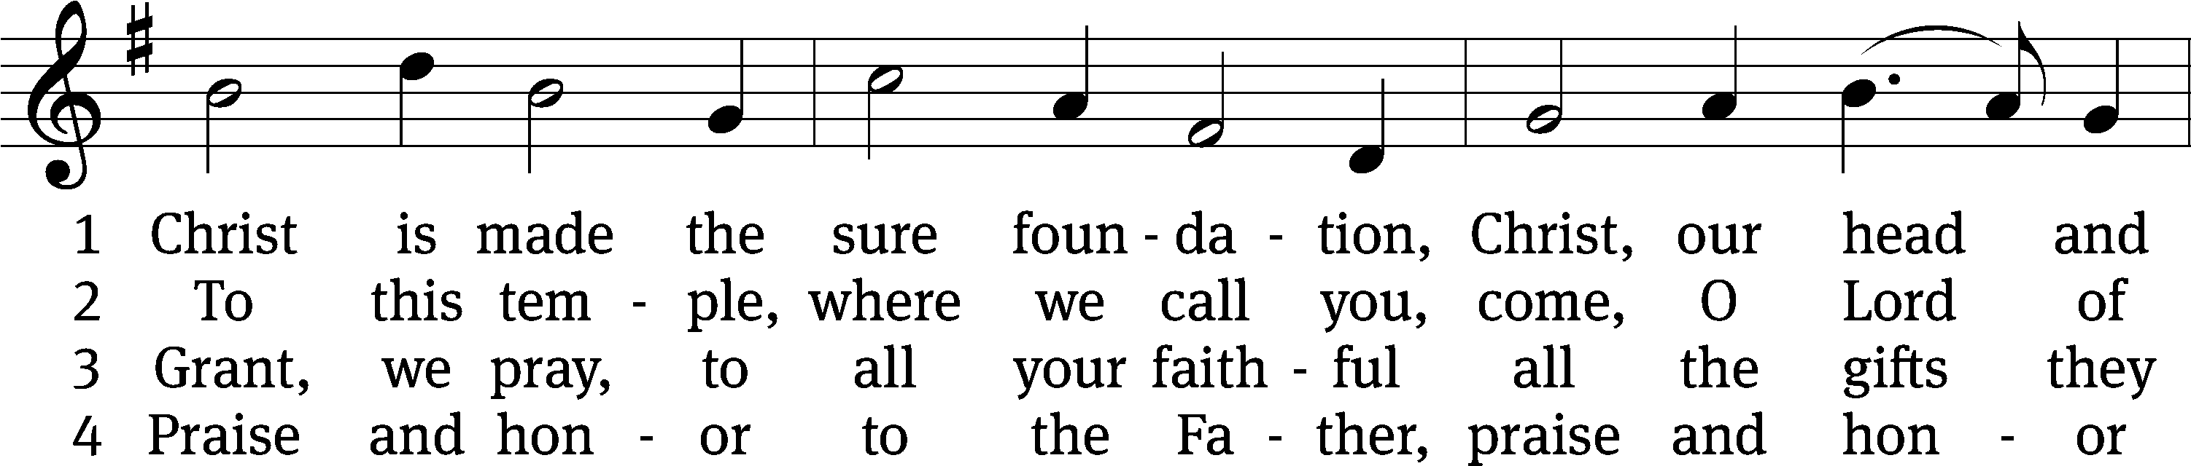
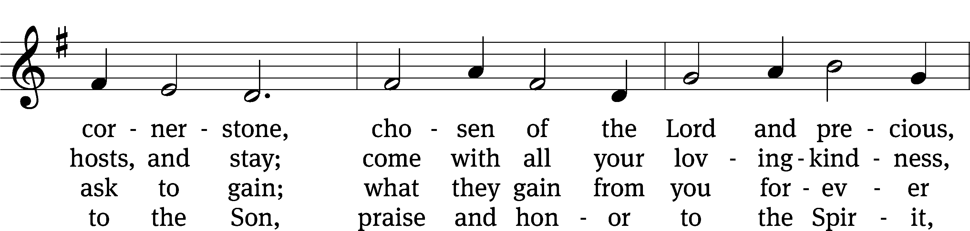
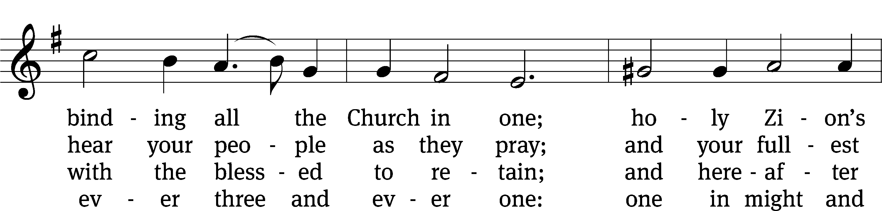
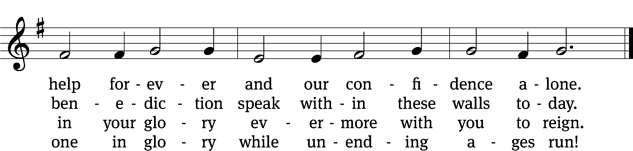
Text: tr. John Mason Neale, 1818–1866, abr., alt.; Latin, c. 8th cent., abr.
Tune: Henry Purcell, 1659–1695, adapt.
Text and tune: Public domain

PLEASE STAND, IF YOU ARE ABLE

invocation
M: The grace of our Lord (+) Jesus Christ and the love of God and the fellowship of the Holy Spirit be with you.
C: And also with you.

CONFESSION OF SINS
M: We have come into the presence of God, who created us to love and serve him as his dear children. But we have disobeyed him and deserve only his wrath and punishment. Therefore, let us confess our sins to him and plead for his mercy.

C: Merciful Father in heaven, I am altogether sinful from birth. In countless ways I have sinned against you and do not deserve to be called your child. But trusting in Jesus, my Savior, I pray: Have mercy on me according to your unfailing love. Cleanse me from my sin, and take away my guilt.

M: God, our heavenly Father, has forgiven all your sins. By the perfect life and innocent death of our Lord Jesus Christ, he has removed your guilt forever. You are his own dear child. May God give you strength to live according to his will.

C: Amen.
PRAYER AND PRAISE

M: In the peace of forgiveness, let us praise the Lord.

OH, TASTE AND SEE

PRAYER OF THE DAY

Let us pray.

O Lord Jesus Christ, preserve the congregation of believers with your never failing mercy. Help us avoid whatever is wicked and harmful, and guide us in the way that leads to our salvation; for you live and reign with the Father and the Holy Spirit, one God, now and forever.

PLEASE BE SEATED
The Word

the FIRST LESSON Isaiah 5:1-7

¹ Let me sing for my loved one a song about my loved one’s vineyard.
My loved one had a vineyard on a fertile ridge.
² He dug it up and gathered the stones out of it.
He planted it with the best vines.
He built a tower in the middle of it.
He also cut a winepress into it.
He expected it to produce clusters of sweet grapes,
but it produced only sour grapes.
³ So now, you residents of Jerusalem and you men of Judah,
judge between me and my vineyard.
⁴ What more could have been done for my vineyard
that I have not already done for it?
When I expected it to produce clusters of sweet grapes,
why did it produce sour grapes?
⁵ Now, let me tell you what I will do to my vineyard.
I will take away its hedge, and it will become a pasture.
I will break down its wall, and it will be trampled down.
⁶ I will make it a wasteland.
It will not be pruned or hoed.
So briers and thorns will shoot up.
I will also command the clouds not to pour rain on it.
⁷ Yes, the vineyard of the Lord of Armies is the house of Israel,
and the men of Judah are the planting that was pleasing to him.
He expected justice, but instead there was oppression.
He expected righteousness, but there was an outcry.

PSALM OF THE DAY Psalm 80
Sing only verses 3 & 4

SECOND LESSON Philippians 3:12-21
¹² Not that I have already obtained this or have already reached the goal, but I press on to take hold of that for which Christ Jesus also took hold of me. ¹³ Brothers, I do not consider myself to have taken hold of it yet, but there is one thing I do: Forgetting the things that are behind and straining toward the things that are ahead, ¹⁴ I press on toward the goal, for the prize of the upward call of God in Christ Jesus. ¹⁵ Therefore, let all of us who are mature continue to think this way. And if you think differently about anything, God will reveal this to you too. ¹⁶ Only let us think the same thing and walk in line with what we already have attained.
¹⁷ Brothers, join together in imitating me and in paying attention to those who are walking according to the pattern we gave you. ¹⁸ To be sure, many walk as enemies of the cross of Christ. I told you about them often, and now I am saying it while weeping. ¹⁹ Their end is destruction, their god is their appetite, and their glory is in their shame. They are thinking only about earthly things. ²⁰ But our citizenship is in heaven. We are eagerly waiting for a Savior from there, the Lord Jesus Christ. ²¹ By the power that enables him to subject all things to himself, he will transform our humble bodies to be like his glorious body.

please stand, if you are ablE

Verse of the day Ephesians 2:10
Alleluia. For we are God’s handiwork, created in Christ Jesus to do good works. Alleluia.

THE GOSPEL LESSON Matthew 21:33-43
M: The Gospel according to Matthew chapter 21, verses 33-43
³³ “Listen to another parable. There was a landowner who planted a vineyard, put a fence around it, dug a winepress in it, and built a watchtower. He leased it out to some tenant farmers and went away on a journey. ³⁴ When the time approached to harvest the fruit, he sent his servants to the tenants to get his fruit. ³⁵ The tenant farmers seized his servants. They beat one, killed another, and stoned a third. ³⁶ Then the landowner sent even more servants than the first time. The tenant farmers treated them the same way. ³⁷ Finally, he sent his son to them. ‘They will respect my son,’ he said. ³⁸ But when the tenant farmers saw the son, they said to each other, ‘This is the heir. Come, let’s kill him and take his inheritance!’ ³⁹ They took him, threw him out of the vineyard, and killed him. ⁴⁰ So when the landowner comes, what will he do to those tenant farmers?”
⁴¹ They told him, “He will bring those wretches to a wretched end. Then he will lease out the vineyard to other tenants who will give him his fruit when it is due.”
⁴² Jesus said to them, “Have you never read in the Scriptures:
The stone the builders rejected has become the cornerstone.
This was the Lord’s doing, and it is marvelous in our eyes.
⁴³ “That is why I tell you the kingdom of God will be taken away from you and given to a people that produces its fruit.
M: This is the Gospel of the Lord.

PLEASE BE SEATED

862 Lord, Keep Us Steadfast in Your Word CW 862
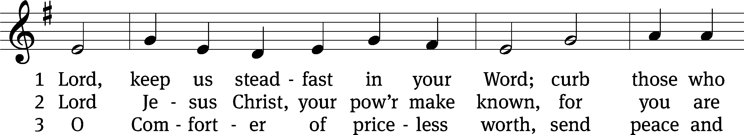
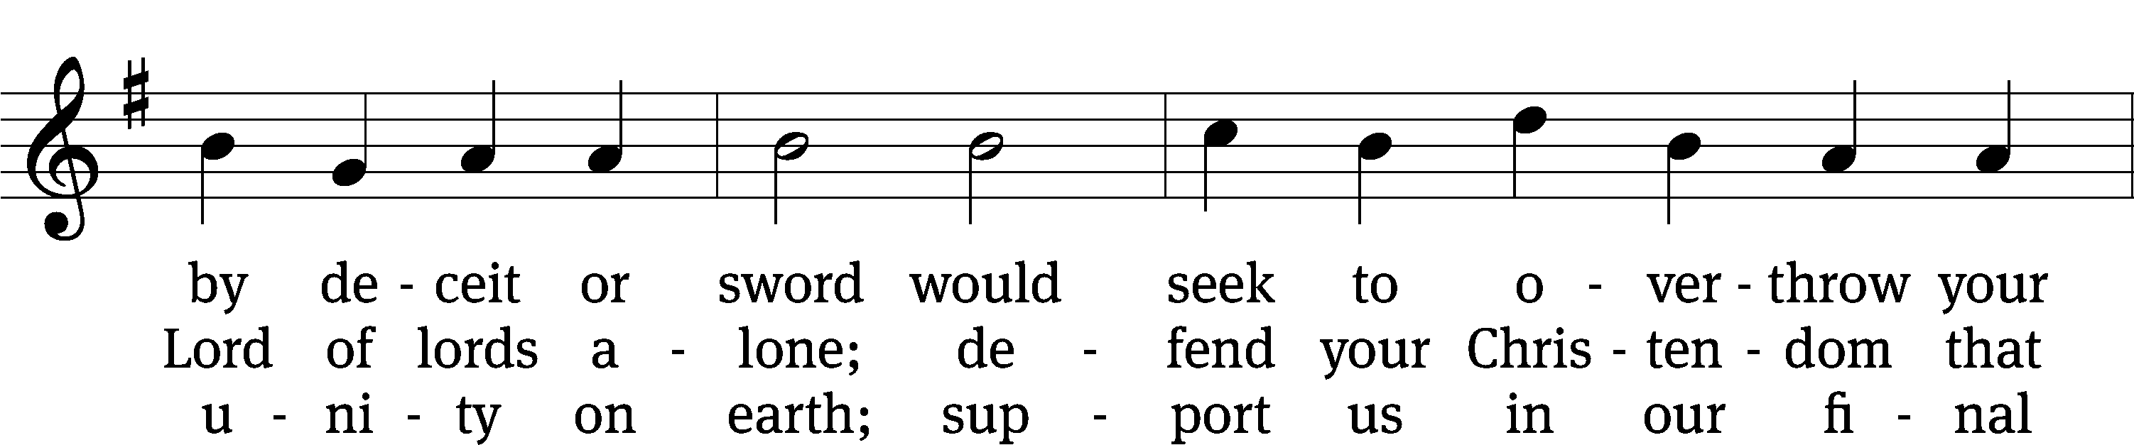
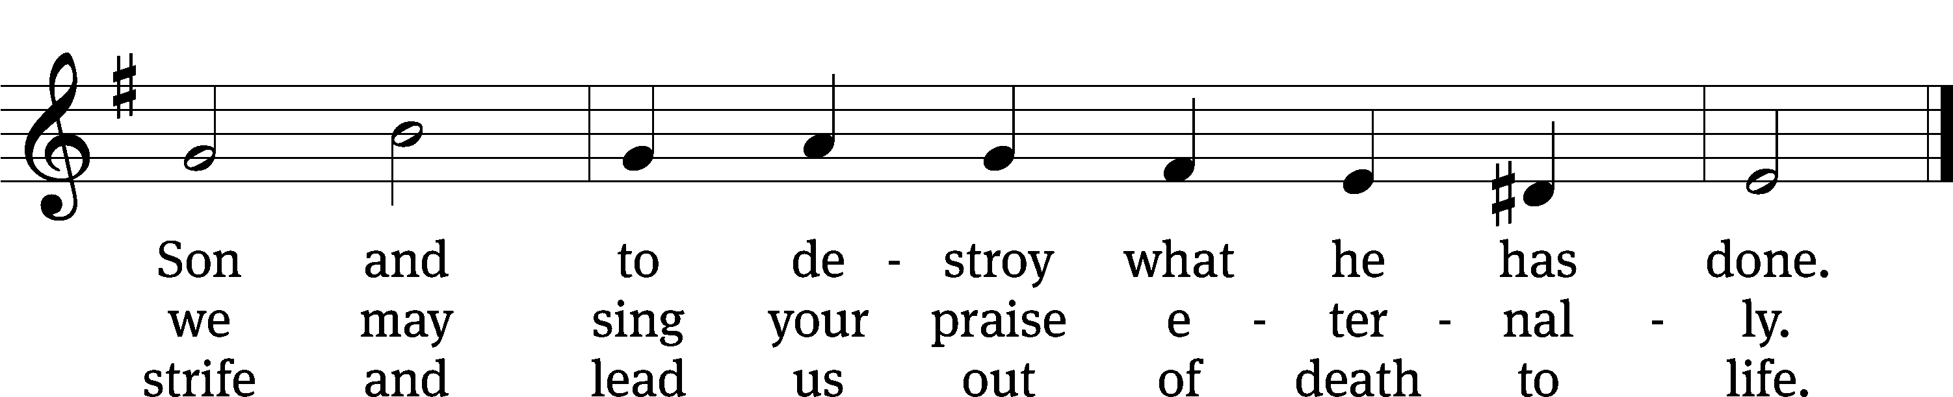
Text: tr. Catherine Winkworth, 1827–1878, alt.; Martin Luther, 1483–1546
Tune: Geistliche Lieder zu Wittemberg, Wittenberg, 1543, ed. Joseph Klug
Text and tune: Public domain

SERMON Matthew 21:33-43
“Listen to Another Parable”
Of wretched rejection
Of Reckless patience

PLEASE STAND, IF YOU ARE ABLE
THE APOSTLES’ CREED

I believe in God, the Father almighty,
maker of heaven and earth.
I believe in Jesus Christ, his only Son, our Lord,
who was conceived by the Holy Spirit,
born of the virgin Mary,
suffered under Pontius Pilate,
was crucified, died, and was buried.
He descended into hell.
The third day he rose again from the dead.
He ascended into heaven
and is seated at the right hand of God the Father almighty.
From there he will come to judge the living and the dead.
I believe in the Holy Spirit,
the holy Christian Church,
the communion of saints,
the forgiveness of sins,
the resurrection of the body,
and the life everlasting. Amen.

PLEASE BE SEATED
DUET (8:30) Pachelbel’s Canon/Seek Ye First

PLEASE STAND, IF YOU ARE ABLE

PRAYER OF THE CHURCH

THE LORD’S PRAYER

C: Our Father, who art in heaven, hallowed be thy name, thy kingdom come, thy will be done on earth as it is in heaven. Give us this day our daily bread; and forgive us our trespasses, as we forgive those who trespass against us; and lead us not into temptation, but deliver us from evil. For thine is the kingdom and the power and the glory forever and ever. Amen.

PLEASE BE SEATED
817 Lord, Thee I Love with All My Heart CW 817
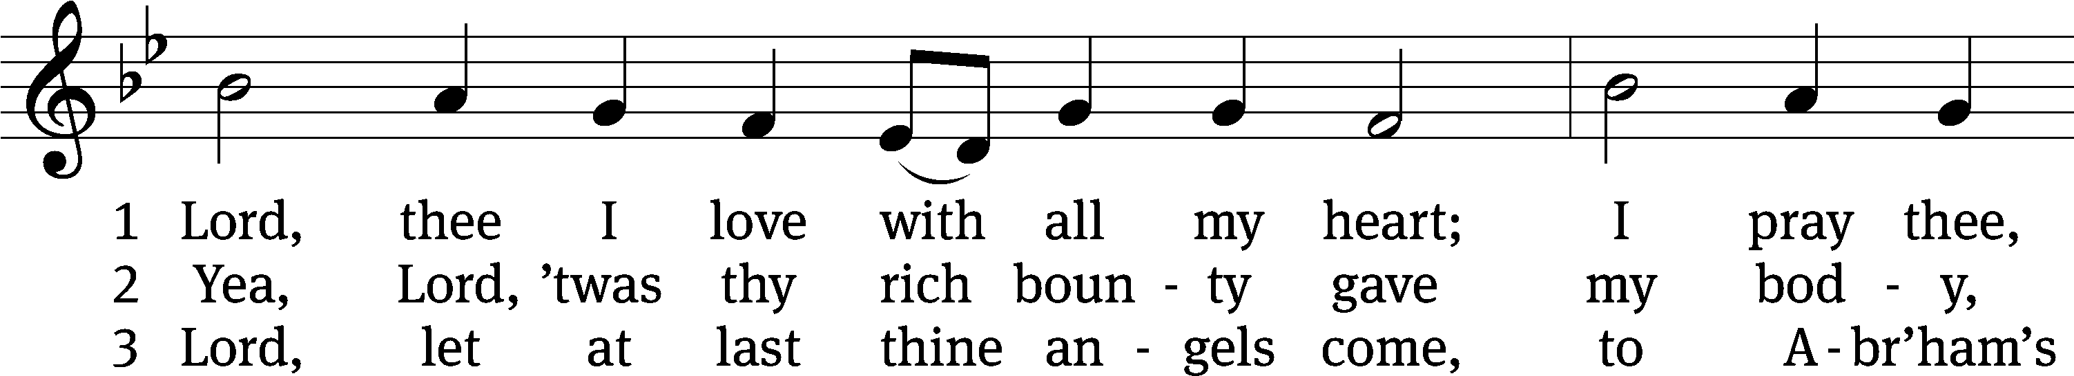
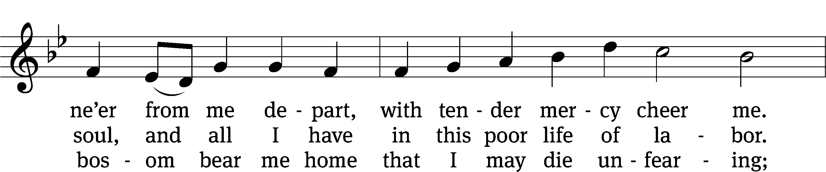
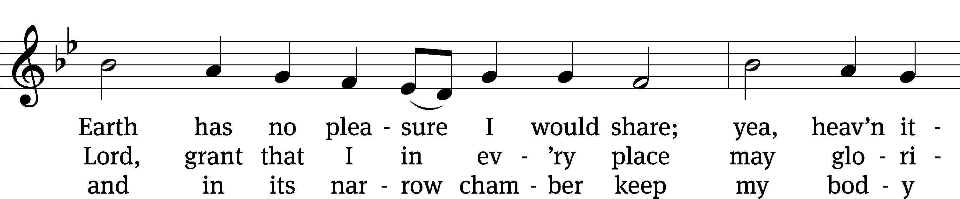
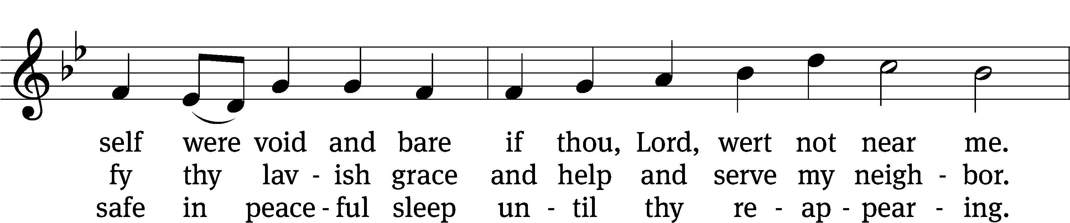
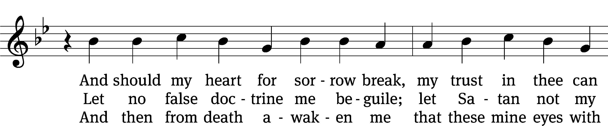
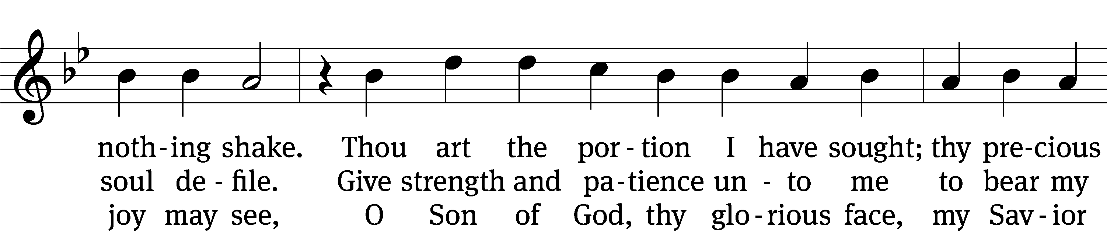
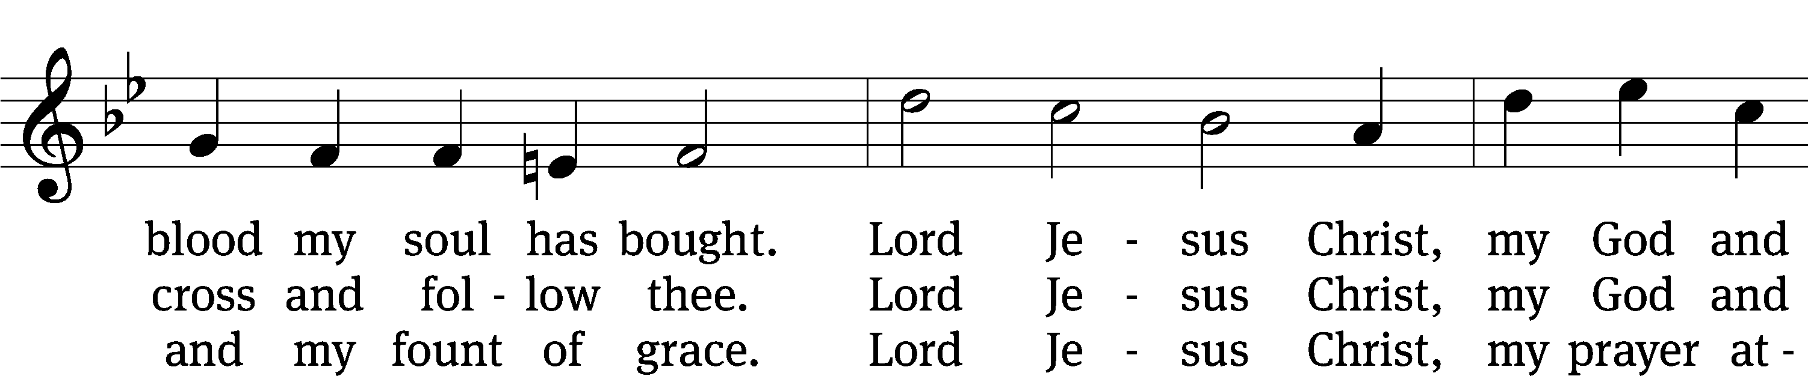
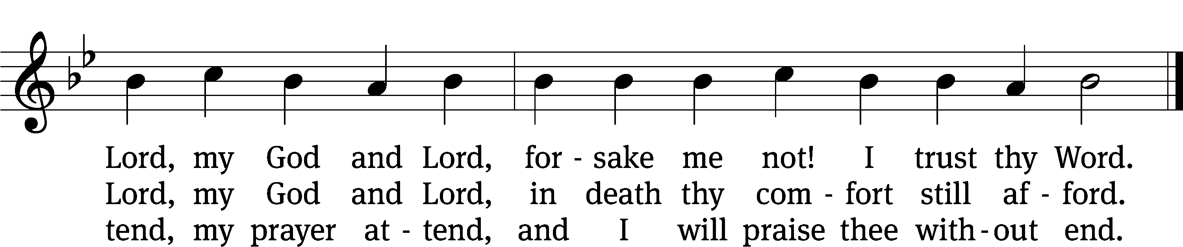
Text: tr. Catherine Winkworth, 1827–1878, alt.; Martin M. Schalling, 1532–1608
Tune: Zwey Bücher . . . Tablatur, Strassburg, 1577
Text and tune: Public domain

PLEASE STAND, IF YOU ARE ABLE

CLOSING PRAYER
M: Almighty God, we thank you for teaching us the things you want us to believe and do. Help us by your Holy Spirit to keep your Word in pure hearts that we may be strengthened in faith, guided in holiness, and comforted in life and in death, through Jesus Christ, our Lord, who lives and reigns with you and the Holy Spirit, one God, now and forever.

M: Brothers and sisters, go in peace. Live in harmony with one another. Serve the Lord with gladness.
The Lord bless you and keep you.
The Lord make his face shine on you and be gracious to you.
The Lord look on you with favor and (+) give you peace.

PLEASE BE SEATED
932 Sent Forth by God’s Blessing CW 932
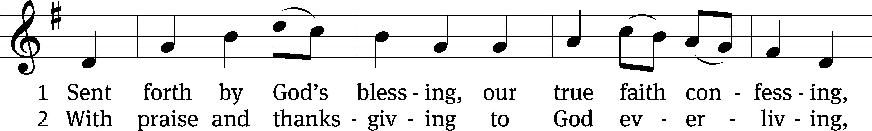
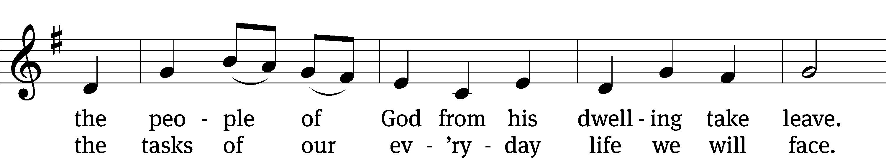
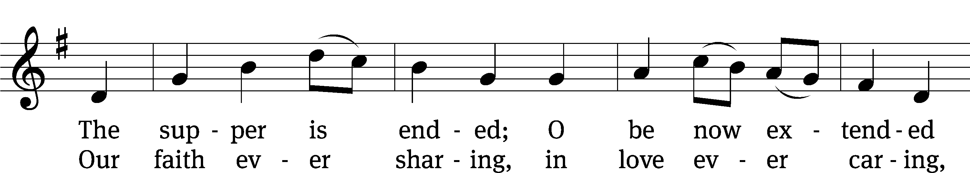
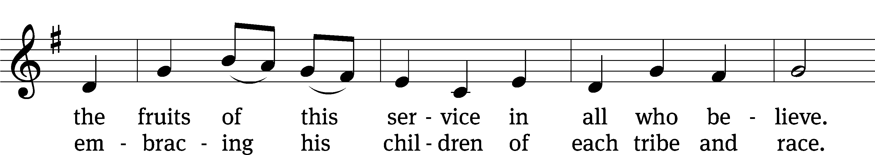
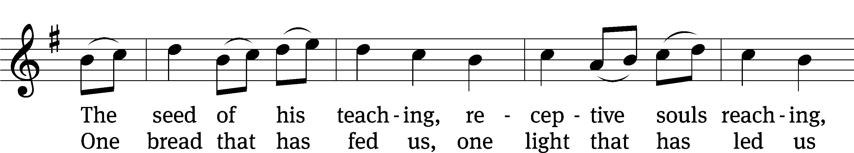
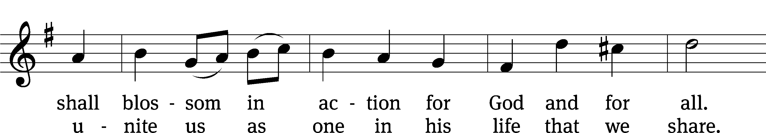
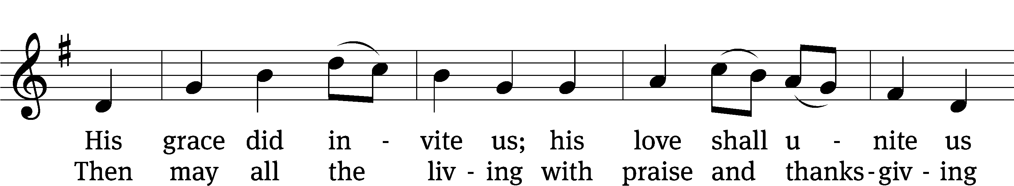
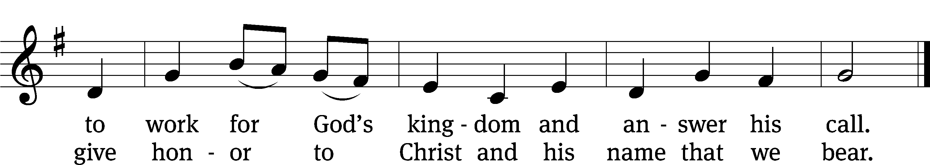
Text: Omer Westendorf, 1916–1997, alt.
Tune: Welsh
Text: © 1964 World Library Publications, a division of GIA Publications, Inc. Used by permission: OneLicense no. 727703
Tune: Public domain

Serving In Worship
Officiant Pastor Pappenfuss
Organist Marcia Marion Ackling
Instrumental Duet Marcia Marion Ackling and Sarah Hanke
Deacons (8:30) Dave Stevenson and Jim Tice
(11:00) Steve Hoeft and Jeff Neuburger
Ushers (8:30) Dale Finkbeiner and Mark Finkbeiner
(11:00) Ed Sala and Al Whitley
Altar Guild Barb Neuburger and Karen Tice
Videographer Jake Vershum

Copyright information
Service of the Word: Christian Worship. © 1993 Northwestern Publishing House. All rights reserved.
Reprinted with permission under ONE LICENSE #A-727703 and CCLI #1151741/CSPL126093

Words and Music: All rights reserved. Reprinted with permission under ONE LICENSE #A-727703 and
CCLI #1151741/CSPL126093
tlcsaline.church

