the fifteENTH sunday
AFTER PENTECOST

TRINITY EVANGELICAL LUTHERAN CHURCH | Saline, Michigan
WELCOME TO WORSHIP September 18, 2022

Thank you for joining us in God’s house today! We cordially ask that our guests sign one of the guestbooks located at either the front or back entryways.

THANK OFFERING: Members of Trinity give their offering as an expression of love and thankfulness to the Lord and to help support the Lord’s work in our community and around the world. Visitors need not feel obligated to participate in this offering which supports our ministry.

Restrooms are located at the back of the upper level (the annex), and in the basement (down the back stairs of the sanctuary or annex). Handicap access is available, please ask an usher for assistance.

celebration of holy communion:
In His Word, God makes it clear that the Lord’s Supper is to be shared by people of a common proclamation of faith (1 Corinthians 11:26; 1 Corinthians 10:16-17). Without judging anyone’s hearts, we invite those who share in our confession by their membership in our congregation or another congregation of the Wisconsin Evangelical Lutheran Synod (WELS) or the Evangelical Lutheran Synod (ELS) and who are properly prepared (1 Corinthians 11;27-29) to receive the Sacrament. Page 295 in the front of Christian Worship provides a guide for preparation.

Guests, we would love to have you join us in communion fellowship in the future, and for that to be possible, we ask that you speak with one of the pastors so that we may speak with you on how that would be possible. We thank you for respecting the way we celebrate the Lord’s Supper in our congregations.

SERVICE OF WORD AND SACRAMENT

749 God, Whose Giving Knows No Ending CW 749
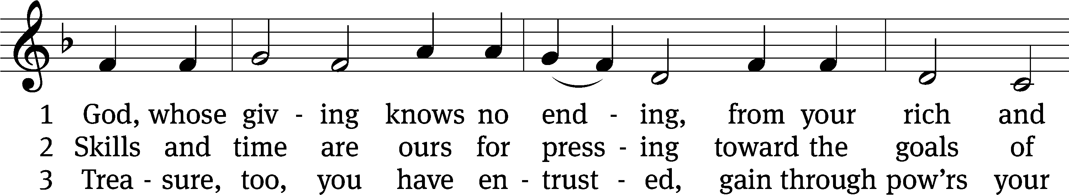
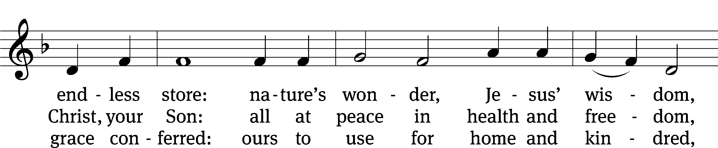
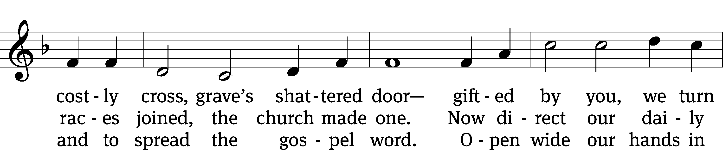
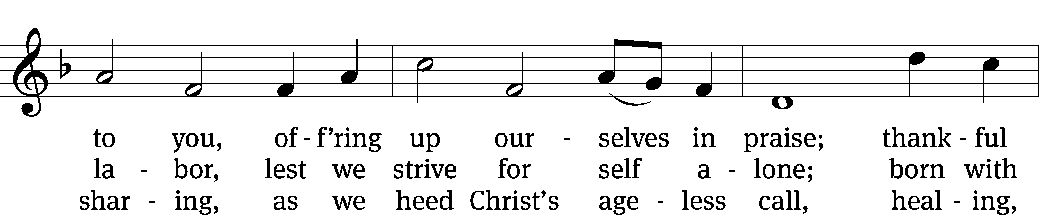
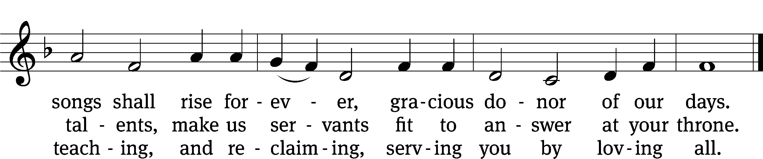
Text: Robert L. Edwards, 1915–2006
Tune: The Sacred Harp, Philadelphia, 1844
Text: © 1961, ren. 1989 The Hymn Society, admin. Hope Publishing Co. Used by permission: OneLicense no. 727703
Tune: Public domain

PLEASE STAND, IF YOU ARE ABLE

invocation

M: The grace of our Lord (+) Jesus Christ and the love of God and the fellowship of the Holy Spirit be with you.
C: And also with you.
CONFESSION OF SINS
M: God invites us to come into his presence and worship him with humble and penitent hearts. Therefore, let us acknowledge our sinfulness and ask him to forgive us.
C: Holy and merciful Father, I confess that I am by nature sinful, and that I have disobeyed you in my thoughts, words, and actions. I have done what is evil and failed to do what is good. For this I deserve your punishment both now and in eternity. But I am truly sorry for my sins, and trusting in my Savior Jesus Christ, I pray: Lord, have mercy on me, a sinner.
M: God, our heavenly Father, has been merciful to us and has given his only Son to be the atoning sacrifice for our sins. Therefore, as a called servant of Christ and by his authority, I forgive you all your sins in the name of the Father and of the Son (+) and of the Holy Spirit.
C: Amen.

PRAYER AND PRAISE

LORD, HAVE MERCY
Kyrie
M: For all that we need in life and for the wisdom to use all your gifts with gratitude and joy, hear our prayer, O Lord.

M: For the steadfast assurance that nothing can separate us from your love and for the courage to stand firm against the assaults of Satan and every evil, hear our prayer, O Christ.

M: For the well-being of your holy Church in all the world and for those who offer here their worship and praise, hear our prayer, O Lord.

M: Merciful God, maker and preserver of life, uphold us by your power and keep us in your tender care:

M: The works of the Lord are great and glorious; his name is worthy of praise.

Prayer of the day

M: Let us pray.
The minister says the Prayer of the Day.

PLEASE BE SEATED

The Word

first lesson Ecclesiastes 5:10-20
¹⁰ Anyone who loves money is never satisfied with money, and anyone who loves wealth is never satisfied with his income. This too is vanishing vapor.
¹¹ When goods increase, so do those who eat them. What profit, then, does the owner get, except to see these things with his eyes?
¹² The worker’s sleep is sweet, whether he eats little or much, but a rich person’s abundant possessions allow him no sleep.
¹³ I have seen a sickening evil under the sun—wealth hoarded by its owner to his own harm, ¹⁴ or wealth that is lost in a bad investment. Or a man fathers a son, but he has nothing left in his hand to give him. ¹⁵ As he came out from his mother’s womb, so he will go again, naked as he came. From his hard work he can pick up nothing that he can carry away in his hand. ¹⁶ This too is a sickening evil: Just as he came, so he will go. So what does he gain, he who works for the wind? ¹⁷ Besides this, during all his days he eats in darkness, with great frustration, sickness, and anger.
¹⁸ So then, here is what I have seen to be good: It is beautiful to eat, to drink, and to look for good in all a person’s hard work which he has done under the sun, during the few days of his life that God has given him, for that is his reward. ¹⁹ Likewise, for everyone to whom God has given wealth and riches, if God has also given him ability to eat from it, to enjoy his reward, and to rejoice in the results of his hard work—this is a gift of God, ²⁰ for the man seldom reflects on the days of his life, since God keeps him busy with the joy in his heart.

128C Blest Are Those Who Love You Psalm 128C
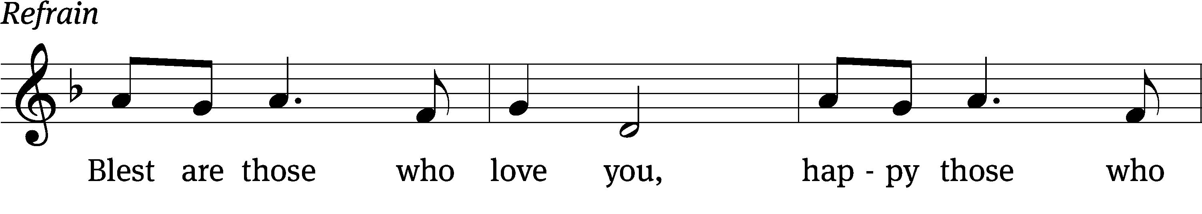
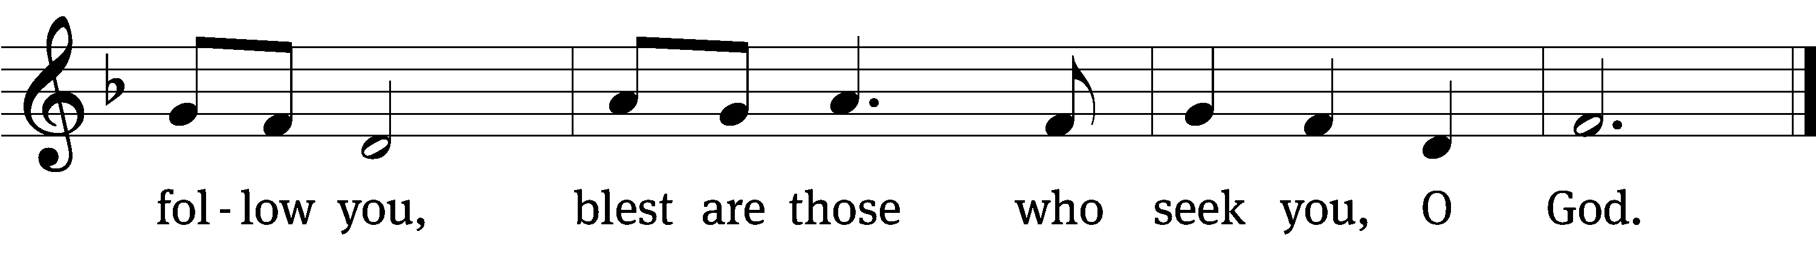

Blessed are all who / fear the Lord,
who walk in obedi- / ence to him.
You will eat the fruit of your / labor;
blessings and prosperity / will be yours.
Your wife will be like a fruitful vine with- / in your house;
your children will be like olive shoots around your / table. Refrain

Yes, this will be the / blessing
for the man who / fears the Lord.
May the Lord bless you from / Zion;
may you see the prosperity of Jerusalem all the days / of your life.
May you live to see your children’s / children—
peace be on / Israel.
Glory be to the Father and / to the Son
and to the Holy / Spirit,
as it was in the be- / ginning,
is now, and will be forever. / Amen. Refrain
Text: Marty Haugen
Tune: Marty Haugen
Text and tune: © 1987 GIA Publications, Inc. Used by permission: OneLicense no. 727703
Setting: © 2011 Faith Alive Christian Resources. Used by permission: License no. 130003540

second lesson 1 TIMOTHY 6:6-10, 17-19
⁶ But godliness with contentment is great gain. ⁷ For we brought nothing into the world, and we certainly cannot take anything out. ⁸ But if we have food and clothing, with these we will be satisfied.
⁹ Those who want to get rich fall into temptation and a trap and many foolish and harmful desires, which plunge them into complete destruction and utter ruin. ¹⁰ For the love of money is a root of all sorts of evils. By striving for money, some have wandered away from the faith and have pierced themselves with many pains.
¹⁷ Instruct those who are rich in this present age not to be arrogant or to put their hope in the uncertainty of riches, but rather in God, who richly supplies us with all things for our enjoyment. ¹⁸ Instruct them to do good, to be rich in good works, to be generous and willing to share. ¹⁹ In this way they are storing up for themselves the treasure of a good foundation for the future, so that they may take hold of that which is truly life.

PLEASE STAND, IF YOU ARE ABLE

VERSE OF THE DAY

GOSPEL LUKE 16:1-13
¹ Jesus also said to his disciples, “There was a rich man who had a manager who was accused of wasting his possessions. ² The rich man called him in and said to him, ‘What is this that I hear about you? Give an account of your management, because you can no longer be manager.’
³ “The manager said to himself, ‘What will I do, since my master is taking away the management position from me? I am not strong enough to dig. I am ashamed to beg. ⁴ I know what I will do, so that when I am removed from my position as manager, people will receive me into their houses.’
⁵ “He called each one of his master’s debtors to him. He asked the first, ‘How much do you owe my master?’ ⁶ He said, ‘Six hundred gallons of olive oil.’ He said to him, ‘Take your bill, sit down quickly, and write three hundred.’ ⁷ Then he said to another, ‘How much do you owe?’ And he said, ‘Six hundred bushels of wheat.’ He said to him, ‘Take your bill and write four hundred and eighty.’
⁸ “The master commended the dishonest manager because he had acted shrewdly. For the children of this world are more shrewd in dealing with their own generation than the children of the light are. ⁹ I tell you, make friends for yourselves with unrighteous mammon, so that when it runs out, they will welcome you into the eternal dwellings. ¹⁰ The person who is faithful with very little is also faithful with much. And the person who is unrighteous with very little is also unrighteous with much. ¹¹ So if you have not been faithful with unrighteous mammon, who will entrust you with what is really valuable? ¹² If you have not been faithful with what belongs to someone else, who will give you something to be your own? ¹³ No servant can serve two masters. Indeed, either he will hate the one and love the other, or he will be devoted to the one and despise the other. You cannot serve both God and mammon.”

M: This is the Gospel of the Lord.

PLEASE BE SEATED

823 Jesus, Priceless Treasure CW 823
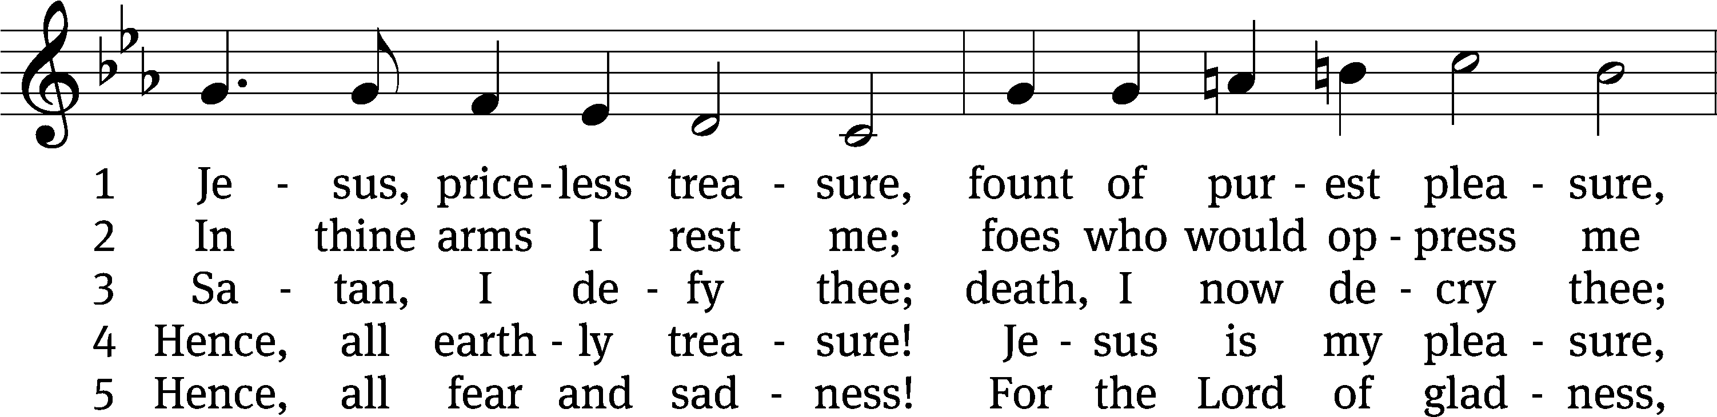
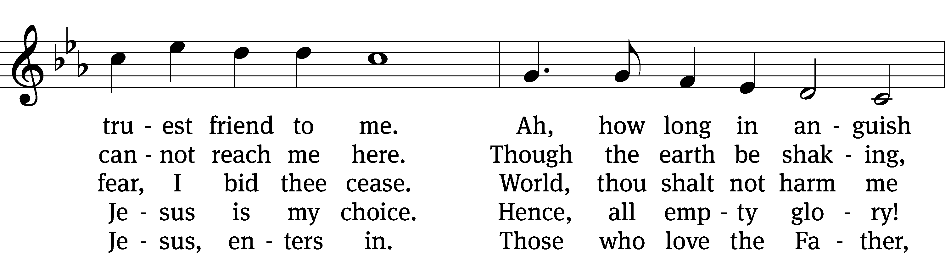
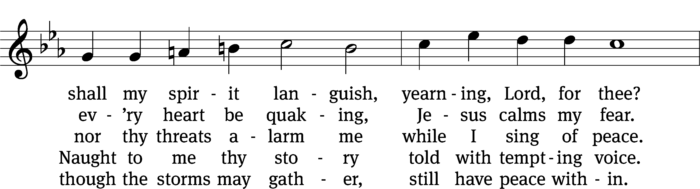
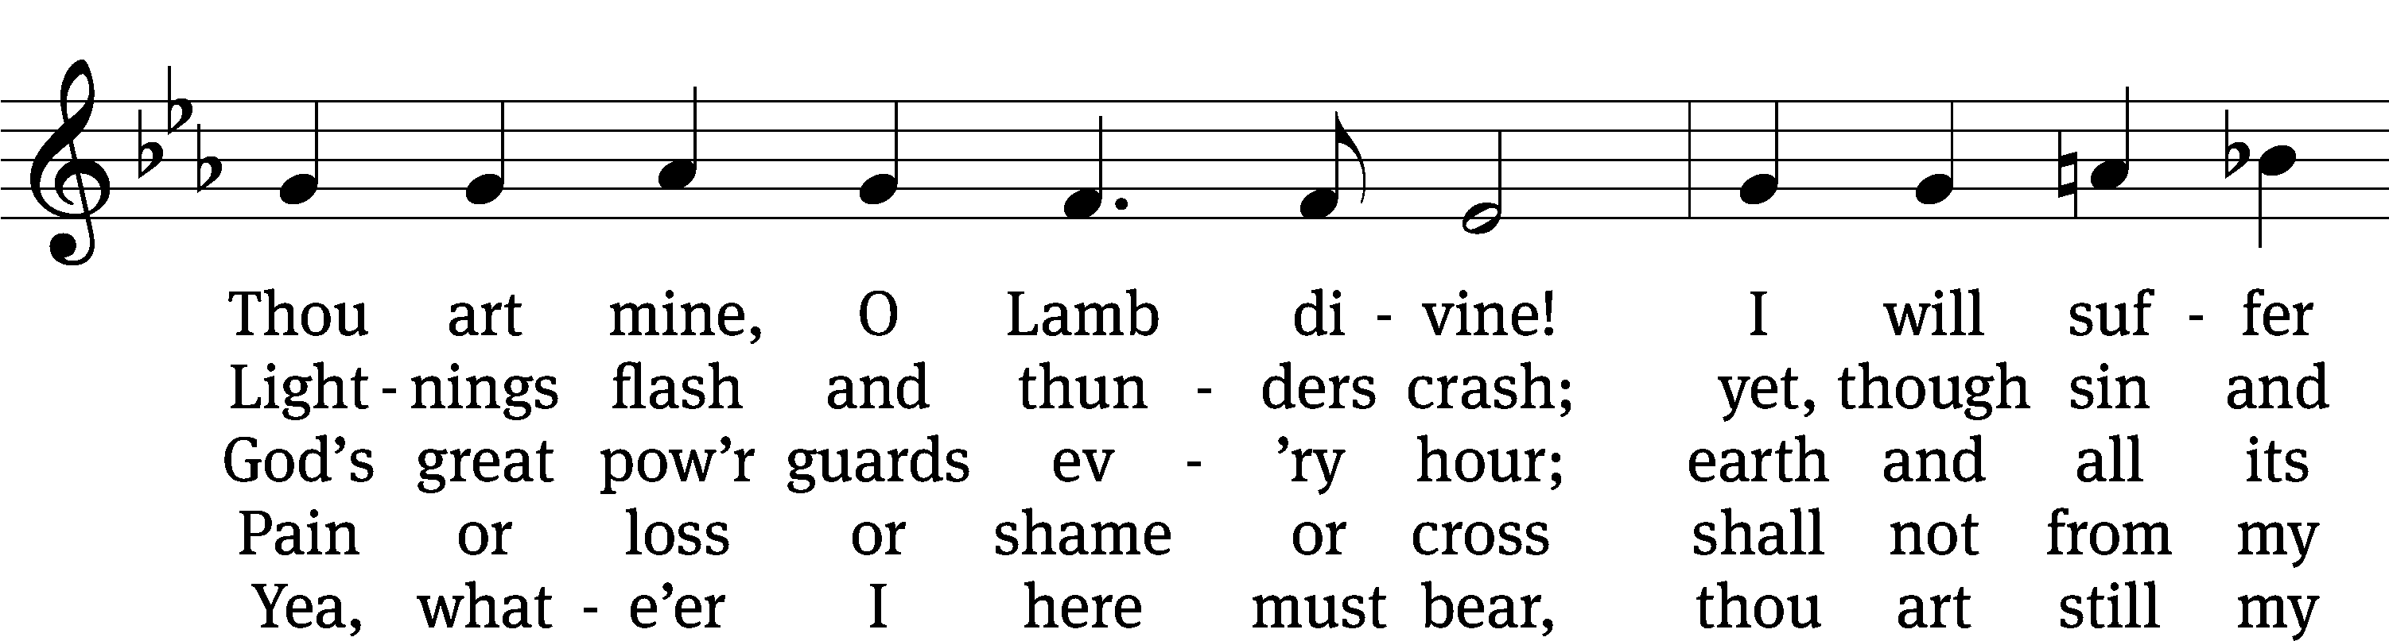
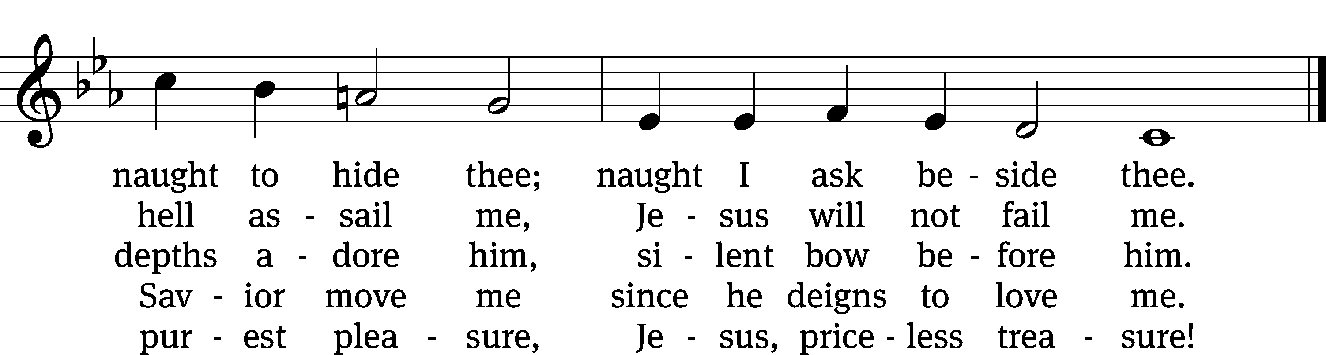
Text: Johann Franck, 1618–1677, abr.; (sts. 1–2, 4–5): tr. Catherine Winkworth, 1827–1878, alt.; (st. 3): tr. The Lutheran Hymnal, 1941
Tune: Johann Crüger, 1598–1662
Text and tune: Public domain

Sermon 1 TIMOTHY 6:6-10
“The Riches of Contentment”

please stand, if you are able

nicene creed
We believe in one God, the Father, the Almighty, maker of heaven and earth, of all that is, seen and unseen.
We believe in one Lord, Jesus Christ, the only Son of God, eternally begotten of the Father, God from God, Light from Light, true God from true God, begotten, not made, of one being with the Father. Through him all things were made. For us and for our salvation, he came down from heaven, was incarnate of the Holy Spirit and the virgin Mary, and became truly human. For our sake he was crucified under Pontius Pilate. He suffered death and was buried. On the third day he rose again in accordance with the Scriptures. He ascended into heaven and is seated at the right hand of the Father. He will come again in glory to judge the living and the dead, and his kingdom will have no end.
We believe in the Holy Spirit, the Lord, the giver of life, who proceeds from the Father and the Son, who in unity with the Father and the Son is worshiped and glorified, who has spoken through the prophets. We believe in one holy Christian and apostolic Church. We acknowledge one baptism for the forgiveness of sins. We look for the resurrection of the dead and the life of the world to come. Amen.

PLEASE BE SEATED

offertory

PLEASE STAND, IF YOU ARE ABLE

prayer of the church

lord’s prayer

C: Our Father, who art in heaven,
hallowed be thy name,
thy kingdom come,
thy will be done
on earth as it is in heaven.
Give us this day our daily bread;
and forgive us our trespasses,
as we forgive those
who trespass against us;
and lead us not into temptation,
but deliver us from evil.
For thine is the kingdom
and the power and the glory
forever and ever. Amen.

The Sacrament of Holy Communion
Trinity Lutheran Church follows the historic Christian practice of close communion. We ask that only members of Trinity or one of our sister congregations partake of the sacrament. If you are not a member, please see the note about Holy Communion in the beginning of the Worship Folder.

M: The Lord be with you.

M: Lift up your hearts.

M: Let us give thanks to the Lord our God.

M: Praise to the God and Father of our Lord Jesus Christ! In love he has blessed us with every spiritual blessing. He sends the Holy Spirit to testify that we are his children and to strengthen us when we are weak. Now have come the salvation and the power and the kingdom of our God and the authority of his Christ. To him who sits on the throne and to the Lamb be praise and thanks and honor and glory for ever and ever:

Holy, Holy, Holy

Words of institution
M: Our Lord Jesus Christ, on the night he was betrayed, took bread; and when he had given thanks, he broke it and gave it to his disciples, saying: “Take and eat. This is my ✙ body, which is given for you. Do this in remembrance of me.”
Then he took the cup, gave thanks, and gave it to them, saying, “Drink from it all of you; this is my ✙ blood of the new covenant, which is poured out for you for the forgiveness of sins. Do this, whenever you drink it, in remembrance of me.”
The peace of the Lord be with you always.

O CHRIST, LAMB OF GOD

Distribution Hymn CW 663
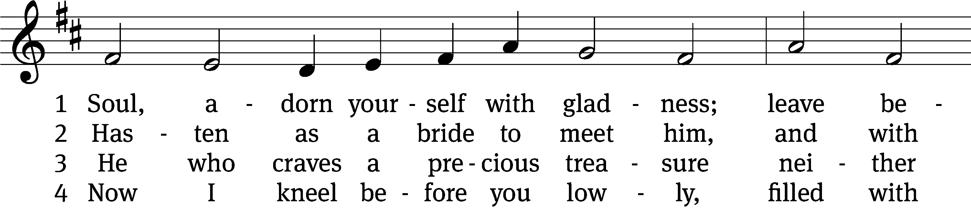
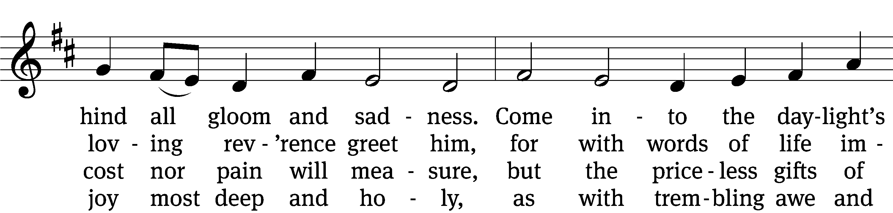
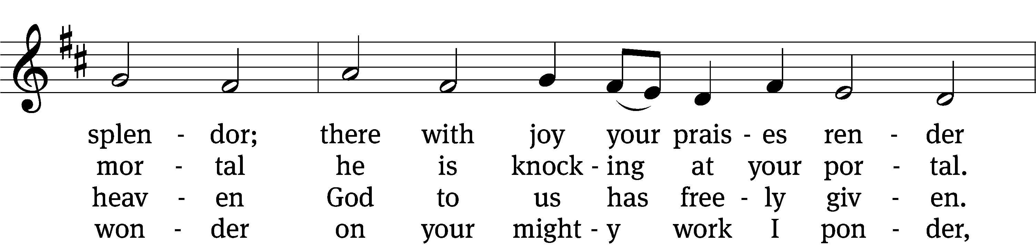
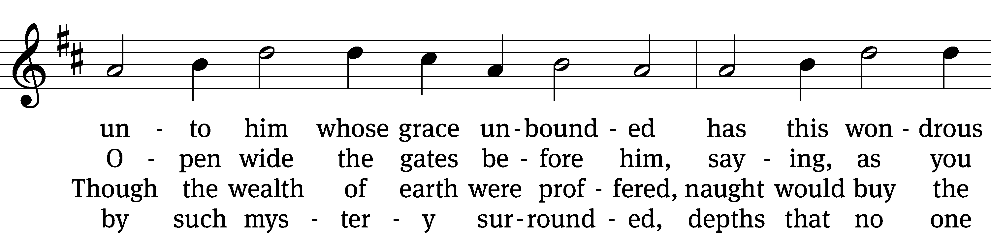
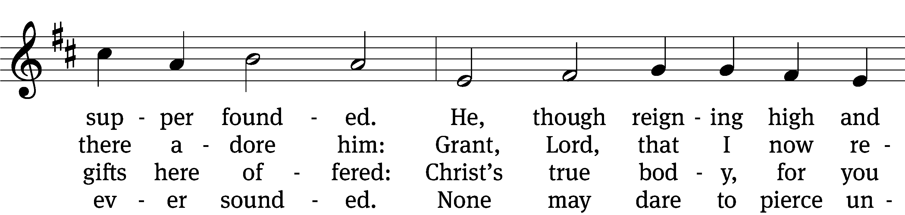
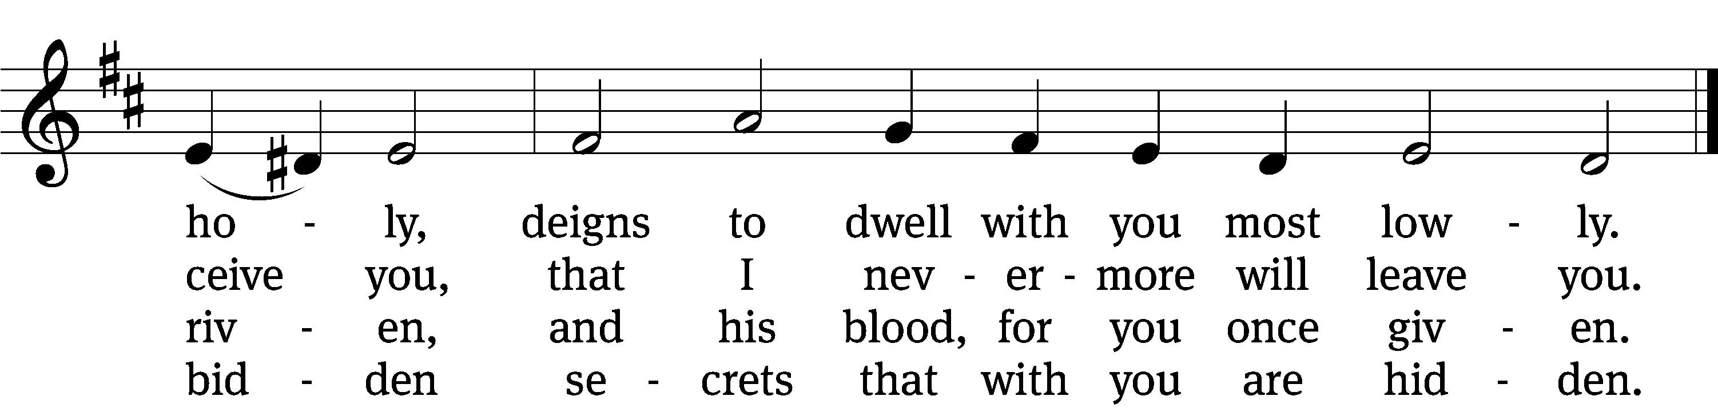

5 Human reason, though it ponders,
cannot fathom these great wonders,
that Christ’s body must be boundless
since the souls it feeds are countless,
and that he his blood is giving
with the wine we are receiving.
These great mysteries unsounded
are by God alone expounded.

6 Lord, by love and mercy driven,
you have left your throne in heaven
on the cross for me to languish
and to die in bitter anguish,
to forgo all joy and gladness
and to shed your blood in sadness.
By this blood redeemed and living,
Lord, I praise you with thanksgiving.

7 Jesus, sun of life, my splendor,
Jesus, friend of friends most tender,
Jesus, joy of my desiring,
fount of life, my soul inspiring:
at your feet I cry, my maker,
let me be a fit partaker
of this blessèd food from heaven
for our good, your glory, given.

8 Jesus, Lord of life in heaven,
help me when this meal is given
to receive it for my blessing
as I come, my sins confessing.
In this supper let me measure,
Lord, how deep is your love’s treasure,
that, as I on earth have eaten,
I may be your guest in heaven.
Text: Johann Franck, 1618–1677, abr.; (sts. 1–2, 4, 7): tr. Catherine Winkworth, 1827–1878, alt.; (sts. 3, 5–6): tr. The Lutheran Hymnal, 1941, alt.; (st. 8): tr. Peter M. Prange, b. 1972
Tune: Johann Crüger, 1598–1662
Text (st. 8): © 2021 Northwestern Publishing House. Used by permission: OneLicense no. 727703
Text (sts. 1–7) and tune: Public domain

PLEASE STAND, IF YOU ARE ABLE

THANKSGIVING

M: Hear the prayer of your people, O Lord, that the lips which have praised you here may glorify you in the world, that the eyes which have seen the coming of your Son may long for his coming again, and that all who have received in his true body and blood the pledge of your forgiveness may be restored to live a new and holy life, through Jesus Christ, our Lord, who lives and reigns with you and the Holy Spirit, one God, now and forever.

M: Brothers and sisters, go in peace. Live in harmony with one another.
Serve the Lord with gladness.

The Lord bless you and keep you.
The Lord make his face shine on you and be gracious to you.
The Lord look on you with favor and (+) give you peace.

PLEASE BE SEATED

617 Praise God, from Whom All Blessings Flow CW 617
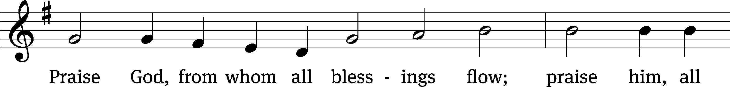
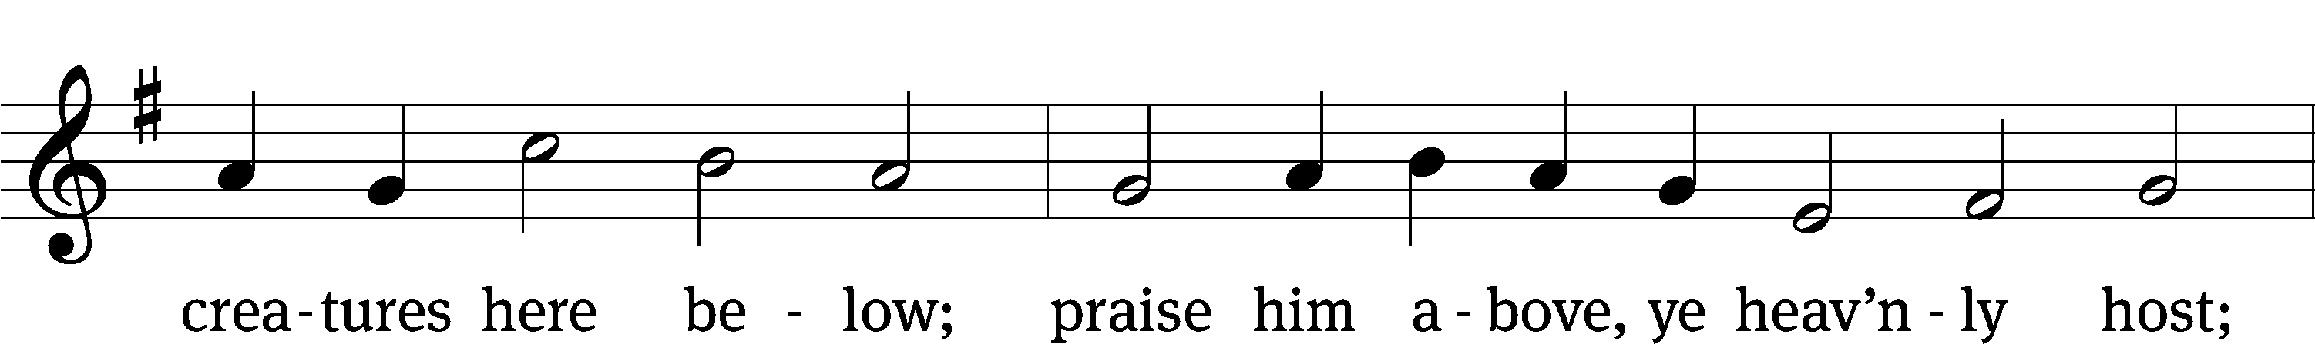
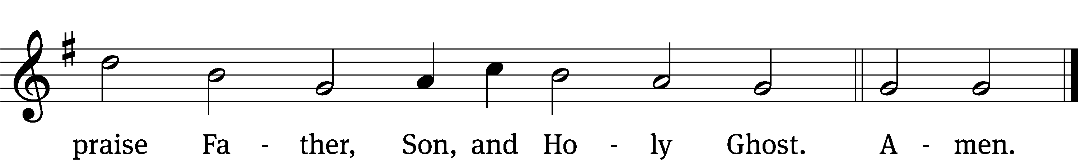
Text: Thomas Ken, 1637–1711
Tune: Trente quatre Pseaumes de David, Geneva, 1551, ed. Louis Bourgeois
Text and tune: Public domain

Serving In Worship

Officiant Pastor Natsis
Organist Ann Hoeft
Deacons (8:30) Dave Frey and Jim Tice
(11:00) Jeff Neuburger and Ed Wheeler
Ushers (8:30) Robert Newman and Henry Schneider
(11:00) Bill Barnett and Jake Vershum
Altar Guild Marcia Marion Ackling and Judy Lindemann
Videographer Cindy Dresch

Copyright information
Service of Word and Sacrament: Christian Worship. © 1993 Northwestern Publishing House. All rights reserved. Reprinted under ONE LICENSE #A-727703 and CCLI #1151741/ CSPL126093
Words and Music: All rights reserved. Reprinted/Podcast/Streamed with permission under ONE LICENSE #A-727703 and CCLI #1151741/CSPL126093

