THE SIXTEENth SUNDAY
AFTER PENTECOST

TRINITY EVANGELICAL LUTHERAN CHURCH | Saline, Michigan
WELCOME TO WORSHIP September 17, 2023

Thank you for joining us in God’s house today! We cordially ask that our guests sign one of the guestbooks located at either the front or back entryways.

THANK OFFERING: Members of Trinity give their offering as an expression of love and thankfulness to the Lord and to help support the Lord’s work in our community and around the world. Visitors need not feel obligated to participate in this offering which supports our ministry.

Restrooms are located at the back of the upper level (the annex), and in the basement (down the back stairs of the sanctuary or annex). Handicap access is available, please ask an usher for assistance.

celebration of holy communion:
In His Word, God makes it clear that the Lord’s Supper is to be shared by people of a common proclamation of faith (1 Corinthians 11:26; 1 Corinthians 10:16-17). Without judging anyone’s hearts, we invite those who share in our confession by their membership in our congregation or another congregation of the Wisconsin Evangelical Lutheran Synod (WELS) or the Evangelical Lutheran Synod (ELS) and who are properly prepared (1 Corinthians 11;27-29) to receive the Sacrament. Page 295 in the front of Christian Worship provides a guide for preparation.

Guests, we would love to have you join us in communion fellowship in the future, and for that to be possible, we ask that you speak with one of the pastors so that we may speak with you on how that would be possible. We thank you for respecting the way we celebrate the Lord’s Supper in our congregations.

SERVICE OF WORD AND SACRAMENT
579 His Mercy Is More CW 579
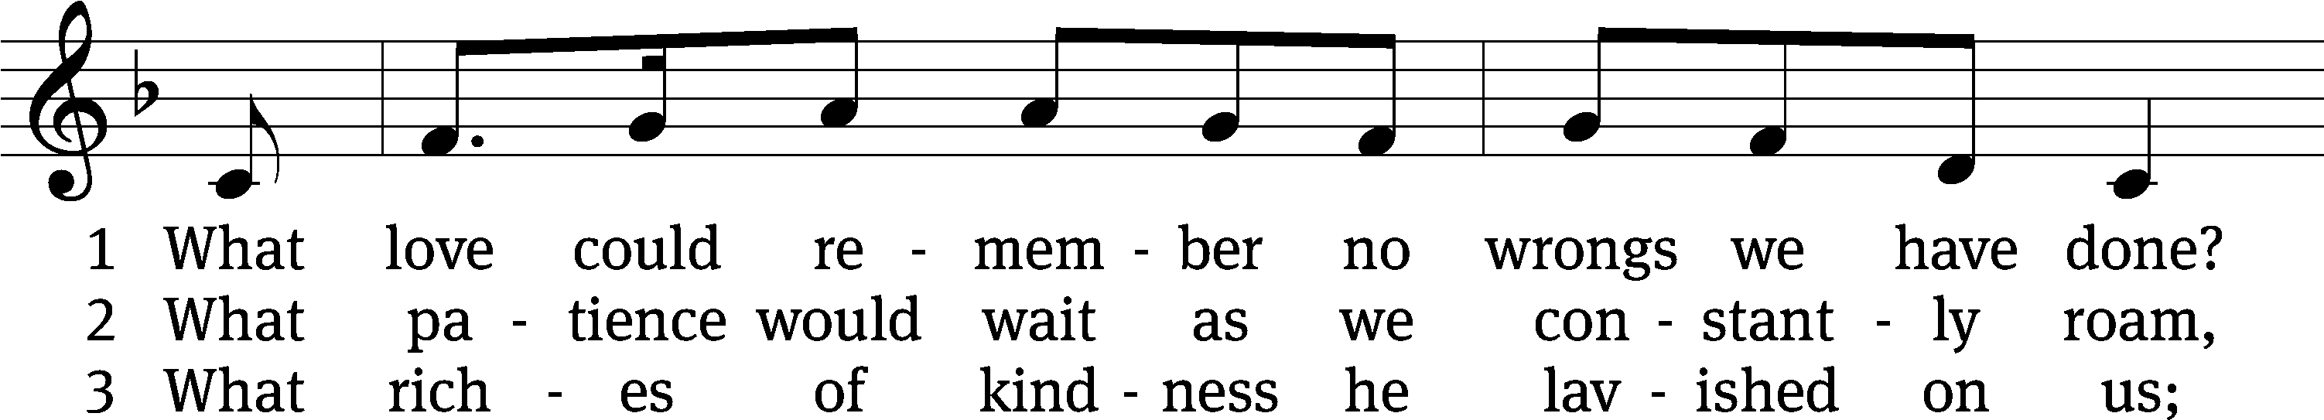
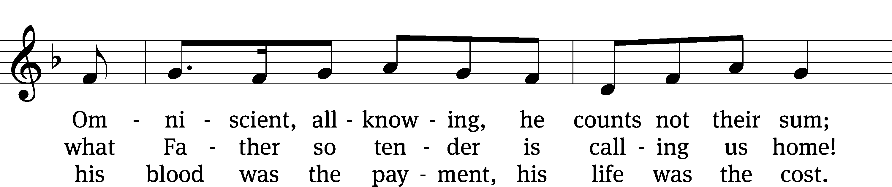
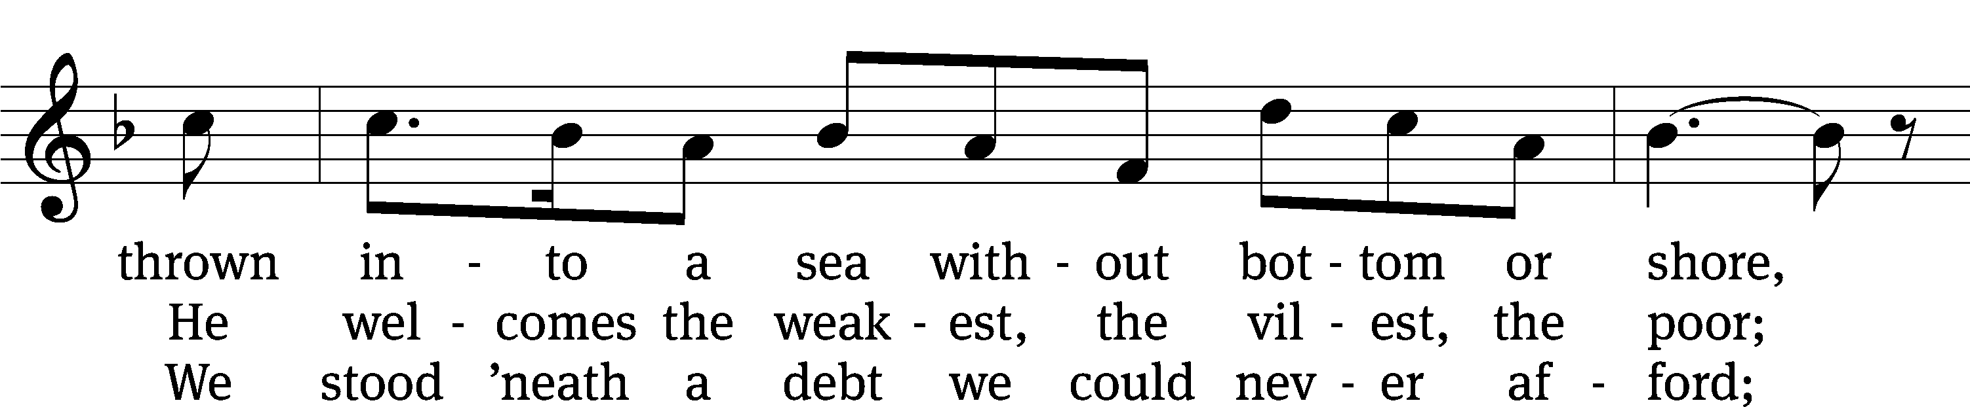
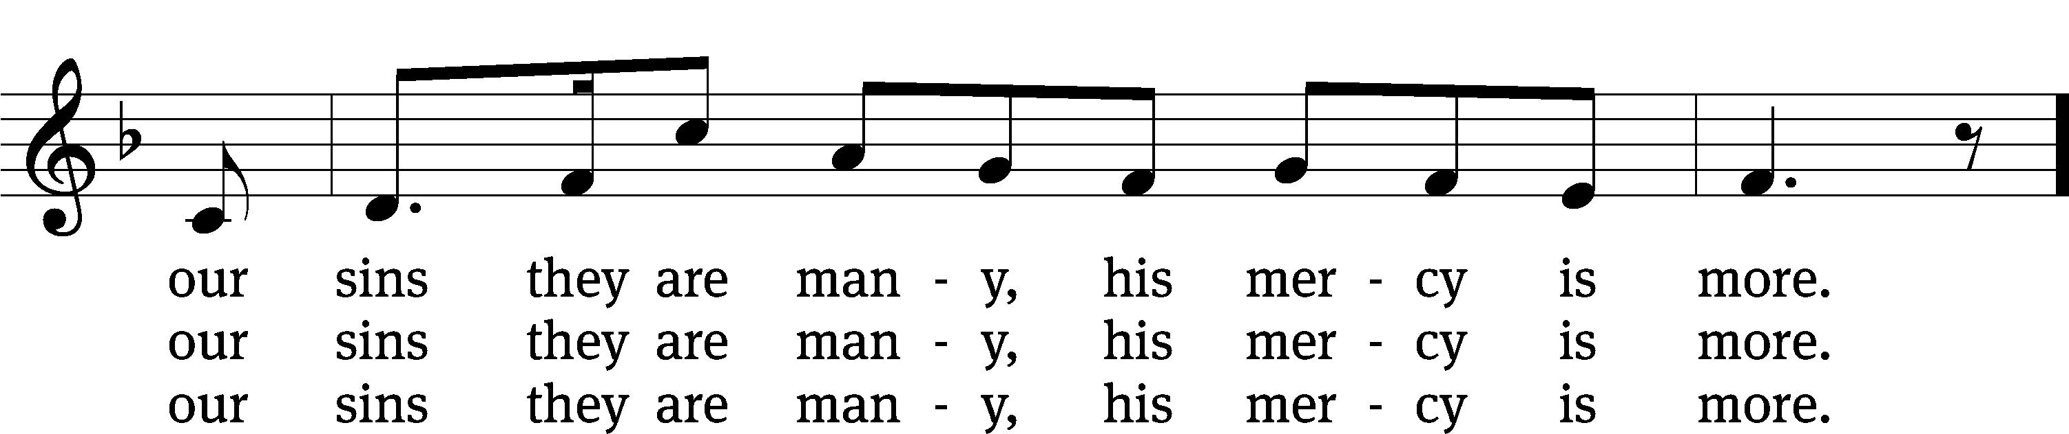
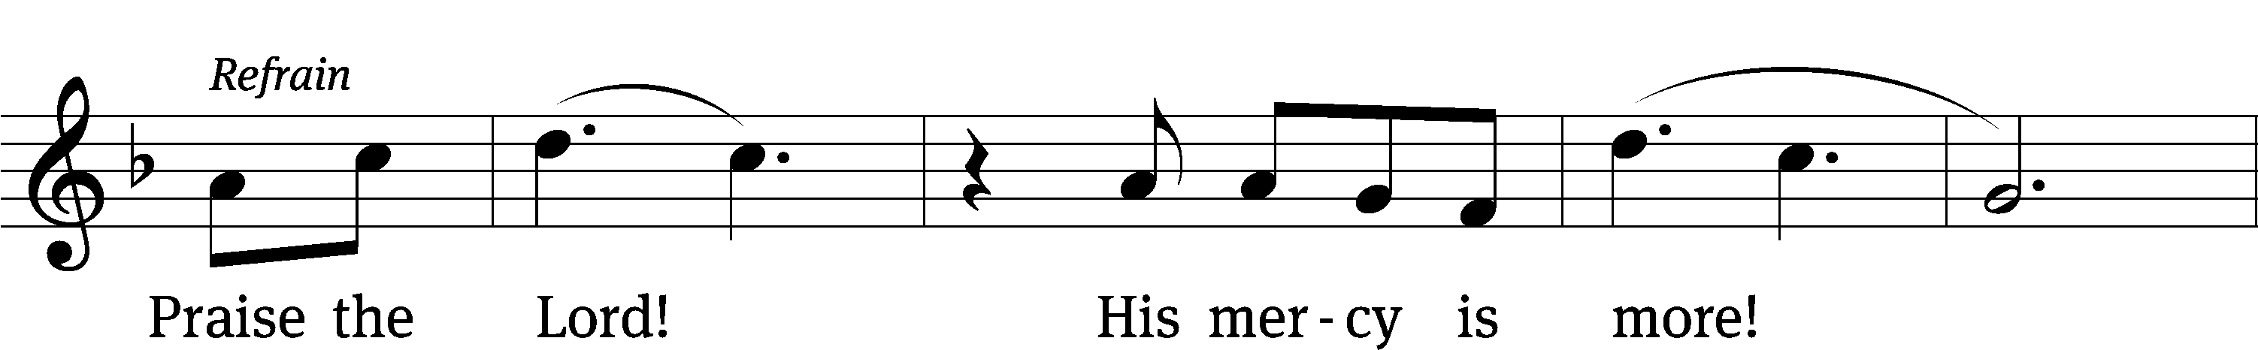
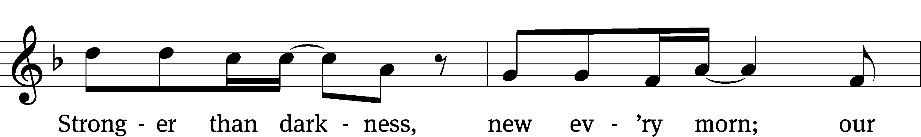
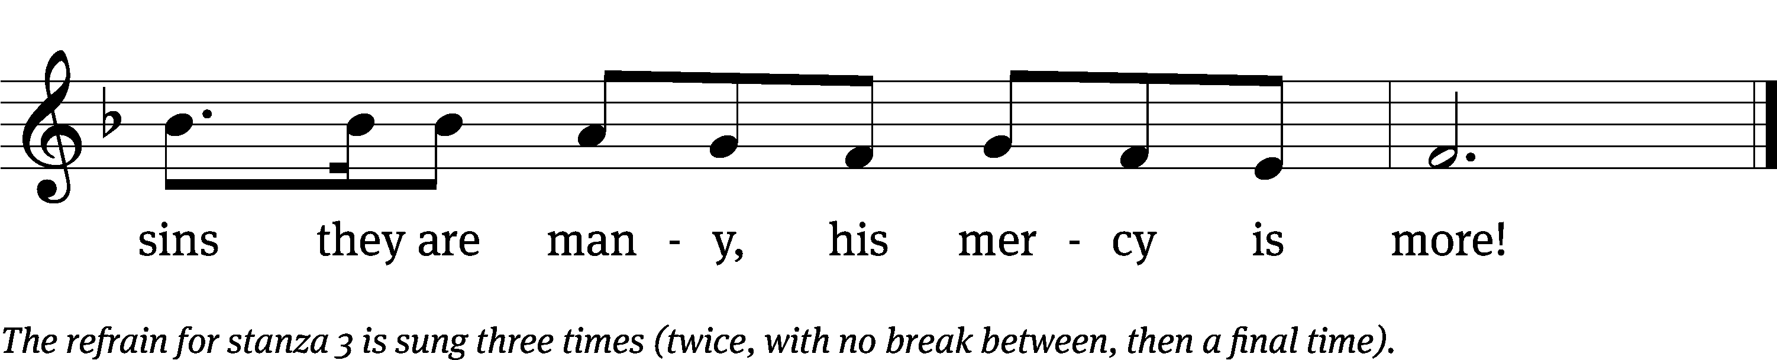
Text: Matt Papa, b. 1983; Matt Boswell, b. 1979
Tune: Matt Papa, b. 1983; Matt Boswell, b. 1979
Text and tune: © 2016 Getty Music Songs, Messenger Hymns, and Love Your Enemies Publishing, admin. MusicServices.org. Used by permission: OneLicense no. 727703
PLEASE STAND, IF YOU ARE ABLE

invocation

M: The grace of our Lord (+) Jesus Christ and the love of God and the fellowship of the Holy Spirit be with you.
C: And also with you.
CONFESSION OF SINS
M: God invites us to come into his presence and worship him with humble and penitent hearts. Therefore, let us acknowledge our sinfulness and ask him to forgive us.
C: Holy and merciful Father, I confess that I am by nature sinful, and that I have disobeyed you in my thoughts, words, and actions. I have done what is evil and failed to do what is good. For this I deserve your punishment both now and in eternity. But I am truly sorry for my sins, and trusting in my Savior Jesus Christ, I pray: Lord, have mercy on me, a sinner.
M: God, our heavenly Father, has been merciful to us and has given his only Son to be the atoning sacrifice for our sins. Therefore, as a called servant of Christ and by his authority, I forgive you all your sins in the name of the Father and of the Son (+) and of the Holy Spirit.
C: Amen.
PRAYER AND PRAISE
LORD, HAVE MERCY
Kyrie
M: For all that we need in life and for the wisdom to use all your gifts with gratitude and joy, hear our prayer, O Lord.

M: For the steadfast assurance that nothing can separate us from your love and for the courage to stand firm against the assaults of Satan and every evil, hear our prayer, O Christ.

M: For the well-being of your holy Church in all the world and for those who offer here their worship and praise, hear our prayer, O Lord.

M: Merciful God, maker and preserver of life, uphold us by your power and keep us in your tender care:

M: The works of the Lord are great and glorious; his name is worthy of praise.

Prayer of the day

M: Let us pray.

Lord God, heavenly Father, you graciously forgive us all our sins and abundantly provide for all our needs of body and soul. Give us confidence in your mercy, and teach us also to be merciful to our neighbor, that we willingly forgive all people, and judging only ourselves, lead blessed lives to your glory; through your Son, Jesus Christ our Lord, who lives and reigns with you and the Holy Spirit, one God, now and forever.

PLEASE BE SEATED

The Word

first lesson Genesis 50:15-21

¹⁵ When Joseph’s brothers saw that their father was dead, they said, “It may be that Joseph will hate us and will pay us back in full for all of the evil that we did to him.”
¹⁶ They sent the following message to Joseph: “Before he died your father commanded us, ¹⁷ ‘You are to tell Joseph, “Please forgive the offense of your brothers and their sin, because they did evil to you.”’ Now, please forgive the offense of the servants of the God of your father.”
Joseph wept when they spoke to him.
¹⁸ His brothers also came and fell down in front of him, and they said, “See now, we are your servants.”
¹⁹ Joseph said to them, “Do not be afraid, for am I in the place of God? ²⁰ You meant evil against me, but God meant it for good, to bring this to pass and to keep many people alive, as it is this day. ²¹ Now therefore, do not be afraid. I will nourish you and your little ones.” He comforted them and spoke to them in a kind way.
103A The LORD Is Kind and Merciful Psalm 103A
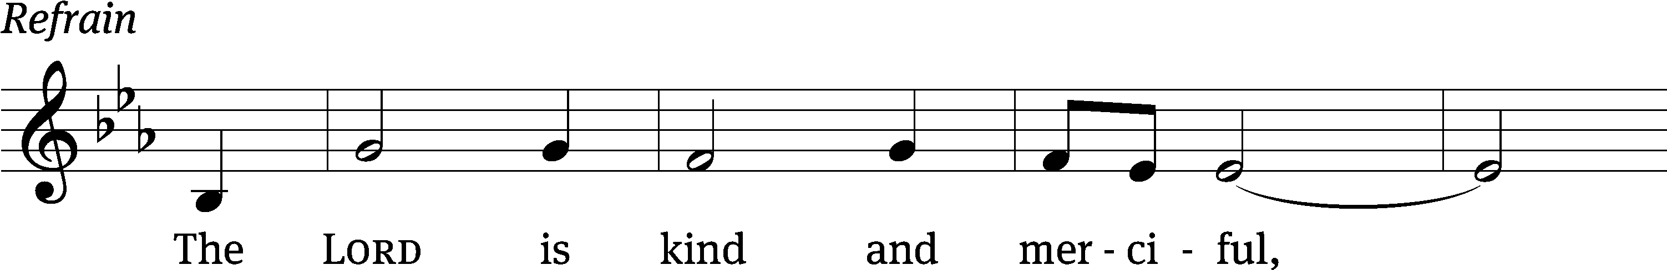
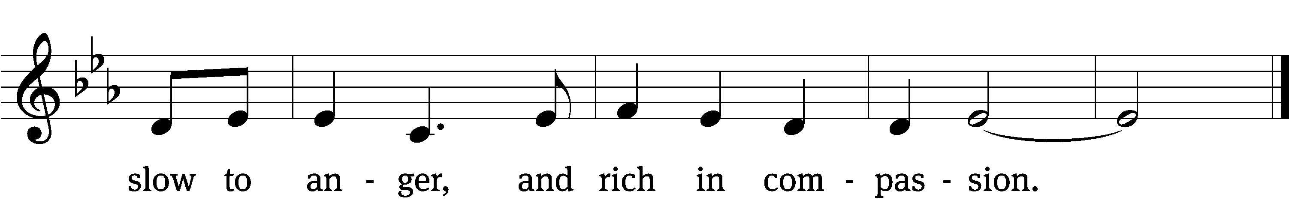

Praise the Lord, / my soul;
all my inmost being, praise his / holy name—
who forgives / all your sins
and heals all your dis- / eases,
who redeems your life / from the pit
and crowns you with love and com- / passion,
who satisfies your desires / with good things
so that your youth is renewed like the / eagle’s. Refrain

The Lord is compassionate and / gracious,
slow to anger, abound- / ing in love.
He does not treat us as our / sins deserve
or repay us according to our in- / iquities.
For as high as the heavens are a- / bove the earth,
so great is his love for those who / fear him;
as far as the east is / from the west,
so far has he removed our transgressions / from us.
Glory be to the Father and / to the Son
and to the Holy / Spirit,
as it was in the be- / ginning,
is now, and will be forever. / Amen. Refrain
Text: © 1969, 1981, 1997 ICEL (refrain). Used by permission: OneLicense no. 727703
Music: © 2013 GIA Publications, Inc. Used by permission: OneLicense no. 727703

second lesson Ephesians 4:29-52
²⁹ Do not let any unwholesome talk come from your mouths. Say only what is beneficial when there is a need to build up others, so that it will be a blessing to those who hear. ³⁰ Do not grieve the Holy Spirit of God, with whom you were sealed for the day of redemption. ³¹ Get rid of every kind of bitterness, rage, anger, quarreling, and slander, along with every kind of malice. ³² Instead, be kind and compassionate to one another, forgiving one another, just as God in Christ has forgiven us.
5 Therefore, be imitators of God as his dearly loved children. ² And walk in love, just as Christ loved us and gave himself for us, as a fragrant offering and sacrifice to God.

PLEASE STAND, IF YOU ARE ABLE

VERSE OF THE DAY Colossians 3:13
Alleluia. Bear with each other and forgive one another.
Forgive as the Lord forgave you. Alleluia.

GOSPEL Matthew 18:21-35
²¹ Then Peter came up and asked Jesus, “Lord, how many times must I forgive my brother when he sins against me? As many as seven times?”
²² Jesus said to him, “Not seven times, but I tell you as many as seventy-seven times. ²³ For this reason the kingdom of heaven is like a king who wanted to settle accounts with his servants. ²⁴ When he began to settle them, a man who owed him ten thousand talents was brought to him. ²⁵ Because the man was not able to pay the debt, his master ordered that he be sold, along with his wife, children, and all that he owned to repay the debt.
²⁶ “Then the servant fell down on his knees in front of him, saying, ‘Master, be patient with me, and I will pay you everything!’ ²⁷ The master of that servant had pity on him, released him, and forgave him the debt.
²⁸ “But when that servant went out, he found one of his fellow servants who owed him one hundred denarii. He grabbed him and began choking him, saying, ‘Pay me what you owe!’
²⁹ “So his fellow servant fell down and begged him, saying, ‘Be patient with me, and I will pay you back!’ ³⁰ But he refused. Instead he went off and threw the man into prison until he could pay back what he owed.
³¹ “When his fellow servants saw what had happened, they were very distressed. They went and reported to their master everything that had taken place.
³² “Then his master called him in and said to him, ‘You wicked servant! I forgave you all that debt when you begged me to. ³³ Should you not have had mercy on your fellow servant just as I had mercy on you?’ ³⁴ His master was angry and handed him over to the jailers until he could pay back everything he owed.
³⁵ “This is what my heavenly Father will also do to you unless each one of you forgives his brother from his heart.”

M: This is the Gospel of the Lord.

PLEASE BE SEATED

733 Forgive Our Sins as We Forgive CW 733
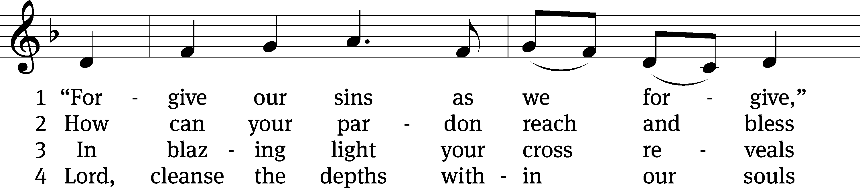
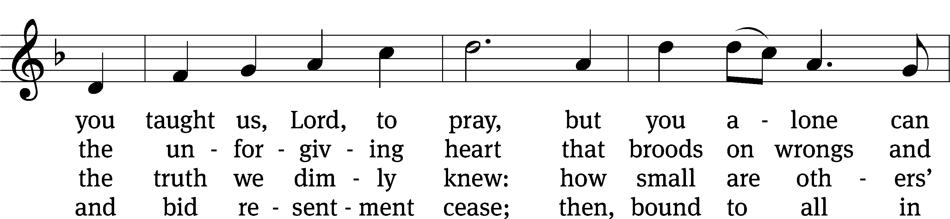
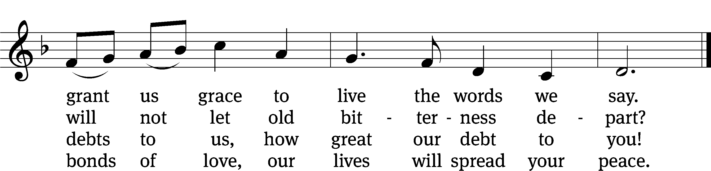
Text: Rosamond E. Herklots, 1905–1987, alt.
Tune: Rosamond E. Herklots, 1905–1987, alt.
Text: © 1969 Oxford University Press. Used by permission: OneLicense no. 727703
Tune: Public domain

Sermon Matthew 18:21-35

“Our Handy-dandy spiritual remote control”
- Rewind to our redemption
- Fast forward to forgive others

please stand, if you are able

nicene creed
We believe in one God, the Father, the Almighty, maker of heaven and earth, of all that is, seen and unseen.
We believe in one Lord, Jesus Christ, the only Son of God, eternally begotten of the Father, God from God, Light from Light, true God from true God, begotten, not made, of one being with the Father. Through him all things were made. For us and for our salvation, he came down from heaven, was incarnate of the Holy Spirit and the virgin Mary, and became truly human. For our sake he was crucified under Pontius Pilate. He suffered death and was buried. On the third day he rose again in accordance with the Scriptures. He ascended into heaven and is seated at the right hand of the Father. He will come again in glory to judge the living and the dead, and his kingdom will have no end.
We believe in the Holy Spirit, the Lord, the giver of life, who proceeds from the Father and the Son, who in unity with the Father and the Son is worshiped and glorified, who has spoken through the prophets. We believe in one holy Christian and apostolic Church. We acknowledge one baptism for the forgiveness of sins. We look for the resurrection of the dead and the life of the world to come. Amen.

prayer of the church

lord’s prayer

C: Our Father, who art in heaven,
hallowed be thy name,
thy kingdom come,
thy will be done
on earth as it is in heaven.
Give us this day our daily bread;
and forgive us our trespasses,
as we forgive those
who trespass against us;
and lead us not into temptation,
but deliver us from evil.
For thine is the kingdom
and the power and the glory
forever and ever. Amen.

The Sacrament of Holy Communion
Trinity Lutheran Church follows the historic Christian practice of close communion. We ask that only members of Trinity or one of our sister congregations partake of the sacrament. If you are not a member, please see the note about Holy Communion in the beginning of the Worship Folder.

M: The Lord be with you.

M: Lift up your hearts.

M: Let us give thanks to the Lord our God.

M: Praise to the God and Father of our Lord Jesus Christ! In love he has blessed us with every spiritual blessing. He sends the Holy Spirit to testify that we are his children and to strengthen us when we are weak. Now have come the salvation and the power and the kingdom of our God and the authority of his Christ. To him who sits on the throne and to the Lamb be praise and thanks and honor and glory for ever and ever:

Holy, Holy, Holy

Words of institution
M: Our Lord Jesus Christ, on the night he was betrayed, took bread; and when he had given thanks, he broke it and gave it to his disciples, saying: “Take and eat. This is my ✙ body, which is given for you. Do this in remembrance of me.”
Then he took the cup, gave thanks, and gave it to them, saying, “Drink from it all of you; this is my ✙ blood of the new covenant, which is poured out for you for the forgiveness of sins. Do this, whenever you drink it, in remembrance of me.”
M: The peace of the Lord be with you always.

O CHRIST, LAMB OF GOD

PLEASE BE SEATED

570 God Loved the World So That He Gave CW 570
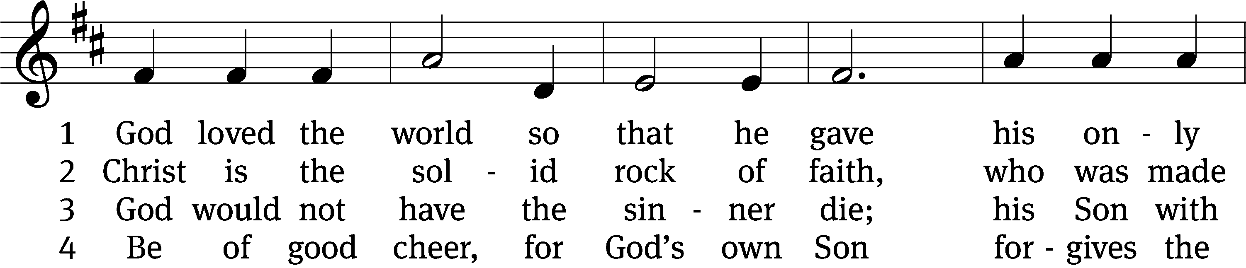
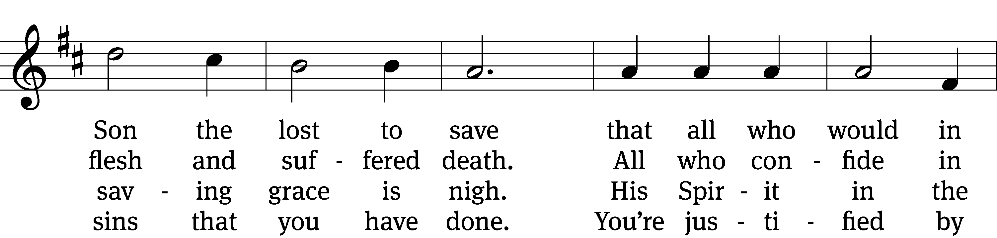
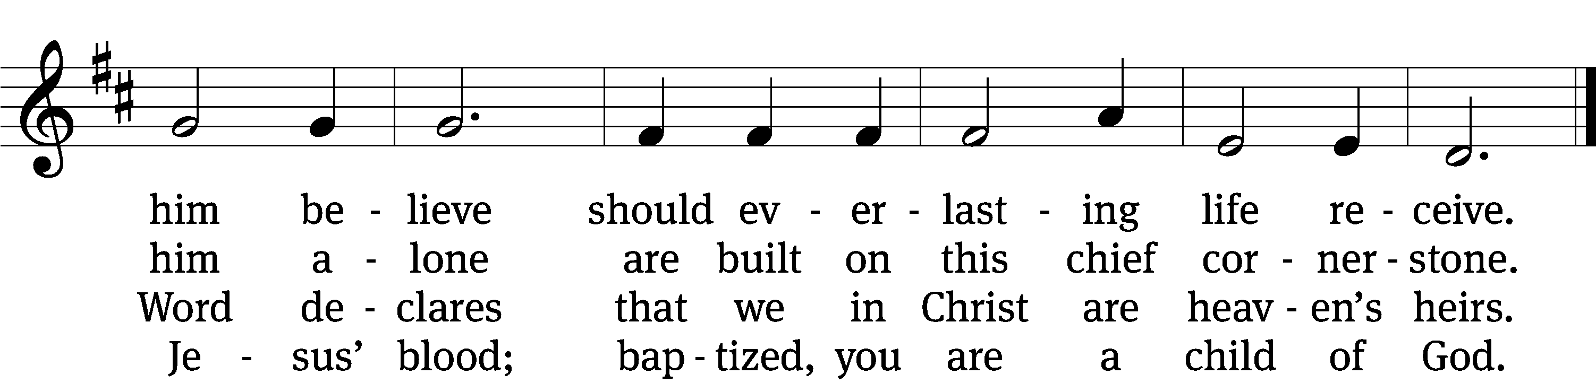

5 If you are sick, if death is near,
this truth your troubled heart can cheer:
Christ Jesus saves my soul from death;
this is the anchor of my faith!

6 Glory to God the Father, Son,
and Holy Spirit, Three in One!
To you, O blessèd Trinity,
be praise now and eternally!
Text: tr. August Crull, 1845–1923, alt.; Heiliges Lippen- und Hertzens- Opffer, Stettin, c. 1778
Tune: George J. Elvey, 1816–1893
Text and tune: Public domain

573 Jesus, Your Blood and Righteousness CW 573
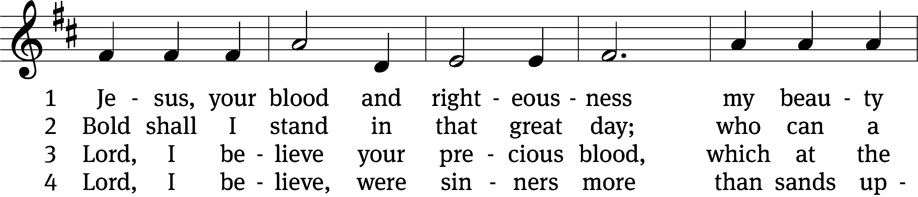
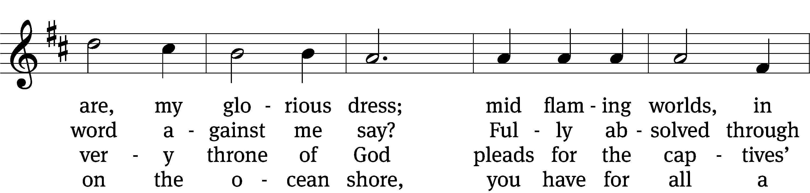
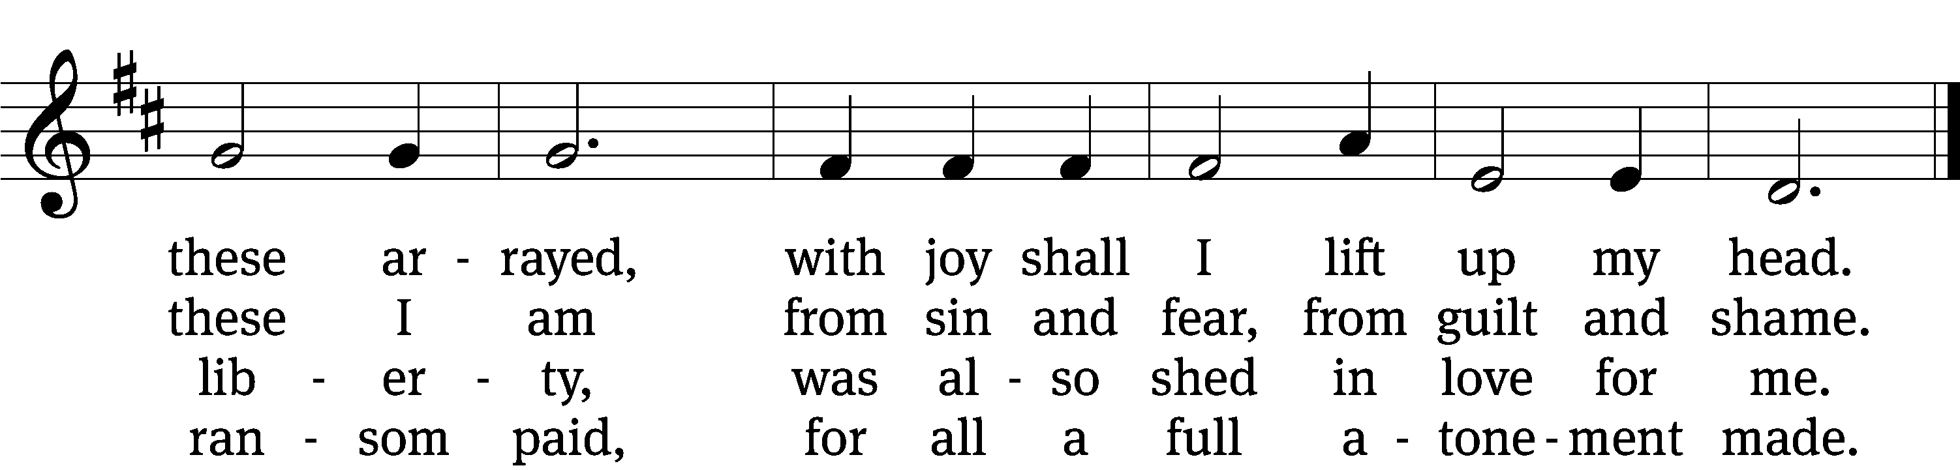

5 When from the dust of death I rise
to claim my mansion in the skies,
this then shall be my only plea:
Jesus has lived and died for me.

6 Jesus, be worshiped endlessly!
Your boundless mercy has for me,
for me and all your hands have made,
an everlasting ransom paid.
Text: tr. John B. Wesley, 1703–1791, alt.; Nicolaus L. von Zinzendorf, 1700–1760, abr.
Tune: George J. Elvey, 1816–1893
Text and tune: Public domain

PLEASE STAND, IF YOU ARE ABLE

M: Hear the prayer of your people, O Lord, that the lips which have praised you here may glorify you in the world, that the eyes which have seen the coming of your Son may long for his coming again, and that all who have received in his true body and blood the pledge of your forgiveness may be restored to live a new and holy life, through Jesus Christ, our Lord, who lives and reigns with you and the Holy Spirit, one God, now and forever.

M: Brothers and sisters, go in peace. Live in harmony with one another.
Serve the Lord with gladness.
The Lord bless you and keep you.
The Lord make his face shine on you and be gracious to you.
The Lord look on you with favor and (+) give you peace.

PLEASE BE SEATED

617 Praise God, from Whom All Blessings Flow CW 617
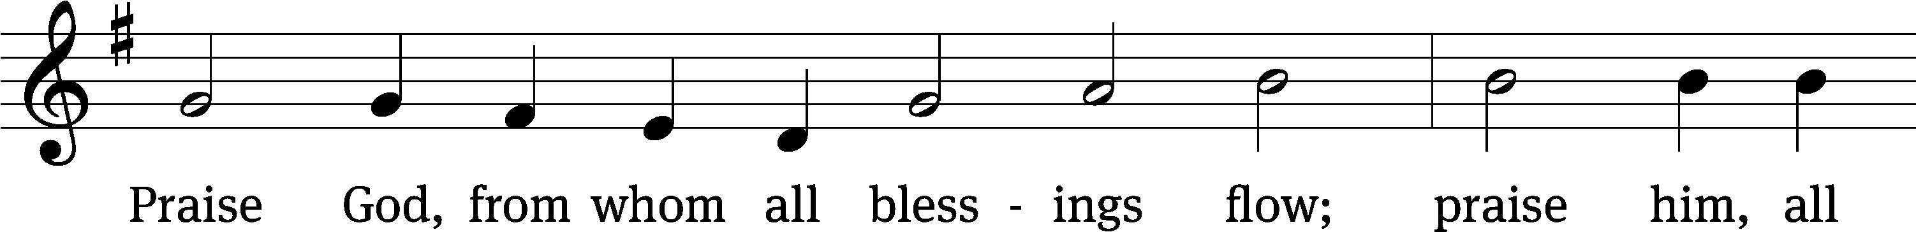
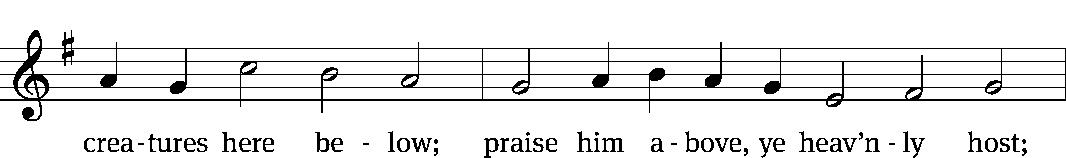
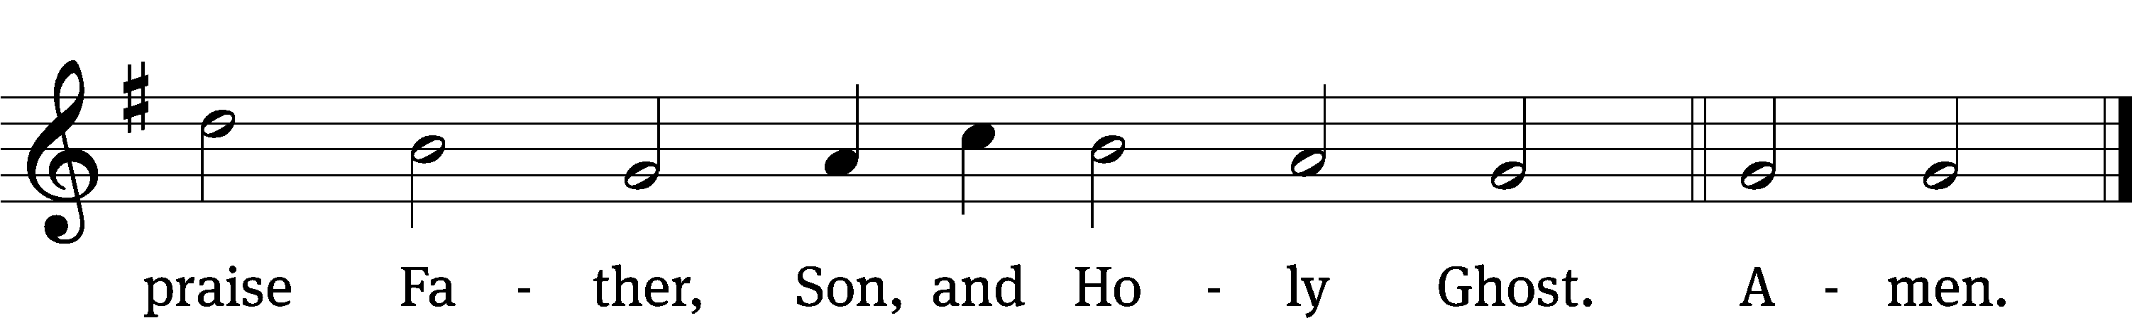
Text: Thomas Ken, 1637–1711
Tune: Trente quatre Pseaumes de David, Geneva, 1551, ed. Louis Bourgeois
Text and tune: Public domain

Serving In Worship

Officiant Pastor William Natsis
Organist Marcia Marion Ackling
Deacons (8:30) Duane Mason and Jim Tice
(11:00) Steve Hoeft and Jeff Neuburger
Ushers (8:30) Bob Newman and Henry Schneider
(11:00) Dave Boswell and Jake Vershum
Altar Guild Marcia Marion Ackling and Judy Lindemann
Videographer Rick Schneider

Copyright information
Service of Word and Sacrament: Christian Worship. © 1993 Northwestern Publishing House. All rights reserved. Reprinted under ONE LICENSE #A-727703 and CCLI #1151741/ CSPL126093
Words and Music: All rights reserved. Reprinted/Podcast/Streamed with permission under ONE LICENSE #A-727703 and CCLI #1151741/CSPL126093

