the ELEVENTH sunday
AFTER PENTECOST

TRINITY EVANGELICAL LUTHERAN CHURCH | Saline, Michigan
WELCOME TO WORSHIP August 18/21, 2022

Thank you for joining us in God’s house today! We cordially ask that our guests sign one of the guestbooks located at either the front or back entryways.

THANK OFFERING: Members of Trinity give their offering as an expression of love and thankfulness to the Lord and to help support the Lord’s work in our community and around the world. Visitors need not feel obligated to participate in this offering which supports our ministry.

Restrooms are located at the back of the upper level (the annex), and in the basement (down the back stairs of the sanctuary or annex). Handicap access is available, please ask an usher for assistance.

celebration of holy communion:
In His Word, God makes it clear that the Lord’s Supper is to be shared by people of a common proclamation of faith (1 Corinthians 11:26; 1 Corinthians 10:16-17). Without judging anyone’s hearts, we invite those who share in our confession by their membership in our congregation or another congregation of the Wisconsin Evangelical Lutheran Synod (WELS) or the Evangelical Lutheran Synod (ELS) and who are properly prepared (1 Corinthians 11;27-29) to receive the Sacrament. Page 295 in the front of Christian Worship provides a guide for preparation.

Guests, we would love to have you join us in communion fellowship in the future, and for that to be possible, we ask that you speak with one of the pastors so that we may speak with you on how that would be possible. We thank you for respecting the way we celebrate the Lord’s Supper in our congregations.

SERVICE OF WORD AND SACRAMENT

606 Alleluia! Sing to Jesus CW 606
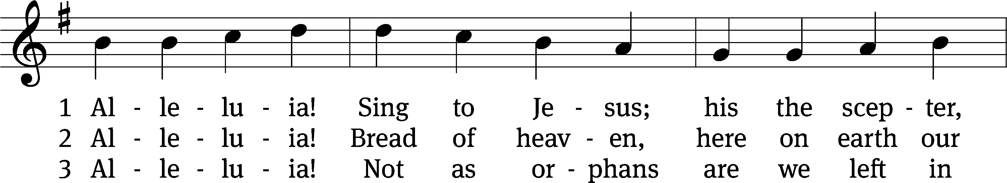
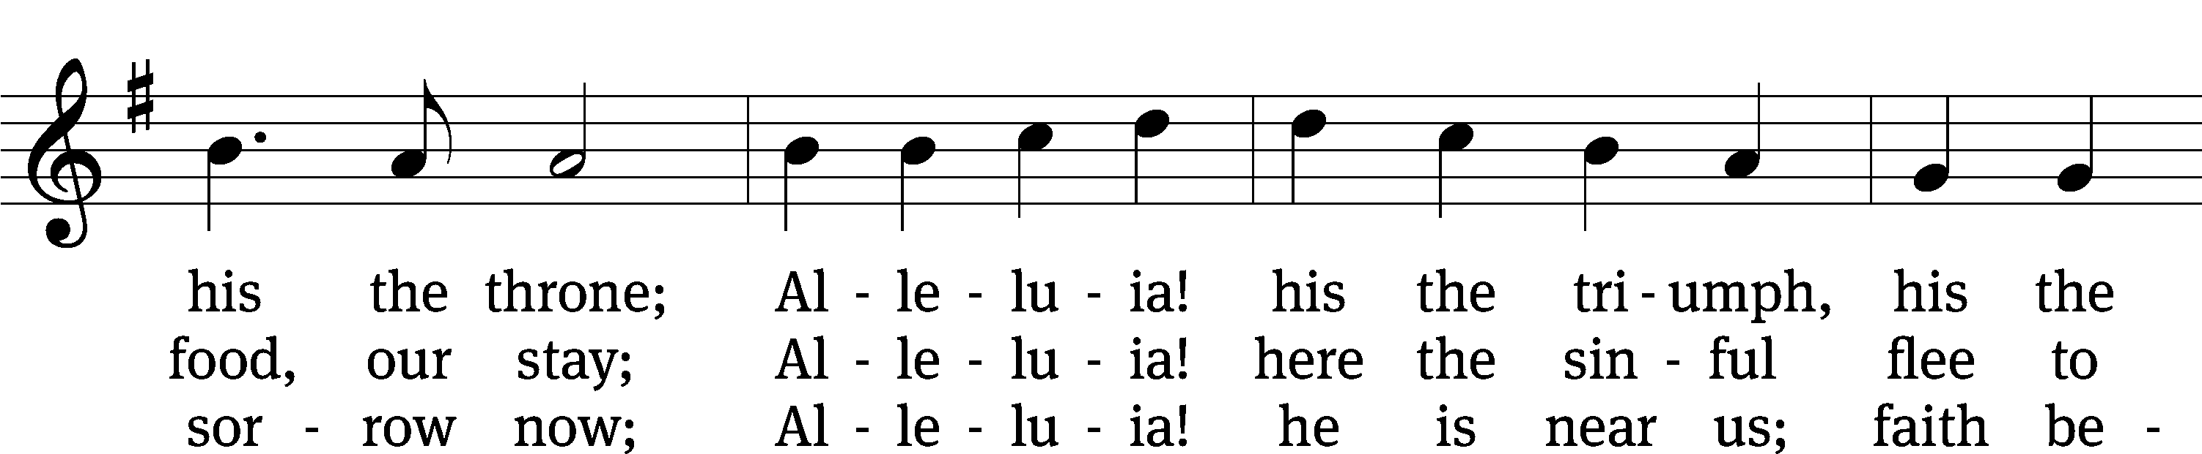
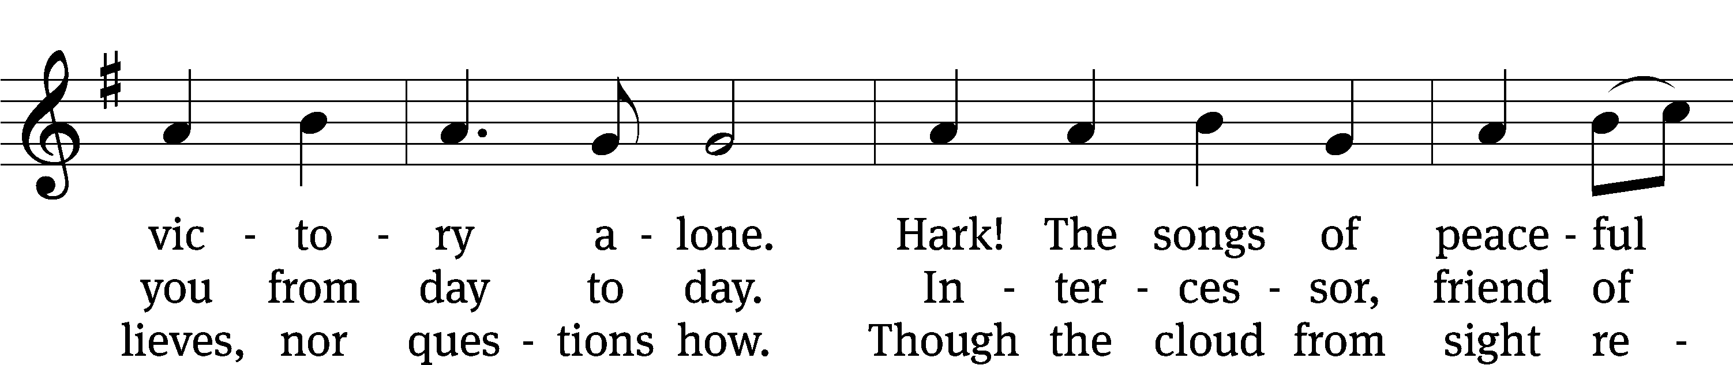
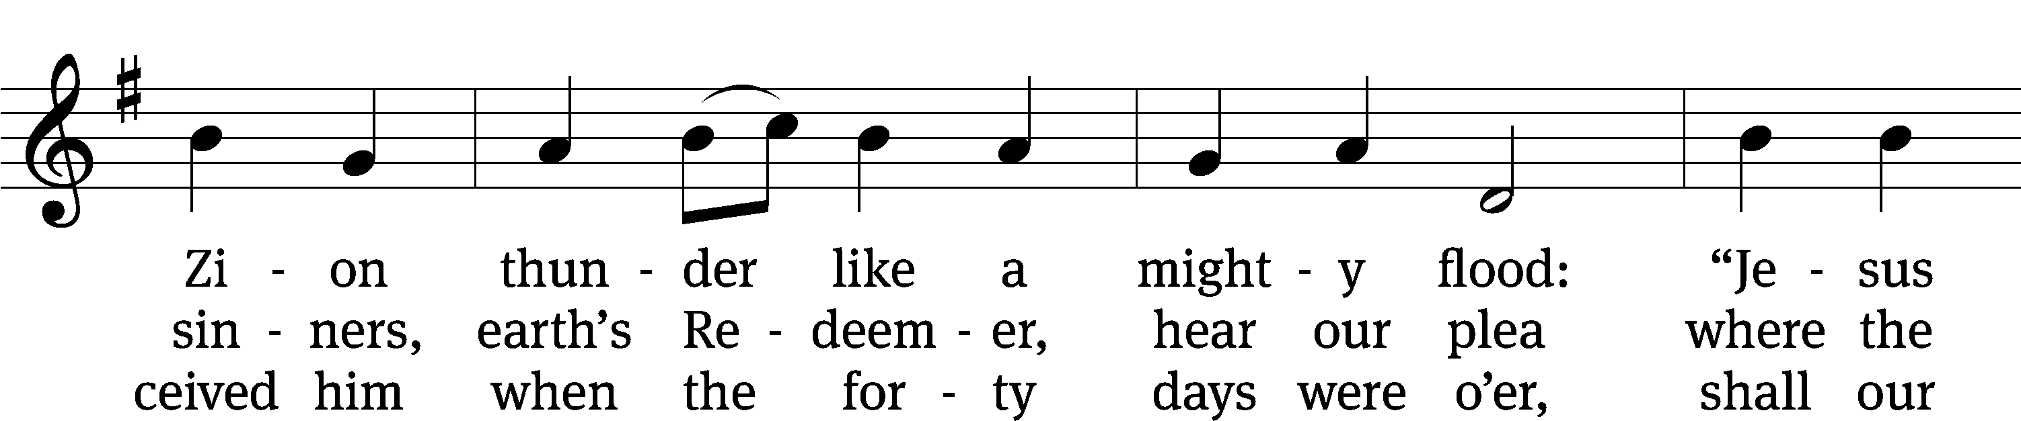
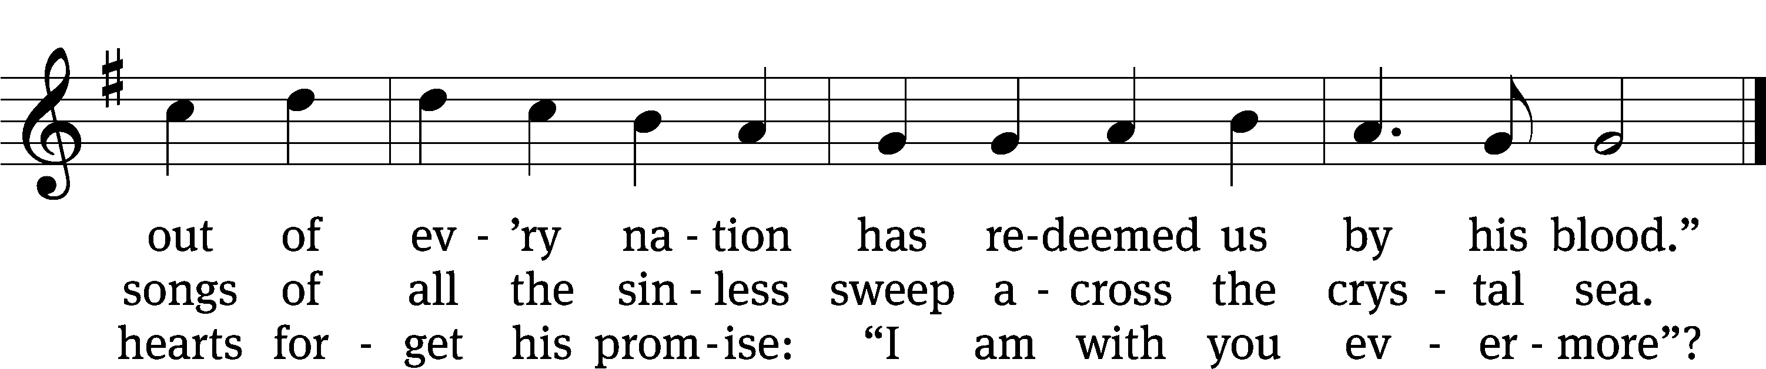
Text: William C. Dix, 1837–1898, abr., alt.
Tune: adapt. Edward Hodges, 1796–1867; Ludwig van Beethoven, 1770–1827
Text and tune: Public domain

PLEASE STAND, IF YOU ARE ABLE

invocation

M: The grace of our Lord (+) Jesus Christ and the love of God and the fellowship of the Holy Spirit be with you.
C: And also with you.
CONFESSION OF SINS
M: God invites us to come into his presence and worship him with humble and penitent hearts. Therefore, let us acknowledge our sinfulness and ask him to forgive us.
C: Holy and merciful Father, I confess that I am by nature sinful, and that I have disobeyed you in my thoughts, words, and actions. I have done what is evil and failed to do what is good. For this I deserve your punishment both now and in eternity. But I am truly sorry for my sins, and trusting in my Savior Jesus Christ, I pray: Lord, have mercy on me, a sinner.
M: God, our heavenly Father, has been merciful to us and has given his only Son to be the atoning sacrifice for our sins. Therefore, as a called servant of Christ and by his authority, I forgive you all your sins in the name of the Father and of the Son (+) and of the Holy Spirit.
C: Amen.

PRAYER AND PRAISE

LORD, HAVE MERCY
Kyrie
M: For all that we need in life and for the wisdom to use all your gifts with gratitude and joy, hear our prayer, O Lord.

M: For the steadfast assurance that nothing can separate us from your love and for the courage to stand firm against the assaults of Satan and every evil, hear our prayer, O Christ.

M: For the well-being of your holy Church in all the world and for those who offer here their worship and praise, hear our prayer, O Lord.

M: Merciful God, maker and preserver of life, uphold us by your power and keep us in your tender care:

M: The works of the Lord are great and glorious; his name is worthy of praise.

Prayer of the day

M: Let us pray.
The minister says the Prayer of the Day.

PLEASE BE SEATED

The Word

first lesson ISaiah 66:18-24
¹⁸ As for me, because of their works and their thoughts,
the time is coming for me to gather people from all nations
and all languages.
They will come, and they will see my glory.
¹⁹ Then I will set up a sign among them,
and I will send out survivors from among them to the nations,
to Tarshish, Pul, and Lud, to those who are archers,
to Tubal and Javan, to the distant coastlands,
who have not heard my message and have not seen my glory.
Then they will declare my glory among the nations.
²⁰ Then they will bring all your brothers from all the nations as an offering to the Lord. They will bring them on horses and chariots and wagons and mules and dromedaries to my holy mountain Jerusalem, says the Lord, in the same way that the people of Israel bring an offering in a clean vessel to the Lord’s house. ²¹ Even from among these people I will take priests and Levites, says the Lord.
²² For just as the new heavens and the new earth that I am making will remain standing before me, declares the Lord, in the same way your offspring and your name will stand. ²³ As often as one new moon follows another and one Sabbath follows another, all flesh will come to worship before me, says the Lord.
²⁴ They will go out, and they will see the corpses of the ones who were rebelling against me, for their worm will not die, and their fire will not be quenched, and all flesh will be horrified by them.
103B Praise, My Soul, the King of Heaven Psalm 103B
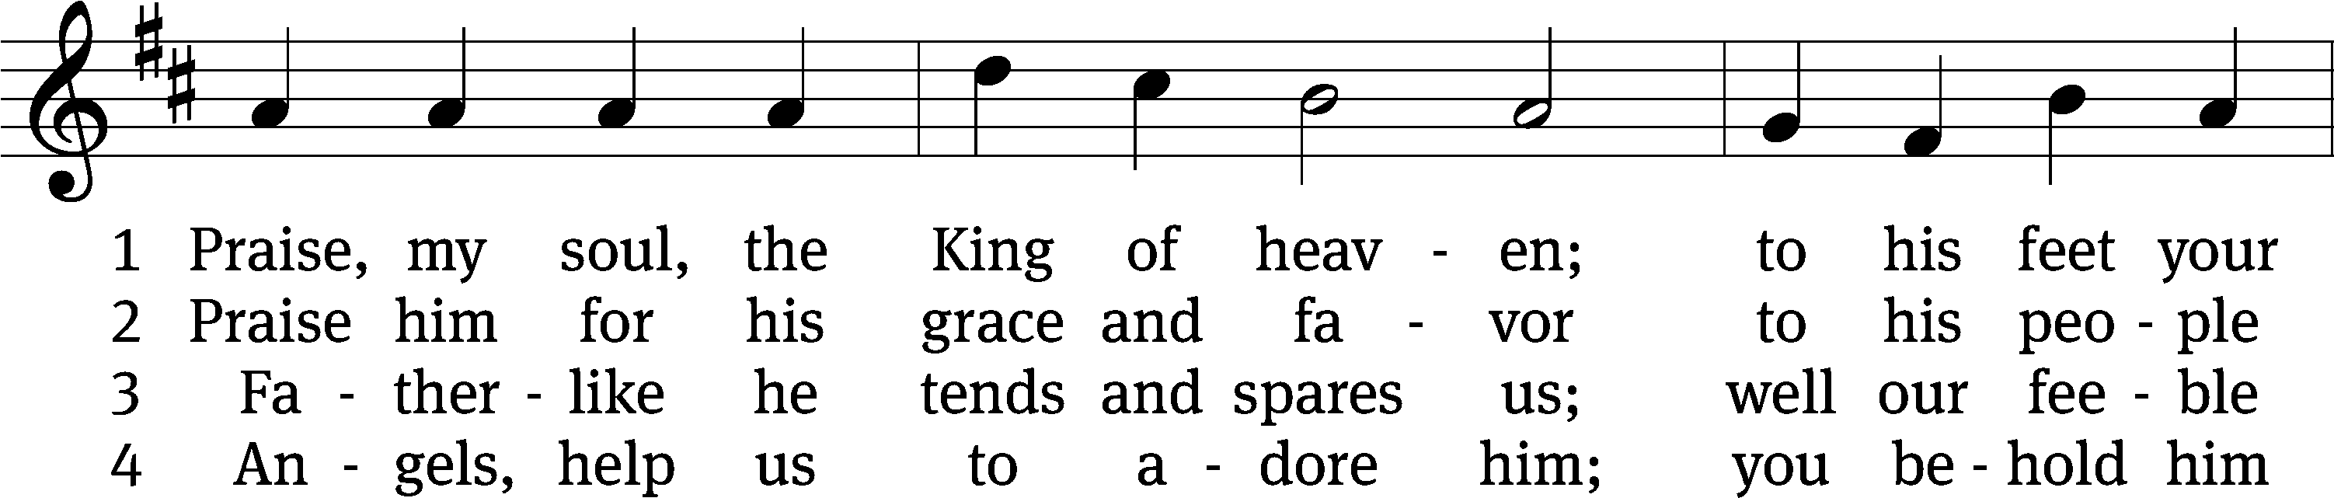
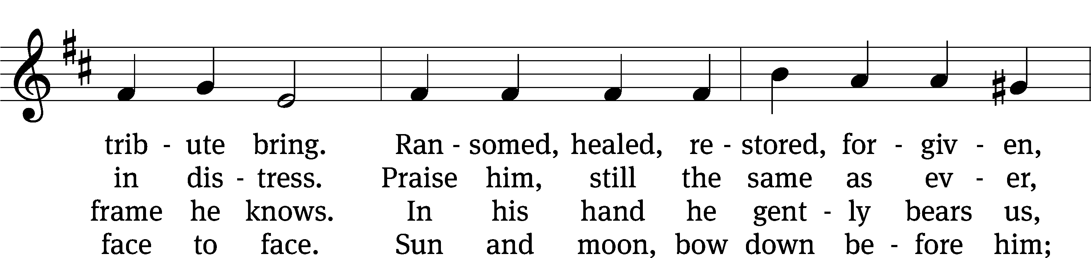
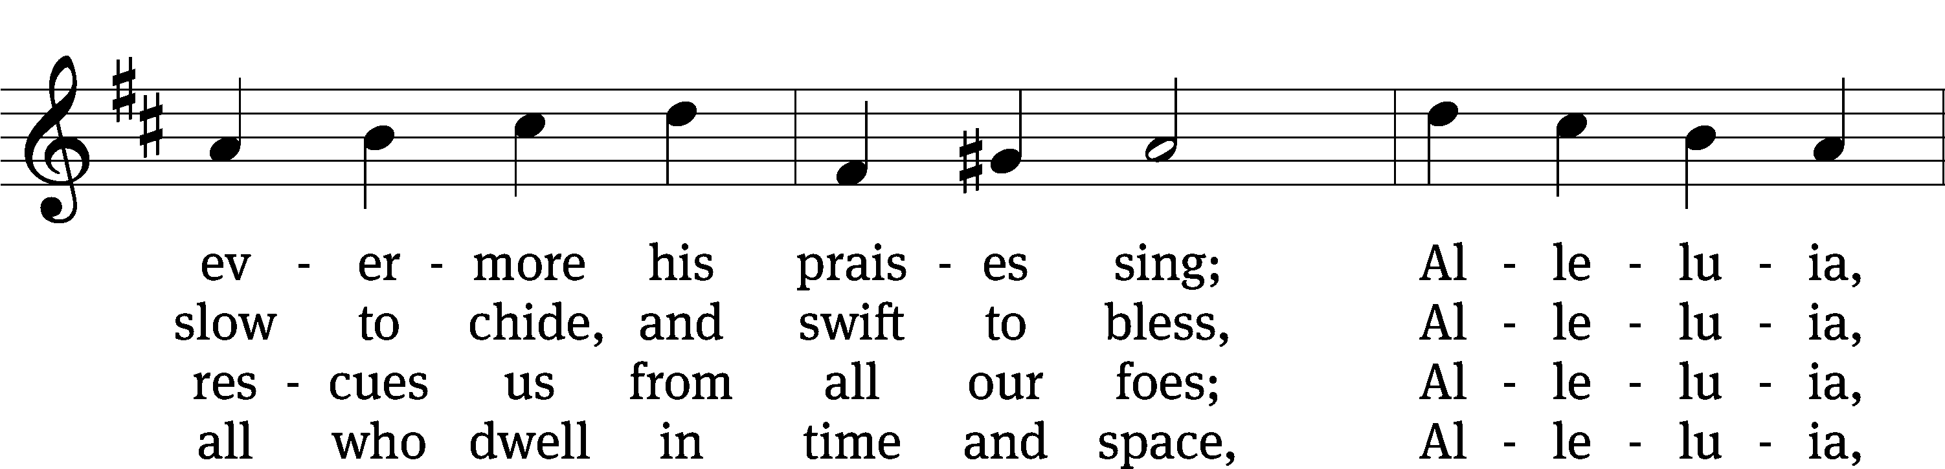
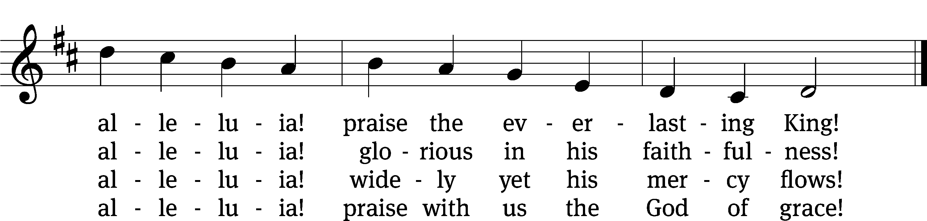
Text: Henry F. Lyte
Tune: John Goss
Text and tune: Public domain

second lesson HEBREWS 12:18-24
¹⁸ You have not come to a mountain that can be touched and to burning fire, to darkness, to gloom, to a raging storm, ¹⁹ to the sound of a trumpet, and to a voice that spoke. Those who heard the voice asked that not one more word be added, ²⁰ because they could not endure what was commanded: “If even an animal touches the mountain, it must be stoned.” ²¹ The sight was so terrifying that even Moses said, “I am trembling with fear.”
²² Instead, you have come to Mount Zion, the city of the living God; to the heavenly Jerusalem; to tens of thousands of angels in joyful assembly; ²³ to the church of the firstborn whose names are written in heaven; to God, who is the judge of all; to the spirits of righteous people who have been made perfect; ²⁴ to Jesus, the mediator of a new testament; and to the sprinkled blood that speaks a better message than the blood of Abel.

PLEASE STAND, IF YOU ARE ABLE

VERSE OF THE DAY

GOSPEL LUKE 13:22-30
²² He went on his way from one town and village to another, teaching, and making his way to Jerusalem. ²³ Someone said to him, “Lord, are only a few going to be saved?”
He said to them, ²⁴ “Strive to enter through the narrow door, because many, I tell you, will try to enter and will not be able. ²⁵ Once the master of the house gets up and shuts the door, you will begin to stand outside and knock on the door, saying, ‘Lord, open for us!’ He will tell you in reply, ‘I don’t know you or where you come from.’ ²⁶ Then you will begin to say, ‘We ate and drank in your presence, and you taught in our streets.’ ²⁷ And he will say, ‘I don’t know where you come from. Depart from me, all you evildoers.’ ²⁸ There will be weeping and gnashing of teeth when you see Abraham, Isaac, and Jacob, and all the prophets in the kingdom of God, but you yourselves thrown outside. ²⁹ People will come from east and west, from north and south, and will recline at the table in the kingdom of God. ³⁰ And note this: Some are last who will be first, and some are first who will be last.”

M: This is the Gospel of the Lord.

PLEASE BE SEATED

510 In Christ Alone CW 510
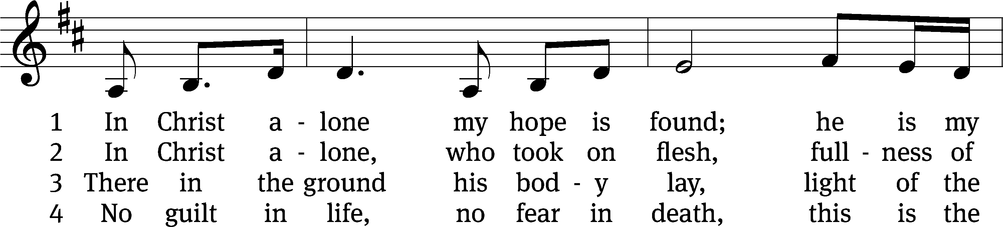
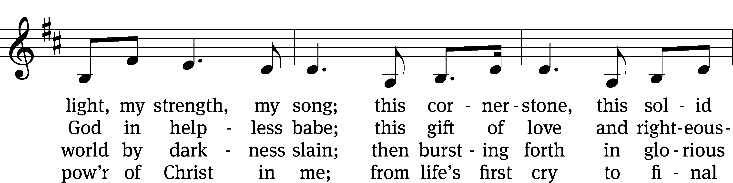
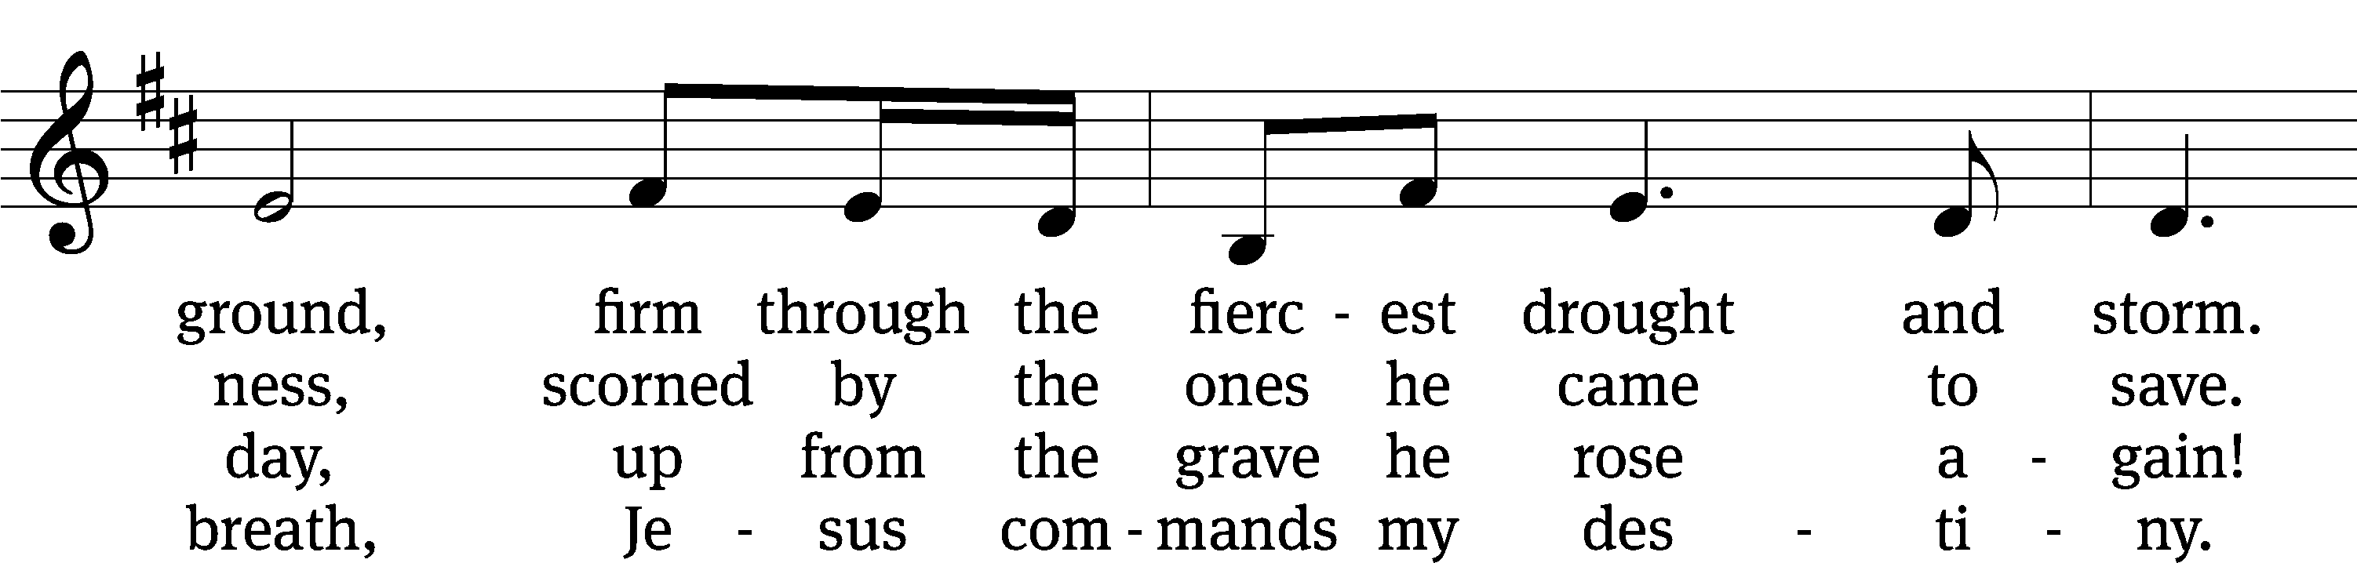
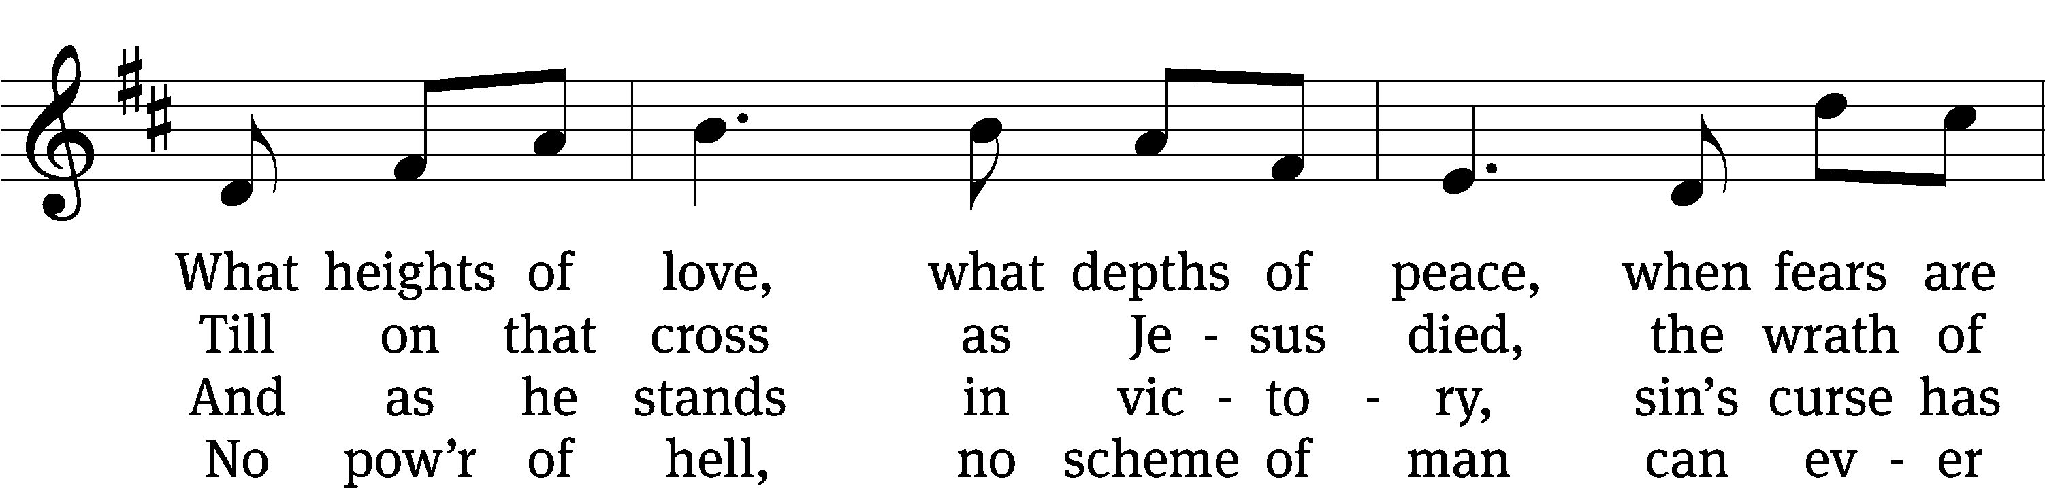
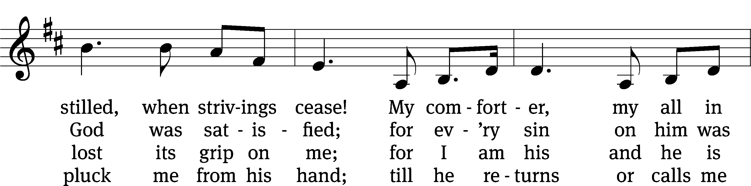
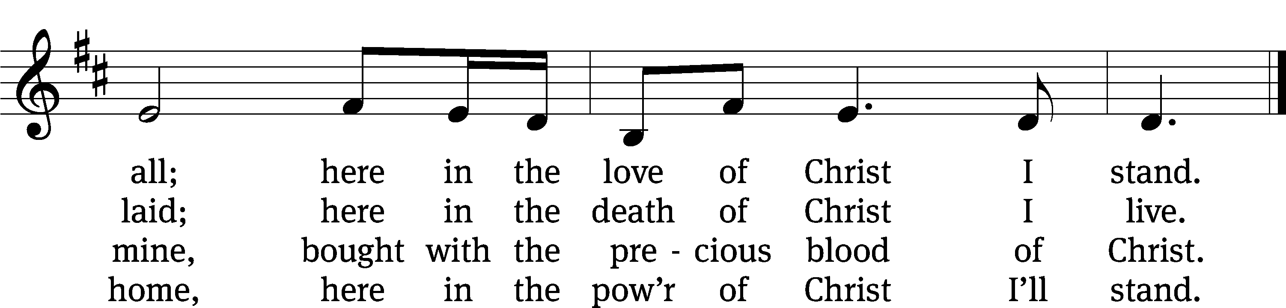
Text: Stuart Townend, b. 1963; Keith Getty, b. 1974
Tune: Stuart Townend, b. 1963; Keith Getty, b. 1974
Text and tune: © 2002 Thankyou Music. Used by permission: OneLicense no. 727703

Sermon Luke 13:22-30
“The Narrow Door”

please stand, if you are able

nicene creed
We believe in one God, the Father, the Almighty, maker of heaven and earth, of all that is, seen and unseen.
We believe in one Lord, Jesus Christ, the only Son of God, eternally begotten of the Father, God from God, Light from Light, true God from true God, begotten, not made, of one being with the Father. Through him all things were made. For us and for our salvation, he came down from heaven, was incarnate of the Holy Spirit and the virgin Mary, and became truly human. For our sake he was crucified under Pontius Pilate. He suffered death and was buried. On the third day he rose again in accordance with the Scriptures. He ascended into heaven and is seated at the right hand of the Father. He will come again in glory to judge the living and the dead, and his kingdom will have no end.
We believe in the Holy Spirit, the Lord, the giver of life, who proceeds from the Father and the Son, who in unity with the Father and the Son is worshiped and glorified, who has spoken through the prophets. We believe in one holy Christian and apostolic Church. We acknowledge one baptism for the forgiveness of sins. We look for the resurrection of the dead and the life of the world to come. Amen.

PLEASE BE SEATED

offertory

PLEASE STAND, IF YOU ARE ABLE

prayer of the church

lord’s prayer

C: Our Father, who art in heaven,
hallowed be thy name,
thy kingdom come,
thy will be done
on earth as it is in heaven.
Give us this day our daily bread;
and forgive us our trespasses,
as we forgive those
who trespass against us;
and lead us not into temptation,
but deliver us from evil.
For thine is the kingdom
and the power and the glory
forever and ever. Amen.

The Sacrament of Holy Communion
Trinity Lutheran Church follows the historic Christian practice of close communion. We ask that only members of Trinity or one of our sister congregations partake of the sacrament. If you are not a member, please see the note about Holy Communion in the beginning of the Worship Folder.

M: The Lord be with you.

M: Lift up your hearts.

M: Let us give thanks to the Lord our God.

M: Praise to the God and Father of our Lord Jesus Christ! In love he has blessed us with every spiritual blessing. He sends the Holy Spirit to testify that we are his children and to strengthen us when we are weak. Now have come the salvation and the power and the kingdom of our God and the authority of his Christ. To him who sits on the throne and to the Lamb be praise and thanks and honor and glory for ever and ever:

Holy, Holy, Holy

Words of institution
M: Our Lord Jesus Christ, on the night he was betrayed, took bread; and when he had given thanks, he broke it and gave it to his disciples, saying: “Take and eat. This is my ✙ body, which is given for you. Do this in remembrance of me.”
Then he took the cup, gave thanks, and gave it to them, saying, “Drink from it all of you; this is my ✙ blood of the new covenant, which is poured out for you for the forgiveness of sins. Do this, whenever you drink it, in remembrance of me.”
The peace of the Lord be with you always.

O CHRIST, LAMB OF GOD

PLEASE BE SEATED
DISTRIBUTION HYMN
840 All Men Living Are But Mortal CW 840
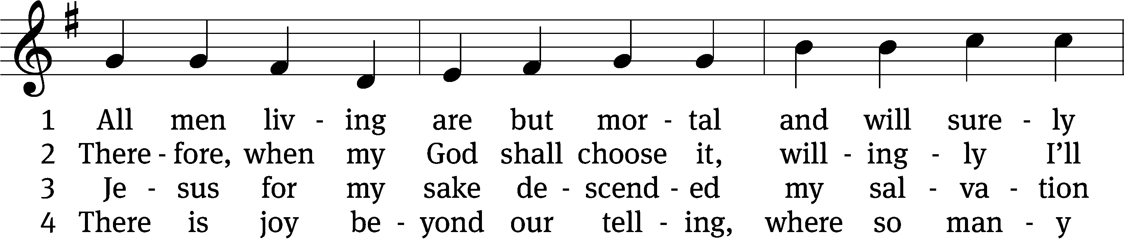
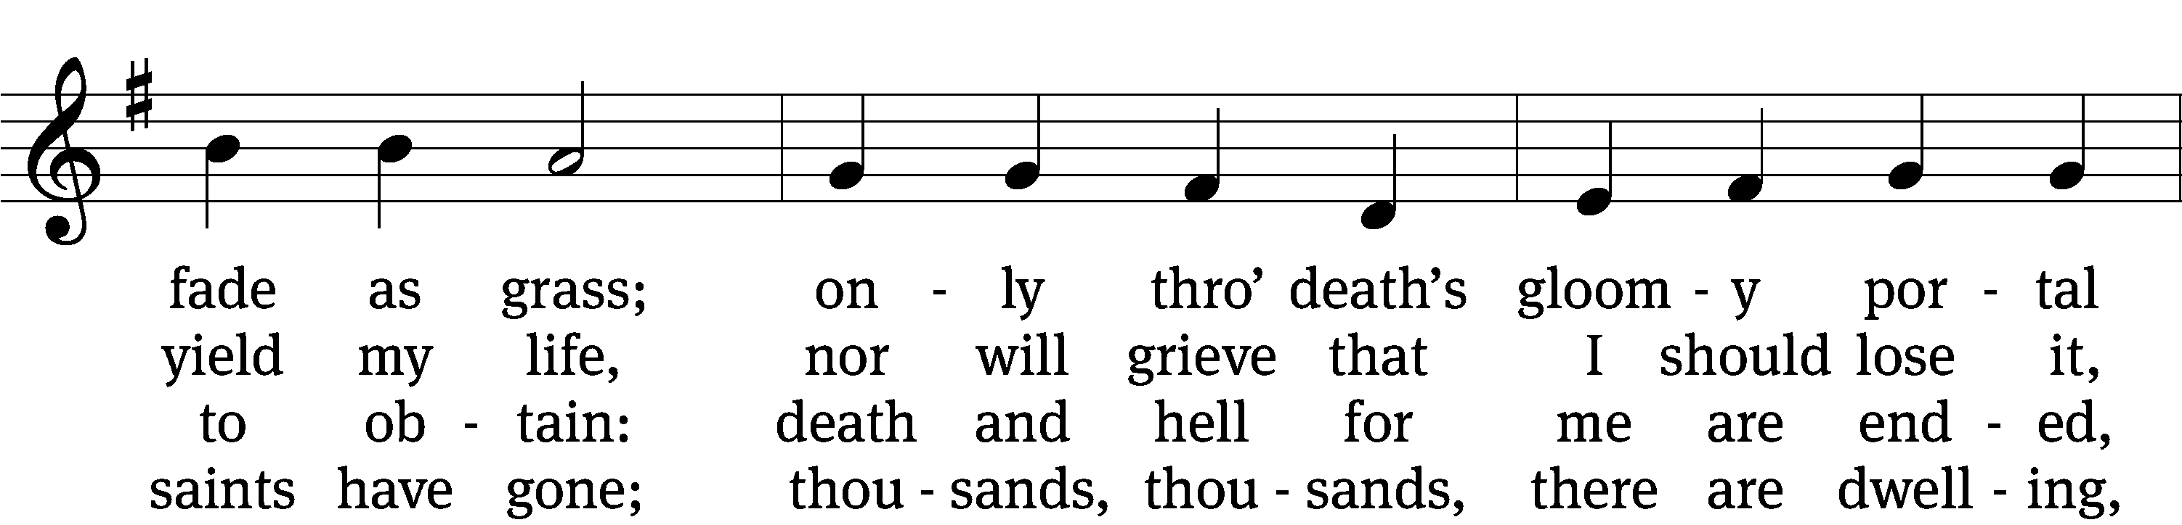
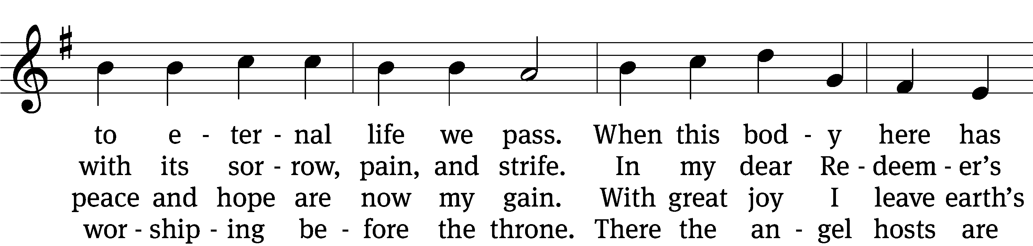
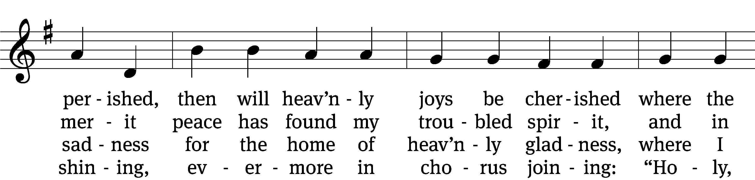
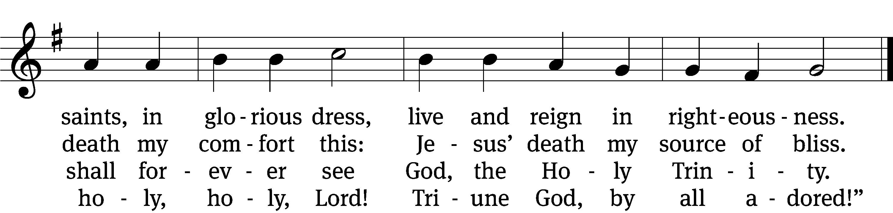

5 Patriarchs of sacred story
and the prophets there are found;
twelve apostles, bright with glory,
on twelve seats are there enthroned.
All the saints that have ascended
age on age, through time extended,
there in blissful concert sing
hallelujahs to their King.

6 O Jerusalem, how glorious
are your heav’nly mansions fair!
I can hear the tones victorious
ever sweetly sounding there.
Oh, the bliss that there surprises!
Look, my soul, the sun now rises,
and the breaking day I see
that shall never end for me.

7 Now I see what here was told me,
see that wondrous glory shine,
feel the spotless robes enfold me,
know a golden crown is mine.
Thus before the throne so glorious
now I stand, a soul victorious,
filled with purest joy and peace
that in Christ shall never cease.
Text: J. G. Albinus, 1624–1679; (sts. 1–4, 6–7): tr. Catherine Winkworth, 1827–1878, alt.; (st. 5): unknown, alt.
Tune: Das grosse Cantional, Darmstadt, 1687
Text and tune: Public domain

PLEASE STAND, IF YOU ARE ABLE

THANKSGIVING

M: Hear the prayer of your people, O Lord, that the lips which have praised you here may glorify you in the world, that the eyes which have seen the coming of your Son may long for his coming again, and that all who have received in his true body and blood the pledge of your forgiveness may be restored to live a new and holy life, through Jesus Christ, our Lord, who lives and reigns with you and the Holy Spirit, one God, now and forever.

M: Brothers and sisters, go in peace. Live in harmony with one another.
Serve the Lord with gladness.

The Lord bless you and keep you.
The Lord make his face shine on you and be gracious to you.
The Lord look on you with favor and (+) give you peace.

PLEASE BE SEATED

916 Today Your Mercy Calls Us CW 916
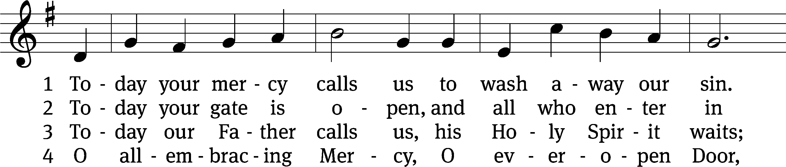
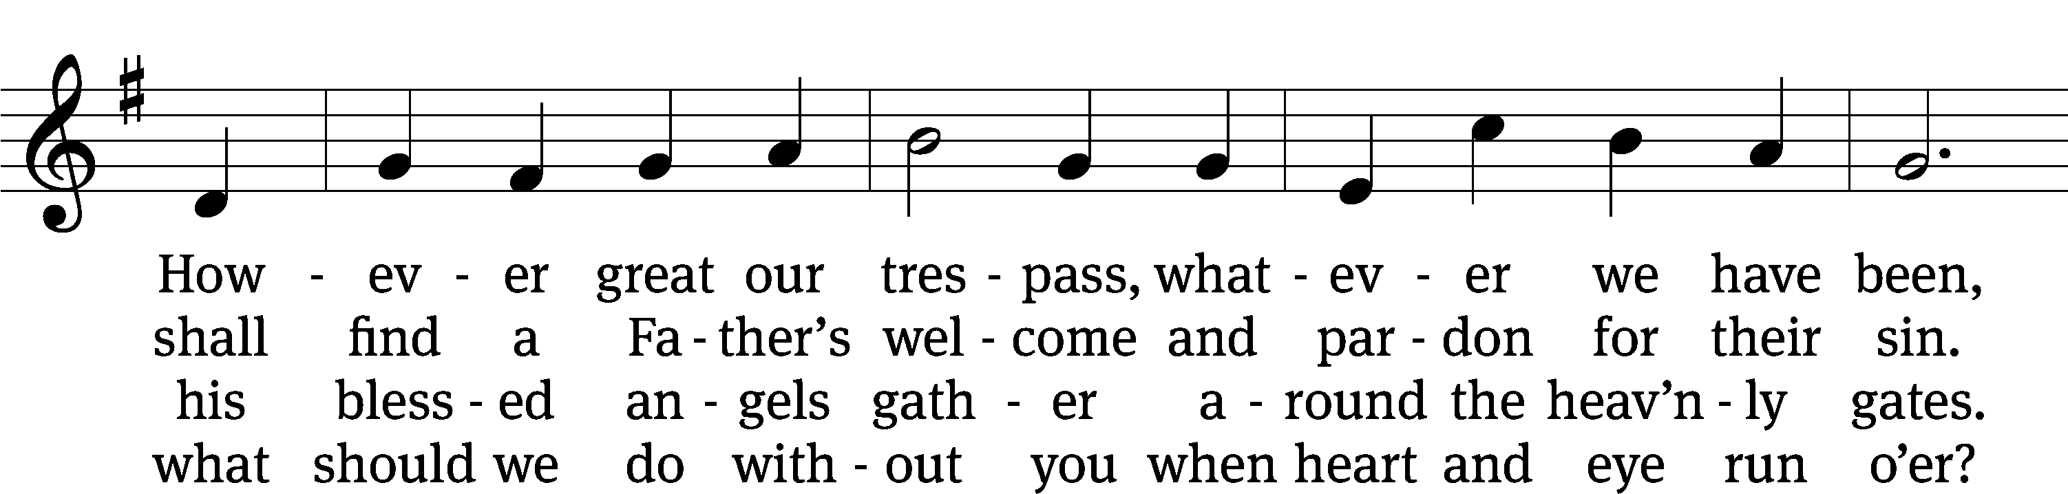
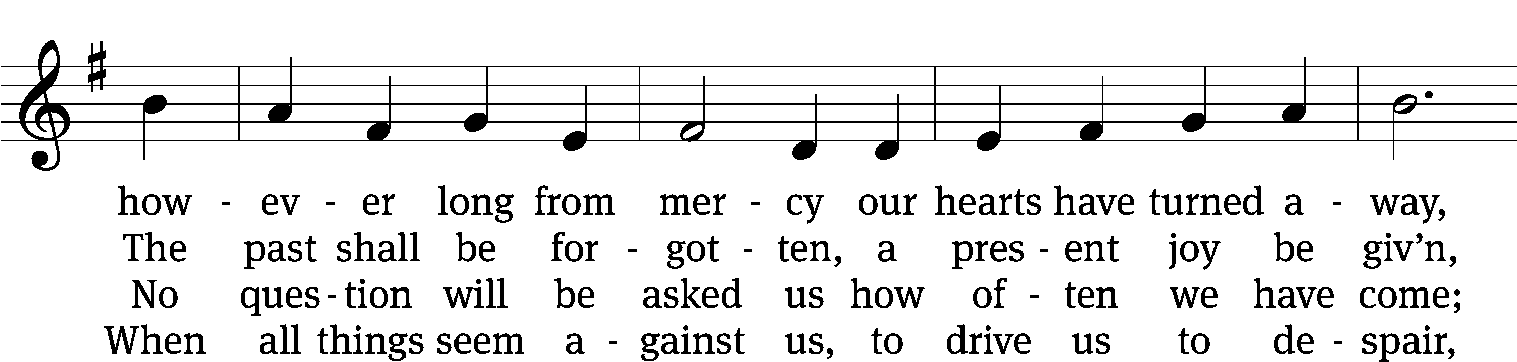
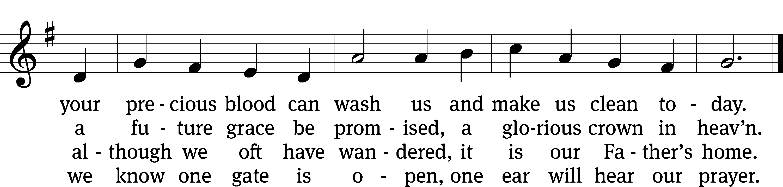
Text: Oswald Allen, 1816–1878, alt.
Tune: Friedrich K. Anthes, 1812–after 1857
Text and tune: Public domain

Serving In Worship

Officiant Pastor Natsis
Organist Marcia Marion Ackling
Deacons (Thursday) Dave Frey and Steve Hoeft
(Sunday) Dave Stevenson and Ed Wheeler
Ushers (Thursday) Dale Radak
(Sunday) Ron Zahn
Altar Guild Scott Ackling and Marcia Marion Ackling
Videographer Cindy Dresch

Copyright information
Service of Word and Sacrament: Christian Worship. © 1993 Northwestern Publishing House. All rights reserved. Reprinted under ONE LICENSE #A-727703 and CCLI #1151741/ CSPL126093
Words and Music: All rights reserved. Reprinted/Podcast/Streamed with permission under ONE LICENSE #A-727703 and CCLI #1151741/CSPL126093

