THE TWELFth SUNDAY
AFTER PENTECOST

TRINITY EVANGELICAL LUTHERAN CHURCH | Saline, Michigan
WELCOME TO WORSHIP August 17/20, 2023

Thank you for joining us in God’s house today! We cordially ask that our guests sign one of the guestbooks located at either the front or back entryways.

THANK OFFERING: Members of Trinity give their offering as an expression of love and thankfulness to the Lord and to help support the Lord’s work in our community and around the world. Visitors need not feel obligated to participate in this offering which supports our ministry.

Restrooms are located at the back of the upper level (the annex), and in the basement (down the back stairs of the sanctuary or annex). Handicap access is available, please ask an usher for assistance.

celebration of holy communion:
In His Word, God makes it clear that the Lord’s Supper is to be shared by people of a common proclamation of faith (1 Corinthians 11:26; 1 Corinthians 10:16-17). Without judging anyone’s hearts, we invite those who share in our confession by their membership in our congregation or another congregation of the Wisconsin Evangelical Lutheran Synod (WELS) or the Evangelical Lutheran Synod (ELS) and who are properly prepared (1 Corinthians 11;27-29) to receive the Sacrament. Page 295 in the front of Christian Worship provides a guide for preparation.

Guests, we would love to have you join us in communion fellowship in the future, and for that to be possible, we ask that you speak with one of the pastors so that we may speak with you on how that would be possible. We thank you for respecting the way we celebrate the Lord’s Supper in our congregations.

SERVICE OF WORD AND SACRAMENT
914 Christ Is Our Cornerstone CW 914
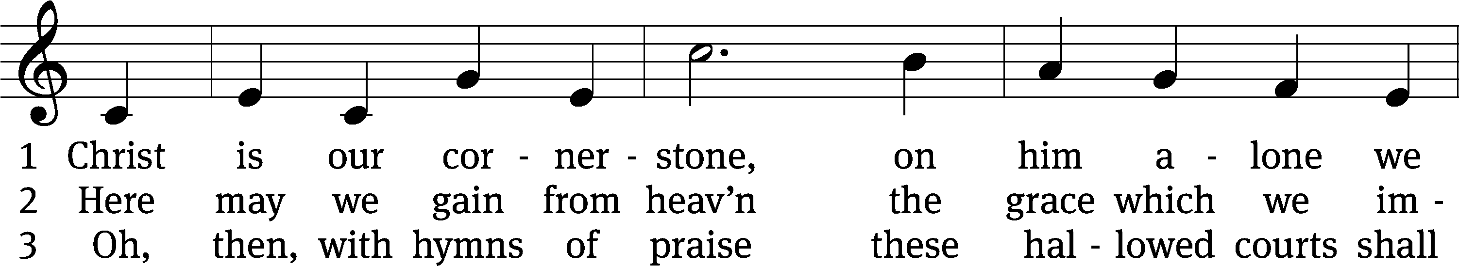
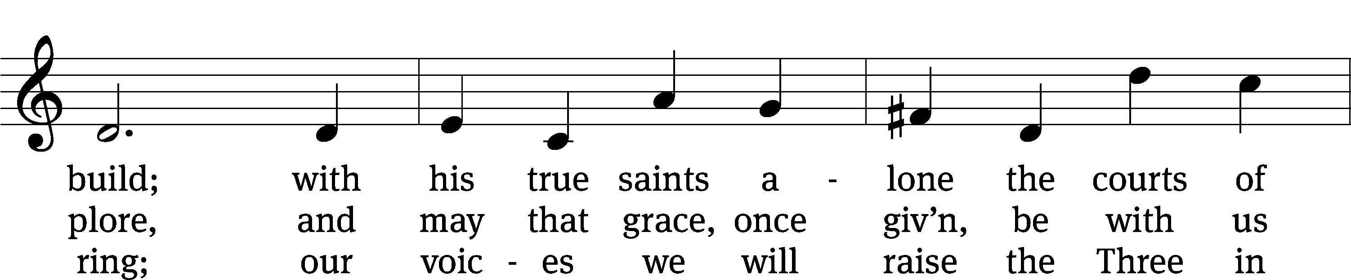
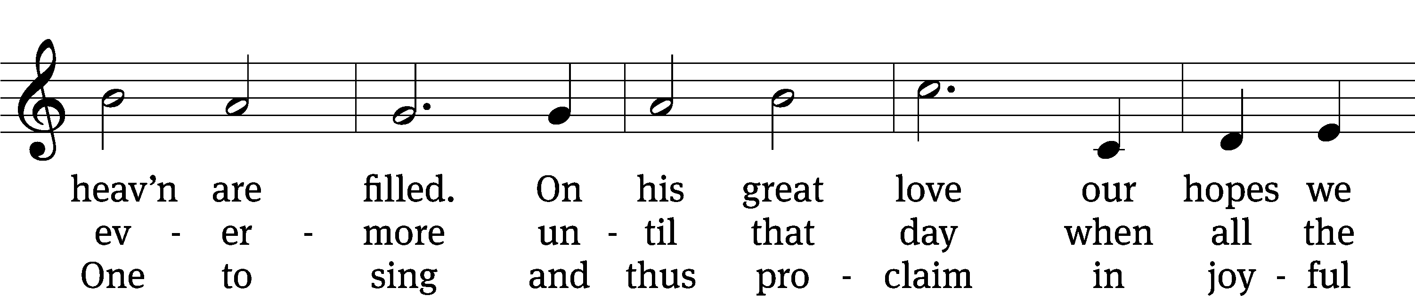
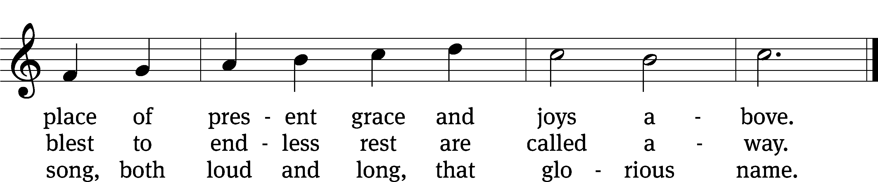
Text: tr. John Chandler, 1806–1876, alt.; Latin, c. 8th cent., abr.
Tune: John Darwall, 1731–1789
Text and tune: Public domain

PLEASE STAND, IF YOU ARE ABLE

invocation

M: The grace of our Lord (+) Jesus Christ and the love of God and the fellowship of the Holy Spirit be with you.
C: And also with you.
CONFESSION OF SINS
M: God invites us to come into his presence and worship him with humble and penitent hearts. Therefore, let us acknowledge our sinfulness and ask him to forgive us.
C: Holy and merciful Father, I confess that I am by nature sinful, and that I have disobeyed you in my thoughts, words, and actions. I have done what is evil and failed to do what is good. For this I deserve your punishment both now and in eternity. But I am truly sorry for my sins, and trusting in my Savior Jesus Christ, I pray: Lord, have mercy on me, a sinner.
M: God, our heavenly Father, has been merciful to us and has given his only Son to be the atoning sacrifice for our sins. Therefore, as a called servant of Christ and by his authority, I forgive you all your sins in the name of the Father and of the Son (+) and of the Holy Spirit.
C: Amen.
PRAYER AND PRAISE
LORD, HAVE MERCY
Kyrie
M: For all that we need in life and for the wisdom to use all your gifts with gratitude and joy, hear our prayer, O Lord.

M: For the steadfast assurance that nothing can separate us from your love and for the courage to stand firm against the assaults of Satan and every evil, hear our prayer, O Christ.

M: For the well-being of your holy Church in all the world and for those who offer here their worship and praise, hear our prayer, O Lord.

M: Merciful God, maker and preserver of life, uphold us by your power and keep us in your tender care:

M: The works of the Lord are great and glorious; his name is worthy of praise.

Prayer of the day

M: Let us pray.

The minister says the Prayer of the Day.

PLEASE BE SEATED

The Word

first lesson Isaiah 56:1,6-8

¹ This is what the Lord says.
Protect justice, and carry out righteousness,
because my salvation is coming very soon.
My righteousness is ready to be revealed.
² How blessed is everyone who does this,
who grabs hold of it,
who keeps the Sabbath and does not profane it,
who holds back his hand from doing any evil.
³ Therefore, the foreigner who joins himself to the Lord should not say,
“The Lord will certainly exclude me from his people.”
The eunuch should not say,
“I am just a dried-up tree.”
⁴ Because this is what the Lord says:
“If the eunuchs keep my Sabbaths,
choose things that delight me,
and take hold of my covenant,
⁵ then I will set up in my house and on my walls
a monument and a name for them
that is better than that of sons and daughters.
I will give them an everlasting name which will not be cut off.”

⁶ Then the foreigners who join themselves to the Lord,
to minister to him and to love the name of the Lord
and to become his servants,
every one of them who keeps the Sabbath and does not profane it,
those who take hold of my covenant—
⁷ I will bring them to my holy mountain,
and I will make them glad in my house of prayer.
Their whole burnt offerings and their sacrifices will be
acceptable on my altar.
For my house will be called a house of prayer for all the peoples
of the world.
⁸ This is the declaration of God the Lord,
who gathers Israel’s dispersed people:
“I will gather still more people to my house besides
the ones already gathered.”

67E O God, Show Us Your Mercy Psalm 67E
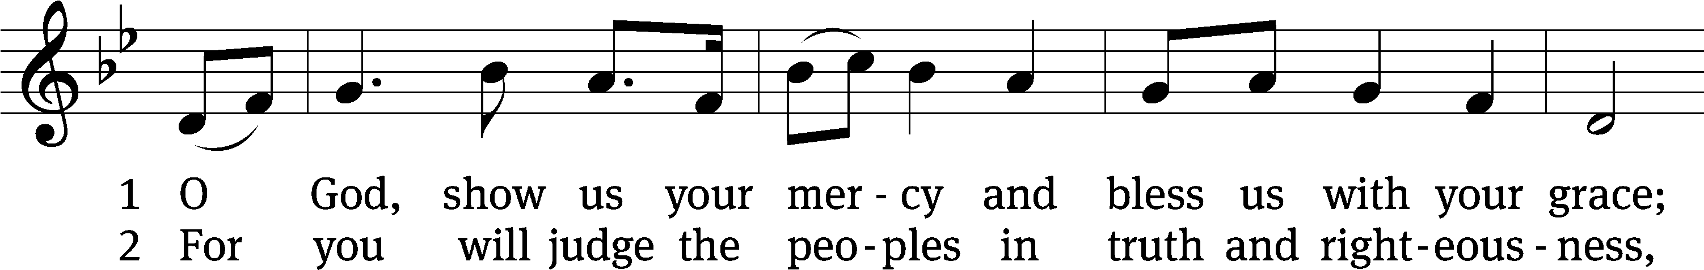
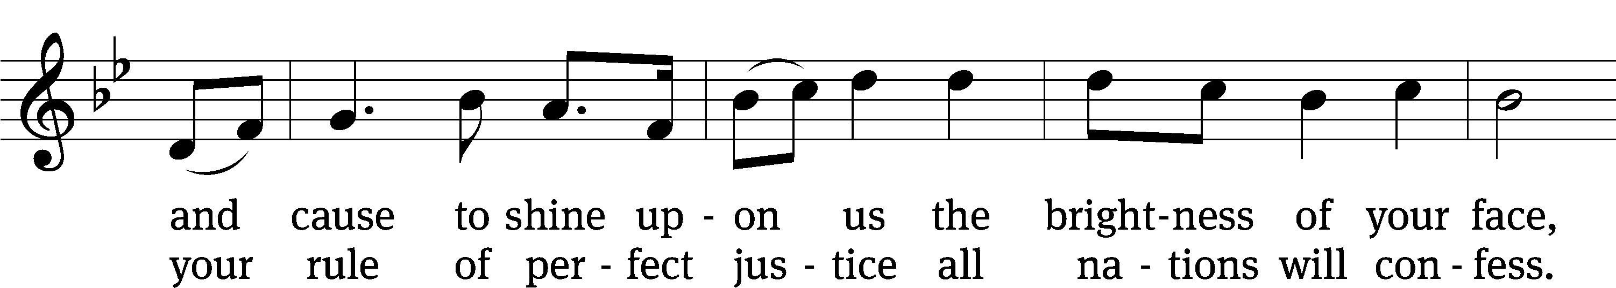
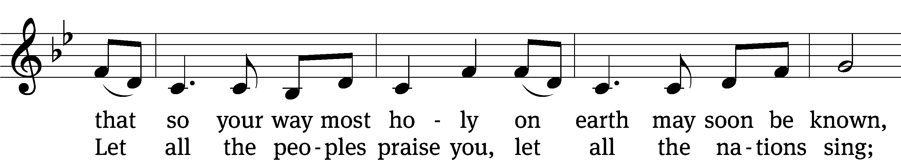
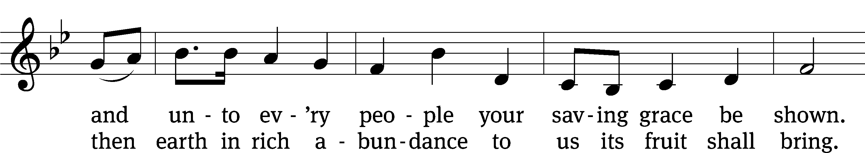
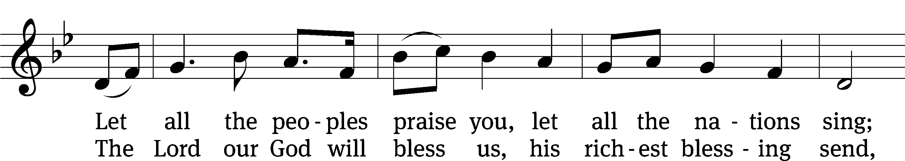
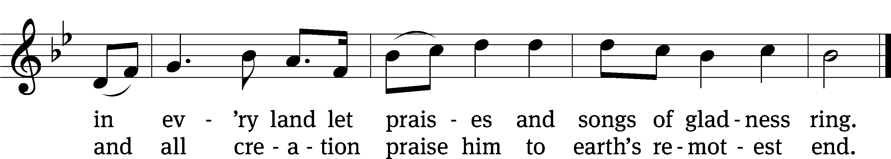
Text: The New Metrical Version of the Psalms, 1909, alt.
Tune: Gustav Holst, alt.
Text and tune: Public domain

second lesson Ephesians 2:13-22
¹³ But now in Christ Jesus, you who once were far away have been brought near by the blood of Christ. ¹⁴ For he himself is our peace. He made the two groups one by destroying the wall of hostility that divided them ¹⁵ when he abolished the law of commandments and regulations in his flesh. He did this to create in himself one new person out of the two, in this way making peace. ¹⁶ And he did this to reconcile both to God in one body through the cross by putting the hostility to death on it. ¹⁷ He also came and preached peace to you who were far away and peace to those who were near. ¹⁸ For through him we both have access to the Father by one Spirit.
¹⁹ So then, you are no longer foreigners and strangers, but you are fellow citizens with the saints and members of God’s household. ²⁰ You have been built on the foundation of the apostles and prophets, with Christ Jesus himself as the Cornerstone. ²¹ In him the whole building is joined together and grows into a holy temple in the Lord. ²² In him you too are being built together into a dwelling place for God by the Spirit.

PLEASE STAND, IF YOU ARE ABLE

VERSE OF THE DAY Ephesians 2:13
Alleluia. But now in Christ Jesus you who once were far away have been brought near by the blood of Christ. Alleluia.

GOSPEL Matthew 15:21-28
²¹ Jesus left that place and withdrew into the region of Tyre and Sidon. ²² There a Canaanite woman from that territory came and kept crying out, “Have mercy on me, Lord, Son of David! A demon is severely tormenting my daughter!”
²³ But he did not answer her a word.
His disciples came and pleaded, “Send her away, because she keeps crying out after us.”
²⁴ He answered, “I was sent only to the lost sheep of the house of Israel.”
²⁵ But she came and knelt in front of him, saying, “Lord, help me.”
²⁶ He answered her, “It is not good to take the children’s bread and throw it to their little dogs.”
²⁷ “Yes, Lord,” she said, “yet their little dogs also eat the crumbs that fall from their masters’ table.”
²⁸ Then Jesus answered her, “Woman, your faith is great! It will be done for you, just as you desire.” And her daughter was healed at that very hour.

M: This is the Gospel of the Lord.

PLEASE BE SEATED

855 The Church’s One Foundation CW 855 sts. 1–5
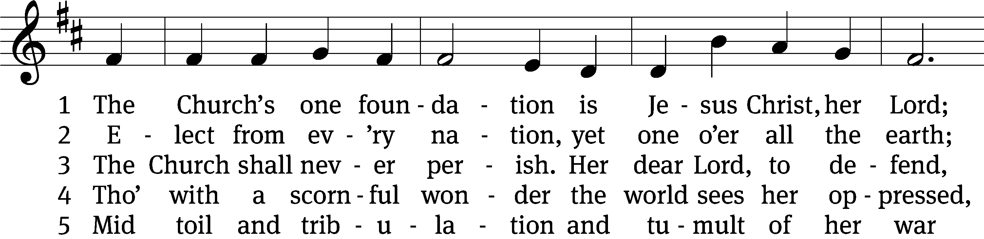
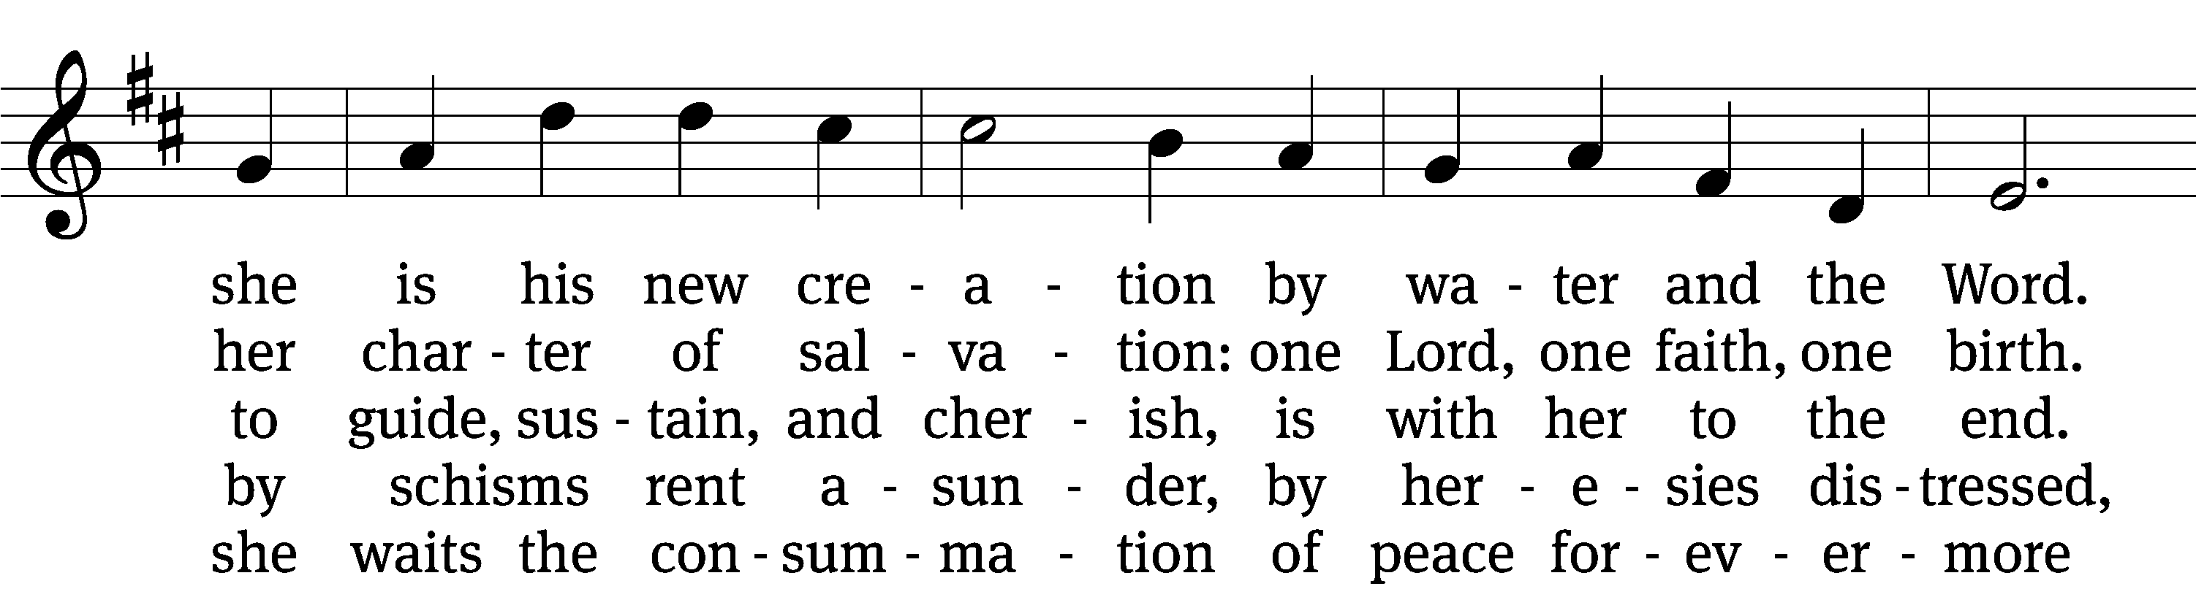
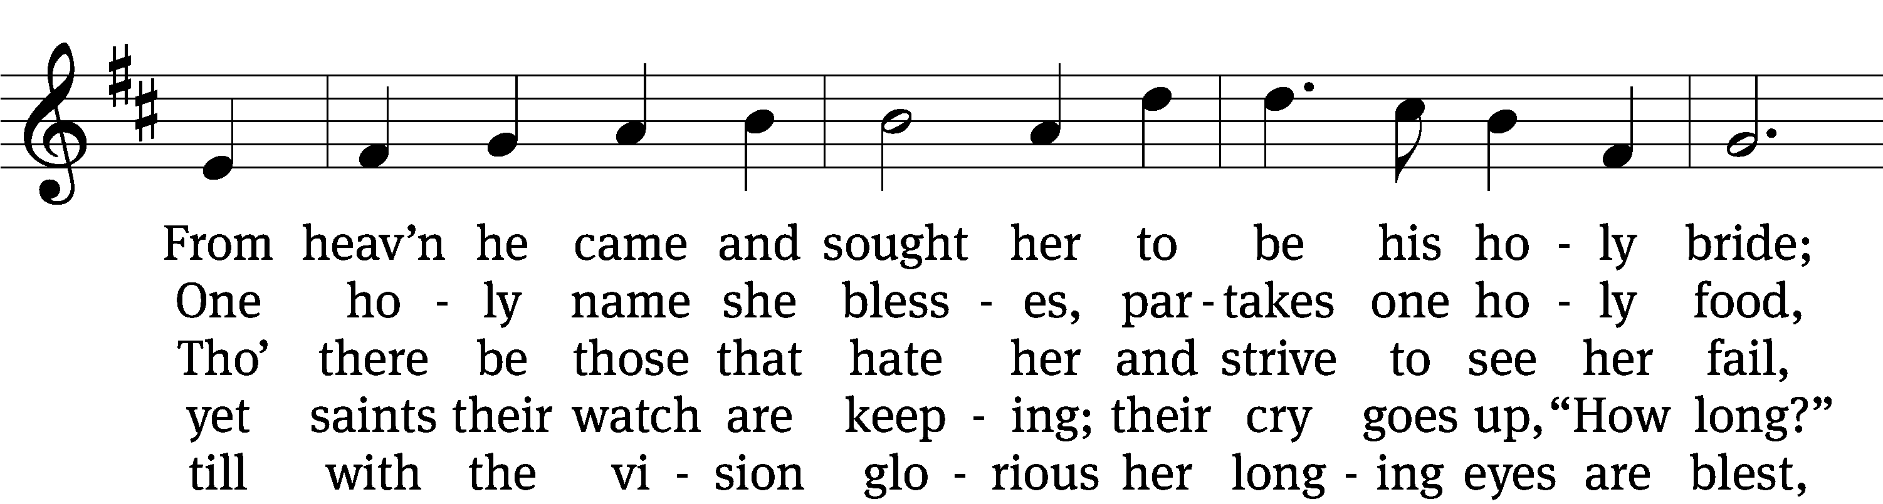
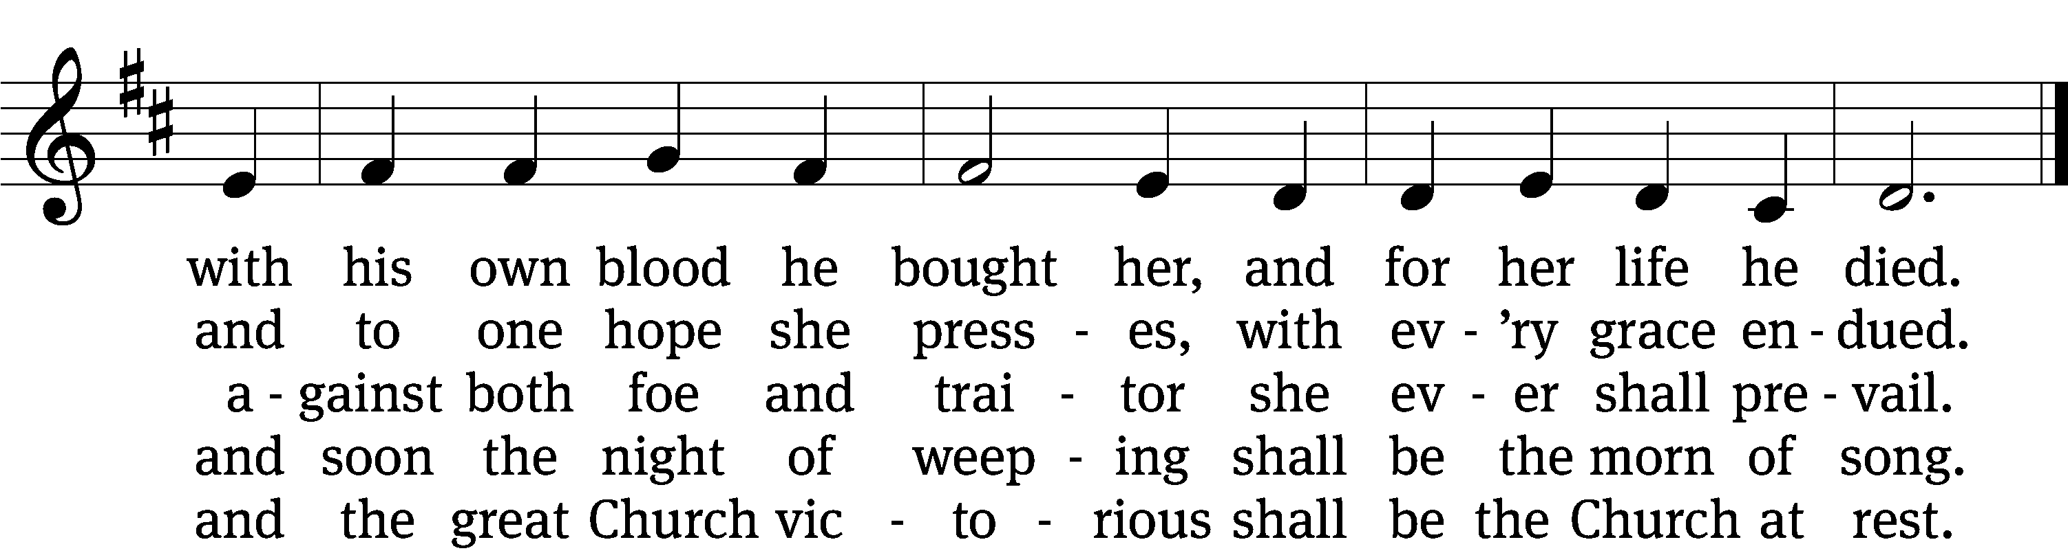
Text: Samuel J. Stone, 1839–1900, abr., alt.
Tune: Samuel S. Wesley, 1810–1876
Text and tune: Public domain

Sermon Matthew 15:21-28

“Torn down”

please stand, if you are able

nicene creed
We believe in one God, the Father, the Almighty, maker of heaven and earth, of all that is, seen and unseen.
We believe in one Lord, Jesus Christ, the only Son of God, eternally begotten of the Father, God from God, Light from Light, true God from true God, begotten, not made, of one being with the Father. Through him all things were made. For us and for our salvation, he came down from heaven, was incarnate of the Holy Spirit and the virgin Mary, and became truly human. For our sake he was crucified under Pontius Pilate. He suffered death and was buried. On the third day he rose again in accordance with the Scriptures. He ascended into heaven and is seated at the right hand of the Father. He will come again in glory to judge the living and the dead, and his kingdom will have no end.
We believe in the Holy Spirit, the Lord, the giver of life, who proceeds from the Father and the Son, who in unity with the Father and the Son is worshiped and glorified, who has spoken through the prophets. We believe in one holy Christian and apostolic Church. We acknowledge one baptism for the forgiveness of sins. We look for the resurrection of the dead and the life of the world to come. Amen.

prayer of the church

lord’s prayer

C: Our Father, who art in heaven,
hallowed be thy name,
thy kingdom come,
thy will be done
on earth as it is in heaven.
Give us this day our daily bread;
and forgive us our trespasses,
as we forgive those
who trespass against us;
and lead us not into temptation,
but deliver us from evil.
For thine is the kingdom
and the power and the glory
forever and ever. Amen.

The Sacrament of Holy Communion
Trinity Lutheran Church follows the historic Christian practice of close communion. We ask that only members of Trinity or one of our sister congregations partake of the sacrament. If you are not a member, please see the note about Holy Communion in the beginning of the Worship Folder.

M: The Lord be with you.

M: Lift up your hearts.

M: Let us give thanks to the Lord our God.

M: Praise to the God and Father of our Lord Jesus Christ! In love he has blessed us with every spiritual blessing. He sends the Holy Spirit to testify that we are his children and to strengthen us when we are weak. Now have come the salvation and the power and the kingdom of our God and the authority of his Christ. To him who sits on the throne and to the Lamb be praise and thanks and honor and glory for ever and ever:

Holy, Holy, Holy

Words of institution
M: Our Lord Jesus Christ, on the night he was betrayed, took bread; and when he had given thanks, he broke it and gave it to his disciples, saying: “Take and eat. This is my ✙ body, which is given for you. Do this in remembrance of me.”
Then he took the cup, gave thanks, and gave it to them, saying, “Drink from it all of you; this is my ✙ blood of the new covenant, which is poured out for you for the forgiveness of sins. Do this, whenever you drink it, in remembrance of me.”
M: The peace of the Lord be with you always.

O CHRIST, LAMB OF GOD

PLEASE BE SEATED

768 Lord of All Nations, Grant Me Grace CW 768
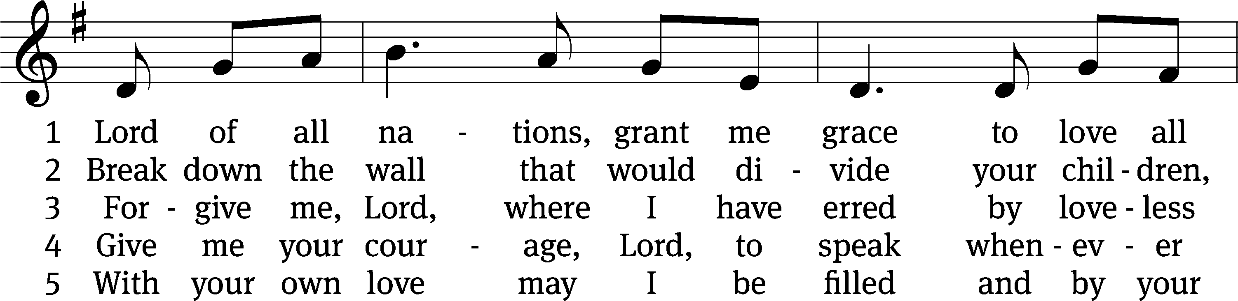
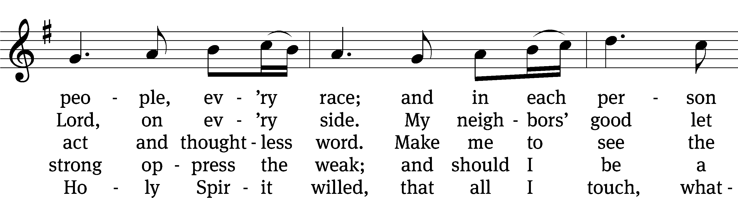
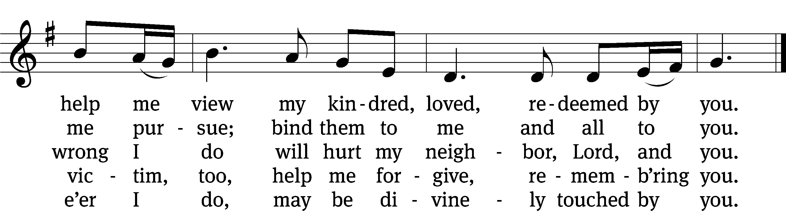
Text: Olive Wise Spannaus, 1916–2018, alt.
Tune: English
Text: © 1969 Concordia Publishing House. Used by permission: OneLicense no. 727703
Tune: Public domain

693 O Gracious Lord, with Love Draw Near CW 693
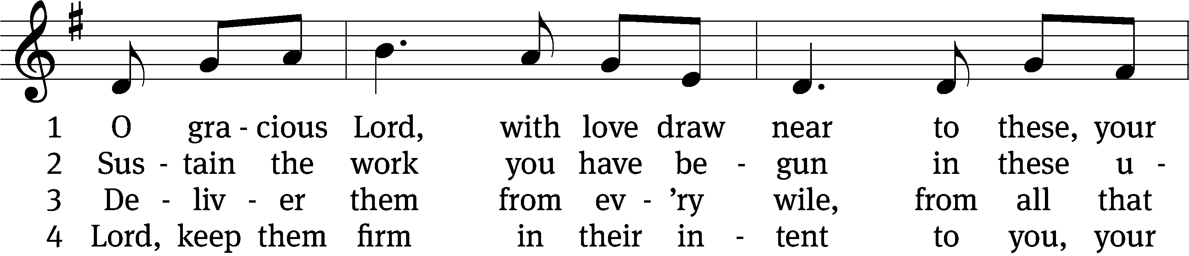
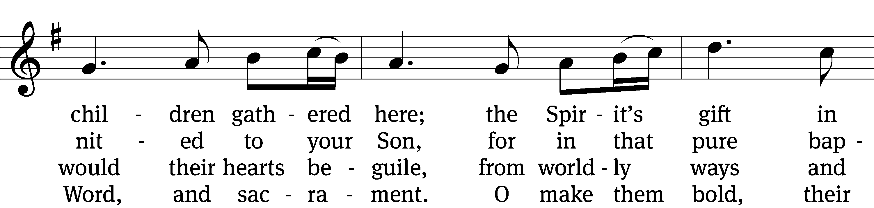
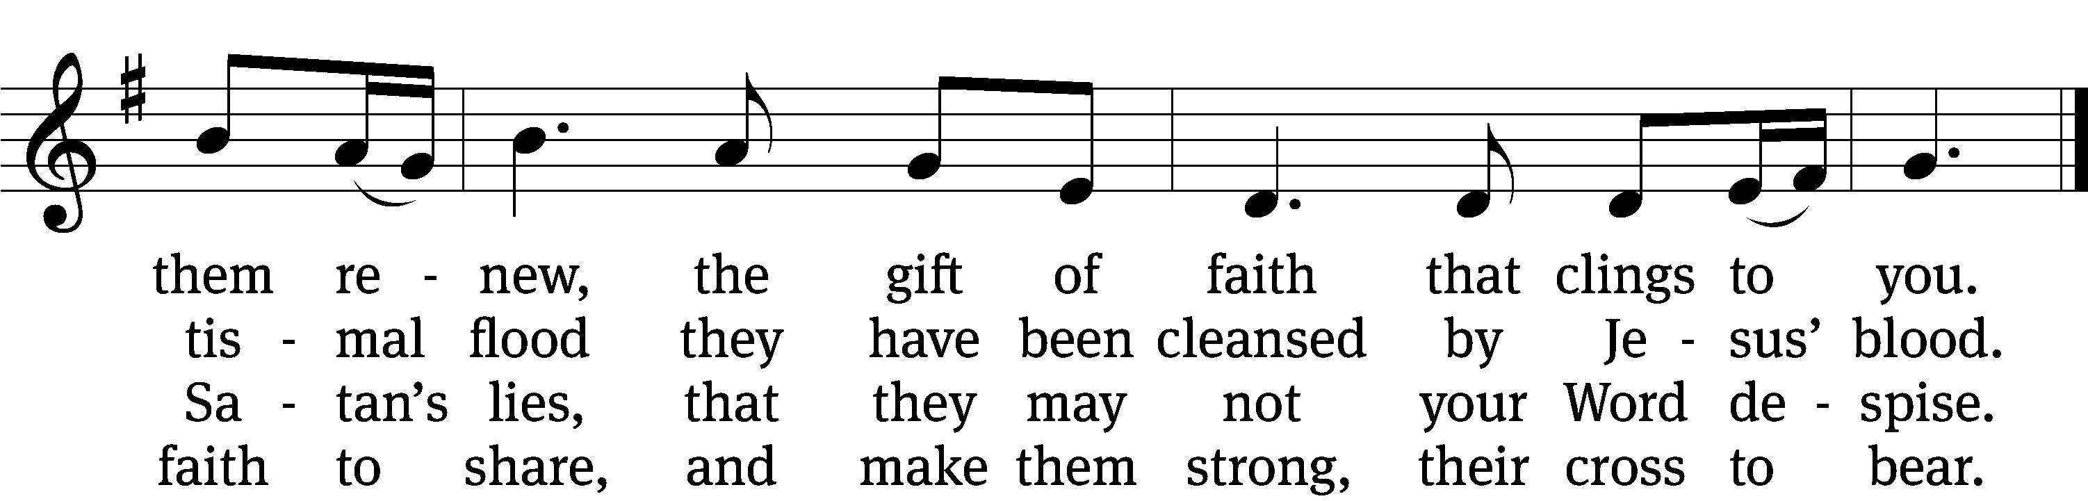

5 O Father, grant that by your grace
they may your will each day embrace,
with fruits of faith their lives now bless,
till they at death your name confess.

6 Then robed in white before your throne,
your holy saints, by you foreknown,
predestined, called, and justified,
shall, crowned in light, be glorified.
Text: Stephen P. Starke, b. 1955
Tune: English
Text: © 2003 Stephen P. Starke, admin. Concordia Publishing House. Used by permission: OneLicense no. 727703
Tune: Public domain

PLEASE STAND, IF YOU ARE ABLE

M: Hear the prayer of your people, O Lord, that the lips which have praised you here may glorify you in the world, that the eyes which have seen the coming of your Son may long for his coming again, and that all who have received in his true body and blood the pledge of your forgiveness may be restored to live a new and holy life, through Jesus Christ, our Lord, who lives and reigns with you and the Holy Spirit, one God, now and forever.

M: Brothers and sisters, go in peace. Live in harmony with one another.
Serve the Lord with gladness.
The Lord bless you and keep you.
The Lord make his face shine on you and be gracious to you.
The Lord look on you with favor and (+) give you peace.

PLEASE BE SEATED
860 In Christ There Is No East or West CW 860
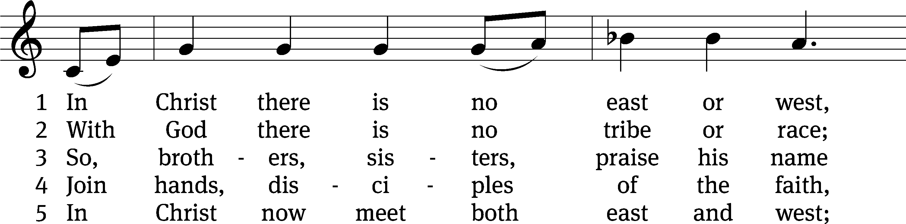
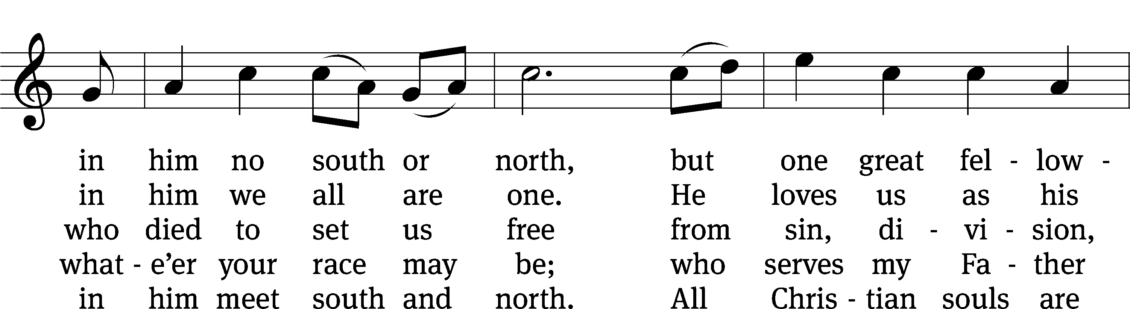
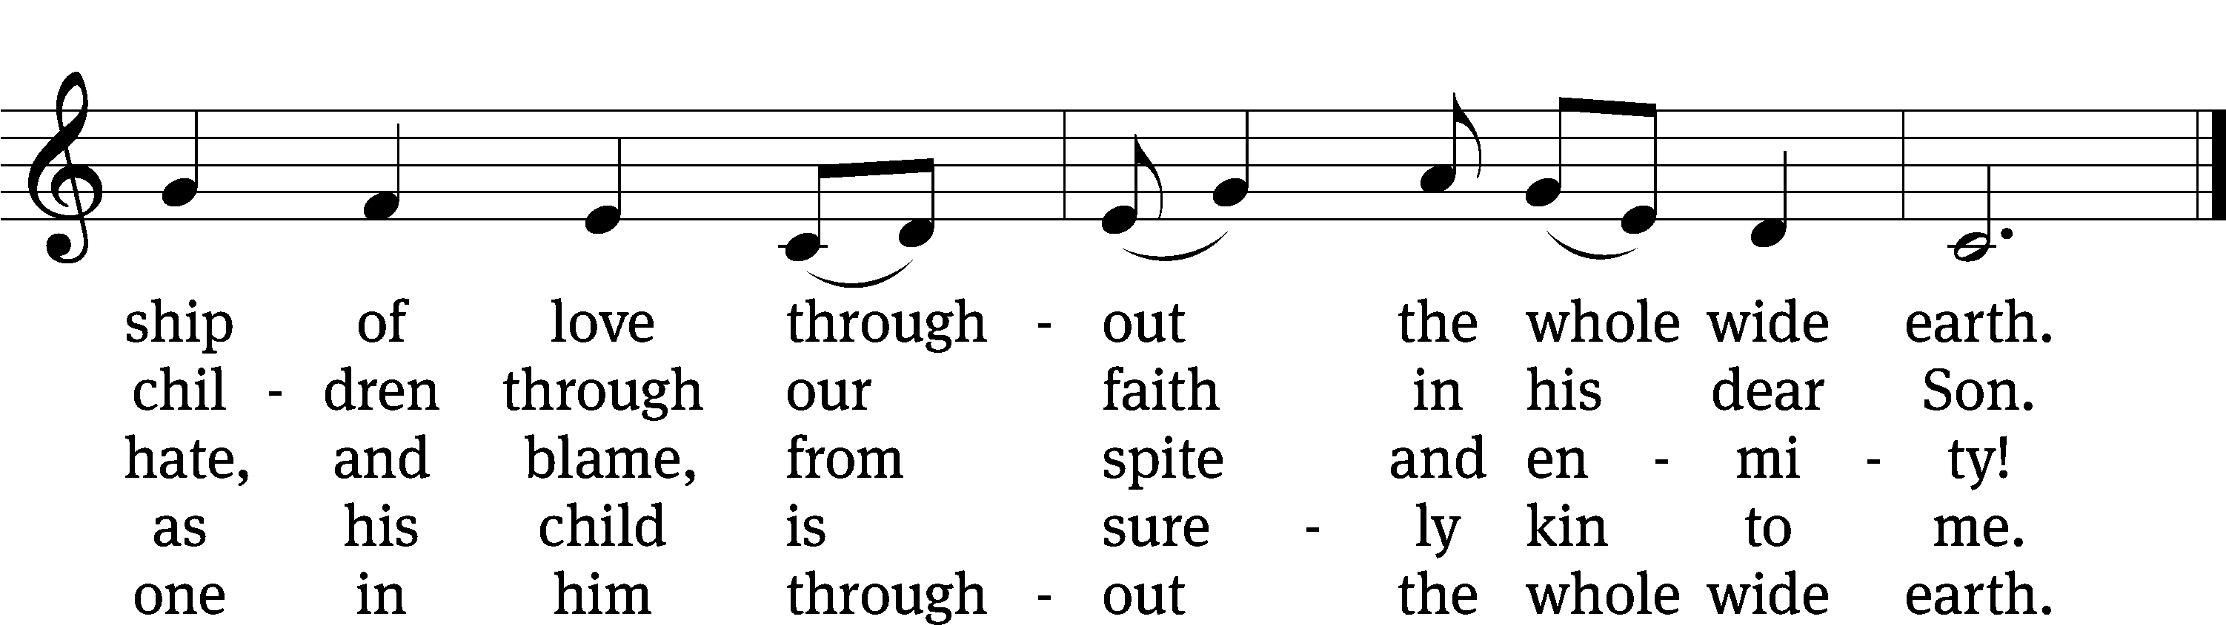
Text (sts. 1, 4–5): John Oxenham, 1852–1941; (st. 2): Mark A. Jeske, b. 1952; (st. 3): Michael A. Perry, 1942–1996
Tune: African-American spiritual; adapt. Harry T. Burleigh, 1866–1949
Text (st. 2): © 1993 Mark A. Jeske, admin. Northwestern Publishing House; (st. 3): © 1982 The Jubilate Group, admin. Hope Publishing Co. Used by permission: OneLicense no. 727703
Text (sts. 1, 4–5) and tune: Public domain

Serving In Worship

Officiant Pastor Isaac Pappenfuss
Organist Marcia Marion Ackling
Instrumentalist Malory Marion
Deacons (Thursday) Duane Mason and Dave Stevenson
(Sunday) Jeff Neuburger and Robert Niethammer
Ushers (Thursday) Tim Phelps
(Sunday) Ron Zahn
Altar Guild Marcia Marion Ackling and Scott Ackling
Videographer Rick Schneider

Copyright information
Service of Word and Sacrament: Christian Worship. © 1993 Northwestern Publishing House. All rights reserved. Reprinted under ONE LICENSE #A-727703 and CCLI #1151741/ CSPL126093
Words and Music: All rights reserved. Reprinted/Podcast/Streamed with permission under ONE LICENSE #A-727703 and CCLI #1151741/CSPL126093

