THE TENTH SUNDAY
AFTER PENTECOST
TRINITY EVANGELICAL LUTHERAN CHURCH | Saline, Michigan
WELCOME TO WORSHIP August 3/6, 2023
Thank you for joining us in God’s house today! We cordially ask that our Guests sign one of the guestbooks located at either the front or back entryways, or fill out a “Let’s Get Acquainted” card located in the hymnal pew rack and place it in the collection plate.

Thank Offering: Members of Trinity give their offering as an expression of love and thankfulness to the Lord and to help support the Lord’s work in our community and around the world. Visitors need not feel obligated to participate in this offering .

Restrooms are located at the back of the upper level (the annex), and in the basement (down the back stairs of the sanctuary or annex). Handicap access is available, please ask an usher for assistance.

Young Families / Toddler Bags – We are GLAD YOU BROUGHT YOUR CHILDREN to our worship service. Jesus said: “Let the little children come to me and do not hinder them, for the kingdom of God belongs to such as these.” We know that having little children in church can be a challenge, but DO NOT WORRY about it. Many of your fellow worshippers have been in your shoes and are just happy you brought your children with you. For your convenience, we have reserved the back rows of seating for parents with small children. These areas provide more flexibility for your family, as well as, easy access to move downstairs if necessary. A closed-circuit TV system allows families to continue participating in the service while downstairs. Pre-school toddler bags and children’s bulletins are available for their enjoyment. Ask an usher for one to use during the service and please return the toddler bag afterwards.

Holy Communion – In His Word, God makes it clear that the Lord’s Supper is to be shared by people of a common proclamation of faith (1 Corinthians 11:26; 1 Corinthians 10:16-17). Without judging anyone’s hearts, we invite those who share in our confession by their membership in our congregation or another congregation of the Wisconsin Evangelical Lutheran Synod (WELS) or the Evangelical Lutheran Synod (ELS) and who are properly prepared (1 Corinthians 11;27-29) to receive the Sacrament. Page 295 in Christian Worship provides a guide for preparation.
Guests, we would love to have you join us in communion fellowship in the future, and for that to be possible, we ask that you speak with one of the pastors so that we may speak with you on how that would be possible. We thank you for respecting the way we celebrate the Lord’s Supper in our congregations.

the SERVICE – setting one - WITH HOLY COMMUNION CW, page 154
509 Feed Your Children, God Most Holy CW 509
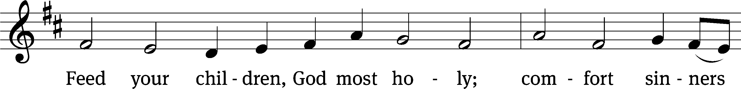
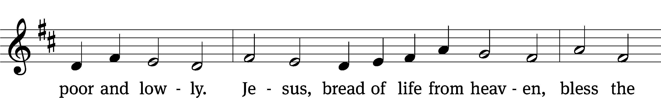
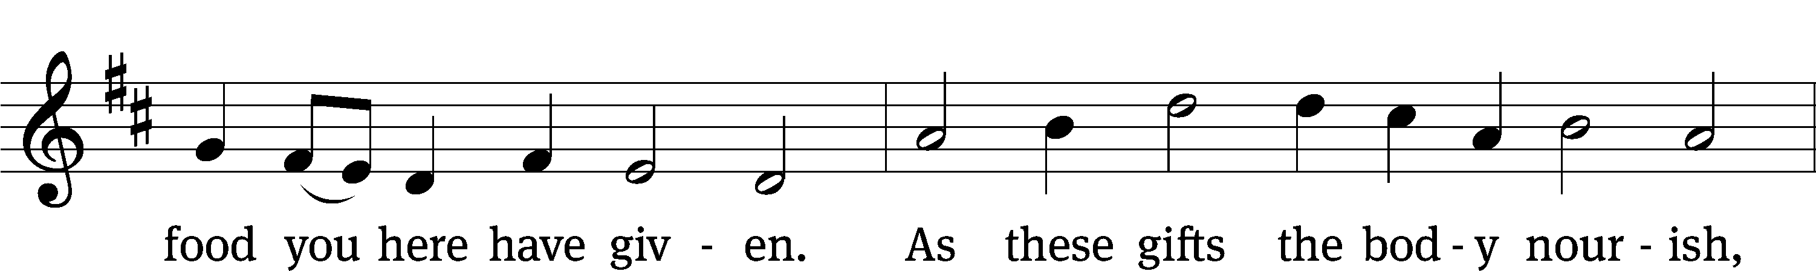
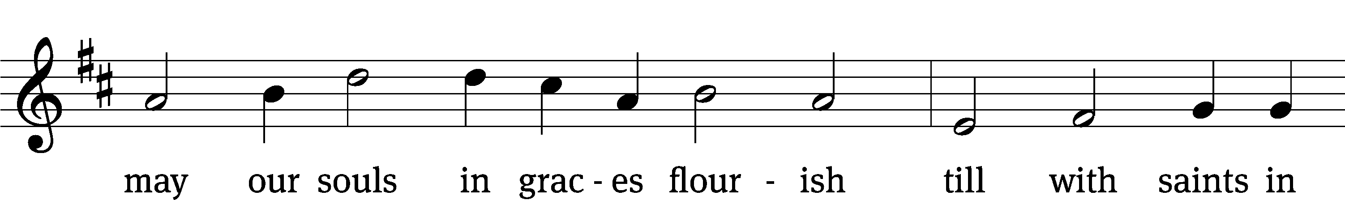
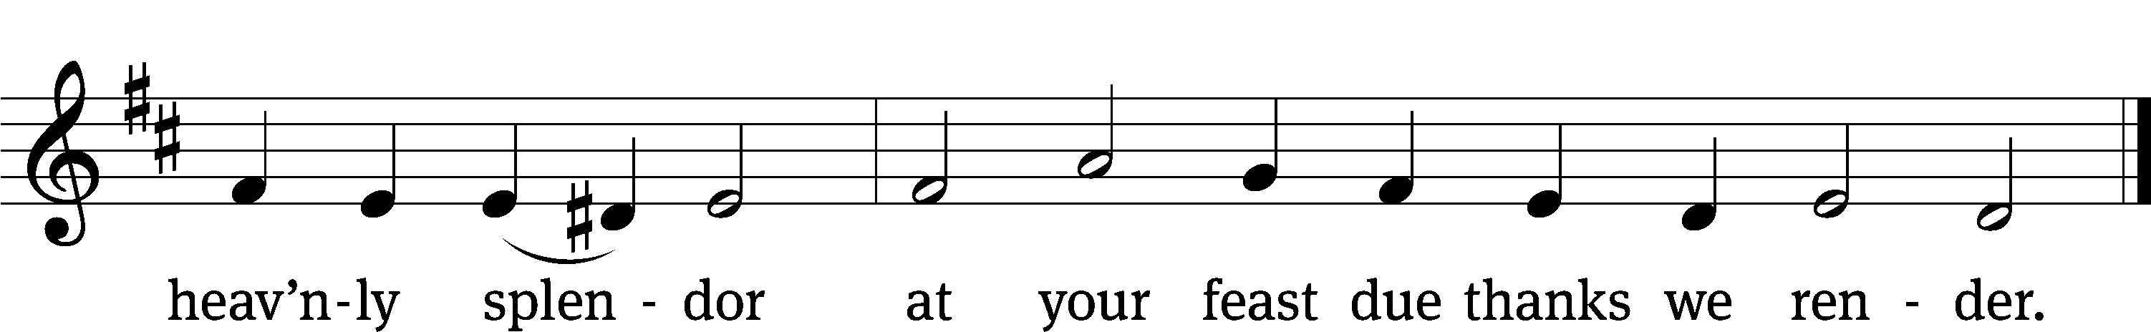
Text: tr. The Lutheran Hymnal, 1941, alt.; Johann Heermann, 1585–1647
Tune: Johann Crüger, 1598–1662
Text: © 1941 Concordia Publishing House. Used by permission: OneLicense no. 727703
Tune: Public domain

Please stand, if you are able

Invocation
In the name of the Father and of the Son and of the Holy Spirit.
Amen.
Confession
If we claim to be without sin, we deceive ourselves and the truth is not in us.
If we confess our sins, God is faithful and just
and will forgive us our sins
and purify us from all unrighteousness.

Let us confess our sins to the Lord.
Holy God, gracious Father,
I am sinful by nature
and have sinned against you in my thoughts, words, and actions.
I have not loved you with my whole heart;
I have not loved others as I should.
I deserve your punishment both now and forever.
But Jesus, my Savior, paid for my sins
with his innocent suffering and death.
Trusting in him, I pray: God, have mercy on me, a sinner.

Our gracious Father in heaven has been merciful to us. He sent his only Son, Jesus Christ, who gave his life as the atoning sacrifice for the sins of the whole world. Therefore, as a called servant of Christ and by his authority, I forgive you all your sins in the name of the Father and of the Son and of the Holy Spirit.
Amen.

Lord, Have Mercy

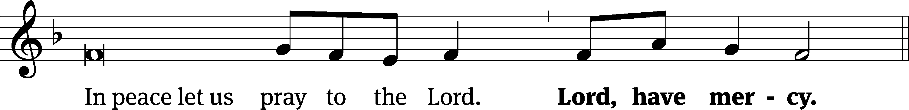
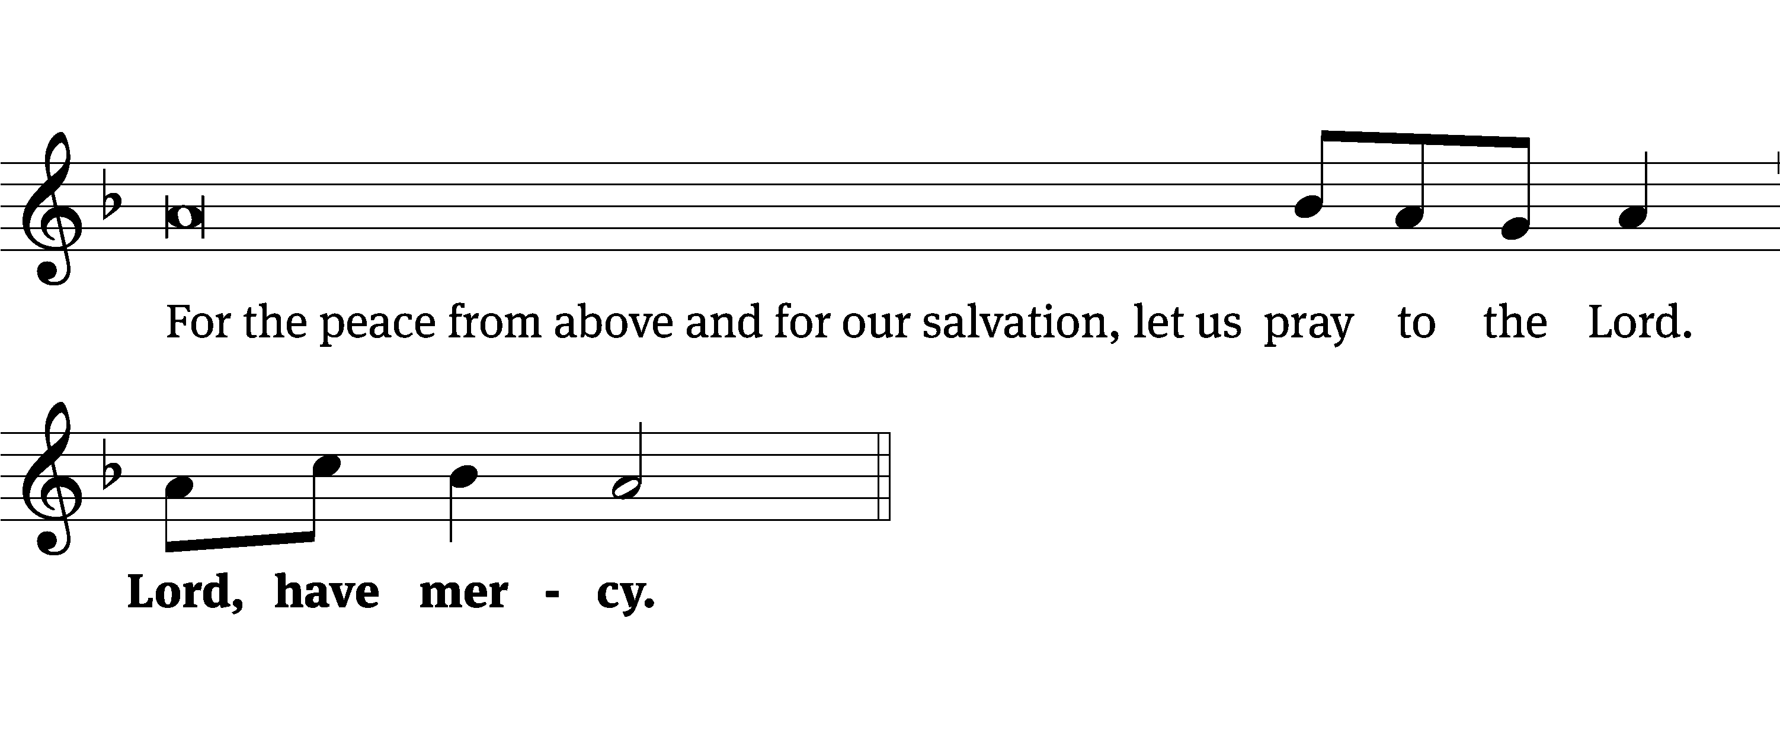
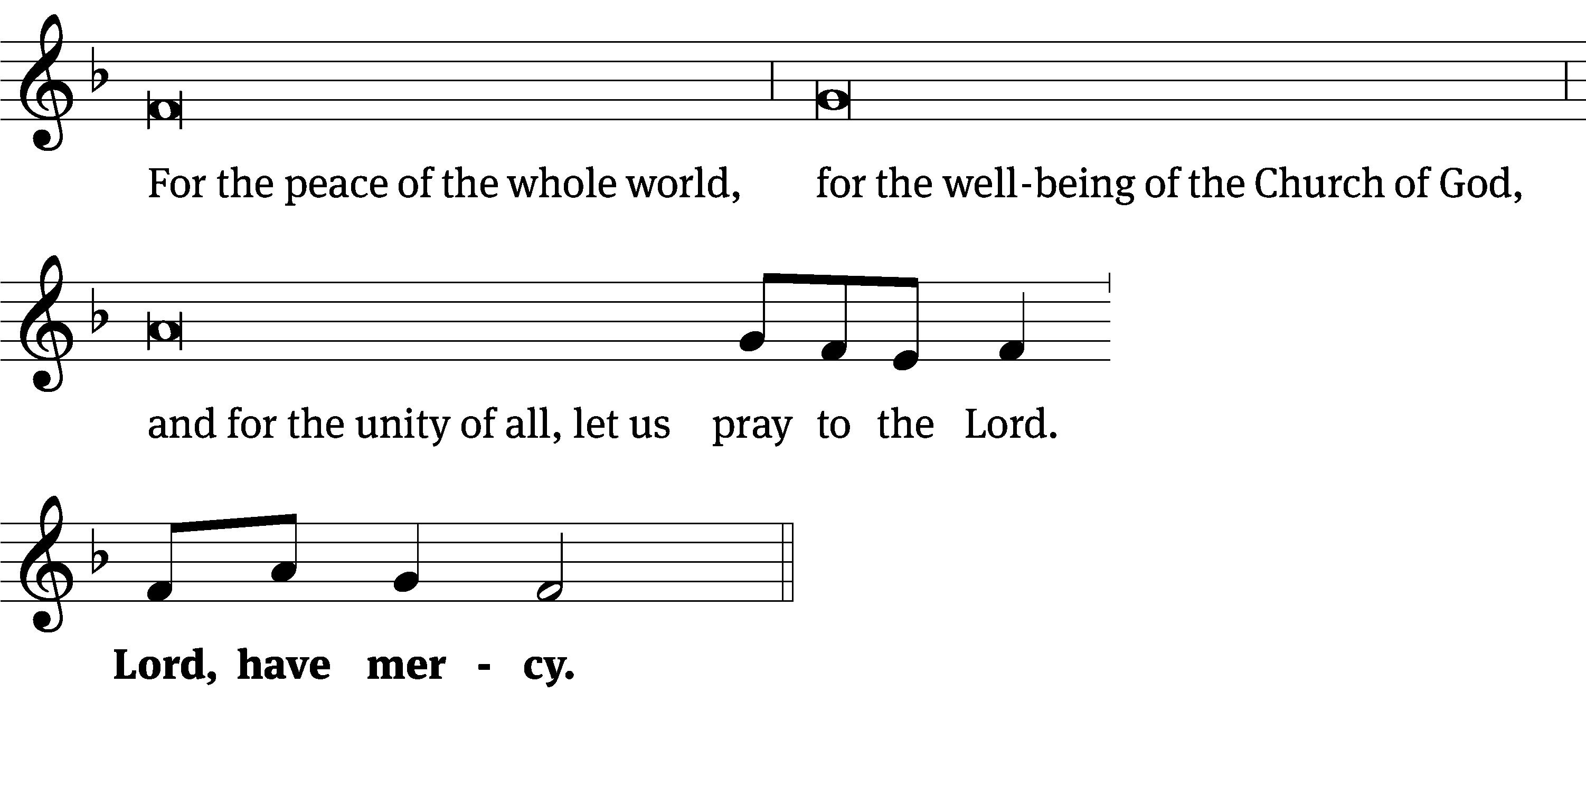
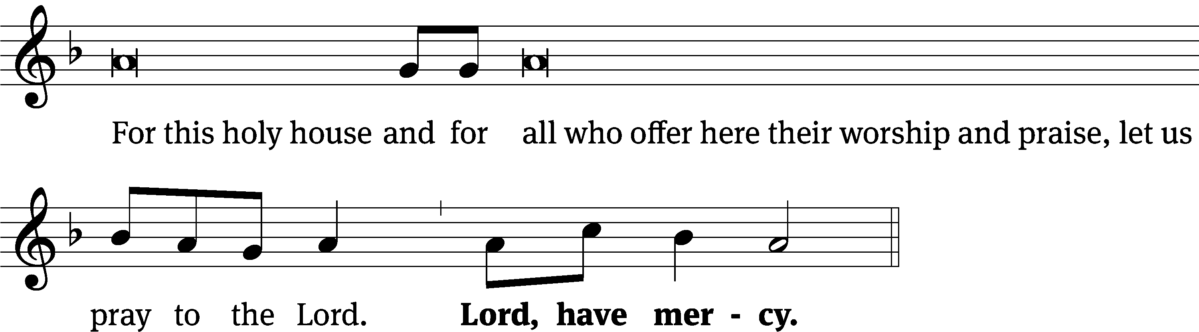
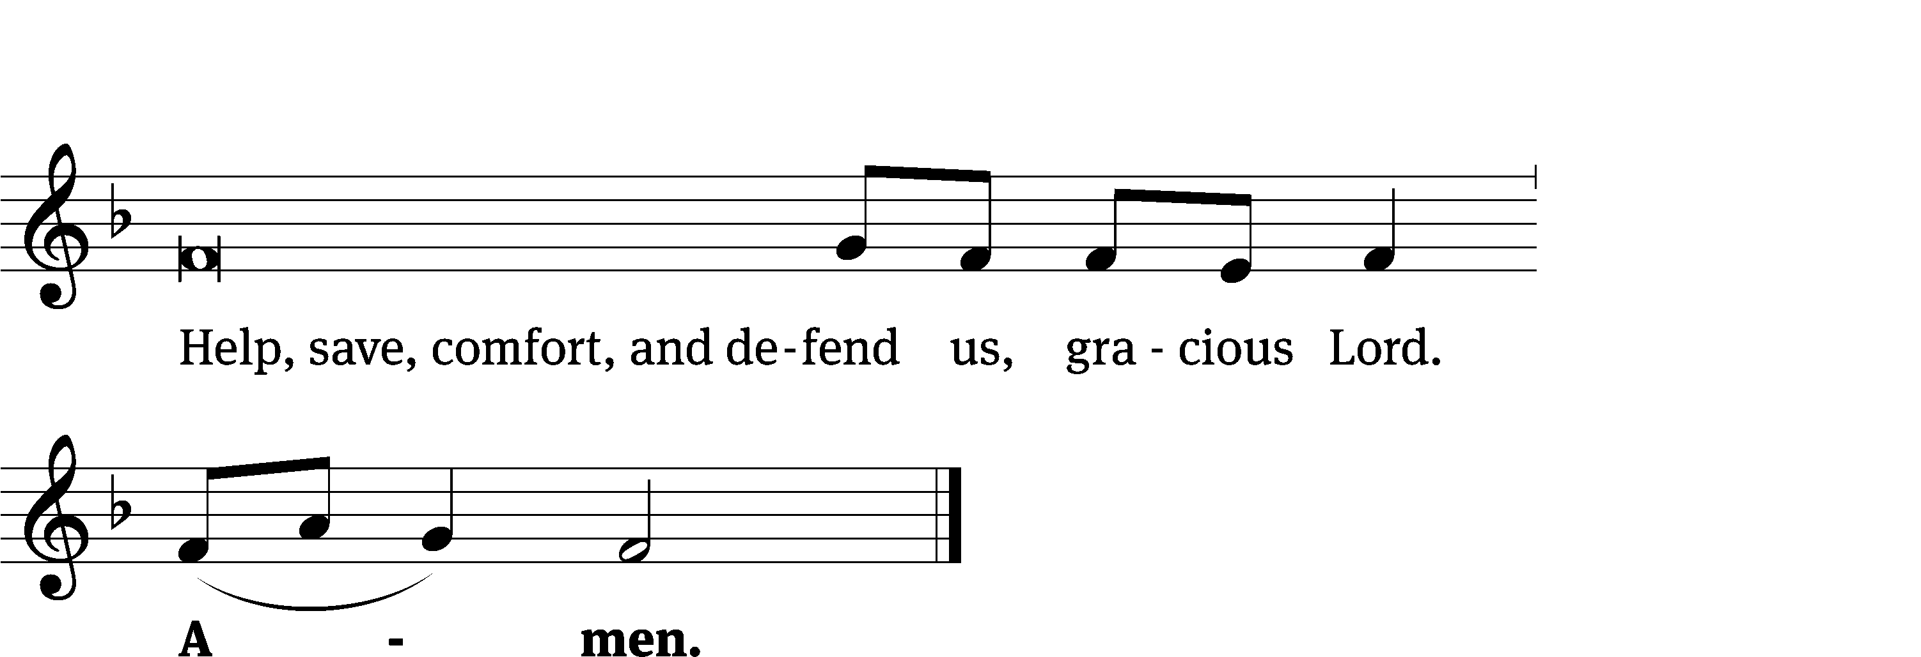
Glory Be to God on High CW 157
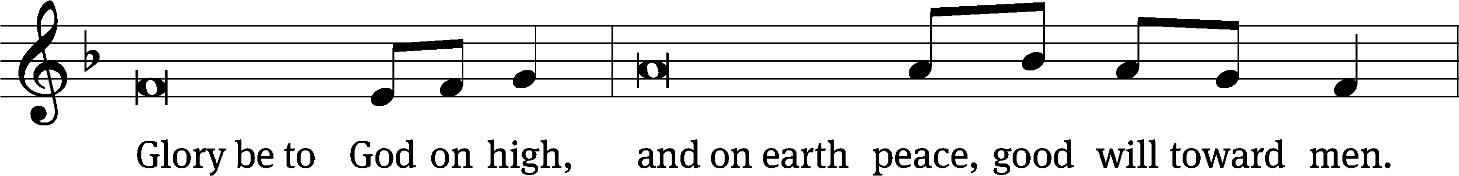
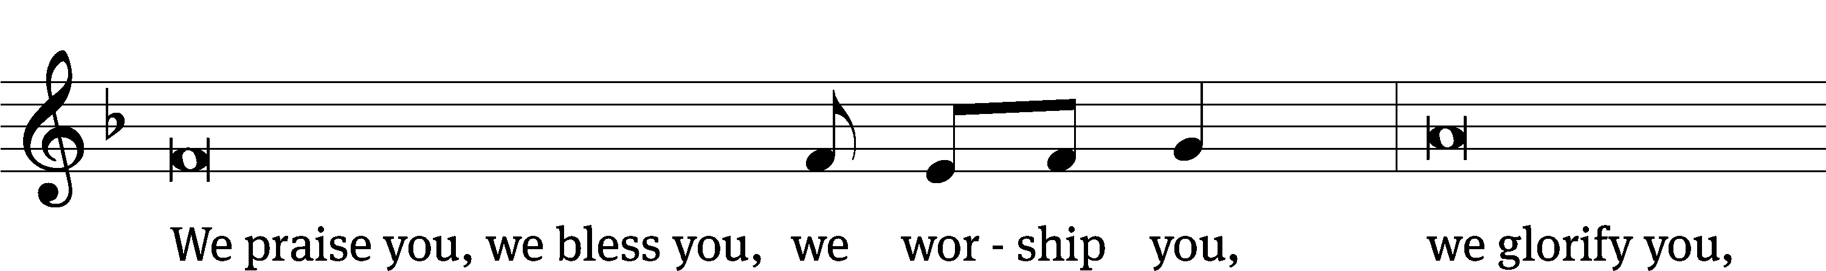
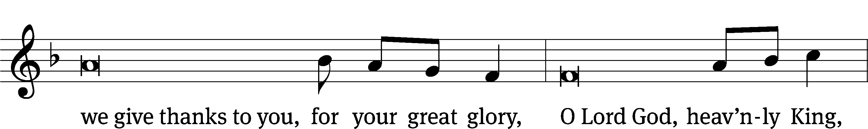
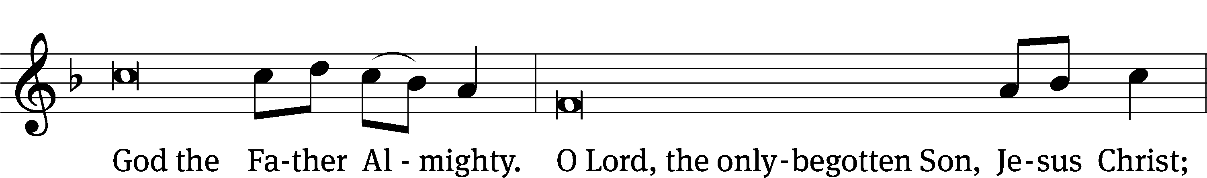
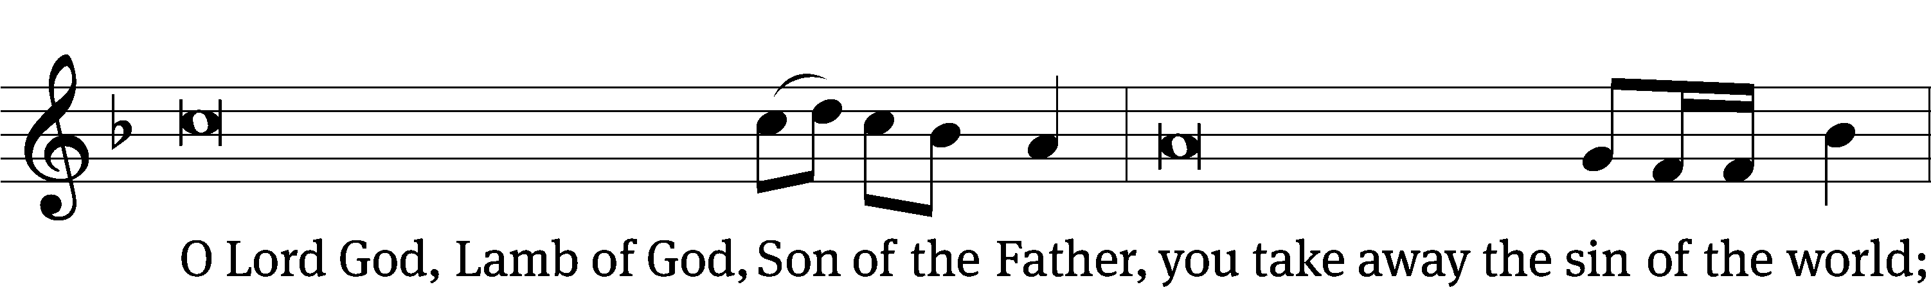
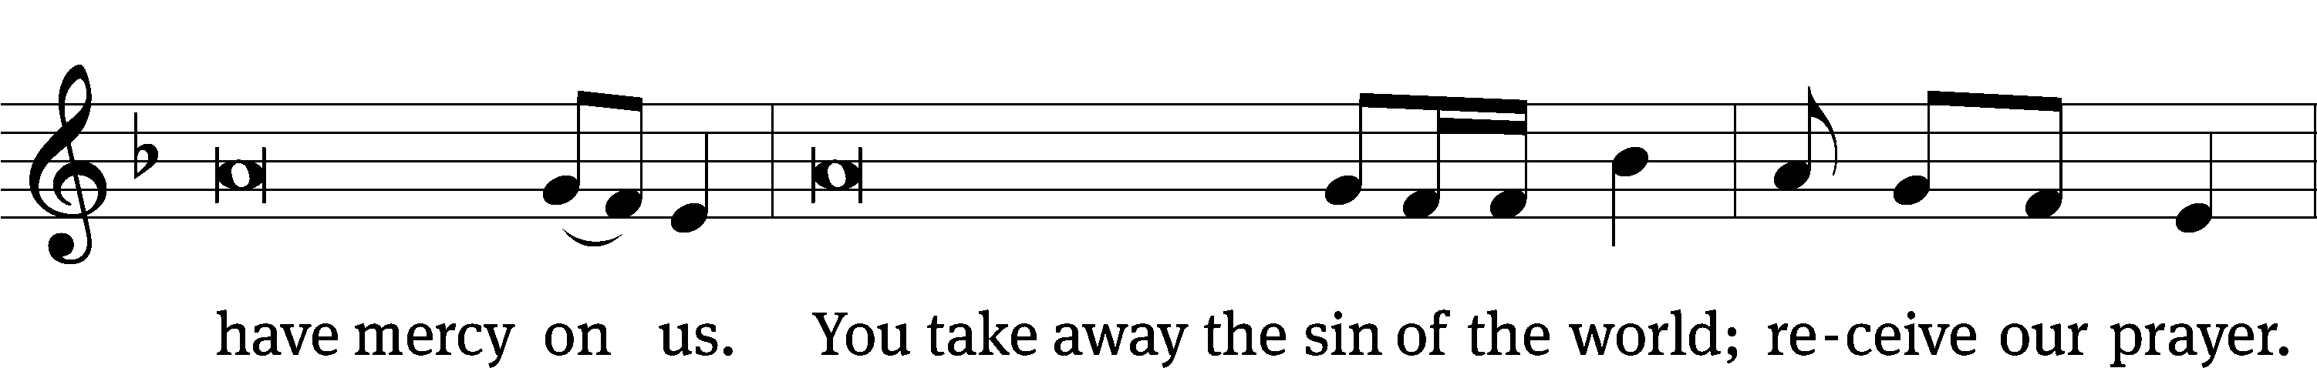
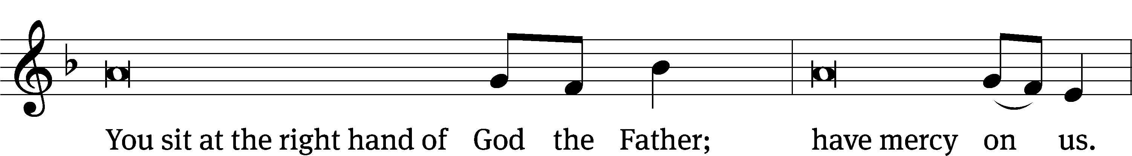
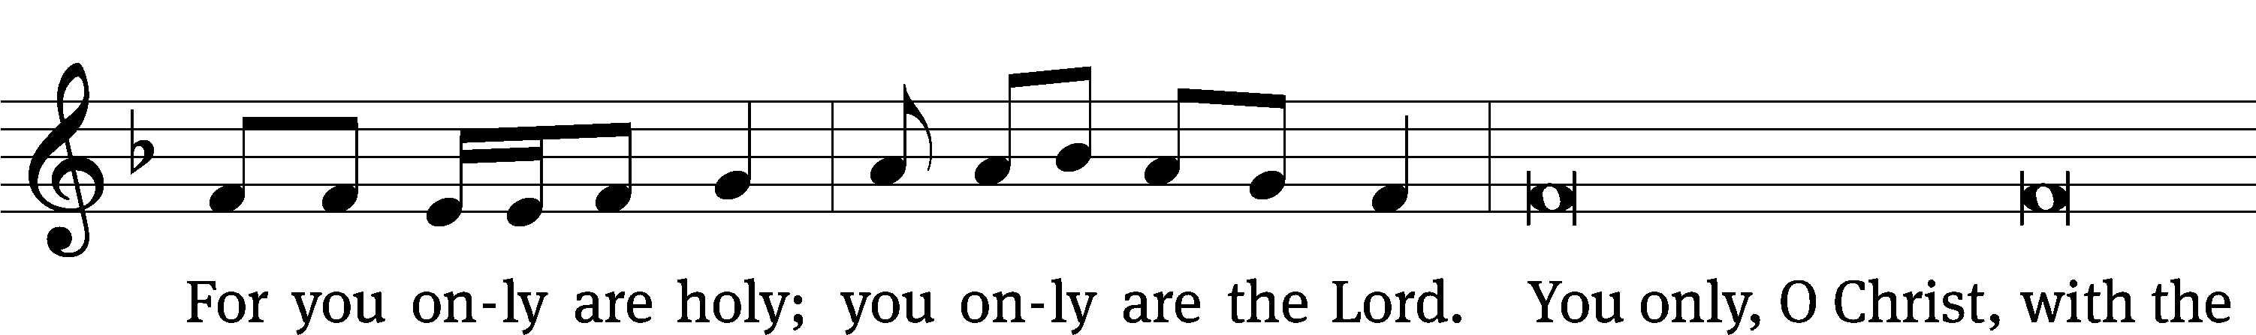
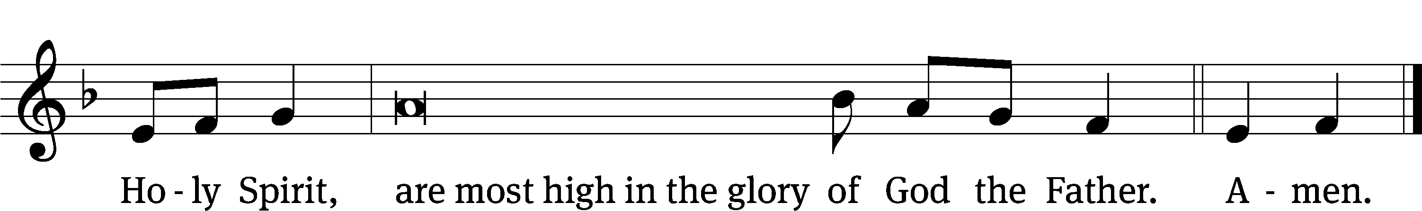

The Lord be with you.
And also with you.

Prayer of the Day
Let us pray.

God of all power and might, you are the giver of all that is good. Help us love you with all our heart, strengthen us in true faith, provide us with all we need, and keep us safe in your care; through your Son, Jesus Christ our Lord, who lives and reigns with you and the Holy Spirit, one God, now and forever.
Amen.

Please be seated

First Reading 1 Kings 17:1-6
¹ Elijah from Tishbe, one of the settlers in Gilead, said to Ahab, “As surely as the Lord lives, the God of Israel before whom I stand, there will be no dew or rain during the coming years, except at my word.”
² Then the word of the Lord came to him: ³ “Leave this place and turn east. Hide yourself by the Kerith Ravine, east of the Jordan. ⁴ You will drink from the stream, and I will command the ravens to provide for you there.”
⁵ So Elijah went and did just as the Lord had said. He lived in the Kerith Ravine, east of the Jordan. ⁶ The ravens brought him bread and meat in the morning and in the evening, and he drank from the stream.

The Word of the Lord.
Thanks be to God.

136C We Thank You, LORD, for You Are Good Psalm 136C
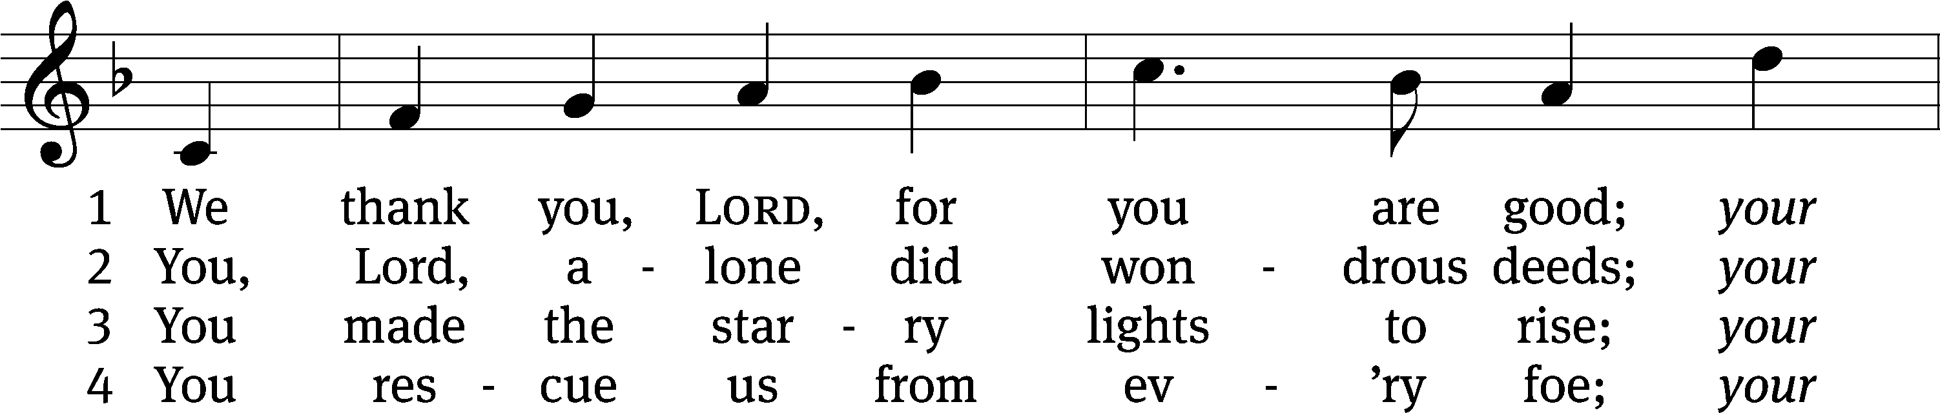
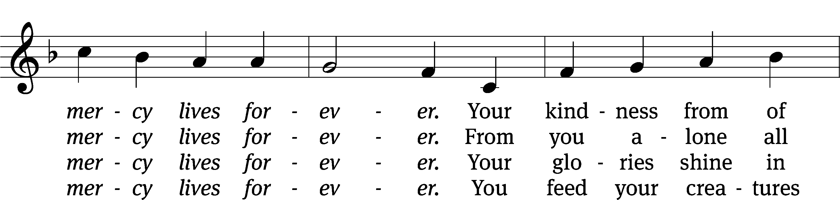
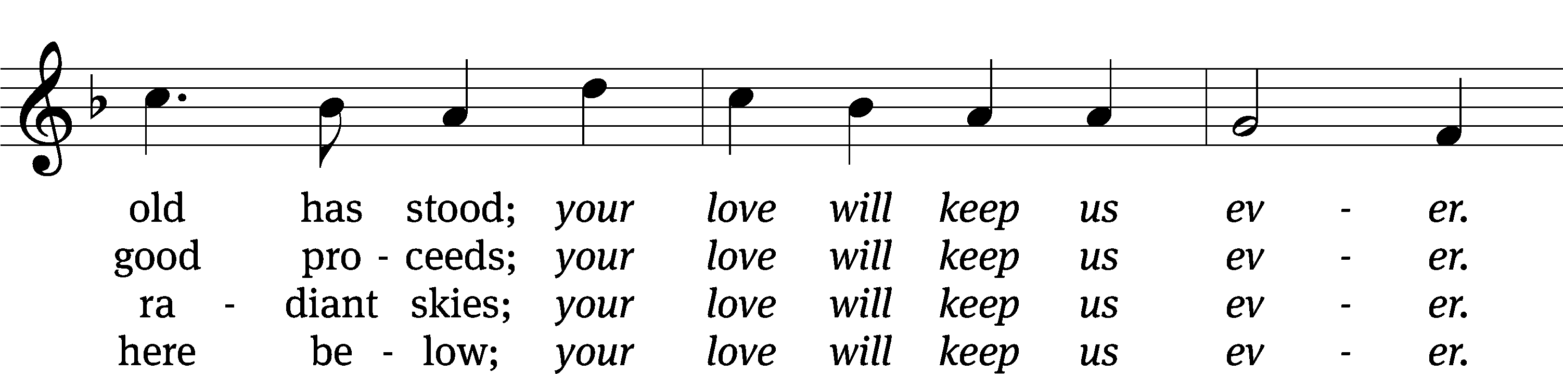
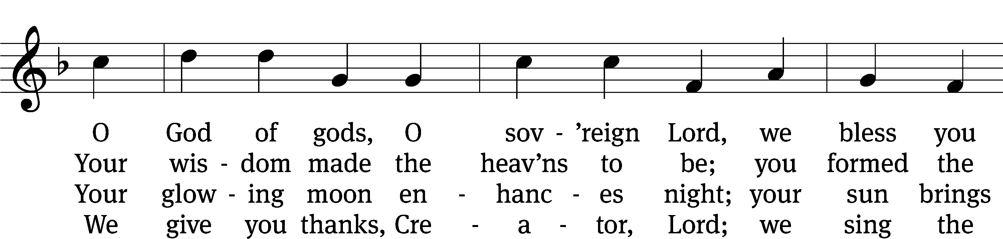
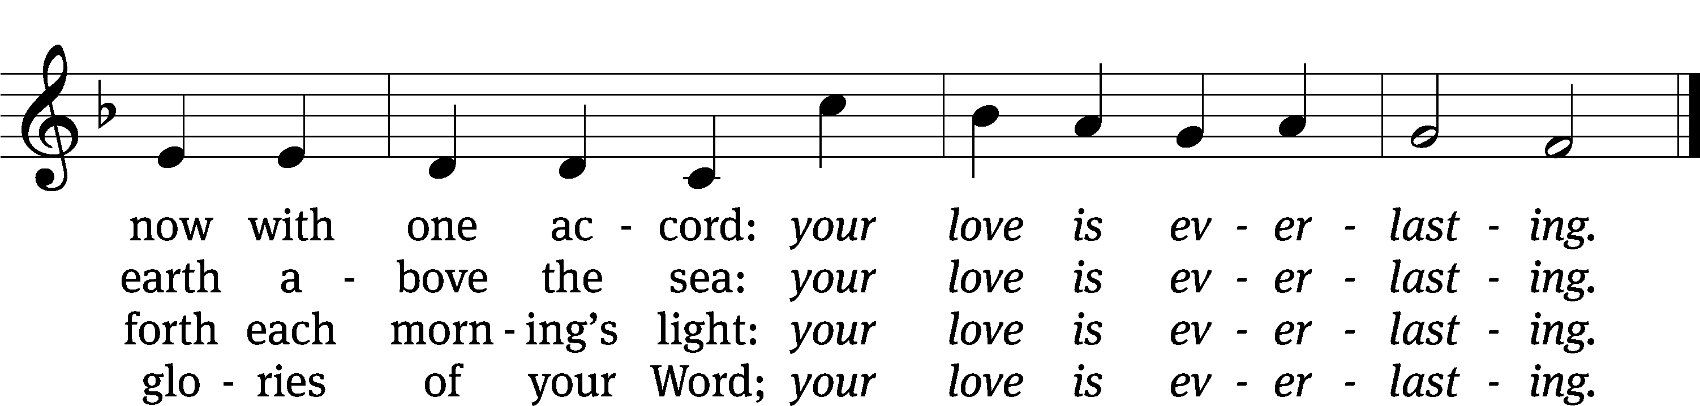
Tune: Severus Gastorius
Text: © 1985 John G. Dunn. Used by permission: OneLicense no. 727703
Tune: Public domain

Second Reading Ephesians 1:3-10
³ Blessed be the God and Father of our Lord Jesus Christ, who has blessed us in Christ with every spiritual blessing in the heavenly places.
⁴ He did this when he chose us in Christ before the foundation of the world, so that we would be holy and blameless in his sight. In love ⁵ he predestined us to be adopted as his sons through Jesus Christ. He did this in accordance with the good purpose of his will, ⁶ and for the praise of his glorious grace, which he has graciously given us in the one he loves.
⁷ In him we also have redemption through his blood, the forgiveness of sins, in keeping with the riches of his grace, ⁸ which he lavished on us in all wisdom and insight. ⁹ He made known to us the mystery of his will in keeping with his good purpose, which he planned in Christ. ¹⁰ This was to be carried out when the time had fully come, in order to bring all things together in Christ, things in heaven and things on earth.
The Word of the Lord.
Thanks be to God.

Please stand, if you are able
Gospel Acclamation Romans 8:32
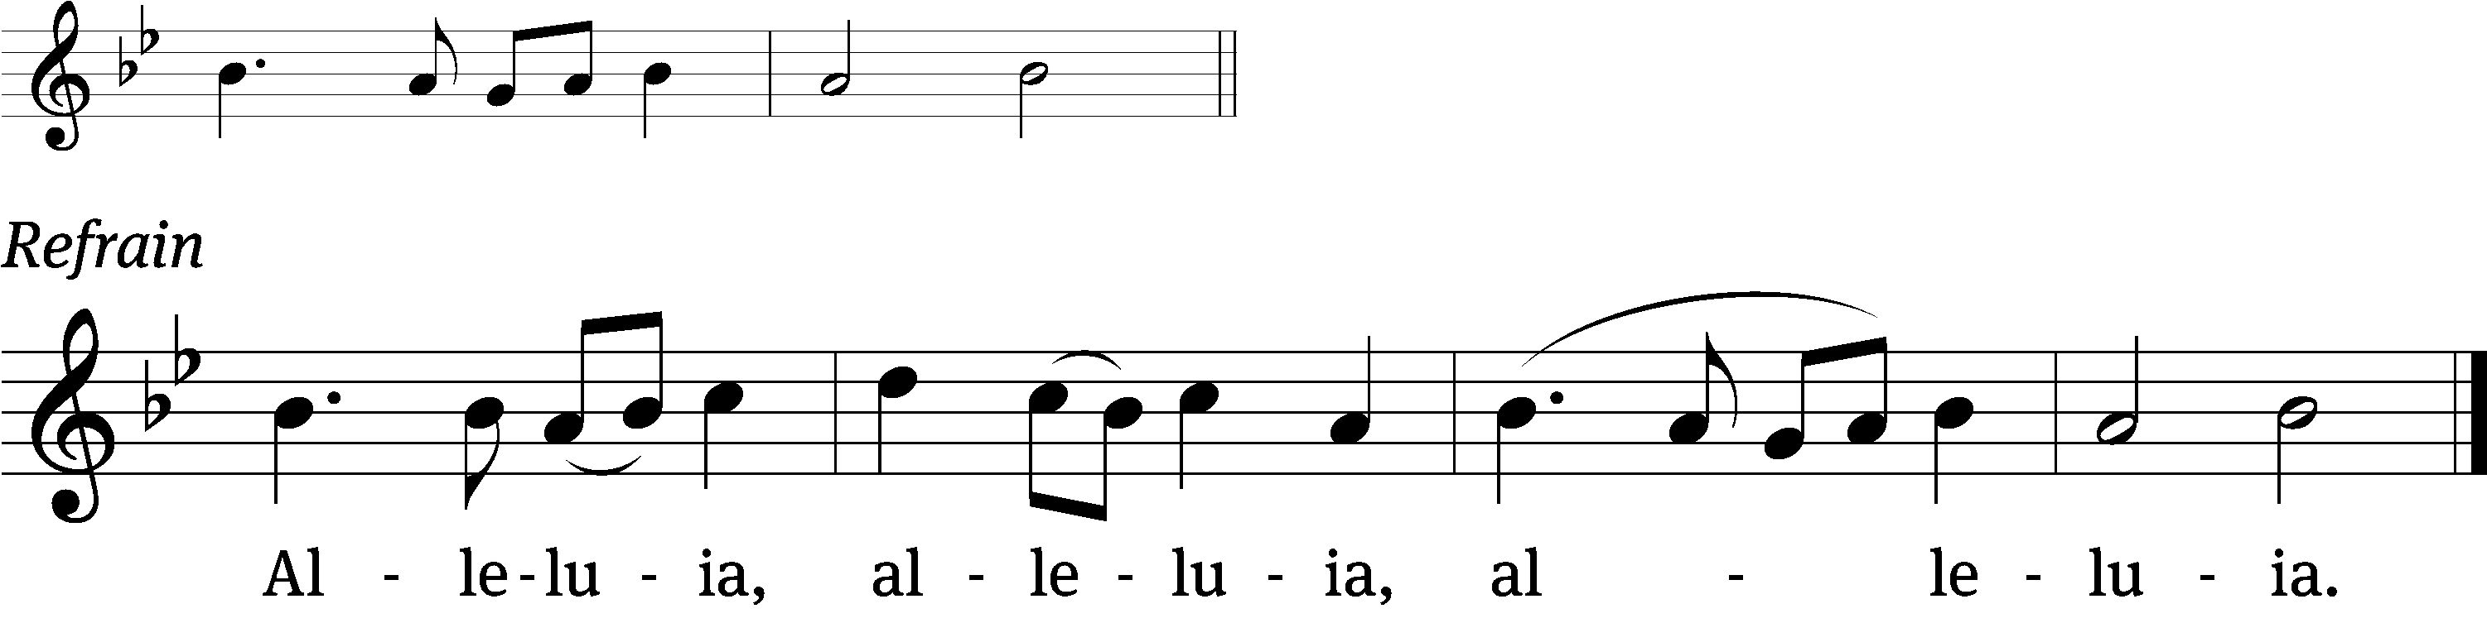
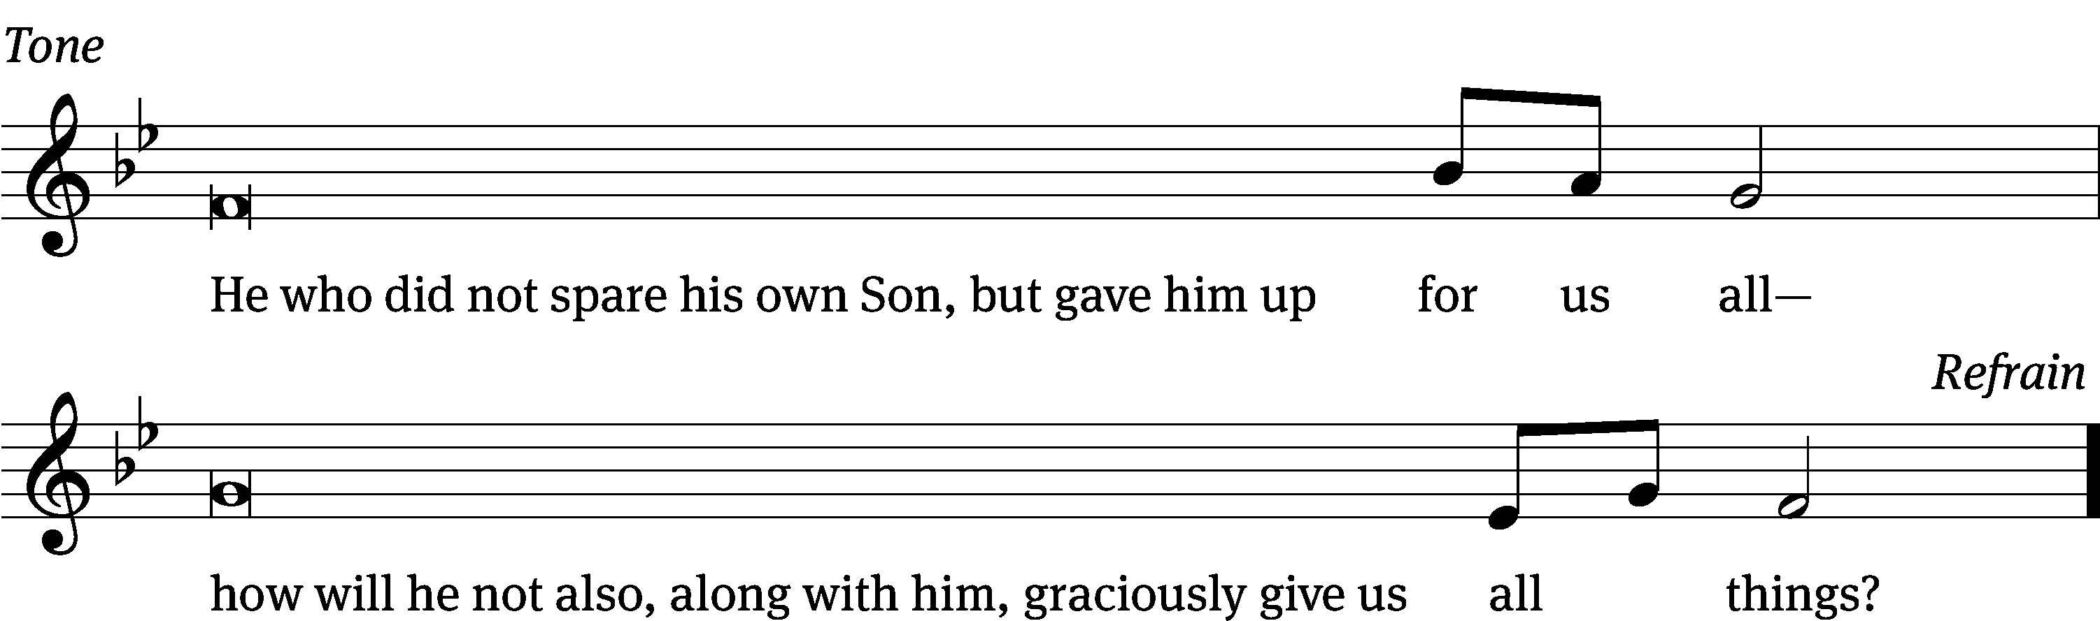

Tune: © 2021 Northwestern Publishing House. Used by permission: OneLicense no. 727703
Gospel Matthew 14:13-21
¹³ When Jesus heard this, he withdrew from there in a boat to a deserted place to be alone. When the crowds heard this, they followed him on foot from the towns.
¹⁴ When Jesus got out of the boat, he saw a large crowd. He had compassion on them and healed their sick. ¹⁵ When evening came, his disciples came to him and said, “This is a deserted place and the hour is already late. Send the crowds away, so that they can go into the villages and buy food for themselves.”
¹⁶ But Jesus said to them, “They do not need to go away. You give them something to eat.”
¹⁷ They told him, “We have here only five loaves and two fish.”
¹⁸ “Bring them here to me,” he replied. ¹⁹ Then he instructed the people to sit down on the grass. He took the five loaves and the two fish. After looking up to heaven, he blessed them. He broke the loaves and gave them to the disciples. The disciples gave the food to the people. ²⁰ They all ate and were filled. They picked up twelve basketfuls of what was left over from the broken pieces. ²¹ Those who ate were about five thousand men, not even counting women and children.

The Gospel of the Lord.
Praise be to you, O Christ!

Please be seated

582 Not unto Us CW 582
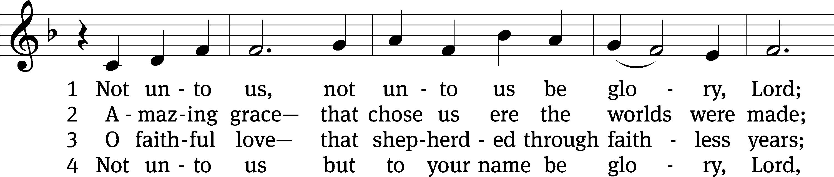
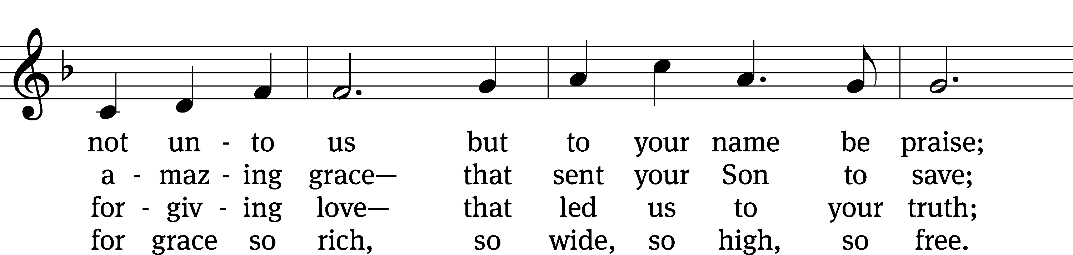
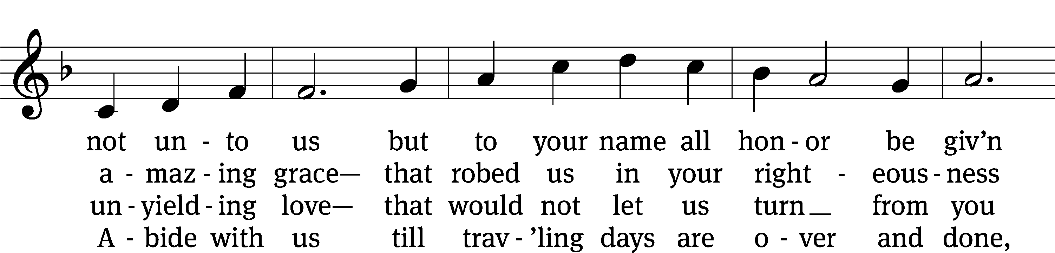
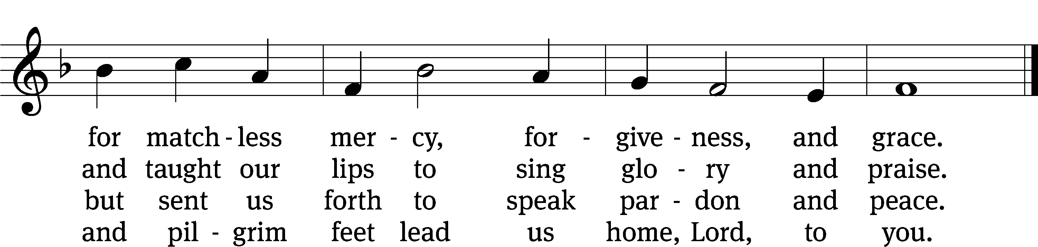
Text: Kurt J. Eggert, 1923–1993, alt.
Tune: Kurt J. Eggert, 1923–1993
Text and tune: © 1975 Kurt J. Eggert, admin. Northwestern Publishing House. Used by permission: OneLicense no. 727703

SERMON 1 Kings 17:1-6
“Trust God’s Control”

Please stand, if you are able

nicene creed
We believe in one God, the Father, the Almighty, maker of heaven and earth, of all that is, seen and unseen.
We believe in one Lord, Jesus Christ, the only Son of God, eternally begotten of the Father, God from God, Light from Light, true God from true God, begotten, not made, of one being with the Father. Through him all things were made. For us and for our salvation, he came down from heaven, was incarnate of the Holy Spirit and the virgin Mary, and became truly human. For our sake he was crucified under Pontius Pilate. He suffered death and was buried. On the third day he rose again in accordance with the Scriptures. He ascended into heaven and is seated at the right hand of the Father. He will come again in glory to judge the living and the dead, and his kingdom will have no end.
We believe in the Holy Spirit, the Lord, the giver of life, who proceeds from the Father and the Son, who in unity with the Father and the Son is worshiped and glorified, who has spoken through the prophets. We believe in one holy Christian and apostolic Church. We acknowledge one baptism for the forgiveness of sins. We look for the resurrection of the dead and the life of the world to come. Amen.

Prayer of the Church

The Sacrament
Preface CW 165
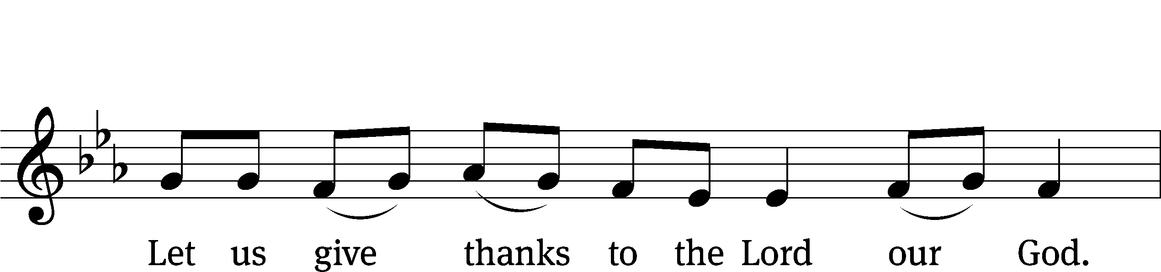
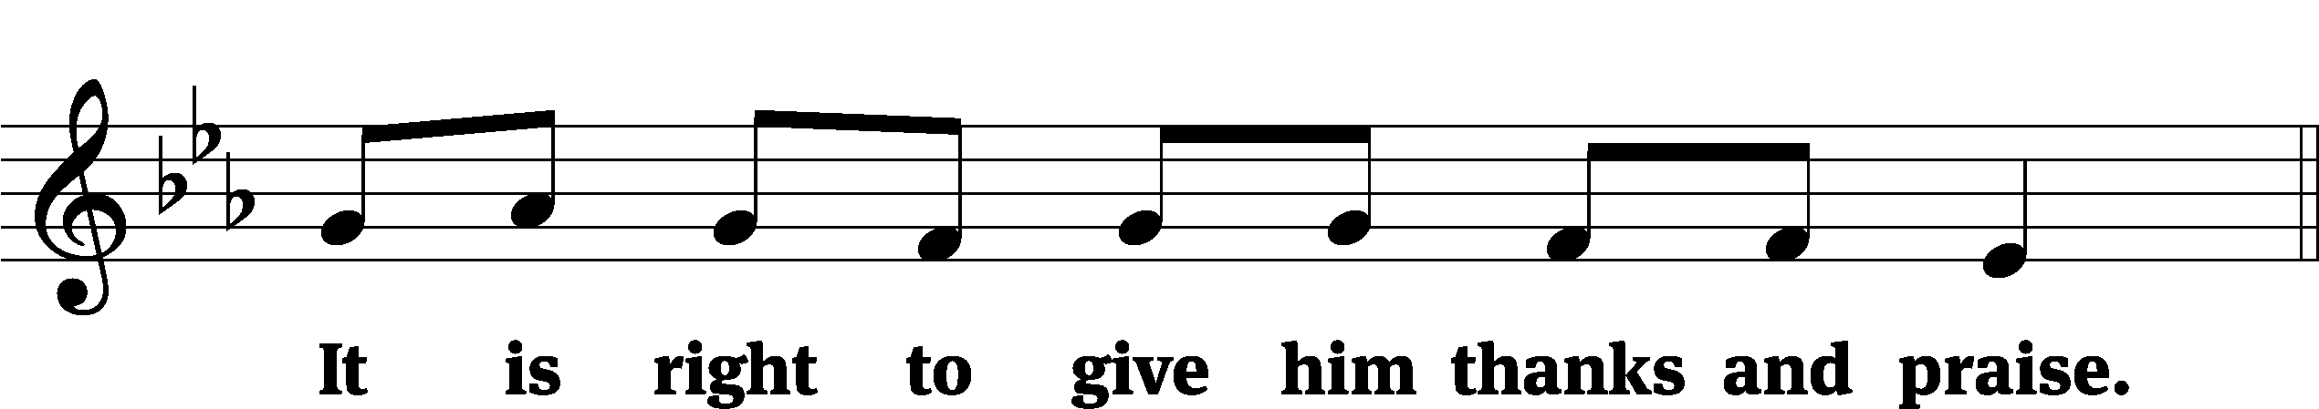

It is truly good and right that we should at all times and in all places give you thanks, O Lord, holy Father, almighty and everlasting God, through Jesus Christ our Lord, who by his willing sacrifice on the cross took away the sins of the world and by his glorious resurrection restored everlasting life. Therefore, with all the saints on earth and hosts of heaven, we praise your holy name and join their glorious song:

Holy, Holy, Holy CW 167
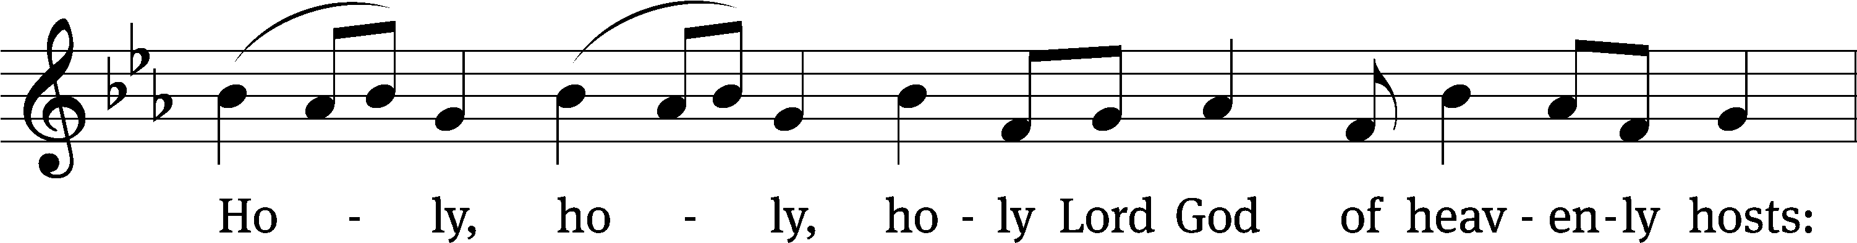
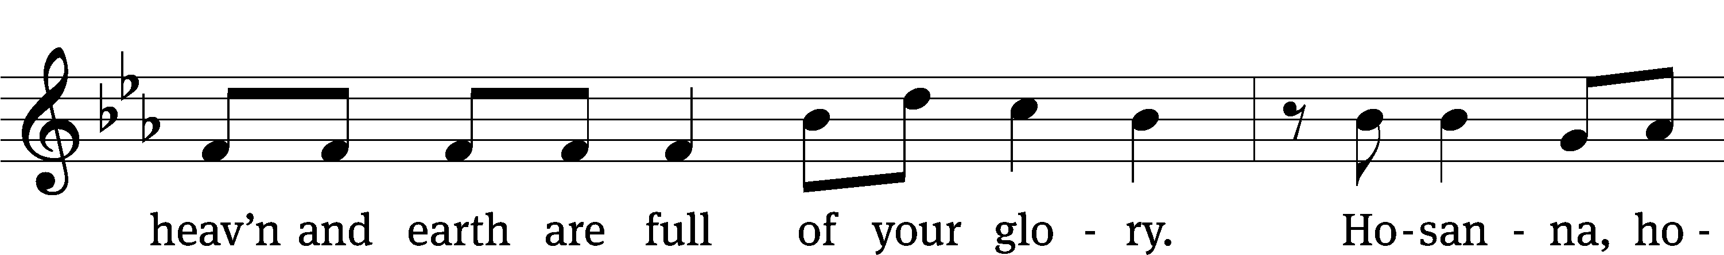
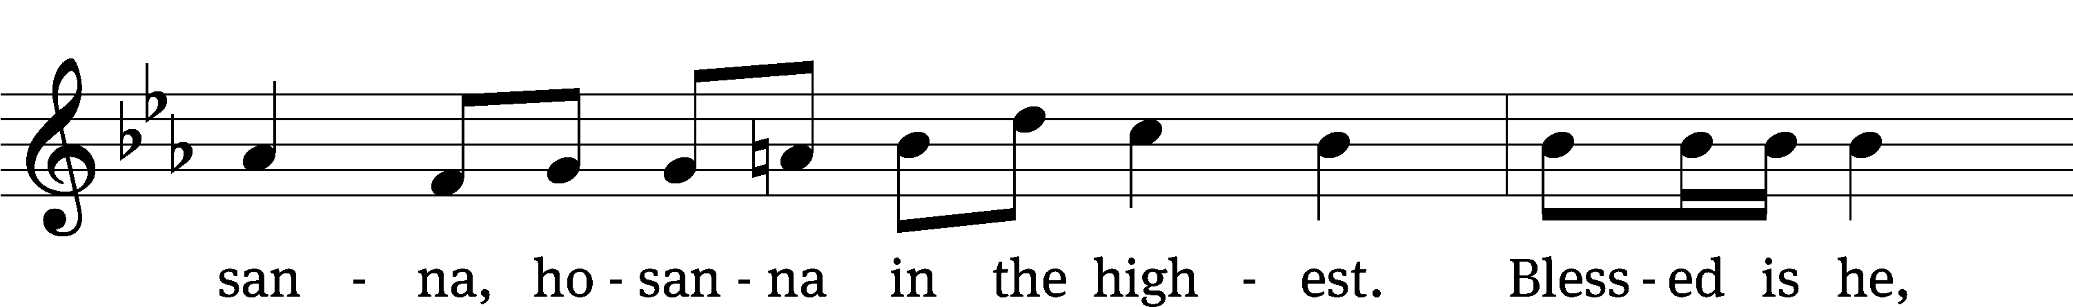
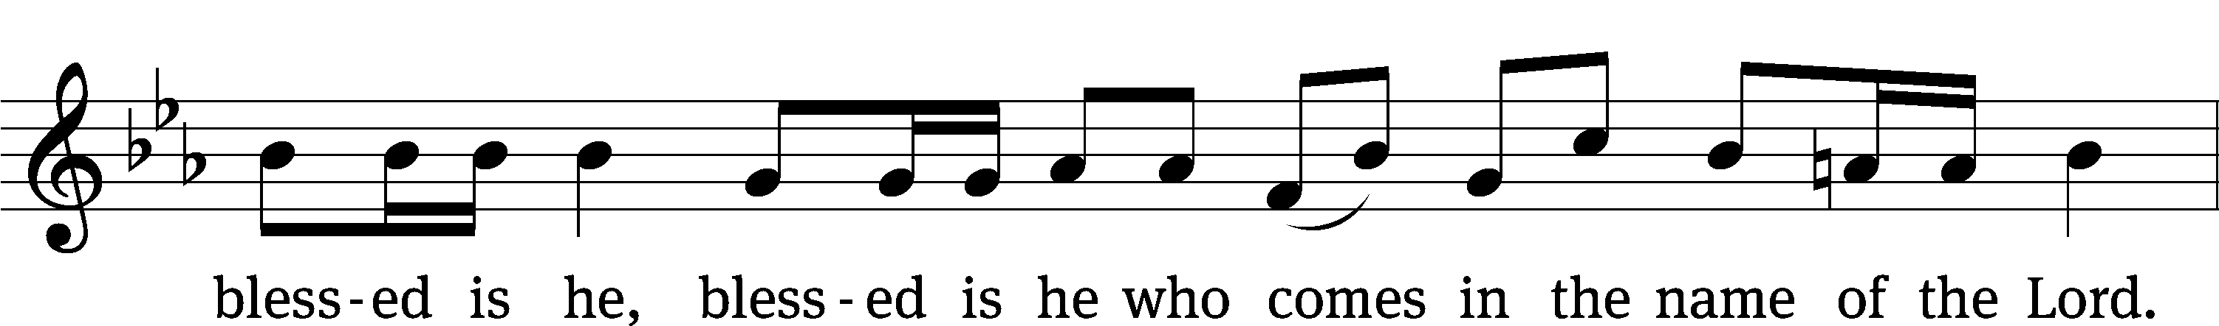
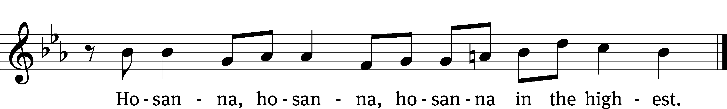

Prayer of Thanksgiving
We give thanks to you, O God, through your dear Son, Jesus Christ, whom you sent to be our Savior, our Redeemer, and the messenger of your grace. Through him you made all things; in him you are well pleased. He is the incarnate Word, conceived by the Holy Spirit and born of the Virgin Mary. To fulfill your promises, he stretched out his hands on the cross and released from eternal death all who believe in you.

As we remember Jesus’ death and resurrection, we thank you that you have gathered us together to receive your Son’s body and blood. Send us your Spirit, unite us as one, and strengthen our faith so that we may praise you in your Son, Jesus Christ. Through him, we glorify and honor you, O God our Father, with the Holy Spirit, one God, now and forever.
Amen.

Lord’s Prayer
Our Father, who art in heaven, hallowed be thy name, thy kingdom come, thy will be done on earth as it is in heaven. Give us this day our daily bread; and forgive us our trespasses, as we forgive those who trespass against us; and lead us not into temptation, but deliver us from evil. For thine is the kingdom and the power and the glory forever and ever. Amen.

Words of Institution
Our Lord Jesus Christ, on the night he was betrayed, took bread; and when he had given thanks, he broke it and gave it to his disciples, saying, “Take and eat; this is my body, which is given for you. Do this in remembrance of me.”
Then he took the cup, gave thanks, and gave it to them, saying, “Drink from it, all of you; this is my blood of the new covenant, which is poured out for you for the forgiveness of sins. Do this, whenever you drink it, in remembrance of me.”

The peace of the Lord be with you always.
Amen.
O Christ, Lamb of God CW 169
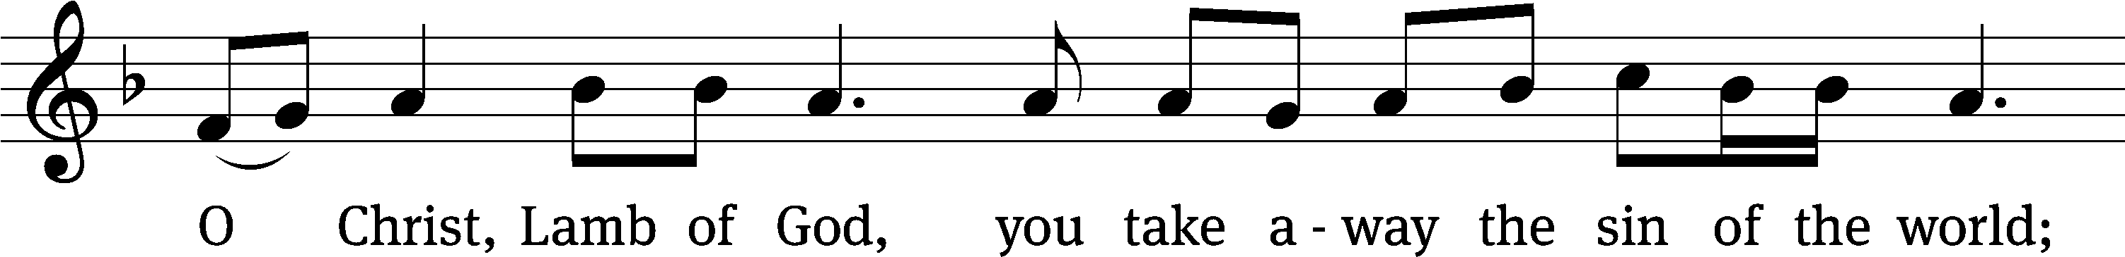
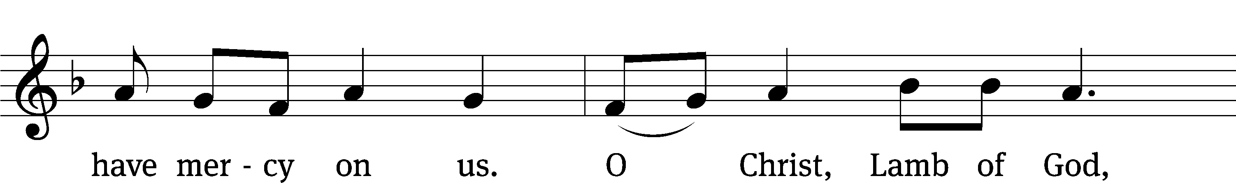
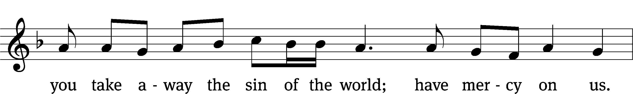
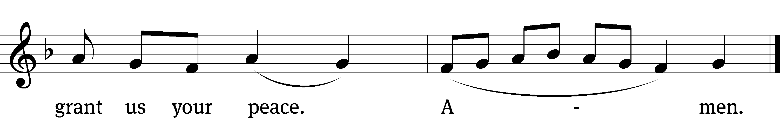
Please be seated
603 All Praise to God Who Reigns Above CW 603
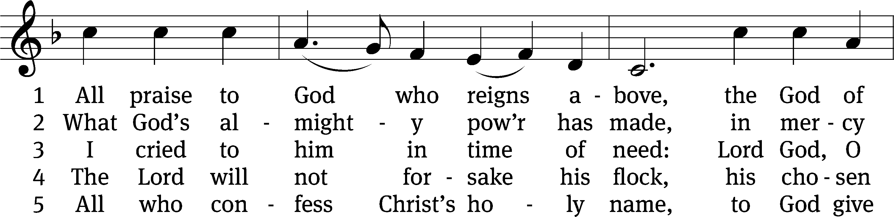
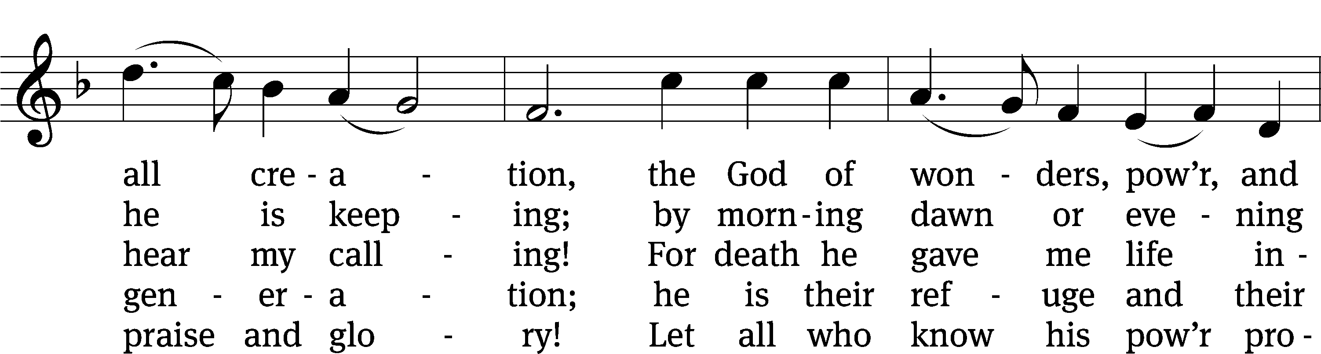
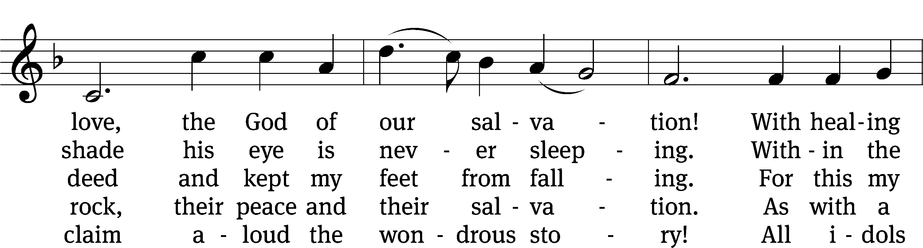
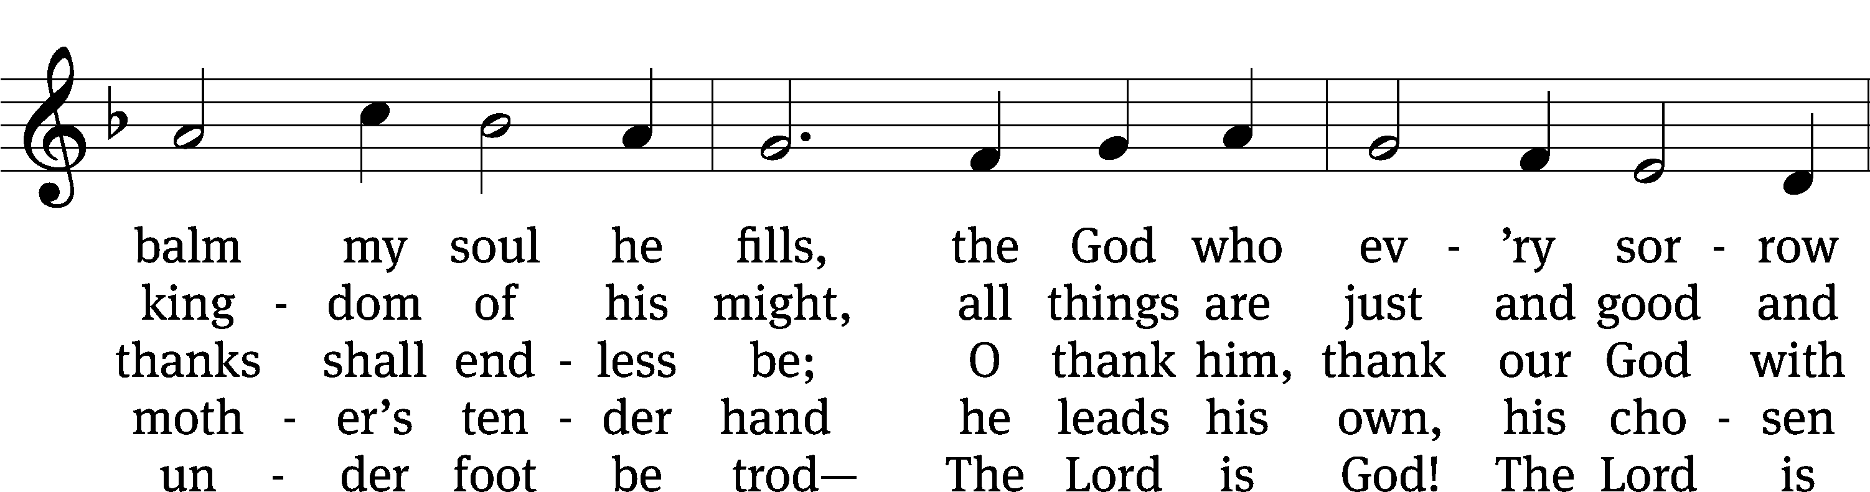
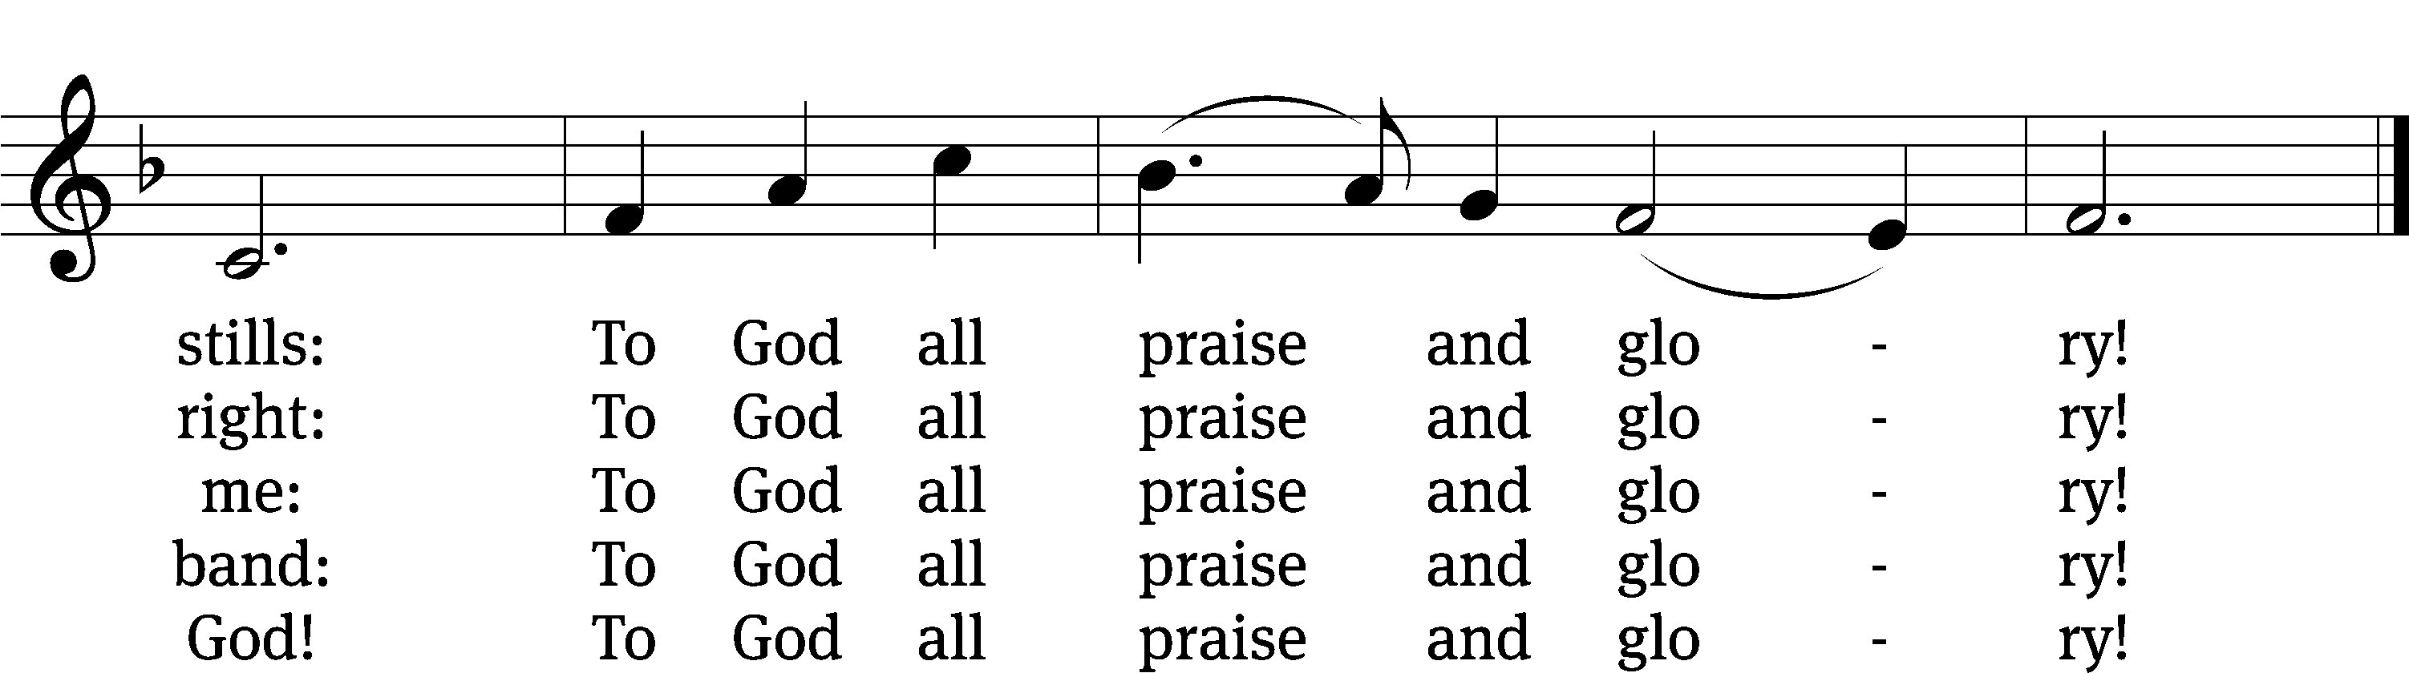
Text: tr. composite; Johann Jacob Schütz, 1640–1690, abr.
Tune: Trente quatre Pseaumes de David, Geneva, 1551, ed. Louis Bourgeois
Text and tune: Public domain

Please stand, if you are able

Give thanks to the Lord, for he is good;
his mercy endures forever.

Whenever we eat this bread and drink this cup,
we proclaim the Lord’s death until he comes.

We give thanks, almighty God, that you have refreshed us with this saving gift. We pray that through it you will strengthen our faith in you and increase our love for one another. We ask this in the name of Jesus Christ our Lord, who lives and reigns with you and the Holy Spirit, one God, now and forever.
Amen.

Blessing
The Lord bless you and keep you.
The Lord make his face shine on you and be gracious to you.
The Lord look on you with favor and give you peace.
Amen.

Please be seated

517 Praise the One Who Breaks the Darkness CW 517
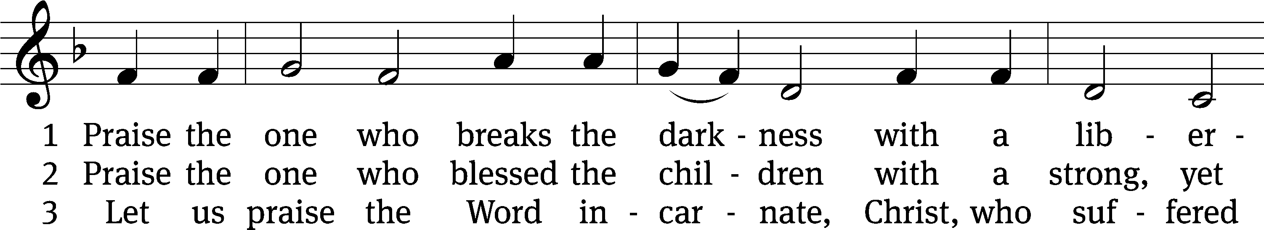
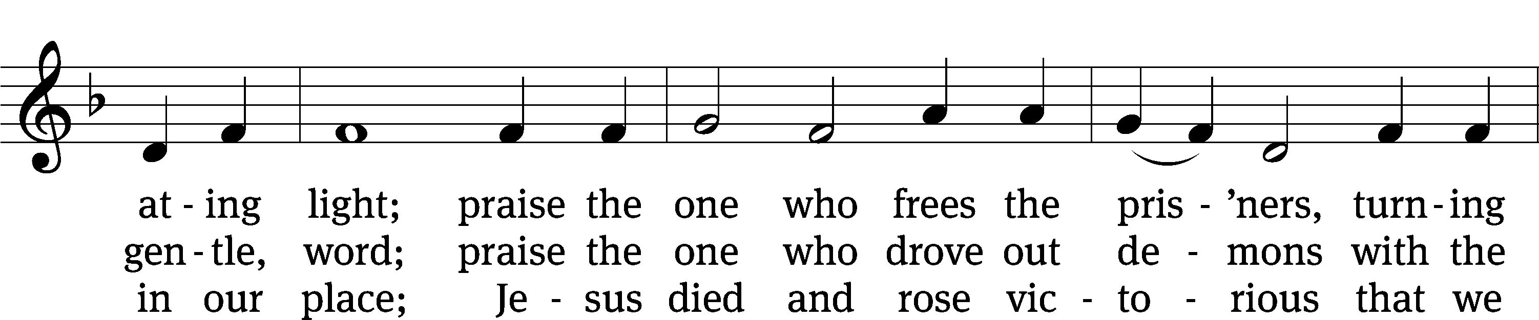
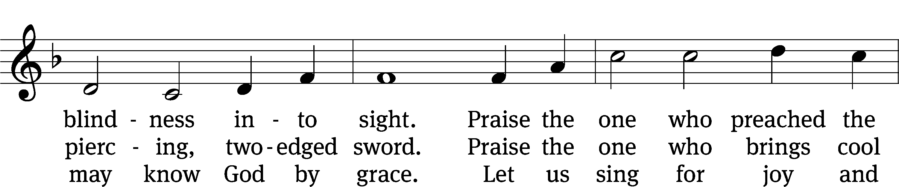
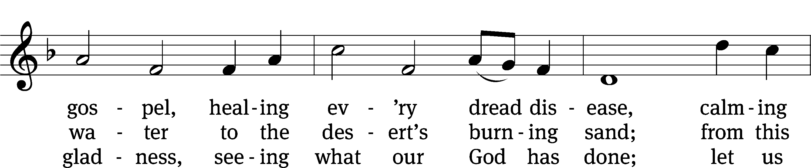
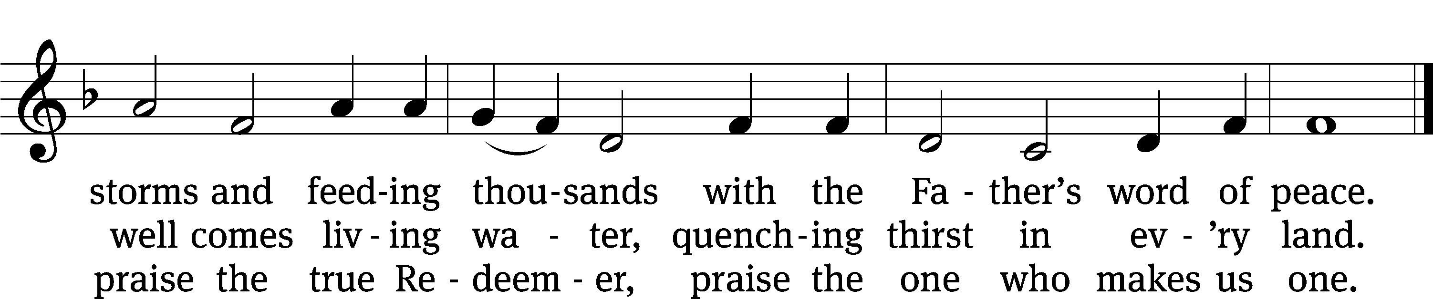
Text: Rusty Edwards, b. 1955, alt.
Tune: The Sacred Harp, Philadelphia, 1844
Text: © 1987 Hope Publishing Co. Used by permission: OneLicense no. 727703
Tune: Public domain

Acknowledgments
Setting One from Christian Worship
Software distributed in partnership with Northwestern Publishing House.
Created by Christian Worship: Service Builder © 2022 Concordia Publishing House.

Serving in Worship
Officiant Pastor Isaac Pappenfuss
Organist Marcia Marion Ackling
Deacons (Thursday) Duane Mason and Dave Stevenson
Deacons (Sunday) Jeff Neuburger and Robert Niethammer
Ushers (Thursday) Tim Phelps
Ushers (Sunday) Ron Zahn
Altar Guild Marcia Marion Ackling and Scott Ackling
Videographer Ann Latowski

