THE seventh SUNDAY
AFTER PENTECOST

TRINITY EVANGELICAL LUTHERAN CHURCH | Saline, Michigan
WELCOME TO WORSHIP July 13/16, 2023

Thank you for joining us in God’s house today! We cordially ask that our guests sign one of the guestbooks located at either the front or back entryways.

THANK OFFERING: Members of Trinity give their offering as an expression of love and thankfulness to the Lord and to help support the Lord’s work in our community and around the world. Visitors need not feel obligated to participate in this offering which supports our ministry.

Restrooms are located at the back of the upper level (the annex), and in the basement (down the back stairs of the sanctuary or annex). Handicap access is available, please ask an usher for assistance.

celebration of holy communion:
In His Word, God makes it clear that the Lord’s Supper is to be shared by people of a common proclamation of faith (1 Corinthians 11:26; 1 Corinthians 10:16-17). Without judging anyone’s hearts, we invite those who share in our confession by their membership in our congregation or another congregation of the Wisconsin Evangelical Lutheran Synod (WELS) or the Evangelical Lutheran Synod (ELS) and who are properly prepared (1 Corinthians 11;27-29) to receive the Sacrament. Page 295 in the front of Christian Worship provides a guide for preparation.

Guests, we would love to have you join us in communion fellowship in the future, and for that to be possible, we ask that you speak with one of the pastors so that we may speak with you on how that would be possible. We thank you for respecting the way we celebrate the Lord’s Supper in our congregations.

SERVICE OF WORD AND SACRAMENT
923 Guide Me, O Thou Great Jehovah CW 923
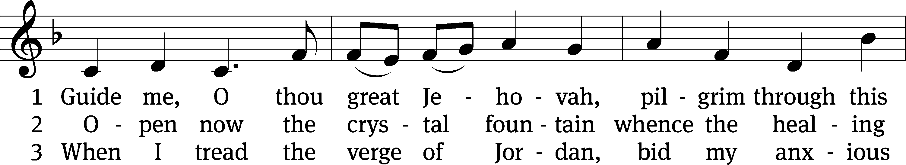
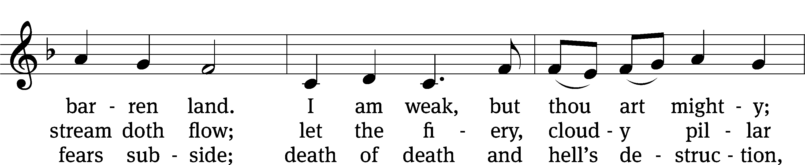
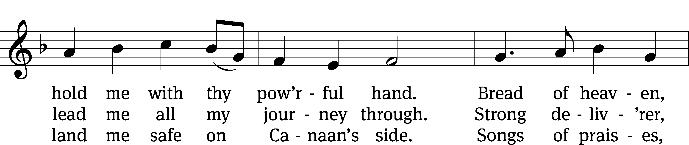
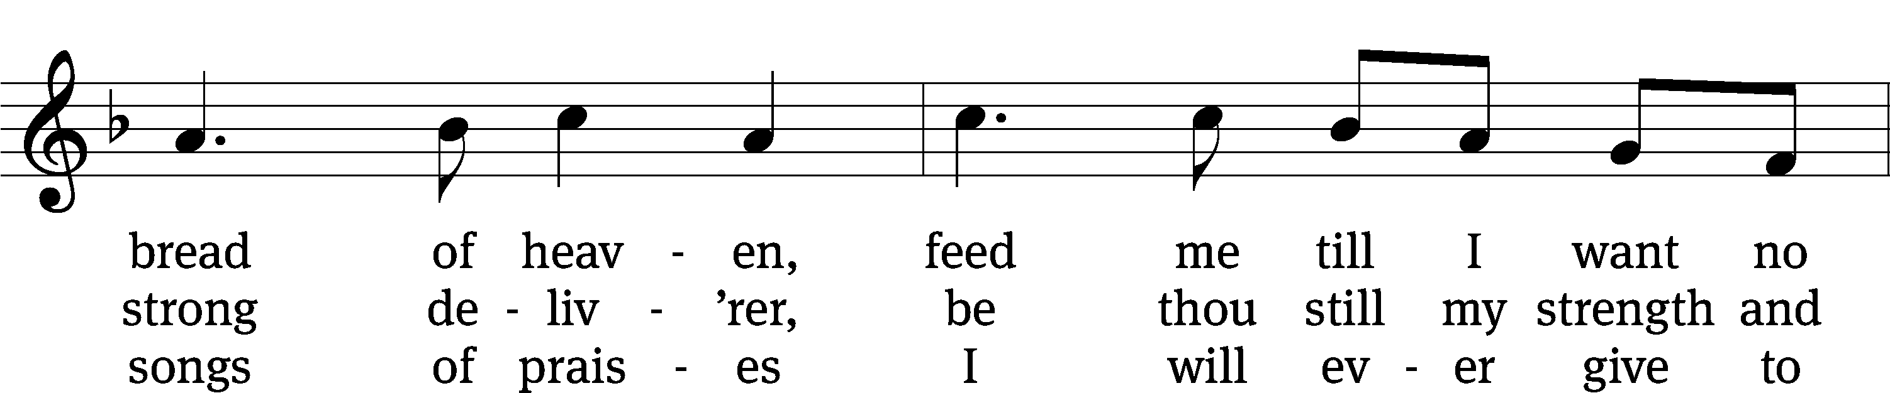
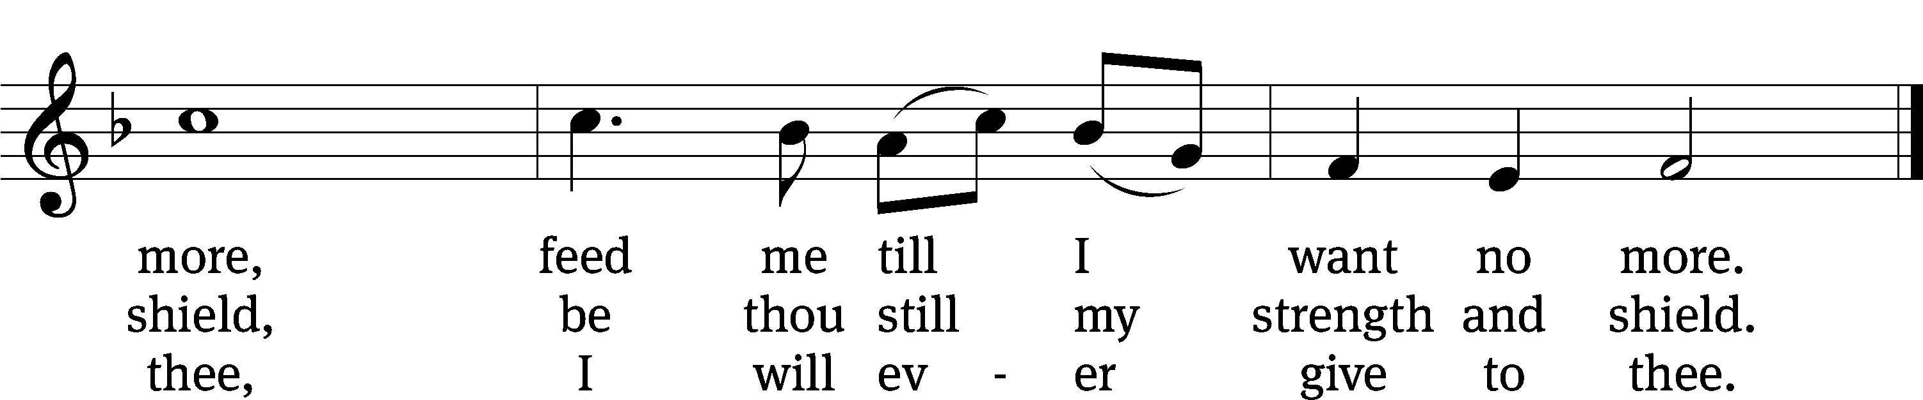
Text: William Williams, 1717–1791, abr.; (st. 1): tr. Peter Williams, 1722–1796, alt.; (sts. 2–3): tr. William Williams, 1717–1791
Tune: John Hughes, 1873–1932
Text and tune: Public domain

PLEASE STAND, IF YOU ARE ABLE

invocation
M: The grace of our Lord (+) Jesus Christ and the love of God and the fellowship of the Holy Spirit be with you.
C: And also with you.
CONFESSION OF SINS
M: God invites us to come into his presence and worship him with humble and penitent hearts. Therefore, let us acknowledge our sinfulness and ask him to forgive us.
C: Holy and merciful Father, I confess that I am by nature sinful, and that I have disobeyed you in my thoughts, words, and actions. I have done what is evil and failed to do what is good. For this I deserve your punishment both now and in eternity. But I am truly sorry for my sins, and trusting in my Savior Jesus Christ, I pray: Lord, have mercy on me, a sinner.
M: God, our heavenly Father, has been merciful to us and has given his only Son to be the atoning sacrifice for our sins. Therefore, as a called servant of Christ and by his authority, I forgive you all your sins in the name of the Father and of the Son (+) and of the Holy Spirit.
C: Amen.
PRAYER AND PRAISE
LORD, HAVE MERCY
Kyrie
M: For all that we need in life and for the wisdom to use all your gifts with gratitude and joy, hear our prayer, O Lord.

M: For the steadfast assurance that nothing can separate us from your love and for the courage to stand firm against the assaults of Satan and every evil, hear our prayer, O Christ.

M: For the well-being of your holy Church in all the world and for those who offer here their worship and praise, hear our prayer, O Lord.

M: Merciful God, maker and preserver of life, uphold us by your power and keep us in your tender care:

M: The works of the Lord are great and glorious; his name is worthy of praise.

Prayer of the day

M: Let us pray.

The minister says the Prayer of the Day.

PLEASE BE SEATED

The Word

first lesson Isaiah 55:1-11

Hey, all of you who are thirsty, come to the water,
even if you have no money!
Come, buy and eat!
Come, buy wine and milk without money and without cost.
² Why do you spend money on something that is not bread?
Why do you waste your labor on something that does not satisfy?
Listen carefully to me, and eat what is good.
Satisfy your appetite with rich food.
³ Turn your ear toward me, and come to me.
Listen, so that you may continue to live.
Yes, I will make an everlasting covenant with you,
the faithful mercies promised to David.
⁴ Look, I appointed him as a witness for peoples,
a leader and commander of peoples.
⁵ Look, you will call out to a nation you do not know,
and a nation that does not know you will run to you,
on account of the Lord your God,
because of the Holy One of Israel,
for he has glorified you.
⁶ Seek the Lord while he may be found!
Call on him while he is near!
⁷ Let the wicked man abandon his way.
Let an evil man abandon his thoughts.
Let him turn to the Lord,
and he will show him mercy.
Let him turn to our God,
because he will abundantly pardon.
⁸ Certainly my plans are not your plans,
and your ways are not my ways, declares the Lord.
⁹ Just as the heavens are higher than the earth,
so my ways are higher than your ways,
and my plans are higher than your plans.
¹⁰ Just as the rain and the snow come down from the sky
and do not return there
unless they first water the earth, make it give birth, and cause it to sprout,
so that it gives seed to the sower and bread to the eater,
¹¹ in the same way my word that goes out from my mouth
will not return to me empty.
Rather, it will accomplish whatever I please,
and it will succeed in the purpose for which I sent it.

65B Every Heart Its Tribute Pays Psalm 65B
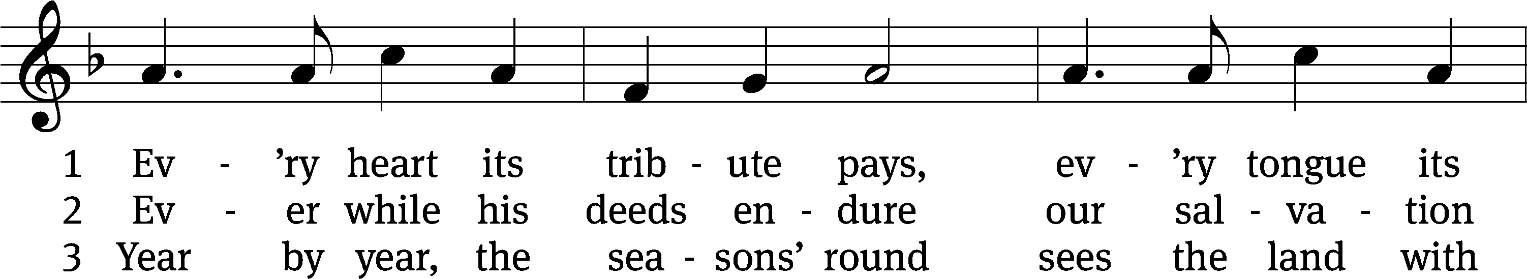
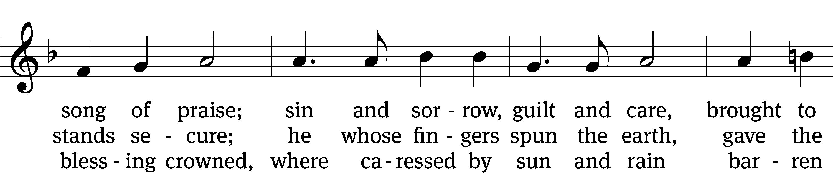
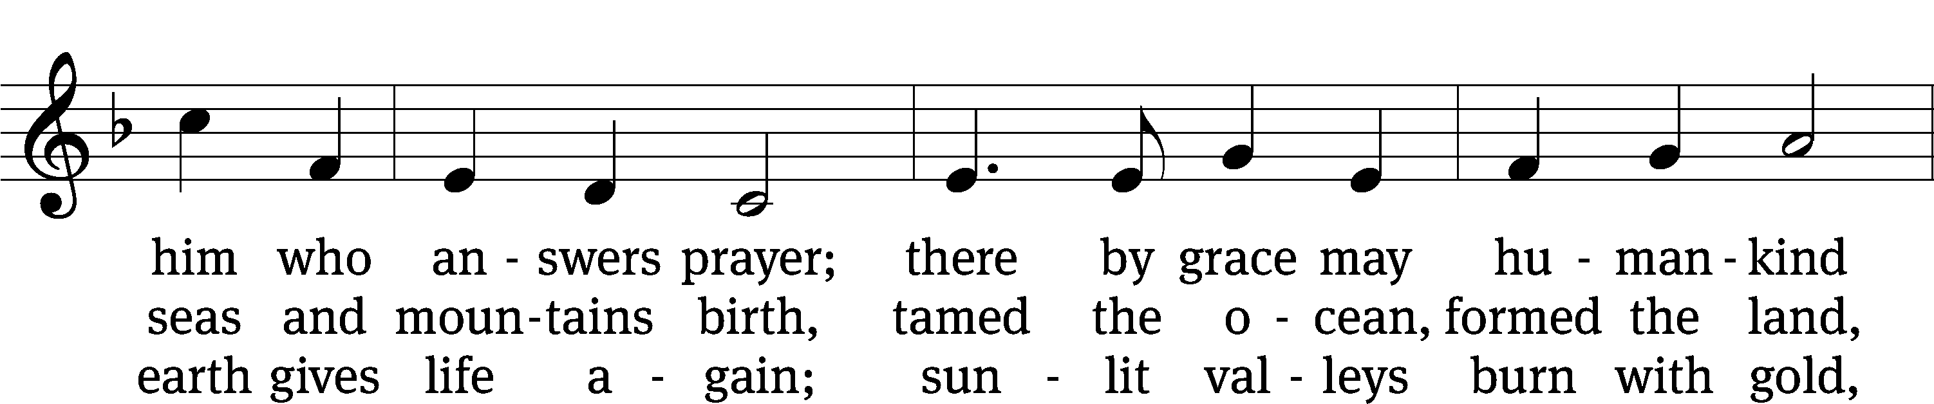
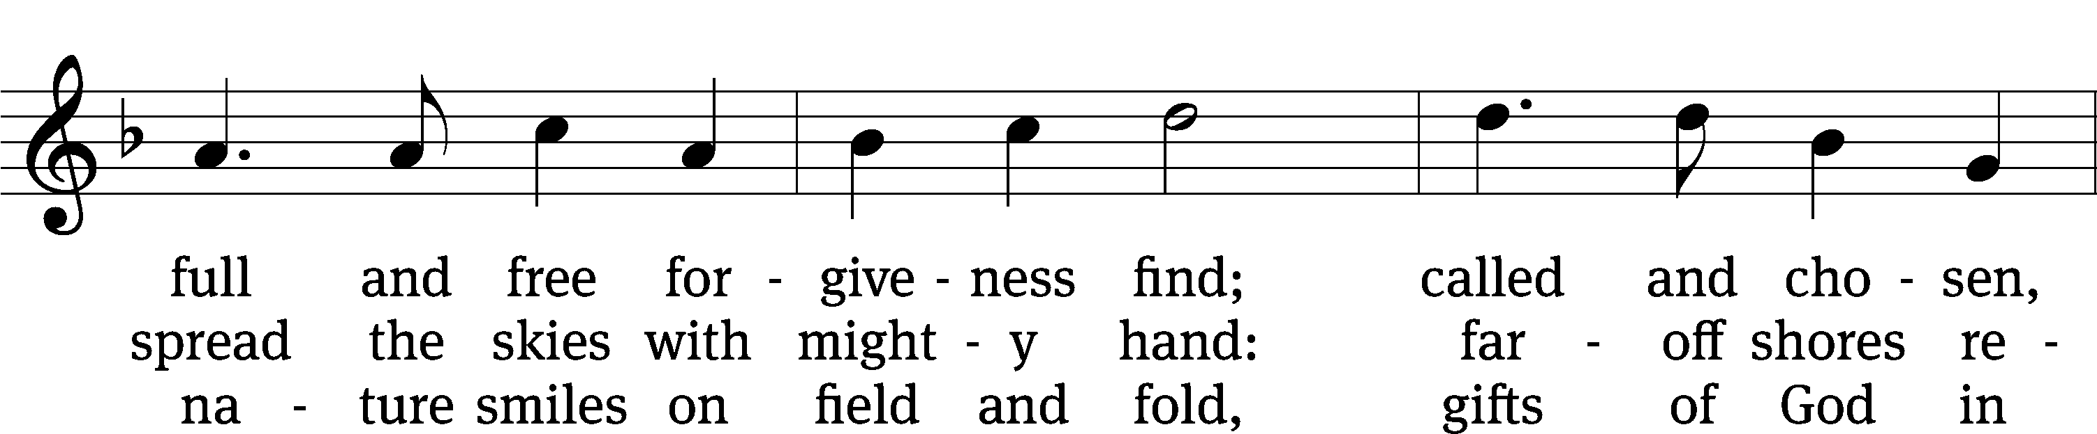
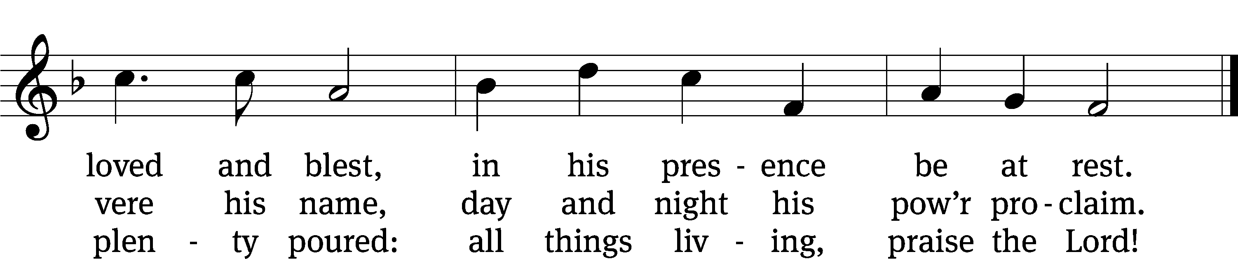
Text: Timothy Dudley-Smith
Tune: George J. Elvey
Text: © 1984 Hope Publishing Co. Used by permission: OneLicense no. 727703
Tune: Public domain

second lesson 1 Corinthians 3:5-11
⁵ What then is Apollos? And what is Paul? They are ministers through whom you believed, and each served as the Lord gave him his role. ⁶ I planted, Apollos watered, but God was causing the growth. ⁷ So then, neither the one who plants nor the one who waters is anything, but it is God who causes the growth. ⁸ The one who plants and the one who waters are united, and each will receive his own reward according to his own labor. ⁹ For God is the one whom we serve as coworkers, and you are God’s field, God’s building.
¹⁰ In keeping with the grace of God given to me, as a wise master builder, I laid a foundation, and someone else is building on it. But let each person be careful how he builds on it. ¹¹ In fact, no one can lay any other foundation than the one that has been laid, which is Jesus Christ.
PLEASE STAND, IF YOU ARE ABLE

VERSE OF THE DAY Isaiah 55:11
Alleluia. My word will not return to me empty, but will accomplish what I desire,
And achieve the purpose for which I sent it. Alleluia.

GOSPEL Matthew 13:1-9, 18-23
¹ That same day Jesus left the house and was sitting by the sea. ² A large crowd gathered around him. So he stepped into a boat and sat down, while all the people stood on the shore. ³ He told them many things in parables, saying: “Listen, a sower went out to sow. ⁴ As he sowed, some seed fell along the path, and the birds came and ate it. ⁵ Other seed fell on rocky ground, where it did not have much soil. Immediately the seed sprang up, because the soil was not deep. ⁶ But when the sun rose, the seed was scorched. Because it had no root, it withered away. ⁷ Other seed fell among thorns. The thorns grew up and choked it. ⁸ But some seed fell on good ground and produced grain: some one hundred times, some sixty, and some thirty times more than was sown. ⁹ Whoever has ears to hear, let him hear.”
¹⁸ “So listen carefully to the parable of the sower. ¹⁹ When anyone hears the word of the kingdom and does not understand it, the Evil One comes and snatches away what has been sown in his heart. This is the seed that was sown along the path. ²⁰ The seed that was sown on rocky ground is the person who hears the word and immediately receives it with joy, ²¹ yet he is not deeply rooted and does not endure. When trouble or persecution comes because of the word, he immediately falls away. ²² The seed that was sown among the thorns is the one who hears the word, but the worry of this world and the deceitfulness of wealth choke the word, and it produces no fruit. ²³ But the seed that was sown on the good ground is the one who continues to hear and understand the word. Indeed he continues to produce fruit: some a hundred, some sixty, and some thirty times more than was sown.”

M: This is the Gospel of the Lord.

PLEASE BE SEATED
591 O Holy Spirit, Grant Us Grace CW 591
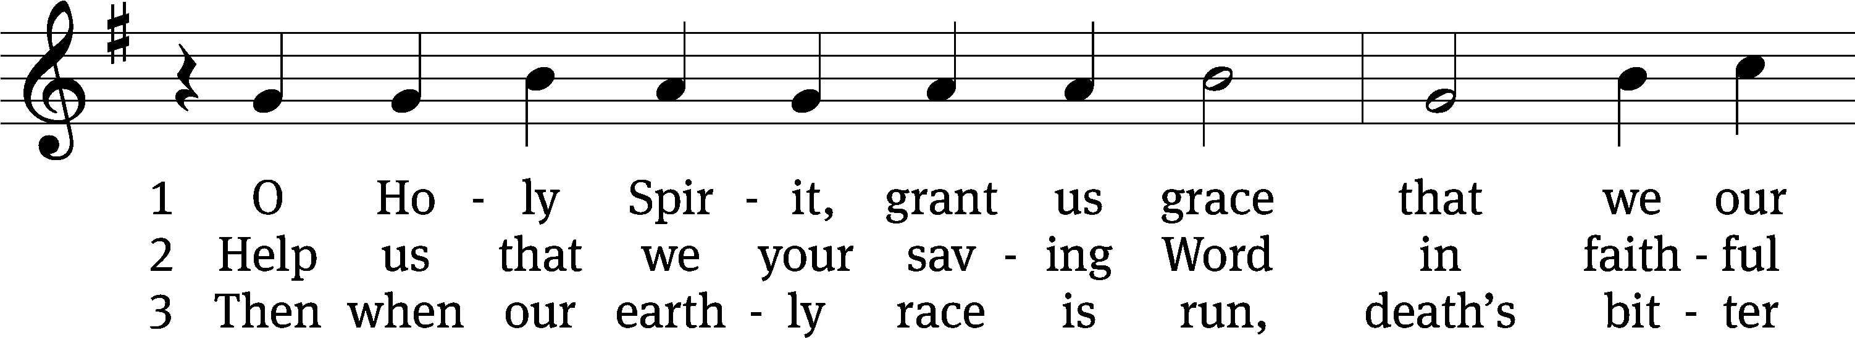
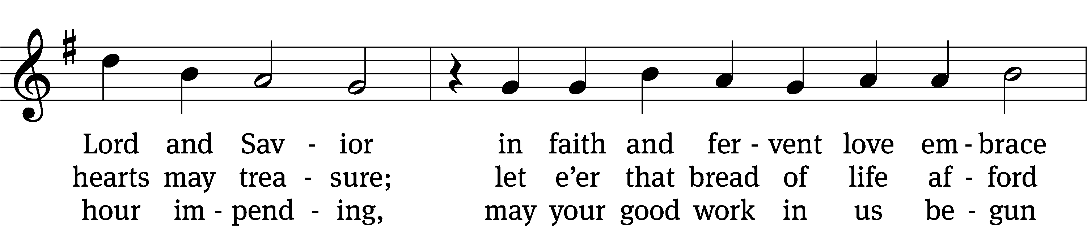
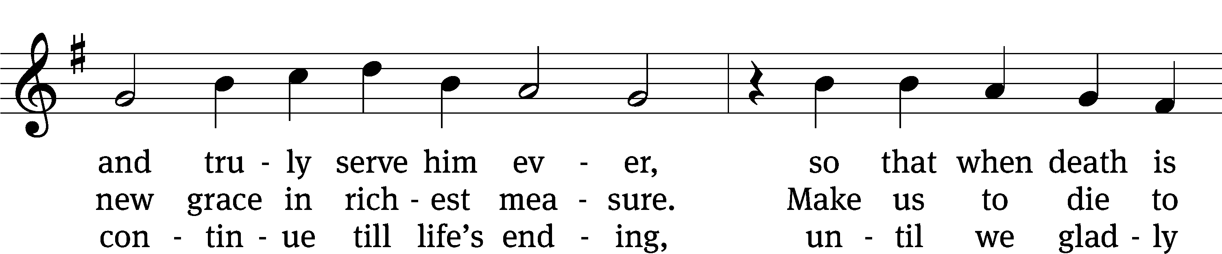
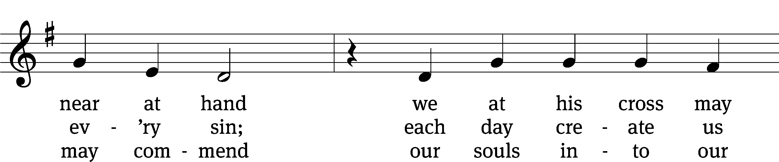
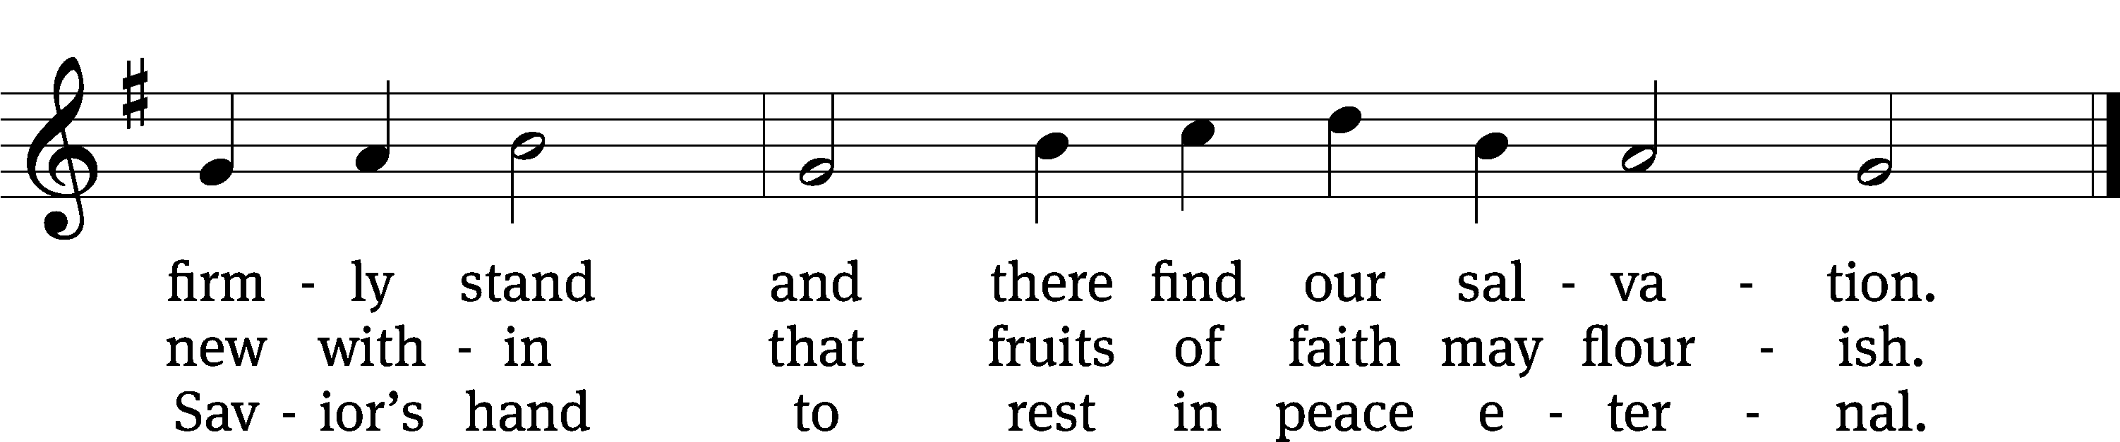
Text: tr. Oluf H. Smeby, 1851–1929, alt.; Bartholomäus Ringwaldt, 1532–1599
Tune: Geistliche Lieder auffs new gebessert, Wittenberg, 1535, ed. Joseph Klug
Text and tune: Public domain

Sermon John 6:35. 48-51

Jesus says, “I AM the bread of life”

³⁵ “I am the Bread of Life,” Jesus told them. “The one who comes to me will never be hungry, and the one who believes in me will never be thirsty. ⁴⁸ “I am the Bread of Life. ⁴⁹ Your fathers ate manna in the wilderness, and they died. ⁵⁰ This is the bread that comes down from heaven, so that anyone may eat it and not die. ⁵¹ I am the living bread which came down from heaven. If anyone eats this bread, he will live forever. The bread that I will give for the life of the world is my flesh.”

please stand, if you are able

nicene creed
We believe in one God, the Father, the Almighty, maker of heaven and earth, of all that is, seen and unseen.
We believe in one Lord, Jesus Christ, the only Son of God, eternally begotten of the Father, God from God, Light from Light, true God from true God, begotten, not made, of one being with the Father. Through him all things were made. For us and for our salvation, he came down from heaven, was incarnate of the Holy Spirit and the virgin Mary, and became truly human. For our sake he was crucified under Pontius Pilate. He suffered death and was buried. On the third day he rose again in accordance with the Scriptures. He ascended into heaven and is seated at the right hand of the Father. He will come again in glory to judge the living and the dead, and his kingdom will have no end.
We believe in the Holy Spirit, the Lord, the giver of life, who proceeds from the Father and the Son, who in unity with the Father and the Son is worshiped and glorified, who has spoken through the prophets. We believe in one holy Christian and apostolic Church. We acknowledge one baptism for the forgiveness of sins. We look for the resurrection of the dead and the life of the world to come. Amen.

prayer of the church

lord’s prayer

C: Our Father, who art in heaven,
hallowed be thy name,
thy kingdom come,
thy will be done
on earth as it is in heaven.
Give us this day our daily bread;
and forgive us our trespasses,
as we forgive those
who trespass against us;
and lead us not into temptation,
but deliver us from evil.
For thine is the kingdom
and the power and the glory
forever and ever. Amen.

The Sacrament of Holy Communion
Trinity Lutheran Church follows the historic Christian practice of close communion. We ask that only members of Trinity or one of our sister congregations partake of the sacrament. If you are not a member, please see the note about Holy Communion in the beginning of the Worship Folder.

M: The Lord be with you.

M: Lift up your hearts.

M: Let us give thanks to the Lord our God.

M: Praise to the God and Father of our Lord Jesus Christ! In love he has blessed us with every spiritual blessing. He sends the Holy Spirit to testify that we are his children and to strengthen us when we are weak. Now have come the salvation and the power and the kingdom of our God and the authority of his Christ. To him who sits on the throne and to the Lamb be praise and thanks and honor and glory for ever and ever:

Holy, Holy, Holy

Words of institution
M: Our Lord Jesus Christ, on the night he was betrayed, took bread; and when he had given thanks, he broke it and gave it to his disciples, saying: “Take and eat. This is my ✙ body, which is given for you. Do this in remembrance of me.”
Then he took the cup, gave thanks, and gave it to them, saying, “Drink from it all of you; this is my ✙ blood of the new covenant, which is poured out for you for the forgiveness of sins. Do this, whenever you drink it, in remembrance of me.”
M: The peace of the Lord be with you always.

O CHRIST, LAMB OF GOD

PLEASE BE SEATED
661 Draw Near and Take the Body of Your Lord CW 661
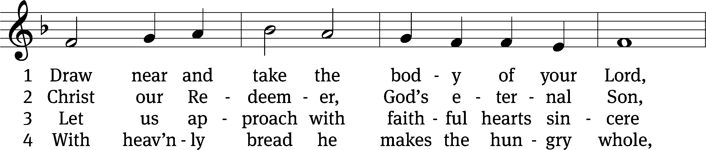
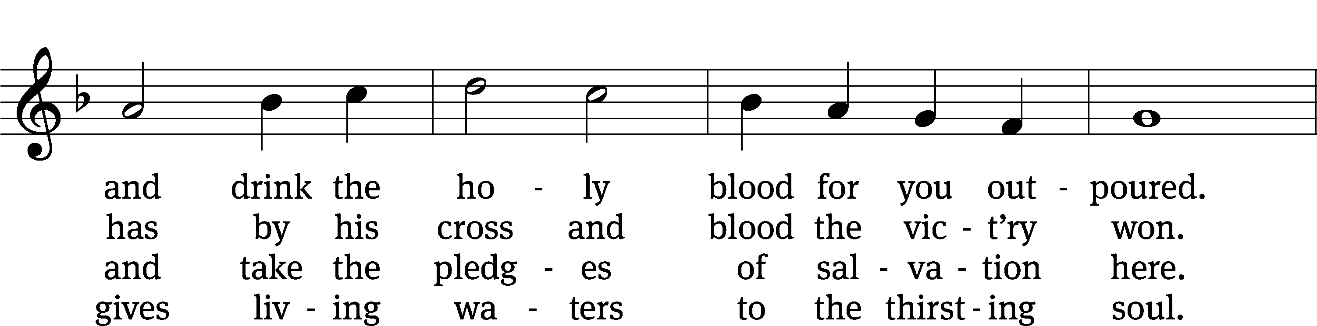
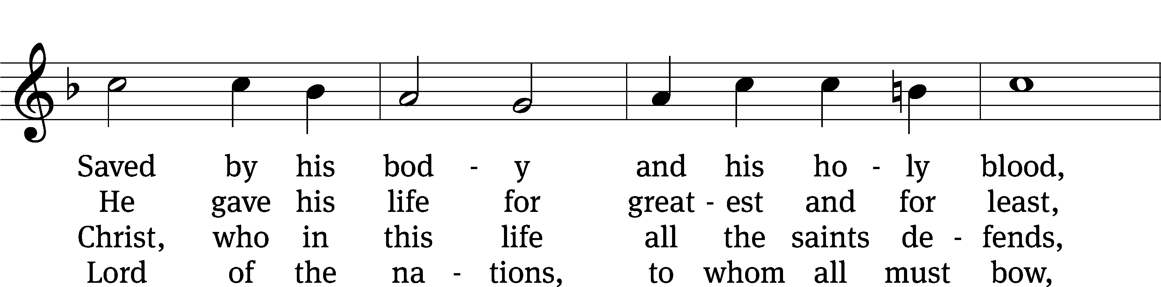
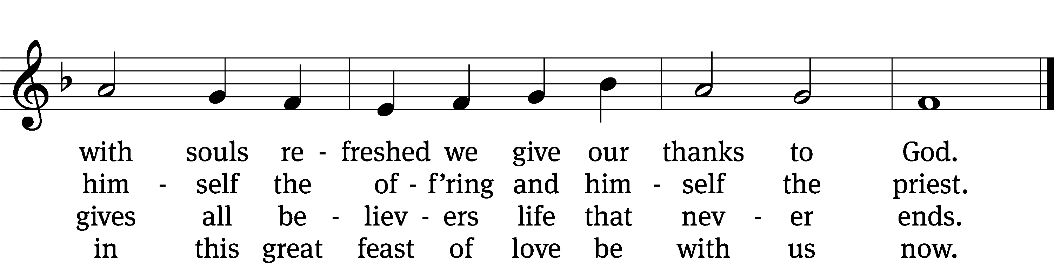
Text: tr. John Mason Neale, 1818–1866, alt.; Latin, 7th cent., abr.
Tune: Trente quatre Pseaumes de David, Geneva, 1551, ed. Louis Bourgeois
Text and tune: Public domain

631 Speak, O Savior, I Am Listening CW 631
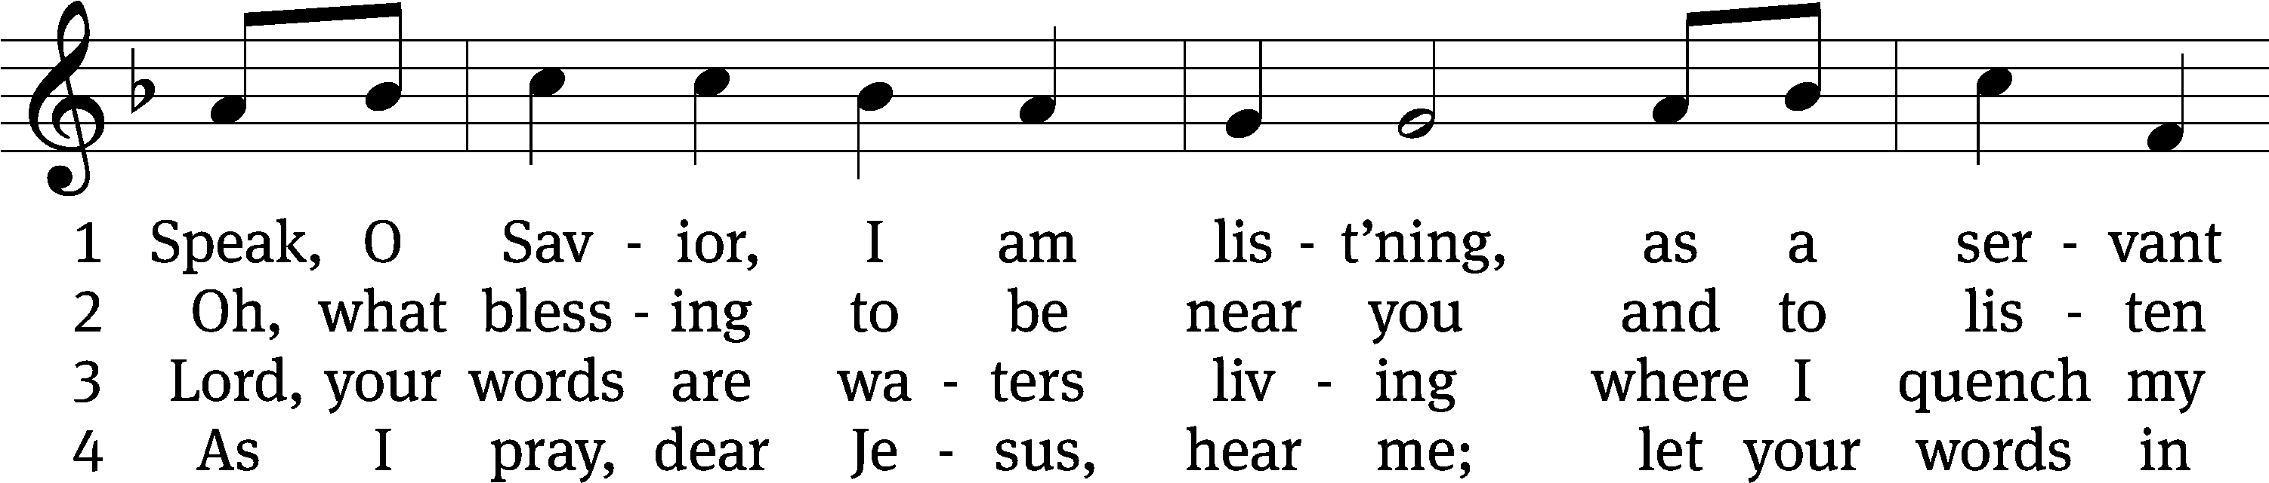
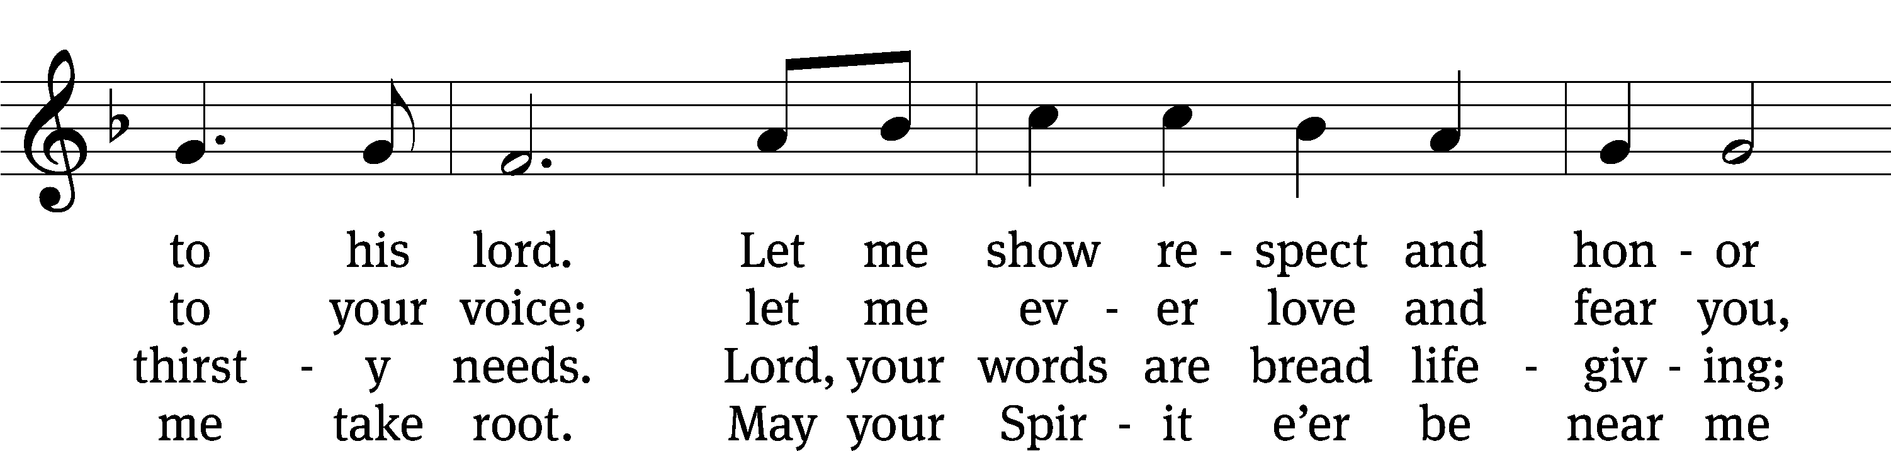
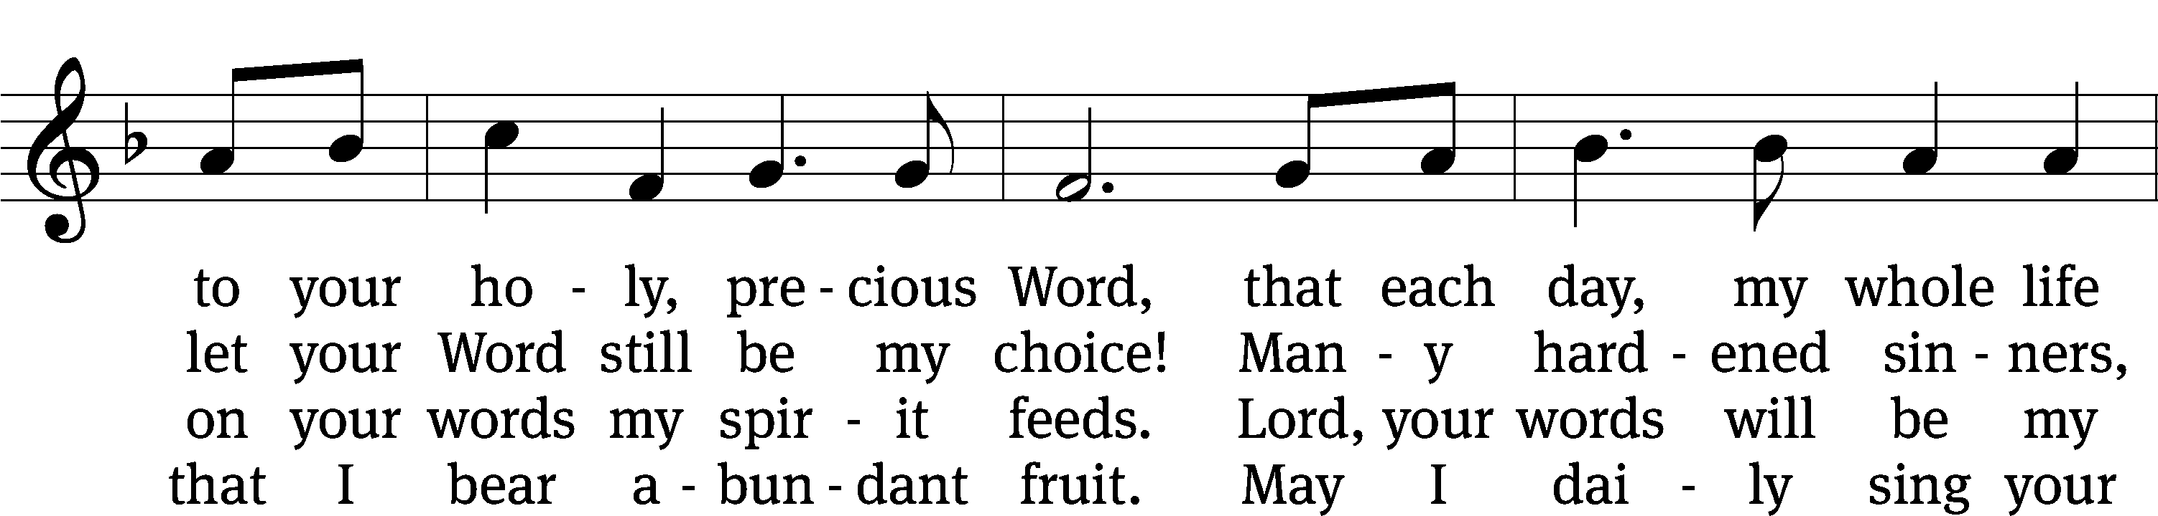
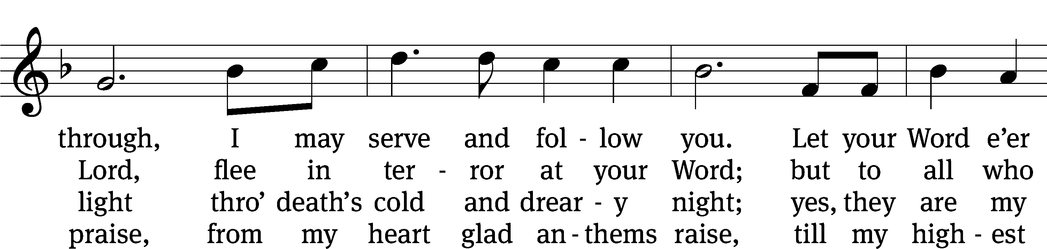
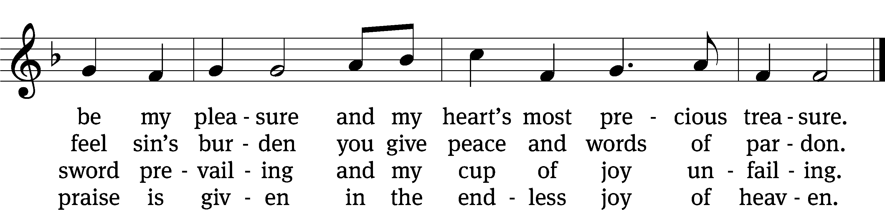
Text: Anna Sophia von Hessen-Darmstadt, 1638–1683; (sts. 1, 4): tr. Christian Worship, 1993; (sts. 2–3): tr. George A. T. Rygh, 1860–1942, alt.
Tune: Johann Schop, c. 1590–1667
Text and tune: Public domain

PLEASE STAND, IF YOU ARE ABLE

M: Hear the prayer of your people, O Lord, that the lips which have praised you here may glorify you in the world, that the eyes which have seen the coming of your Son may long for his coming again, and that all who have received in his true body and blood the pledge of your forgiveness may be restored to live a new and holy life, through Jesus Christ, our Lord, who lives and reigns with you and the Holy Spirit, one God, now and forever.

M: Brothers and sisters, go in peace. Live in harmony with one another.
Serve the Lord with gladness.
The Lord bless you and keep you.
The Lord make his face shine on you and be gracious to you.
The Lord look on you with favor and (+) give you peace.

PLEASE BE SEATED

509 Feed Your Children, God Most Holy CW 509
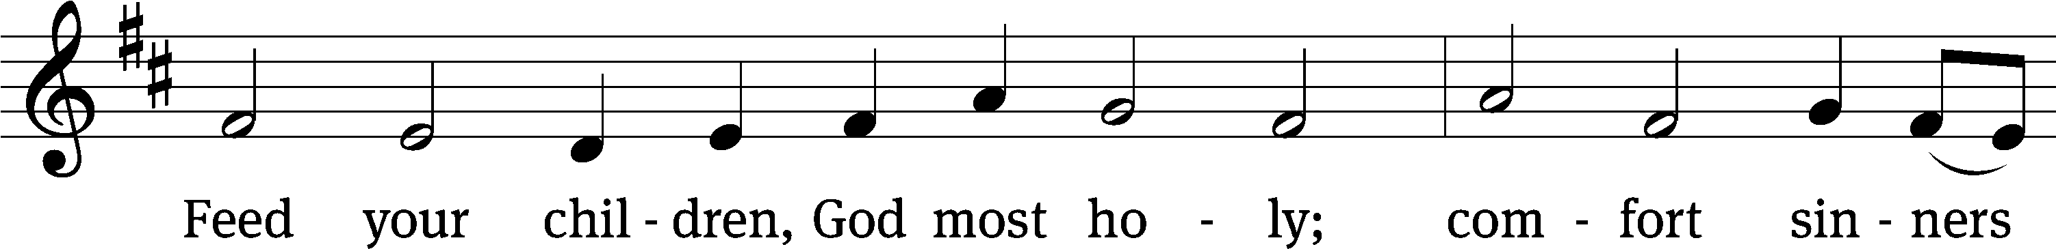
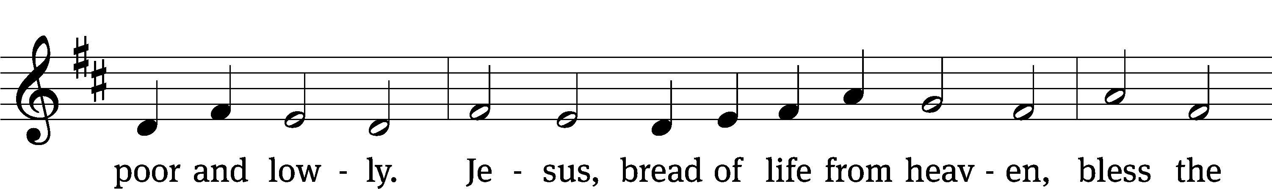
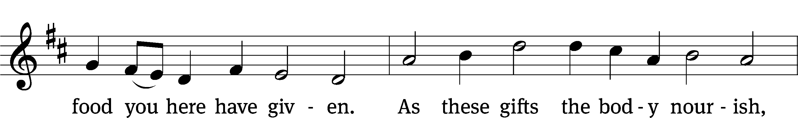
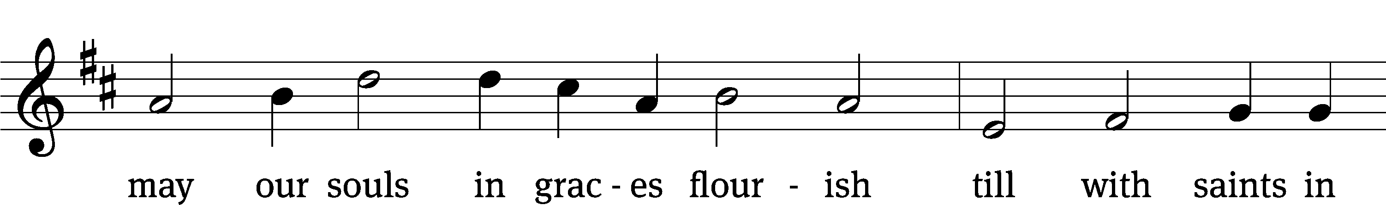
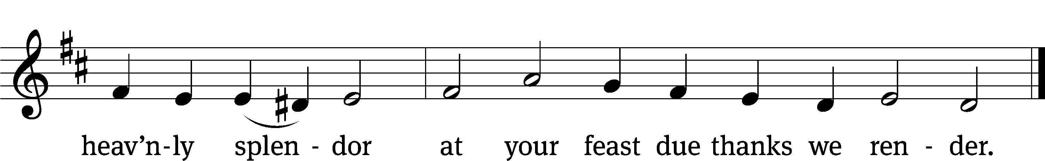
Text: tr. The Lutheran Hymnal, 1941, alt.; Johann Heermann, 1585–1647
Tune: Johann Crüger, 1598–1662
Text: © 1941 Concordia Publishing House. Used by permission: OneLicense no. 727703
Tune: Public domain

Serving In Worship

Officiant Pastor Natsis
Organist Marcia Marion Ackling
Deacons (Thursday) Steve Hoeft and Jim Tice
(Sunday) Jeff Neuburger and Dave Stevenson
Ushers (Thursday) Dale Finkbeiner and Mark Finkbeiner
(Sunday) Al Whitley
Altar Guild Esther Gross and Diane Stevenson
Videographer Jake Vershum

Copyright information
Service of Word and Sacrament: Christian Worship. © 1993 Northwestern Publishing House. All rights reserved. Reprinted under ONE LICENSE #A-727703 and CCLI #1151741/ CSPL126093
Words and Music: All rights reserved. Reprinted/Podcast/Streamed with permission under ONE LICENSE #A-727703 and CCLI #1151741/CSPL126093

