The FOURTH SUNDAY
AFTER pentecost

TRINITY EVANGELICAL LUTHERAN CHURCH | Saline, Michigan
WELCOME TO WORSHIP June 22/25, 2023
Thank you for joining us in God’s house today! We cordially ask that our Guests sign one of the guestbooks located at either the front or back entryways, or fill out a “Let’s Get Acquainted” card located in the hymnal pew rack and place it in the collection plate.

THANK OFFERING: Members of Trinity give their offering as an expression of love and thankfulness to the Lord and to help support the Lord’s work in our community and around the world. Visitors need not feel obligated to participate in this offering which supports our ministry.

Restrooms are located at the back of the upper level (the annex), and in the basement (down the back stairs of the sanctuary or annex). Handicap access is available, please ask an usher for assistance.

Young Families / Toddler Bags – We are GLAD YOU BROUGHT YOUR CHILDREN to our worship service. Jesus said: “Let the little children come to me and do not hinder them, for the kingdom of God belongs to such as these.” We know that having little children in church can be a challenge, but DO NOT WORRY about it. Many of your fellow worshippers have been in your shoes and are just happy you brought your children with you. For your convenience, we have reserved the back rows of seating for parents with small children. These areas provide more flexibility for your family, as well as, easy access to move downstairs if necessary. A closed-circuit TV system allows families to continue participating in the service while downstairs. Pre-school toddler bags and children’s bulletins are available for their enjoyment. Ask an usher for one to use during the service and please return the toddler bag afterwards.

the SERVICE – setting one - WITHOUT HOLY COMMUNION CW, page 154

876 Fight the Good Fight CW 876
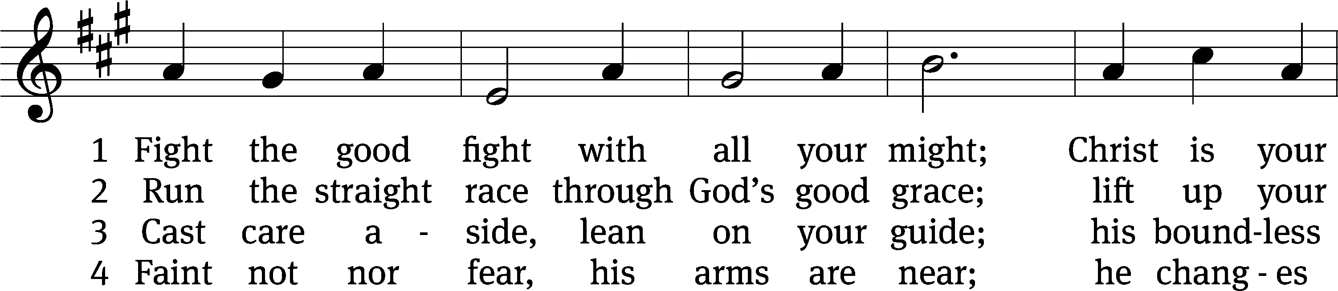
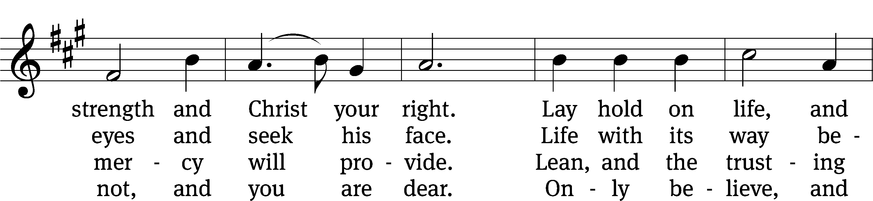
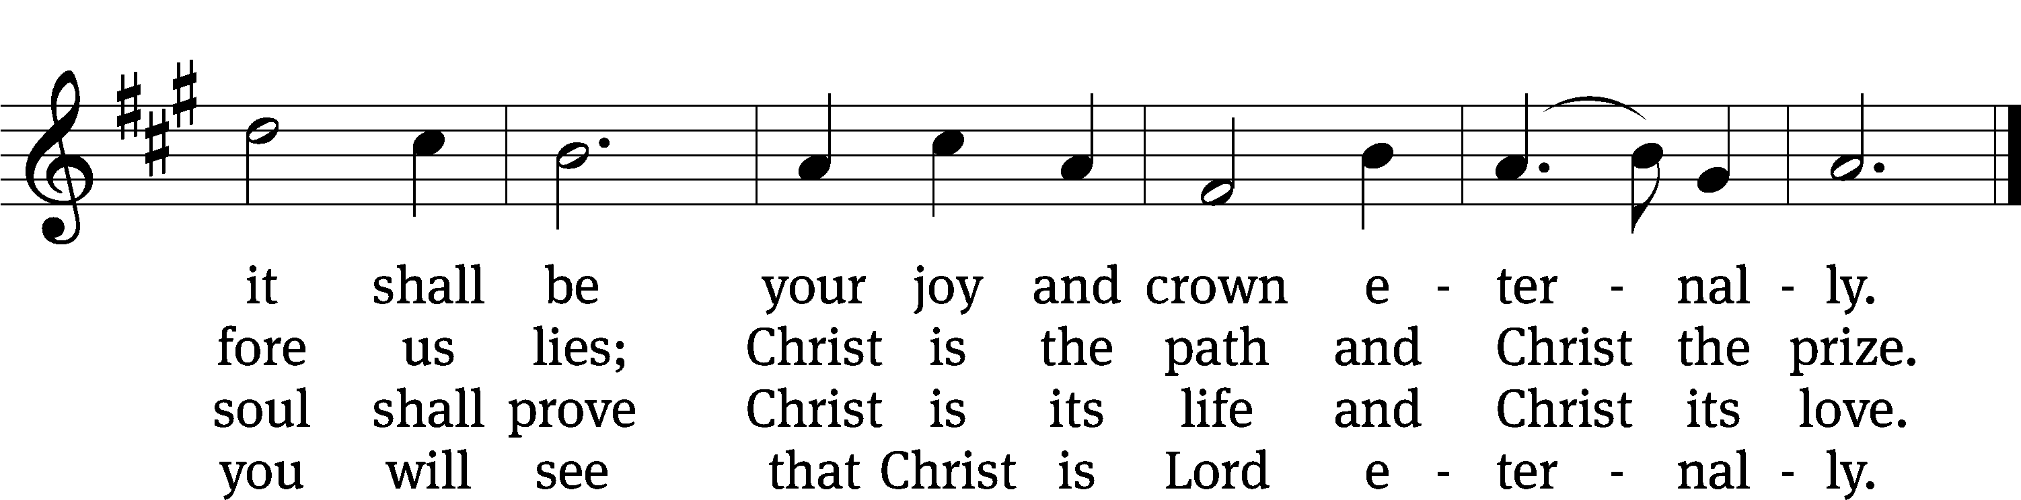
Text: John S. B. Monsell, 1811–1875, alt.
Tune: The Methodist Harmonist, New York, 1821
Text and tune: Public domain

Please stand, if you are able
Invocation
In the name of the Father and of the Son and of the Holy Spirit.
Amen.
Confession
If we claim to be without sin, we deceive ourselves and the truth is not in us.
If we confess our sins, God is faithful and just
and will forgive us our sins
and purify us from all unrighteousness.

Let us confess our sins to the Lord.
Holy God, gracious Father,
I am sinful by nature
and have sinned against you in my thoughts, words, and actions.
I have not loved you with my whole heart;
I have not loved others as I should.
I deserve your punishment both now and forever.
But Jesus, my Savior, paid for my sins
with his innocent suffering and death.
Trusting in him, I pray: God, have mercy on me, a sinner.

Our gracious Father in heaven has been merciful to us. He sent his only Son, Jesus Christ, who gave his life as the atoning sacrifice for the sins of the whole world. Therefore, as a called servant of Christ and by his authority, I forgive you all your sins in the name of the Father and of the Son and of the Holy Spirit.
Amen.

Lord, Have Mercy
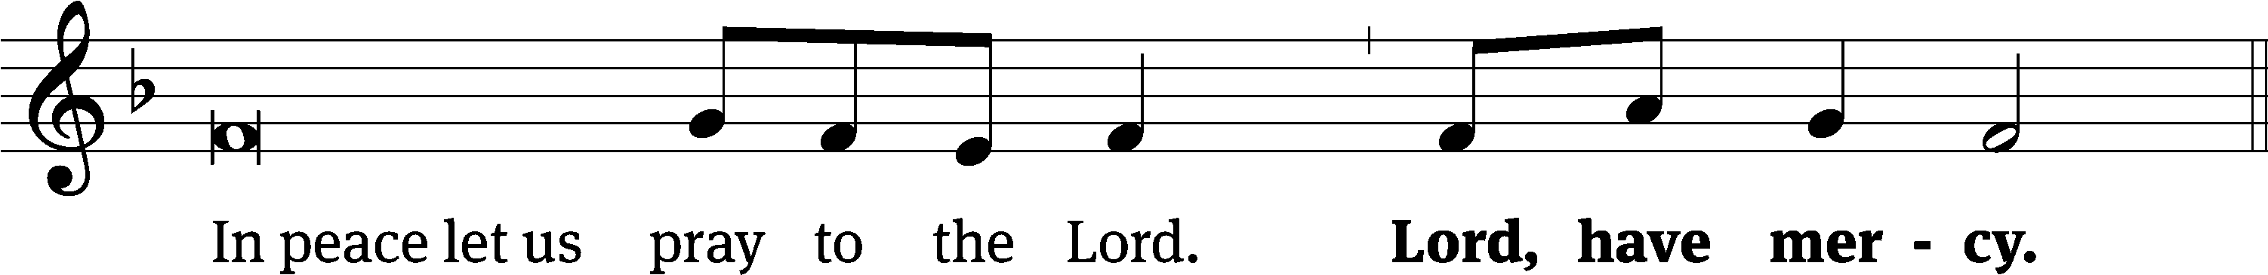
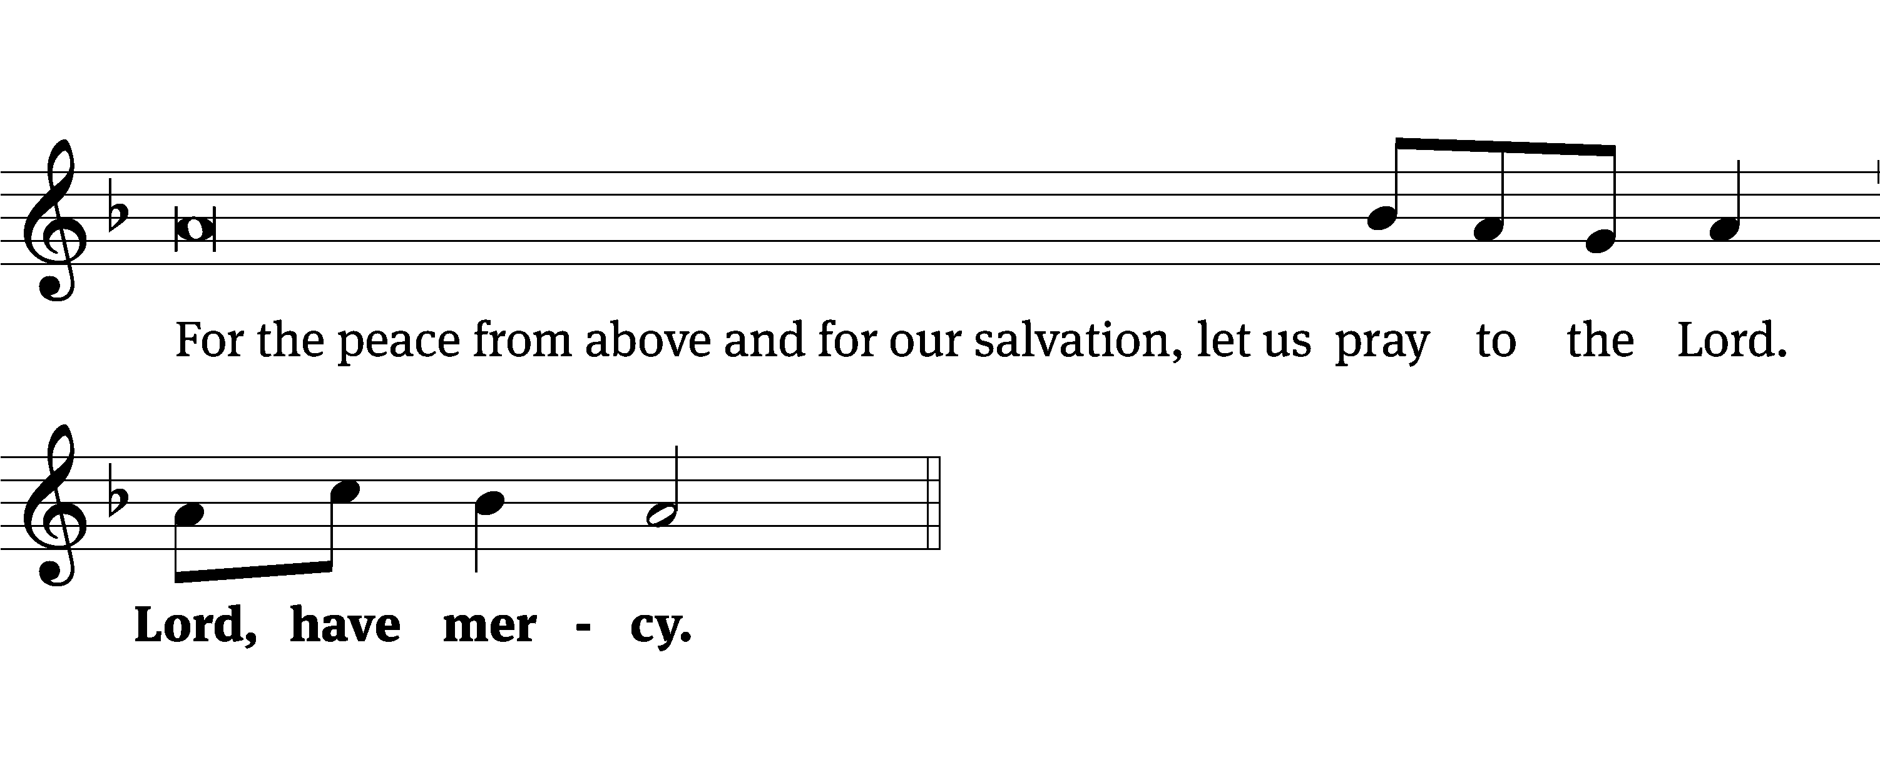
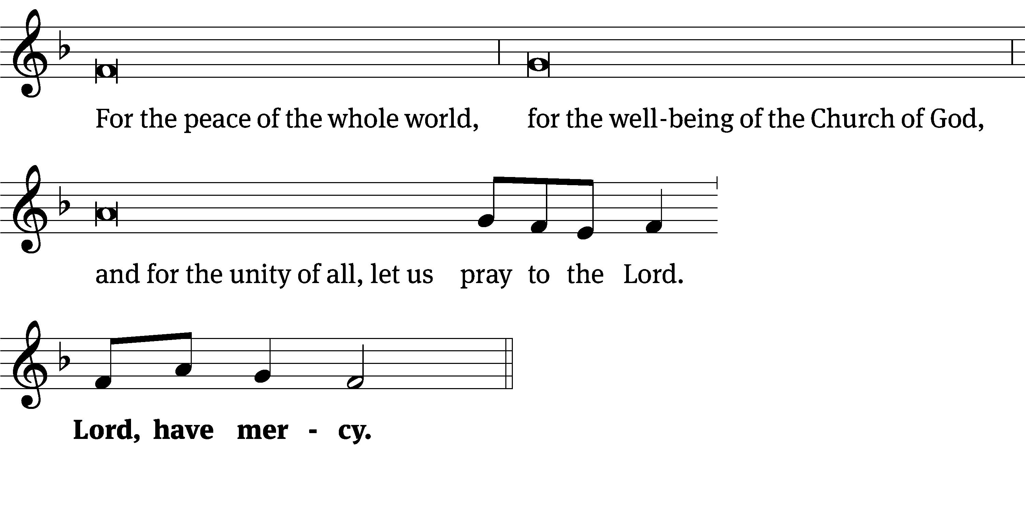
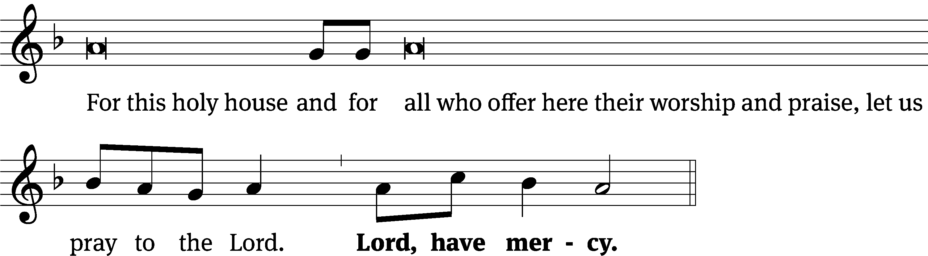
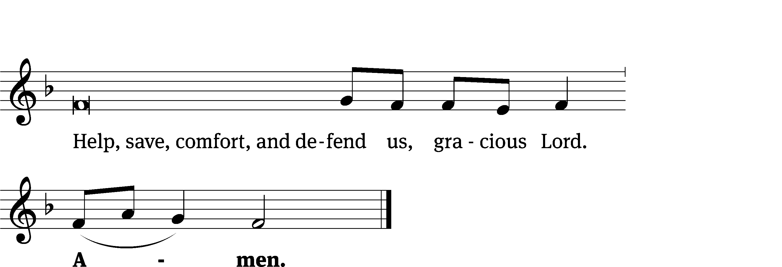
Tune: Kevin Becker
Tune: © 2021 Northwestern Publishing House. Used by permission: OneLicense no. 727703

Glory Be to God CW 157
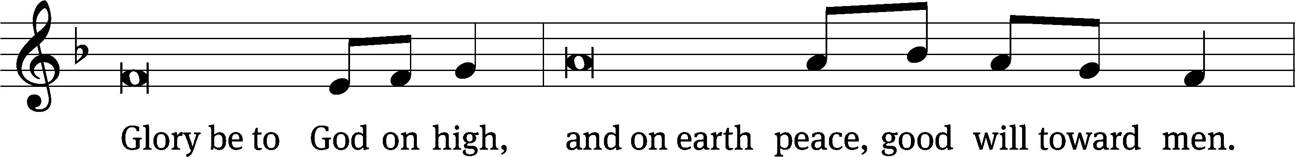
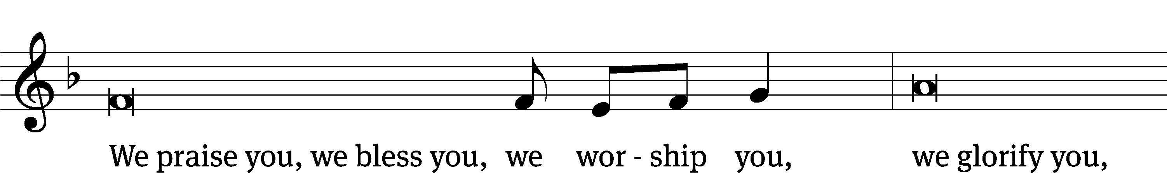
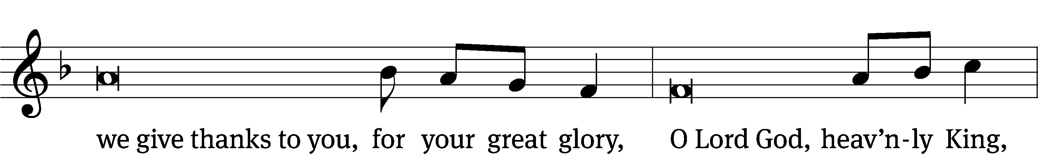
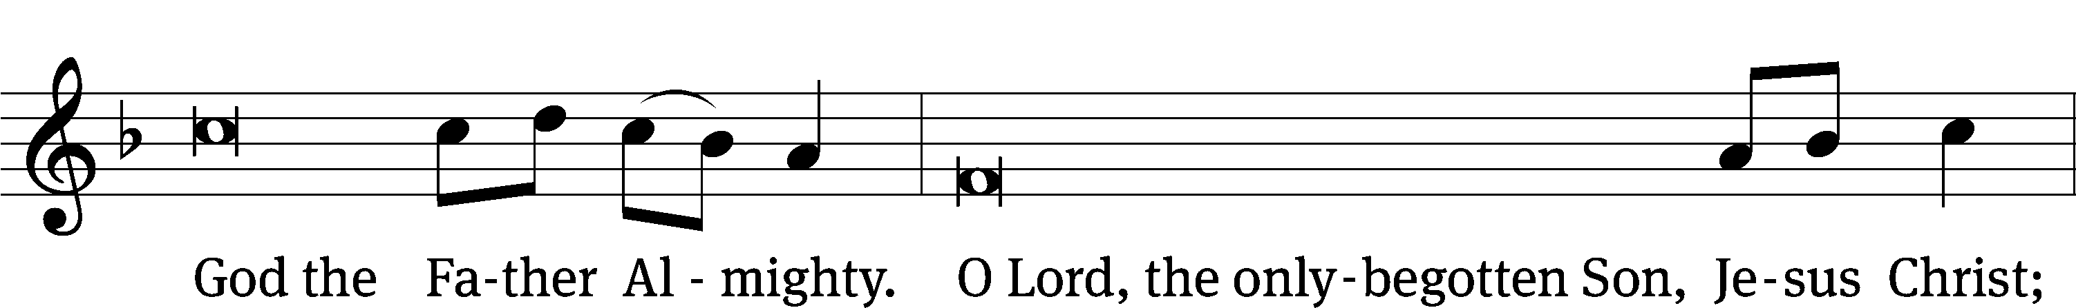
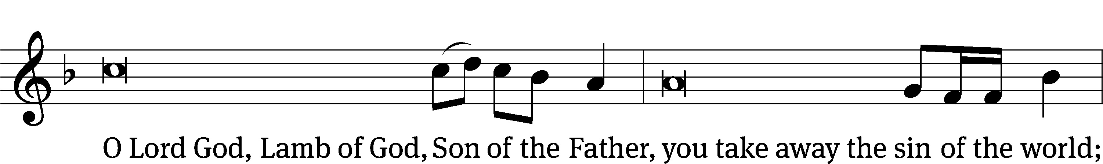
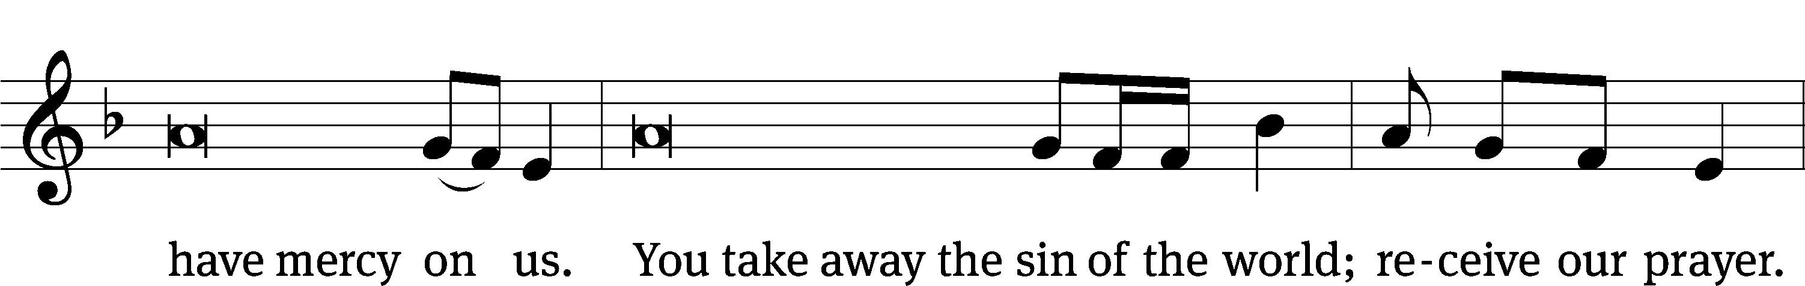
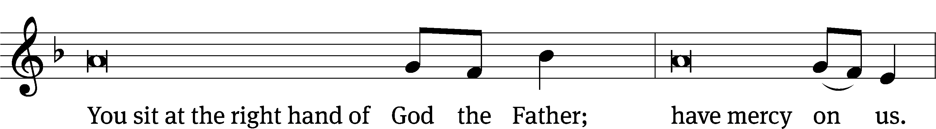
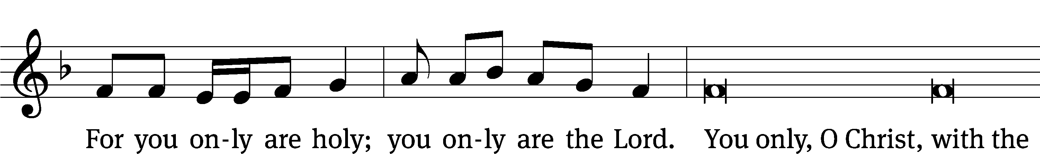
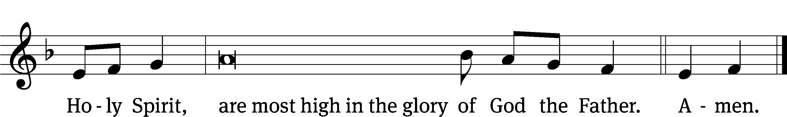

Tune: © 2021 Northwestern Publishing House. Used by permission: OneLicense no. 727703
The Lord be with you.
And also with you.
Prayer of the Day
Let us pray.

O God, because your abiding presence always goes with us, keep us aware of your daily mercies that we may live secure and content in your eternal love; through your Son, Jesus Christ our Lord, who lives and reigns with you and the Holy Spirit, one God, now and forever.

Amen.

Please be seated

First Reading Jeremiah 20:7-13

⁷ You persuaded me, Lord, and I agreed to it. You are stronger than I am, and you won out.
I have become a laughingstock all day long, and everyone is mocking me.
⁸ Whenever I speak, I cry out. I cry out, “Violence and destruction!”
But the word of the Lord has brought scorn on me. I am mocked all day long.
⁹ If I say, “I will not mention him or speak in his name anymore,”
then there is a burning fire in my heart, shut up in my bones,
and I am weary of holding it in. I cannot!
¹⁰ I hear many whispering, “Terror on every side!”
All my close friends, those who are watching for my fall, say,
“Denounce him! Let’s denounce him. Perhaps he can be pressured into making a mistake.
Then we will have the upper hand against him, and we will take our revenge on him.”
¹¹ But the Lord is with me like a terrifying warrior.
So my persecutors will stumble, and they will not gain the upper hand.
They will be put to shame completely, because they have not been successful.
Their eternal disgrace will never be forgotten.
¹² Lord of Armies, you test the righteous. You see the heart and the mind.
Let me see your vengeance on them, for I have laid out my case before you.
¹³ Sing to the Lord! Praise the Lord,
for he has delivered the life of the needy from the hand of the wicked.

The Word of the Lord.
Thanks be to God.
Psalm 23F My Shepherd Will Supply My Need Psalm 23F
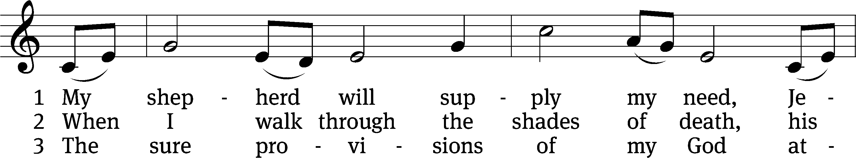
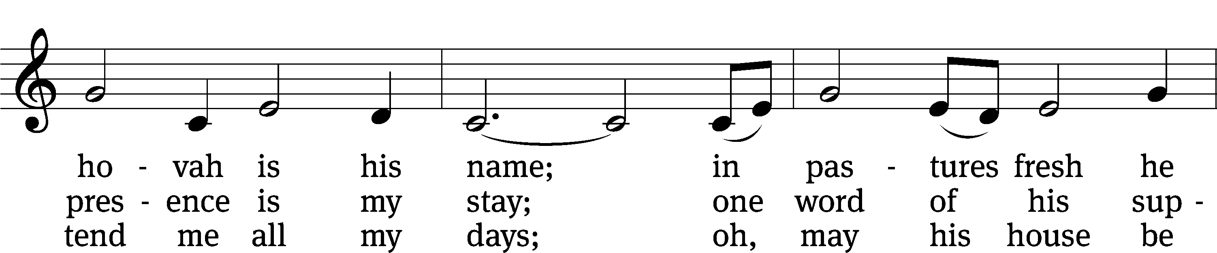
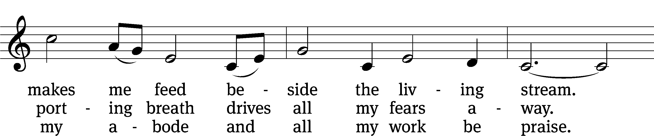
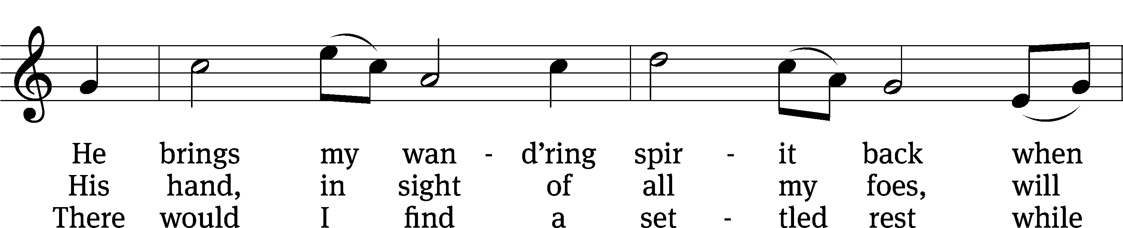
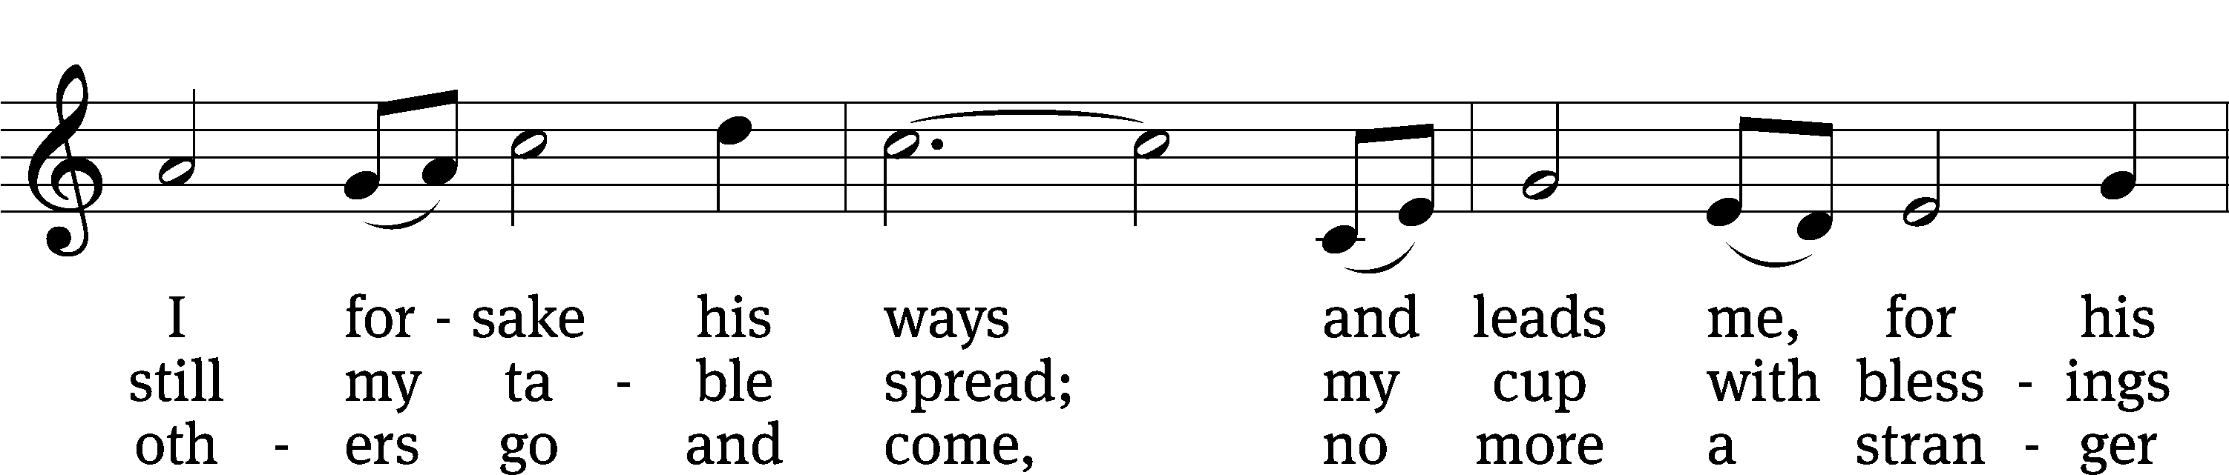
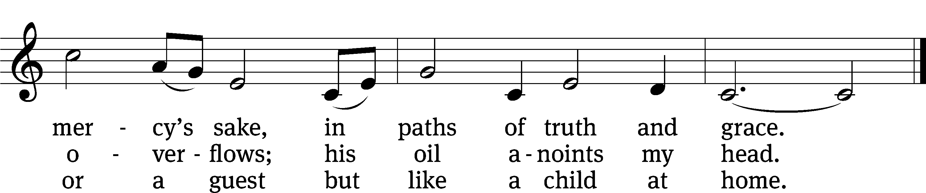
Text: Isaac Watts, alt.
Tune: Southern Harmony, 1835, ed. William Walker
Text and tune: Public domain

Second Reading 2 Timothy 4:1-8
¹ I solemnly charge you in the presence of God and Christ Jesus, who is going to judge the living and the dead, and in view of his appearing and his kingdom: ² Preach the word. Be ready whether it is convenient or not.^{[a]} Correct, rebuke, and encourage, with all patience and teaching.^{[b]} ³ For there will come a time when people will not put up with sound doctrine. Instead, because they have itching ears, they will accumulate for themselves teachers in line with their own desires. ⁴ They will also turn their ears away from the truth and will turn aside to myths.
⁵ As for you, keep a clear head in every situation. Bear hardship. Do the work of an evangelist. Fulfill your ministry.
⁶ You see, I am already being poured out like a drink offering, and the time of my departure has come. ⁷ I have fought the good fight; I have finished the race; I have kept the faith. ⁸ From now on, there is reserved for me the crown of righteousness. The Lord, the righteous Judge, will give it to me on that day, and not only to me but also to everyone who loved his appearing.
The Word of the Lord.
Thanks be to God.

Please stand, if you are able
Gospel Acclamation 2 Corinthians 12:9
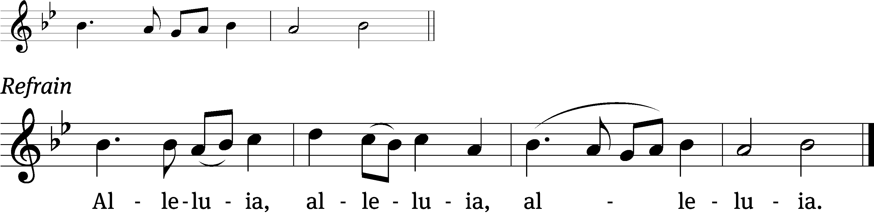
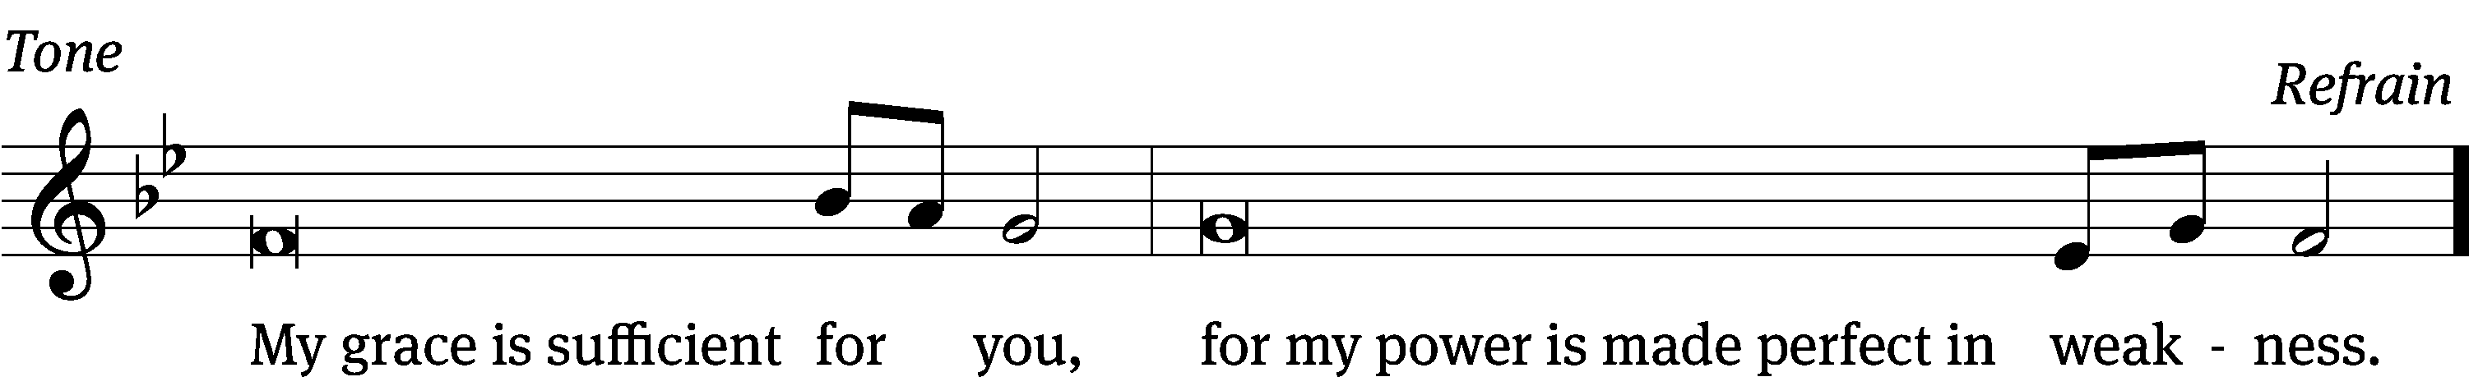
Tune: © 2021 Northwestern Publishing House. Used by permission: OneLicense no. 727703

Gospel Matthew 10:5a, 21-33
⁵ Jesus sent these twelve out and commanded them, ²¹ “Brother will hand over his brother to death, and a father will do the same with his child. Children will rise up against parents and have them put to death. ²² You will be hated by all people because of my name, but whoever endures to the end will be saved. ²³ And when they persecute you in one town, flee to the next. Amen I tell you: You will not finish going through the cities of Israel before the Son of Man comes.
²⁴ “A disciple is not above his teacher, nor is a servant above his master. ²⁵ It is enough for the disciple to be like his teacher and the servant like his master. If the master of the house was called Beelzebul, how much more the members of his household!
²⁶ “So do not be afraid of them, because there is nothing concealed that will not be revealed, and nothing hidden that will not be made known. ²⁷ What I tell you in the dark, speak in the daylight; and what you hear whispered in your ear, proclaim from the housetops. ²⁸ Do not fear those who kill the body but cannot kill the soul. Rather, fear the one who is able to destroy both soul and body in hell.
²⁹ “Are not two sparrows sold for a small coin? Yet not one of them will fall to the ground without the knowledge and consent of your Father. ³⁰ And even the hairs of your head are all numbered. ³¹ So do not be afraid. You are worth more than many sparrows.
³² “Everyone who confesses me before others, I will also confess before my Father who is in heaven. ³³ But whoever denies me before others, I will also deny before my Father who is in heaven.
The Gospel of the Lord.
Praise be to you, O Christ!

Please be seated

555 The Lord’s My Shepherd, I'll Not Want CW 555
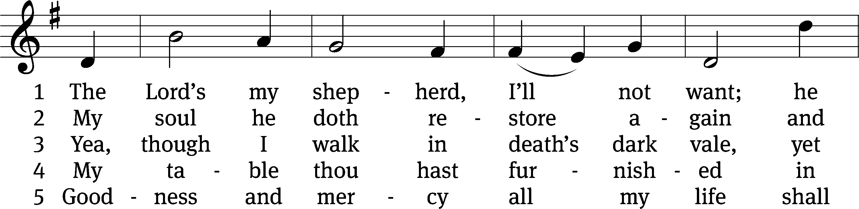
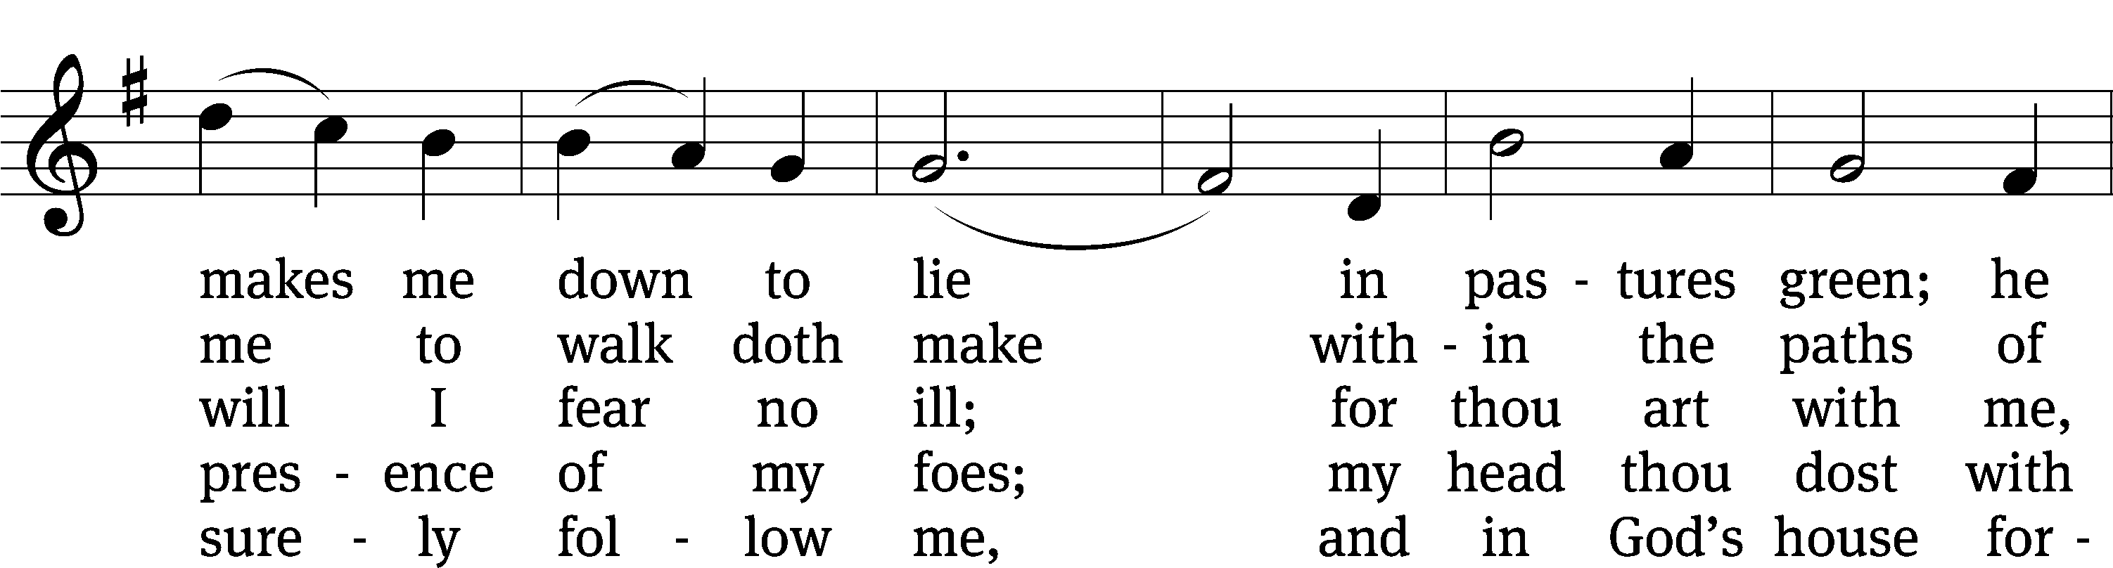
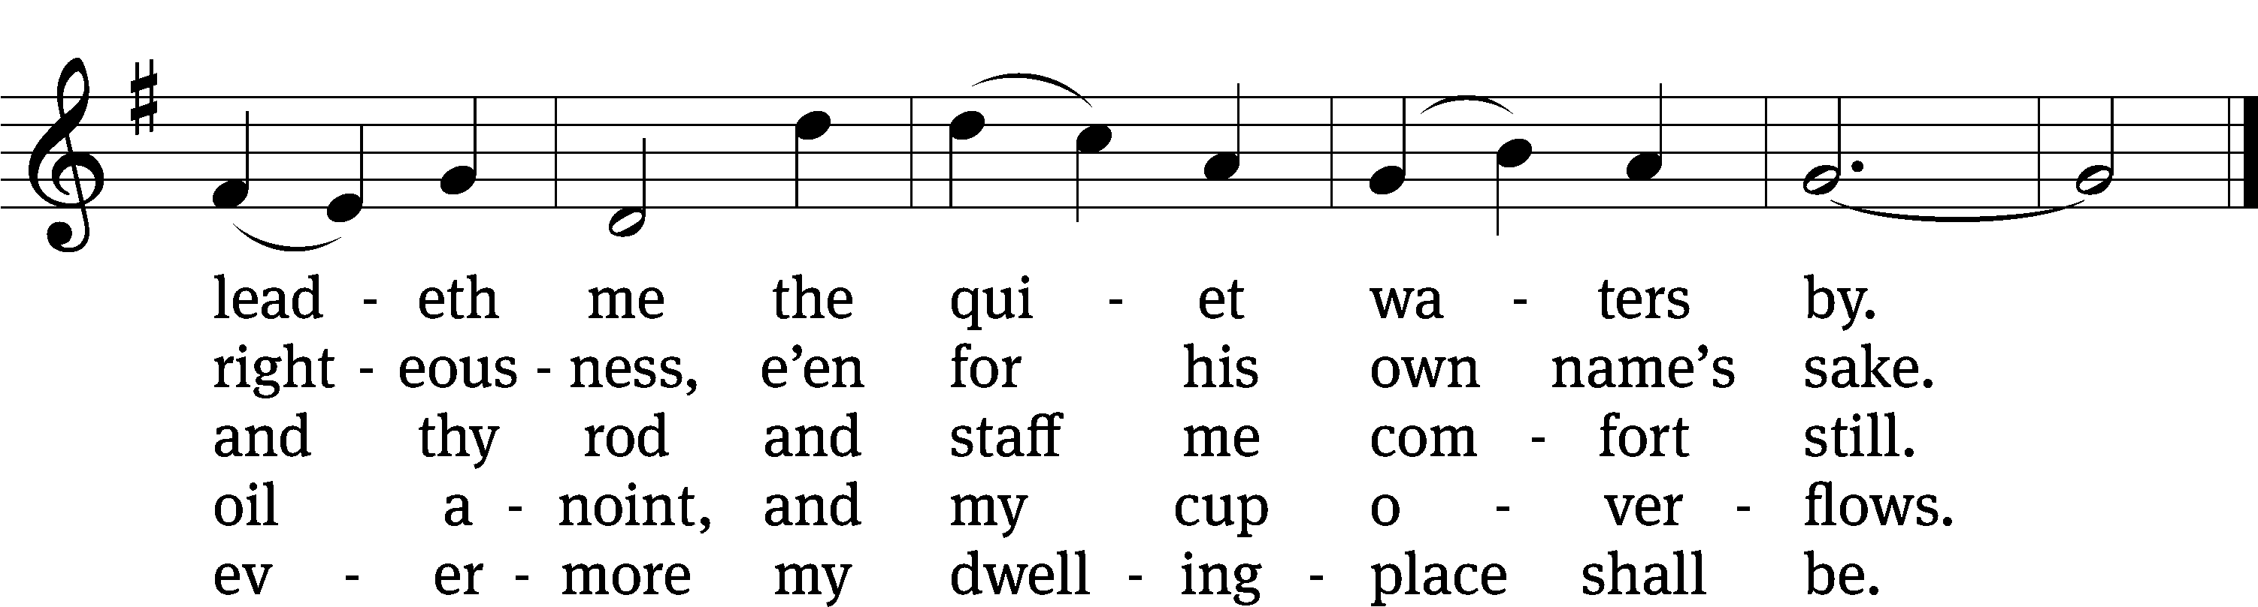
Text: The Psalms of David in Meeter, Edinburgh, 1650
Tune: William Gardiner, 1770–1853
Text and tune: Public domain

Sermon John 10:11-16
“Jesus Says, “I AM the Good Shepherd”

¹¹ “I am the Good Shepherd. The Good Shepherd lays down his life for the sheep. ¹² The hired man, who is not a shepherd, does not own the sheep. He sees the wolf coming, leaves the sheep, and runs away. Then the wolf attacks the sheep and scatters them. ¹³ Because he works for money, he does not care about the sheep.
¹⁴ “I am the Good Shepherd. I know my sheep and my sheep know me ¹⁵ (just as the Father knows me and I know the Father). And I lay down my life for the sheep. ¹⁶ I also have other sheep that are not of this sheep pen. I must bring them also, and they will listen to my voice. Then there will be one flock and one shepherd.

Please stand, if you are able
Apostles’ Creed
I believe in God, the Father Almighty,
maker of heaven and earth.

I believe in Jesus Christ, his only Son, our Lord,
who was conceived by the Holy Spirit,
born of the Virgin Mary,
suffered under Pontius Pilate,
was crucified, died, and was buried.
He descended into hell.
The third day he rose again from the dead.
He ascended into heaven
and is seated at the right hand of God the Father Almighty.
From there he will come to judge the living and the dead.

I believe in the Holy Spirit,
the holy Christian Church,
the communion of saints,
the forgiveness of sins,
the resurrection of the body,
and the life everlasting. Amen.

Prayer of the Church

Please be seated

823 Jesus, Priceless Treasure CW 823
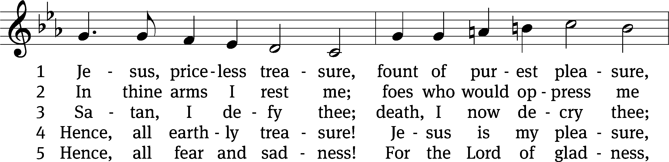
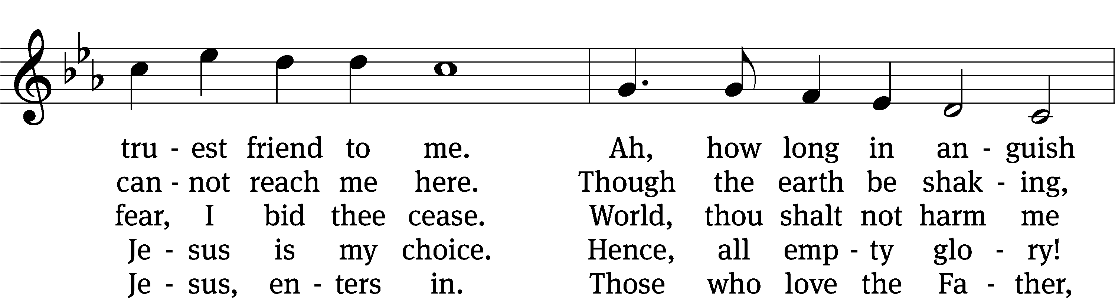
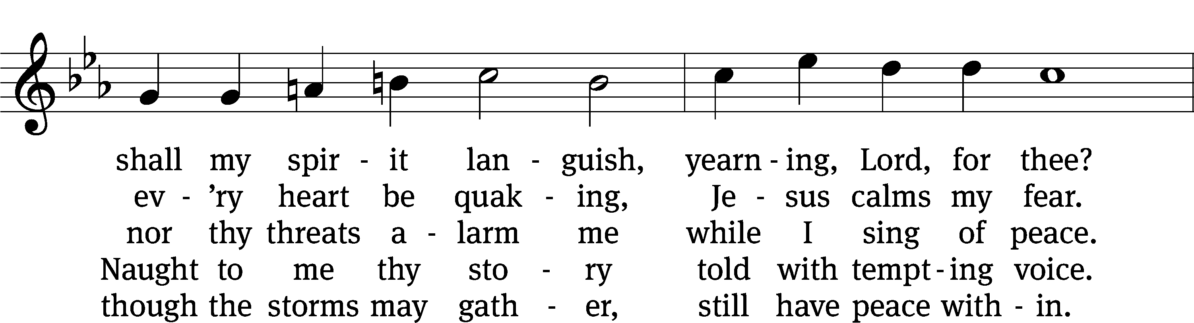
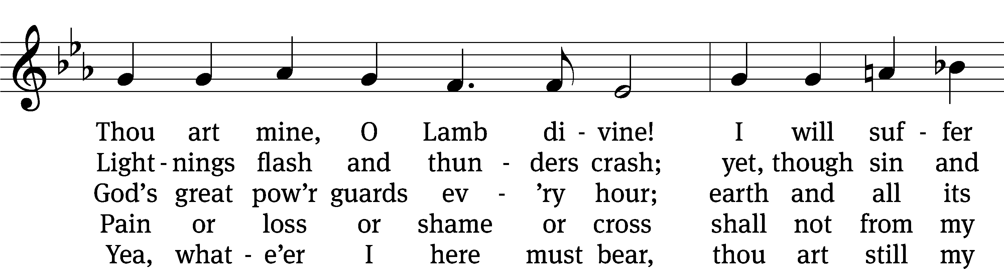
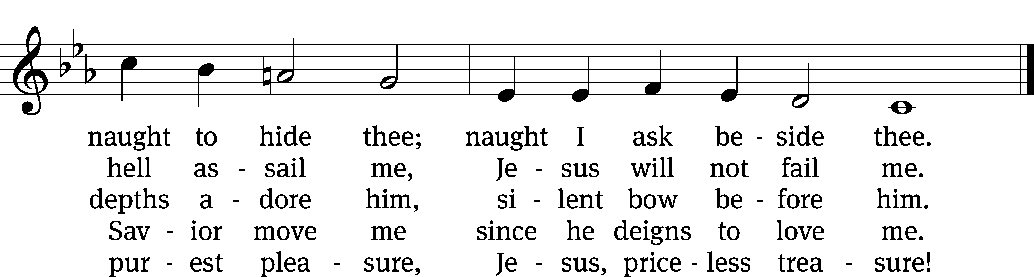
Text: Johann Franck, 1618–1677, abr.; (sts. 1–2, 4–5): tr. Catherine Winkworth, 1827–1878, alt.; (st. 3): tr. The Lutheran Hymnal, 1941
Tune: Johann Crüger, 1598–1662
Text and tune: Public domain
Please stand, if you are able

Prayer
Blessed Lord, you have given us your Holy Scriptures for our learning. May we so hear them, read, learn, and take them to heart that, being strengthened and comforted by your holy Word, we may cling to the blessed hope of everlasting life; through Jesus Christ our Lord, who lives and reigns with you and the Holy Spirit, one God, now and forever.
Amen.
Lord’s Prayer
Our Father, who art in heaven, hallowed be thy name, thy kingdom come, thy will be done on earth as it is in heaven. Give us this day our daily bread; and forgive us our trespasses, as we forgive those who trespass against us; and lead us not into temptation, but deliver us from evil. For thine is the kingdom and the power and the glory forever and ever. Amen.

Blessing
The Lord bless you and keep you.
The Lord make his face shine on you and be gracious to you.
The Lord look on you with favor and give you peace.
Amen.

Please be seated

621 Praise, My Soul, the King of Heaven CW 621
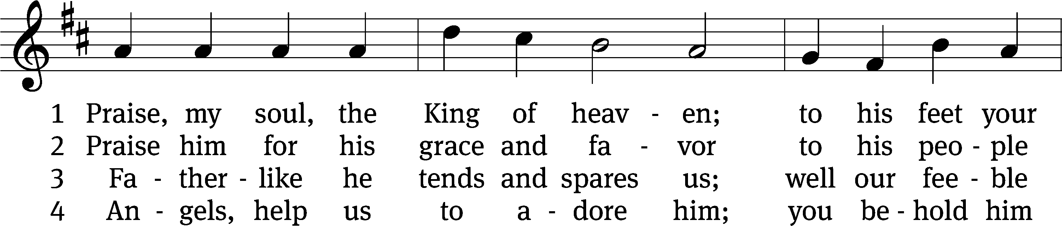
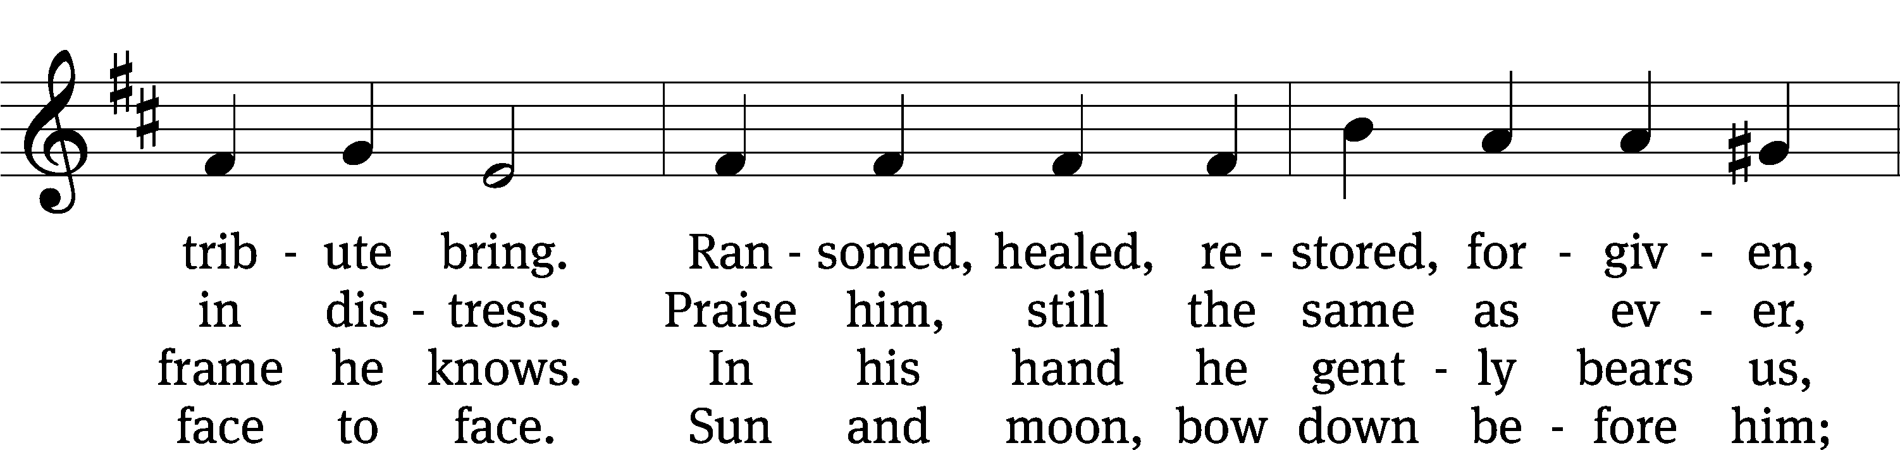
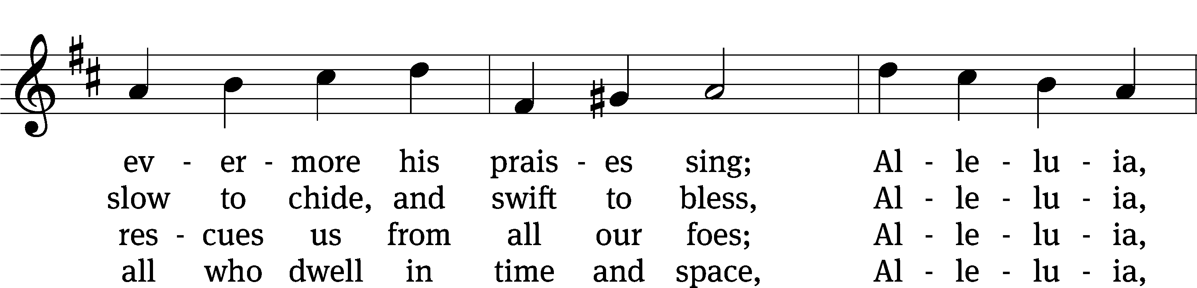
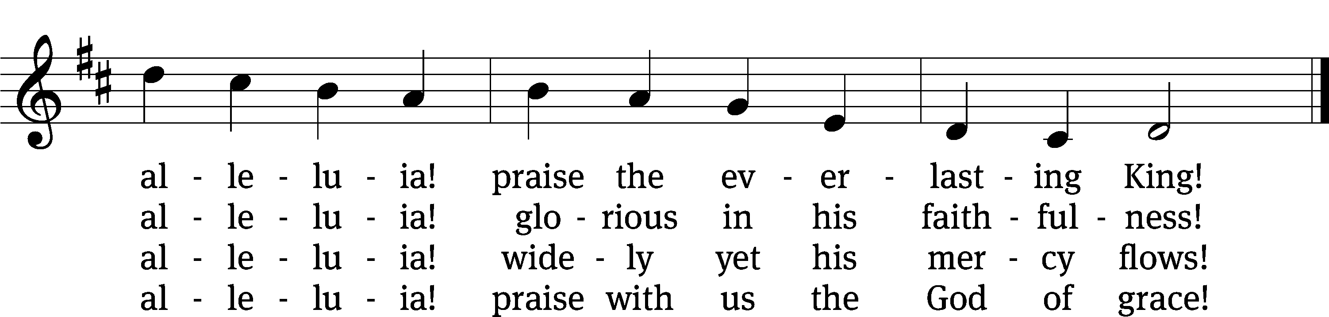
Text: Henry F. Lyte, 1793–1847
Tune: John Goss, 1800–1880
Text and tune: Public domain

Acknowledgments
Setting One from Christian Worship
Software distributed in partnership with Northwestern Publishing House.
Created by Christian Worship: Service Builder © 2022 Concordia Publishing House.

Serving in Worship
Officiant Pastor Natsis
Organist Ann Hoeft
Deacons (Thursday) Steve Hoeft and Jim Tice
(Sunday) Duane Mason and Robert Niethammer
Ushers (Thursday) Robert Newman and Henry Schneider
(Sunday) Dave Boswell and Jake Vershum
Altar Guild Diane Stevenson and Karen Tice
Videographer Rick Schneider

