the SECOND sunday
AFTER PENTECOST

TRINITY EVANGELICAL LUTHERAN CHURCH | Saline, Michigan
WELCOME TO WORSHIP June 16/19, 2022

Thank you for joining us in God’s house today! We cordially ask that our guests sign one of the guestbooks located at either the front or back entryways.

THANK OFFERING: Members of Trinity give their offering as an expression of love and thankfulness to the Lord and to help support the Lord’s work in our community and around the world. Visitors need not feel obligated to participate in this offering which supports our ministry.

Restrooms are located at the back of the upper level (the annex), and in the basement (down the back stairs of the sanctuary or annex). Handicap access is available, please ask an usher for assistance.

celebration of holy communion:
In His Word, God makes it clear that the Lord’s Supper is to be shared by people of a common proclamation of faith (1 Corinthians 11:26; 1 Corinthians 10:16-17). Without judging anyone’s hearts, we invite those who share in our confession by their membership in our congregation or another congregation of the Wisconsin Evangelical Lutheran Synod (WELS) or the Evangelical Lutheran Synod (ELS) and who are properly prepared (1 Corinthians 11;27-29) to receive the Sacrament. Page 295 in the front of Christian Worship provides a guide for preparation.

Guests, we would love to have you join us in communion fellowship in the future, and for that to be possible, we ask that you speak with one of the pastors so that we may speak with you on how that would be possible. We thank you for respecting the way we celebrate the Lord’s Supper in our congregations.

SERVICE OF WORD AND SACRAMENT

603 All Praise to God Who Reigns Above CW 603
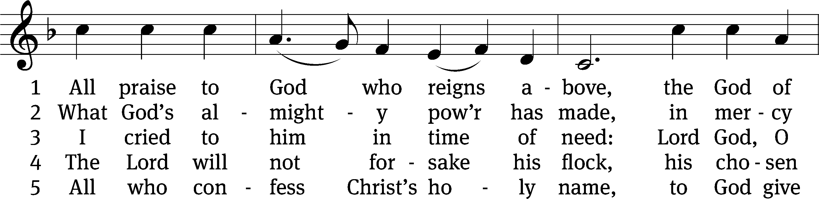
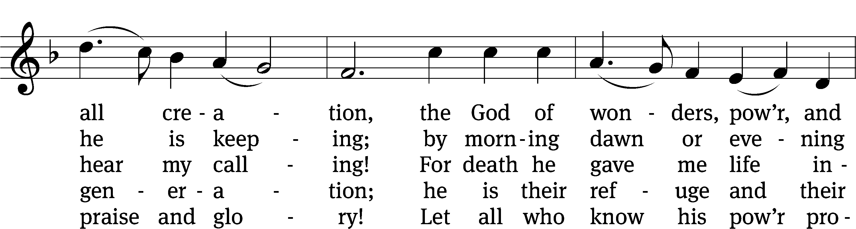
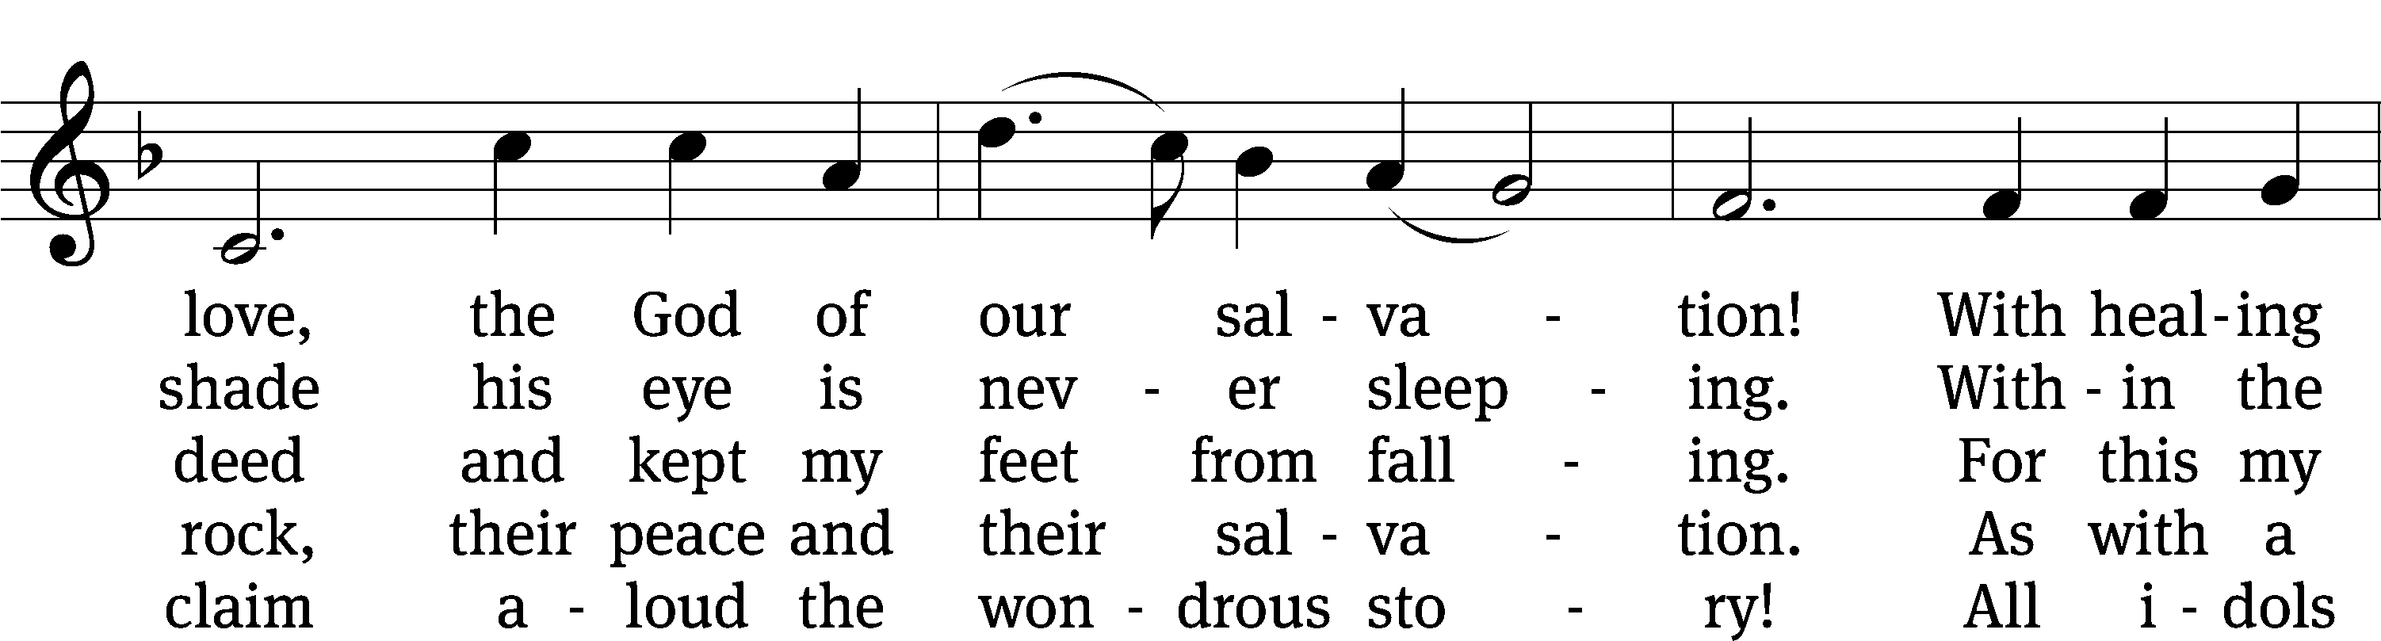
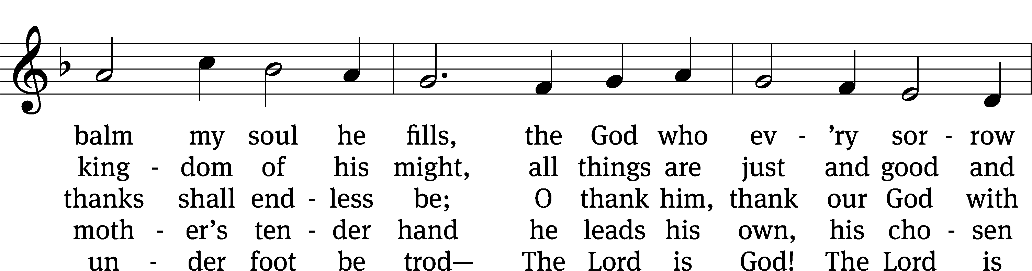
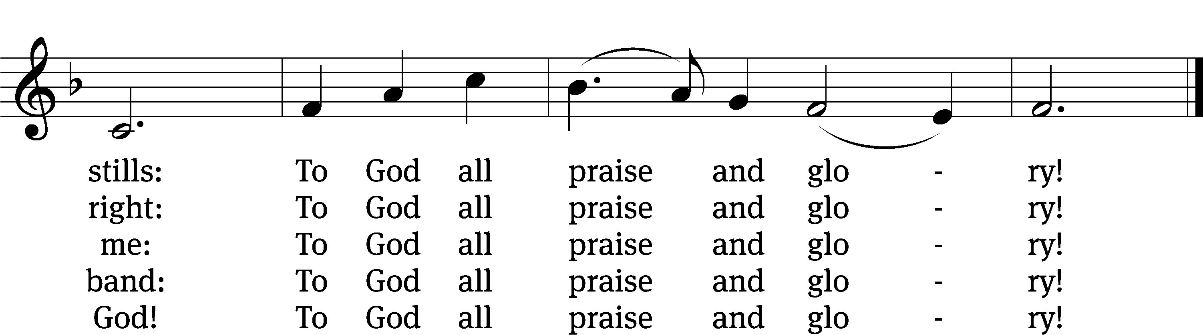
Text: tr. composite; Johann Jacob Schütz, 1640–1690, abr.
Tune: Trente quatre Pseaumes de David, Geneva, 1551, ed. Louis Bourgeois
Text and tune: Public domain
PLEASE STAND, IF YOU ARE ABLE

invocation

M: The grace of our Lord (+) Jesus Christ and the love of God and the fellowship of the Holy Spirit be with you.
C: And also with you.
CONFESSION OF SINS
M: God invites us to come into his presence and worship him with humble and penitent hearts. Therefore, let us acknowledge our sinfulness and ask him to forgive us.
C: Holy and merciful Father, I confess that I am by nature sinful, and that I have disobeyed you in my thoughts, words, and actions. I have done what is evil and failed to do what is good. For this I deserve your punishment both now and in eternity. But I am truly sorry for my sins, and trusting in my Savior Jesus Christ, I pray: Lord, have mercy on me, a sinner.
M: God, our heavenly Father, has been merciful to us and has given his only Son to be the atoning sacrifice for our sins. Therefore, as a called servant of Christ and by his authority, I forgive you all your sins in the name of the Father and of the Son (+) and of the Holy Spirit.
C: Amen.

PRAYER AND PRAISE

LORD, HAVE MERCY
Kyrie
M: For all that we need in life and for the wisdom to use all your gifts with gratitude and joy, hear our prayer, O Lord.

M: For the steadfast assurance that nothing can separate us from your love and for the courage to stand firm against the assaults of Satan and every evil, hear our prayer, O Christ.

M: For the well-being of your holy Church in all the world and for those who offer here their worship and praise, hear our prayer, O Lord.

M: Merciful God, maker and preserver of life, uphold us by your power and keep us in your tender care:

M: The works of the Lord are great and glorious; his name is worthy of praise.

Prayer of the day

M: Let us pray.
The minister says the Prayer of the Day.

PLEASE BE SEATED

The Word

first lesson iSAIAH 43:8-13
⁸ Bring out the people who are blind, though they have eyes,
and the people who are deaf, though they have ears.
⁹ Let all the nations be gathered together,
and let peoples be assembled.
Who among them has declared this?
Who has made known to us the former things?
Let them produce their witnesses to show that they were right,
so that people can hear and say, “This is truth.”
¹⁰ You are my witnesses, declares the Lord.
You are my servant, whom I have chosen,
so that you may know me and believe in me,
so that you will understand that I am he.
Before me no god was formed,
and after me there will not be another.
¹¹ I, yes I, am the Lord,
and apart from me there is no savior.
¹² I myself declared it.
I brought salvation, and I announced it.
It was not some strange god among you.
You are my witnesses, declares the Lord,
and I am God.
¹³ Indeed, from the first day, I am he.
There is no one who can deliver anyone from my hand.
I act, and who can reverse it?
66C Let All the Earth Sing Out Psalm 66C
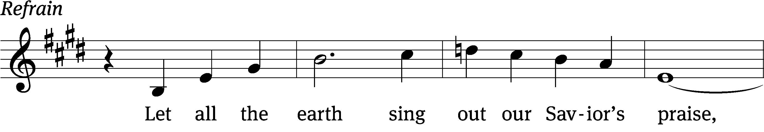
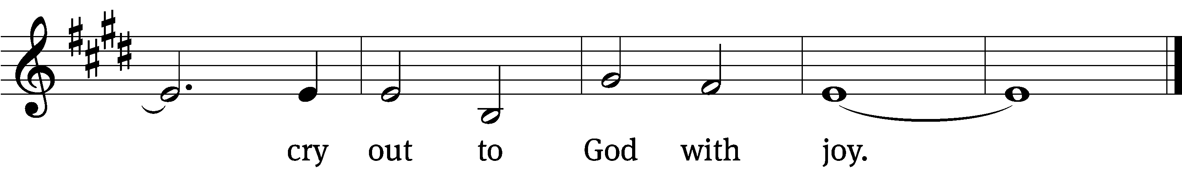

Shout for joy to God, / all the earth!
Sing the glory of his name; make his praise / glorious.
Praise our God, all / peoples,
let the sound of his / praise be heard;
he has pre- / served our lives
and kept our feet from / slipping. Refrain

Come and hear, all you who / fear God;
let me tell you what he has / done for me.
If I had cherished sin / in my heart,
the Lord would not have / listened;
but God has surely / listened
and has / heard my prayer.
Glory be to the Father and / to the Son
and to the Holy / Spirit,
as it was in the be- / ginning,
is now, and will be forever. / Amen. Refrain
Tune: David Haas
Text and setting: © 2021 Northwestern Publishing House. Used by permission: OneLicense no. 727703
Tune: © 1997 GIA Publications, Inc. Used by permission: OneLicense no. 727703

second lesson 2 TIMOTHY 1:3-10
³ I thank God, whom I serve with a clean conscience as my ancestors did, as I constantly remember you in my prayers night and day. ⁴ When I remember your tears, I long to see you, so that I may be filled with joy. ⁵ I remember your sincere faith, which first lived in your grandmother Lois and your mother Eunice, and I am convinced that it also lives in you.
⁶ For this reason I am reminding you to fan into flame the gift of God, which is in you through the laying on of my hands. ⁷ For God did not give us a timid spirit, but a spirit of power and love and sound judgment. ⁸ So do not be ashamed of the testimony about our Lord or of me his prisoner. Instead, join with me in suffering for the gospel while relying on the power of God. ⁹ He saved us and called us with a holy calling, not because of our works, but because of his own purpose and grace. This grace was given to us in Christ Jesus before time began, ¹⁰ and it has now been revealed through the appearance of our Savior Christ Jesus, who abolished death and brought life and immortality to light through the gospel.

PLEASE STAND, IF YOU ARE ABLE

VERSE OF THE DAY

GOSPEL LUKE 8:26-39
²⁶ They sailed down to the region of the Gerasenes, which is across from Galilee. ²⁷ When Jesus stepped ashore, a man from the town met him. He was possessed by demons and for a long time had not worn any clothes. He did not live in a house but in the tombs. ²⁸ When he saw Jesus, he cried out, fell down before him, and said with a loud voice, “What do I have to do with you, Jesus, Son of the Most High God? I beg you, don’t torment me!” ²⁹ For Jesus had commanded the unclean spirit to come out of the man. In fact, the unclean spirit had seized him many times. He was kept under guard, and although he was bound with chains and shackles, he would break the restraints and was driven by the demon into deserted places.
³⁰ Jesus asked him, “What is your name?” He said, “Legion,” because many demons had gone into him. ³¹ They were begging Jesus that he would not order them to go into the abyss. ³² A herd of many pigs was feeding there on the mountain. The demons begged Jesus to let them go into the pigs, and he gave them permission. ³³ The demons went out of the man and entered the pigs, and the herd rushed down the steep bank into the lake and drowned.
³⁴ When those who were feeding the pigs saw what happened, they ran away and reported it in the town and in the countryside. ³⁵ People went out to see what had happened. They came to Jesus and found the man from whom the demons had gone out, sitting at Jesus’ feet. He was clothed and in his right mind, and the people were afraid. ³⁶ Those who saw it told them how the demon-possessed man was saved. ³⁷ The whole crowd of people from the surrounding country of the Gerasenes asked Jesus to leave them, because they were gripped with great fear.
As Jesus got into the boat and started back, ³⁸ the man from whom the demons had gone out begged to be with him. But Jesus sent him away, saying, ³⁹ “Return to your home and tell how much God has done for you.” Then he went through the whole town proclaiming what Jesus had done for him.

M: This is the Gospel of the Lord.

PLEASE BE SEATED
484 Oh, That I Had a Thousand Voices CW 484
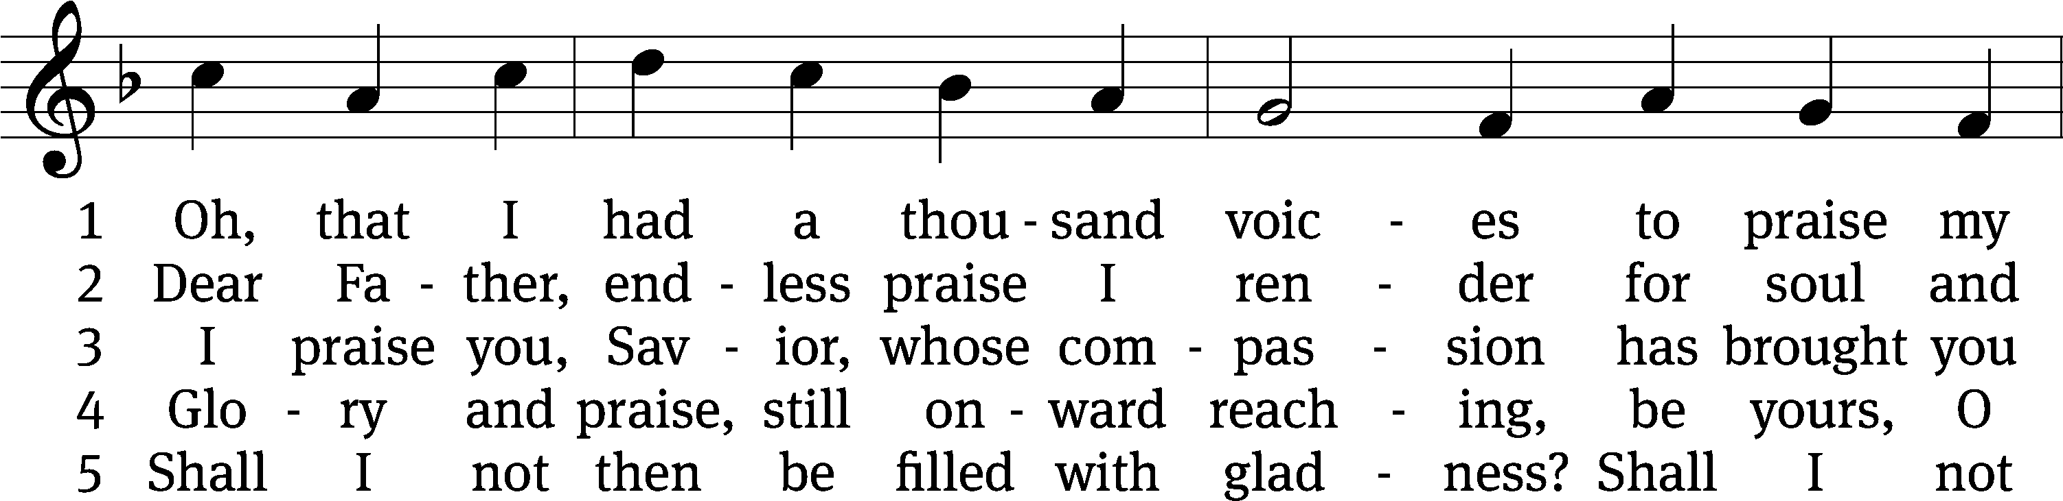
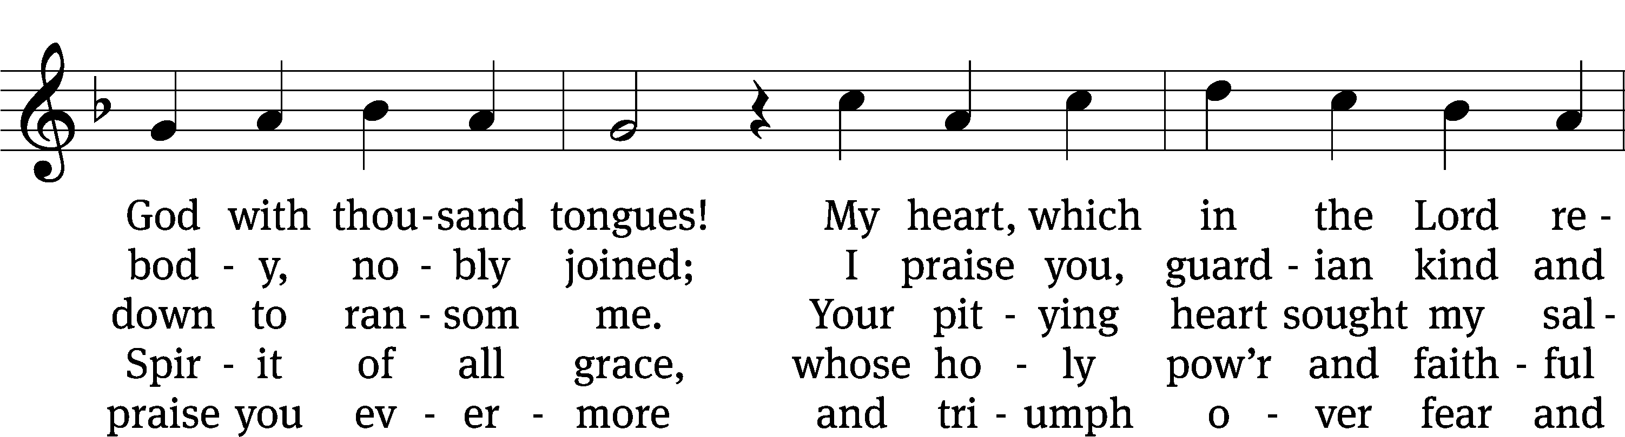
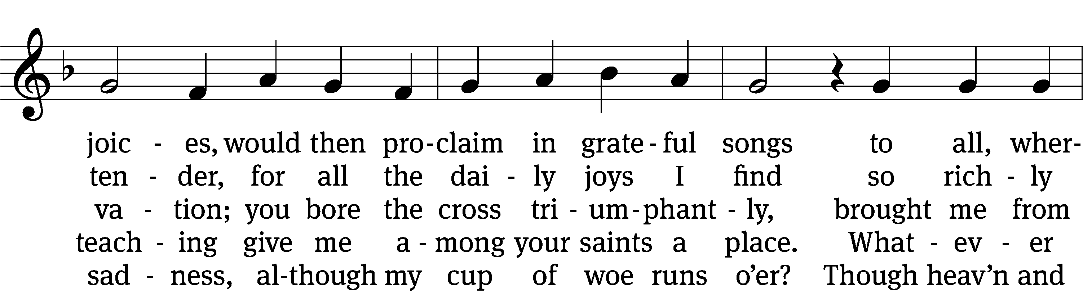
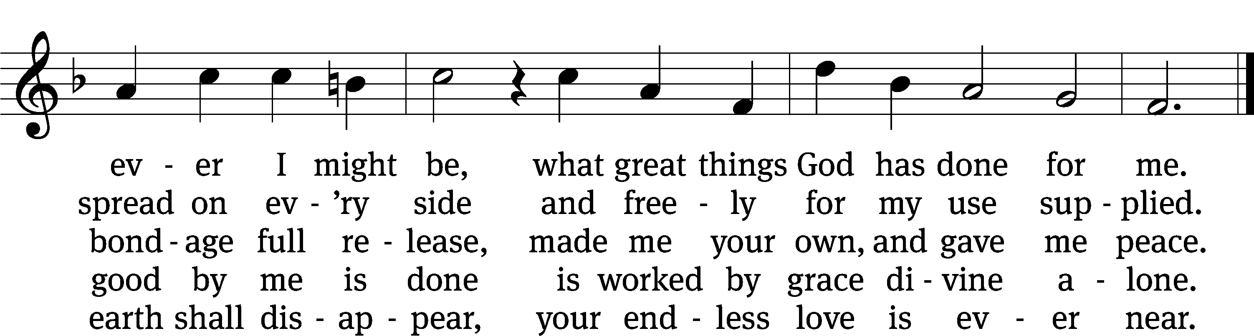
Text: tr. The Lutheran Hymnal, 1941, alt.; Johann Mentzer, 1658–1734, abr.
Tune: Johann B. König, 1691–1758
Text: © 1941 Concordia Publishing House. Used by permission: OneLicense no. 727703
Tune: Public domain

Sermon Numbers 6:24-26

“The Lord bless you and keep you.

The Lord make his face shine on you and be gracious top you.

The Lord look on you with favor and give you peace.”
“More than a Mystery”

please stand, if you are able

nicene creed
We believe in one God, the Father, the Almighty, maker of heaven and earth, of all that is, seen and unseen.
We believe in one Lord, Jesus Christ, the only Son of God, eternally begotten of the Father, God from God, Light from Light, true God from true God, begotten, not made, of one being with the Father. Through him all things were made. For us and for our salvation, he came down from heaven, was incarnate of the Holy Spirit and the virgin Mary, and became truly human. For our sake he was crucified under Pontius Pilate. He suffered death and was buried. On the third day he rose again in accordance with the Scriptures. He ascended into heaven and is seated at the right hand of the Father. He will come again in glory to judge the living and the dead, and his kingdom will have no end.
We believe in the Holy Spirit, the Lord, the giver of life, who proceeds from the Father and the Son, who in unity with the Father and the Son is worshiped and glorified, who has spoken through the prophets. We believe in one holy Christian and apostolic Church. We acknowledge one baptism for the forgiveness of sins. We look for the resurrection of the dead and the life of the world to come. Amen.

PLEASE BE SEATED

offertory

PLEASE STAND, IF YOU ARE ABLE

prayer of the church

lord’s prayer

C: Our Father, who art in heaven,
hallowed be thy name,
thy kingdom come,
thy will be done
on earth as it is in heaven.
Give us this day our daily bread;
and forgive us our trespasses,
as we forgive those
who trespass against us;
and lead us not into temptation,
but deliver us from evil.
For thine is the kingdom
and the power and the glory
forever and ever. Amen.

The Sacrament of Holy Communion
Trinity Lutheran Church follows the historic Christian practice of close communion. We ask that only members of Trinity or one of our sister congregations partake of the sacrament. If you are not a member, please see the note about Holy Communion in the beginning of the Worship Folder.

M: The Lord be with you.

M: Lift up your hearts.

M: Let us give thanks to the Lord our God.

M: Praise to the God and Father of our Lord Jesus Christ! In love he has blessed us with every spiritual blessing. He sends the Holy Spirit to testify that we are his children and to strengthen us when we are weak. Now have come the salvation and the power and the kingdom of our God and the authority of his Christ. To him who sits on the throne and to the Lamb be praise and thanks and honor and glory for ever and ever:

Holy, Holy, Holy

Words of institution
M: Our Lord Jesus Christ, on the night he was betrayed, took bread; and when he had given thanks, he broke it and gave it to his disciples, saying: “Take and eat. This is my ✙ body, which is given for you. Do this in remembrance of me.”
Then he took the cup, gave thanks, and gave it to them, saying, “Drink from it all of you; this is my ✙ blood of the new covenant, which is poured out for you for the forgiveness of sins. Do this, whenever you drink it, in remembrance of me.”
The peace of the Lord be with you always.

O CHRIST, LAMB OF GOD

PLEASE BE SEATED
DISTRIBUTION HYMN
675 At the Lamb’s High Feast We Sing CW 675
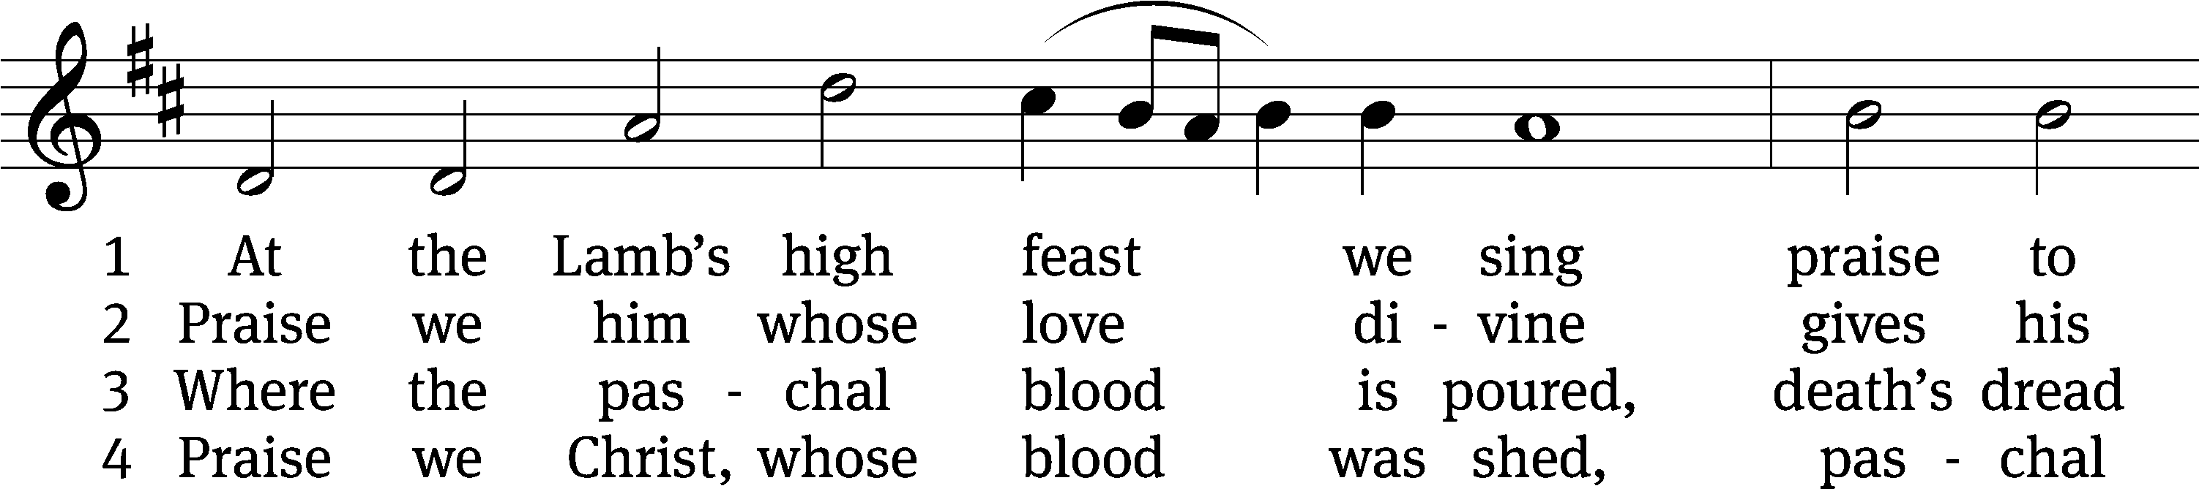
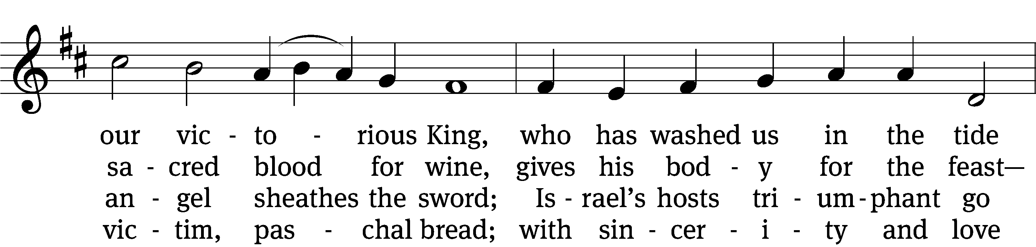
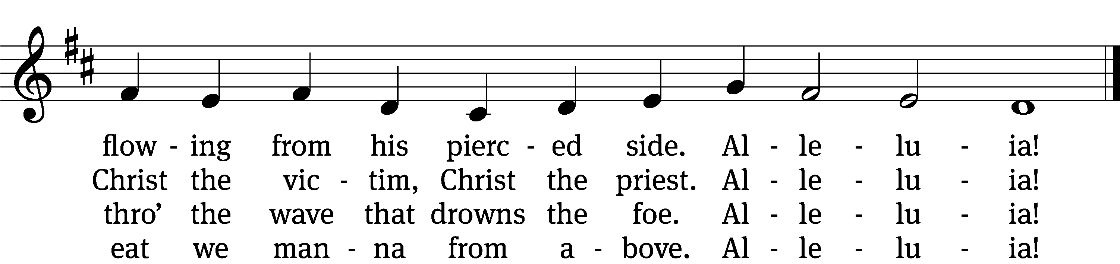

5 Mighty Victim from the sky,
hell’s fierce pow’rs beneath you lie.
You have conquered in the fight,
you have brought us life and light.
Alleluia!

6 Now no more can death appall,
now no more the grave enthrall;
you have opened paradise,
and your saints in you shall rise.
Alleluia!

7 Easter triumph, Easter joy!
This alone can sin destroy;
from sin’s pow’r, Lord, set us free,
newborn souls in you to be.
Alleluia!

8 Father, who the crown shall give,
Savior, by whose death we live,
Spirit, guide through all our days,
Three in One, your name we praise.
Alleluia!
Text: tr. Robert Campbell, 1814–1868, alt.; Latin, c. 4th–10th cent., alt. 17th cent.
Tune: Kirchengeseng, Ivancice, 1566
Text and tune: Public domain

THANKSGIVING

PLEASE STAND, IF YOU ARE ABLE

M: Hear the prayer of your people, O Lord, that the lips which have praised you here may glorify you in the world, that the eyes which have seen the coming of your Son may long for his coming again, and that all who have received in his true body and blood the pledge of your forgiveness may be restored to live a new and holy life, through Jesus Christ, our Lord, who lives and reigns with you and the Holy Spirit, one God, now and forever.

M: Brothers and sisters, go in peace. Live in harmony with one another.
Serve the Lord with gladness.

The Lord bless you and keep you.
The Lord make his face shine on you and be gracious to you.
The Lord look on you with favor and (+) give you peace.

PLEASE BE SEATED

746 I Love to Tell the Story CW 746 sts. 1, Ref, 2–3
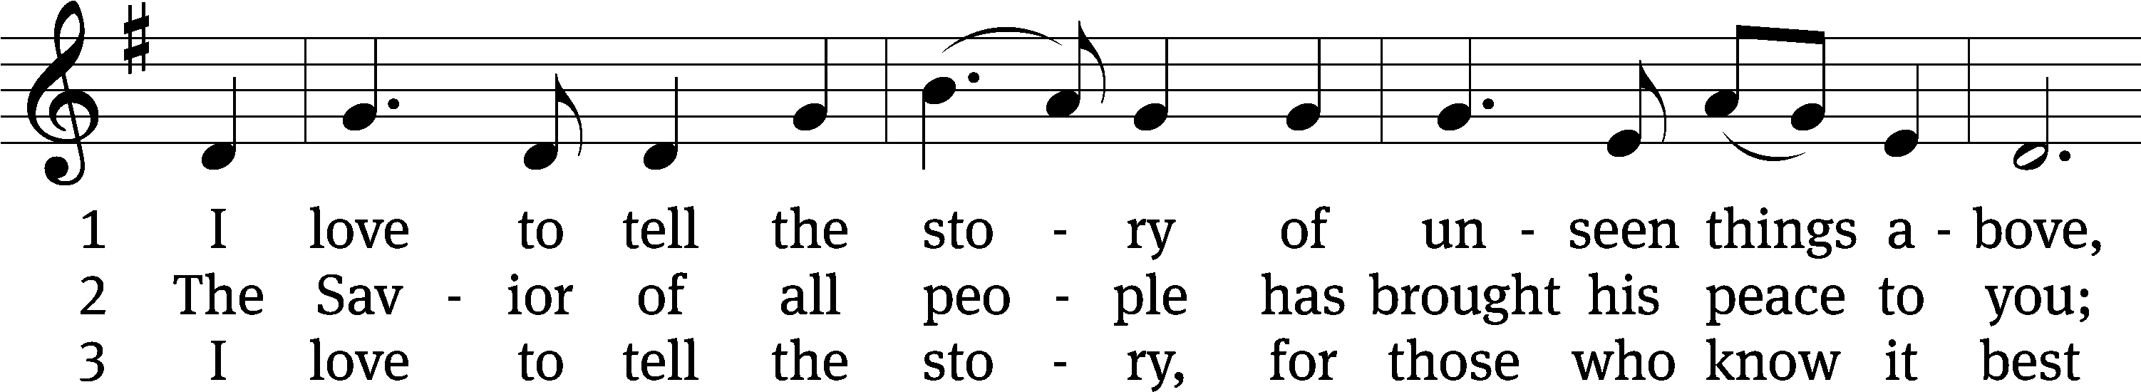
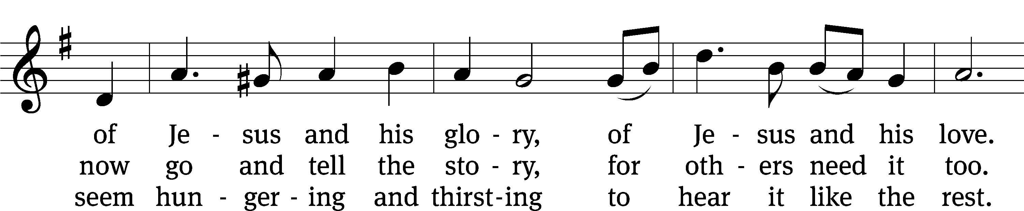
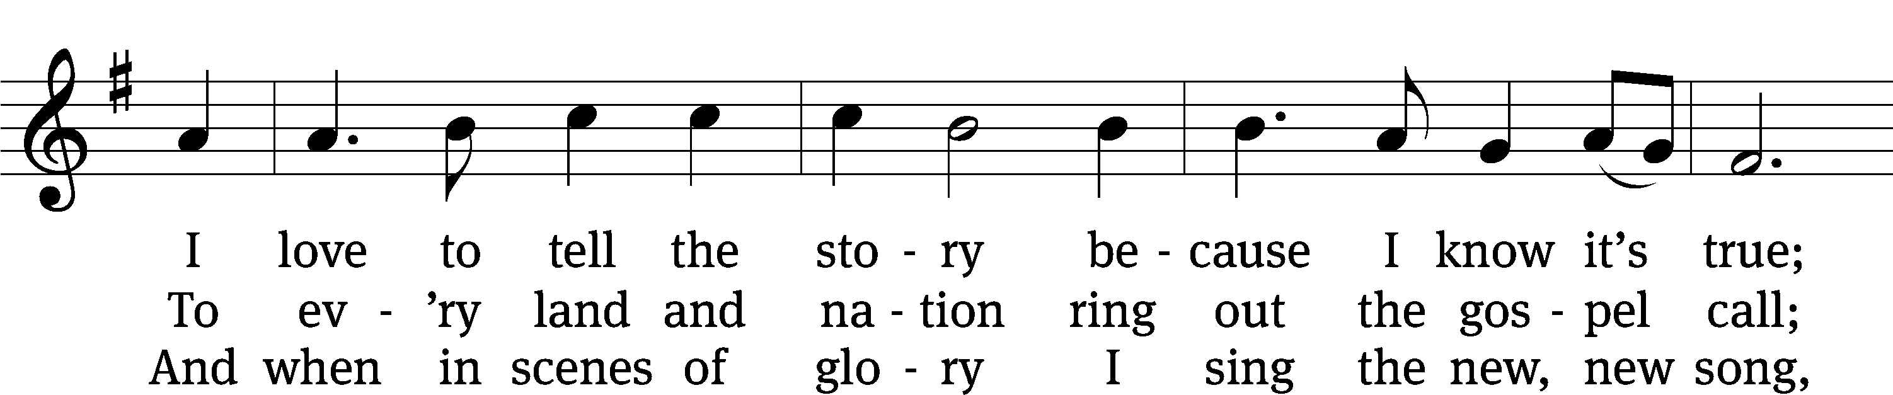
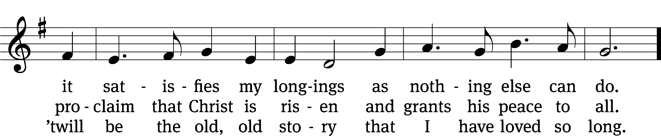
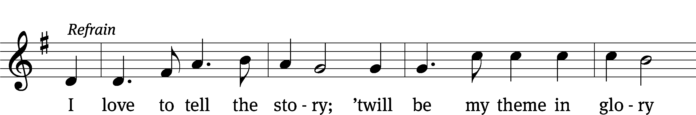
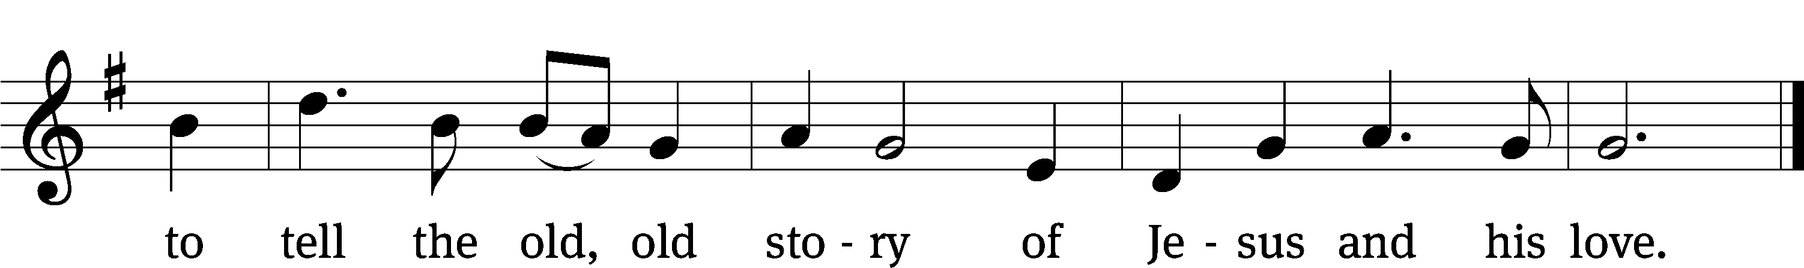
Text (sts. 1–3): Katherine Hankey, 1834–1911, verses, abr., alt.; (Ref): William G. Fischer, 1835–1912, refrain
Text and tune: Public domain

Serving In Worship

Officiant Pastor Natsis
Organist Ann Hoeft
Deacons (Thursday) Dave Frey and Jim Tice
(Sunday) Jeff Neuburger and Ed Wheeler
Ushers (Thursday) Robert Newman and Henry Schneider
(Sunday) Ed Sala and Al Whitley
Altar Guild Esther Gross and Diane Stevenson
Videographer Rick Schneider

Copyright information
Service of Word and Sacrament: Christian Worship. © 1993 Northwestern Publishing House. All rights reserved. Reprinted under ONE LICENSE #A-727703 and CCLI #1151741/ CSPL126093
Words and Music: All rights reserved. Reprinted/Podcast/Streamed with permission under ONE LICENSE #A-727703 and CCLI #1151741/CSPL126093

