THE Second SUNDAY
after pentecost
tRINITY EVANGELICAL LUTHERAN CHURCH | Saline, Michigan
June 8/11, 2023

WELCOME TO WORSHIP

Thank you for joining us in God’s house today! We cordially ask that our Guests with us this morning sign one of the guestbooks located at either the front or back entryways.

THANK OFFERING: Members of Trinity give their offering as an expression of love and thankfulness to the Lord and to help support the Lord’s work in our community and around the world. Visitors need not feel obligated to participate in this offering which supports our ministry.

Restrooms are located at the back of the upper level (the annex), and in the basement (down the back stairs of the sanctuary or annex). Handicap access is available, please ask an usher for assistance.

Young Families / Toddler Bags – We are GLAD YOU BROUGHT YOUR CHILDREN to our worship service. Jesus said: “Let the little children come to me and do not hinder them, for the kingdom of God belongs to such as these.” We know that having little children in church can be a challenge, but DO NOT WORRY about it. Many of your fellow worshippers have been in your shoes and are just happy you brought your children with you. For your convenience, we have reserved the back rows of seating for parents with small children. These areas provide more flexibility for your family, as well as, easy access to move downstairs if necessary. A closed-circuit TV system allows families to continue participating in the service while downstairs. Pre-school toddler bags and children’s bulletins are available for their enjoyment. Ask an usher for one to use during the service and please return the toddler bag afterwards.

SERVICE of the word
658 With All My Heart I Praise You, Lord CW 658
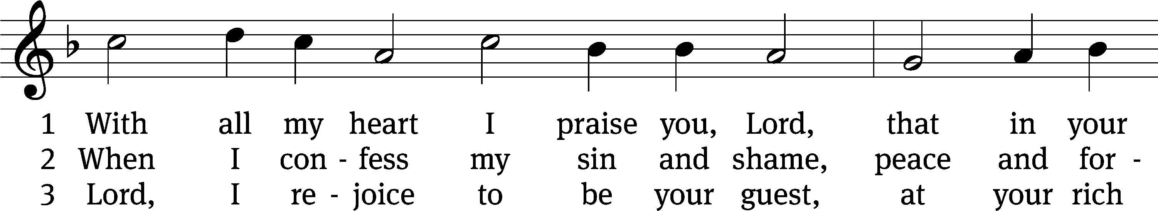
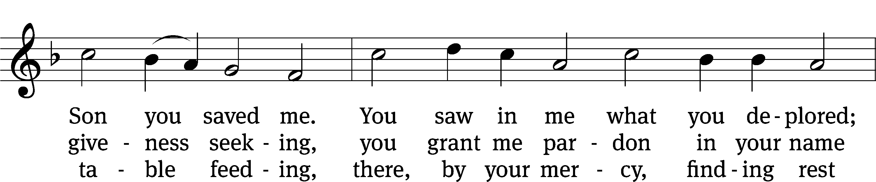
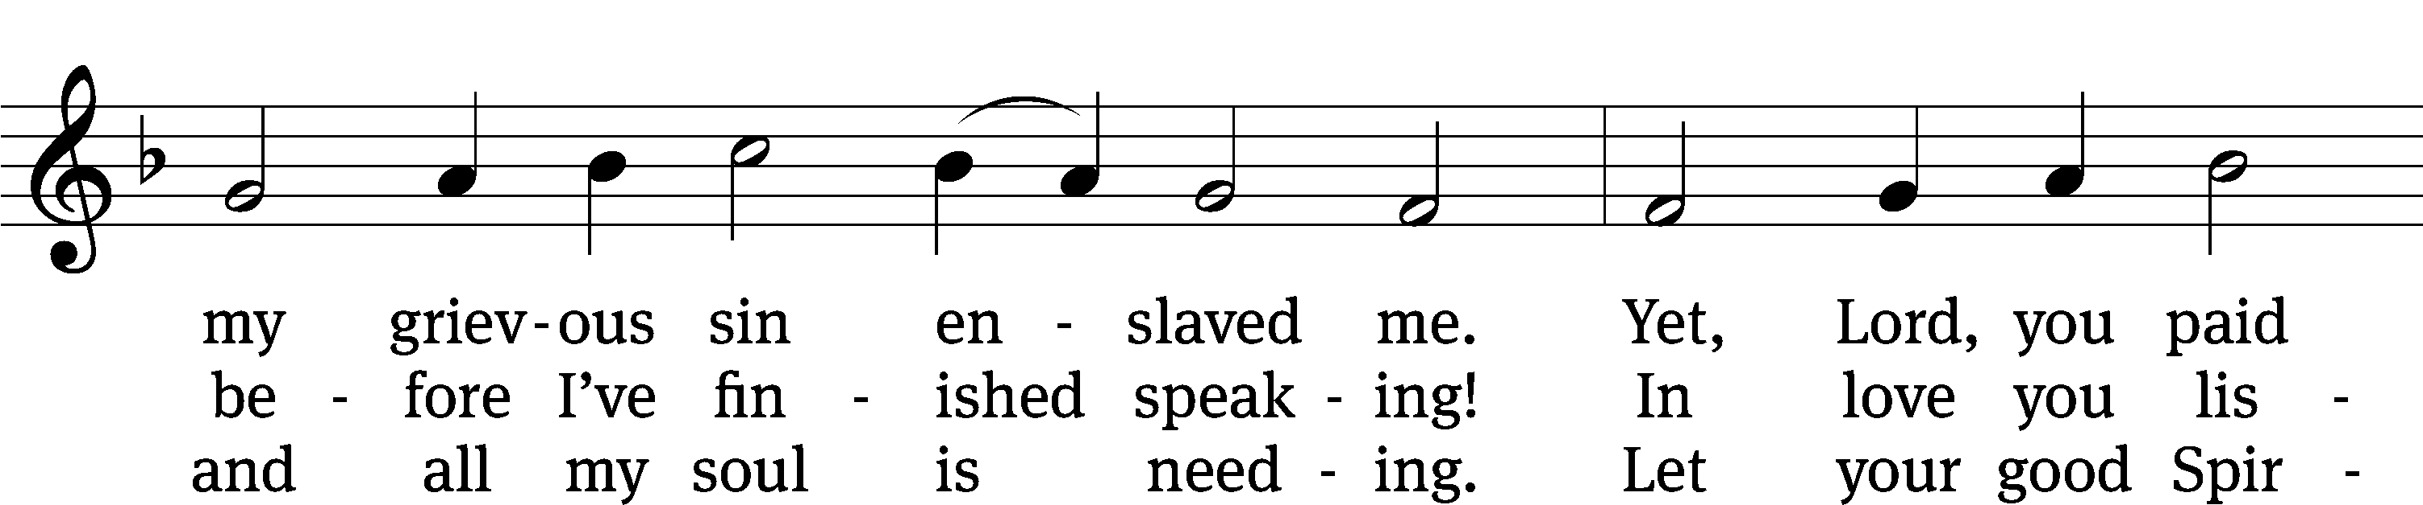
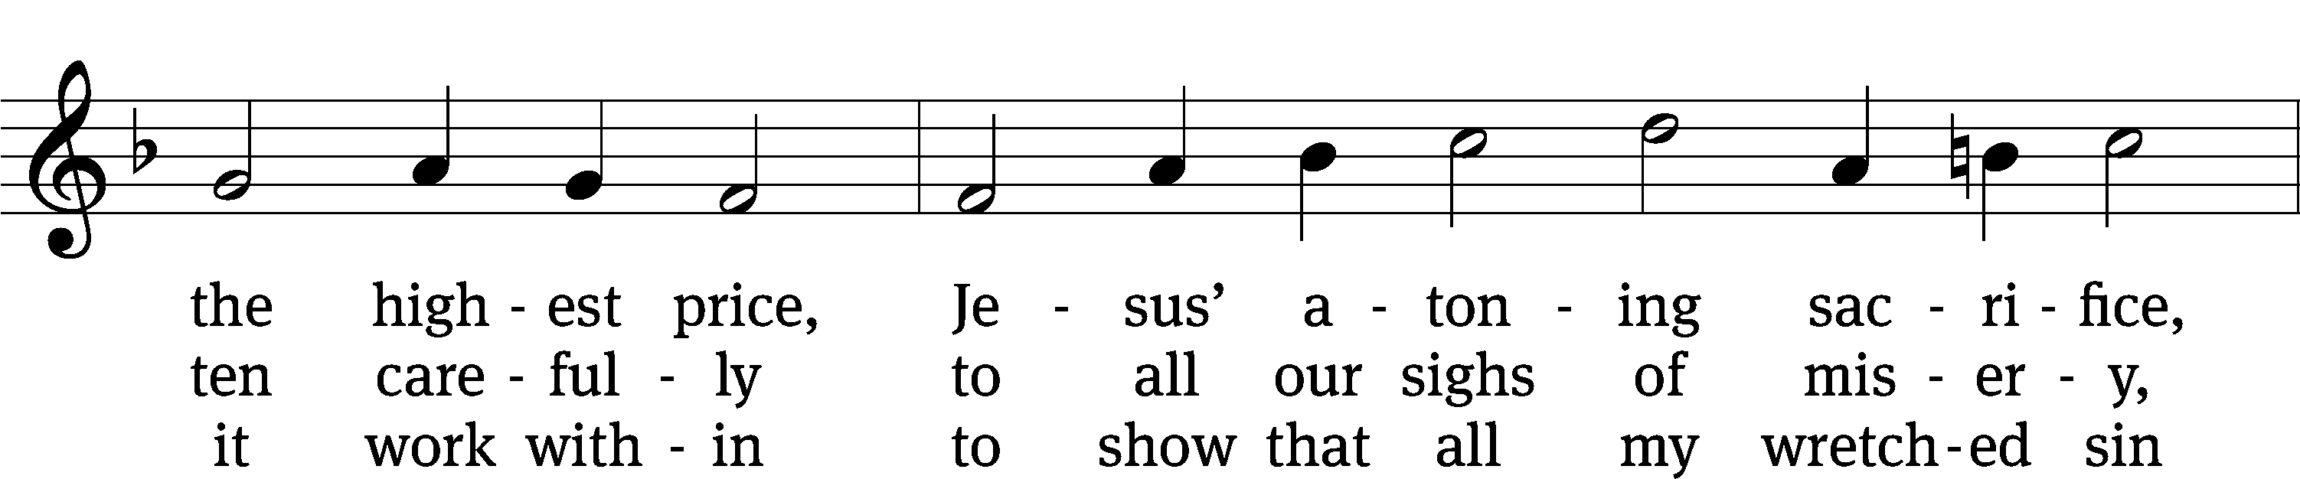
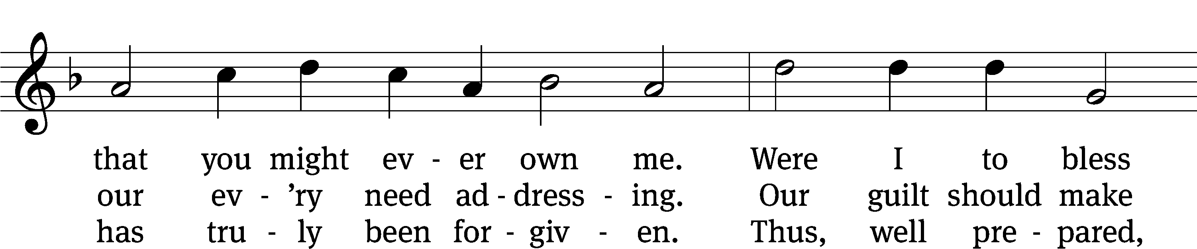
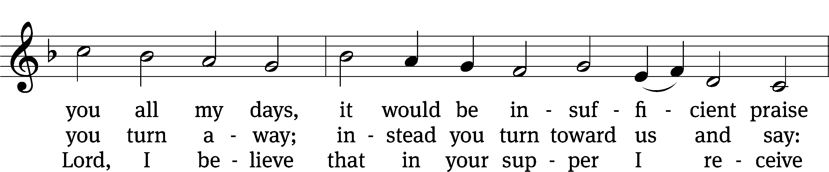
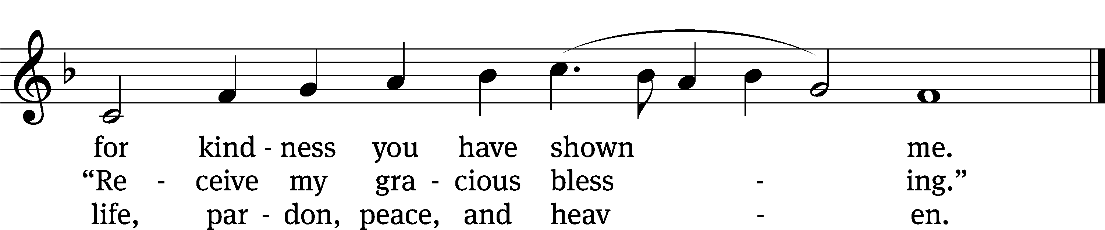
Text: tr. Michael D. Schultz, b. 1963; Johann Rist, 1607–1667
Tune: Wolfgang Dachstein, c. 1487–1553
Text: © 2021 Northwestern Publishing House. Used by permission: OneLicense no. 727703
Tune: Public domain

PLEASE STAND, IF YOU ARE ABLE

invocation
M: The grace of our Lord (+) Jesus Christ and the love of God and the fellowship of the Holy Spirit be with you.
C: And also with you.
CONFESSION OF SINS
M: We have come into the presence of God, who created us to love and serve him as his dear children. But we have disobeyed him and deserve only his wrath and punishment. Therefore, let us confess our sins to him and plead for his mercy.

C: Merciful Father in heaven, I am altogether sinful from birth. In countless ways I have sinned against you and do not deserve to be called your child. But trusting in Jesus, my Savior, I pray: Have mercy on me according to your unfailing love. Cleanse me from my sin, and take away my guilt.

M: God, our heavenly Father, has forgiven all your sins. By the perfect life and innocent death of our Lord Jesus Christ, he has removed your guilt forever. You are his own dear child. May God give you strength to live according to his will.

C: Amen.
PRAYER AND PRAISE

M: In the peace of forgiveness, let us praise the Lord.

OH, TASTE AND SEE

PRAYER OF THE DAY

Let us pray.

Almighty and merciful God, you sent your Son, Jesus Christ, to seek and to save the lost. Graciously open our ears and our hearts to hear his call and follow him by faith that we may feast with him forever in his kingdom; through your Son, Jesus Christ our Lord, who lives and reigns with you and the Holy Spirit, one God, now and forever.

PLEASE BE SEATED

The Word

the FIRST LESSON Exodus 3:1-15
¹ Now Moses was shepherding the flock of Jethro, his father-in-law, a priest of Midian, and he led the flock to the far side of the wilderness and came to Horeb, the mountain of God. ² The Angel of the Lord appeared to him in blazing fire from within a bush. Moses saw that the bush was on fire, but the bush was not burning up. ³ So he said, “I will go over and look at this amazing sight—to find out why the bush is not burning up.”
⁴ When the Lord saw that Moses had gone over to take a look, God called to him from the middle of the bush and said, “Moses! Moses!”
Moses said, “I am here.”
⁵ The Lord said, “Do not come any closer. Take your sandals off your feet, for the place where you are standing is holy ground.” ⁶ He then said, “I am the God of your fathers, the God of Abraham, the God of Isaac, and the God of Jacob.”
Moses hid his face, because he was afraid to look at God.
⁷ The Lord said, “I have certainly seen the misery of my people in Egypt, and I have heard their cry for help because of their slave drivers. Yes, I am aware of their suffering. ⁸ So I have come down to deliver them from the hand of the Egyptians and to bring them up out of that land to a good and spacious land, to a land flowing with milk and honey, to the place of the Canaanites, the Hittites, the Amorites, the Perizzites, the Hivites, and the Jebusites. ⁹ Now indeed, the Israelites’ cry for help has come to me. Yes, I have seen how the Egyptians are oppressing them. ¹⁰ Come now, I will send you to Pharaoh to bring my people, the Israelites, out of Egypt.”
¹¹ But Moses said to God, “Who am I, that I should go to Pharaoh, and that I should bring the Israelites out of Egypt?”
¹² So he said, “I will certainly be with you. This will be the sign to you that I have sent you: When you have brought the people out of Egypt, you will serve God on this mountain.”
¹³ But Moses said to God, “If I go to the Israelites and say to them, ‘The God of your fathers has sent me to you,’ and they ask me, ‘What is his name?’ what should I say to them?”
¹⁴ So God replied to Moses, “I am who I am.” He also said, “You will say this to the Israelites: I am has sent me to you.”
¹⁵ God also told Moses, “Say this to the Israelites: ‘The Lord, the God of your fathers—the God of Abraham, the God of Isaac, and the God of Jacob—has sent me to you. This is my name forever, and this is how I am to be remembered from generation to generation.’
119C Teach Me, O LORD Psalm 119C
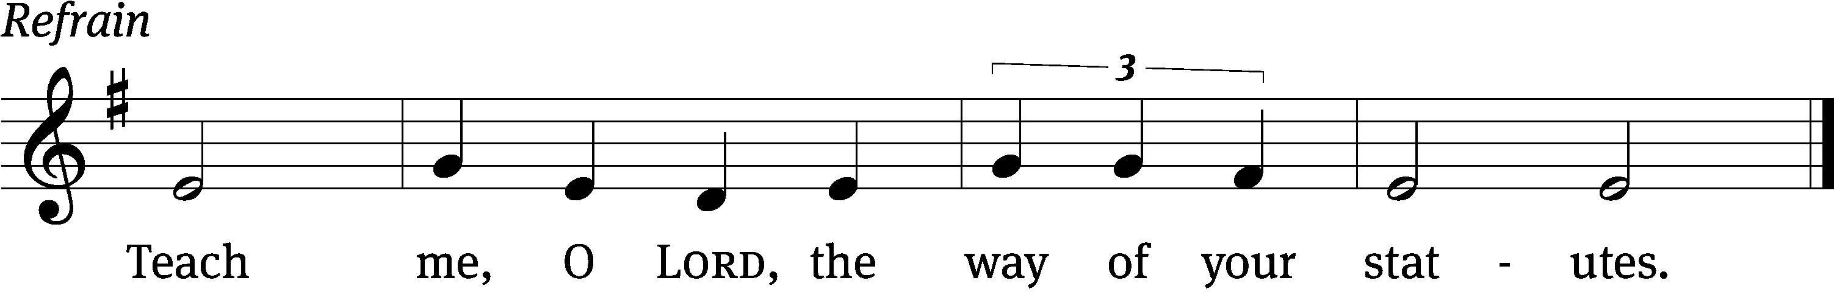

Do good to your / servant
according to your / word, Lord.
Teach me knowledge and good / judgment,
for I trust / your commands.
Before I was afflicted I / went astray,
but now I o- / bey your word. Refrain
You are good, and what you / do is good;
teach me / your decrees.
It was good for me to be af- / flicted
so that I might learn / your decrees.
The law from your mouth is more pre- / cious to me
than thousands of pieces of sil- / ver and gold.
Glory be to the Father and / to the Son
and to the Holy / Spirit,
as it was in the be- / ginning,
is now, and will be forever. / Amen. Refrain
THE SECOND LESSON 1 Timothy 1:12-17

¹² I give thanks to the one who empowered me, namely, Christ Jesus our Lord, that he treated me as trustworthy, appointing me into his ministry. ¹³ He did this even though formerly I was a blasphemer, a persecutor, and a violent man. But I was shown mercy, because I acted ignorantly in unbelief. ¹⁴ The grace of our Lord overflowed on me along with the faith and love that are in Christ Jesus. ¹⁵ This saying is trustworthy and worthy of full acceptance: “Christ Jesus came into the world to save sinners,” of whom I am the worst. ¹⁶ But I was shown mercy for this reason: that in me, the worst sinner, Christ Jesus might demonstrate his unlimited patience as an example for those who are going to believe in him, resulting in eternal life. ¹⁷ Now to the King eternal, to the immortal, invisible, only God, be honor and glory forever and ever. Amen.

please stand, if you are able

Verse of the day
Alleluia. It is not the healthy who need a doctor, but the sick.
I have not come to call the righteous, but sinners. Alleluia.
Matthew 9:12-13

THE GOSPEL LESSON Matthew 9:9-13

M: The Gospel according to Matthew chapter 9, verses 9-13

⁹ As Jesus went on from there, he saw a man named Matthew sitting in the tax collector’s booth. He said to him, “Follow me.” Matthew got up and followed him.
¹⁰ As Jesus was reclining at the table in Matthew’s house, many tax collectors and sinners were actually there too, eating with Jesus and his disciples. ¹¹ When the Pharisees saw this, they said to his disciples, “Why does your teacher eat with tax collectors and sinners?”
¹² When Jesus heard this, he said to them, “The healthy do not need a physician, but the sick do. ¹³ Go and learn what this means: ‘I desire mercy, and not sacrifice.’ In fact, I did not come to call the righteous, but sinners.”

M: This is the Gospel of the Lord.

PLEASE BE SEATED

614 Immortal, Invisible, God Only Wise CW 614
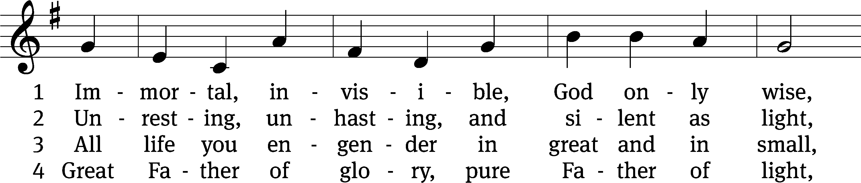
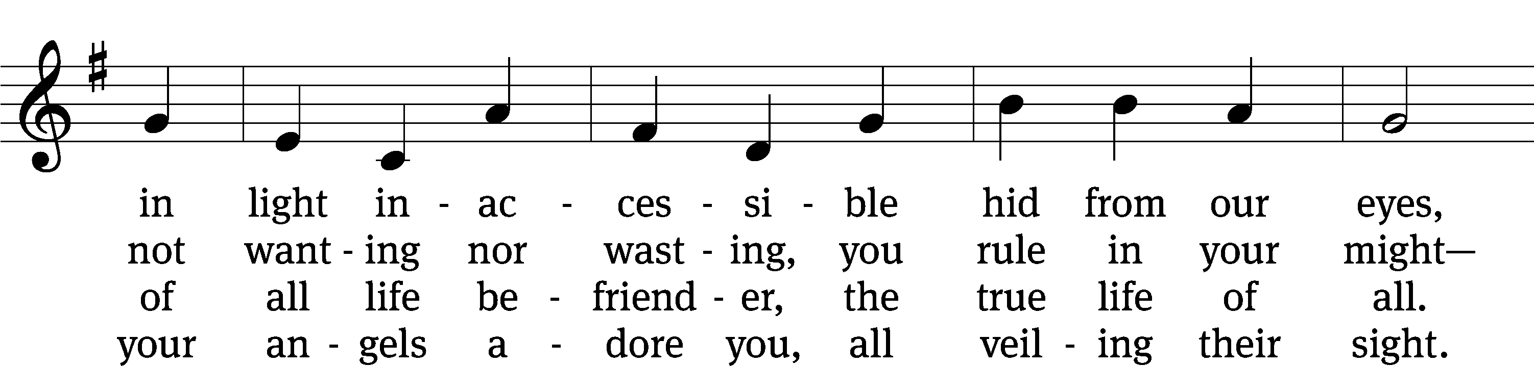
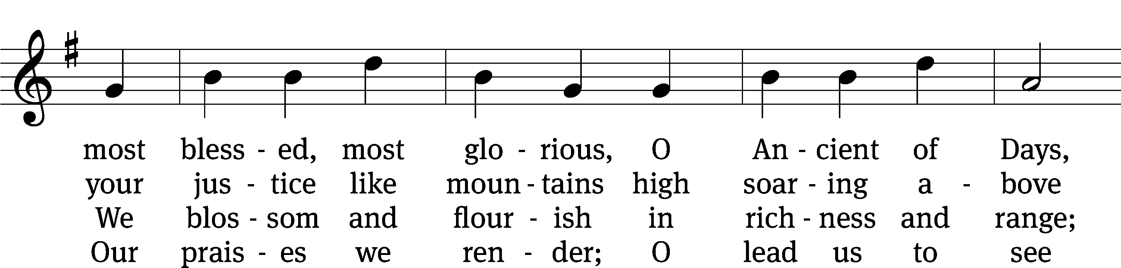
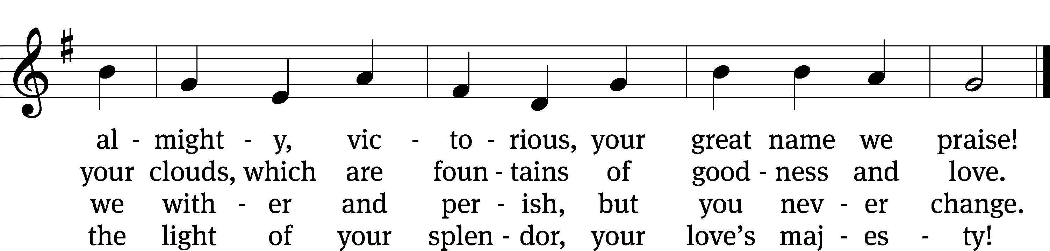
Text: W. Chalmers Smith, 1824–1908, abr., alt.
Tune: Welsh, Caniadau y Cyssegr, Denbigh, 1839
Text and tune: Public domain

SERMON Exodus 3:1-15
“I AM”

PLEASE STAND, IF YOU ARE ABLE

THE APOSTLES’ CREED

I believe in God, the Father almighty,
maker of heaven and earth.
I believe in Jesus Christ, his only Son, our Lord,
who was conceived by the Holy Spirit,
born of the virgin Mary,
suffered under Pontius Pilate,
was crucified, died, and was buried.
He descended into hell.
The third day he rose again from the dead.
He ascended into heaven
and is seated at the right hand of God the Father almighty.
From there he will come to judge the living and the dead.
I believe in the Holy Spirit,
the holy Christian Church,
the communion of saints,
the forgiveness of sins,
the resurrection of the body,
and the life everlasting. Amen.

PRAYER OF THE CHURCH

THE LORD’S PRAYER

C: Our Father, who art in heaven, hallowed be thy name, thy kingdom come, thy will be done on earth as it is in heaven. Give us this day our daily bread; and forgive us our trespasses, as we forgive those who trespass against us; and lead us not into temptation, but deliver us from evil. For thine is the kingdom and the power and the glory forever and ever. Amen.

816 I Am Trusting You, Lord Jesus CW 816
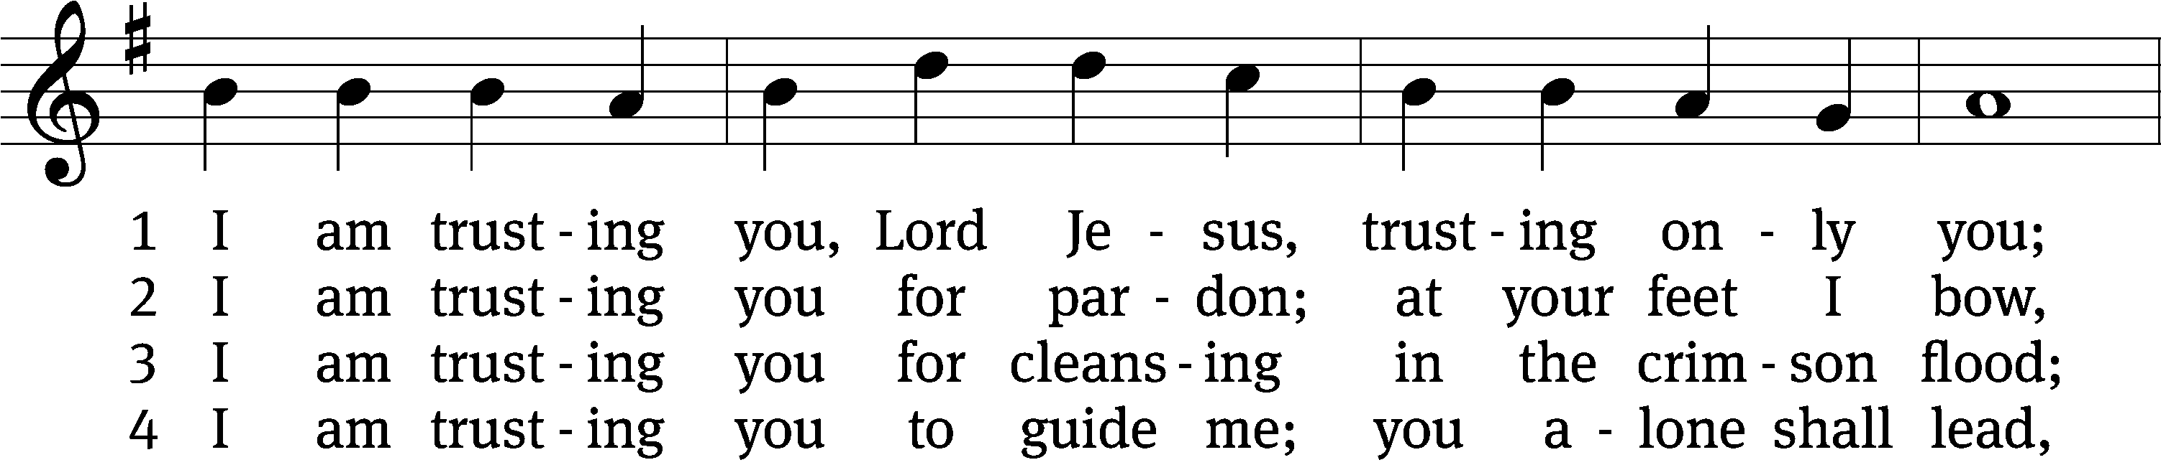
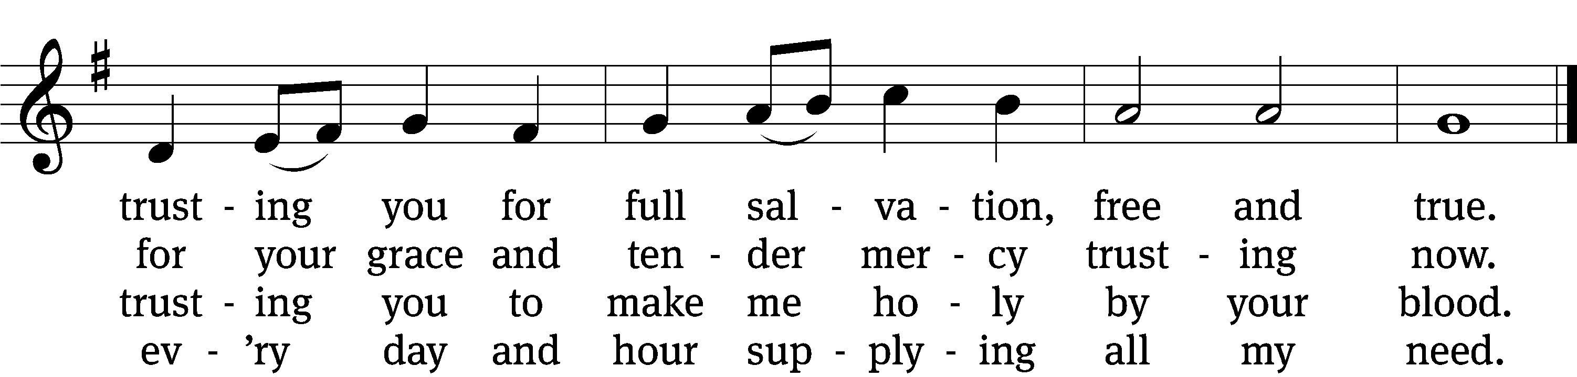

5 I am trusting you for power;
you can never fail.
Words which you yourself shall give me
must prevail.

6 I am trusting you, Lord Jesus;
never let me fall.
I am trusting you forever
and for all.
Text: Frances R. Havergal, 1836–1879, alt.
Tune: Henry W. Baker, 1821–1877
Text and tune: Public domain

PLEASE STAND, IF YOU ARE ABLE

CLOSING PRAYER
M: Almighty God, we thank you for teaching us the things you want us to believe and do. Help us by your Holy Spirit to keep your Word in pure hearts that we may be strengthened in faith, guided in holiness, and comforted in life and in death, through Jesus Christ, our Lord, who lives and reigns with you and the Holy Spirit, one God, now and forever.

M: Brothers and sisters, go in peace. Live in harmony with one another. Serve the Lord with gladness.
The Lord bless you and keep you.
The Lord make his face shine on you and be gracious to you.
The Lord look on you with favor and (+) give you peace.

PLEASE BE SEATED

803 Day by Day CW 803
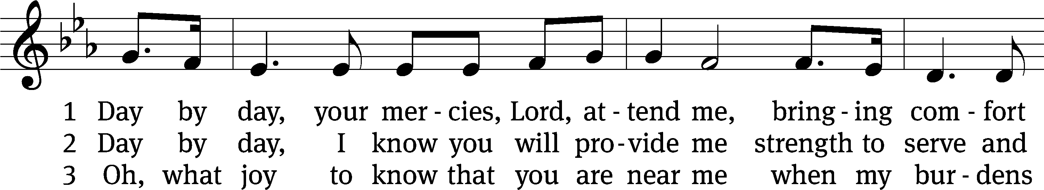
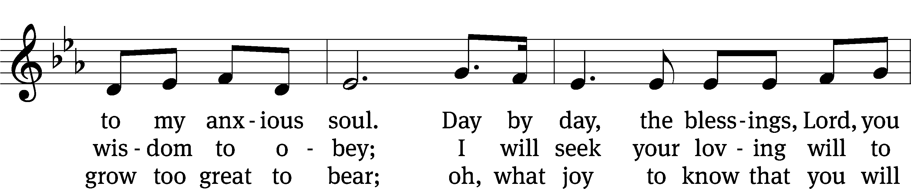
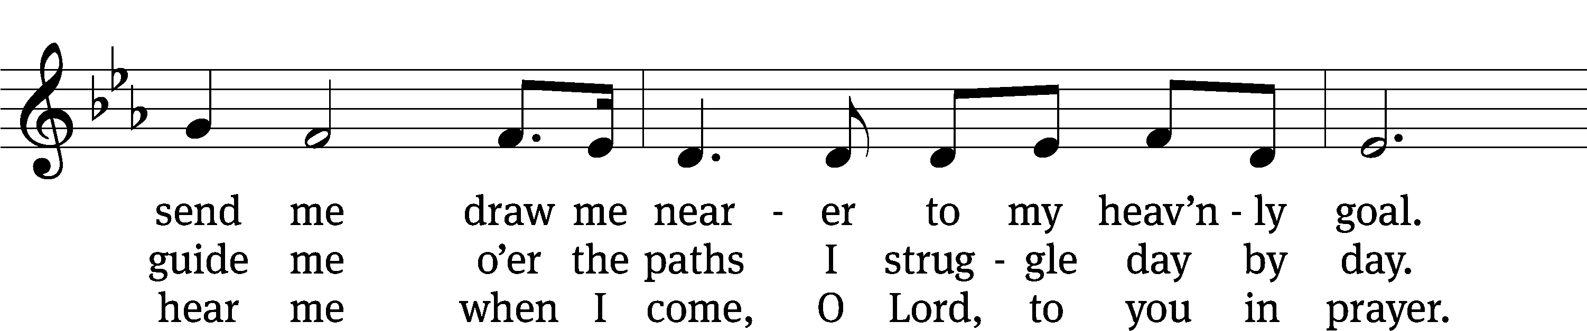
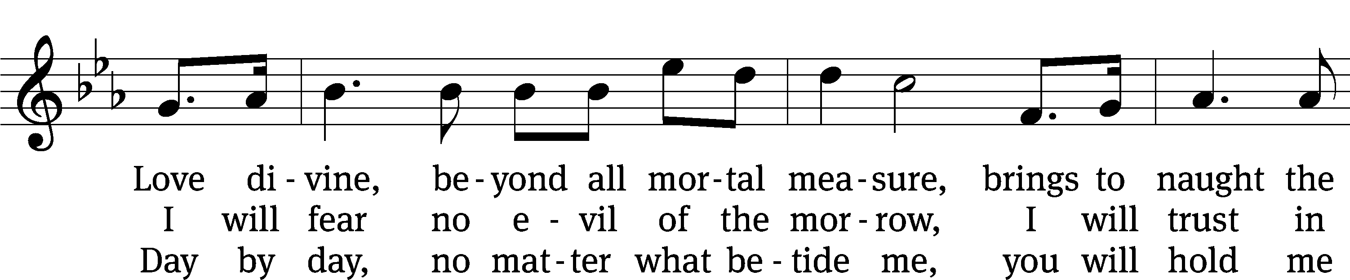
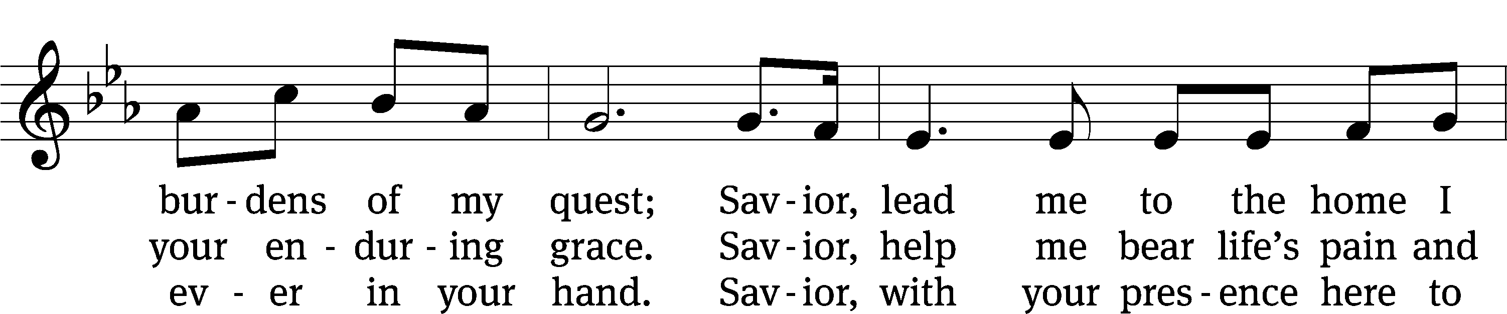
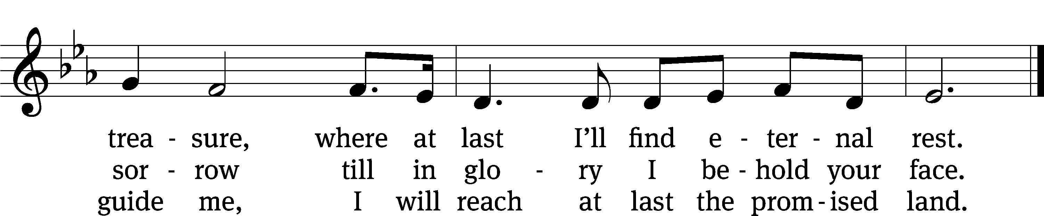
Text: tr. Robert Leaf, 1936–2005; Carolina Sandell Berg, 1832–1903
Tune: Oskar Ahnfelt, 1813–1882
Text: © 1992 Augsburg Fortress. Used by permission: OneLicense no. 727703
Tune: Public domain

Serving In Worship
Officiant Pastor Natsis
Organist Sarah Hanke
Deacons (Thursday) Steve Hoeft and Jim Tice
(Sunday) Duane Mason and Robert Niethammer
Ushers (Thursday) Robert Newman and Henry Schneider
(Sunday) Dave Boswell and Jake Vershum
Altar Guild Diane Stevenson and Karen Tice
Videographer Jake Vershum

Copyright information
Service of the Word: Christian Worship. © 1993 Northwestern Publishing House. All rights reserved.
Reprinted with permission under ONE LICENSE #A-727703 and CCLI #1151741/CSPL126093

Words and Music: All rights reserved. Reprinted with permission under ONE LICENSE #A-727703 and
CCLI #1151741/CSPL126093
tlcsaline.church

