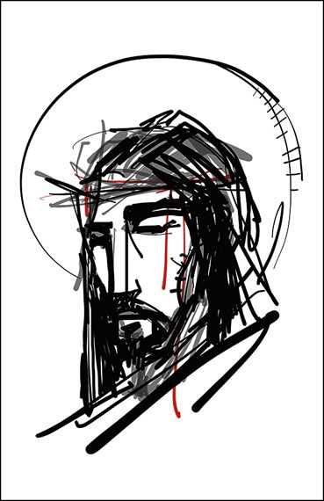

GOOD FRIDAY

tRINITY EVANGELICAL LUTHERAN CHURCH | Saline, Michigan
April 15, 2022

WELCOME TO WORSHIP
Thank you for joining us in God’s house today! We cordially ask that our Guests with us this morning sign one of the guestbooks located at either the front or back entryways.
THANK OFFERING: Members of Trinity give their offering as an expression of love and thankfulness to the Lord and to help support the Lord’s work in our community and around the world. Visitors need not feel obligated to participate in this offering which supports our ministry.
Restrooms are located at the back of the upper level (the annex), and in the basement (down the back stairs of the sanctuary or annex). Handicap access is available, please ask an usher for assistance.
Young Families / Toddler Bags – We are GLAD YOU BROUGHT YOUR CHILDREN to our worship service. Jesus said: “Let the little children come to me and do not hinder them, for the kingdom of God belongs to such as these.” We know that having little children in church can be a challenge, but DO NOT WORRY about it. Many of your fellow worshippers have been in your shoes and are just happy you brought your children with you. For your convenience, we have reserved the back rows of seating for parents with small children. These areas provide more flexibility for your family, as well as, easy access to move downstairs if necessary. A closed-circuit TV system allows families to continue participating in the service while downstairs. Pre-school toddler bags and children’s bulletins are available for their enjoyment. Ask an usher for one to use during the service and please return the toddler bag afterwards.
+ + +

CALL TO WORSHIP (CHOIR) “The Holy Heart”

WORDS OF WELCOME

OPENING HYMN CW #420 (v. 1-5)
420 Jesus, I Will Ponder Now CW 420 sts. 1–5
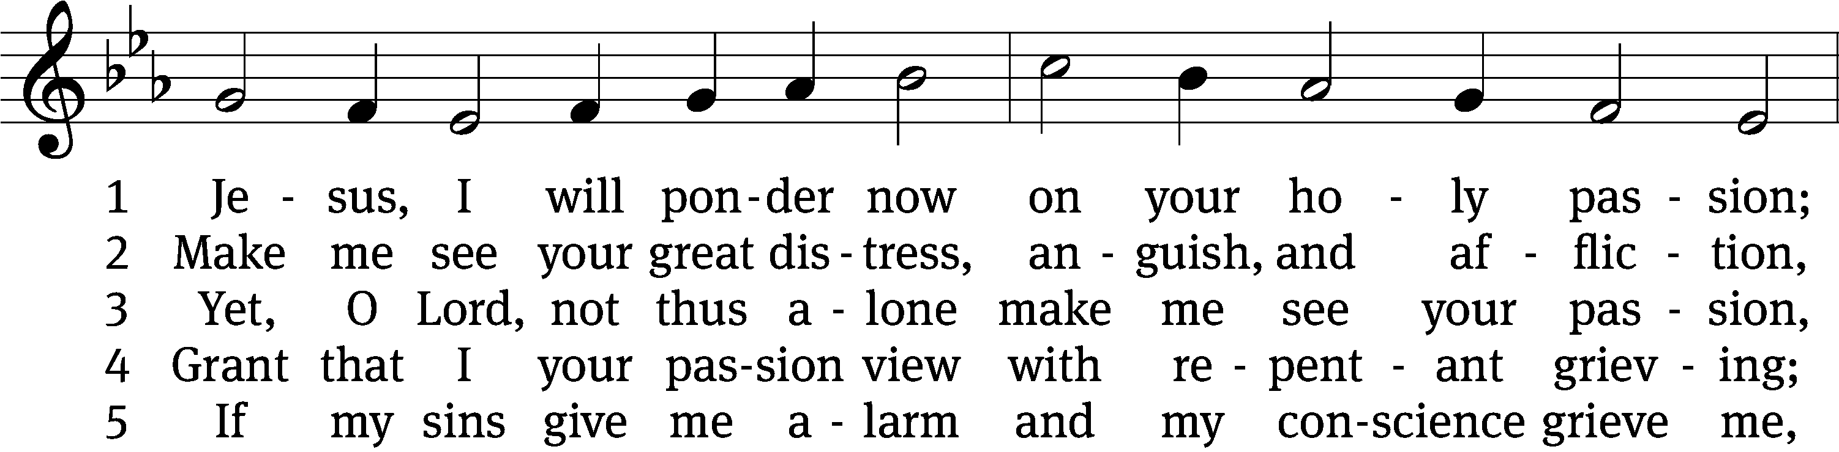
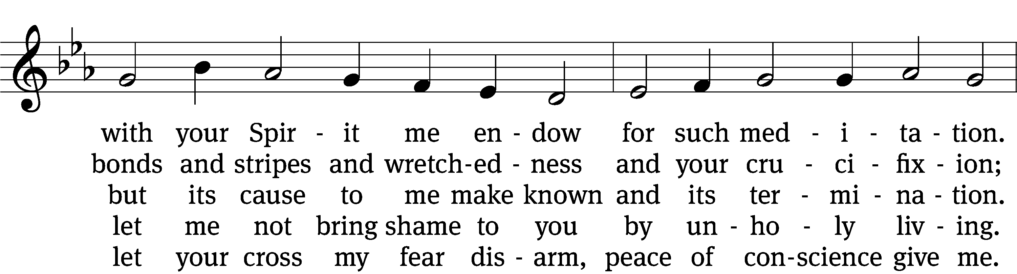
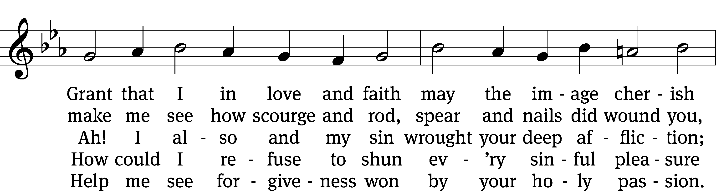
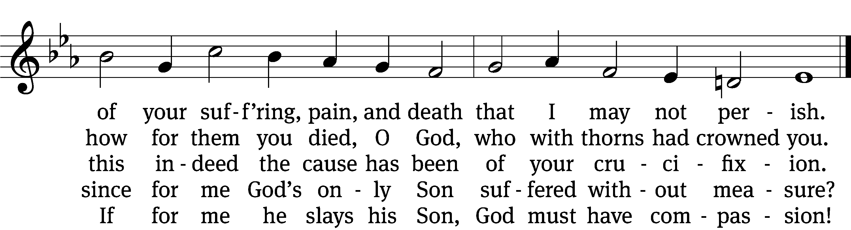
Text: tr. August Crull, 1845–1923, alt.; Sigmund von Birken, 1626–1681
Tune: Melchior Vulpius, c. 1570–1615
Text and tune: Public domain

invocation

Please stand, if you are able

M: In the name of the Father and of the Son (+) and of the Holy Spirit.
C: Amen.

CONFESSION

M: Dear friends, let us approach God with a true heart and confess our sins, asking him in the name of our Lord Jesus Christ to forgive us.
C: Lord of life, I confess that I am by nature dead in sin.
For faithless worrying and selfish pride, for sins of habit and sins of choice,
For the evil I have done and the good I have failed to do,
You should cast me away from your presence forever.
O Lord, I am sorry for my sins. Forgive me, for Jesus’ sake.

ABSOLUTION
M: Christ has died. Christ is risen. Christ will come again. In his great mercy, God made us alive in Christ even when we were dead in our sins. Hear the word of Christ through his called servant:
I forgive you all your sins in the name of the Father and of the Son (+) and of the Holy Spirit.

C: Amen.

PRAYER
M: Lord God, you have brought us safely to this hour of prayer. We thank you for providing all that we need for body and life. Bless us who have gathered in your name. Forgive our sins. Speak to our hearts. Dispel our sorrows with the comfort of your Word, and receive our hymns of thanks and praise, through Jesus Christ, our living Savior, who reigns with you and the Holy Spirit, one God, now and forever.
C: Amen.
Please be seated
PSALM Psalm 22
22D LORD, Why Have You Forsaken Me Psalm 22D
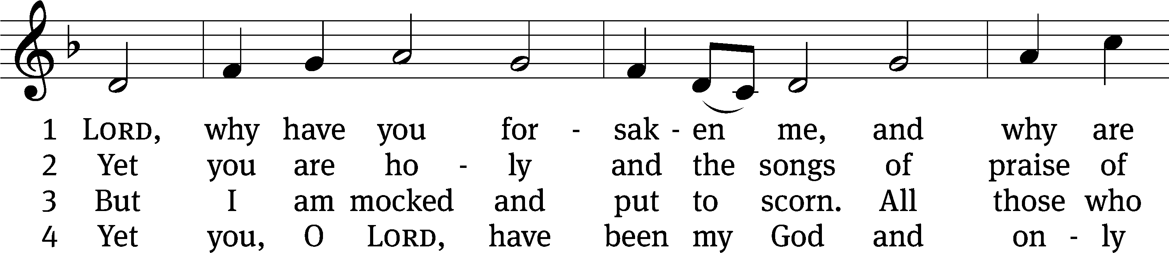
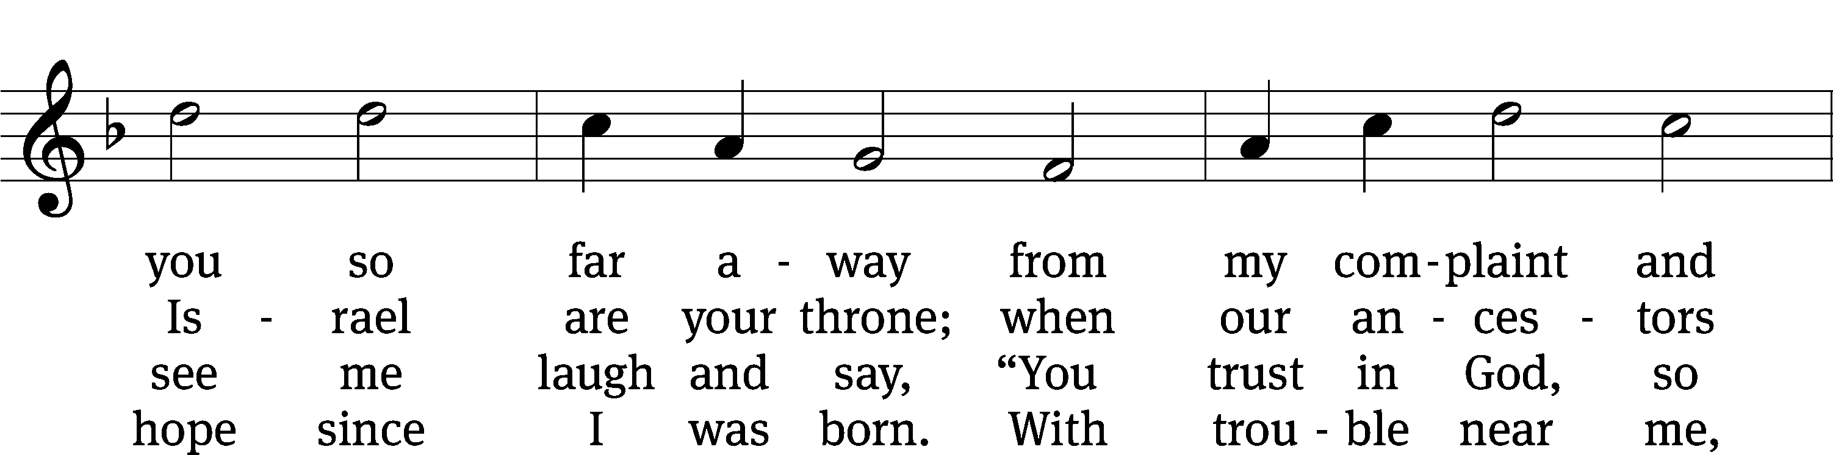
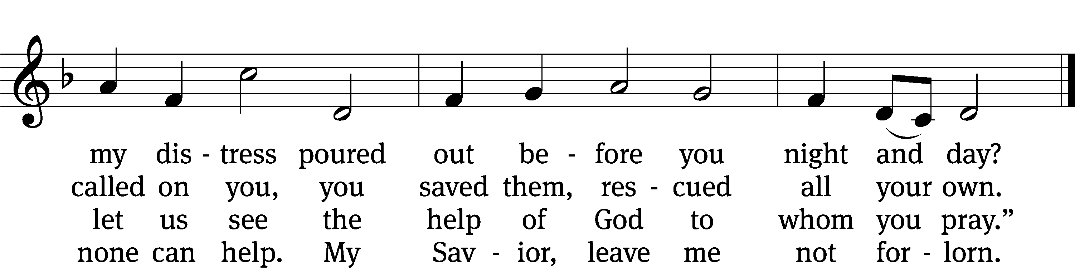

Text: Christopher L. Webber
Tune: Southern Harmony, 1835, ed. William Walker
Text: © 1968 Christopher L. Webber, admin. Church Publishing Inc. Used by permission: OneLicense no. 727703
Tune: Public domain

PSALM PRAYER

M: Father, when your Son hung on the cross, he cried out to you in agony and grief. You gave him the strength to endure, so that death might be destroyed and life restored. Have mercy on us all our days and preserve us in true faith unto life everlasting; through your Son, Jesus Christ our Lord, who lives and reigns with you and the Holy Spirit, one God, now and forever.
C: Amen.

INSTRUMENTAL SOLO “Were You There?”

LESSON ONE: The Passion History – Part Six
550 Lamb of God
LESSON TWO: The Passion History – Part Seven

INSTRUMENTAL SOLO: “O Darkest Woe”

SERMON TEXT AND THEME: Mark 15:30

“Come Down from the Cross and Save Yourself”

Please stand, if you are able

APOSTLES’ CREED

I believe in God, the Father almighty,
maker of heaven and earth.
I believe in Jesus Christ, his only Son, our Lord,
who was conceived by the Holy Spirit,
born of the virgin Mary,
suffered under Pontius Pilate,
was crucified, died, and was buried.
He descended into hell.
The third day he rose again from the dead.
He ascended into heaven
and is seated at the right hand of God the Father almighty.
From there he will come to judge the living and the dead.
I believe in the Holy Spirit,
the holy Christian Church,
the communion of saints,
the forgiveness of sins,
the resurrection of the body,
and the life everlasting. Amen.

CHOIR “Jesus, Refuge of the Weary”

PRAYER OF THE CHURCH
THE LORD’S PRAYER
C: Our Father, who art in heaven, hallowed be thy name, thy kingdom come, thy will be done on earth as it is in heaven. Give us this day our daily bread; and forgive us our trespasses, as we forgive those who trespass against us; and lead us not into temptation, but deliver us from evil. For thine is the kingdom and the power and the glory forever and ever. Amen.

Please be seated

433 God Was There on Calvary CW 433
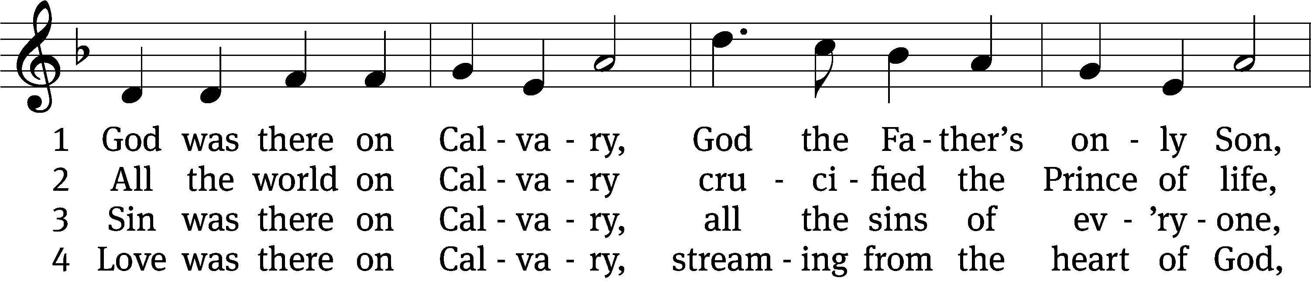
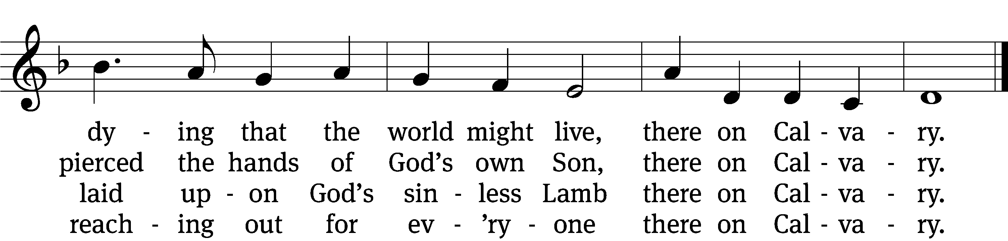

5 Life was there on Calvary,
flowing from his wounded side,
spent that death itself might die
there on Calvary.

6 We were there on Calvary;
we were pardoned, saved, set free,
saved to live eternally—
blessèd Calvary!
Text: Kurt J. Eggert, 1923–1993
Tune: Kurt J. Eggert, 1923–1993
Text and tune: © 1993 Kurt J. Eggert, admin. Northwestern Publishing House. Used by permission: OneLicense no. 727703

Please stand, if you are able

CLOSING PRAYER
M: Lord God, all holy desires, all good counsels, and all just works come from you. Give to us, your servants, that peace which the world cannot give, that our hearts may be set to obey your commandments. Defend us also from the fear of our enemies that we may live in peace and quietness, through the merits of Jesus Christ our Savior, who lives and reigns with you and the Holy Spirit, one God, now and forever.

M: Brothers and sisters, go in peace. Live in harmony with one another. Serve the Lord with gladness.
M: The Lord bless you and keep you.
The Lord make his face shine on you and be gracious to you.
The Lord look on you with favor and (+) give you peace.

Please be seated
396 Christ, the Life of All the Living CW 396
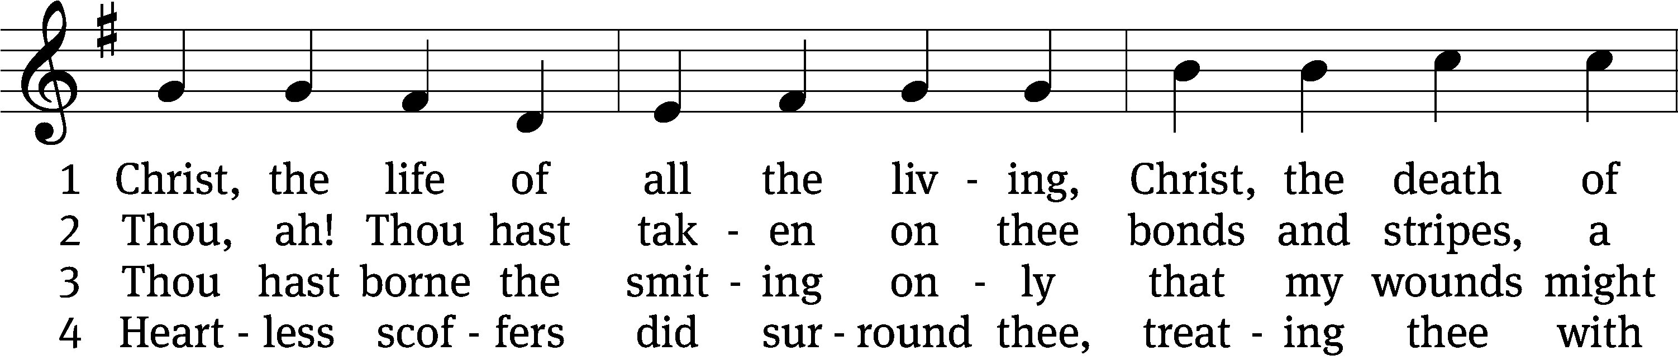
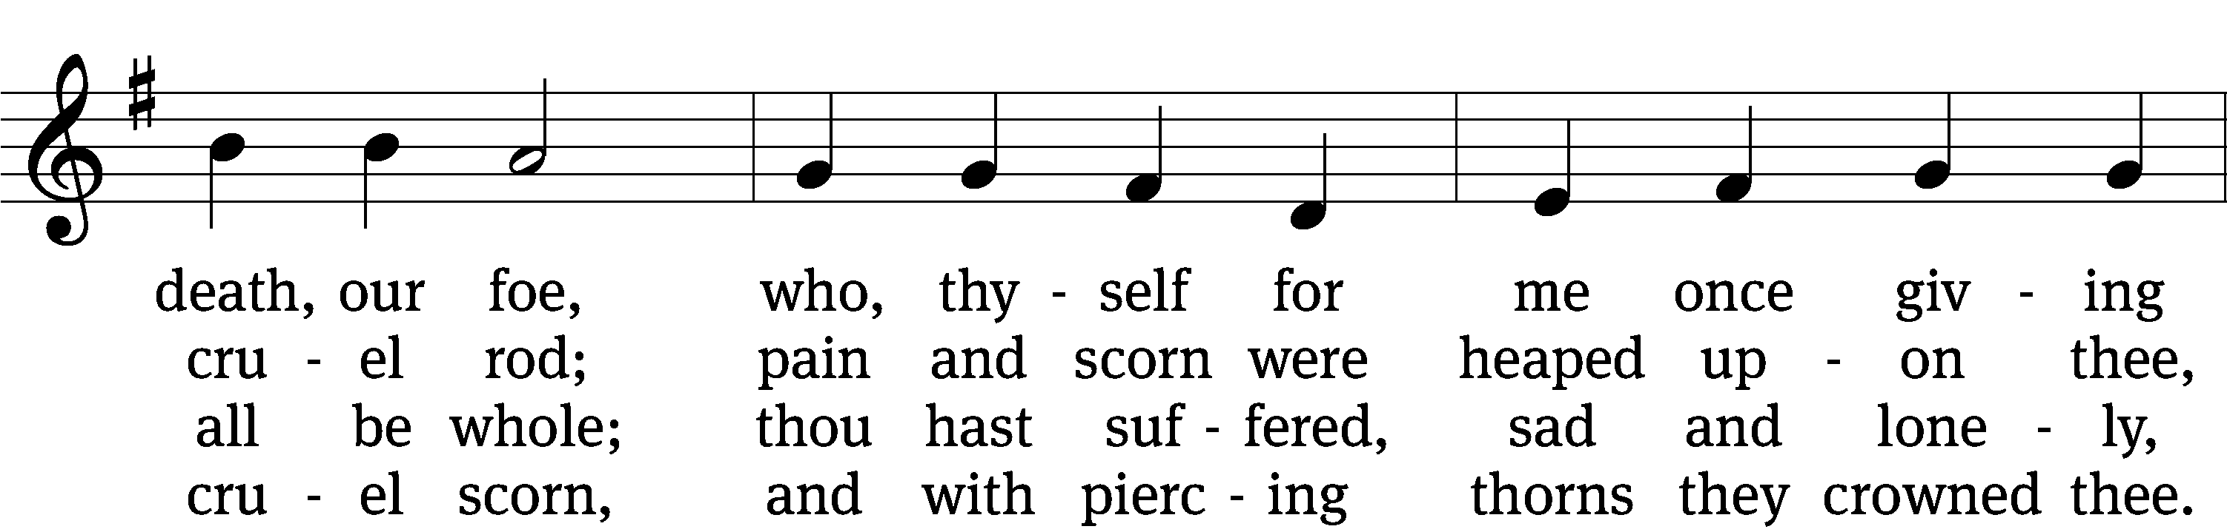
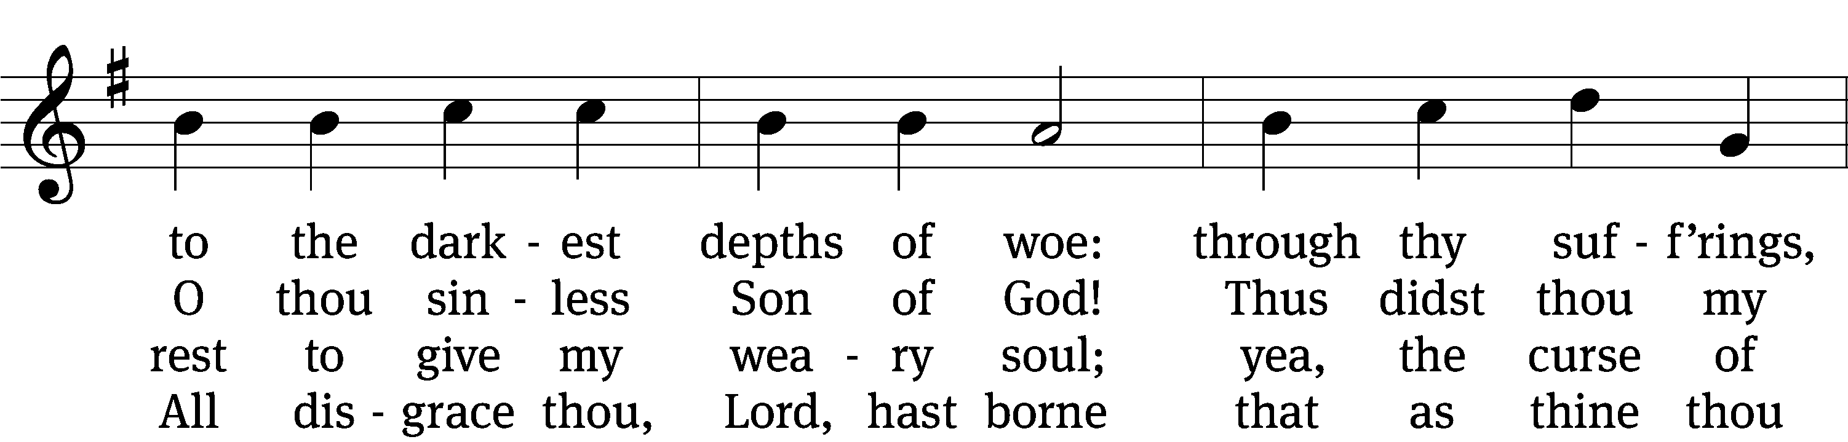
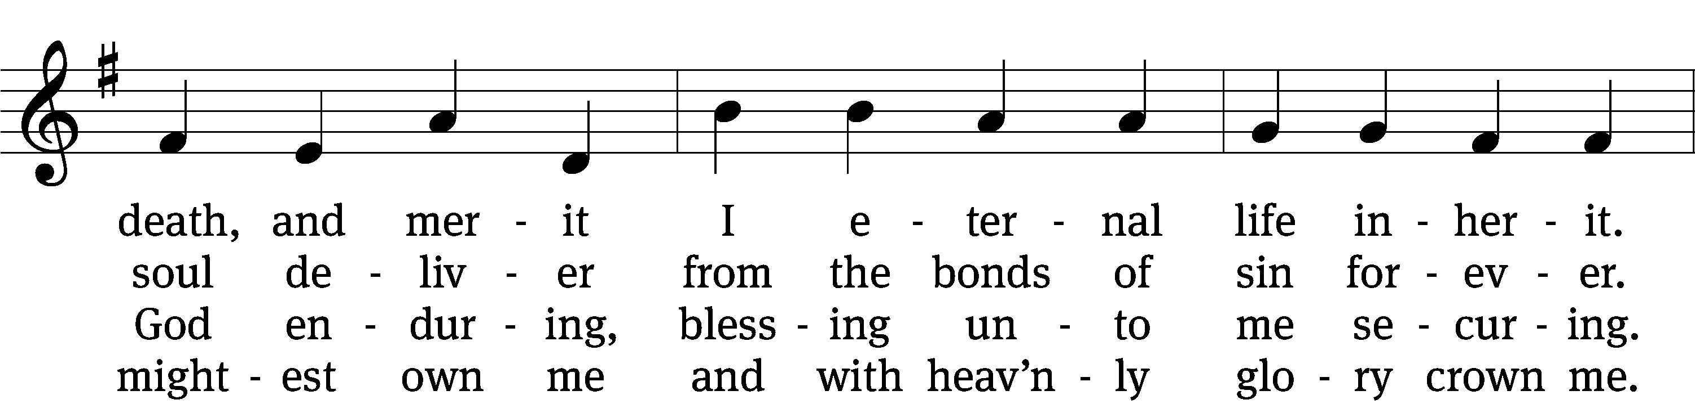
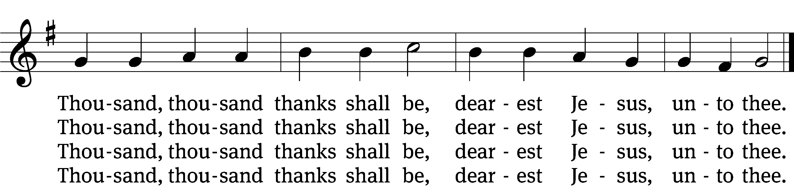

5 Thou hast suffered men to bruise thee
that from pain I might be free;
falsely did thy foes accuse thee:
thence I gain security.
Comfortless thy soul did languish
me to comfort in my anguish.
Thousand, thousand thanks shall be,
dearest Jesus, unto thee.

6 Thou hast suffered great affliction
and hast borne it patiently,
even death by crucifixion,
fully to atone for me.
Thou didst choose to be tormented
that my doom should be prevented.
Thousand, thousand thanks shall be,
dearest Jesus, unto thee.

7 Then, for all that wrought my pardon,
for thy sorrows deep and sore,
for thine anguish in the garden,
I will thank thee evermore,
thank thee for thy groaning, sighing,
for thy bleeding and thy dying,
for that last triumphant cry
and shall praise thee, Lord, on high.
Text: Ernst C. Homburg, 1605–1681, abr.; (sts. 1–2, 5, 7): tr. Catherine Winkworth, 1827–1878, alt.; (sts. 3–4, 6): tr. Evangelical Lutheran Hymn-Book, 1912, alt.
Tune: Das grosse Cantional, Darmstadt, 1687, alt.
Text and tune: Public domain
+ + +

Serving In Worship
Preacher Pastor Natsis
Organist Marcia Marion Ackling
Accompanists Laura Sala and Sarah Hanke
Instrumentalist Tom Amerman
Choir Director Cynthia Natsis
Deacons Jeff Neuburger and Dave Frey
Altar Guild Judy Lindemann and Connie Marion
Videographer Ann Latowski

Copyright information
Service of the Word: Christian Worship. © 1993 Northwestern Publishing House. All rights reserved.
Reprinted with permission under ONE LICENSE #A-727703 and CCLI #1151741/CSPL126093

Words and Music: All rights reserved. Reprinted with permission under ONE LICENSE #A-727703 and
CCLI #1151741/CSPL126093

