Maundy Thursday – April 14, 2022
“This Is My Body…This Is My Blood”
OPENING HYMN #416 CWS
416 When You Woke That Thursday Morning CW 416
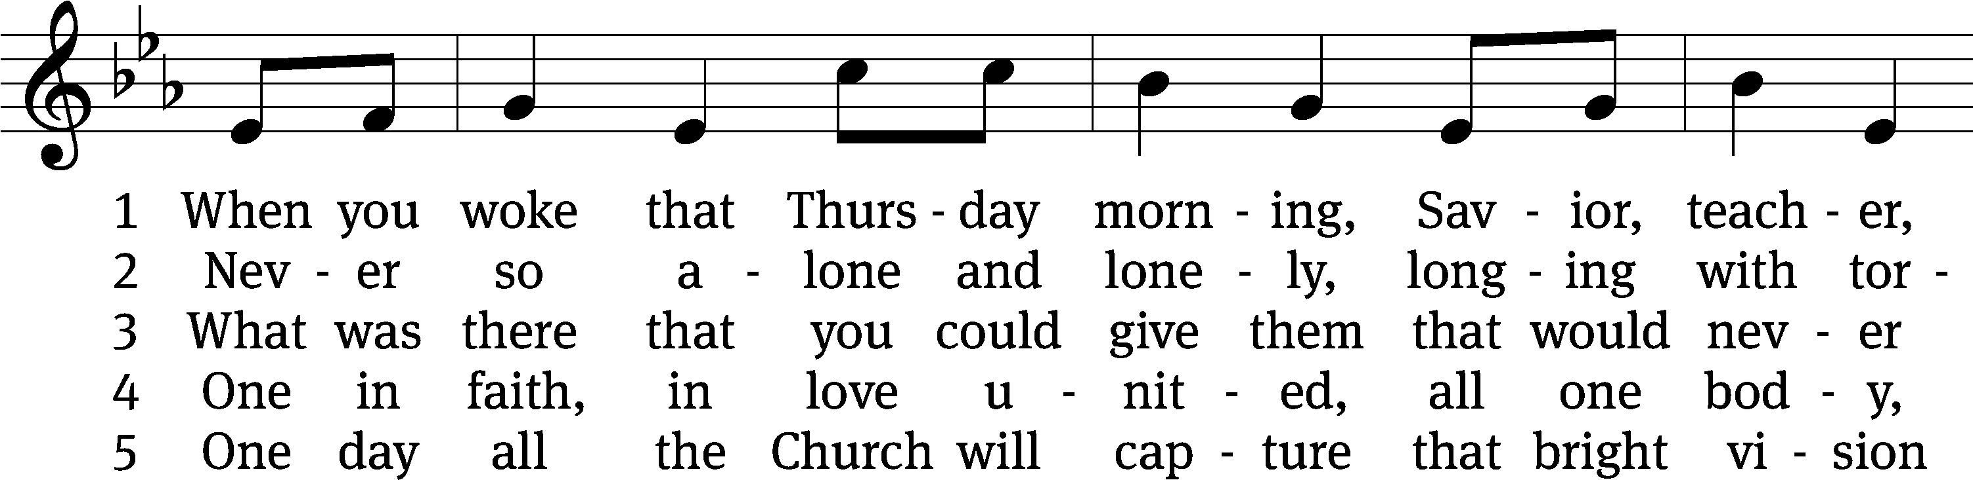
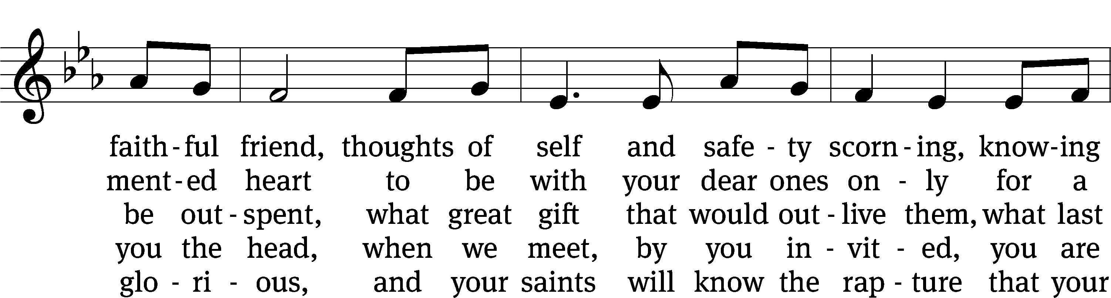
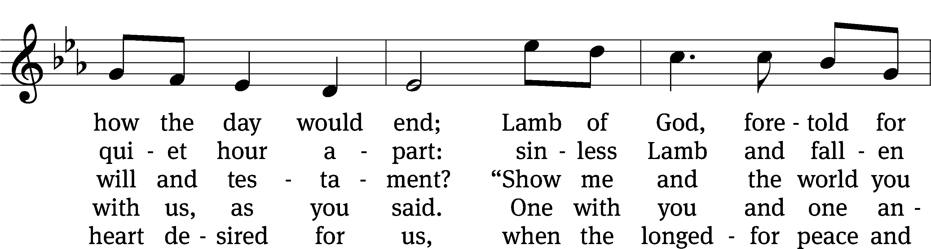
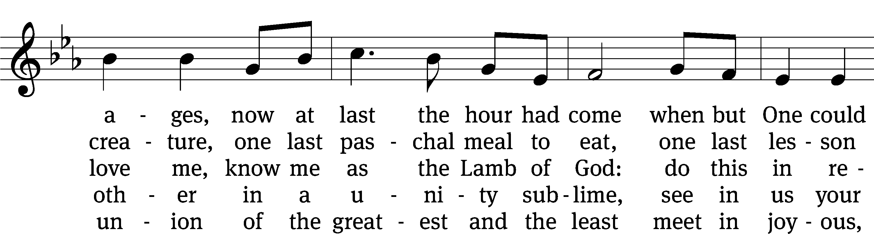
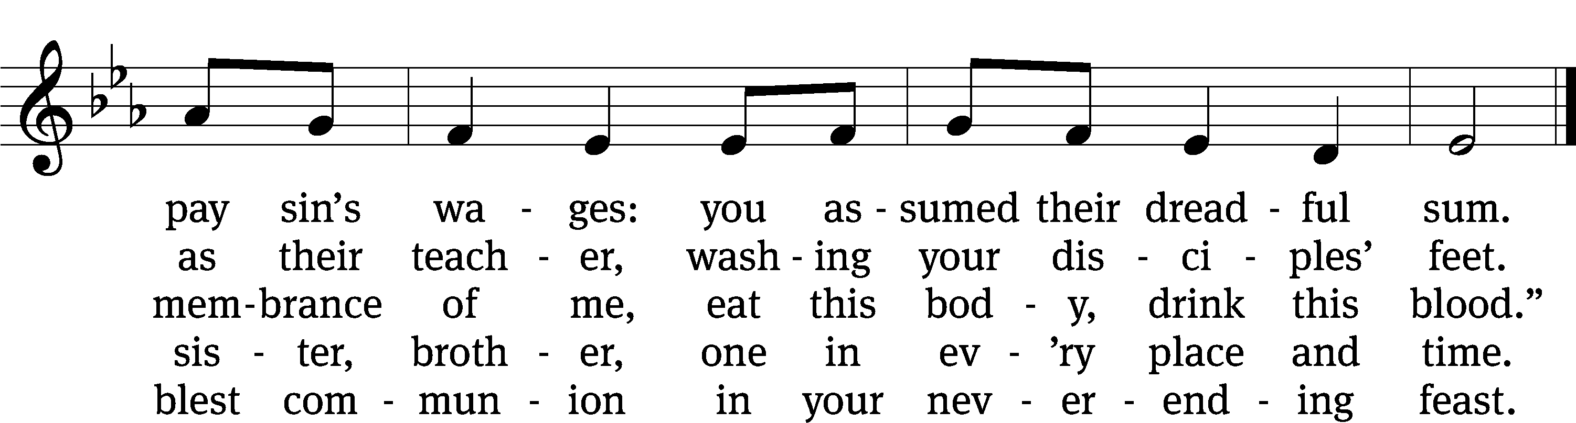
Text: Jaroslav J. Vajda, 1919–2008
Tune: Marty Haugen, b. 1950
Text: © 1991 Concordia Publishing House. Used by permission: OneLicense no. 727703
Tune: © 1987 GIA Publications, Inc. Used by permission: OneLicense no. 727703

CONFESSION

Pastor:
In the name of our God, to whom all hearts are open and from whom no secrets are hidden. Amen.
Pastor and Penitents:
O Lord, hear my prayer, listen to my cry for mercy,
and in your faithfulness, come to my relief.
Do not bring your servant into judgment,
for no one living is righteous before you.
Answer me quickly, O Lord; my spirit fails.
Do not hide your face from me, for I have put my trust in you.
Show me the way I should go,
for to you I lift up my soul.
Teach me to do your will, for you are my God.
Penitents:
Almighty God, merciful Father, I, a troubled and repentant sinner, confess that I have sinned against you in my thoughts, my words, and my actions. I have not loved you with my whole heart; I have not loved others as I should. I am distressed by the sins that trouble me and am deeply sorry for them.
Pastor:
Jesus says to his people: “If you forgive the sins of any, they are forgiven.” His death paid for the guilt of your sins and the sins of the whole world. Do you believe this?
Penitents:
Yes, I believe.
Pastor:
Because of the promise of our Savior Jesus, I forgive you all your sins. Be assured that you are a dear child of God and an heir of eternal life.
Pastor and Penitent:
O Lord, my God, I called to you for help, and you answered me. I thank you for the love you have shown me in Jesus Christ, my Savior. Through him you have rescued me from the guilt of my sin and given me the peace of forgiveness. Help me fight against temptation, correct whatever wrongs I can, and serve you and those around me with love and good works. In Jesus’ name, I pray. Amen.
Pastor:
We continue the service in peace. The Lord be with you.
(Congregation is seated)

BELL CHOIR “WHAT WONDROUS LOVE IS THIS”

FIRST LESSON EXODUS 12:1-14
¹The Lord told Moses and Aaron this in the land of Egypt:

²This month is to be the beginning of your calendar. It is to be the first month of the year for you. ³Tell the entire Israelite community that on the tenth day of this month, they are to take a lamb or a kid goat for themselves, according to their fathers’ households, one lamb per household. ⁴But if the household is too small for a whole lamb, then that person and his neighbor next door to him must select one, based on the number of people. Determine what size lamb is needed according to how much each person will eat.

⁵Your lamb must be unblemished, a year-old male. You may take it from the sheep or the goats. ⁶You are to keep it until the fourteenth day of this month. Then the whole assembly of the Israelite community is to slaughter the lambs at sunset. ⁷They shall take some of the blood and put it on the two doorposts and the lintel of the houses where they eat the lamb. ⁸That night they shall eat the meat that has been roasted over a fire, along with unleavened bread. They shall eat it with bitter herbs. ⁹Do not eat it raw or boiled in water, but roasted over a fire—with its head, its legs, and its internal organs. ¹⁰You shall not leave any of it until the morning. Whatever remains until the morning, you shall burn in the fire. ¹¹This is how you are to eat it: with your cloak tucked into your belt ready for travel, your sandals on your feet, and your staff in your hand. Eat it in haste. It is the Lord’s Passover.

¹²For on that night I will pass through the land of Egypt. I will strike down every firstborn in the land of Egypt, both people and animals. Against all the gods of Egypt I will execute judgment. I am the Lord. ¹³The blood will be a sign for you on the houses where you are. When I see the blood, I will pass over you. There will be no plague among you to destroy you, when I strike down the land of Egypt.

¹⁴This day shall be a memorial for you, and you are to celebrate it as a festival to the Lord. Throughout your generations you must celebrate it as a permanent regulation.

525 The Lamb CW 525
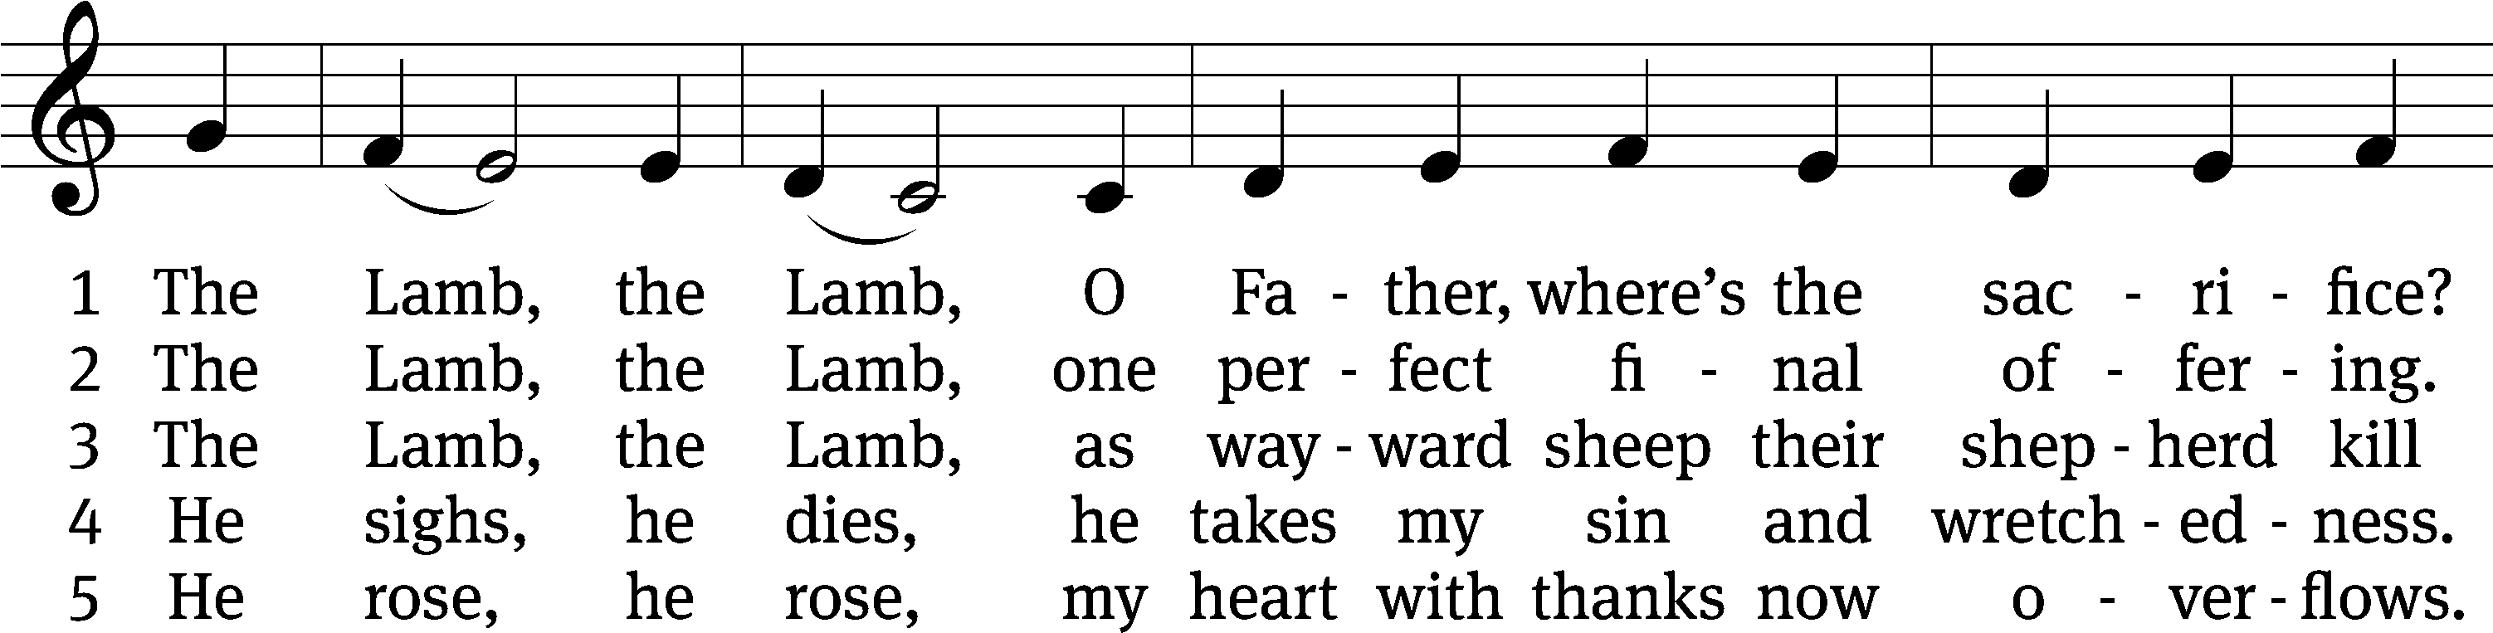
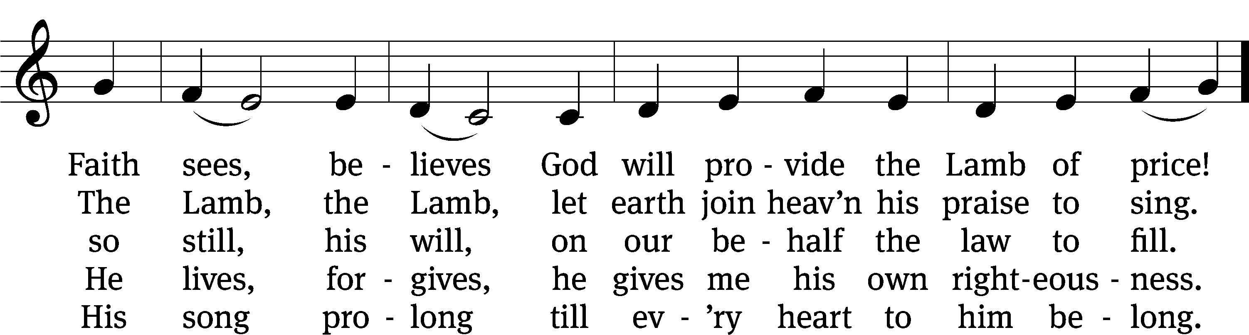
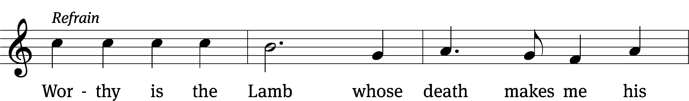
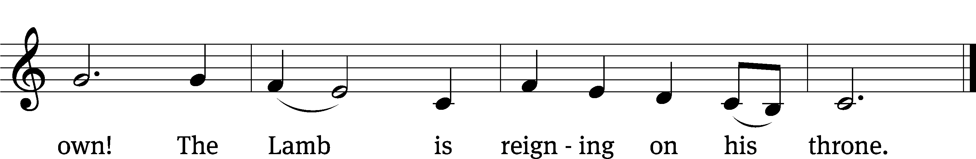
Text: Gerald P. Coleman, b. 1953
Tune: Gerald P. Coleman, b. 1953
Text and tune: © 1987 MorningStar Music Publishers, Inc. Used by permission: OneLicense no. 727703

EPISTLE LESSON 1 CORINTHIANS 11:23-29
²³For I received from the Lord what I also delivered to you: The Lord Jesus, on the night when he was betrayed, took bread, ²⁴and when he had given thanks, he broke it and said, “This is my body, which is for you. Do this in remembrance of me.” ²⁵In the same way, after the meal, he also took the cup, saying, “This cup is the new testament in my blood. Do this, as often as you drink it, in remembrance of me.” ²⁶For as often as you eat this bread and drink the cup, you proclaim the Lord’s death until he comes.

²⁷Therefore whoever eats the bread or drinks the cup of the Lord in an unworthy manner will be guilty of sinning against the Lord’s body and blood. ²⁸Instead, let a person examine himself and after doing so, let him eat of the bread and drink from the cup. ²⁹ For if anyone eats and drinks in an unworthy way because he does not recognize the Lord’s body, he eats and drinks judgment on himself.

SENIOR CHOIR “Eat of this Bread””

(Congregation stands)

GOSPEL LESSON LUKE 22:14-20
¹⁴ When the hour had come, Jesus reclined at the table with the twelve apostles. ¹⁵ He said to them, “I have eagerly desired to eat this Passover with you before I suffer, ¹⁶ for I tell you, I will not eat it again until it is fulfilled in the kingdom of God.”
¹⁷ He took a cup, gave thanks, and said, “Take this and divide it among yourselves, ¹⁸ for I tell you, from now on I will not drink of the fruit of the vine until the kingdom of God comes.”
¹⁹ He took bread, and when he had given thanks, he broke it and gave it to them, saying, “This is my body, which is given for you. Do this in remembrance of me.” ²⁰ In the same way, he took the cup after the supper, saying, “This cup is the new testament in my blood, which is being poured out for you.”

(Congregation is seated)

417 It Was a Dark and Dismal Night CW 417
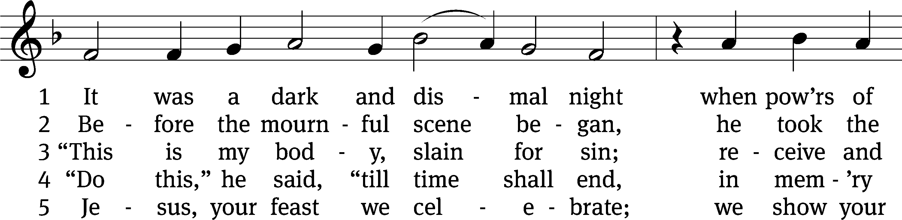
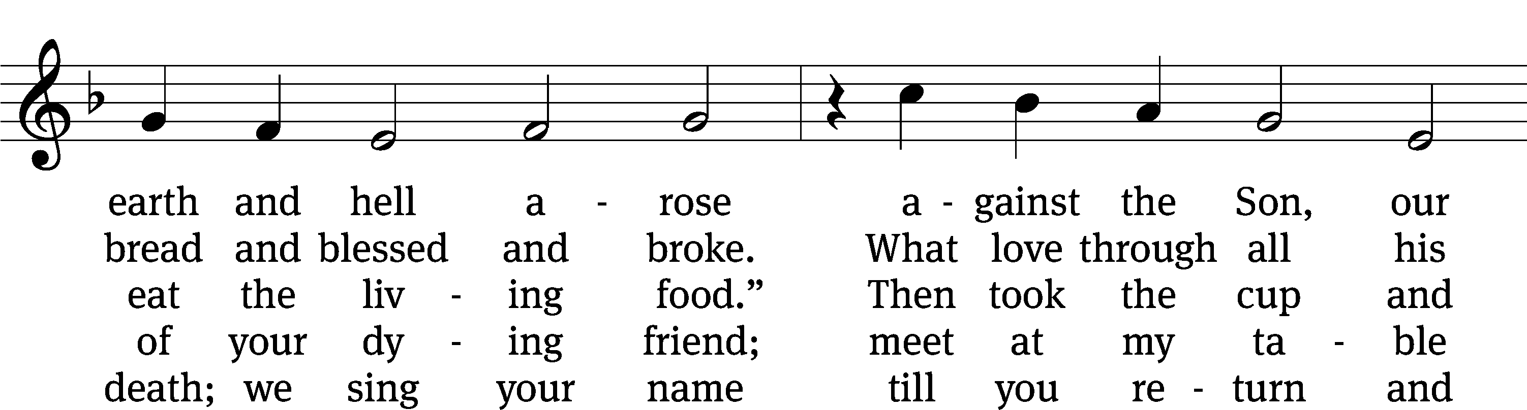
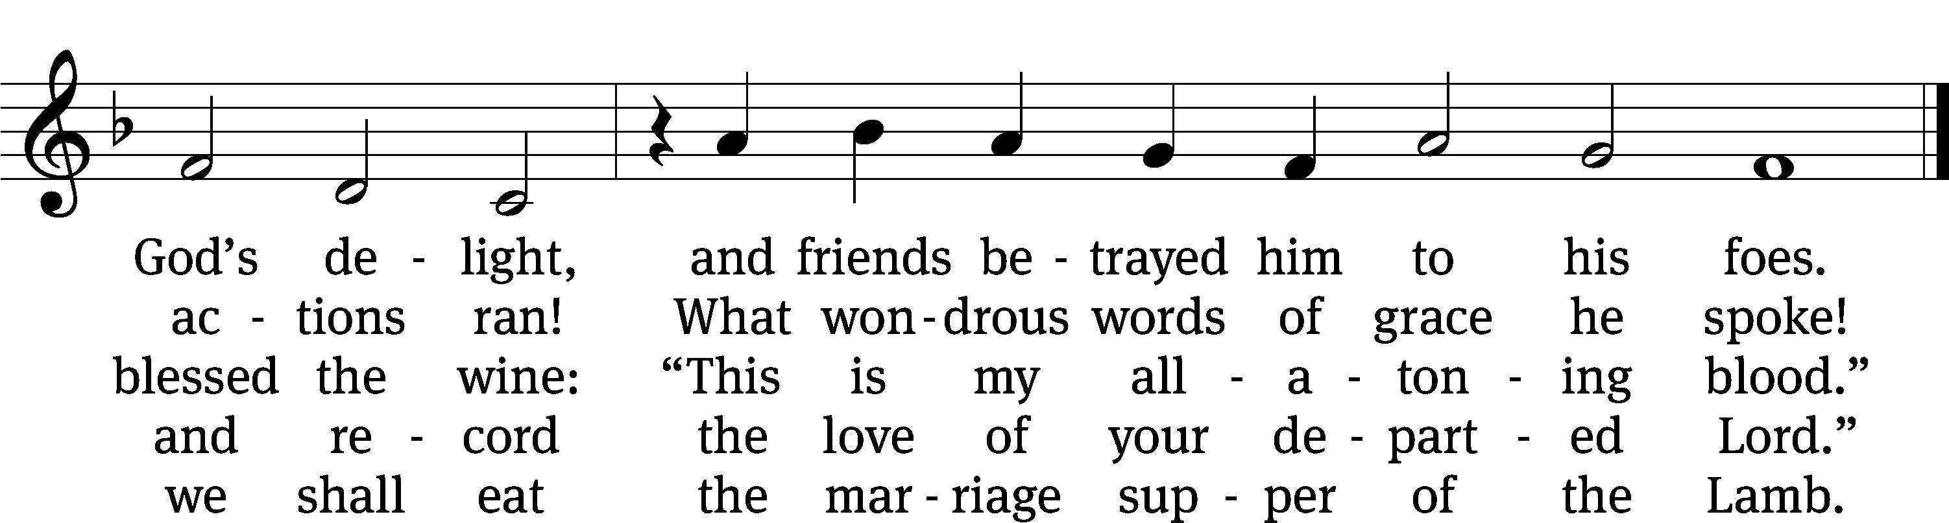
Text: Isaac Watts, 1674–1748, abr., alt.
Tune: Louis Bourgeois, c. 1510–c. 1561
Text and tune: Public domain

SERMON TEXT MATTHEW 26:20-30
“Take and Eat; Take and Drink”
²⁰ When evening came, Jesus was reclining at the table with the Twelve.
²¹ As they were eating, he said, “Amen I tell you: One of you will betray me.”
²² They were very sad and began to say to him one after another, “Surely, not I, Lord?”
²³ He replied, “The one who dipped his hand in the bowl with me will betray me. ²⁴ The Son of Man is going just as it is written about him, but woe to that man by whom the Son of Man is betrayed! It would be better for that man if he had not been born.”
²⁵ Judas, who betrayed him, replied, “Surely, not I, Rabbi?”
He said to him, “Yes, you are the one.”
²⁶ While they were eating, Jesus took bread, blessed and broke it, and gave it to the disciples. He said, “Take, eat, this is my body.” ²⁷ Then he took the cup, gave thanks, and gave it to them, saying, “Drink from it all of you, ²⁸ for this is my blood of the new testament, which is poured out for many for the forgiveness of sins. ²⁹ I tell you that I will not drink of this fruit of the vine from now until that day when I drink it new with you in my Father’s kingdom.” ³⁰ After they sang a hymn, they went out to the Mount of Olives.
(Congregation Stands)

CONFESSION OF FAITH THE NICENE CREED

We believe in one God, the Father, the Almighty,
maker of heaven and earth,
of all that is, seen and unseen.
We believe in one Lord, Jesus Christ, the only Son of God,
eternally begotten of the Father,
God from God, Light from Light, true God from true God,
begotten, not made,
of one being with the Father.
Through him all things were made.
For us and for our salvation, he came down from heaven,
was incarnate of the Holy Spirit and the virgin Mary,
and became truly human.
For our sake he was crucified under Pontius Pilate.
He suffered death and was buried.
On the third day he rose again in accordance with the Scriptures.
He ascended into heaven
and is seated at the right hand of the Father.
He will come again in glory to judge the living and the dead,
and his kingdom will have no end.
We believe in the Holy Spirit,
the Lord, the giver of life,
who proceeds from the Father and the Son,
who in unity with the Father and the Son is worshiped and glorified,
who has spoken through the prophets.
We believe in one holy Christian and apostolic Church.
We acknowledge one baptism for the forgiveness of sins.
We look for the resurrection of the dead
and the life of the world to come. Amen.

(Congregation is seated)

OFFERTORY

(Congregation Stands)

MAUNDY THURSDAY PRAYER

THE LORD’S PRAYER

Our Father, who art in heaven, hallowed be thy name, thy kingdom come, thy will be done on earth as it is in heaven. Give us this day our daily bread; and forgive us our trespasses, as we forgive those who trespass against us; and lead us not into temptation, but deliver us from evil. For thine is the kingdom and the power and the glory forever and ever. Amen.
THE WORDS OF INSTITUTION
Our Lord Jesus Christ, on the night he was betrayed, took bread; and when he had given thanks, he broke it and gave it to his disciples, saying, “Take and eat; this is my body, which is given for you. Do this in remembrance of me.”
Then he took the cup, gave thanks, and gave it to them, saying, “Drink from it, all of you; this is my blood of the new covenant, which is poured out for you for the forgiveness of sins. Do this, whenever you drink it, in remembrance of me.”

THE DISTRIBUTION OF THE SACRAMENT
677 The Death of Jesus Christ, Our Lord CW 677
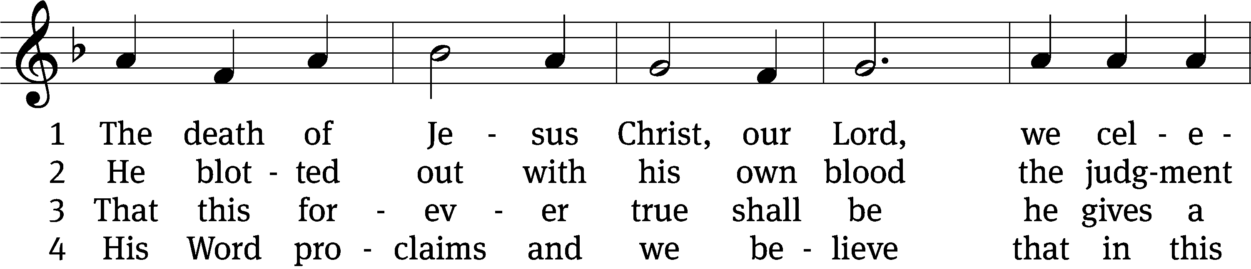
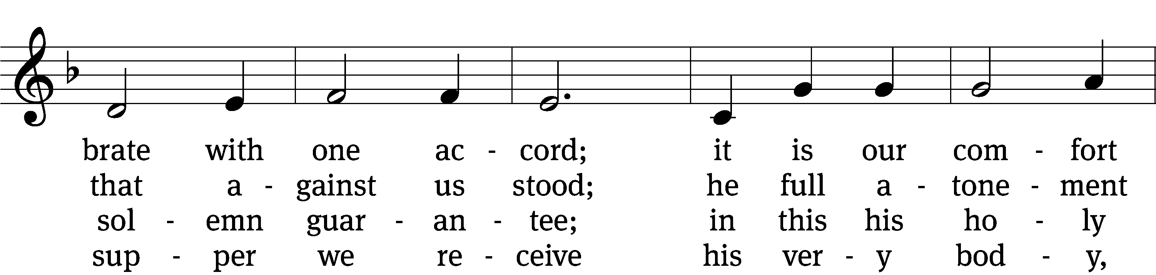
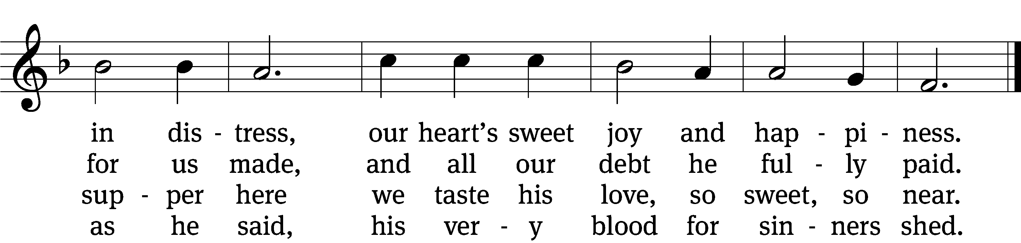

5 A precious food is this indeed,
it never fails us in our need,
a heav’nly manna for our soul
until we safely reach our goal.

6 How blest is each believing guest
who in these promises finds rest,
for Jesus will in love abide
with those who do in him confide!

7 They who his Word do not believe
this food unworthily receive,
salvation here will never find—
may we this warning keep in mind!

8 Help us sincerely to believe
that we may worthily receive
your supper and in you find rest.
Amen! They who believe are blest.
Text: tr. Olof Olsson, 1841–1900, alt.; Haquin Spegel, 1645–1714, abr.
Tune: Sammlung alter und neuer . . . Melodien, 1742
Text and tune: Public domain

THE STRIPPING OF THE ALTAR
The stripping of the altar marks the transition from the celebration of Holy Communion to the remembrance of Jesus’ crucifixion and death. Symbolically, the Lord Jesus, voluntarily stripped of his power and glory, is now in the hands of his captors. The events of Good Friday are near. Please observe this ceremony in quiet contemplation, and then depart in peace.

GETHSEMANE AND JESUS’ ARREST MATTHEW 26:36-56
³⁶ Then Jesus went with them to a place called Gethsemane. He told his disciples, “Sit here, while I go over there and pray.” ³⁷ He took with him Peter and the two sons of Zebedee, and he began to be sorrowful and distressed. ³⁸ Then he said to them, “My soul is very sorrowful, even to the point of death. Stay here, and keep watch with me.”
³⁹ He went a little farther, fell on his face, and prayed. He said, “My Father, if it is possible, let this cup pass from me. Yet not as I will, but as you will.”
⁴⁰ He came to the disciples and found them sleeping. He said to Peter, “So, were you not able to stay awake with me for one hour? ⁴¹ Watch and pray, so that you do not enter into temptation. The spirit is willing, but the flesh is weak.”
⁴² He went away a second time and prayed, “My Father, if it is not possible for this cup to pass from me unless I drink it, may your will be done.” ⁴³ Again he returned and found them sleeping, because their eyes were heavy. ⁴⁴ He left them again, went away, and prayed a third time. He said the same words as before. ⁴⁵ Then he returned to his disciples and said to them, “Are you still sleeping and resting? Look, the hour is near, and the Son of Man is betrayed into the hands of sinners. ⁴⁶ Rise. Let us go. Look, my betrayer is near.”
⁴⁷ While Jesus was still speaking, suddenly Judas (one of the Twelve) arrived. With him was a large crowd with swords and clubs, who came from the chief priests and elders of the people. ⁴⁸ Now the betrayer had given them a sign: “The one I kiss is the man. Arrest him.” ⁴⁹ Immediately he went to Jesus and said, “Greetings, Rabbi!” and kissed him.
⁵⁰ Jesus said to him, “Friend, why are you here?”
Then they advanced, took hold of Jesus, and arrested him. ⁵¹ Suddenly, one of the men with Jesus reached out his hand, drew his sword, and struck the servant of the high priest, cutting off his ear. ⁵² Then Jesus said to him, “Put your sword back into its place, because all who take the sword will die by the sword. ⁵³ Do you not realize that I could call on my Father, and at once he would provide me with more than twelve legions of angels? ⁵⁴ But then how would the Scriptures be fulfilled that say it must happen this way?”
⁵⁵ At that same time Jesus said to the crowd, “Have you come out to arrest me with swords and clubs as if I were a robber? Day after day I was sitting in the temple courts teaching, and you did not arrest me. ⁵⁶ But all this has happened so that the writings of the prophets would be fulfilled.” Then all the disciples deserted him and fled.

THE CONGREGATION LEAVES IN SILENCE

+ + +
HOLY COMMUNION, also called “the Lord’s Supper,” offers us a priceless medicine for the soul. However, we also realize from Scripture (1 Corinthians 11:23-32) that this spiritual medicine is a prescription item! Used at the wrong time or place by the wrong person for the wrong reason, the Lord’s Supper can cause immeasurable harm! Therefore we, like the corner druggist, do not dispense communion “over the counter.” Instead, we ask our guests and visitors to please speak with a pastor before coming forward for Holy Communion. We do this out of concern for souls!

AT YOUR SERVICE TONIGHT:
Officiant – Pastor William Natsis
Organist – Emily Wheeler
Accompanist – Sarah Hanke
Choir Director – Cynthia Natsis
Deacons – Dave Frey and Dave Stevenson
Altar Guild – Connie Marion and Judy Lindemann
Videographer – Cindy Dresch

HOLY WEEK SERVICES:
Good Friday Festival Service – 1:30 p.m.
Good Friday Tenebrae Service of Darkness – 8:00 p.m.
Easter Sunrise Service – 6:30 a.m.
Easter Festival Service – 9:30 a.m.

