PALM sunday

tRINITY EVANGELICAL LUTHERAN CHURCH | Saline, Michigan
April 10, 2022

WELCOME TO WORSHIP

Thank you for joining us in God’s house today! We cordially ask that our Guests with us this morning sign one of the guestbooks located at either the front or back entryways.

THANK OFFERING: Members of Trinity give their offering as an expression of love and thankfulness to the Lord and to help support the Lord’s work in our community and around the world. Visitors need not feel obligated to participate in this offering which supports our ministry.

Restrooms are located at the back of the upper level (the annex), and in the basement (down the back stairs of the sanctuary or annex). Handicap access is available, please ask an usher for assistance.

Young Families / Toddler Bags – We are GLAD YOU BROUGHT YOUR CHILDREN to our worship service. Jesus said: “Let the little children come to me and do not hinder them, for the kingdom of God belongs to such as these.” We know that having little children in church can be a challenge, but DO NOT WORRY about it. Many of your fellow worshippers have been in your shoes and are just happy you brought your children with you. For your convenience, we have reserved the back rows of seating for parents with small children. These areas provide more flexibility for your family, as well as, easy access to move downstairs if necessary. A closed-circuit TV system allows families to continue participating in the service while downstairs. Pre-school toddler bags and children’s bulletins are available for their enjoyment. Ask an usher for one to use during the service and please return the toddler bag afterwards.

SERVICE of the word

SUNDAY SCHOOL/CHOIR “HOSANNA”

OPENING HYMN CW 413
413 Hosanna, Loud Hosanna CW 413
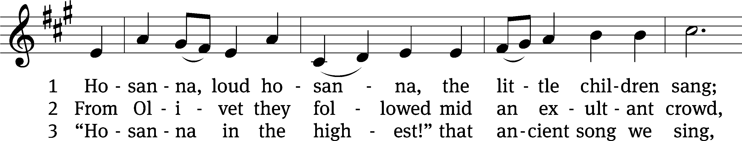
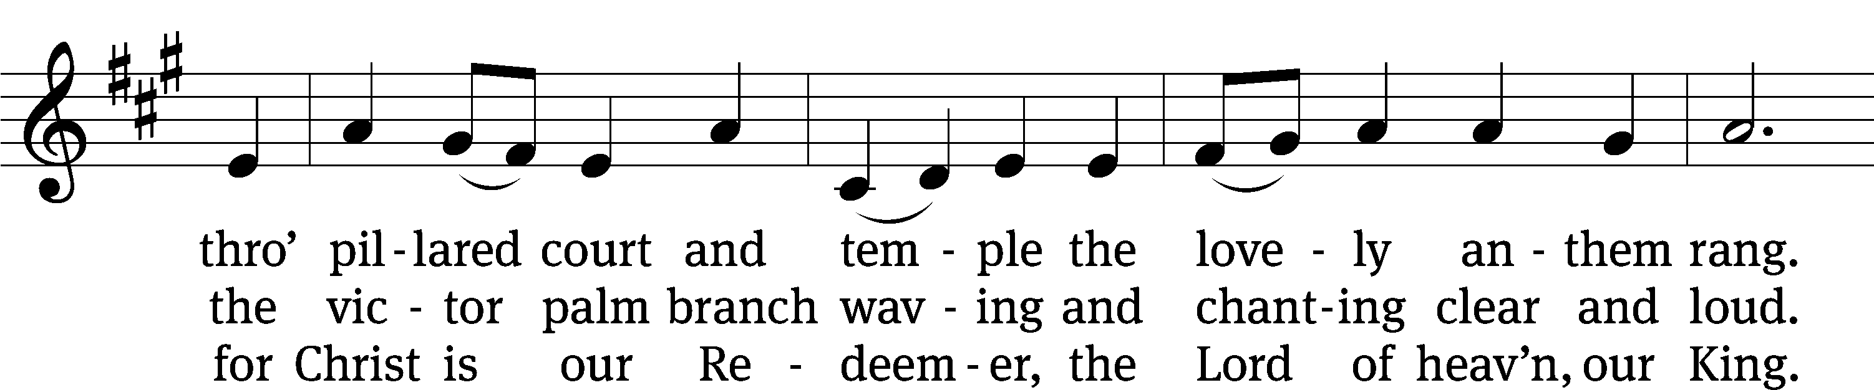
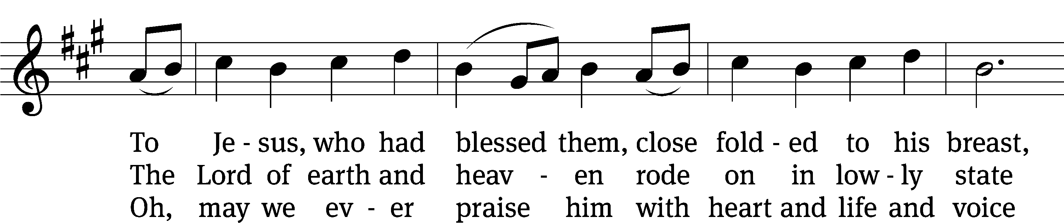
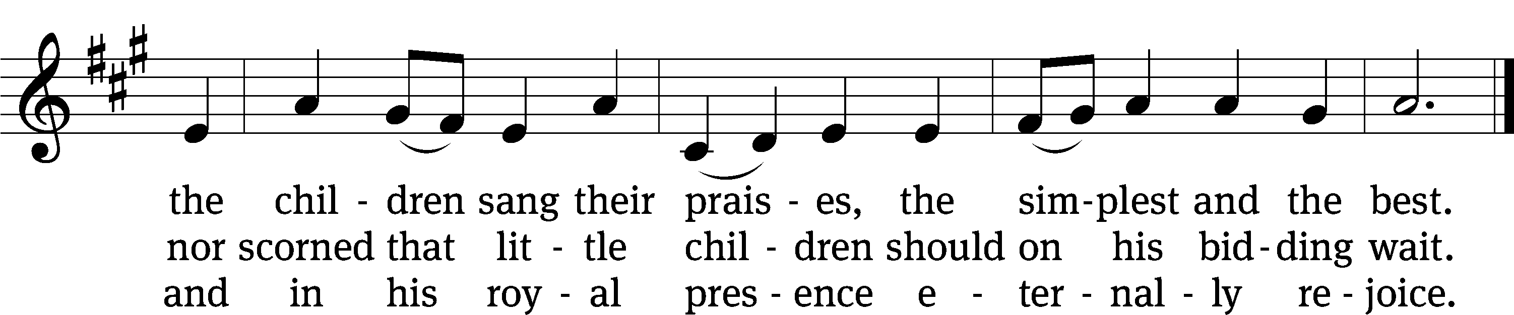
Text: Jeannette Threlfall, 1821–1880, alt.
Tune: Gesang-Buch Herzogl. Hofkapelle, Württemberg, 1784
Text and tune: Public domain

PLEASE STAND, IF YOU ARE ABLE

invocation
M: The grace of our Lord (+) Jesus Christ and the love of God and the fellowship of the Holy Spirit be with you.
C: And also with you.
CONFESSION OF SINS
M: We have come into the presence of God, who created us to love and serve him as his dear children. But we have disobeyed him and deserve only his wrath and punishment. Therefore, let us confess our sins to him and plead for his mercy.

C: Merciful Father in heaven, I am altogether sinful from birth. In countless ways I have sinned against you and do not deserve to be called your child. But trusting in Jesus, my Savior, I pray: Have mercy on me according to your unfailing love. Cleanse me from my sin, and take away my guilt.
M: God, our heavenly Father, has forgiven all your sins. By the perfect life and innocent death of our Lord Jesus Christ, he has removed your guilt forever. You are his own dear child. May God give you strength to live according to his will.

C: Amen.
PRAYER AND PRAISE

M: In the peace of forgiveness, let us praise the Lord.

OH, TASTE AND SEE

PRAYER OF THE DAY

M: Let us pray.
The minister says the Prayer of the Day.

PLEASE BE SEATED

The Word

the FIRST LESSON Isaiah 42:1-4

¹ Here is my servant, whom I uphold,
my chosen one in whom I delight.
I am placing my Spirit on him.
He will announce a just verdict^{[b]} for the nations.
² He will not cry out.
He will not raise his voice.
He will not make his voice heard in the street.
³ A bent reed he will not break,
and a dimly burning wick he will not snuff out.
He will faithfully bring forth a just verdict.
⁴ He will not burn out, and he will not be broken
until he establishes justice on the earth.
The coastlands will wait for his law.

PSALM OF THE DAY Psalm 24
24B Welcome the King Psalm 24B
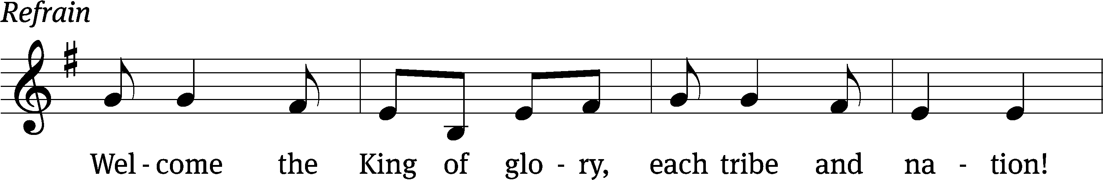
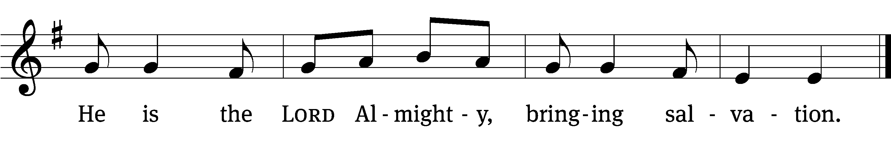
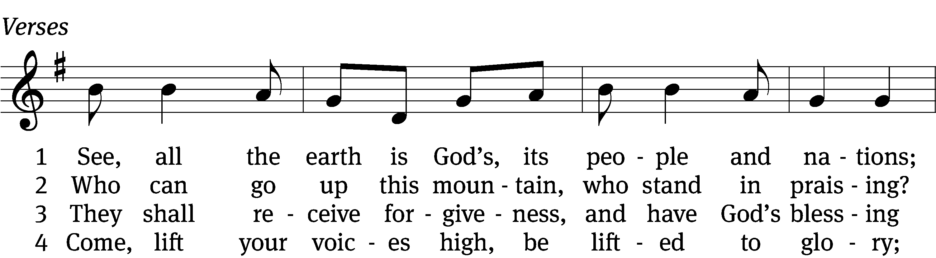
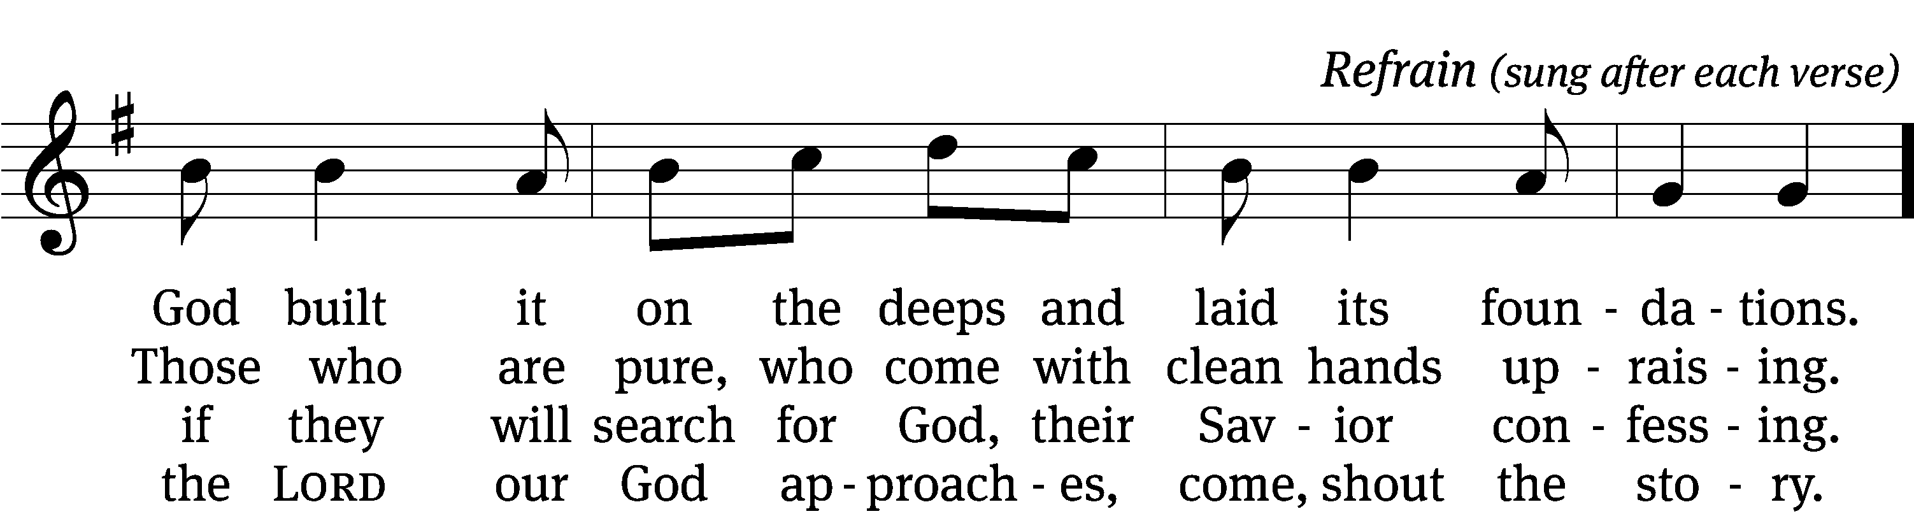

5 Who is this glorious one, for whom we are waiting?
We wait the mighty LORD, our God celebrating. (Refrain)

6 Come, lift your heads with joy; come, lift up your tower;
the King of glory comes in full might and power. (Refrain)

7 Who is this King of glory of whom we’re singing?
Our God, this LORD of hosts, the vict’ry is bringing. (Refrain)

Text (sts. 1–7): Arlo D. Duba; (Ref): Northwestern Publishing House
Tune: Israeli
Text (sts. 1–7): © 1986 Arlo D. Duba. Used by permission: License no. 130003540
Text (Ref): © 2021 Northwestern Publishing House. Used by permission: OneLicense no. 727703
Tune: Public domain
THE SECOND LESSON PHILIPPIANS 2:5-11

⁵ Indeed, let this attitude be in you, which was also in Christ Jesus. ⁶ Though he was by nature God, he did not consider equality with God as a prize to be displayed, ⁷ but he emptied himself by taking the nature^{[d]} of a servant. When he was born in human likeness, and his appearance was like that of any other man,^{[e]} ⁸ he humbled himself and became obedient to the point of death—even death on a cross. ⁹ Therefore God also highly exalted him and gave him the name that is above every name, ¹⁰ so that at the name of Jesus every knee will bow, in heaven and on earth and under the earth, ¹¹ and every tongue will confess that Jesus Christ is Lord, to the glory of God the Father.

PLEASE Stand, if you are able

THE GOSPEL LESSON LUKE 19:28-40
M: The Gospel according to Luke chapter 19, verses 28-40
²⁸ After Jesus had said these things, he went on ahead, going up to Jerusalem. ²⁹ As he came near to Bethphage and Bethany, at the place called the Mount of Olives, he sent two of his disciples ahead, ³⁰ saying, “Go to the village ahead of you. When you enter it, you will find a colt tied, on which no one has ever sat. Untie it and bring it here. ³¹ And if anyone asks you, ‘Why are you untying it?’ you will say this: ‘The Lord needs it.’”
³² Those who were sent ahead went and found things just as he had told them. ³³ As they were untying the colt, its owners said to them, “Why are you untying the colt?”
³⁴ They said, “The Lord needs it.”
³⁵ Then they brought the colt to Jesus. They threw their robes on the colt and set Jesus on it. ³⁶ As he went along, people spread their robes on the road. ³⁷ As he was approaching the slope of the Mount of Olives, the whole crowd of disciples began to praise God joyfully, with a loud voice, for all the miracles they had seen, ³⁸ saying, “Blessed is the King who comes in the name of the Lord!^{[a]} Peace in heaven and glory in the highest!”
³⁹ Some of the Pharisees from the crowd said to him, “Teacher, rebuke your disciples!”
⁴⁰ He replied, “I tell you, if these people would be silent, the stones would cry out.”

M: This is the Gospel of the Lord.

PLEASE BE SEATED

SERMON HYMN 412 CW
412 All Glory, Laud, and Honor CW 412
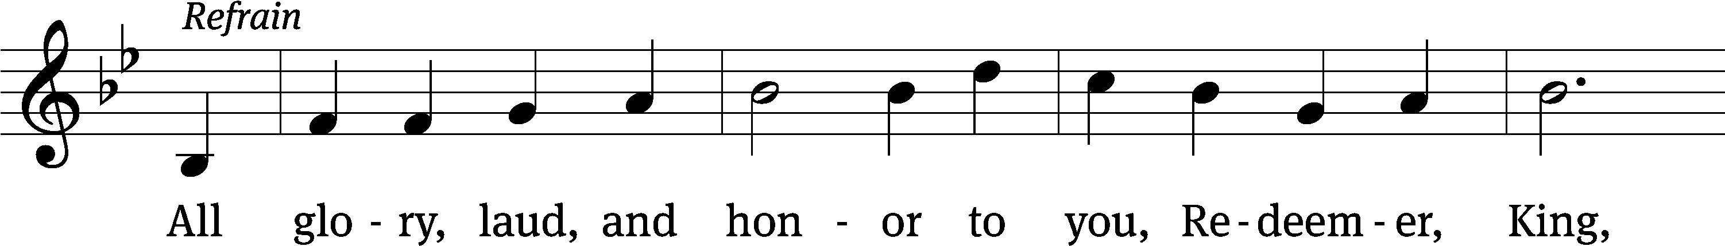
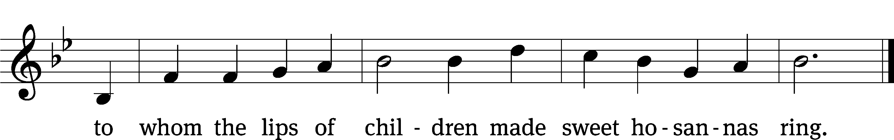
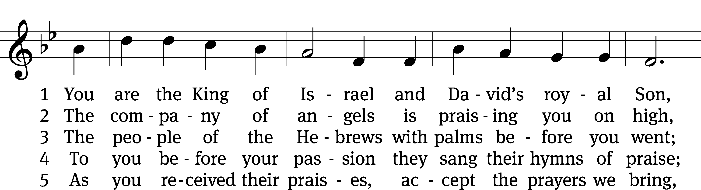
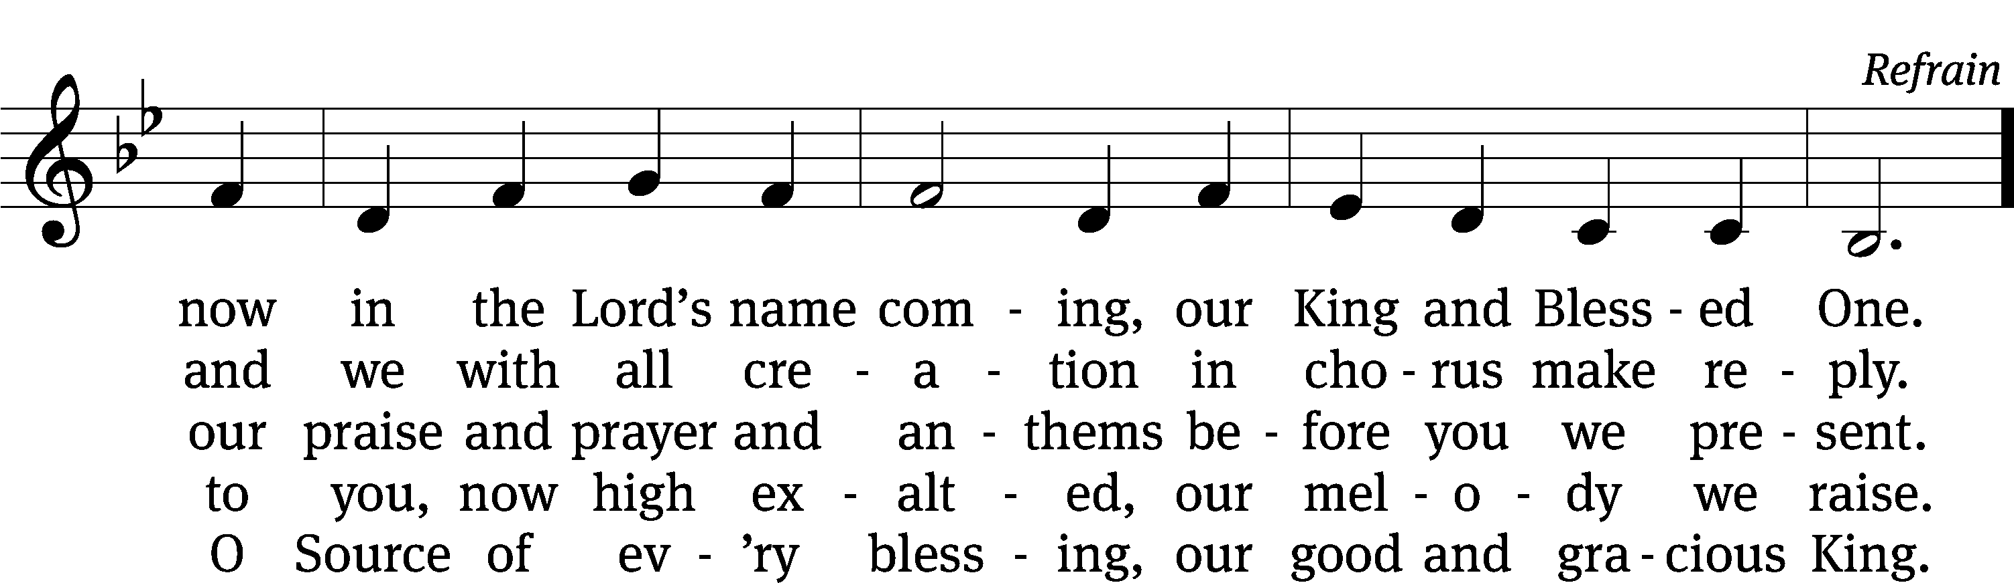

Text: tr. John Mason Neale, 1818–1866, alt.; Theodulph of Orleans, c. 762–821
Tune: Melchior Teschner, 1584–1635, alt.
Text and tune: Public domain
SERMON Matthew 21:1-11
“Listen to the Lessons about the Lord”
From the donkey, from the palm branches, and from the hosannas
As they approached Jerusalem and came to Bethphage on the Mount of Olives, Jesus sent two disciples, ² telling them, “Go to the village ahead of you. Immediately you will find a donkey tied there along with her colt. Untie them and bring them to me. ³ If anyone says anything to you, you are to say, ‘The Lord needs them,’ and he will send them at once.” ⁴ This took place to fulfill what was spoken through the prophet: ⁵ Tell the daughter of Zion: Look, your King comes to you, humble, and riding on a donkey, on a colt, the foal of a donkey.
⁶ The disciples went and did just as Jesus commanded them. ⁷ They brought the donkey and the colt, laid their outer clothing on them, and he sat on it. ⁸ A very large crowd spread their outer clothing on the road. Others were cutting branches from the trees and spreading them out on the road. ⁹ The crowds who went in front of him and those who followed kept shouting, “Hosanna to the Son of David! Blessed is he who comes in the name of the Lord! Hosanna in the highest!”
¹⁰ When he entered Jerusalem, the whole city was stirred up, asking, “Who is this?” ¹¹ And the crowds were saying, “This is Jesus, the prophet from Nazareth in Galilee.”

PLEASE STAND, IF YOU ARE ABLE

THE APOSTLES’ CREED
I believe in God, the Father almighty,
maker of heaven and earth.
I believe in Jesus Christ, his only Son, our Lord,
who was conceived by the Holy Spirit,
born of the virgin Mary,
suffered under Pontius Pilate,
was crucified, died, and was buried.
He descended into hell.
The third day he rose again from the dead.
He ascended into heaven
and is seated at the right hand of God the Father almighty.
From there he will come to judge the living and the dead.
I believe in the Holy Spirit,
the holy Christian Church,
the communion of saints,
the forgiveness of sins,
the resurrection of the body,
and the life everlasting. Amen.
PRAYER OF THE CHURCH

THE LORD’S PRAYER

C: Our Father, who art in heaven, hallowed be thy name, thy kingdom come, thy will be done on earth as it is in heaven. Give us this day our daily bread; and forgive us our trespasses, as we forgive those who trespass against us; and lead us not into temptation, but deliver us from evil. For thine is the kingdom and the power and the glory forever and ever. Amen.

PLEASE BE SEATED
414 No Tramp of Soldiers’ Marching Feet CW 414
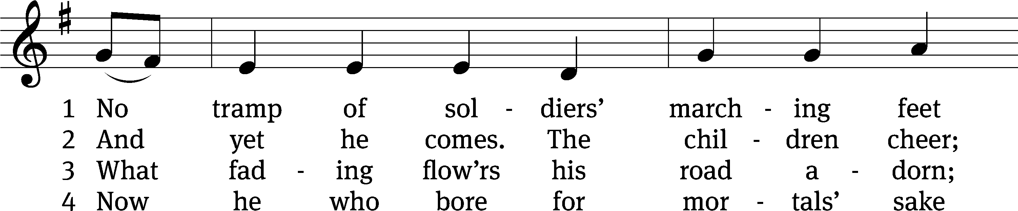
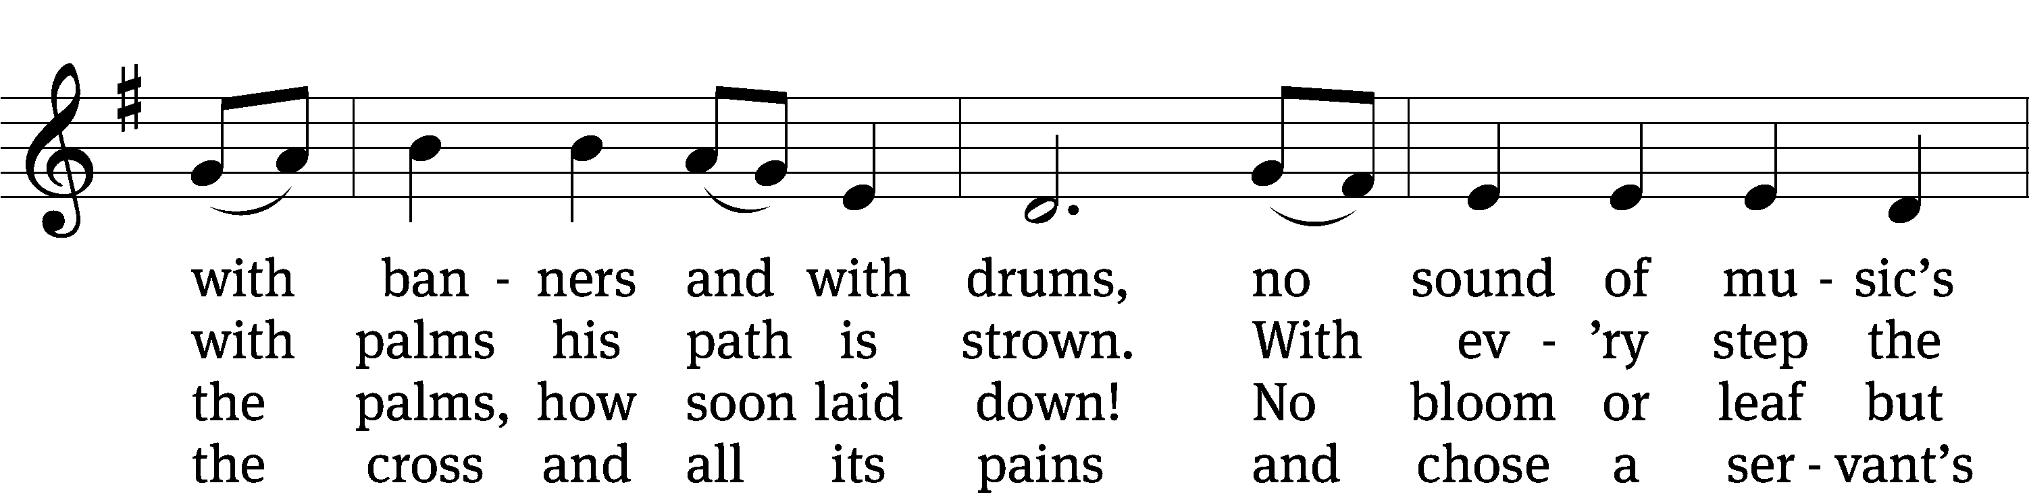
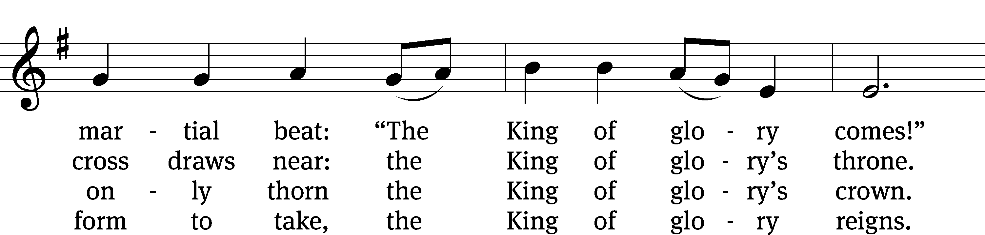
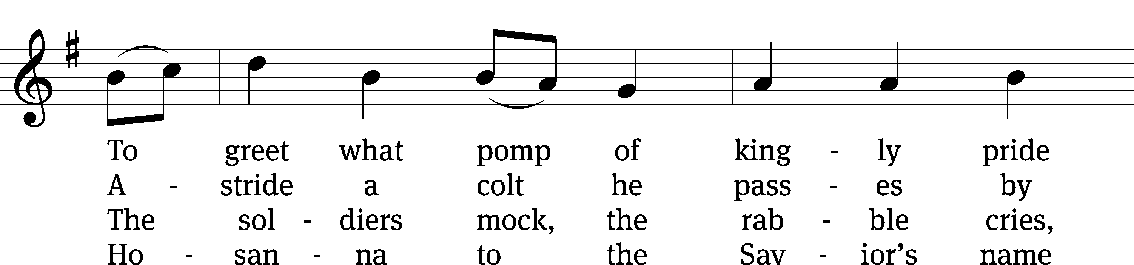
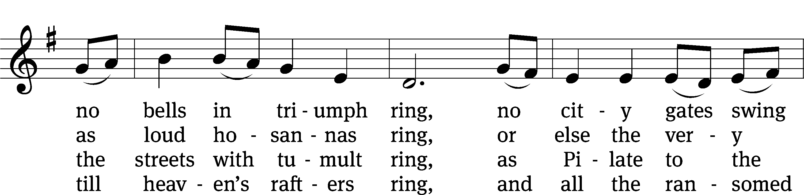
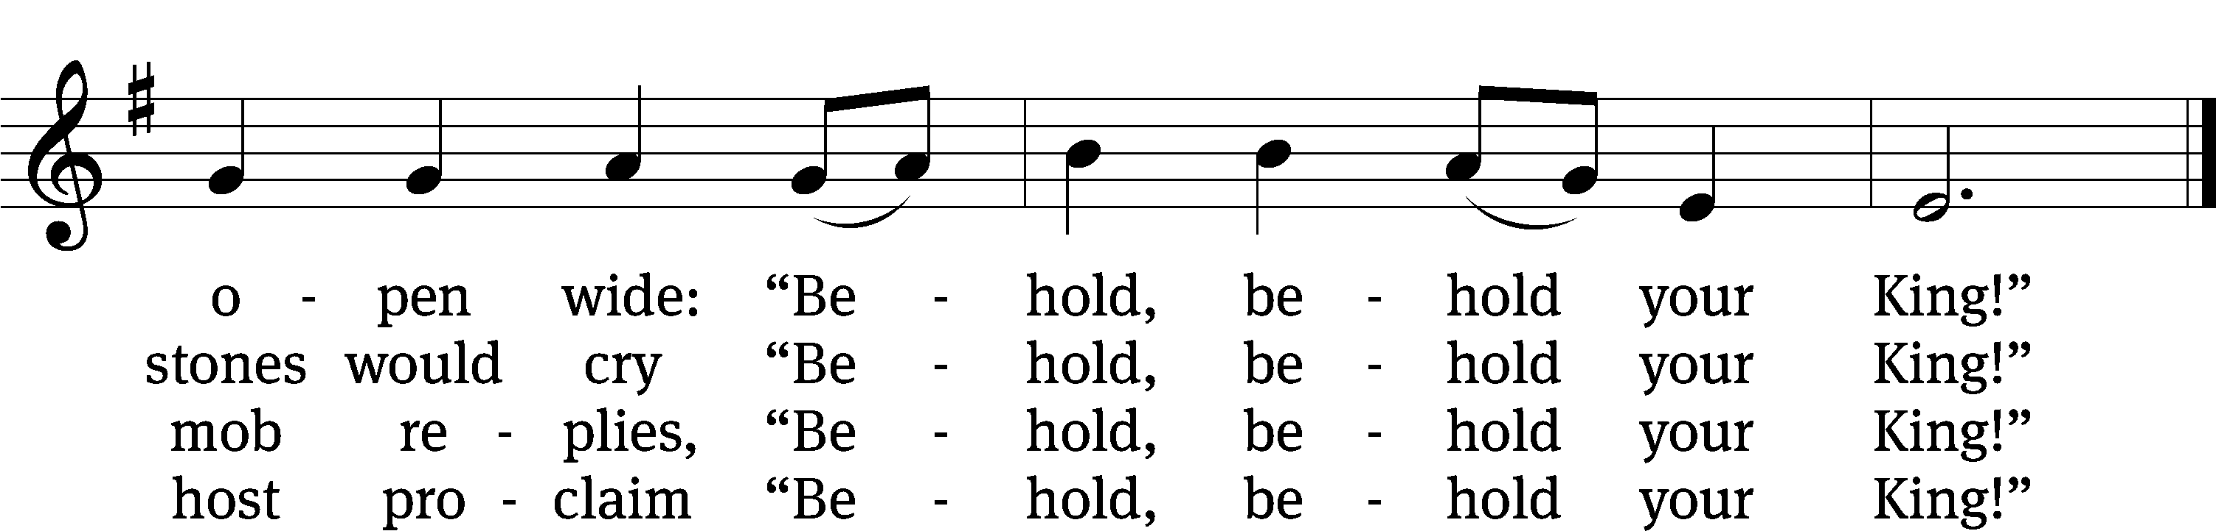
Text: Timothy Dudley-Smith, b. 1926
Tune: English; adapt. Ralph Vaughan Williams, 1872–1958
Text: © 1984 Hope Publishing Co. Used by permission: OneLicense no. 727703
Tune: Public domain

PLEASE STAND, IF YOU ARE ABLE

CLOSING PRAYER
M: Almighty God, we thank you for teaching us the things you want us to believe and do. Help us by your Holy Spirit to keep your Word in pure hearts that we may be strengthened in faith, guided in holiness, and comforted in life and in death, through Jesus Christ, our Lord, who lives and reigns with you and the Holy Spirit, one God, now and forever.

M: Brothers and sisters, go in peace. Live in harmony with one another. Serve the Lord with gladness.
The Lord bless you and keep you.
The Lord make his face shine on you and be gracious to you.
The Lord look on you with favor and (+) give you peace.

PLEASE BE SEATED
411 Ride On, Ride On in Majesty CW 411
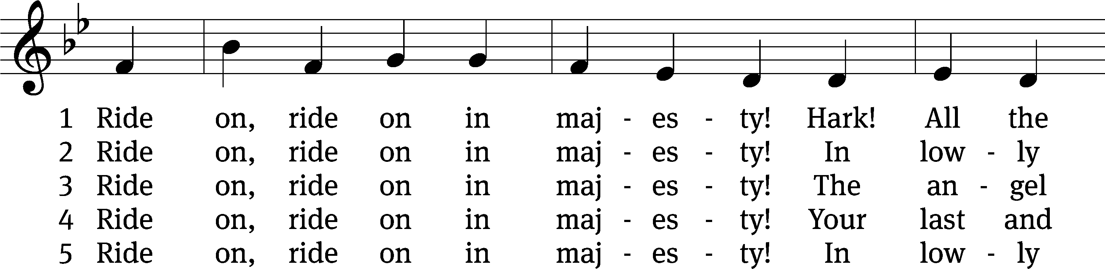
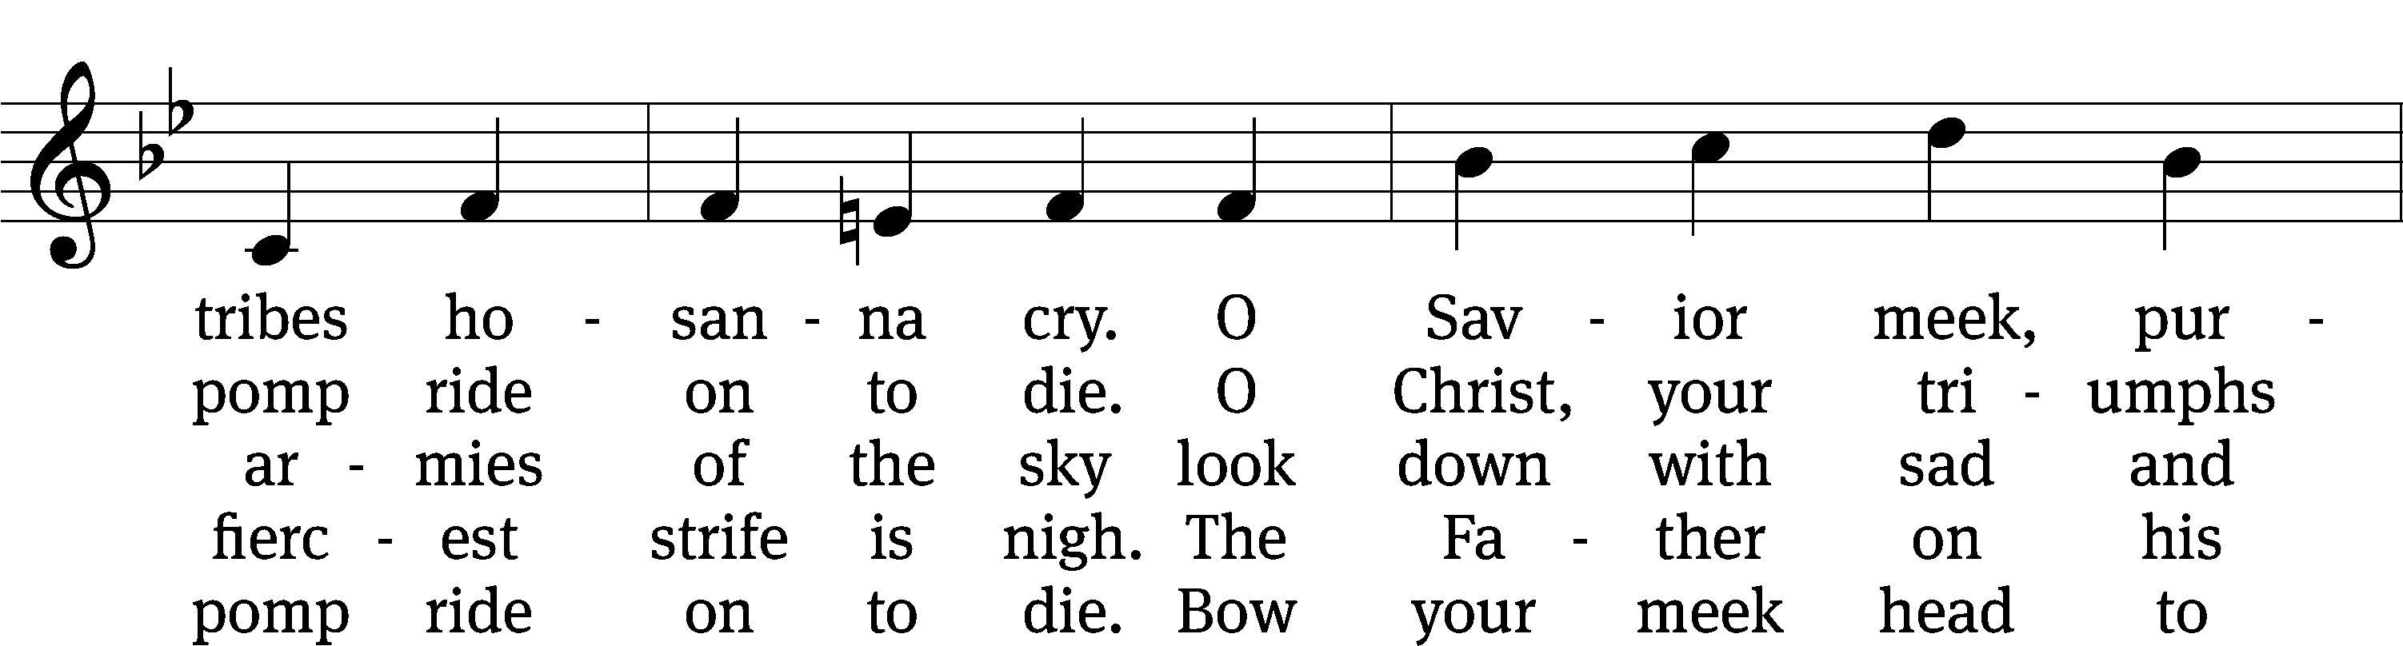
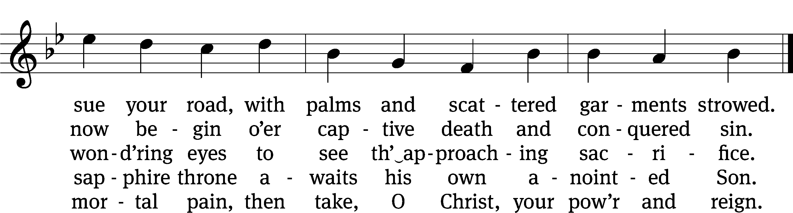

Text: Henry H. Milman, 1791–1868, alt.
Tune: Musicalisch Hand-Buch der Geistlichen Melodien, Hamburg, 1690, alt.
Text and tune: Public domain

Serving In Worship
Officiant Pastor William Natsis
Organist Marcia Marion Ackling
Accompanist Laura Sala
Choir Director Cynthia Natsis
Deacons (8:30) Jim Tice and Dave Stevenson
(11:00) Steve Hoeft and Jeff Neuburger
Ushers (8:30) Dale Finkbeiner and Mark Finkbeiner
(11:00) Ed Sala and Al Whitley
Altar Guild Shirley Klumpp and Ann Latowski
Videographer Rick Schneider

Copyright information
Service of the Word: Christian Worship. © 1993 Northwestern Publishing House. All rights reserved.
Reprinted with permission under ONE LICENSE #A-727703 and CCLI #1151741/CSPL126093

Words and Music: All rights reserved. Reprinted with permission under ONE LICENSE #A-727703 and
CCLI #1151741/CSPL126093

tlcsaline.church

