THE SIXTH SUNDAY
after epiphany
tRINITY EVANGELICAL LUTHERAN CHURCH | Saline, Michigan
February 12, 2023

WELCOME TO WORSHIP

Thank you for joining us in God’s house today! We cordially ask that our Guests with us this morning sign one of the guestbooks located at either the front or back entryways.

THANK OFFERING: Members of Trinity give their offering as an expression of love and thankfulness to the Lord and to help support the Lord’s work in our community and around the world. Visitors need not feel obligated to participate in this offering which supports our ministry.

Restrooms are located at the back of the upper level (the annex), and in the basement (down the back stairs of the sanctuary or annex). Handicap access is available, please ask an usher for assistance.

Young Families / Toddler Bags – We are GLAD YOU BROUGHT YOUR CHILDREN to our worship service. Jesus said: “Let the little children come to me and do not hinder them, for the kingdom of God belongs to such as these.” We know that having little children in church can be a challenge, but DO NOT WORRY about it. Many of your fellow worshippers have been in your shoes and are just happy you brought your children with you. For your convenience, we have reserved the back rows of seating for parents with small children. These areas provide more flexibility for your family, as well as, easy access to move downstairs if necessary. A closed-circuit TV system allows families to continue participating in the service while downstairs. Pre-school toddler bags and children’s bulletins are available for their enjoyment. Ask an usher for one to use during the service and please return the toddler bag afterwards.

SERVICE of the word
728 This Is My Will CW 728
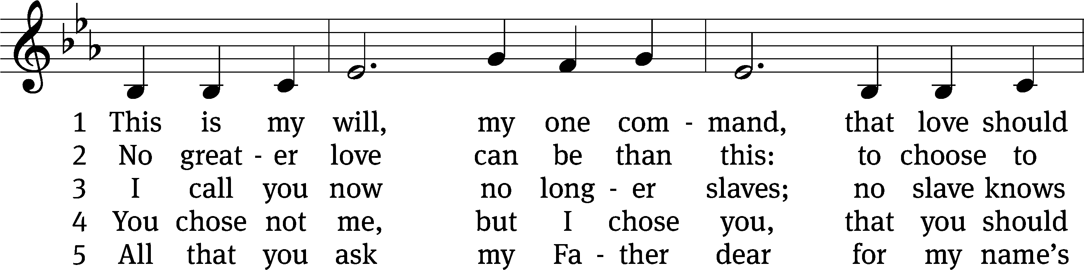
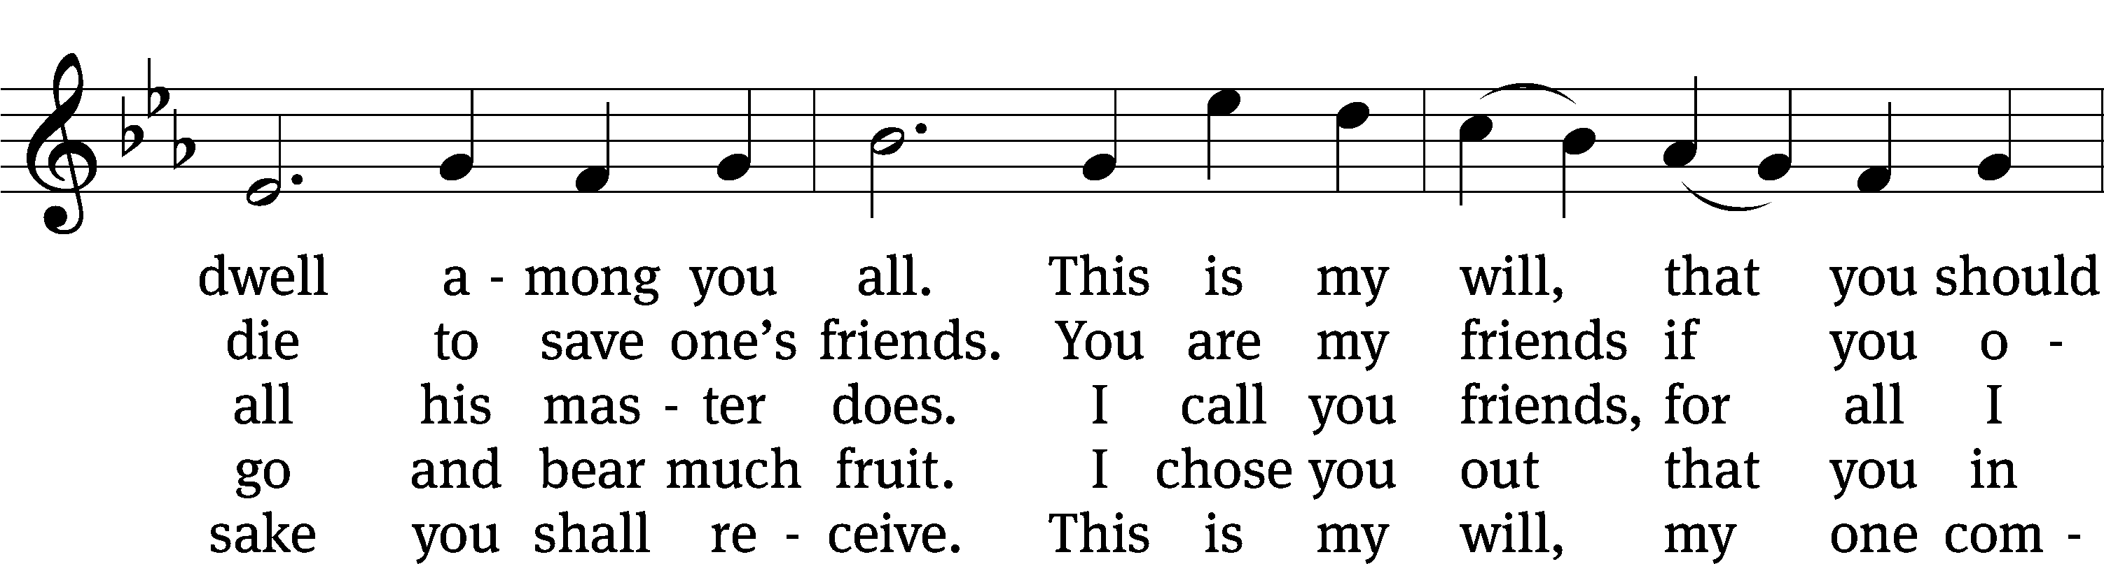
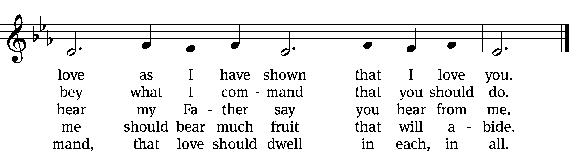
Text: James Quinn, SJ, 1919–2010, alt.
Tune: Gaelic, 19th cent.
Text: © 1969 James Quinn, SJ, admin. OCP Publications. Used by permission: OneLicense no. 727703
Tune: Public domain

PLEASE STAND, IF YOU ARE ABLE

invocation
M: The grace of our Lord (+) Jesus Christ and the love of God and the fellowship of the Holy Spirit be with you.
C: And also with you.

CONFESSION OF SINS
M: We have come into the presence of God, who created us to love and serve him as his dear children. But we have disobeyed him and deserve only his wrath and punishment. Therefore, let us confess our sins to him and plead for his mercy.

C: Merciful Father in heaven, I am altogether sinful from birth. In countless ways I have sinned against you and do not deserve to be called your child. But trusting in Jesus, my Savior, I pray: Have mercy on me according to your unfailing love. Cleanse me from my sin, and take away my guilt.

M: God, our heavenly Father, has forgiven all your sins. By the perfect life and innocent death of our Lord Jesus Christ, he has removed your guilt forever. You are his own dear child. May God give you strength to live according to his will.

C: Amen.
PRAYER AND PRAISE

M: In the peace of forgiveness, let us praise the Lord.

OH, TASTE AND SEE

PRAYER OF THE DAY

Let us pray.

Lord God, in mercy receive the prayers of your people. Grant them the wisdom to know the things that please you and the grace and power always to accomplish them; through your Son, Jesus Christ our Lord, who lives and reigns with you and the Holy Spirit, one God, now and forever.

PLEASE BE SEATED

The Word

the FIRST LESSON 2 Samuel 11:1-17, 26-27
¹ Springtime arrived, the time when kings go out to war. David sent Joab out with his officers and with all Israel. They ravaged the Ammonites and besieged Rabbah. But David stayed in Jerusalem.
² One evening David had gotten up from his couch and was walking around on the roof of the palace. From the roof he saw a woman bathing. The woman was very good looking. ³ David sent to inquire about the woman, and he was told, “Isn’t this Bathsheba daughter of Eliam, the wife of Uriah the Hittite?”
⁴ David sent messengers to bring her. She came to him, and he lay down with her. (She had been purifying herself from her ceremonial uncleanness.) She then returned to her house.
⁵ The woman became pregnant, so she sent a message and told David, “I am pregnant.”
⁶ David sent a message to Joab, “Send Uriah the Hittite to me.” So Joab sent Uriah to David, ⁷ and Uriah came to him.
David asked how Joab and the troops were doing, and how the war effort was going. ⁸ Then David said to Uriah, “Go down to your house and wash your feet.”
When Uriah went out from the palace, the king sent a gift to him. ⁹ But Uriah slept at the entrance to the palace with all the servants of his master. He did not go down to his own house.
¹⁰ David was informed, “Uriah has not gone down to his house.” So David said to Uriah, “Haven’t you come a long distance? Why didn’t you go down to your house?”
¹¹ Uriah said to David, “The ark and Israel and Judah are living in shelters, and my master Joab and the servants of my master are camped on the bare ground in the open countryside. Should I go to my house to eat and to drink and to lie down with my wife? By your life, as surely as you live, I will not do such a thing.”
¹² Then David said to Uriah, “Stay here today also. Tomorrow I will send you back.” So Uriah remained in Jerusalem that day and the next. ¹³ David summoned him, and Uriah ate as his guest, and David got him drunk. But in the evening he went and slept on his mat where the servants of his master were. He did not go to his own house.
¹⁴ In the morning David wrote a letter to Joab, and he sent it in the hands of Uriah. ¹⁵ In the letter he wrote, “Station Uriah opposite the fiercest fighting. Then withdraw from behind him so that he will be struck down and die.”
¹⁶ So when Joab was besieging the city, he assigned Uriah to a place where he knew that the enemy’s strongest warriors were. ¹⁷ The men of the city came out and fought against Joab, and some of the troops of David fell. Uriah the Hittite also died.
²⁶ The wife of Uriah the Hittite heard that her husband was dead, so she mourned for her husband. ²⁷ When her mourning was completed, David sent for her and brought her to his house, and she became his wife. She gave birth to a son for him. But what David had done was evil in the eyes of the Lord.

119A Teach Me, O LORD Psalm 119A
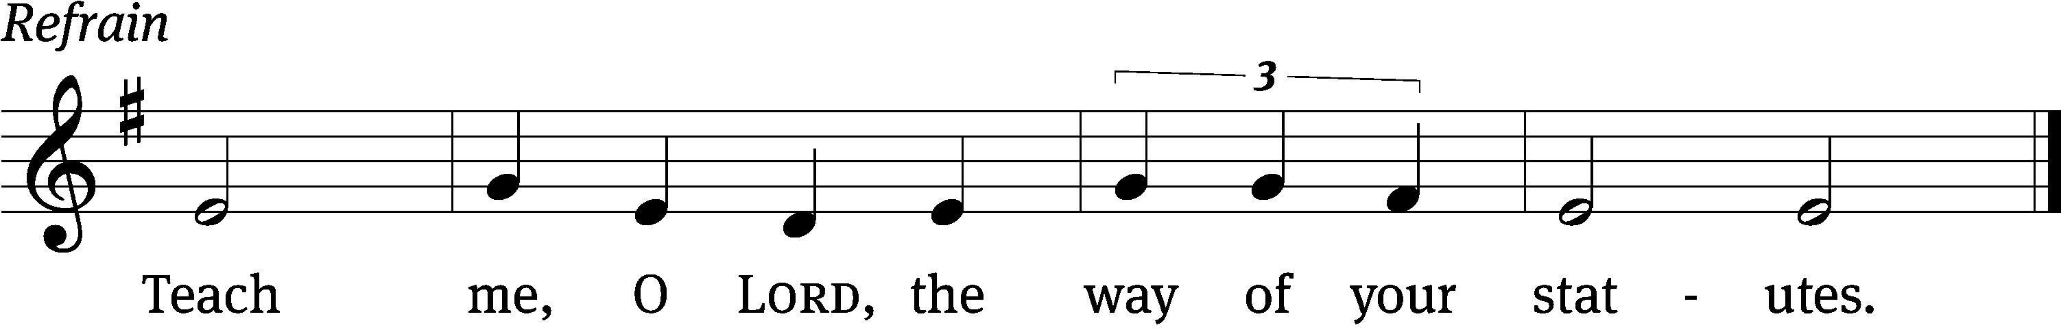

Blessed are those whose ways are / blameless,
who walk according to the law / of the Lord.
Blessed are those who keep his / statutes
and seek him with / all their heart.
You have laid down / precepts
that are to be ful- / ly obeyed. Refrain

Oh, that my ways were / steadfast
in obeying / your decrees!
Then I would not be / put to shame
when I consider all / your commands.
I will praise you with an / upright heart
as I learn your / righteous laws.
Glory be to the Father and / to the Son
and to the Holy / Spirit,
as it was in the be- / ginning,
is now, and will be forever. / Amen. Refrain
Tune: Thomas Pavlechko
Setting: Thomas Pavlechko
Music: © 2004, 2012 Augsburg Fortress. Used by permission: OneLicense no. 727703

THE SECOND LESSON 1 Thessalonians 4:1-12

¹ Therefore, beyond this, brothers, just as you received instruction from us about how you are to walk so as to please God (as indeed you are doing), we ask and urge you in the Lord Jesus that you do so even more. ² To be sure, you know what instructions we gave you through the Lord Jesus. ³ Indeed, this is God’s will: that you be sanctified, namely, that you keep yourselves away from sexual immorality. ⁴ He wants each of you to learn to obtain a wife for yourself in a way that is holy and honorable, ⁵ not in lustful passion like the heathen, who do not know God. ⁶ No one is to overstep and take advantage of his brother in this matter, because the Lord is an avenger in all these things, just as we said previously and solemnly testified to it. ⁷ For God did not call us for uncleanness, but in sanctification. ⁸ Consequently, whoever rejects this is not rejecting a man, but the God who gives you his Holy Spirit.
⁹ Concerning brotherly love, there is no need to write to you, for you yourselves have been taught by God, with the result that you love one another. ¹⁰ In fact, you are doing so toward all the brothers throughout Macedonia. But we encourage you, brothers, to do this even more, ¹¹ and to make it your ambition to live a quiet life, to mind your own business, and to work with your own hands, just as we instructed you. ¹² Do this so that you are conducting yourselves decently toward outsiders and are not lacking anything.

please stand, if you are able

Verse of the day

Alleluia. Christ loved us and gave himself for us as a fragrant offering and sacrifice to God. Alleluia. (Ephesians 5:2)

THE GOSPEL LESSON Matthew 5:21-37

M: The Gospel according to Matthew chapter 5, verses 21-37
²¹ “You have heard that it was said to people long ago, ‘You shall not murder, and whoever murders will be subject to judgment.’ ²² But I tell you that everyone who is angry with his brother without a cause will be subject to judgment, and whoever says to his brother, ‘Raca,’ will have to answer to the Sanhedrin. But whoever says, ‘You fool!’ will be in danger of hell fire.
²³ “So if you are about to offer your gift at the altar, and there you remember that your brother has something against you, ²⁴ leave your gift there in front of the altar and go. First be reconciled to your brother. Then come and offer your gift.
²⁵ “If someone accuses you, reach an agreement with him quickly, while you are with him on the way. Otherwise your accuser may bring you to the judge, and the judge may hand you over to the officer, and you will be thrown into prison. ²⁶ Amen I tell you: You will never get out until you have paid the last penny.
²⁷ “You have heard that it was said, ‘You shall not commit adultery,’ ²⁸ but I tell you that everyone who looks at a woman with lust has already committed adultery with her in his heart. ²⁹ If your right eye causes you to fall into sin, pluck it out and throw it away from you. It is better for you to lose one part of your body than for your whole body to be thrown into hell. ³⁰ If your right hand causes you to fall into sin, cut it off and throw it away from you. It is better for you to lose one part of your body than for your whole body to be thrown into hell.
³¹ “It was also said, ‘Whoever divorces his wife must give her a certificate of divorce.’ ³² But I tell you that whoever divorces his wife, except for sexual immorality, causes her to be regarded as an adulteress. And whoever marries the divorced woman is regarded as an adulterer.
³³ “Again you have heard that it was said to people long ago, ‘Do not break your oaths, but fulfill your vows to the Lord.’ ³⁴ But I tell you, do not swear at all: not by heaven, because it is God’s throne; ³⁵ and not by earth, because it is his footstool; and not by Jerusalem, because it is the city of the great King. ³⁶ And do not swear by your own head, since you cannot make one hair white or black. ³⁷ Instead, let your statement be, ‘Yes, yes,’ or ‘No, no.’ Whatever goes beyond these is from the Evil One.

M: This is the Gospel of the Lord.

PLEASE BE SEATED

695 Take My Life and Let It Be CW 695
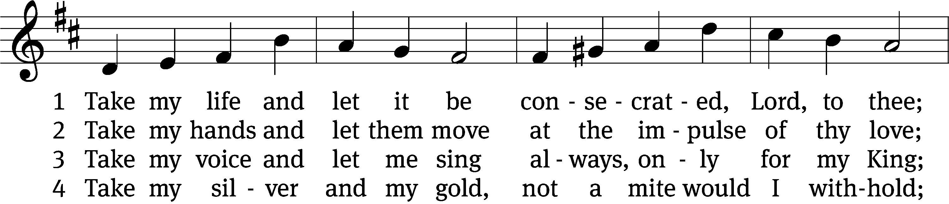
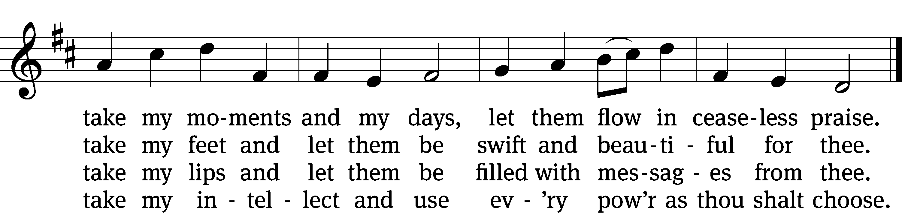

5 Take my will and make it thine,
it shall be no longer mine;
take my heart, it is thine own,
it shall be thy royal throne.

6 Take my love, my Lord, I pour
at thy feet its treasure store;
take myself, and I will be
ever, only, all for thee.
Text: Frances R. Havergal, 1836–1879
Tune: William H. Havergal, 1793–1870
Text and tune: Public domain

SERMON Matthew 5:21-37
“Lines in the Sand; Ours and God’s”

PLEASE STAND, IF YOU ARE ABLE

THE APOSTLES’ CREED
I believe in God, the Father almighty,
maker of heaven and earth.
I believe in Jesus Christ, his only Son, our Lord,
who was conceived by the Holy Spirit,
born of the virgin Mary,
suffered under Pontius Pilate,
was crucified, died, and was buried.
He descended into hell.
The third day he rose again from the dead.
He ascended into heaven
and is seated at the right hand of God the Father almighty.
From there he will come to judge the living and the dead.
I believe in the Holy Spirit,
the holy Christian Church,
the communion of saints,
the forgiveness of sins,
the resurrection of the body,
and the life everlasting. Amen.

PRAYER OF THE CHURCH

THE LORD’S PRAYER

C: Our Father, who art in heaven, hallowed be thy name, thy kingdom come, thy will be done on earth as it is in heaven. Give us this day our daily bread; and forgive us our trespasses, as we forgive those who trespass against us; and lead us not into temptation, but deliver us from evil. For thine is the kingdom and the power and the glory forever and ever. Amen.

PLEASE BE SEATED

404 Jesus, Grant That Balm and Healing CW 404
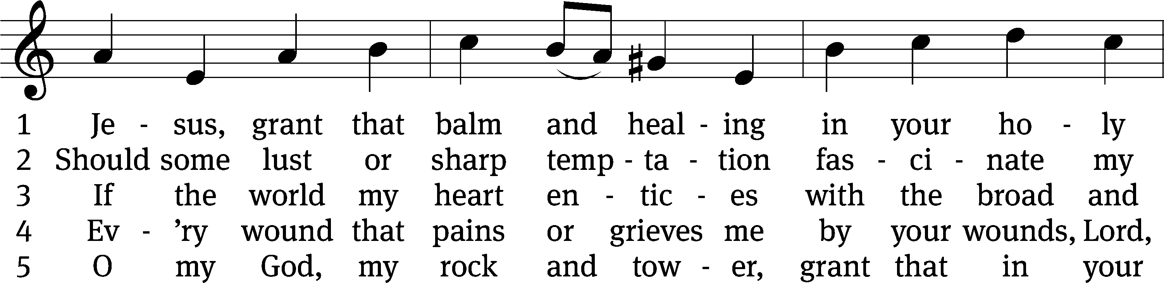
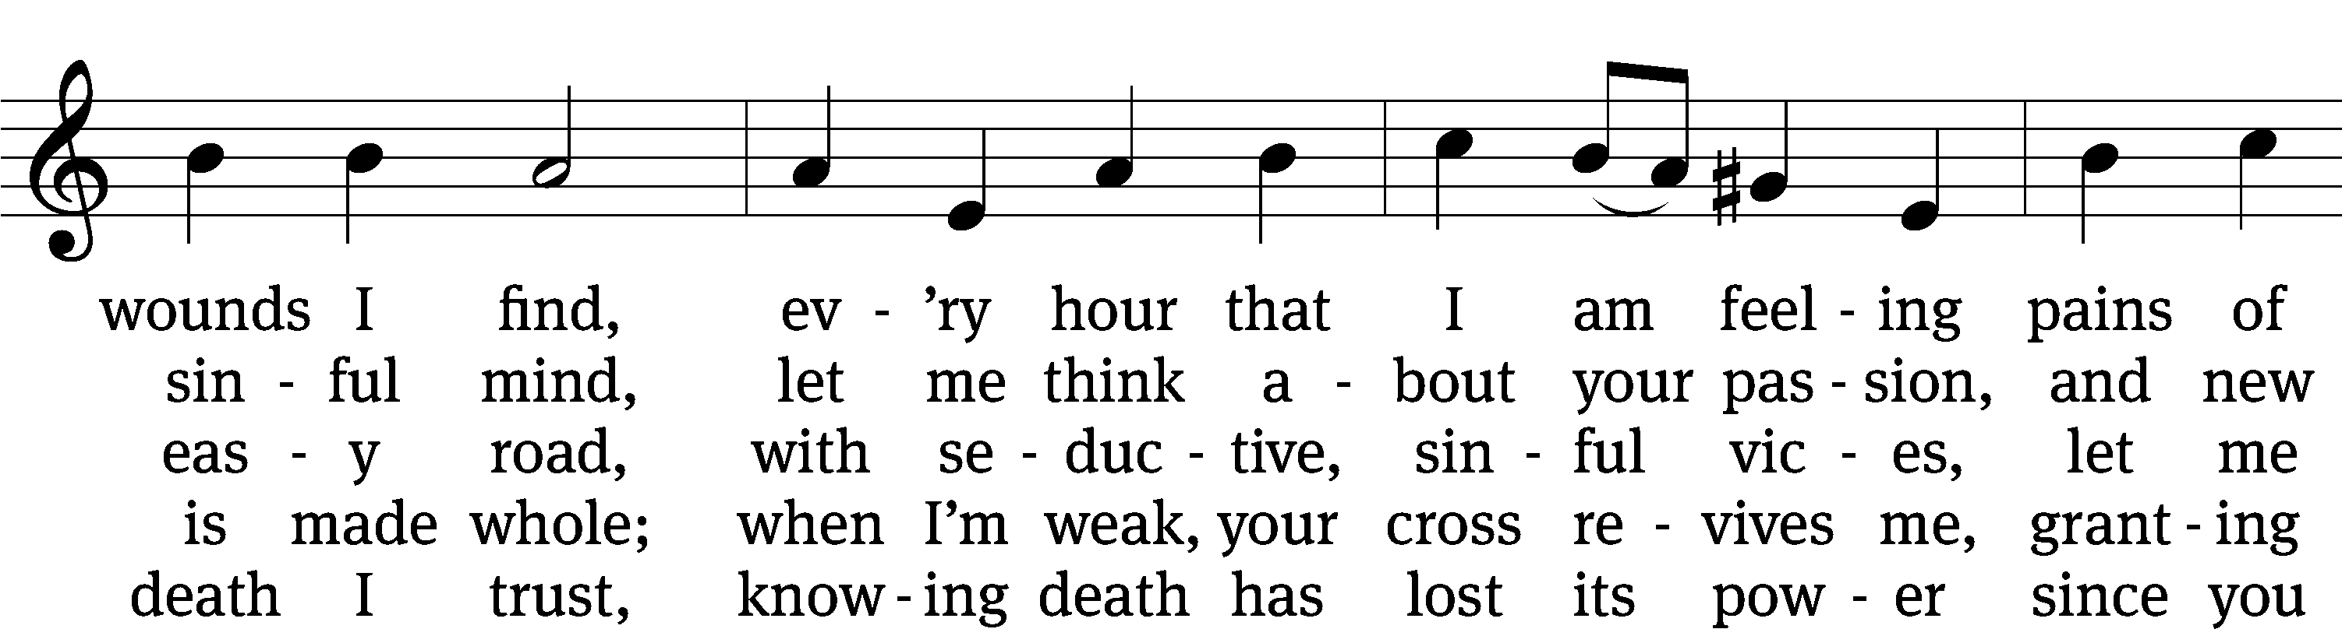
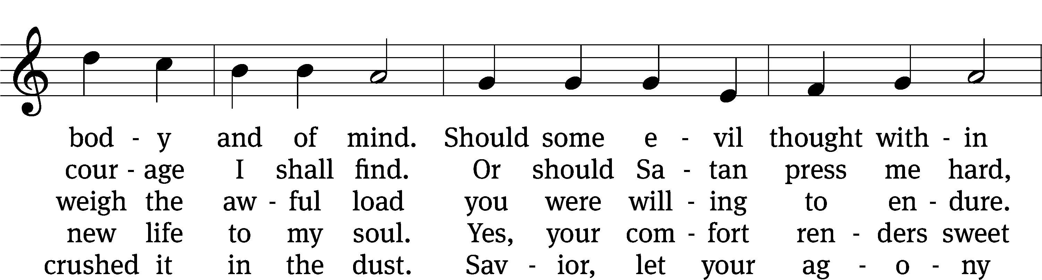
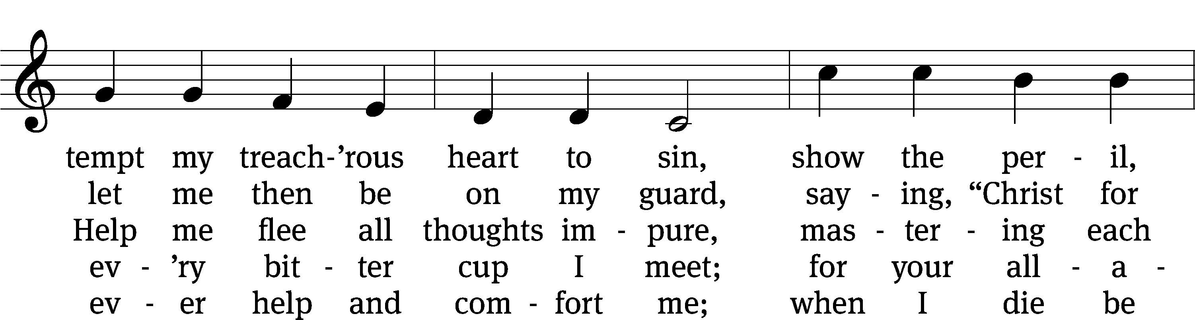
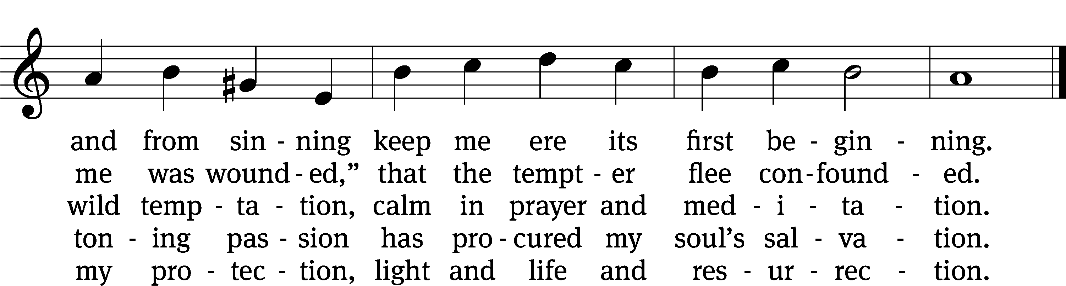
Text: tr. composite; Johann Heermann, 1585–1647, abr.
Tune: Johann B. König, 1691–1758
Text and tune: Public domain

PLEASE STAND, IF YOU ARE ABLE

CLOSING PRAYER
M: Almighty God, we thank you for teaching us the things you want us to believe and do. Help us by your Holy Spirit to keep your Word in pure hearts that we may be strengthened in faith, guided in holiness, and comforted in life and in death, through Jesus Christ, our Lord, who lives and reigns with you and the Holy Spirit, one God, now and forever.

M: Brothers and sisters, go in peace. Live in harmony with one another. Serve the Lord with gladness.
The Lord bless you and keep you.
The Lord make his face shine on you and be gracious to you.
The Lord look on you with favor and (+) give you peace.

PLEASE BE SEATED

697 May We Your Precepts, Lord, Fulfill CW 697
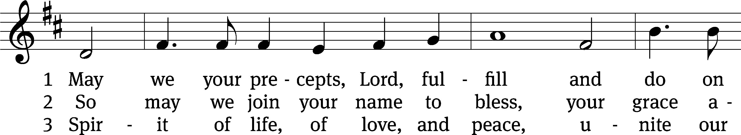
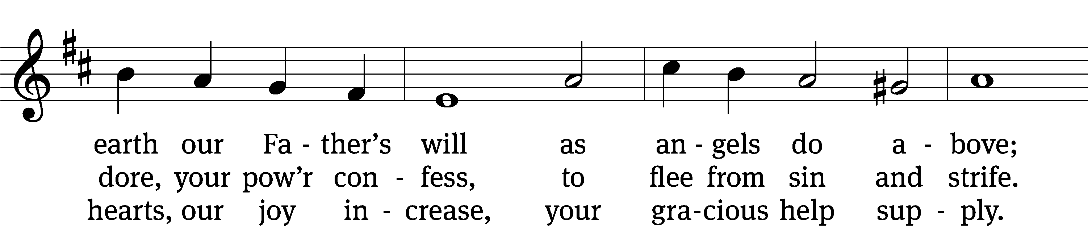
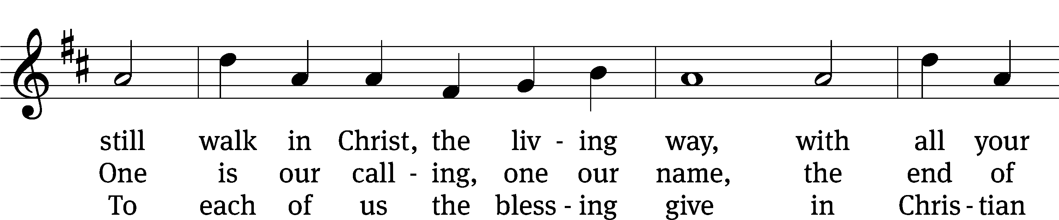
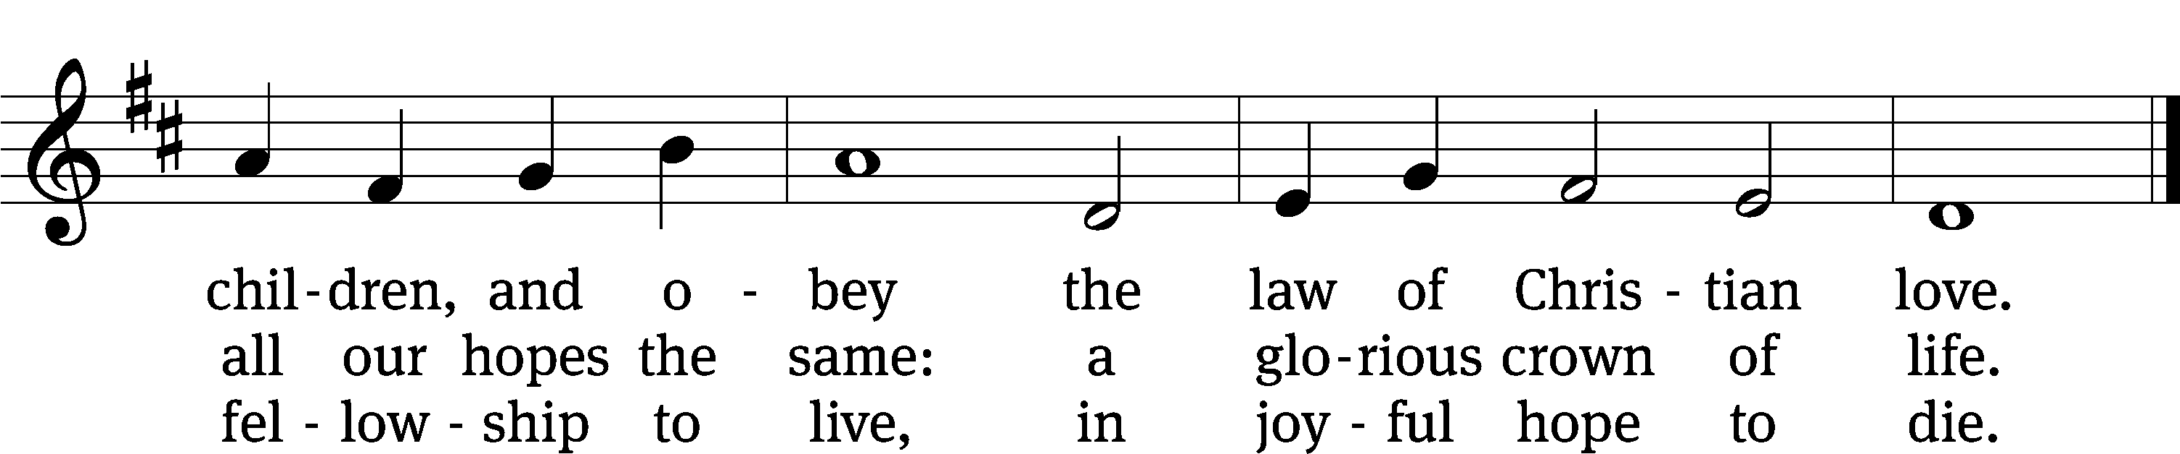
Text: Edward Osler, 1789–1863, alt.
Tune: Lowell Mason, 1792–1872
Text and tune: Public domain

Serving In Worship
Officiant Pastor Natsis
Organist Sarah Hanke
Deacons (8:30) Duane Mason and Dave Stevenson
(11:00) Jeff Neuburger and Robert Niethammer
Ushers (8:30) Tim Phelps
(11:00) Ron Zahn
Altar Guild Margaret Hoeft and Laura Lindemann
Videographer Rick Schneider

Copyright information
Service of the Word: Christian Worship. © 1993 Northwestern Publishing House. All rights reserved.
Reprinted with permission under ONE LICENSE #A-727703 and CCLI #1151741/CSPL126093

Words and Music: All rights reserved. Reprinted with permission under ONE LICENSE #A-727703 and
CCLI #1151741/CSPL126093

tlcsaline.church

