the SECOND sunday
after EPIPHANY

tRINITY EVANGELICAL LUTHERAN CHURCH | Saline, Michigan
January 14, 2024

WELCOME TO WORSHIP

Thank you for joining us in God’s house today! We cordially ask that our Guests with us this morning sign one of the guestbooks located at either the front or back entryways.

THANK OFFERING: Members of Trinity give their offering as an expression of love and thankfulness to the Lord and to help support the Lord’s work in our community and around the world. Visitors need not feel obligated to participate in this offering which supports our ministry.

Restrooms are located at the back of the upper level (the annex), and in the basement (down the back stairs of the sanctuary or annex). Handicap access is available, please ask an usher for assistance.

Young Families / Toddler Bags – We are GLAD YOU BROUGHT YOUR CHILDREN to our worship service. Jesus said: “Let the little children come to me and do not hinder them, for the kingdom of God belongs to such as these.” We know that having little children in church can be a challenge, but DO NOT WORRY about it. Many of your fellow worshippers have been in your shoes and are just happy you brought your children with you. For your convenience, we have reserved the back rows of seating for parents with small children. These areas provide more flexibility for your family, as well as, easy access to move downstairs if necessary. A closed-circuit TV system allows families to continue participating in the service while downstairs. Pre-school toddler bags and children’s bulletins are available for their enjoyment. Ask an usher for one to use during the service and please return the toddler bag afterwards.

SERVICE of the word

Hymn CW 681
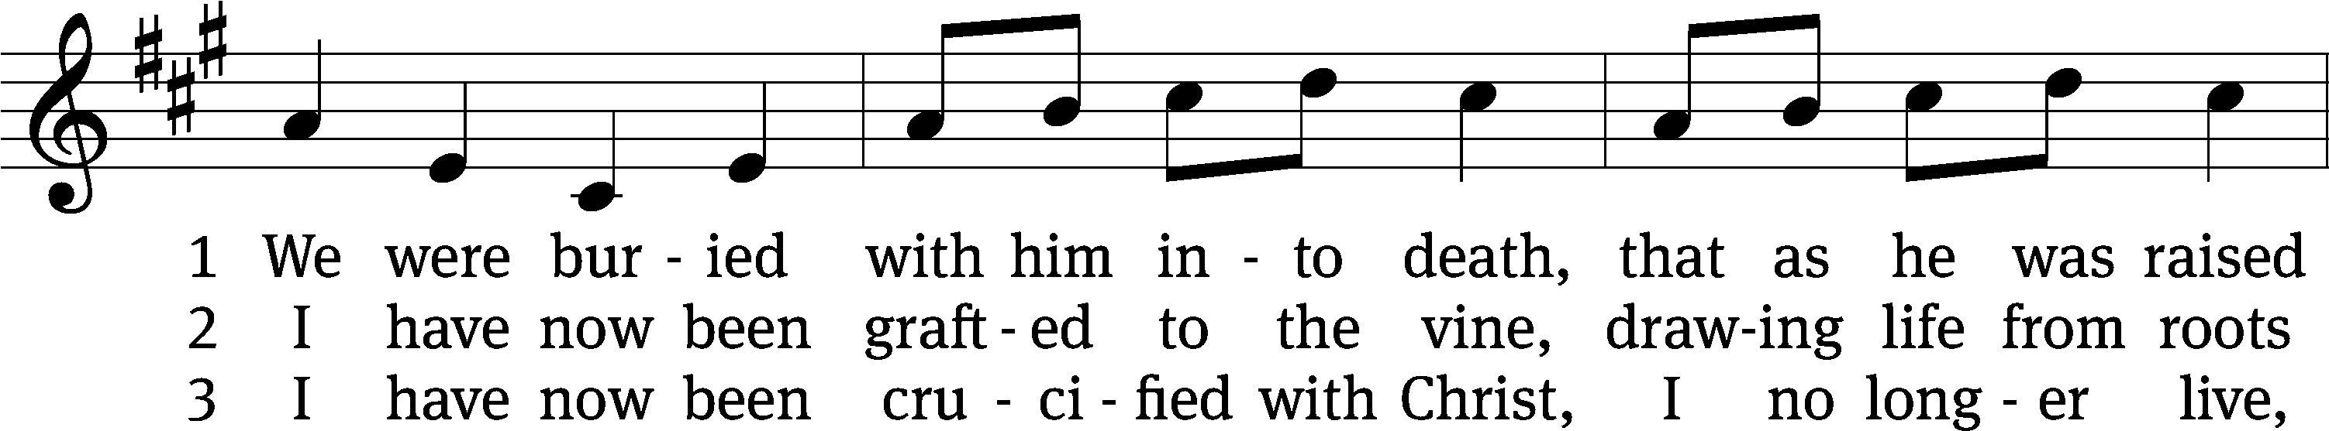
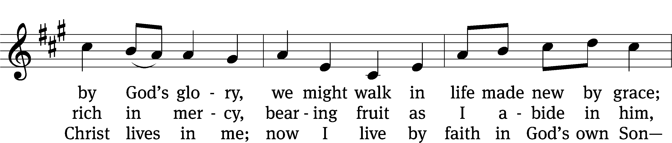
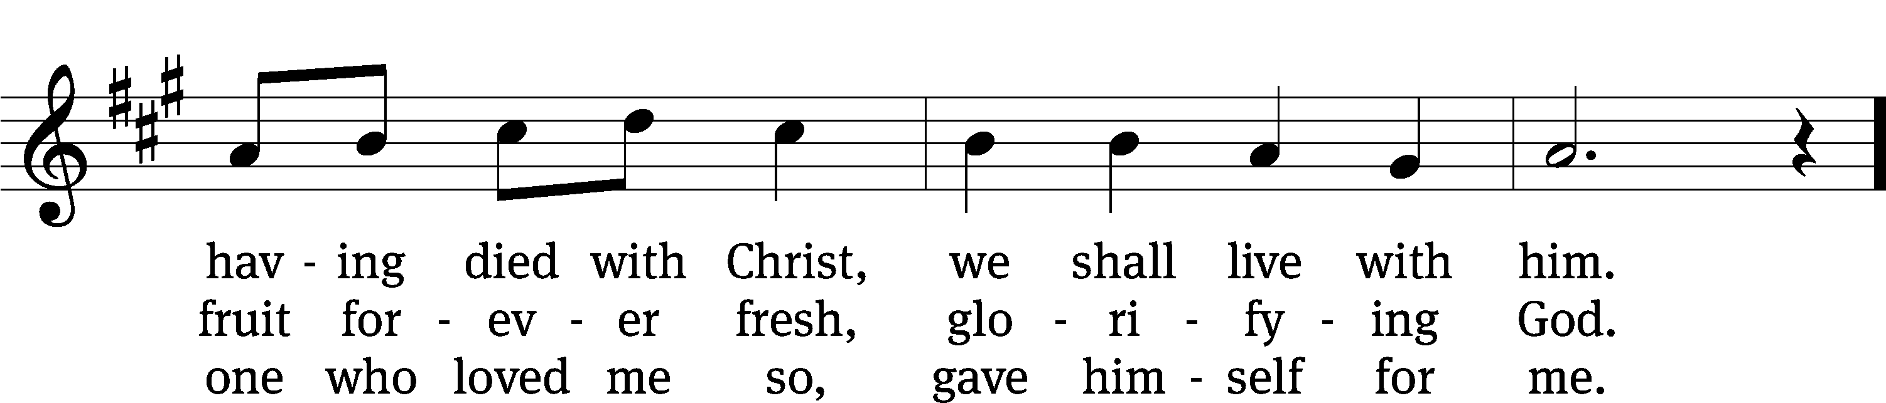
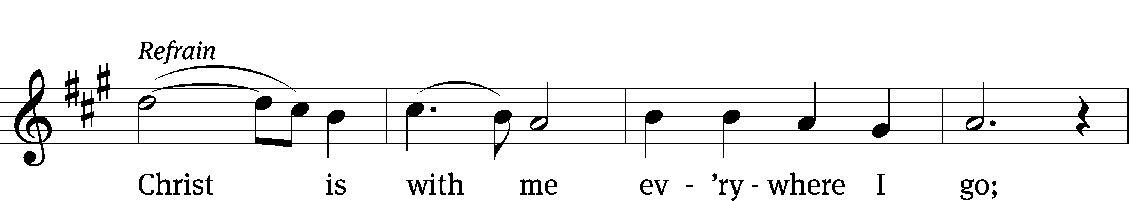
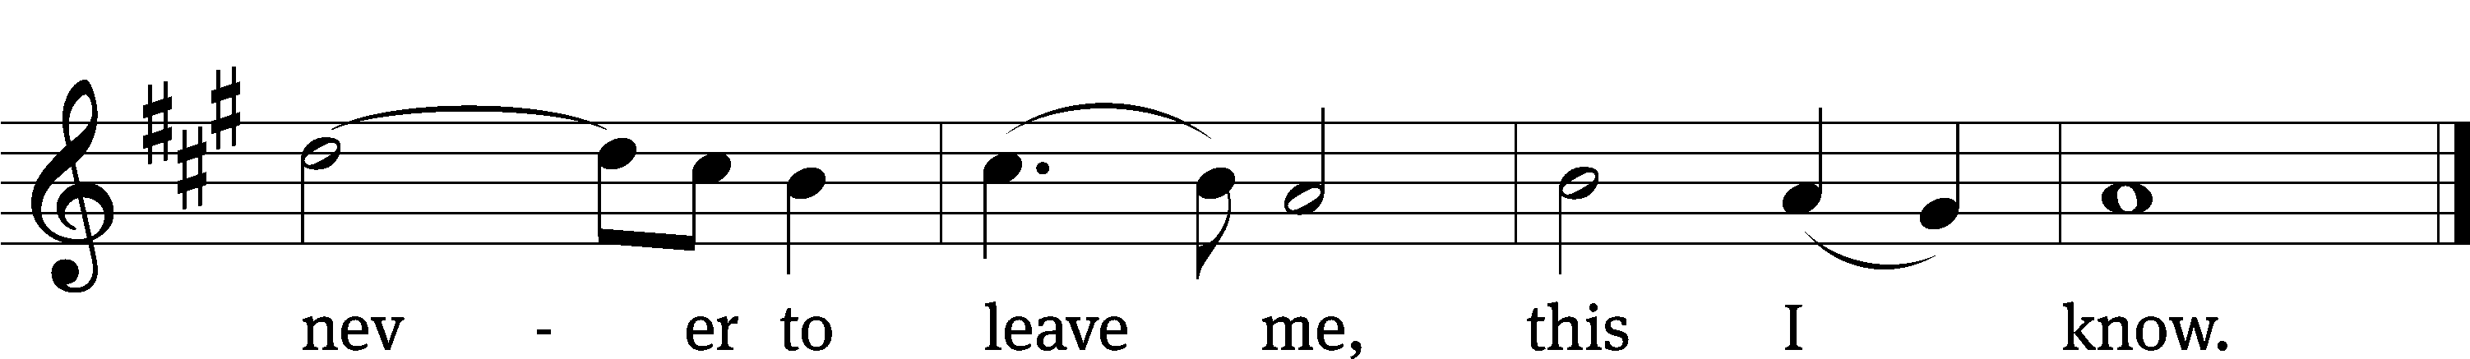
Text: Gerald P. Coleman, b. 1953, alt.
Tune: Gerald P. Coleman, b. 1953, alt.
Text and tune: © 1992 Concordia Publishing House. Used by permission: OneLicense no. 727703

PLEASE STAND, IF YOU ARE ABLE

invocation
M: The grace of our Lord (+) Jesus Christ and the love of God and the fellowship of the Holy Spirit be with you.
C: And also with you.

CONFESSION OF SINS
M: We have come into the presence of God, who created us to love and serve him as his dear children. But we have disobeyed him and deserve only his wrath and punishment. Therefore, let us confess our sins to him and plead for his mercy.

C: Merciful Father in heaven, I am altogether sinful from birth. In countless ways I have sinned against you and do not deserve to be called your child. But trusting in Jesus, my Savior, I pray: Have mercy on me according to your unfailing love. Cleanse me from my sin, and take away my guilt.

M: God, our heavenly Father, has forgiven all your sins. By the perfect life and innocent death of our Lord Jesus Christ, he has removed your guilt forever. You are his own dear child. May God give you strength to live according to his will.

C: Amen.
PRAYER AND PRAISE

M: In the peace of forgiveness, let us praise the Lord.

OH, TASTE AND SEE

PRAYER OF THE DAY

Let us pray.

Father in heaven, at the baptism of Jesus in the River Jordan, you proclaimed him your beloved Son and anointed him with the Holy Spirit. Keep us who are baptized into Christ faithful in our calling as your children, and make us heirs with him of everlasting life; through your Son, Jesus Christ our Lord, who lives and reigns with you and the Holy Spirit, one God, now and forever.

PLEASE BE SEATED
The Word

the FIRST LESSON Isaiah 49:1-6

¹ Listen to me, you coastlands.
Pay attention, you faraway peoples!
The Lord called me from the womb.
When I was inside my mother, he mentioned my name.
² He made my mouth like a sharpened sword.
He hid me in the shadow of his hand.
He made me a polished arrow.
He concealed me in his quiver.
³ He said to me, “You are my servant Israel,
in whom I will display my glory.”
⁴ But I said to myself, “I have labored in vain.
I spent my strength and came up empty, with nothing.
Yet a just verdict for me rests with the Lord,
and my reward is with my God.”
⁵ But now the Lord,
who formed me from the womb to be his servant,
to turn Jacob back to him,
so that Israel might be gathered to him,
so that I will be honored in the eyes of the Lord,
because my God has been my strength—
⁶ the Lord said:
It is too small a thing that you should just be my servant
to raise up only the tribes of Jacob
and to restore the ones I have preserved in Israel,
so I will appoint you to be a light for the nations,
so that my salvation will be known to the end of the earth.

2D Great Are the Works of the LORD Psalm 2D
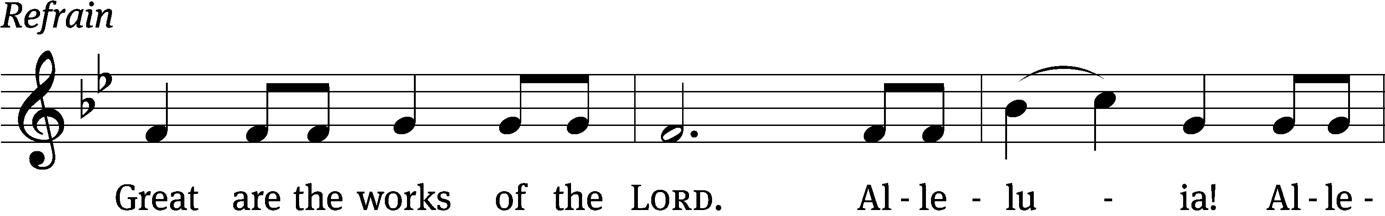
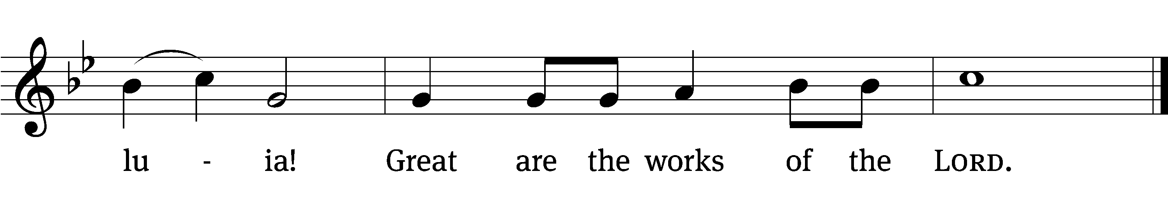

Why do the nations / conspire
and the peoples / plot in vain?
The kings of the earth rise up and the rulers band together a- / gainst the Lord
and against his A- / nointed. Refrain

The One enthroned in / heaven laughs;
the Lord / scoffs at them.
He rebukes them in his anger and terrifies them in his wrath, / saying,
“I have installed my King on Zion, my holy / mountain.” Refrain

I will proclaim the / Lord’s decree:
He said to me, “You are my Son; today I have become your / Father.”
Glory be to the Father and / to the Son
and to the Holy / Spirit,
as it was in the be- / ginning,
is now, and will be forever. / Amen. Refrain
Tune: Kermit G. Moldenhauer
Setting: Kermit G. Moldenhauer
Music: © 1993 Kermit G. Moldenhauer, admin. Northwestern Publishing House. Used by permission: OneLicense no. 727703

SECOND LESSON Romans 6:1-11
¹ What shall we say then? Shall we keep on sinning so that grace may increase? ² Absolutely not! We died to sin. How can we go on living in it any longer? ³ Or do you not know that all of us who were baptized into Christ Jesus were baptized into his death? ⁴ We were therefore buried with him by this baptism into his death, so that just as he was raised from the dead through the glory of the Father, we too would also walk in a new life.
⁵ For if we have been united with him in the likeness of his death, we will certainly also be united with him in the likeness of his resurrection.
⁶ We know that our old self was crucified with him, to make our sinful body powerless, so that we would not continue to serve sin. ⁷ For the person who has died has been declared free from sin. ⁸ And since we died with Christ, we believe that we will also live with him. ⁹ We know that since Christ has been raised from the dead, he will never die again. Death no longer has control over him. ¹⁰ For the death he died, he died to sin once and for all, but the life he lives, he lives to God. ¹¹ In the same way also consider yourselves dead to sin, but alive to God in Christ Jesus.
PLEASE STAND, IF YOU ARE ABLE

Verse of the day

Alleluia. You are my Son, whom I love; with you I am well pleased. Alleluia.

THE GOSPEL LESSON Mark 1:4-11
M: The Gospel according to Mark chapter 1, verses 4-11
⁴ John appeared, baptizing in the wilderness and preaching a baptism of repentance for the forgiveness of sins.
⁵ The whole Judean countryside and all the people of Jerusalem were going out to him. They were baptized by him in the Jordan River as they confessed their sins. ⁶ John was clothed in camel’s hair, and he wore a leather belt around his waist. He ate locusts and wild honey. ⁷ He preached, “One more powerful than I is coming after me. I am not worthy to stoop down and untie the strap of his sandals! ⁸ I baptized you with water, but he will baptize you with the Holy Spirit.”
⁹ In those days Jesus came from Nazareth of Galilee and was baptized by John in the Jordan. ¹⁰ Just as Jesus came up out of the water, he saw the heavens being torn open and the Spirit descending on him like a dove. ¹¹ And a voice came from heaven: “You are my Son, whom I love. I am well pleased with you.”

M: This is the Gospel of the Lord.

PLEASE BE SEATED

685 Through Simple Water, Drawn and Poured CW 685
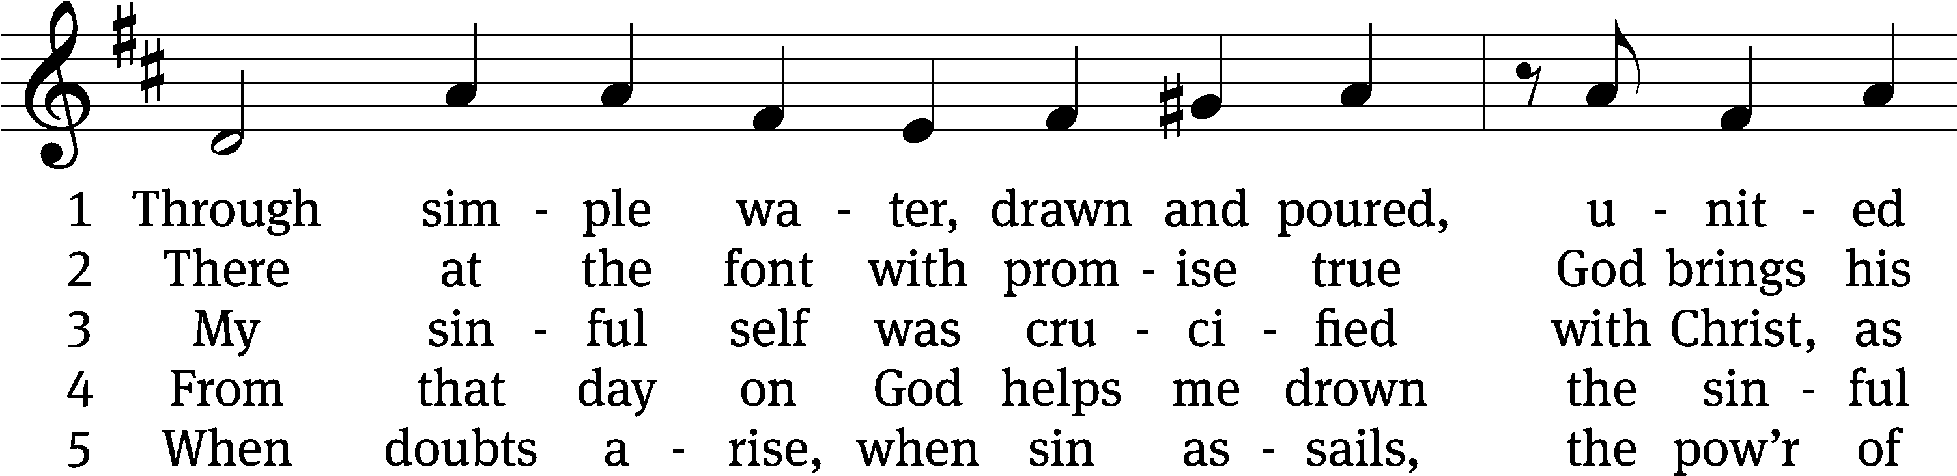
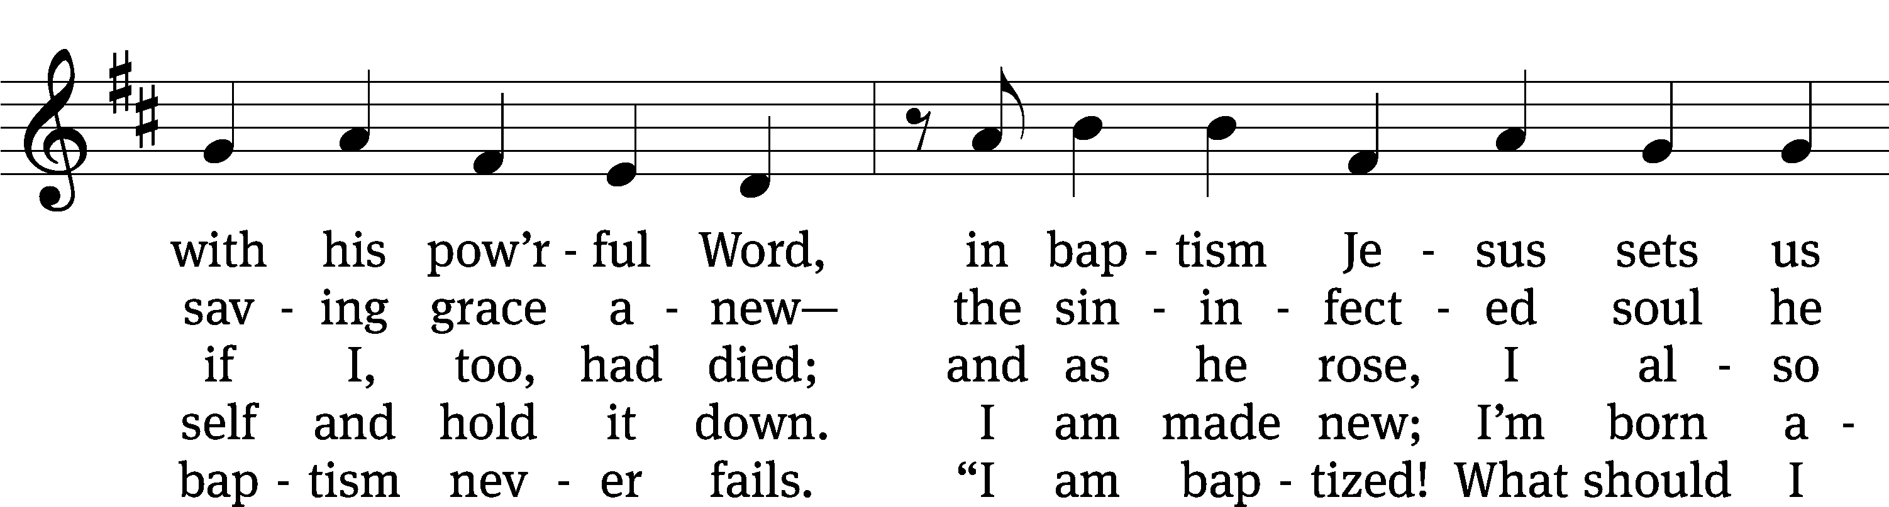
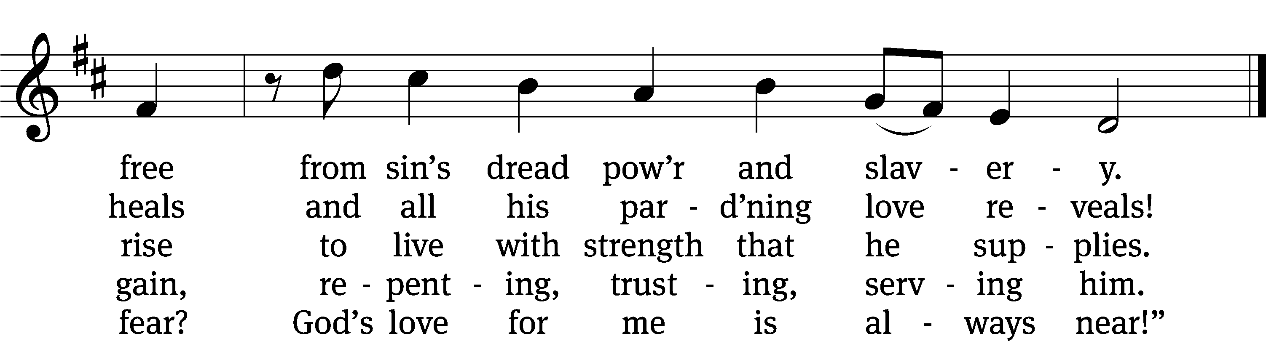
Text: tr. Mark G. Schroeder, b. 1954; Nicolaus Selnecker, 1532–1592, abr.
Tune: Geistliche Lieder auffs new gebessert, Wittenberg, 1535, ed. Joseph Klug
Text: © 2021 Mark G. Schroeder, admin. Northwestern Publishing House. Used by permission: OneLicense no. 727703
Tune: Public domain

SERMON Romans 6:1-11
“Baptized to Die”

PLEASE STAND, IF YOU ARE ABLE

THE APOSTLES’ CREED

I believe in God, the Father almighty,
maker of heaven and earth.
I believe in Jesus Christ, his only Son, our Lord,
who was conceived by the Holy Spirit,
born of the virgin Mary,
suffered under Pontius Pilate,
was crucified, died, and was buried.
He descended into hell.
The third day he rose again from the dead.
He ascended into heaven
and is seated at the right hand of God the Father almighty.
From there he will come to judge the living and the dead.
I believe in the Holy Spirit,
the holy Christian Church,
the communion of saints,
the forgiveness of sins,
the resurrection of the body,
and the life everlasting. Amen.

PRAYER OF THE CHURCH

THE LORD’S PRAYER

C: Our Father, who art in heaven, hallowed be thy name, thy kingdom come, thy will be done on earth as it is in heaven. Give us this day our daily bread; and forgive us our trespasses, as we forgive those who trespass against us; and lead us not into temptation, but deliver us from evil. For thine is the kingdom and the power and the glory forever and ever. Amen.

PLEASE BE SEATED
679 God’s Own Child, I Gladly Say It CW 679
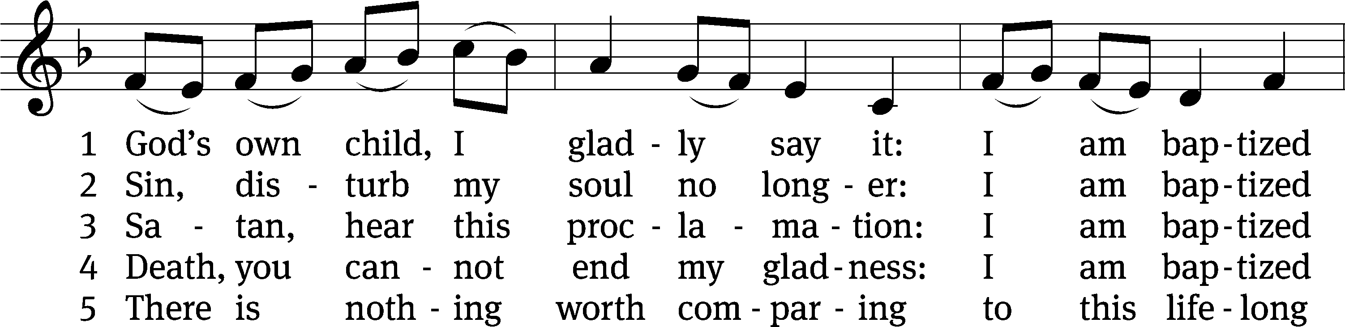
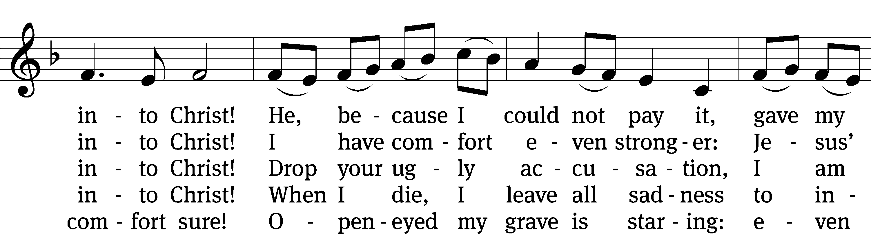
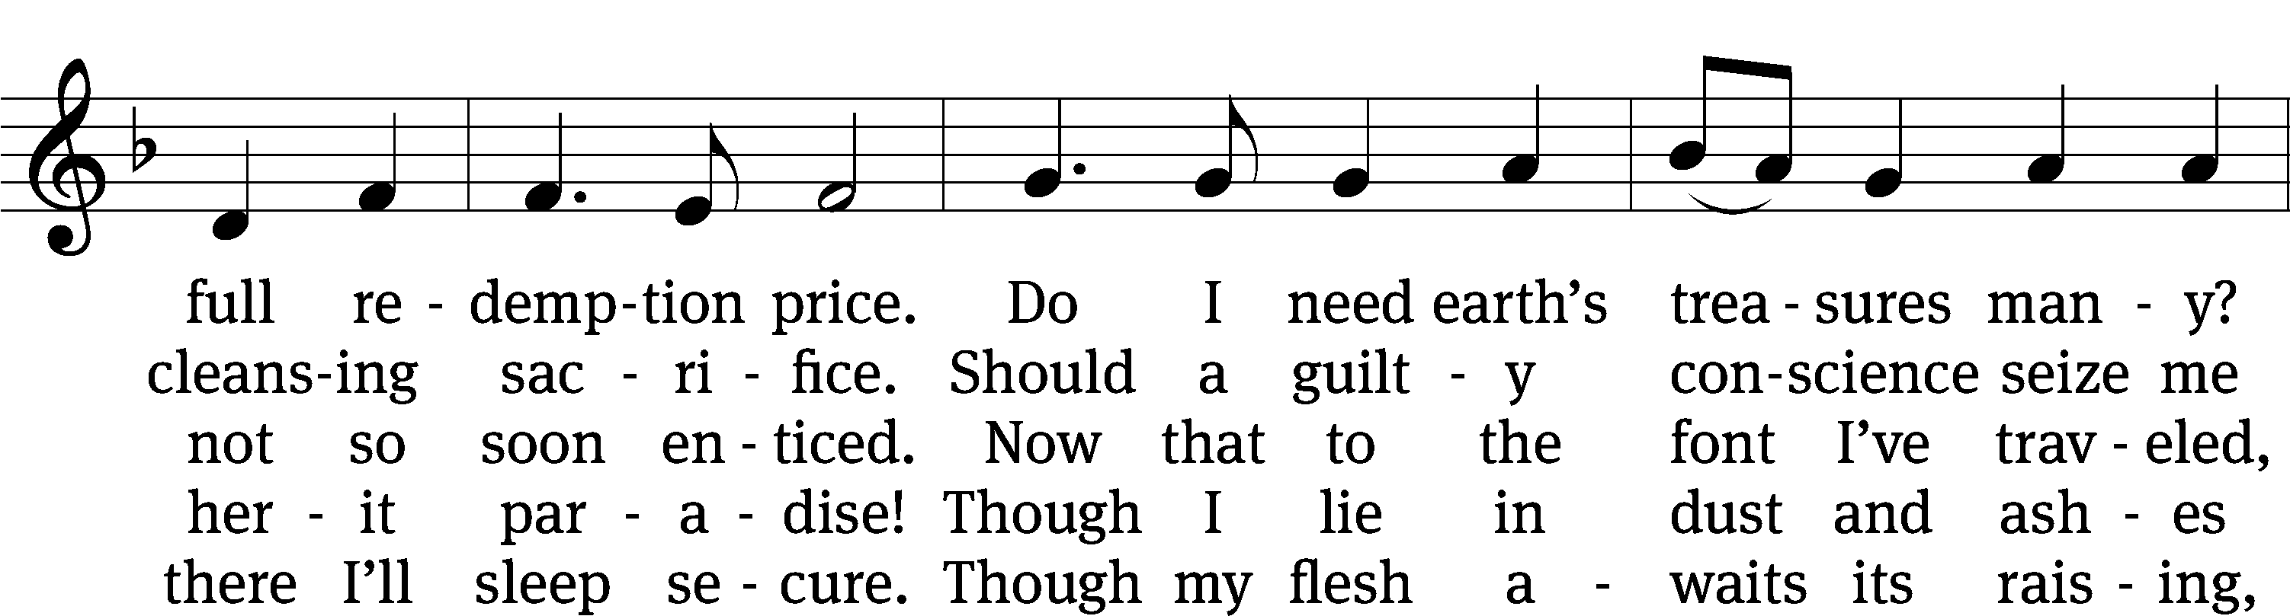
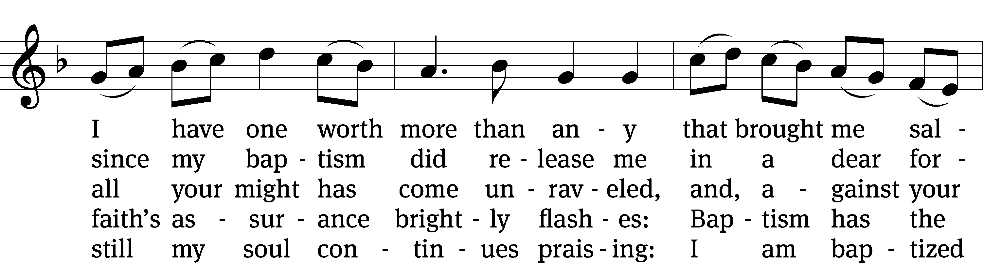
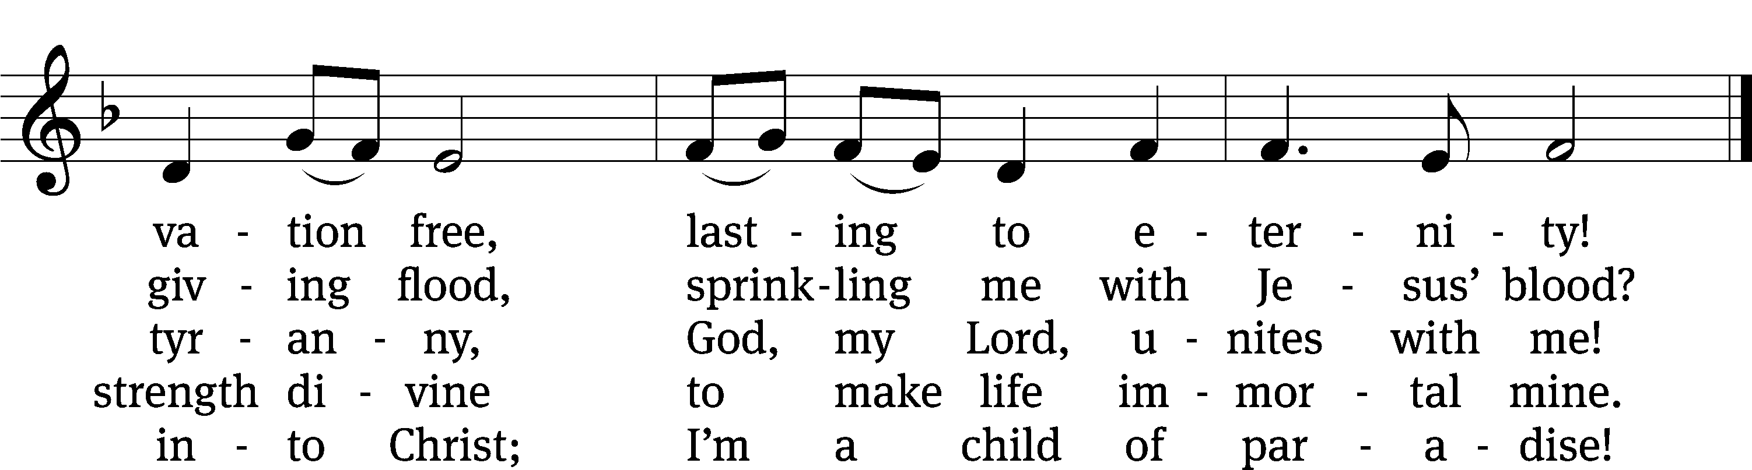
Text: tr. Robert E. Voelker, b. 1957; Erdmann Neumeister, 1671–1756
Tune: Johann Caspar Bachofen, 1695–1755, alt.
Text: © 1991 Robert E. Voelker. Used by permission: OneLicense no. 727703
Tune: Public domain
PLEASE STAND, IF YOU ARE ABLE

CLOSING PRAYER
M: Almighty God, we thank you for teaching us the things you want us to believe and do. Help us by your Holy Spirit to keep your Word in pure hearts that we may be strengthened in faith, guided in holiness, and comforted in life and in death, through Jesus Christ, our Lord, who lives and reigns with you and the Holy Spirit, one God, now and forever.

M: Brothers and sisters, go in peace. Live in harmony with one another. Serve the Lord with gladness.
The Lord bless you and keep you.
The Lord make his face shine on you and be gracious to you.
The Lord look on you with favor and (+) give you peace.

PLEASE BE SEATED

692 All Who Believe and Are Baptized CW 692
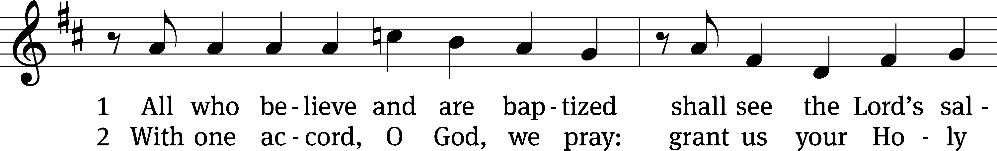
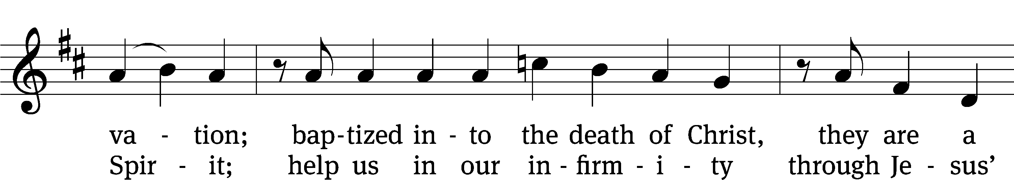
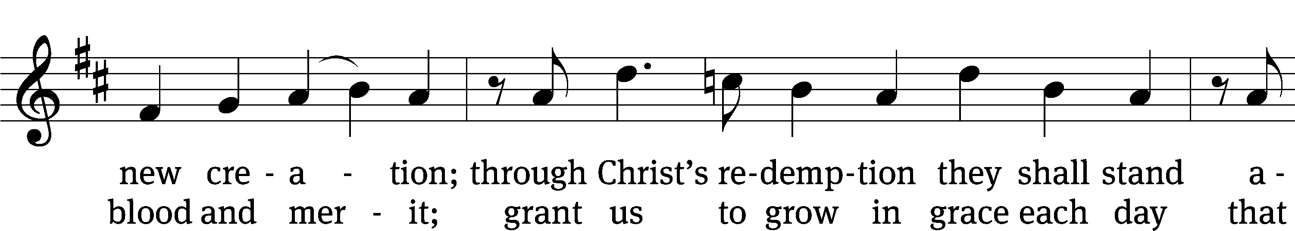
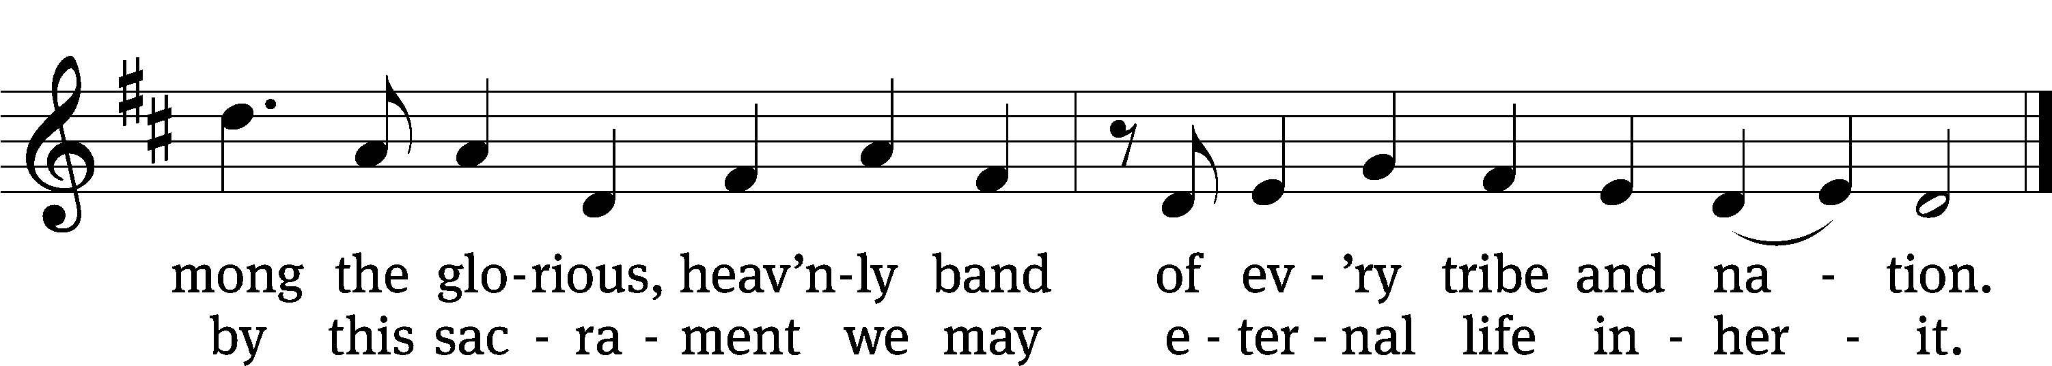
Text: tr. George A. T. Rygh, 1860–1942, alt.; Thomas H. Kingo, 1634–1703
Tune: Etlich Cristlich lider, Wittenberg, 1524
Text and tune: Public domain

Serving In Worship
Officiant Pastor Pappenfuss
Organist Sarah Hanke
Deacons (8:30) Ron Roehm and Dave Stevenson
Deacons (11:00) Dave Frey and Gary Knowlton
Ushers (8:30) Bob Newman and Henry Schneider
Ushers (11:00) Ed Sala and Al Whitley
Altar Guild Sharon Boswell and Laura Lindemann
Videographer Cindy Dresch

Copyright information
Service of the Word: Christian Worship. © 1993 Northwestern Publishing House. All rights reserved.
Reprinted with permission under ONE LICENSE #A-727703 and CCLI #1151741/CSPL126093

Words and Music: All rights reserved. Reprinted with permission under ONE LICENSE #A-727703 and
CCLI #1151741/CSPL126093
tlcsaline.church

