THE FIRST SUNDAY
AFTER PENTECOST;
the holy triniTy
TRINITY EVANGELICAL LUTHERAN CHURCH | Saline, Michigan
WELCOME TO WORSHIP June 1/4, 2023
Thank you for joining us in God’s house today! We cordially ask that our Guests sign one of the guestbooks located at either the front or back entryways, or fill out a “Let’s Get Acquainted” card located in the hymnal pew rack and place it in the collection plate.

Thank Offering: Members of Trinity give their offering as an expression of love and thankfulness to the Lord and to help support the Lord’s work in our community and around the world. Visitors need not feel obligated to participate in this offering .

Restrooms are located at the back of the upper level (the annex), and in the basement (down the back stairs of the sanctuary or annex). Handicap access is available, please ask an usher for assistance.

Young Families / Toddler Bags – We are GLAD YOU BROUGHT YOUR CHILDREN to our worship service. Jesus said: “Let the little children come to me and do not hinder them, for the kingdom of God belongs to such as these.” We know that having little children in church can be a challenge, but DO NOT WORRY about it. Many of your fellow worshippers have been in your shoes and are just happy you brought your children with you. For your convenience, we have reserved the back rows of seating for parents with small children. These areas provide more flexibility for your family, as well as, easy access to move downstairs if necessary. A closed-circuit TV system allows families to continue participating in the service while downstairs. Pre-school toddler bags and children’s bulletins are available for their enjoyment. Ask an usher for one to use during the service and please return the toddler bag afterwards.

Holy Communion – In His Word, God makes it clear that the Lord’s Supper is to be shared by people of a common proclamation of faith (1 Corinthians 11:26; 1 Corinthians 10:16-17). Without judging anyone’s hearts, we invite those who share in our confession by their membership in our congregation or another congregation of the Wisconsin Evangelical Lutheran Synod (WELS) or the Evangelical Lutheran Synod (ELS) and who are properly prepared (1 Corinthians 11;27-29) to receive the Sacrament. Page 295 in Christian Worship provides a guide for preparation.
Guests, we would love to have you join us in communion fellowship in the future, and for that to be possible, we ask that you speak with one of the pastors so that we may speak with you on how that would be possible. We thank you for respecting the way we celebrate the Lord’s Supper in our congregations.

the SERVICE – setting one - WITH HOLY COMMUNION CW, page 154
481 Alleluia! Let Praises Ring CW 481
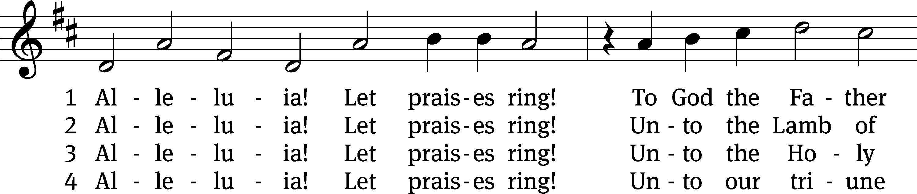
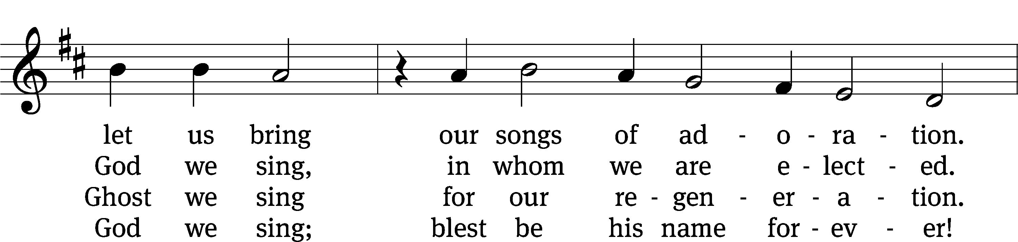
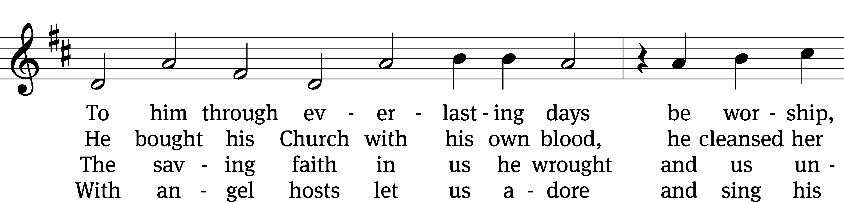
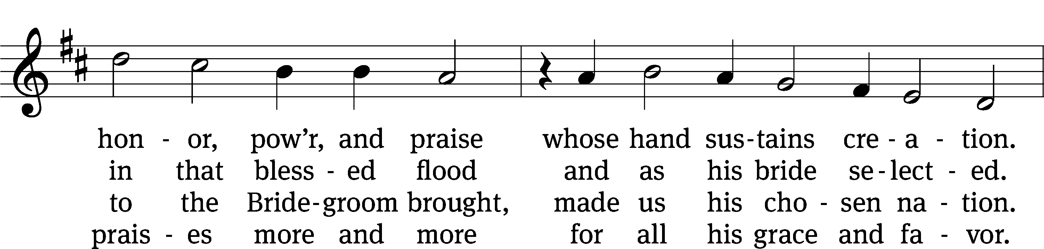
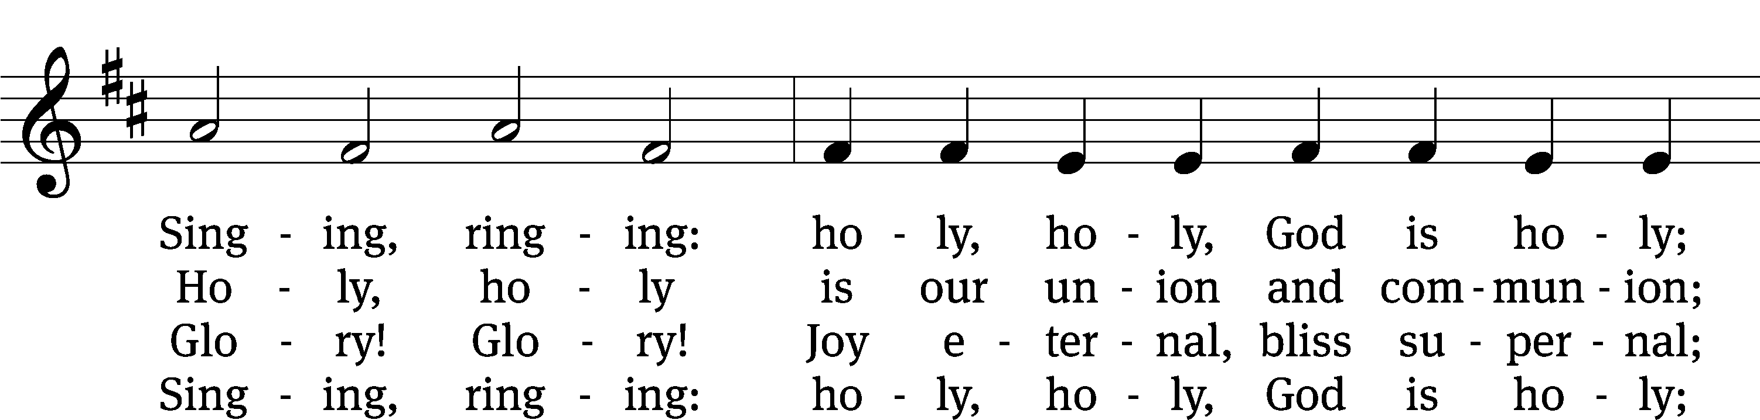
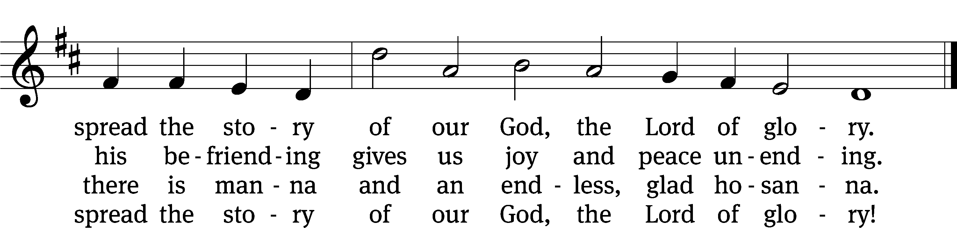
Text: tr. The Lutheran Hymnal, 1941, alt.; Geistreiches Gesang-Buch, Darmstadt, 1698, abr.
Tune: Philipp Nicolai, 1556–1608
Text and tune: Public domain

Please stand, if you are able
Invocation
In the name of the Father and of the Son and of the Holy Spirit.
Amen.
Confession
If we claim to be without sin, we deceive ourselves and the truth is not in us.
If we confess our sins, God is faithful and just
and will forgive us our sins
and purify us from all unrighteousness.

Let us confess our sins to the Lord.
Holy God, gracious Father,
I am sinful by nature
and have sinned against you in my thoughts, words, and actions.
I have not loved you with my whole heart;
I have not loved others as I should.
I deserve your punishment both now and forever.
But Jesus, my Savior, paid for my sins
with his innocent suffering and death.
Trusting in him, I pray: God, have mercy on me, a sinner.

Our gracious Father in heaven has been merciful to us. He sent his only Son, Jesus Christ, who gave his life as the atoning sacrifice for the sins of the whole world. Therefore, as a called servant of Christ and by his authority, I forgive you all your sins in the name of the Father and of the Son and of the Holy Spirit.
Amen.

Lord, Have Mercy

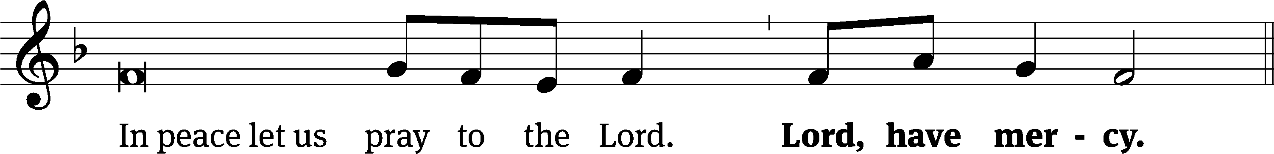
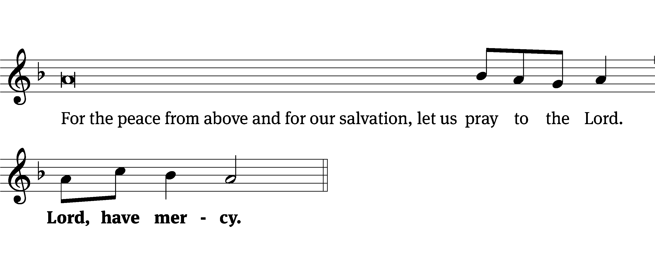
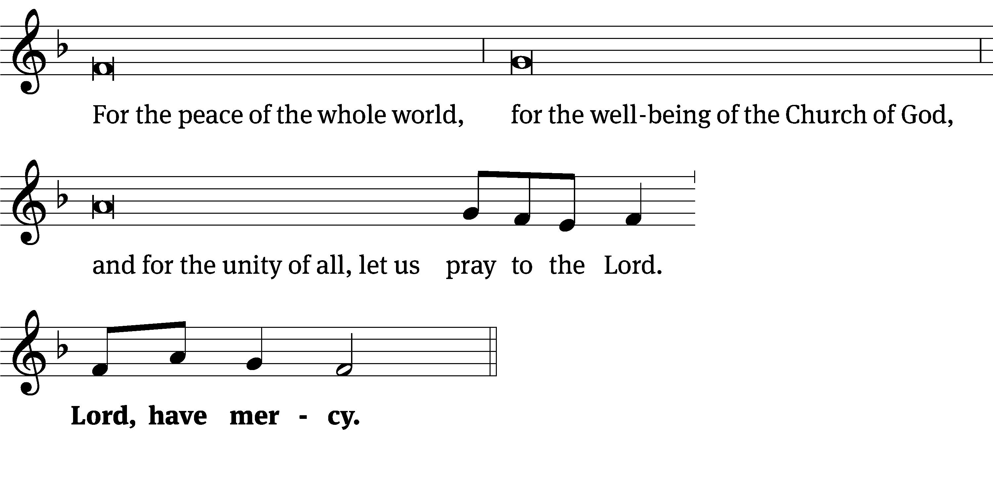
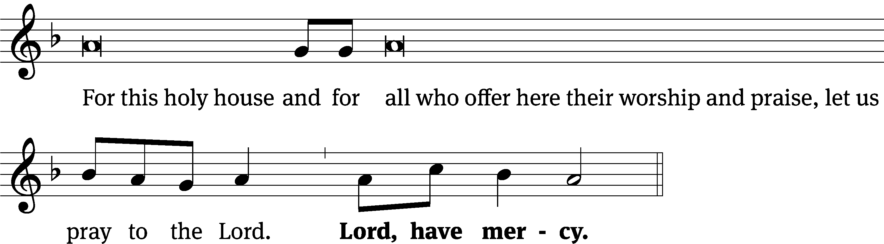
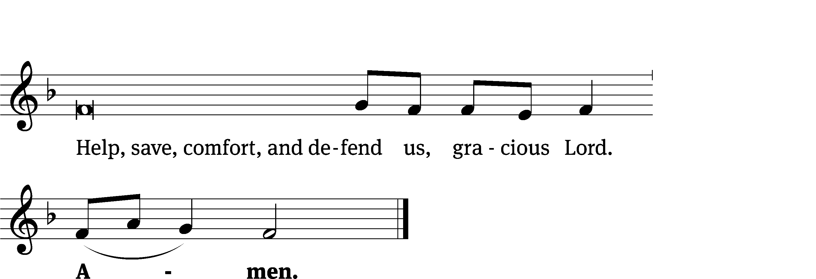
Glory Be to God on High CW 157
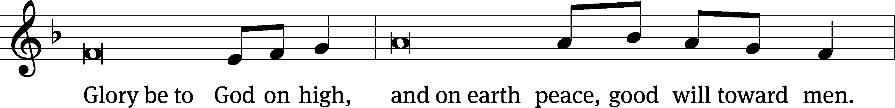
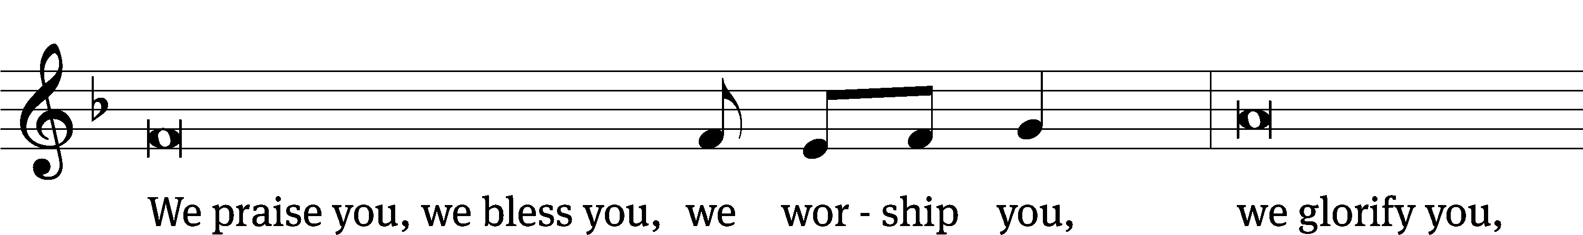
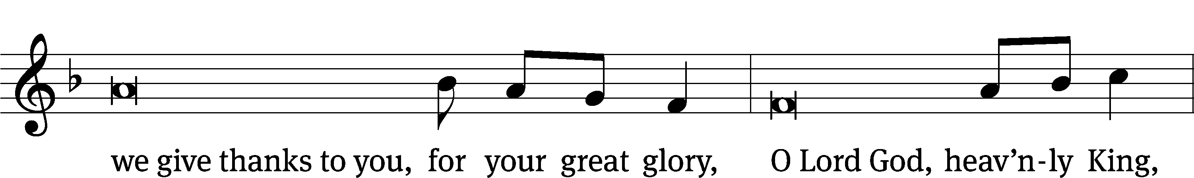
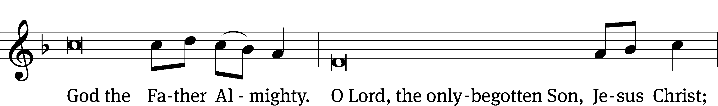
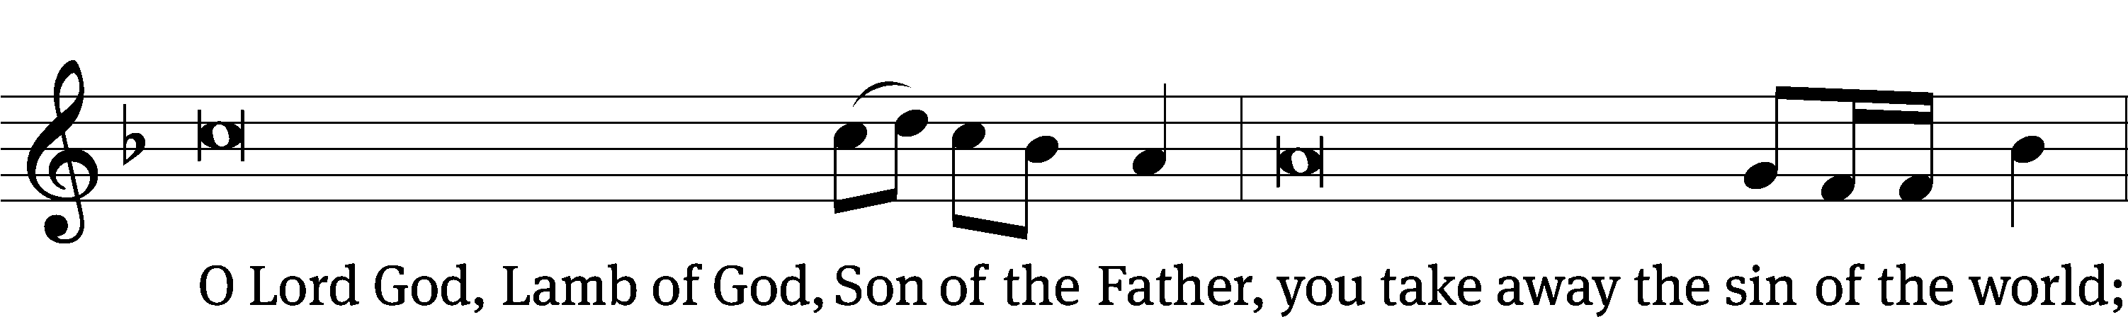
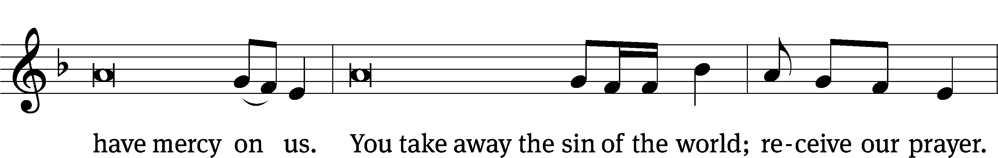
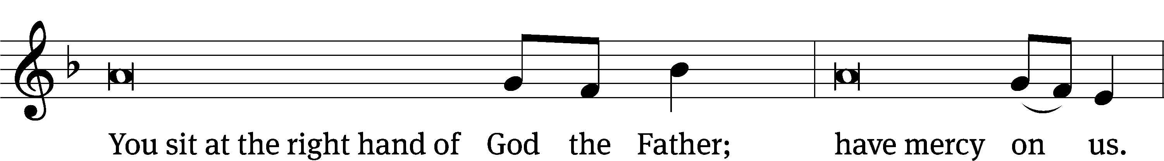
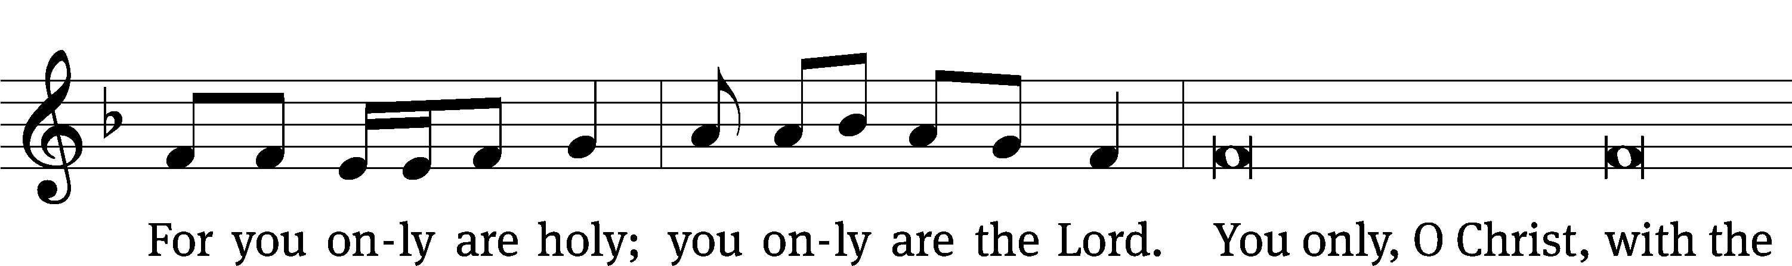
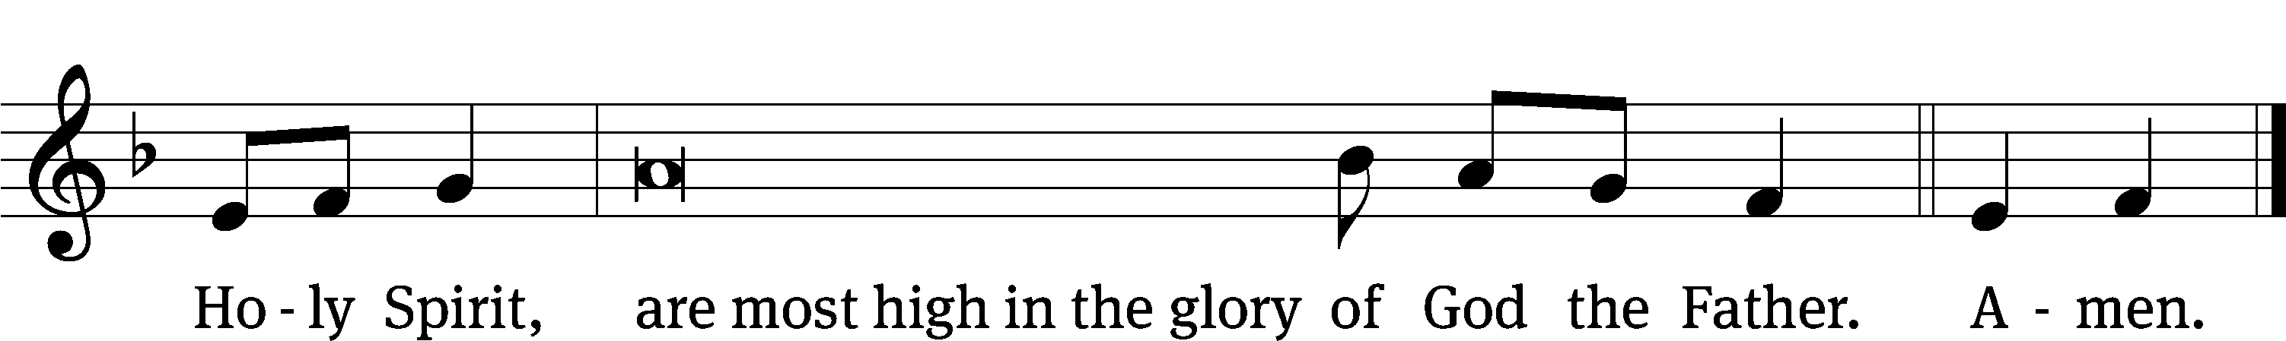

The Lord be with you.
And also with you.
Prayer of the Day
Let us pray.

Almighty God and Father, dwelling in majesty and mystery, filling and renewing all creation by your eternal Spirit, and manifesting your saving grace through our Lord Jesus Christ, in mercy cleanse our hearts and lips that, free from doubt and fear, we may ever worship you, one true, immortal God, with your Son and the Holy Spirit, living and reigning, now and forever.
Amen.

Please be seated

First Reading Genesis 1:1-2:3
1 In the beginning, God created the heavens and the earth. ² The earth was undeveloped and empty. Darkness covered the surface of the deep, and the Spirit of God was hovering over the surface of the waters.
³ God said, “Let there be light,” and there was light. ⁴ God saw that the light was good. He separated the light from the darkness. ⁵ God called the light “day,” and the darkness he called “night.” There was evening and there was morning—the first day.
⁶ God said, “Let there be an expanse between the waters, and let it separate the water from the water.” ⁷ God made the expanse, and he separated the water that was below the expanse from the water that was above the expanse, and it was so. ⁸ God called the expanse “sky.” There was evening and there was morning—the second day.
⁹ God said, “Let the waters under the sky be gathered together to one place, and let the dry land appear,” and it was so. The waters under the sky gathered to their own places, and the dry land appeared. ¹⁰ God called the dry ground “land,” and the gathering places of the waters he called “seas.” God saw that it was good. ¹¹ God said, “Let the earth produce plants—vegetation that produces seed, and trees that bear fruit with its seed in it—each according to its own kind on the earth,” and it was so. ¹² The earth brought forth plants, vegetation that produces seed according to its own kind, and trees that bear fruit with its seed in it, each according to its own kind, and God saw that it was good. ¹³ There was evening and there was morning—the third day.
¹⁴ God said, “Let there be lights in the expanse of the sky to divide the day from the night, and let them serve as markers to indicate seasons, days, and years. ¹⁵ Let them serve as lights in the expanse of the sky to give light to the earth,” and it was so. ¹⁶ God made the two great lights: the greater light to rule the day, and the lesser light to rule the night. He also made the stars. ¹⁷ God set these lights in place in the expanse of the sky to provide light for the earth, ¹⁸ to rule over the day and over the night, and to divide the light from the darkness. God saw that it was good. ¹⁹ There was evening and there was morning—the fourth day.
²⁰ God said, “Let the waters swarm with living creatures, and let birds and other winged creatures fly above the earth in the open expanse of the sky.” ²¹ God created the large sea creatures and every living creature that moves, with which the waters swarm, according to their own kind, and every winged bird according to its own kind. God saw that it was good. ²² God blessed them when he said, “Be fruitful and multiply. Fill the waters of the seas, and let birds multiply on the earth.” ²³ There was evening and there was morning—the fifth day.
²⁴ God said, “Let the earth produce living creatures according to their own kind, livestock, creeping things, and wild animals according to their own kind,” and it was so. ²⁵ God made the wild animals according to their own kind, and the livestock according to their own kind, and everything that creeps on the ground according to its own kind. God saw that it was good.
²⁶ God said, “Let us make man in our image, according to our likeness, and let them have dominion over the fish of the sea, and over the birds of the sky, and over the livestock, and over all the earth, and over every creeping thing that crawls on the earth.”
²⁷ God created the man in his own image.
In the image of God he created him.
Male and female he created them.
²⁸ God blessed them and said to them, “Be fruitful, multiply, fill the earth, and subdue it. Have dominion over the fish of the sea, over the birds of the sky, and over every living thing that moves on the earth.” ²⁹ God said, “Look, I have given you every plant that produces seed on the face of the whole earth, and every tree that bears fruit that produces seed. It will be your food. ³⁰ To every animal of the earth, and to every bird of the sky, and to everything that creeps on the earth, in which there is the breath of life, I have given every green plant for food.” And it was so.
³¹ God saw everything that he had made, and indeed, it was very good. There was evening and there was morning—the sixth day.
2 The heavens and the earth were finished, along with everything in them. ² On the seventh day God had finished his work that he had done, and he rested on the seventh day from all his work that he had been doing. ³ God blessed the seventh day and set it apart as holy, because on it he rested from all his work of creation that he had done.
The Word of the Lord.
Thanks be to God.
8D I Will Praise Your Name Forever Psalm 8D
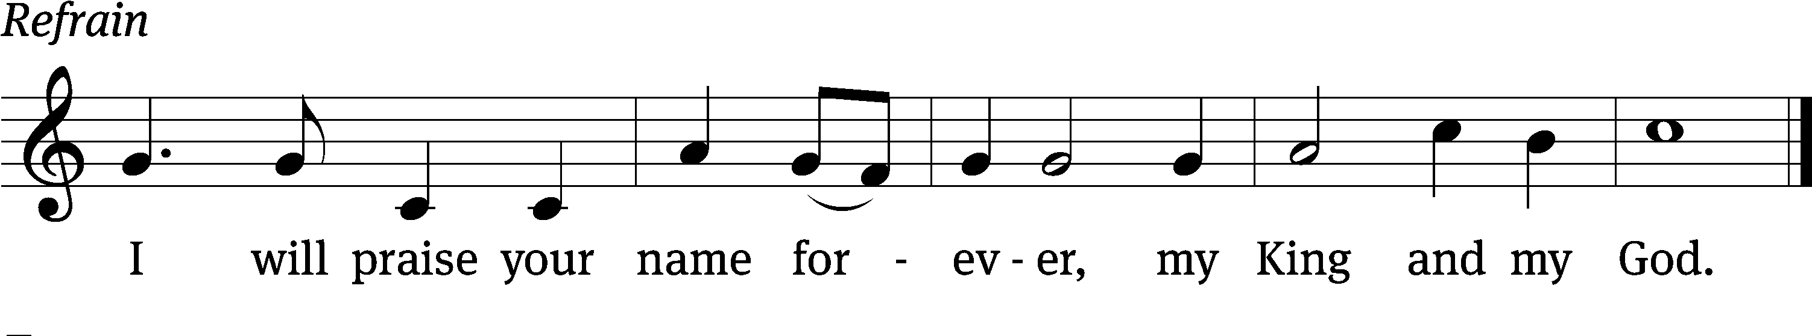

Lord, our Lord, how majestic is your name in / all the earth!
You have set your glory in the / heavens.
When I consider your heavens, the work of your / fingers,
the moon and the stars, which you have / set in place,
what is a human being that you are mind- / ful of him,
a Son of Man that you / care for him? Refrain

You made him a little lower than the / angels
and crowned him with glory and / honor.
You made him ruler over the works / of your hands;
you put everything un- / der his feet.
Glory be to the Father and / to the Son
and to the Holy / Spirit,
as it was in the be- / ginning,
is now, and will be forever. / Amen. Refrain
Text: Lectionary for Mass
Tune: Lynn Trapp
Setting: Kermit G. Moldenhauer
Text: © 1969 ICEL (refrain). Used by permission: OneLicense no. 727703
Second Reading 2 Corinthians 13:11-14
¹¹ Finally, brothers, rejoice. Set things in order. Be encouraged. Agree with one another. Be at peace. And the God of love and peace will be with you.
¹² Greet one another with a holy kiss. ¹³ All the saints greet you.
¹⁴ The grace of the Lord Jesus Christ, and the love of God, and the fellowship of the Holy Spirit be with you all.
The Word of the Lord.
Thanks be to God.

Please stand, if you are able

Gospel Acclamation Isaiah 6:3
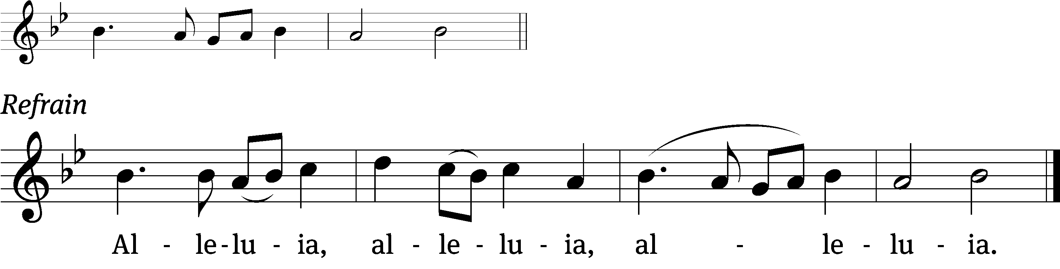
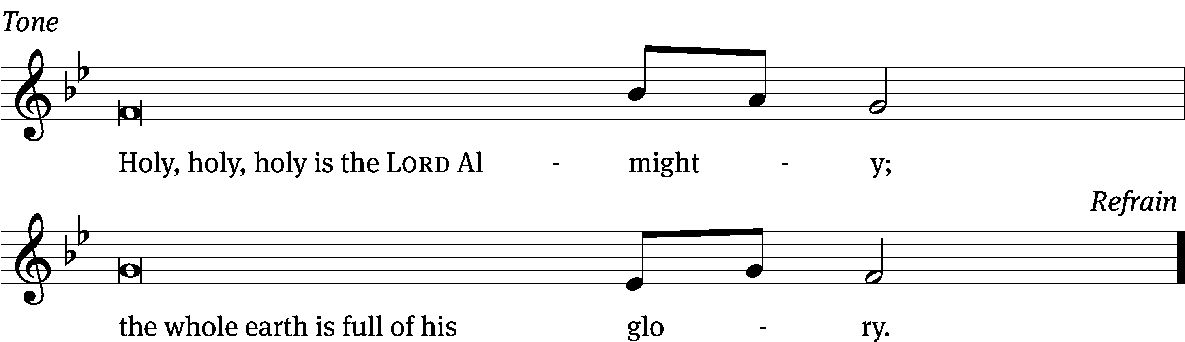
Tune: © 2021 Northwestern Publishing House. Used by permission: OneLicense no. 727703
Gospel Matthew 28:16-20
¹⁶ The eleven disciples went to Galilee, to the mountain where Jesus had directed them. ¹⁷ When they saw him, they worshipped him, but some hesitated because they were uncertain.
¹⁸ Jesus approached and spoke to them saying, “All authority in heaven and on earth has been given to me. ¹⁹ Therefore go and gather disciples from all nations by baptizing them in the name of the Father and of the Son and of the Holy Spirit, ²⁰ and by teaching them to keep all the instructions I have given you. And surely I am with you always until the end of the age.”
The Gospel of the Lord.
Praise be to you, O Christ!

Please be seated
483 Holy, Holy, Holy! Lord God Almighty CW 483
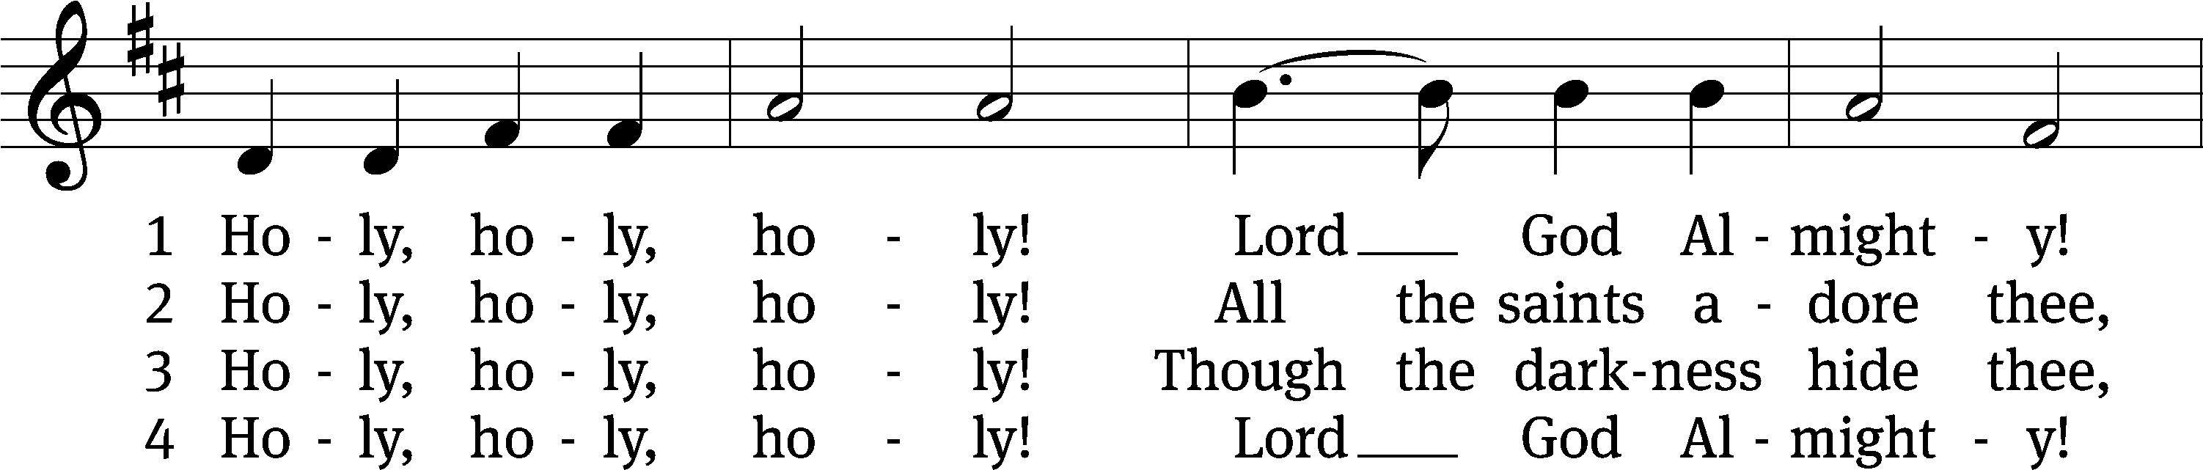
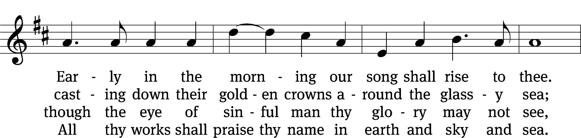
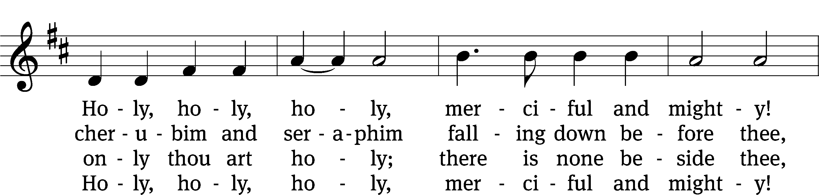
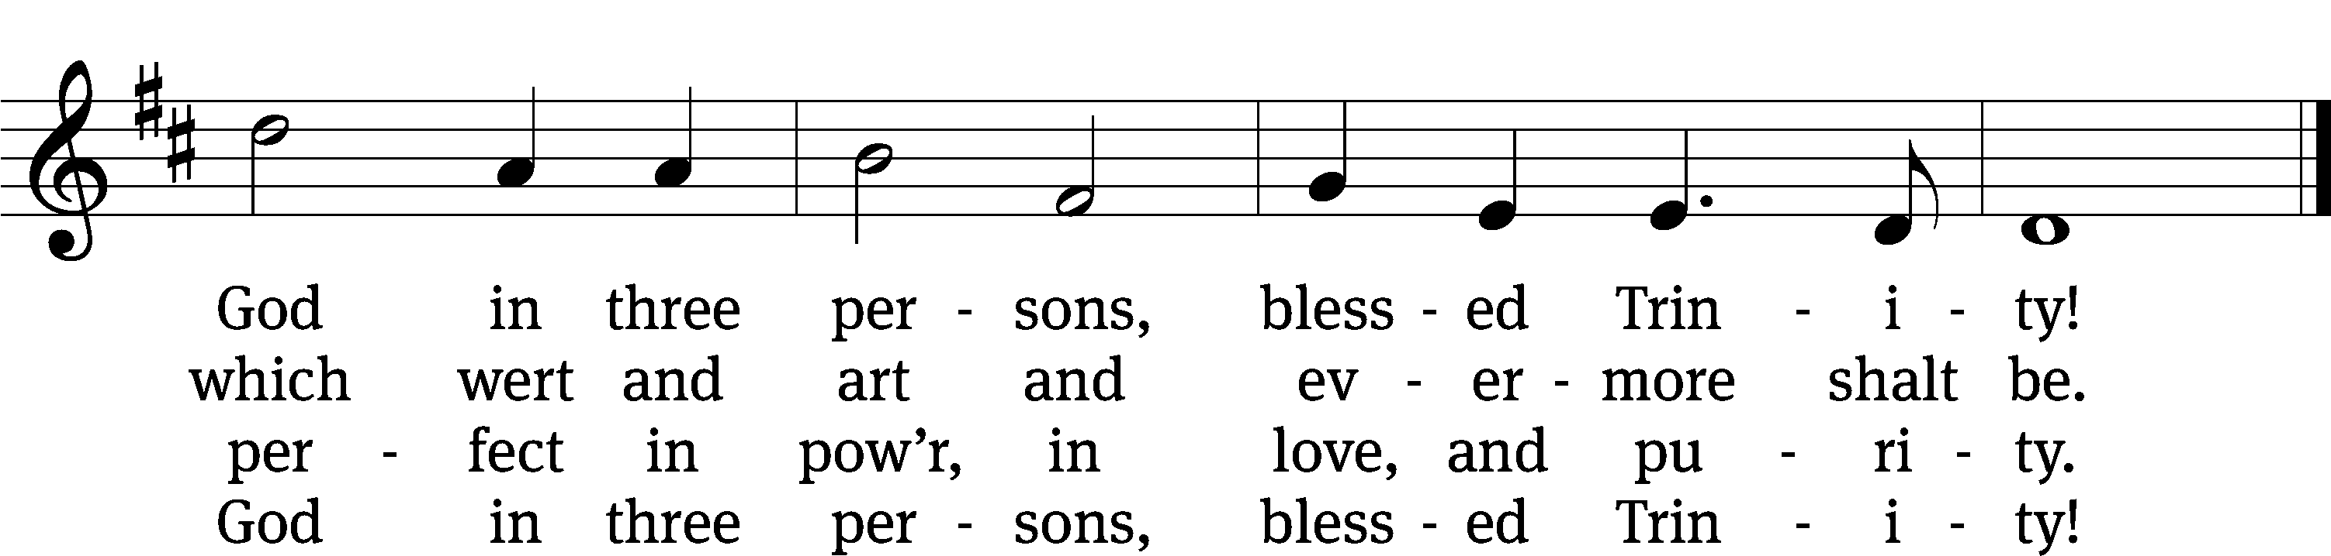
Text: Reginald Heber, 1783–1826, alt.
Tune: John B. Dykes, 1823–1876
Text and tune: Public domain
SERMON Genesis 1:1-2:3
“All Present and Accounted for”

Please stand, if you are able

THE ATHANASIAN CREED
This creed is named after St. Athanasius, a staunch defender of the Christian faith in the fourth century. It was prepared to assist the Church in combating two errors that undermined Bible teaching. One error denied that God ’s Son and the Holy Spirit are of one being or Godhead with the Father. The other error denied that Jesus Christ is true God and true man in one person. The Athanasian Creed continues to serve the Christian Church as a standard of the truth. It declares that whoever rejects the doctrine of the Trinity and the doctrine of Christ is without the saving faith.

Whoever wishes to be saved must, above all else, hold to the true Christian faith.
Whoever does not keep this faith pure in all points will certainly perish forever.

Now this is the true Christian faith:
We worship one God in three persons and three persons in one God,
without mixing the persons or dividing the divine being.
For each person—the Father, the Son, and the Holy Spirit—is distinct,
but the deity of Father, Son, and Holy Spirit is one,
equal in glory and coeternal in majesty.
What the Father is, so is the Son, and so is the Holy Spirit.
The Father is uncreated, the Son uncreated, the Holy Spirit uncreated;
the Father is infinite, the Son infinite, the Holy Spirit infinite;
the Father is eternal, the Son eternal, the Holy Spirit eternal;
yet they are not three who are eternal, but there is one who is eternal,
just as they are not three who are uncreated, nor three who are infinite,
but there is one who is uncreated and one who is infinite.
In the same way the Father is almighty, the Son is almighty, the Holy Spirit is almighty;
yet they are not three who are almighty, but there is one who is almighty.
So the Father is God, the Son is God, the Holy Spirit is God;
yet they are not three Gods, but one God.
So the Father is Lord, the Son is Lord, the Holy Spirit is Lord;
yet they are not three Lords, but one Lord.
For just as Christian truth compels us to confess each person individually to be God and Lord,
so the true Christian faith forbids us to speak of three Gods or three Lords.
The Father is neither made nor created nor begotten of anyone.
The Son is neither made nor created, but is begotten of the Father alone.
The Holy Spirit is neither made nor created nor begotten,
but proceeds from the Father and the Son.
So there is one Father, not three Fathers; one Son, not three Sons;
one Holy Spirit, not three Holy Spirits.
And within this Trinity none comes before or after; none is greater or inferior,
but all three persons are coequal and coeternal,
so that in every way, as stated before, all three persons are to be worshiped as one God
and one God worshiped as three persons.
Whoever wishes to be saved must have this conviction of the Trinity.

It is furthermore necessary for eternal salvation truly to believe
that our Lord Jesus Christ also took on human flesh.
Now this is the true Christian faith:
We believe and confess that our Lord Jesus Christ, God’s Son,
is both God and man.
He is God, eternally begotten from the nature of the Father, and he is man, born in time
from the nature of his mother, fully God, fully man, with rational soul and human flesh,
equal to the Father as to his deity, less than the Father as to his humanity;
and though he is both God and man, Christ is not two persons but one,
one, not by changing the deity into flesh, but by taking the humanity into God;
one, indeed, not by mixture of the natures, but by unity in one person;
for just as the rational soul and flesh are one human being,
so God and man are one Christ.
He suffered for our salvation, descended into hell, rose the third day from the dead.
He ascended into heaven, is seated at the right hand of God the Father almighty,
and from there will come to judge the living and the dead.
At his coming all people will rise with their own bodies
to answer for their personal deeds.
Those who have done good will enter eternal life,
but those who have done evil will go into eternal fire.

This is the true Christian faith.
Whoever does not faithfully and firmly believe this cannot be saved.

Prayer of the Church

The Sacrament
Preface CW 165
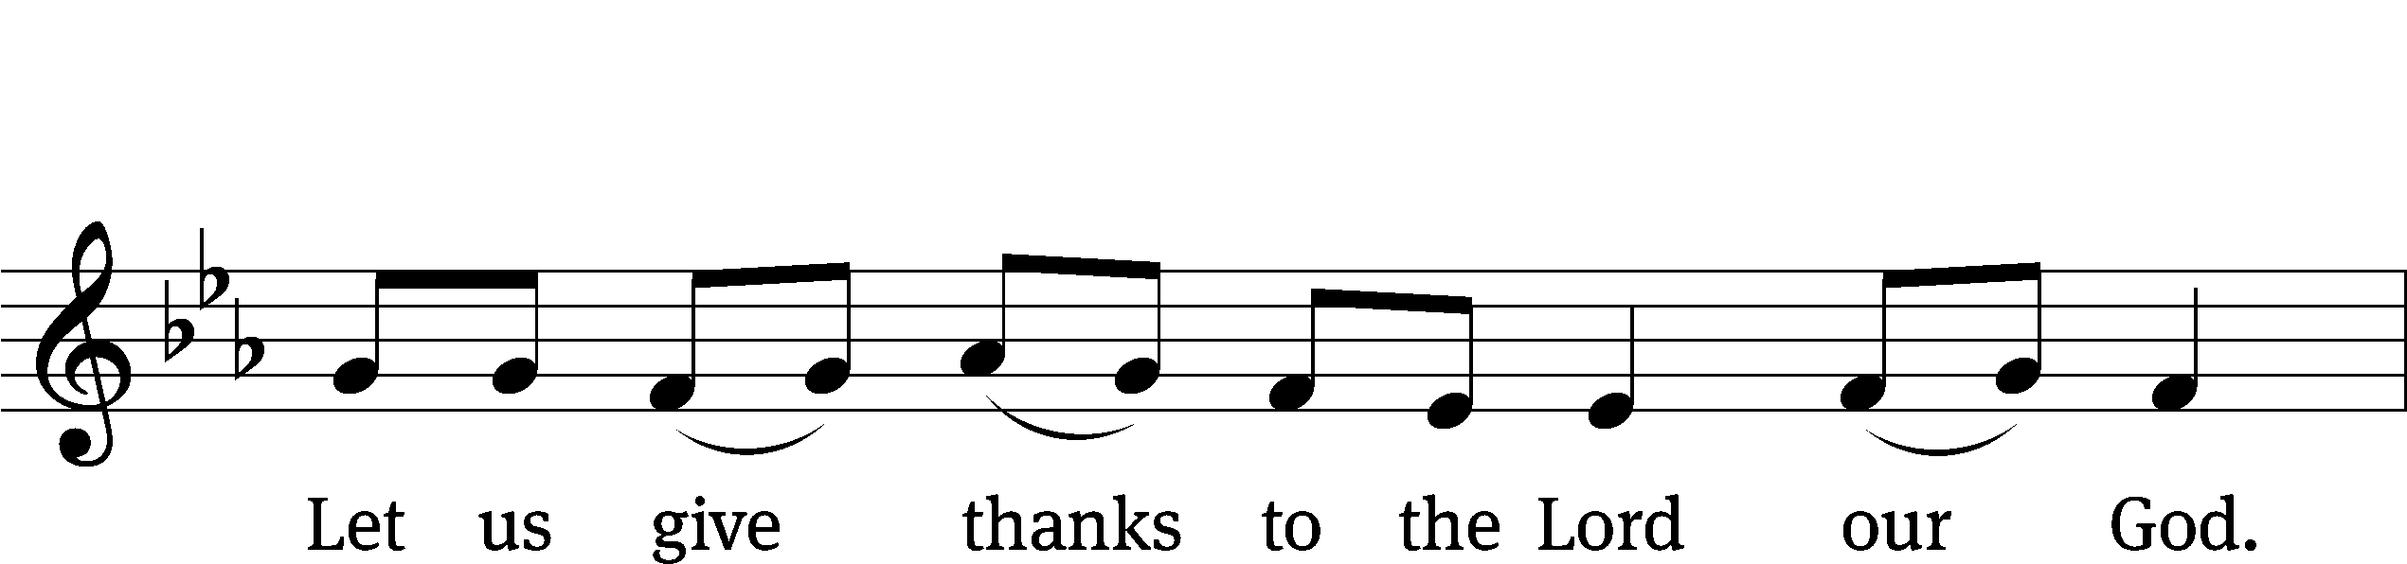
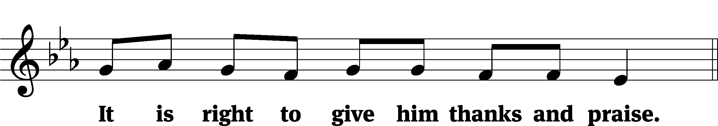

It is truly good and right that we should at all times and in all places give you thanks, O Lord, holy Father, almighty and everlasting God, through Jesus Christ our Lord, who by his willing sacrifice on the cross took away the sins of the world and by his glorious resurrection restored everlasting life. Therefore, with all the saints on earth and hosts of heaven, we praise your holy name and join their glorious song:
Holy, Holy, Holy CW 167
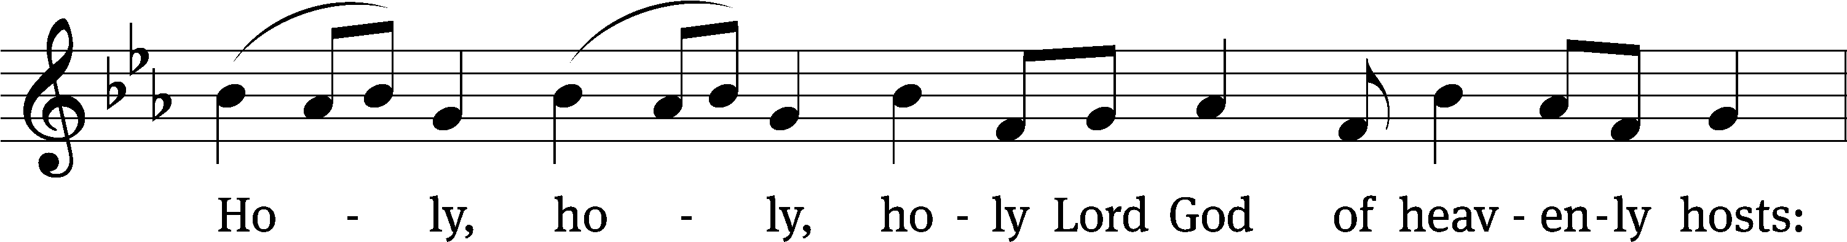
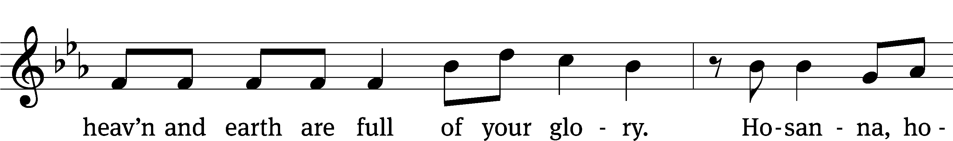
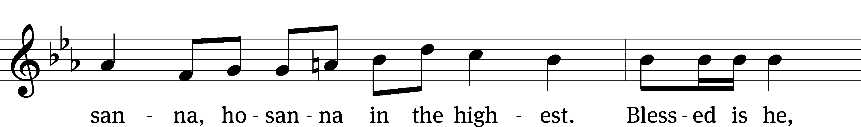
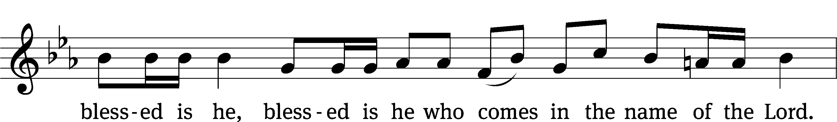
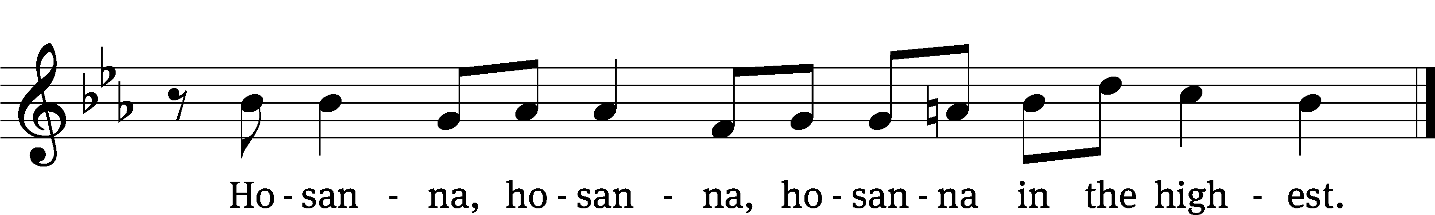

Prayer of Thanksgiving
We give thanks to you, O God, through your dear Son, Jesus Christ, whom you sent to be our Savior, our Redeemer, and the messenger of your grace. Through him you made all things; in him you are well pleased. He is the incarnate Word, conceived by the Holy Spirit and born of the Virgin Mary. To fulfill your promises, he stretched out his hands on the cross and released from eternal death all who believe in you.

As we remember Jesus’ death and resurrection, we thank you that you have gathered us together to receive your Son’s body and blood. Send us your Spirit, unite us as one, and strengthen our faith so that we may praise you in your Son, Jesus Christ. Through him, we glorify and honor you, O God our Father, with the Holy Spirit, one God, now and forever.
Amen.

Lord’s Prayer
Our Father, who art in heaven, hallowed be thy name, thy kingdom come, thy will be done on earth as it is in heaven. Give us this day our daily bread; and forgive us our trespasses, as we forgive those who trespass against us; and lead us not into temptation, but deliver us from evil. For thine is the kingdom and the power and the glory forever and ever. Amen.

Words of Institution
Our Lord Jesus Christ, on the night he was betrayed, took bread; and when he had given thanks, he broke it and gave it to his disciples, saying, “Take and eat; this is my body, which is given for you. Do this in remembrance of me.”
Then he took the cup, gave thanks, and gave it to them, saying, “Drink from it, all of you; this is my blood of the new covenant, which is poured out for you for the forgiveness of sins. Do this, whenever you drink it, in remembrance of me.”

The peace of the Lord be with you always.
Amen.
O Christ, Lamb of God CW 169
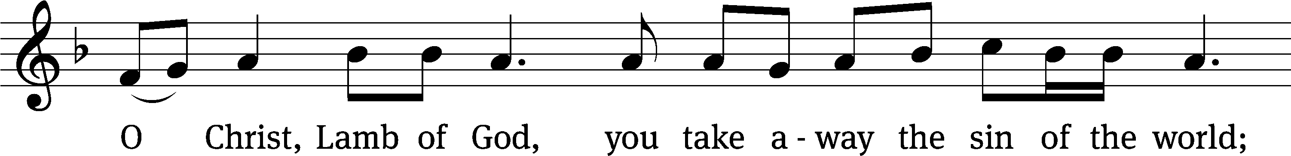
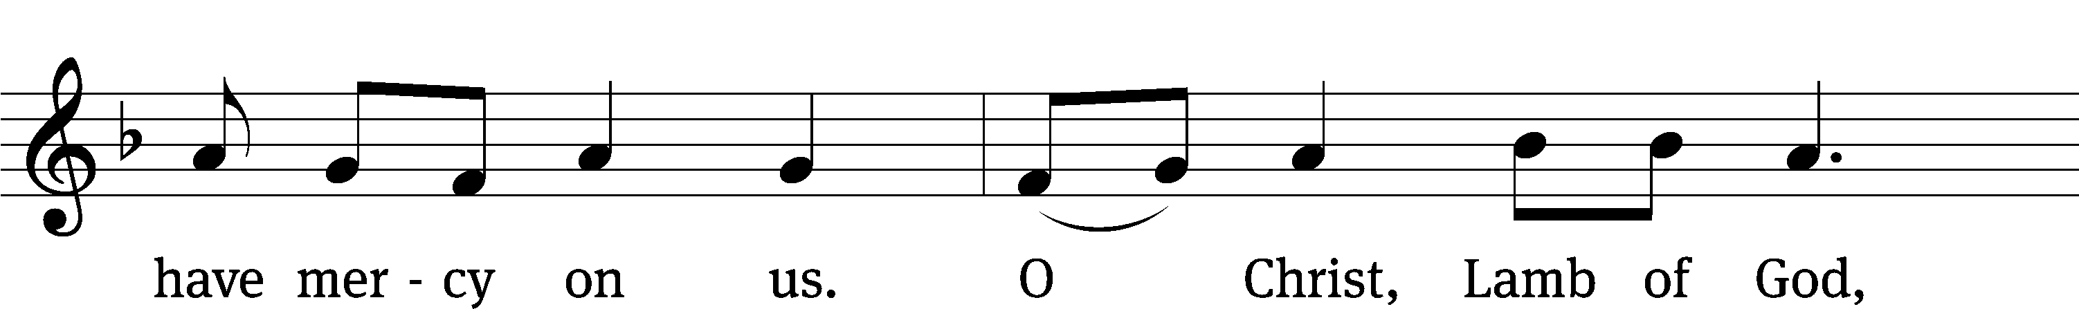
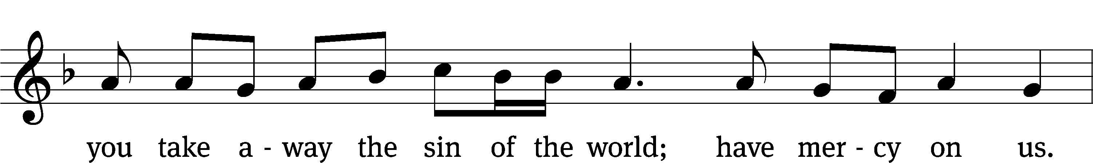
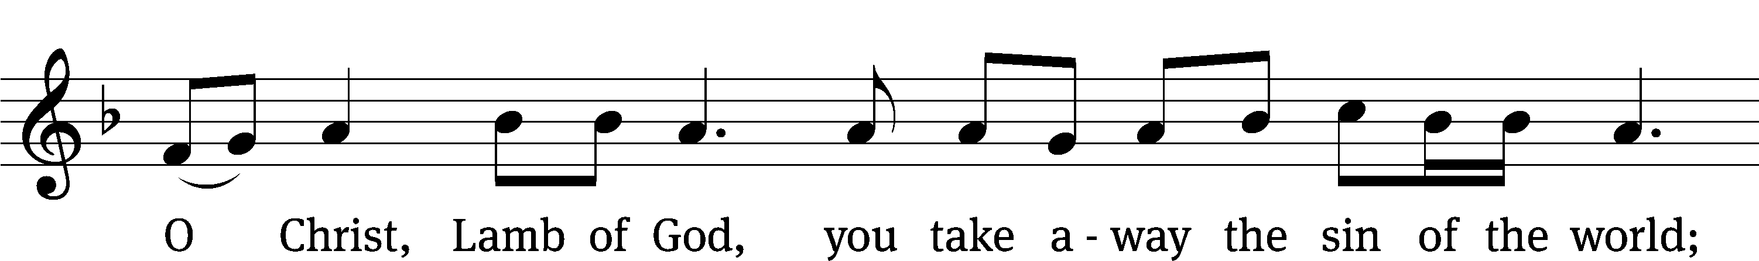
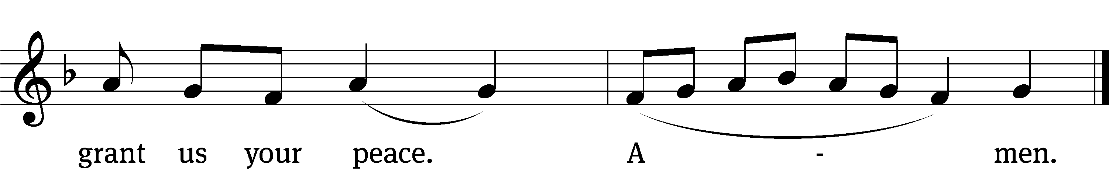
Please be seated

566 Father, God of Grace, You Knew Us CW 566
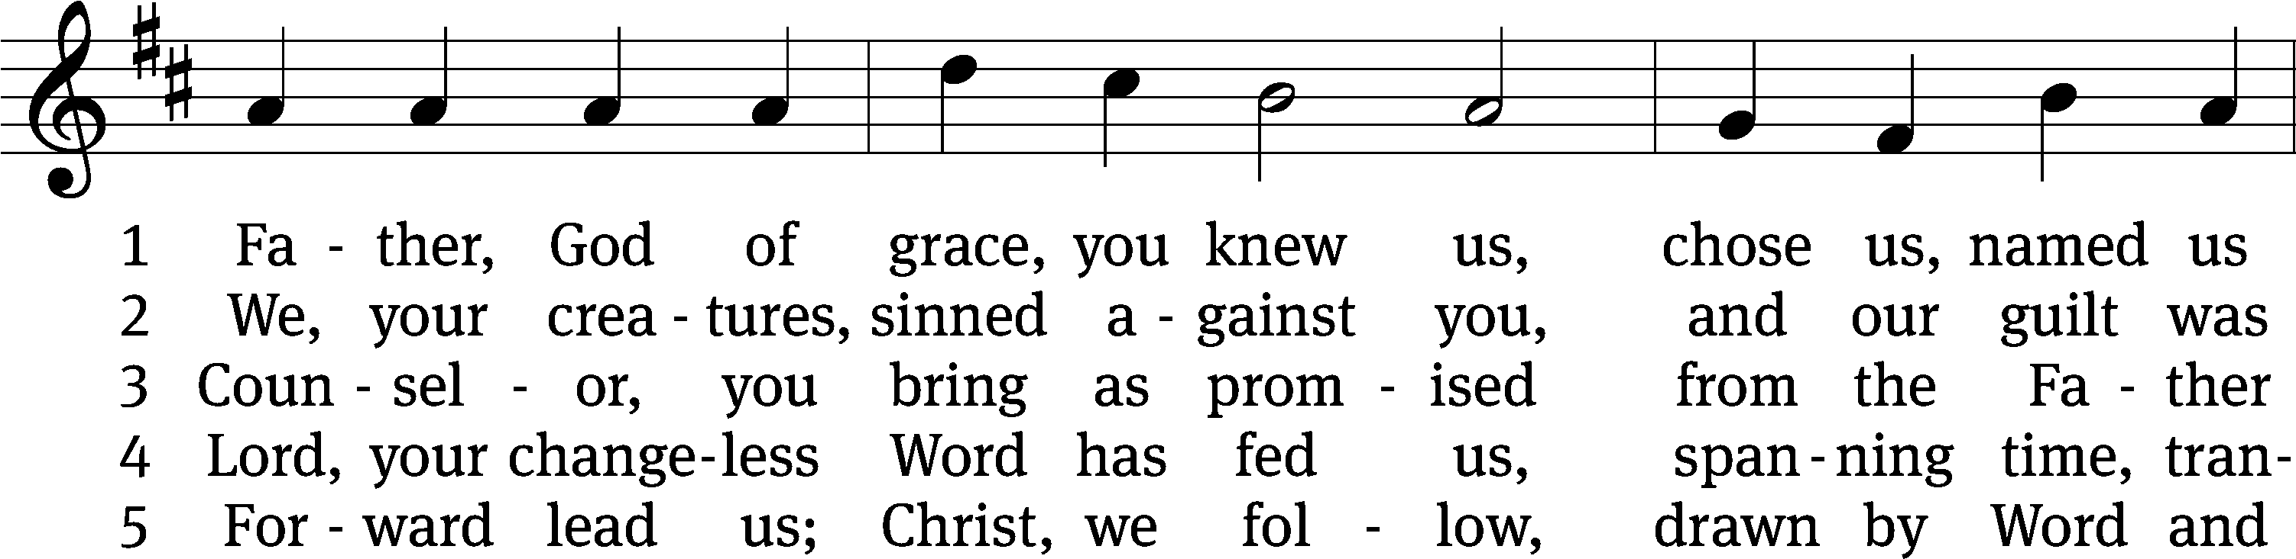
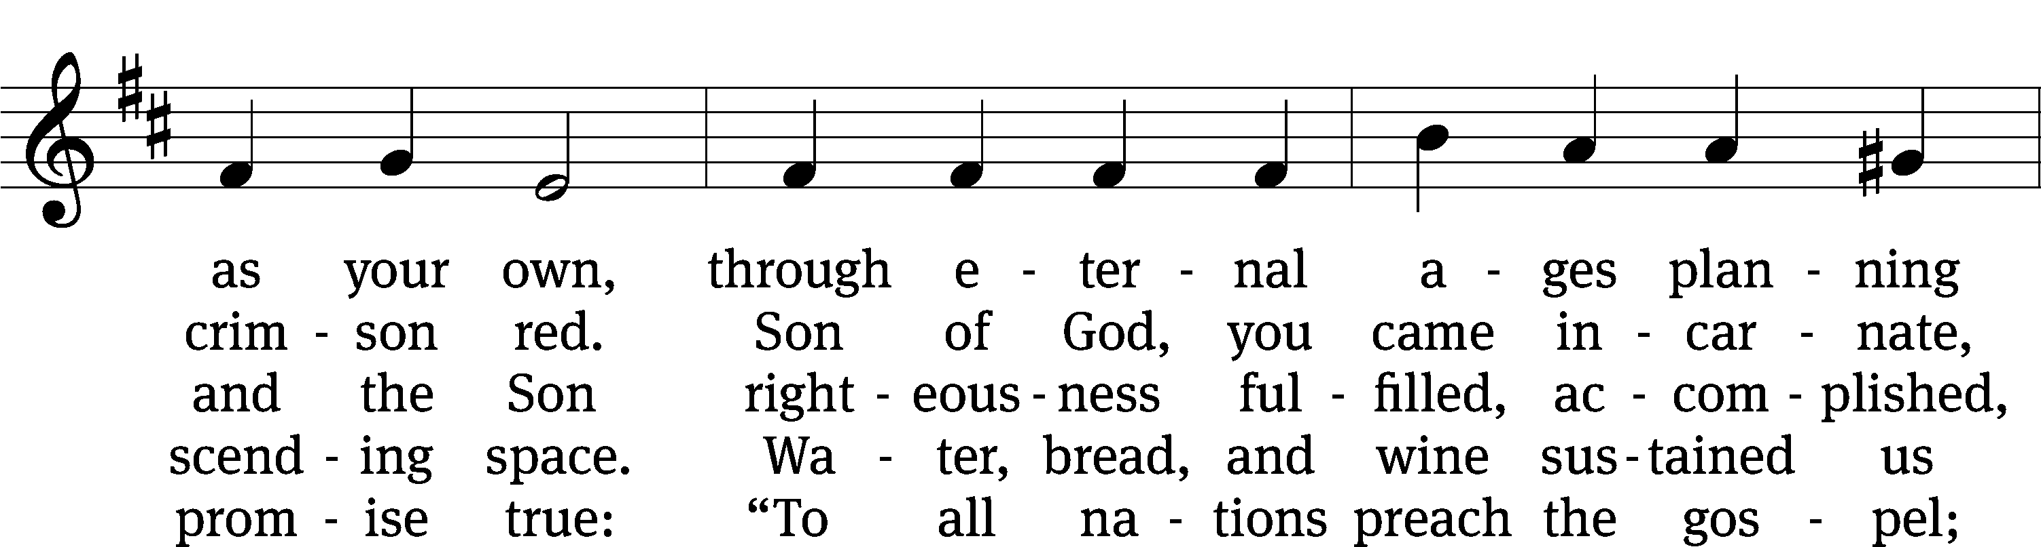
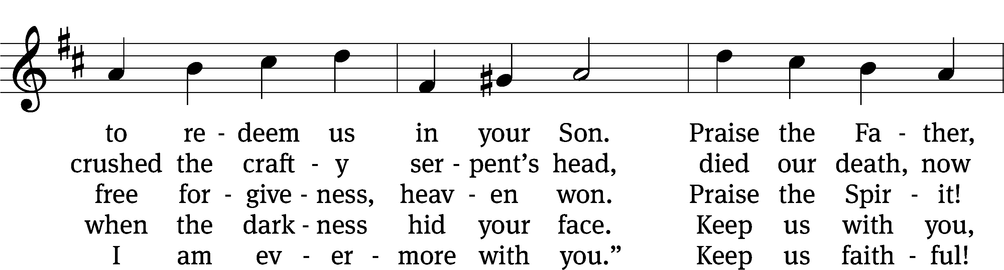
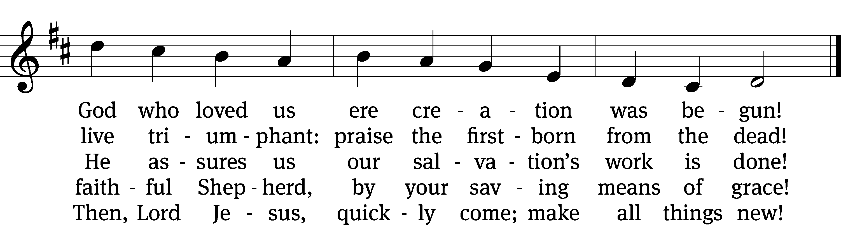
Text: Paul E. Eickmann, 1928–2006, abr.
Tune: John Goss, 1800–1880
Text: © 1999 Northwestern Publishing House. Used by permission: OneLicense no. 727703
Tune: Public domain

680 Baptized into Your Name Most Holy CW 680
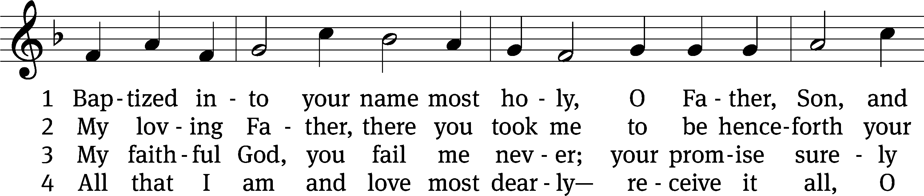
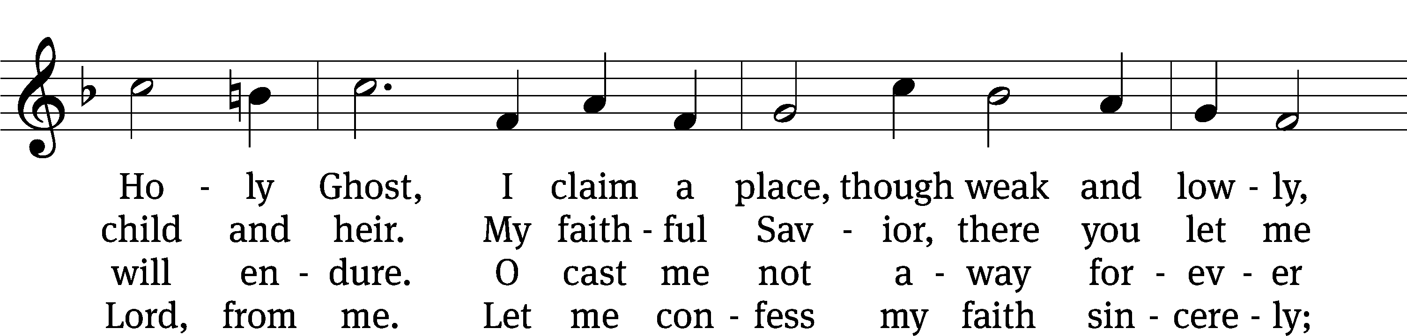
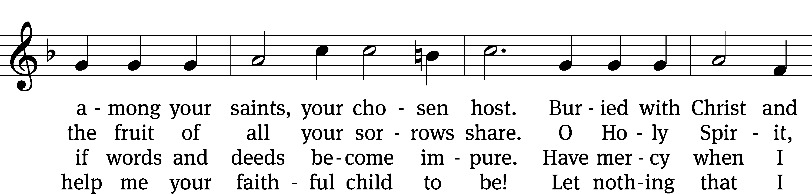
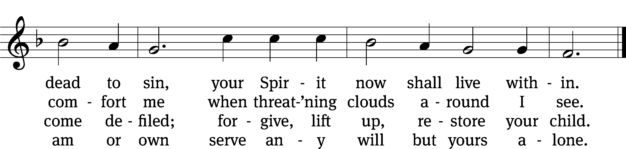
Text: tr. Catherine Winkworth, 1827–1878, alt.; Johann J. Rambach, 1693–1735, abr.
Tune: Cornelius H. Dretzel, 1697–1775
Text and tune: Public domain

Please stand, if you are able

Give thanks to the Lord, for he is good;
his mercy endures forever.

Whenever we eat this bread and drink this cup,
we proclaim the Lord’s death until he comes.

We give thanks, almighty God, that you have refreshed us with this saving gift. We pray that through it you will strengthen our faith in you and increase our love for one another. We ask this in the name of Jesus Christ our Lord, who lives and reigns with you and the Holy Spirit, one God, now and forever.
Amen.

Blessing
The Lord bless you and keep you.
The Lord make his face shine on you and be gracious to you.
The Lord look on you with favor and give you peace.
Amen.

Please be seated
940 We All Believe in One True God CW 940
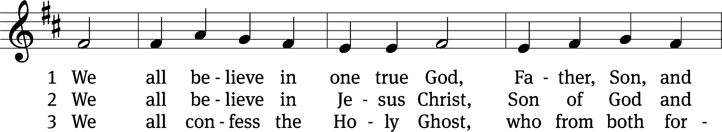
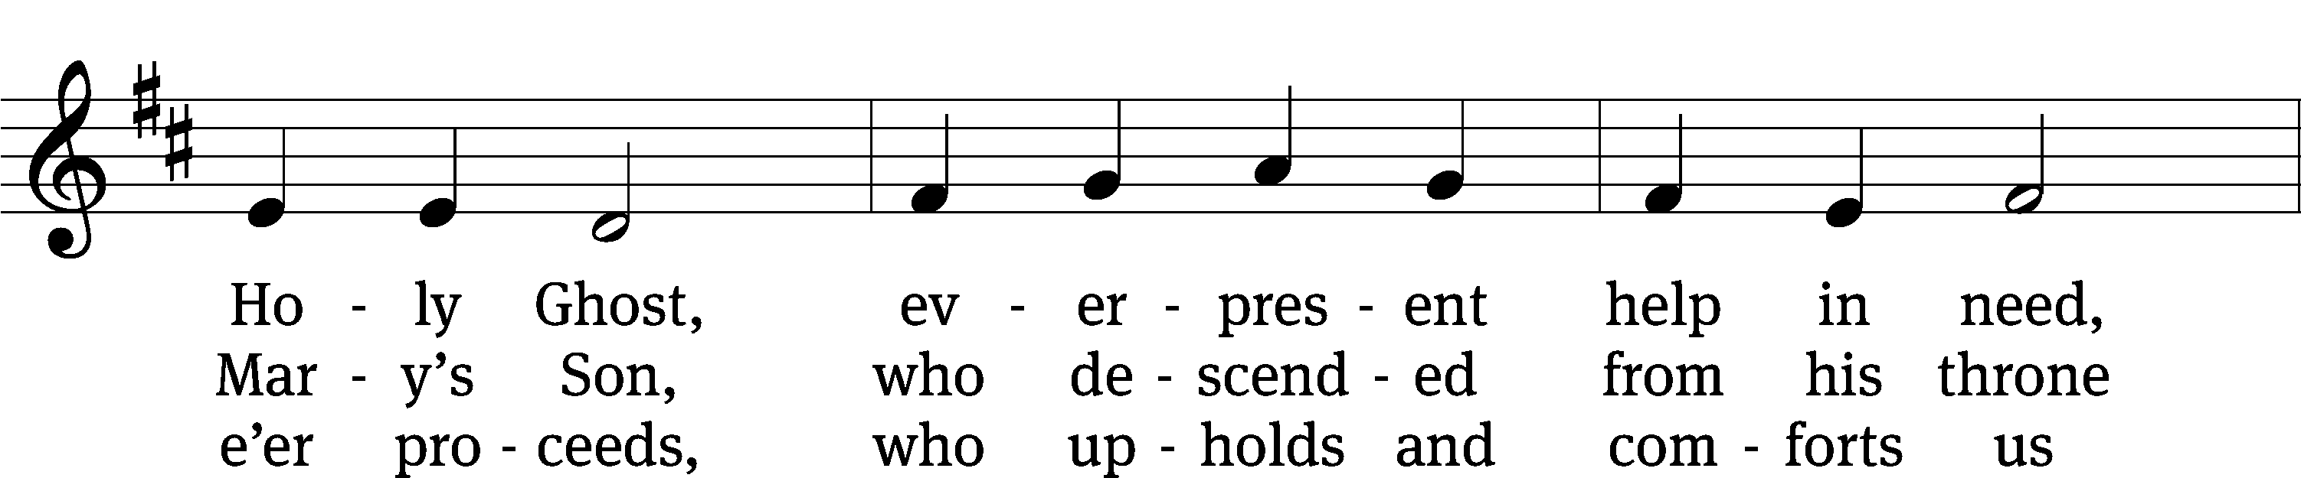
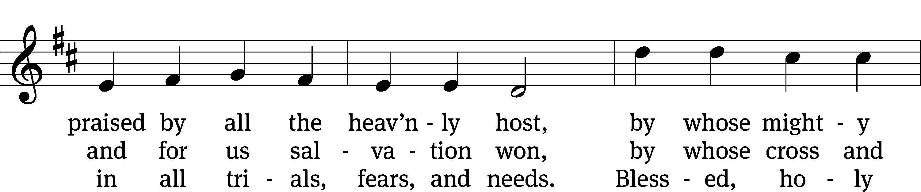
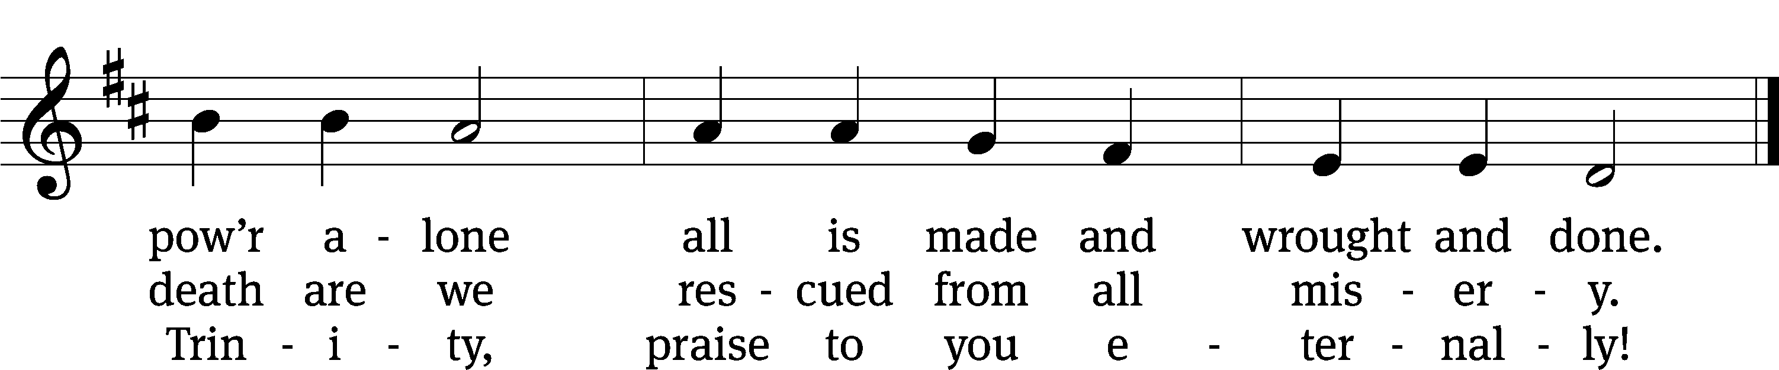
Text: tr. Catherine Winkworth, 1827–1878, alt.; Tobias Clausnitzer, 1619–1684
Tune: adapt. Cornelius H. Dretzel, 1697–1775; Neu-vermehrtes . . . Gesangbuch, 3rd. ed., Meiningen, 1693
Text and tune: Public domain
Acknowledgments
Setting One from Christian Worship
Software distributed in partnership with Northwestern Publishing House.
Created by Christian Worship: Service Builder © 2022 Concordia Publishing House.
Serving in Worship
Officiant Pastor William Natsis
Organist Marcia Marion Ackling
Deacons (Thursday) Steve Hoeft and Jim Tice
Deacons (Sunday) Duane Mason and Robert Niethammer
Ushers (Thursday) Robert Newman and Henry Schneider
Ushers (Sunday) Dave Boswell and Jake Vershum
Altar Guild Diane Stevenson and Karen Tice
Videographer Cindy Dresch

