The FOURTH sunday
AFTER EPIPHANY

tRINITY EVANGELICAL LUTHERAN CHURCH | Saline, Michigan
January 30, 2022

WELCOME TO WORSHIP

Thank you for joining us in God’s house today! We cordially ask that our Guests with us this morning sign one of the guestbooks located at either the front or back entryways.

THANK OFFERING: Members of Trinity give their offering as an expression of love and thankfulness to the Lord and to help support the Lord’s work in our community and around the world. Visitors need not feel obligated to participate in this offering which supports our ministry.

Restrooms are located at the back of the upper level (the annex), and in the basement (down the back stairs of the sanctuary or annex). Handicap access is available, please ask an usher for assistance.

Young Families / Toddler Bags – We are GLAD YOU BROUGHT YOUR CHILDREN to our worship service. Jesus said: “Let the little children come to me and do not hinder them, for the kingdom of God belongs to such as these.” We know that having little children in church can be a challenge, but DO NOT WORRY about it. Many of your fellow worshippers have been in your shoes and are just happy you brought your children with you. For your convenience, we have reserved the back rows of seating for parents with small children. These areas provide more flexibility for your family, as well as, easy access to move downstairs if necessary. A closed-circuit TV system allows families to continue participating in the service while downstairs. Pre-school toddler bags and children’s bulletins are available for their enjoyment. Ask an usher for one to use during the service and please return the toddler bag afterwards.

SERVICE of the word

BELL CHOIR (11:00 SERVICE ONLY) “Let Us Ever Walk With Jesus”

OPENING HYMN #901 CW
901 O Christians, Haste CW 901
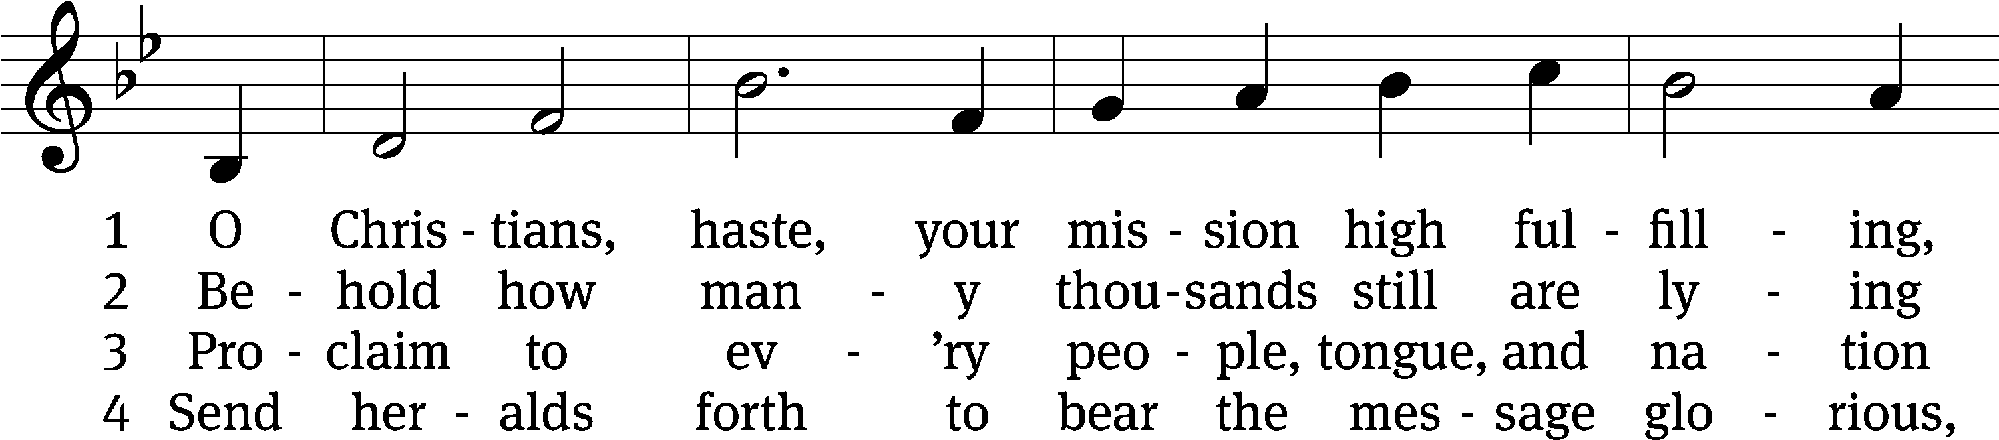
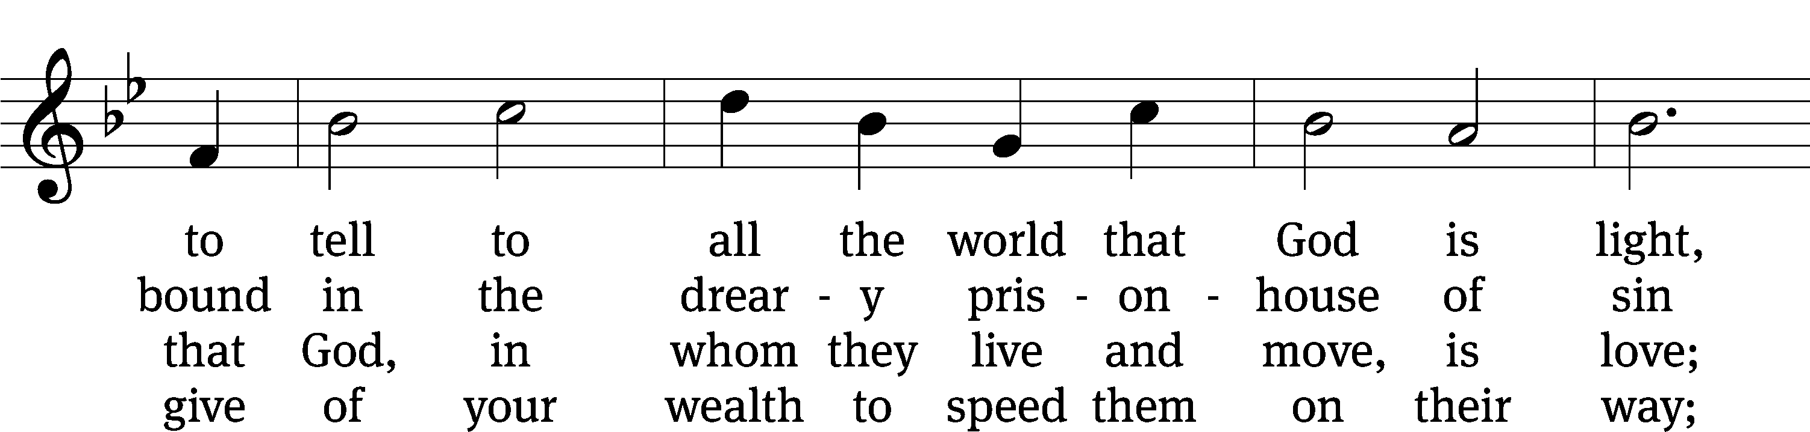
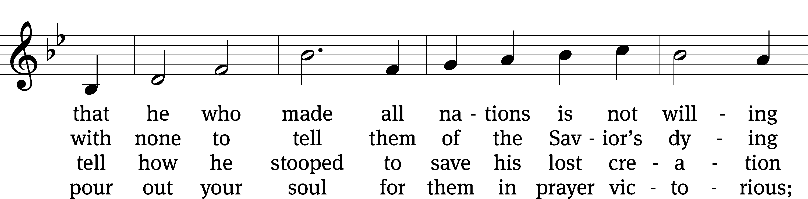
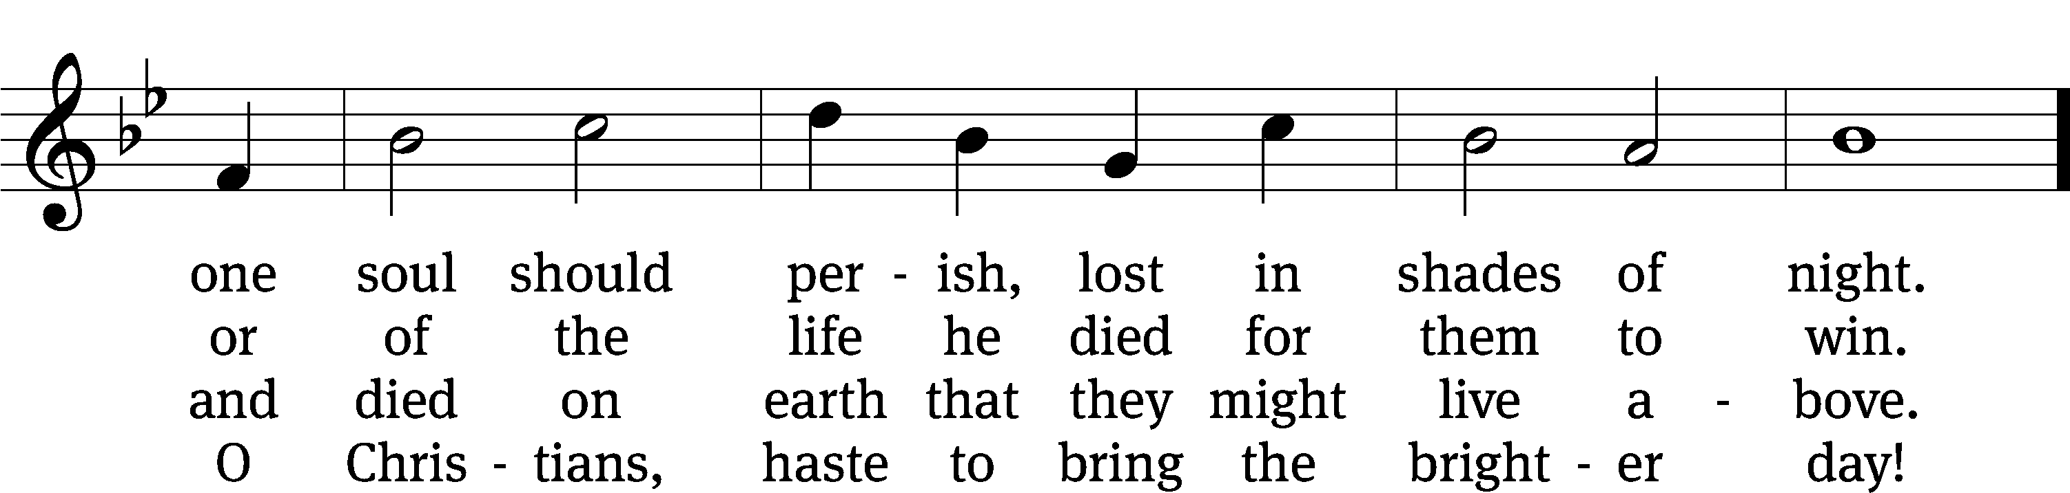
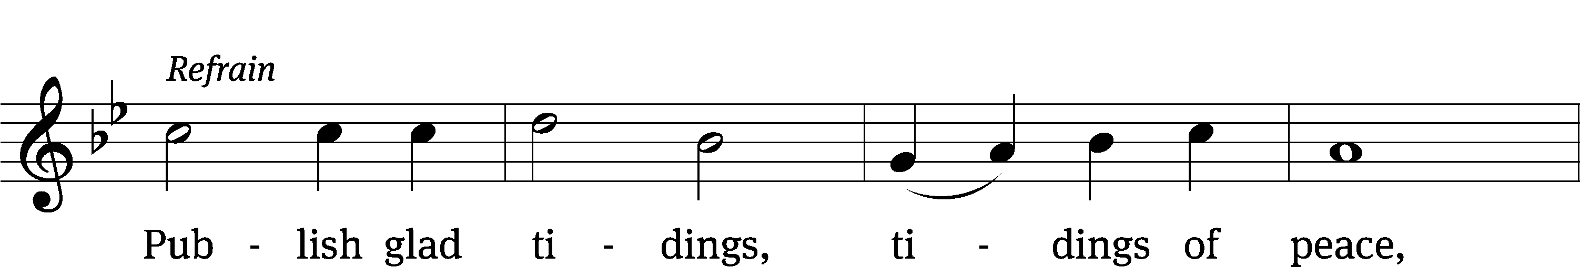
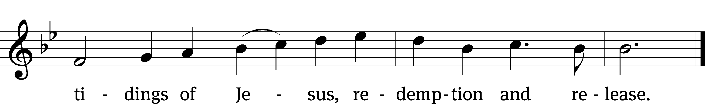
Text: Public domain
Tune: © 1993 Bruce R. Backer, admin. Northwestern Publishing House. Used by permission: OneLicense no. 727703

PLEASE STAND, IF YOU ARE ABLE

invocation
M: The grace of our Lord (+) Jesus Christ and the love of God and the fellowship of the Holy Spirit be with you.
C: And also with you.

CONFESSION OF SINS
M: We have come into the presence of God, who created us to love and serve him as his dear children. But we have disobeyed him and deserve only his wrath and punishment. Therefore, let us confess our sins to him and plead for his mercy.

C: Merciful Father in heaven, I am altogether sinful from birth. In countless ways I have sinned against you and do not deserve to be called your child. But trusting in Jesus, my Savior, I pray: Have mercy on me according to your unfailing love. Cleanse me from my sin, and take away my guilt.

M: God, our heavenly Father, has forgiven all your sins. By the perfect life and innocent death of our Lord Jesus Christ, he has removed your guilt forever. You are his own dear child. May God give you strength to live according to his will.

C: Amen.
PRAYER AND PRAISE

M: In the peace of forgiveness, let us praise the Lord.

OH, TASTE AND SEE

PRAYER OF THE DAY

M: Let us pray.
The minister says the Prayer of the Day.

PLEASE BE SEATED

The Word

the FIRST LESSON jeremiah 1:4-10

⁴ The word of the Lord came to me.
⁵ Before I formed you in the womb, I knew you,
and before you were born, I set you apart.
I appointed you to be a prophet to the nations.
⁶ But I said, “Ah, Lord God! I really do not know how to speak! I am only a child!”
⁷ The Lord said to me, “Do not say, ‘I am only a child.’ You must go to everyone to whom I send you and say whatever I command you. ⁸ Do not be afraid of them, because I am with you, and I will rescue you, declares the Lord.”
⁹ Then the Lord stretched out his hand and touched my mouth. The Lord said to me:
There! I have now placed my words in your mouth.
¹⁰ Look, today I appoint you over nations and kingdoms
to uproot and to tear down,
to destroy and to overthrow,
to build and to plant.

PSALM OF THE DAY Psalm 71A

71A God Is My Strong Salvation Psalm 71A
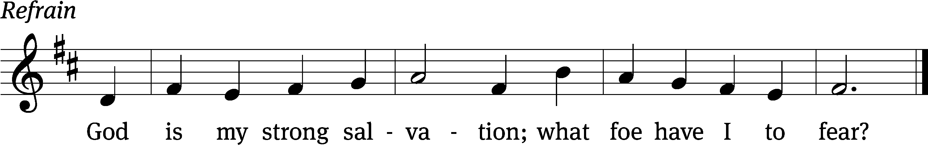

In you, Lord, I have taken / refuge;
let me never be / put to shame.
In your righteousness, rescue me and de- / liver me;
turn your ear to me and / save me.
Be my rock of / refuge,
to which I can / always go.

Refrain

Since my youth, God, you have / taught me,
and to this day I declare your / marv’lous deeds.
Even when I am / old and gray,
do not forsake / me, my God,
till I declare your power to the next gener- / ation,
your mighty acts to all who / are to come.
Glory be to the Father and / to the Son
and to the Holy / Spirit,
as it was in the be- / ginning,
is now, and will be forever. / Amen.

Refrain
Tune: Public domain
Setting: © 1988 Hope Publishing Co. Used by permission: OneLicense no. 727703
THE SECOND LESSON 2 TIMOTHY 3:14-4:4
¹⁴ As for you, continue in the things you have learned and about which you have become convinced. You know from whom you learned them ¹⁵ and that from infancy you have known the Holy Scriptures, which are able to make you wise for salvation through faith in Christ Jesus. ¹⁶ All Scripture is God breathed and is useful for teaching, for rebuking, for correcting, and for training in righteousness, ¹⁷ so that the man of God may be complete, well equipped for every good work.
4 I solemnly charge you in the presence of God and Christ Jesus, who is going to judge the living and the dead, and in view of his appearing and his kingdom: ² Preach the word. Be ready whether it is convenient or not. Correct, rebuke, and encourage, with all patience and teaching. ³ For there will come a time when people will not put up with sound doctrine. Instead, because they have itching ears, they will accumulate for themselves teachers in line with their own desires. ⁴ They will also turn their ears away from the truth and will turn aside to myths.

Verse of the day

PLEASE Stand, if you are able

THE GOSPEL LESSON LUKE 4:38-44
M: The Gospel according to Luke chapter 4, verses 38-44

³⁸ Jesus got up, left the synagogue, and went into Simon’s house. Simon’s mother-in-law was suffering from a high fever. They asked him to help her. ³⁹ He stood over her, rebuked the fever, and it left her. Immediately she got up and began to serve them. ⁴⁰ As the sun was setting, they brought to him all who were sick with various diseases. He laid his hands on every one of them and healed them. ⁴¹ Demons also came out of many people, crying out, “You are the Son of God!” He rebuked them and did not allow them to speak, because they knew that he was the Christ.
⁴² When it was day, he went out to a deserted place. The crowds were looking for him. They went up to him and were trying to prevent him from leaving them. ⁴³ But he told them, “I must preach the good news of the kingdom of God to the other towns too, because that is why I was sent.” ⁴⁴ And he continued to preach in the synagogues in the land of the Jews.

M: This is the Gospel of the Lord.

PLEASE BE SEATED

SERMON HYMN #900 CW
900 Lift High the Cross CW 900
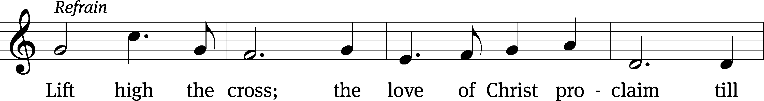
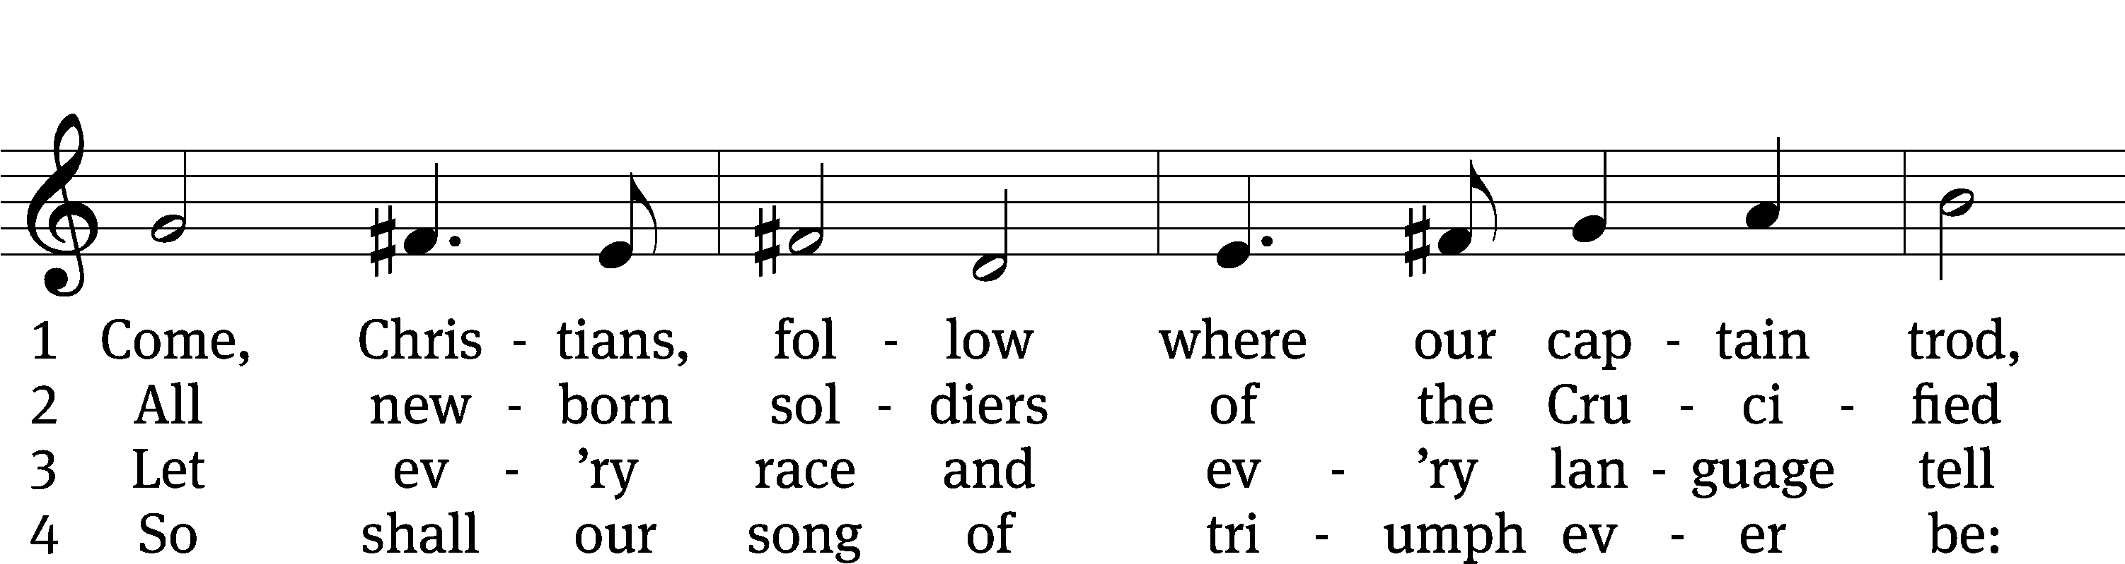
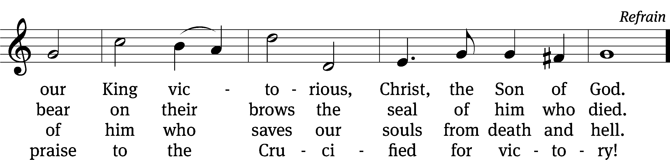
Text and tune: © 1974 Hope Publishing Co. Used by permission: OneLicense no. 727703

SERMON Luke 4:38-44
“A Tale of Two Cities…and More”

PLEASE STAND, IF YOU ARE ABLE

THE APOSTLES’ CREED
I believe in God, the Father almighty,
maker of heaven and earth.
I believe in Jesus Christ, his only Son, our Lord,
who was conceived by the Holy Spirit,
born of the virgin Mary,
suffered under Pontius Pilate,
was crucified, died, and was buried.
He descended into hell.
The third day he rose again from the dead.
He ascended into heaven
and is seated at the right hand of God the Father almighty.
From there he will come to judge the living and the dead.
I believe in the Holy Spirit,
the holy Christian Church,
the communion of saints,
the forgiveness of sins,
the resurrection of the body,
and the life everlasting. Amen.

BELL CHOIR (8:30 SERVICE ONLY) “Let Us Ever Walk With Jesus”

PRAYER OF THE CHURCH

THE LORD’S PRAYER

C: Our Father, who art in heaven, hallowed be thy name, thy kingdom come, thy will be done on earth as it is in heaven. Give us this day our daily bread; and forgive us our trespasses, as we forgive those who trespass against us; and lead us not into temptation, but deliver us from evil. For thine is the kingdom and the power and the glory forever and ever. Amen.

PLEASE BE SEATED

HYMN #902 CW
902 Spread Abroad, O Mighty Word CW 902
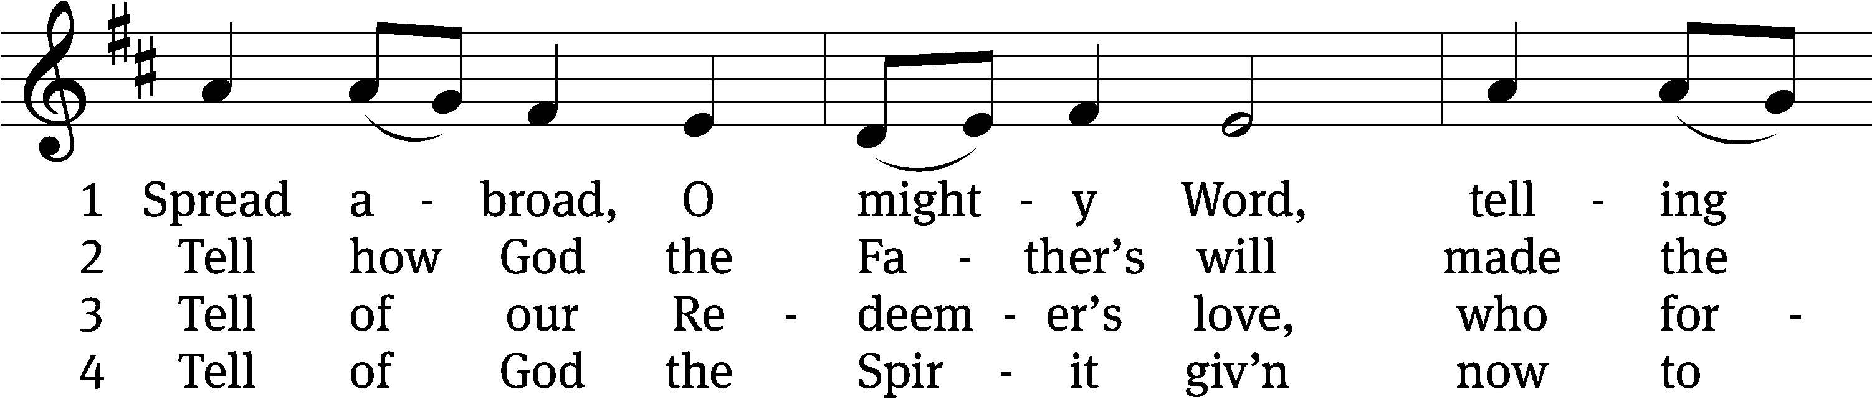
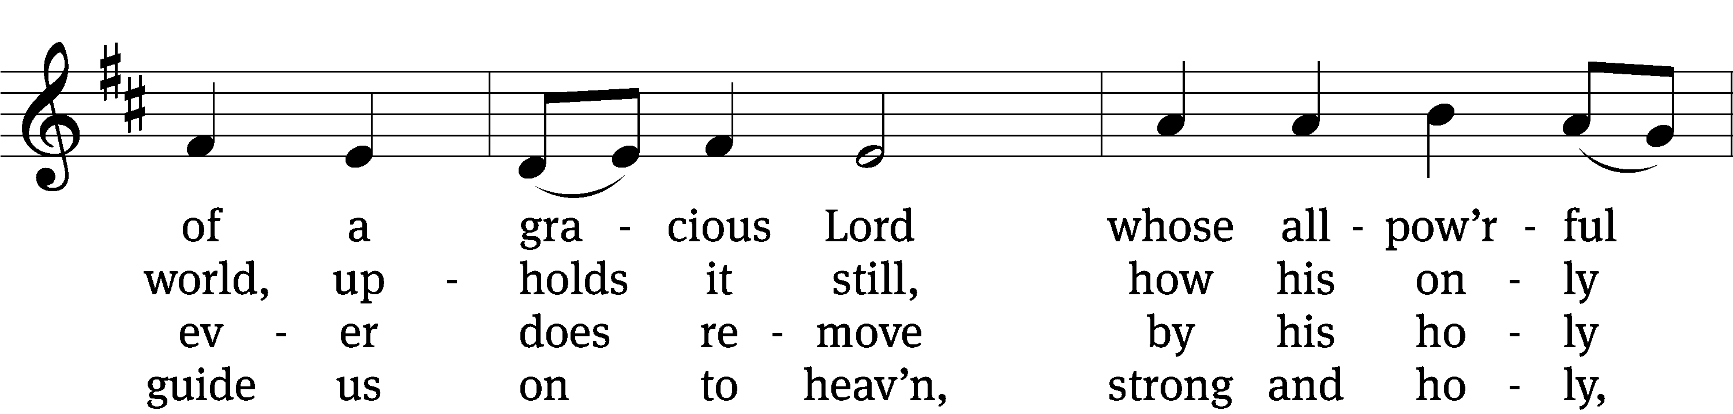
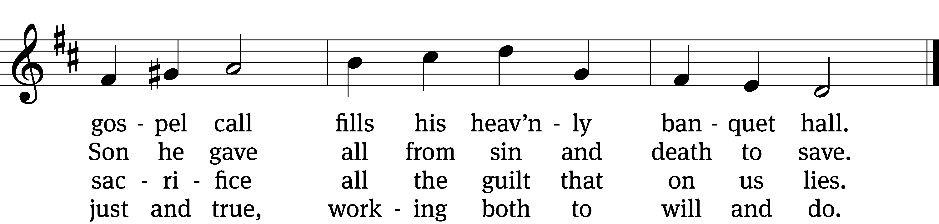

5 Spread abroad! Ripe fields of grain
all throughout the world remain,
but the reapers still are few;
great the work they have to do.

6 Lord of harvest, great and kind,
rouse to action heart and mind;
let the gath’ring nations all
see your light and heed your call.
Text and tune: Public domain

PLEASE STAND, IF YOU ARE ABLE

CLOSING PRAYER
M: Almighty God, we thank you for teaching us the things you want us to believe and do. Help us by your Holy Spirit to keep your Word in pure hearts that we may be strengthened in faith, guided in holiness, and comforted in life and in death, through Jesus Christ, our Lord, who lives and reigns with you and the Holy Spirit, one God, now and forever.

M: Brothers and sisters, go in peace. Live in harmony with one another. Serve the Lord with gladness.
The Lord bless you and keep you.
The Lord make his face shine on you and be gracious to you.
The Lord look on you with favor and (+) give you peace.

PLEASE BE SEATED

CLOSING HYMN #908 CW
908 Go Forth and Preach the Gospel CW 908
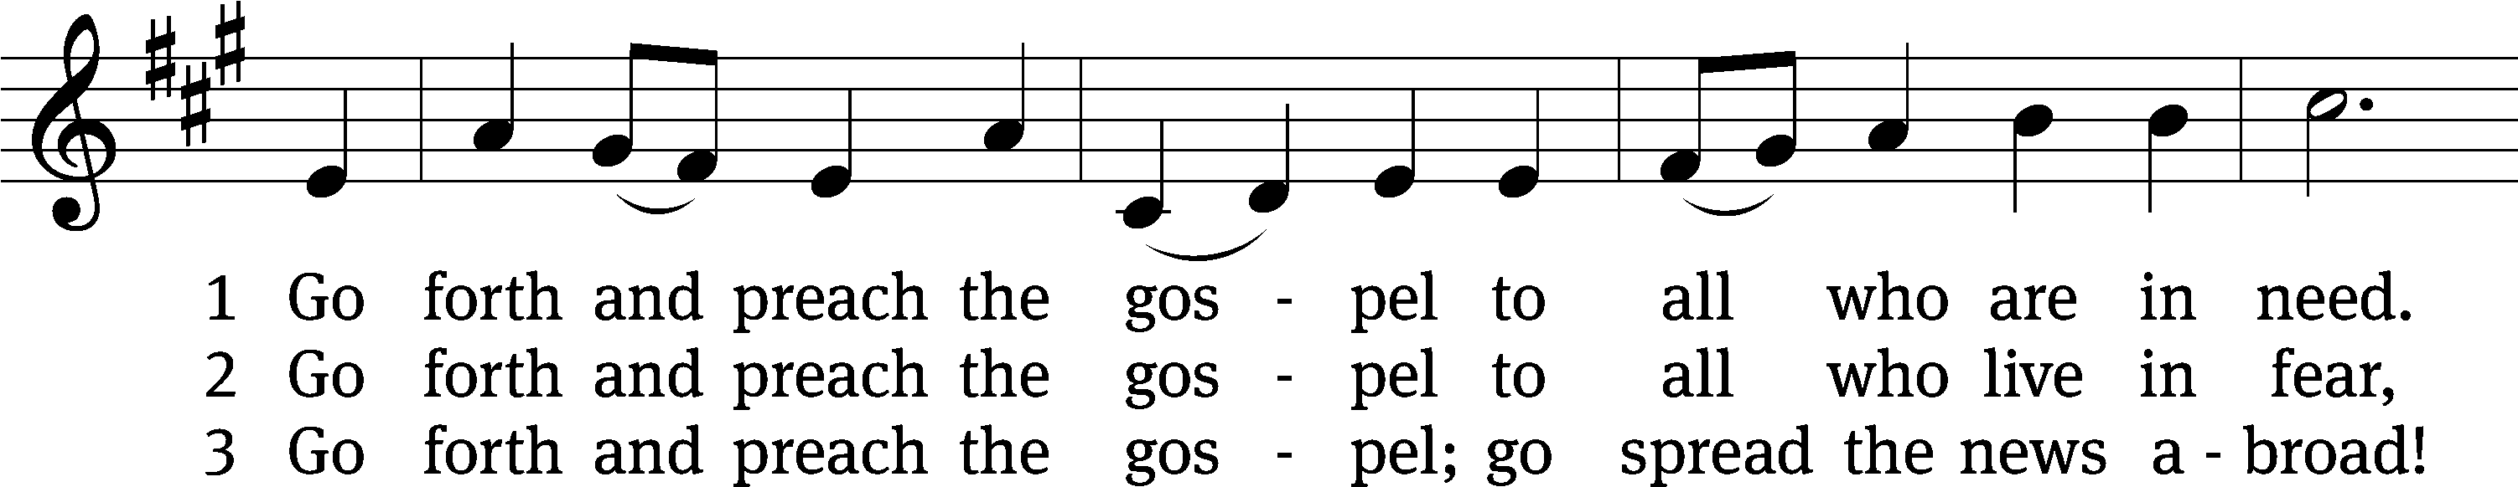
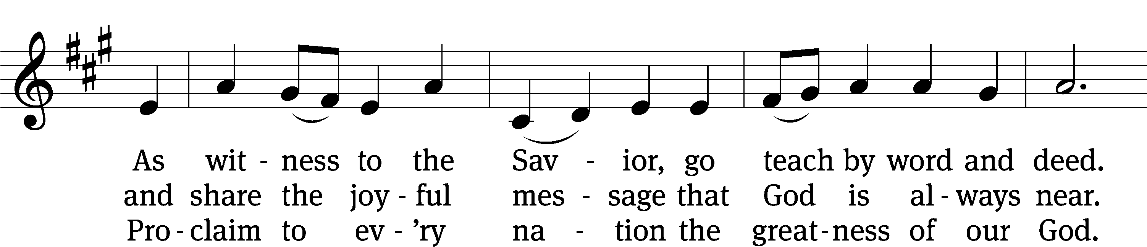
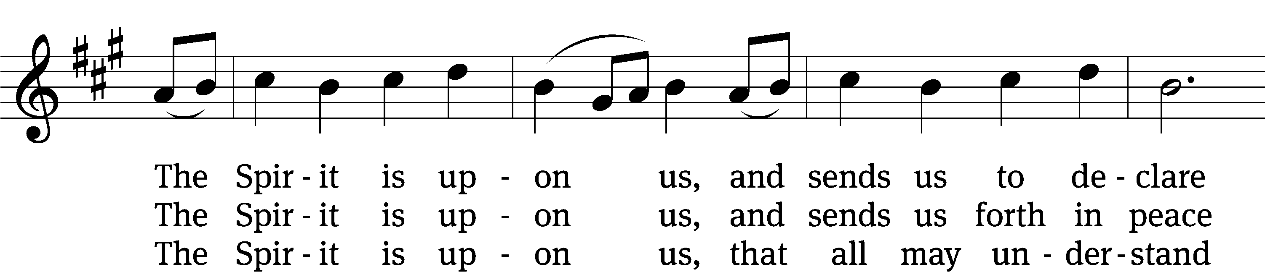
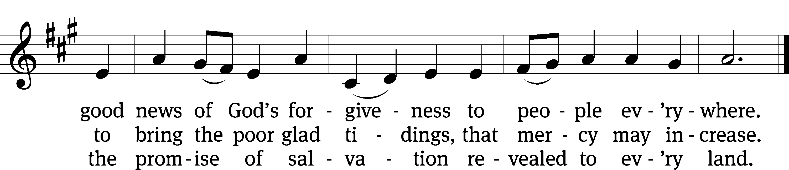
Text: © 2009 Birnamwood Publications, a div. of MorningStar Music Publishers, Inc. Used by permission: OneLicense no. 727703
Tune: Public domain

Serving In Worship
Officiant Pastor William Natsis
Organist Ann Hoeft
Cell Choir Director Emily Wheeler
Deacons (8:30) Dave Stevenson and Jim Tice
(11:00) Steve Hoeft and Jeff Neuburger
Ushers (8:30) Dale Finkbeiner and Mark Finkbeiner
(11:00) Ed Sala and Al Whitley
Altar Guild Sharon Boswell and Laura Lindemann
Videographer Richard Schneider

Copyright information
Service of the Word: Christian Worship. © 1993 Northwestern Publishing House. All rights reserved.
Reprinted with permission under ONE LICENSE #A-727703 and CCLI #1151741/CSPL126093

Words and Music: All rights reserved. Reprinted with permission under ONE LICENSE #A-727703 and
CCLI #1151741/CSPL126093

tlcsaline.church

