the SECOND sunday
AFTER EPIPHANY

TRINITY EVANGELICAL LUTHERAN CHURCH | Saline, Michigan
WELCOME TO WORSHIP January 16, 2022

Thank you for joining us in God’s house today! We cordially ask that our guests sign one of the guestbooks located at either the front or back entryways.

THANK OFFERING: Members of Trinity give their offering as an expression of love and thankfulness to the Lord and to help support the Lord’s work in our community and around the world. Visitors need not feel obligated to participate in this offering which supports our ministry.

Restrooms are located at the back of the upper level (the annex), and in the basement (down the back stairs of the sanctuary or annex). Handicap access is available, please ask an usher for assistance.

celebration of holy communion:
In His Word, God makes it clear that the Lord’s Supper is to be shared by people of a common proclamation of faith (1 Corinthians 11:26; 1 Corinthians 10:16-17). Without judging anyone’s hearts, we invite those who share in our confession by their membership in our congregation or another congregation of the Wisconsin Evangelical Lutheran Synod (WELS) or the Evangelical Lutheran Synod (ELS) and who are properly prepared (1 Corinthians 11;27-29) to receive the Sacrament. Page 156 in the front of Christian Worship provides a guide for preparation.

Guests, we would love to have you join us in communion fellowship in the future, and for that to be possible, we ask that you speak with one of the pastors so that we may speak with you on how that would be possible. We thank you for respecting the way we celebrate the Lord’s Supper in our congregations.

SERVICE OF WORD AND SACRAMENT

Opening hymn CW #375

375 Arise and Shine in Splendor CW 375
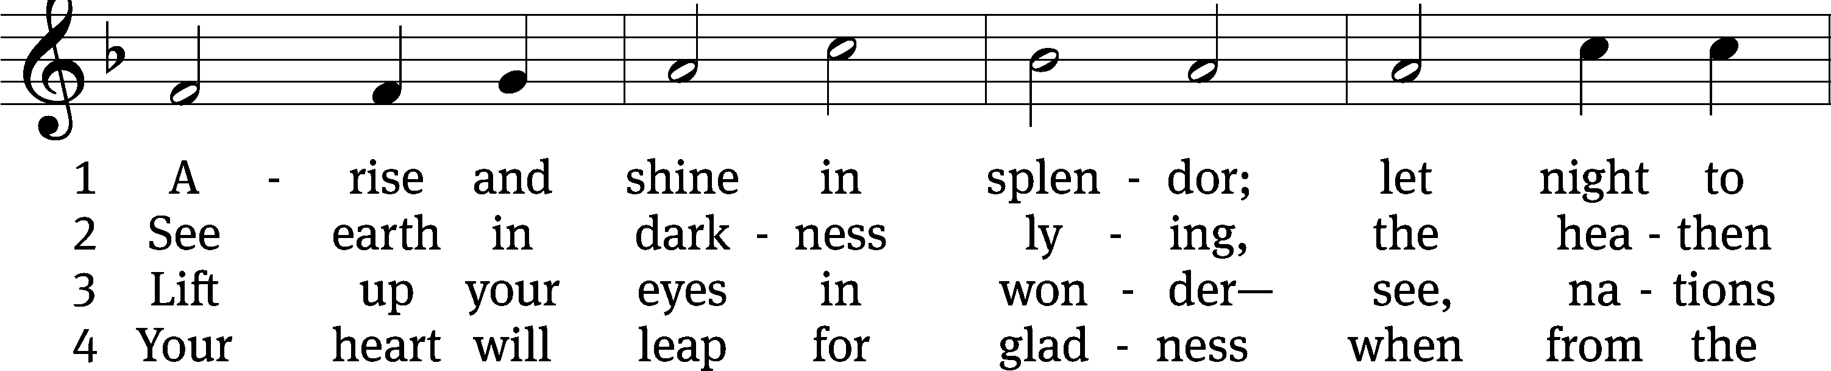
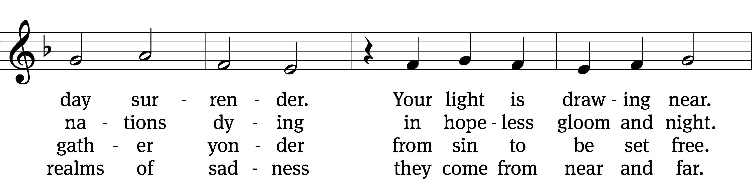
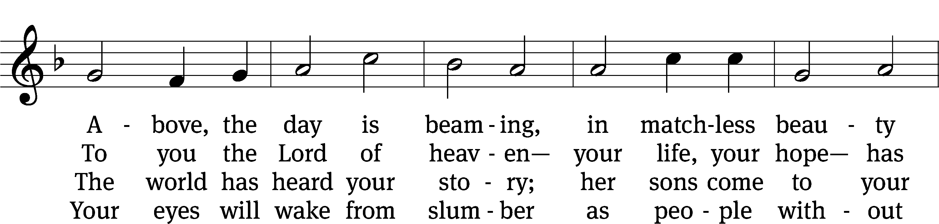
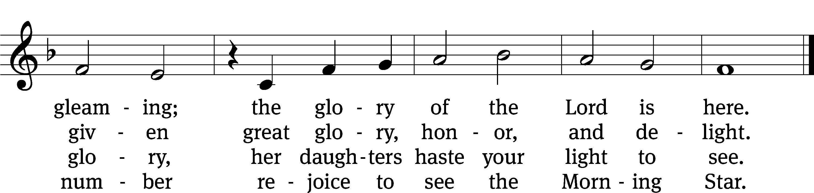
Text: © 1941 Concordia Publishing House. Used by permission: OneLicense no. 727703
Tune: Public domain

PLEASE STAND, IF YOU ARE ABLE

invocation

M: The grace of our Lord (+) Jesus Christ and the love of God and the fellowship of the Holy Spirit be with you.
C: And also with you.
CONFESSION OF SINS
M: God invites us to come into his presence and worship him with humble and penitent hearts. Therefore, let us acknowledge our sinfulness and ask him to forgive us.
C: Holy and merciful Father, I confess that I am by nature sinful, and that I have disobeyed you in my thoughts, words, and actions. I have done what is evil and failed to do what is good. For this I deserve your punishment both now and in eternity. But I am truly sorry for my sins, and trusting in my Savior Jesus Christ, I pray: Lord, have mercy on me, a sinner.
M: God, our heavenly Father, has been merciful to us and has given his only Son to be the atoning sacrifice for our sins. Therefore, as a called servant of Christ and by his authority, I forgive you all your sins in the name of the Father and of the Son (+) and of the Holy Spirit.
C: Amen.

PRAYER AND PRAISE

LORD, HAVE MERCY
Kyrie
M: For all that we need in life and for the wisdom to use all your gifts with gratitude and joy, hear our prayer, O Lord.

M: For the steadfast assurance that nothing can separate us from your love and for the courage to stand firm against the assaults of Satan and every evil, hear our prayer, O Christ.

M: For the well-being of your holy Church in all the world and for those who offer here their worship and praise, hear our prayer, O Lord.

M: Merciful God, maker and preserver of life, uphold us by your power and keep us in your tender care:

M: The works of the Lord are great and glorious; his name is worthy of praise.

Prayer of the day

M: Let us pray.

The minister says the Prayer of the Day.

PLEASE BE SEATED

The Word

first lesson Isaiah 62:1-5
¹ For the sake of Zion I will not be silent.
For the sake of Jerusalem I will not be quiet,
until her righteousness goes forth shining brightly,
and her salvation burns like a torch.
² Nations will see your righteousness,
and all kings will see your glory.
You will be called by a new name
that the mouth of the Lord will assign to you.
³ Then you will be a beautiful crown in the Lord’s hand,
and a royal diadem in the palm of your God.
⁴ You will never again be called Abandoned,
and your land will never again be called Desolation,
for you will be called My Delight Is in Her,
and your land will be called Married,
because the Lord delights in you,
and your land will be married.
⁵ For just as a young man marries a virgin,
your sons will marry you,
and just as a bridegroom rejoices over a bride,
your God will rejoice over you.

Psalm of the day PSALM 145B
145B I Will Praise Your Name Forever Psalm 145B
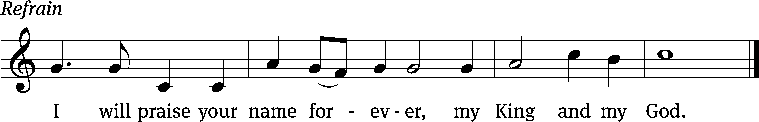

Great is the Lord and most wor- / thy of praise;
his greatness no one can / fathom.
One generation commends your works to an- / other;
they tell of your / mighty acts.
The Lord upholds / all who fall
and lifts up all who are / bowed down. Refrain

The eyes of all look to you, and you give them their food at the / proper time.
You open your hand and satisfy the desires of every / living thing.
The Lord is near to all who / call on him,
to all who call on / him in truth.
He fulfills the desires of those who / fear him;
he hears their cry and / saves them.
Glory be to the Father and / to the Son
and to the Holy / Spirit,
as it was in the be- / ginning,
is now, and will be forever. / Amen. Refrain
Text: © 1969, 1981, 1997 ICEL. Used by permission: License no. 130003540
Tune: © 1989 MorningStar Music Publishers. Used by permission: OneLicense no. 727703

OR SENIOR CHOIR SINGS “CANON OF PRAISE”

second lesson EPHESIANS 3:14-21
¹⁴ For this reason I kneel before the Father of our Lord Jesus Christ, ¹⁵ from whom the entire family in heaven and on earth receives its name. ¹⁶ I pray that, according to the riches of his glory, he would strengthen you with power through his Spirit in your inner self, ¹⁷ so that Christ may dwell in your hearts through faith. Then, being rooted and grounded in love, ¹⁸ I pray that you would be able to comprehend, along with all the saints, how wide and long and high and deep his love is, ¹⁹ and that you would be able to know the love of Christ that surpasses knowledge, so that you may be filled to all the fullness of God.
²⁰ Now to him, who is able, according to the power that is at work within us, to do infinitely more than we can ask or imagine, ²¹ to him be the glory in the church and in Christ Jesus throughout all generations, forever and ever! Amen.

Verse of the day

PLEASE STAND, if you are able

gospel JOHN 2:1-11
M: The Gospel according to St. John chapter 2, verses 1-11
¹ Three days later, there was a wedding in Cana of Galilee. Jesus’ mother was there. ² Jesus and his disciples were also invited to the wedding.
³ When the wine was gone, Jesus’ mother said to him, “They have no wine.”
⁴ Jesus said to her, “Woman, what does that have to do with you and me? My time has not come yet.”
⁵ His mother said to the servants, “Do whatever he tells you.”
⁶ Six stone water jars, which the Jews used for ceremonial cleansing, were standing there, each holding twenty or thirty gallons. ⁷ Jesus told them, “Fill the jars with water.” So they filled them to the brim. ⁸ Then he said to them, “Now draw some out and take it to the master of the banquet.” And they did.
⁹ When the master of the banquet tasted the water that had now become wine, he did not know where it came from (though the servants who had drawn the water knew). The master of the banquet called the bridegroom ¹⁰ and said to him, “Everyone serves the good wine first, and when the guests have had plenty to drink, then the cheaper wine. You saved the good wine until now!”
¹¹ This, the beginning of his miraculous signs, Jesus performed in Cana of Galilee. He revealed his glory, and his disciples believed in him.

M: This is the Gospel of the Lord.

PLEASE BE SEATED

SERMON HYMN CW #386
386 Songs of Thankfulness and Praise 386
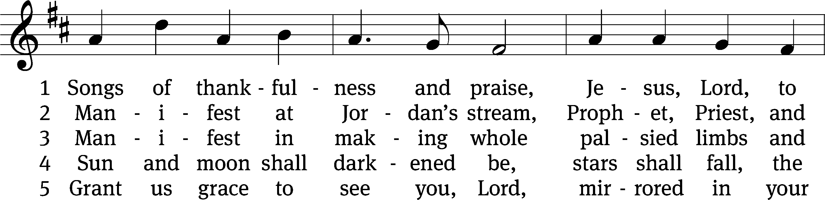
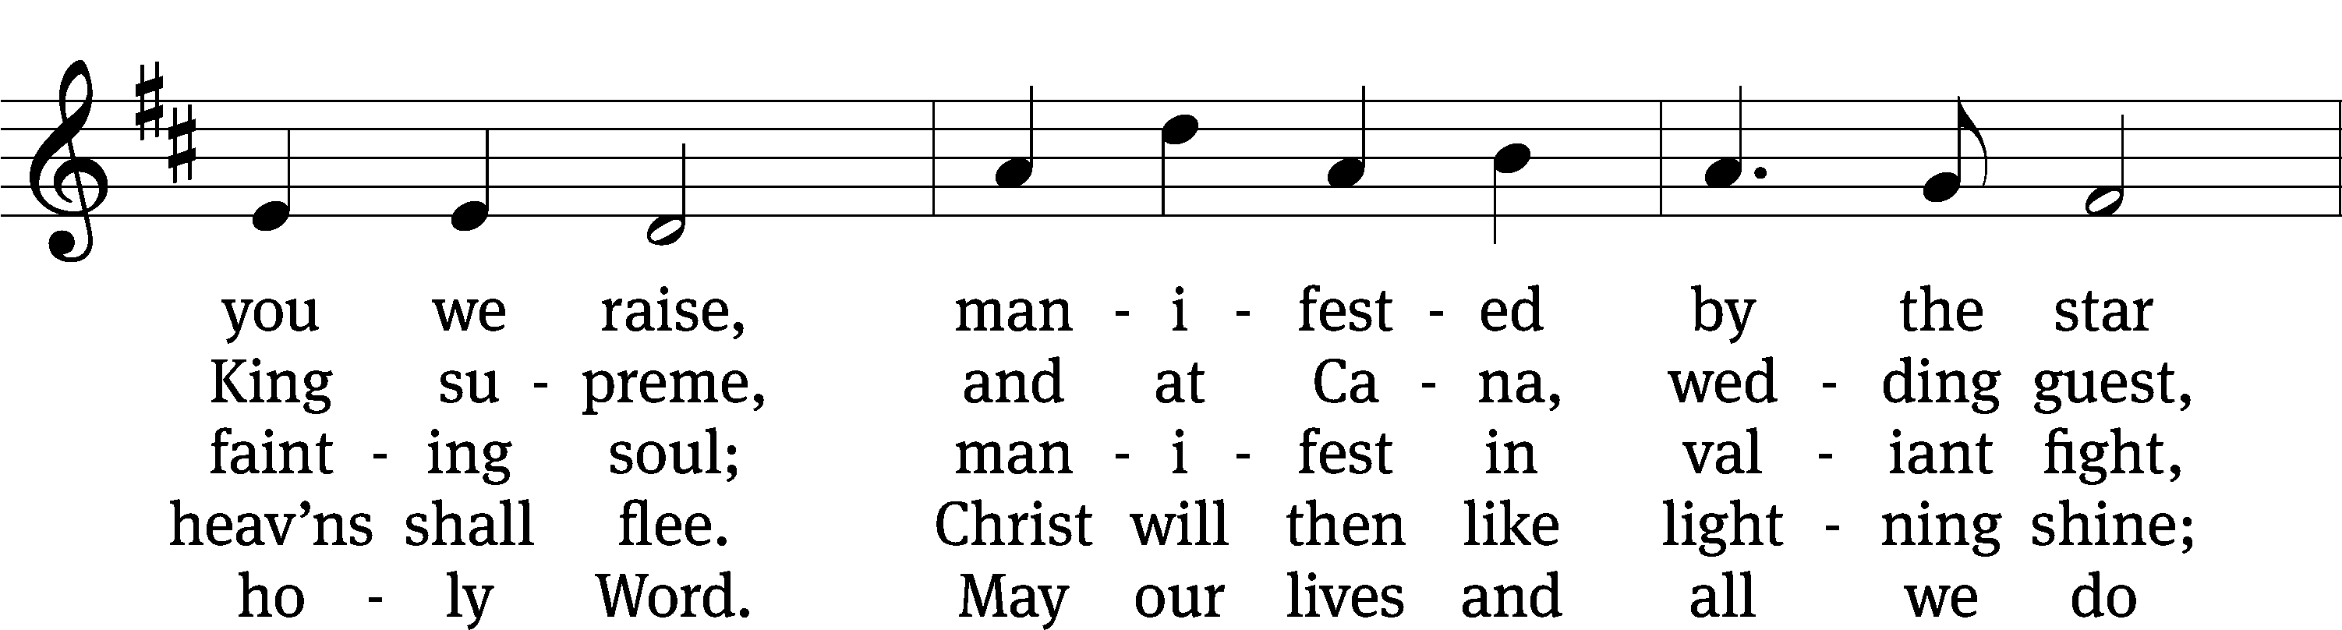
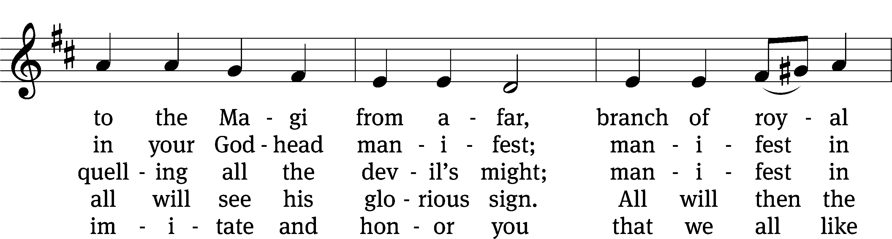
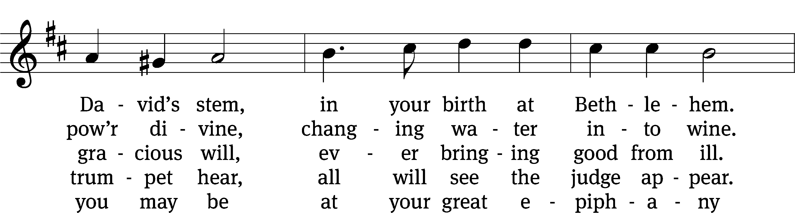
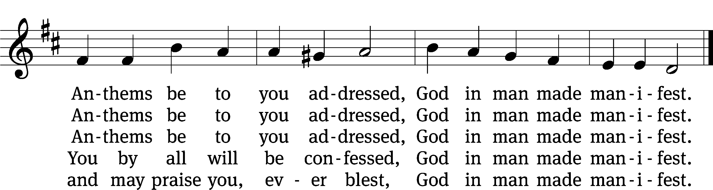

Sermon JOHN 2:1-11
“The Perfect Guest”

please stand, if you are able

nicene creed
We believe in one God, the Father, the Almighty, maker of heaven and earth, of all that is, seen and unseen.
We believe in one Lord, Jesus Christ, the only Son of God, eternally begotten of the Father, God from God, Light from Light, true God from true God, begotten, not made, of one being with the Father. Through him all things were made. For us and for our salvation, he came down from heaven, was incarnate of the Holy Spirit and the virgin Mary, and became fully human. For our sake he was crucified under Pontius Pilate. He suffered death and was buried. On the third day he rose again in accordance with the Scriptures. He ascended into heaven and is seated at the right hand of the Father. He will come again in glory to judge the living and the dead, and his kingdom will have no end.
We believe in the Holy Spirit, the Lord, the giver of life, who proceeds from the Father and the Son, who in unity with the Father and the Son is worshiped and glorified, who has spoken through the prophets. We believe in one holy Christian and apostolic Church. We acknowledge one baptism for the forgiveness of sins. We look for the resurrection of the dead and the life of the world to come. Amen.

PLEASE BE SEATED

INSTALLATION OF OFFICERS (8:30 SERVICE)

PLEASE STAND, IF YOU ARE ABLE

prayer of the church prayer of the church

lord’s prayer

C: Our Father, who art in heaven,
hallowed be thy name,
thy kingdom come,
thy will be done
on earth as it is in heaven.
Give us this day our daily bread;
and forgive us our trespasses,
as we forgive those
who trespass against us;
and lead us not into temptation,
but deliver us from evil.
For thine is the kingdom
and the power and the glory
forever and ever. Amen.

The Sacrament of Holy Communion
Trinity Lutheran Church follows the historic Christian practice of close communion. We ask that only members of Trinity or one of our sister congregations partake of the sacrament. If you are not a member, please see the note about Holy Communion in the beginning of the Worship Folder.

M: The Lord be with you.

M: Lift up your hearts.

M: Let us give thanks to the Lord our God.

M: Praise to the God and Father of our Lord Jesus Christ! In love he has blessed us with every spiritual blessing. In the past he spoke to us through the prophets, but in these last days he has spoken to us by his Son, who is the radiance of his glory. Now have come the salvation and the power and the kingdom of our God and the authority of his Christ. To him who sits on the throne and to the Lamb be praise and thanks and honor and glory for ever and ever:

Holy, Holy, Holy

Words of institution
M: Our Lord Jesus Christ, on the night he was betrayed, took bread; and when he had given thanks, he broke it and gave it to his disciples, saying: “Take and eat. This is my ✙ body, which is given for you. Do this in remembrance of me.”
Then he took the cup, gave thanks, and gave it to them, saying, “Drink from it all of you; this is my ✙ blood of the new covenant, which is poured out for you for the forgiveness of sins. Do this, whenever you drink it, in remembrance of me.”
The peace of the Lord be with you always.

O CHRIST, LAMB OF GOD

PLEASE BE SEATED

DISTRIBUTION HYMN CW # 667
667 Lord Jesus Christ, You Have Prepared CW 667
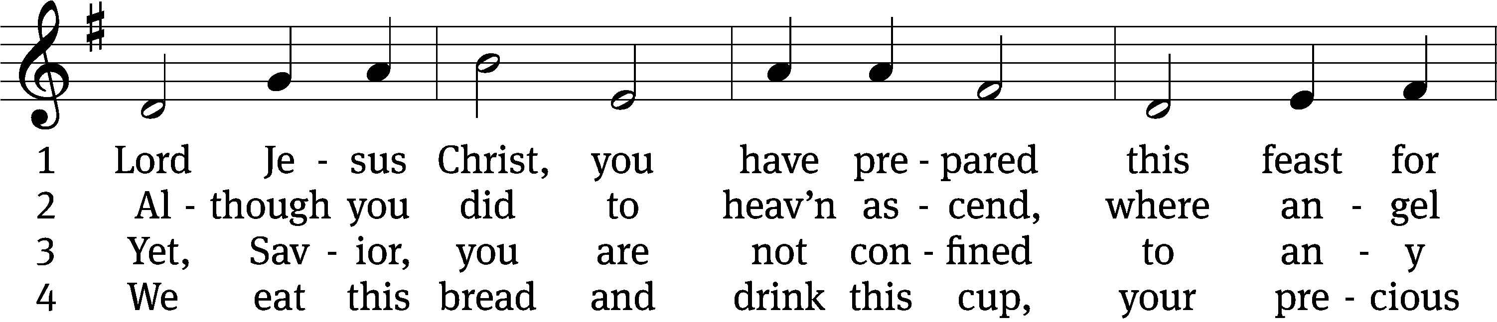
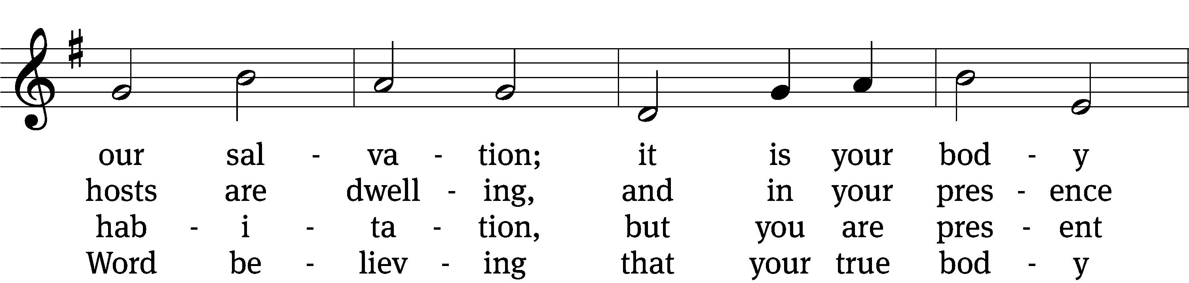
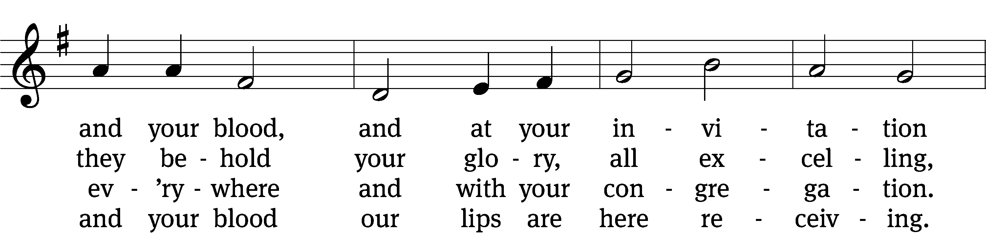
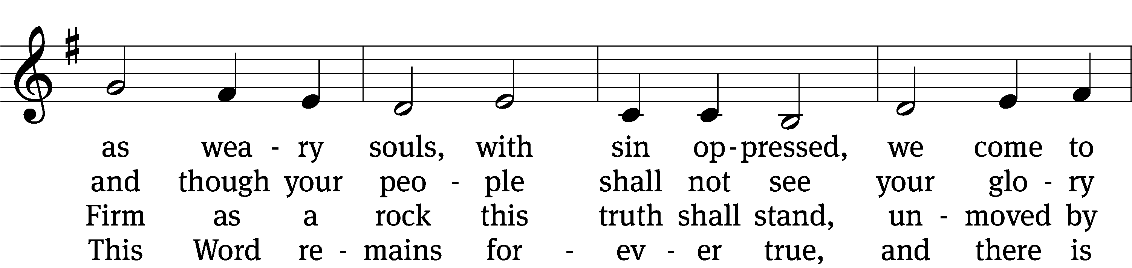
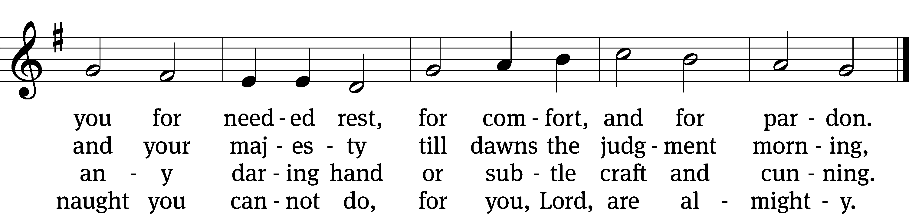

5 Though reason cannot understand,
yet faith this truth embraces:
your body, Lord, is even now
at once in many places.
I leave to you how this can be;
your Word alone suffices me;
I trust its truth unfailing.

6 Lord, I believe what you have said;
help me when doubts assail me.
Remember that I am but dust,
and let my faith not fail me.
Your supper in this vale of tears
refreshes me and stills my fears
and is my priceless treasure.

7 Grant that we worthily receive
your supper, Lord, our Savior,
and, truly grieving for our sins,
may prove by our behavior
that we are thankful for your grace
and day by day may run our race,
in holiness increasing.

8 For your consoling supper, Lord,
be praised through out all ages!
Preserve it, for in ev’ry place
the world against it rages.
Grant that this sacrament may be
a blessèd comfort unto me
when living and when dying.
Text and tune: Public domain

THANKSGIVING

PLEASE STAND, IF YOU ARE ABLE

THANK THE LORD

M: Hear the prayer of your people, O Lord, that the lips which have praised you here may glorify you in the world, that the eyes which have seen the coming of your Son may long for his coming again, and that all who have received in his true body and blood the pledge of your forgiveness may be restored to live a new and holy life, through Jesus Christ, our Lord, who lives and reigns with you and the Holy Spirit, one God, now and forever.

M: Brothers and sisters, go in peace. Live in harmony with one another.
Serve the Lord with gladness.

The Lord bless you and keep you.
The Lord make his face shine on you and be gracious to you.
The Lord look on you with favor and (+) give you peace.

CLOSING HYMN CW #384
384 Hail to the Lord’s Anointed CW 384
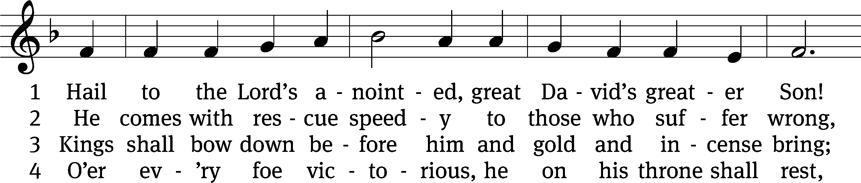
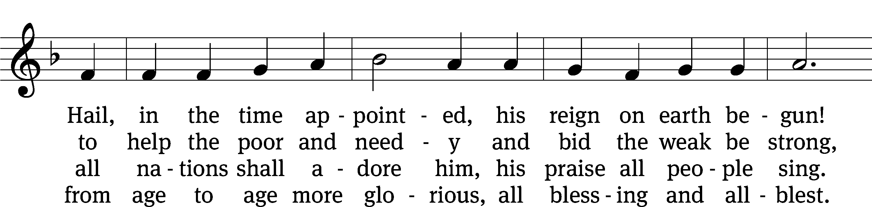
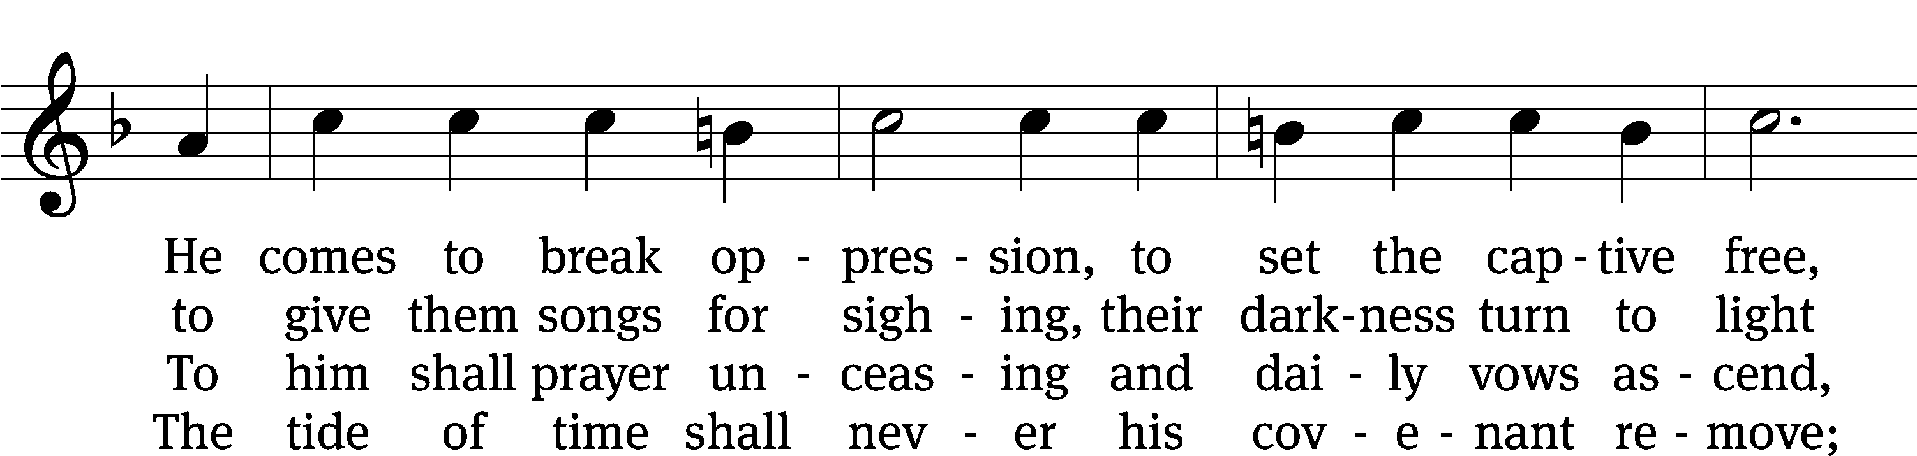
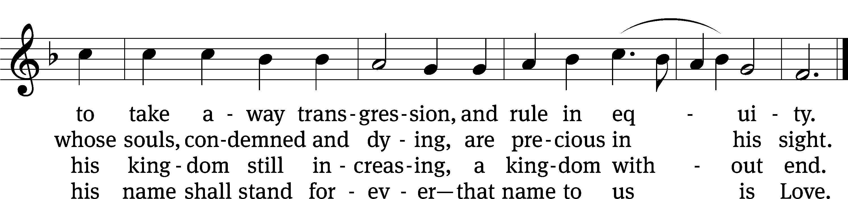
Text and tune: Public domain

Serving In Worship

Officiant Pastor Natsis
Organist Emily Wheeler
Choir Director Cynthia Natsis
Choir Accompanist Laura Sala
Deacons (8:30) Dave Stevenson and Jim Tice
(11:00) Steve Hoeft and Jeff Nueburger
Ushers (8:30) Dale Finkbeiner and Mark Finkbeiner
(11:00) Ed Sala and Al Whitley
Altar Guild Sharon Boswell and Laura Lindemann
Videographer Ann Latowski

Copyright information
Service of Word and Sacrament: Christian Worship. © 1993 Northwestern Publishing House. All rights reserved. Reprinted under ONE LICENSE #A-727703 and CCLI #1151741/ CSPL126093
Words and Music: All rights reserved. Reprinted/Podcast/Streamed with permission under ONE LICENSE #A-727703 and CCLI #1151741/CSPL126093

