the fourth sunday in advent

TRINITY EVANGELICAL LUTHERAN CHURCH | Saline, Michigan
WELCOME TO WORSHIP December 18, 2022

Thank you for joining us in God’s house today! We cordially ask that our guests sign one of the guestbooks located at either the front or back entryways.

THANK OFFERING: Members of Trinity give their offering as an expression of love and thankfulness to the Lord and to help support the Lord’s work in our community and around the world. Visitors need not feel obligated to participate in this offering which supports our ministry.

Restrooms are located at the back of the upper level (the annex), and in the basement (down the back stairs of the sanctuary or annex). Handicap access is available, please ask an usher for assistance.

celebration of holy communion:
In His Word, God makes it clear that the Lord’s Supper is to be shared by people of a common proclamation of faith (1 Corinthians 11:26; 1 Corinthians 10:16-17). Without judging anyone’s hearts, we invite those who share in our confession by their membership in our congregation or another congregation of the Wisconsin Evangelical Lutheran Synod (WELS) or the Evangelical Lutheran Synod (ELS) and who are properly prepared (1 Corinthians 11;27-29) to receive the Sacrament. Page 295 in the front of Christian Worship provides a guide for preparation.

Guests, we would love to have you join us in communion fellowship in the future, and for that to be possible, we ask that you speak with one of the pastors so that we may speak with you on how that would be possible. We thank you for respecting the way we celebrate the Lord’s Supper in our congregations.

SERVICE OF WORD AND SACRAMENT
Bell Choir (11:00) “Repeat the Sounding Joy”
Hymn CW 344
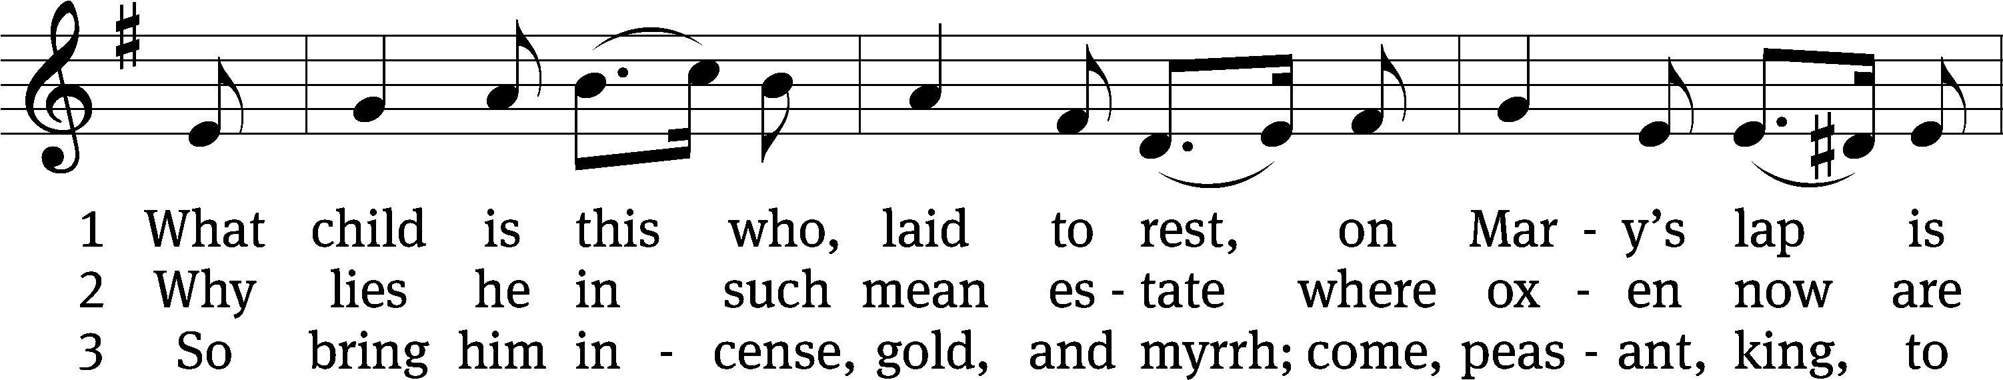
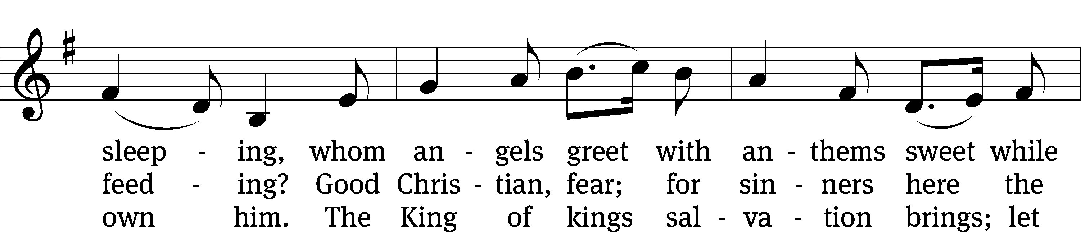
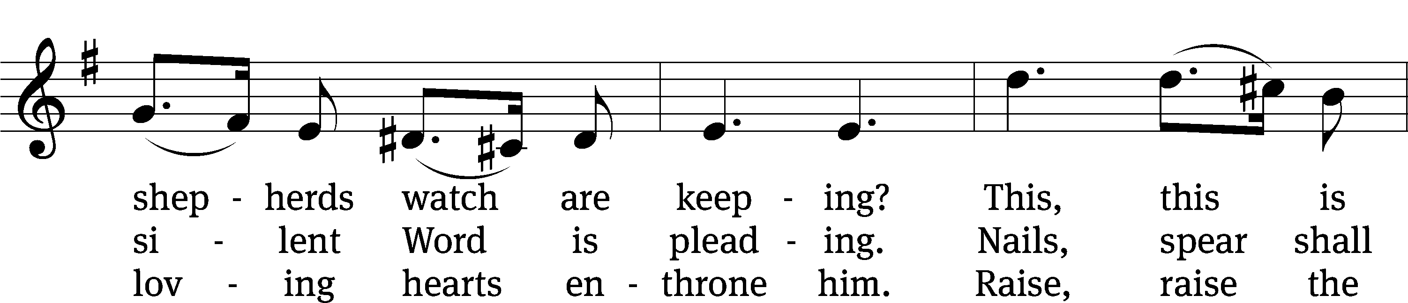
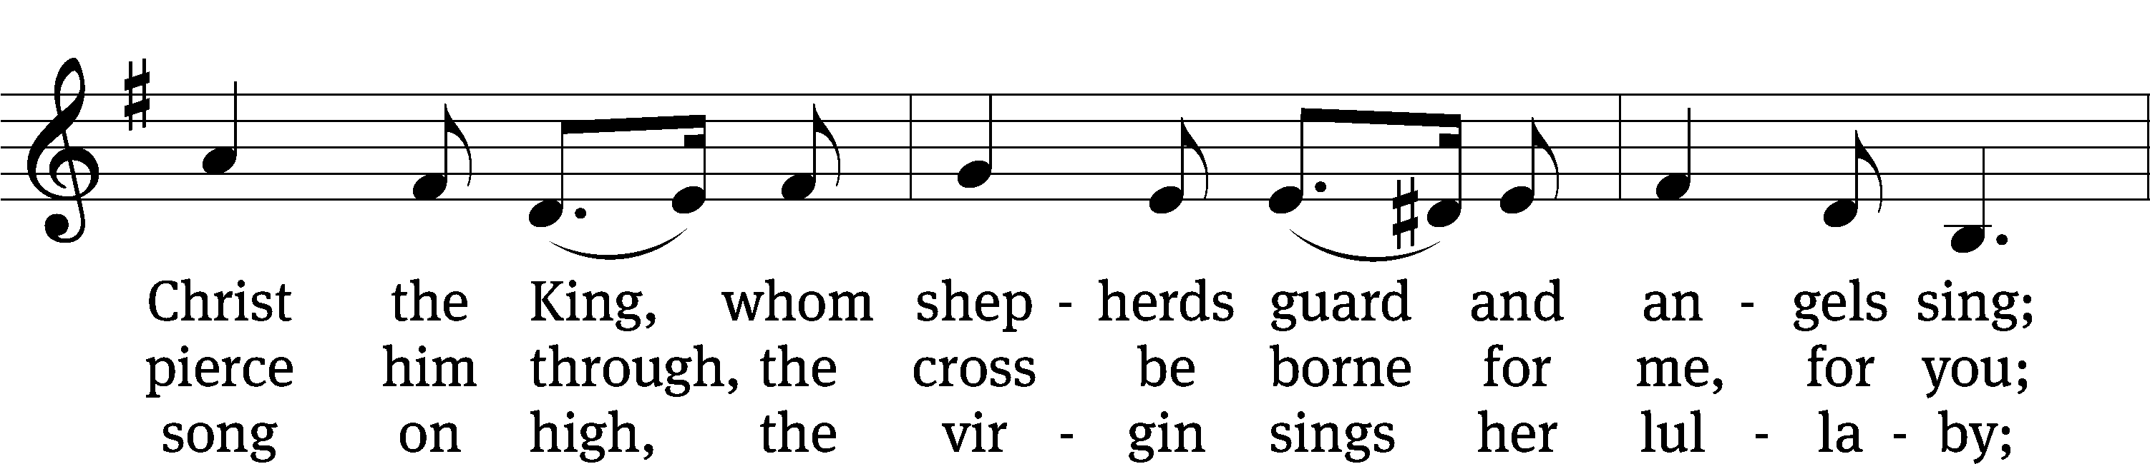
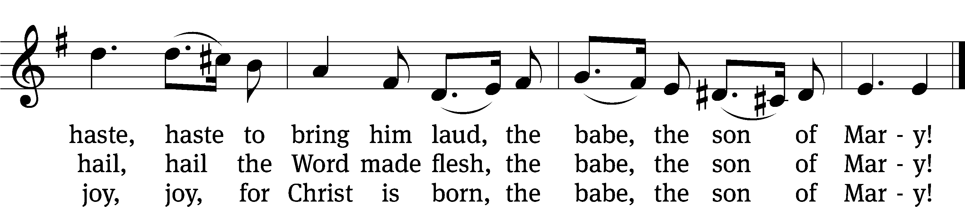
Text: William C. Dix, 1837–1898, alt.
Tune: English, 16th cent.
Text and tune: Public domain

PLEASE STAND, IF YOU ARE ABLE

invocation

M: The grace of our Lord (+) Jesus Christ and the love of God and the fellowship of the Holy Spirit be with you.
C: And also with you.
CONFESSION OF SINS
M: God invites us to come into his presence and worship him with humble and penitent hearts. Therefore, let us acknowledge our sinfulness and ask him to forgive us.
C: Holy and merciful Father, I confess that I am by nature sinful, and that I have disobeyed you in my thoughts, words, and actions. I have done what is evil and failed to do what is good. For this I deserve your punishment both now and in eternity. But I am truly sorry for my sins, and trusting in my Savior Jesus Christ, I pray: Lord, have mercy on me, a sinner.
M: God, our heavenly Father, has been merciful to us and has given his only Son to be the atoning sacrifice for our sins. Therefore, as a called servant of Christ and by his authority, I forgive you all your sins in the name of the Father and of the Son (+) and of the Holy Spirit.
C: Amen.
PRAYER AND PRAISE
LORD, HAVE MERCY
Kyrie
M: For all that we need in life and for the wisdom to use all your gifts with gratitude and joy, hear our prayer, O Lord.

M: For the steadfast assurance that nothing can separate us from your love and for the courage to stand firm against the assaults of Satan and every evil, hear our prayer, O Christ.

M: For the well-being of your holy Church in all the world and for those who offer here their worship and praise, hear our prayer, O Lord.

M: Merciful God, maker and preserver of life, uphold us by your power and keep us in your tender care:

M: The works of the Lord are great and glorious; his name is worthy of praise.

Prayer of the day

M: Let us pray.
The minister says the Prayer of the Day.

PLEASE BE SEATED

The Word

first lesson Isaiah 7:10-14
¹⁰ The Lord spoke to Ahaz again. He said, ¹¹ “Ask for a sign from the Lord your God. Ask for it either in the depths below or in the heights above.”
¹² But Ahaz responded, “I will not ask. I will not test the Lord.”
¹³ So Isaiah said:
Listen now, you house of David. Is it not enough for you to test the patience of men? Will you test the patience of my God as well? ¹⁴ Therefore the Lord himself will give a sign for all of you. Look! The virgin will conceive and give birth to a son and name him Immanuel.

Psalm of the Day Psalm 146D
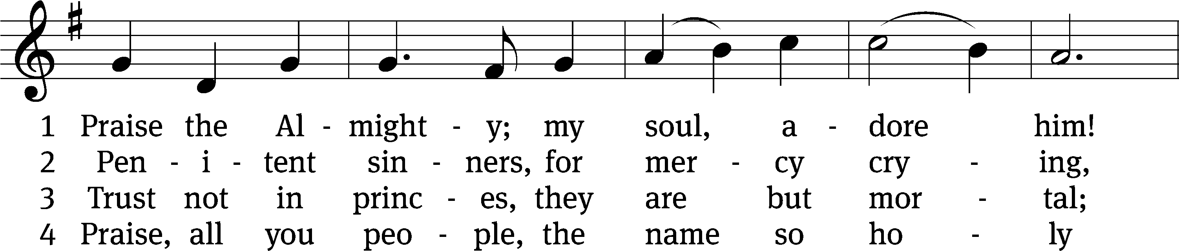
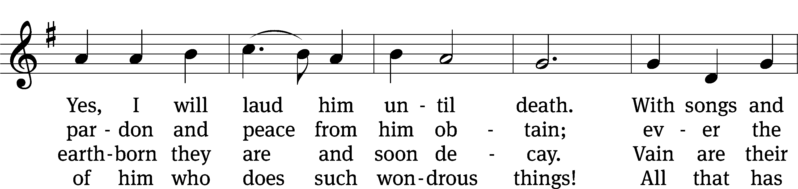
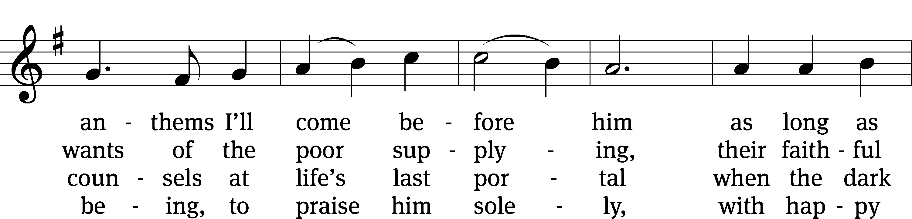
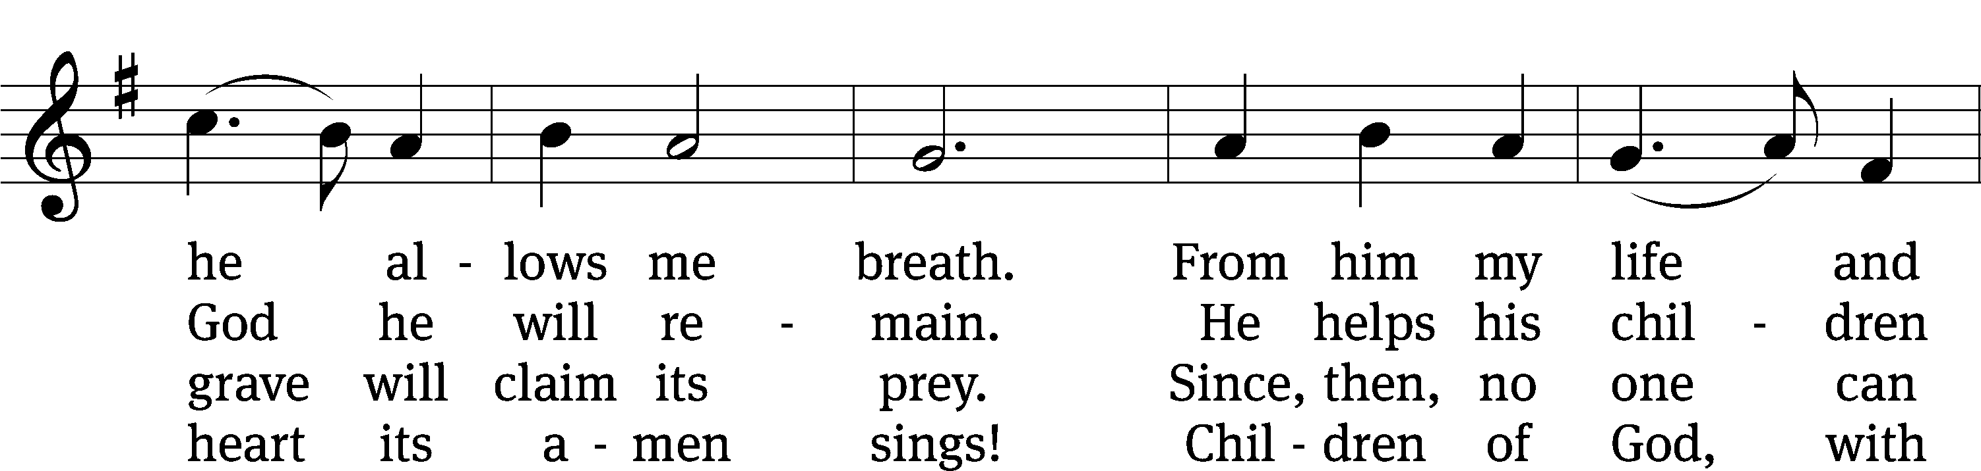
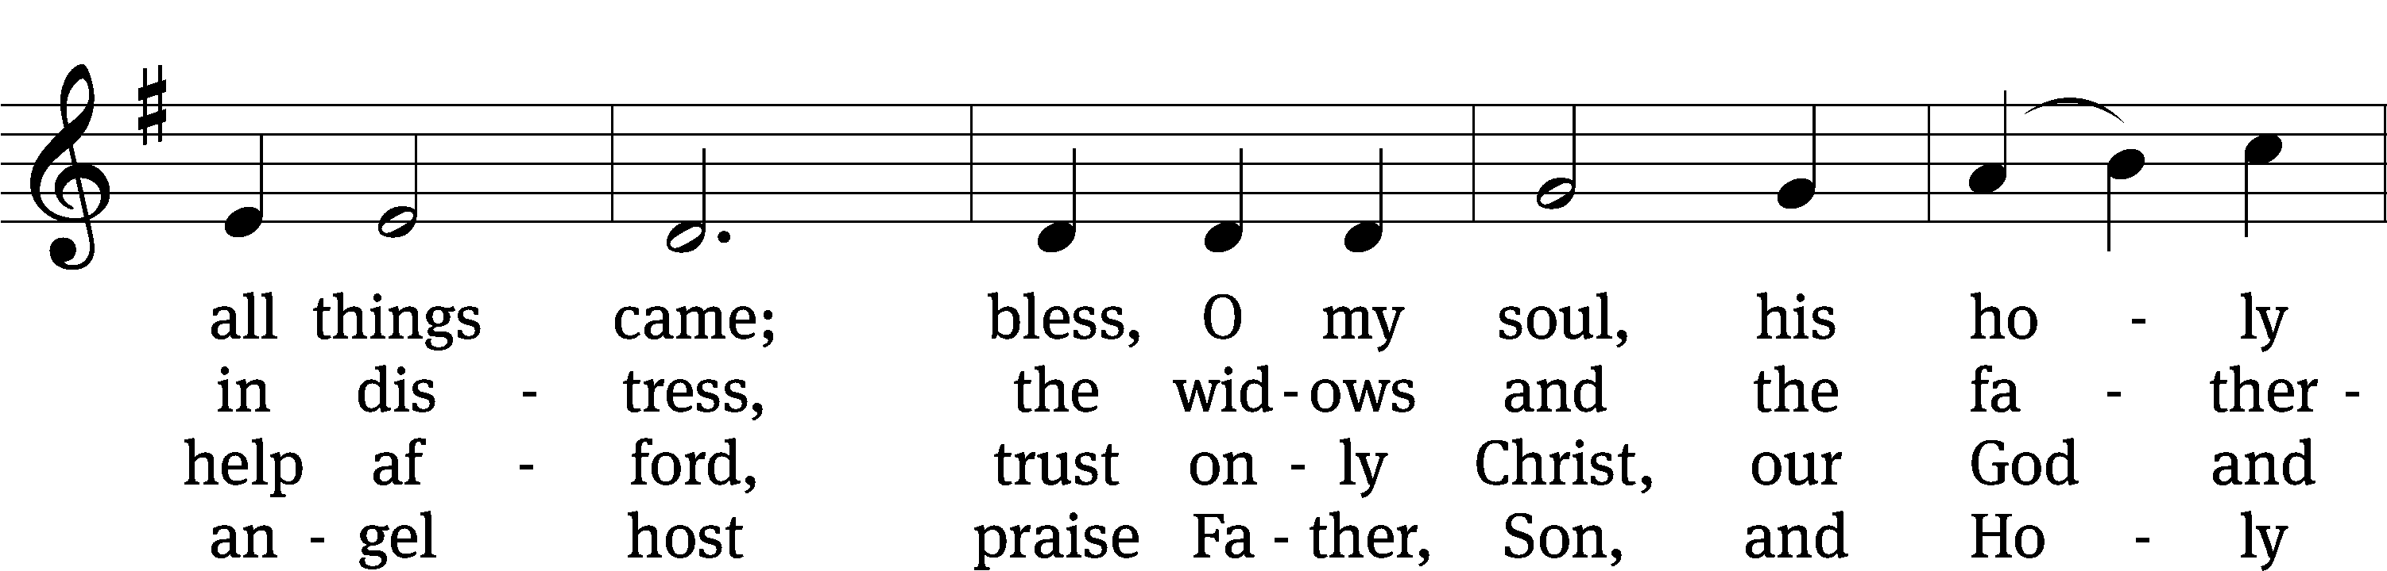
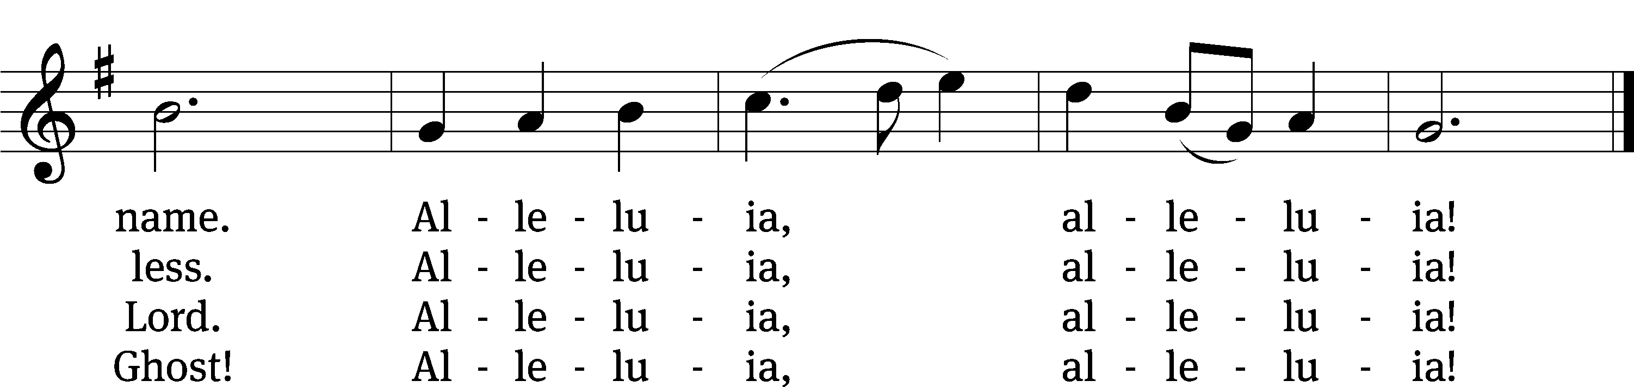
Text: tr. Alfred E. R. Brauer, alt.; Johann D. Herrnschmidt
Tune: Neu-vermehrte Christliche Seelenharpf, Ansbach, 1665, alt.
Text: © 1941 Concordia Publishing House. Used by permission: OneLicense no. 727703
Tune: Public domain

second lesson Romans 1:1-7
¹ Paul, a servant of Christ Jesus, called to be an apostle, set apart for the gospel of God, ² which he promised in advance through his prophets in the Holy Scriptures. ³ This gospel is about his Son—who in the flesh was born a descendant of David, ⁴ who in the spirit of holiness was declared to be God’s powerful Son by his resurrection from the dead—Jesus Christ, our Lord. ⁵ Through him we received grace and the call to be an apostle on behalf of his name, to bring about the obedience of faith among all the Gentiles, ⁶ including you, who were called by Jesus Christ.
⁷ To all those loved by God who are in Rome, called to be saints:
Grace to you and peace from God our Father and the Lord Jesus Christ.

PLEASE STAND, IF YOU ARE ABLE

VERSE OF THE DAY

GOSPEL Luke 1:26-38
²⁶ In the sixth month, the angel Gabriel was sent from God to a town of Galilee named Nazareth, ²⁷ to a virgin pledged in marriage to a man whose name was Joseph, of the house of David. The virgin’s name was Mary. ²⁸ The angel went to her and said, “Greetings, you who are highly favored! The Lord is with you. Blessed are you among women.”
²⁹ But she was greatly troubled by the statement and was wondering what kind of greeting this could be. ³⁰ The angel said to her, “Do not be afraid, Mary, because you have found favor with God. ³¹ Listen, you will conceive and give birth to a son, and you are to name him Jesus. ³² He will be great and will be called the Son of the Most High. The Lord God will give him the throne of his father David. ³³ He will reign over the house of Jacob forever, and his kingdom will never end.”
³⁴ Mary said to the angel, “How will this be, since I am a virgin?”
³⁵ The angel answered her, “The Holy Spirit will come upon you, and the power of the Most High will overshadow you. So the holy one to be born will be called the Son of God. ³⁶ Listen, Elizabeth, your relative, has also conceived a son in her old age even though she was called barren, and this is her sixth month. ³⁷ For nothing will be impossible for God.”
³⁸ Then Mary said, “See, I am the Lord’s servant. May it happen to me as you have said.” Then the angel left her.

M: This is the Gospel of the Lord.

PLEASE BE SEATED

349 A Great and Mighty Wonder CW 349
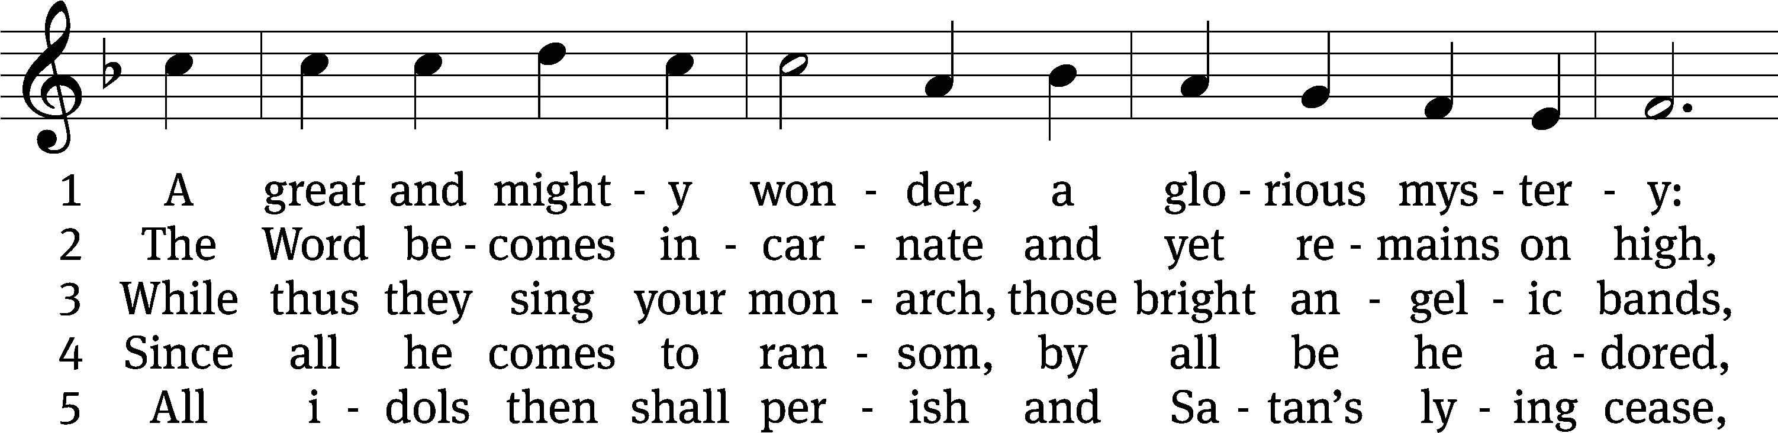
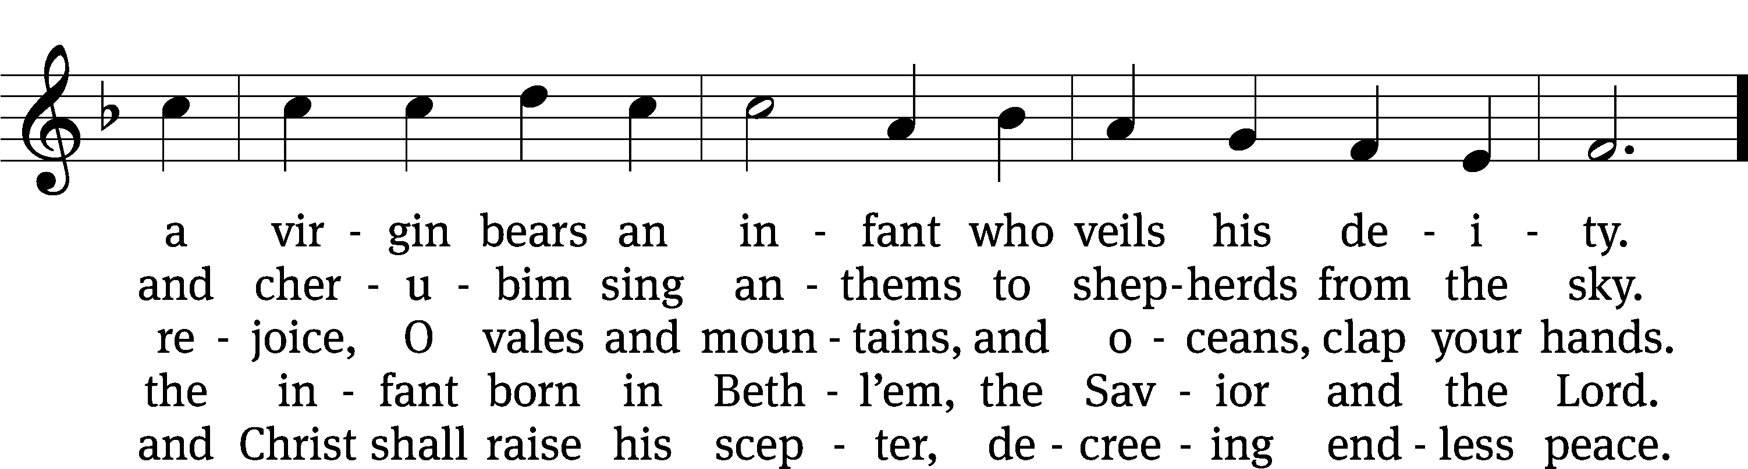
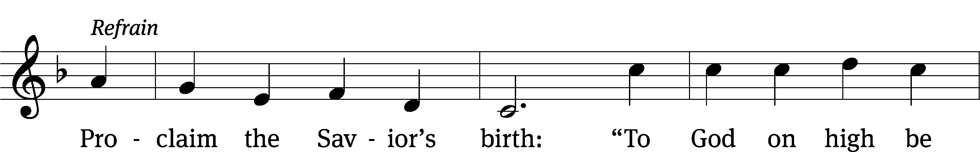
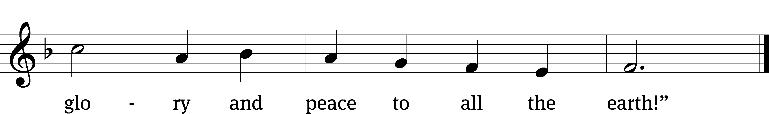
Text: tr. John Mason Neale, 1818–1866, alt.; Germanus, c. 634–c. 734
Tune: Alte Catholische Geistliche Kirchengeseng, Köln, 1599
Text and tune: Public domain

Sermon Luke 1:26-38

“Mary’s angle on angels”

please stand, if you are able

nicene creed
We believe in one God, the Father, the Almighty, maker of heaven and earth, of all that is, seen and unseen.
We believe in one Lord, Jesus Christ, the only Son of God, eternally begotten of the Father, God from God, Light from Light, true God from true God, begotten, not made, of one being with the Father. Through him all things were made. For us and for our salvation, he came down from heaven, was incarnate of the Holy Spirit and the virgin Mary, and became truly human. For our sake he was crucified under Pontius Pilate. He suffered death and was buried. On the third day he rose again in accordance with the Scriptures. He ascended into heaven and is seated at the right hand of the Father. He will come again in glory to judge the living and the dead, and his kingdom will have no end.
We believe in the Holy Spirit, the Lord, the giver of life, who proceeds from the Father and the Son, who in unity with the Father and the Son is worshiped and glorified, who has spoken through the prophets. We believe in one holy Christian and apostolic Church. We acknowledge one baptism for the forgiveness of sins. We look for the resurrection of the dead and the life of the world to come. Amen.

PLEASE BE SEATED

OFFERTORY - Bell Choir (8:30) “Repeat the Sounding Joy”

PLEASE STAND, IF YOU ARE ABLE

prayer of the church

lord’s prayer

C: Our Father, who art in heaven,
hallowed be thy name,
thy kingdom come,
thy will be done
on earth as it is in heaven.
Give us this day our daily bread;
and forgive us our trespasses,
as we forgive those
who trespass against us;
and lead us not into temptation,
but deliver us from evil.
For thine is the kingdom
and the power and the glory
forever and ever. Amen.

The Sacrament of Holy Communion
Trinity Lutheran Church follows the historic Christian practice of close communion. We ask that only members of Trinity or one of our sister congregations partake of the sacrament. If you are not a member, please see the note about Holy Communion in the beginning of the Worship Folder.

M: The Lord be with you.

M: Lift up your hearts.

M: Let us give thanks to the Lord our God.

M: Praise to the God and Father of our Lord Jesus Christ! In love he has blessed us with every spiritual blessing. He sends the Holy Spirit to testify that we are his children and to strengthen us when we are weak. Now have come the salvation and the power and the kingdom of our God and the authority of his Christ. To him who sits on the throne and to the Lamb be praise and thanks and honor and glory for ever and ever:

Holy, Holy, Holy

Words of institution
M: Our Lord Jesus Christ, on the night he was betrayed, took bread; and when he had given thanks, he broke it and gave it to his disciples, saying: “Take and eat. This is my ✙ body, which is given for you. Do this in remembrance of me.”
Then he took the cup, gave thanks, and gave it to them, saying, “Drink from it all of you; this is my ✙ blood of the new covenant, which is poured out for you for the forgiveness of sins. Do this, whenever you drink it, in remembrance of me.”
The peace of the Lord be with you always.

O CHRIST, LAMB OF GOD

331 From Heaven Above to Earth I Come CW 331
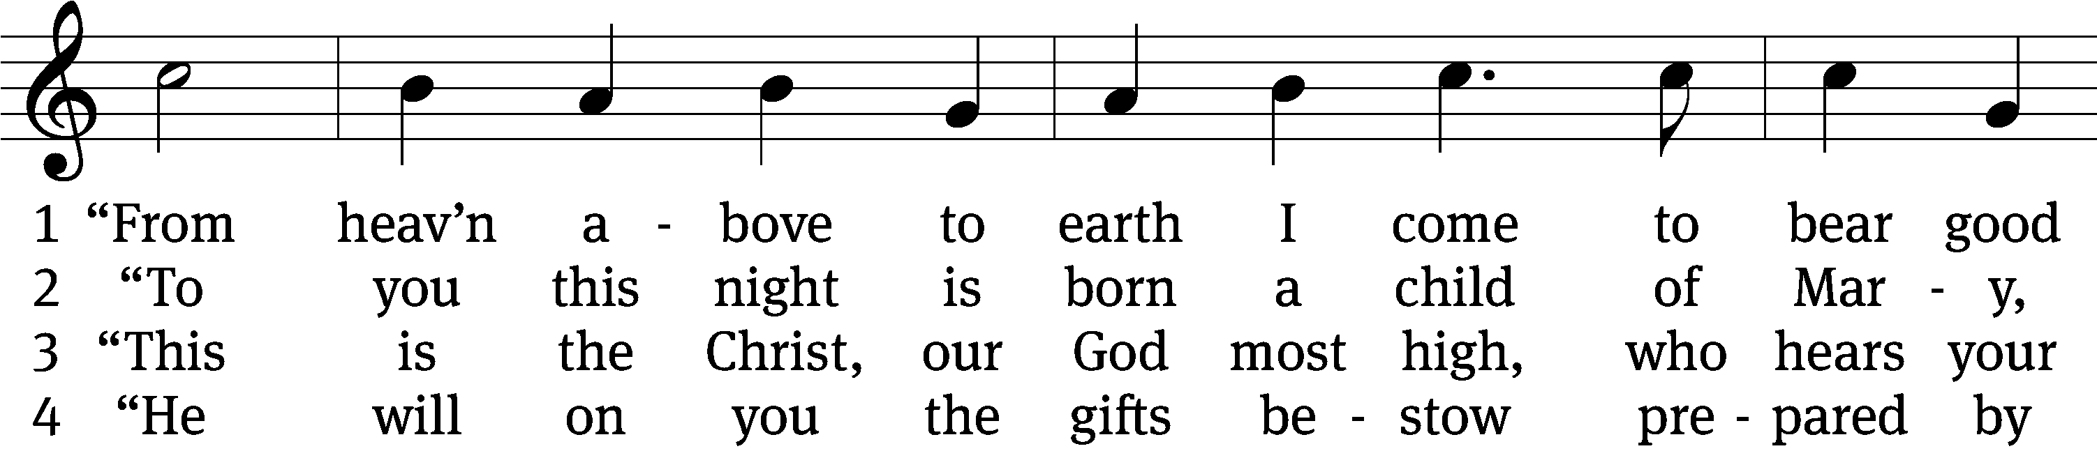
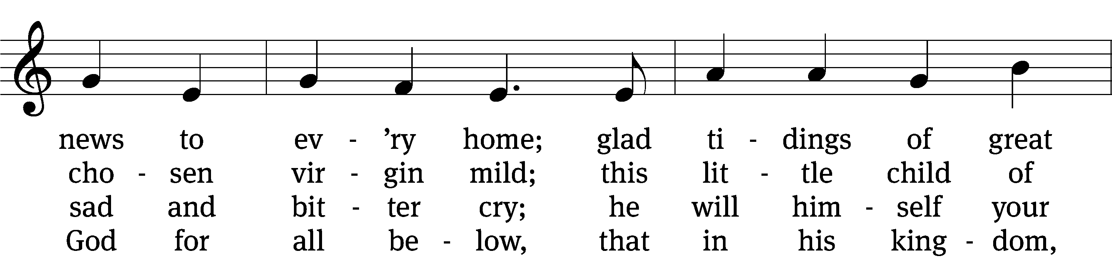
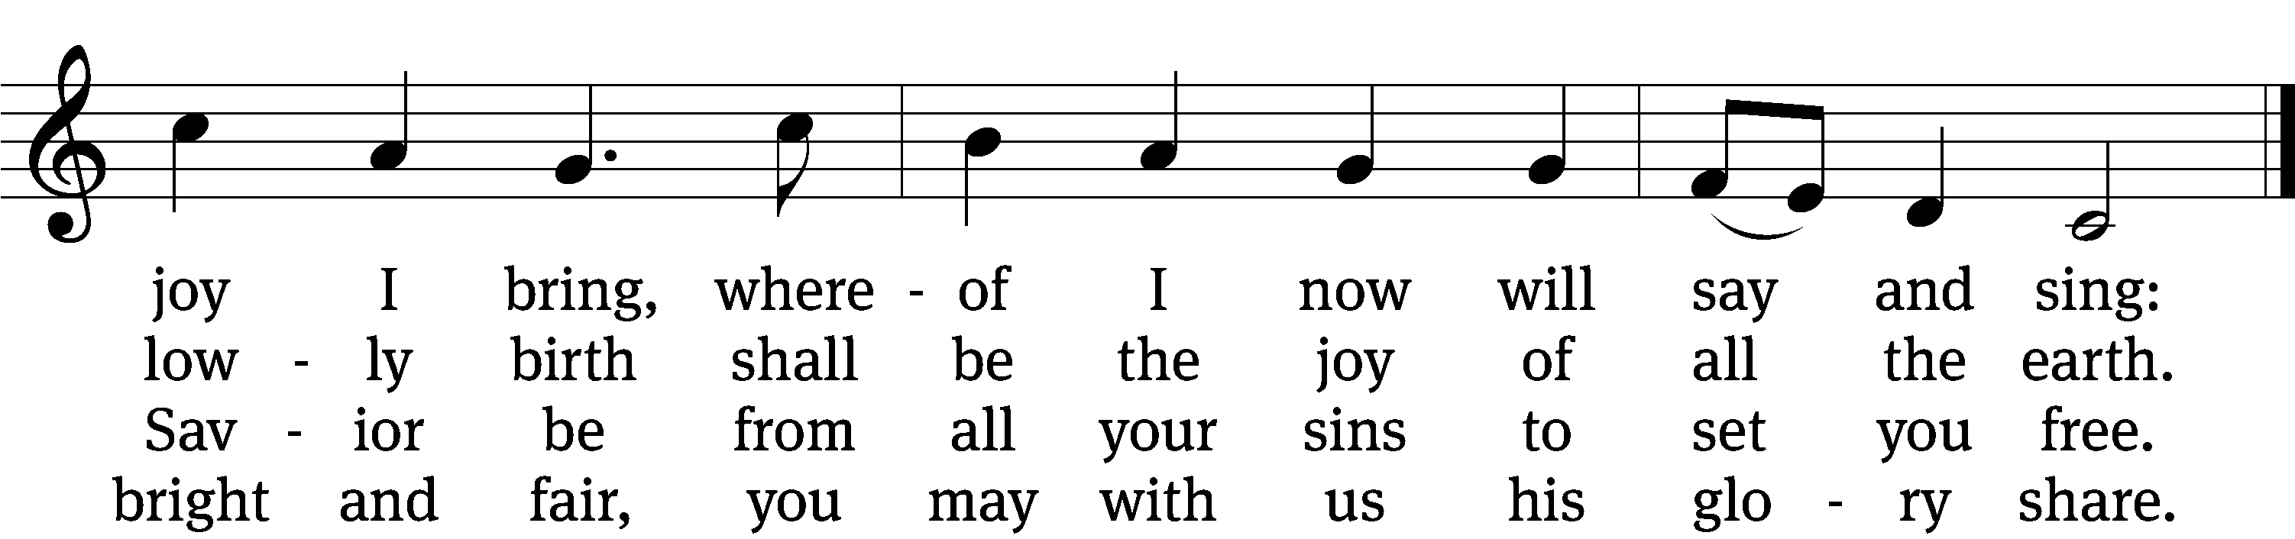

5 “These are the signs which you shall mark:
the swaddling clothes and manger dark.
There you will find the infant laid
by whom the heav’ns and earth were made.”

6 How glad we’ll be to find it so!
Then with the shepherds let us go
to see what God for us has done
in sending us his own dear Son.

7 Come here, my friends, lift up your eyes,
and see what in the manger lies.
Who is this child, so young and fair?
It is the Christ Child lying there.

8 Welcome to earth, O noble Guest,
through whom the sinful world is blest!
You came to share my misery,
that you might share your joy with me.

9 Ah, Lord, though you created all,
how weak you are, so poor and small,
that you should choose to lay your head
where lowly cattle lately fed!

10 Were earth a thousand times as fair
and set with gold and jewels rare,
it would be far too poor and small
a cradle for the Lord of all.

11 Instead of soft and silken stuff
you have but hay and straw so rough
on which as king, so rich and great,
to be enthroned in royal state.

12 And so it pleases you to see
this simple truth revealed to me:
that worldly honor, wealth, and might
are weak and worthless in your sight.

13 Ah, dearest Jesus, holy Child,
prepare a bed, soft, undefiled
within my heart, made clean and new,
a quiet chamber kept for you.

14 My heart for very joy must leap;
my lips no more can silence keep.
I too must sing with joyful tongue
that sweetest ancient cradle song:

15 Glory to God in highest heav’n,
who unto us his Son has giv’n,
while angels sing with pious mirth
a glad new year to all the earth!
Text: tr. Catherine Winkworth, 1827–1878, alt.; Martin Luther, 1483–1546
Tune: Geistliche lieder, Leipzig, 1539, ed. Valten Schumann
Text and tune: Public domain

PLEASE STAND, IF YOU ARE ABLE

THANKSGIVING

M: Hear the prayer of your people, O Lord, that the lips which have praised you here may glorify you in the world, that the eyes which have seen the coming of your Son may long for his coming again, and that all who have received in his true body and blood the pledge of your forgiveness may be restored to live a new and holy life, through Jesus Christ, our Lord, who lives and reigns with you and the Holy Spirit, one God, now and forever.

M: Brothers and sisters, go in peace. Live in harmony with one another.
Serve the Lord with gladness.

The Lord bless you and keep you.
The Lord make his face shine on you and be gracious to you.
The Lord look on you with favor and (+) give you peace.

PLEASE BE SEATED

318 Hark! A Thrilling Voice Is Sounding CW 318
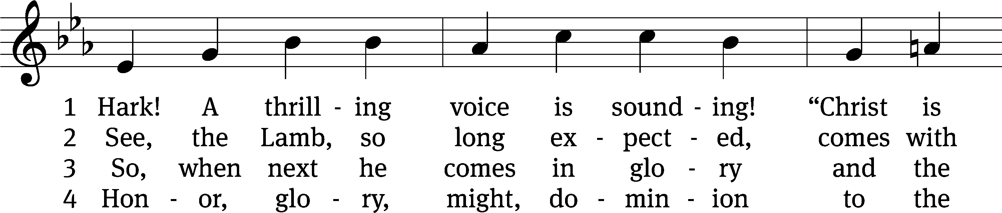
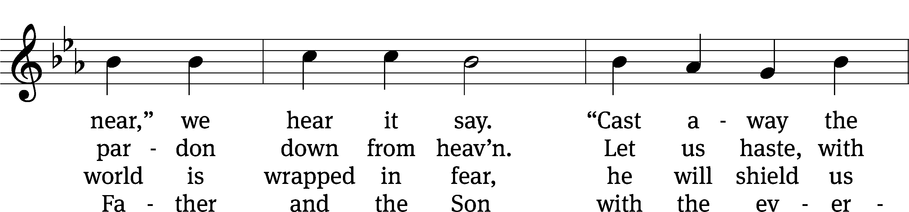
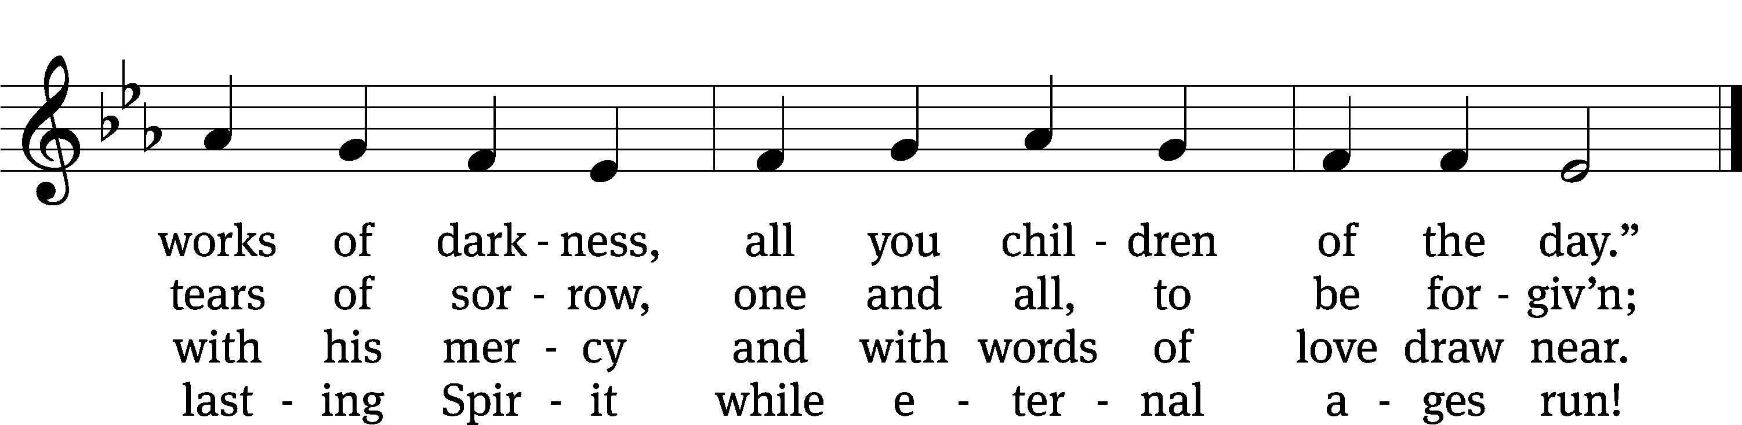
Text: tr. Edward Caswall, 1814–1878, alt.; Latin, c. 5th–10th cent.
Tune: William H. Monk, 1823–1889
Text and tune: Public domain

Serving In Worship

Officiant Pastor Natsis
Organist Ann Hoeft
Bell Choir Director Meg Nortley
Deacons (8:30) Dave Frey and Jim Tice
(11:00) Jeff Neuburger and Ed Wheeler
Ushers (8:30) Bob Newman and Henry Schneider
(11:00) Bill Barnett and Jake Vershum
Altar Guild Sharon Boswell and Connie Marion
Videographer Ann Latowski

Copyright information
Service of Word and Sacrament: Christian Worship. © 1993 Northwestern Publishing House. All rights reserved. Reprinted under ONE LICENSE #A-727703 and CCLI #1151741/ CSPL126093
Words and Music: All rights reserved. Reprinted/Podcast/Streamed with permission under ONE LICENSE #A-727703 and CCLI #1151741/CSPL126093

