THE FIRST SUNDAY
IN ADVENT

TRINITY EVANGELICAL LUTHERAN CHURCH | Saline, Michigan
WELCOME TO WORSHIP December 3, 2023
Thank you for joining us in God’s house today! We cordially ask that our Guests sign one of the guestbooks located at either the front or back entryways, or fill out a “Let’s Get Acquainted” card located in the hymnal pew rack and place it in the collection plate.

Thank Offering: Members of Trinity give their offering as an expression of love and thankfulness to the Lord and to help support the Lord’s work in our community and around the world. Visitors need not feel obligated to participate in this offering .

Restrooms are located at the back of the upper level (the annex), and in the basement (down the back stairs of the sanctuary or annex). Handicap access is available, please ask an usher for assistance.

Young Families / Toddler Bags – We are GLAD YOU BROUGHT YOUR CHILDREN to our worship service. Jesus said: “Let the little children come to me and do not hinder them, for the kingdom of God belongs to such as these.” We know that having little children in church can be a challenge, but DO NOT WORRY about it. Many of your fellow worshippers have been in your shoes and are just happy you brought your children with you. For your convenience, we have reserved the back rows of seating for parents with small children. These areas provide more flexibility for your family, as well as, easy access to move downstairs if necessary. A closed-circuit TV system allows families to continue participating in the service while downstairs. Pre-school toddler bags and children’s bulletins are available for their enjoyment. Ask an usher for one to use during the service and please return the toddler bag afterwards.

Holy Communion – In His Word, God makes it clear that the Lord’s Supper is to be shared by people of a common proclamation of faith (1 Corinthians 11:26; 1 Corinthians 10:16-17). Without judging anyone’s hearts, we invite those who share in our confession by their membership in our congregation or another congregation of the Wisconsin Evangelical Lutheran Synod (WELS) or the Evangelical Lutheran Synod (ELS) and who are properly prepared (1 Corinthians 11;27-29) to receive the Sacrament. Page 295 in Christian Worship provides a guide for preparation.
Guests, we would love to have you join us in communion fellowship in the future, and for that to be possible, we ask that you speak with one of the pastors so that we may speak with you on how that would be possible. We thank you for respecting the way we celebrate the Lord’s Supper in our congregations.

the SERVICE – setting one - WITH HOLY COMMUNION CW, page 154
495 The King Shall Come CW 495
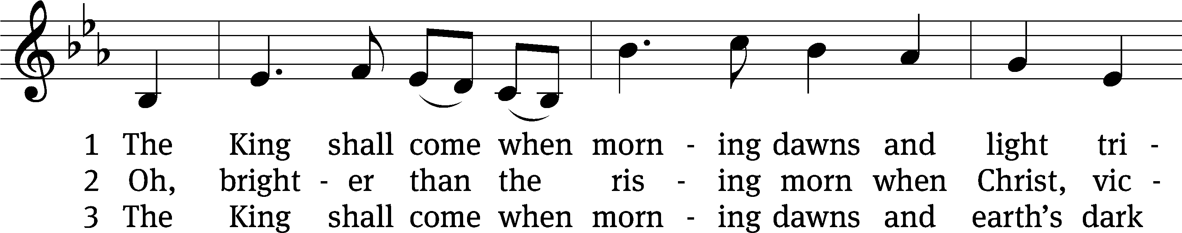
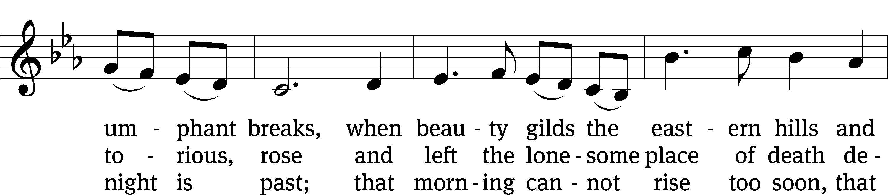
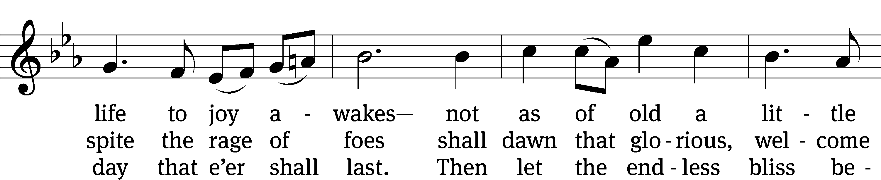
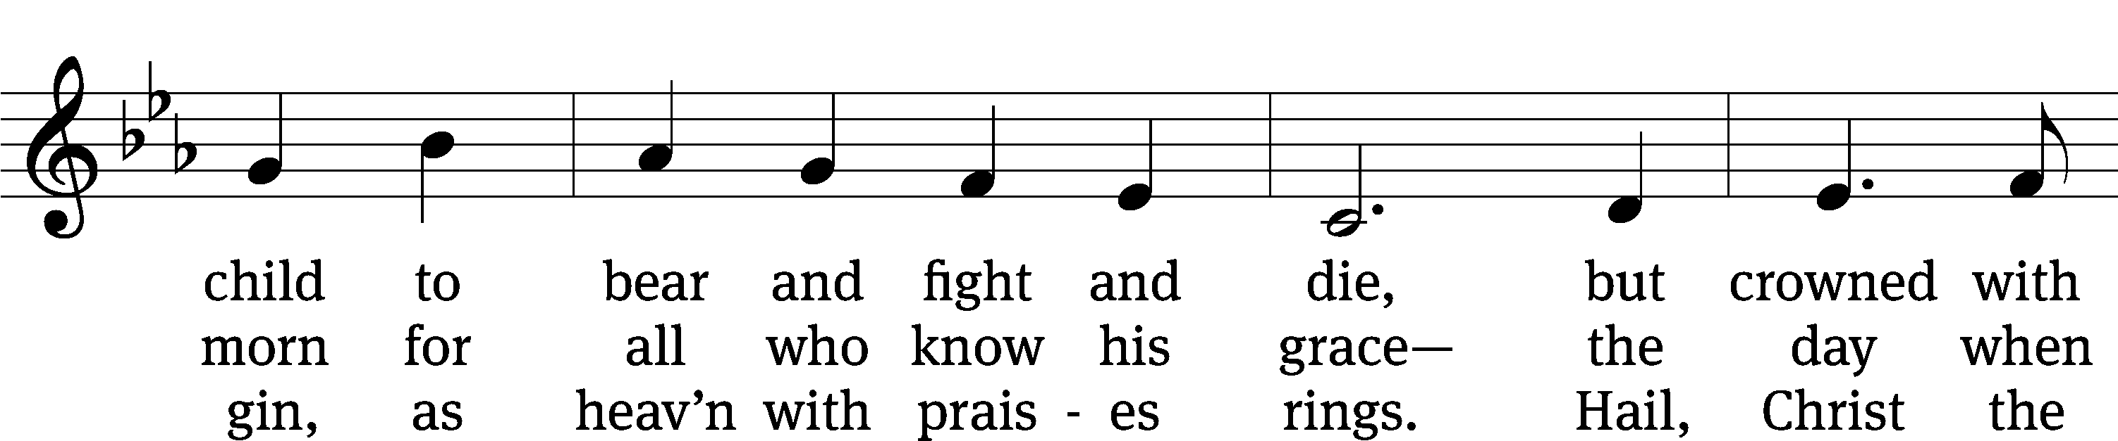
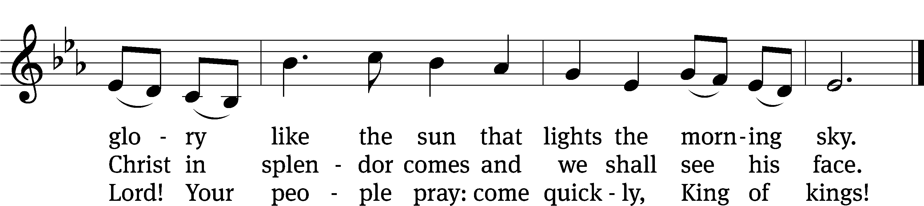
Text: John Brownlie, 1859–1925, abr., alt.
Tune: Irish
Text and tune: Public domain

Please stand, if you are able

Invocation

In the name of the Father and of the Son and of the Holy Spirit.
Amen.

Confession

If we claim to be without sin, we deceive ourselves and the truth is not in us.
If we confess our sins, God is faithful and just
and will forgive us our sins
and purify us from all unrighteousness.

Let us confess our sins to the Lord.
Holy God, gracious Father,
I am sinful by nature
and have sinned against you in my thoughts, words, and actions.
I have not loved you with my whole heart;
I have not loved others as I should.
I deserve your punishment both now and forever.
But Jesus, my Savior, paid for my sins
with his innocent suffering and death.
Trusting in him, I pray: God, have mercy on me, a sinner.

Our gracious Father in heaven has been merciful to us. He sent his only Son, Jesus Christ, who gave his life as the atoning sacrifice for the sins of the whole world. Therefore, as a called servant of Christ and by his authority, I forgive you all your sins in the name of the Father and of the Son and of the Holy Spirit.
Amen.

Lord, Have Mercy

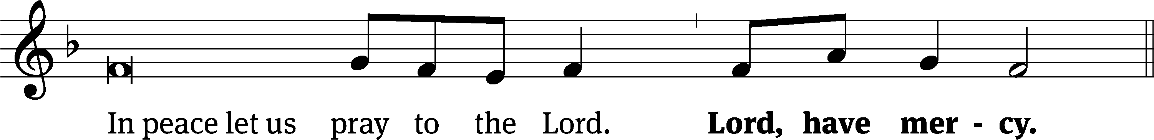
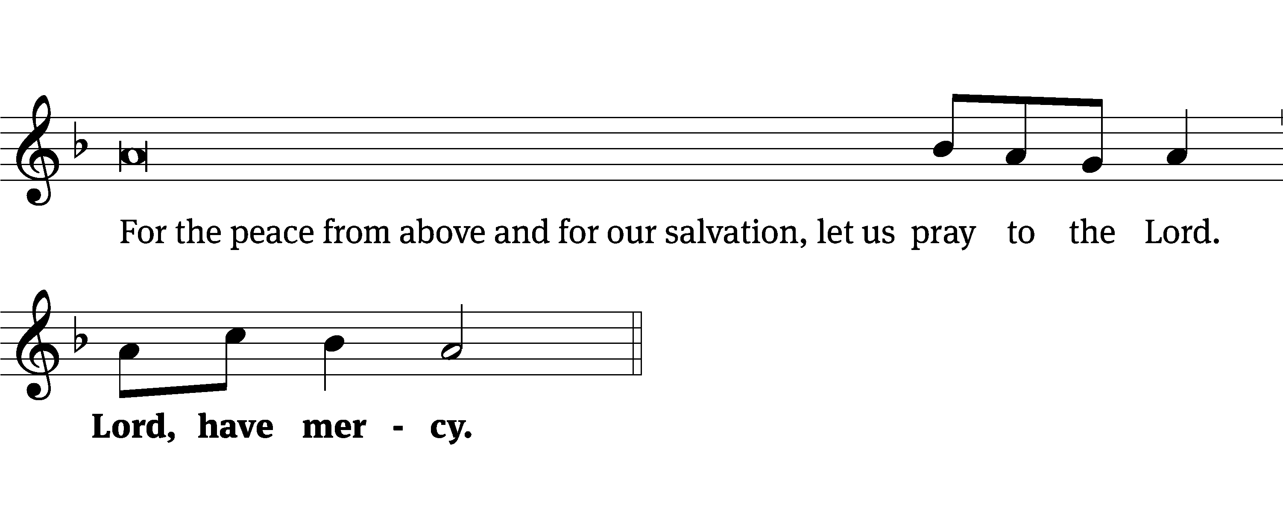
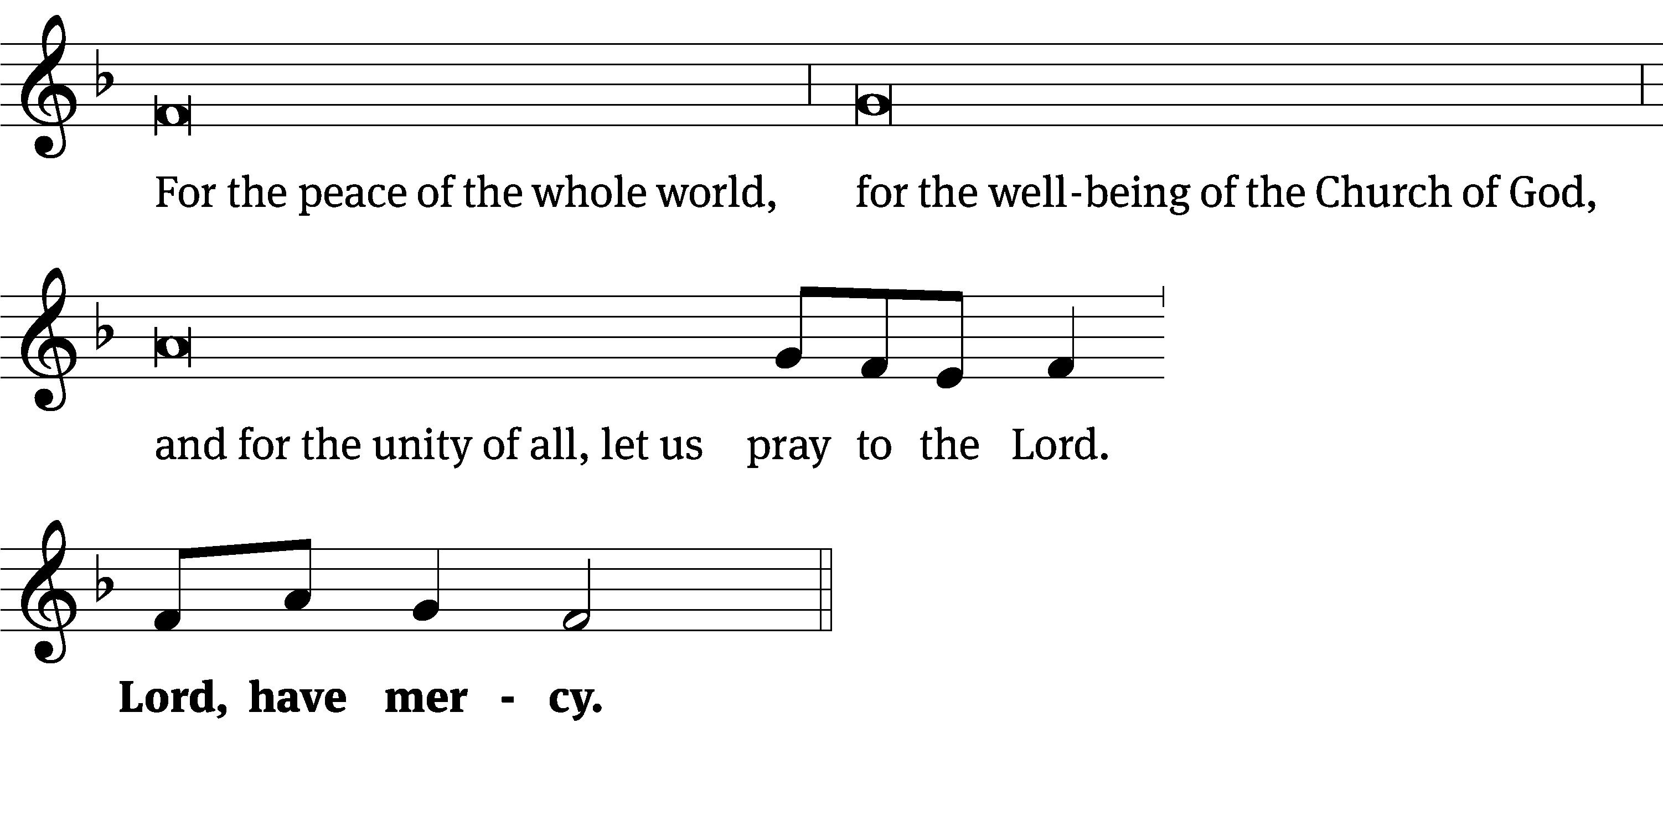
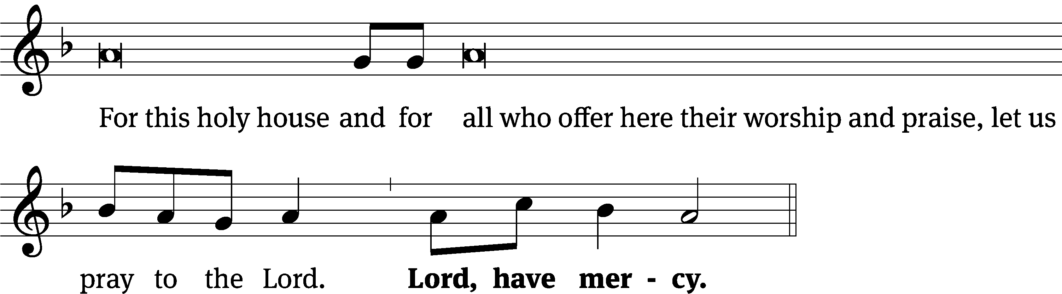
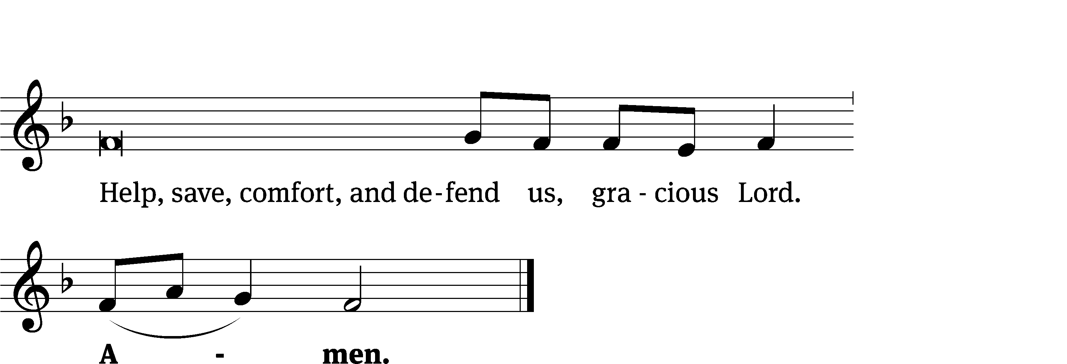
Glory Be to God on High CW 157
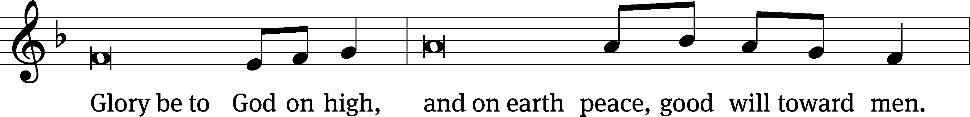
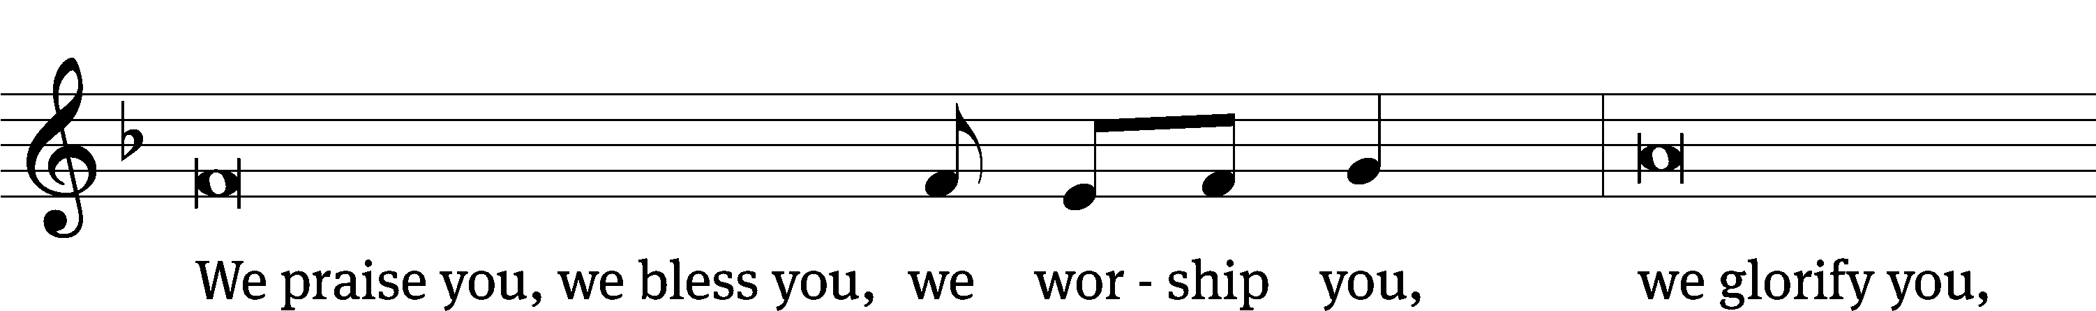
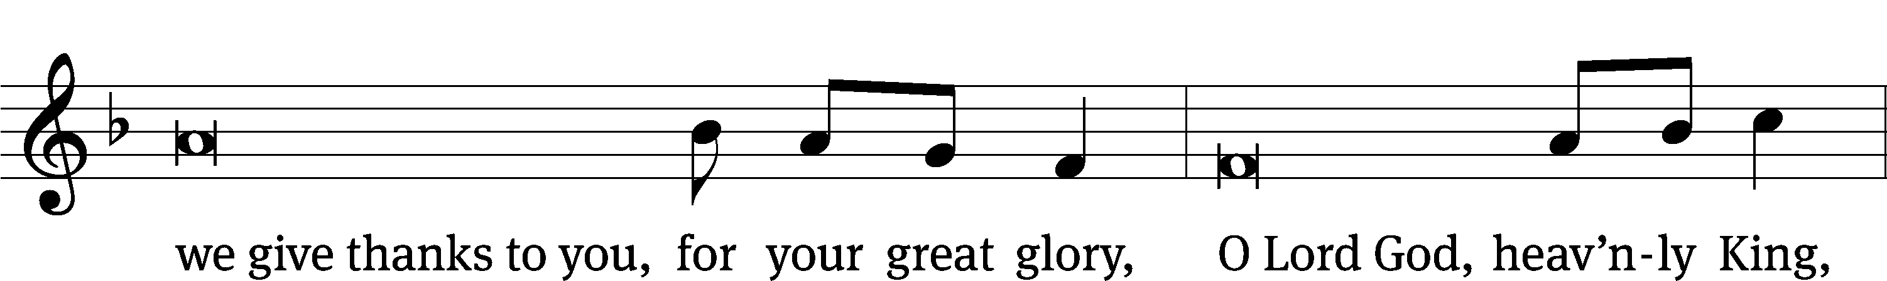
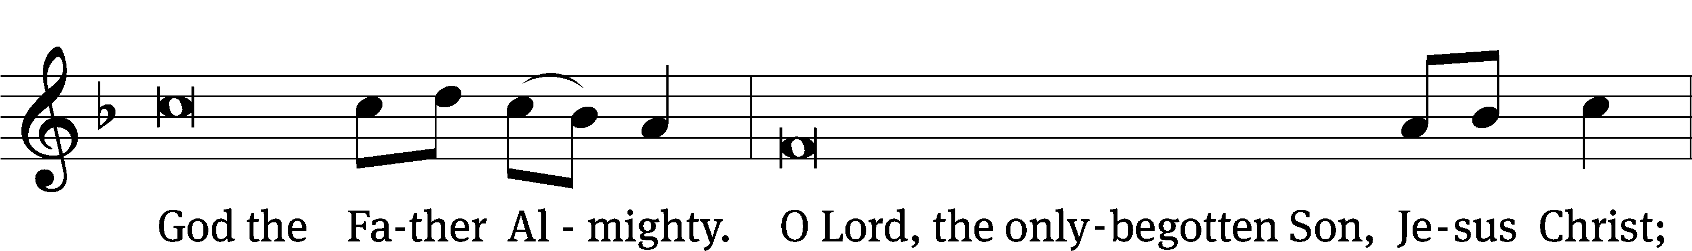
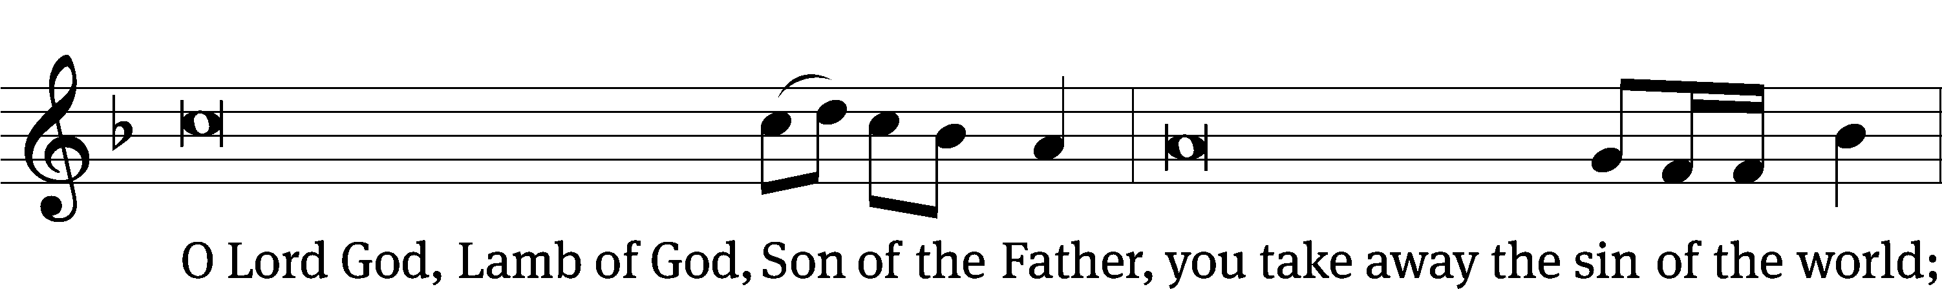
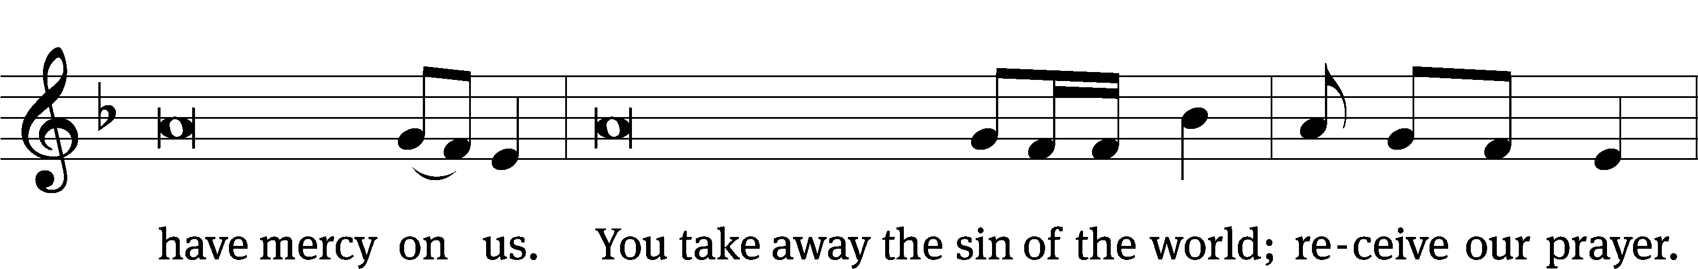
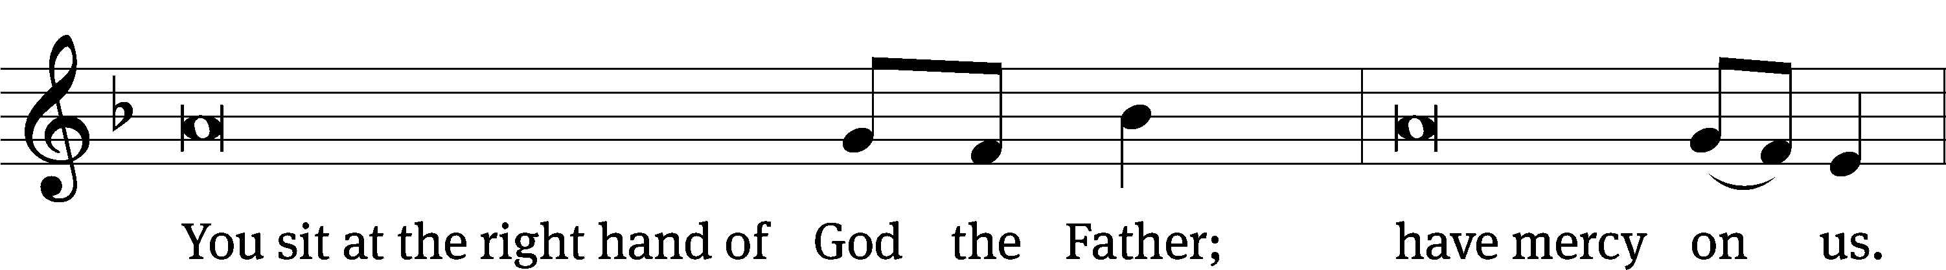
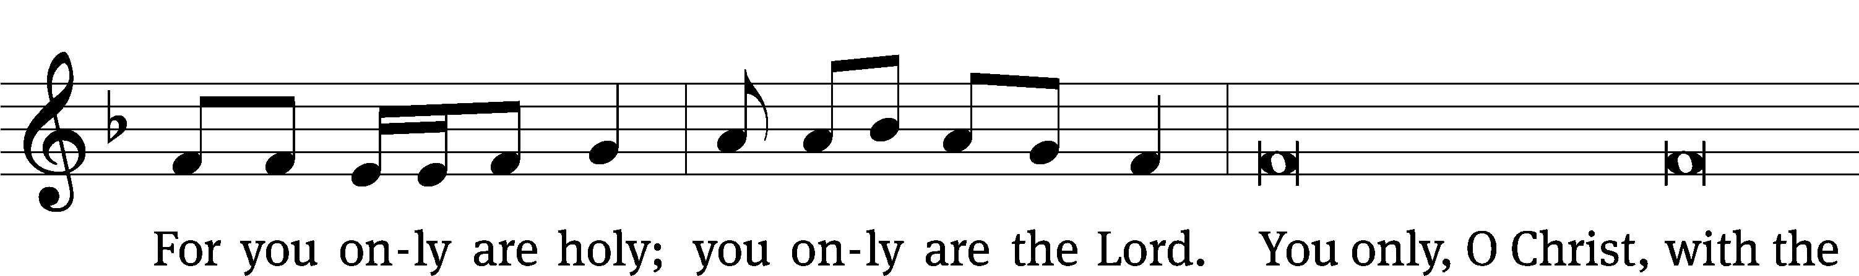
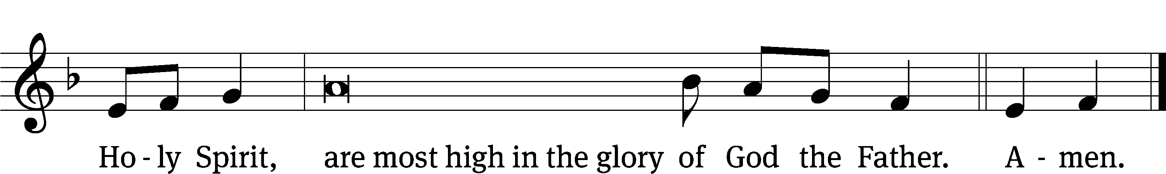

The Lord be with you.
And also with you.
Prayer of the Day
Let us pray.

Stir up your power, O Lord, and come. Protect us by your strength, and save us from the threatening dangers of our sins; for you live and reign with the Father and the Holy Spirit, one God, now and forever.
Amen.

Please be seated

First Reading Isaiah 64:1-9

¹ Oh, that you would rip open the heavens and come down.
Mountains then would quake because of your presence.^{[a]}
² As fire ignites stubble and as fire makes water boil,
make your name known to your adversaries.
Then nations would quake in your presence.
³ You did amazing things that we did not expect.
You came down. Mountains quaked because of your presence.
⁴ From ancient times no one has heard.
No ear has understood.
No eye has seen any god except you,
who goes into action for the one who waits for him.
⁵ You meet anyone who joyfully practices righteousness,
who remembers you by walking in your ways!
But you were angry because we sinned.
We have remained in our sins for a long time.
Can we still be saved?
⁶ All of us have become like something unclean,
and all our righteous acts are like a filthy cloth.^{[b]}
All of us have withered like a leaf,
and our guilt carries us away like the wind.
⁷ There is no one who calls on your name,
who rouses himself to take hold of you.
So you hid your face from us.
You made us melt by the power of our guilt.
⁸ But now, Lord, you are our father.
We are the clay, and you are our potter.
All of us are the work of your hand.
⁹ Do not be angry, Lord, without limit.
Do not remember our guilt forever.
Please look closely.
All of us are your people.

The Word of the Lord.
Thanks be to God.

Psalm of the Day
24A Welcome the King of Glory Psalm 24A
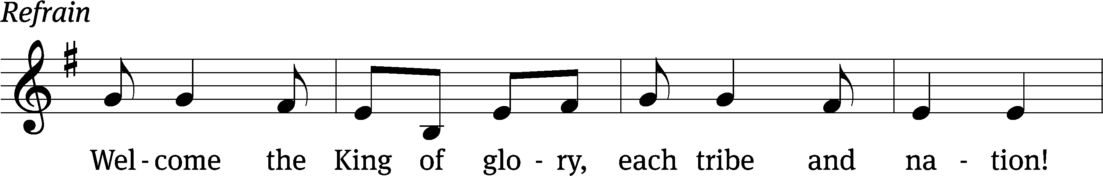
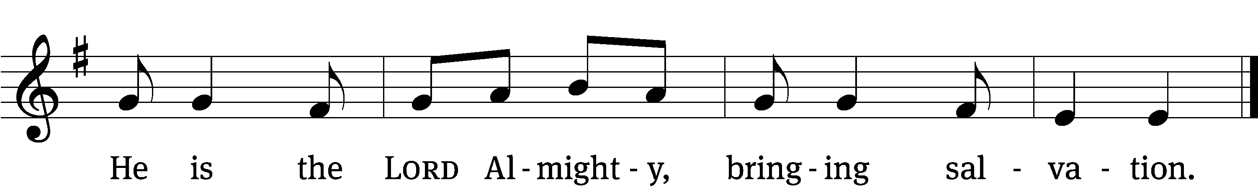

(continued)
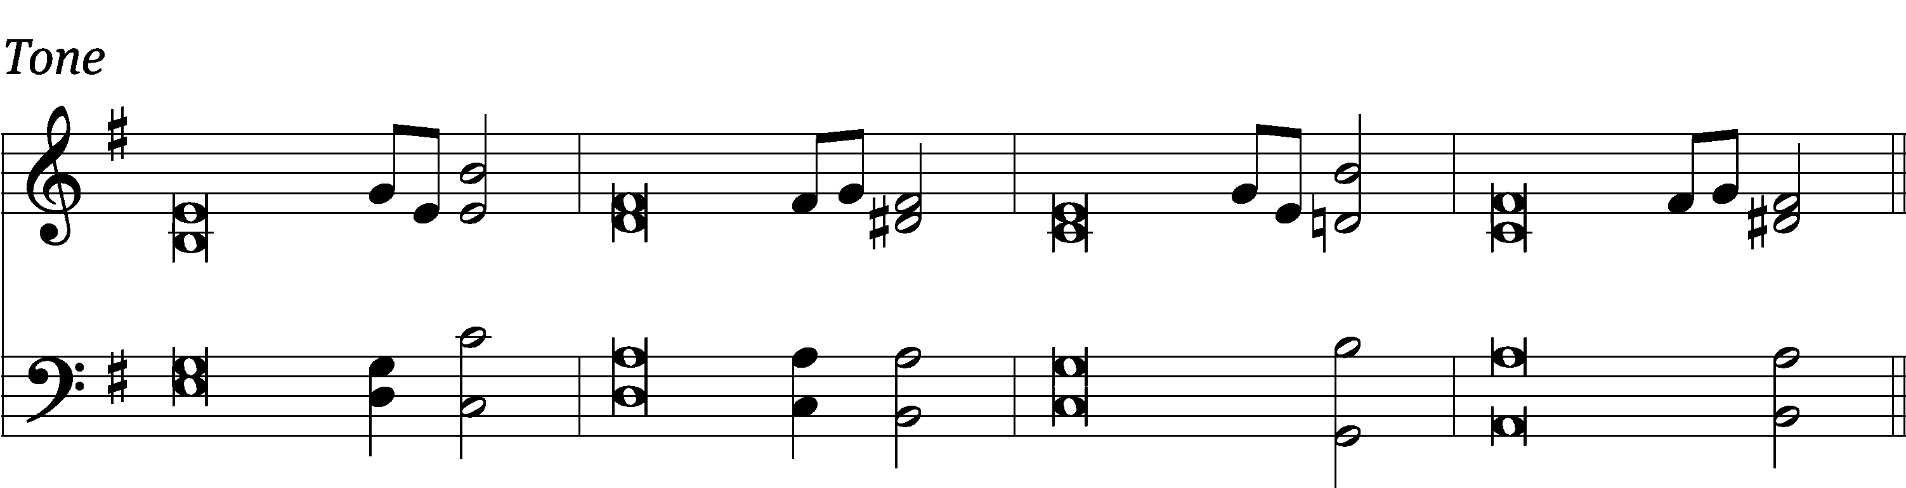

The earth is the Lord’s, and every- / thing in it,
the world, and all who / live in it;
for he founded it / on the seas
and established it on the / waters.

Who may ascend the mountain / of the Lord?
Who may stand in his / holy place?
The one who has clean hands and a / pure heart,
they will receive blessing from God their / Savior. Refrain

Lift up your heads, you gates; be lifted up, you / ancient doors,
that the King of glory / may come in.
Who is this King of / glory?
The Lord strong and mighty, the Lord mighty in / battle.

Lift up your heads, you gates; lift them up, you / ancient doors,
that the King of glory / may come in.
Who is he, this King of / glory?
The Lord Almighty—he is the King of / glory.

Glory be to the Father and / to the Son
and to the Holy / Spirit,
as it was in the be- / ginning,
is now, and will be forever. / Amen. Refrain
Tune: Israeli
Text: © 2021 Northwestern Publishing House (refrain). Used by permission: OneLicense no. 727703
Tune: Public domain
Setting: © 2021 Northwestern Publishing House. Used by permission: OneLicense no. 727703

Second Reading 1 Corinthians 1:3-9

³ Grace to you and peace from God our Father and the Lord Jesus Christ!
⁴ I always thank my God for you because of the grace of God given to you in Christ Jesus. ⁵ You were enriched in him in every way, in all your speaking and all your knowledge, ⁶ because the testimony about Christ was established in you. ⁷ As a result you do not lack any gift as you eagerly wait for the revelation of our Lord Jesus Christ. ⁸ He will also keep you strong until the end, so that you will be blameless on the day of our Lord Jesus Christ. ⁹ God is faithful, who called you into fellowship with his Son, Jesus Christ, our Lord.
The Word of the Lord.
Thanks be to God.

Please stand, if you are able
Gospel Acclamation Revelation 22:20
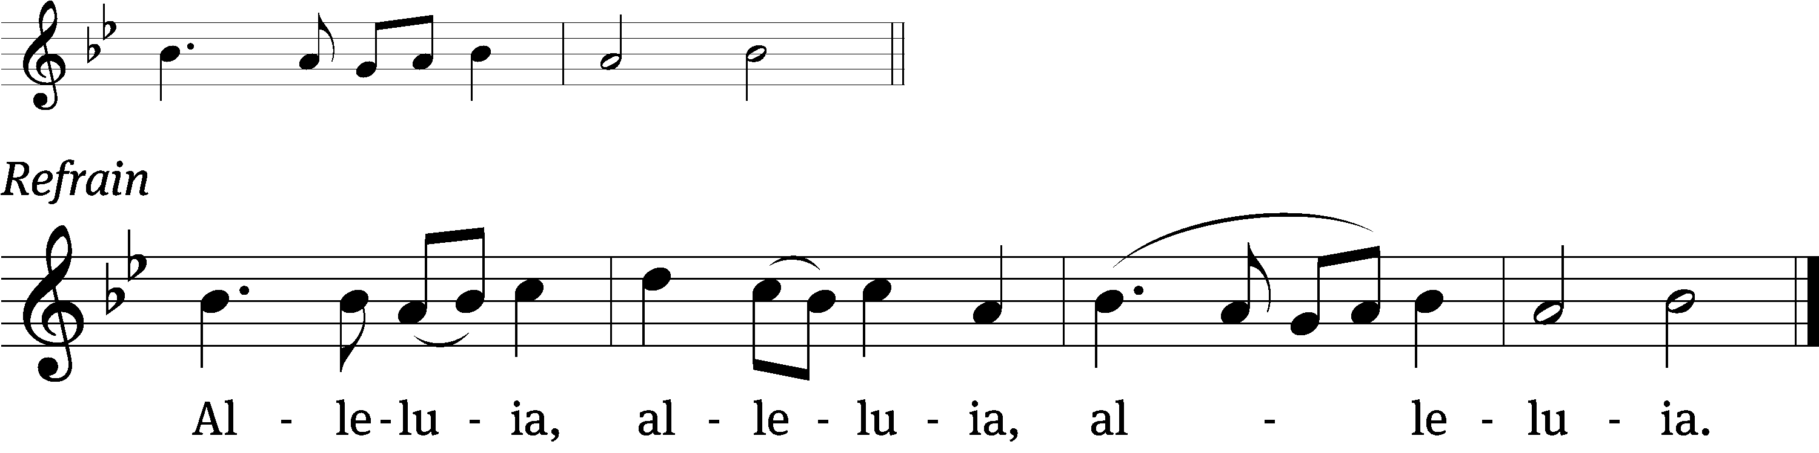
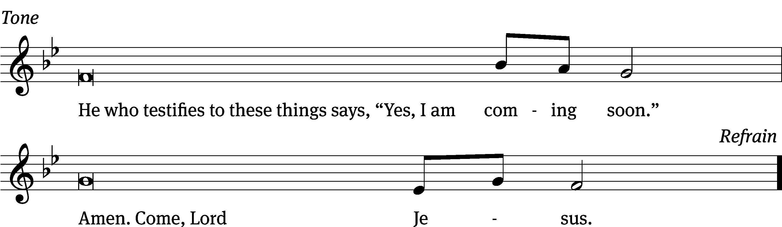
Tune: © 2021 Northwestern Publishing House. Used by permission: OneLicense no. 727703

Gospel Mark 11:1-10
¹ As they approached Jerusalem, at Bethphage and Bethany, on the Mount of Olives, he sent two of his disciples ² and told them, “Go into the village ahead of you. As soon as you enter it, you will find a colt tied there, on which no one has ever sat. Untie it and bring it here. ³ If anyone asks you, ‘Why are you doing this?’ say, ‘The Lord needs it, and he will send it back here without delay.’”
⁴ They left and found a colt on the street, tied at a door; and they untied it. ⁵ Some who were standing there asked them, “What are you doing, untying that colt?” ⁶ The disciples answered them just as Jesus had instructed them, and the men let them go.
⁷ They brought the colt to Jesus, threw their garments on it, and Jesus sat on it. ⁸ Many people spread their garments on the road. Others spread branches that they had cut from the fields. ⁹ Those who went in front and those who followed were crying out,
Hosanna!
Blessed is he who comes in the name of the Lord!
¹⁰ Blessed is the coming kingdom of our father David!
Hosanna in the highest!

The Gospel of the Lord.
Praise be to you, O Christ!

Please be seated

301 Savior of the Nations, Come CW 301
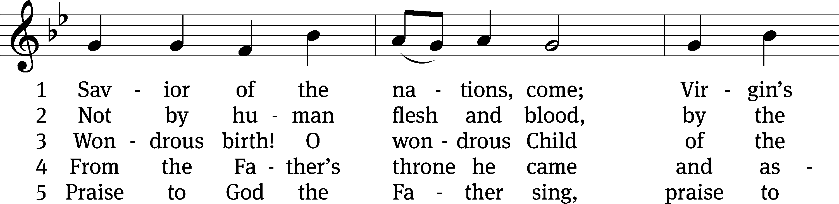
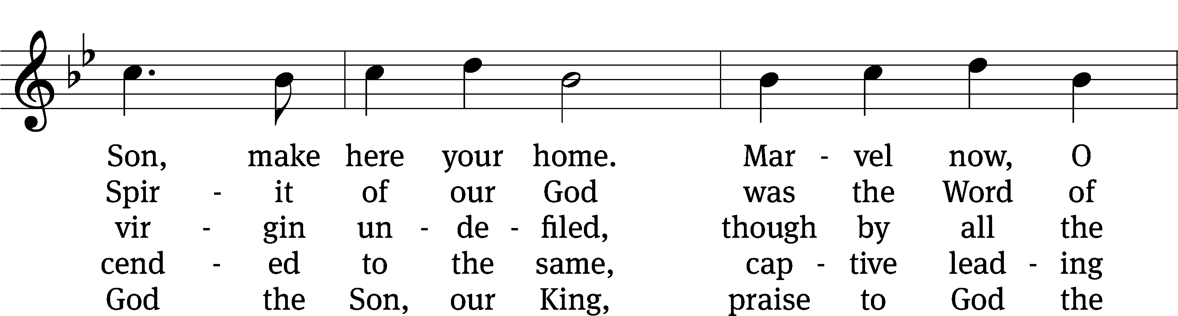
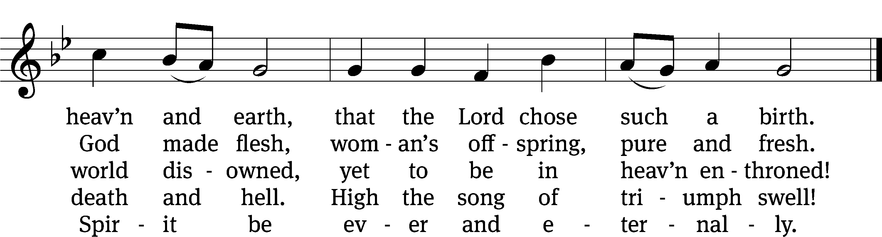
Text: tr. William M. Reynolds, 1812–1876, alt.; German version, Martin Luther, 1483–1546, abr.; Ambrose of Milan, 340–397, abr.
Tune: Geystliche gesangk Buchleyn, Wittenberg, 1524, ed. Johann Walter
Text and tune: Public domain

SERMON Mark 11:1-10
“Already – Now – Yet to Come”

Please stand, if you are able

nicene creed
We believe in one God, the Father, the Almighty, maker of heaven and earth, of all that is, seen and unseen.
We believe in one Lord, Jesus Christ, the only Son of God, eternally begotten of the Father, God from God, Light from Light, true God from true God, begotten, not made, of one being with the Father. Through him all things were made. For us and for our salvation, he came down from heaven, was incarnate of the Holy Spirit and the virgin Mary, and became truly human. For our sake he was crucified under Pontius Pilate. He suffered death and was buried. On the third day he rose again in accordance with the Scriptures. He ascended into heaven and is seated at the right hand of the Father. He will come again in glory to judge the living and the dead, and his kingdom will have no end.
We believe in the Holy Spirit, the Lord, the giver of life, who proceeds from the Father and the Son, who in unity with the Father and the Son is worshiped and glorified, who has spoken through the prophets. We believe in one holy Christian and apostolic Church. We acknowledge one baptism for the forgiveness of sins. We look for the resurrection of the dead and the life of the world to come. Amen.

Prayer of the Church

The Sacrament
Preface CW 165

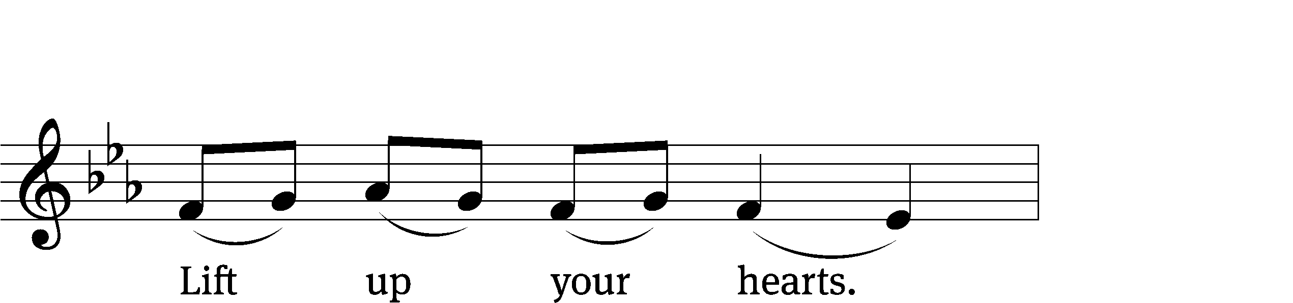
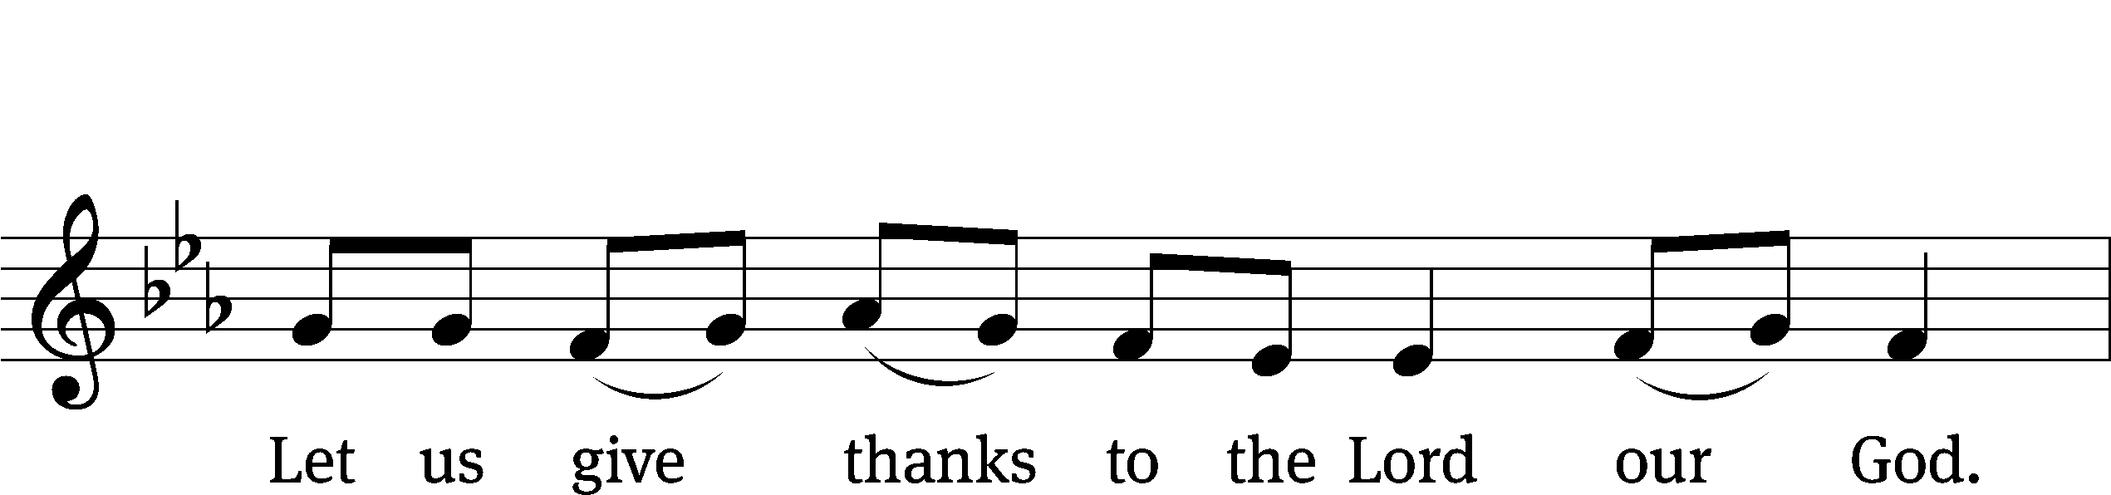
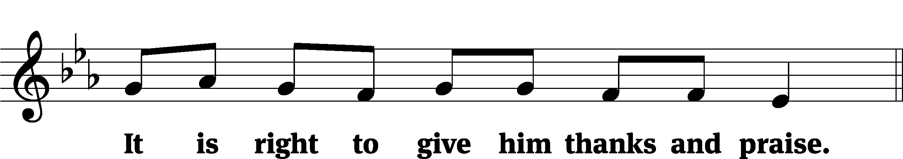

It is truly good and right that we should at all times and in all places give you thanks, O Lord, holy Father, almighty and everlasting God, through Jesus Christ our Lord, who by his willing sacrifice on the cross took away the sins of the world and by his glorious resurrection restored everlasting life. Therefore, with all the saints on earth and hosts of heaven, we praise your holy name and join their glorious song:

Holy, Holy, Holy CW 167
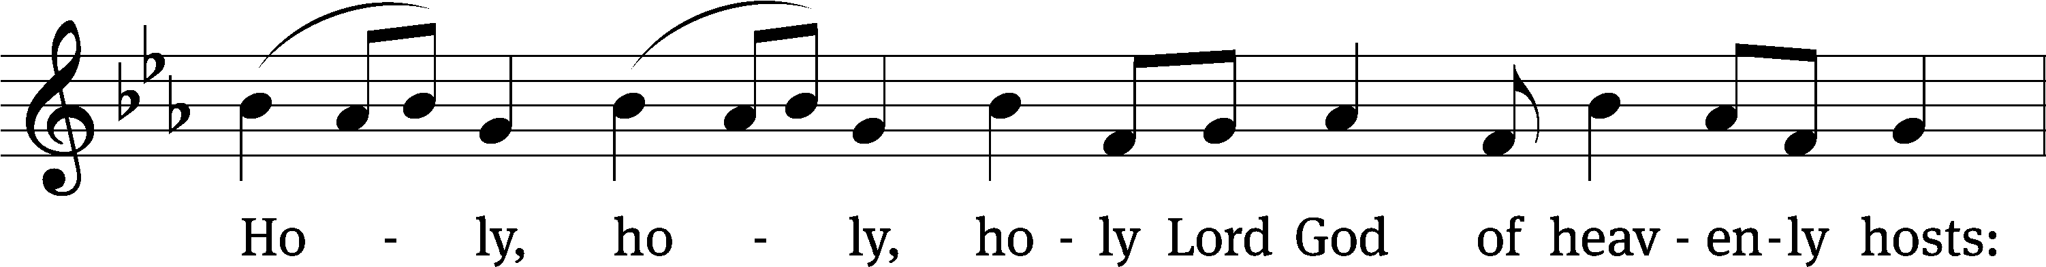
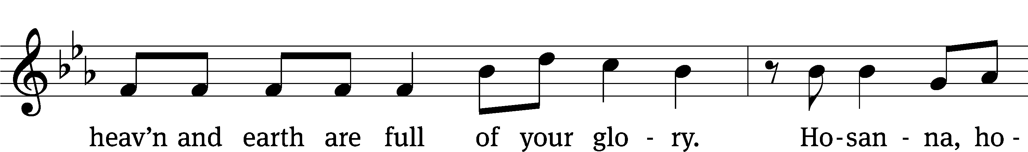
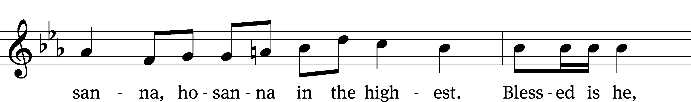
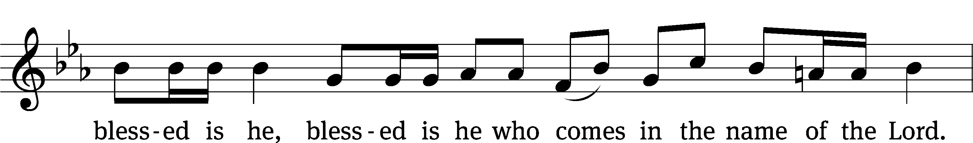
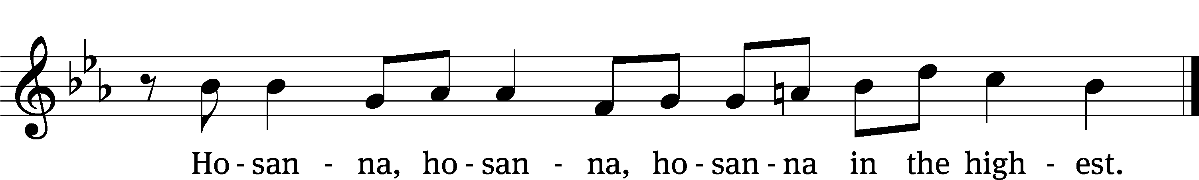

Prayer of Thanksgiving
We give thanks to you, O God, through your dear Son, Jesus Christ, whom you sent to be our Savior, our Redeemer, and the messenger of your grace. Through him you made all things; in him you are well pleased. He is the incarnate Word, conceived by the Holy Spirit and born of the Virgin Mary. To fulfill your promises, he stretched out his hands on the cross and released from eternal death all who believe in you.
As we remember Jesus’ death and resurrection, we thank you that you have gathered us together to receive your Son’s body and blood. Send us your Spirit, unite us as one, and strengthen our faith so that we may praise you in your Son, Jesus Christ. Through him, we glorify and honor you, O God our Father, with the Holy Spirit, one God, now and forever.
Amen.

Lord’s Prayer
Our Father, who art in heaven, hallowed be thy name, thy kingdom come, thy will be done on earth as it is in heaven. Give us this day our daily bread; and forgive us our trespasses, as we forgive those who trespass against us; and lead us not into temptation, but deliver us from evil. For thine is the kingdom and the power and the glory forever and ever. Amen.

Words of Institution
Our Lord Jesus Christ, on the night he was betrayed, took bread; and when he had given thanks, he broke it and gave it to his disciples, saying, “Take and eat; this is my body, which is given for you. Do this in remembrance of me.”
Then he took the cup, gave thanks, and gave it to them, saying, “Drink from it, all of you; this is my blood of the new covenant, which is poured out for you for the forgiveness of sins. Do this, whenever you drink it, in remembrance of me.”

The peace of the Lord be with you always.
Amen.
O Christ, Lamb of God CW 169
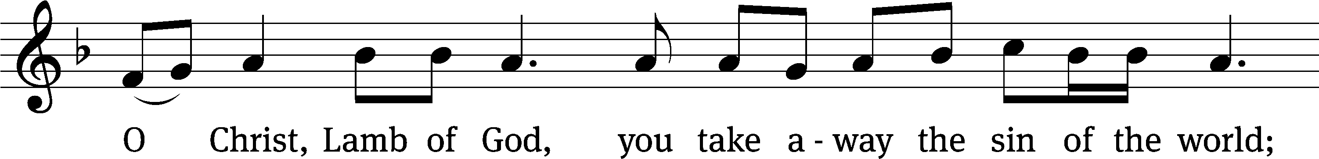
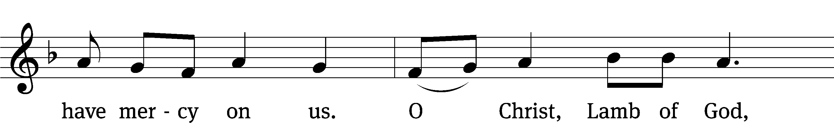
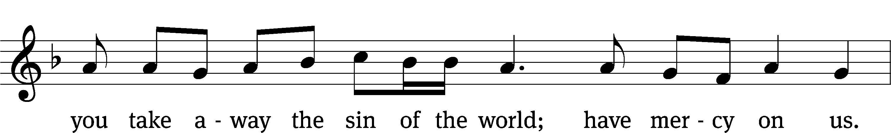
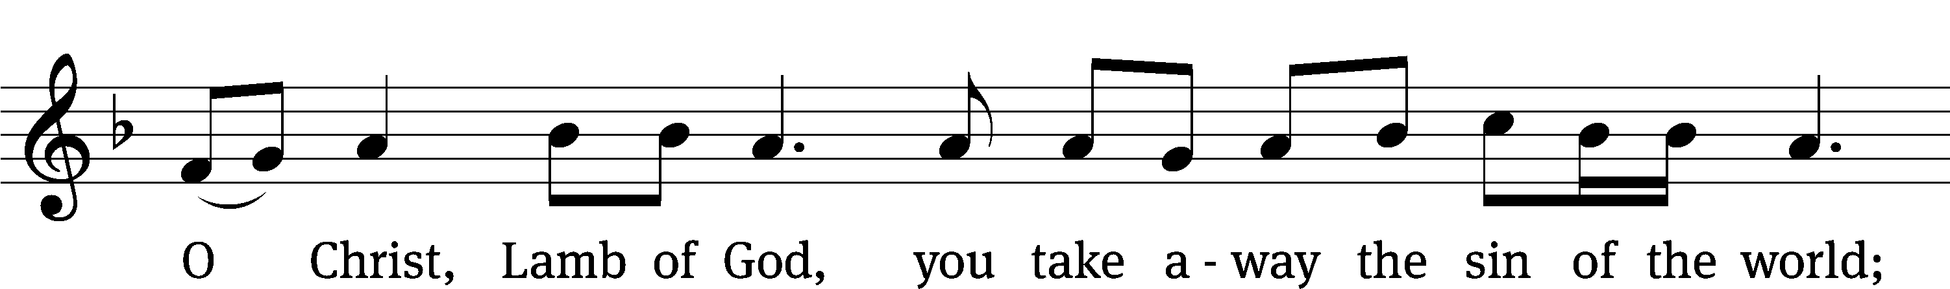
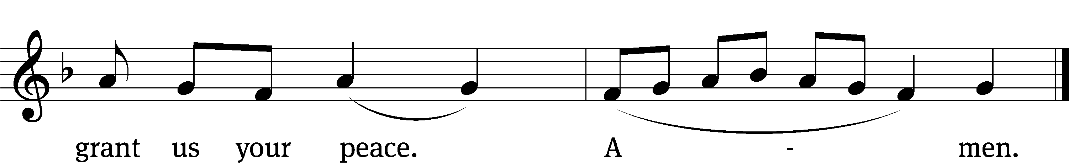
548 The King of Glory Comes CW 548
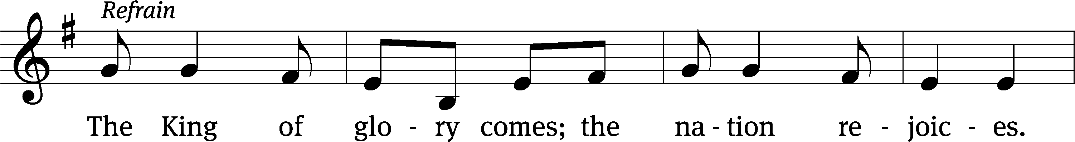
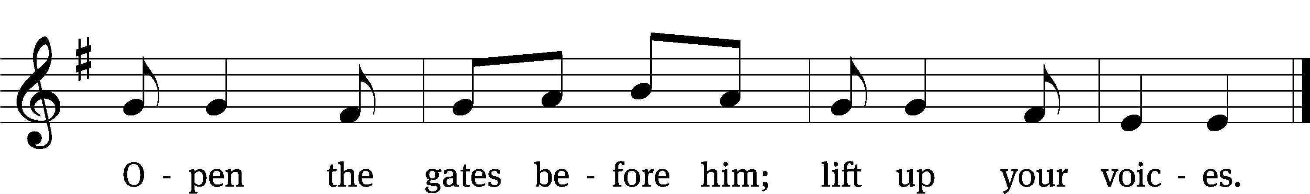
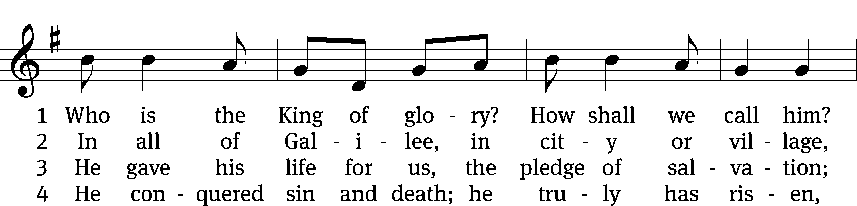
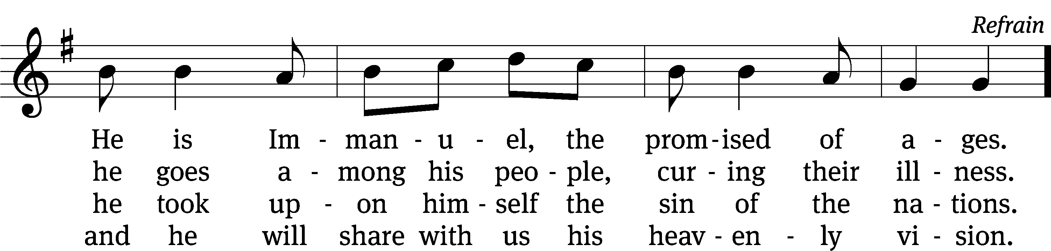
Text: Willard F. Jabusch, 1930–2018, alt.
Tune: Israeli, 20th cent.
Text: © 1966, 1985 Willard F. Jabusch, admin. OCP Publications. Used by permission: OneLicense no. 727703
Tune: Public domain

Please stand, if you are able

Give thanks to the Lord, for he is good;
his mercy endures forever.

Whenever we eat this bread and drink this cup,
we proclaim the Lord’s death until he comes.

We give thanks, almighty God, that you have refreshed us with this saving gift. We pray that through it you will strengthen our faith in you and increase our love for one another. We ask this in the name of Jesus Christ our Lord, who lives and reigns with you and the Holy Spirit, one God, now and forever.
Amen.
Blessing
The Lord bless you and keep you.
The Lord make his face shine on you and be gracious to you.
The Lord look on you with favor and give you peace.
Amen.

Please be seated

313 Hark the Glad Sound! The Savior Comes CW 313
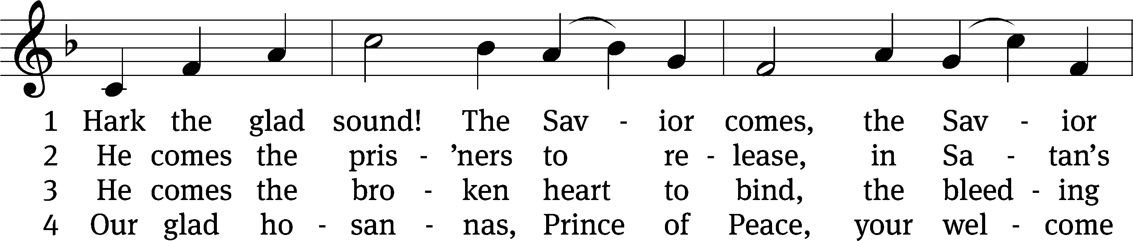
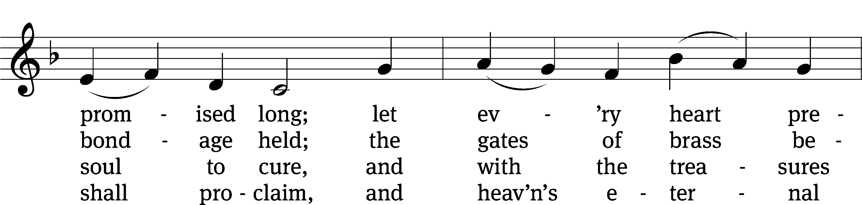
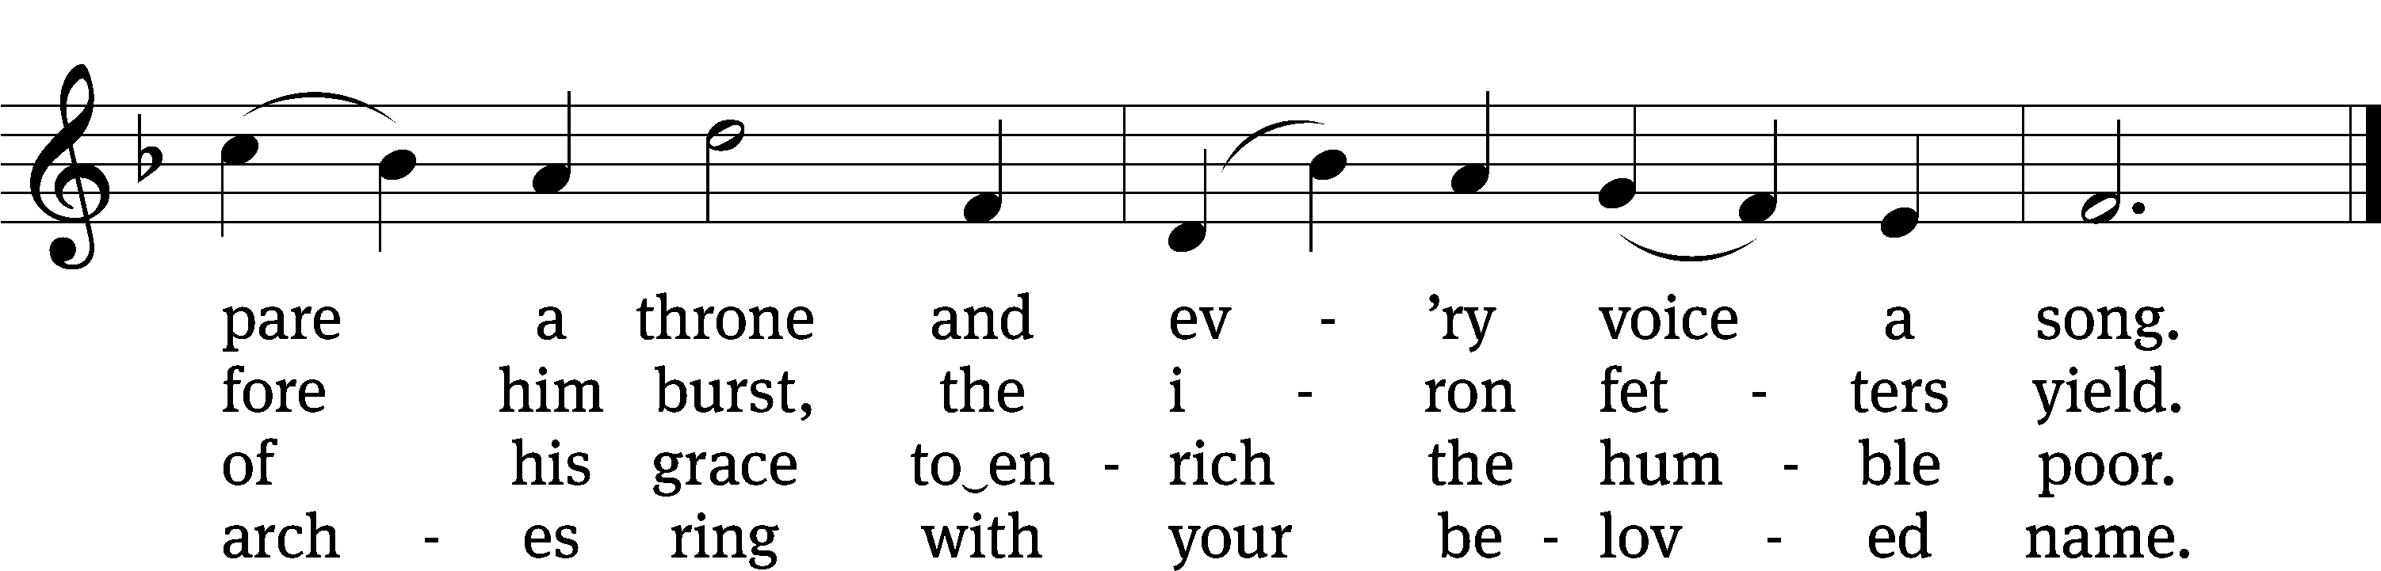
Text: Philip Doddridge, 1702–1751, abr., alt.
Tune: Thomas Haweis, 1734–1820, alt.
Text and tune: Public domain

Acknowledgments
Setting One from Christian Worship
Software distributed in partnership with Northwestern Publishing House.
Created by Christian Worship: Service Builder © 2022 Concordia Publishing House.
Serving in Worship
Officiant Pastor Pappenfuss
Organist Marcia Marion Ackling
Deacons (8:30) Duane Mason and Jim Tice
Deacons (11:00) Jeff Neuburger and Robert Niethammer
Ushers (8:30) Bob Newman and Henry Schneider
Ushers (11:00) Dave Boswell and Jake Vershum
Altar Guild Sharon Boswell
Videographer Rick Schneider

