THE TWENTY-FOURTH SUNDAY
after pentecost
tRINITY EVANGELICAL LUTHERAN CHURCH | Saline, Michigan
November 12, 2023

WELCOME TO WORSHIP

Thank you for joining us in God’s house today! We cordially ask that our Guests with us this morning sign one of the guestbooks located at either the front or back entryways.

THANK OFFERING: Members of Trinity give their offering as an expression of love and thankfulness to the Lord and to help support the Lord’s work in our community and around the world. Visitors need not feel obligated to participate in this offering which supports our ministry.

Restrooms are located at the back of the upper level (the annex), and in the basement (down the back stairs of the sanctuary or annex). Handicap access is available, please ask an usher for assistance.

Young Families / Toddler Bags – We are GLAD YOU BROUGHT YOUR CHILDREN to our worship service. Jesus said: “Let the little children come to me and do not hinder them, for the kingdom of God belongs to such as these.” We know that having little children in church can be a challenge, but DO NOT WORRY about it. Many of your fellow worshippers have been in your shoes and are just happy you brought your children with you. For your convenience, we have reserved the back rows of seating for parents with small children. These areas provide more flexibility for your family, as well as, easy access to move downstairs if necessary. A closed-circuit TV system allows families to continue participating in the service while downstairs. Pre-school toddler bags and children’s bulletins are available for their enjoyment. Ask an usher for one to use during the service and please return the toddler bag afterwards.

SERVICE of the word

Bell Choir (11 a.m.) “What a Friend We Have in Jesus”
890 Jerusalem the Golden CW 890
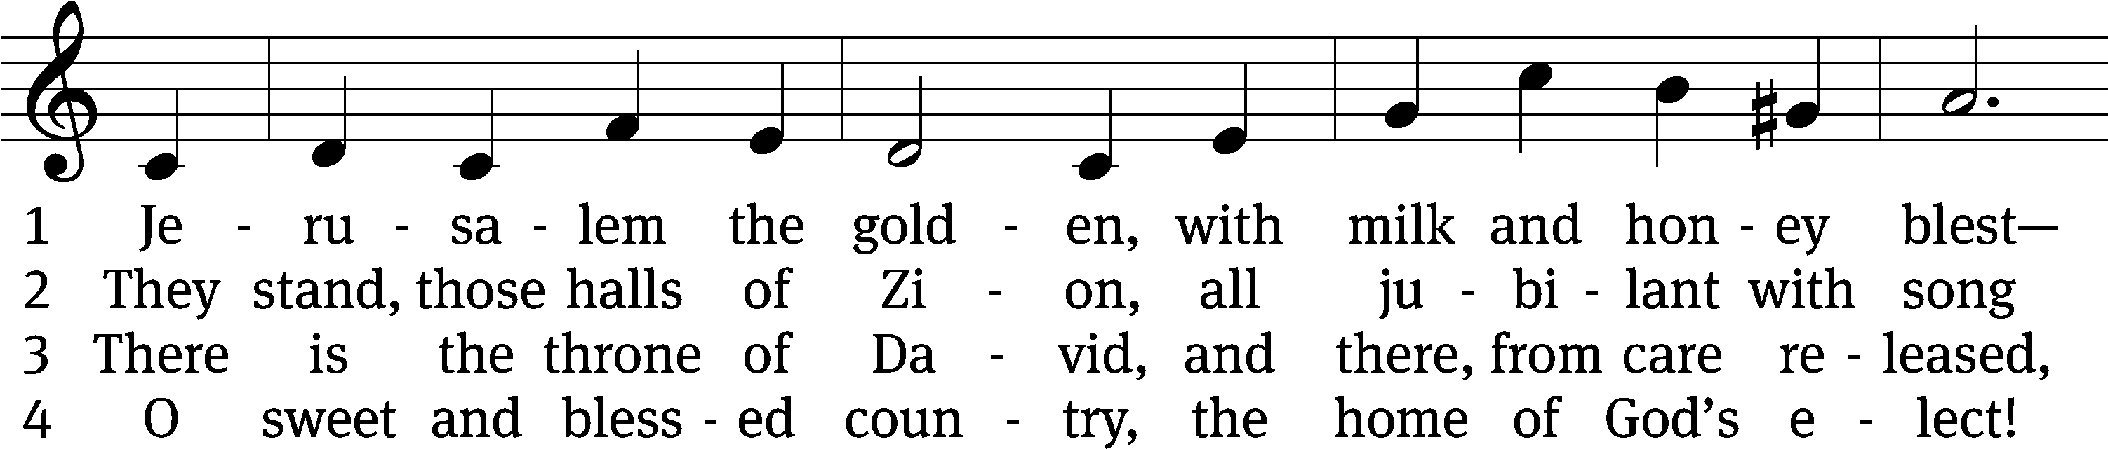
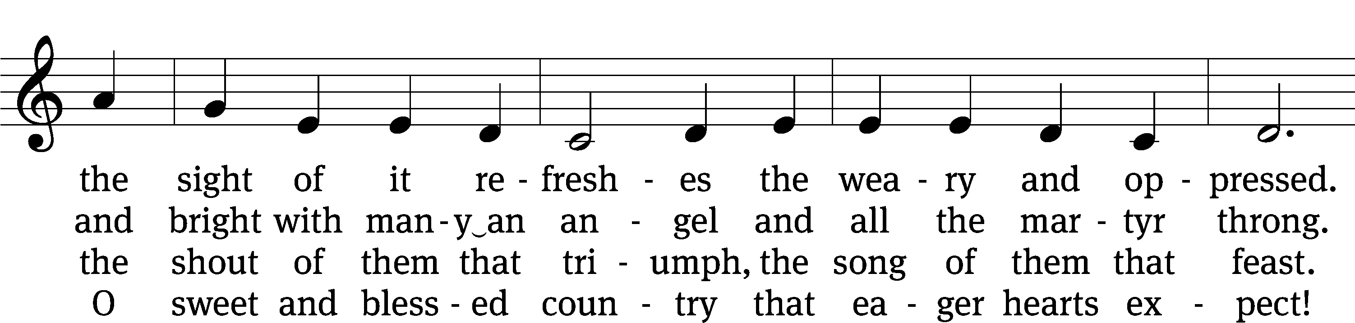
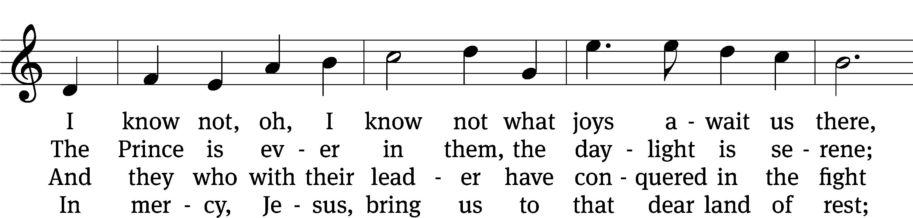
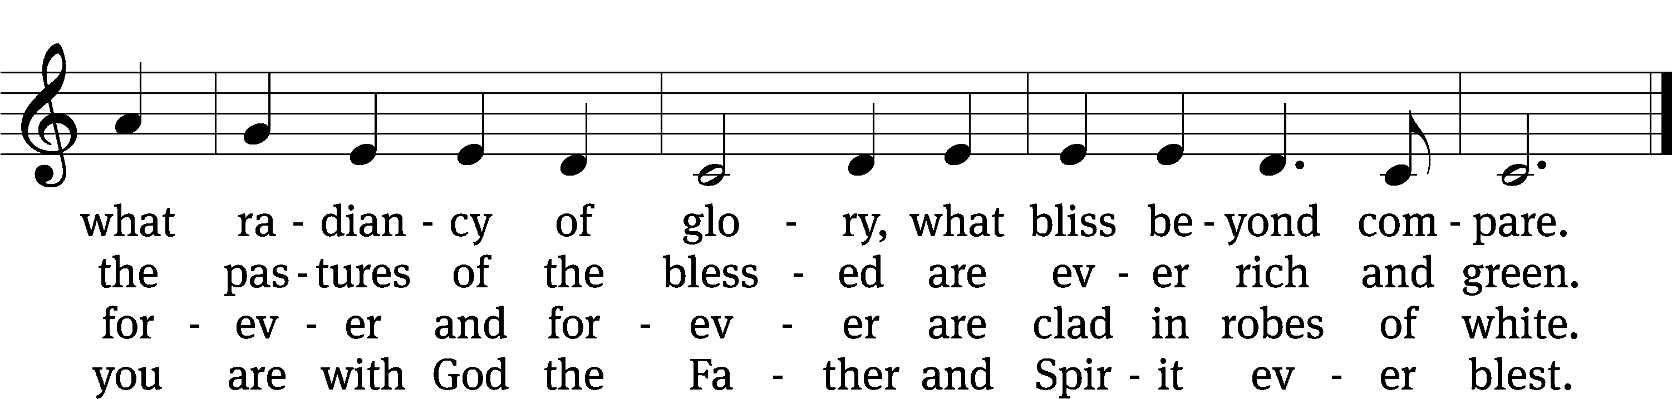
Text: tr. John Mason Neale, 1818–1866, alt.; Bernard of Cluny, 12th cent., abr.
Tune: Alexander C. Ewing, 1830–1895
Text and tune: Public domain

PLEASE STAND, IF YOU ARE ABLE

invocation
M: The grace of our Lord (+) Jesus Christ and the love of God and the fellowship of the Holy Spirit be with you.
C: And also with you.

CONFESSION OF SINS
M: We have come into the presence of God, who created us to love and serve him as his dear children. But we have disobeyed him and deserve only his wrath and punishment. Therefore, let us confess our sins to him and plead for his mercy.

C: Merciful Father in heaven, I am altogether sinful from birth. In countless ways I have sinned against you and do not deserve to be called your child. But trusting in Jesus, my Savior, I pray: Have mercy on me according to your unfailing love. Cleanse me from my sin, and take away my guilt.

M: God, our heavenly Father, has forgiven all your sins. By the perfect life and innocent death of our Lord Jesus Christ, he has removed your guilt forever. You are his own dear child. May God give you strength to live according to his will.

C: Amen.
PRAYER AND PRAISE

M: In the peace of forgiveness, let us praise the Lord.

OH, TASTE AND SEE

PRAYER OF THE DAY

Let us pray.

Almighty God and Savior, you have set the final day and hour when we shall be delivered from this world of sin and death. Keep us ever watchful for the coming of your Son that we may sit with him and all your holy ones at the marriage feast in heaven; through your Son, Jesus Christ our Lord, who lives and reigns with you and the Holy Spirit, one God, now and forever.

PLEASE BE SEATED
The Word

the FIRST LESSON Isaiah 52:1-6

¹ Wake, awake!
Clothe yourself with strength, O Zion.
Put on your beautiful garments,
Jerusalem, you holy city,
for never again will the uncircumcised
and the unclean enter you.
² Shake off the dust.
Get up and take your seat, Jerusalem.
Loosen the chains from your neck,
you captive daughter of Zion.
³ Yes, this is what the Lord says.
You were sold for nothing,
and you will be redeemed without money.
⁴ Yes, this is what the Lord God says.
In the beginning, my people went down to Egypt to stay there
for a while.
Later Assyria oppressed them without cause.
⁵ Now what do I have here? declares the Lord.
Indeed, my people have been taken away for nothing.
Their rulers howl with mockery, declares the Lord.
My name is continually despised all day.
⁶ Therefore my people will know my name.
So on that day they will know that I am the one—
the one who is saying, “Here I am!”

90D O God, Our Help in Ages Past Psalm 90D
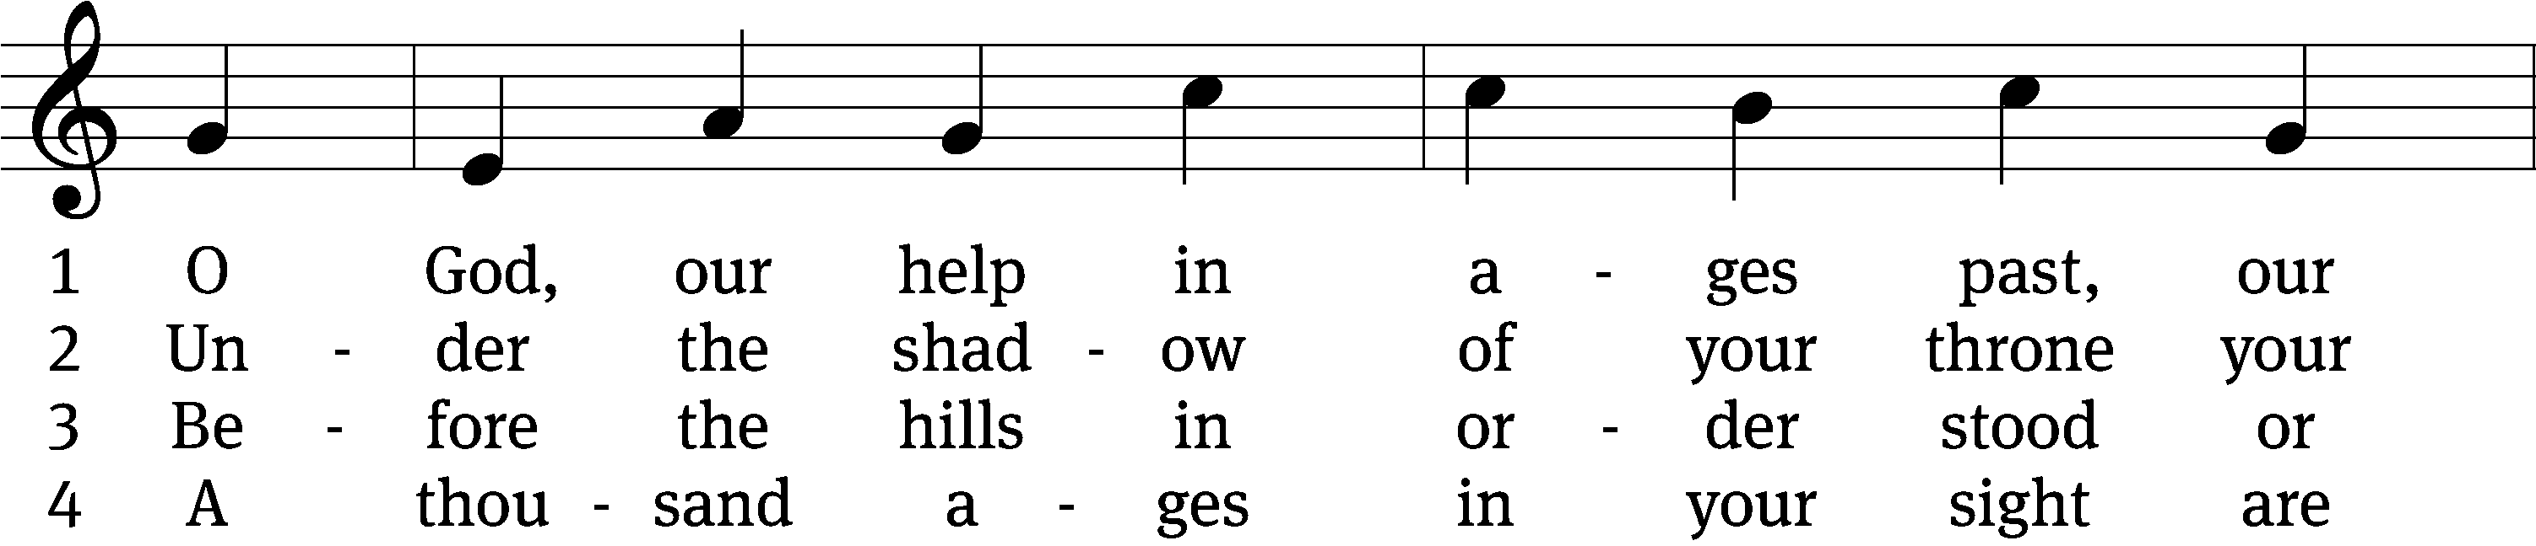
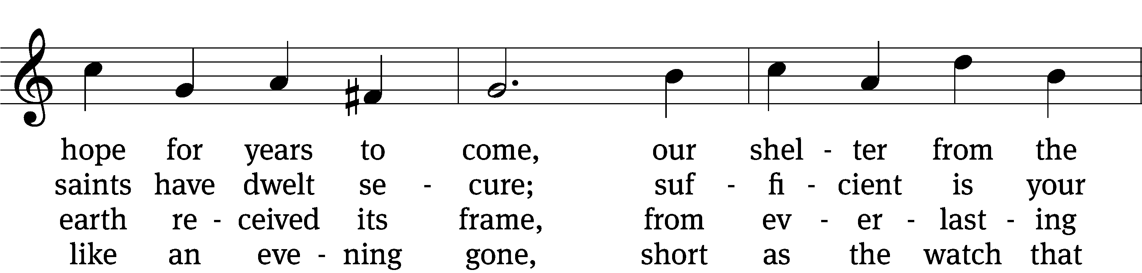
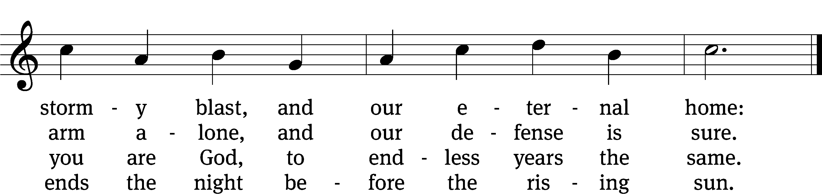

5 Time, like an everrolling stream,
soon bears us all away;
we fly forgotten, as a dream
dies at the op’ning day.

6 O God, our help in ages past,
our hope for years to come,
still be our guard while troubles last
and our eternal home!
Text: Isaac Watts, abr., alt.
Tune: William Croft
Text and tune: Public domain

SECOND LESSON 1 Thessalonians 5:1-11
¹ Concerning the times and dates, brothers, there is no need to write to you, ² for you yourselves know very well that the day of the Lord will come like a thief in the night. ³ When people are saying, “Peace and security,” destruction will suddenly come on them, like labor pains on a pregnant woman, and they will certainly not escape. ⁴ But you, brothers, are not in the dark so that this day takes you by surprise like a thief, ⁵ for you are all sons of the light and sons of the day. We do not belong to the night or the darkness. ⁶ So then let us not sleep like everyone else, but rather let us remain alert and sober.
⁷ To be sure, those who sleep, sleep at night, and those who get drunk, get drunk at night. ⁸ But since we belong to the day, let us be sober, putting on faith and love as a breastplate, and the hope of salvation as a helmet. ⁹ You see, God did not appoint us for wrath, but for obtaining salvation through our Lord Jesus Christ. ¹⁰ He died for us, so that whether we are awake or asleep, we may live together with him. ¹¹ Therefore, encourage one another and build each other up, just as you are also doing.

Verse of the day

Alleluia. Therefore, keep watch, because you do not know on what day your Lord will come. Alleluia.

THE GOSPEL LESSON Matthew 25:1-13
M: The Gospel according to Matthew chapter 25, verses 1-13

“At that time the kingdom of heaven will be like ten virgins who took their lamps and went out to meet the bridegroom. ² Five of them were foolish, and five were wise. ³ When the foolish ones took their lamps, they did not take any oil with them; ⁴ but the wise took oil in their containers with their lamps. ⁵ While the bridegroom was delayed, they all became drowsy and fell asleep. ⁶ But at midnight there was a shout, ‘Look, the bridegroom! Come out to meet him!’ ⁷ Then all those virgins got up and trimmed their lamps. ⁸ The foolish ones said to the wise, ‘Give us some of your oil because our lamps are going out.’ ⁹ But the wise answered, ‘No, there may not be enough for us and for you. Instead, go to those who sell oil and buy some for yourselves.’ ¹⁰ But while they were away buying oil, the bridegroom came. Those who were ready went in with him to the wedding banquet, and the door was shut. ¹¹ Later, the other virgins also came and said, ‘Lord, Lord, let us in.’ ¹² But he answered, ‘Amen I tell you: I do not know you.’ ¹³ Therefore, keep watch, because you do not know the day or the hour.

M: This is the Gospel of the Lord.

PLEASE BE SEATED
486 Wake, Awake, for Night Is Flying CW 486
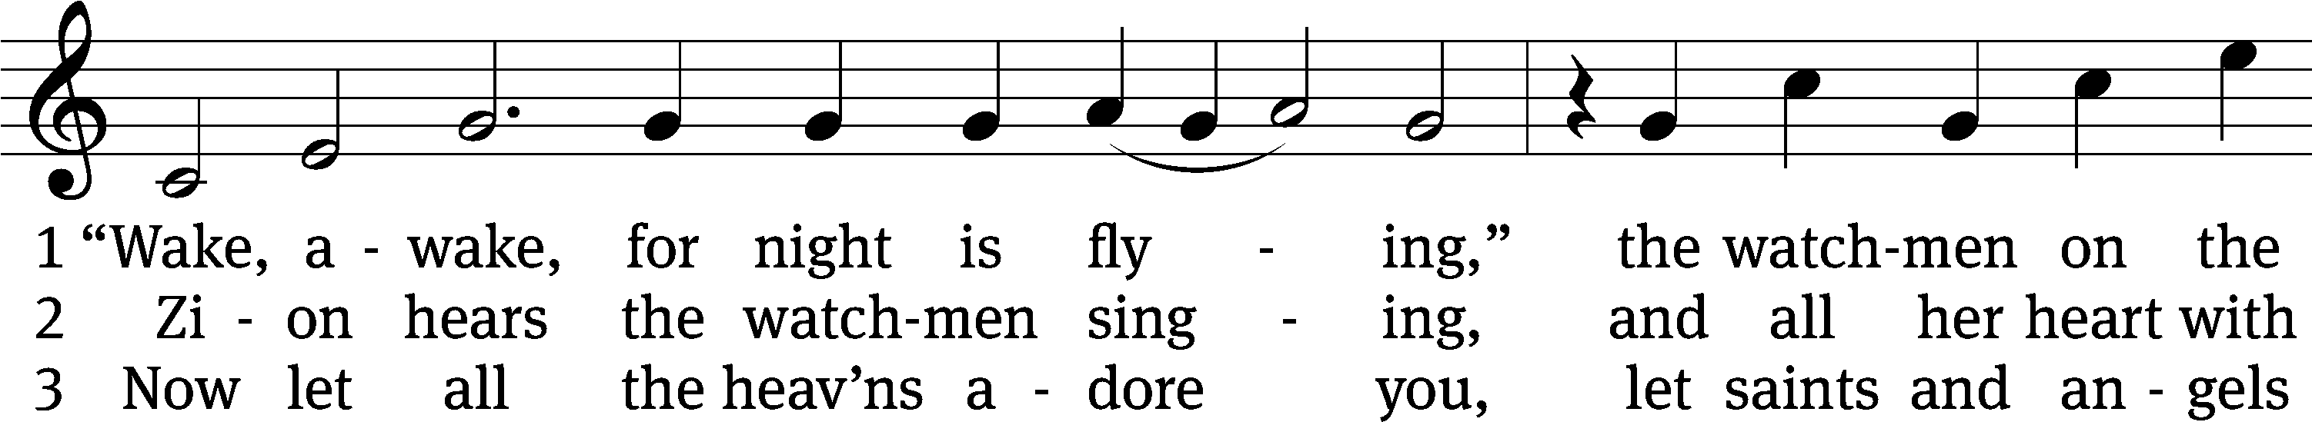
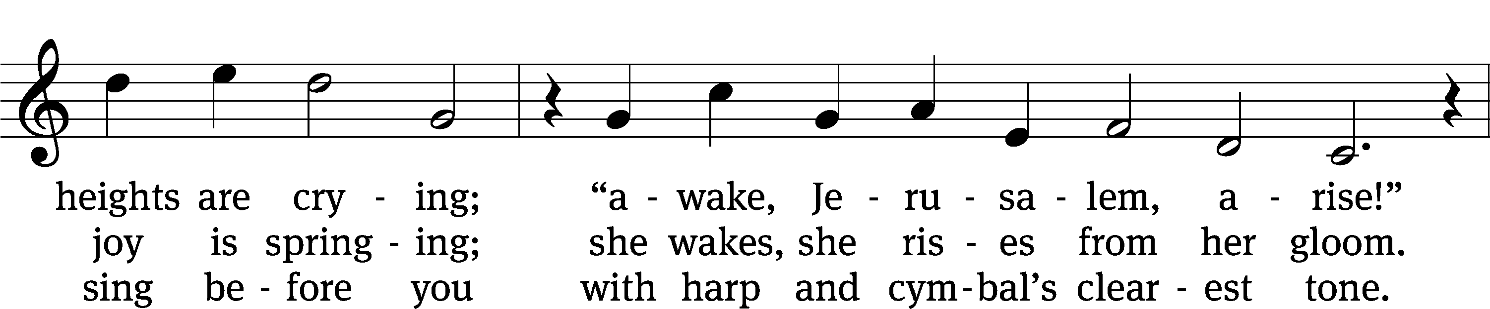
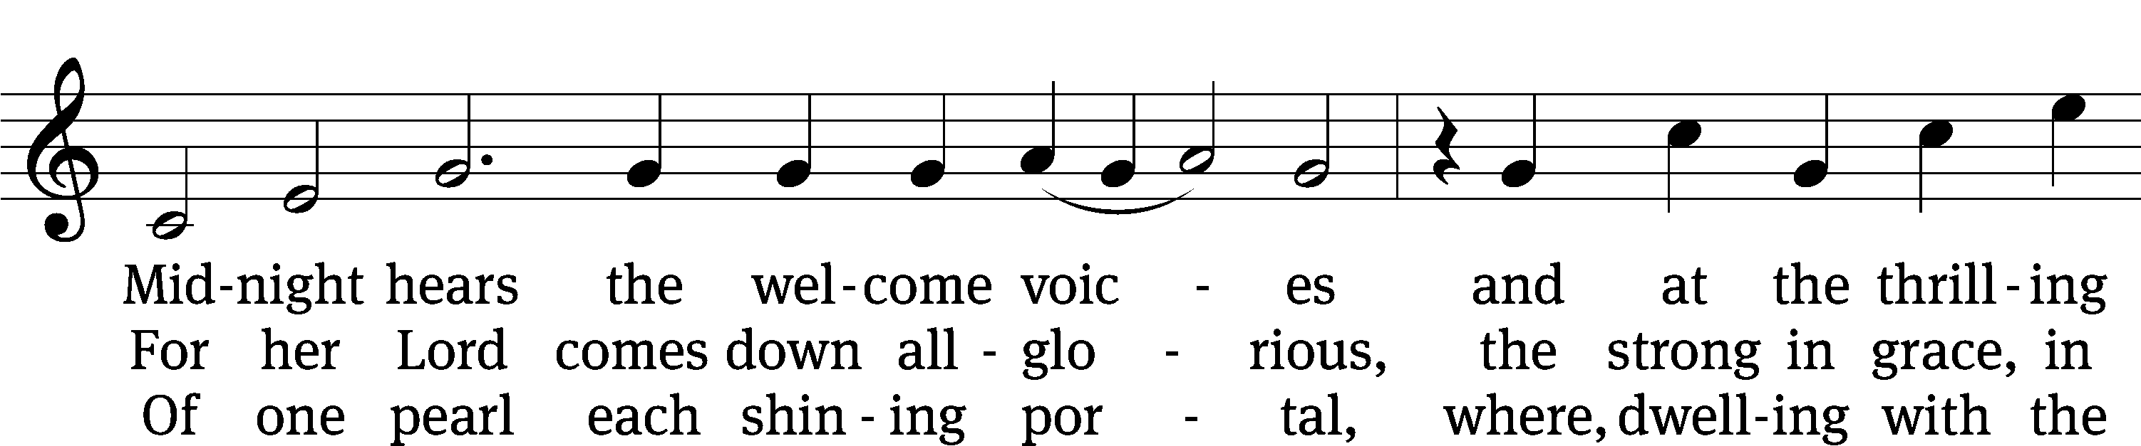
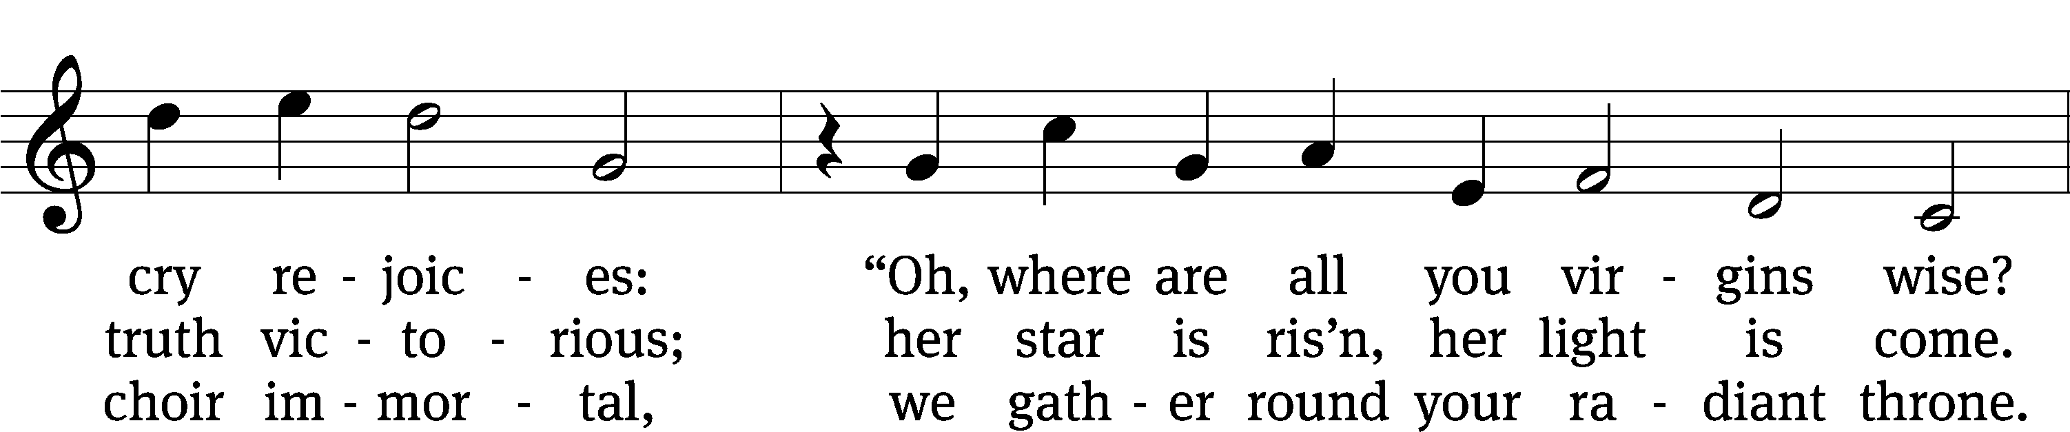
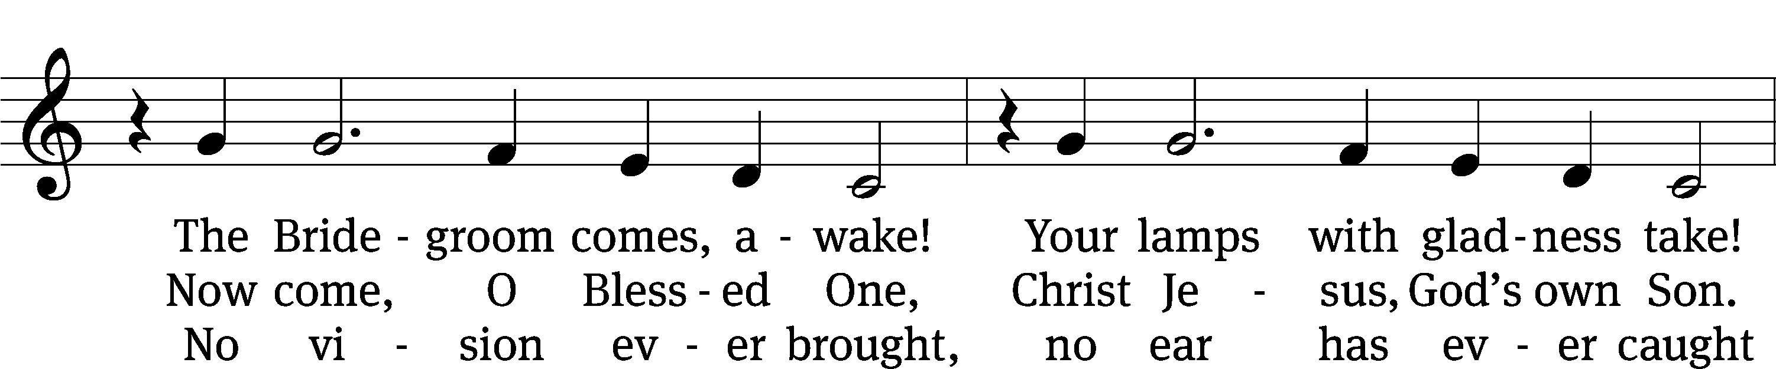
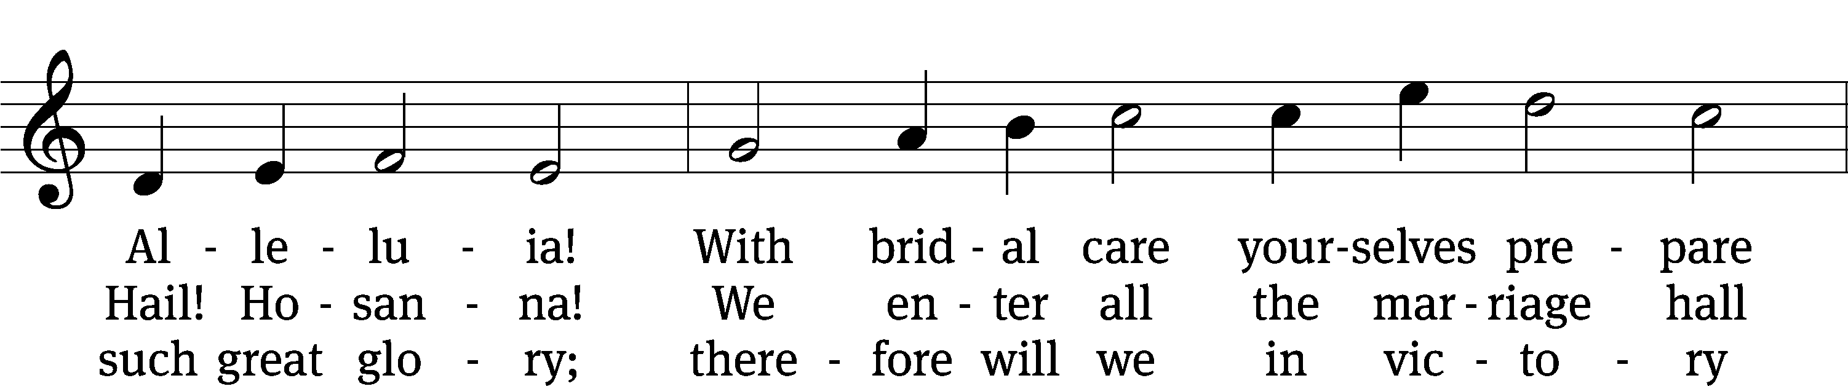
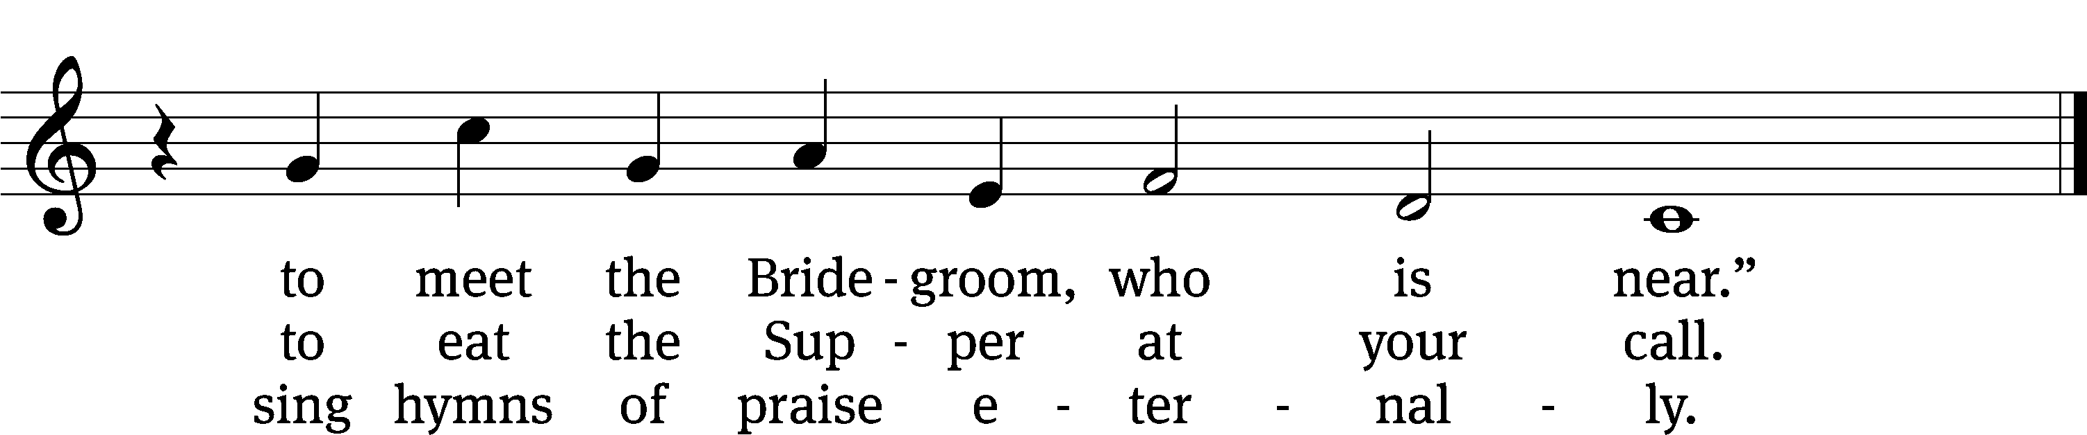
Text: tr. Catherine Winkworth, 1827–1878, alt.; Philipp Nicolai, 1556–1608
Tune: Philipp Nicolai, 1556–1608
Text and tune: Public domain

SERMON Matthew 25:1-13
“Ready Or Not, Here I Come”

PLEASE STAND, IF YOU ARE ABLE

THE APOSTLES’ CREED

I believe in God, the Father almighty,
maker of heaven and earth.
I believe in Jesus Christ, his only Son, our Lord,
who was conceived by the Holy Spirit,
born of the virgin Mary,
suffered under Pontius Pilate,
was crucified, died, and was buried.
He descended into hell.
The third day he rose again from the dead.
He ascended into heaven
and is seated at the right hand of God the Father almighty.
From there he will come to judge the living and the dead.
I believe in the Holy Spirit,
the holy Christian Church,
the communion of saints,
the forgiveness of sins,
the resurrection of the body,
and the life everlasting. Amen.

BELL CHOIR (8:30 a.m.) “What a Friend We Have in Jesus”

PRAYER OF THE CHURCH

THE LORD’S PRAYER

C: Our Father, who art in heaven, hallowed be thy name, thy kingdom come, thy will be done on earth as it is in heaven. Give us this day our daily bread; and forgive us our trespasses, as we forgive those who trespass against us; and lead us not into temptation, but deliver us from evil. For thine is the kingdom and the power and the glory forever and ever. Amen.

PLEASE BE SEATED
713 I Want to Walk as a Child of the Light CW 713
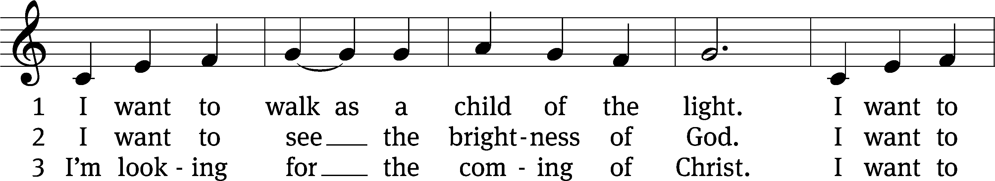
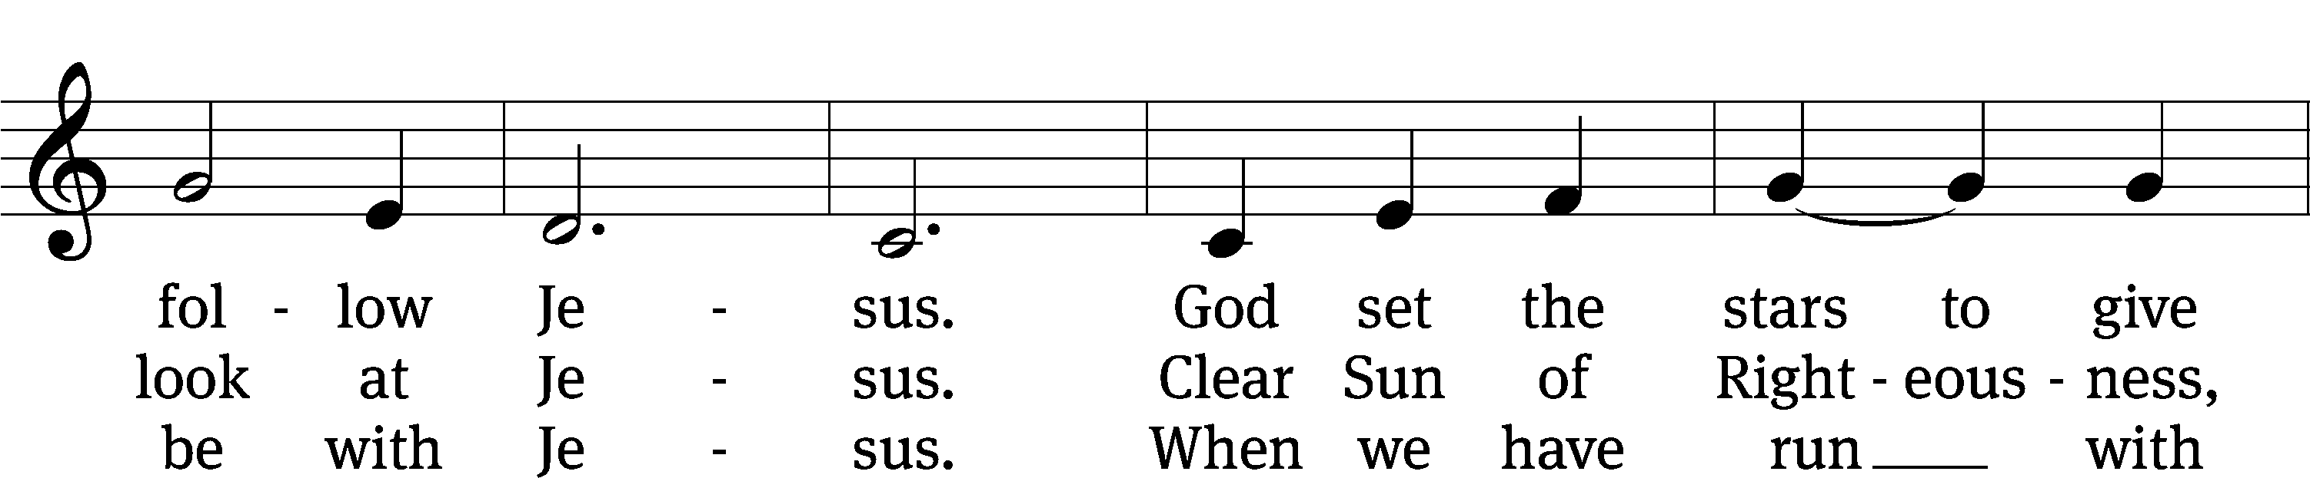
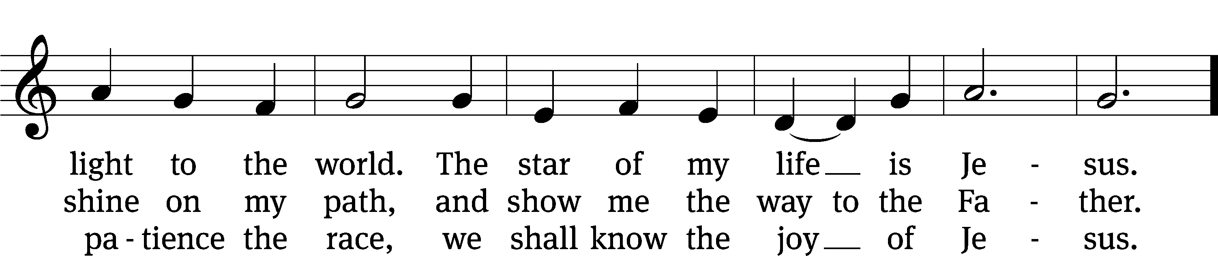
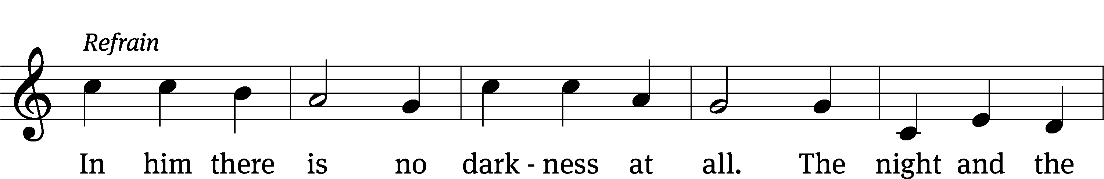
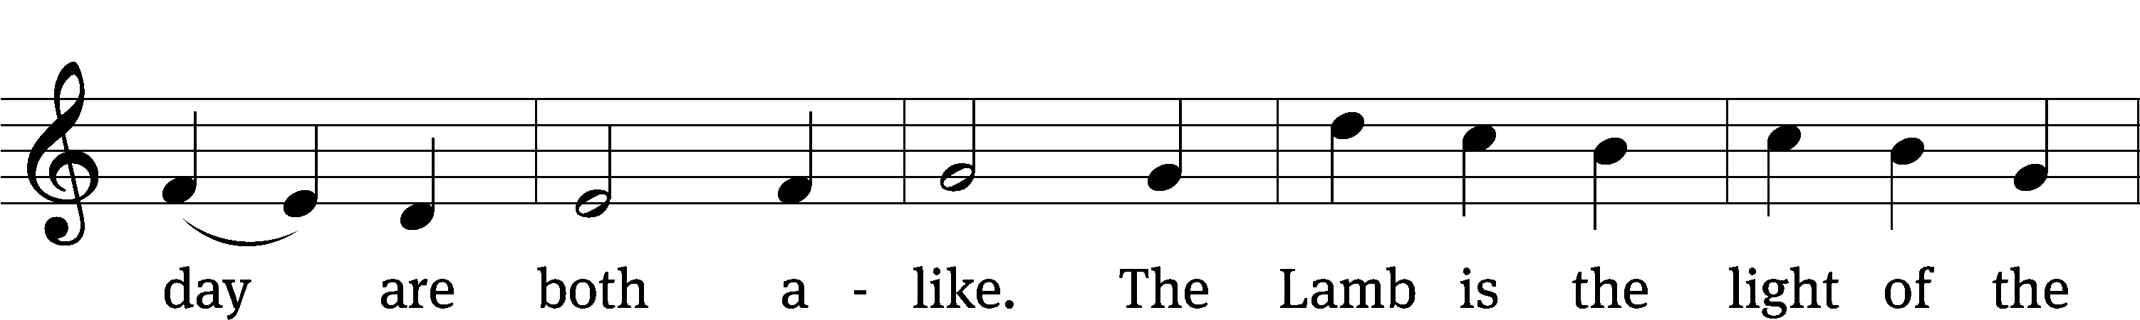
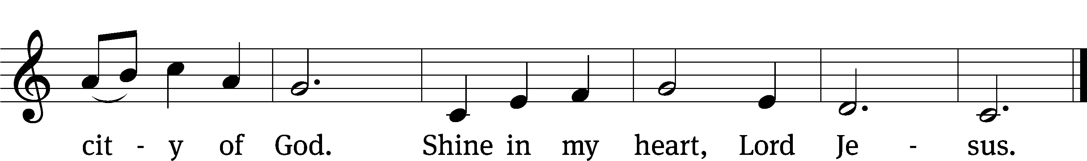
Text: Kathleen Thomerson, b. 1934
Tune: Kathleen Thomerson, b. 1934
Text and tune: © 1970, 1975 Celebration. Used by permission: OneLicense no. 727703

PLEASE STAND, IF YOU ARE ABLE

CLOSING PRAYER
M: Almighty God, we thank you for teaching us the things you want us to believe and do. Help us by your Holy Spirit to keep your Word in pure hearts that we may be strengthened in faith, guided in holiness, and comforted in life and in death, through Jesus Christ, our Lord, who lives and reigns with you and the Holy Spirit, one God, now and forever.

M: Brothers and sisters, go in peace. Live in harmony with one another. Serve the Lord with gladness.
The Lord bless you and keep you.
The Lord make his face shine on you and be gracious to you.
The Lord look on you with favor and (+) give you peace.

PLEASE BE SEATED

884 Lord, When Your Glory I Shall See CW 884
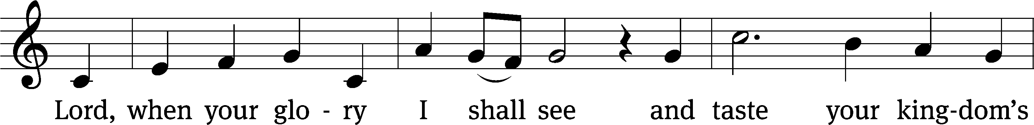
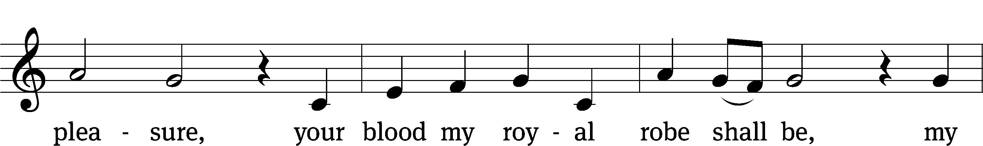
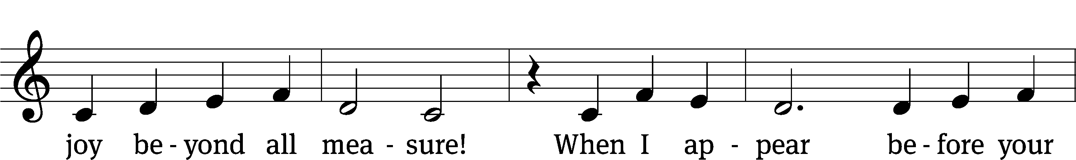
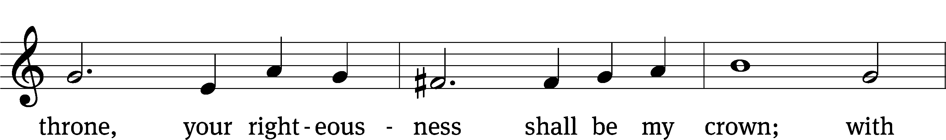
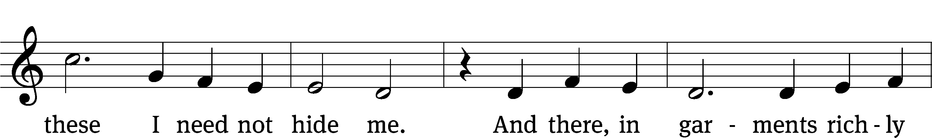
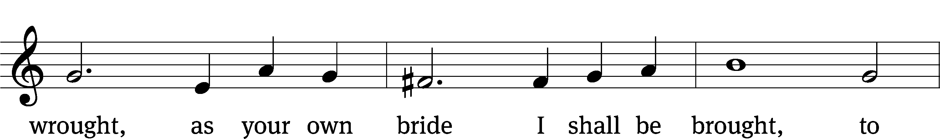
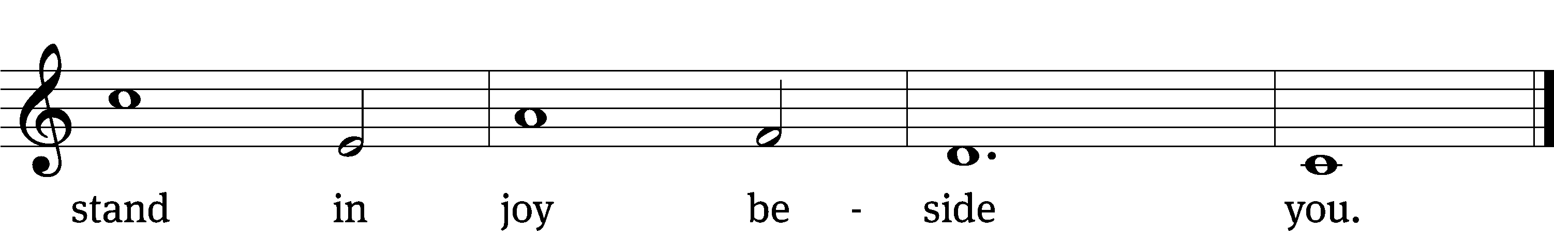
Text: tr. The Lutheran Hymnal, 1941, alt.; Paul Gerhardt, 1607–1676
Tune: Kurt J. Eggert, 1923–1993
Text: Public domain
Tune: © 1993 Kurt J. Eggert, admin. Northwestern Publishing House. Used by permission: OneLicense no. 727703

Serving In Worship
Officiant Pastor Natsis
Organist Sarah Hanke
Bell Choir Director Meg Nortley
Deacons (8:30) Duane Mason and Dave Stevenson
(11:00) Jeff Neuburger and Robert Niethammer
Ushers (8:30) Tim Phelps
(11:00) Ron Zahn
Altar Guild Margaret Hoeft and Brenda Stevenson
Videographer Rick Schneider

Copyright information
Service of the Word: Christian Worship. © 1993 Northwestern Publishing House. All rights reserved.
Reprinted with permission under ONE LICENSE #A-727703 and CCLI #1151741/CSPL126093

Words and Music: All rights reserved. Reprinted with permission under ONE LICENSE #A-727703 and
CCLI #1151741/CSPL126093
tlcsaline.church

