REFORMATION SUNDAY

tRINITY EVANGELICAL LUTHERAN CHURCH | Saline, Michigan
October 30, 2022

WELCOME TO WORSHIP

Thank you for joining us in God’s house today! We cordially ask that our Guests with us this morning sign one of the guestbooks located at either the front or back entryways.

THANK OFFERING: Members of Trinity give their offering as an expression of love and thankfulness to the Lord and to help support the Lord’s work in our community and around the world. Visitors need not feel obligated to participate in this offering which supports our ministry.

Restrooms are located at the back of the upper level (the annex), and in the basement (down the back stairs of the sanctuary or annex). Handicap access is available, please ask an usher for assistance.

Young Families / Toddler Bags – We are GLAD YOU BROUGHT YOUR CHILDREN to our worship service. Jesus said: “Let the little children come to me and do not hinder them, for the kingdom of God belongs to such as these.” We know that having little children in church can be a challenge, but DO NOT WORRY about it. Many of your fellow worshippers have been in your shoes and are just happy you brought your children with you. For your convenience, we have reserved the back rows of seating for parents with small children. These areas provide more flexibility for your family, as well as, easy access to move downstairs if necessary. A closed-circuit TV system allows families to continue participating in the service while downstairs. Pre-school toddler bags and children’s bulletins are available for their enjoyment. Ask an usher for one to use during the service and please return the toddler bag afterwards.

divine SERVICE ii adapted
Preservice (11:00 a.m.) Bell Choir The church’s one foundation
OPENING HYMN
(Choir Sings Verse 2 alone)
630 Thy Strong Word CW 630
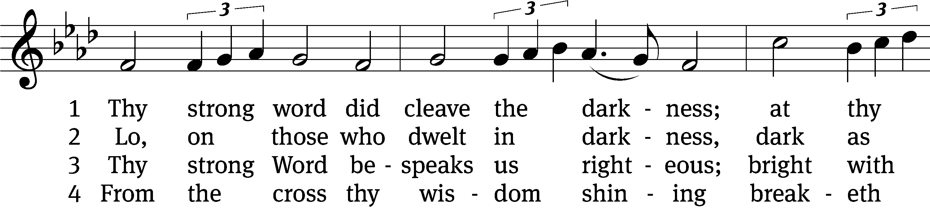
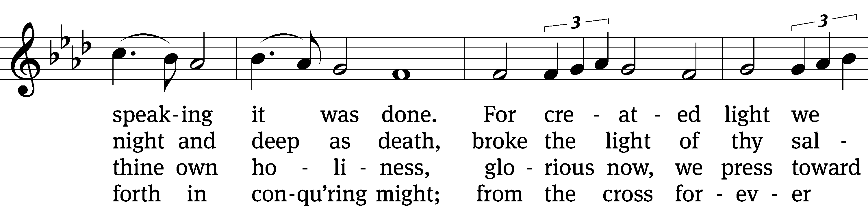
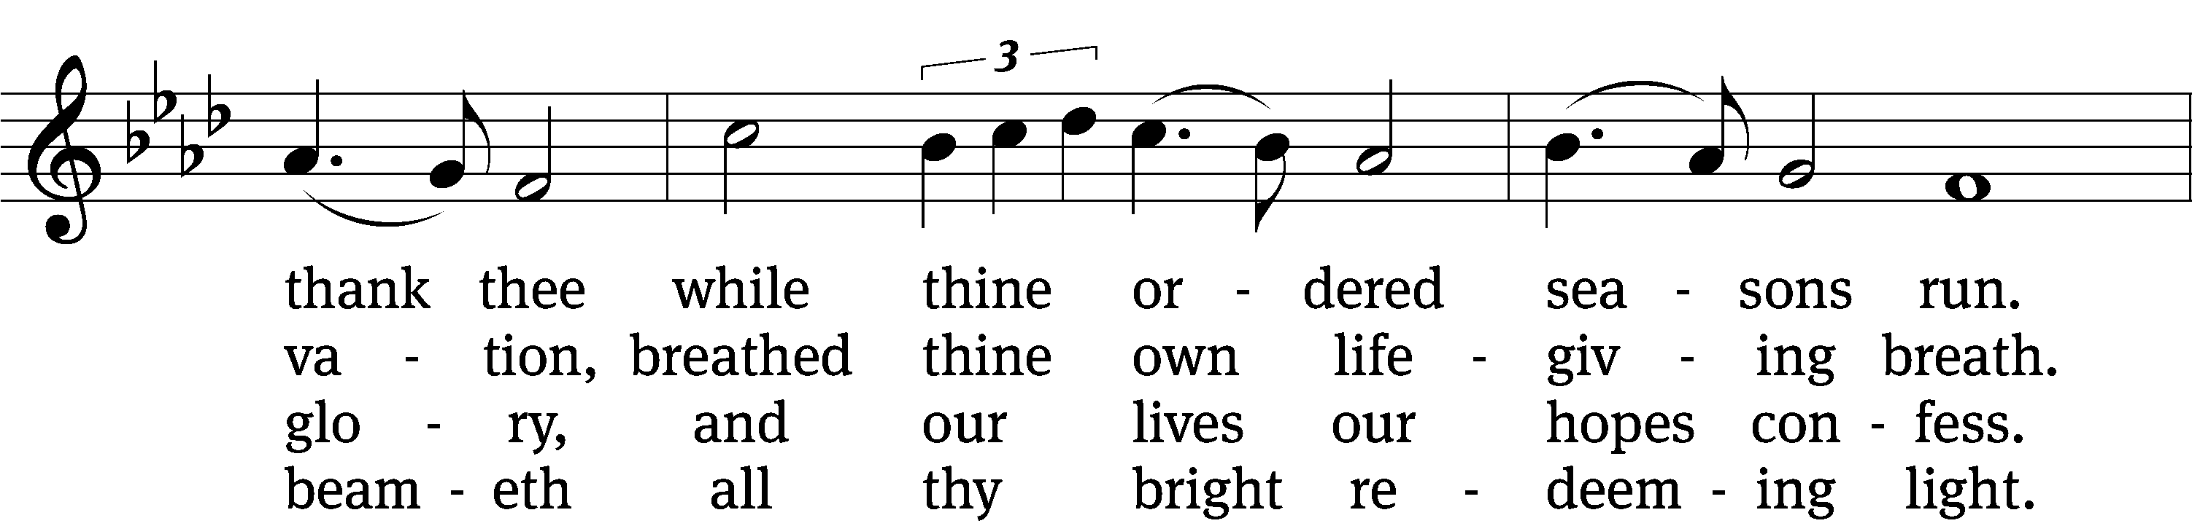
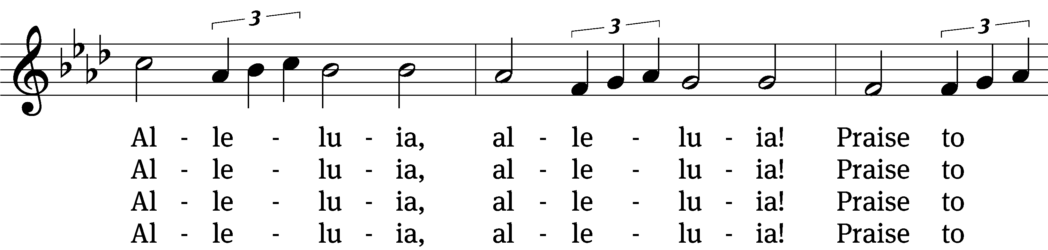
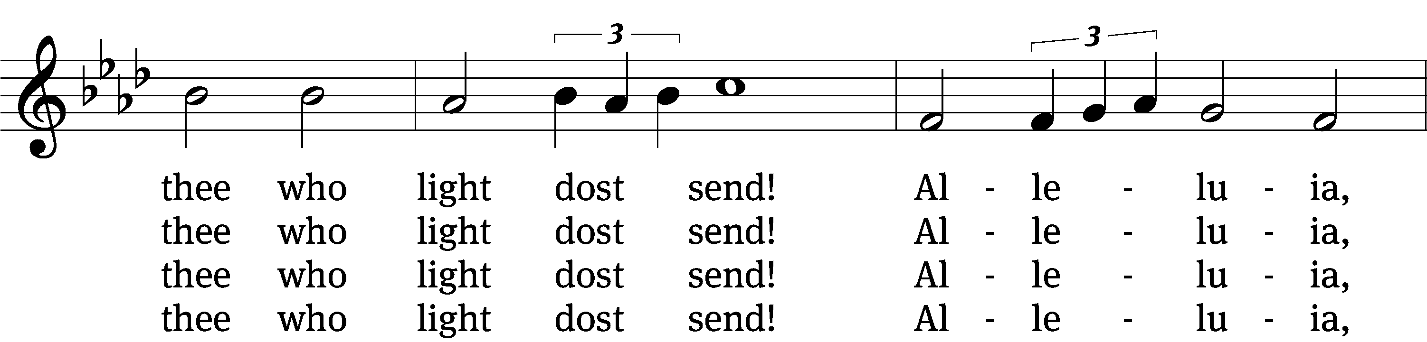
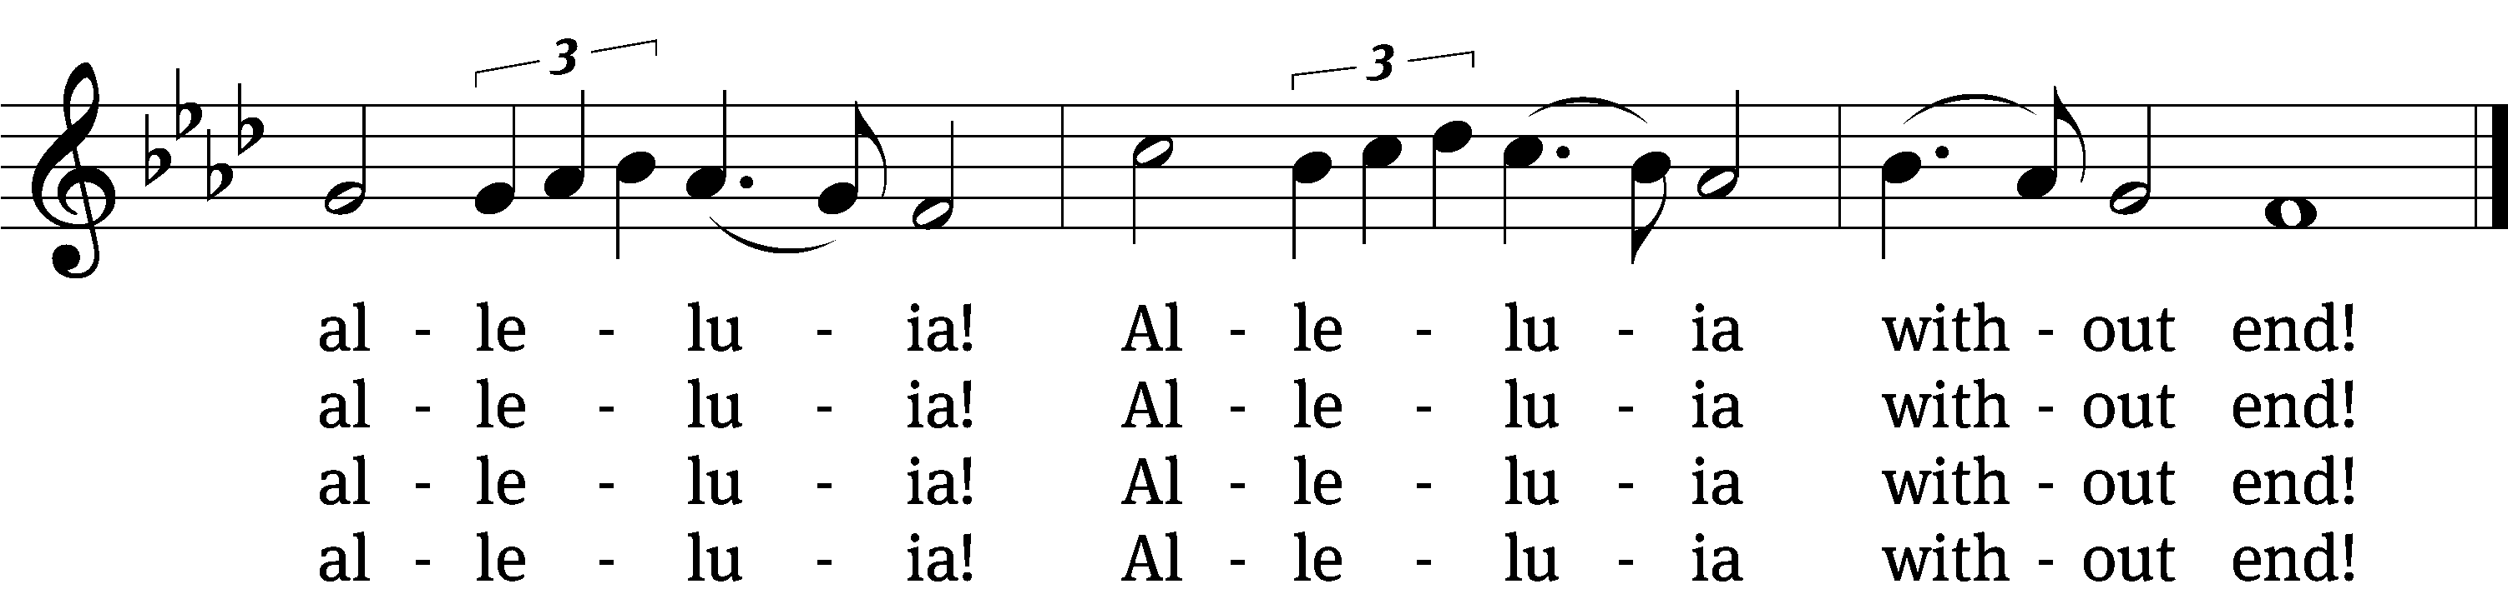

5 Give us lips to sing thy glory,
tongues thy mercy to proclaim,
throats to shout the hope that fills us,
mouths to speak thy holy name.
Alleluia, alleluia!
May the light which thou dost send
fill our songs with alleluias,
alleluias without end!

6 God the Father, light-creator,
to thee laud and honor be.
To thee, Light from Light begotten,
praise be sung eternally.
Holy Spirit, light-revealer,
glory, glory be to thee.
Mortals, angels, now and ever
praise the holy Trinity! Amen.
Text: Martin H. Franzmann, 1907–1976
Tune: Thomas J. Williams, 1869–1944
Text: © 1969 Concordia Publishing House. Used by permission: OneLicense no. 727703
Tune: Public domain

invocation

Please stand, if you are able

M: In the name of the Father and of the Son (+) and of the Holy Spirit.
C: Amen.

CONFESSION

M: Dear friends, let us approach God with a true heart and confess our sins, asking him in the name of our Lord Jesus Christ to forgive us.

C: Lord of life, I confess that I am by nature dead in sin.
For faithless worrying and selfish pride,
For sins of habit and sins of choice,
For the evil I have done and the good I have failed to do,
You should cast me away from your presence forever.
O Lord, I am sorry for my sins. Forgive me, for Jesus’ sake.

ABSOLUTION

M: Christ has died. Christ is risen. Christ will come again. In his great mercy, God made us alive in Christ even when we were dead in our sins. Hear the word of Christ through his called servant:
I forgive you all your sins in the name of the Father and of the Son (+) and of the Holy Spirit.
C: Amen.

LORD, HAVE MERCY

M: In peace, let us pray to the Lord.

For the well-being of all people everywhere, that they may receive from you all they need to sustain body and life, hear our prayer, O Lord.
C: Lord, have mercy.
M: For the spread of your life-giving gospel throughout the world, that all who are lost in sin may be brought to faith in you, hear our prayer, O Christ.
C: Christ, have mercy.
M: For patience and perseverance in this life, that we may not lose the hope of heaven as we await your return, hear our prayer, O Lord.
C: Lord, have mercy.
M: Lord of life, live in us that we may live for you.
C: Amen.

THE WORD
M: The Lord be with you.
C: And also with you.

PRAYER OF THE DAY
M: Let us pray.

Gracious Lord, our refuge and strength, pour out your Holy Spirit on your faithful people. Keep them steadfast in your Word, protect and comfort them in all temptations, defend them against all their enemies, and bestow on the church your saving peace; through your Son, Jesus Christ our Lord, who lives and reigns with you and the Holy Spirit, one God, now and forever.

C: Amen.
Please Be Seated

FIRST LESSON Jeremiah 31:31-34
³¹ Yes, the days are coming, declares the Lord,
when I will make a new covenant with the house of Israel
and with the house of Judah.
³² It will not be like the covenant I made with their fathers,
when I took them by the hand
and led them out of the land of Egypt.
They broke that covenant of mine,
although I was a husband to them, declares the Lord.
³³ But this is the covenant I will make with the house of Israel
after those days,
declares the Lord.
I will put my law in their minds,
and I will write it on their hearts.
I will be their God,
and they will be my people.
³⁴ No longer will each one teach his neighbor,
or each one teach his brother, saying, “Know the Lord,”
because they will all know me,
from the least of them to the greatest, declares the Lord,
for I will forgive their guilt,
and I will remember their sins no more.
46A The LORD Almighty Is with Us Psalm 46A
(The Choir will sing the refrain; the congregation will sing the psalm tone)

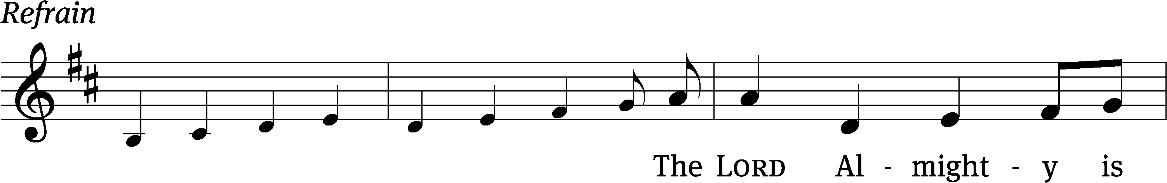
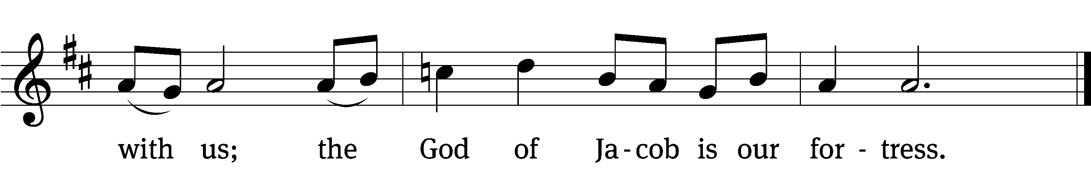

God is our ref- / uge and strength,
an ever-present help in / trouble.
Therefore we will not fear, though the / earth give way
and the mountains fall into the heart / of the sea,
though its waters / roar and foam
and the mountains quake with their / surging. Refrain

There is a river whose streams make glad the cit- / y of God,
the holy place where the Most / High dwells.
God is within her, she / will not fall;
God will help her at / break of day.
“Be still, and know that / I am God;
I will be exalted among the nations, I will be exalted / in the earth.”
Glory be to the Father and / to the Son
and to the Holy / Spirit,
as it was in the be- / ginning,
is now, and will be forever. / Amen. Refrain
Text: Public domain
Music: © 2021 Dale A. Witte, admin. Northwestern Publishing House. Used by permission: OneLicense no. 727703

THE SECOND LESSON Galatians 5:1–6
It is for freedom that Christ has set us free. Stand firm, then, and do not allow anyone to put the yoke of slavery on you again. ²Look, I, Paul, tell you that if you allow yourselves to be circumcised, Christ will be of no benefit to you. ³I testify again to every man who allows himself to be circumcised that he is obligated to do the whole law. ⁴You who are trying to be declared righteous by the law are completely separated from Christ. You have fallen from grace.
⁵Indeed, through the Spirit, we by faith are eagerly waiting for the sure hope of righteousness. ⁶For in Christ Jesus neither circumcision nor uncircumcision matters. Rather, it is faith working through love that matters.

Please stand, if you are able
Gospel Acclamation John 8:31,32
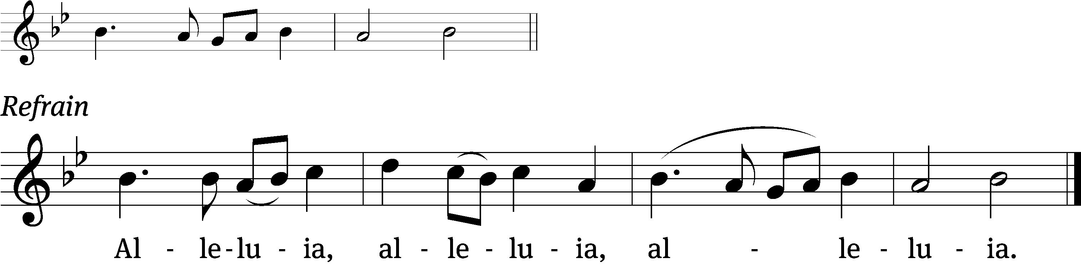
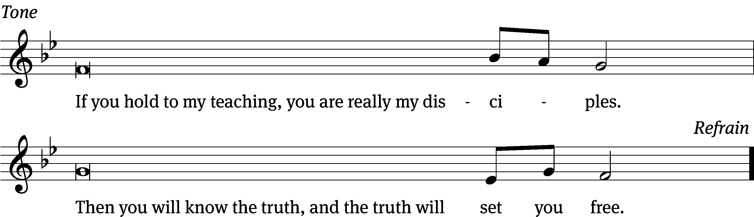
Tune: © 2021 Northwestern Publishing House. Used by permission: OneLicense no. 727703

M: The Gospel according to St. John, chapter 8, verses 31-36
C: Glory be to you, O Lord.

THE GOSPEL LESSON John 8:31-36

³¹ So Jesus said to the Jews who had believed him, “If you remain in my word, you are really my disciples. ³² You will also know the truth, and the truth will set you free.”
³³ “We are Abraham’s descendants,” they answered, “and we have never been slaves of anyone. How can you say, ‘You will be set free’?”
³⁴ Jesus answered, “Amen, Amen, I tell you: Everyone who keeps committing sin is a slave to sin. ³⁵ But a slave does not remain in the family forever. A son does remain forever. ³⁶ So if the Son sets you free, you really will be free.

After the Gospel:

M: This is the Gospel of the Lord.
C: Praise be to you, O Christ.

Please Be Seated

863 A Mighty Fortress Is Our God CW 863
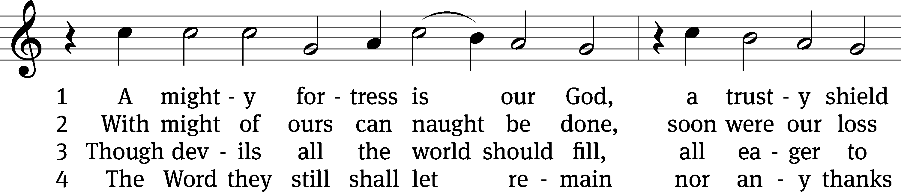
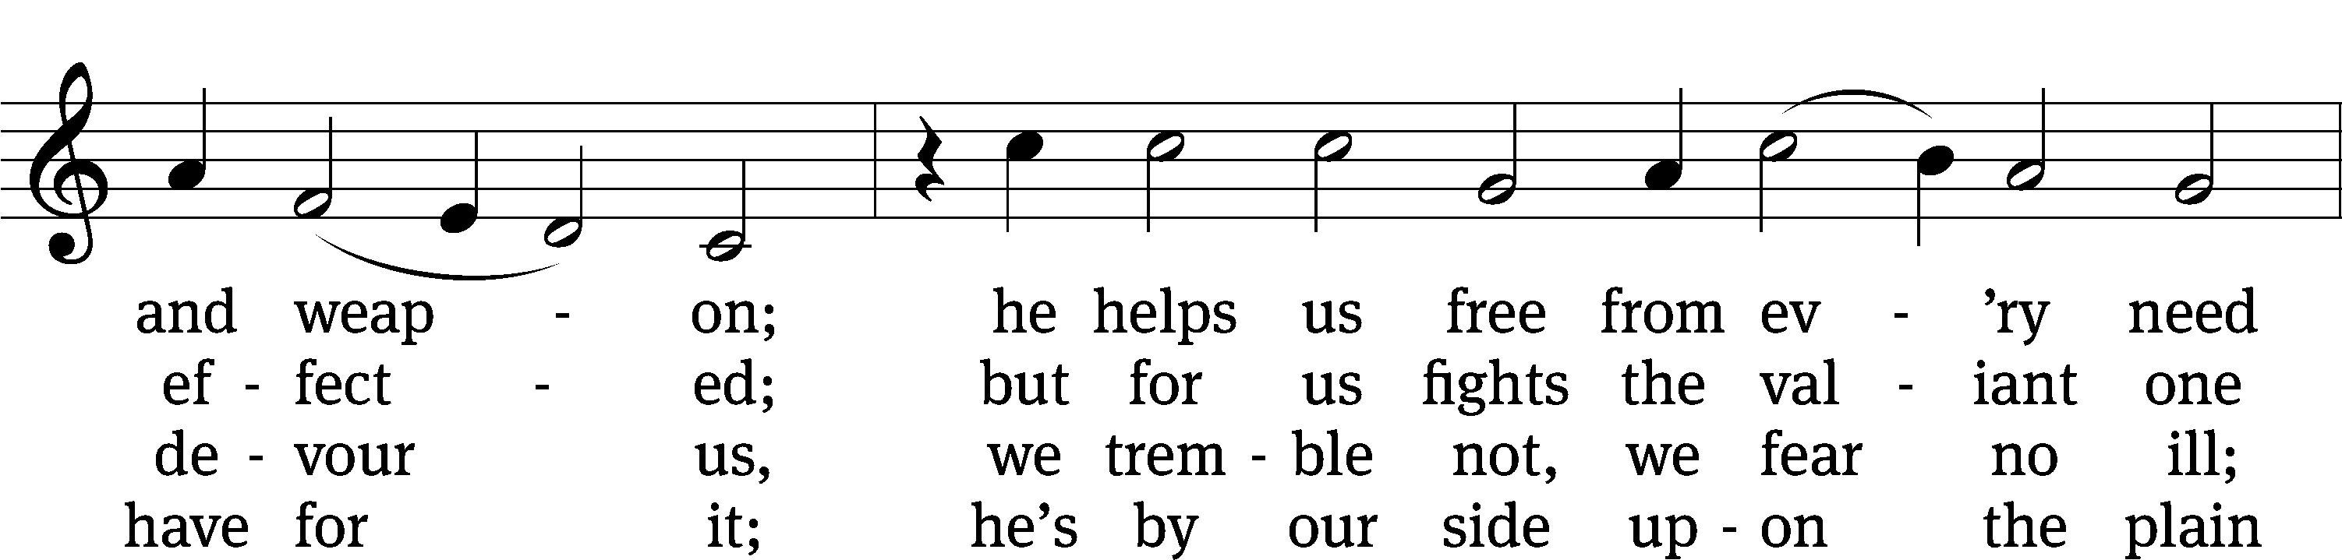
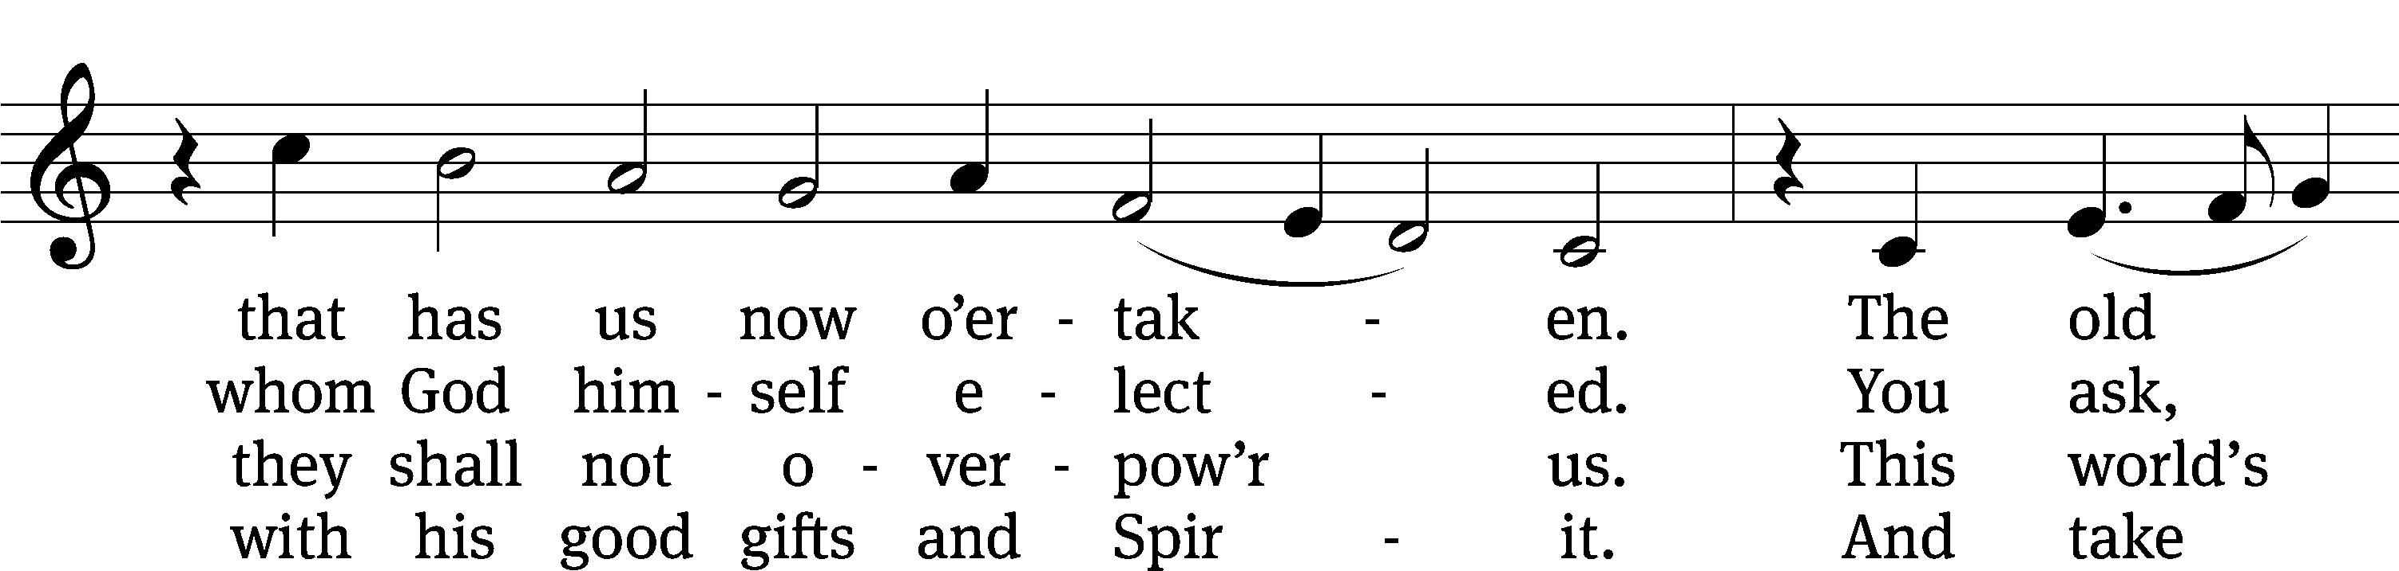
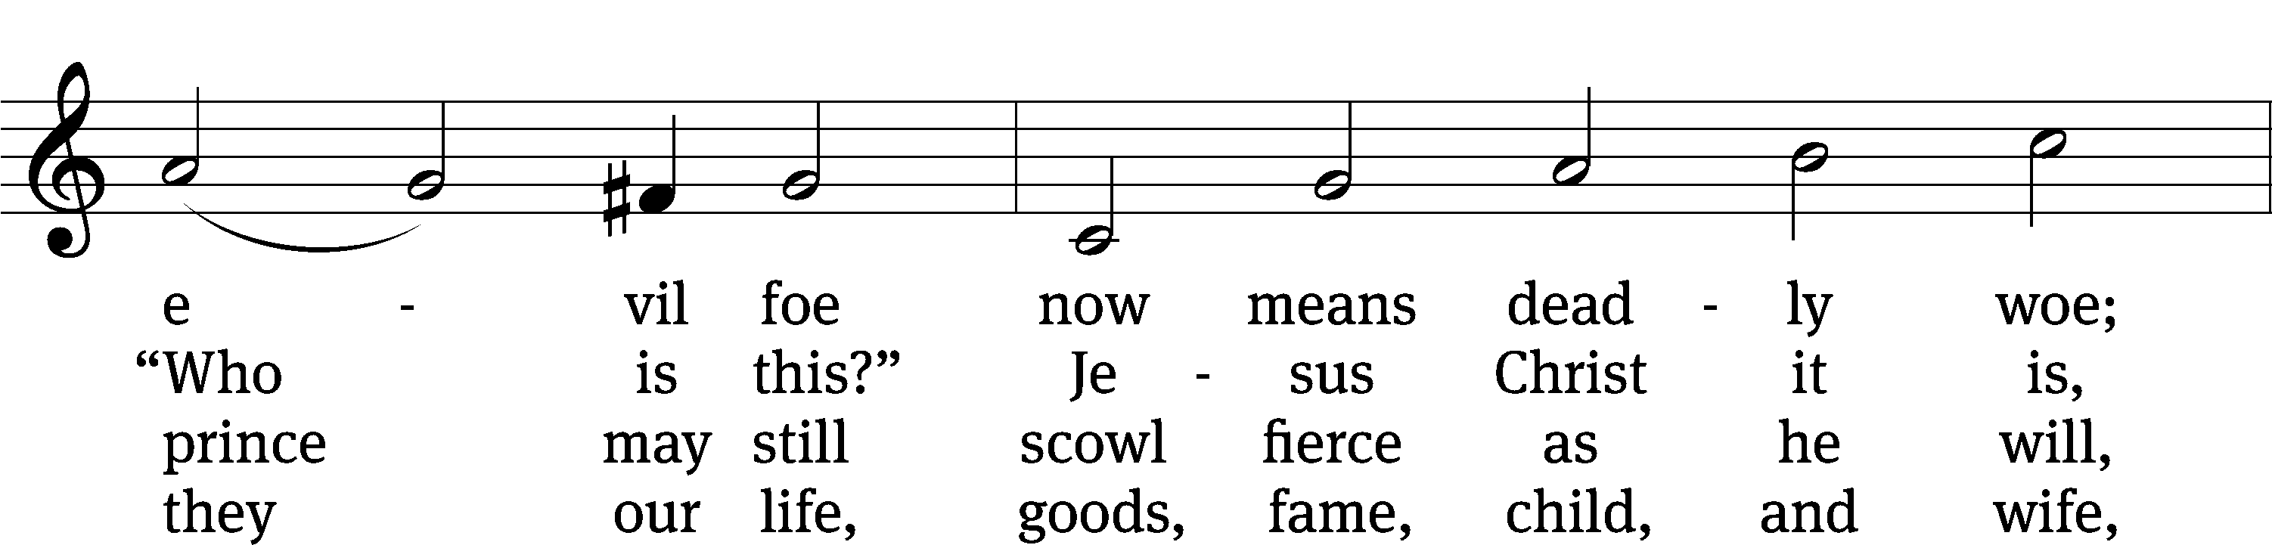
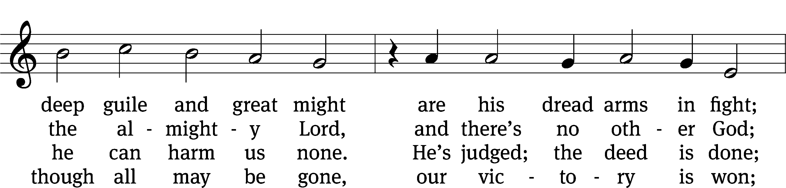
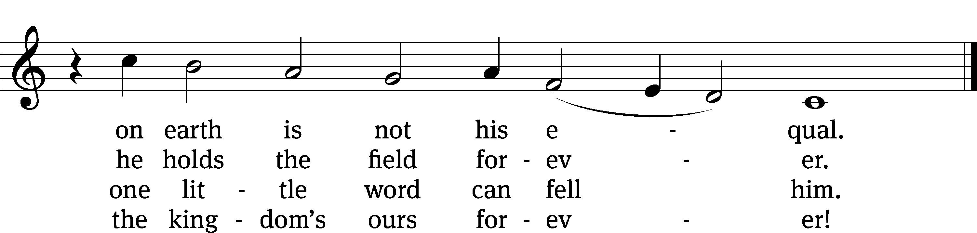
Text: tr. composite; Martin Luther, 1483–1546
Tune: Martin Luther, 1483–1546
Text and tune: Public domain

SERMON John 8:31-36

“god’s heavenly rescue operation”

Please stand, if you are able

Apostles’ Creed
I believe in God, the Father Almighty,
maker of heaven and earth.

I believe in Jesus Christ, his only Son, our Lord,
who was conceived by the Holy Spirit,
born of the Virgin Mary,
suffered under Pontius Pilate,
was crucified, died, and was buried.
He descended into hell.
The third day he rose again from the dead.
He ascended into heaven
and is seated at the right hand of God the Father Almighty.
From there he will come to judge the living and the dead.

I believe in the Holy Spirit,
the holy Christian Church,
the communion of saints,
the forgiveness of sins,
the resurrection of the body,
and the life everlasting. Amen.

Please Be Seated

OFFERTORY (BELL CHOIR – 8:30 SERVICE) “The Church’s One Foundation”

Please stand, if you are able

PRAYER OF THE CHURCH
Based on Luther’s prayer at the Diet of Worms (1521) as he faced the papal and imperial authorities

M: Almighty, eternal God, out of the depths we call to you. The world opens its mouth to swallow your church, and our faith in you is too small to confront its lures and attractions!
C: We confess the weakness of our sinful flesh. Satan deceives us daily. If we are to depend upon any strength from ourselves, all is lost. Help us, we beg, to withstand the ungodly way of life that the world has to offer.
M: The work is not ours, O God, but yours. O Sovereign Lord and Creator, we have no way to satisfy your righteousness, nothing to contest the Deceiver’s earthly power, nothing to mute its false attractions, nothing to uproot the rule of our sinful flesh.
C: We would gladly pass our days in happiness and peace in an age awash with iniquity. Hear us, heavenly Father, for the cause is yours. Yes, Creator of all that is, your cause is righteous and everlasting. Vindicate your name among the nations!
M: O all-seeing Lord, have mercy on your church. You understand our plight. We thank you for sending a messenger of peace to correct the times between life and death. This One is your Son, Jesus the Christ, the incarnate Savior, who saves us from calamities that plague your church.
C: You have chosen us to do your work. Therefore, O God, accomplish it by your will. Stand by your church each day in the name of Jesus, who is our shelter and shield, our mighty fortress. Through the strength of the Holy Spirit, such faith works joy and peace and willingness to serve a world in need.
M: We are even ready to lay down our life for this cause, as were your servants Martin Luther and his fellow Reformers and Confessors, who forcefully stormed the kingdom of heaven to restore the gospel of your righteousness to its central place in Christian life.
C: For the cause is holy. Though this world is filled with devils and though our bodies perish in persecution, your Word and your Spirit still remain. The church always needs reform as its message encounters the false and frivolous. But the Word of God stands firm forever.
M: In the confidence of this faith, gracious Lord, bless our efforts to spread the gospel of the glory and grace of God throughout the world to the joy and edifying of all who hear and believe and for your glory and our good.
C: Amen.

LORD’S PRAYER

C: Our Father, who art in heaven, hallowed be thy name, thy kingdom come, thy will be done on earth as it is in heaven. Give us this day our daily bread; and forgive us our trespasses, as we forgive those who trespass against us; and lead us not into temptation, but deliver us from evil. For thine is the kingdom and the power and the glory forever and ever. Amen.

Please Be Seated
563 My Hope Is Built on Nothing Less CW 563
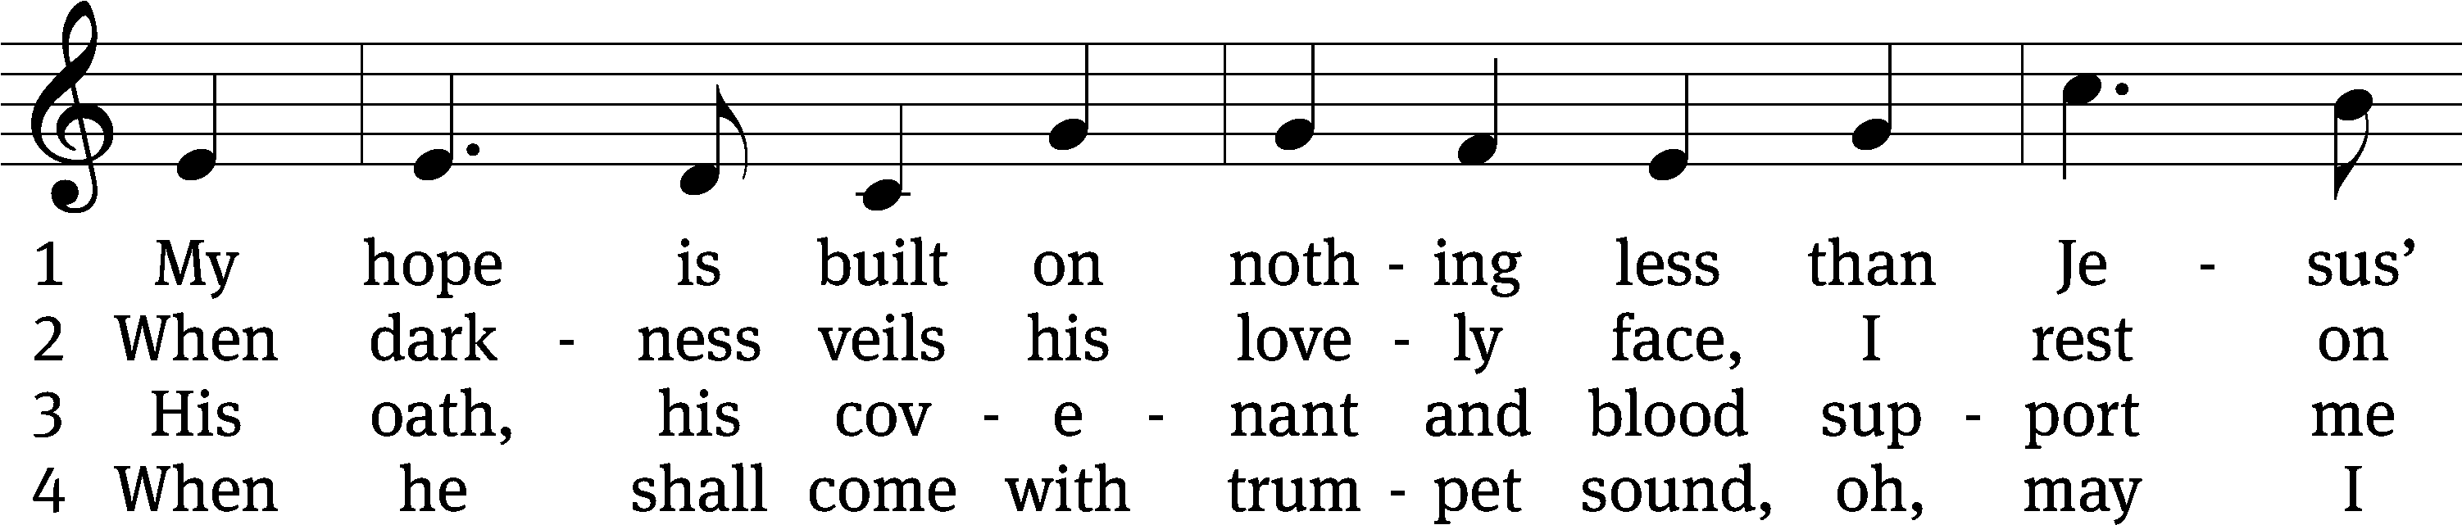
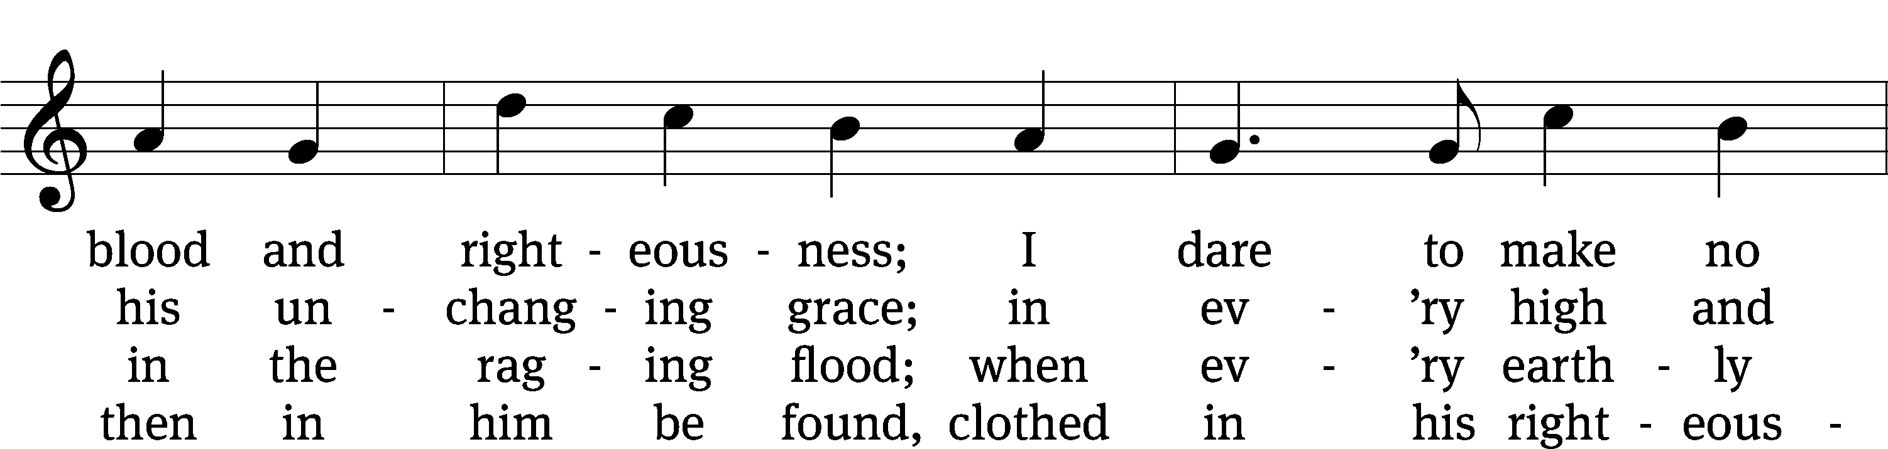
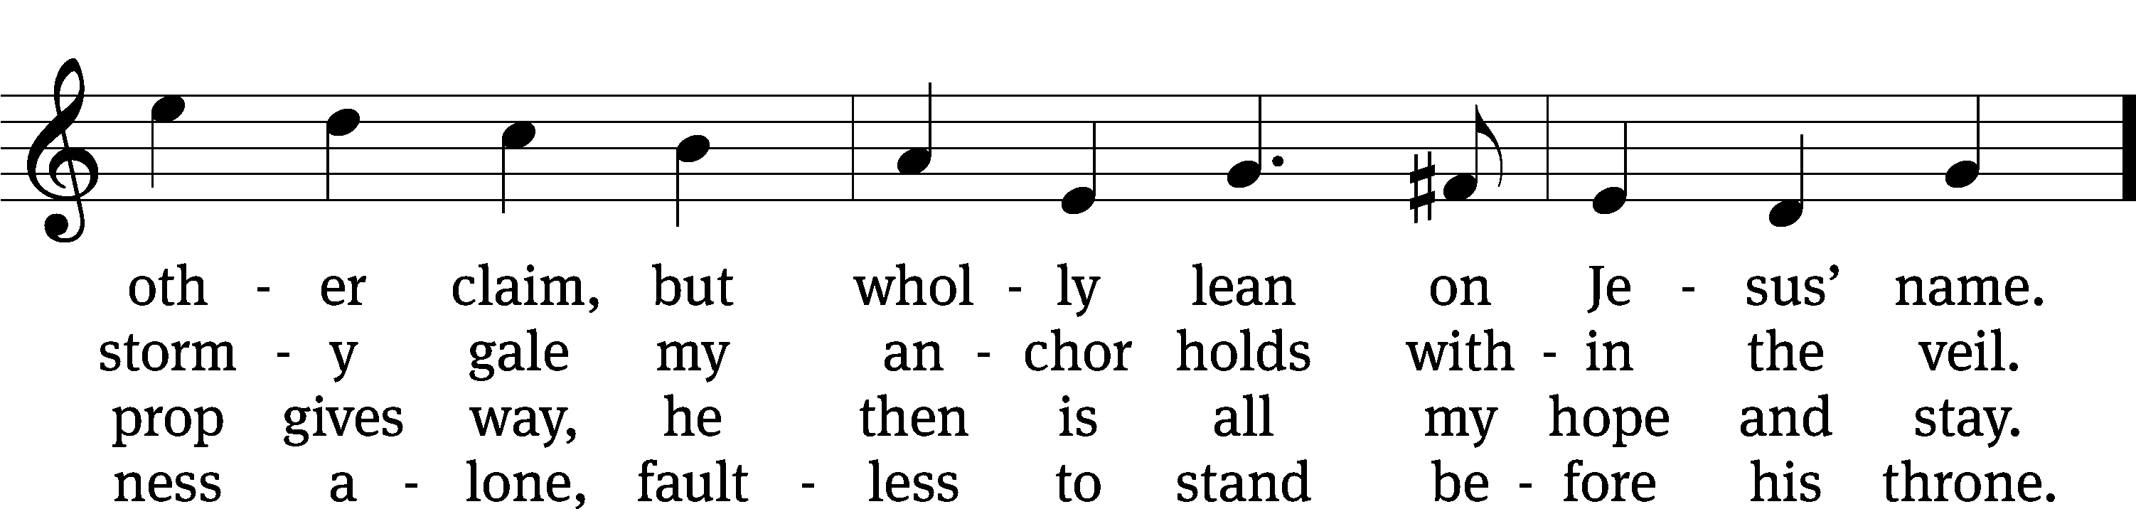
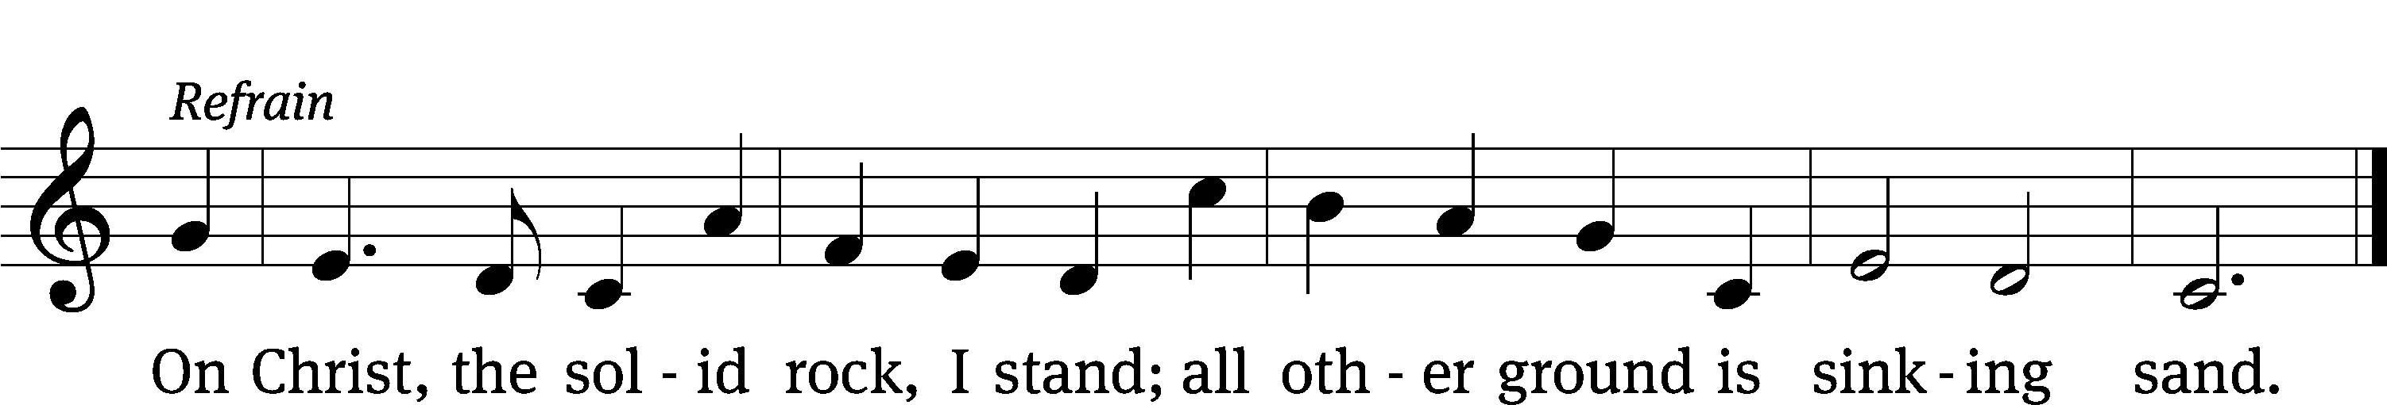
Text: Edward Mote, 1797–1874, alt.
Tune: John Stainer, 1840–1901, alt.
Text and tune: Public domain

Please stand, if you are able.

CLOSING PRAYER
M: Almighty God, we thank you for teaching us the things you want us to believe and do. Help us by your Holy Spirit to keep your Word in pure hearts that we may be strengthened in faith, guided in holiness, and comforted in life and in death, through Jesus Christ, our Lord, who lives and reigns with you and the Holy Spirit, one God, now and forever.

M: Brothers and sisters, go in peace. Live in harmony with one another. Serve the Lord with gladness.
The Lord bless you and keep you.
The Lord make his face shine on you and be gracious to you.
The Lord look on you with favor and (+) give you peace.

Please Be Seated

862 Lord, Keep Us Steadfast in Your Word CW 862
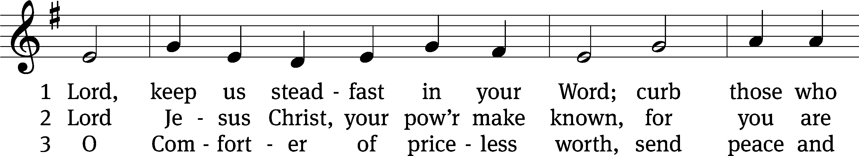
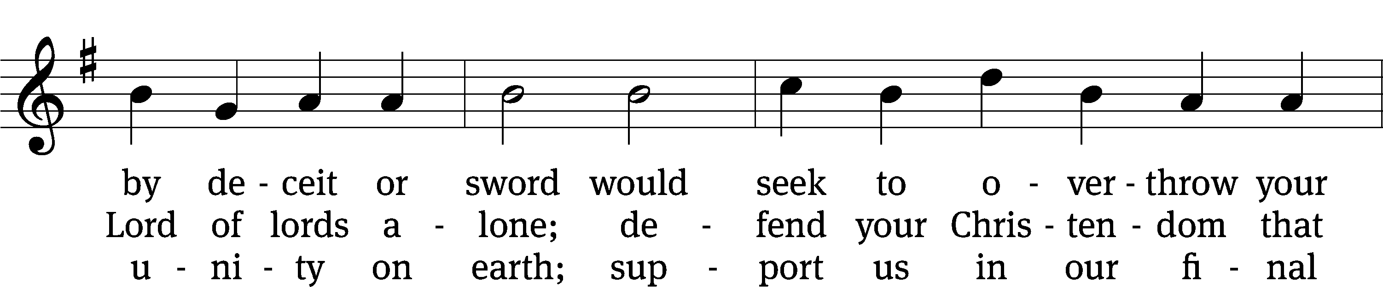
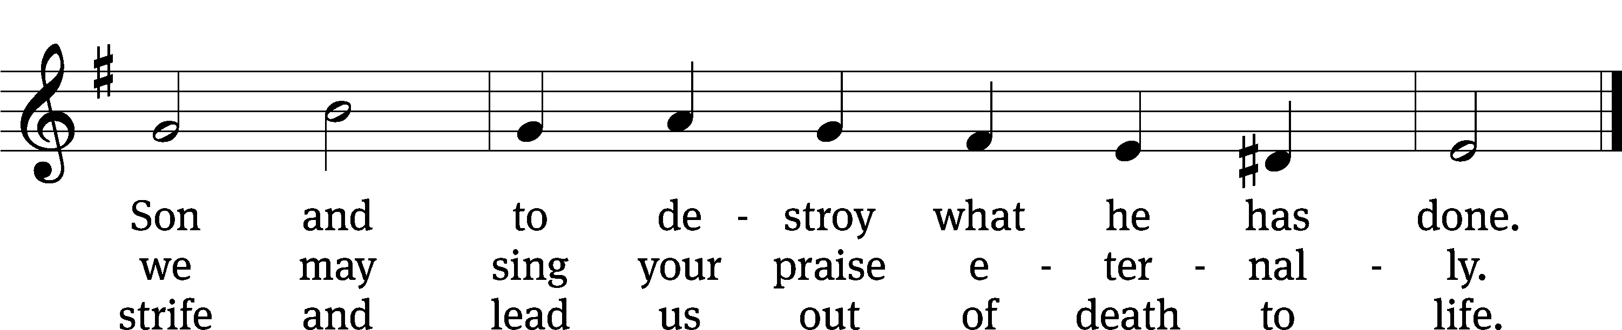
Text: tr. Catherine Winkworth, 1827–1878, alt.; Martin Luther, 1483–1546
Tune: Geistliche Lieder zu Wittemberg, Wittenberg, 1543, ed. Joseph Klug
Text and tune: Public domain

Serving In Worship

Officiant Pastor Natsis
Organist Sarah Hanke
Choir Director Cynthia Natsis
Bell Choir Director Meg Nortley
Deacons (8:30) Dave Stevenson and Jim Tice
(11:00) Steve Hoeft and Jeff Neuburger
Ushers (8:30) Dale Finkbeiner and Mark Finkbeiner
Ushers (11:00) Ed Sala and Al Whitley
Altar Guild Sandy Kirkpatrick and Barb Neuburger
Videographer Ann Latowski

Service of the Word: Christian Worship. © 1993 Northwestern Publishing House. All rights reserved.
Reprinted with permission under ONE LICENSE #A-727703 and CCLI #1151741/CSPL126093

Words and Music: All rights reserved. Reprinted with permission under ONE LICENSE #A-727703 and
CCLI #1151741/CSPL126093

trinitylutheran-saline.org

