THE FIFTEENth SUNDAY
after pentecost
tRINITY EVANGELICAL LUTHERAN CHURCH | Saline, Michigan
September 10, 2023

WELCOME TO WORSHIP

Thank you for joining us in God’s house today! We cordially ask that our Guests with us this morning sign one of the guestbooks located at either the front or back entryways.

THANK OFFERING: Members of Trinity give their offering as an expression of love and thankfulness to the Lord and to help support the Lord’s work in our community and around the world. Visitors need not feel obligated to participate in this offering which supports our ministry.

Restrooms are located at the back of the upper level (the annex), and in the basement (down the back stairs of the sanctuary or annex). Handicap access is available, please ask an usher for assistance.

Young Families / Toddler Bags – We are GLAD YOU BROUGHT YOUR CHILDREN to our worship service. Jesus said: “Let the little children come to me and do not hinder them, for the kingdom of God belongs to such as these.” We know that having little children in church can be a challenge, but DO NOT WORRY about it. Many of your fellow worshippers have been in your shoes and are just happy you brought your children with you. For your convenience, we have reserved the back rows of seating for parents with small children. These areas provide more flexibility for your family, as well as, easy access to move downstairs if necessary. A closed-circuit TV system allows families to continue participating in the service while downstairs. Pre-school toddler bags and children’s bulletins are available for their enjoyment. Ask an usher for one to use during the service and please return the toddler bag afterwards.

SERVICE of the word
839 Rock of Ages, Cleft for Me CW 839
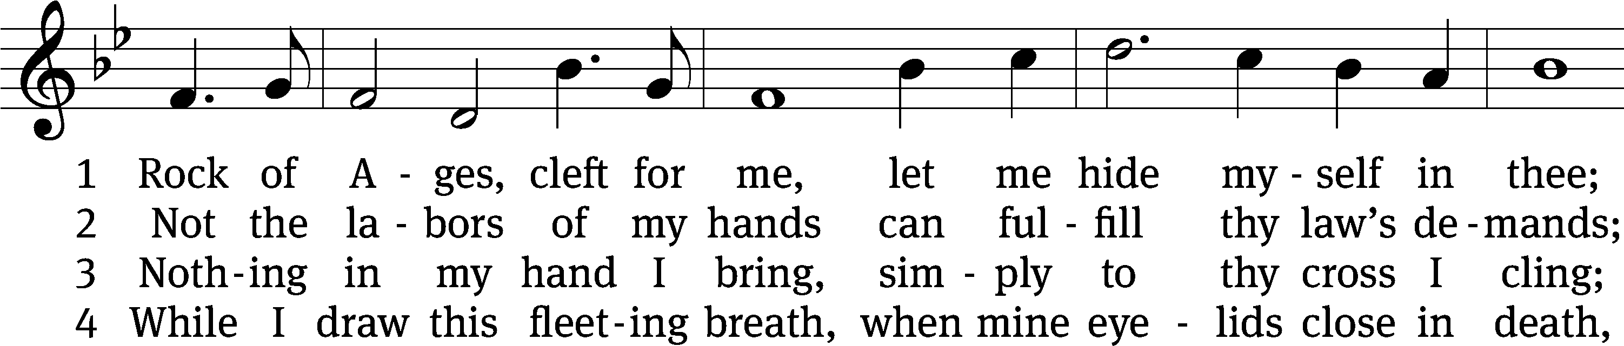
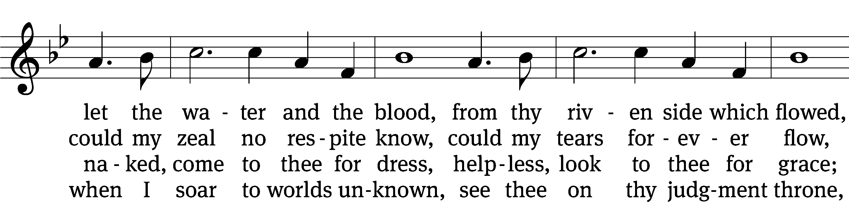
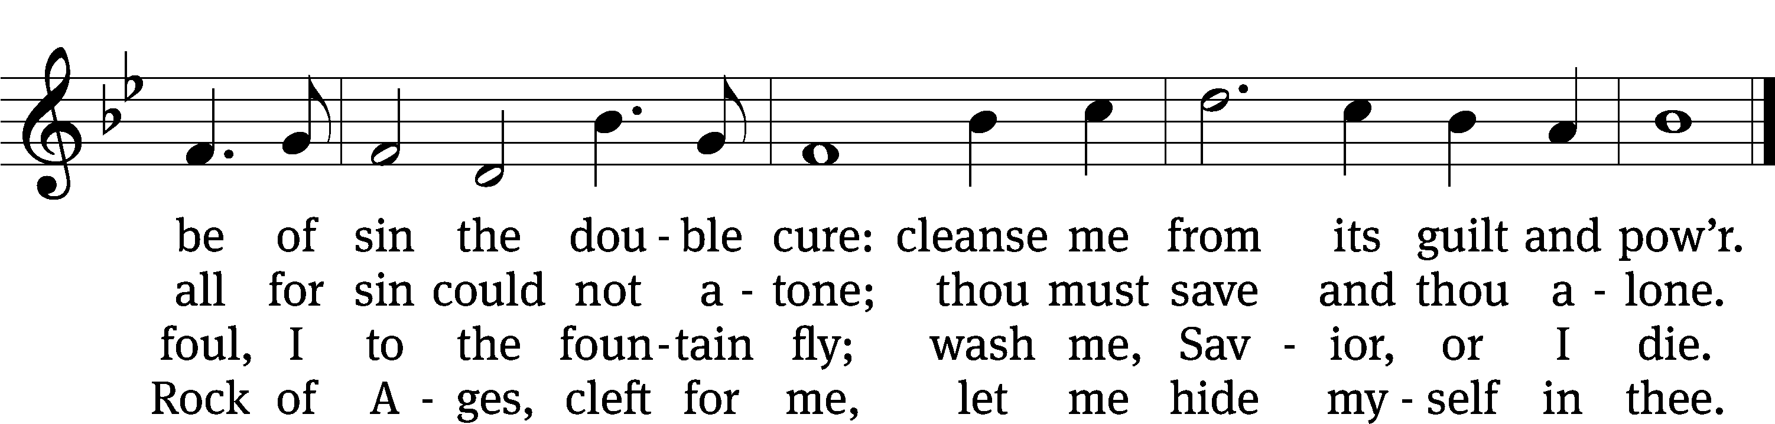
Text: Augustus M. Toplady, 1740–1778, alt.
Tune: Thomas Hastings, 1784–1872
Text and tune: Public domain

PLEASE STAND, IF YOU ARE ABLE

invocation
M: The grace of our Lord (+) Jesus Christ and the love of God and the fellowship of the Holy Spirit be with you.
C: And also with you.

CONFESSION OF SINS
M: We have come into the presence of God, who created us to love and serve him as his dear children. But we have disobeyed him and deserve only his wrath and punishment. Therefore, let us confess our sins to him and plead for his mercy.

C: Merciful Father in heaven, I am altogether sinful from birth. In countless ways I have sinned against you and do not deserve to be called your child. But trusting in Jesus, my Savior, I pray: Have mercy on me according to your unfailing love. Cleanse me from my sin, and take away my guilt.

M: God, our heavenly Father, has forgiven all your sins. By the perfect life and innocent death of our Lord Jesus Christ, he has removed your guilt forever. You are his own dear child. May God give you strength to live according to his will.

C: Amen.
PRAYER AND PRAISE

M: In the peace of forgiveness, let us praise the Lord.

OH, TASTE AND SEE

PRAYER OF THE DAY

Let us pray.

O Lord Jesus Christ, preserve the congregation of believers with your never failing mercy. Help us avoid whatever is wicked and harmful, and guide us in the way that leads to our salvation; for you live and reign with the Father and the Holy Spirit, one God, now and forever.

PLEASE BE SEATED
The Word

the FIRST LESSON Ezekiel 33:7-11
⁷ But I have appointed you, son of man, to be a watchman for the house of Israel. So whenever you hear a word from my mouth, you are to warn them from me. ⁸ When I say to a wicked man, “Wicked man, you shall surely die,” if you do not speak to warn the wicked man against his way, that wicked man will die because of his guilt, but I will also hold you responsible for his blood. ⁹ But if you do warn the wicked man to turn from his way, and he does not turn from his way, he will die because of his guilt, but you will have saved your life.
¹⁰ So you, son of man, say the following to the house of Israel.
This is what you people are saying: “Certainly our rebellion and our sins weigh us down, and because of them we are rotting away. How then can we live?” ¹¹ Say to them, “As I live, declares the Lord God, I take no pleasure in the death of the wicked, but rather that the wicked turn from their way and live. Turn back, turn back from your evil ways, for why should you die, O house of Israel?”

32B How Blest Are Those Psalm 32B
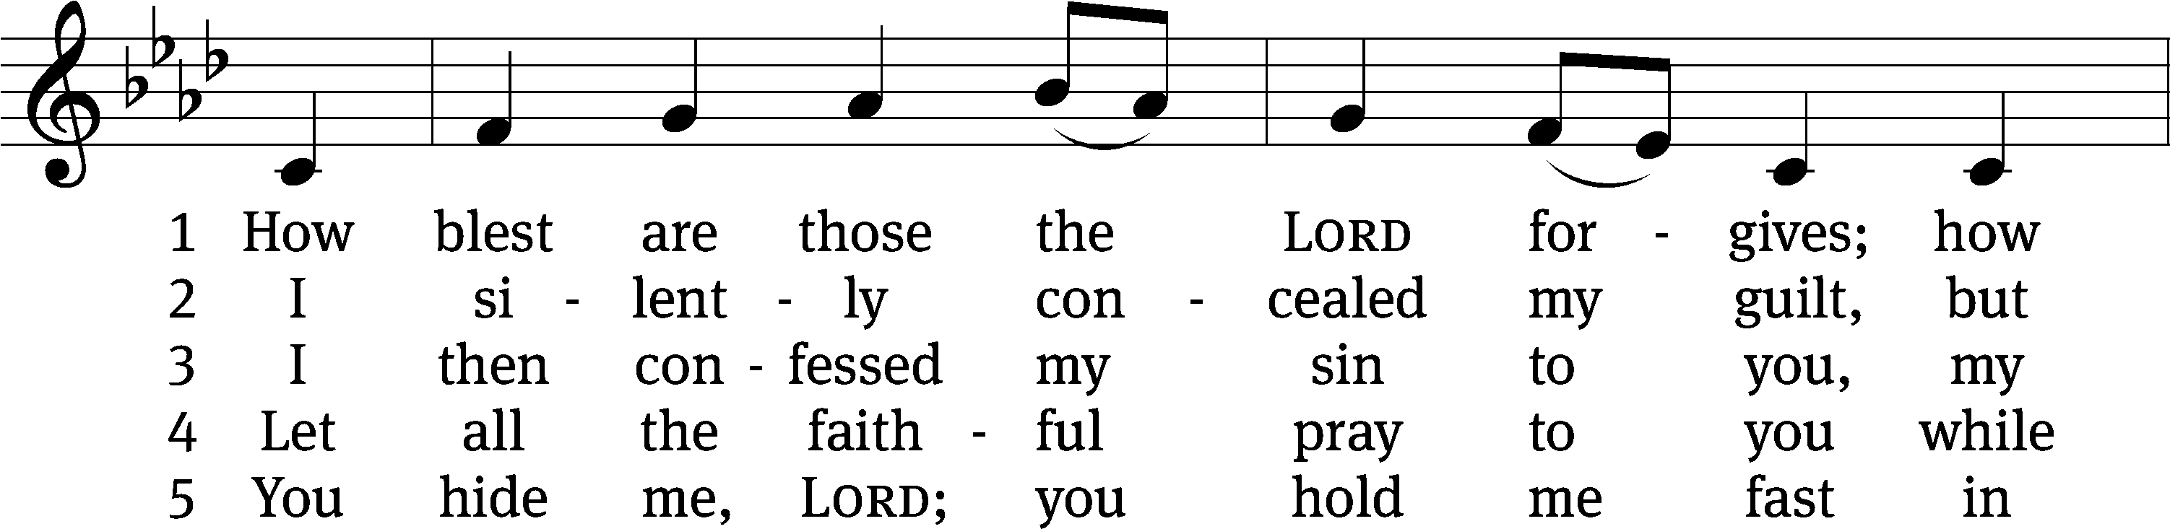
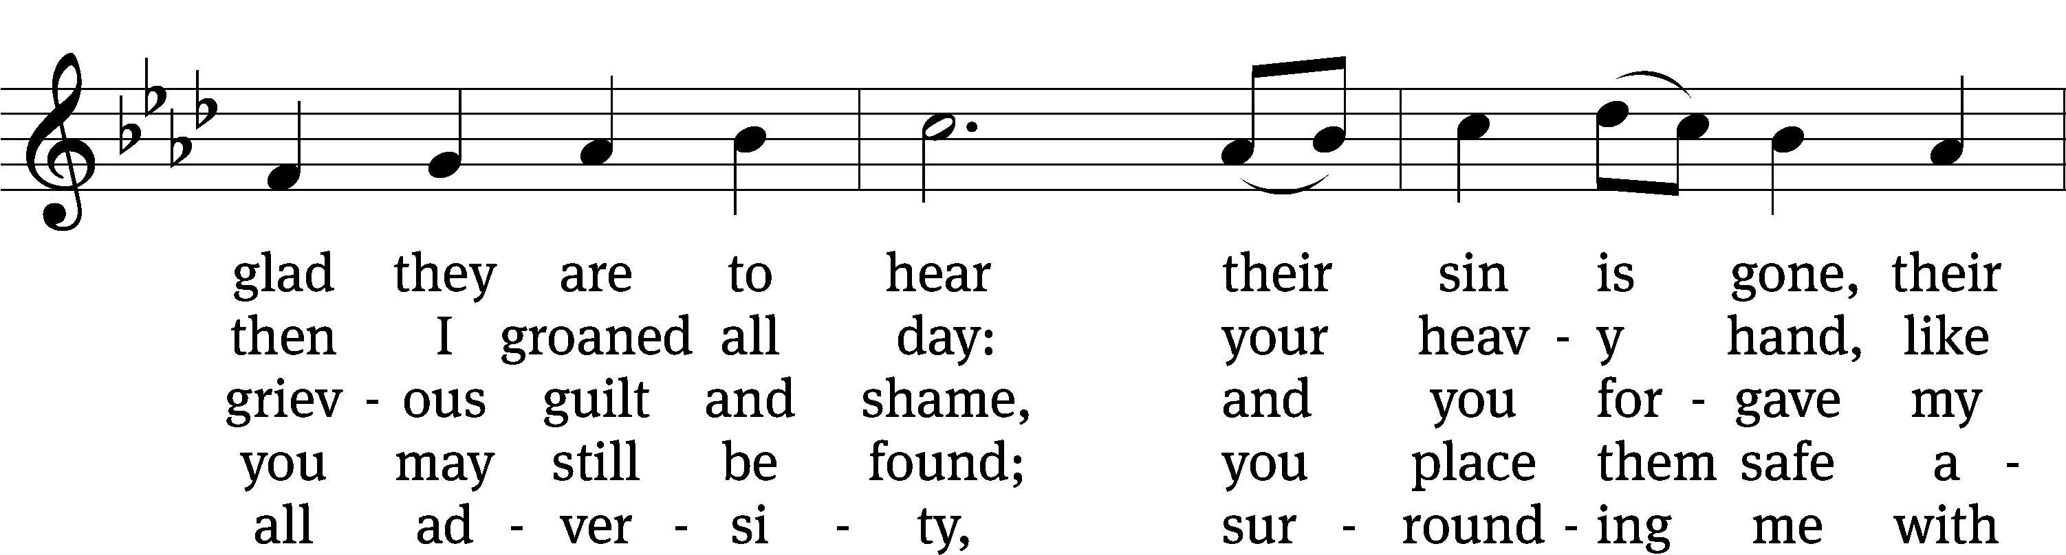
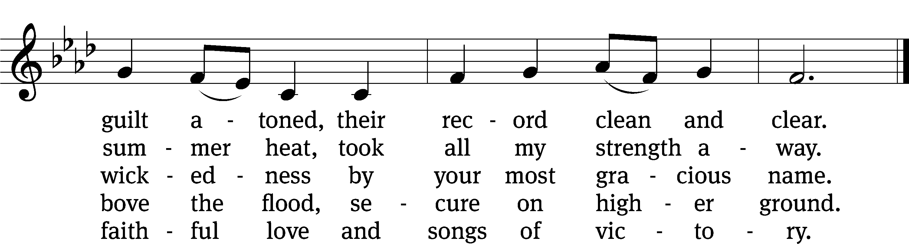
Text: Michael D. Schultz
Tune: Repository of Sacred Music, Part Second, 1813, ed. John Wyeth
Text: © 2021 Northwestern Publishing House. Used by permission: OneLicense no. 727703
Tune: Public domain

SECOND LESSON Galatians 2:11-16

¹¹ But when Cephas came to Antioch, I opposed him to his face, because he was clearly wrong. ¹² For before some people came from James, he ate with the Gentiles. But when those people came, he drew back and separated himself, because he feared those from the circumcision group. ¹³ And the rest of the Jews joined him in his hypocrisy, with the result that even Barnabas was carried away by their hypocrisy. ¹⁴ But when I saw that they were not acting according to the truth of the gospel, I said to Cephas in front of all of them, “If you, a Jew, live like the Gentiles and not like the Jews, why do you compel the Gentiles to live like the Jews?”
¹⁵ “We are Jews by birth and not Gentile sinners. ¹⁶ We know that a person is not justified by the works of the law but through faith in Jesus Christ. So we also believed in Christ Jesus that we might be justified by faith in Christ and not by the works of the law, because no one will be justified by the works of the law.

please stand, if you are ablE

Verse of the day 1 Timothy 2:4

Alleluia. God wants all people to be saved and to come to the knowledge of the truth. Alleluia.

THE GOSPEL LESSON Matthew 18:15-20

M: The Gospel according to Matthew chapter 18, verses 15-20

¹⁵ “If your brother sins against you, go and show him his sin just between the two of you. If he listens to you, you have regained your brother. ¹⁶ But if he will not listen, take one or two others along with you, so that ‘every matter may be established by the testimony of two or three witnesses.’ ¹⁷ If he refuses to listen to them, tell it to the church. And, if he refuses to listen even to the church, then treat him as an unbeliever or a tax collector. ¹⁸ Amen I tell you: Whatever you bind on earth will be bound in heaven, and whatever you loose on earth will be loosed in heaven. ¹⁹ Amen I tell you again: If two of you on earth agree to ask for anything, it will be done for them by my Father who is in heaven. ²⁰ In fact where two or three have gathered together in my name, there I am among them.”
M: This is the Gospel of the Lord.

PLEASE BE SEATED

654 Jesus Sinners Does Receive CW 654
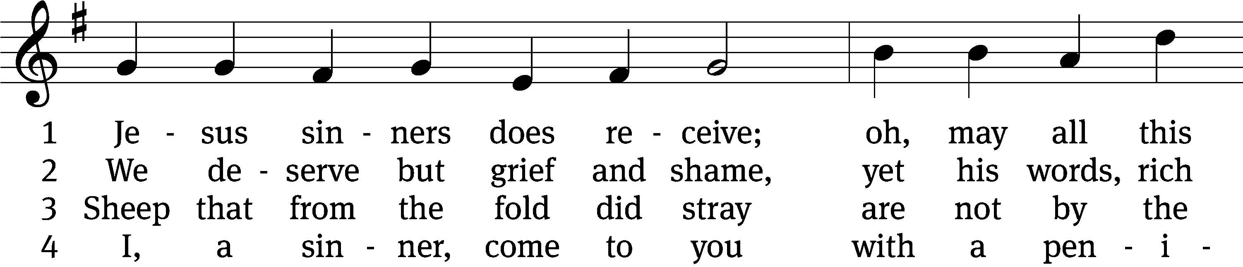
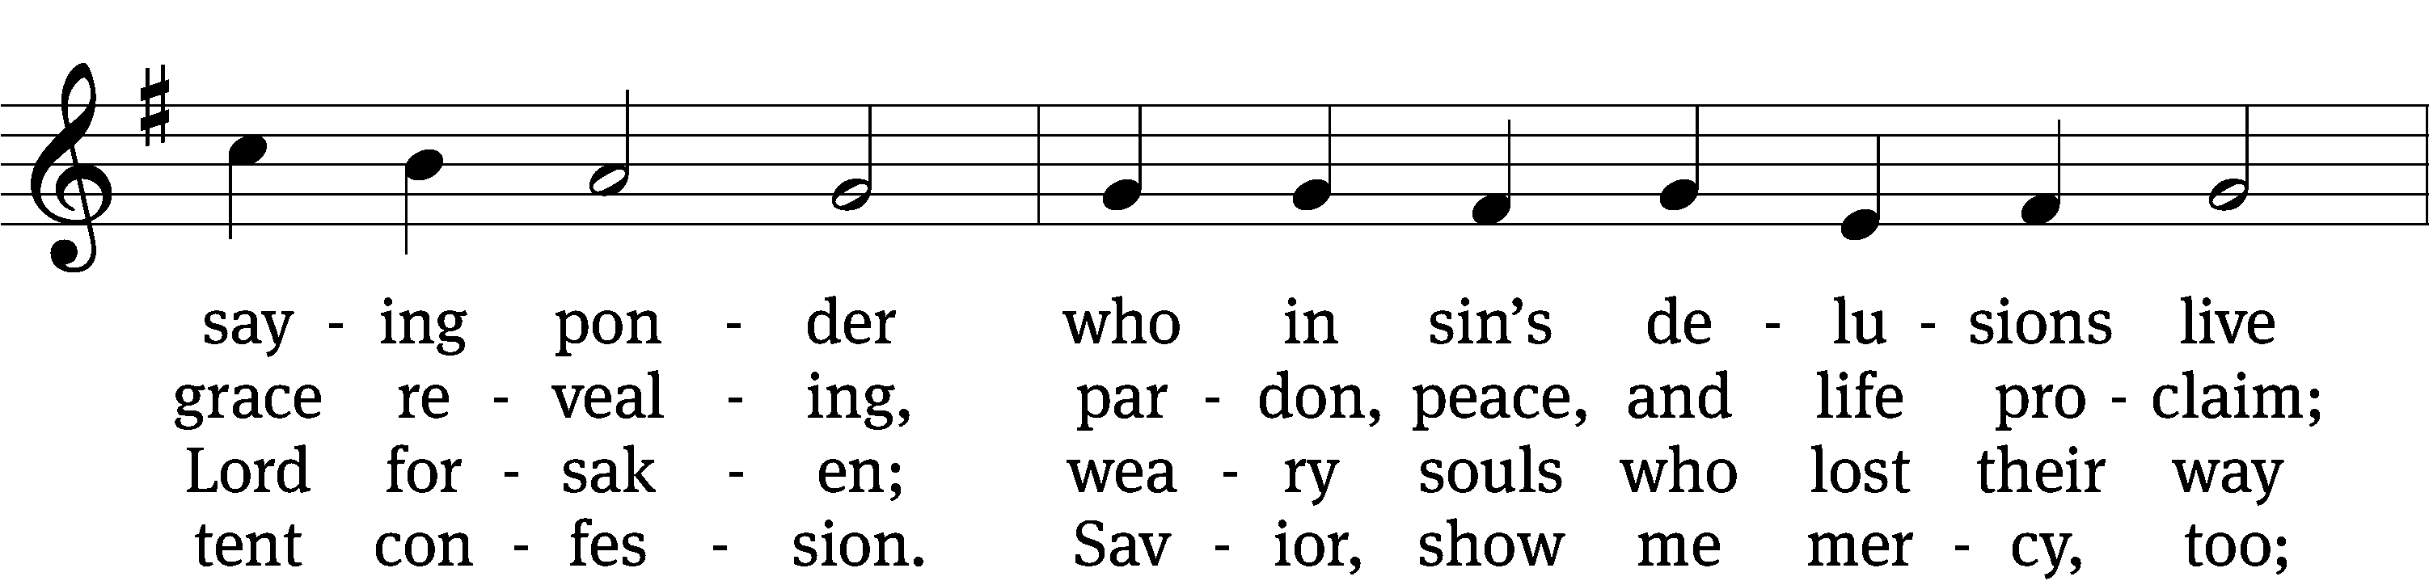
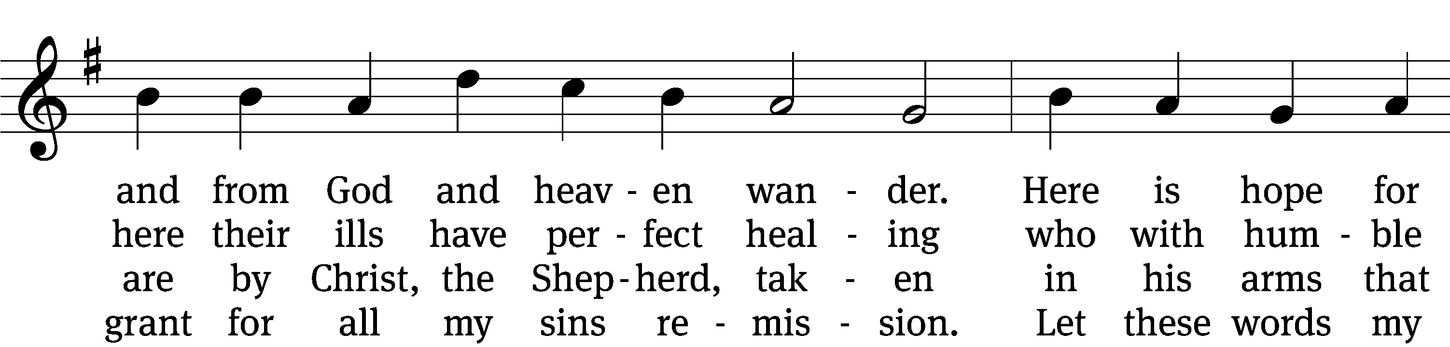
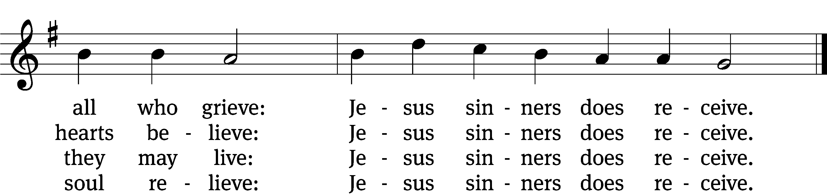

5 Oh, how blest it is to know,
were as scarlet my transgression,
it shall be as white as snow
by your blood and bitter passion,
for these words I do believe:
Jesus sinners does receive.

6 Now my conscience is at peace,
from the law I stand acquitted.
Christ has purchased my release
and my ev’ry sin remitted.
Naught remains my soul to grieve:
Jesus sinners does receive.

7 Jesus sinners does receive,
even I have been forgiven.
And when I this earth must leave,
I shall find an open heaven.
Dying, still to him I cleave:
Jesus sinners does receive.
Text: tr. The Lutheran Hymnal, 1941, alt.; Erdmann Neumeister, 1671–1756, abr.
Tune: Neu-verfertigtes Darmstädtisches Gesang-Buch, Darmstadt, 1699
Text and tune: Public domain

SERMON Galatians 2:11-16
“He Stood Condemned”

PLEASE STAND, IF YOU ARE ABLE

THE APOSTLES’ CREED

I believe in God, the Father almighty,
maker of heaven and earth.
I believe in Jesus Christ, his only Son, our Lord,
who was conceived by the Holy Spirit,
born of the virgin Mary,
suffered under Pontius Pilate,
was crucified, died, and was buried.
He descended into hell.
The third day he rose again from the dead.
He ascended into heaven
and is seated at the right hand of God the Father almighty.
From there he will come to judge the living and the dead.
I believe in the Holy Spirit,
the holy Christian Church,
the communion of saints,
the forgiveness of sins,
the resurrection of the body,
and the life everlasting. Amen.

PRAYER OF THE CHURCH

THE LORD’S PRAYER

C: Our Father, who art in heaven, hallowed be thy name, thy kingdom come, thy will be done on earth as it is in heaven. Give us this day our daily bread; and forgive us our trespasses, as we forgive those who trespass against us; and lead us not into temptation, but deliver us from evil. For thine is the kingdom and the power and the glory forever and ever. Amen.

PLEASE BE SEATED

559 If Your Beloved Son, O God CW 559
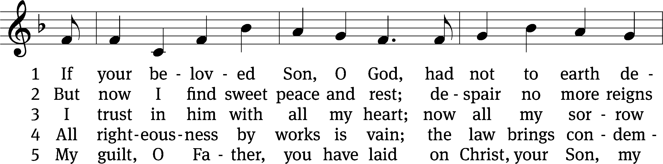
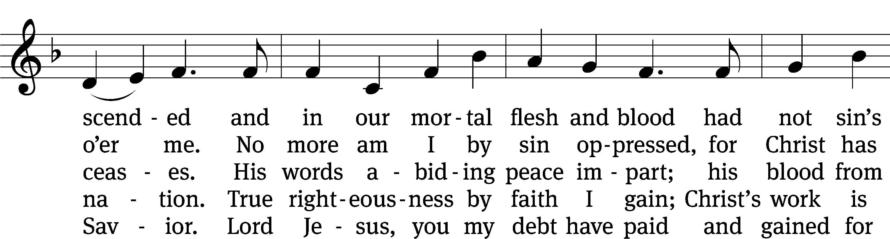
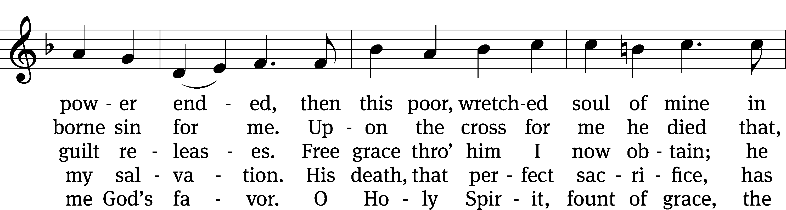
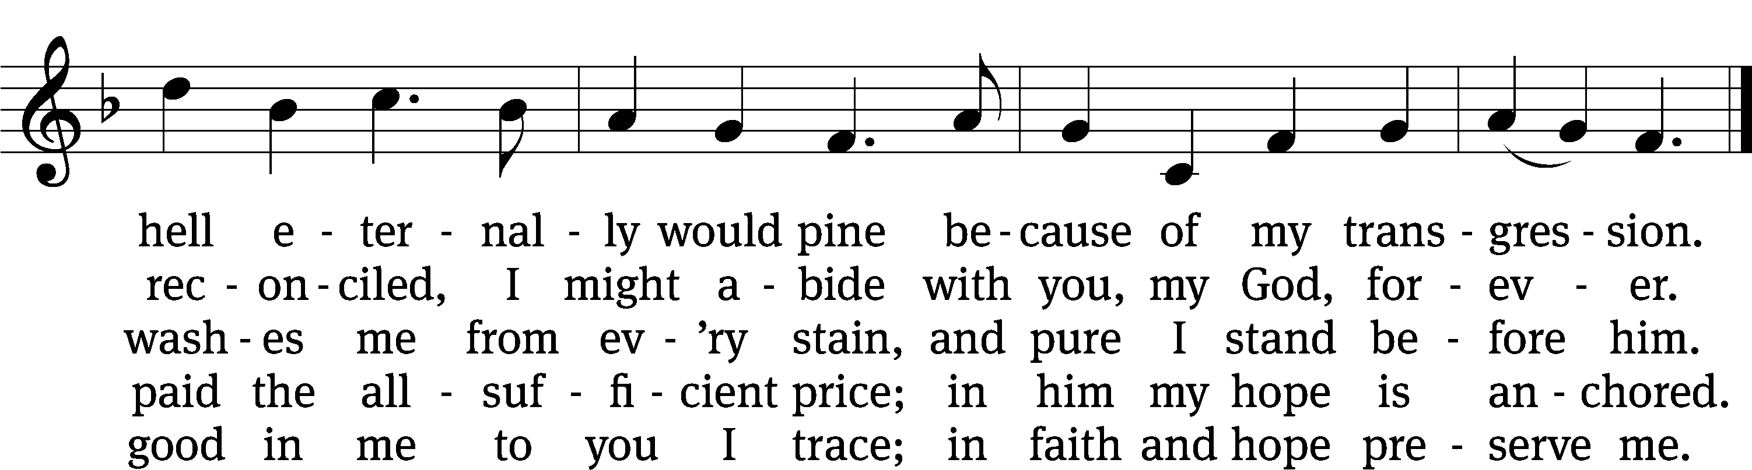
Text: tr. The Lutheran Hymnal, 1941; (sts. 1–4): Johann Heermann, 1585–1647, abr.; (st. 5): Neu-vermehrtes . . . Gesangbuch, Braunschweig, 1661
Tune: Etlich Cristlich lider, Wittenberg, 1524
Text and tune: Public domain

PLEASE STAND, IF YOU ARE ABLE

CLOSING PRAYER
M: Almighty God, we thank you for teaching us the things you want us to believe and do. Help us by your Holy Spirit to keep your Word in pure hearts that we may be strengthened in faith, guided in holiness, and comforted in life and in death, through Jesus Christ, our Lord, who lives and reigns with you and the Holy Spirit, one God, now and forever.

M: Brothers and sisters, go in peace. Live in harmony with one another. Serve the Lord with gladness.
The Lord bless you and keep you.
The Lord make his face shine on you and be gracious to you.
The Lord look on you with favor and (+) give you peace.

PLEASE BE SEATED

926 Lead Me, Lord CW 926
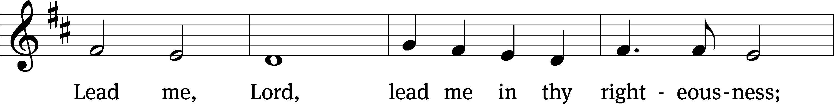
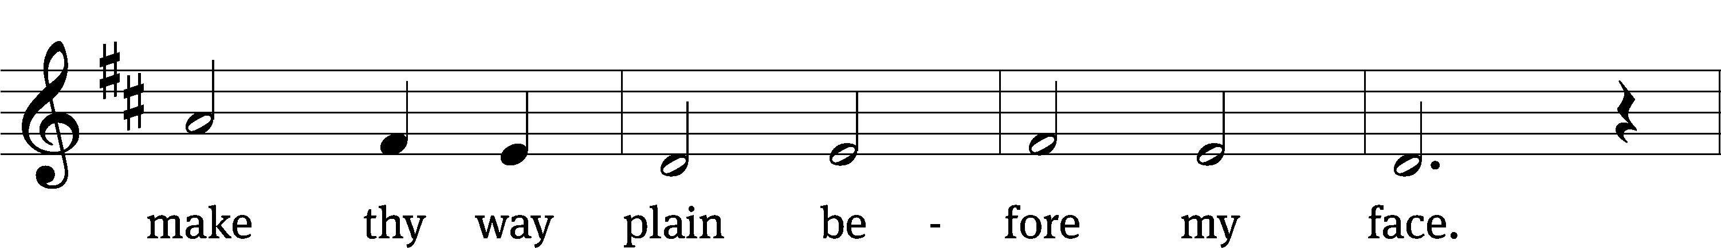
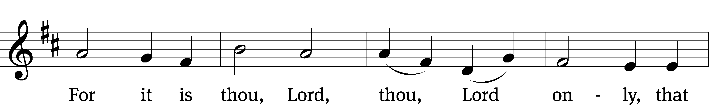
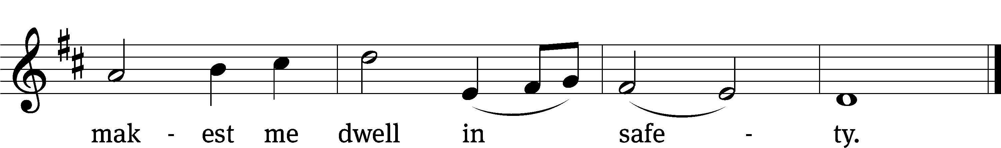
Text: Psalm 4:8; 5:8
Tune: Samuel S. Wesley, 1810–1876
Text and tune: Public domain

Serving In Worship
Officiant Pastor Pappenfuss
Organist Sarah Hanke
Deacons (8:30) Duane Mason and Jim Tice
(11:00) Steve Hoeft and Robert Niethammer
Ushers (8:30) Bob Newman and Henry Schneider
(11:00) Dave Boswell and Jake Vershum
Altar Guild Marcia Marion Ackling and Judy Lindemann
Videographer Jake Vershum

Copyright information
Service of the Word: Christian Worship. © 1993 Northwestern Publishing House. All rights reserved.
Reprinted with permission under ONE LICENSE #A-727703 and CCLI #1151741/CSPL126093

Words and Music: All rights reserved. Reprinted with permission under ONE LICENSE #A-727703 and
CCLI #1151741/CSPL126093
tlcsaline.church

