THE THIRTEENTH SUNDAY
AFTER PENTECOST

TRINITY EVANGELICAL LUTHERAN CHURCH | Saline, Michigan
WELCOME TO WORSHIP September 1/4, 2022
Thank you for joining us in God’s house today! We cordially ask that our Guests sign one of the guestbooks located at either the front or back entryways, or fill out a “Let’s Get Acquainted” card located in the hymnal pew rack and place it in the collection plate.

THANK OFFERING: Members of Trinity give their offering as an expression of love and thankfulness to the Lord and to help support the Lord’s work in our community and around the world. Visitors need not feel obligated to participate in this offering which supports our ministry.

Restrooms are located at the back of the upper level (the annex), and in the basement (down the back stairs of the sanctuary or annex). Handicap access is available, please ask an usher for assistance.

Young Families / Toddler Bags – We are GLAD YOU BROUGHT YOUR CHILDREN to our worship service. Jesus said: “Let the little children come to me and do not hinder them, for the kingdom of God belongs to such as these.” We know that having little children in church can be a challenge, but DO NOT WORRY about it. Many of your fellow worshippers have been in your shoes and are just happy you brought your children with you. For your convenience, we have reserved the back rows of seating for parents with small children. These areas provide more flexibility for your family, as well as, easy access to move downstairs if necessary. A closed-circuit TV system allows families to continue participating in the service while downstairs. Pre-school toddler bags and children’s bulletins are available for their enjoyment. Ask an usher for one to use during the service and please return the toddler bag afterwards.

celebration of holy communion:
In His Word, God makes it clear that the Lord’s Supper is to be shared by people of a common proclamation of faith (1 Corinthians 11:26; 1 Corinthians 10:16-17). Without judging anyone’s hearts, we invite those who share in our confession by their membership in our congregation or another congregation of the Wisconsin Evangelical Lutheran Synod (WELS) or the Evangelical Lutheran Synod (ELS) and who are properly prepared (1 Corinthians 11;27-29) to receive the Sacrament. Page 295 in Christian Worship provides a guide for preparation.
Guests, we would love to have you join us in communion fellowship in the future, and for that to be possible, we ask that you speak with one of the pastors so that we may speak with you on how that would be possible. We thank you for respecting the way we celebrate the Lord’s Supper in our congregations.
the SERVICE – setting one - WITH HOLY COMMUNION CW, page 154
633 Speak, O Lord CW 633
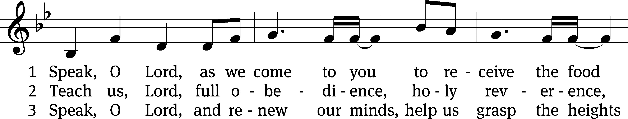
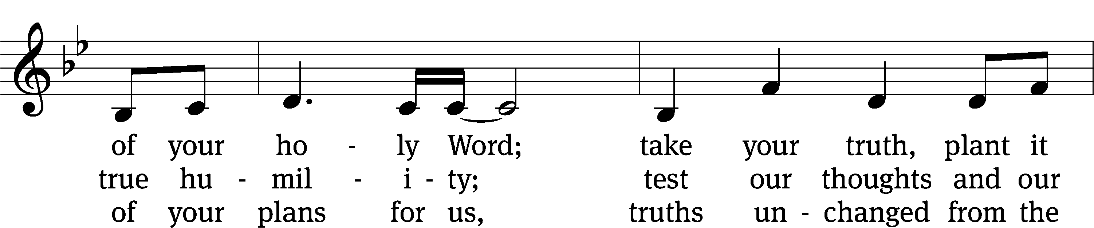
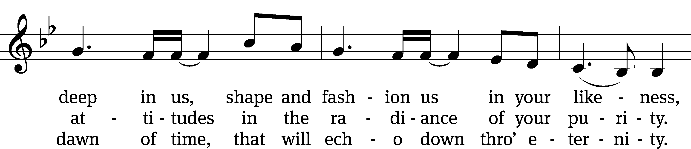
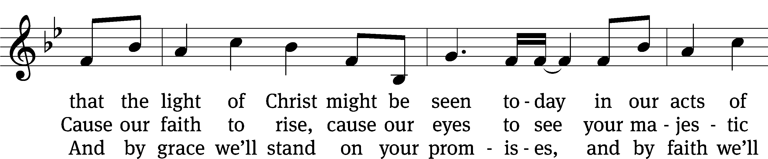
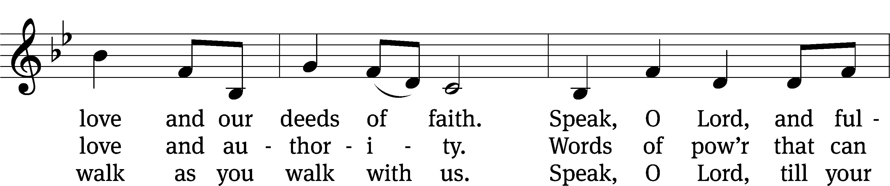
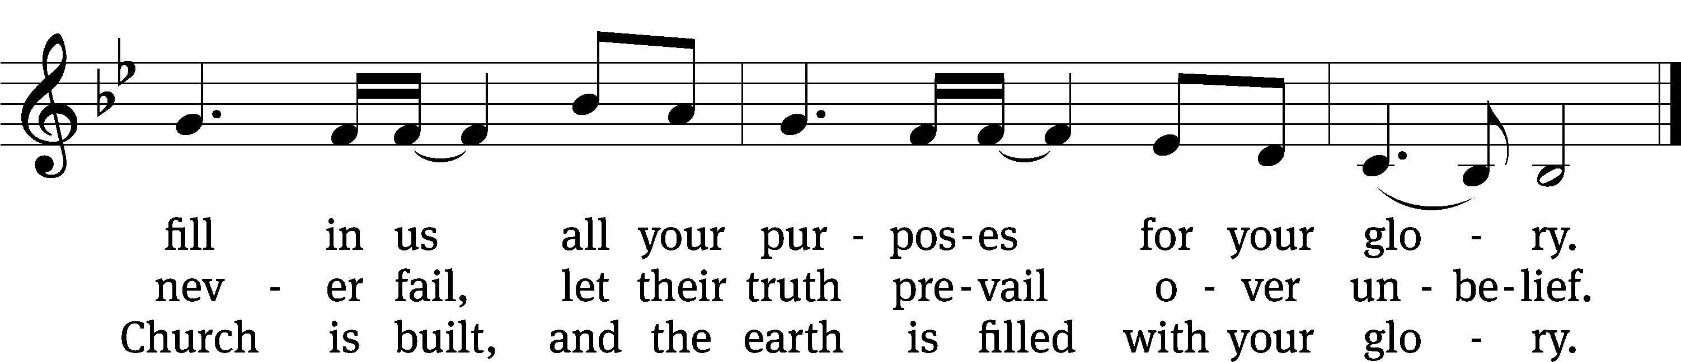
Text: Stuart Townend, b. 1963; Keith Getty, b. 1974
Tune: Stuart Townend, b. 1963; Keith Getty, b. 1974
Text and tune: © 2006 Thankyou Music, admin. CapitolCMGPublishing,com. Used by permission: OneLicense no. 727703

Please stand, if you are able
Invocation
In the name of the Father and of the Son and of the Holy Spirit.
Amen.
Confession
If we claim to be without sin, we deceive ourselves and the truth is not in us.
If we confess our sins, God is faithful and just
and will forgive us our sins
and purify us from all unrighteousness.

Let us confess our sins to the Lord.
Holy God, gracious Father,
I am sinful by nature
and have sinned against you in my thoughts, words, and actions.
I have not loved you with my whole heart;
I have not loved others as I should.
I deserve your punishment both now and forever.
But Jesus, my Savior, paid for my sins
with his innocent suffering and death.
Trusting in him, I pray: God, have mercy on me, a sinner.

Our gracious Father in heaven has been merciful to us. He sent his only Son, Jesus Christ, who gave his life as the atoning sacrifice for the sins of the whole world. Therefore, as a called servant of Christ and by his authority, I forgive you all your sins in the name of the Father and of the Son and of the Holy Spirit.
Amen.

Lord, Have Mercy

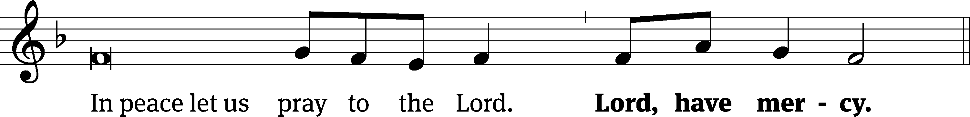
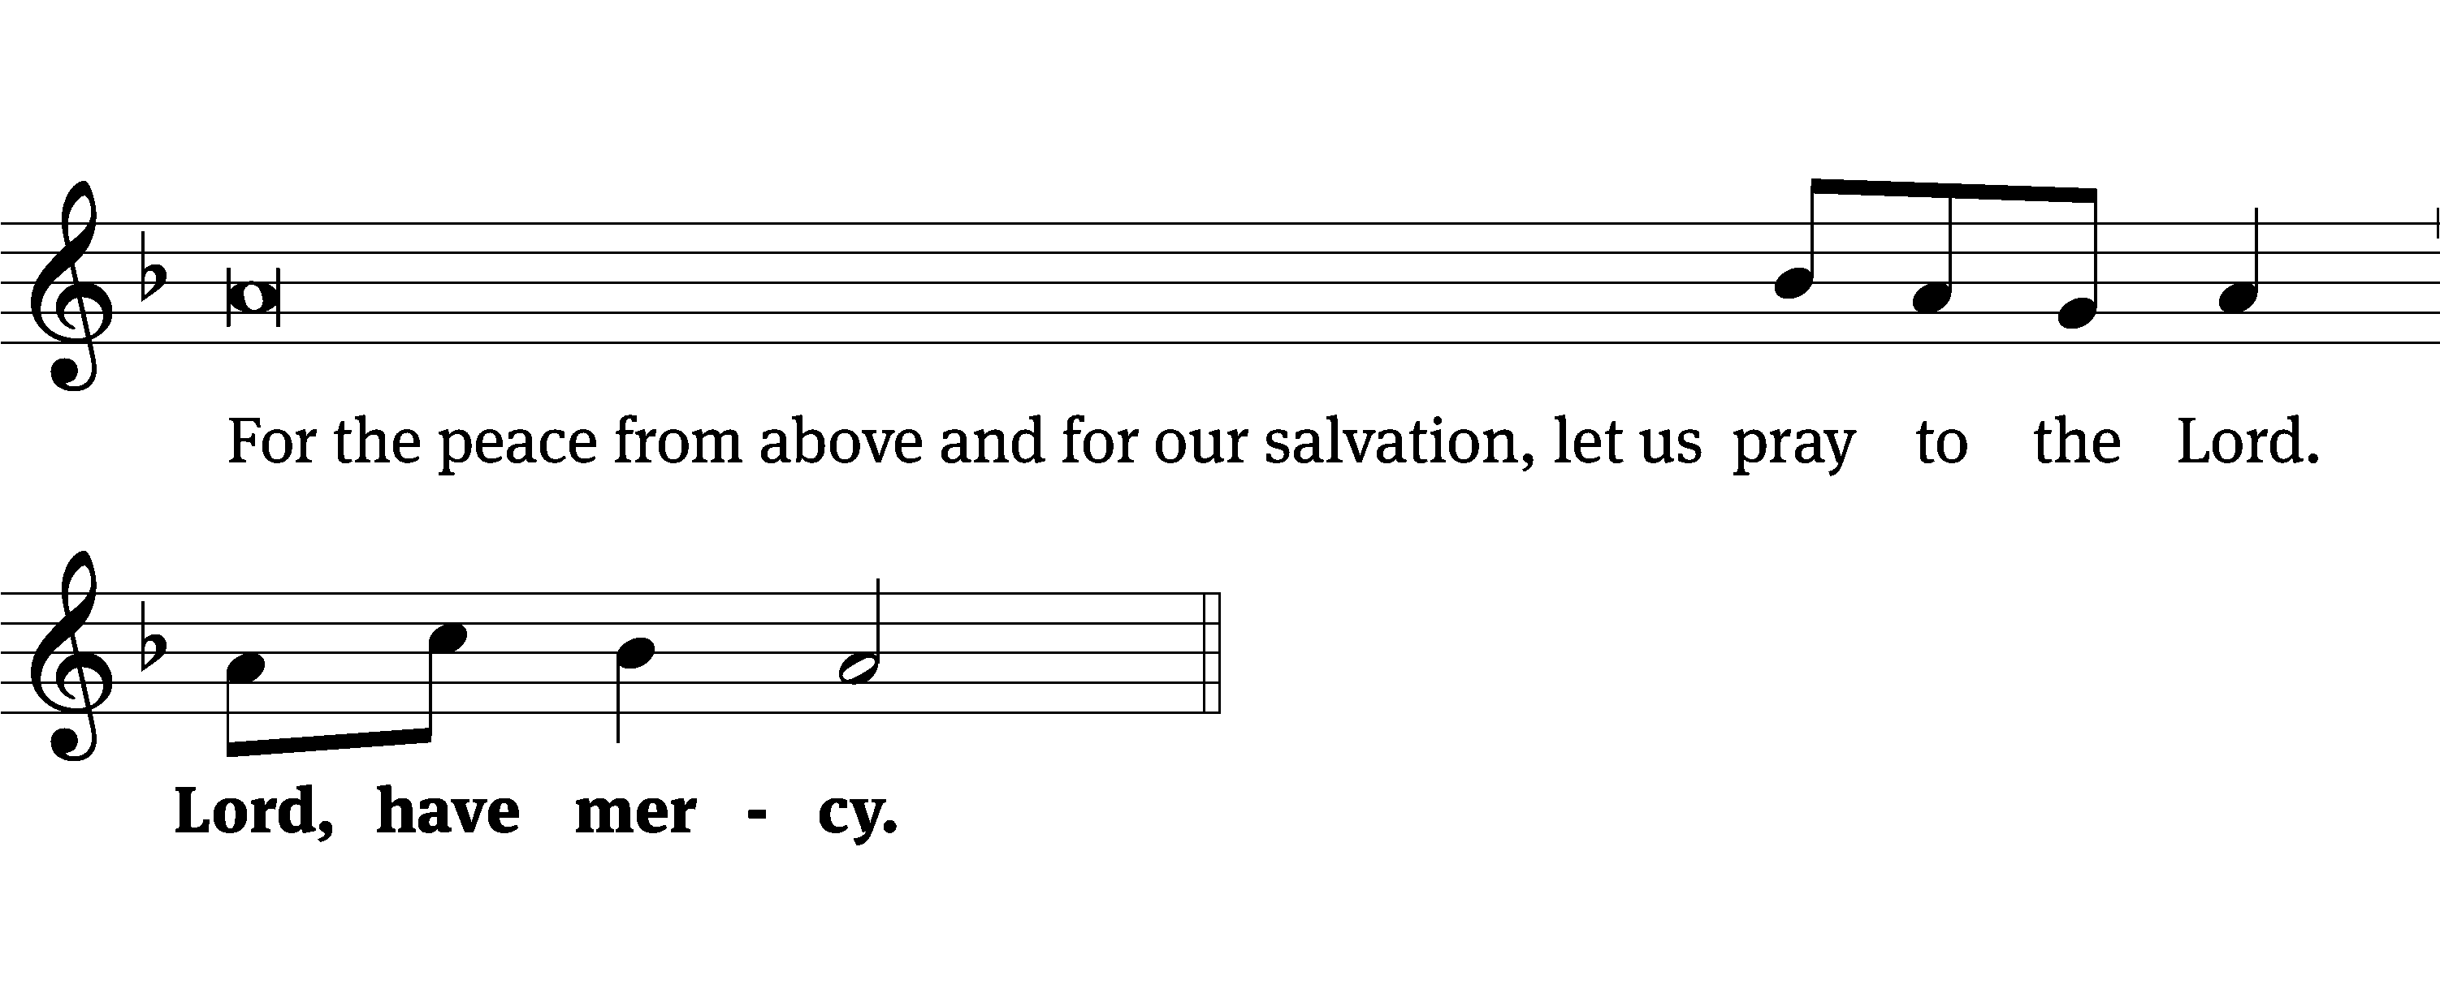
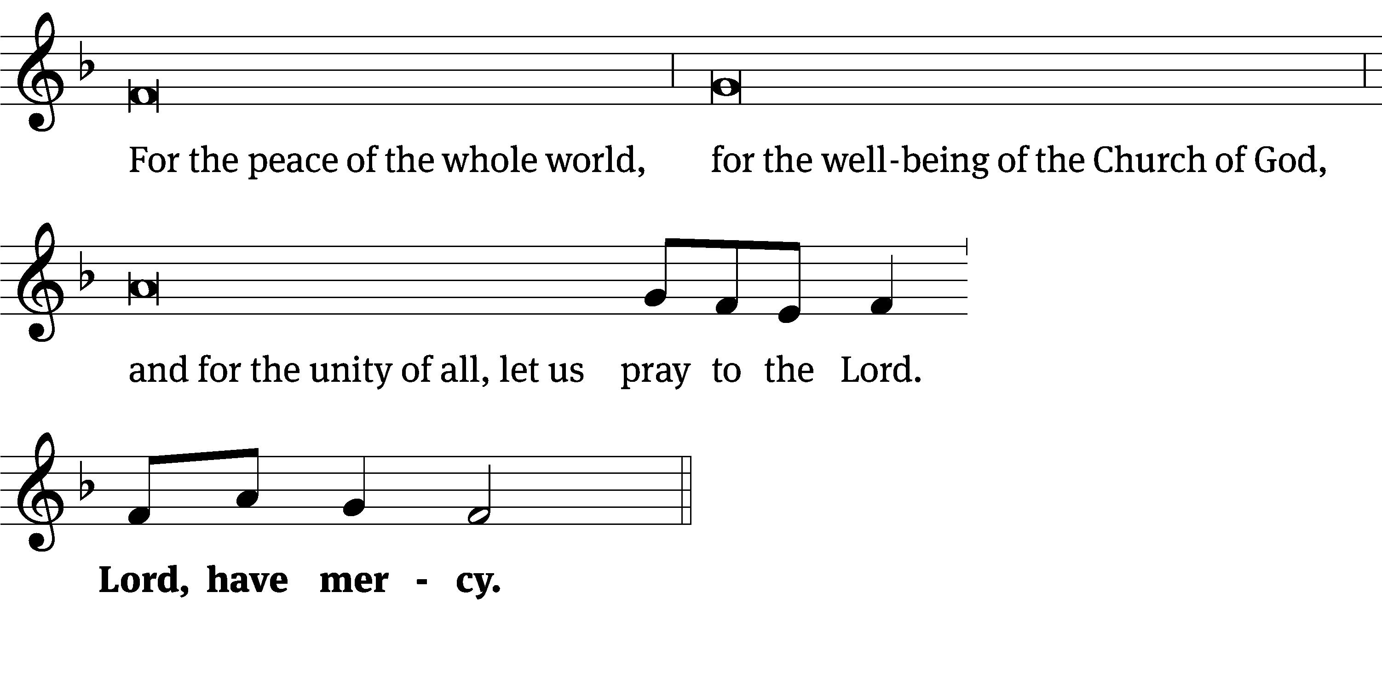
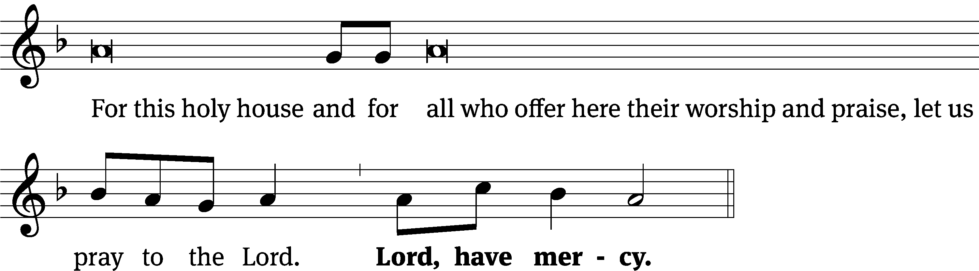
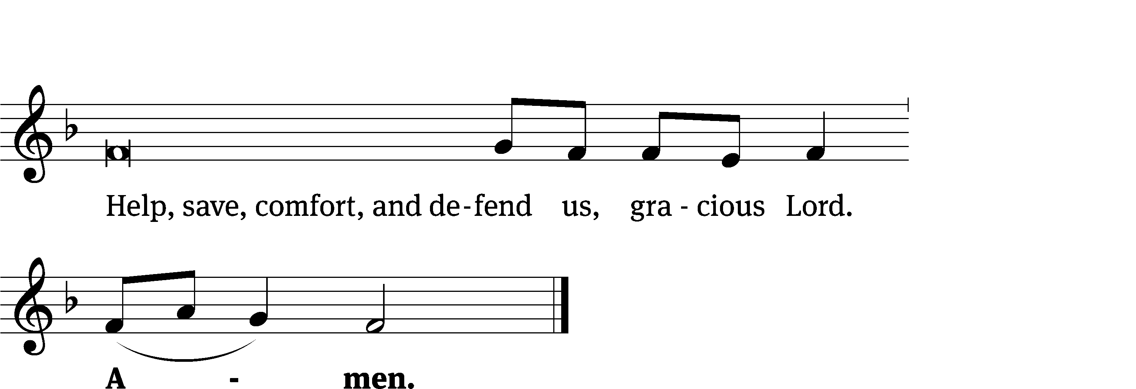
Tune: Kevin Becker
Tune: © 2021 Northwestern Publishing House. Used by permission: OneLicense no. 727703
Glory Be to God CW 157
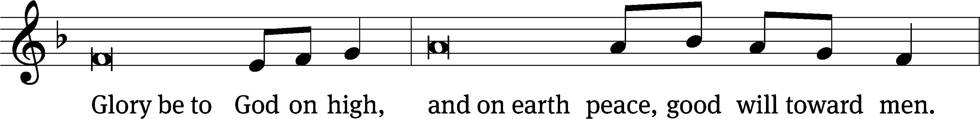
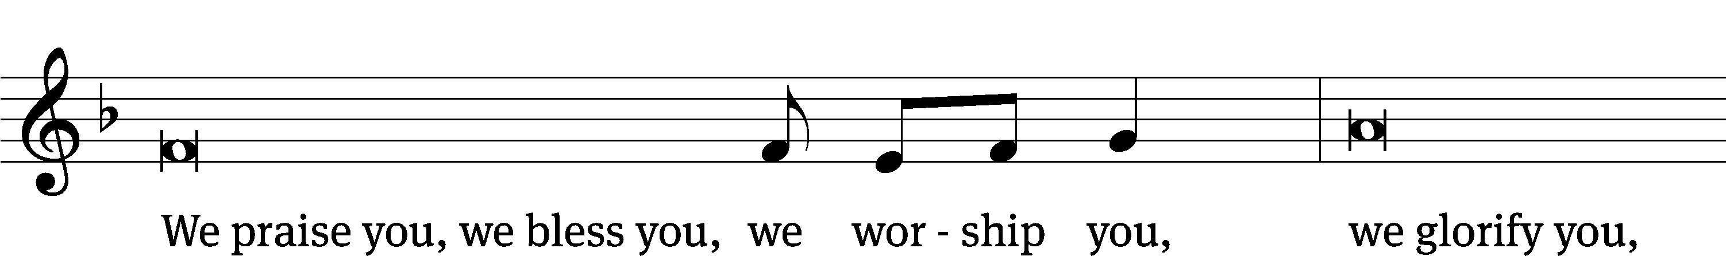
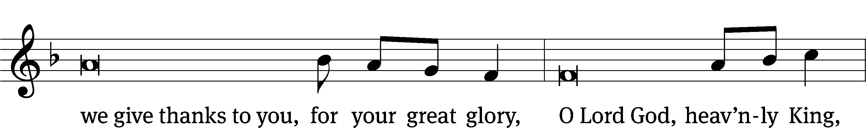
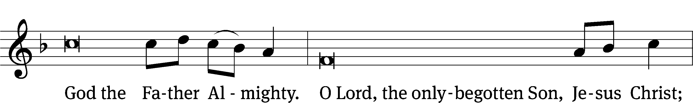
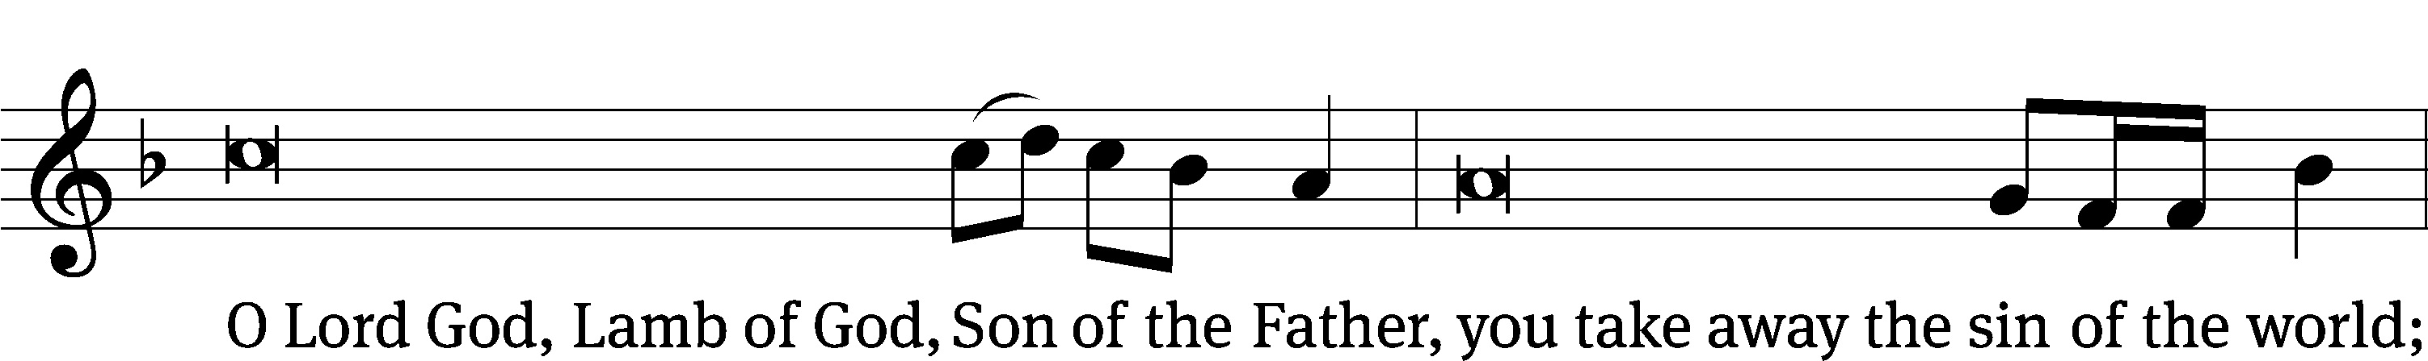
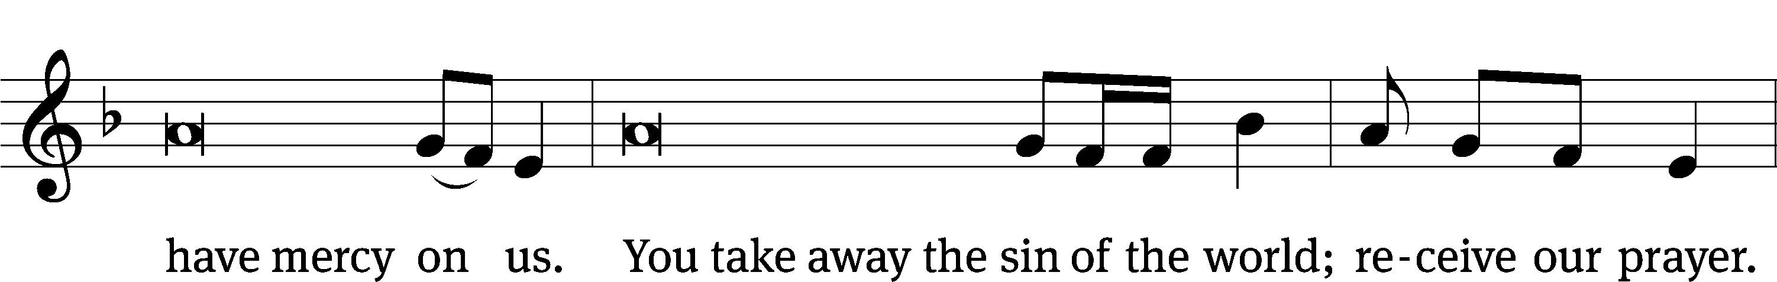
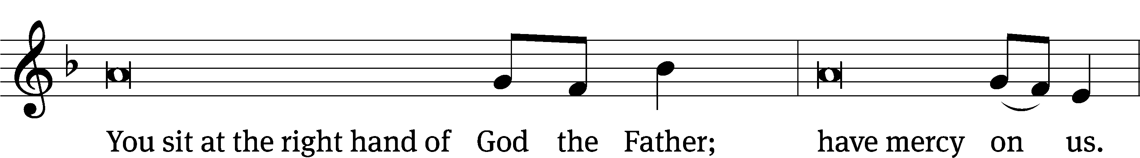
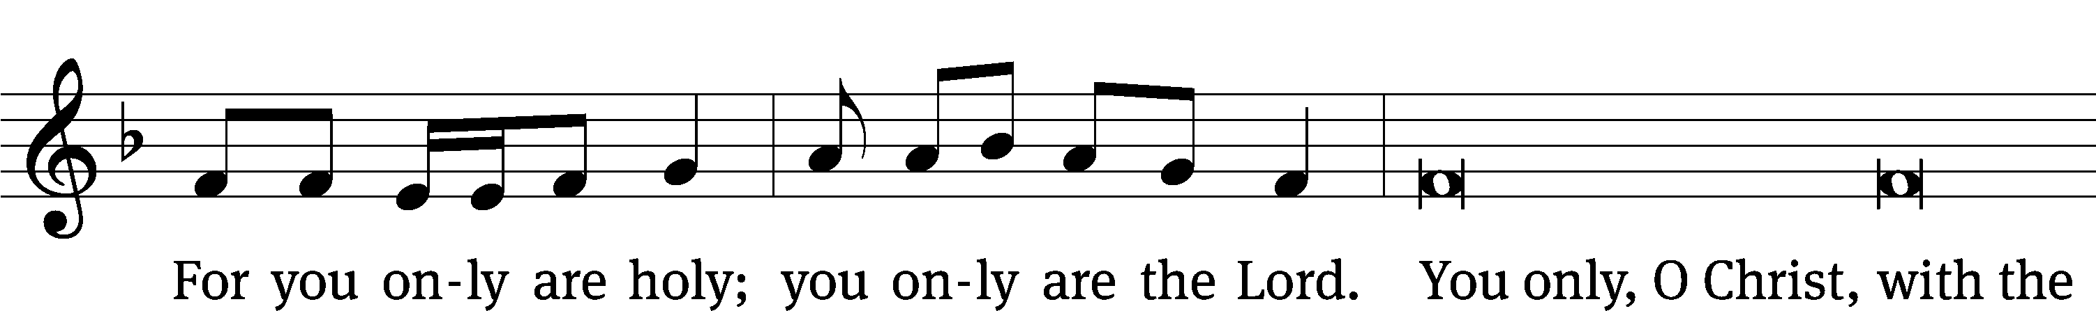
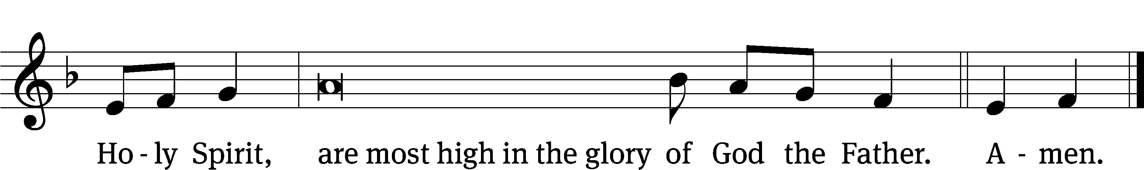
The Lord be with you.
And also with you.
Prayer of the Day
Let us pray.

O merciful Lord, you did not spare your only Son but delivered him up for us all. Grant us courage and strength to take up the cross and follow him, who lives and reigns with you and the Holy Spirit, one God, now and forever.
Amen.

Please be seated

First Reading Deuteronomy 30:15-20
¹⁵ See now, today I have set before you life and prosperity, death and disaster. ¹⁶ This is what I am commanding you today: Love the Lord your God, walk in his ways, and keep his commandments, his statutes, and his ordinances. Then you will live and increase in number, and the Lord your God will bless you in the land that you are going to possess.
¹⁷ But if your heart turns away, and you do not listen, and you are lured away, and you bow down to other gods and serve them, ¹⁸ then I declare to you today that you will most certainly perish. You will not live a long life on the land that you are about to enter and possess by crossing over the Jordan.
¹⁹ I call the heavens and the earth to witness against you today that I have set before you life and death, a blessing and a curse. Choose life so that you and your descendants may live ²⁰ by loving the Lord your God, by listening to his voice, and by clinging to him, because that means life for you, and you will live a long life on your land that the Lord swore to give to your fathers, to Abraham, Isaac, and Jacob.

The Word of the Lord.
Thanks be to God.

1B How Truly Blest Are They Psalm 1B
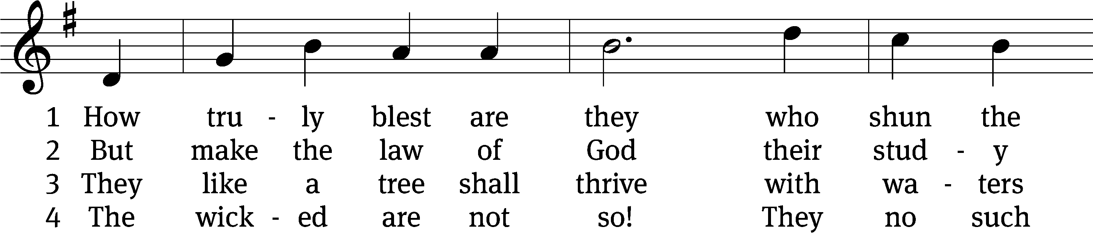
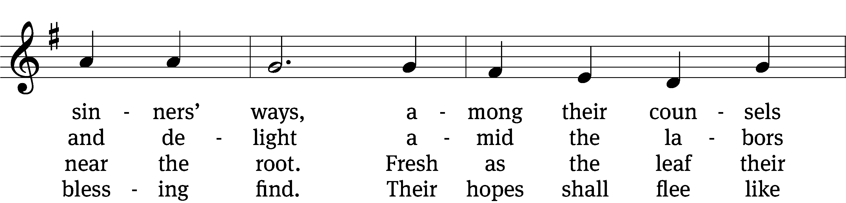
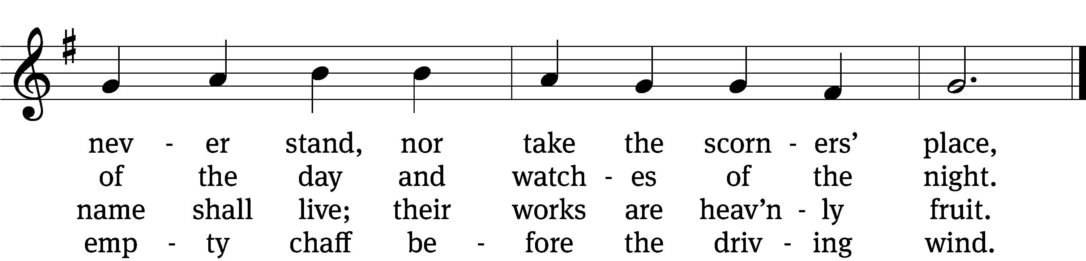

5 How will they bear to stand
before that judgment seat
where all the saints at Christ’s right hand
in full assembly meet?

6 God knows and he approves
the way the righteous go,
but sinners and their works shall meet
a dreadful overthrow.
Text: Isaac Watts, alt.
Tune: Trente quatre Pseaumes de David, Geneva, 1551, alt.
Text and tune: Public domain

Second Reading Philemon 1, 7-21
¹ To Philemon, our dear friend and coworker,
⁷ I have received great joy and encouragement from your love, because the hearts of the saints have been refreshed by you, brother.
⁸ For that reason, even though I have plenty of boldness in Christ to order you to do what is proper, ⁹ I am appealing to you, instead, on the basis of love, just as I, Paul, am an old man and now also a prisoner of Jesus Christ. ¹⁰ I am appealing to you on behalf of my child Onesimus. I became his father while I was in chains. ¹¹ There was a time when he was useless to you, but now he is useful both to you and to me. ¹² I have sent him (who is my very heart) back to you. Welcome him. ¹³ I wanted to keep him with me, so that he might serve me in your place while I am in chains for the gospel. ¹⁴ But I did not want to do anything without your consent, so that your kindness would not be the result of compulsion, but of willingness. ¹⁵ Perhaps this is why he was separated from you for a while: so that you would have him back forever, ¹⁶ no longer as a slave, but as more than a slave, as a dear brother. He certainly is dear to me, but he is even more of a dear brother to you, both in the flesh and in the Lord.
¹⁷ So if you consider me your partner, welcome him as you would welcome me. ¹⁸ And if he has wronged you in any way or owes you anything, charge it to me. ¹⁹ I, Paul, have written this with my own hand: I will repay it—not to mention that you owe me your very self. ²⁰ Yes, brother, I am asking for a favor from you in the Lord. Refresh my heart in Christ. ²¹ Confident of your obedience, I write to you, knowing that you will do even more than I ask.

The Word of the Lord.
Thanks be to God.

Please stand, if you are able

Gospel Acclamation John 6:68
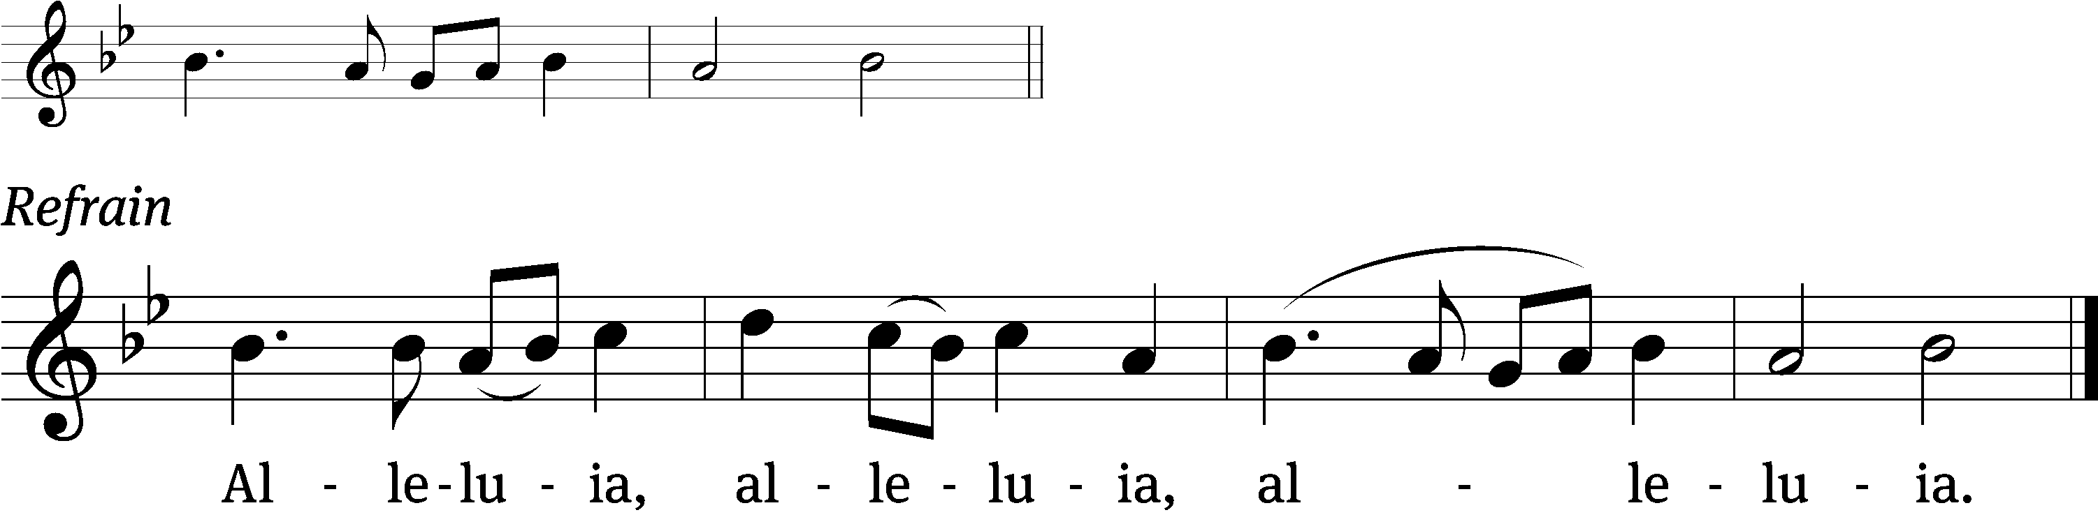
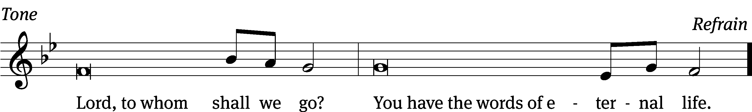
Tune: © 2021 Northwestern Publishing House. Used by permission: OneLicense no. 727703

Gospel Luke 14:25-35
²⁵ Large crowds were traveling with Jesus. He turned and said to them, ²⁶ “If anyone comes to me and does not hate his own father and mother, wife and children, brothers and sisters, yes, even his own life, he cannot be my disciple. ²⁷ Whoever does not carry his own cross and follow me cannot be my disciple. ²⁸ For which of you, if he wants to build a tower, does not first sit down and count the cost to see if he has enough to complete it? ²⁹ Otherwise, when he has laid a foundation and is not able to finish, everyone who sees it will begin to ridicule him, ³⁰ saying, ‘This fellow began to build, but was not able to finish.’ ³¹ Or what king, as he goes out to confront another king in war, will not first sit down and consider if he is able with ten thousand to oppose the one who comes against him with twenty thousand? ³² And if he is not able, he sends out a delegation and asks for terms of peace while his opponent is still far away. ³³ So then, any one of you who does not say farewell to all his own possessions cannot be my disciple. ³⁴ Salt is good, but if the salt has lost its flavor, how will it become salty again? ³⁵ It is not fit for the soil or for the manure pile. It is thrown away. The one who has ears to hear, let him hear.”

The Gospel of the Lord.
Praise be to you, O Christ!

Please be seated

694 Jesus, I My Cross Have Taken CW 694
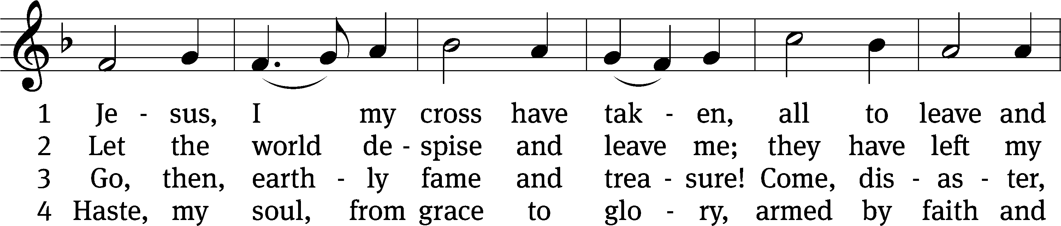
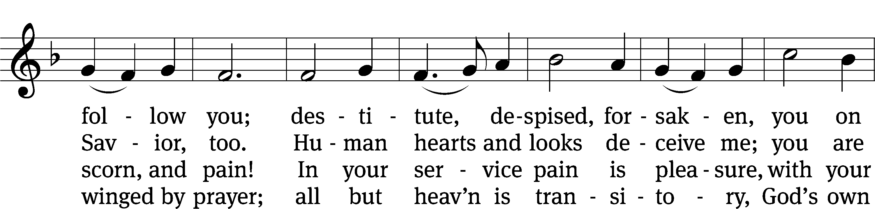
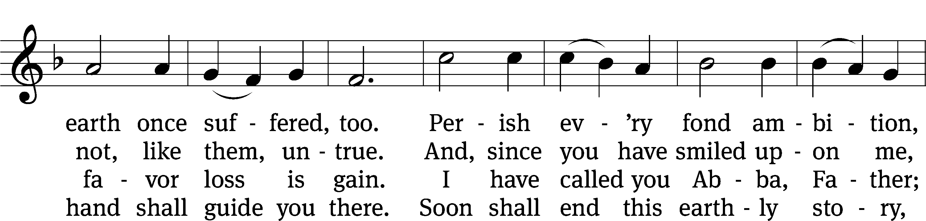
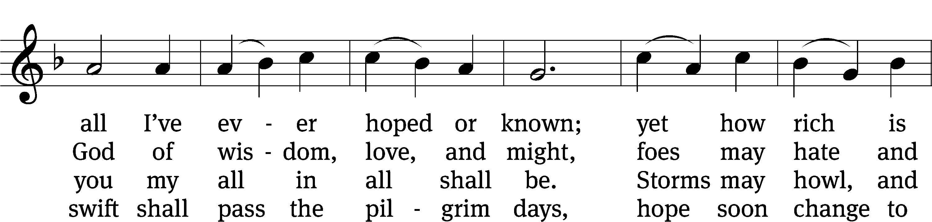
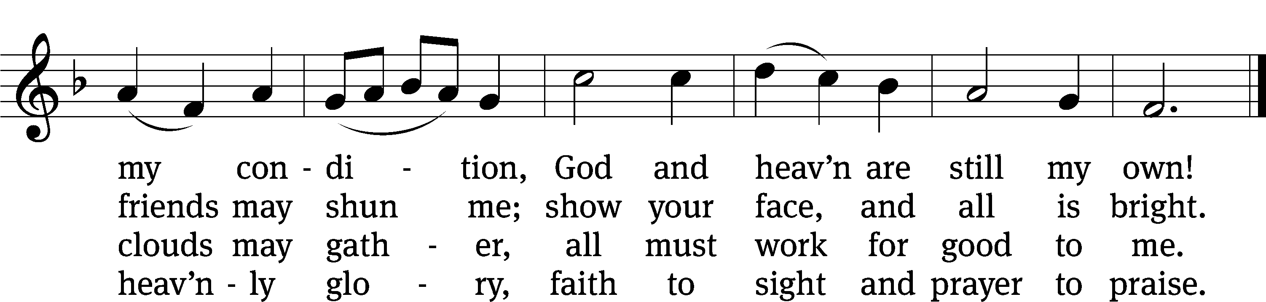
Text: Henry Francis Lyte, 1793–1847, abr., alt.
Tune: Rowland H. Prichard, 1811–1887
Text and tune: Public domain

SERMON Luke 14:25-35
“Counting the Cost of Christianity

Please stand, if you are able
Nicene Creed
We believe in one God, the Father, the Almighty,
maker of heaven and earth,
of all that is,
seen and unseen.
We believe in one Lord, Jesus Christ, the only Son of God,
eternally begotten of the Father,
God from God, Light from Light, true God from true God,
begotten, not made,
of one being with the Father.
Through him all things were made.
For us and for our salvation, he came down from heaven,
was incarnate of the Holy Spirit and the Virgin Mary,
and became truly human.
For our sake he was crucified under Pontius Pilate.
He suffered death and was buried.
On the third day he rose again in accordance with the Scriptures.
He ascended into heaven
and is seated at the right hand of the Father.
He will come again in glory to judge the living and the dead,
and his kingdom will have no end.
We believe in the Holy Spirit,
the Lord, the giver of life,
who proceeds from the Father and the Son,
who in unity with the Father and the Son
is worshiped and glorified,
who has spoken through the prophets.
We believe in one holy Christian and apostolic Church.
We acknowledge one baptism for the forgiveness of sins.
We look for the resurrection of the dead
and the life of the world to come. Amen.
Offertory
Prayer of the Church

The Sacrament
Preface CW 165
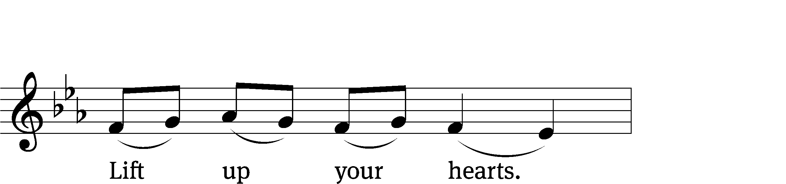
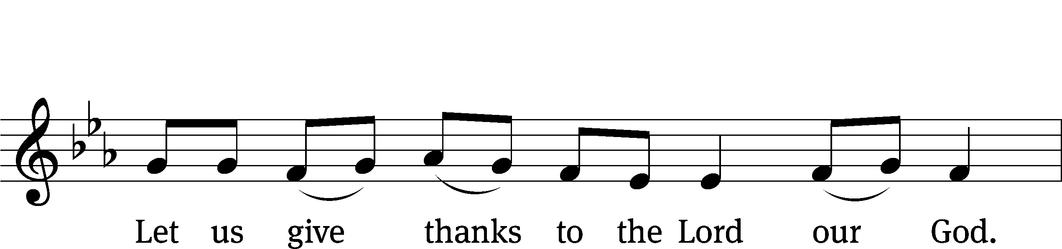
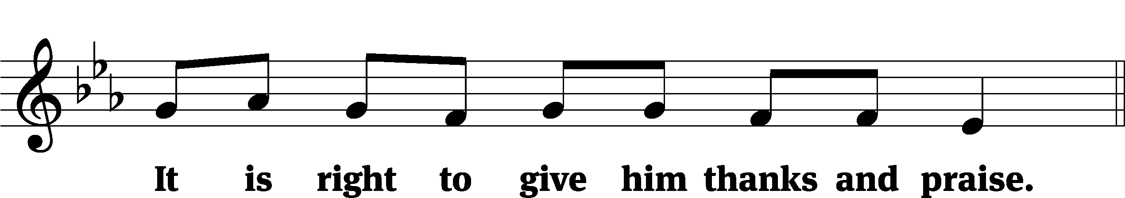

It is truly good and right that we should at all times and in all places give you thanks, O Lord, holy Father, almighty and everlasting God, through Jesus Christ our Lord, who promised that wherever two or three come together in his name, there he is with them to shepherd his flock until he comes again in glory. Therefore, with all the saints on earth and hosts of heaven, we praise your holy name and join their glorious song:

Holy, Holy, Holy CW 167
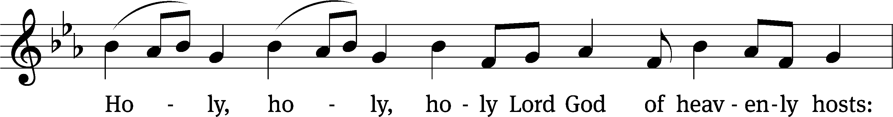
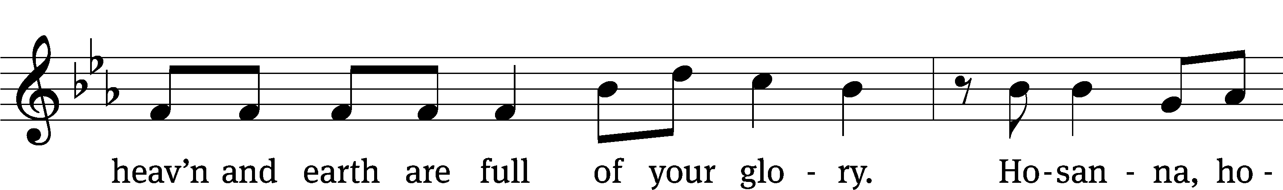
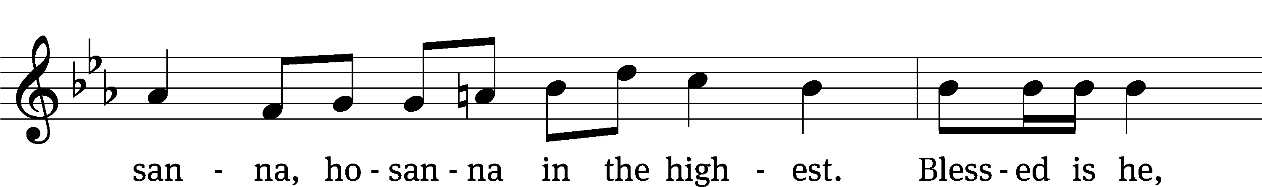
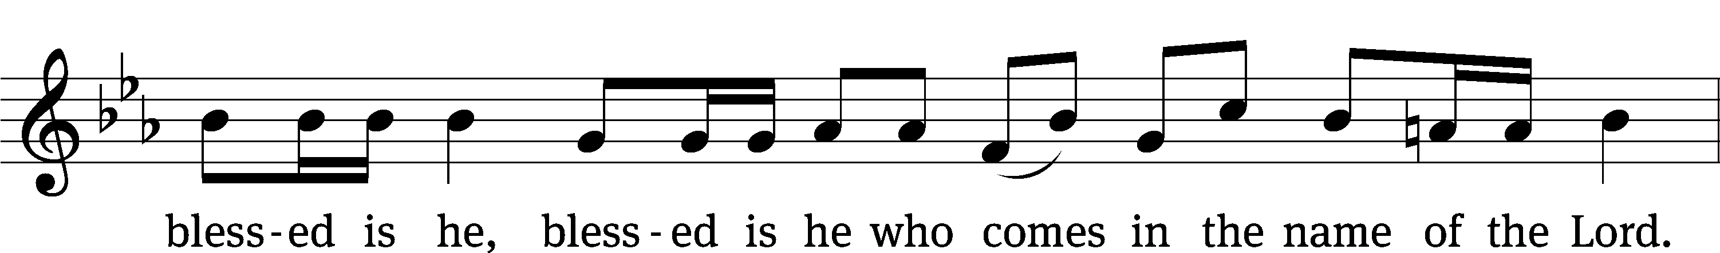
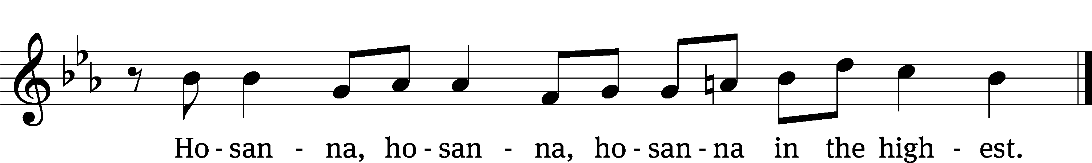

Prayer of Thanksgiving
We give thanks to you, O God, through your dear Son, Jesus Christ, whom you sent to be our Savior, our Redeemer, and the messenger of your grace. Through him you made all things; in him you are well pleased. He is the incarnate Word, conceived by the Holy Spirit and born of the Virgin Mary. To fulfill your promises, he stretched out his hands on the cross and released from eternal death all who believe in you.

As we remember Jesus’ death and resurrection, we thank you that you have gathered us together to receive your Son’s body and blood. Send us your Spirit, unite us as one, and strengthen our faith so that we may praise you in your Son, Jesus Christ. Through him, we glorify and honor you, O God our Father, with the Holy Spirit, one God, now and forever.
Amen.

Lord’s Prayer
Our Father, who art in heaven, hallowed be thy name, thy kingdom come, thy will be done on earth as it is in heaven. Give us this day our daily bread; and forgive us our trespasses, as we forgive those who trespass against us; and lead us not into temptation, but deliver us from evil. For thine is the kingdom and the power and the glory forever and ever. Amen.

Words of Institution
Our Lord Jesus Christ, on the night he was betrayed, took bread; and when he had given thanks, he broke it and gave it to his disciples, saying, “Take and eat; this is my body, which is given for you. Do this in remembrance of me.”
Then he took the cup, gave thanks, and gave it to them, saying, “Drink from it, all of you; this is my blood of the new covenant, which is poured out for you for the forgiveness of sins. Do this, whenever you drink it, in remembrance of me.”

The peace of the Lord be with you always.
Amen.
O Christ, Lamb of God CW 169
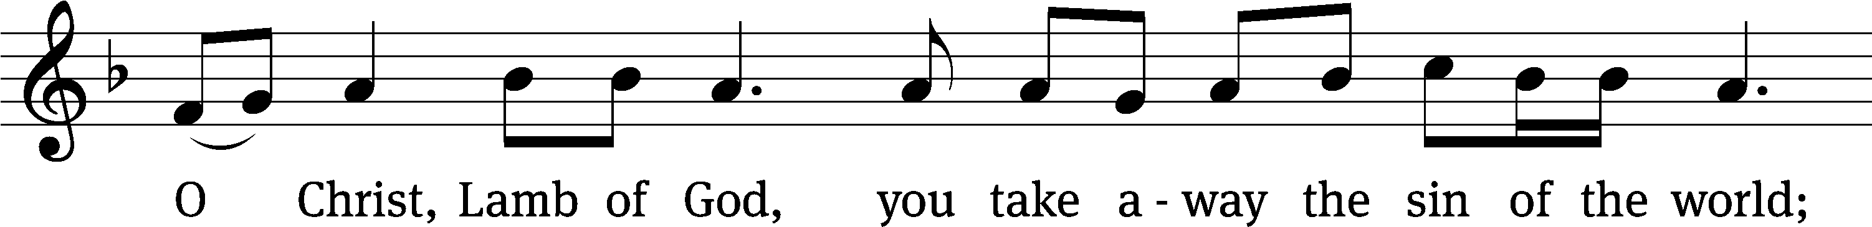
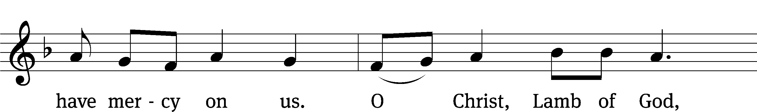
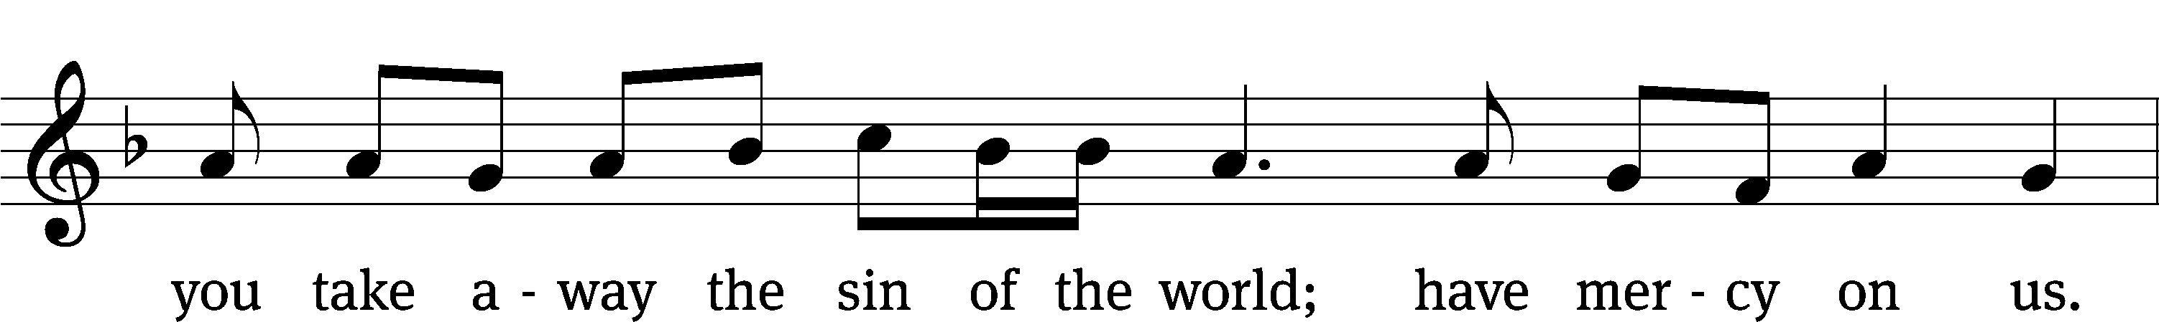
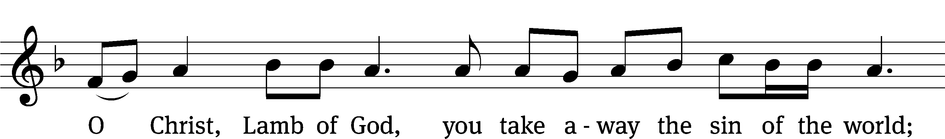
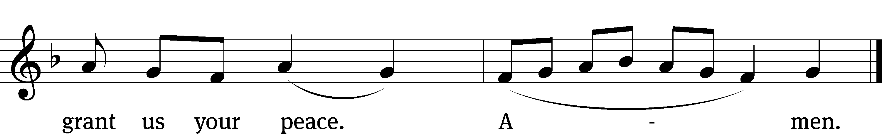
Please be seated

711 Jesus Calls Us O’er the Tumult CW 711
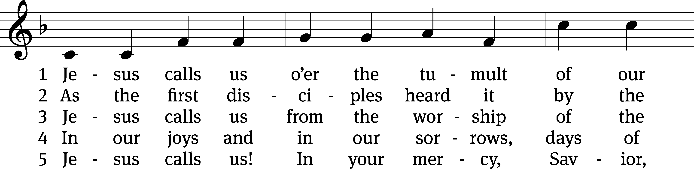
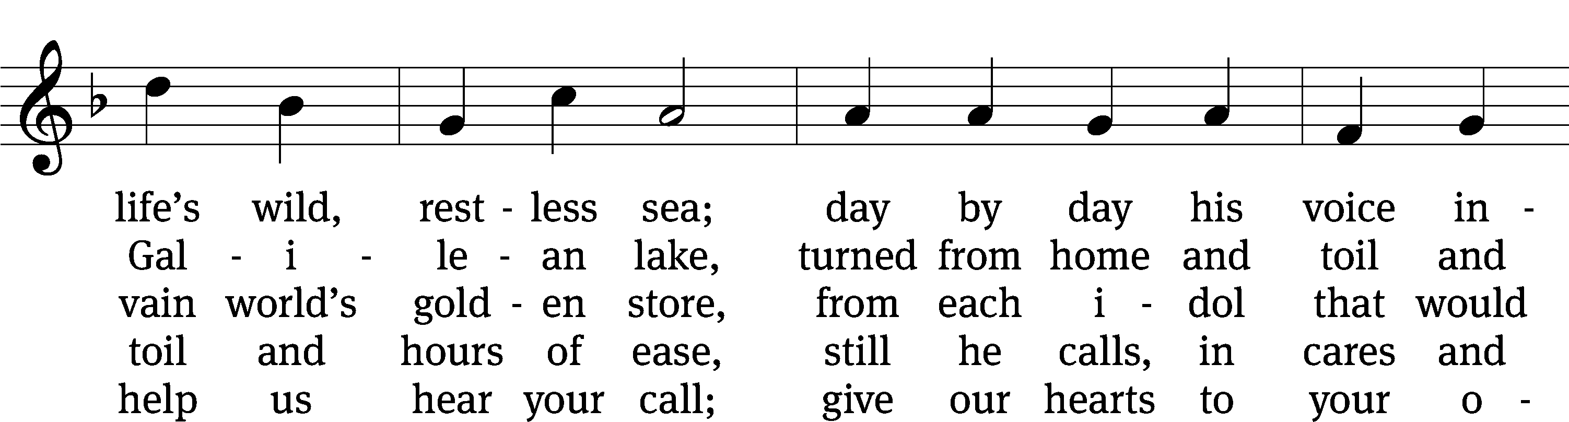
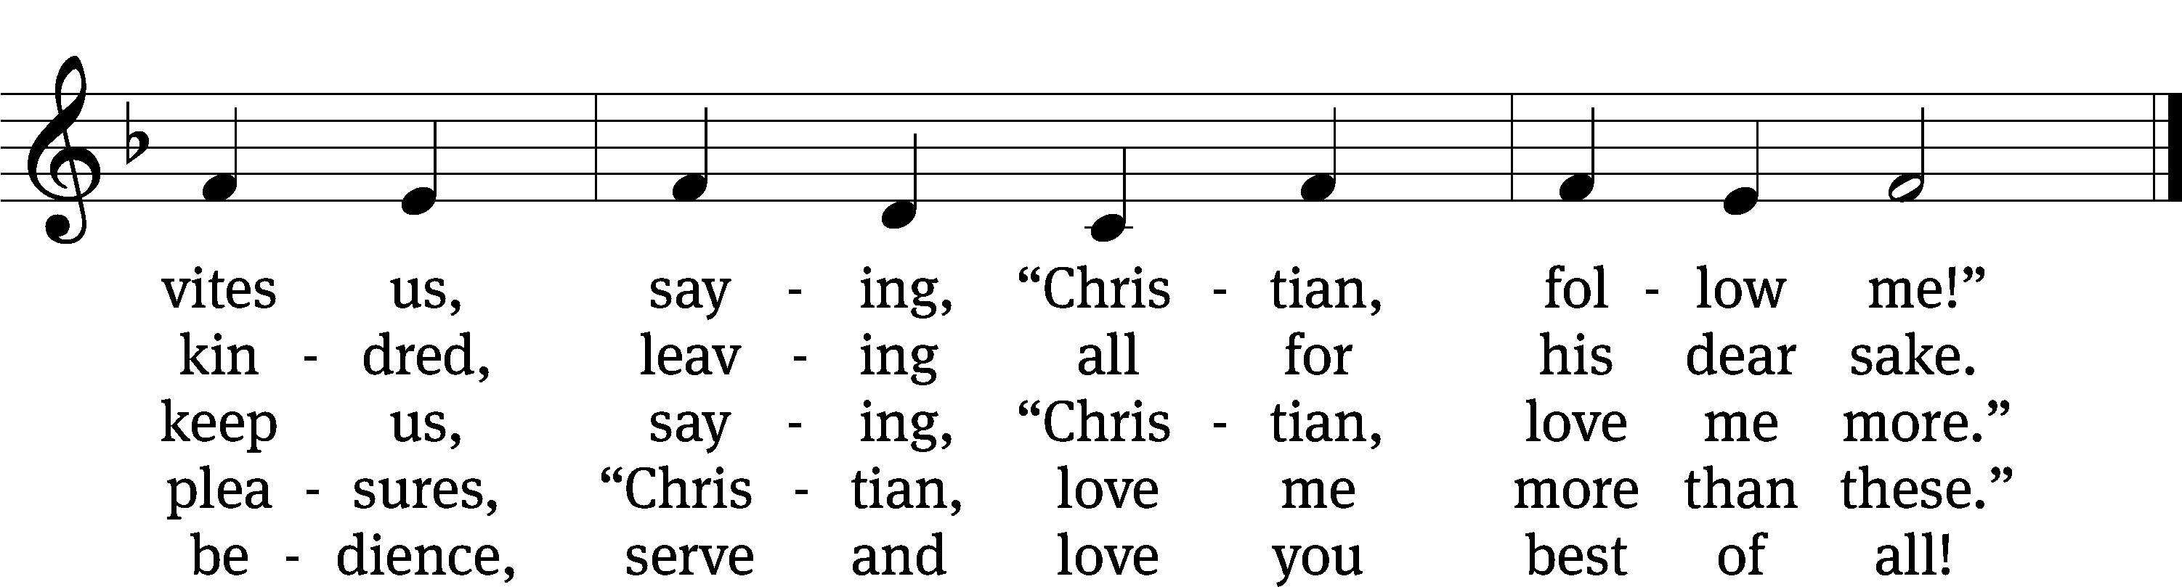
Text: Cecil F. Alexander, 1818–1895, alt.
Text and tune: Public domain

831 Why Should Cross and Trial Grieve Me CW 831
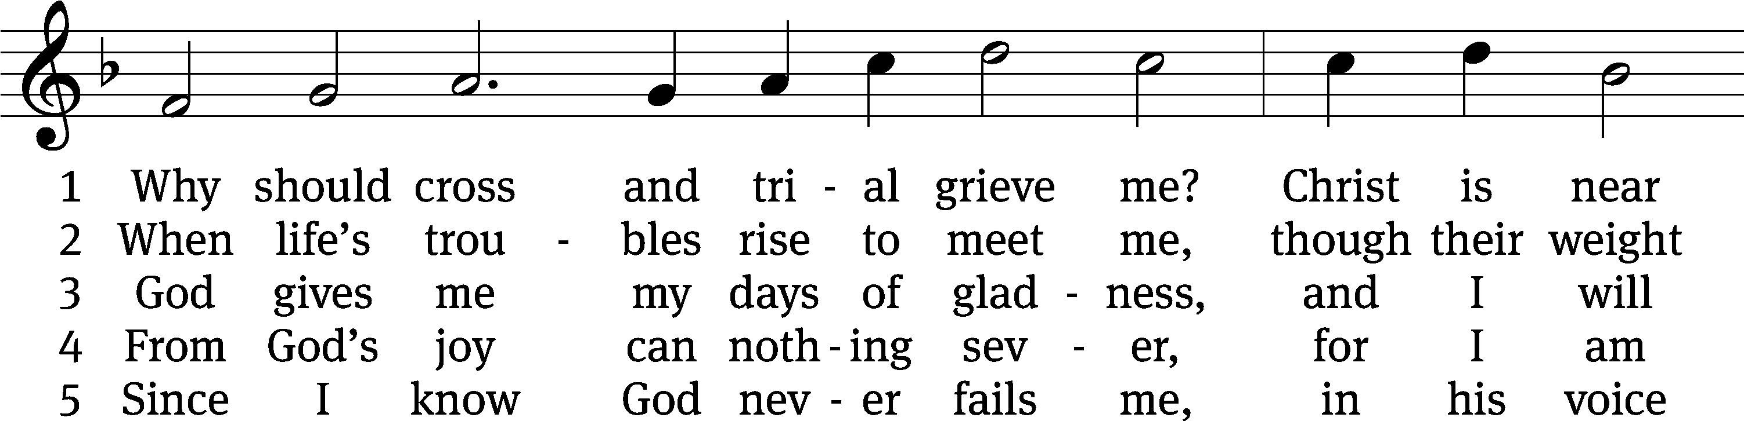
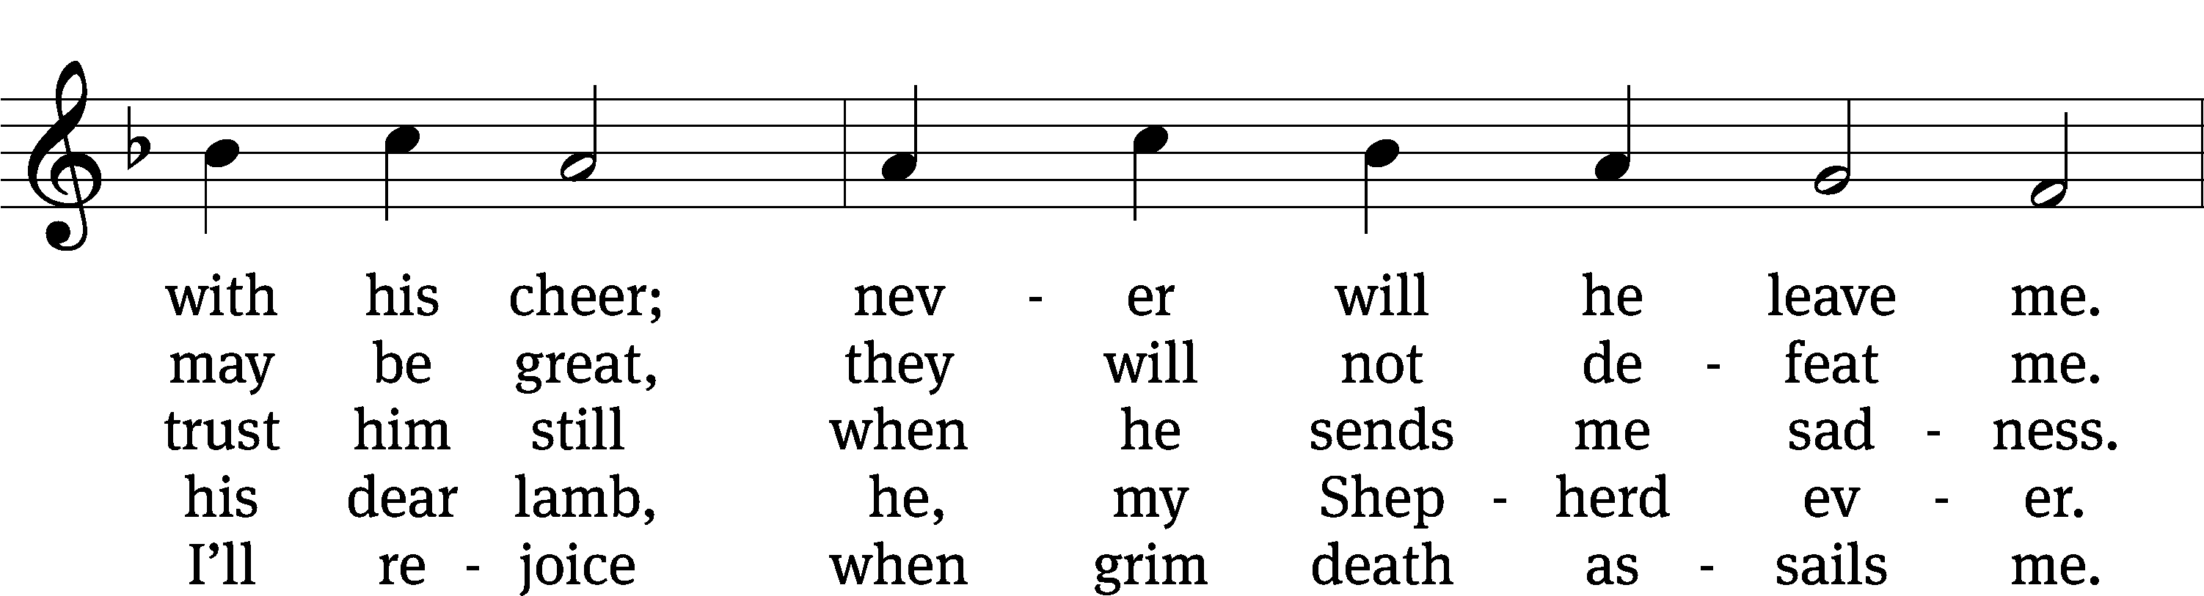
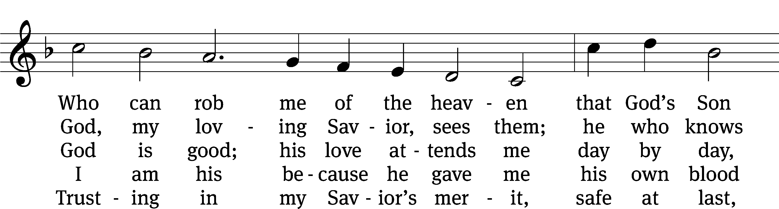
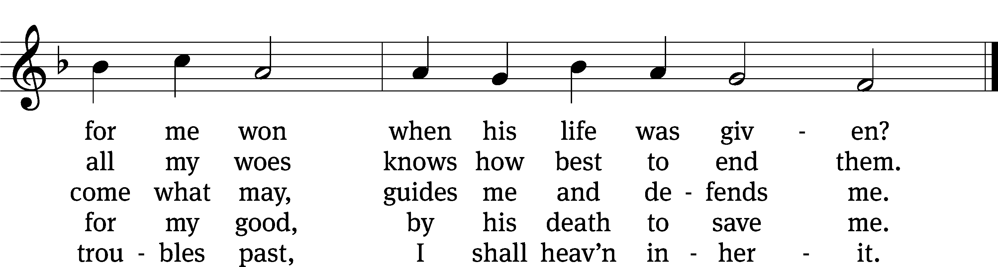
Text: Paul Gerhardt, 1607–1676, abr.; (sts. 1–3): tr. Christian Worship, 1993; (st. 4): tr. Stephen P. Starke, b. 1955; (st. 5): tr. Harlyn J. Kuschel, b. 1945
Tune: Johann G. Ebeling, 1637–1676
Text (st. 4): © 2004 Stephen P. Starke, admin. Concordia Publishing House; (st. 5): © 1993 Harlyn J. Kuschel, admin. Northwestern Publishing House. Used by permission: OneLicense no. 727703
Text (sts. 1–3) and tune: Public domain

Please stand, if you are able

Give thanks to the Lord, for he is good;
his mercy endures forever.
Whenever we eat this bread and drink this cup,
we proclaim the Lord’s death until he comes.

We give thanks, almighty God, that you have refreshed us with this saving gift. We pray that through it you will strengthen our faith in you and increase our love for one another. We ask this in the name of Jesus Christ our Lord, who lives and reigns with you and the Holy Spirit, one God, now and forever.
Amen.

Blessing
The Lord bless you and keep you.
The Lord make his face shine on you and be gracious to you.
The Lord look on you with favor and give you peace.
Amen.

Please be seated

705 Oh, That the Lord Would Guide My Ways CW 705
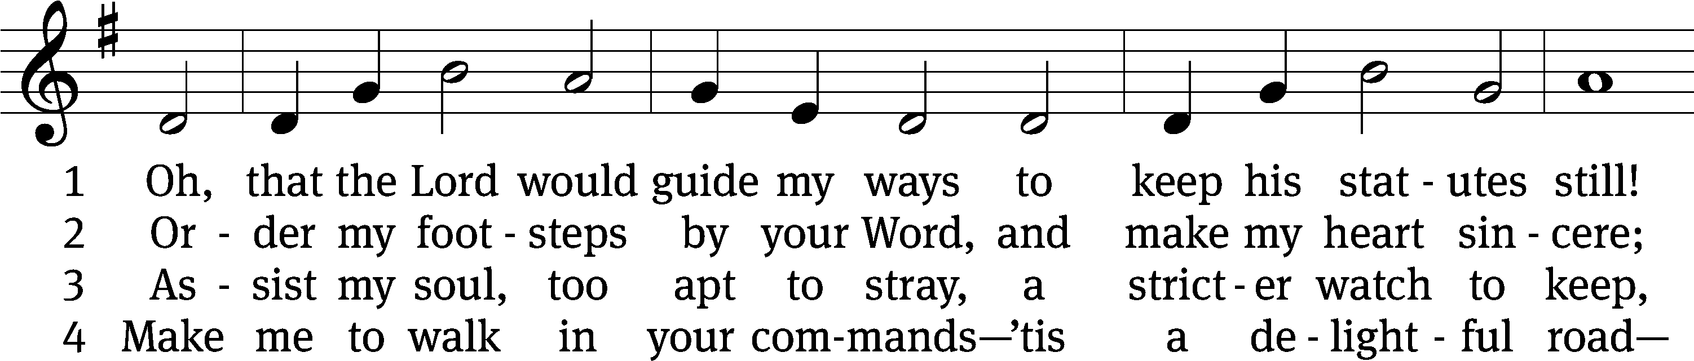
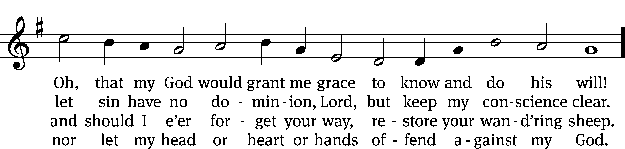
Text: Isaac Watts, 1674–1748, abr., alt.
Tune: William H. Havergal, 1793–1870
Text and tune: Public domain

Acknowledgments
Setting One from Christian Worship
Software distributed in partnership with Northwestern Publishing House.
Created by Christian Worship: Service Builder © 2022 Concordia Publishing House.

Serving in Worship
Officiant Pastor Natsis
Organist Marcia Marion Ackling
Deacons (Thursday) Dave Frey and Jim Tice
(Sunday) Jeff Neuburger and Ed Wheeler
Ushers (Thursday) Robert Newman and Henry Schneider
(Sunday) Bill Barnett and Jake Vershum
Altar Guild Maria Marion Ackling and Judy Lindemann
Videographer Jake Vershum

