SEVENTH SUNDAY OF EASTER
ascension

TRINITY EVANGELICAL LUTHERAN CHURCH | Saline, Michigan
WELCOME TO WORSHIP May 29, 2022
Thank you for joining us in God’s house today! We cordially ask that our Guests sign one of the guestbooks located at either the front or back entryways, or fill out a “Let’s Get Acquainted” card located in the hymnal pew rack and place it in the collection plate.

THANK OFFERING: Members of Trinity give their offering as an expression of love and thankfulness to the Lord and to help support the Lord’s work in our community and around the world. Visitors need not feel obligated to participate in this offering which supports our ministry.

Restrooms are located at the back of the upper level (the annex), and in the basement (down the back stairs of the sanctuary or annex). Handicap access is available, please ask an usher for assistance.

Young Families / Toddler Bags – We are GLAD YOU BROUGHT YOUR CHILDREN to our worship service. Jesus said: “Let the little children come to me and do not hinder them, for the kingdom of God belongs to such as these.” We know that having little children in church can be a challenge, but DO NOT WORRY about it. Many of your fellow worshippers have been in your shoes and are just happy you brought your children with you. For your convenience, we have reserved the back rows of seating for parents with small children. These areas provide more flexibility for your family, as well as, easy access to move downstairs if necessary. A closed-circuit TV system allows families to continue participating in the service while downstairs. Pre-school toddler bags and children’s bulletins are available for their enjoyment. Ask an usher for one to use during the service and please return the toddler bag afterwards.

the SERVICE – setting one – american hymn tunes
474 Hail the Day That Sees Him Rise CW 474
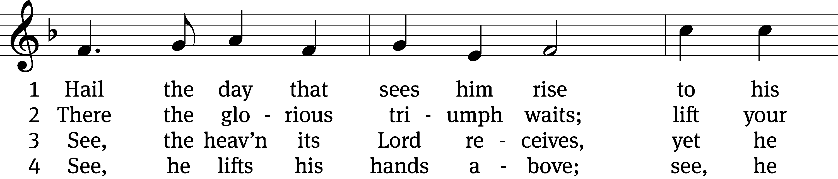
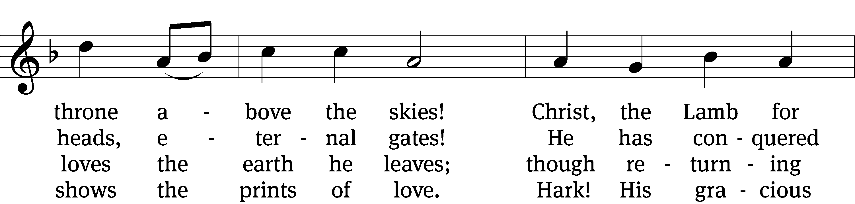
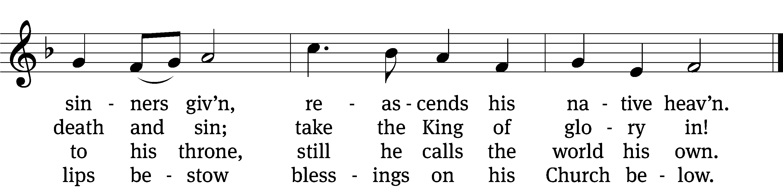

5 Still for us he intercedes,
his atoning death he pleads.
He, the first of all our race,
near himself prepares a place.

6 There we shall with him remain,
partners in his endless reign,
there his face unclouded see,
live with him eternally.
Text and tune: Public domain
Text: Charles Wesley, 1707–1788, abr., alt.
Tune: adapt. Richard Redhead, 1820–1901; Pierre de Corbeille, d. 1221

Please stand, if you are able
Invocation
In the name of the Father and of the Son and of the Holy Spirit.
Amen.
Confession
If we claim to be without sin, we deceive ourselves and the truth is not in us.
If we confess our sins, God is faithful and just
and will forgive us our sins
and purify us from all unrighteousness.

Let us confess our sins to the Lord.
Holy God, gracious Father,
I am sinful by nature
and have sinned against you in my thoughts, words, and actions.
I have not loved you with my whole heart;
I have not loved others as I should.
I deserve your punishment both now and forever.
But Jesus, my Savior, paid for my sins
with his innocent suffering and death.
Trusting in him, I pray: God, have mercy on me, a sinner.

Our gracious Father in heaven has been merciful to us. He sent his only Son, Jesus Christ, who gave his life as the atoning sacrifice for the sins of the whole world. Therefore, as a called servant of Christ and by his authority, I forgive you all your sins in the name of the Father and of the the Son and of the Holy Spirit.
Amen.
Lord, Have Mercy
In peace let us pray to the Lord.
Lord, have mercy.

For the peace from above and for our salvation, let us pray to the Lord.
Lord, have mercy.

For the peace of the whole world, for the well-being of the Church of God, and for the unity of all, let us pray to the Lord.
Lord, have mercy.

For this holy house and for all who offer here their worship and praise, let us pray to the Lord.
Lord, have mercy.

Help, save, comfort, and defend us, gracious Lord.
Amen.

Glory to God in the Highest
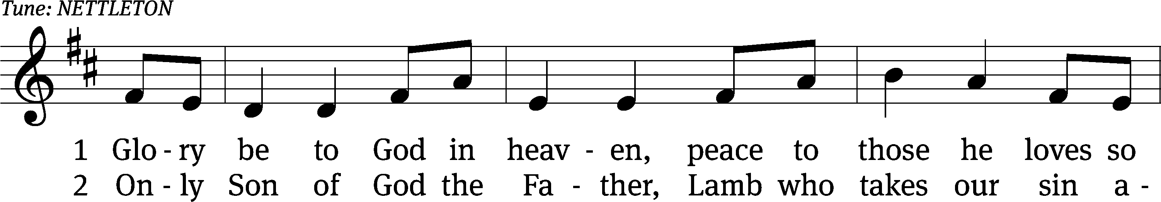
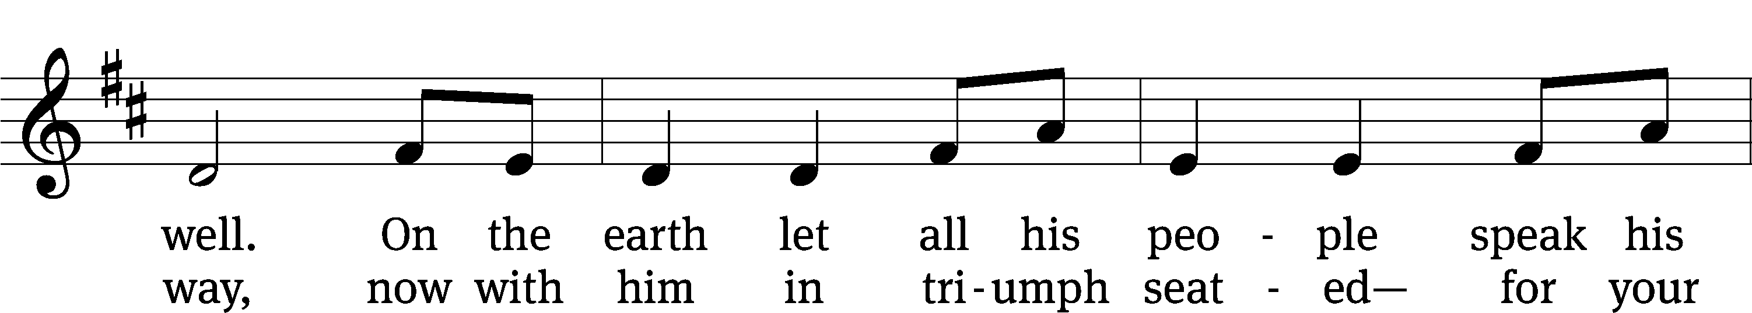
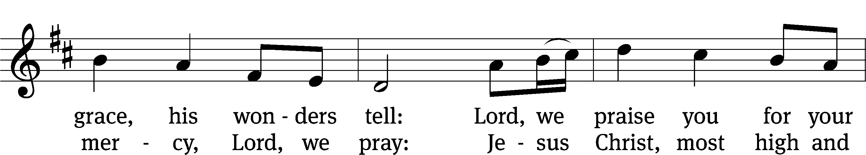
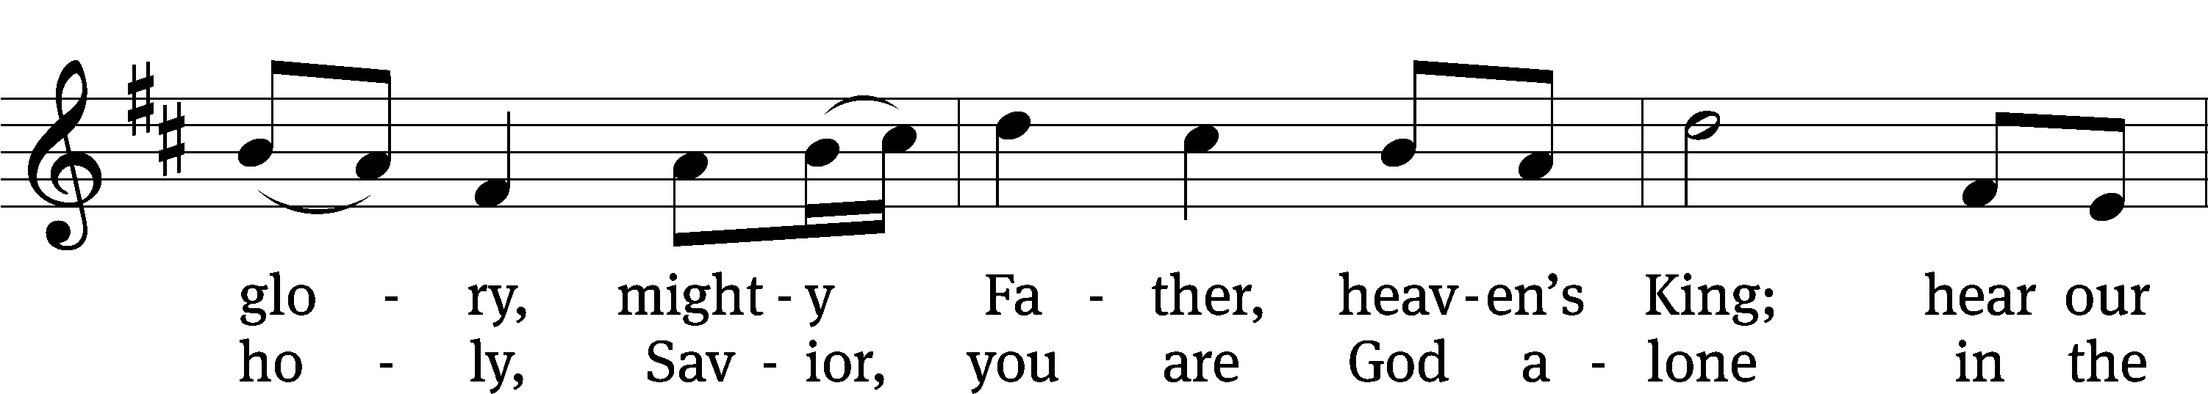
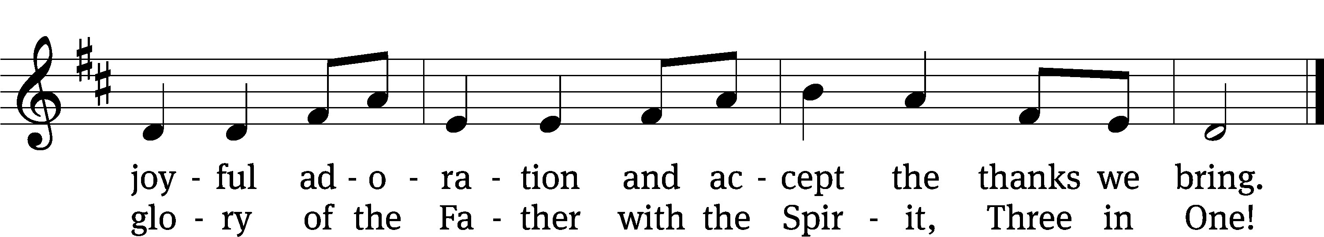
Text: © 1982 Hope Publishing Co. Used by permission: OneLicense no. 727703
Text: Michael A. Perry
The Lord be with you.
And also with you.
Prayer of the Day
Let us pray.

Lord Jesus, King of glory, on this day you ascended far above the heavens, and at God’s right hand you rule the nations. Leave us not alone, we pray, but grant us the Spirit of truth that, at your command and by your power, we may be your witnesses in all the world; for you live and reign with the Father and the Holy Spirit, one God, now and forever.
Amen.

Please be seated

First Reading Acts 1:1-11
¹ I wrote my first book, Theophilus, about everything Jesus began doing and teaching ² until the day he was taken up, after he had given instructions through the Holy Spirit to the apostles he had chosen. ³ After he had suffered, he presented himself alive to the apostles with many convincing proofs. He appeared to them over a period of forty days and told them things about the kingdom of God.
⁴ Once, when he was eating with them, he commanded them, “Do not depart from Jerusalem, but wait for what the Father promised, which you heard from me. ⁵ For John baptized with water, but you will be baptized with the Holy Spirit not many days from now.”
⁶ So when they were together with him, they asked, “Lord, is this the time when you are going to restore the kingdom to Israel?”
⁷ He said to them, “It is not for you to know the times or seasons that the Father has set by his own authority. ⁸ But you will receive power when the Holy Spirit has come upon you, and you will be my witnesses in Jerusalem, in all Judea and Samaria, and to the ends of the earth.”
⁹ After he said these things, he was taken up while they were watching, and a cloud took him out of their sight. ¹⁰ They were looking intently into the sky as he went away. Suddenly, two men in white clothes stood beside them. ¹¹ They said, “Men of Galilee, why are you standing here looking up into the sky? This same Jesus, who has been taken up from you into heaven, will come back in the same way you have seen him go into heaven.”
The Word of the Lord.
Thanks be to God.

Psalm of the Day

47D All Peoples, Clap Your Hands Psalm 47D
(to the tune of “Crown Him with Many Crowns”)

All peoples, clap your hands, and shout with joy and sing.
The Lord Most High is to be feared; he is the earth’s great King.
He brings the nations down, subdues them in our sight;
He chooses our inheritance; his love is Jacob’s might.

God has gone up on high, with shout and trumpet voice;
Sing praise to God, our glorious King, sing praise to him, rejoice!
For God is King of all. Sing praise with all your skill;
He sits upon his holy throne and rules the nations still.

Nobles from all the earth are joined with Abram’s seed;
The rulers of the world are God’s; he’s lifted high indeed!
So to the Father raise, with his ascended Son,
And Holy Spirit endless praise, eternal Three in One.
Second Reading Revelation 19:11-16
¹¹ I saw heaven standing open, and there was a white horse! Its rider is called Faithful and True, and he judges and makes war in righteousness. ¹² His eyes are like blazing flames, and on his head are many crowns. He has a name written on him, which no one knows except he himself. ¹³ He is also clothed in a garment that had been dipped in blood, and his name is the Word of God. ¹⁴ The armies in heaven, which were clothed with white, clean, fine linen, were following him on white horses. ¹⁵ Out of his mouth comes a sharp sword with which to strike down the nations. He will shepherd them with an iron staff. He himself is going to trample the winepress of the fierce anger of the Almighty God. ¹⁶ On his garment and on his thigh this name is written: King of Kings and Lord of Lords.

The Word of the Lord.
Thanks be to God.

Please stand, if you are able
Gospel Acclamation Matthew 28:20
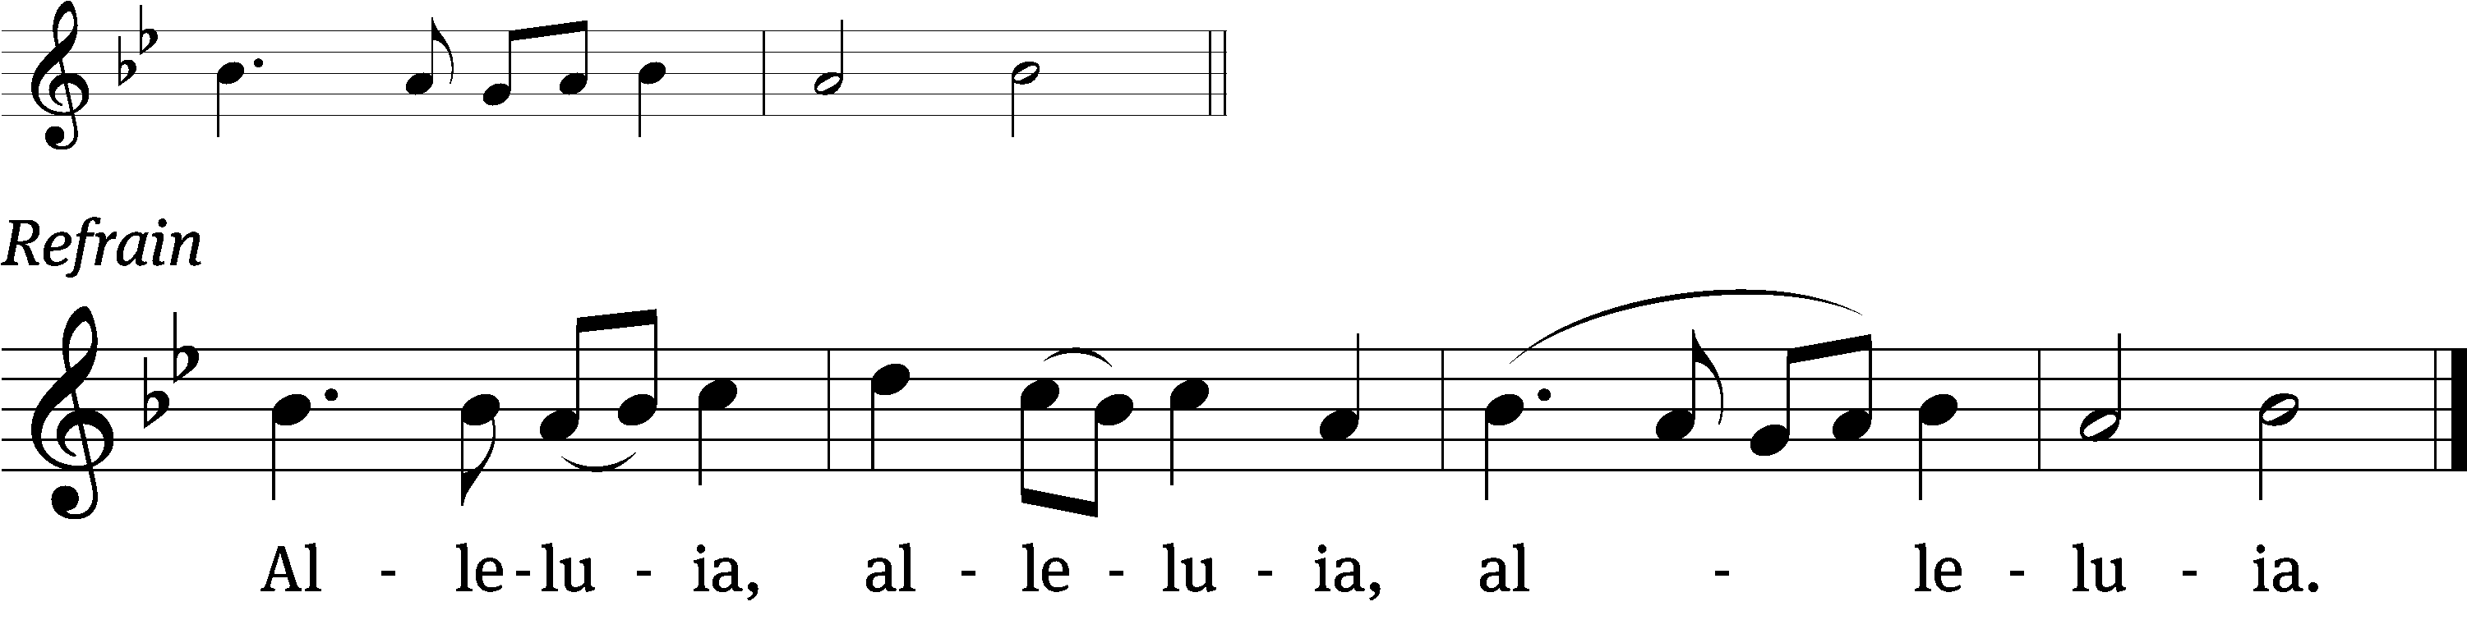
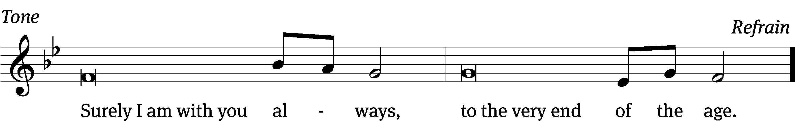
Tune: © 2021 Northwestern Publishing House. Used by permission: OneLicense no. 727703

Gospel Luke 24:44-53
⁴⁴ He said to them, “These are my words that I spoke to you while I was still with you: Everything must be fulfilled that is written about me in the Law of Moses, the Prophets, and the Psalms.”
⁴⁵ Then he opened their minds to understand the Scriptures. ⁴⁶ He said to them, “This is what is written and so it must be: The Christ will suffer and rise from the dead on the third day, ⁴⁷ and repentance and forgiveness of sins will be preached in his name to all nations, beginning from Jerusalem. ⁴⁸ You are witnesses of these things. ⁴⁹ Look, I am sending you what my Father promised. But stay in the city until you are clothed with power from on high.”
⁵⁰ He led them out as far as the vicinity of Bethany. He lifted up his hands and blessed them. ⁵¹ And while he was blessing them, he parted from them and was taken up into heaven. ⁵² So they worshipped him and returned to Jerusalem with great joy. ⁵³ They were continually in the temple courts, praising and blessing God. Amen.

The Gospel of the Lord.
Praise be to you, O Christ!

Please be seated
Sermon Hymn
A Hymn of Glory Let Us Sing CW 472
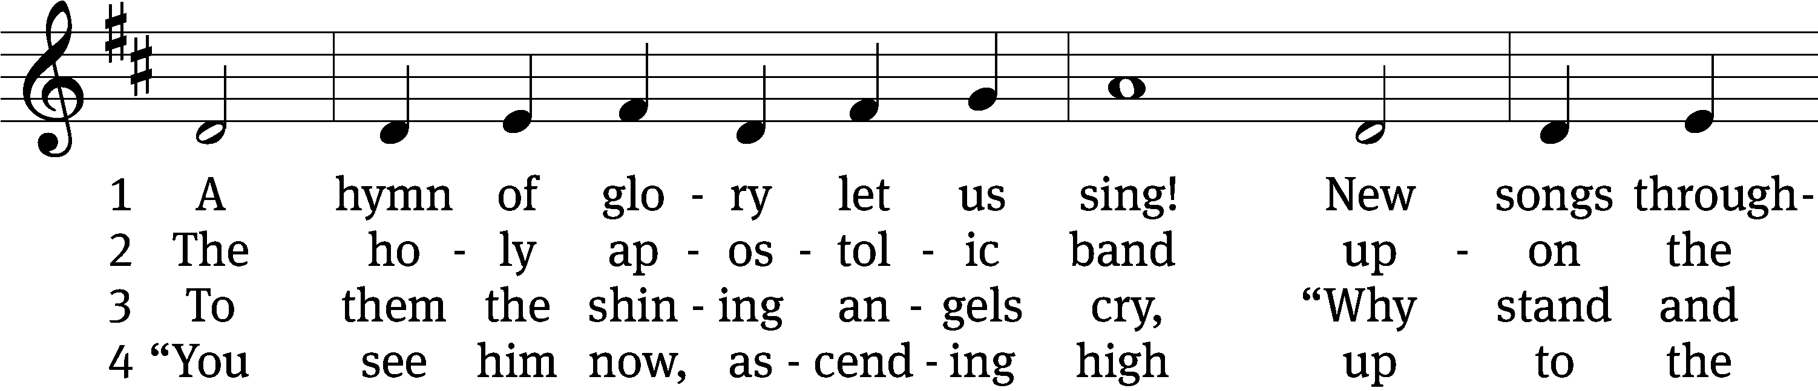
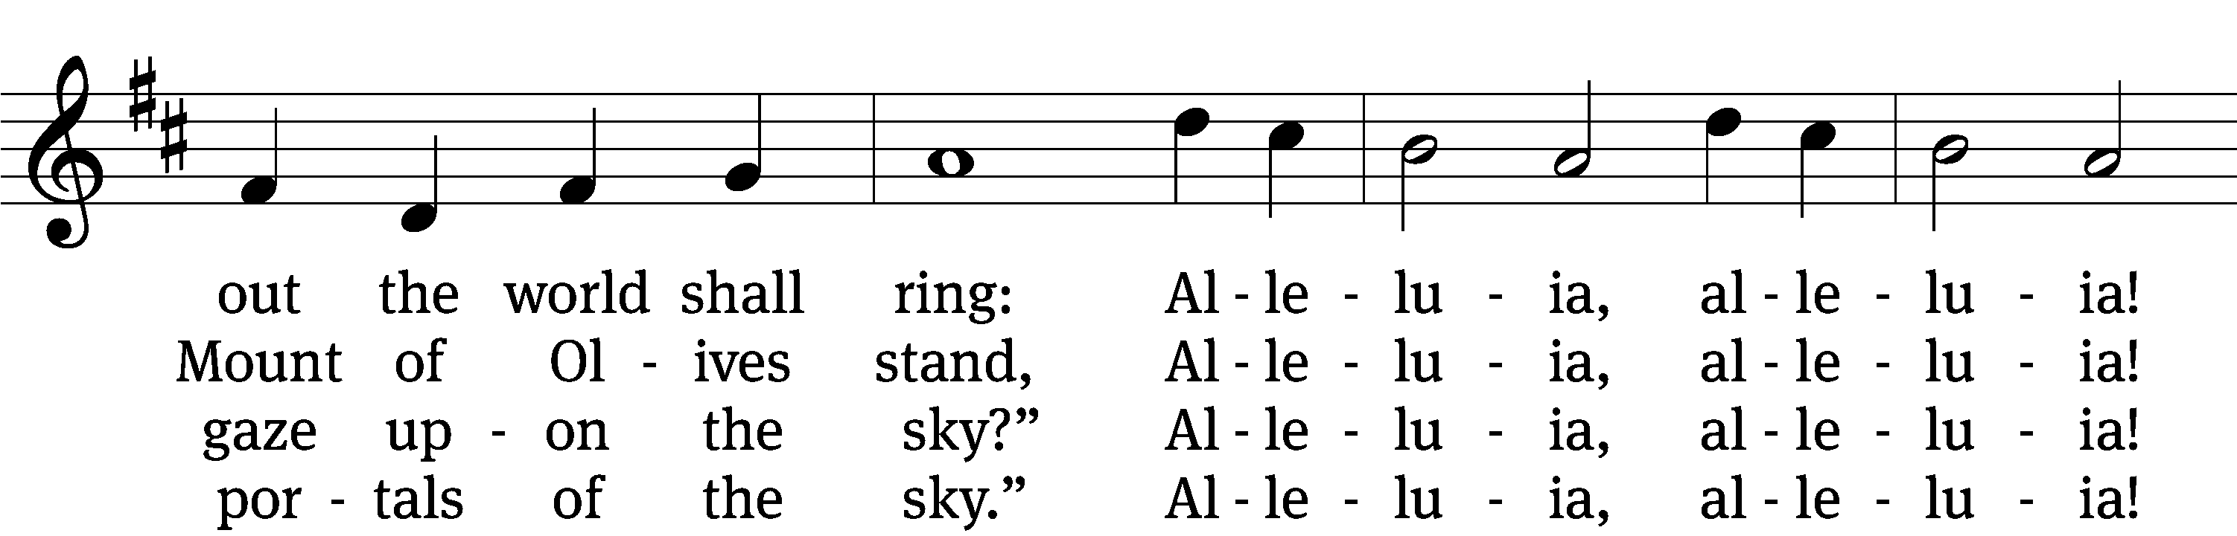
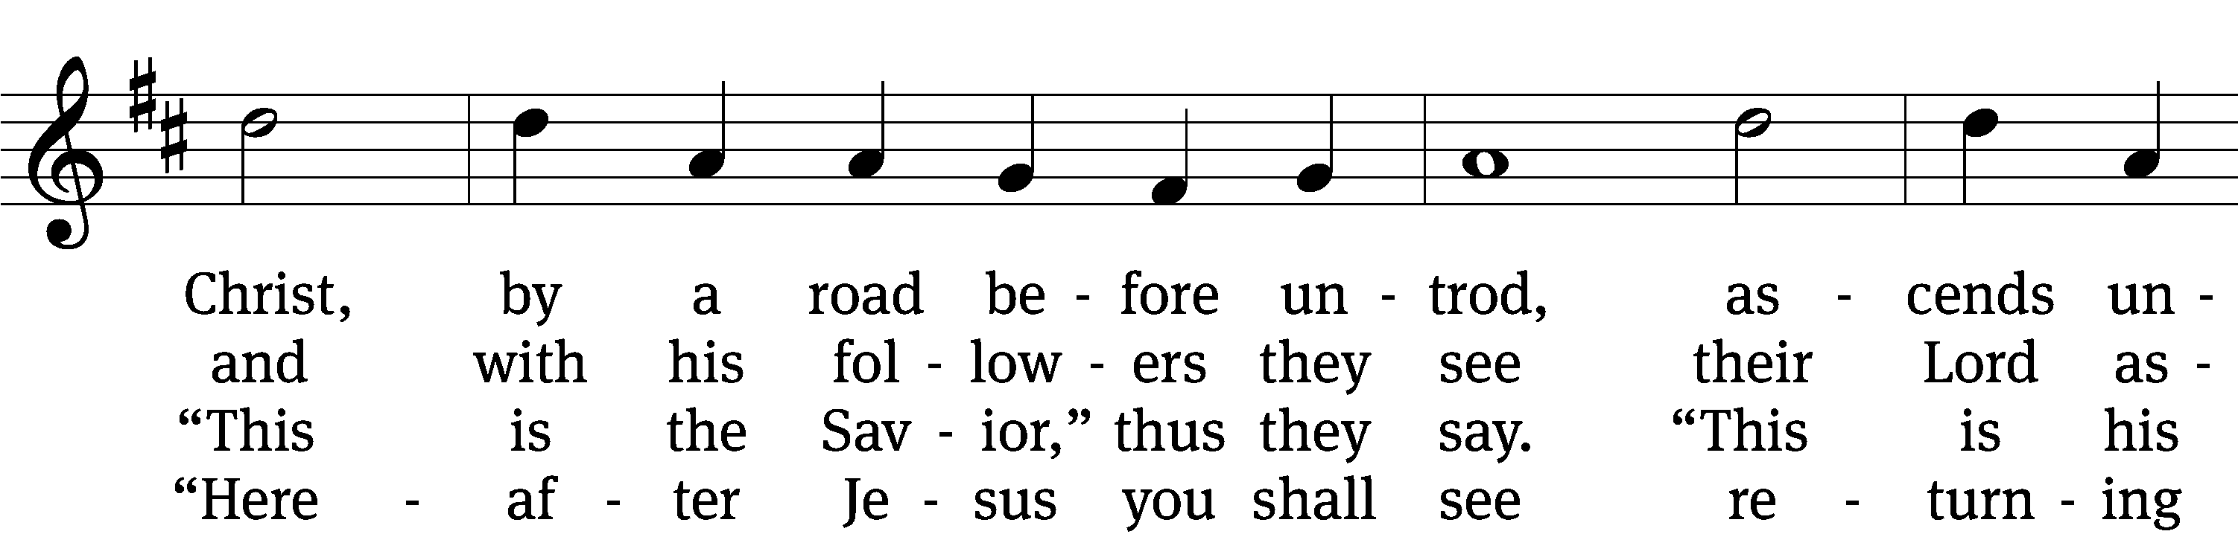
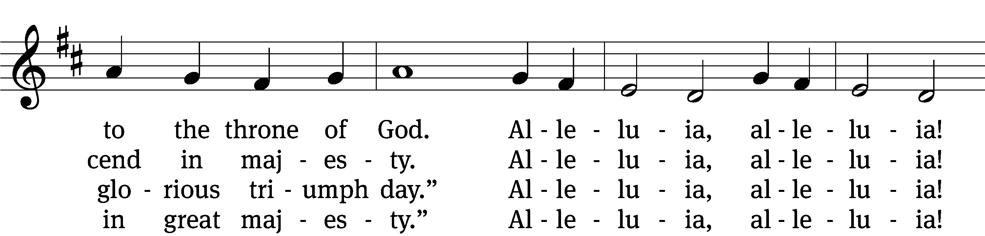
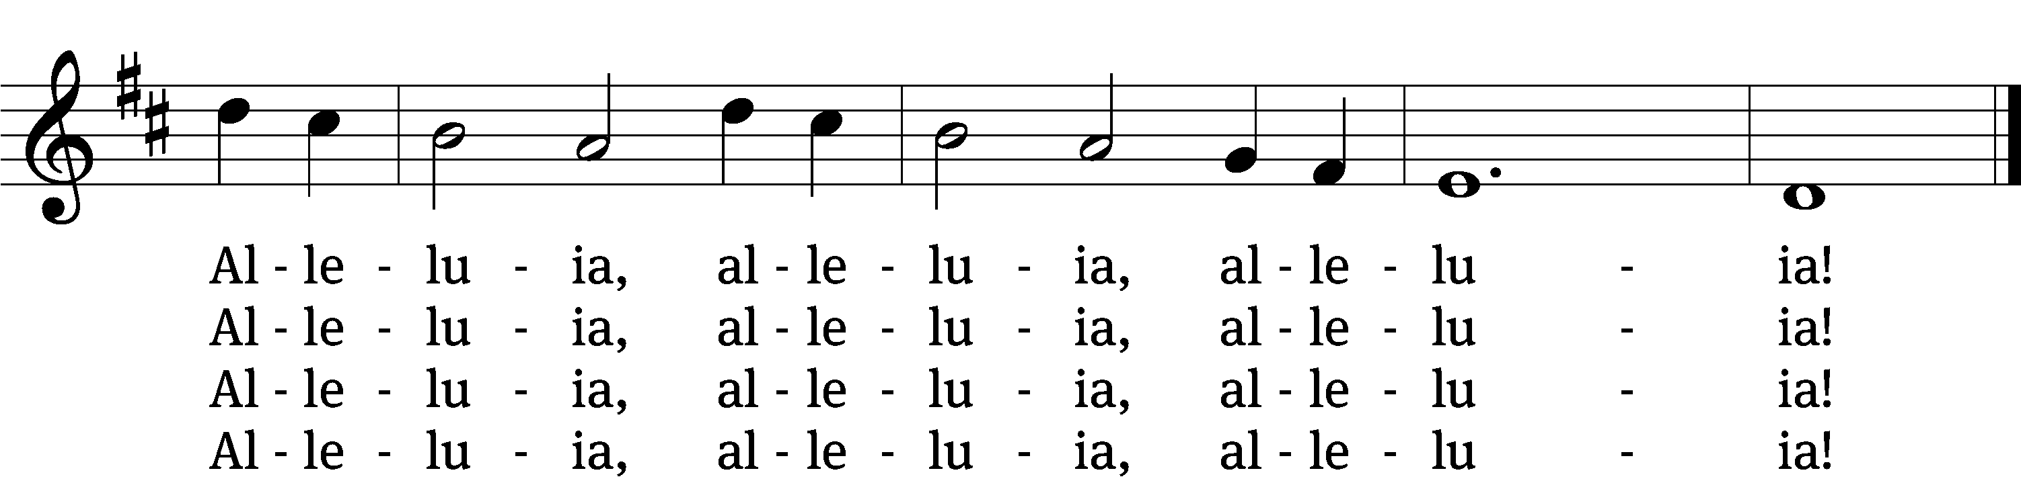

5 Be now our joy on earth, O Lord,
and be our future great reward.
Alleluia, alleluia!
Then, throned with you forever, we
shall praise your name eternally.
Alleluia, alleluia!
Alleluia, alleluia, alleluia!

6 O risen Christ, ascended Lord,
all praise to you let earth accord.
Alleluia, alleluia!
You are, while endless ages run,
with Father and with Spirit one.
Alleluia, alleluia!
Alleluia, alleluia, alleluia!
Text and tune: Public domain
Text: tr. composite; The Venerable Bede, 673–735, abr.
Tune: Geistliche Kirchengesäng, Köln, 1623

Sermon Ephesians 1:18-22

¹⁸ I pray that the eyes of your heart may be enlightened, so that you may know the hope to which he has called you, just how rich his glorious inheritance among the saints is, ¹⁹ and just how surpassingly great his power is for us who believe. ²⁰ It is as great as the working of his mighty strength, which God worked in Christ when he raised him from the dead and seated him at his right hand in the heavenly places, ²¹ far above all rule, authority, power, and dominion, and above every name that is given, not only in this age but also in the one to come. ²² God also placed all things under his feet and made him head over everything for the church.

“Who’s Your Jesus?”

Please stand, if you are able
Apostles’ Creed
I believe in God, the Father Almighty,
maker of heaven and earth.

I believe in Jesus Christ, his only Son, our Lord,
who was conceived by the Holy Spirit,
born of the Virgin Mary,
suffered under Pontius Pilate,
was crucified, died, and was buried.
He descended into hell.
The third day he rose again from the dead.
He ascended into heaven
and is seated at the right hand of God the Father Almighty.
From there he will come to judge the living and the dead.

I believe in the Holy Spirit,
the holy Christian Church,
the communion of saints,
the forgiveness of sins,
the resurrection of the body,
and the life everlasting. Amen.

Prayer of the Church

742 On Galilee’s High Mountain CW 742
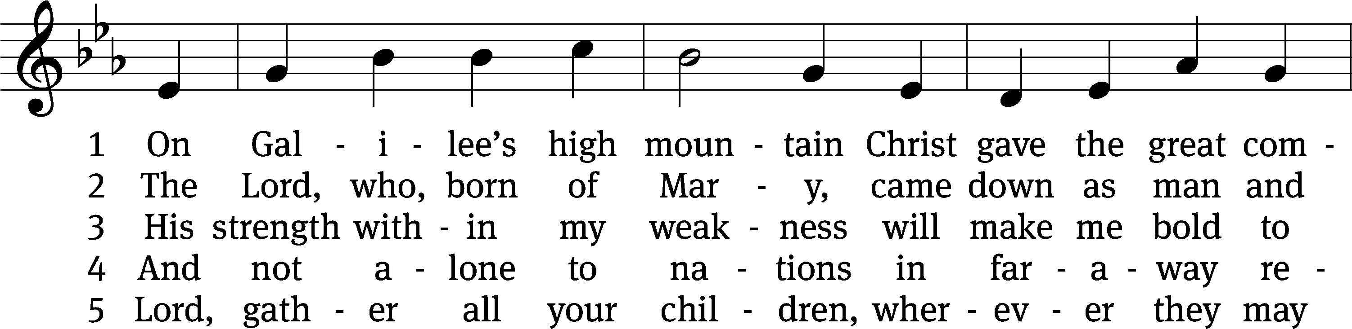
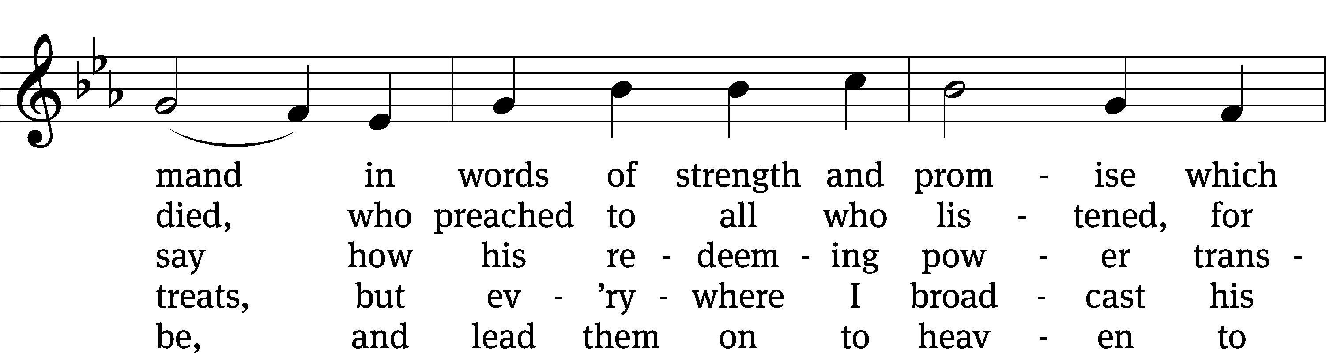
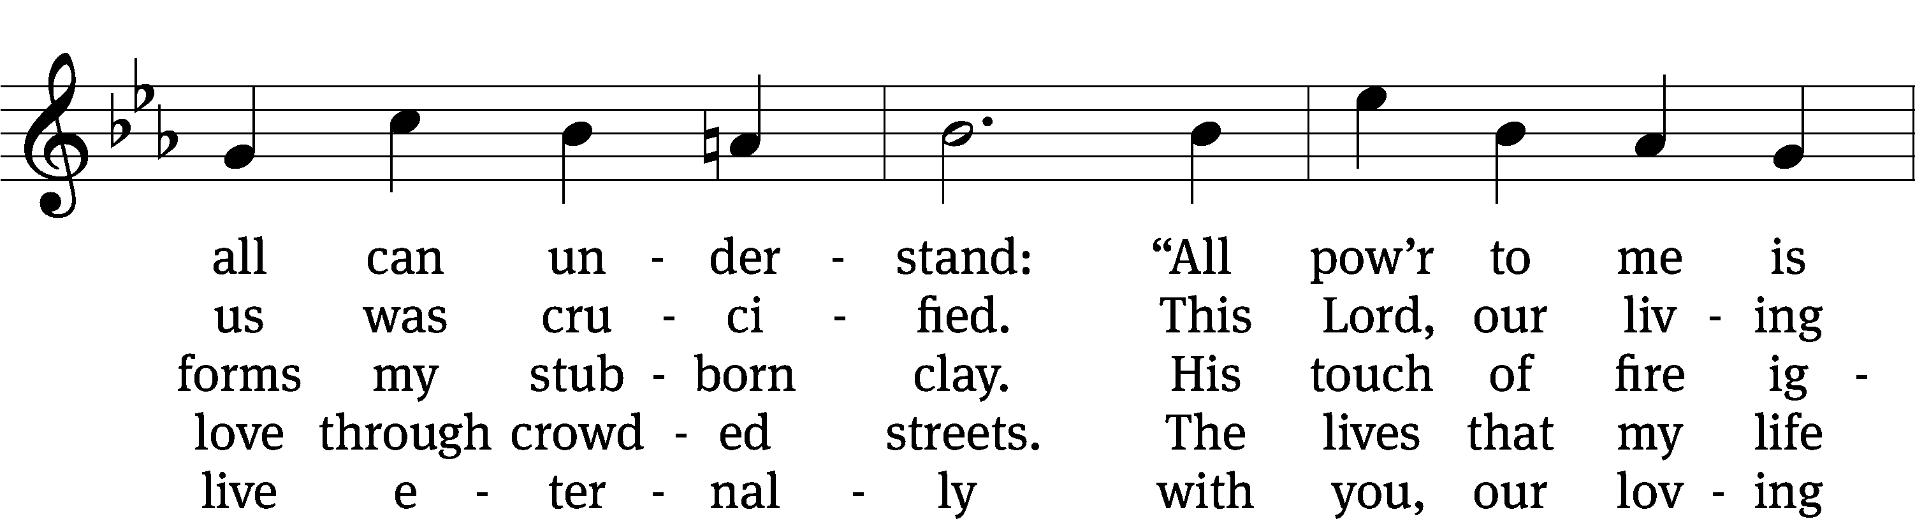
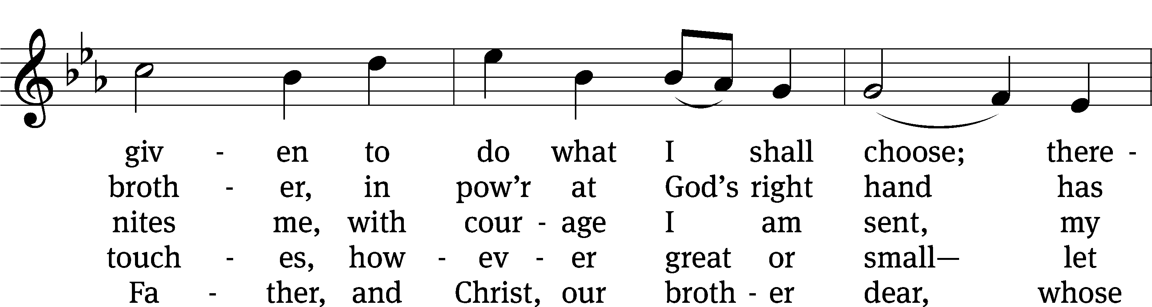
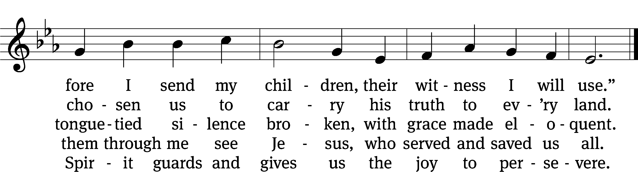
Text: © 1982 Concordia Publishing House. Used by permission: OneLicense no. 727703
Tune: Public domain
Text: Henry L. Lettermann, 1932–1996, abr.
Tune: Lowell Mason, 1792–1872
Prayer
Blessed Lord, you have given us your Holy Scriptures for our learning. May we so hear them, read, learn, and take them to heart that, being strengthened and comforted by your holy Word, we may cling to the blessed hope of everlasting life; through Jesus Christ our Lord, who lives and reigns with you and the Holy Spirit, one God, now and forever.
Amen.
Lord’s Prayer
Our Father, who art in heaven, hallowed be thy name, thy kingdom come, thy will be done on earth as it is in heaven. Give us this day our daily bread; and forgive us our trespasses, as we forgive those who trespass against us; and lead us not into temptation, but deliver us from evil. For thine is the kingdom and the power and the glory forever and ever. Amen.

Blessing

The Lord bless you and keep you.
The Lord make his face shine on you and be gracious to you.
The Lord look on you with favor and give you peace.
Amen.

Please be seated

476 On Christ’s Ascension I Now Build CW 476
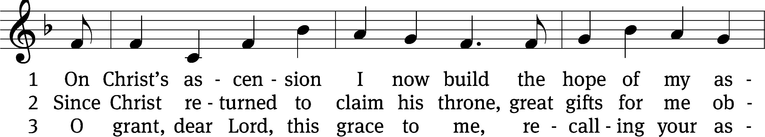
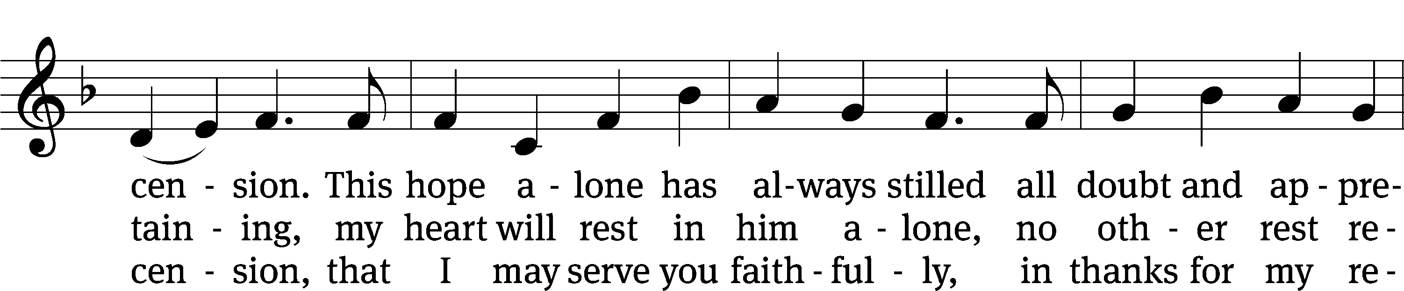
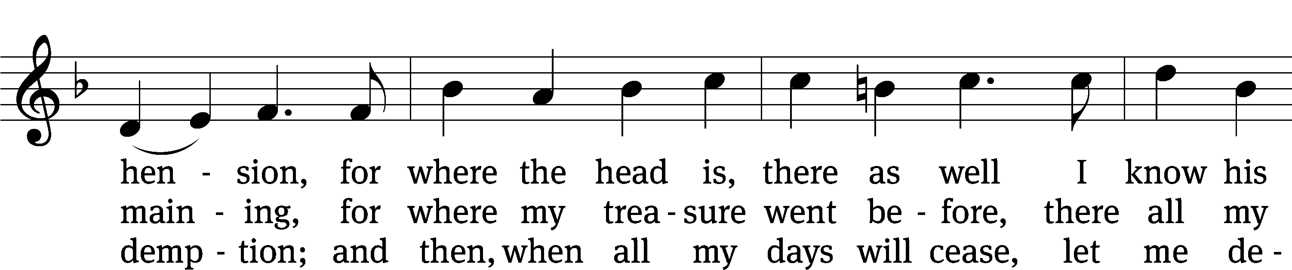
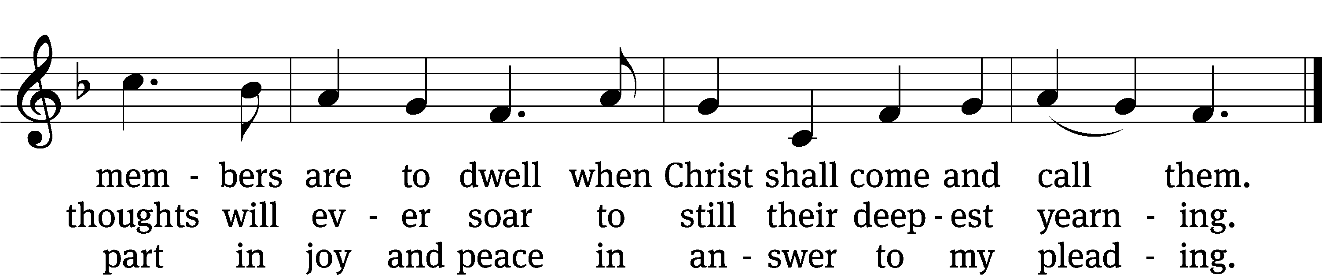
Text: © 1941 Concordia Publishing House. Used by permission: OneLicense no. 727703
Tune: Public domain
Text: tr. William M. Czamanske, 1873–1964, alt.; Josua Wegelin, 1604–1640
Tune: Etlich Cristlich lider, Wittenberg, 1524

Acknowledgments
American Hymn Tunes from Christian Worship
Software distributed in partnership with Northwestern Publishing House.
Created by Christian Worship: Service Builder © 2022 Concordia Publishing House.

Serving in Worship
Officiant Pastor Natsis
Organist Marcia Marion Ackling
Instrumentalist (Thursday) Tom Amerman
Deacons (Thursday) Dave Frey and Steve Hoeft
Deacons (Sunday) Dave Stevenson and Ed Wheeler
Ushers (Thursday Dale Radak
Ushers (Sunday) Ron Zahn
Altar Guild Sandy Kirkpatrick and Barb Neuburger
Videographer Cindy Dresch

