the FIFTH sunday
OF EASTER

TRINITY EVANGELICAL LUTHERAN CHURCH | Saline, Michigan
WELCOME TO WORSHIP May 15, 2022

Thank you for joining us in God’s house today! We cordially ask that our guests sign one of the guestbooks located at either the front or back entryways.

THANK OFFERING: Members of Trinity give their offering as an expression of love and thankfulness to the Lord and to help support the Lord’s work in our community and around the world. Visitors need not feel obligated to participate in this offering which supports our ministry.

Restrooms are located at the back of the upper level (the annex), and in the basement (down the back stairs of the sanctuary or annex). Handicap access is available, please ask an usher for assistance.

celebration of holy communion:
In His Word, God makes it clear that the Lord’s Supper is to be shared by people of a common proclamation of faith (1 Corinthians 11:26; 1 Corinthians 10:16-17). Without judging anyone’s hearts, we invite those who share in our confession by their membership in our congregation or another congregation of the Wisconsin Evangelical Lutheran Synod (WELS) or the Evangelical Lutheran Synod (ELS) and who are properly prepared (1 Corinthians 11;27-29) to receive the Sacrament. Page 295 in the front of Christian Worship provides a guide for preparation.

Guests, we would love to have you join us in communion fellowship in the future, and for that to be possible, we ask that you speak with one of the pastors so that we may speak with you on how that would be possible. We thank you for respecting the way we celebrate the Lord’s Supper in our congregations.

SERVICE OF WORD AND SACRAMENT
704 Let Us Ever Walk with Jesus CW 704
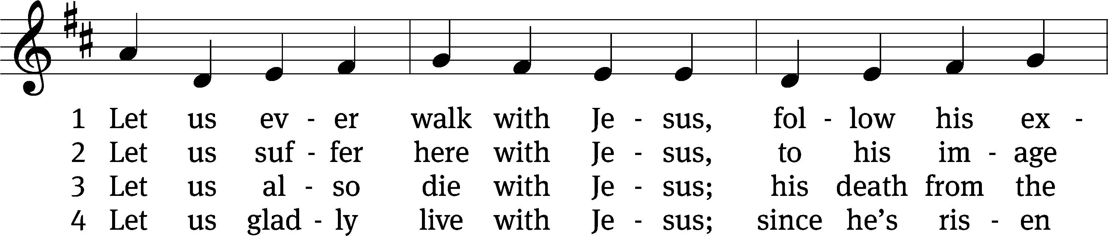
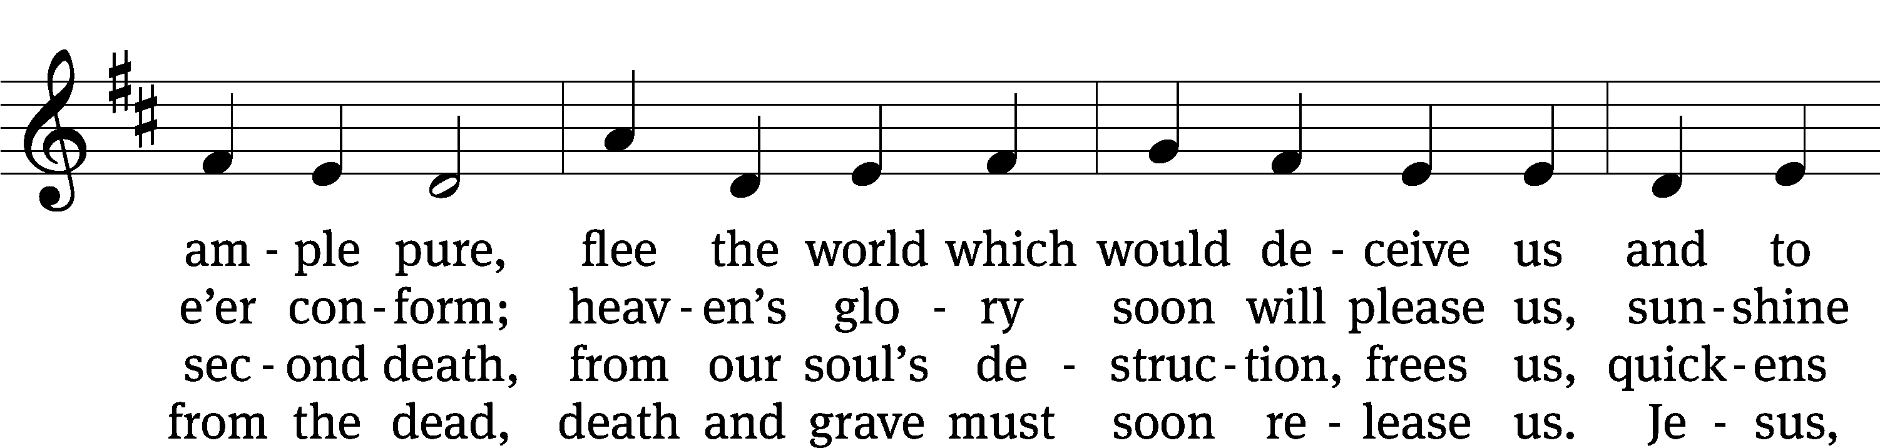
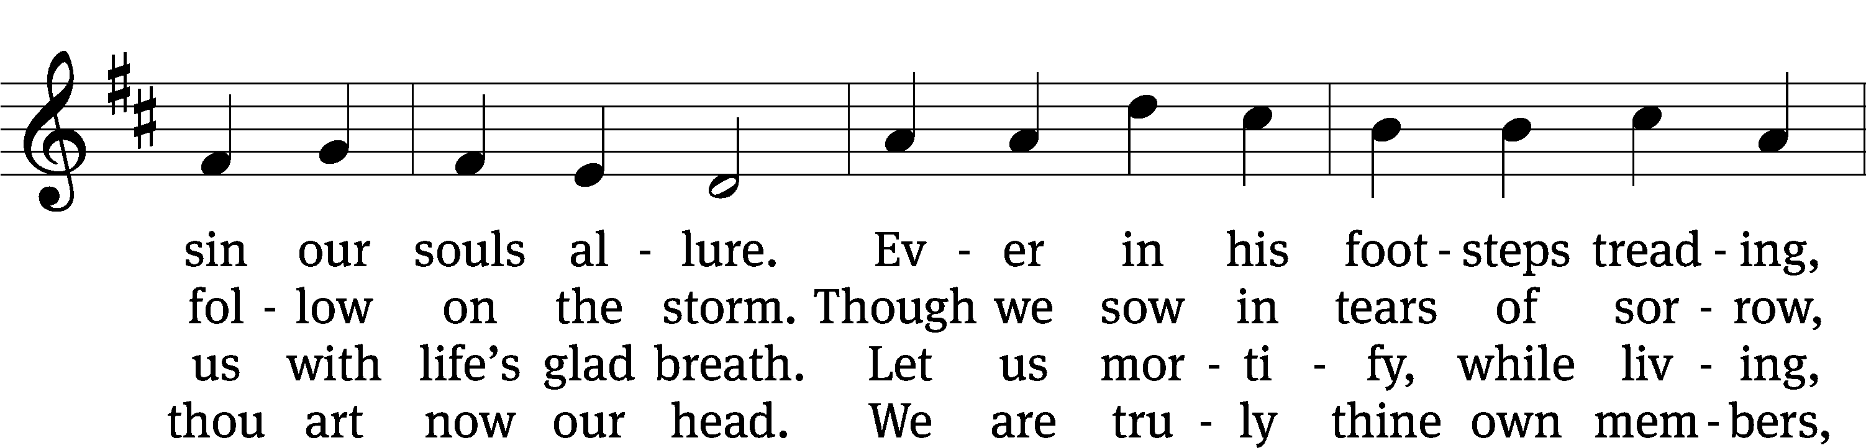
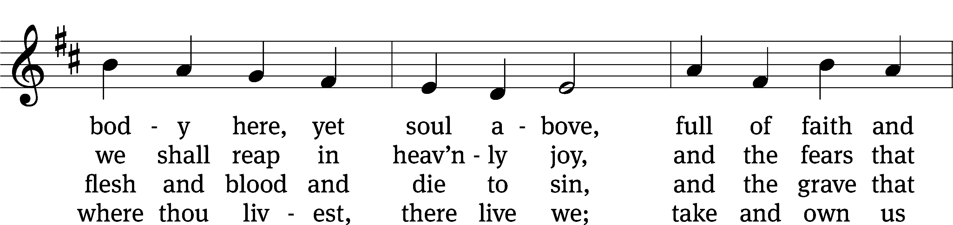
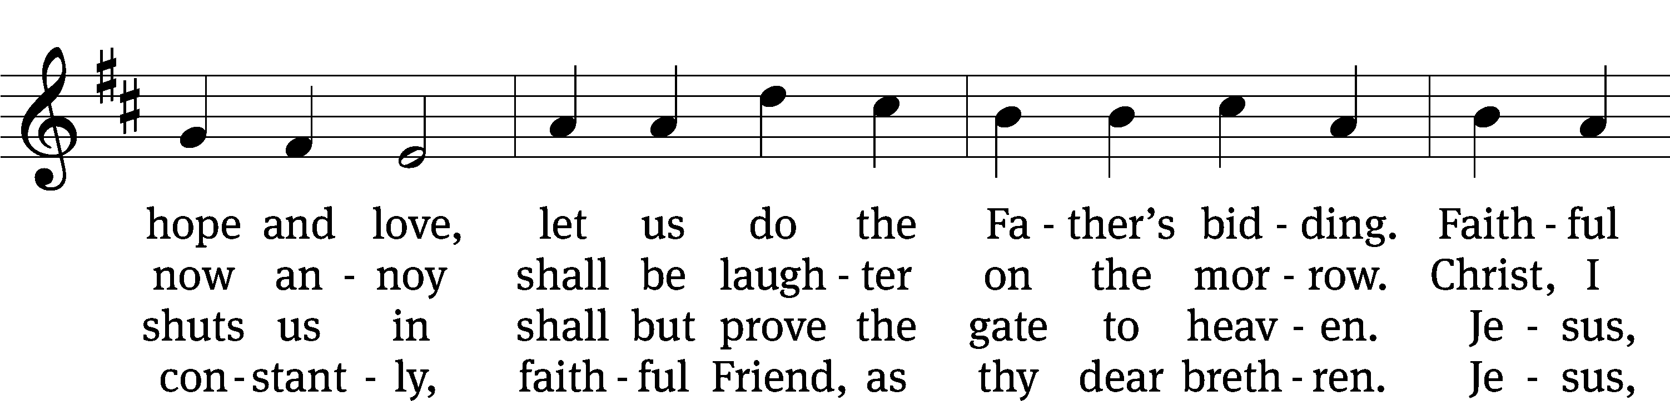
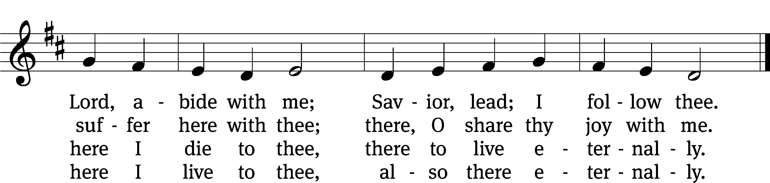
Text: tr. J. Adam Rimbach, 1871–1941, alt.; Sigmund von Birken, 1626–1681
Tune: Georg G. Boltze, 18th cent.
Text and tune: Public domain

PLEASE STAND, IF YOU ARE ABLE

invocation

M: The grace of our Lord (+) Jesus Christ and the love of God and the fellowship of the Holy Spirit be with you.
C: And also with you.
CONFESSION OF SINS
M: God invites us to come into his presence and worship him with humble and penitent hearts. Therefore, let us acknowledge our sinfulness and ask him to forgive us.
C: Holy and merciful Father, I confess that I am by nature sinful, and that I have disobeyed you in my thoughts, words, and actions. I have done what is evil and failed to do what is good. For this I deserve your punishment both now and in eternity. But I am truly sorry for my sins, and trusting in my Savior Jesus Christ, I pray: Lord, have mercy on me, a sinner.
M: God, our heavenly Father, has been merciful to us and has given his only Son to be the atoning sacrifice for our sins. Therefore, as a called servant of Christ and by his authority, I forgive you all your sins in the name of the Father and of the Son (+) and of the Holy Spirit.
C: Amen.

PRAYER AND PRAISE

LORD, HAVE MERCY
Kyrie
M: For all that we need in life and for the wisdom to use all your gifts with gratitude and joy, hear our prayer, O Lord.

M: For the steadfast assurance that nothing can separate us from your love and for the courage to stand firm against the assaults of Satan and every evil, hear our prayer, O Christ.

M: For the well-being of your holy Church in all the world and for those who offer here their worship and praise, hear our prayer, O Lord.

M: Merciful God, maker and preserver of life, uphold us by your power and keep us in your tender care:

M: The works of the Lord are great and glorious; his name is worthy of praise.

Prayer of the day

M: Let us pray.
The minister says the Prayer of the Day.

PLEASE BE SEATED

The Word

first lesson Acts 11:1-18
¹ The apostles and brothers throughout Judea heard that the Gentiles had also received the word of God. ² When Peter went up to Jerusalem, those who insisted on circumcision criticized him, ³ saying, “You went to visit men who were uncircumcised and ate with them!”
⁴ So Peter began to explain everything to them, point by point. He said, ⁵ “I was in the city of Joppa praying, and in a trance I saw a vision in which an object like a large sheet was let down from heaven by its four corners. It came right to me. ⁶ When I inspected it very carefully, I saw four-footed animals of the earth, wild beasts, reptiles, and birds of the air. ⁷ I also heard a voice telling me, ‘Get up, Peter! Kill and eat!’
⁸ “But I replied, ‘Certainly not, Lord, for nothing impure or unclean has ever entered my mouth.’
⁹ “A voice spoke from heaven a second time: ‘What God has made clean, you must not continue to call unclean.’ ¹⁰ This happened three times, and then everything was pulled up into heaven again.
¹¹ “At that very moment, three men who had been sent to me from Caesarea arrived at the house where we were. ¹² The Spirit told me to go with them without any hesitation. These six brothers also accompanied me, and we entered the man’s house. ¹³ He told us how he saw an angel standing in his house and saying, ‘Send to Joppa and call for Simon, the one called Peter. ¹⁴ He will speak words to you by which you and all your household will be saved.’
¹⁵ “As I began to speak, the Holy Spirit came down on them, just as he came down on us at the beginning. ¹⁶ Then I remembered how the Lord had said, ‘John baptized with water, but you will be baptized with the Holy Spirit.’ ¹⁷ So if God gave them the same gift as he gave us when we believed in the Lord Jesus Christ, who was I to try to stand in God’s way?”
¹⁸ When they heard these things, they had no further objections, and they praised God, saying, “So then, God has granted repentance that results in life also to the Gentiles!”
145B I Will Praise Your Name Forever Psalm 145B
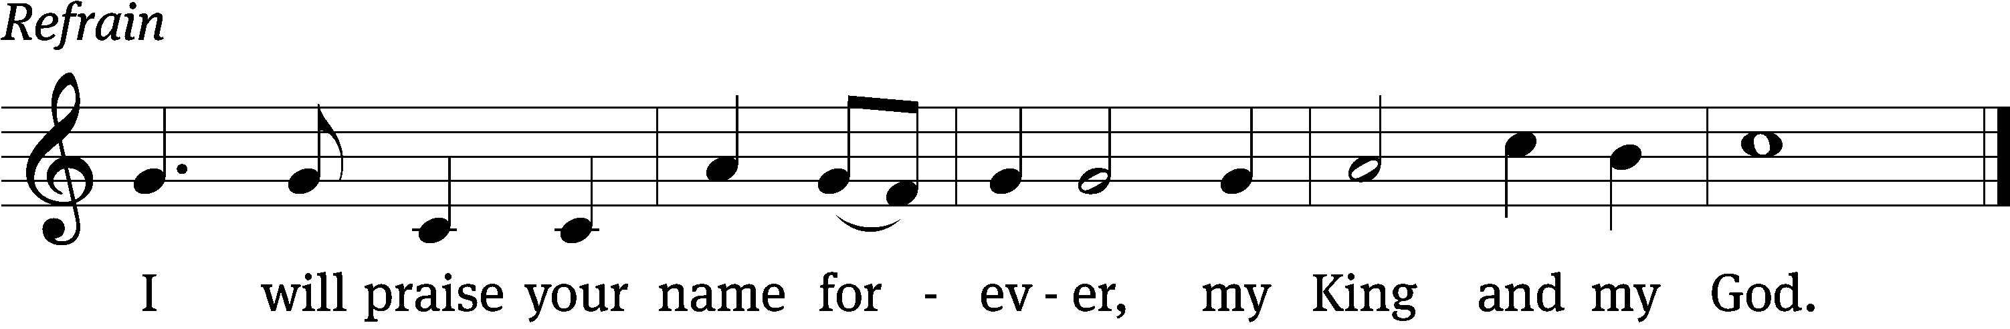
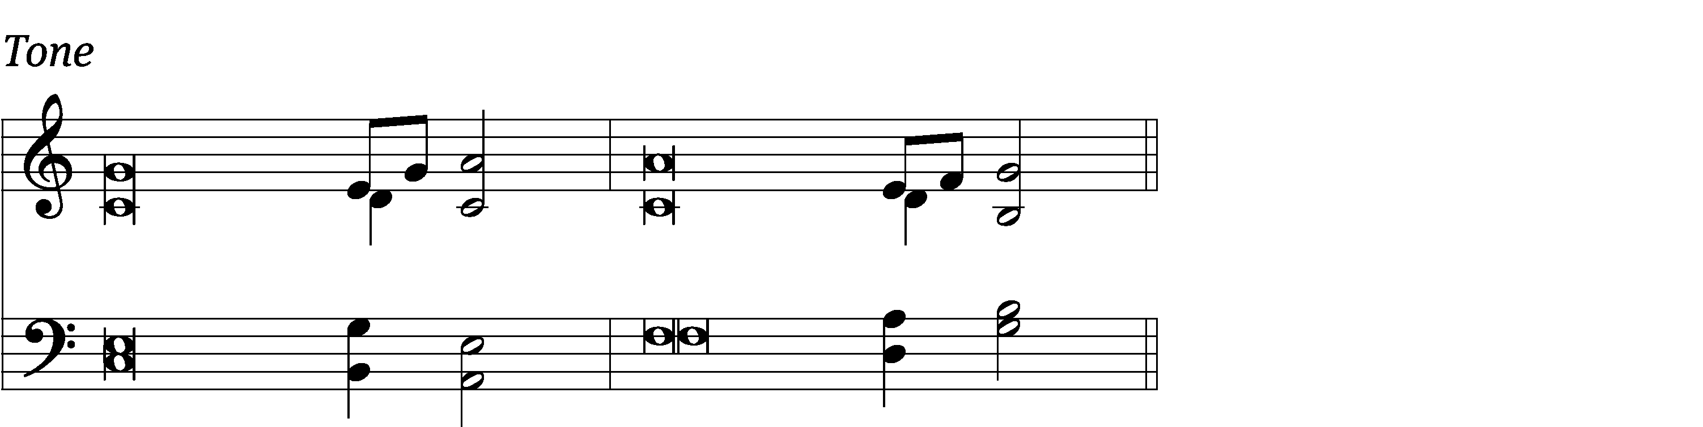

Great is the Lord and most wor- / thy of praise;
his greatness no one can / fathom.
One generation commends your works to an- / other;
they tell of your / mighty acts.
The Lord upholds / all who fall
and lifts up all who are / bowed down. Refrain

The eyes of all look to you, and you give them their food at the / proper time.
You open your hand and satisfy the desires of every / living thing.
The Lord is near to all who / call on him,
to all who call on / him in truth.
He fulfills the desires of those who / fear him;
he hears their cry and / saves them.
Glory be to the Father and / to the Son
and to the Holy / Spirit,
as it was in the be- / ginning,
is now, and will be forever. / Amen. Refrain
Text: Lectionary for Mass
Tune: Lynn Trapp
Setting: Lynn Trapp; Lectionary for Mass
Text: © 1969, 1981, 1997 ICEL. Used by permission: License no. 130003540
Music: © 1989 MorningStar Music Publishers. Used by permission: OneLicense no. 727703
Setting: © 1993 Kermit G. Moldenhauer, admin. Northwestern Publishing House. Used by permission: OneLicense no. 727703

second lesson 1 CORINTHIANS 12:27-13:13
²⁷ You are the body of Christ, and individually you are members of it. ²⁸ And God appointed in the church: first apostles, second prophets, third teachers; then miracles, healing gifts, helpful acts, leadership abilities, kinds of tongues. ²⁹ Are all apostles? Are all prophets? Are all teachers? Are all miracle workers? ³⁰ Do all have healing gifts? Do all speak in tongues? Do all interpret? ³¹ But eagerly seek the greater gifts. And now, I am going to show you a more excellent way.
13 If I speak in the tongues of men and of angels but do not have love, I have become a noisy gong or a clanging cymbal. ² If I have the gift of prophecy and know all the mysteries and have all knowledge, and if I have all faith, so as to move mountains, but do not have love, I am nothing. ³ If I give away everything I own, and if I give up my body that I may be burned but do not have love, I gain nothing.
⁴ Love is patient. Love is kind. Love does not envy. It does not brag. It is not arrogant. ⁵ It does not behave indecently. It is not selfish. It is not irritable. It does not keep a record of wrongs. ⁶ It does not rejoice over unrighteousness but rejoices with the truth. ⁷ It bears all things, believes all things, hopes all things, endures all things.
⁸ Love never comes to an end. But if there are prophetic gifts, they will be done away with; if tongues, they will cease; if knowledge, it will be done away with. ⁹ For we know only in part, and we prophesy only in part, ¹⁰ but when that which is complete has come, that which is partial will be done away with. ¹¹ When I was a child, I spoke like a child, I thought like a child, I reasoned like a child. When I became a man, I put away childish things. ¹² Now we see indirectly using a mirror, but then we will see face to face. Now I know in part, but then I will know fully, just as I was fully known.
¹³ So now these three remain: faith, hope, and love—and the greatest of these is love.
PLEASE STAND IF YOU ARE ABLE

VERSE OF THE DAY

GOSPEL John 13:31-35
³¹ After Judas left, Jesus said, “Now the Son of Man is glorified, and God is glorified in him. ³² If God is glorified in him, God will also glorify the Son in himself and will glorify him at once.”
³³ “Dear children, I am going to be with you only a little longer. You will look for me, and just as I told the Jews, so I tell you now: Where I am going, you cannot come.
³⁴ “A new commandment I give you: Love one another. Just as I have loved you, so also you are to love one another. ³⁵ By this everyone will know that you are my disciples, if you have love for one another.”

M: This is the Gospel of the Lord.

PLEASE BE SEATED
697 May We Your Precepts, Lord, Fulfill CW 697
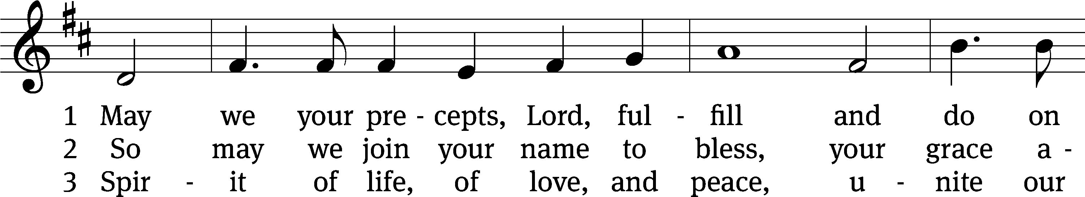
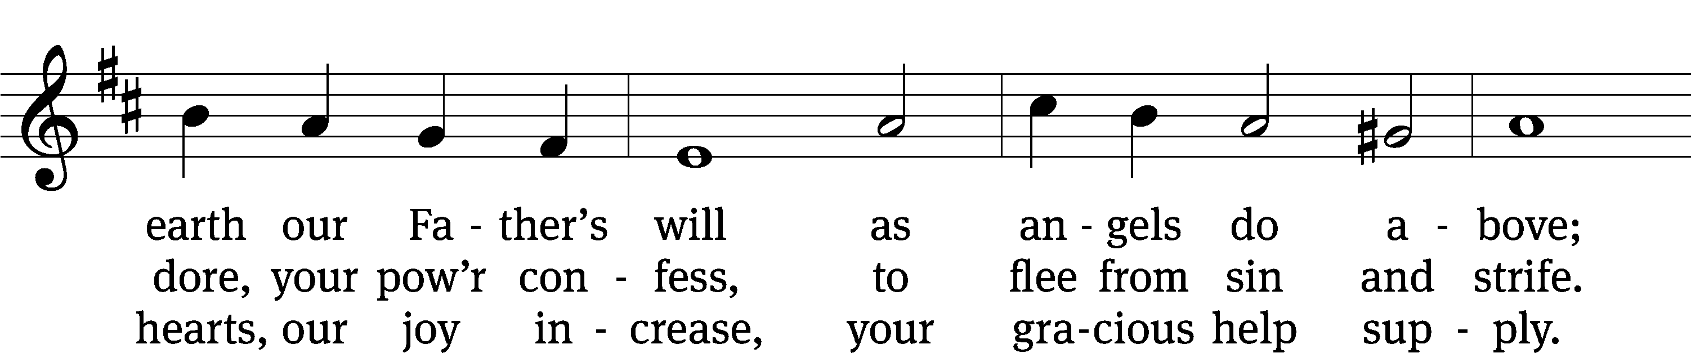
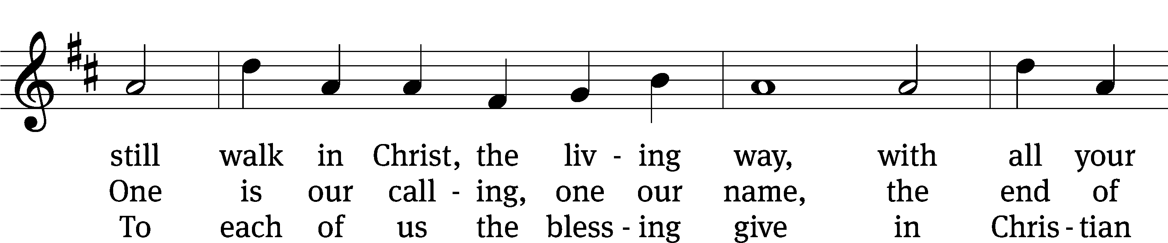
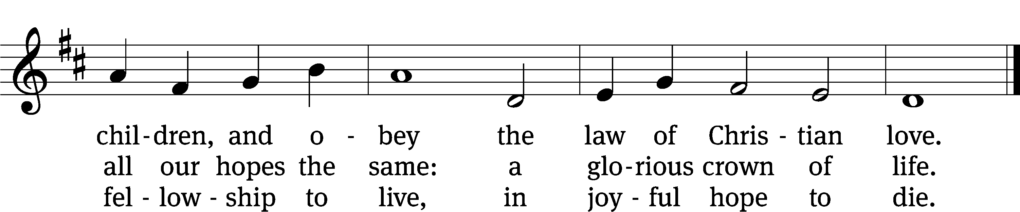

Text: Edward Osler, 1789–1863, alt.
Tune: Lowell Mason, 1792–1872
Text and tune: Public domain

Sermon 1 Corinthians 12:27-13:13
“Love’s Role in Our Church Building”

please stand, if you are able

nicene creed
We believe in one God, the Father, the Almighty, maker of heaven and earth, of all that is, seen and unseen.
We believe in one Lord, Jesus Christ, the only Son of God, eternally begotten of the Father, God from God, Light from Light, true God from true God, begotten, not made, of one being with the Father. Through him all things were made. For us and for our salvation, he came down from heaven, was incarnate of the Holy Spirit and the virgin Mary, and became truly human. For our sake he was crucified under Pontius Pilate. He suffered death and was buried. On the third day he rose again in accordance with the Scriptures. He ascended into heaven and is seated at the right hand of the Father. He will come again in glory to judge the living and the dead, and his kingdom will have no end.
We believe in the Holy Spirit, the Lord, the giver of life, who proceeds from the Father and the Son, who in unity with the Father and the Son is worshiped and glorified, who has spoken through the prophets. We believe in one holy Christian and apostolic Church. We acknowledge one baptism for the forgiveness of sins. We look for the resurrection of the dead and the life of the world to come. Amen.

PLEASE BE SEATED

offertory

PLEASE STAND, IF YOU ARE ABLE

prayer of the church

lord’s prayer

C: Our Father, who art in heaven,
hallowed be thy name,
thy kingdom come,
thy will be done
on earth as it is in heaven.
Give us this day our daily bread;
and forgive us our trespasses,
as we forgive those
who trespass against us;
and lead us not into temptation,
but deliver us from evil.
For thine is the kingdom
and the power and the glory
forever and ever. Amen.

The Sacrament of Holy Communion
Trinity Lutheran Church follows the historic Christian practice of close communion. We ask that only members of Trinity or one of our sister congregations partake of the sacrament. If you are not a member, please see the note about Holy Communion in the beginning of the Worship Folder.

M: The Lord be with you.

M: Lift up your hearts.

M: Let us give thanks to the Lord our God.

M: Praise to the God and Father of our Lord Jesus Christ! In love he has blessed us with every spiritual blessing. He raised Christ from the dead and seated him at his right hand in the heavenly realms and placed all things under his feet for the benefit of the Church. Now have come the salvation and the power and the kingdom of our God and the authority of his Christ. To him who sits on the throne and to the Lamb be praise and thanks and honor and glory for ever and ever:

Holy, Holy, Holy

Words of institution
M: Our Lord Jesus Christ, on the night he was betrayed, took bread; and when he had given thanks, he broke it and gave it to his disciples, saying: “Take and eat. This is my ✙ body, which is given for you. Do this in remembrance of me.”
Then he took the cup, gave thanks, and gave it to them, saying, “Drink from it all of you; this is my ✙ blood of the new covenant, which is poured out for you for the forgiveness of sins. Do this, whenever you drink it, in remembrance of me.”
The peace of the Lord be with you always.

O CHRIST, LAMB OF GOD

PLEASE BE SEATED
DISTRIBUTION HYMNS
467 With High Delight Let Us Unite CW 467
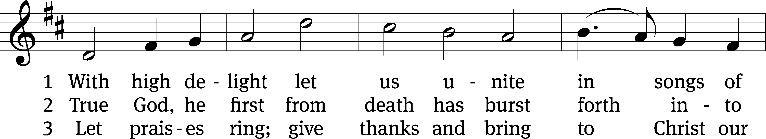
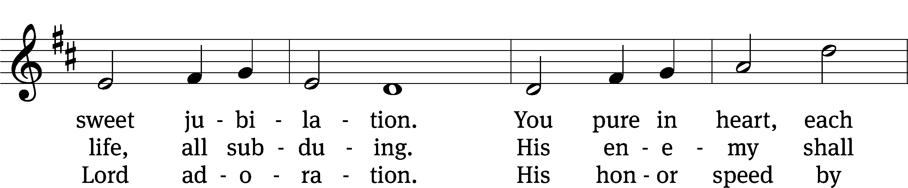
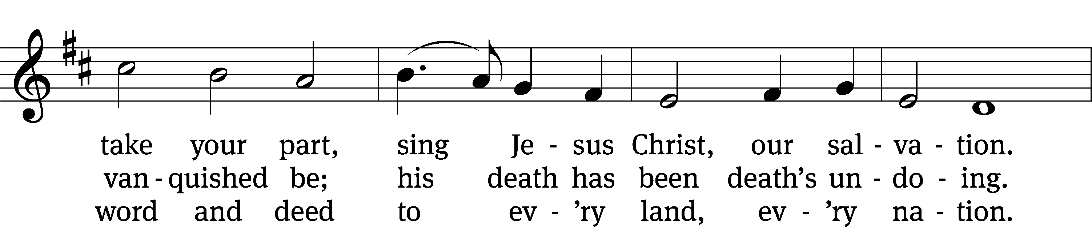
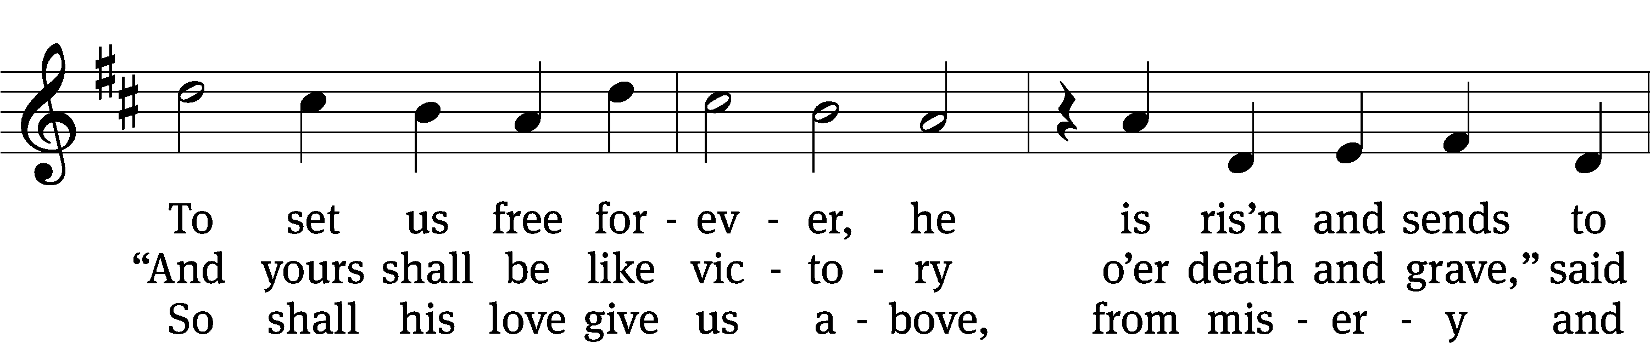
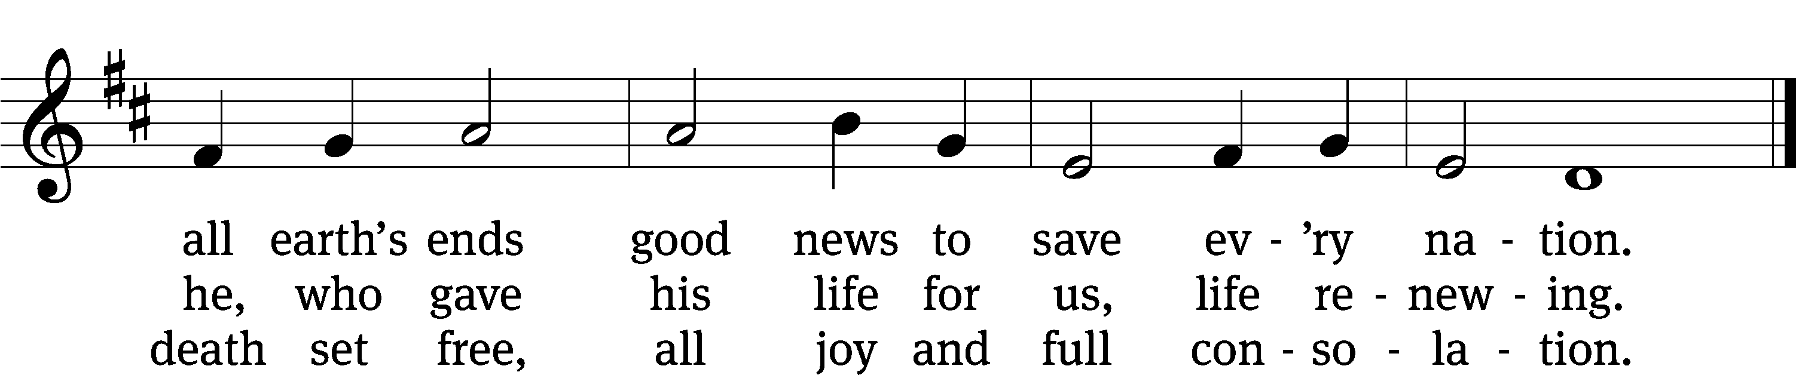

Text: tr. Martin H. Franzmann, 1907–1976, alt.; Georg Vetter, 1536–1599, abr.
Tune: Cinquante Pseaumes, Geneva, 1543, alt.
Text: © 1969 Concordia Publishing House. Used by permission: OneLicense no. 727703
Tune: Public domain

730 Blest Be the Tie That Binds CW 730
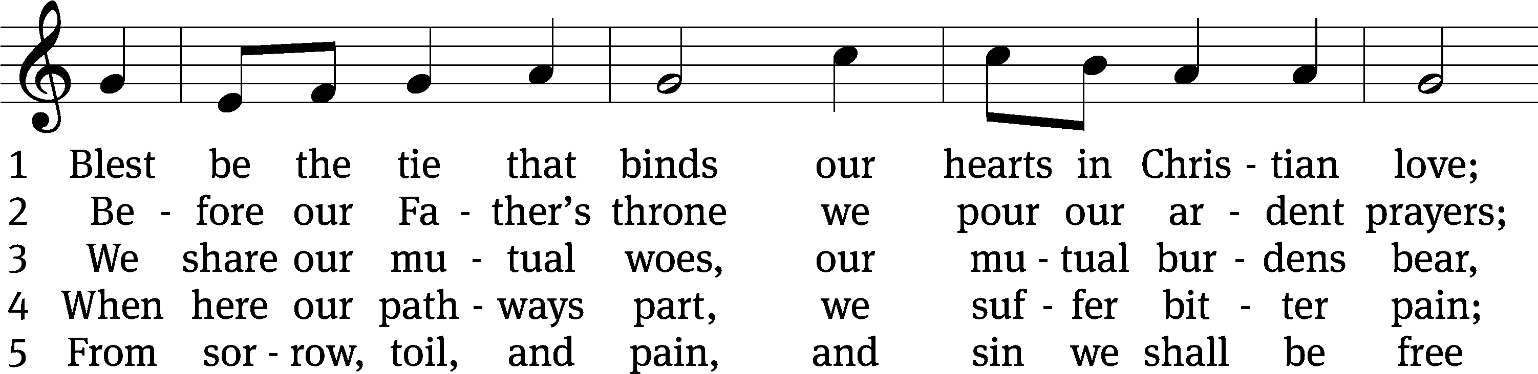
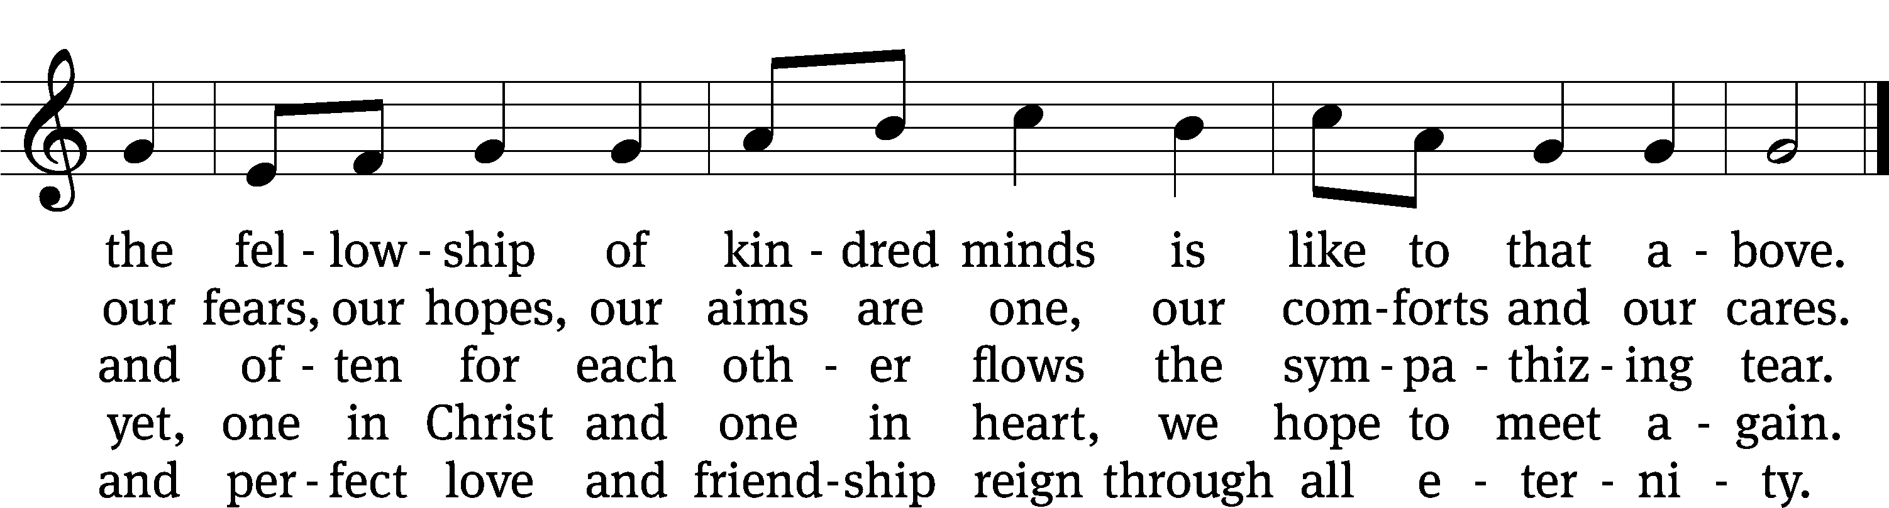

Text: John Fawcett, 1740–1817
Tune: Lowell Mason, 1792–1872
Text and tune: Public domain

THANKSGIVING
PLEASE STAND, IF YOU ARE ABLE
M: Hear the prayer of your people, O Lord, that the lips which have praised you here may glorify you in the world, that the eyes which have seen the coming of your Son may long for his coming again, and that all who have received in his true body and blood the pledge of your forgiveness may be restored to live a new and holy life, through Jesus Christ, our Lord, who lives and reigns with you and the Holy Spirit, one God, now and forever.

M: Brothers and sisters, go in peace. Live in harmony with one another.
Serve the Lord with gladness.

The Lord bless you and keep you.
The Lord make his face shine on you and be gracious to you.
The Lord look on you with favor and (+) give you peace.
PLEASE BE SEATED

726 Love in Christ Is Strong and Living CW 726
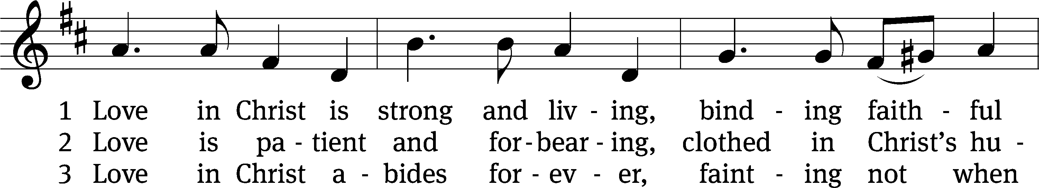
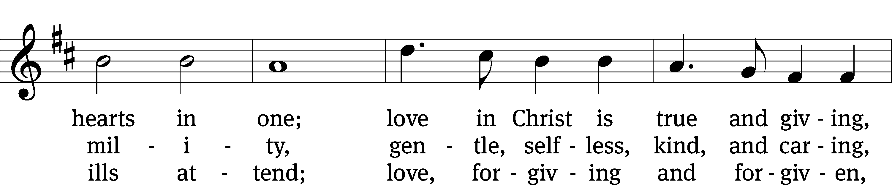
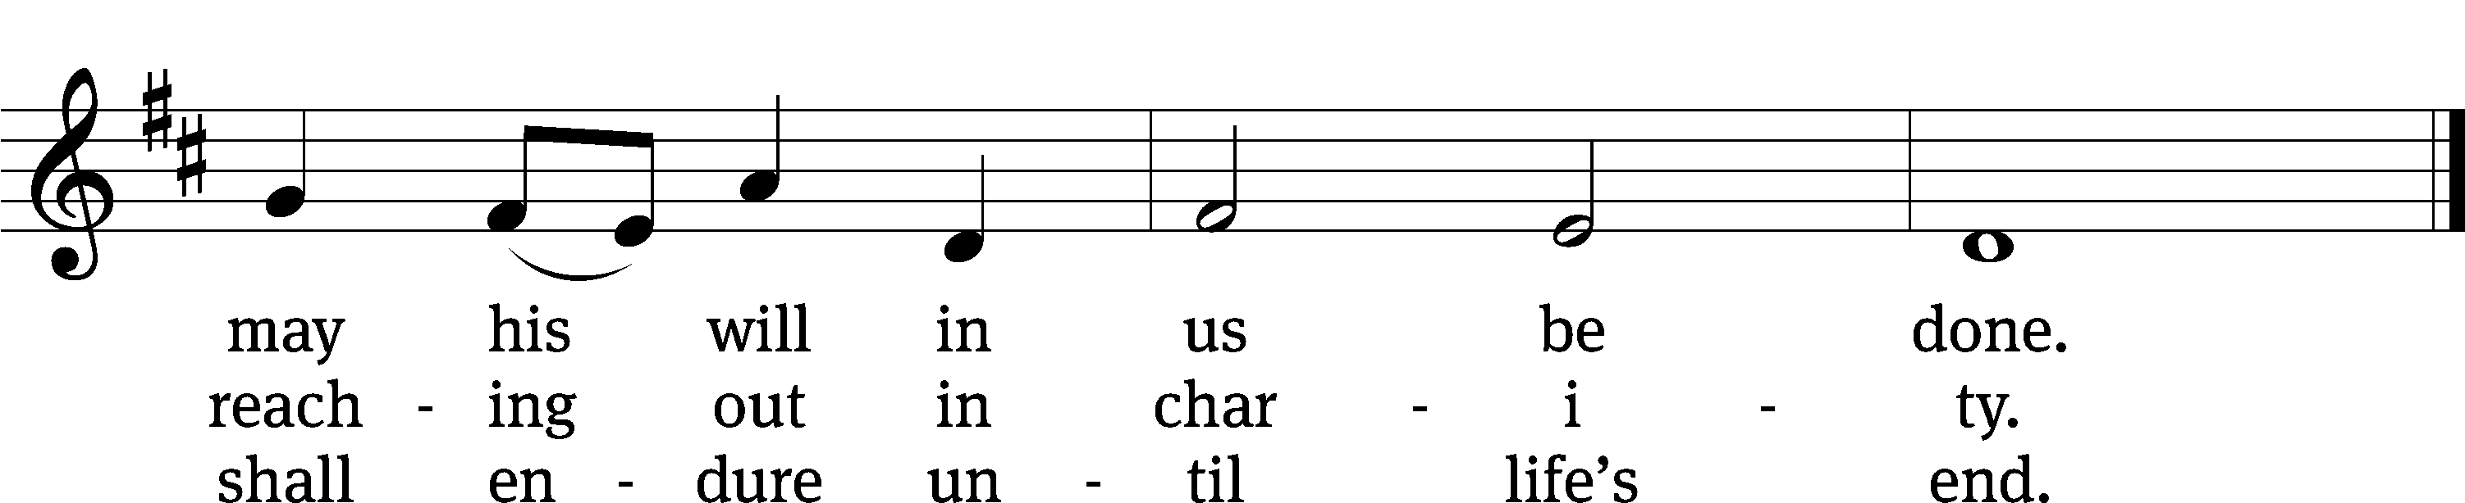

Text: Dorothy R. Schultz, b. 1934
Tune: Ralph C. Schultz, b. 1932
Text and tune: © 1980 Concordia Publishing House. Used by permission: OneLicense no. 727703

Serving In Worship

Officiant Pastor Natsis
Organist Emily Wheeler
Deacons (8:30) Dave Stevenson and Ed Wheeler
(11:00) Dave Frey and Steve Hoeft
Ushers (8:30) Dale Radak
(11:00) Ron Zahn
Altar Guild Sandy Kirkpatrick and Barb Neuburger
Videographer Jake Vershum

Copyright information
Service of Word and Sacrament: Christian Worship. © 1993 Northwestern Publishing House. All rights reserved. Reprinted under ONE LICENSE #A-727703 and CCLI #1151741/ CSPL126093
Words and Music: All rights reserved. Reprinted/Podcast/Streamed with permission under ONE LICENSE #A-727703 and CCLI #1151741/CSPL126093

