first SUNDAY in lent

TRINITY EVANGELICAL LUTHERAN CHURCH | Saline, Michigan
WELCOME TO WORSHIP March 6, 2022
Thank you for joining us in God’s house today! We cordially ask that our Guests sign one of the guestbooks located at either the front or back entryways, or fill out a “Let’s Get Acquainted” card located in the hymnal pew rack and place it in the collection plate.

THANK OFFERING: Members of Trinity give their offering as an expression of love and thankfulness to the Lord and to help support the Lord’s work in our community and around the world. Visitors need not feel obligated to participate in this offering which supports our ministry.

Restrooms are located at the back of the upper level (the annex), and in the basement (down the back stairs of the sanctuary or annex). Handicap access is available, please ask an usher for assistance.

Young Families / Toddler Bags – We are GLAD YOU BROUGHT YOUR CHILDREN to our worship service. Jesus said: “Let the little children come to me and do not hinder them, for the kingdom of God belongs to such as these.” We know that having little children in church can be a challenge, but DO NOT WORRY about it. Many of your fellow worshippers have been in your shoes and are just happy you brought your children with you. For your convenience, we have reserved the back rows of seating for parents with small children. These areas provide more flexibility for your family, as well as, easy access to move downstairs if necessary. A closed-circuit TV system allows families to continue participating in the service while downstairs. Pre-school toddler bags and children’s bulletins are available for their enjoyment. Ask an usher for one to use during the service and please return the toddler bag afterwards.

celebration of holy communion:
In His Word, God makes it clear that the Lord’s Supper is to be shared by people of a common proclamation of faith (1 Corinthians 11:26; 1 Corinthians 10:16-17). Without judging anyone’s hearts, we invite those who share in our confession by their membership in our congregation or another congregation of the Wisconsin Evangelical Lutheran Synod (WELS) or the Evangelical Lutheran Synod (ELS) and who are properly prepared (1 Corinthians 11;27-29) to receive the Sacrament. Page 295 in Christian Worship provides a guide for preparation.
Guests, we would love to have you join us in communion fellowship in the future, and for that to be possible, we ask that you speak with one of the pastors so that we may speak with you on how that would be possible. We thank you for respecting the way we celebrate the Lord’s Supper in our congregations.
the SERVICE – setting one - WITH HOLY COMMUNION CW, page 154
Sunday School “Father I Adore You”
721 What a Friend We Have in Jesus CW 721
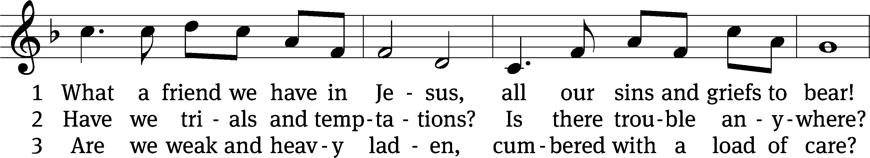
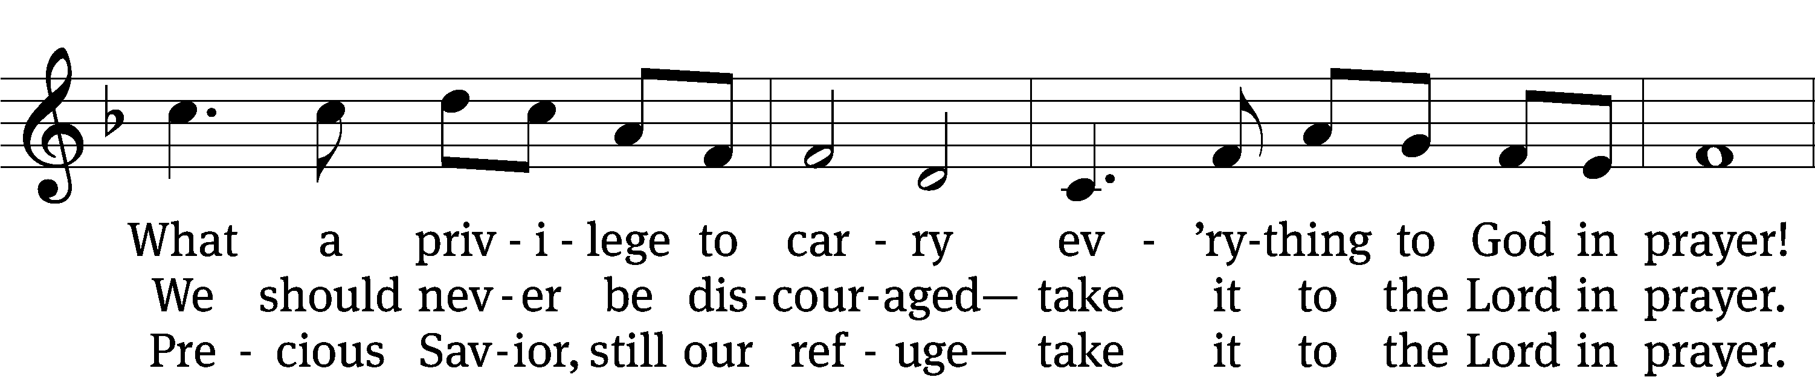
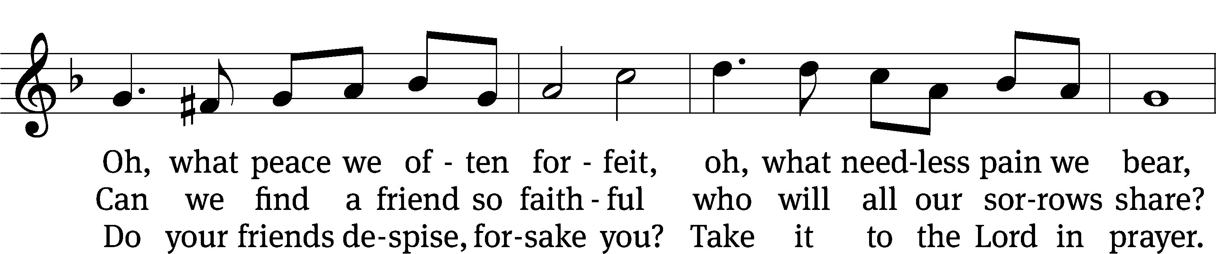
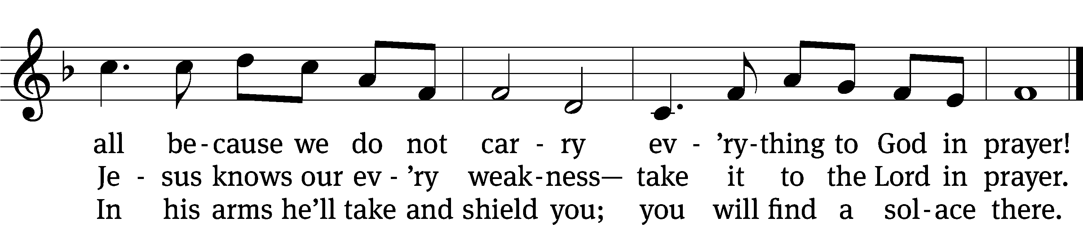
Text: Joseph M. Scriven, 1819–1886, alt.
Tune: Charles C. Converse, 1832–1918
Text and tune: Public domain

Please stand, if you are able
Invocation
In the name of the Father and of the T Son and of the Holy Spirit.
Amen.
Confession
If we claim to be without sin, we deceive ourselves and the truth is not in us.
If we confess our sins, God is faithful and just
and will forgive us our sins
and purify us from all unrighteousness.

Let us confess our sins to the Lord.
Holy God, gracious Father,
I am sinful by nature
and have sinned against you in my thoughts, words, and actions.
I have not loved you with my whole heart;
I have not loved others as I should.
I deserve your punishment both now and forever.
But Jesus, my Savior, paid for my sins
with his innocent suffering and death.
Trusting in him, I pray: God, have mercy on me, a sinner.

Our gracious Father in heaven has been merciful to us. He sent his only Son, Jesus Christ, who gave his life as the atoning sacrifice for the sins of the whole world. Therefore, as a called servant of Christ and by his authority, I forgive you all your sins in the name of the Father and of the T Son and of the Holy Spirit. Amen.

Lord, Have Mercy

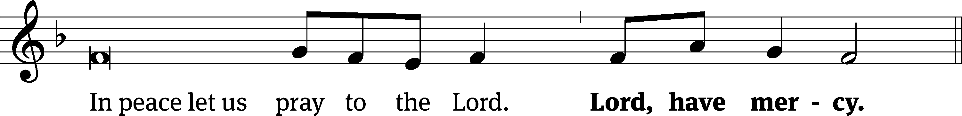
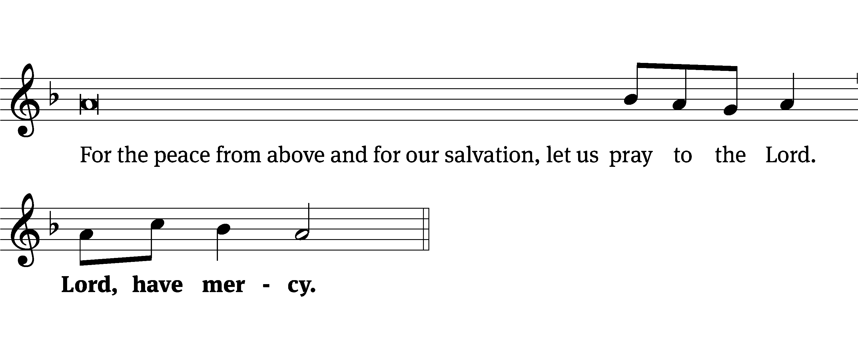
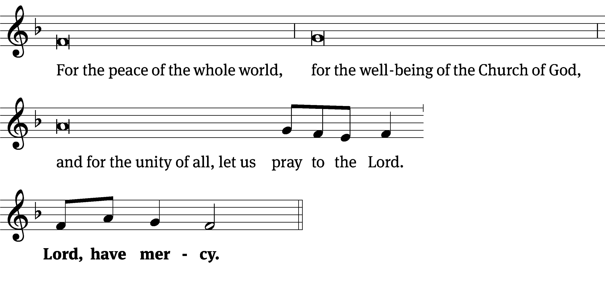
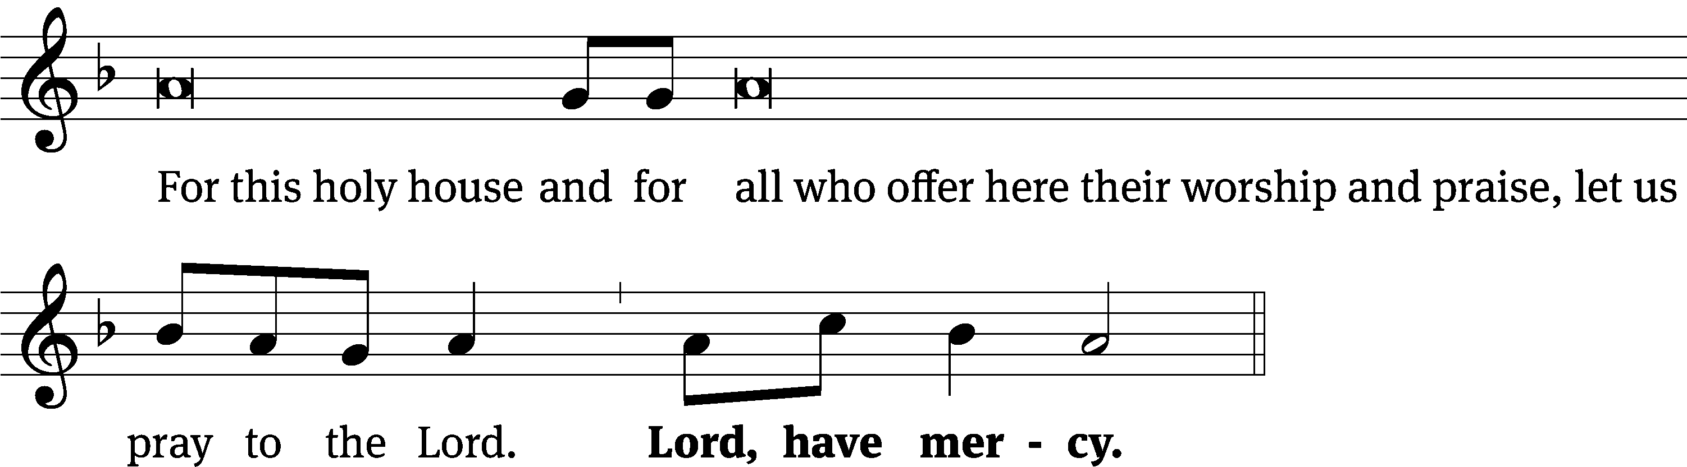
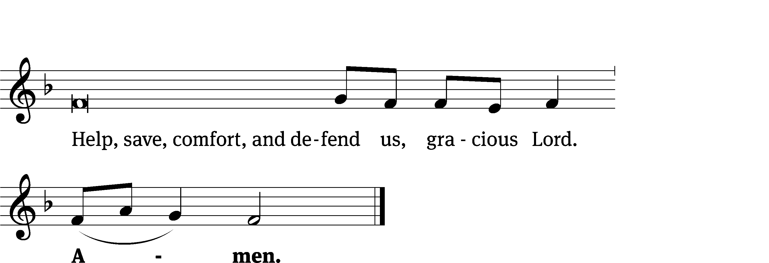
Tune: Kevin Becker
Tune: © 2021 Northwestern Publishing House. Used by permission: OneLicense no. 727703

Glory Be to God CW 157
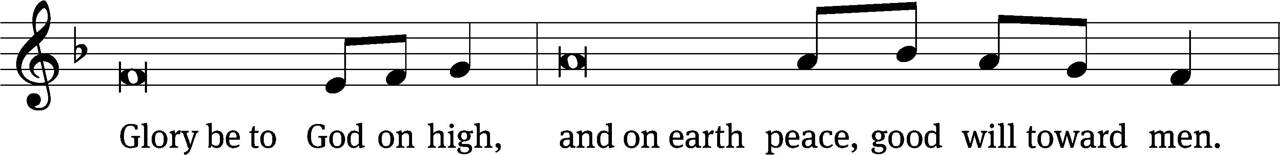
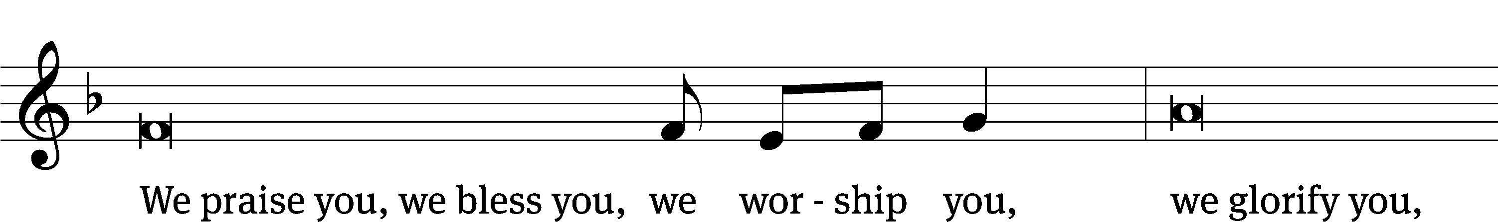
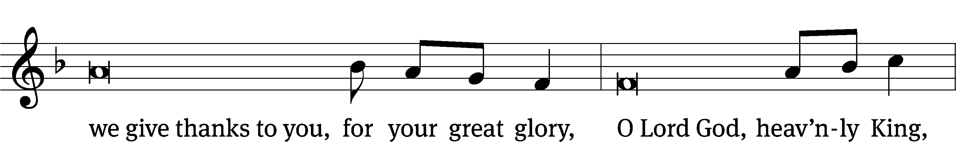
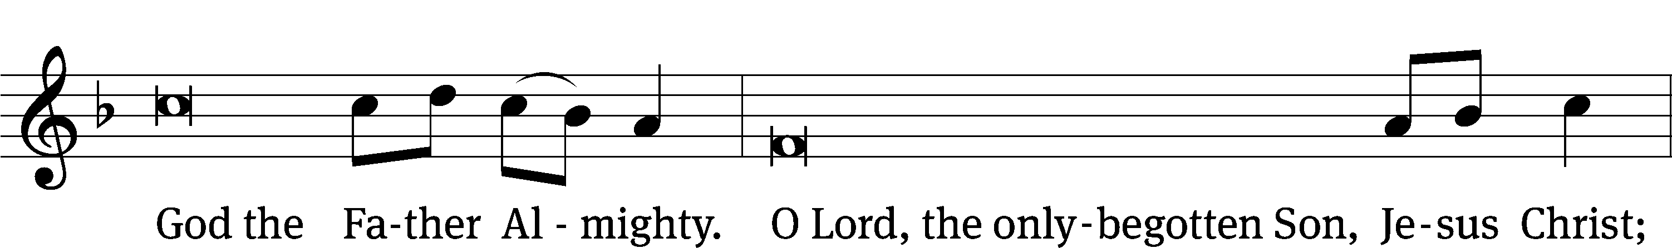
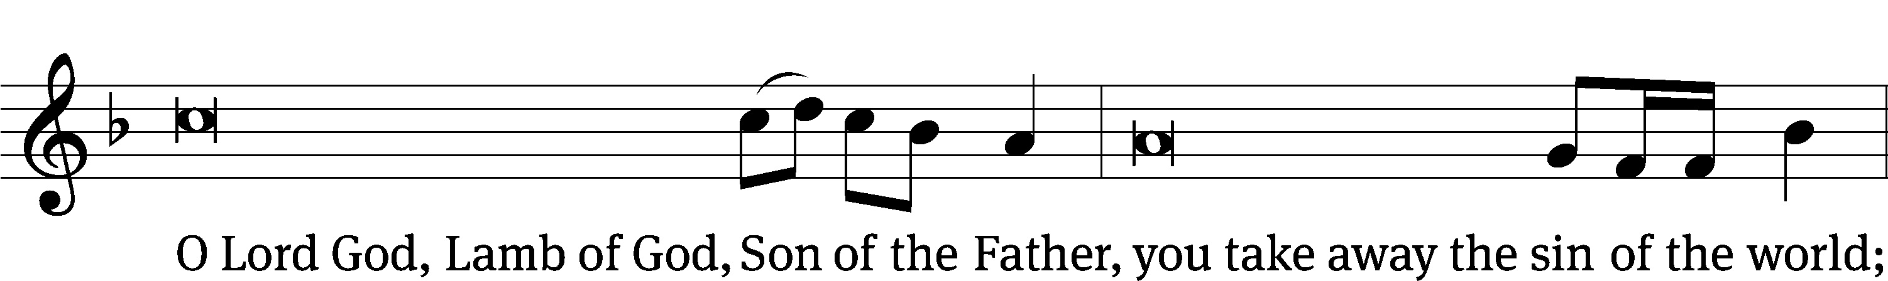
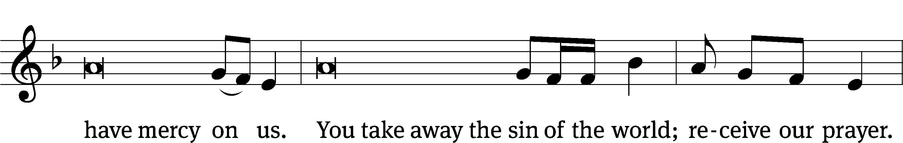
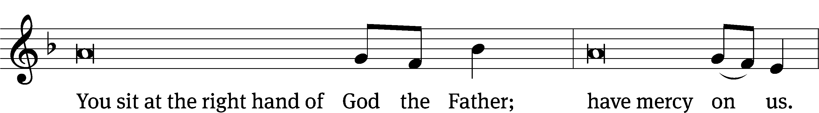
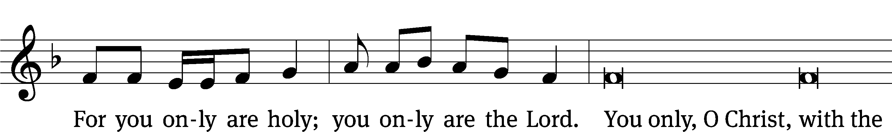
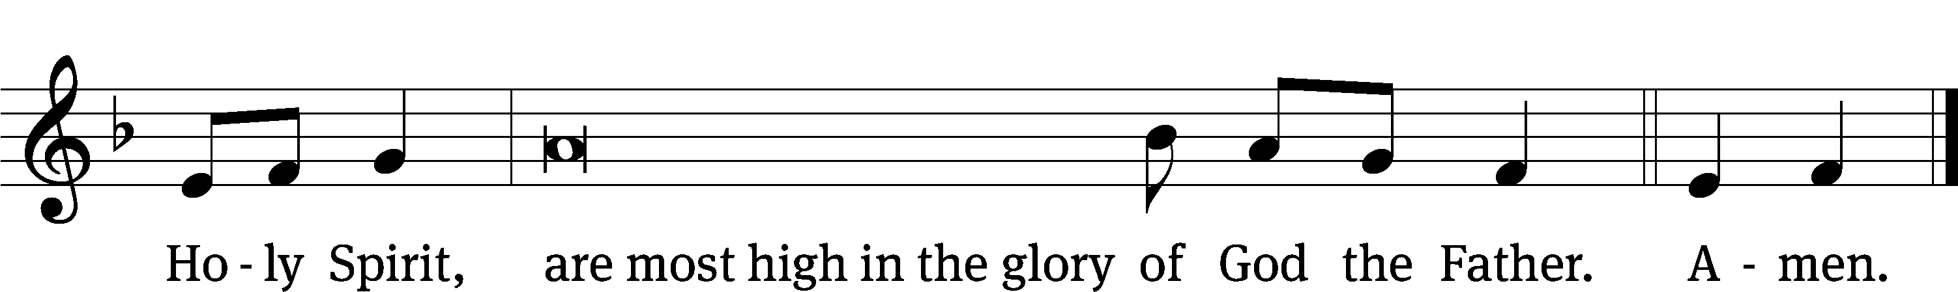

The Lord be with you.
And also with you.
Prayer of the Day
Let us pray.

Mighty God and Father, our Lord Jesus walked into the wilderness to face the devil’s temptations, but he did not succumb to Satan’s lies or falter in his resolve to save the world from the prison of hell. Bolster our faith by his mighty victory that we may battle against the forces of evil with courage and confidence; through your Son, Jesus Christ our Lord, who lives and reigns with you and the Holy Spirit, one God, now and forever.
Amen.

Please be seated

First Reading 1 Samuel 17:4-11, 32-40, 45-49
4 A challenger who represented the Philistines came out from the camp of the Philistines. He was named Goliath of Gath. He was nine feet, six inches tall. 5 He had a bronze helmet on his head, and he wore scaled body armor, which was made of more than one hundred pounds of bronze. 6 He had bronze greaves on his shins and a bronze spear slung between his shoulders. 7 The shaft of his spear was like a weaver’s beam, and his spearhead was made of fifteen pounds of iron. His shield bearer went out ahead of him.

8 He would stand up and shout to the armies of Israel, “Why have you come out to line up in battle formation? I am a Philistine, and you are servants of Saul, aren’t you? Choose a man to represent you, and let him come down to me. 9 If he is able to fight with me and kill me, we will be your servants. But if I overcome him and kill him, you will become our servants, and you will serve us.” 10 The Philistine would say, “I defy the ranks of Israel today! Give me a man, and we will fight each other!” 11 When Saul and all Israel heard those words of the Philistine, they lost their courage and were terrified.

32 David said to Saul, “Do not let anyone lose heart because of this Philistine! Your servant will go and fight him.”

33 But Saul said to David, “You cannot go against this Philistine to fight with him, because you are just a boy, and he has been a warrior since he was a youth.”
34 David said to Saul, “Your servant has been taking care of his father’s sheep. When a lion or a bear came and took a lamb from the flock, 35 I went after it and struck it and rescued the lamb out of its mouth. When the lion reared up against me, I grabbed it by its mane, struck it, and killed it. 36 Your servant struck both the lion and the bear. This uncircumcised Philistine will be like one of them, since he has defied the ranks of the living God.” 37 David added, “The Lord, who delivered me from the paw of the lion and from the paw of the bear, will deliver me from the hand of this Philistine.”

Saul said to David, “Go then! May the Lord be with you.” 38 So Saul dressed David in his own gear. He placed a bronze helmet on his head and dressed him in scaled body armor. 39 David strapped his sword over his gear. David tried to walk around in them, since he had never trained with this kind of equipment before.
David said to Saul, “I cannot go in these, because I have never trained with them.” So David took them off.

40 Then David took his staff in his hand and picked five smooth stones out of the stream bed and put them into the pouch of his shepherd’s bag. He took his sling in his hand and approached the Philistine.

45 Then David said to the Philistine, “You come against me with a sword, with a spear, and with a javelin, but I come against you in the name of the Lord of Armies, the God of the ranks of Israel, whom you have defied. 46 Today the Lord will hand you over to me. I will strike you down and cut off your head. Today I will give the dead bodies of the army of the Philistines to the birds of the air and to the wild animals of the earth. Then all the earth will know that there is a God in Israel, 47 and all those gathered here will know that the Lord does not save with sword and spear, for the battle belongs to the Lord, and he will deliver you into our hand.”

48 Then, when the Philistine started advancing to attack David, David ran quickly toward the battle line to meet the Philistine. 49 David put his hand into his bag, took a stone from it, shot it from his sling, and struck the Philistine on the forehead. The stone sank into his forehead, and he fell facedown to the ground.

The Word of the Lord.
Thanks be to God.

91E Dwell in God Most High as Shelter Psalm 91E
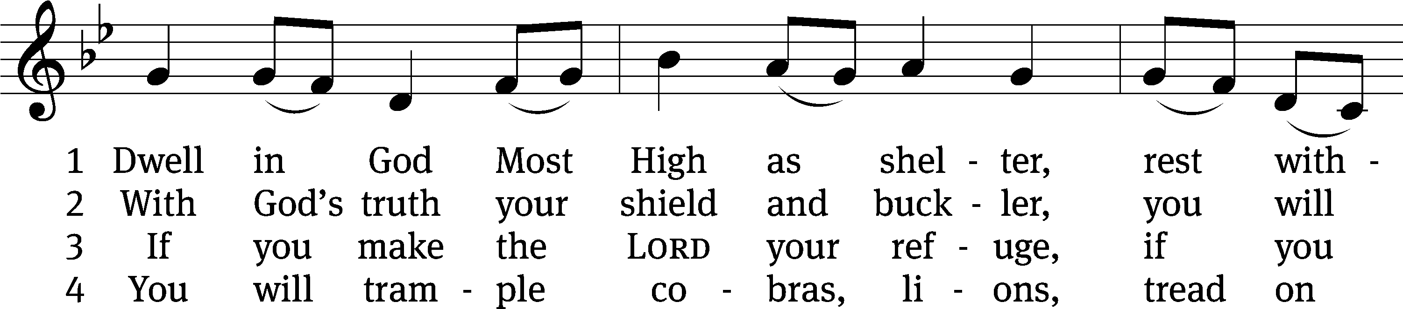
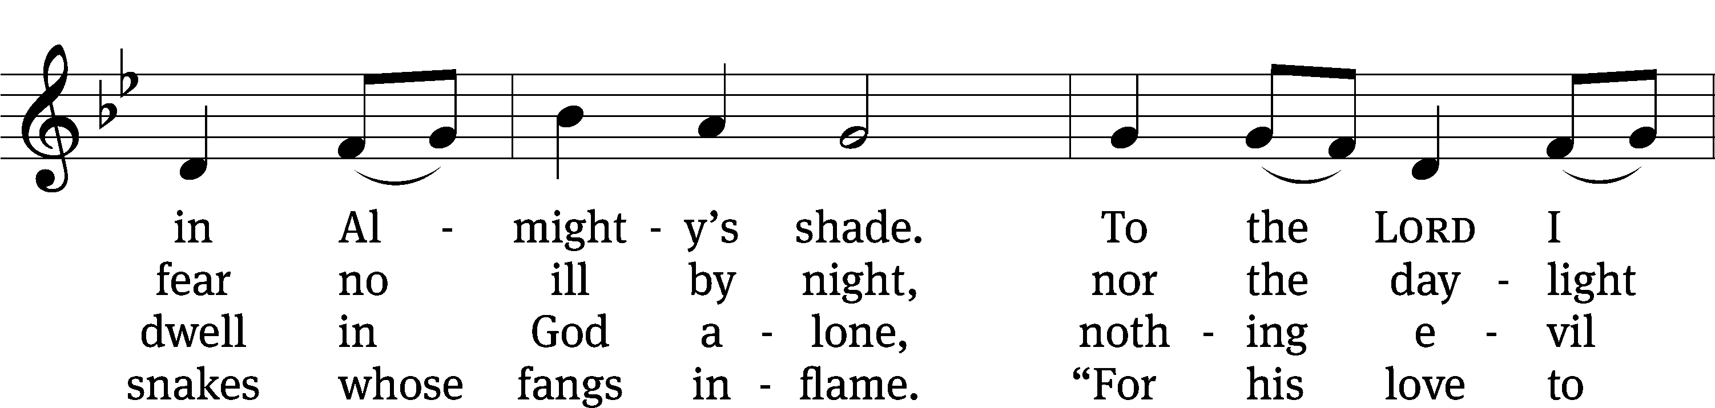
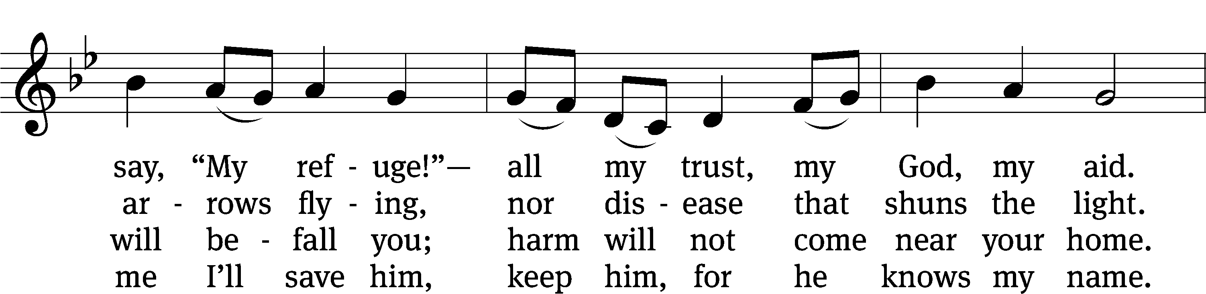
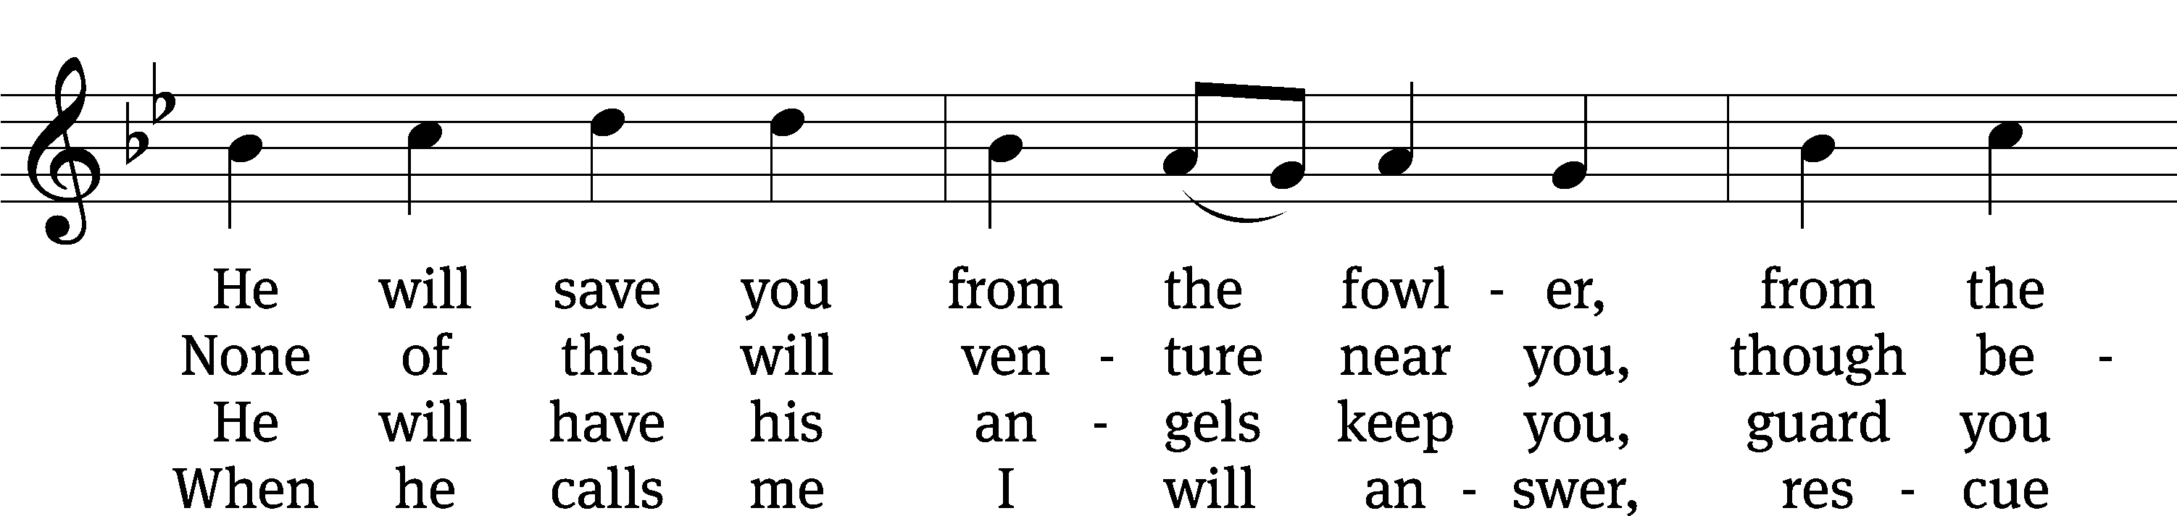
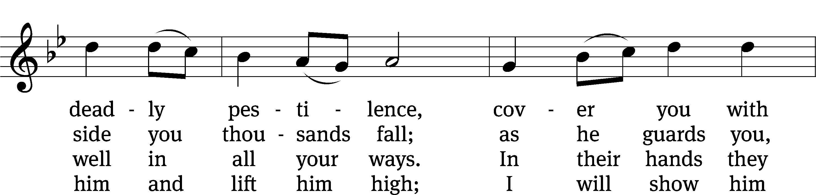
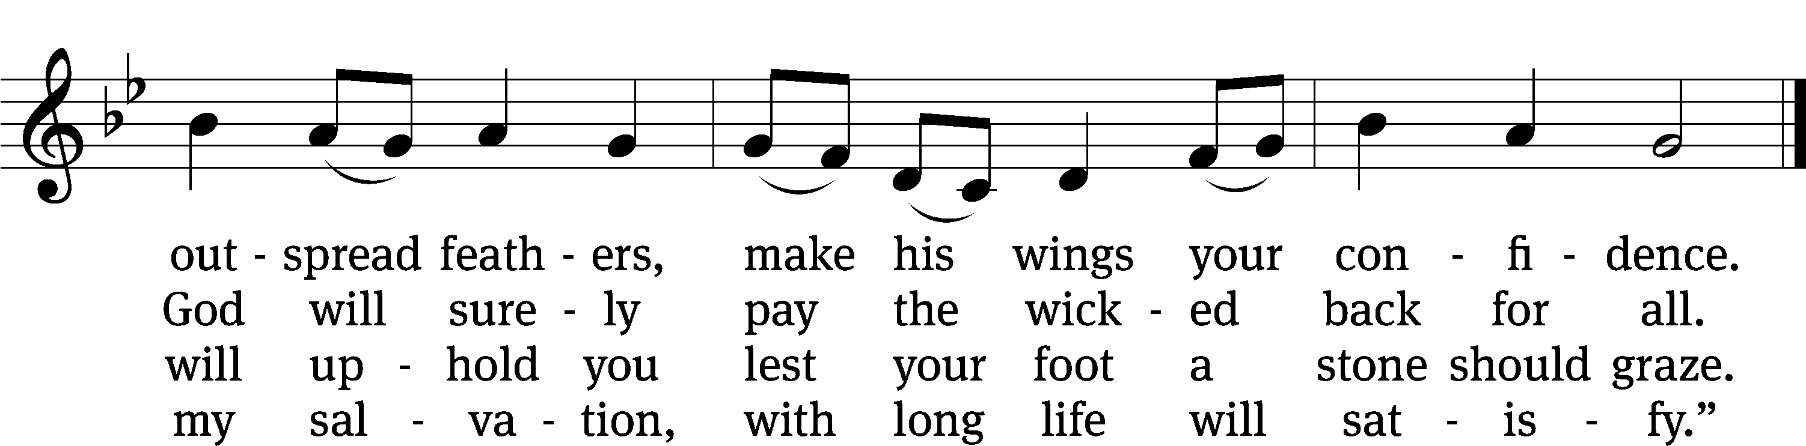
Text: Daniel Witte
Tune: Tennessee Harmony, 1818, ed. Alexander Johnson
Text: © 2021 Northwestern Publishing House. Used by permission: OneLicense no. 727703
Tune: Public domain

Second Reading Hebrews 4:14-16
14 Therefore, since we have a great high priest, who has gone through the heavens, namely, Jesus the Son of God, let us continue to hold on to our confession. 15 For we do not have a high priest who is unable to sympathize with our weaknesses, but one who has been tempted in every way, just as we are, yet was without sin. 16 So let us approach the throne of grace with confidence, so that we may receive mercy and find grace to help in time of need.

The Word of the Lord.
Thanks be to God.

Please stand, if you are able

Gospel Acclamation 1 John 3:8
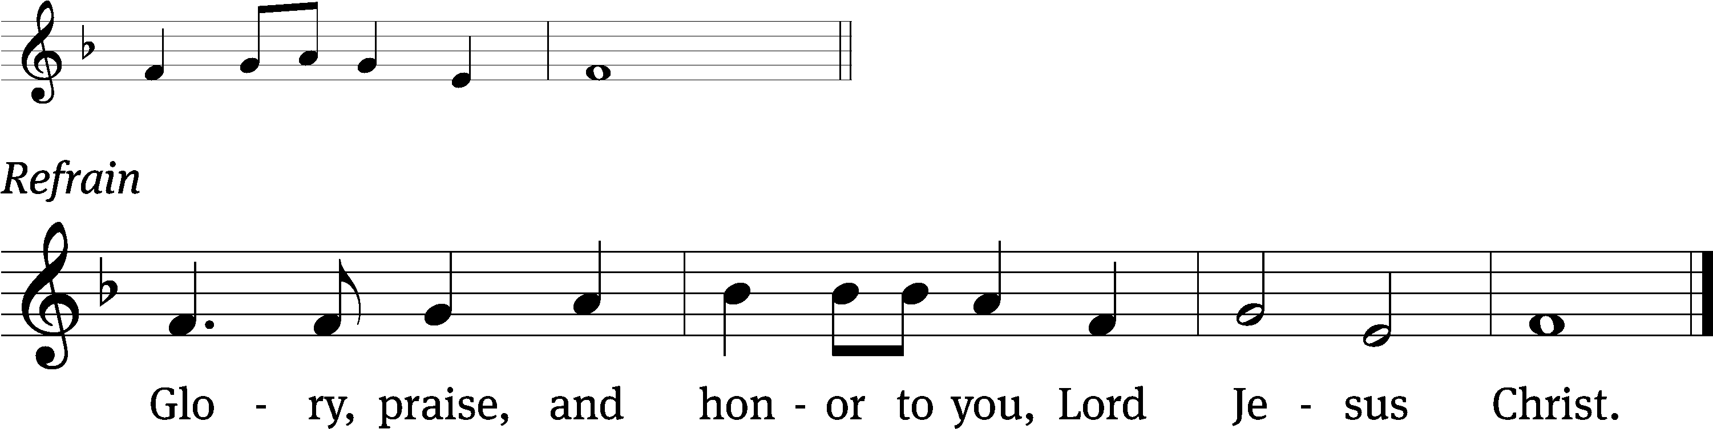
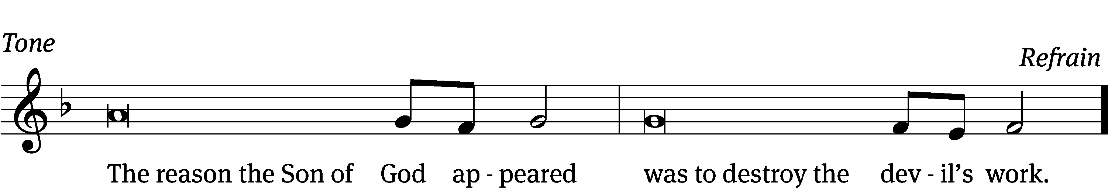
Tune: © 2021 Northwestern Publishing House. Used by permission: OneLicense no. 727703

Gospel Luke 4:1-13
1 Jesus, full of the Holy Spirit, returned from the Jordan and was led by the Spirit in the wilderness, 2 where he was tempted by the Devil for forty days. He did not eat anything during those days. When they came to an end, he was hungry. 3 The Devil said to him, “If you are the Son of God, tell this stone to become bread.”
4 Jesus answered him, “It is written: ‘Man shall not live by bread alone, but by every word of God.’”
5 The Devil led him up to a high mountain and showed him all the kingdoms of the world in a moment of time. 6 The Devil told him, “I will give you all this power and the glory of these kingdoms, because it has been entrusted to me, and I can give it to anyone I want. 7 So, if you worship me, it will all be yours.”
8 Jesus answered him, “It is written: ‘You shall worship the Lord your God and serve him only.’”
9 The Devil led him to Jerusalem and had him stand on the pinnacle of the temple. “If you are the Son of God,” he said, “throw yourself down from here, 10 because it is written:
He will command his angels concerning you, to protect you.
11 And,
they will lift you up with their hands,
so that you will not strike your foot against a stone.”
12 Jesus answered him, “It says: ‘You shall not test the Lord your God.’”
13 When the Devil had finished every temptation, he left him until an opportune time.

The Gospel of the Lord.
Praise be to you, O Christ!

Please be seated

864 A Mighty Fortress Is Our God CW 864 sts. 1–4
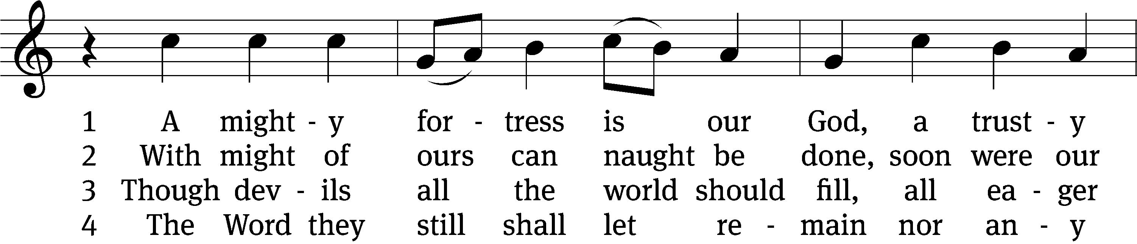
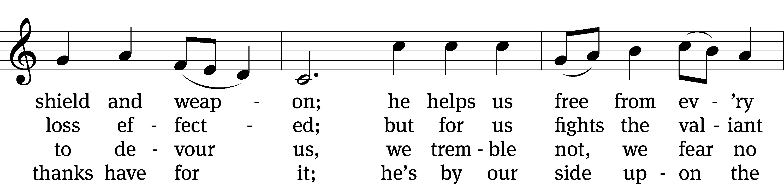
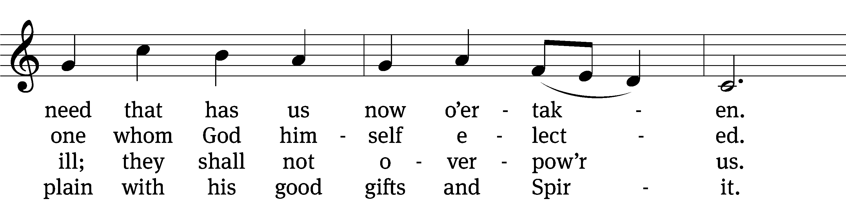
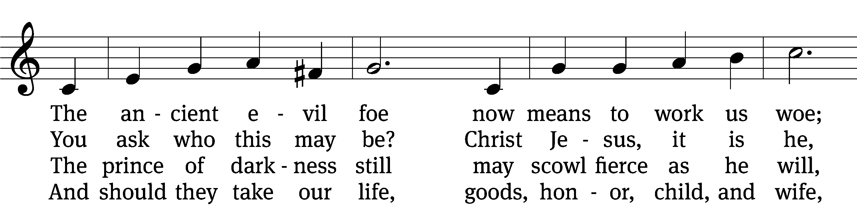
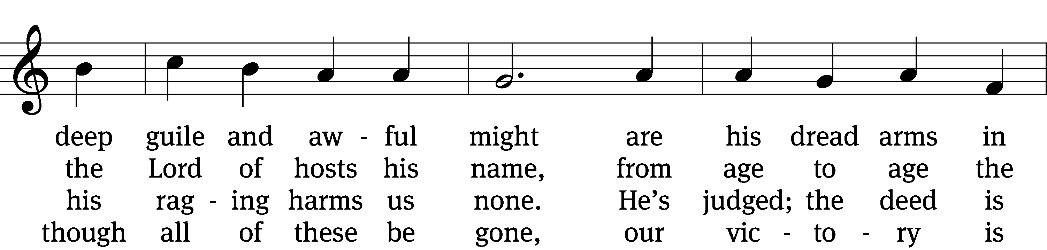
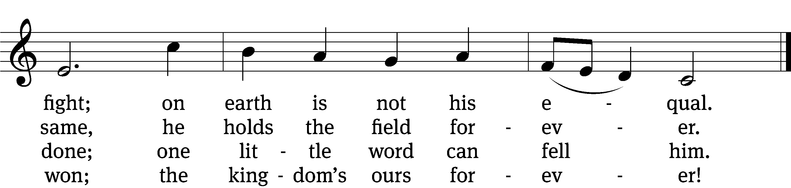
Text: tr. composite; Martin Luther, 1483–1546
Tune: Martin Luther, 1483–1546
Text and tune: Public domain

SERMON Luke 4:1-13
“The Devil Couldn’t Make Him Do It”

Please stand, if you are able
Nicene Creed
We believe in one God, the Father, the Almighty,
maker of heaven and earth,
of all that is,
seen and unseen.
We believe in one Lord, Jesus Christ, the only Son of God,
eternally begotten of the Father,
God from God, Light from Light, true God from true God,
begotten, not made,
of one being with the Father.
Through him all things were made.
For us and for our salvation, he came down from heaven,
was incarnate of the Holy Spirit and the Virgin Mary,
and became truly human.
For our sake he was crucified under Pontius Pilate.
He suffered death and was buried.
On the third day he rose again in accordance with the Scriptures.
He ascended into heaven
and is seated at the right hand of the Father.
He will come again in glory to judge the living and the dead,
and his kingdom will have no end.
We believe in the Holy Spirit,
the Lord, the giver of life,
who proceeds from the Father and the Son,
who in unity with the Father and the Son
is worshiped and glorified,
who has spoken through the prophets.
We believe in one holy Christian and apostolic Church.
We acknowledge one baptism for the forgiveness of sins.
We look for the resurrection of the dead
and the life of the world to come. Amen.
Prayer of the Church

The Sacrament
Preface CW 165
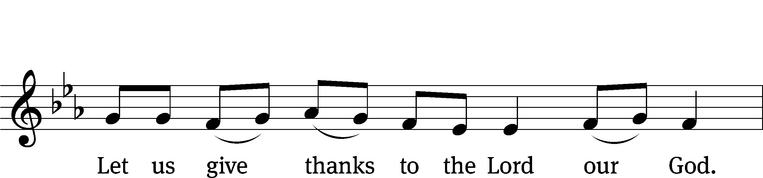

It is truly good and right that we should at all times and in all places give you thanks, O Lord, holy Father, almighty and everlasting God, through Jesus Christ our Lord, who brought the gift of salvation to all people by his death on the tree of the cross so that the devil, who overcame us by a tree, would in turn by a tree be overcome. Therefore, with all the saints on earth and hosts of heaven, we praise your holy name and join their glorious song:

Holy, Holy, Holy CW 167
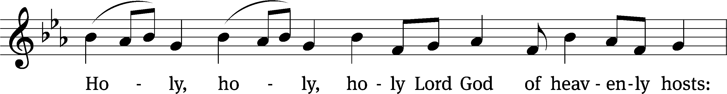
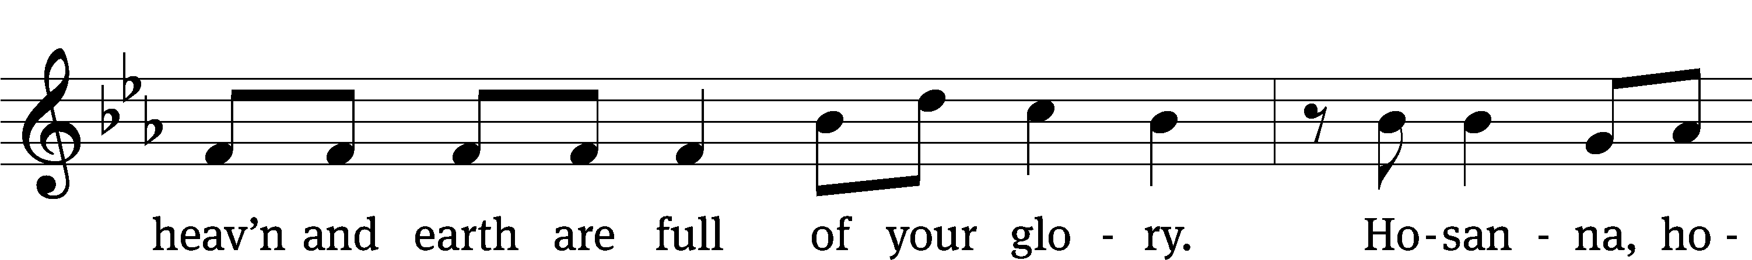
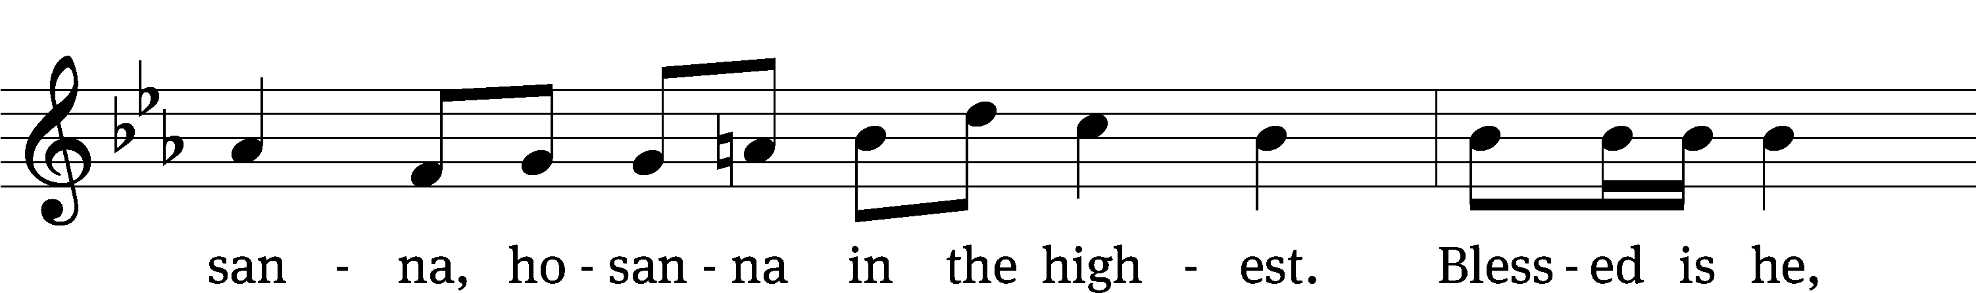
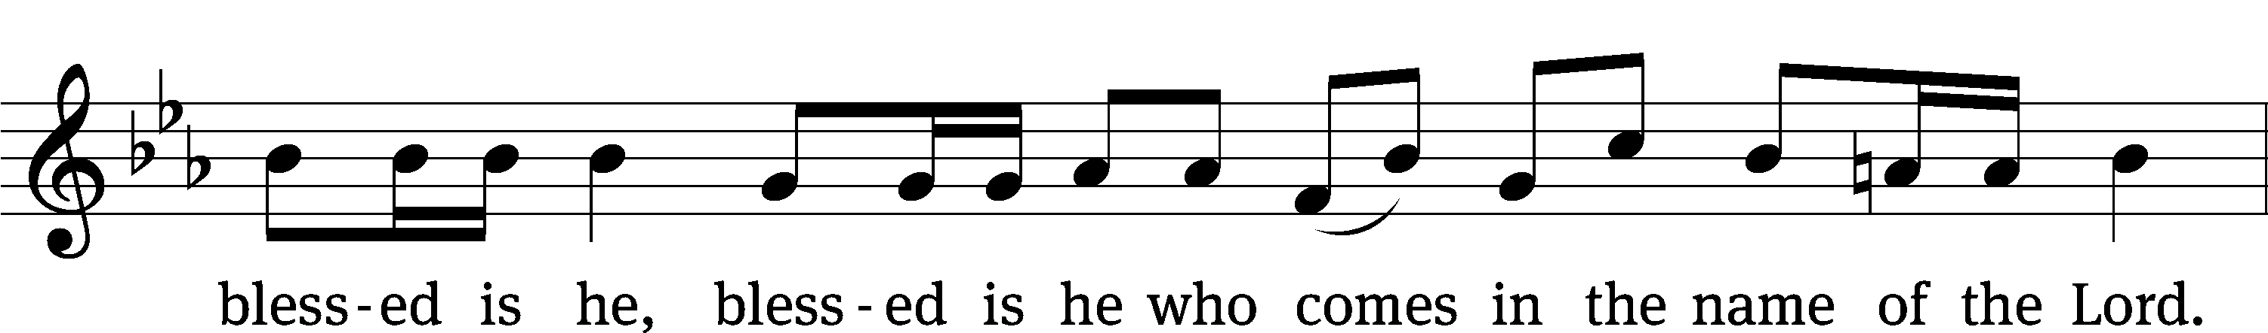
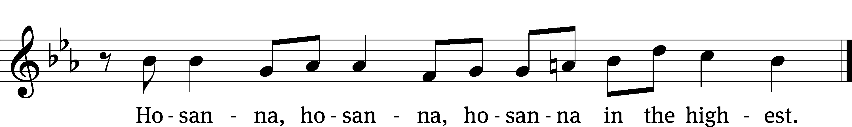

Prayer of Thanksgiving
We give thanks to you, O God, through your dear Son, Jesus Christ, whom you sent to be our Savior, our Redeemer, and the messenger of your grace. Through him you made all things; in him you are well pleased. He is the incarnate Word, conceived by the Holy Spirit and born of the Virgin Mary. To fulfill your promises, he stretched out his hands on the cross and released from eternal death all who believe in you.

As we remember Jesus’ death and resurrection, we thank you that you have gathered us together to receive your Son’s body and blood. Send us your Spirit, unite us as one, and strengthen our faith so that we may praise you in your Son, Jesus Christ. Through him, we glorify and honor you, O God our Father, with the Holy Spirit, one God, now and forever.
Amen.

Lord’s Prayer
Our Father, who art in heaven, hallowed be thy name, thy kingdom come, thy will be done on earth as it is in heaven. Give us this day our daily bread; and forgive us our trespasses, as we forgive those who trespass against us; and lead us not into temptation, but deliver us from evil. For thine is the kingdom and the power and the glory forever and ever. Amen.

Words of Institution
Our Lord Jesus Christ, on the night he was betrayed, took bread; and when he had given thanks, he broke it and gave it to his disciples, saying, “Take and eat; this is my T body, which is given for you. Do this in remembrance of me.”

Then he took the cup, gave thanks, and gave it to them, saying, “Drink from it, all of you; this is my T blood of the new covenant, which is poured out for you for the forgiveness of sins. Do this, whenever you drink it, in remembrance of me.”

The peace of the Lord be with you always.
Amen.

O Christ, Lamb of God CW 169
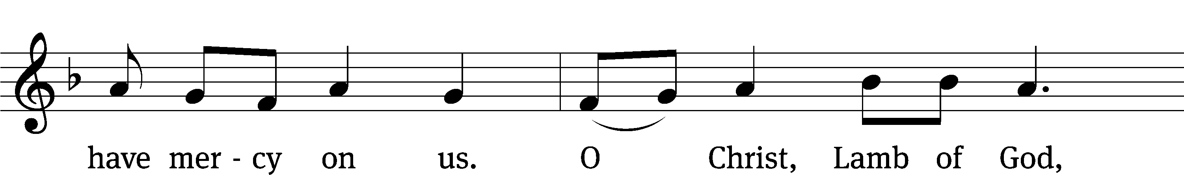
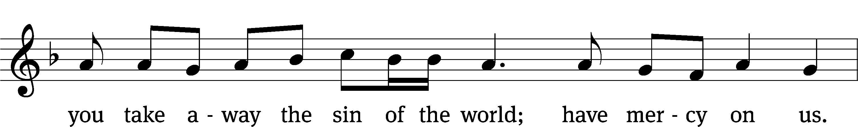

Please be seated
819 If God Himself Be for Me CW 819
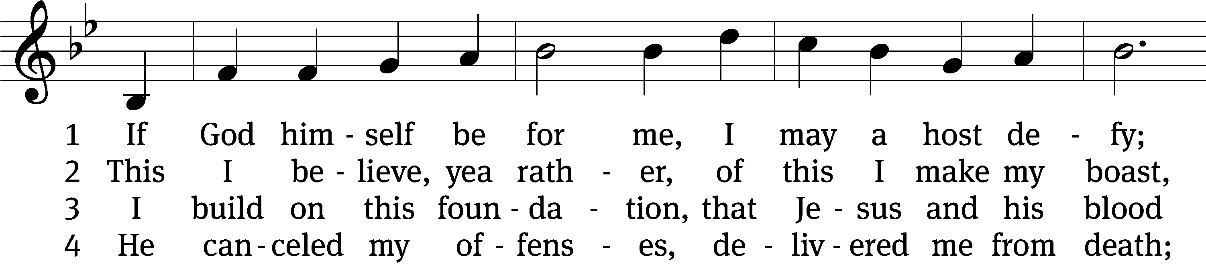
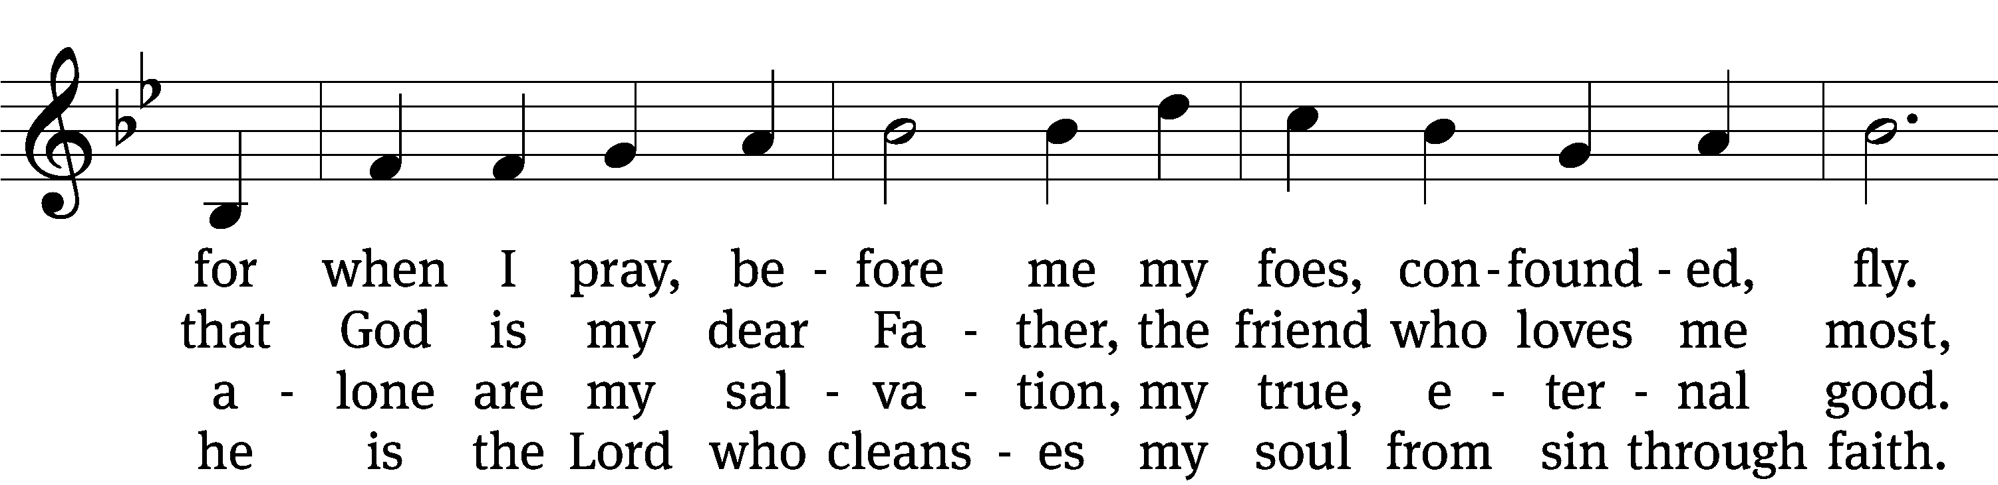
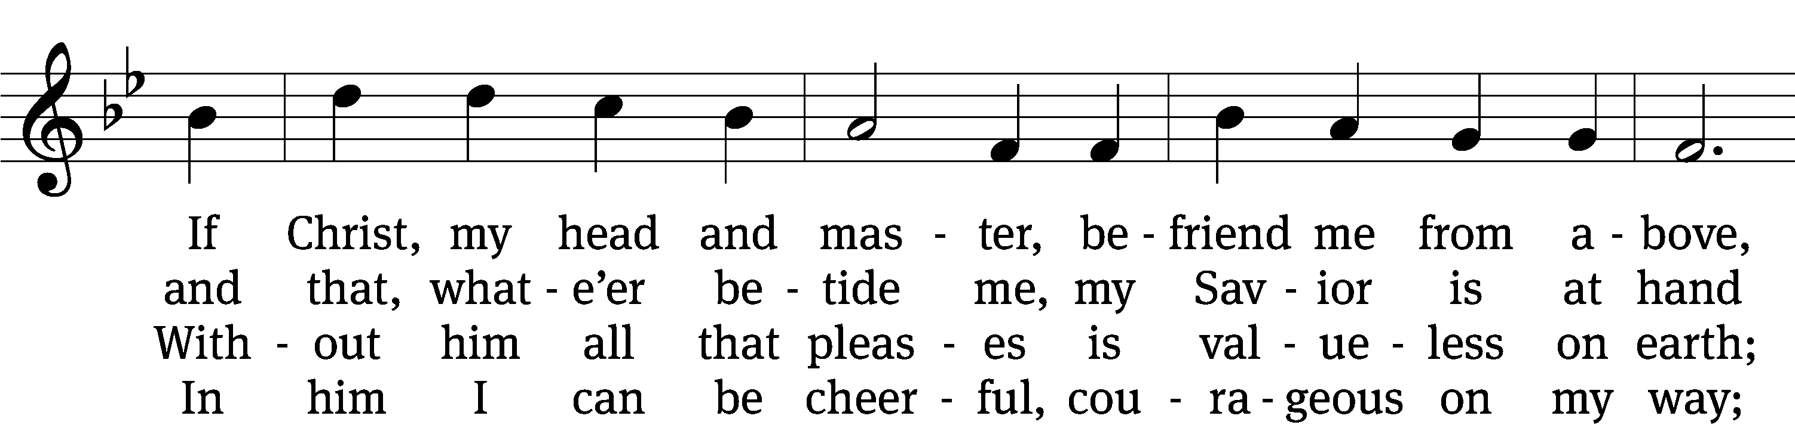
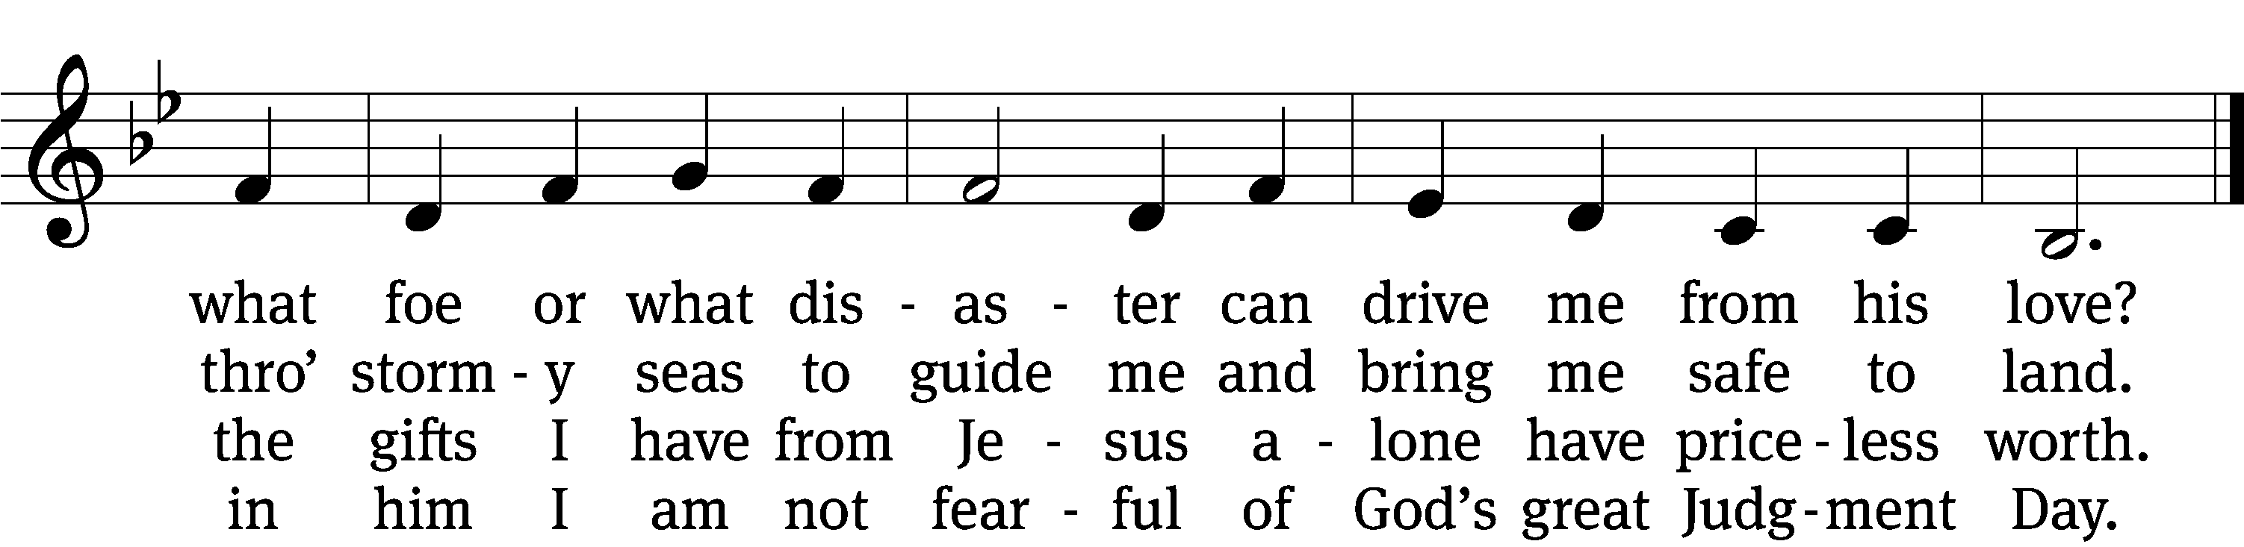

5 Now no one can condemn me
or set my hope aside;
now hell no more can claim me,
its fury I deride.
No sentence now reproves me,
no guilt destroys my peace,
for Christ, my Savior, loves me
and shields me with his grace.

6 No danger, thirst, or hunger,
no pain or poverty,
no earthly tyrant’s anger
shall ever vanquish me.
Though earth should break asunder,
you are my Savior true;
no fire or sword or thunder
shall sever me from you.

7 My heart for joy is springing
and can no more be sad;
my soul is filled with singing,
sees only sunshine glad.
The sun that cheers my spirit
is Jesus Christ, my King;
the heav’n I shall inherit
makes me rejoice and sing.
Text: Paul Gerhardt, 1607–1676, abr.; (sts. 1, 4–5, 7): tr. Evangelical Lutheran Hymn-book, 1907; (sts. 2–3, 6): tr. Richard Massie, 1800–1887
Tune: Melchior Teschner, 1584–1635, alt.
Text and tune: Public domain

Please stand, if you are able

Give thanks to the Lord, for he is good;
his mercy endures forever.

Whenever we eat this bread and drink this cup,
we proclaim the Lord’s death until he comes.

We give thanks, almighty God, that you have refreshed us with this saving gift. We pray that through it you will strengthen our faith in you and increase our love for one another. We ask this in the name of Jesus Christ our Lord, who lives and reigns with you and the Holy Spirit, one God, now and forever.
Amen.

Blessing
The Lord bless you and keep you.
The Lord make his face shine on you and be gracious to you.
The Lord look on you with favor and T give you peace.
Amen.

Please be seated

839 Rock of Ages, Cleft for Me CW 839
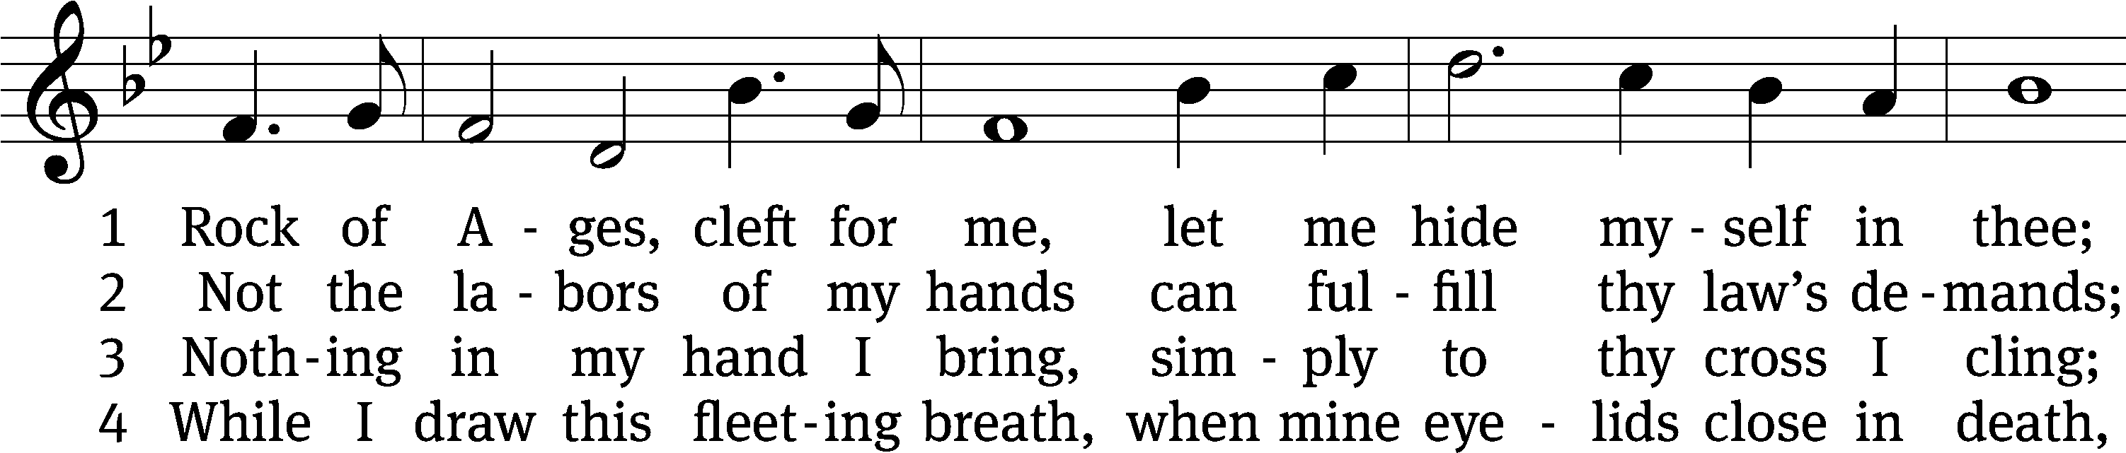
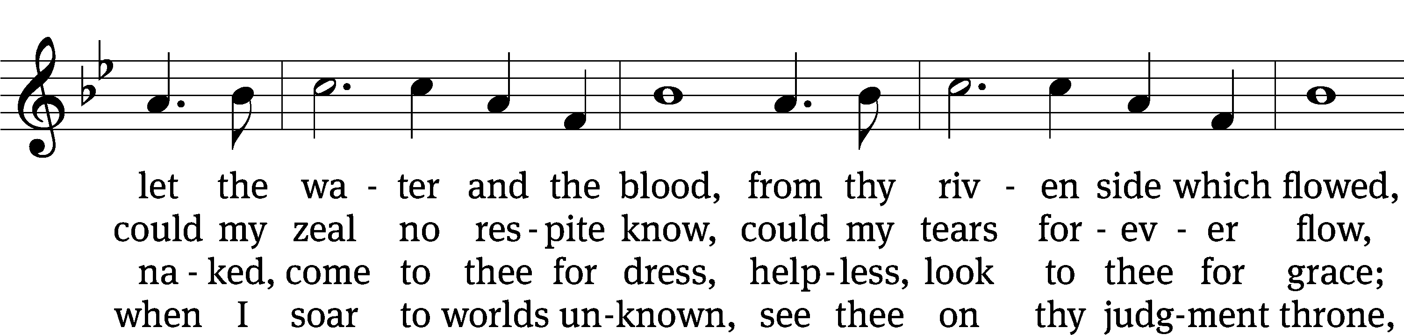
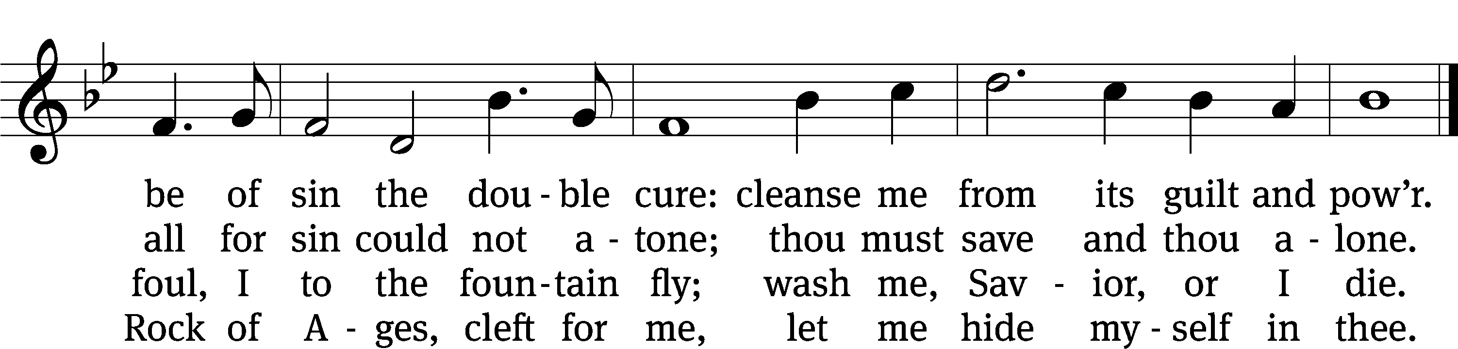
Text: Augustus M. Toplady, 1740–1778, alt.
Tune: Thomas Hastings, 1784–1872
Text and tune: Public domain
Acknowledgments
Setting One from Christian Worship
Software distributed in partnership with Northwestern Publishing House.
Created by Christian Worship: Service Builder © 2022 Concordia Publishing House.

Serving in Worship
Officiant Pastor Natsis
Organist Marcia Marion Ackling
Deacons (8:30) Jim Tice and Ed Wheeler
(11:00) Dave Frey and Jeff Neuburger
Ushers (8:30) Robert Newman and Henry Schneider
(11:00) Bill Barnett and Jake Vershum
Altar Guild Shirley Klumpp and Ann Latowski
Videographer Ann Latowski

* * * * * * * * * * * * * * * * * * * * * * * * * *

trinitylutheran-saline.org

