the LAST sunday
after EPIPHANY
TRANSFIGURATION
tRINITY EVANGELICAL LUTHERAN CHURCH | Saline, Michigan
February 11, 2024

WELCOME TO WORSHIP

Thank you for joining us in God’s house today! We cordially ask that our Guests with us this morning sign one of the guestbooks located at either the front or back entryways.

THANK OFFERING: Members of Trinity give their offering as an expression of love and thankfulness to the Lord and to help support the Lord’s work in our community and around the world. Visitors need not feel obligated to participate in this offering which supports our ministry.

Restrooms are located at the back of the upper level (the annex), and in the basement (down the back stairs of the sanctuary or annex). Handicap access is available, please ask an usher for assistance.

Young Families / Toddler Bags – We are GLAD YOU BROUGHT YOUR CHILDREN to our worship service. Jesus said: “Let the little children come to me and do not hinder them, for the kingdom of God belongs to such as these.” We know that having little children in church can be a challenge, but DO NOT WORRY about it. Many of your fellow worshippers have been in your shoes and are just happy you brought your children with you. For your convenience, we have reserved the back rows of seating for parents with small children. These areas provide more flexibility for your family, as well as, easy access to move downstairs if necessary. A closed-circuit TV system allows families to continue participating in the service while downstairs. Pre-school toddler bags and children’s bulletins are available for their enjoyment. Ask an usher for one to use during the service and please return the toddler bag afterwards.

SERVICE of the word

855 The Church’s One Foundation CW 855 sts. 1–5
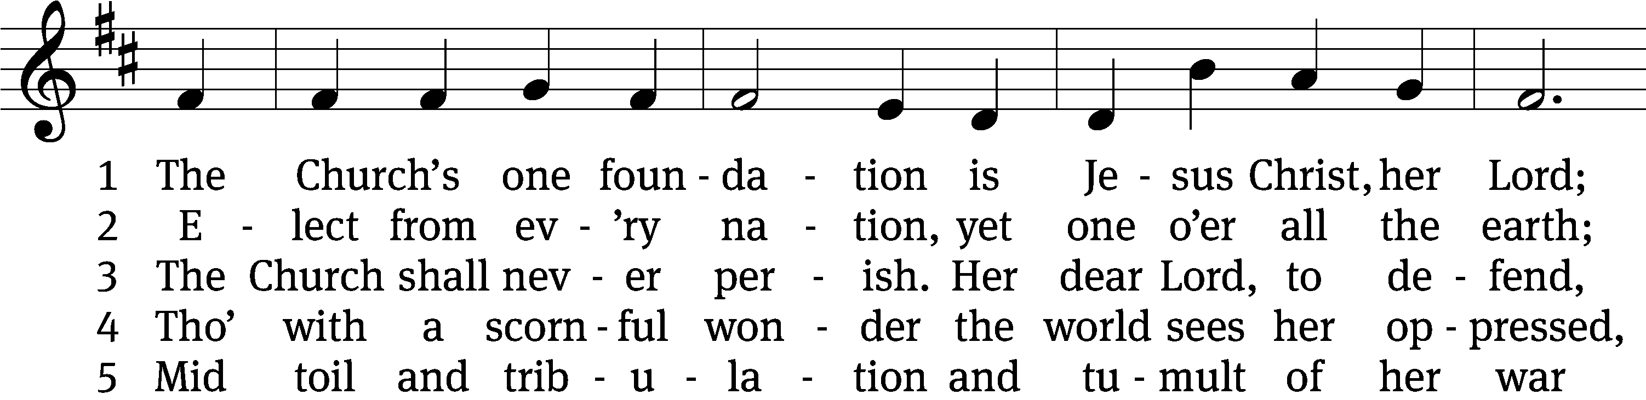
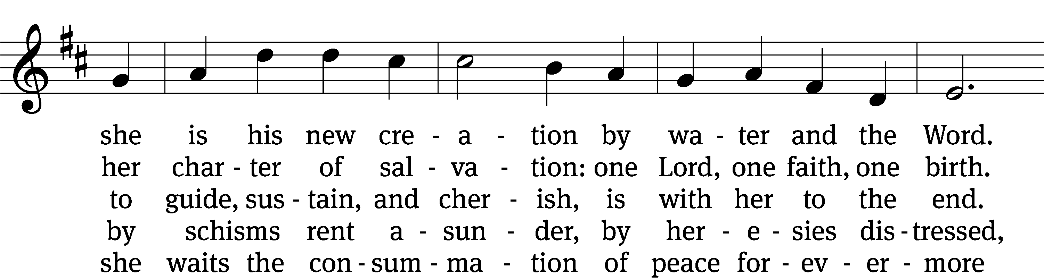
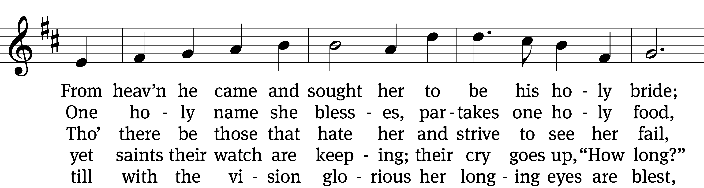
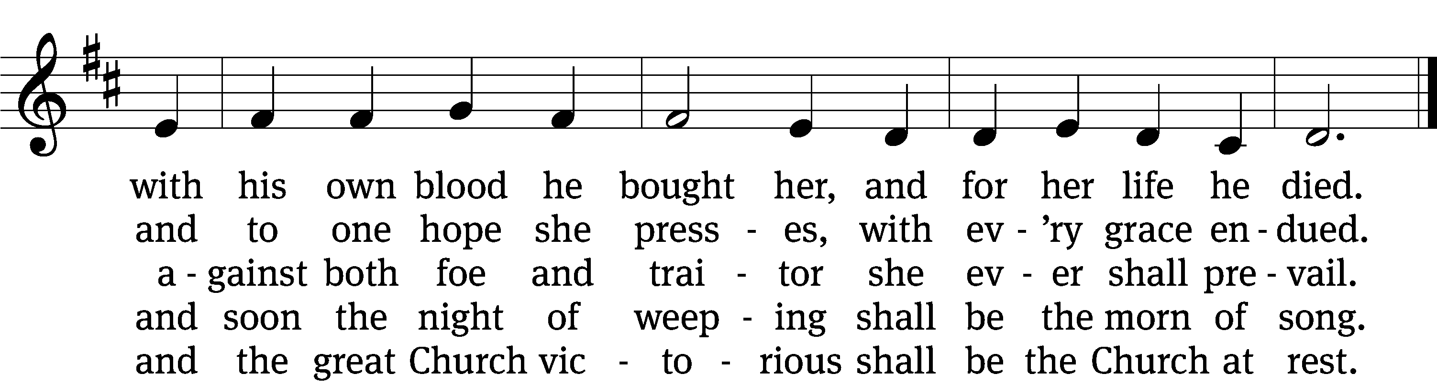
Text: Samuel J. Stone, 1839–1900, abr., alt.
Tune: Samuel S. Wesley, 1810–1876
Text and tune: Public domain

PLEASE STAND, IF YOU ARE ABLE

invocation
M: The grace of our Lord (+) Jesus Christ and the love of God and the fellowship of the Holy Spirit be with you.
C: And also with you.

CONFESSION OF SINS
M: We have come into the presence of God, who created us to love and serve him as his dear children. But we have disobeyed him and deserve only his wrath and punishment. Therefore, let us confess our sins to him and plead for his mercy.

C: Merciful Father in heaven, I am altogether sinful from birth. In countless ways I have sinned against you and do not deserve to be called your child. But trusting in Jesus, my Savior, I pray: Have mercy on me according to your unfailing love. Cleanse me from my sin, and take away my guilt.

M: God, our heavenly Father, has forgiven all your sins. By the perfect life and innocent death of our Lord Jesus Christ, he has removed your guilt forever. You are his own dear child. May God give you strength to live according to his will.

C: Amen.

PRAYER AND PRAISE

M: In the peace of forgiveness, let us praise the Lord.

OH, TASTE AND SEE

PRAYER OF THE DAY

Let us pray.

O God, in the glorious transfiguration of your only-begotten Son, you confirmed the mysteries of the faith by the testimony of Moses and Elijah, and in the voice that came from the bright cloud, you foreshadowed our adoption as your sons. In your mercy, make us co-heirs of glory with Jesus our King, and bring us at last to heaven; through your Son, Jesus Christ our Lord, who lives and reigns with you and the Holy Spirit, one God, now and forever.
Amen.

PLEASE BE SEATED

The Word

the FIRST LESSON 2 Kings 2: 1-12a
2 When the Lord was about to take Elijah up to heaven in a whirlwind, Elijah was traveling with Elisha from Gilgal. ² Elijah said to Elisha, “Stay here, for the Lord has sent me to Bethel. ”But Elisha said, “As surely as the Lord lives and as your soul lives, I will not leave you.” So they went down to Bethel. ³ The sons of the prophets who were in Bethel came out to Elisha and said to him, “Do you know that today the Lord is taking your master away from you?” Then he said, “Yes, I know. Be quiet.” ⁴ Then Elijah said to him, “Elisha, stay here because the Lord has sent me to Jericho.” But he said, “As surely as the Lord lives and as your soul lives, I will not leave you.” So they went to Jericho. ⁵ Then the sons of the prophets who were in Jericho approached Elisha and said to him, “Do you know that today the Lord is taking your master away from you?” He said, “Yes, I know. Be quiet.” ⁶ Then Elijah said to him, “Stay here because the Lord has sent me to the Jordan.” But he said, “As surely as the Lord lives and as your soul lives, I will not leave you.” So the two of them went on. ⁷ Then fifty men from the sons of the prophets came and stood and watched them from a distance, while the two of them were standing at the Jordan. ⁸ Elijah took his cloak, folded it together, and struck the water. The water divided to the right and to the left. Then the two of them crossed on dry land.
⁹ When they had crossed, Elijah said to Elisha, “Ask me for whatever I can do for you before I am taken from you.” Then Elisha said, “Let there be a double portion of your spirit on me.” ¹⁰ He said, “You have asked for a difficult thing. If you see me being taken from you, it will surely be yours. But if not, then it will not.” ¹¹ While they were walking and talking, suddenly a chariot of fire and horses of fire came and separated them. So Elijah went up to heaven in a whirlwind. ¹² Elisha was watching and crying out, “My father! My father! Israel’s chariot and its charioteers!” Then he did not see him anymore.
How Marvelous Are the Works Choir anthem
How marvelous are the works of the Lord, how excellent are His ways.
How wonderful is His glory and fame, ever the same, great is the name of the Lord.

Great is the God of Israel, and great are the works of His hands.
He alone is the King of kings, creation bows at His command.

How marvelous are the works of the Lord, how excellent are His ways.
How wonderful is His glory and fame, ever the same, great is the name of the Lord.

Great is the God of Abraham and perfect is His law.
In majesty and in holiness He rules Lord of all!

How marvelous are the works of the Lord, how excellent are His ways.
How wonderful is His glory and fame, ever the same, great is the name of the Lord.

Praise the Lord! Praise the Lord! Praise the Lord!

SECOND LESSON 2 Corinthians 4:3-6
³ But even if our gospel is veiled, it is veiled among those who are perishing. ⁴ In the case of those people, the god of this age has blinded the minds of the unbelievers, to keep them from clearly seeing the light of the gospel of the glory of Christ, who is God’s image.
⁵ Indeed, we do not preach ourselves, but Jesus Christ as Lord, and ourselves as your servants for Jesus’ sake. ⁶ For the God who said, “Light will shine out of darkness,” is the same one who made light shine in our hearts to give us the light of the knowledge of the glory of God in the person of Jesus Christ.

PLEASE STAND, IF YOU ARE ABLE

Verse of the day Mark 9:7
Alleluia. A cloud covered them, and a voice came from the cloud: “This is my Son, whom I love. Listen to him!” Alleluia.

THE GOSPEL LESSON Mark 9: 2-9
M: The Gospel according to Mark chapter 9, verses 2-9:
² After six days Jesus took Peter, James, and John with him and led them up a high mountain where they were alone by themselves. There he was transfigured in front of them. ³ His clothes became radiant, dazzling white, whiter than anyone on earth could bleach them. ⁴ And Elijah appeared to them together with Moses, and they were talking with Jesus. ⁵ Peter said to Jesus, “Rabbi, it is good for us to be here. Let us make three tents: one for you, one for Moses, and one for Elijah.” ⁶ He did not know what to say because they were terrified. ⁷ A cloud appeared and overshadowed them, and a voice came from the cloud, saying, “This is my Son, whom I love. Listen to him.” ⁸ Suddenly, when they looked around, they no longer saw anyone with them except Jesus alone. ⁹ As they were coming down the mountain, Jesus commanded them not to tell anyone what they had seen until the Son of Man had risen from the dead.

M: This is the Gospel of the Lord.

PLEASE BE SEATED

390 Jesus, Take Us to the Mountain CW 390
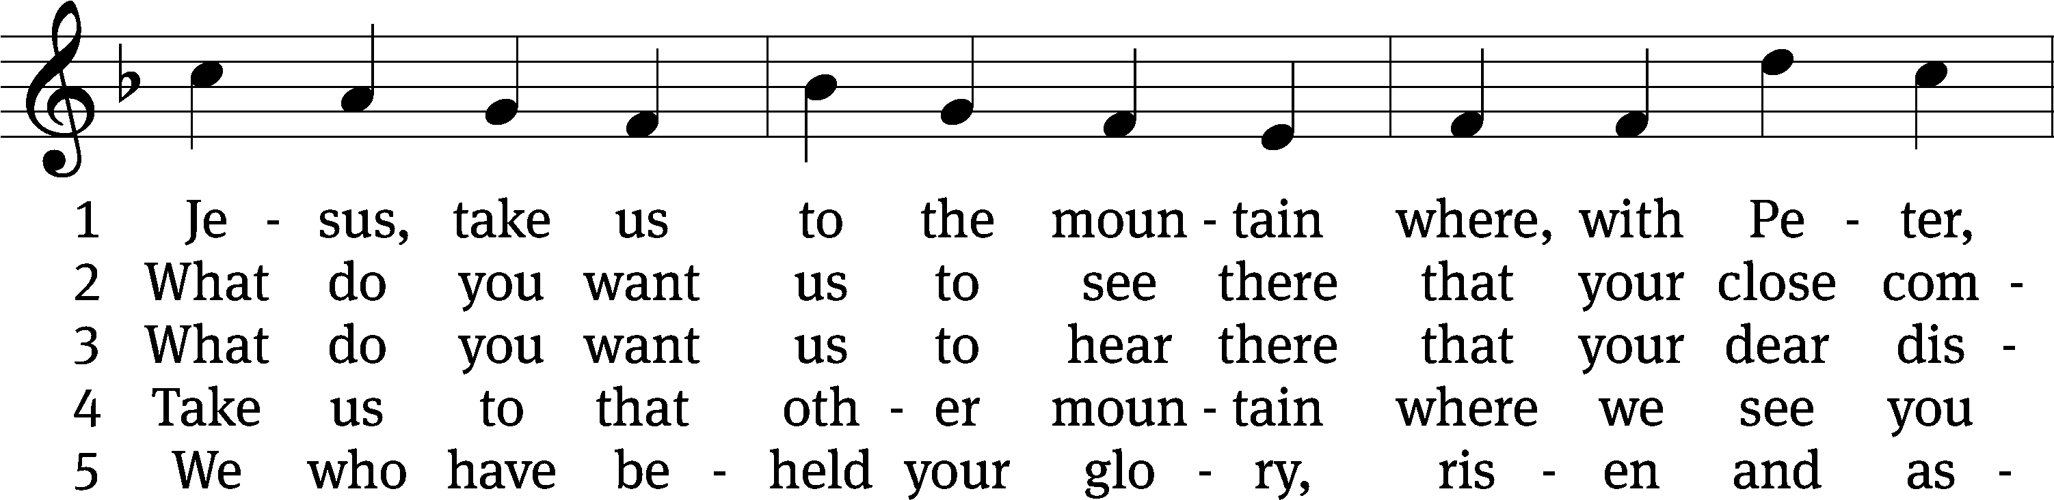
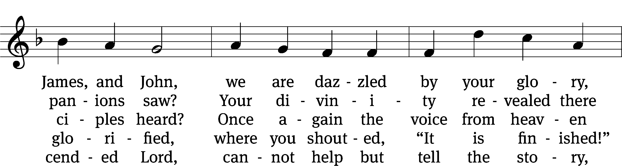
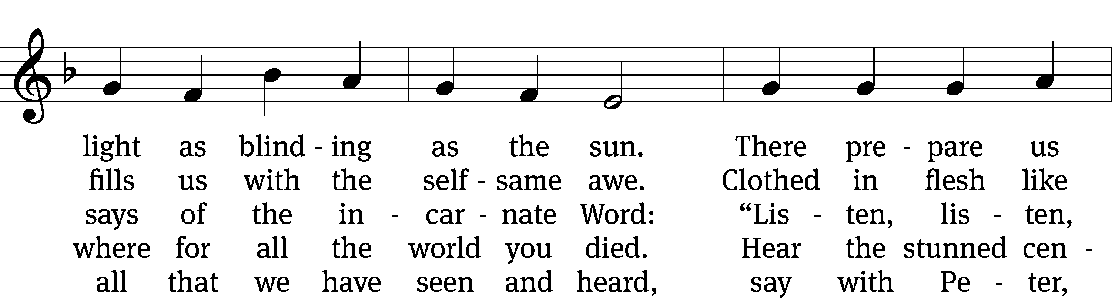
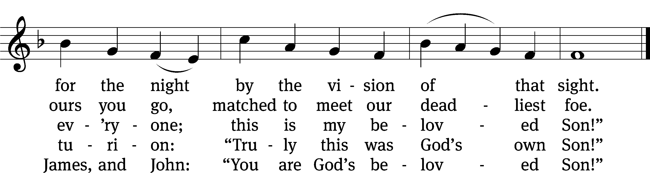
Text: Jaroslav J. Vajda, 1919–2008
Tune: Carl F. Schalk, 1929–2021
Text: © 1991 Concordia Publishing House. Used by permission: OneLicense no. 727703
Tune: © 1991 Carl F. Schalk. Used by permission: OneLicense no. 727703

SERMON Mark 9:2-9
“True Glory”

PLEASE STAND, IF YOU ARE ABLE

THE APOSTLES’ CREED

I believe in God, the Father almighty,
maker of heaven and earth.
I believe in Jesus Christ, his only Son, our Lord,
who was conceived by the Holy Spirit,
born of the virgin Mary,
suffered under Pontius Pilate,
was crucified, died, and was buried.
He descended into hell.
The third day he rose again from the dead.
He ascended into heaven
and is seated at the right hand of God the Father almighty.
From there he will come to judge the living and the dead.
I believe in the Holy Spirit,
the holy Christian Church,
the communion of saints,
the forgiveness of sins,
the resurrection of the body,
and the life everlasting. Amen.

PRAYER OF THE CHURCH

THE LORD’S PRAYER

C: Our Father, who art in heaven, hallowed be thy name, thy kingdom come, thy will be done on earth as it is in heaven. Give us this day our daily bread; and forgive us our trespasses, as we forgive those who trespass against us; and lead us not into temptation, but deliver us from evil. For thine is the kingdom and the power and the glory forever and ever. Amen.

PLEASE BE SEATED
713 I Want to Walk as a Child of the Light CW 713
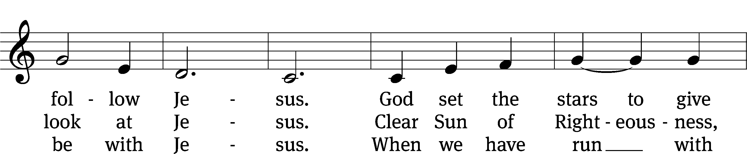
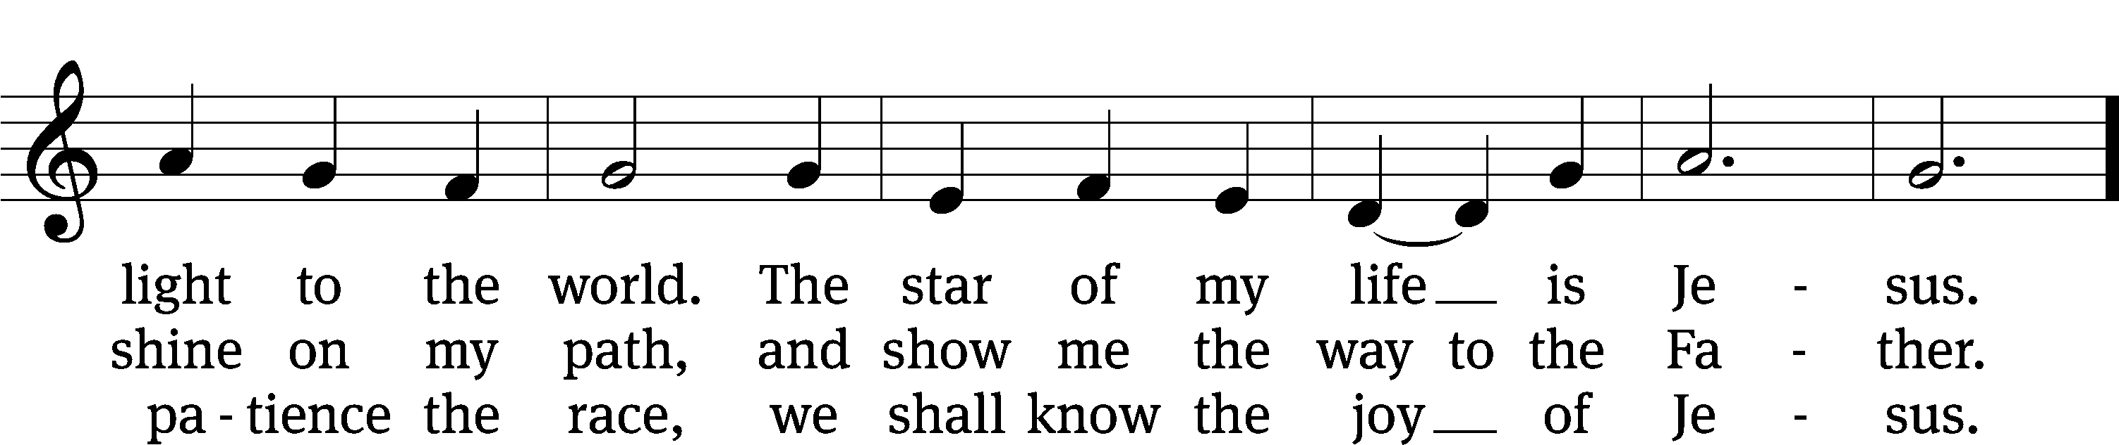
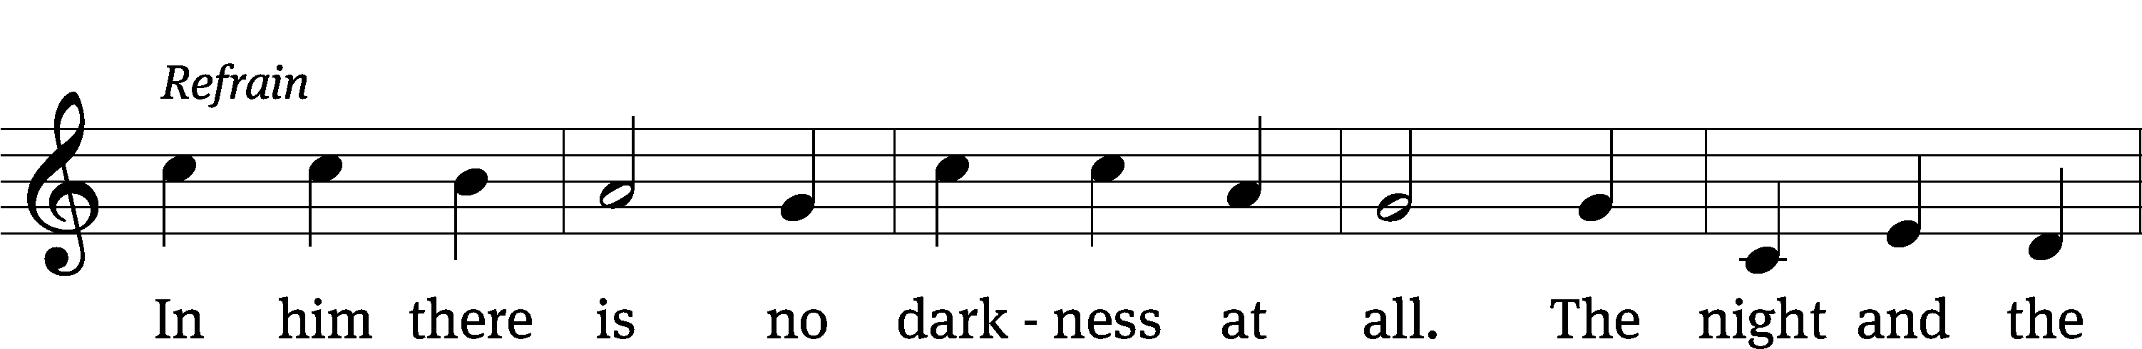
Text: Kathleen Thomerson, b. 1934
Tune: Kathleen Thomerson, b. 1934
Text and tune: © 1970, 1975 Celebration. Used by permission: OneLicense no. 727703

PLEASE STAND, IF YOU ARE ABLE

CLOSING PRAYER
M: Almighty God, we thank you for teaching us the things you want us to believe and do. Help us by your Holy Spirit to keep your Word in pure hearts that we may be strengthened in faith, guided in holiness, and comforted in life and in death, through Jesus Christ, our Lord, who lives and reigns with you and the Holy Spirit, one God, now and forever.

M: Brothers and sisters, go in peace. Live in harmony with one another. Serve the Lord with gladness.
The Lord bless you and keep you.
The Lord make his face shine on you and be gracious to you.
The Lord look on you with favor and (+) give you peace.

PLEASE BE SEATED

522 Beautiful Savior CW 522
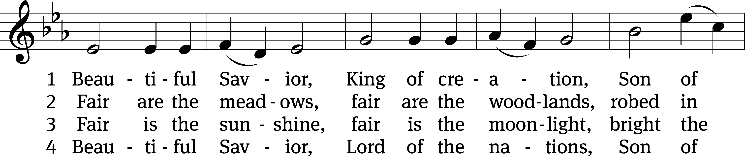
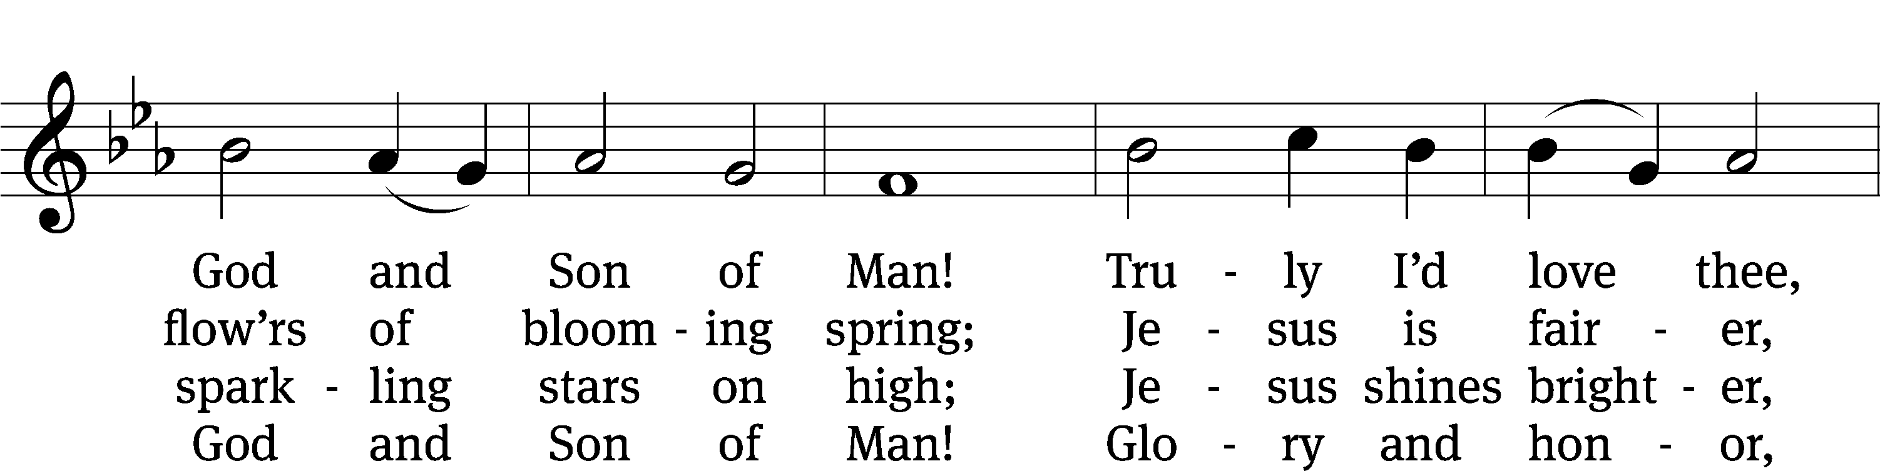
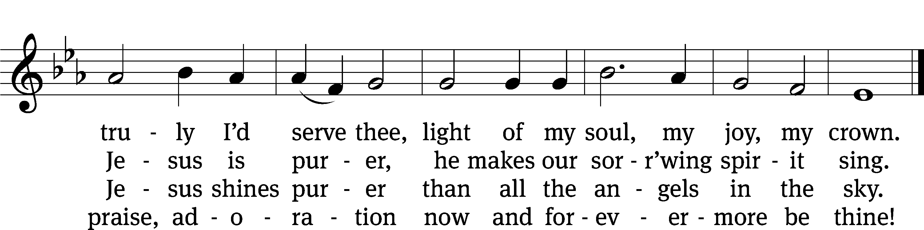
Text: tr. Joseph A. Seiss, 1823–1904; Münsterisch Gesangbuch, Münster, 1677, abr.
Tune: Silesian, 19th cent.
Text and tune: Public domain

Serving In Worship
Officiant Pastor Pappenfuss
Organist Sarah Hanke
Choir Director Cynthia Natsis
Instrumentalist Tom Amerman
Deacons (8:30) Ron Roehm and Duane Mason
Deacons (11:00) Dave Frey and Robert Niethammer
Ushers (8:30) Brian Graham and Tim Phelps
Ushers (11:00) Ron Zahn
Altar Guild Judy Lindemann and Barb Neuburger
Videographer Jake Vershum

Copyright information
Service of the Word: Christian Worship. © 1993 Northwestern Publishing House. All rights reserved.
Reprinted with permission under ONE LICENSE #A-727703 and CCLI #1151741/CSPL126093

Words and Music: All rights reserved. Reprinted with permission under ONE LICENSE #A-727703 and
CCLI #1151741/CSPL126093
tlcsaline.church

