THE FIfth SUNDAY
AFTER EPIPHANY

TRINITY EVANGELICAL LUTHERAN CHURCH | Saline, Michigan
WELCOME TO WORSHIP February 4, 2024
Thank you for joining us in God’s house today! We cordially ask that our Guests sign one of the guestbooks located at either the front or back entryways, or fill out a “Let’s Get Acquainted” card located in the hymnal pew rack and place it in the collection plate.

Thank Offering: Members of Trinity give their offering as an expression of love and thankfulness to the Lord and to help support the Lord’s work in our community and around the world. Visitors need not feel obligated to participate in this offering .

Restrooms are located at the back of the upper level (the annex), and in the basement (down the back stairs of the sanctuary or annex). Handicap access is available, please ask an usher for assistance.

Young Families / Toddler Bags – We are GLAD YOU BROUGHT YOUR CHILDREN to our worship service. Jesus said: “Let the little children come to me and do not hinder them, for the kingdom of God belongs to such as these.” We know that having little children in church can be a challenge, but DO NOT WORRY about it. Many of your fellow worshippers have been in your shoes and are just happy you brought your children with you. For your convenience, we have reserved the back rows of seating for parents with small children. These areas provide more flexibility for your family, as well as, easy access to move downstairs if necessary. A closed-circuit TV system allows families to continue participating in the service while downstairs. Pre-school toddler bags and children’s bulletins are available for their enjoyment. Ask an usher for one to use during the service and please return the toddler bag afterwards.

Holy Communion – In His Word, God makes it clear that the Lord’s Supper is to be shared by people of a common proclamation of faith (1 Corinthians 11:26; 1 Corinthians 10:16-17). Without judging anyone’s hearts, we invite those who share in our confession by their membership in our congregation or another congregation of the Wisconsin Evangelical Lutheran Synod (WELS) or the Evangelical Lutheran Synod (ELS) and who are properly prepared (1 Corinthians 11;27-29) to receive the Sacrament. Page 295 in Christian Worship provides a guide for preparation.
Guests, we would love to have you join us in communion fellowship in the future, and for that to be possible, we ask that you speak with one of the pastors so that we may speak with you on how that would be possible. We thank you for respecting the way we celebrate the Lord’s Supper in our congregations.

the SERVICE – setting one - WITH HOLY COMMUNION CW, page 154
Bell Choir (11:00) “Praise to the Lord”
863 A Mighty Fortress Is Our God CW 863
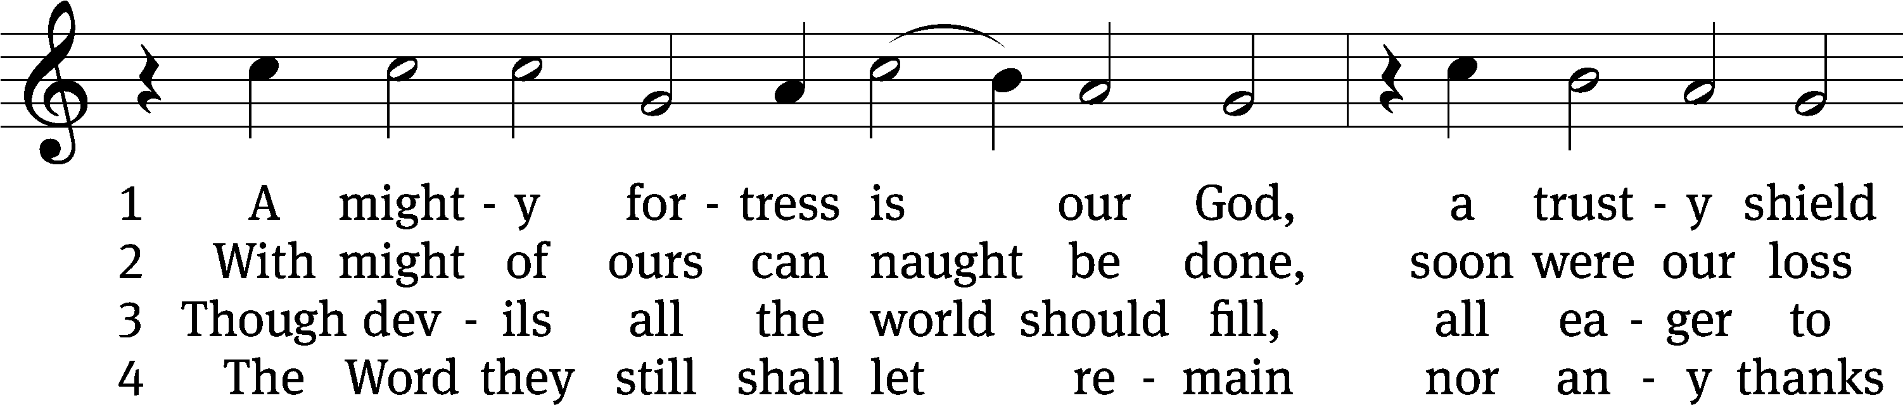
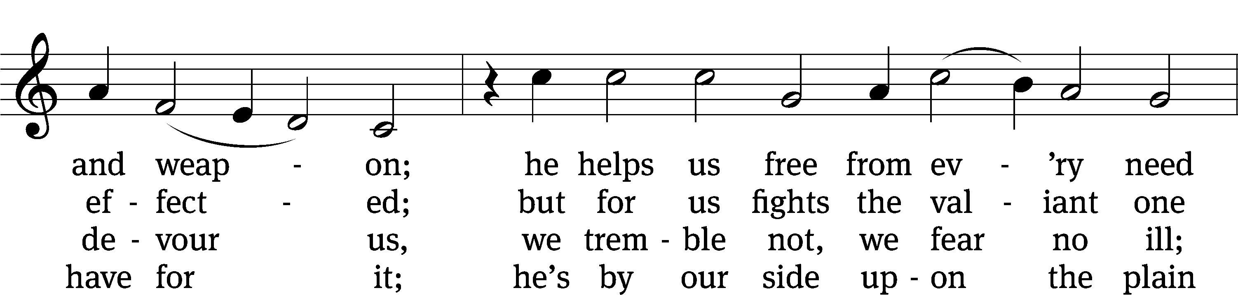
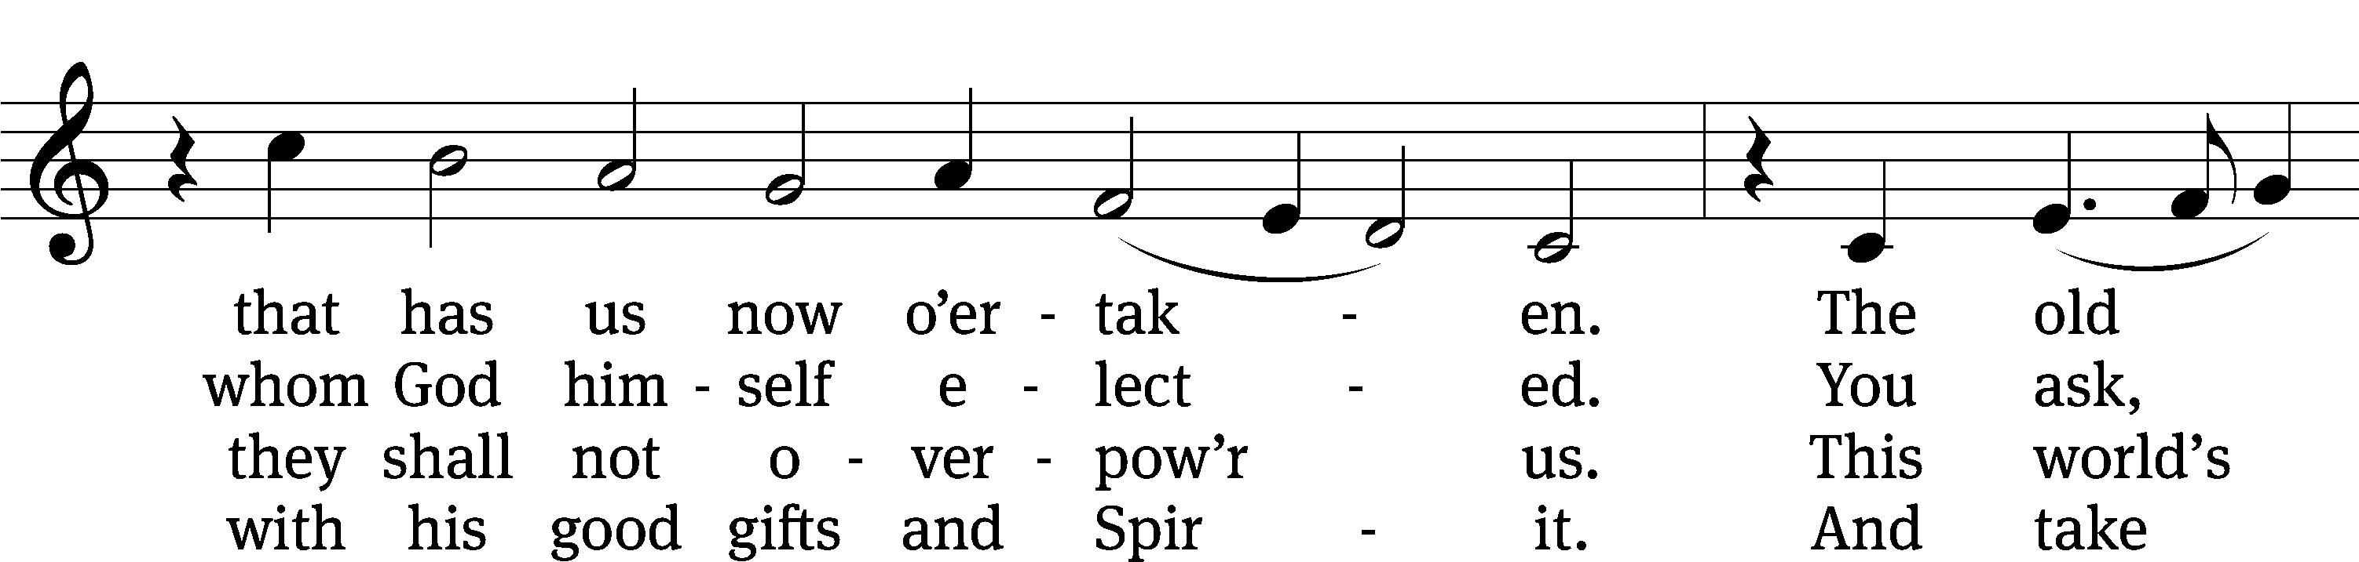
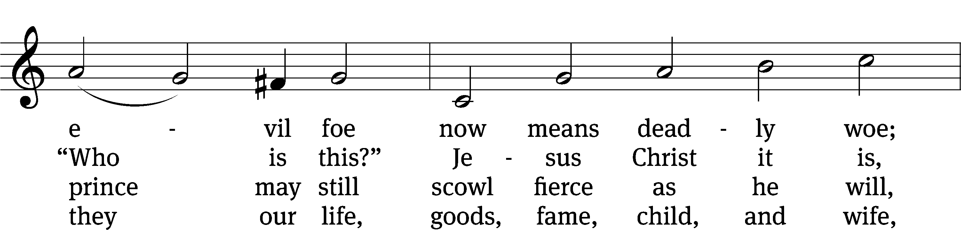
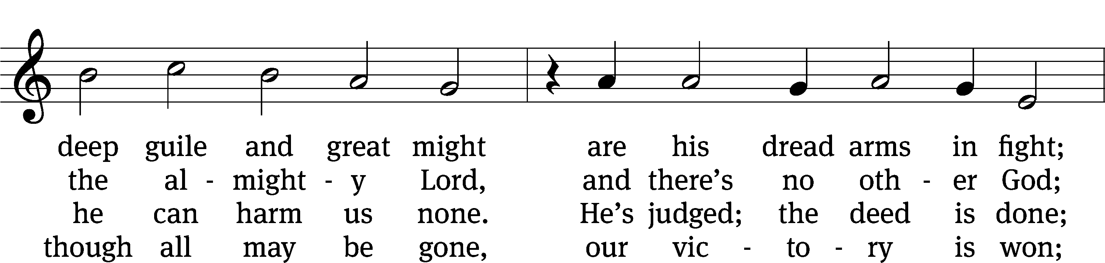
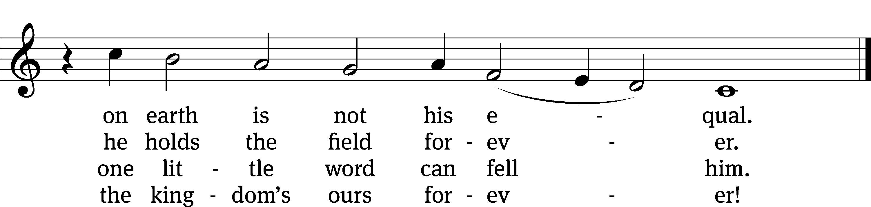
Text: tr. composite; Martin Luther, 1483–1546
Tune: Martin Luther, 1483–1546
Text and tune: Public domain

Please stand, if you are able

Invocation

In the name of the Father and of the Son and of the Holy Spirit.
Amen.

Confession

If we claim to be without sin, we deceive ourselves and the truth is not in us.
If we confess our sins, God is faithful and just
and will forgive us our sins
and purify us from all unrighteousness.

Let us confess our sins to the Lord.
Holy God, gracious Father,
I am sinful by nature
and have sinned against you in my thoughts, words, and actions.
I have not loved you with my whole heart;
I have not loved others as I should.
I deserve your punishment both now and forever.
But Jesus, my Savior, paid for my sins
with his innocent suffering and death.
Trusting in him, I pray: God, have mercy on me, a sinner.

Our gracious Father in heaven has been merciful to us. He sent his only Son, Jesus Christ, who gave his life as the atoning sacrifice for the sins of the whole world. Therefore, as a called servant of Christ and by his authority, I forgive you all your sins in the name of the Father and of the Son and of the Holy Spirit.
Amen.
Lord, Have Mercy

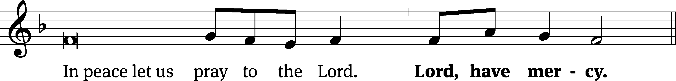
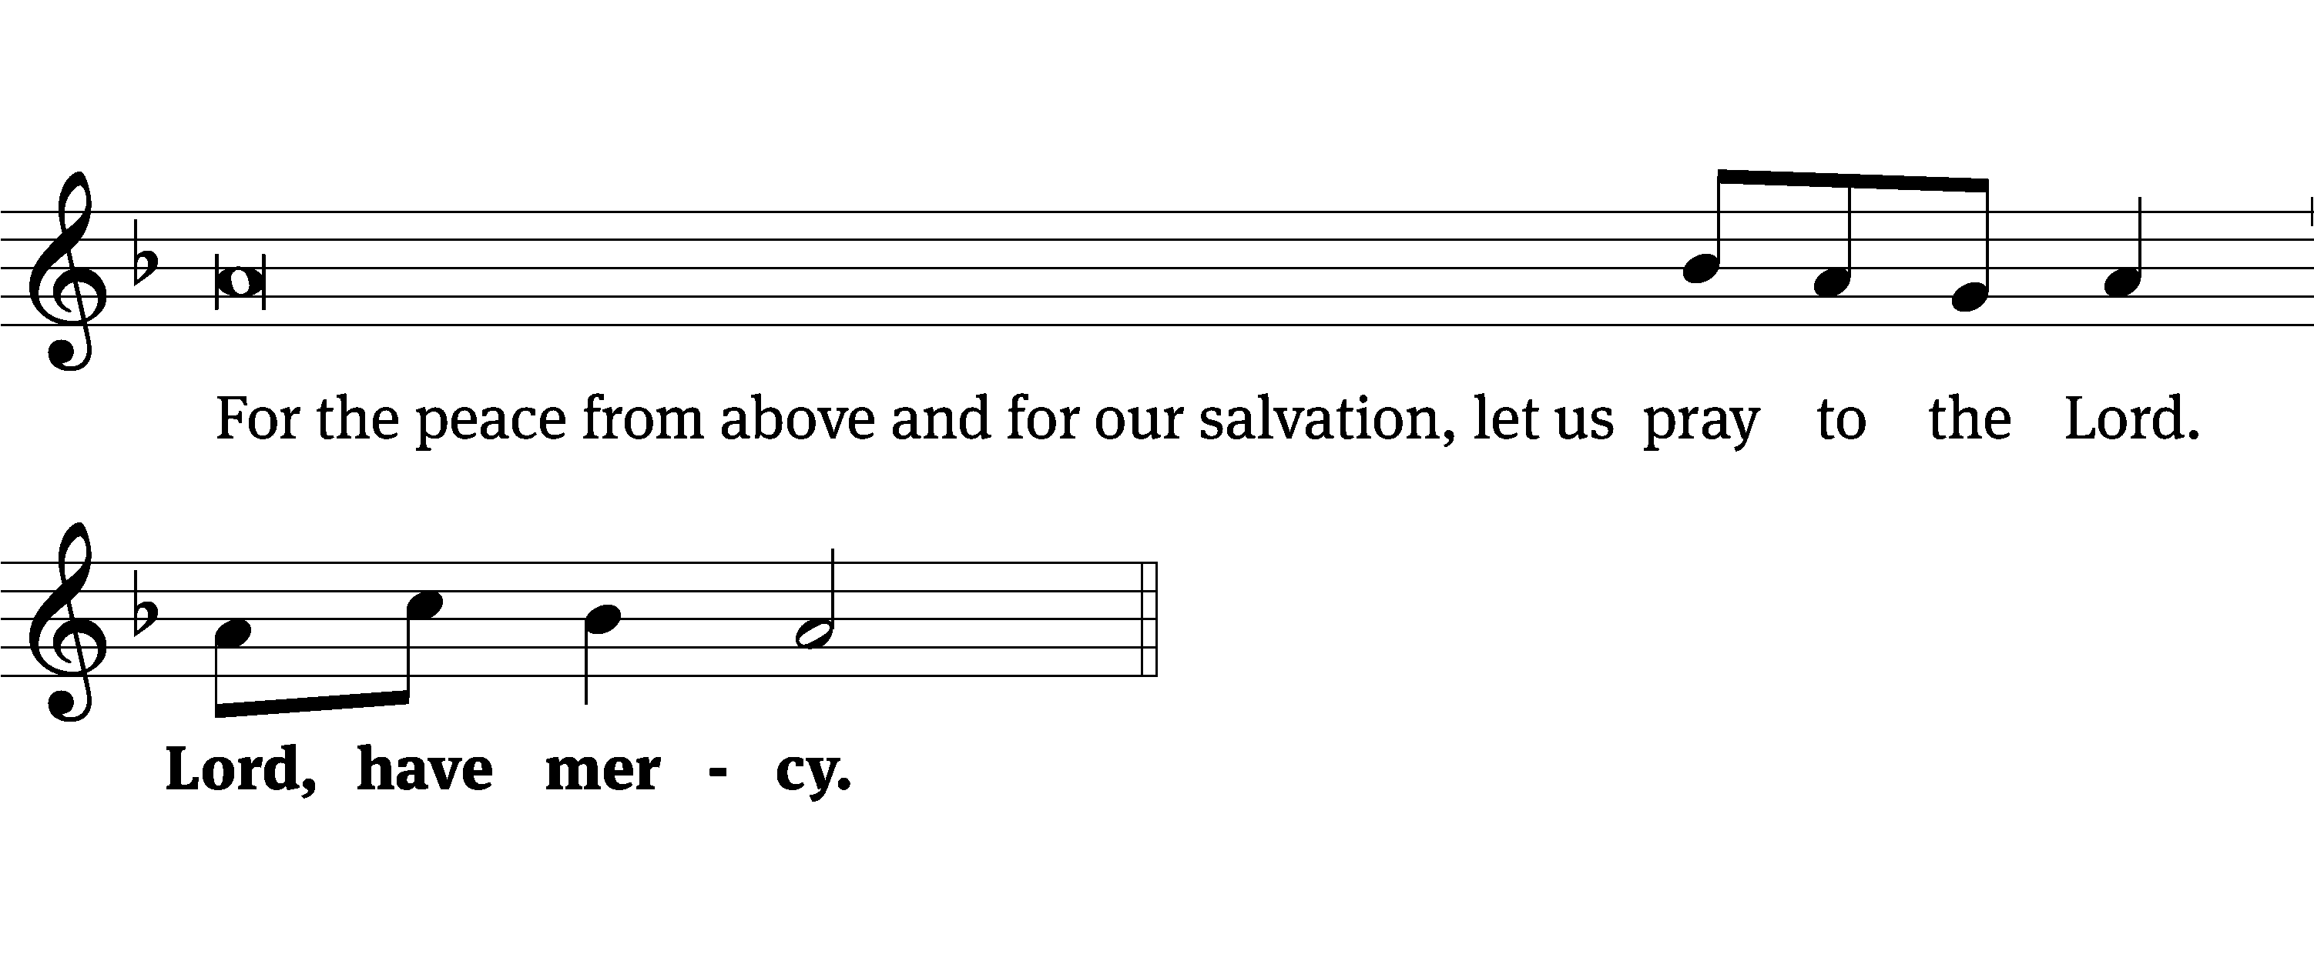
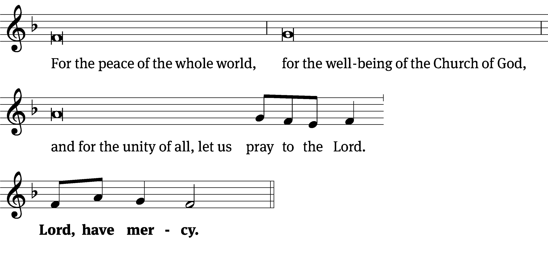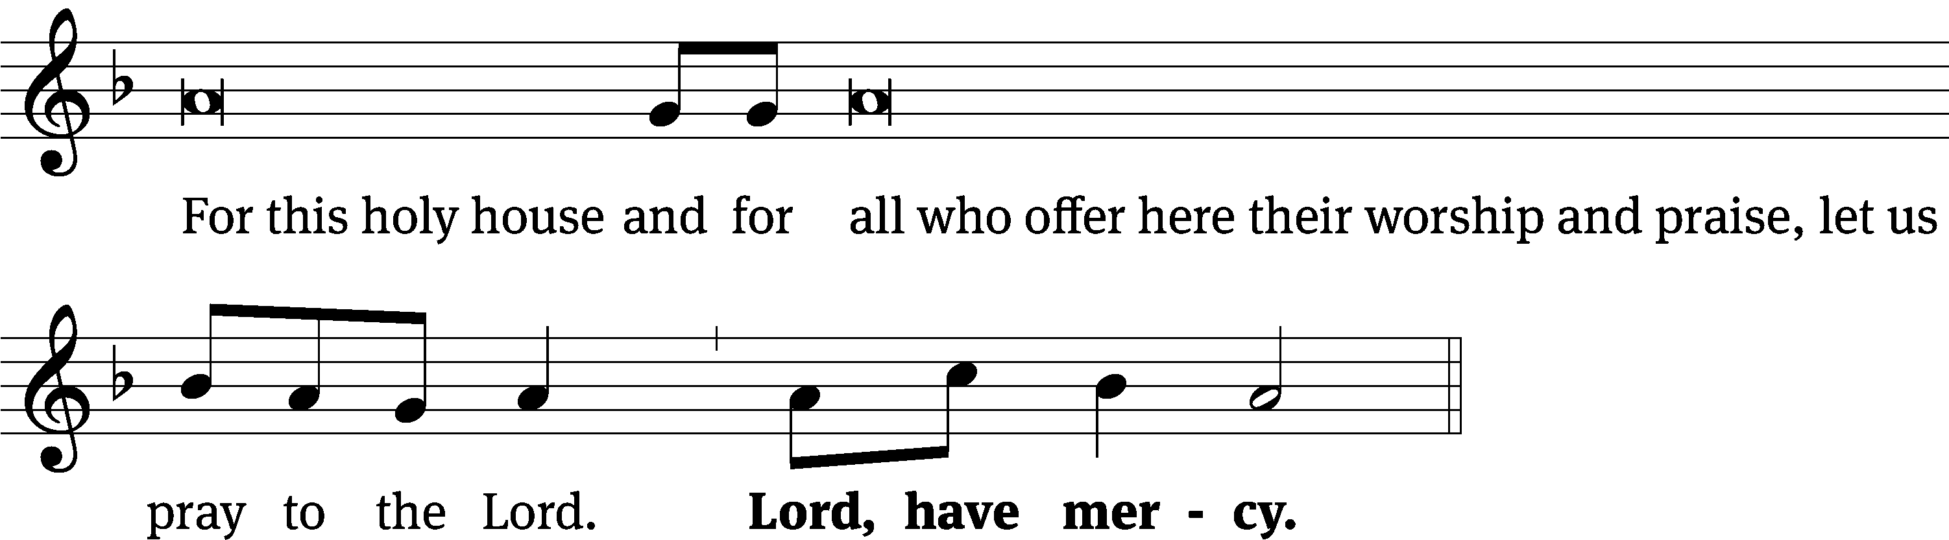
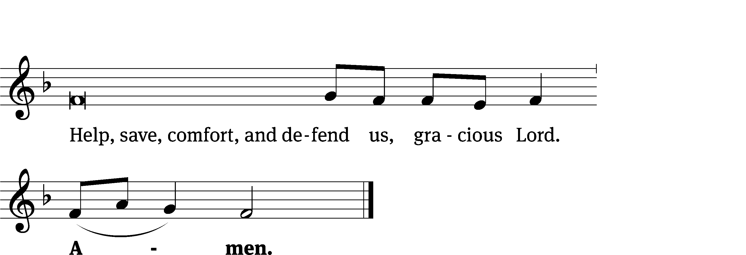
Glory Be to God on High CW 157
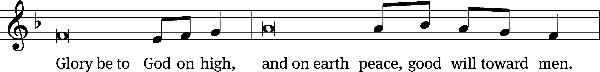
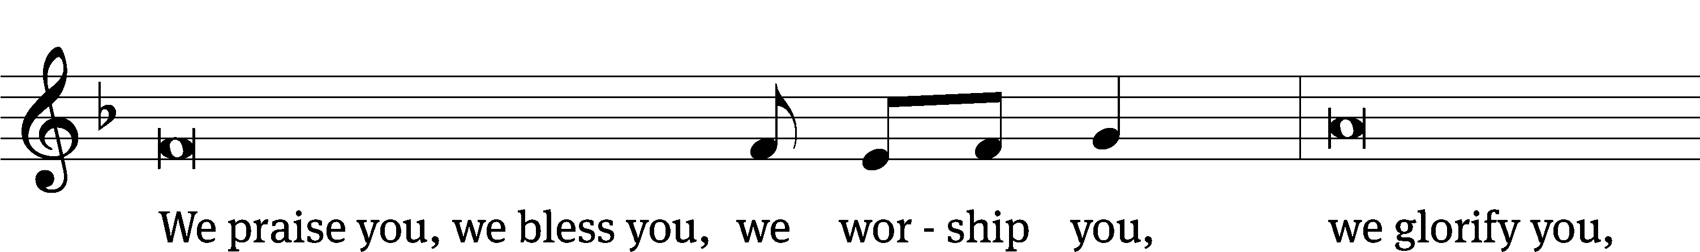
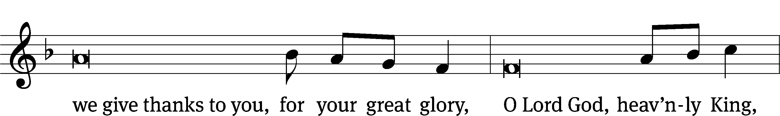
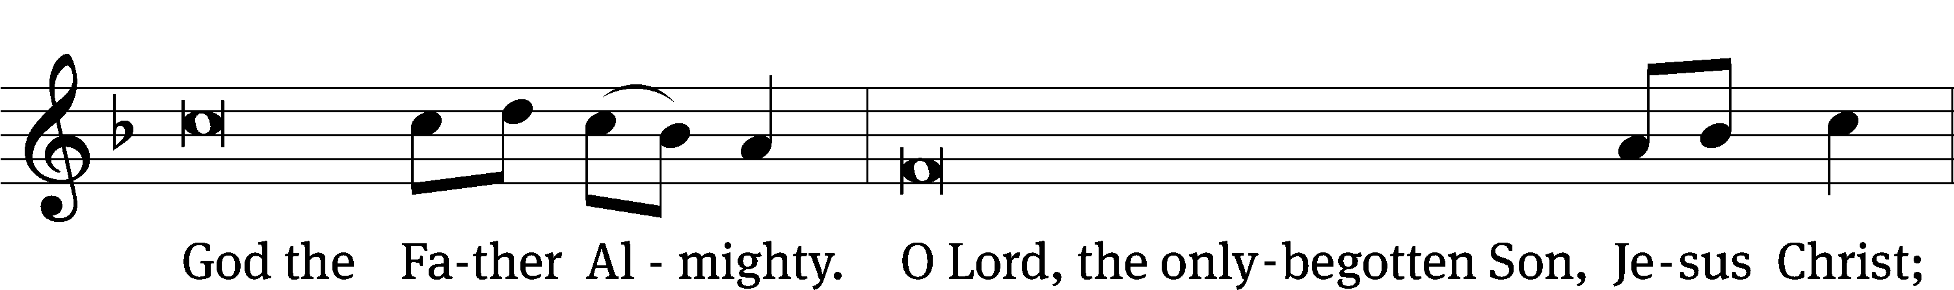
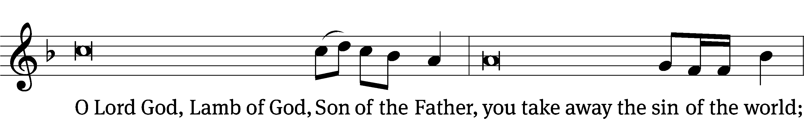
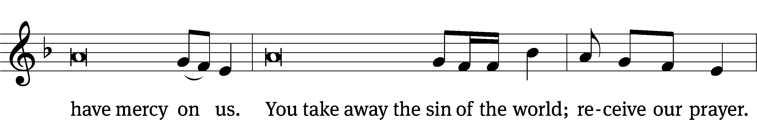
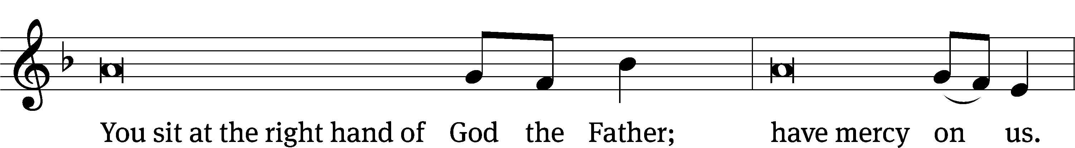
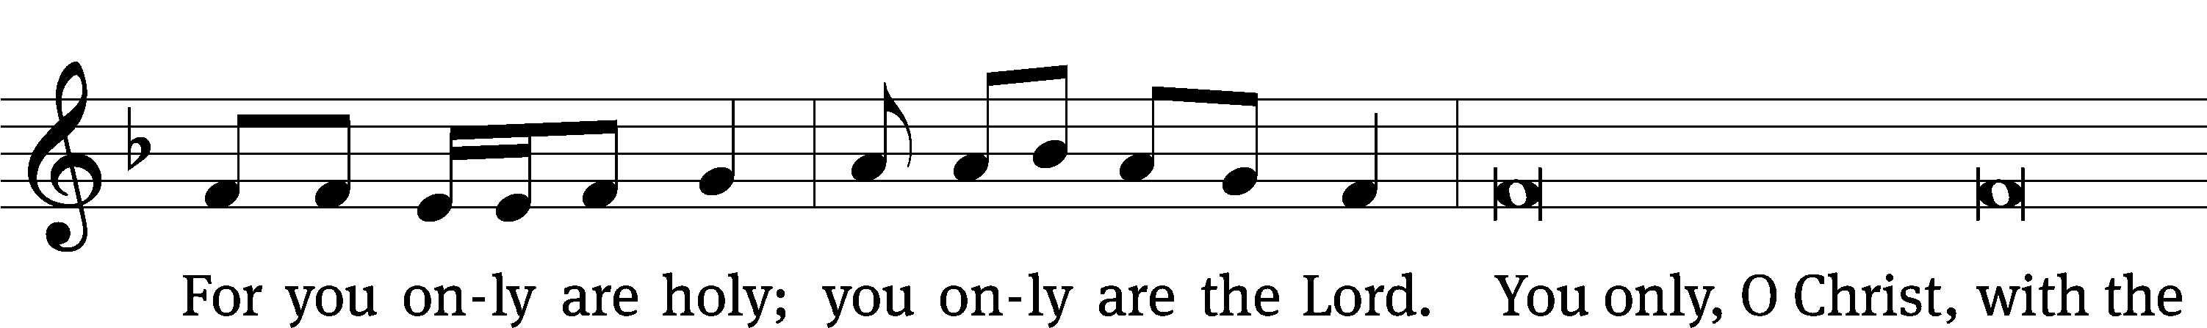
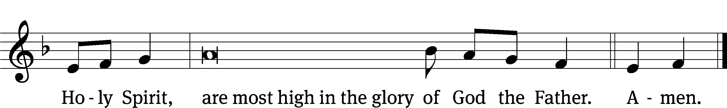

The Lord be with you.
And also with you.
Prayer of the Day
Let us pray.

Heavenly Father, keep your family continually in true faith, so that those who rely only on the hope of your heavenly grace may be protected by your mighty power; through your Son, Jesus Christ our Lord, who lives and reigns with you and the Holy Spirit, one God, now and forever.

Amen.

Please be seated

First Reading Isaiah 40:27-31

²⁷ Why do you speak, O Jacob?
O Israel, why do you say,
“My way is hidden from the Lord,
and justice for me is ignored by my God”?
²⁸ Do you not know? Have you not heard?
The Lord is the eternal God.
He is the Creator of the ends of the earth.
He will not grow tired, and he will not become weary.
No one can find a limit to his understanding.
²⁹ He is the one who gives strength to the weak,
and he increases the strength of those who lack power.
³⁰ Young men grow tired and become weary.
Even strong men stumble and fall.
³¹ But those who wait for the Lord will receive new strength.
They will lift up their wings and soar like eagles.
They will run and not become weary.
They will walk and not become tired.

The Word of the Lord.
Thanks be to God.

Psalm of the Day
103A The LORD Is Kind and Merciful Psalm 103A
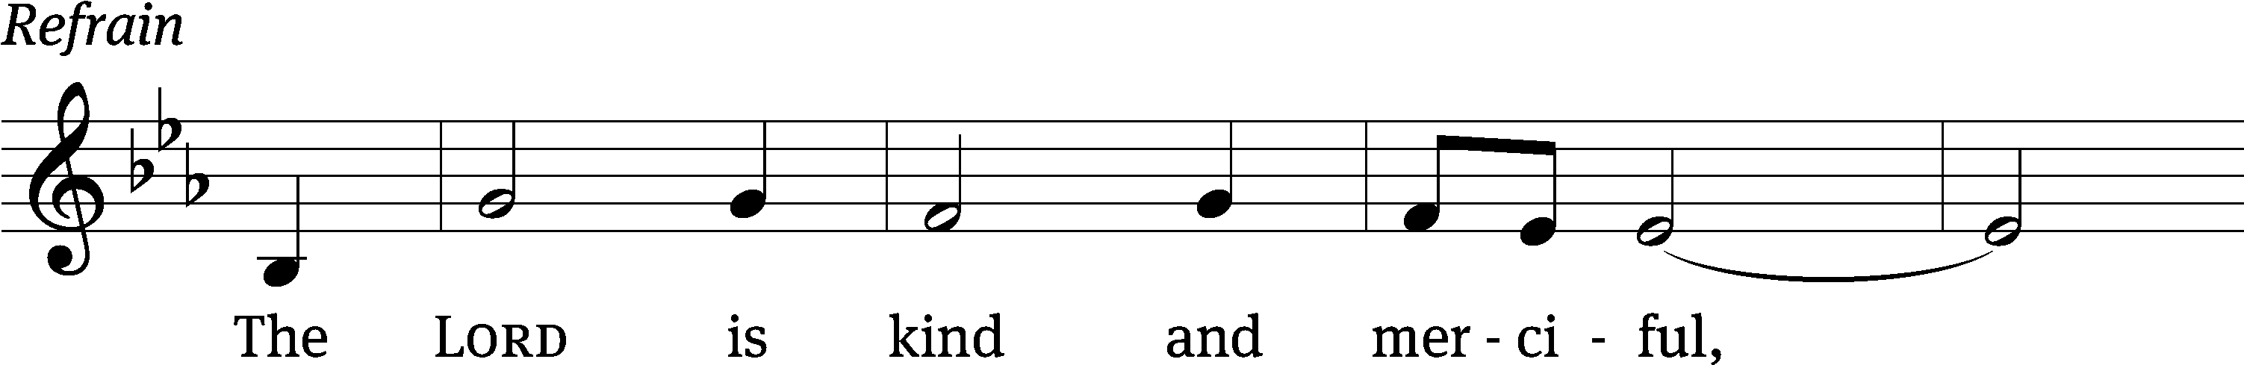
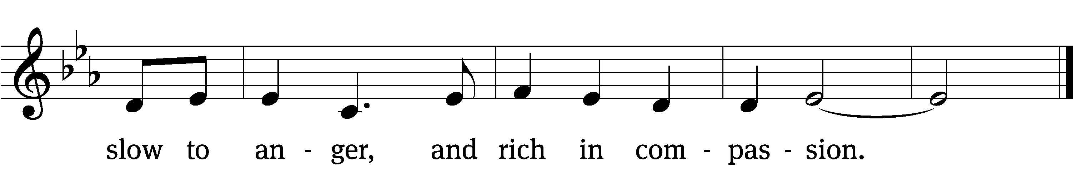

Praise the Lord, / my soul;
all my inmost being, praise his / holy name—
who forgives / all your sins
and heals all your dis- / eases,
who redeems your life / from the pit
and crowns you with love and com- / passion,
who satisfies your desires / with good things
so that your youth is renewed like the / eagle’s. Refrain

The Lord is compassionate and / gracious,
slow to anger, abound- / ing in love.
He does not treat us as our / sins deserve
or repay us according to our in- / iquities.
For as high as the heavens are a- / bove the earth,
so great is his love for those who / fear him;
as far as the east is / from the west,
so far has he removed our transgressions / from us.
Glory be to the Father and / to the Son
and to the Holy / Spirit,
as it was in the be- / ginning,
is now, and will be forever. / Amen. Refrain
Text: Lectionary for Mass
Tune: Paul Tate, alt.
Setting: Paul Tate, alt.
Text: © 1969, 1981, 1997 ICEL (refrain). Used by permission: OneLicense no. 727703
Music: © 2013 GIA Publications, Inc. Used by permission: OneLicense no. 727703

Second Reading I Peter 5:6-11
⁶ Therefore humble yourselves under God’s powerful hand so that he may lift you up at the appointed time. ⁷ Cast all your anxiety on him, because he cares for you. ⁸ Have sound judgment. Be alert. Your adversary, the Devil, prowls around like a roaring lion, looking for someone to devour. ⁹ Resist him by being firm in the faith. You know that the same kinds of sufferings are being laid on your brotherhood all over the world.¹⁰ After you have suffered a little while, the God of all grace, who called you into his eternal glory in Christ Jesus, will himself restore, establish, strengthen, and support you. ¹¹ To him be the glory and^{[d]} the power forever and ever. Amen.

The Word of the Lord.
Thanks be to God.

Please stand, if you are able
Gospel Acclamation Isaiah 40:31
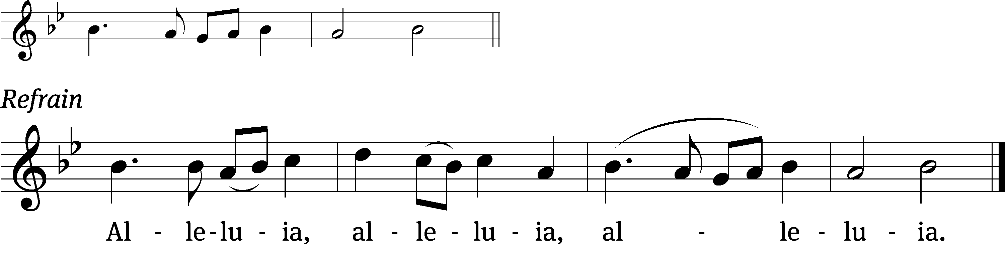
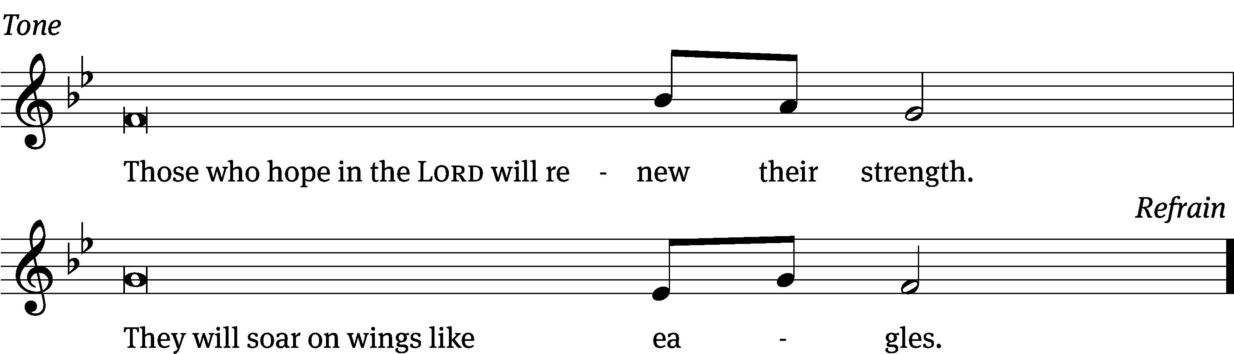
Tune: © 2021 Northwestern Publishing House. Used by permission: OneLicense no. 727703

Gospel Mark 1:29-39
²⁹ They left the synagogue and went with James and John to the home of Simon and Andrew. ³⁰ Simon’s mother-in-law was lying in bed, sick with a fever. Without delay they told Jesus about her. ³¹ He went to her, took her by the hand, and raised her up. The fever left her, and she began to serve them. ³² That evening, when the sun had set, the people kept bringing to him all who were sick and demon-possessed. ³³ The whole town gathered at the door. ³⁴ He healed many people who were sick with various diseases and drove out many demons. But he did not allow the demons to speak, because they knew who he was. ³⁵ Jesus got up early in the morning, while it was still dark, and went out. He withdrew to a solitary place and was praying there. ³⁶ Simon and his companions searched for him, ³⁷ and, when they found him, they said to him, “Everyone is looking for you!”³⁸ He told them, “Let’s go somewhere else, to the neighboring villages, so that I can preach there too. In fact, that is why I have come.” ³⁹ Then he went throughout the whole region of Galilee, preaching in their synagogues and driving out demons.

The Gospel of the Lord.
Praise be to you, O Christ!

Please be seated
850 It Is Well with My Soul CW 850
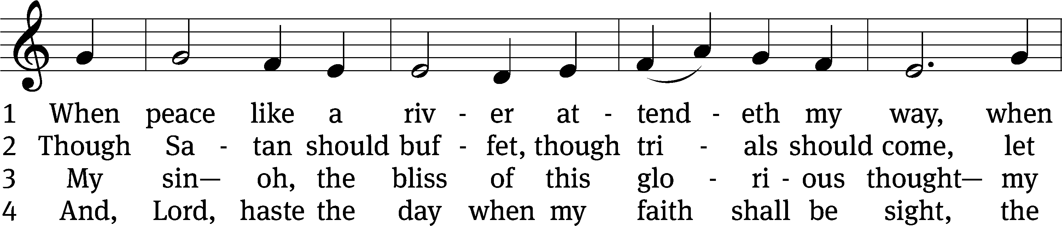
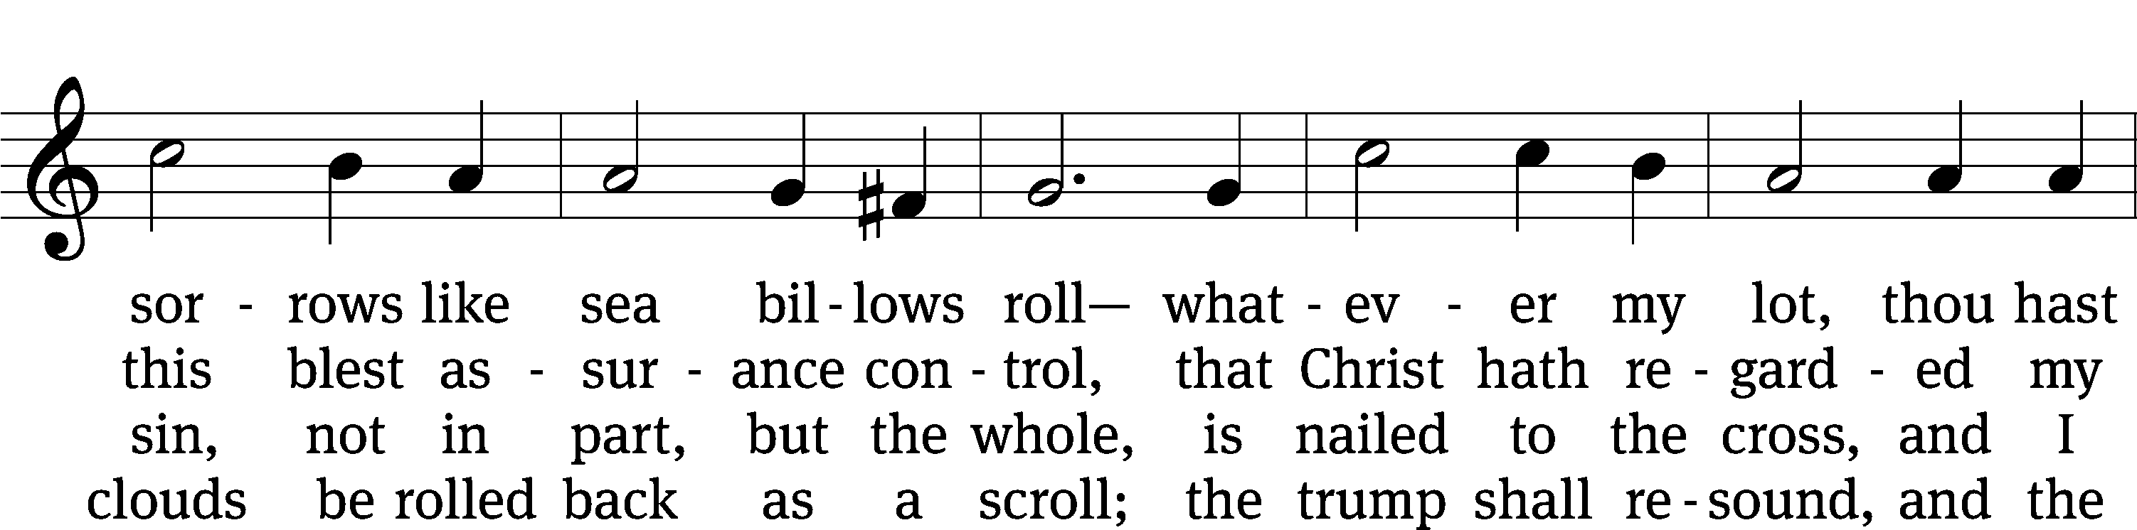
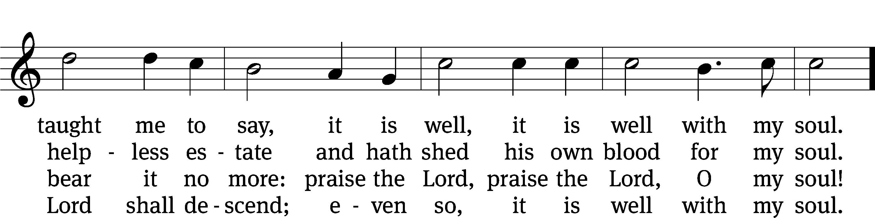
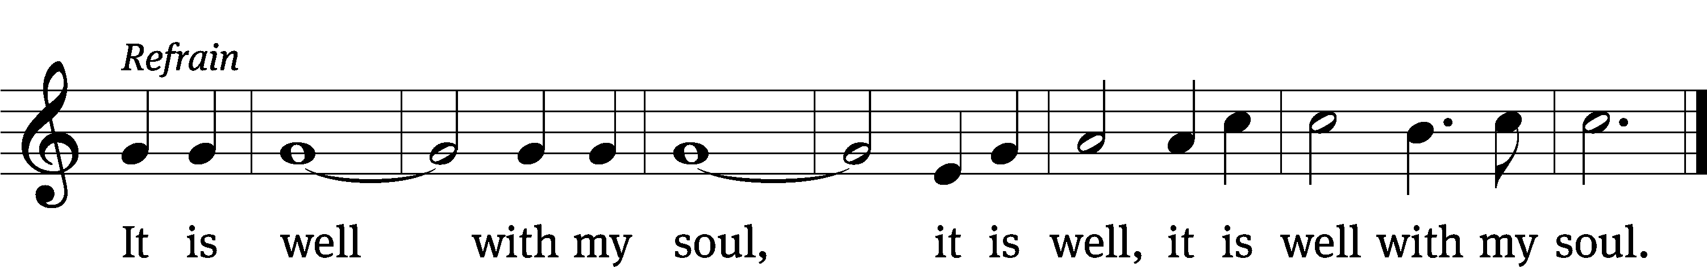
Text: Horatio G. Spafford, 1828–1888, alt.
Tune: Philip P. Bliss, 1838–1876
Text and tune: Public domain

SERMON 1 Peter 5:8
“Have You Seen the Devil Lately?”

Please stand, if you are able

nicene creed
We believe in one God, the Father, the Almighty, maker of heaven and earth, of all that is, seen and unseen.
We believe in one Lord, Jesus Christ, the only Son of God, eternally begotten of the Father, God from God, Light from Light, true God from true God, begotten, not made, of one being with the Father. Through him all things were made. For us and for our salvation, he came down from heaven, was incarnate of the Holy Spirit and the virgin Mary, and became truly human. For our sake he was crucified under Pontius Pilate. He suffered death and was buried. On the third day he rose again in accordance with the Scriptures. He ascended into heaven and is seated at the right hand of the Father. He will come again in glory to judge the living and the dead, and his kingdom will have no end.
We believe in the Holy Spirit, the Lord, the giver of life, who proceeds from the Father and the Son, who in unity with the Father and the Son is worshiped and glorified, who has spoken through the prophets. We believe in one holy Christian and apostolic Church. We acknowledge one baptism for the forgiveness of sins. We look for the resurrection of the dead and the life of the world to come. Amen.

Bell Choir (8:30) “Praise to the Lord”
Prayer of the Church

The Sacrament
Preface CW 165

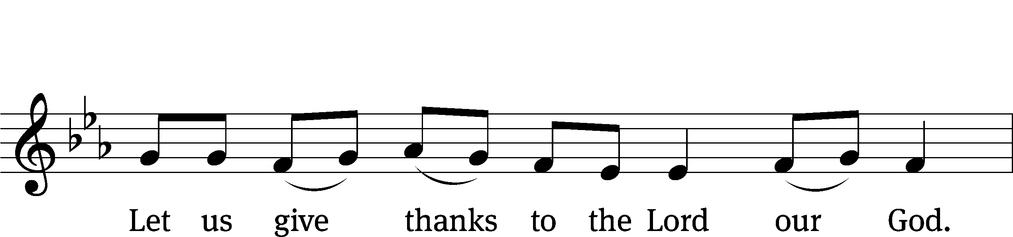
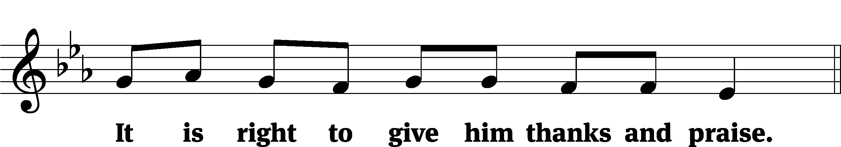

It is truly good and right that we should at all times and in all places give you thanks, O Lord, holy Father, almighty and everlasting God, through Jesus Christ our Lord, who by his willing sacrifice on the cross took away the sins of the world and by his glorious resurrection restored everlasting life. Therefore, with all the saints on earth and hosts of heaven, we praise your holy name and join their glorious song:
Holy, Holy, Holy CW 167
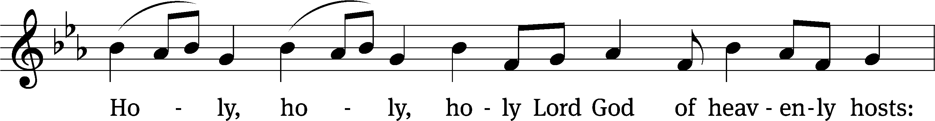
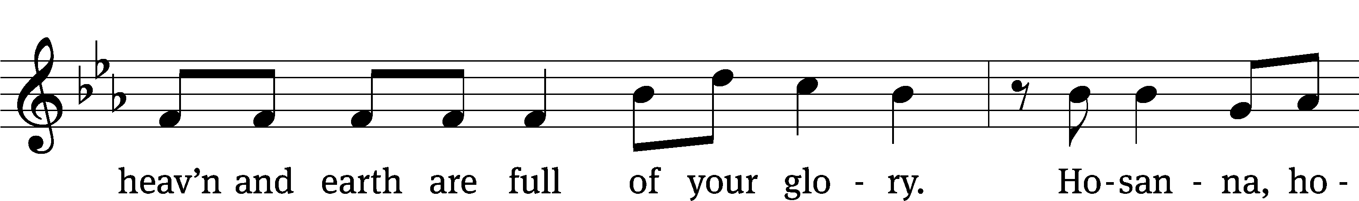
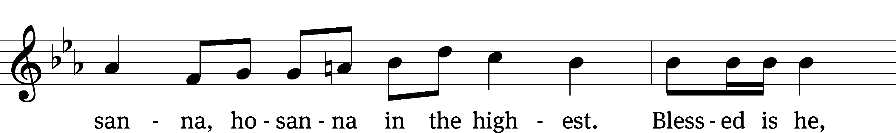
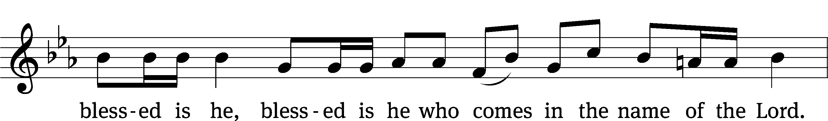
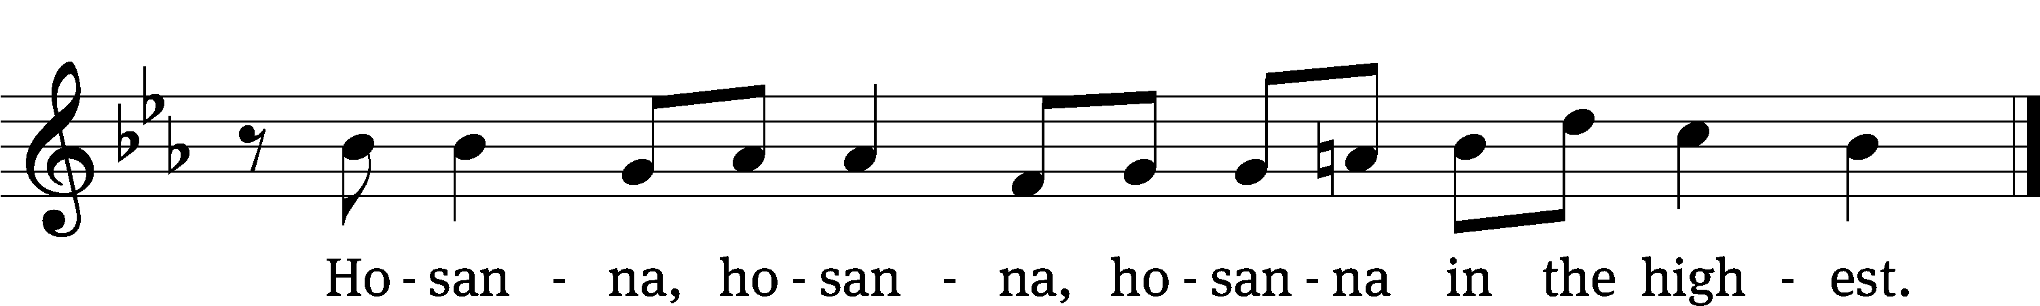

Prayer of Thanksgiving
We give thanks to you, O God, through your dear Son, Jesus Christ, whom you sent to be our Savior, our Redeemer, and the messenger of your grace. Through him you made all things; in him you are well pleased. He is the incarnate Word, conceived by the Holy Spirit and born of the Virgin Mary. To fulfill your promises, he stretched out his hands on the cross and released from eternal death all who believe in you.
As we remember Jesus’ death and resurrection, we thank you that you have gathered us together to receive your Son’s body and blood. Send us your Spirit, unite us as one, and strengthen our faith so that we may praise you in your Son, Jesus Christ. Through him, we glorify and honor you, O God our Father, with the Holy Spirit, one God, now and forever.
Amen.

Lord’s Prayer
Our Father, who art in heaven, hallowed be thy name, thy kingdom come, thy will be done on earth as it is in heaven. Give us this day our daily bread; and forgive us our trespasses, as we forgive those who trespass against us; and lead us not into temptation, but deliver us from evil. For thine is the kingdom and the power and the glory forever and ever. Amen.
Words of Institution
Our Lord Jesus Christ, on the night he was betrayed, took bread; and when he had given thanks, he broke it and gave it to his disciples, saying, “Take and eat; this is my body, which is given for you. Do this in remembrance of me.”
Then he took the cup, gave thanks, and gave it to them, saying, “Drink from it, all of you; this is my blood of the new covenant, which is poured out for you for the forgiveness of sins. Do this, whenever you drink it, in remembrance of me.”

The peace of the Lord be with you always.
Amen.
O Christ, Lamb of God CW 169
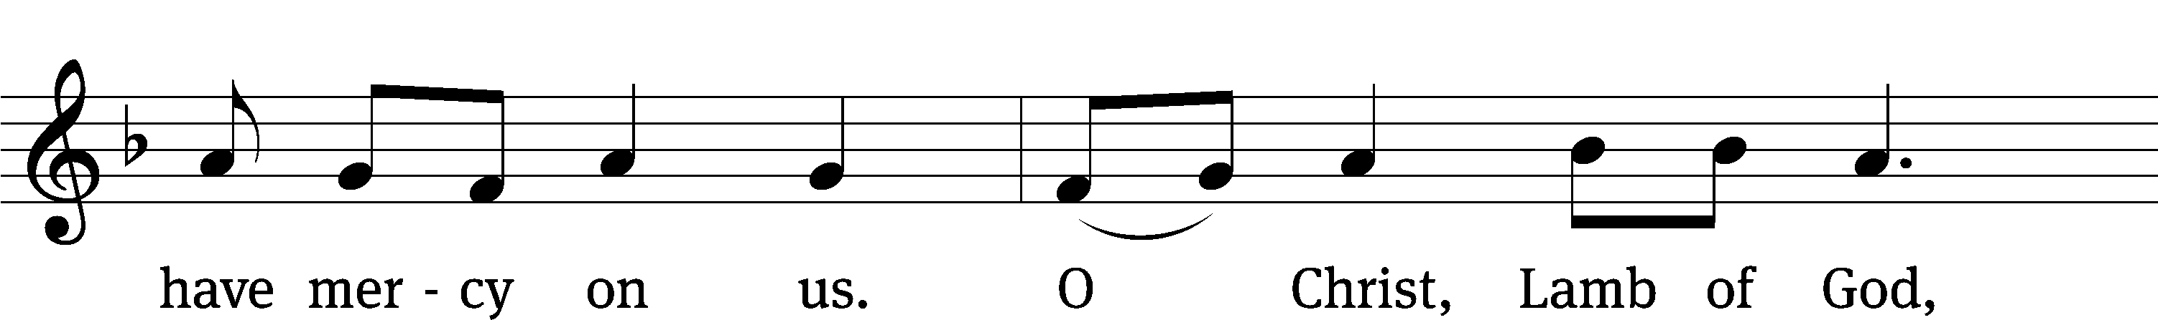
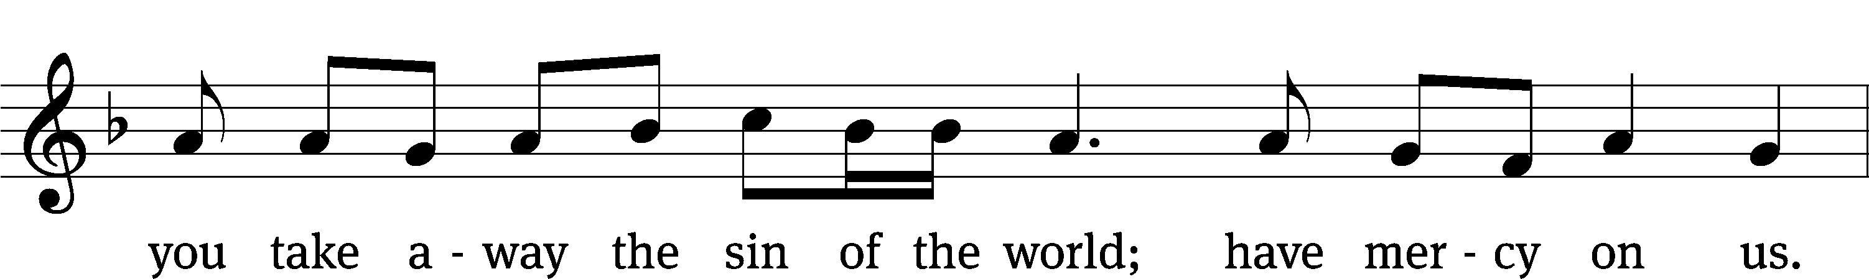
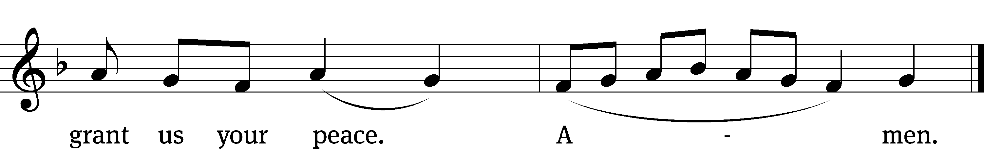

836 I Walk in Danger All the Way CW 836
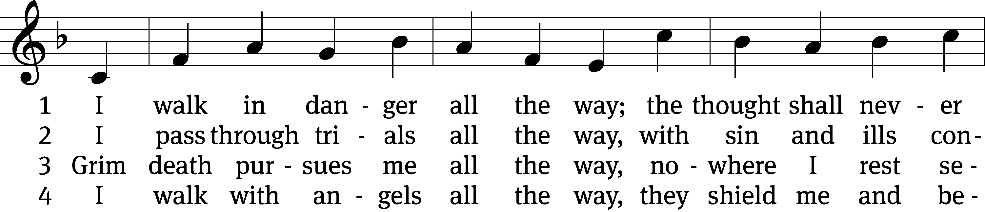
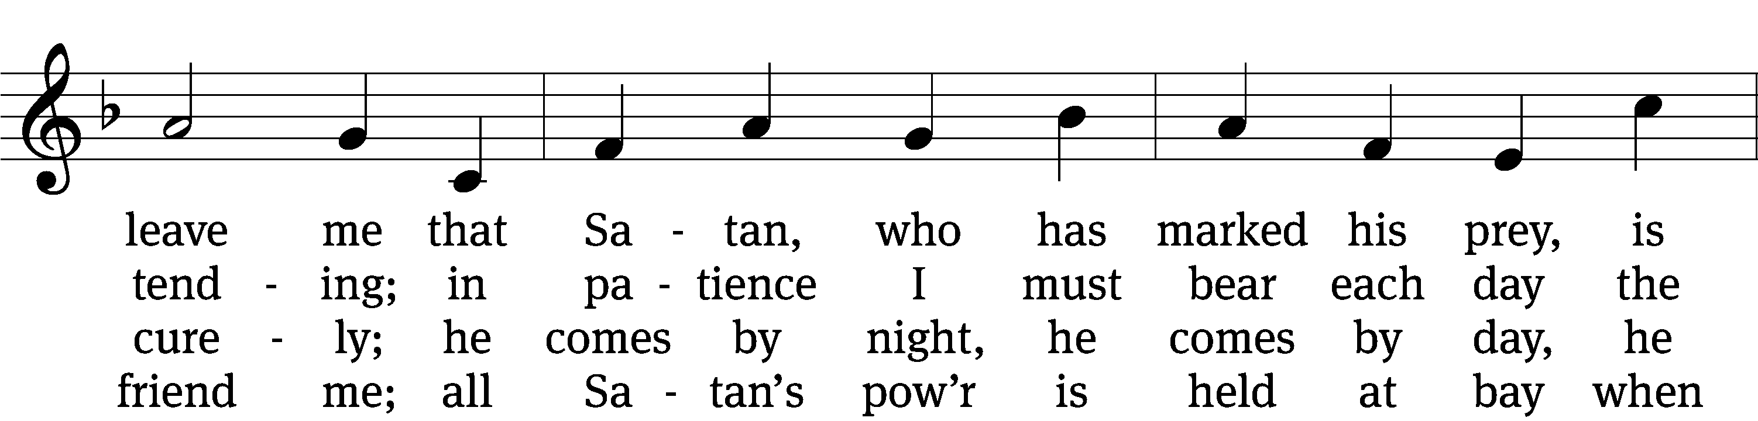
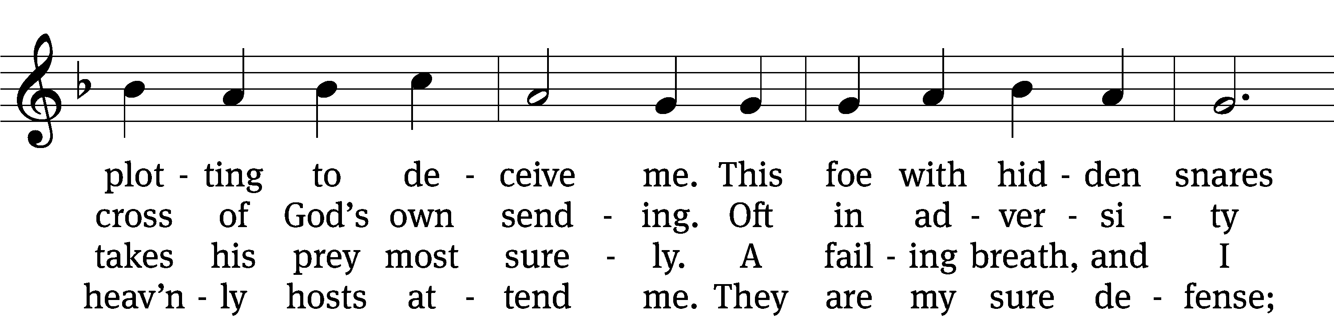
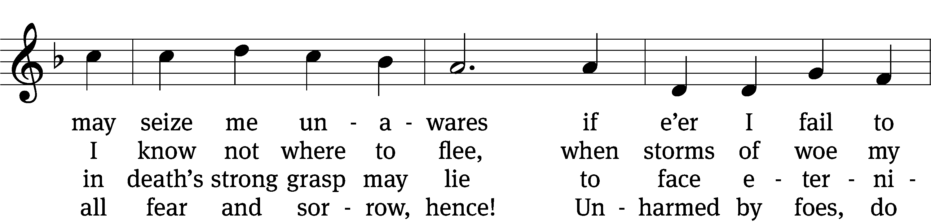
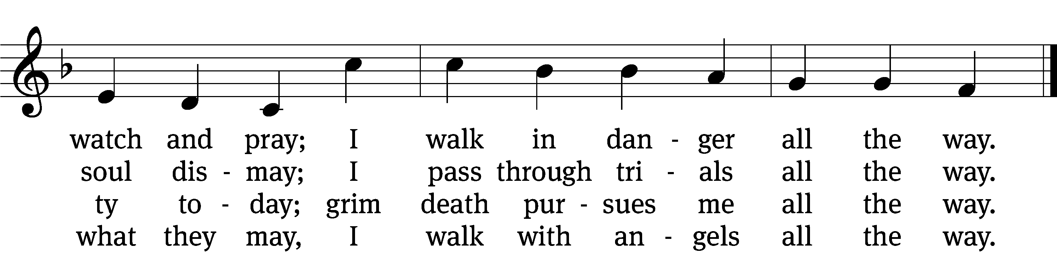

(Continued)

5 I walk with Jesus all the way,
his guidance never fails me;
within his wounds I find a stay
when Satan’s pow’r assails me;
and by his footsteps led,
my path I safely tread.
No evil leads my soul astray;
I walk with Jesus all the way.

6 My walk is heav’nward all the way;
await, my soul, the morrow,
when you at last with joy can say
farewell to sin and sorrow.
All worldly pomp, begone!
To heav’n I now press on.
For all the world I would not stay;
my walk is heav’nward all the way.
Text: tr. Ditlef G. Ristad, 1863–1938, alt.; Hans A. Brorson, 1694–1764
Tune: Geist-reiches Gesang-Buch, Halle, 1708, ed. Johann A. Freylinghausen
Text and tune: Public domain

831 Why Should Cross and Trial Grieve Me CW 831
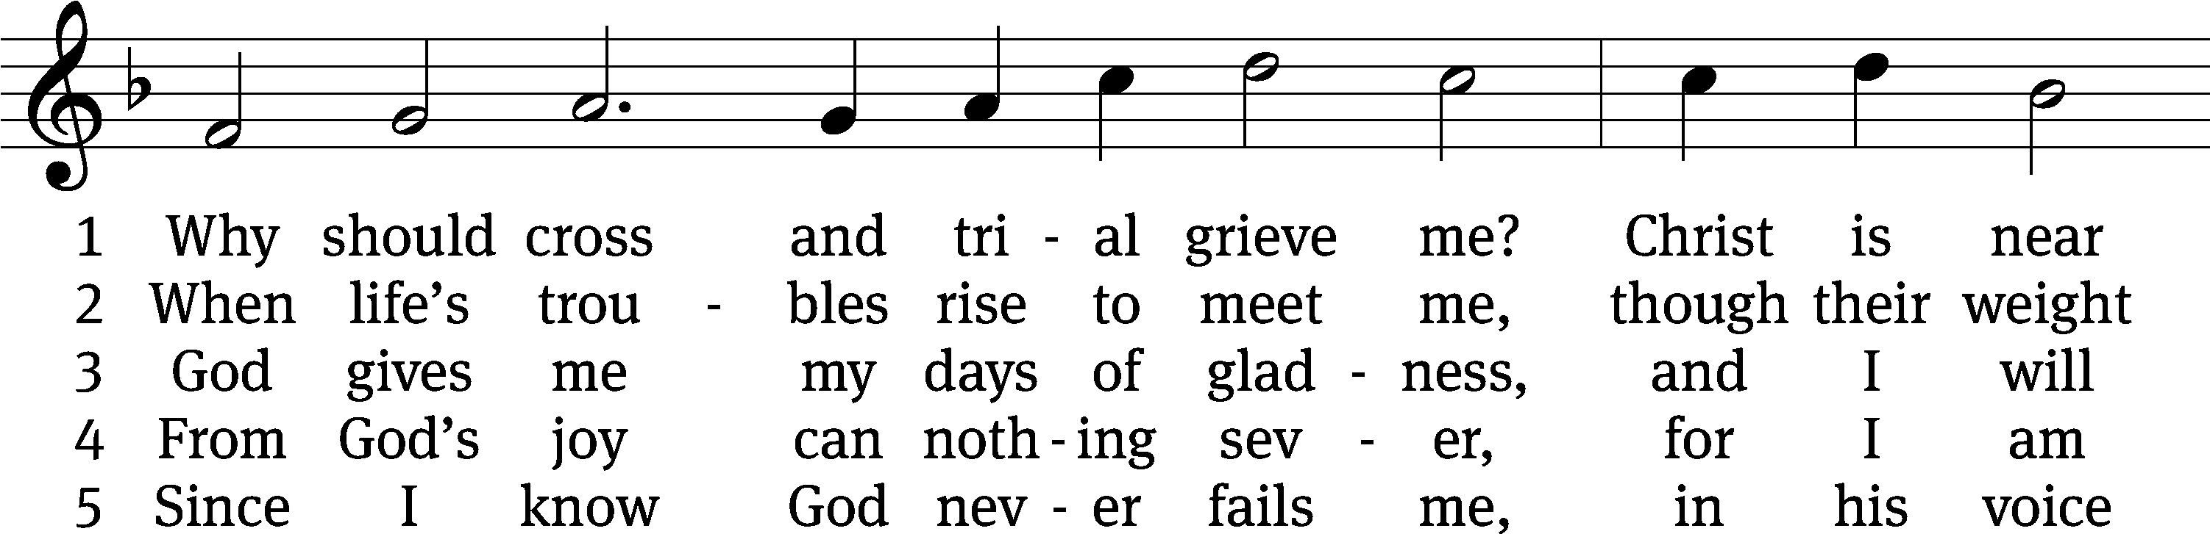
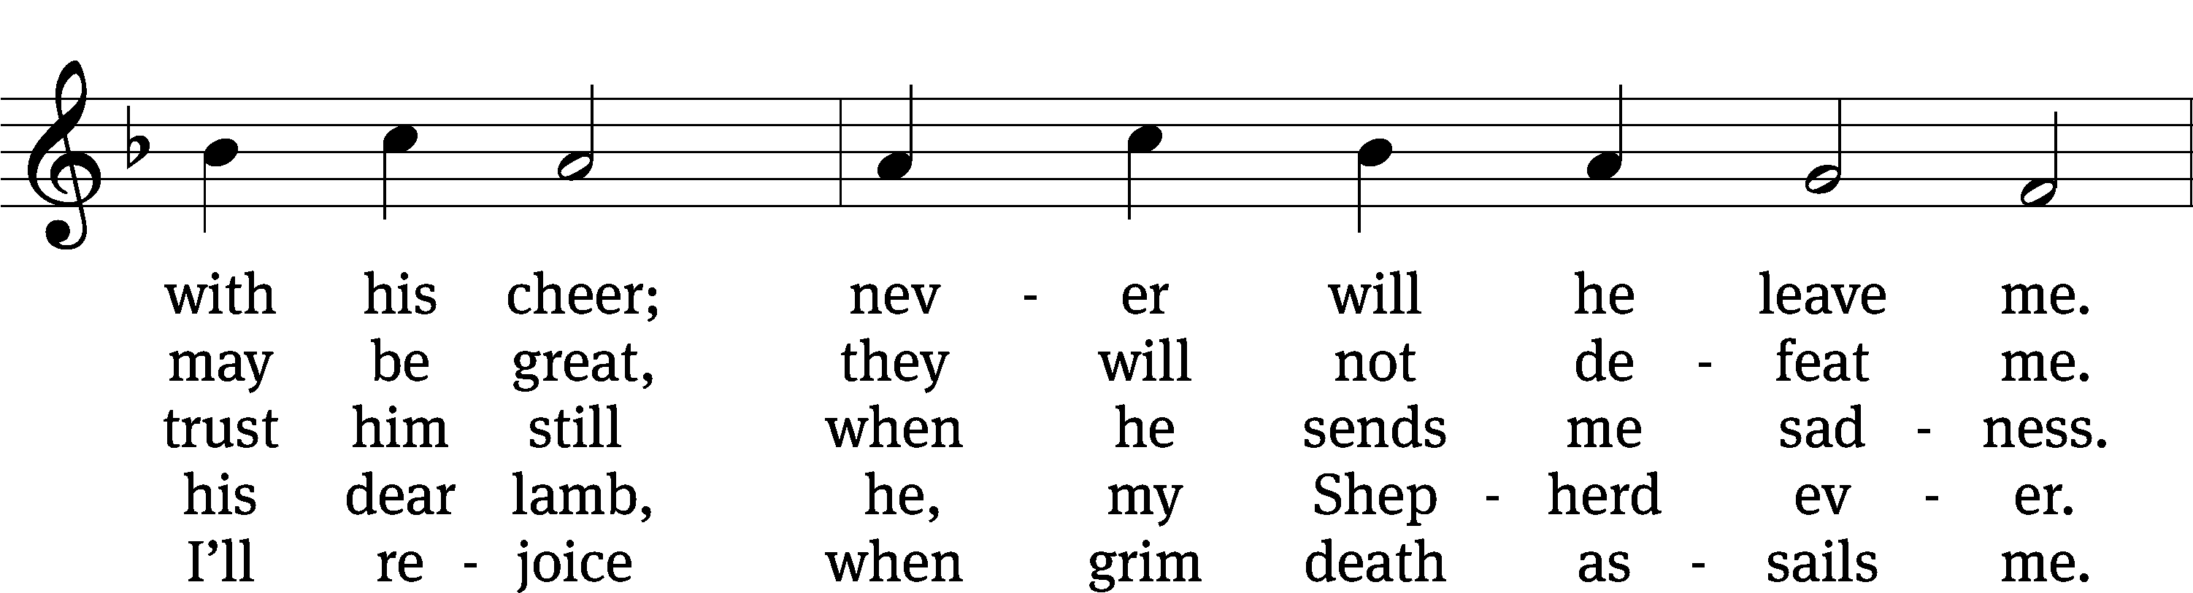
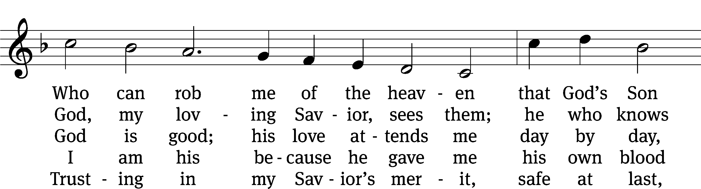
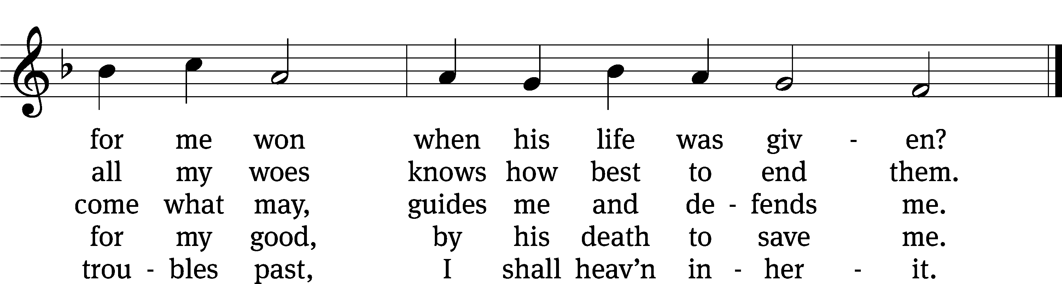
Text: Paul Gerhardt, 1607–1676, abr.; (sts. 1–3): tr. Christian Worship, 1993; (st. 4): tr. Stephen P. Starke, b. 1955; (st. 5): tr. Harlyn J. Kuschel, b. 1945
Tune: Johann G. Ebeling, 1637–1676
Text (st. 4): © 2004 Stephen P. Starke, admin. Concordia Publishing House; (st. 5): © 1993 Harlyn J. Kuschel, admin. Northwestern Publishing House. Used by permission: OneLicense no. 727703
Text (sts. 1–3) and tune: Public domain

Please stand, if you are able

Give thanks to the Lord, for he is good;
his mercy endures forever.

Whenever we eat this bread and drink this cup,
we proclaim the Lord’s death until he comes.

We give thanks, almighty God, that you have refreshed us with this saving gift. We pray that through it you will strengthen our faith in you and increase our love for one another. We ask this in the name of Jesus Christ our Lord, who lives and reigns with you and the Holy Spirit, one God, now and forever.
Amen.

Blessing
The Lord bless you and keep you.
The Lord make his face shine on you and be gracious to you.
The Lord look on you with favor and give you peace.
Amen.

Please be seated

924 Abide, O Dearest Jesus CW 924
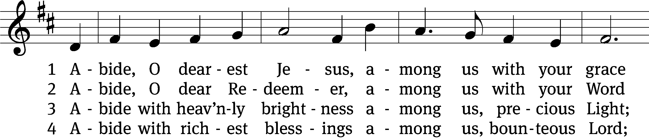
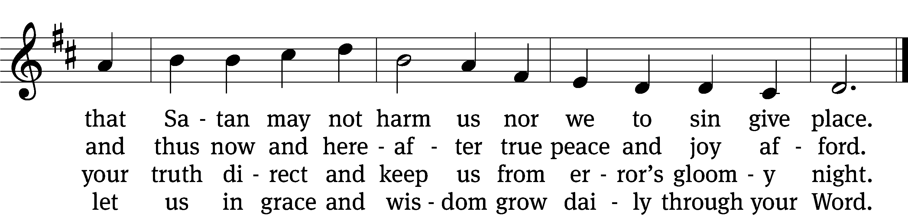

(Continued)
5 Abide with your protection
among us, Lord, our strength,
lest world and Satan fell us
and overcome at length.

6 Abide, O faithful Savior,
among us with your love;
grant steadfastness and help us
to reach our home above.
Text: tr. August Crull, 1845–1923, alt.; Josua Stegmann, 1588–1632
Tune: Melchior Vulpius, c. 1570–1615
Text and tune: Public domain

Acknowledgments
Setting One from Christian Worship
Software distributed in partnership with Northwestern Publishing House.
Created by Christian Worship: Service Builder © 2022 Concordia Publishing House.
Serving in Worship
Officiant Pastor Natsis
Organist Marcia Marion Ackling
Bell Choir Director Meg Nortley
Deacons (8:30) Duane Mason and Ron Roehm
Deacons (11:00) Dave Frey and Robert Niethammer
Ushers (8:30) Brian Graham and Tim Phelps
Ushers (11:00) Ron Zahn
Altar Guild Judy Lindemann and Barb Neuburger
Videographer Ann Latowski

