THE fOURTH SUNDAY
after epiphany
tRINITY EVANGELICAL LUTHERAN CHURCH | Saline, Michigan
January 29, 2023

WELCOME TO WORSHIP

Thank you for joining us in God’s house today! We cordially ask that our Guests with us this morning sign one of the guestbooks located at either the front or back entryways.

THANK OFFERING: Members of Trinity give their offering as an expression of love and thankfulness to the Lord and to help support the Lord’s work in our community and around the world. Visitors need not feel obligated to participate in this offering which supports our ministry.

Restrooms are located at the back of the upper level (the annex), and in the basement (down the back stairs of the sanctuary or annex). Handicap access is available, please ask an usher for assistance.

Young Families / Toddler Bags – We are GLAD YOU BROUGHT YOUR CHILDREN to our worship service. Jesus said: “Let the little children come to me and do not hinder them, for the kingdom of God belongs to such as these.” We know that having little children in church can be a challenge, but DO NOT WORRY about it. Many of your fellow worshippers have been in your shoes and are just happy you brought your children with you. For your convenience, we have reserved the back rows of seating for parents with small children. These areas provide more flexibility for your family, as well as, easy access to move downstairs if necessary. A closed-circuit TV system allows families to continue participating in the service while downstairs. Pre-school toddler bags and children’s bulletins are available for their enjoyment. Ask an usher for one to use during the service and please return the toddler bag afterwards.

SERVICE of the word
Bell Choir (11:00 a.m.) “For the Beauty of the Earth”
916 Today Your Mercy Calls Us CW 916
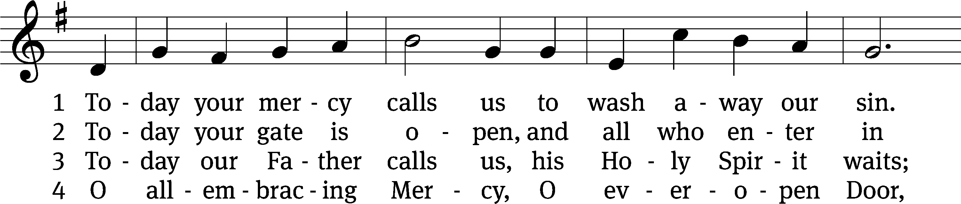
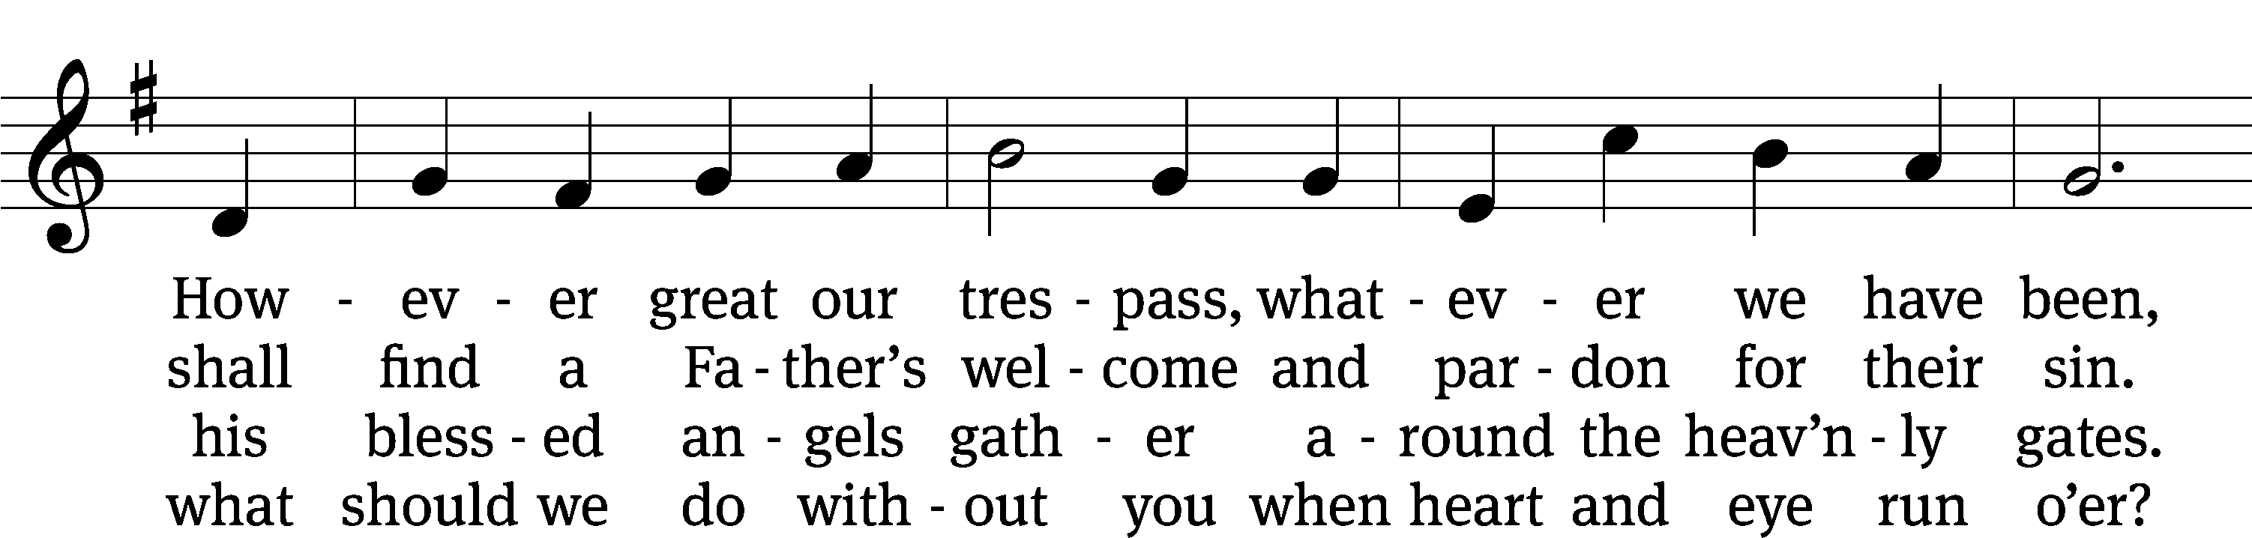
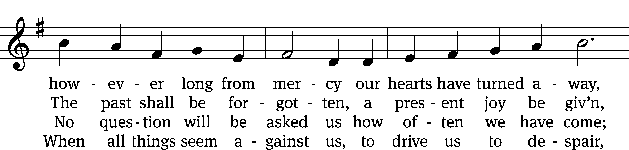
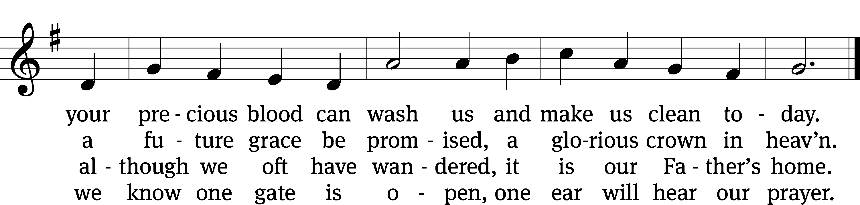
Text: Oswald Allen, 1816–1878, alt.
Tune: Friedrich K. Anthes, 1812–after 1857
Text and tune: Public domain

PLEASE STAND, IF YOU ARE ABLE

invocation
M: The grace of our Lord (+) Jesus Christ and the love of God and the fellowship of the Holy Spirit be with you.
C: And also with you.
CONFESSION OF SINS
M: We have come into the presence of God, who created us to love and serve him as his dear children. But we have disobeyed him and deserve only his wrath and punishment. Therefore, let us confess our sins to him and plead for his mercy.

C: Merciful Father in heaven, I am altogether sinful from birth. In countless ways I have sinned against you and do not deserve to be called your child. But trusting in Jesus, my Savior, I pray: Have mercy on me according to your unfailing love. Cleanse me from my sin, and take away my guilt.

M: God, our heavenly Father, has forgiven all your sins. By the perfect life and innocent death of our Lord Jesus Christ, he has removed your guilt forever. You are his own dear child. May God give you strength to live according to his will.

C: Amen.

PRAYER AND PRAISE

M: In the peace of forgiveness, let us praise the Lord.

OH, TASTE AND SEE

PRAYER OF THE DAY

Let us pray.

Almighty and everlasting God, look with mercy on our weaknesses, and in all our dangers and needs stretch out the right hand of your majesty to help and defend us; through your Son, Jesus Christ our Lord, who lives and reigns with you and the Holy Spirit, one God, now and forever.

PLEASE BE SEATED

The Word

the FIRST LESSON Zephaniah 2:3; 3:11-13

³ Seek the Lord, all you humble people of the earth who have carried out his commands. Seek righteousness. Seek humility. Maybe then you will be sheltered in the day of the Lord’s anger.
¹¹ In that day you will no longer bear the shame of your rebellions against me. Then I will remove the proud boasters from among you, and you will never again be arrogant on my holy hill. ¹² But I will leave among you the people who are humble and weak. They will seek refuge in the name of the Lord. ¹³ The Israelites who remain will no longer act unjustly. They will not lie, and a deceitful tongue will not be found in their mouth. Instead, they will graze peacefully like sheep and lie down. No one will terrify them.

1A Blessed Are They Psalm 1A
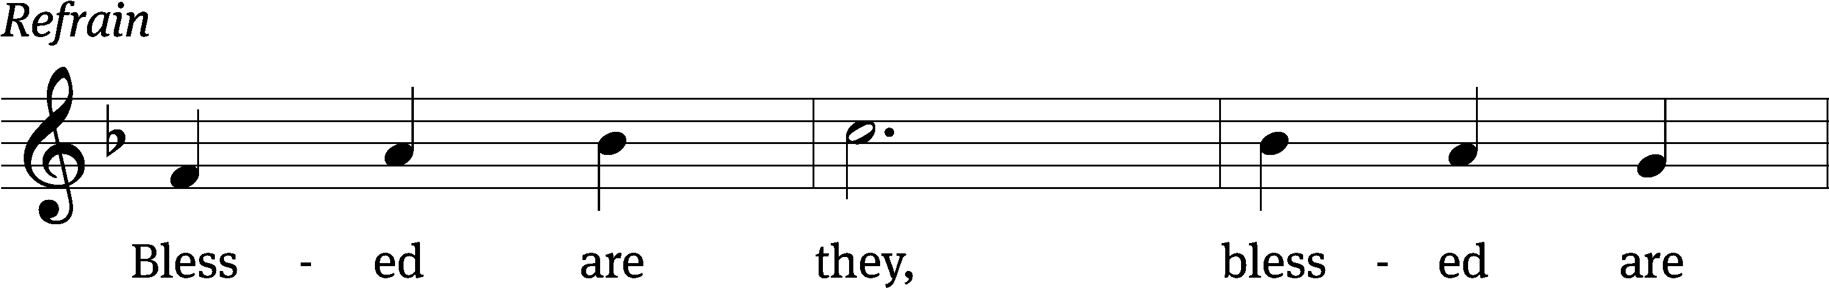
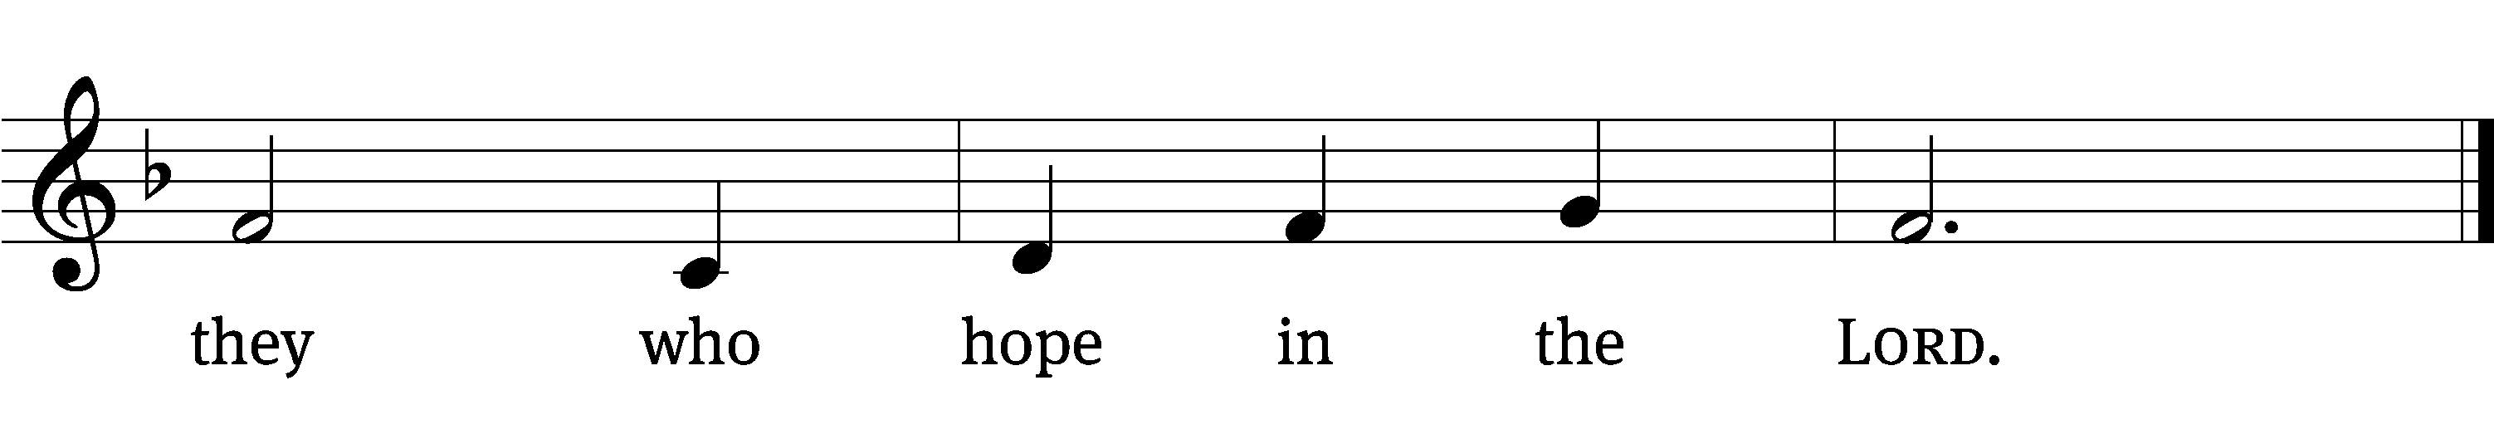
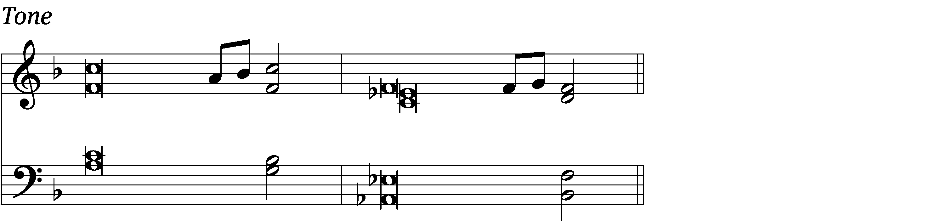

Blessed is the one who / does not walk
in step with the / wicked
or stand in the way that / sinners take
or sit in the company of / mockers,
but whose delight is in the law / of the Lord,
and who meditates on his law / day and night.
That person is like a tree planted by streams of / water,
which yields its fruit in / season
and whose leaf does not / wither—
whatever they do / prospers. Refrain

Not so the / wicked!
They are like chaff that the wind / blows away.
Therefore the wicked will not stand in the / judgment,
nor sinners in the assembly of the / righteous. Refrain

For the Lord watches over the way of the / righteous,
but the way of the wicked leads to de- / struction.
Glory be to the Father and / to the Son
and to the Holy / Spirit,
as it was in the be- / ginning,
is now, and will be forever. / Amen. Refrain
Text: Lectionary for Mass (refrain)
Tune: Michel Guimont
Setting: Michel Guimont
Text: © 1969, 1981, 1997 ICEL (refrain). Used by permission: OneLicense no. 727703
Music: © 1998 GIA Publications, Inc. Used by permission: OneLicense no. 727703

THE SECOND LESSON 1 Corinthians 1:26-31

²⁶ For example, consider your call, brothers. Not many of you were wise from a human point of view, not many were powerful, and not many were born with high status. ²⁷ But God chose the foolish things of the world to put to shame those who are wise. God chose the weak things of the world to put to shame the things that are strong, ²⁸ and God chose the lowly things of the world and the despised things, and the things that are not, to do away with the things that are, ²⁹ so that no one may boast before God. ³⁰ But because of him you are in Christ Jesus, who became for us the wisdom from God, namely, our righteousness and sanctification and redemption. ³¹ God did this so that, just as it is written, “Let the one who boasts boast in the Lord.”

please stand, if you are able

Verse of the day

Alleluia. Blessed are the poor in spirit, for theirs is the kingdom of heaven. Alleluia. (Matt. 5:3)

THE GOSPEL LESSON Matthew 5:1-12
M: The Gospel according to Matthew chapter 5, verses 1-12
¹ When Jesus saw the crowds, he went up onto a mountain. When he sat down, his disciples came to him. ² He opened his mouth and began to teach them. He said these things:
³ “Blessed are the poor in spirit,
because theirs is the kingdom of heaven.
⁴ Blessed are those who mourn,
because they will be comforted.
⁵ Blessed are the gentle,
because they will inherit the earth.
⁶ Blessed are those who hunger and thirst for righteousness,
because they will be filled.
⁷ Blessed are the merciful,
because they will receive mercy.
⁸ Blessed are the pure in heart,
because they will see God.
⁹ Blessed are the peacemakers,
because they will be called sons of God.
¹⁰ Blessed are those who are persecuted because of righteousness,
because theirs is the kingdom of heaven.
¹¹ “Blessed are you when people insult you and persecute you and falsely say all kinds of evil against you because of me. ¹² Rejoice and be glad, because great is your reward in heaven. In fact, that is how they persecuted the prophets who were before you.”

M: This is the Gospel of the Lord.

PLEASE BE SEATED

690 Blest Are They CW 690
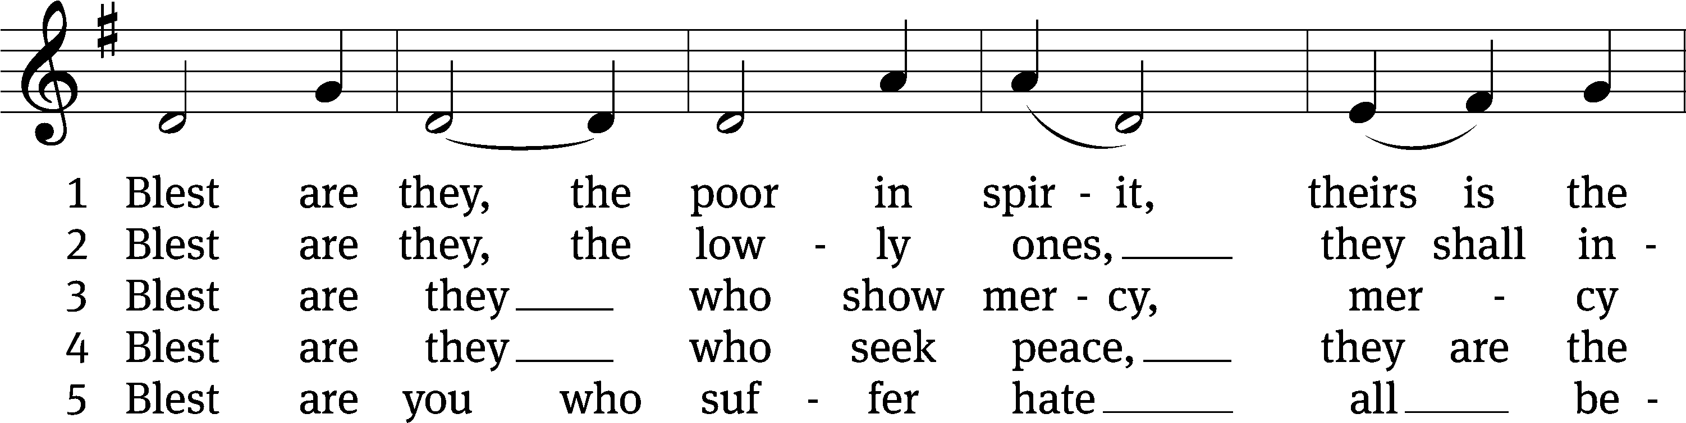
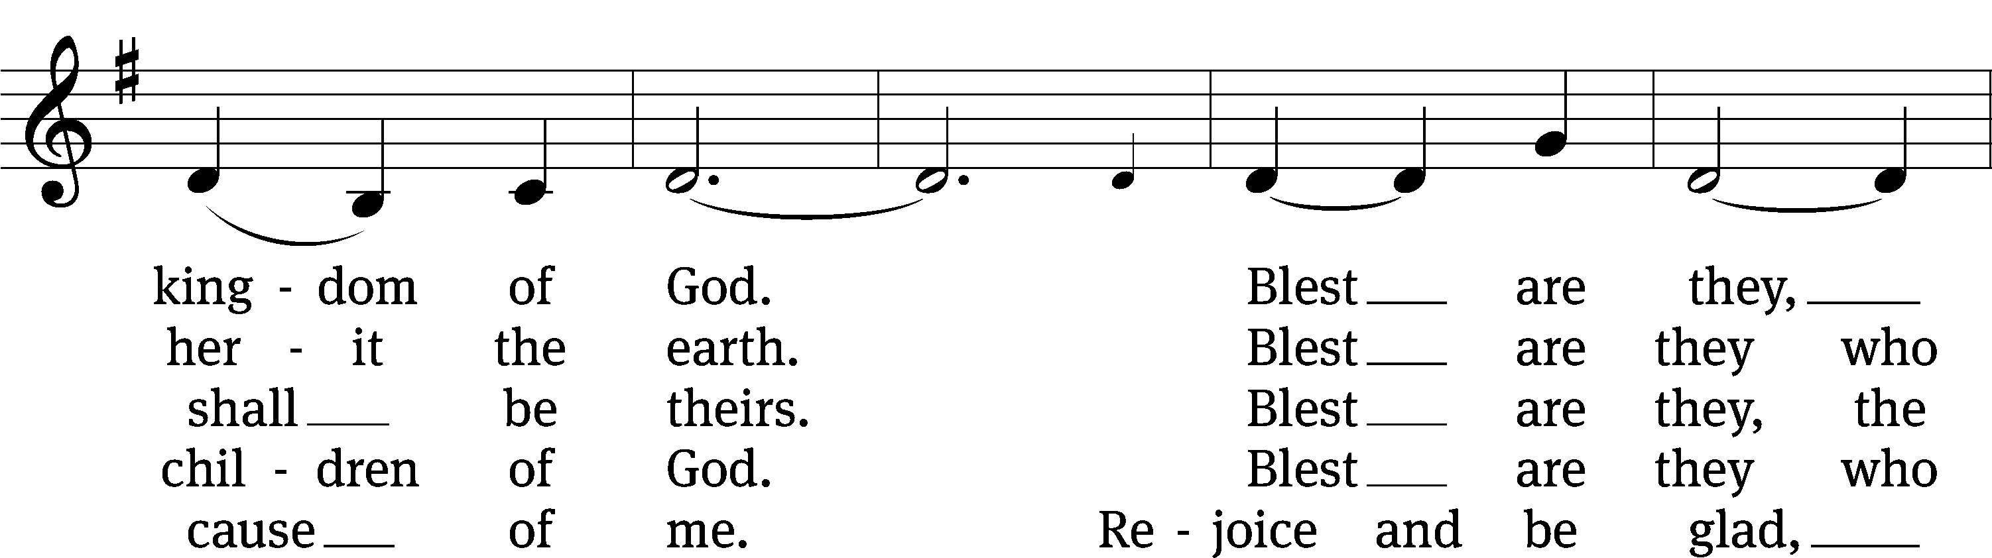
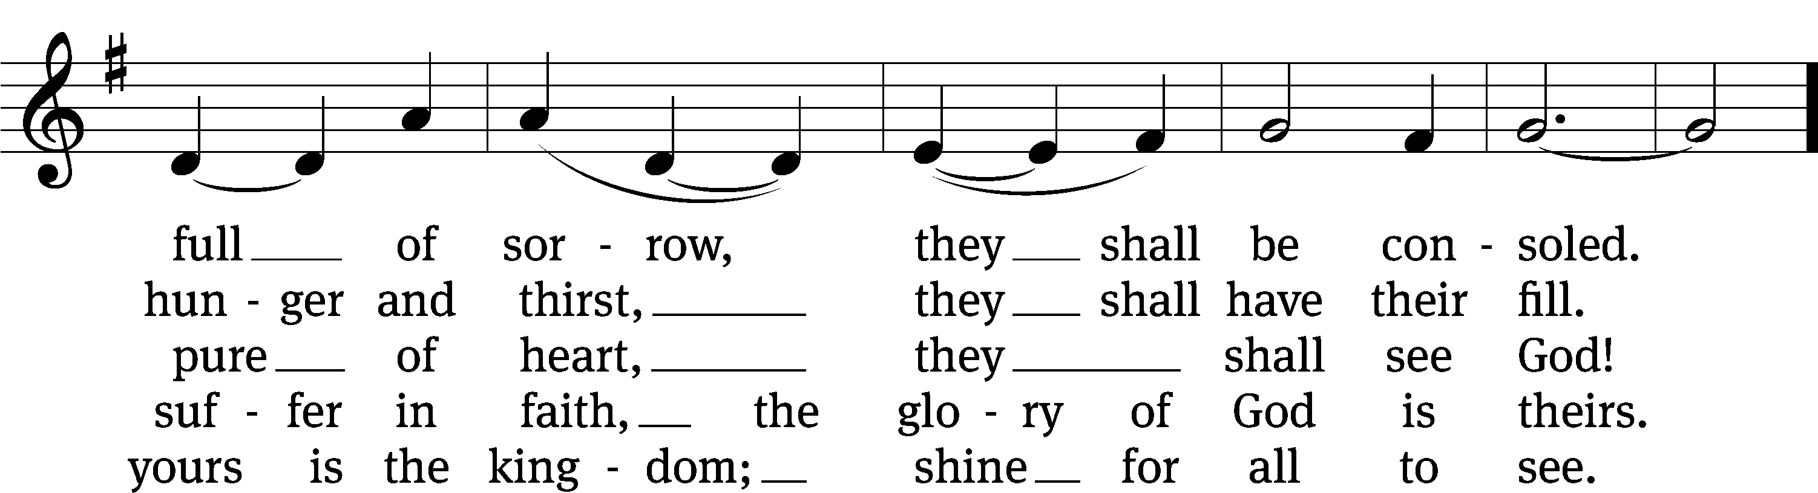
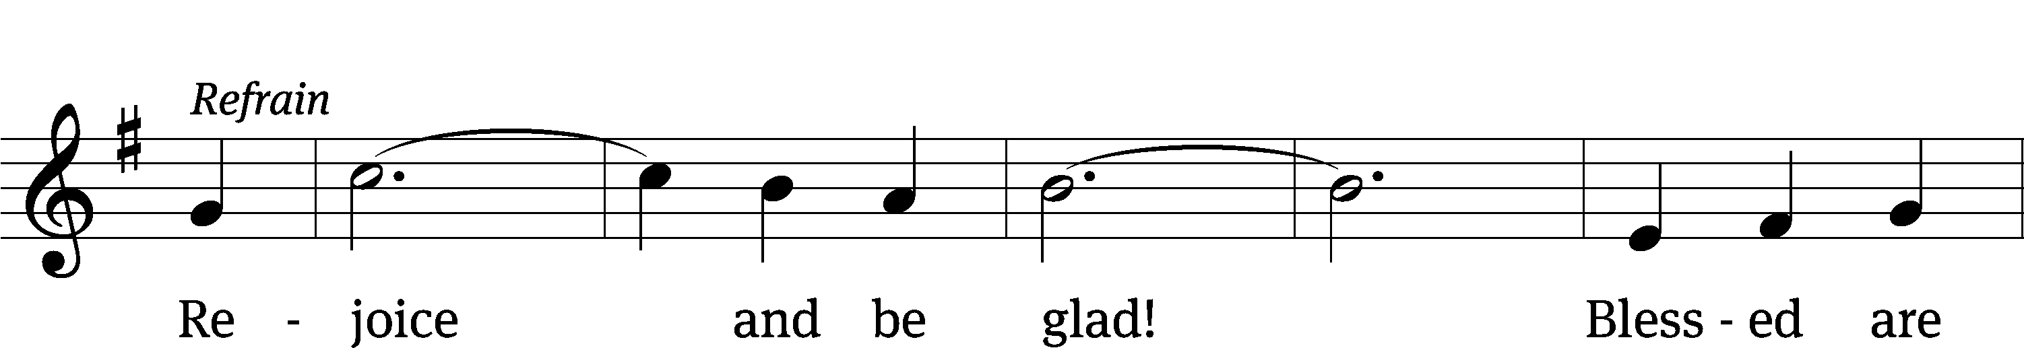
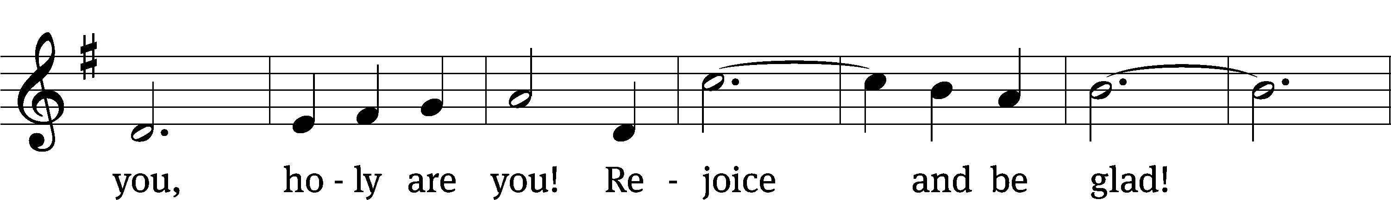
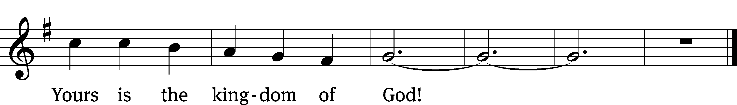
Text: David Haas, b. 1957
Tune: David Haas, b. 1957
Text and tune: © 1985 GIA Publications, Inc. Used by permission: OneLicense no. 727703

SERMON 1 Corinthians 1:26-31
“A Time to Boast”

PLEASE STAND, IF YOU ARE ABLE

THE APOSTLES’ CREED
I believe in God, the Father almighty,
maker of heaven and earth.
I believe in Jesus Christ, his only Son, our Lord,
who was conceived by the Holy Spirit,
born of the virgin Mary,
suffered under Pontius Pilate,
was crucified, died, and was buried.
He descended into hell.
The third day he rose again from the dead.
He ascended into heaven
and is seated at the right hand of God the Father almighty.
From there he will come to judge the living and the dead.
I believe in the Holy Spirit,
the holy Christian Church,
the communion of saints,
the forgiveness of sins,
the resurrection of the body,
and the life everlasting. Amen.
BELL CHOIR (8:30 a.m.) “For the Beauty of the Earth”

PRAYER OF THE CHURCH

THE LORD’S PRAYER

C: Our Father, who art in heaven, hallowed be thy name, thy kingdom come, thy will be done on earth as it is in heaven. Give us this day our daily bread; and forgive us our trespasses, as we forgive those who trespass against us; and lead us not into temptation, but deliver us from evil. For thine is the kingdom and the power and the glory forever and ever. Amen.
PLEASE BE SEATED
633 Speak, O Lord CW 633
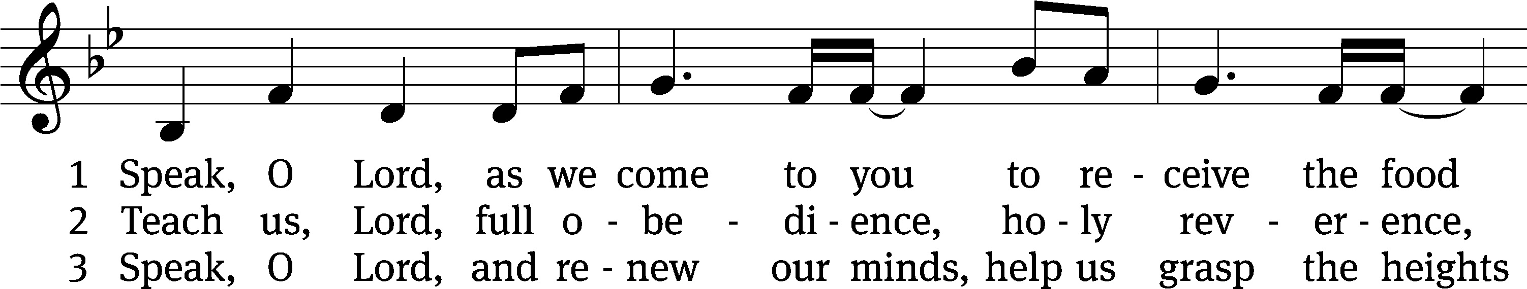
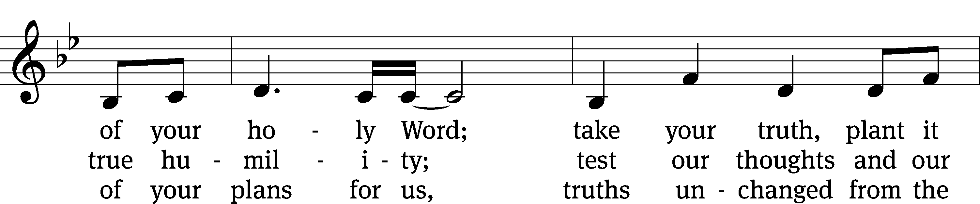
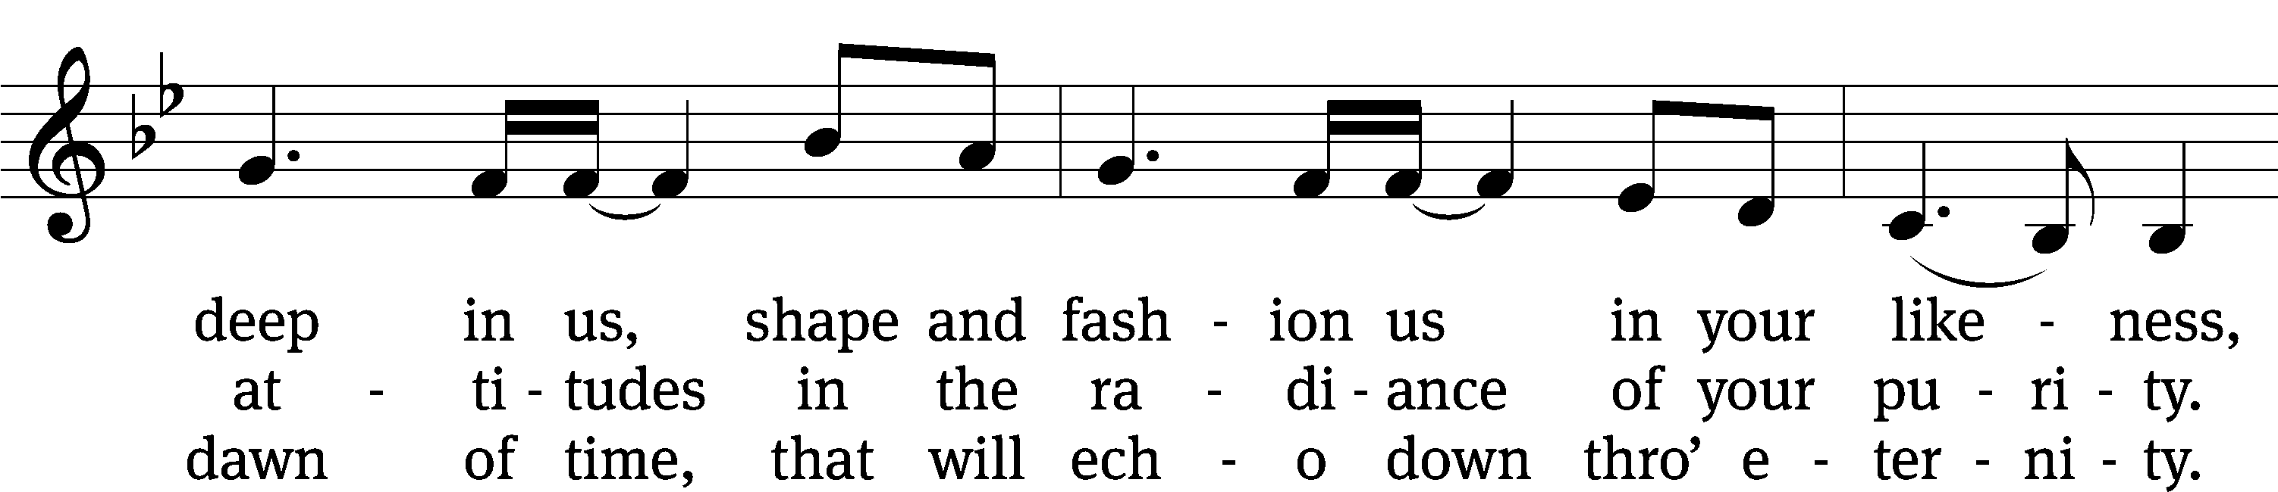
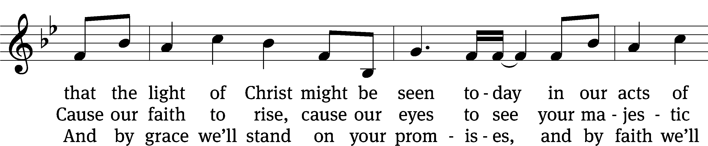
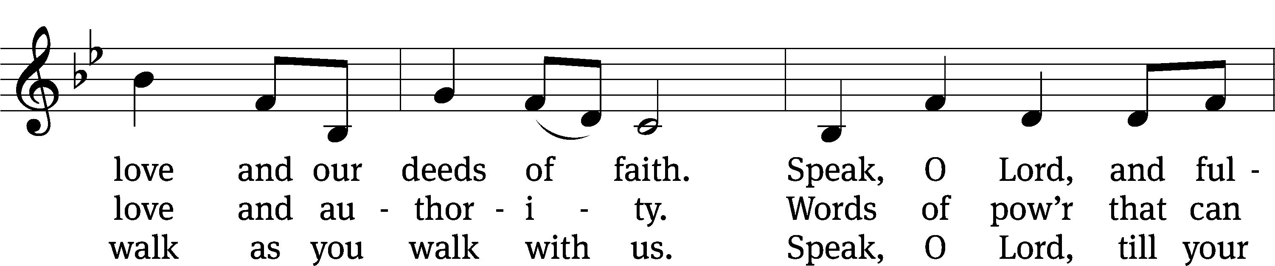
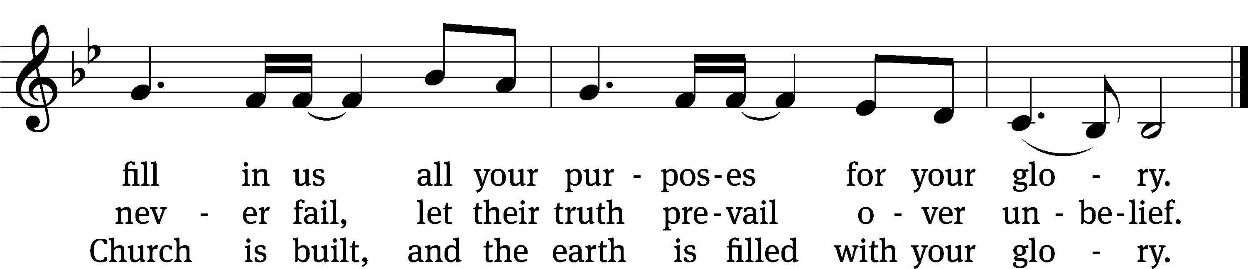
Text: Stuart Townend, b. 1963; Keith Getty, b. 1974
Tune: Stuart Townend, b. 1963; Keith Getty, b. 1974
Text and tune: © 2006 Thankyou Music, admin. CapitolCMGPublishing,com. Used by permission: OneLicense no. 727703
PLEASE STAND, IF YOU ARE ABLE

CLOSING PRAYER
M: Almighty God, we thank you for teaching us the things you want us to believe and do. Help us by your Holy Spirit to keep your Word in pure hearts that we may be strengthened in faith, guided in holiness, and comforted in life and in death, through Jesus Christ, our Lord, who lives and reigns with you and the Holy Spirit, one God, now and forever.

M: Brothers and sisters, go in peace. Live in harmony with one another. Serve the Lord with gladness.
The Lord bless you and keep you.
The Lord make his face shine on you and be gracious to you.
The Lord look on you with favor and (+) give you peace.

PLEASE BE SEATED

923 Guide Me, O Thou Great Jehovah CW 923
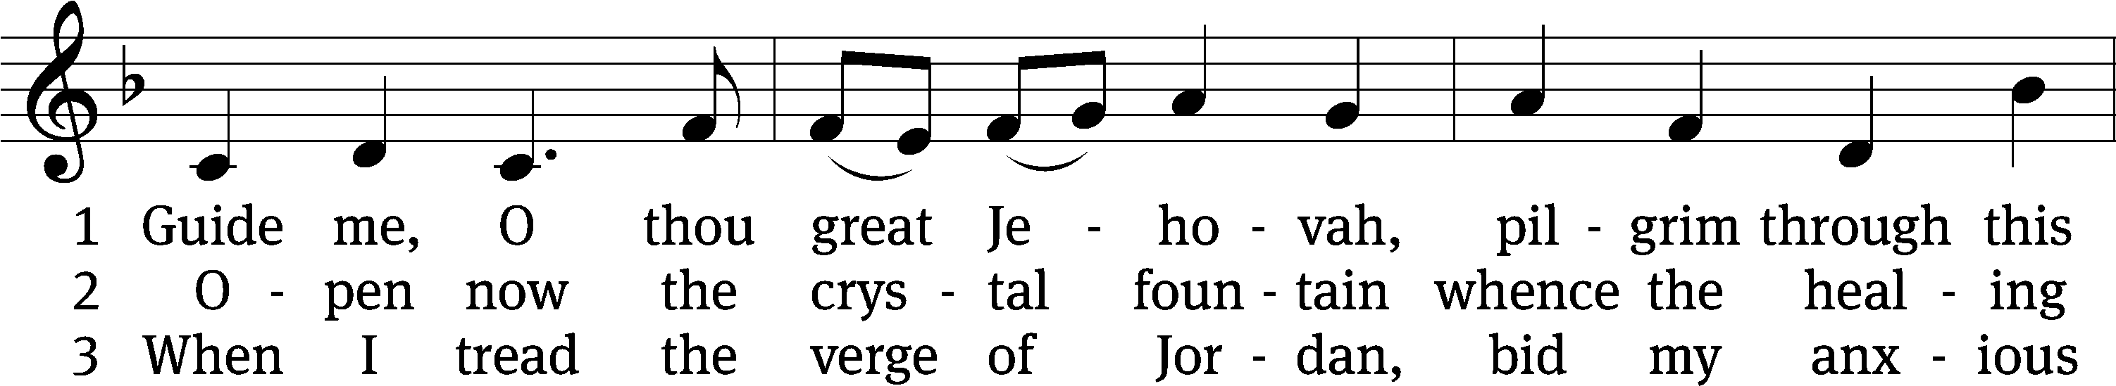
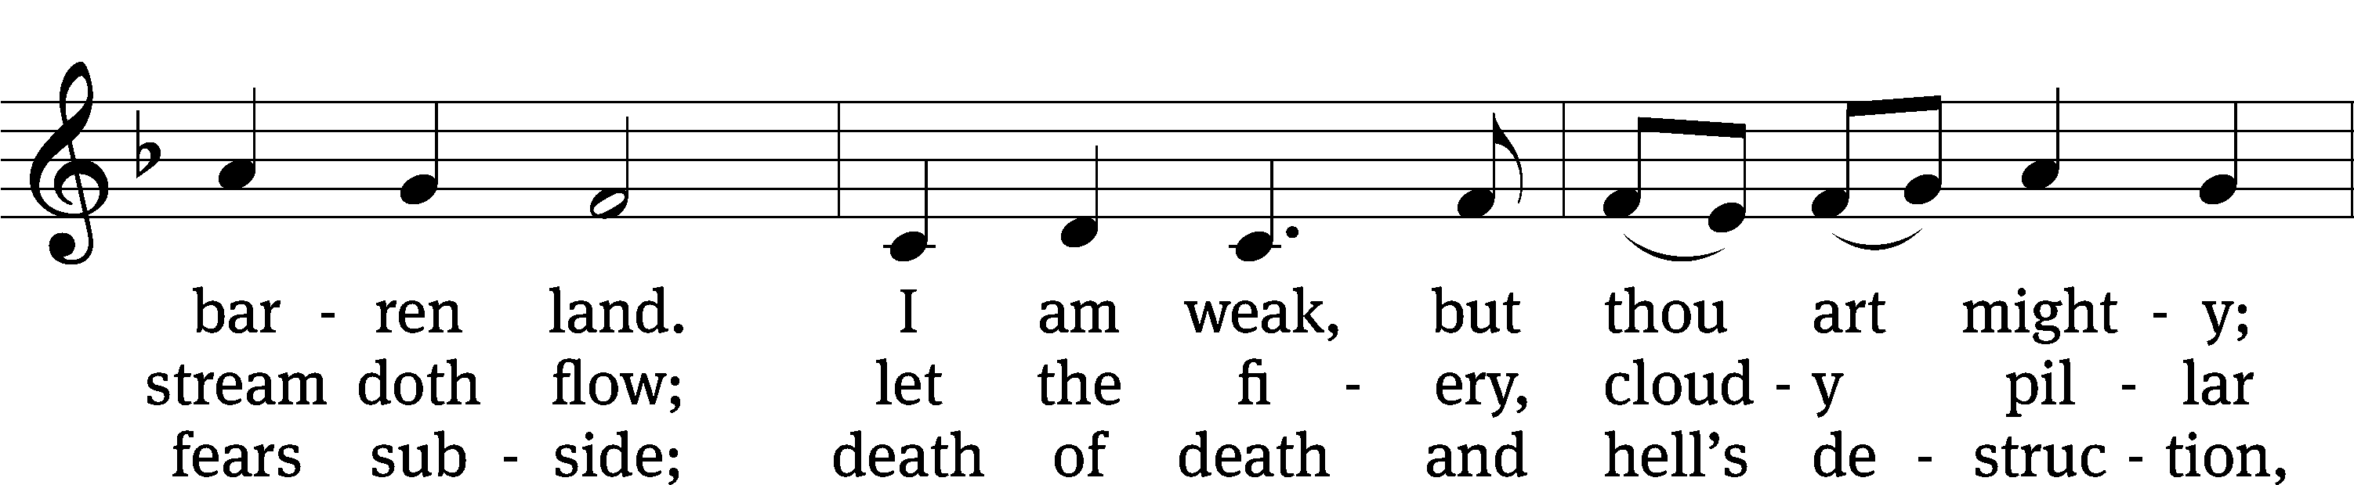
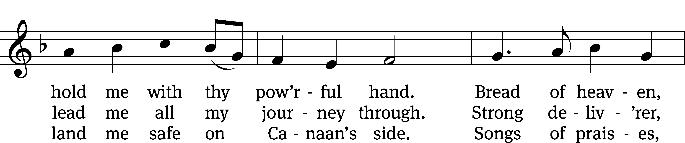
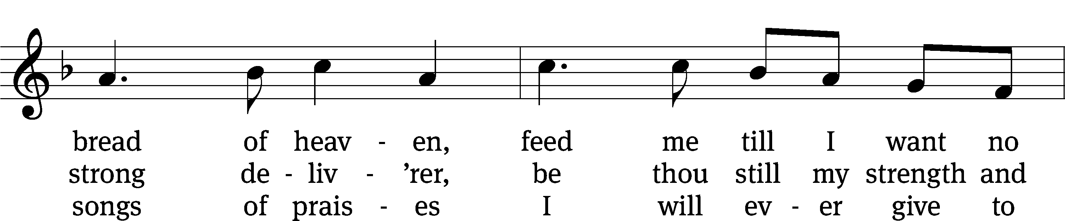
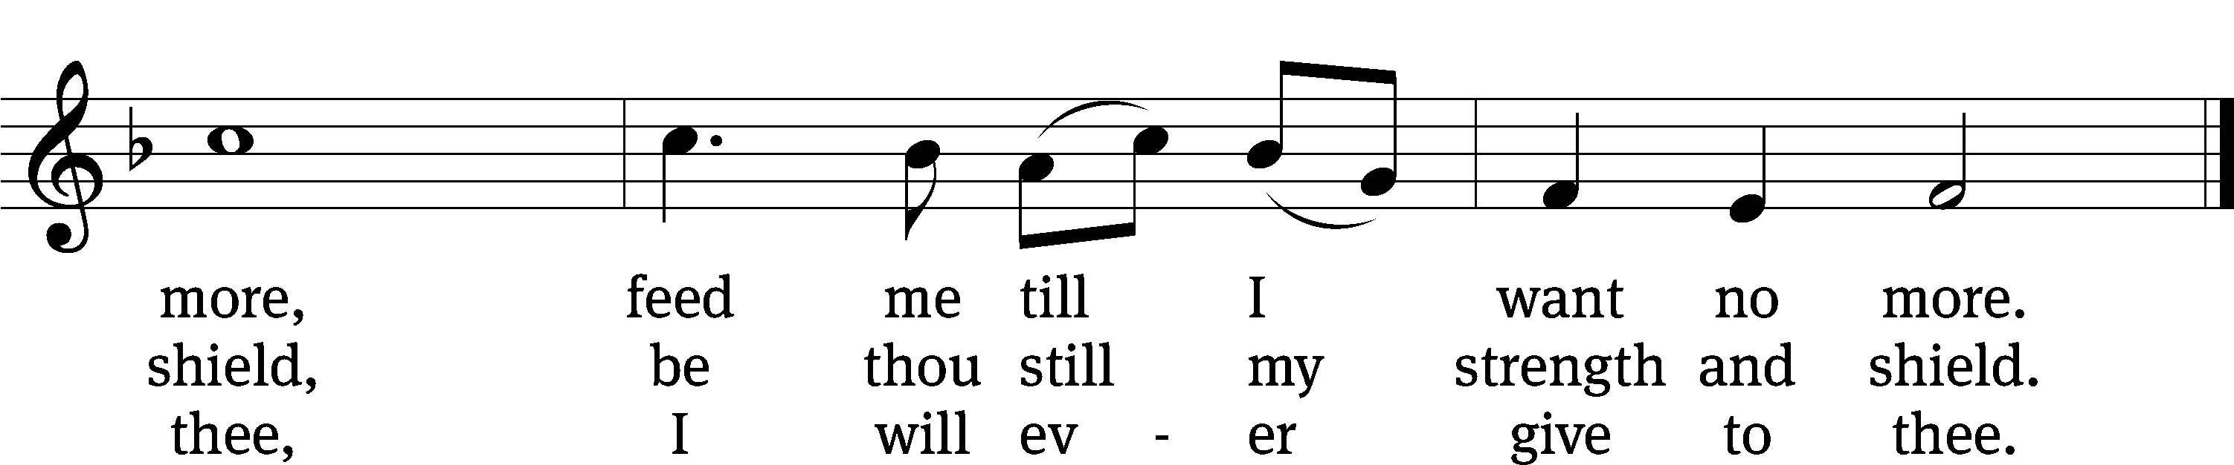
Text: William Williams, 1717–1791, abr.; (st. 1): tr. Peter Williams, 1722–1796, alt.; (sts. 2–3): tr. William Williams, 1717–1791
Tune: John Hughes, 1873–1932
Text and tune: Public domain

Serving In Worship
Officiant Pastor Natsis
Organist Marcia Marion Ackling
Bell Choir Director Meg Nortley
Deacons (8:30) Dave Stevenson and Jim Tice
(11:00) Steve Hoeft and Jeff Neuburger
Ushers (8:30) Dale Finkbeiner and Mark Finkbeiner
(11:00) Al Whitley
Altar Guild Sharon Boswell and Brenda Stevenson
Videographer Ann Latowski

Copyright information
Service of the Word: Christian Worship. © 1993 Northwestern Publishing House. All rights reserved.
Reprinted with permission under ONE LICENSE #A-727703 and CCLI #1151741/CSPL126093

Words and Music: All rights reserved. Reprinted with permission under ONE LICENSE #A-727703 and
CCLI #1151741/CSPL126093

tlcsaline.church

