The FOURTH SUNDAY
after Epiphany

TRINITY EVANGELICAL LUTHERAN CHURCH | Saline, Michigan
WELCOME TO WORSHIP January 28, 2024
Thank you for joining us in God’s house today! We cordially ask that our Guests sign one of the guestbooks located at either the front or back entryways, or fill out a “Let’s Get Acquainted” card located in the hymnal pew rack and place it in the collection plate.

THANK OFFERING: Members of Trinity give their offering as an expression of love and thankfulness to the Lord and to help support the Lord’s work in our community and around the world. Visitors need not feel obligated to participate in this offering which supports our ministry.

Restrooms are located at the back of the upper level (the annex), and in the basement (down the back stairs of the sanctuary or annex). Handicap access is available, please ask an usher for assistance.

Young Families / Toddler Bags – We are GLAD YOU BROUGHT YOUR CHILDREN to our worship service. Jesus said: “Let the little children come to me and do not hinder them, for the kingdom of God belongs to such as these.” We know that having little children in church can be a challenge, but DO NOT WORRY about it. Many of your fellow worshippers have been in your shoes and are just happy you brought your children with you. For your convenience, we have reserved the back rows of seating for parents with small children. These areas provide more flexibility for your family, as well as, easy access to move downstairs if necessary. A closed-circuit TV system allows families to continue participating in the service while downstairs. Pre-school toddler bags and children’s bulletins are available for their enjoyment. Ask an usher for one to use during the service and please return the toddler bag afterwards.

the SERVICE – setting one - WITHOUT HOLY COMMUNION CW, page 154

633 Speak, O Lord CW 633
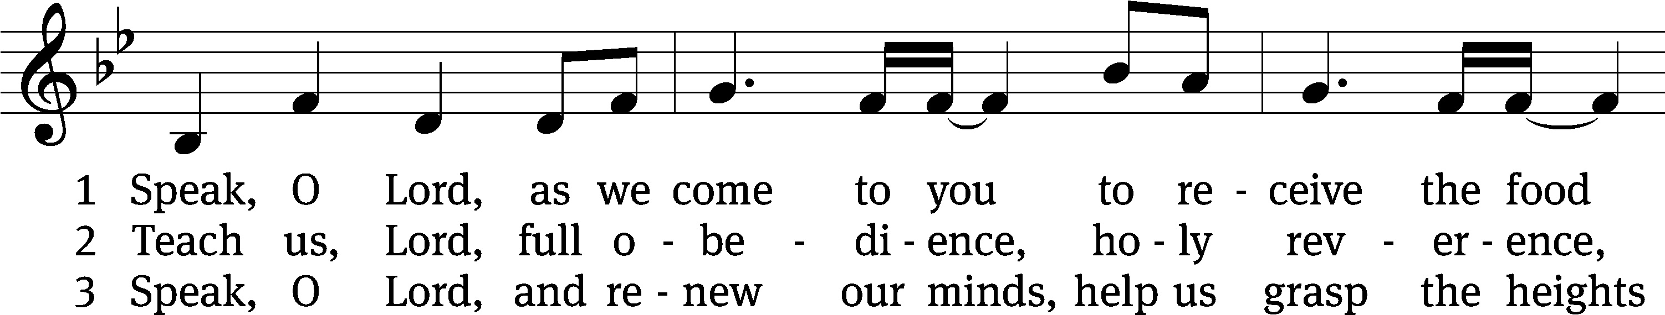
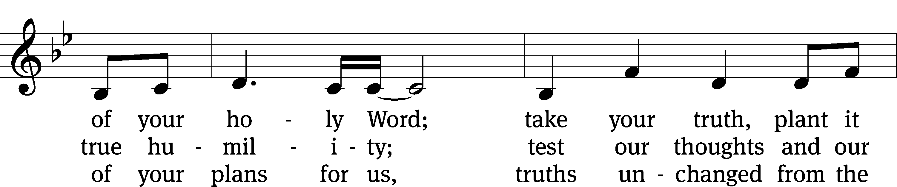
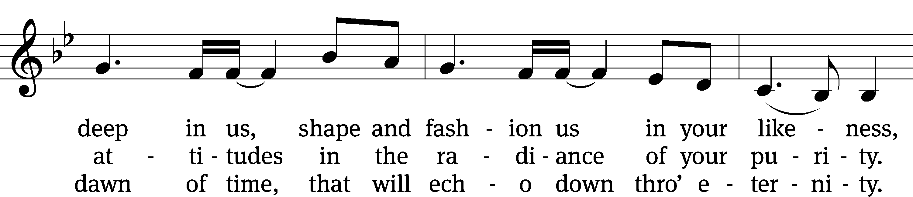
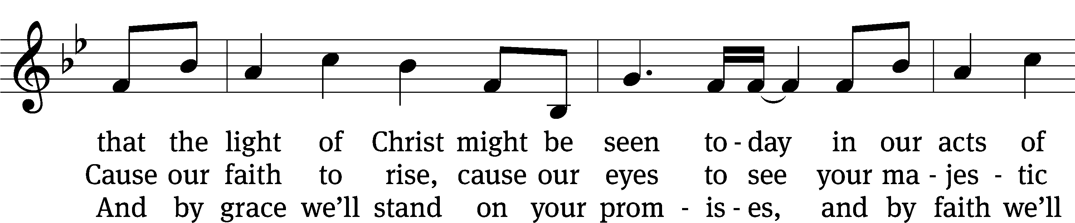
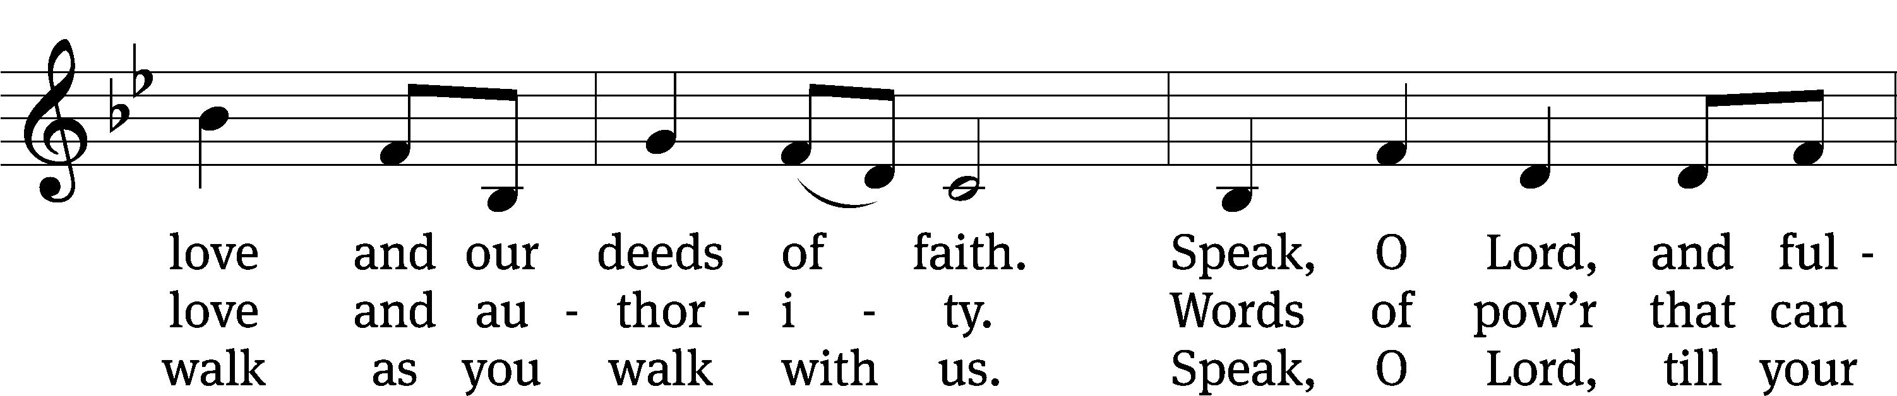
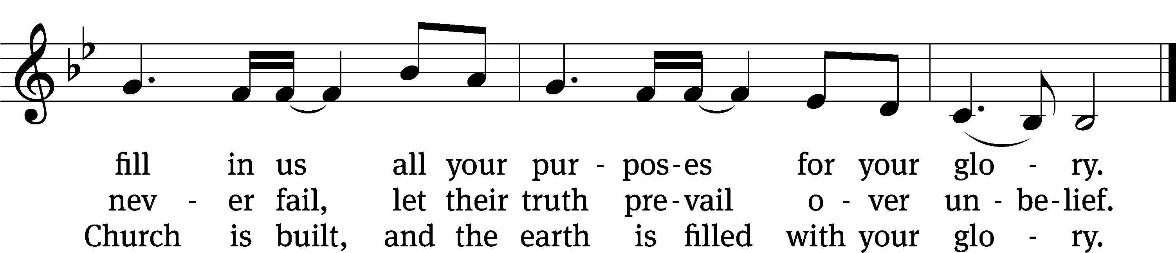
Text: Stuart Townend, b. 1963; Keith Getty, b. 1974
Tune: Stuart Townend, b. 1963; Keith Getty, b. 1974
Text and tune: © 2006 Thankyou Music, admin. CapitolCMGPublishing,com. Used by permission: OneLicense no. 727703

Please stand, if you are able
Invocation
In the name of the Father and of the Son and of the Holy Spirit.
Amen.

Confession
If we claim to be without sin, we deceive ourselves and the truth is not in us.
If we confess our sins, God is faithful and just
and will forgive us our sins
and purify us from all unrighteousness.

Let us confess our sins to the Lord.
Holy God, gracious Father,
I am sinful by nature
and have sinned against you in my thoughts, words, and actions.
I have not loved you with my whole heart;
I have not loved others as I should.
I deserve your punishment both now and forever.
But Jesus, my Savior, paid for my sins
with his innocent suffering and death.
Trusting in him, I pray: God, have mercy on me, a sinner.

Our gracious Father in heaven has been merciful to us. He sent his only Son, Jesus Christ, who gave his life as the atoning sacrifice for the sins of the whole world. Therefore, as a called servant of Christ and by his authority, I forgive you all your sins in the name of the Father and of the Son and of the Holy Spirit.
Amen.

Lord, Have Mercy
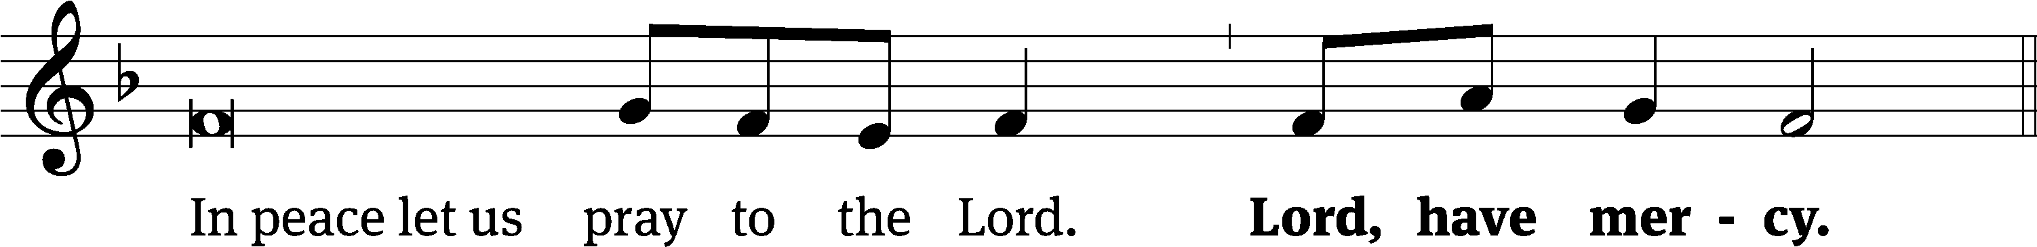
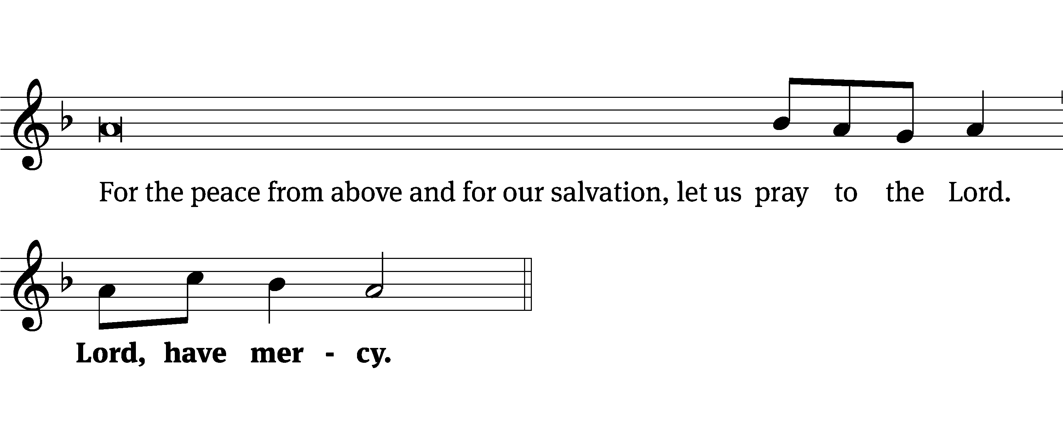
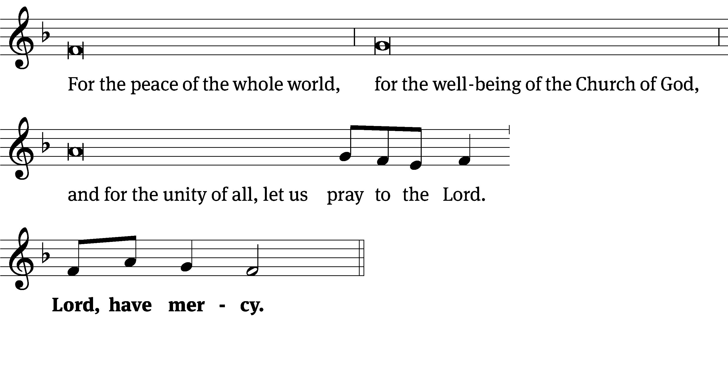
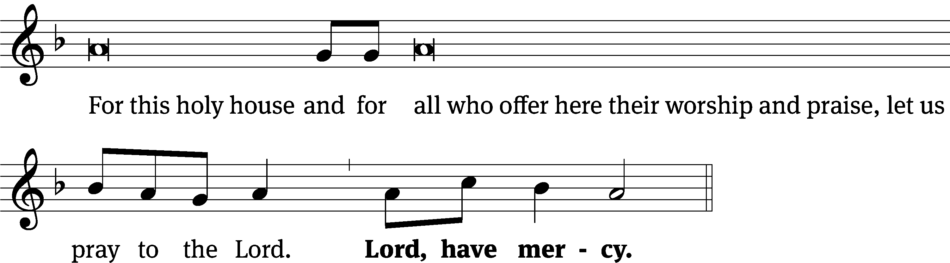
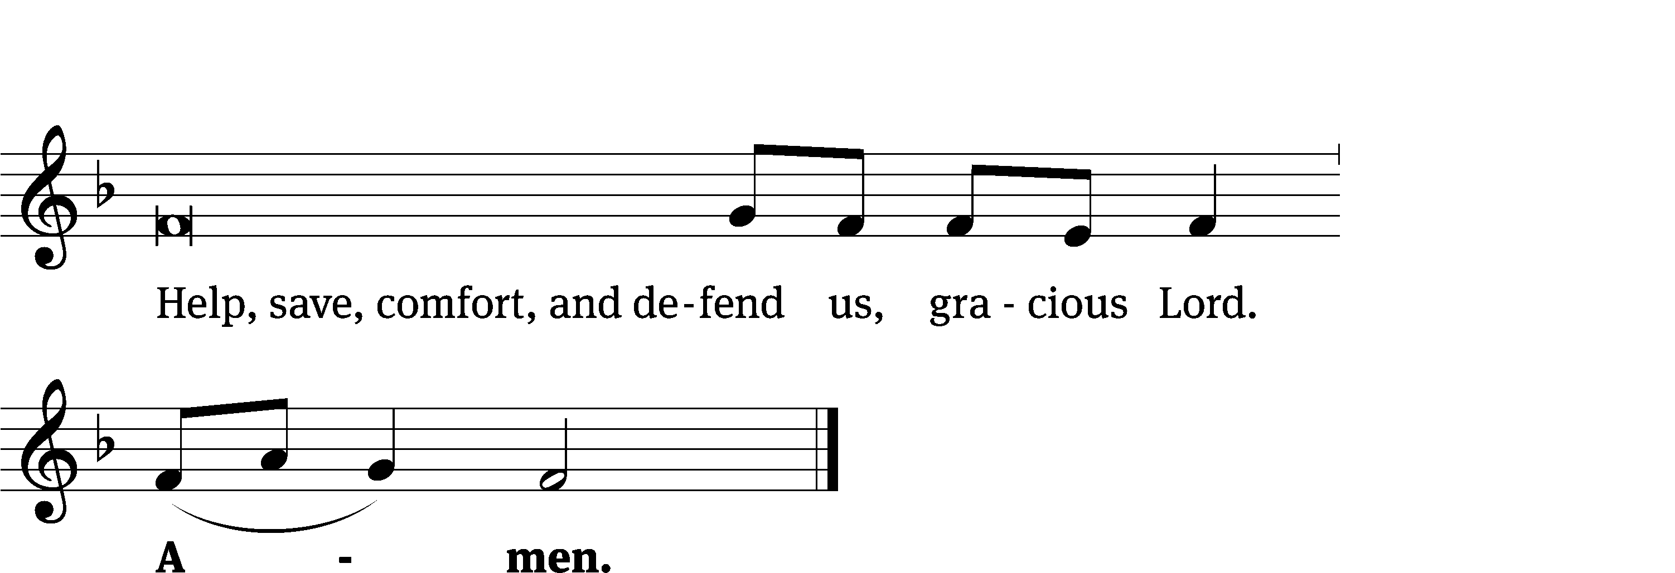
Tune: Kevin Becker
Tune: © 2021 Northwestern Publishing House. Used by permission: OneLicense no. 727703
Glory Be to God CW 157
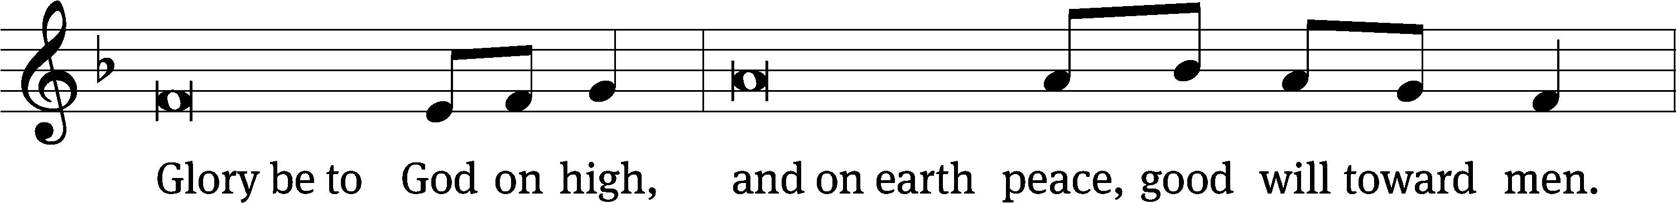
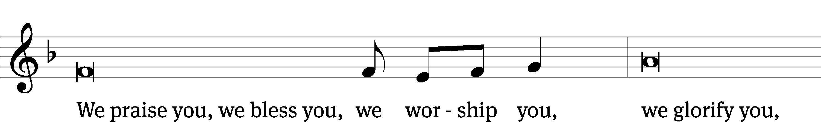
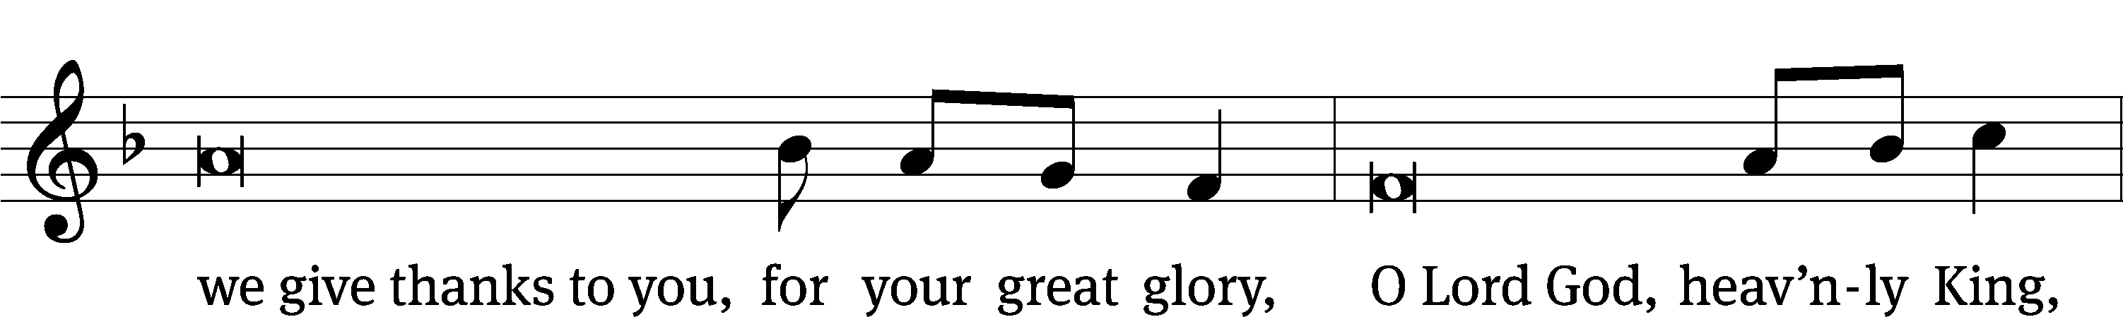
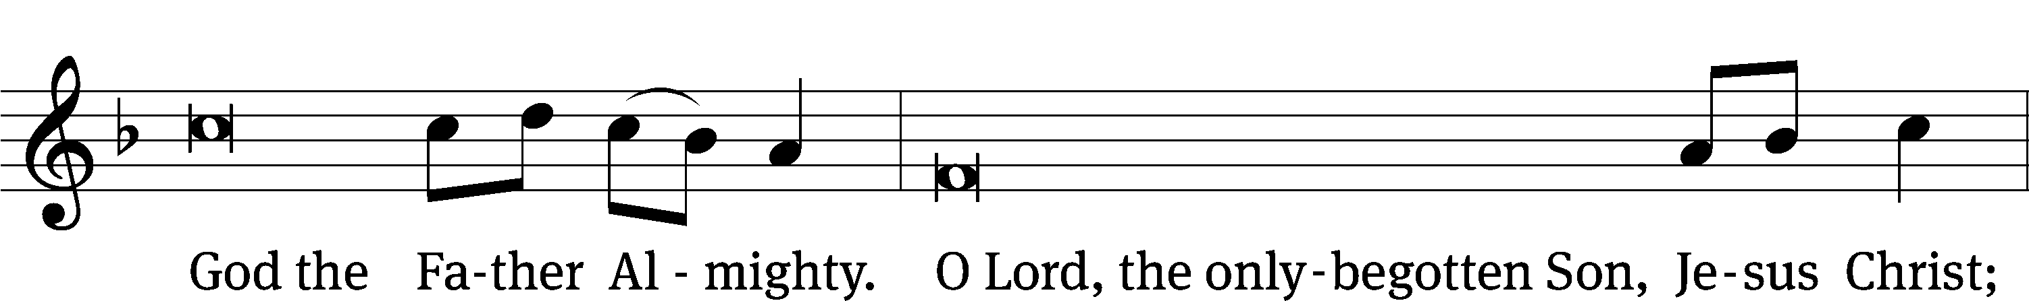
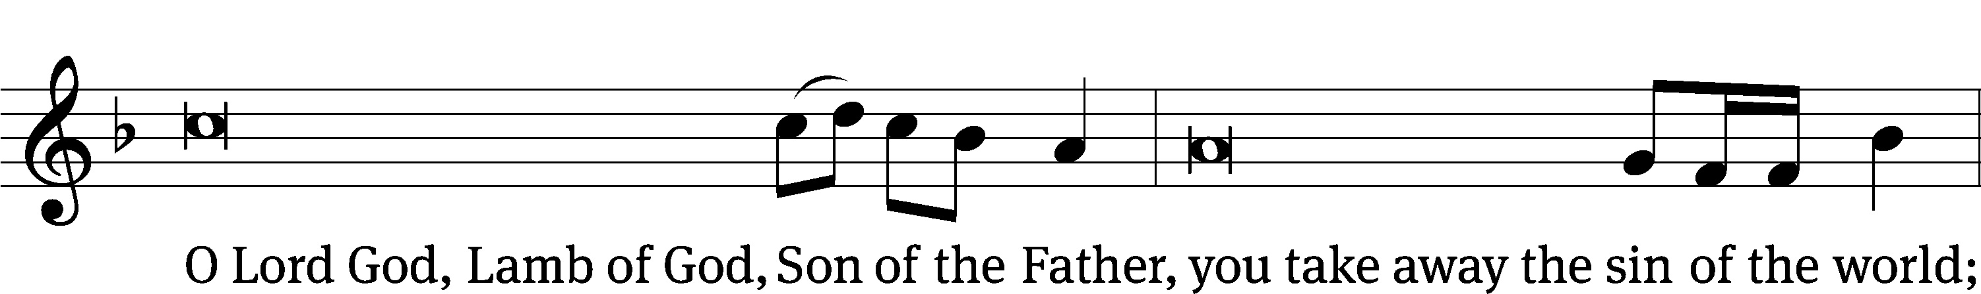
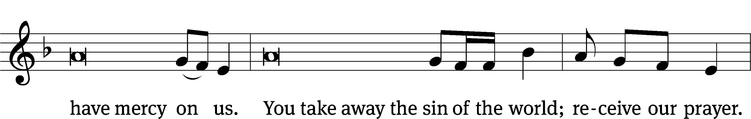
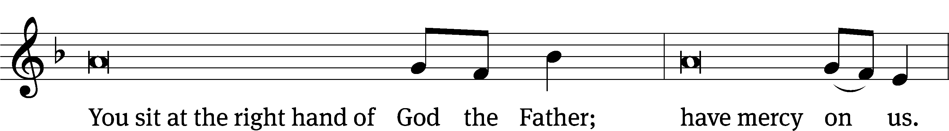
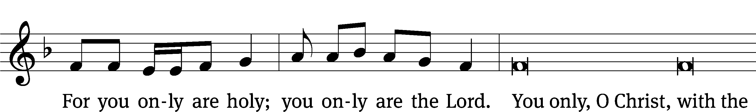
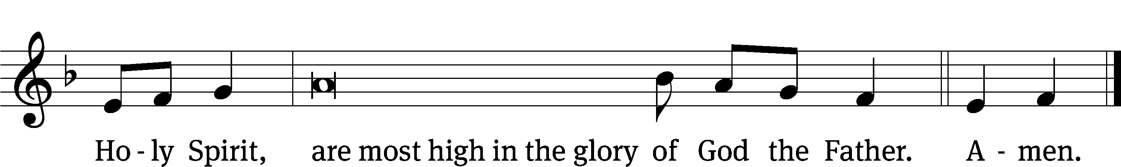

Tune: © 2021 Northwestern Publishing House. Used by permission: OneLicense no. 727703
The Lord be with you.
And also with you.
Prayer of the Day
Let us pray.

Almighty and everlasting God, look with mercy on our weaknesses, and in all our dangers and needs stretch out the right hand of your majesty to help and defend us; through your Son, Jesus Christ our Lord, who lives and reigns with you and the Holy Spirit, one God, now and forever.
Amen.

Please be seated

First Reading Deuteronomy 18:15-20
¹⁵ The Lord your God will raise up for you a prophet like me from among you, from your brother Israelites. Listen to him.
¹⁶ That is exactly what you asked from the Lord your God at Horeb on the day of the assembly. You said, “Do not let me hear the voice of the Lord my God anymore, and do not let me see this great fire again, or I will die.”
¹⁷ Then the Lord said to me, “They have done well by saying what they said. ¹⁸ I will raise up a prophet for them from among their brothers, like you, and I will put my words in his mouth, and he will speak to them everything that I command him. ¹⁹ Anyone who will not listen to my words that the prophet speaks in my name, I myself will call him to account. ²⁰ Any prophet who presumes to speak something in my name that I have not commanded him to speak or who speaks something in the name of other gods—that prophet shall die.”

The Word of the Lord.
Thanks be to God.

29B The Voice Which Shakes the Earth Psalm 29B
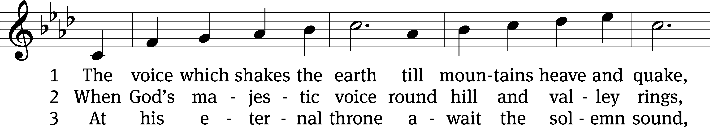
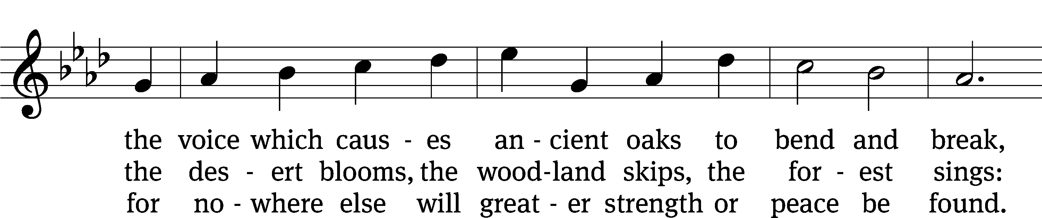
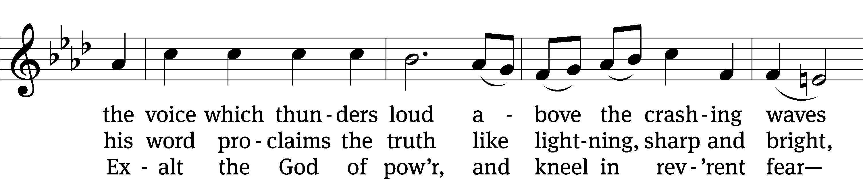
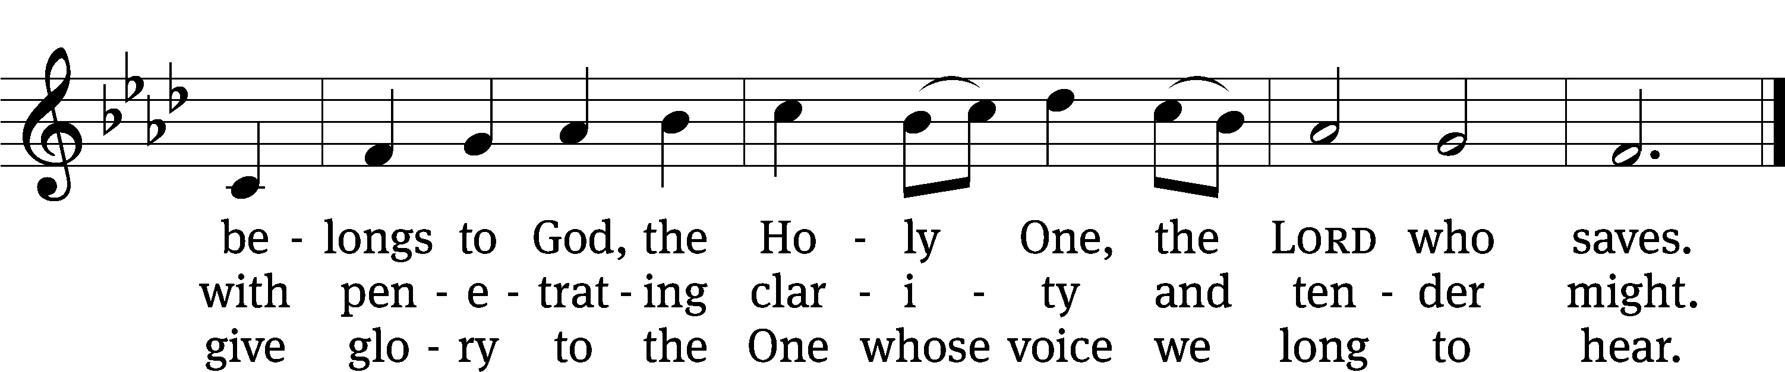
Text: Martin E. Leckebusch
Tune: Hebrew
Text: © 2006 Kevin Mayhew Ltd. Used by permission: License no. 130003540
Tune: Public domain

Second Reading Hebrews 3:1-6
3 Therefore, holy brothers, who share in the heavenly calling, focus your attention on Jesus, the apostle and high priest whom we confess. ² He was faithful to the one who appointed him, as also Moses was faithful in God’s whole house. ³ In fact, Jesus is worthy of greater glory than Moses, in the same way that the builder of a house has more honor than the house. ⁴ For every house is built by someone, and God is the one who built everything.
⁵ Moses was faithful as a servant within God’s whole house by testifying to the things that would be spoken. ⁶ But Christ is faithful as a Son over God’s house. We are his house, if we hold on firmly to our confidence and the hope about which we boast until the end.
The Word of the Lord.
Thanks be to God.

Please stand, if you are able
Gospel Acclamation Mark 1:22
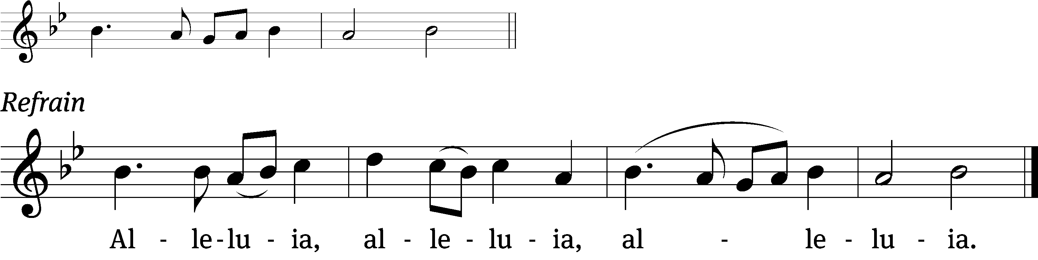
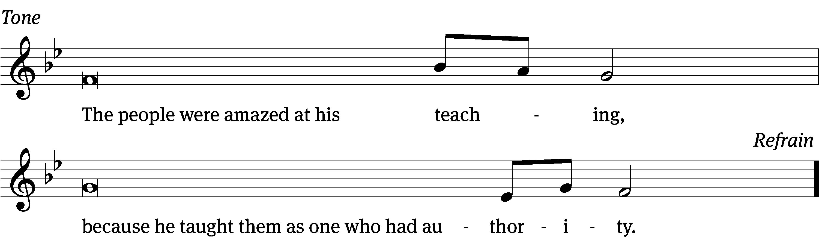
Tune: © 2021 Northwestern Publishing House. Used by permission: OneLicense no. 727703

Gospel Mark 1:21-28
²¹ Then they went into Capernaum. On the next Sabbath day, Jesus went into the synagogue and began to teach. ²² They were amazed at his teaching, because he was teaching them as one who has authority and not as the experts in the law. ²³ Just then there was a man with an unclean spirit in their synagogue. It cried out, ²⁴ “What do we have to do with you, Jesus of Nazareth? Have you come to destroy us? I know who you are—the Holy One of God!”
²⁵ Jesus rebuked the spirit, saying, “Be quiet! Come out of him!”
²⁶ The unclean spirit threw the man into convulsions, and after crying out with a loud voice, it came out of him. ²⁷ Everyone was so amazed that they began to discuss this with each other. They said, “What is this? A new teaching with authority! He even commands the unclean spirits, and they obey him!” ²⁸ News about him spread quickly through all the region of Galilee.
The Gospel of the Lord.
Praise be to you, O Christ!

Please be seated
744 Rise, Shine, You People CW 744
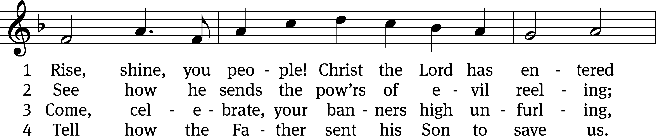
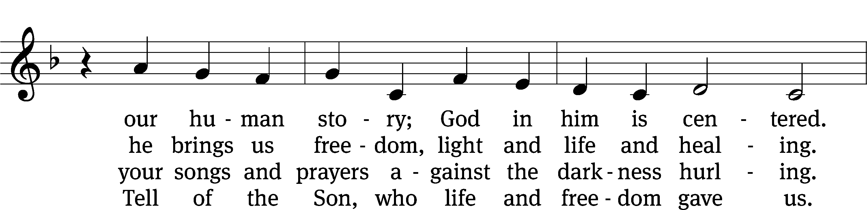
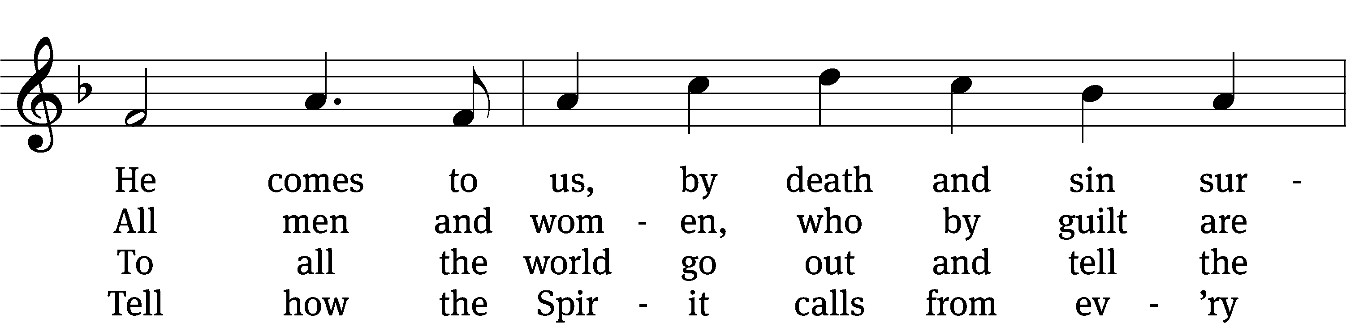
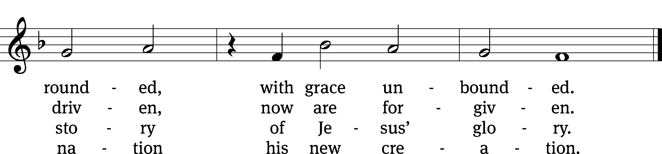
Text: Ronald A. Klug, b. 1939, alt.
Tune: Dale Wood, 1934–2003
Text: © 1974 Augsburg Publishing House, admin. Augsburg Fortress. Used by permission: OneLicense no. 727703
Tune: © 1974 Augsburg Publishing House, admin. Augsburg Fortress. Used by permission: OneLicense no. 727703
Sermon Mark 1:21-28
“Absolute Authority”

Please stand, if you are able
Apostles’ Creed
I believe in God, the Father Almighty,
maker of heaven and earth.

I believe in Jesus Christ, his only Son, our Lord,
who was conceived by the Holy Spirit,
born of the Virgin Mary,
suffered under Pontius Pilate,
was crucified, died, and was buried.
He descended into hell.
The third day he rose again from the dead.
He ascended into heaven
and is seated at the right hand of God the Father Almighty.
From there he will come to judge the living and the dead.

I believe in the Holy Spirit,
the holy Christian Church,
the communion of saints,
the forgiveness of sins,
the resurrection of the body,
and the life everlasting. Amen.

Prayer of the Church

Please be seated

769 Your Hand, O Lord, in Days of Old CW 769
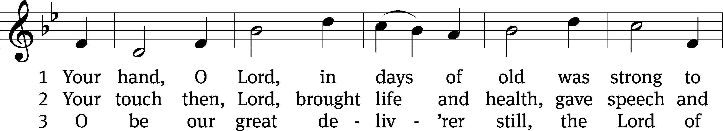
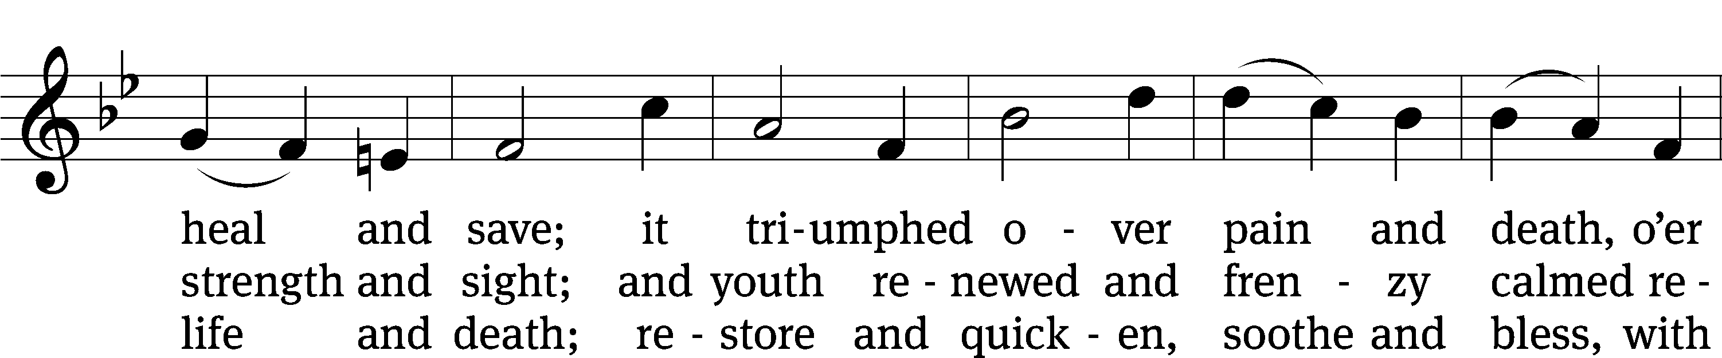
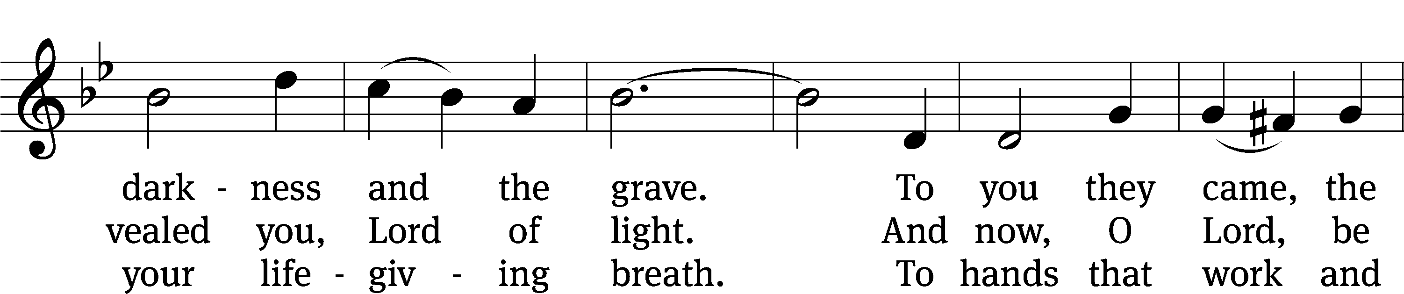
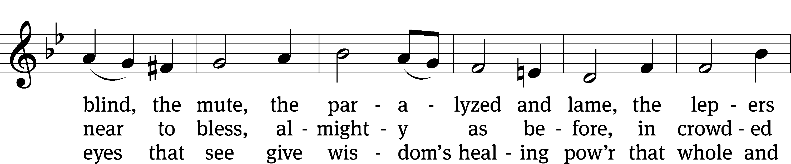
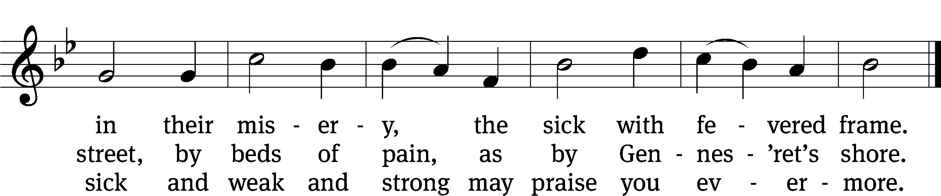
Text: Edward H. Plumptre, 1821–1891, alt.
Tune: William Croft, 1678–1727
Text and tune: Public domain

Please stand, if you are able

Prayer
Blessed Lord, you have given us your Holy Scriptures for our learning. May we so hear them, read, learn, and take them to heart that, being strengthened and comforted by your holy Word, we may cling to the blessed hope of everlasting life; through Jesus Christ our Lord, who lives and reigns with you and the Holy Spirit, one God, now and forever.
Amen.
Lord’s Prayer
Our Father, who art in heaven, hallowed be thy name, thy kingdom come, thy will be done on earth as it is in heaven. Give us this day our daily bread; and forgive us our trespasses, as we forgive those who trespass against us; and lead us not into temptation, but deliver us from evil. For thine is the kingdom and the power and the glory forever and ever. Amen.

Blessing
The Lord bless you and keep you.
The Lord make his face shine on you and be gracious to you.
The Lord look on you with favor and give you peace.
Amen.

Please be seated

386 Songs of Thankfulness and Praise CW 386 sts. 1, 3, 5
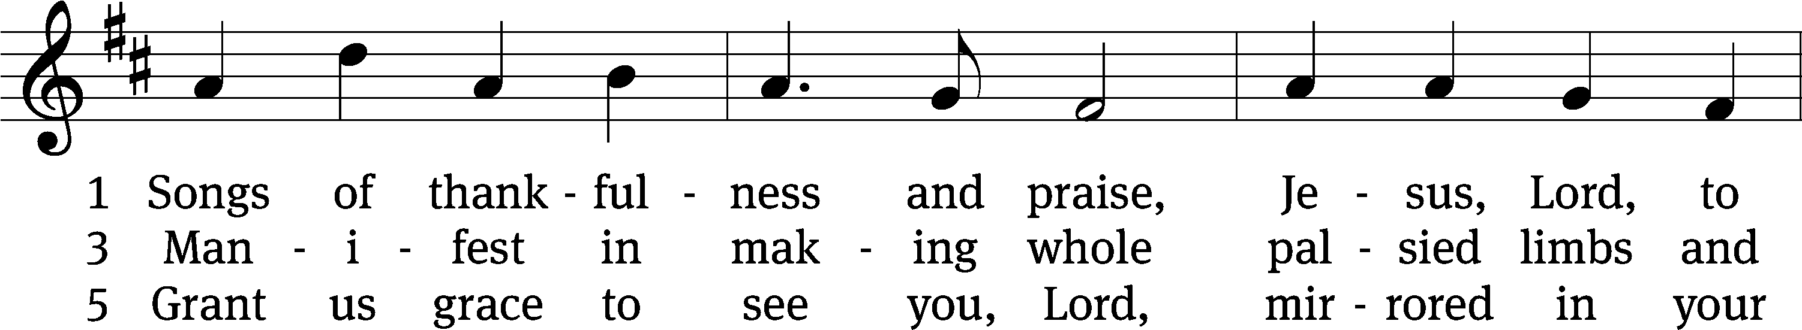
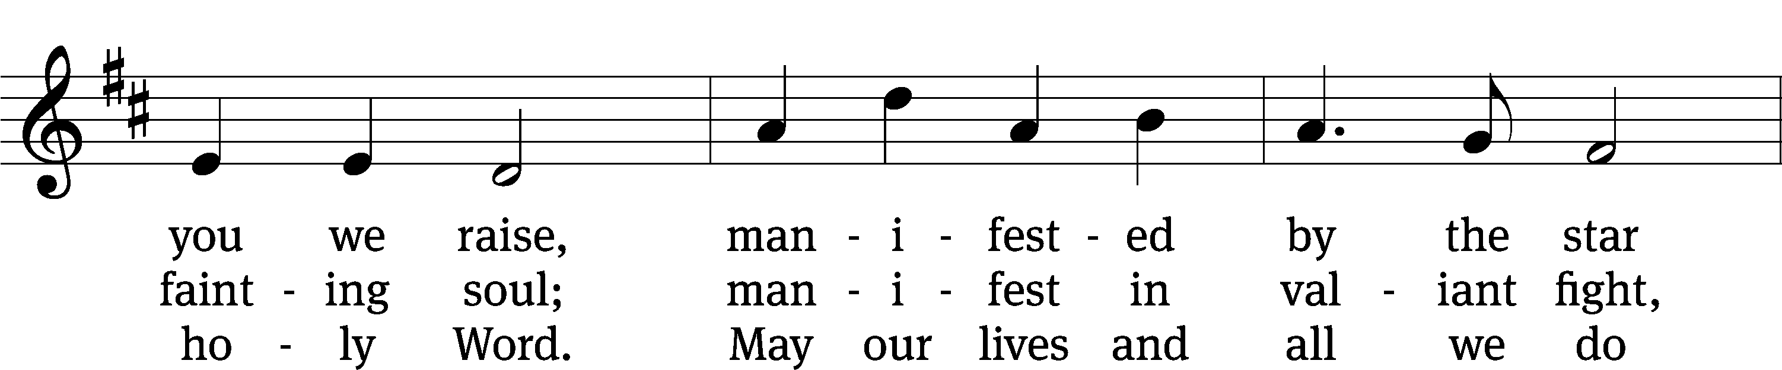
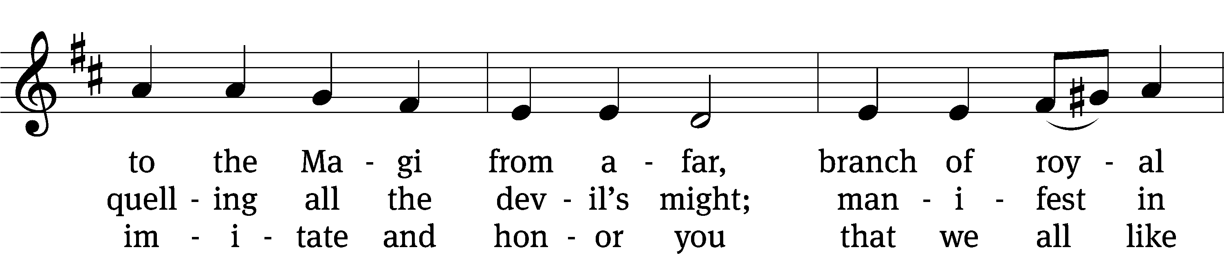
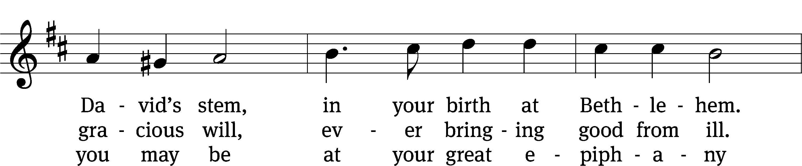
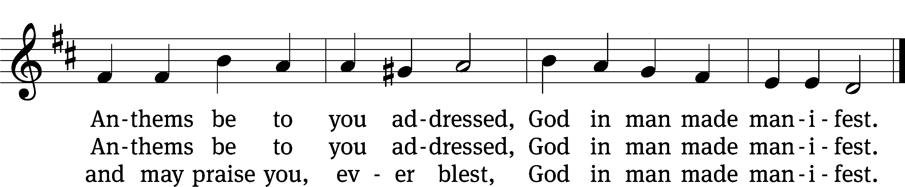
Text: Christopher Wordsworth, 1807–1885, alt.
Tune: Jakob Hintze, 1622–1702
Text and tune: Public domain

Acknowledgments
Setting One from Christian Worship
Software distributed in partnership with Northwestern Publishing House.
Created by Christian Worship: Service Builder © 2022 Concordia Publishing House.

Serving in Worship
Officiant Pastor Pappenfuss
Organist Sarah Hanke
Deacons (8:30) Ron Roehm and Dave Stevenson
(11:00) Dave Frey and Gary Knowlton
Ushers (8:30) Bob Newman and Henry Schneider
(11:00) Ed Sala and Al Whitley
Altar Guild Sharon Boswell and Laura Lindemann
Videographer Jake Vershum

